Simulation of Digital Modulation Techniques

Introduction

This report will outline the basic understanding of digital signal processing, its application and the variations of modulation and digital communication systems. Simulation software will be used to critically compare the performances of different variants; Amplitude shift keying (ASK), phase shift keying (PSK) and more advanced variants such as Quadrature phase shift keying (QPSK) & Quadrature amplitude modulation (QAM) with the addition of additive white Gaussian noise (AWGN).

Background Information

Digital Signal Processing (DSP) plays a massive part in technology, they take real-world signals like voice, audio, temperature or pressure that have been digitized and then mathematically manipulate them, this can be done very quickly, using functions such as ‘add’, ‘subtract’ and ‘multiply’. A signal needs to be processed so it can display its information so it can be analysed or converted to another type of signal.
Converters are used to take the real-world signal and turn it into a digital format of 1’s and 0’s (binary). The DSP can then feed this processed digital information back for use in the real world. This can be done digitally via a digital-to-analogue converter or vice versa. A DSP’s information can be used by computer systems to control CCTV security, telephone systems and home theatre systems. These signals can be compressed in order for them to be transmitted quickly and more efficiently from one place to another. Signals can also be enhanced or manipulated to either improve their quality or to provide more information that is not heard/seen by humans. [1]
There are many reasons for using DSP’s;
- Guaranteed accuracy – this is only determined by the number of bits being used.
- Perfect reproducibility – Identical performance from unit to unit since there is no variation in component tolerances, ie; you can reproduce a digital recording with any degradation.
- No drift in performance with age or temperature.
- Greater flexibility – DSP’s can be programmed and reprogrammed to perform a variety of functions without any modification to the hardware.
- Superior performance – can do functions not possible with analogue signal processing. [2]

In DSP’s, baseband signals must be band-limited in the receiver or transmitter, most of the baseband signal and analysis is accomplished using digital signal processing.[3] Analogue filtering is used along many paths of the signal chain; this can filter out high frequency noise of an RF demodulator or reduce the imaging of a digital-to-analogue converter. In the digital communication system, even after the noise is added, the data that has been sent, either a “1” or “0” is still a “1” or “0” so the receiver can determine that the information was transmitted. In an analogue system the opposite occurs and the receiver is stuck with the noise and can no longer decipher/recover the data that was sent. The effects of noise are much less than the effect on an analogue system. The digital system is now the communication system of choice, due to its rapid availability and low-cost digital components.
The main components that a DSP contains are a Program Memory, this stores the programmes the DSP will use to process all its data. Data Memory which stores the information ready to be processed. Compute Engine, this performs the mathematical processing, assessing the programme from the program memory and the data from the data memory. Input/Output this serves as a range of functions to connect to the outside environment. [4]
To fully understand how modulation is achieved we must look at digital filters. There are 4 mains types of digital filter, Low Pass, High Pass, Band Pass and Band Stop filters. The Low Pass filter will remove any frequencies over the “cutoff”, seemingly the High Pass filter does the opposite in removing any frequencies below the “cutoff”. Band pass/stop filters work by removing frequencies within and outside a distance from the centre. [5]
The process of imposing an input signal onto a carrier wave is called modulation. Modulation changes the shape of the carrier wave to encode the data or information that you want to carry. There are different ways to modulate a carrier wave, by changing either the amplitude (height of the wave), frequency (number of waves per timeframe) or the phase (where the phase is at any timeframe). If an input signal’s height varies with the loudness of a given sound, this is added to the carrier thus increasing the carrier’s amplitude corresponding to the input signal. This is amplitude modulation. [6]
There are 2 types of amplitude modulation, OOK (On-Off keying) and ASK (amplitude shift keying). Amplitude shift-keying represents the binary data in the form of variations in the amplitude of a signal. Any modulated signal has a high frequency carrier, when ASK is modulated, the binary signal gives a zero value for low input while the carrier output a high input. [7]
Frequency modulation (FM) is where the frequency of an input signal can be changed. If this input signal is added to the carrier wave, it will change the frequency of the carrier wave. Users can tweak the frequency to carry information. There any many types of FM, PSK (phase shift keying), QPSK (Quadrature phase shift keying) and BPSK (binary phase shift keying). PSK systems use a differential method for encoding data onto the carrier wave, for example this can be achieved by making a change in phase equal to a 1 and no phase change equal to a 0, alternatively making a change by 90 degrees in one direction for a 1 and 90 degrees the other way for a 0, this retains the 180 degree phase reversal between 1 and 0 states. QPSK is where 4 phase states are used each 90 degrees from the next, 2 bits are modulated simultaneously by choosing from the 4 states. It uses the same bandwidth as standard PSK but carries double the amount of information. [8]
Quadrature amplitude modulation (QAM) is a combination of analog and digital modulation. It modulates the amplitude of the 2 carrier waves with the help of ASK in order to transmit 2 digital bit streams. The 2 carrier waves remain out of phase by 90 degrees from each other, the modulated waves are then merged, the waveform produced is in the form of both PSK and ASK. QAM modulation schemes are sought after in digital communication systems, a suitable constellation size is fixed and restricted by the linearity of the comms channel and the degree of noise, this achieves greater spectral efficiencies.

Simulation Models.

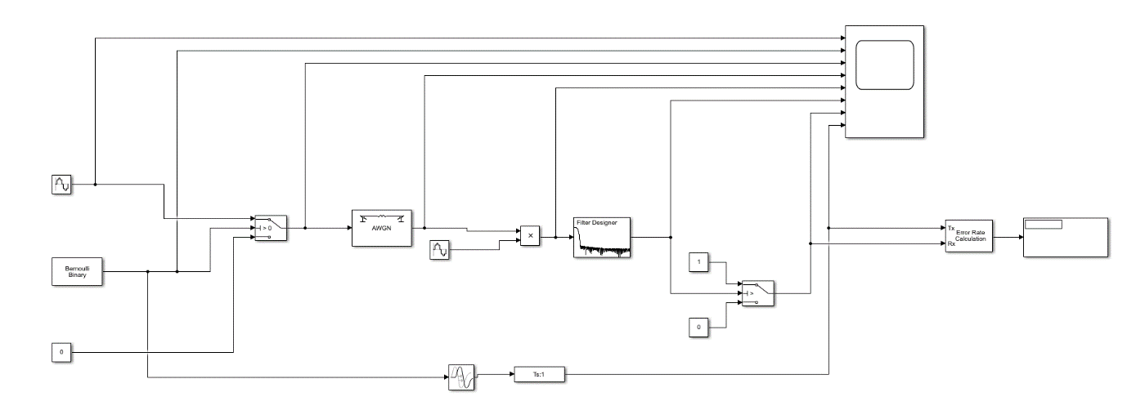
Amplitude Shift Keying;
Figure 1 - ASK

In figure 1, I have designed an ASK modulation simulation, the AWGN block is in the middle to modify the amount of noise the carrier receives. An error rate calculation is at the end of the design to work out Bit Error Rate and the number of errors detected in the carrier wave. A scope is placed along parts of the design to show how the carrier wave is behaving at each given plot.

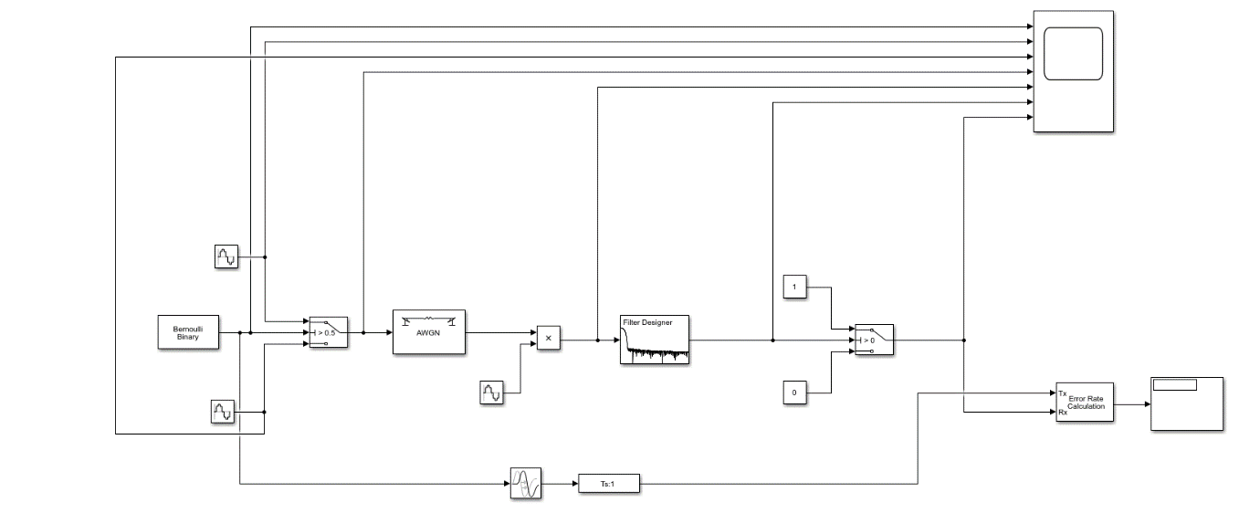
Phase Shift Keying;
Figure 2 - PSK

In figure 2, I have designed a PSK modulation simulation. Much like the ASK simulation in figure 1, it has the AWGN block in the middle to alter the amount of noise and a filter design after. Instead of just 1 sine wave input and a constant in the ASK model, the PSK model has 2 sine waves at the start. It also has an error rate calculator included in the simulation to show the bit error rate when noise is introduced to the signal.
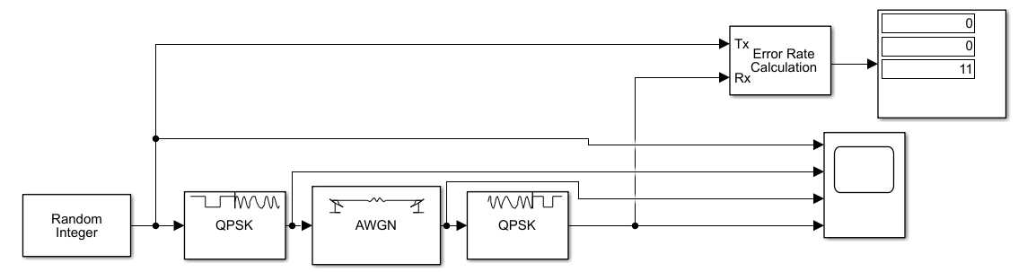
Quadrature Phase Shift Keying;
Figure 3 - QPSK

In figure 3, the QPSK modulator and demodulator blocks were used in this simulation with the AWGN block in the middle. A random integer block was used to produce a series of data. The scope was used to see the carrier wave along the simulation. The error rate calculation was used to understand the bit error rate of the QPSK system.

Quadrature Amplitude Modulation;
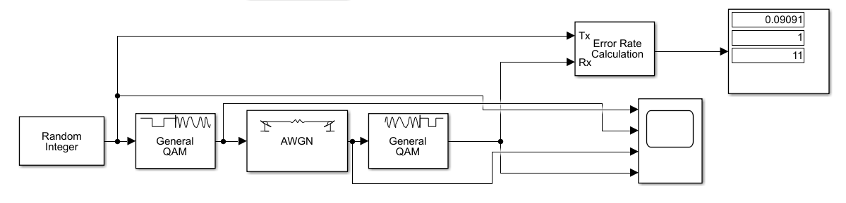
Figure 4 - QAM

In figure 4, the QAM modulator and demodulator blocks were selected to run this simulation. The AWGN block was placed the middle to tweak the signal to noise (SNR). The random integer block was used to produce some date. The error rate calculation was used to understand the effect the SNR would have on the bit error rate.

Results.

To gather the results from each simulation, I selected a range of decibel (SNR) values to run in the AWGN block on the simulations. I ran each simulation 10 times per SNR value and worked out the average bit error rate and recorded it on the table below. We can see from the table of results when each modulation variation achieves zero errors with the given SNR value.

Table 1 - Modulation results
 | Bit Error Rate (%)
SNR (db) | ASK Modulation | PSK Modulation | QPSK Modulation | QAM Modulation
-100 | 0.5637 | 0.3636 | 0.7455 | 0.9273
-75 | 0.4182 | 0.3999 | 0.8364 | 0.9454
-50 | 0.3091 | 0.4181 | 0.7636 | 0.8182
-40 | 0.5091 | 0.3818 | 0.7818 | 0.8
-30 | 0.3818 | 0.3636 | 0.6364 | 0.8909
-20 | 0.3272 | 0.3636 | 0.7455 | 0.8727
-15 | 0.2182 | 0.3272 | 0.6 | 0.8
-10 | 0.2181 | 0.1454 | 0.5636 | 0.7454
-5 | 0.1636 | 0 | 0.4909 | 0.7091
0 | 0.0727 | 0 | 0.2182 | 0.3999
5 | 0 | 0 | 0 | 0.1818
10 | 0 | 0 | 0 | 0.0363

We can see from the graph of results above that the QPSK and QAM modulation techniques are more susceptible to noise interference and have a much higher bit error rate than ASK/PSK.
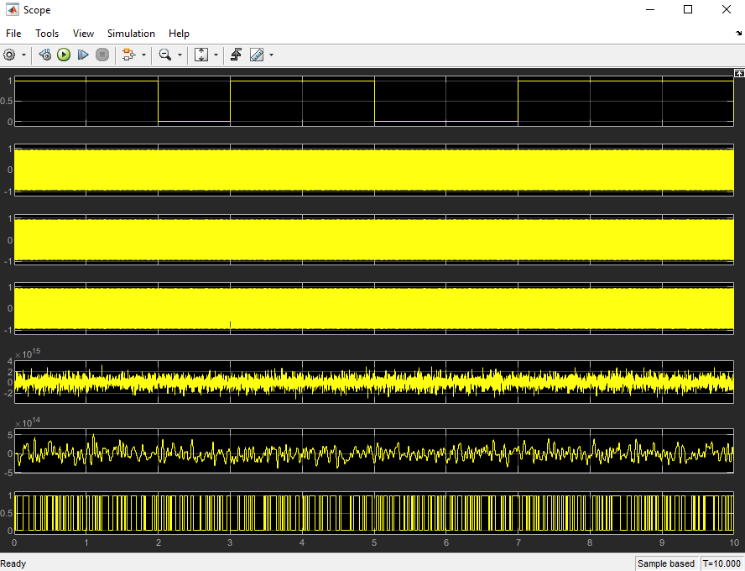
PSK Modulation –
Figure 5- PSK -100db

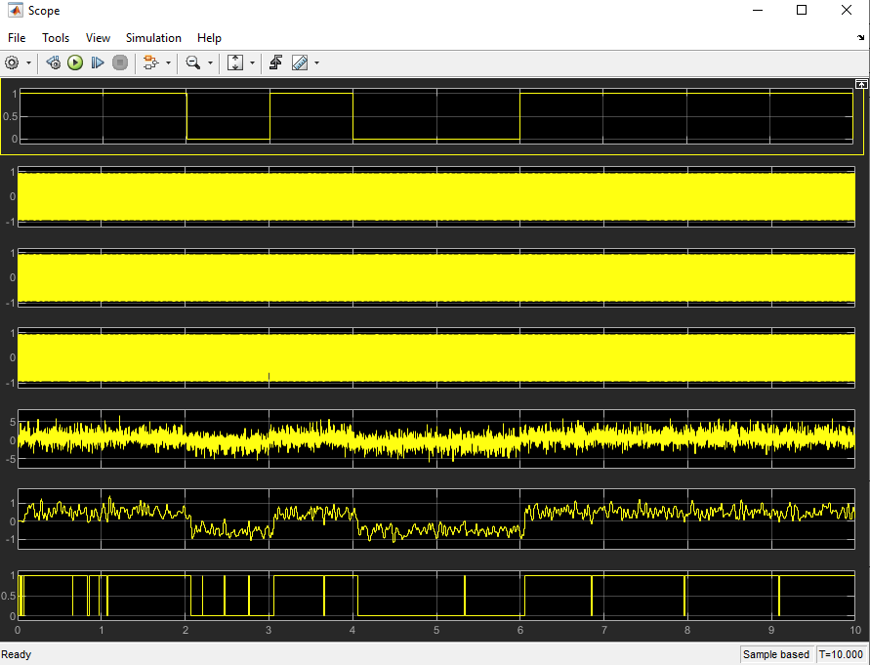
Figure 6 - PSK -5db

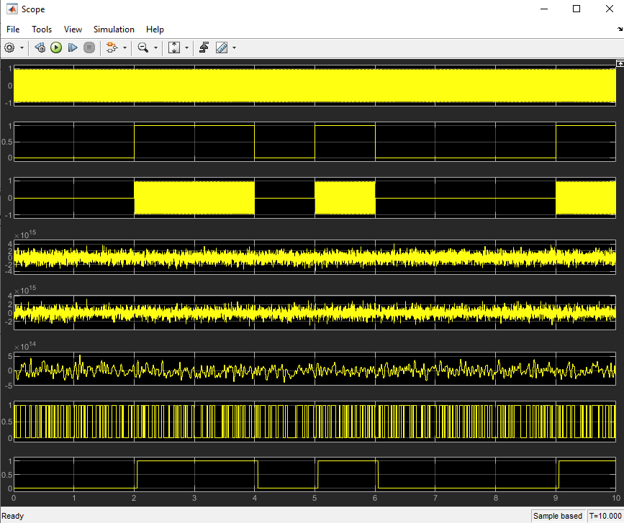
ASK Modulation –
Figure 7 - ASK -100db

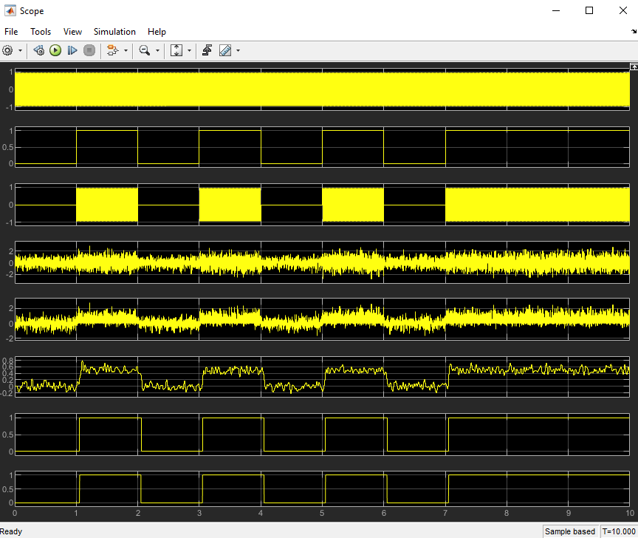
Figure 8 - ASK 5db

QPSK Modulation –
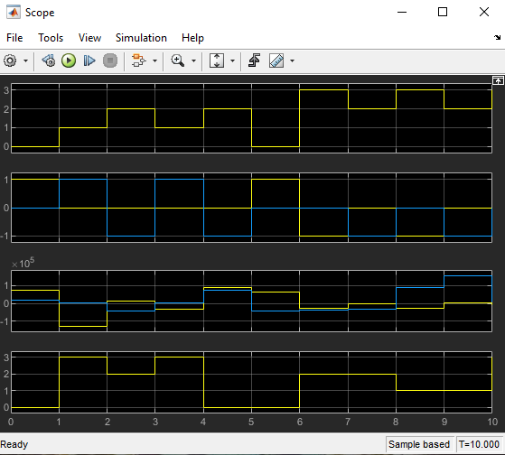
Figure 9 - QPSK -100db

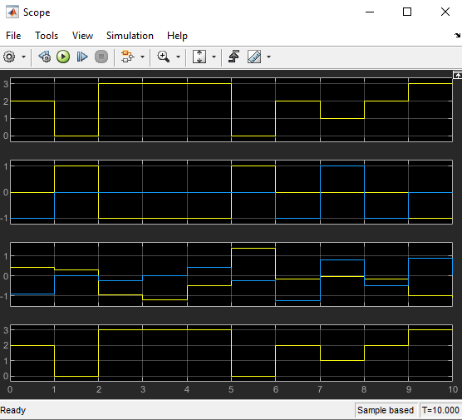
Figure 10 - QPSK 5db

QAM Modulation –
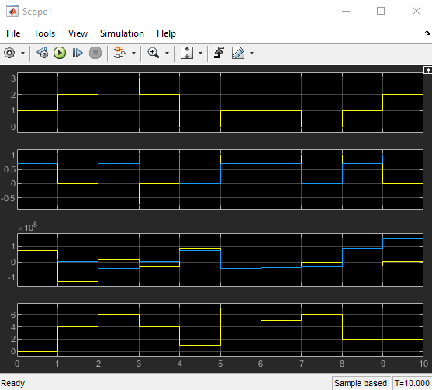
Figure 11 - QAM -100db

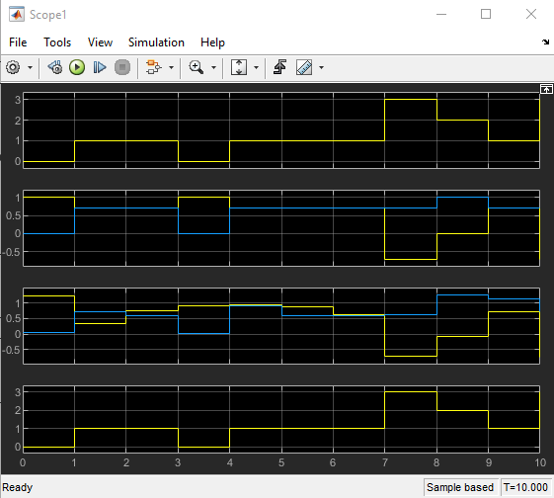
Figure 12 - QAM 10db

The above Figure 5 – Figure 12, show the scope from the simulations. For each modulation technique there is an image to show the carrier wave being modulated and demodulated at different SNR values. The images show each modulation with a high bit error rate and a low/nil bit error rate.

Discussion.

We can see from the table of results that the ASK modulation reaches a 0 bit error rate around 0/-1db, any negative SNR value causes too much noise in the carrier wave and many errors start to occur. The PSK is similar to the ASK system when introduced to negative values of noise but can manage to produce little to no errors around -5db. The QPSK and QAM system both suffer with high bit error rates with any negative value of noise and only start to produce little or no errors around 5-10db.
From figure 5, 7, 9, 11 you can see the system all receiving -100db. The images show the noise interference within the carrier wave and the number of errors in the received signal is high. Figure 6, 8, 10, 12 show the value of noise the modulation techniques can manage. The carrier wave is clearly seen at the end reproduced from the original sent message with no errors.

Conclusion.

Table of figures
Figure 1 - ASK 3
Figure 2 - PSK 3
Figure 3 - QPSK 4
Figure 4 - QAM 4
Figure 5- PSK -100db 6
Figure 6 - PSK -5db 6
Figure 7 - ASK -100db 7
Figure 8 - ASK 5db 7
Figure 9 - QPSK -100db 8
Figure 10 - QPSK 5db 8
Figure 11 - QAM -100db 9
Figure 12 - QAM 10db 9

References

[1]] | “A Beginners guide to DSP,” [Online]. Available: https://www.analog.com/en/design-center/landing-pages/001/beginners-guide-to-dsp.html#.
[2] | B. W. J. Emmanuel C. Ifeachor, Digital Signal Processing: A Practical Approach.
[3] | “Digital Communication System,” [Online]. Available: https://www.sciencedirect.com/topics/engineering/digital-communication-system.
[4] | “A Beginners Guide to DSP,” [Online]. Available: https://www.analog.com/en/design-center/landing-pages/001/beginners-guide-to-dsp.html#:~:text=A%20DSP%20contains%20these%20key,data%20from%20the%20Data%20Memory .
[5] | “How does modulation work,” Keysight Technologys, [Online]. Available: https://community.keysight.com/community/keysight-blogs/oscilloscopes/blog/2016/09/01/how-does-signal-modulation-work .
[6] | “Basic radio awareness,” Radio Academy, [Online]. Available: https://www.taitradioacademy.com/topic/how-does-modulation-work-1-1/#:~:text=This%20process%20of%20imposing%20an,code%20inside%20the%20carrier%20wave. .
[7] | “Amplitude shift keying,” [Online]. Available: https://www.tutorialspoint.com/digital_communication/digital_communication_amplitude_shift_keying.htm .
[8] | “Difference between QPSK & QAM,” [Online]. Available: https://techdifferences.com/difference-between-qam-and-qpsk.html.

