
Master of Business Administration
International Business pathway

Assessment 1: Individual report. Weight: 100%
Module name: International Marketing: Principles and Practices
Module code: LCMB7026
Lecturer name: Dr Amir Homayounfard

Student name: Jatin Makwana
Student ID: 2507163
Word count: 5500
Submission date: 13 August 2026

AI Acknowledgement
I confirm that I have not used any AI tools in the research and creation of this assignment. I confirm that I have not presented any AI generated materials as my own work. I confirm I have copies of my drafts, notes, and other resources I used, which I may be asked to provide in evidence.

Table of Contents
Section 1 5
1. Introduction 5
2. Comparative Market Analysis in Japan and UK 7
3. Comparative Analysis of STP Strategy 14
4. Comparative Analysis of International Marketing Mix (7Ps) 20
5. Analysis of Market Entry Strategy 26
6. Evaluation of Ethical Issues 27
7. Recommendation 27
8. Conclusion 28
Section 2: 30
Reflective Account 30
References 34
Appendices 45
Appendix 1: Japan Automotive Industry Growth 45
Appendix 2: UK Automotive Industry Growth 46

List of Figures
Figure 1: Sales growth of Toyota 6
Figure 2: Country Comparison between Japan and the UK 14
Figure 3: Customer preferences for Vehicles 17
Figure 4: Positioning Map of Toyota in Japan 18
Figure 5: Customer car preferences in the UK 19
Figure 6: Car preferences among males and females 19
Figure 7: Registration of PHEV and BEV in the UK 20
Figure 8: Spending choices of UK customers for next car 21
Figure 9: Positioning Map of Toyota in the UK 22
Figure 10: Toyota’s EV product 24
Figure 11: Toyota at Japan Mobility Show 25
Figure 12: “Toyota Fanatics” advertising campaign 28
Figure 13: Toyota Manufacturing UK 29
Figure 14: Gibbs reflective cycle 35

Section 1

1. Introduction
International marketing allows multinational companies to expand their reach across national borders by responding to several marketing conditions and competitive environments.
The rationale of choosing Toyota for this assessment is that it is the leading automotive manufacturers and has a strong reputation worldwide by producing high-quality and innovative vehicles (Toyota EU, 2026). It operates in more than 170 countries, suggesting the firm successfully expanded its international presence through continuous innovation and a strong marketing strategy (Toyota, 2026). As consumer preferences, regulatory requirements, and cultural values vary across countries, a well-designed international marketing strategy is essential for Toyota to achieve sustainable growth and stay competitive in the dynamic global market. In terms of assessing Toyota's internationalisation, the Japan and UK markets have been chosen. The rationale for selecting Japan is that it emphasises Toyota's domestic markets, which provide advanced manufacturing infrastructure, whereas the UK is characterised by a regulatory framework and intense competition.
The purpose of the report is to critically evaluate Toyota's international marketing strategy by comparing its operations in Japan (home country) and the United Kingdom (host country). To compare these two markets as regards Toyota, the PESTLE framework, Hofstede Cultural Dimension, STP strategy, and the 7Ps marketing mix will be analysed. This report will evaluate Toyota's UK market entry strategy and ethical issues which affect its international operations while providing evidence-based recommendations to strengthen its future international marketing performance. Lastly, the report will include a reflective account using Gibb's Reflective Cycle, highlighting the learning experiences and competencies gained during the completion of this assignment.
Brand and Country Overview
Being a leading automotive company, Toyota manufactures an array of vehicles including SUVs, high-end luxury cars, and EVs (EBSCO, 2026).
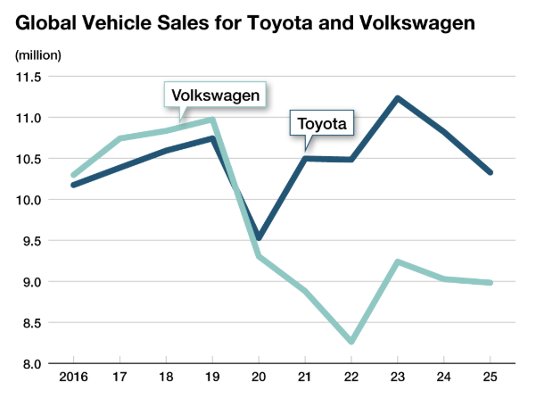
Figure 1: Sales growth of Toyota
(Source: Nippon, 2026)
Toyota has sold a total of 10,327,976 vehicles globally in 2025, increased 4.8% on a yearly basis (Nippon, 2026). In particular, its vision is to lead the future of mobility and hold commitments to quality and innovation to exceed customer expectations (Toyota, 2026p).
Japan has maintained the third-largest economy globally and achieved substantial growth in 2024. The Japanese automotive industry is one of the largest and leading industries globally (Exporters, 2026). In 2024, auto manufacturing comprised 2.9% of Japan's GDP and 13.97 of its manufacturing GDP. With due consideration, Toyota's operation in the Japanese market (Home country) is justified as it has a wide range of dealer networks in the country (International Trade Administration, 2025).
Alternatively, the UK market is famous for the Industrial Revolution with great cultural and political influence globally (BBC, 2024). The UK automotive industry is a global champion of vehicle production, engineering, and innovation, as it has significantly contributed nearly £14.1 billion to the UK's economy (Statista, 2026). Due to this fact, expanding Toyota's operation in the UK market is valid.

2. Comparative Market Analysis in Japan and UK
PESTLE analysis of Japan
Toyota's macro environment in Japan has been analysed using the PESTLE framework.
Factors | Discussions | Favourable/ Unfavourable
Political | The Japan government imposed an Eco-Car Tax policy to support the development of eco-friendly vehicles by offering tax reduction for mandated low-emission vehicles (IEA, 2025). | Toyota develops eco-friendly and fuel-efficient vehicles in Japan (Toyota, 2026c). Thus, this Eco-Car tax policy creates favorable opportunities for Toyota to produce lower-emission vehicles.
Economic | Japan's automotive industry is estimated at $326.91 billion in 2025 and projected to grow 6.95% during 2026 and 2035 (Market Research Future, 2026) (Refer to appendix 1). | Toyota invests in a new manufacturing plant to maintain an annual production capacity of 3 million vehicles in Japan (Toyota, 2025). Thus, the growing automotive market is favorable for Toyota to create a strong foundation to grow.
Social | Japanese consumers highly value hybrid and low-emission vehicles, while 29.3% of people aged 65 years preferred vehicles that offer safety features and comfort (World Economic Forum, 2024). | Hybrid vehicles are the core of Toyota, reducing emissions and providing Toyota Safety Sense (TSS), helps to reduce serious traffic accidents (Toyota, 2026). Hence, Toyota offers vehicles aligning with Japanese customer needs.
Technological | The Japanese government supports technology innovation in the automotive industry by allocating 129.1 billion yen for the Clean Energy Vehicle (CEV) subsidy programme (Meti, 2024). | Toyota accelerates production efficiencies through a diverse line of clean energy vehicles (Toyota, 2026a). Thus, government investments bring opportunities for Toyota to provide more innovative cars.
Legal | The Japanese government imposed the Road Transport Vehicle Act, which requires manufacturers to structure vehicle safety and certification standards (Japanese Law Translation, 2026). | Toyota faces higher testing and strict compliance to ensure its vehicles meet national safety requirements (Shimbun, 2026). Thus, it creates unfavorable conditions for Toyota.
Environmental | Japan emphasises decarbonisation of the automobile industry through the Green Growth Strategy and Carbon Neutrality by 2050 (IEA, 2026). | Investing in hydrogen fuel-cell and battery electric vehicles enables Toyota to reduce carbon emissions (Toyota, 2021). Hence, Japan's environmental goal is favourable for Toyota as they exhibit carbon reduction efforts.
Table 1: PESTLE analysis of Japan
(Source: Self-created)

PESTLE analysis of the UK
Toyota's macro environment in the UK has been analysed using the PESTLE framework.
Factors | Discussions | Favourable/ Unfavourable
Political | The UK government imposed traffic rules and rules of origin for the automotive industry, created uncertainty for manufacturers in the global supply chain (Kelly, 2026). | Toyota highly relies on global logistics for its vehicle production; hence, changing traffic regulations creates production disruption, which mandates rules of origin (WTA Group, 2023), which create unfavorable conditions for Toyota.
Economic | The UK automotive industry market size is estimated at $98.6 billion as of 2025 and anticipated to grow 7.5% during 2025-2035 (Market Research Future, 2026a); (Refer to appendix 2). | Toyota announced plans to invest approximately 8bn yen (£41m) to establish a new production line (GR Corolla) in the UK (Sweney, 2025). Thus, the growing market creates favorable conditions for Toyota to capitalise on this market.
Social | UK customers are increasingly becoming more environmentally conscious and highly prefer low-emission vehicles, as 473,00 zero emission cars were registered in the UK as of 2025, which increased 24% from 2024 (Gov.UK, 2026). | Toyota sells a popular lineup of hybrid electric cars in the UK, which fulfills customer demand (Toyota EU, 2026a). Thus, this social demand is favorable for Toyota to grow.
Technological | The UK government launched the DRIVE35 programme, which allocated £2.5 billion to facilitate the transition of advanced vehicle technologies in 2025 (Gov.UK, 2025). | Toyota significantly expanded its electric vehicles portfolio by investing in innovation in the UK (Toyota, 2025). Thus, this government funding is favourable for Toyota as it encourages them to adopt advanced technologies to produce more vehicles.
Legal | The UK's Zero Emission Vehicle (ZEV) mandate was established by the Vehicle Emission Trading Scheme Order 2023, which requires that at least 33% of newly manufactured cars must be zero-emission vehicles as of 2026 (Gov.UK, 2025a). | As Toyota has a significant presence in hybrid vehicles, stricter regulation on diesel and petrol in the UK creates concern at Toyota in terms of the mandated ZEV rule (Jolly, 2025). Thus, this ZEV mandate creates unfavourable conditions for Toyota as they require it to focus on producing more battery electric vehicles.
Environmental | The UK government aims to reduce carbon emissions within the automotive industry by committing to net-zero carbon emissions by 2050 (Hutton et al., 2025). | Toyota significantly moved forward with investing in hydrogen fuel-cell vehicles to lower carbon emissions in the UK (Toyota, 2026b). Thus, the government's environmental commitment encourages Toyota to reduce carbon emissions, which is a favourable condition for the firm.
Table 2: PESTLE analysis of the UK
(Source: Self-created)
Compare and Contrast
Based on Toyota's PESTLE analysis between Japan and the UK, it is recognised that the political context in Japan highlights the Eco-Car Tax policy for producing eco-friendly vehicles, which Toyota significantly maintained (IEA, 2025). Conversely, tariffs and rules of origin in the UK market create substantial challenges for it. As per the economic factor, Toyota has a greater opportunity to grow in Japan and the UK as both automotive markets are significantly growing. Considering the social perspective, Toyota highly values vehicle efficiency and safety measures while being substantially focused on producing hybrid electric cars in the UK in terms of fulfilling customer demand (Toyota, 2026). While Toyota accelerates its production efficiencies through clean energy vehicles, it invested in vehicle innovation and expanded electric vehicles in the UK. Despite that, in Japan, Toyota faces high-level strict compliance to ensure vehicles adhere to national safety requirements. Consequently, this issue delays vehicle launches and creates supply chain pressure. In comparison with this country, Toyota faces challenges in producing hybrid vehicles in the UK due to the legal Zero Emission Vehicle (ZEV) mandate (Gov.UK, 2025a). In terms of environmental factors, Toyota's greater emphasis on fuel-cell vehicles and battery electric vehicles meets the Japanese government's environmental goals, while Toyota's eco-friendly vehicles (fuel-cell) production supports the UK government's commitments.
2.2 Hofstede’s Cultural Analysis
To examine the custodial preferences of Japan and the UK as regards Toyota's marketing strategy analysis, Hofstede's cultural dimension model has been used.
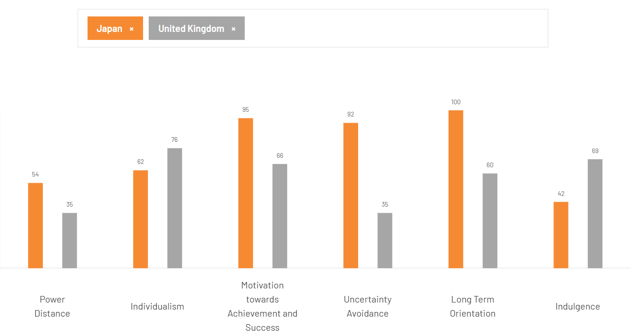
Figure 2: Country Comparison between Japan and the UK
(Source: The Cultural Factor, 2026)
Power Distance: Japan has a higher consciousness of borderline hierarchical structures (The Cultural Factor, 2026). Toyota's management strongly highlights these cultural values by following consensus-based decision-making approaches, which developed through discussion across different levels of management (Actioglobal, 2026). Alternatively, the UK holds flatter organisational structures and believes inequalities must be reduced. Following this, Toyota highly encourages teamwork and employee involvement at the operational level (Burt, 2026).
Individualism: Japan has moderate individualism characteristics as they prefer group harmony, while the UK has a higher individualistic society as they prefer to discover their own contribution (The Cultural Factor, 2026). Considering this fact, in Japan, Toyota fosters a corporate culture that reflects group harmony and mutual trust between labor and management (Toyota, 2026d). In contrast, Toyota encourages individual creativity while maintaining collective responsibility in the UK as a part of their core organisational values (Toyota Motor Manufacturing UK, 2026). Thus, it signifies that Toyota does not completely adopt an individualistic organisational culture in the UK.

Motivation towards achievement and success:
Japan indicates a highly achievement-oriented culture that values individual excellence and competition. In contrast, UK culture reflects a success-driven culture. As regards, Toyota highly focuses on innovation and continuous improvements (Kaizen), which strengthen its reputation for engineering excellence. However, when it operates in the UK, Toyota adapts management practices by fostering employee-wellbeing that aligns with UK cultural expectations (Toyota, 2026e).
Uncertainty Avoidance:
Japan suggests strong preferences for predictability and risk minimisation, whereas UK culture is more comfortable with change and uncertainty (The Cultural Factor, 2026). For example, the Toyota Production System (TPS) in Japan uses the 'Jidoka' process, which automatically stops production when an abnormality is detected, reflecting strict quality control (Toyota, 2026f). In contrast, it shows stronger responsiveness to changing markets as it upgraded the UK-built Corolla Lineup with fifth-generation self-charging hybrid tech (Toyota, 2023).
Long Term Orientation:
Japan shows high Long-term orientation culture as it prioritises steady growth, while the UK emphasises pragmatic cultures. In terms of aligning Japanese cultural expectations, Toyota has highly invested in R&D programmes and battery technologies to accelerate its production (Toyota, 2023a). Meanwhile, it has demonstrated balanced approaches in the UK through expansion of its electrified position in terms of evolving market requirements.
Indulgence:
Japan indicates a more restrained culture where enjoyment is lower by social values. Aligning with Japanese cultural expectations, Toyota emphasises practical mobility and avoiding frivolity (Toyota, 2026g). Conversely, the UK holds a high stance for indulgent cultures where values personal fulfillment and leisure. However, as Toyota's brand identity clearly embraces optimism, it fundamentally exhibits discipline in the UK rather than focusing on leisure.

3. Comparative Analysis of STP Strategy
STP framework for Japan Market
Segmentation
Demographic
In Japan, more than 60% of people aged 65-74 prefer their own car for transportation (Tochibayashi, 2024). Nearly 62.6% of males (under 80 years) responded that they hold a driver's license (Suzuki et al., 2025).
Psychographic
Japanese customers strongly value environmentally-friendly cars with high functionality. As seen, nearly 33.8% of Japanese customers show a higher preference for Hybrid Electric Vehicles (HEVs) rather than Battery Electric Vehicles (BEVs) (Tomoshige, 2025)
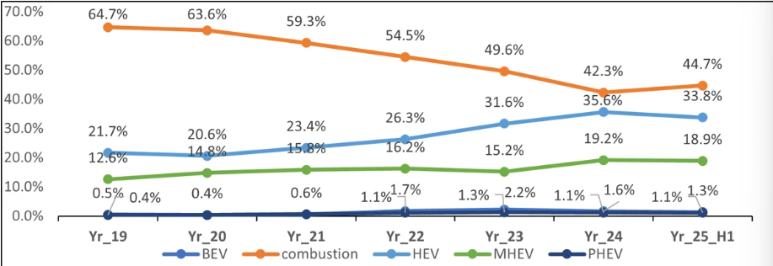
Figure 3: Customer preferences for Vehicles
(Source: Tomoshige, 2025)
Geographic
In Japan, car ownership is higher among households from rural areas (Fukui and Yamagata), whereas in metropolitan cities like Tokyo, car ownership is lower due to efficient transportation systems (Statista, 2025).
Behavioural
Japanese customers seek promotion- and deal-oriented purchase behaviors, as March is considered the best time for purchasing a Japanese car (Adam, 2024).

Targating
Toyota highly focuses on older adults, male customers who value environmentally friendly cars like hybrid electric battery (HEVs) (Tomoshige, 2025). Toyota has taken a differentiated targeting strategy to offer various types of cars to customers.
Positioning
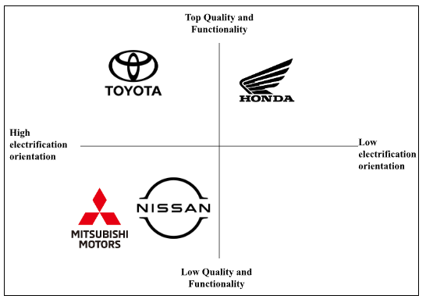
Figure 4: Positioning Map of Toyota in Japan
(Source: Self-created)
In Japan, Toyota faces intense competition from Honda, Mitsubishi Motors, and Nissan. Offering hybrid vehicle segments with a focus on electrification and functionality, Toyota positioned itself as the most valuable brand, which accounts for 42% on a global scale (Brand Finance, 2026). While Mitsubishi Motors and Nissan exhibit low functionality, Honda shows lower electrical orientation compared to Toyota.
STP framework for UK Market
Segmentation
Demographic
In the UK, nearly 25% of customers aged 40 and 54 and 31% of customers aged above 55 prioritise buying a new car (You.UK, 2026). Nearly 34% of males are more willing to consider buying a brand new vehicle in the next 12 months compared to 27% of females (You.UK, 2026).
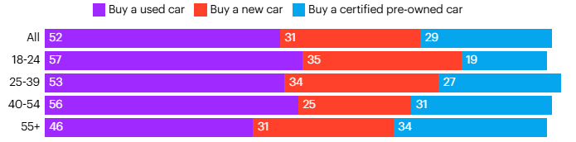
Figure 5: Customer car preferences in the UK
(Source: You.UK, 2026)
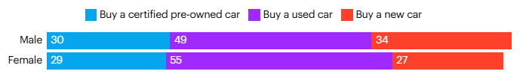
Figure 6: Car preferences among males and females
(Source: You.UK, 2026)
Psychographic
UK customers are increasingly concerned about environmental issues, as nearly 59% of UK customers show interest in electric vehicles (EVs), and HEV and BEV registrations are growing significantly as of 2025 (Electroverse, 2025; JD Power, 2026). Despite that, UK customers increasingly seek to buy used EVs due to their affordability (Energy Mix, 2026).
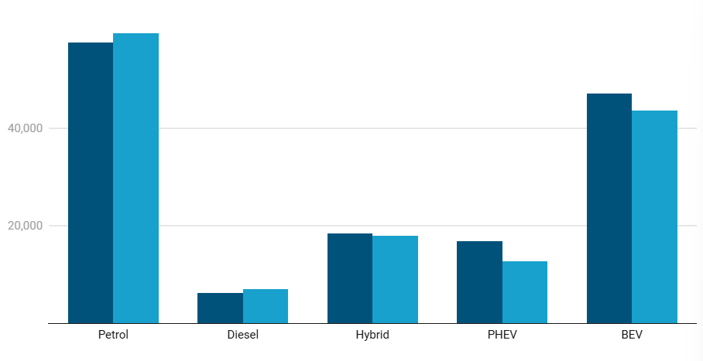
Figure 7: Registration of PHEV and BEV in the UK
(Source: JD Power, 2026)
Geographic
South East and London: 456,289 EVs are registered and in use, representing an important geographic market for electric vehicles (SMMT, 2025).
Behavioural
As UK customers are highly price-conscious, nearly 67% of consumers are planning to buy a car with a budget of £15,000 or less and 49% are willing to spend £10,000 or less (You.Gov, 2021).
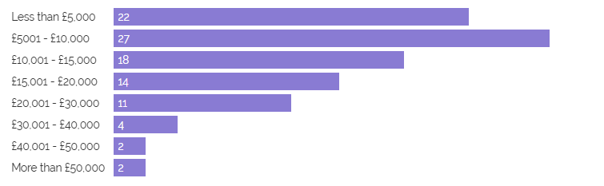
Figure 8: Spending choices of UK customers for next car
(Source: You.Gov, 2021)
Targating
In the UK, Toyota is deliberately focused on customers aged 40 and above 55, particularly male customers who increasingly prioritise electric vehicles and affordable cars (YouGov, 2026). Considering this, it highly follows a differentiated targeting strategy in this market as its commitments to fulfill the diverse needs of customers across several regions through the advancements of a multi-pathway product strategy (Toyota, 2025).
Positioning
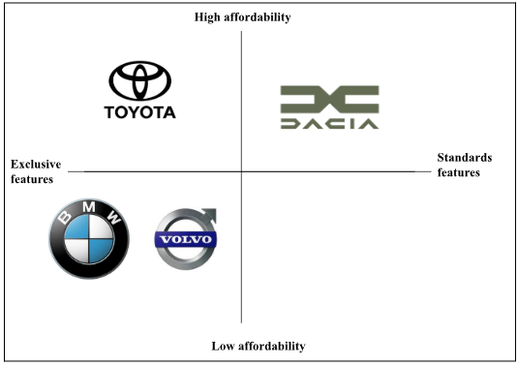
Figure 9: Positioning Map of Toyota in the UK
(Source: Self-created)
BMW, Volvo and Dacia are leading competitors of Toyota in the UK market (Cbinsights, 2026). In the UK, by demonstrating a core focus on affordability and exclusive features including electric power, audio system, and panoramic view, Toyota positions itself at the top among other comparisons like BMW, Volvo, and Dacia.
Compare and contrast
With the help of the STP framework, Toyota's segmentation, targeting, and positioning strategies have been identified in two markets, such as Japan and the UK. Considering the segmentation category, the demographic dimension shows that older adults and male customers mostly prefer cars in Japan, while their psychological preference highly relies on eco-friendly HEVs (Tomoshige, 2025). In contrast, as per the demographic aspect, customers aged 40 and 55 above, especially males, are primarily willing to buy a new car, while as per psychographic nature, customers are more concerned about the environment, as seen in their growing preference towards electric vehicles and affordability considerations (Jdpower, 2026). On the basis of the different market segment choices, it increasingly adopts a differentiated targeting strategy for both the Japan and UK markets. Although Toyota faces significant competition in both markets, its high functional and electrification strategy differentiates it from its rivals in Japan while also positioning itself in the UK market through exclusivity and affordability.

4. Comparative Analysis of International Marketing Mix (7Ps)
Marketing Mix of Toyota in Japan Market
Product
Core: Japanese customers increasingly prefer EV cars as they perceive them as more reliable, safe, and easy to operate, as nearly 60% of total new passenger vehicles registered were HEVs (Statista, 2026).
Actual
Following customer demand, Toyota increasingly focuses on expanding its product lineup, offering HEVs in Japan as part of multi-pathway approaches (Toyota, 2025). Accelerating electrification through HEVs, it fulfills the Japanese customers' preferences.
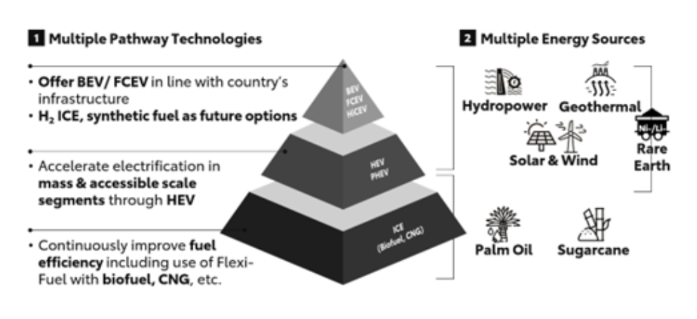
Figure 10: Toyota’s EV product
(Source: Toyota, 2025)
Augmented
Toyota uses a point and rewards system in Japan through tier services, financial cards and programmes such as TS Cubic Card (Toyota, 2026h). It provides benefits such as vehicle-related perks and cash-back for car purchases, which ease taking car ownership.
Price
In Japan, customers increasingly value reliable, high-performance, and affordable cars, which Japanese car manufacturers prioritise. For this reason, Toyota significantly reduced costs and ensured its product quality in the market, signifying it adopts a value-based pricing strategy (Toyota, 2026i). Thus, this strategy directly aligns with market demand, which deepens customer loyalty and maximises profit.
Place
Vehicle consumers in Japan strongly prefer physical dealerships instead of online purchases. Aligning with the customers' preferences, Toyota currently operates nearly 5,000 dealerships in Japan, which provide extensive physical access to customers (Pierre, 2025).
Promotion
As regards promotional strategy, Toyota participated in the Japan Mobility Show in 2025, where they unveiled new concept car models and future brand direction (Toyota, 2025b). This strategy enables Toyota to engage consumers directly with future mobility instead of relying solely on traditional marketing.
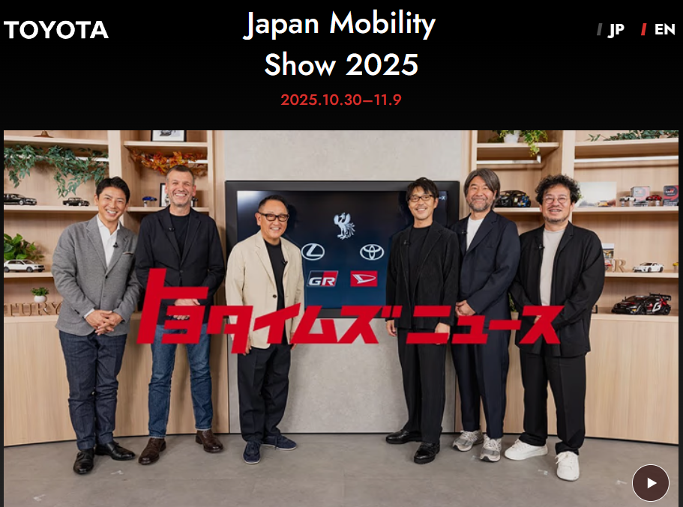
Figure 11: Toyota at Japan Mobility Show
(Source: Toyota, 2025a)
People
Toyota is strengthening employee motivation by arranging more flexible working hours and introducing a four-day workweek option for some employees (Shimbun, 2024). Roughly 50% of employees reported that Toyota offers attractive salary and remuneration (Brand Finance, 2024)
Process
In Japan, Toyota's manufacturing process incorporates a supplier network as it works with nearly 60000 domestic suppliers (Toyota Times, 2026). Also, it uses a Just-in-Time sourcing process to deliver car parts when needed, decreasing unnecessary inventory (Toyota, 2026j).
Physical evidence
Toyota has a professional, branded domestic dealership network, showrooms, and the historic Motomachi Plant, which reflects its physical evidence in the Japan market (EBSCO, 2026). Thus, this extensive physical evidence offers specialised facilities that reinforce brand reputation and customer engagement.

Marketing Mix of Toyota in UK Market
Product
Core
Over half of UK customers expect that their next vehicles will be fully electric or hybrid, indicating growing preferences for electrified vehicles (Fowler, 2025).
Actual
In the UK, Toyota's product lineup features self-charging hybrids, fully electric vehicles (BEVs), and plug-in-hybrid (PHEVs) (Toyota, 2026k). Hence, Toyota's offerings highly align with the customer's expectations and needs, signifying Toyota's adaptation strategy. Hence, Toyota has an embedded adaptation strategy in offering its products.
Augmented
Toyota provides 24/7 roadside assistance, service-activated warranty, and home charging solution for consumers in the UK (Toyota, 2026l; Toyota, 2026m).
Price
Toyota mainly uses a value-based pricing strategy in the UK as it balances competitive upfront purchase prices with a low total cost of ownership (TCO) (Toyota UK, 2026). However, the cost-of-living crisis in the UK is constantly hampering customer purchasing behavior, for which reason customers look for cheaper vehicle options (Close Motor Finance, 2023). Hence, Toyota has followed a standardized strategy in terms of setting pricing strategy.
Place
Customers in the UK have highly demonstrated omnichannel car buying behavior and a digital-led purchase journey, as 15% of buyers are looking to use online platforms for car purchase (NTTData, 2026; Harrod, 2026). To respond to customer preferences, Toyota embraces its digital presence through its website, Toyota UK, and Customer portal.
Promotion
The "Toyota Fanatics" advertising campaign ran across Radio, digital out-of-home, Video on demand, and Social media, which was designed to promote the superior quality of Toyota's aftercare service (Toyota Media Site, 2025).

Figure 12: “Toyota Fanatics” advertising campaign
(Source: Jellyfish, 2025)
People
In the UK, it emphasises skilled employees by using trained technicians to deliver exceptional service and maintenance (Toyota, 2026n). Also, Toyota employs around 3,000 employees across Burnaston and Deeside (Toyota UK, 2026). It highlights its adoption strategy.
Process
Toyota's UK manufacturing plant works with 260 parts and material suppliers and uses a "milk-run" logistics system in which components are collected from supplier locations and delivered to its manufacturing plants as per the Just-in-Time (JIT) process (Toyota UK, 2026a). Thus, Toyota standardised its operation in the UK market.

Figure 13: Toyota Manufacturing UK
(Source: Toyota UK, 2026a)
Physical evidence
Toyota UK uses branded showrooms and vehicle display centres to offer tangible evidence of strong service quality. Toyota introduced Europe's first circular factory in 2026, which focuses on reusing, repurposing, and recycling to improve resource efficiency (Toyota Media Site, 2026).
Compare and Contrast
In Japan, Toyota increasingly focuses on providing HEVs by prioritising growing customer preferences towards EVs. While in the UK, the company designs its product lineup features with electrification as customers' interest moves towards fully electric or hybrid vehicles. In both the Japan and UK markets, the company has followed a value-based pricing strategy as they focus on providing vehicles at low cost with high quality. In the UK market, customers look for cheaper vehicle options due to the cost-of-living crisis, which increases the need to offer cost-effective vehicle models. Within the Japanese operations, Toyota extensively focuses on dealerships, while in the UK, customers also prioritise online platforms for car purchasing. Toyota uses a digital channel alongside its physical presence. The company exhibited a promotional strategy differently; in Japan, the company participated in the Japan Mobility Show to showcase its car model and brand roadmap (Toyota, 2025b). With an extensive supplier network, the company uses a just-in-time sourcing process in Japan while also demonstrating its focus on "milk-run" logistics systems through the JIT approach. Therefore, it can be considered that the company has taken adaptation approaches in both countries by aligning business strategies with the growing market shifts and customer preferences.

5. Analysis of Market Entry Strategy
Toyota entered the UK market through wholly owned subsidiaries, highlighting a form of foreign direct investment (FDI) by establishing Toyota Motor Manufacturing in 1989 (Toyota, 2026o). With this consideration, Toyota's operation in the UK has strengthened its position within the UK's manufacturing industry and export sectors, allowing Toyota to utilise the local production facilities in terms of exporting to international markets (Toyota Media Site, 2026a). Through the FDI-led approaches, Toyota has continuously invested in the UK operation, as currently, it has invested roughly £2.75 billion to improve and modify its production capabilities, demonstrating a significant long-term commitment to the market (Toyota Media Site, 2026a).
Aligning the OLI paradigm as part of supporting Toyota's internationalisation strategy, Toyota highlights strong ownership advantages through advanced manufacturing capabilities and an established production system in the UK. The UK offers a location advantage through its skilled workforce, strong transportation, and established industrial facilities, which Toyota capitalised on (Business Gov.uk, 2026). Internalisation allows Toyota to emphasise greater control over production processes by establishing the Burnaston vehicle plant and Deside engine plants. For evidence, Toyota Manufacturing UK (TMUK) has now produced 5 million vehicles with over £2.82 billion, enabling them to maintain strengthened technological expertise, employee skills, and production capabilities (Toyota Media Site, 2024). For example, Volkswagen entered the UK market through a wholly-owned subsidiary entry mode strategy (Volkswagen, 2026). Although wholly owned manufacturing provides greater control over production, it also poses operational and financial risk for Toyota. Therefore, despite this limitation, it can be considered that this market entry strategy is appropriate for entering the UK, which enhances its production capabilities while providing greater operational control.

6. Evaluation of Ethical Issues
In the UK, Toyota faces ethical issues regarding the electric vehicles' charging performance. As seen, the UK Advertising Standards Authority (ASA) banned a Toyota promotional campaign for bZ4X electric vehicles. ASA received a complaint against Toyota's claim that the vehicles were capable of reaching an 80% battery charge in approximately 30 minutes using a 150W rapid-charging system (Sweney, 2023). This raises an ethical concern regarding the company's transparency since this claim misleads customers about the availability of rapid charging infrastructure across the UK and Ireland. During Toyota's car model safety test, it submitted false data, which consequently halted the production of some cars, signifying the company's other ethical issues (Liang, 2024). Misleading information can erode consumers' trust and negatively affect customers' relationship with the brand (Di Domenico and Ding, 2023). Therefore, this ethical issue at Toyota suggests that the company needs to be more focused on transparency and ethical practices, which strengthen customer trust and brand reputation.

7. Recommendation
Strengthening Physical and Digital Marketing
Based on the marketing mix, it seems that Toyota highly demonstrates its physical presence rather than digital appearance. However, UK customers increasingly seek online platforms for purchasing a car, which increases the need for improving digital channels. In terms of improving international marketing strategy, Toyota must focus on improving its digital marketing by launching interactive content across platforms such as Instagram and YouTube (Theodorakopoulos et al., 2025). However, combining physical and digital marketing approaches can create complex challenges such as high financial cost and message inconsistencies. Through constant campaign planning and an effective content creation strategy, alongside maintaining physical appearance, would be effective for the company (Peggiani, G. and Lamberti, 2026). Despite this limitation, by integrating these approaches, Toyota can convey vehicles' benefits more effectively and reach potential customers.

Enhancing marketing transparency and customer trust
In future internationalisation, Toyota must incorporate greater accuracy and transparency into its marketing strategy, especially when embracing its vehicle performance. In particular, the company must prioritise maintaining transparent disclosure and accountable data handling practices as well as honest communication with consumers (Ali et al., 2025). By following each country's standards, local advertising regulations and customers' expectations would be beneficial for the company to strengthen customers' trust. However, enhancing operational transparency can create vulnerability to security and higher operational costs. Implementing risk and auditing systems and clear organisational policies can help to mitigate these challenges. Therefore, this measure would help to reduce the risk of misleading communication across international markets, which supports the company's credibility.

8. Conclusion
The report significantly focuses on comparative analysis of Toyota between Japan and the UK. Comparing this, it has been demonstrated that the company increasingly focuses on providing EVs as per the consumer preferences in both countries. Through the lens of the Hofstede cultural model, it is noted that Toyota follows group harmony in Japan while also maintaining collective responsibility in the UK, as it is unable to adopt an individualistic organisational culture. Japanese customers highly prefer Hybrid Electric Vehicles (HEVs) while UK customers tend to buy both HEVs and BEVs. As per the promotional strategy, the company exhibits greater emphasis on advertising campaigns and also uses a milk-run logistics system in the UK. The wholly-owned subsidiary has been adopted by the Toyota company while entering the UK market, which increases their production capabilities. Lastly, the company should strategically position its physical and digital presence for long-term internationalization, and maintaining transparency is another key factor to enhance customers' trust and achieve success in the global market.

Section 2:

Reflective Account
Gibbs' reflective cycle is being used to critically evaluate the personal experiences throughout the assessment process.

Figure 14: Gibbs reflective cycle
(Source: Harithuddin, 2021)
Description
At my University, I have conducted a comparative analysis assessment based on Toyota's operation in Japan and the UK. In this process, I began by assessing Toyota's operation in both markets and applied the PESTLE framework to understand the macro environment, from which I have gained crucial insights into the regulatory framework, social expectations, and environmental factors country-wise, including identifying the favorable and unfavorable conditions. I have used Hofstede's cultural dimension framework. Through the use of STP analysis, I have identified the potential customers of Toyota in both markets and their customers' preferences and behavioral traits accordingly, while a differentiated marketing strategy has been adopted. I have evaluated Toyota's marketing mix strategies, where I found that the company strategically responded to the market conditions in terms of running its business. In this process, I have searched credible sources which helped me develop a strong understanding of internationalisation concepts and theories.
Feelings
At the beginning of the assessment, I felt somewhat uncertain about applying a framework like PESTLE to analyse Toyota's international marketing context. Despite that, initially, I also experienced some difficulties with searching for reliable sources that align with Toyota's international marketing. However, with the progression of the assessment, I felt confident and motivated to apply the core marketing framework such as STP, where I am able to identify Toyota's core customers and their preferences, which is key to designing the marketing objectives accordingly. As I became encouraged by my tutor and peers, I was able to apply a theoretical framework, namely OLI, to Toyota's market entry strategies.
Evaluation
I have gained a comprehensive view of Toyota's marketing strategy by conducting the 7Ps framework. This insight helped me understand how Toyota adjusted its strategy to meet customer needs. By doing the STP analysis, I have understood the customer preferences in the two different countries, and Toyota's strategies were adopted accordingly. Alongside this, I have developed critical thinking skills by evaluating Toyota's appropriateness and drawbacks in the Japanese and UK market context. In this context, critical thinking is a crucial component for processing information, making informed decisions, and solving critical problems (Arthi and Gandhimathi, 2025). However, I faced challenges when applying the Hofstede cultural model to examine the cultural preferences in the two different markets and the way the company implements its strategies in these markets. I also faced challenges in recognising relevant sources related to Toyota's international marketing strategies, signifying my lack of research skills. Despite that, I also recognised that I initially spent more time searching for relevant academic sources and applying them in several frameworks. I usually spend more time on one task and realised that I was unable to allocate time properly, which indicates my lack of time management skills.

Analysis
I have come to understand that effective application of an international marketing framework is crucial for exploring marketing concepts in different market conditions. When I explored the 7Ps marketing mix, I identified that the company integrated adoption strategies alongside the standardisation process. I also developed my evidence-based decision-making skills by pointing out the relevant information. Although I faced challenges initially in applying Hofstede's cultural model, comparing Japan and the UK encouraged me to consider how cultural differences could influence consumer behaviours and Toyota's marketing strategies. Conducting these assessments, my perspective has changed as I recognised that comprehensive evaluation requires broader research and needs to include evidence and theoretical context. Exploring the ethical issues of Toyota helped me to understand the importance of maintaining corporate transparency in intentional marketing. As supported by Bag et al (2024), maintaining ethical behaviours within organisations like Toyota can lead to more consumer trust and a better reputation in the market.
Conclusion
Overall, this assessment process offers valuable learning experiences which helped me to develop my knowledge and understanding of international marketing. I gained confidence in incorporating a marketing framework, applying internationalisation theory, and building data-driven arguments. This analysis helped me to realise the value of critical evaluation instead of solely focusing on descriptive analysis. By conducting this research, my understanding has been enhanced as I recognised that the marketing approach is not always applied similarly in all countries, as different cultural, regulatory, and consumer factors significantly influence the marketing strategy of organisations like Toyota. This principle signifies my further development areas such as research skills and time management skills, which strengthen my academic competency more effectively in the future.
Action Plan
I have identified that I have to improve my research skills and time management by setting a clear goal and reading academic journals.
Most importantly, I will combine keywords related to the topic context to refine my searching capabilities. Completing various tasks related to focused research projects under academic supervision helped to strengthen research skills, particularly in recognising relevant sources and developing well-supported arguments (Vieno et al., 2022).
I will focus on improving my time management skills, which help to boost working productivity and complete the work on time. In particular, prioritising tasks is one of the most important factors of time management, which helps to manage workload more effectively. To trace my progress in improving time management, I will use weekly challenges and schedules. Effective time management abilities can help to organise and adapt schedules to achieve academic achievements and meet professional objectives (Patzak et al., 2025). Hence, through this reflection process, I can gather insights into the international market regarding Toyota and be able to know about my key competencies and weaknesses which need to be developed further.

References
Actioglobal (2026) Make decisions slowly by consensus, thoroughly considering all options; implement rapidly (Nemawashi) Available at: https://www.actioglobal.com/en/principle-13-toyota-way/ (Accessed 3rd August 2026)
Adam, C (2024) This Is the Best Month To Buy a Japanese Car To Save Money Available at: https://finance.yahoo.com/news/best-month-buy-japanese-car-123013930.html (Accessed 3rd August 2026)
Ali, S.M.S., Dakshinamurthy, T., Priyadarshi, P. and Mittal, M., (2025). Consumer trust in digital brands: The role of transparency and ethical marketing. Advances in Consumer Research, 2, pp.106-114. Available at: (Accessed 3rd August 2026)
Arthi, M.P. and Gandhimathi, S.N.S., (2025) ‘Research trends and network approach of critical thinking skills in English Language Teaching–A bibliometric analysis implementing R studio’. Heliyon, 11(2). Available at: https://doi.org/10.1016/j.heliyon.2025.e42080 (Accessed 3rd August 2026)
Automotive Council UK (2026) UK Automotive Sector Available at: https://www.automotivecouncil.co.uk/uk-automotive-sector/ (Accessed 3rd August 2026)
Available at: (Accessed 3rd August 2026)
Available at: https://asianews.network/toyotas-safety-tests-do-not-meet-un-regulations-japan-transport-ministry/ (Accessed 3rd August 2026)
Available at: https://media.toyota.co.uk/toyota-launches-the-new-corolla-with-fifth-generation-hybrid-electric-technology/ (Accessed 3rd August 2026)
Available at: https://www.automotivelogistics.media/supply-chain/uk-automotive-supply-chains-face-new-tariff-risks-as-smmt-warns-over-eu-trade-barriers/2692189 (Accessed 3rd August 2026)
Available at: https://www.toyota.co.uk/fleet-business/calculators-advice/what-is-tco (Accessed 3rd August 2026)
Available at:https://www.cbinsights.com/company/toyota-manufacturing-uk/alternatives-competitors (Accessed 3rd August 2026)
Available at:https://www.theculturefactor.com/country-comparison-tool?countries=japan%2Cunited+kingdom (Accessed 3rd August 2026)
Bag, S., Srivastava, G., Gupta, S., Sivarajah, U. and Wilmot, N.V., (2024) ‘The effect of corporate ethical responsibility on social and environmental performance: An empirical study’. Industrial Marketing Management, 117, pp.356-370. Available at: https://doi.org/10.1016/j.indmarman.2024.01.016 (Accessed 3rd August 2026)
BBC (2024) United Kingdom country profile Available at: https://www.bbc.com/news/world-europe-18023389 (Accessed 3rd August 2026)
Brand finance (2024) Enjoyable work, competitive salaries, and flexibility drive Japan’s jobseekers’ employer choices Available at: https://brandfinance.com/press-releases/enjoyable-work-competitive-salaries-and-flexibility-drive-japans-jobseekers-employer-choices (Accessed 3rd August 2026)
Brand Finance (2026) Toyota remains Japan’s most valuable brand for the 11th consecutive year Available at: https://brandfinance.com/press-releases/toyota-remains-japans-most-valuable-brand-for-the-11th-consecutive-year (Accessed 3rd August 2026)
Burt, M (2026) What is kaizen and how does Toyota use it? Available at: https://mag.toyota.co.uk/kaizen-toyota-production-system/ (Accessed 3rd August 2026)
Business gov.uk (2026) UK nations and regions Available at: https://www.business.gov.uk/invest-in-uk/regions/ (Accessed 3rd August 2026)
Cbinsights (2026) Toyota Motor Manufacturing UK Available at: (Accessed 3rd August 2026)
Close Motor Finance (2023) Cost-of-living crisis continues to hamper car buying plans say car dealers Available at: https://www.closemotorfinance.co.uk/cost-of-living-crisis-impacting-car-buying (Accessed 3rd August 2026)
Di Domenico, G. and Ding, Y., (2023). Between brand attacks and broader narratives: How direct and indirect misinformation erode consumer trust. Current Opinion in Psychology, 54, p.101716. Available at: (Accessed 3rd August 2026)
EBSCO (2026) Toyota Motor Corporation Available at: https://www.ebsco.com/research-starters/business-and-management/toyota-motor-corporation (Accessed 3rd August 2026)
EBSCO (2026) Toyota Motor Corporation Available at: https://www.ebsco.com/research-starters/business-and-management/toyota-motor-corporation (Accessed 3rd August 2026)
Electroverse (2025) Why are more UK consumers choosing electric cars? Available at:https://electroverse.com/community/news-and-competitions/why-are-more-uk-consumers-choosing-electric-cars- (Accessed 3rd August 2026)
Energy Mix (2026) EVs Dominate As UK Used Car Buyers Seek Affordability Available at:https://www.theenergymix.com/evs-dominate-as-uk-used-car-buyers-seek-affordability/ (Accessed 3rd August 2026)
Exporters (2026) Automotive industry in Japan: opportunities for car technology suppliers Available at: https://exporteers.com/opportunities-in-the-automotive-industry-in-japan/ (Accessed 3rd August 2026)
Fowler, R (2025) Majority of car buyers expect next vehicle to be electric or hybrid, MOTORS research finds Available at: https://www.motortradenews.com/electric-vehicles/majority-of-car-buyers-expect-next-vehicle-to-be-electric-or-hybrid-motors-research-finds/ (Accessed 3rd August 2026)
Gov.UK (2025) Backing British Industry: Government launches £2.5bn DRIVE35 programme to power UK auto investment and jobs Available at: https://www.gov.uk/government/news/backing-british-industry-government-launches-25bn-drive35-programme-to-power-uk-auto-investment-and-jobs (Accessed 3rd August 2026)
Gov.UK (2025a) Updates to the Vehicle Emissions Trading Schemes (VETS) Order 2023 Available at: https://www.gov.uk/government/publications/vehicle-emissions-trading-schemes-vets-order-2023-updates/updates-to-the-vehicle-emissions-trading-schemes-vets-order-2023 (Accessed 3rd August 2026)
Gov.UK (2026) Vehicle licensing statistics, United Kingdom: 2025 Available at: https://www.gov.uk/government/statistics/vehicle-licensing-statistics-2025/vehicle-licensing-statistics-united-kingdom-2025 (Accessed 3rd August 2026)
Harithuddin, A.S.M., (2021) A first experience of using failure report as a reflective tool in engineering education. International Journal of Emerging Technologies in Learning, 16(18), pp.23-37. Available at: https://doi.org/10.3991/ijet.v16i18.24271 (Accessed 3rd August 2026)
Harrod, D (2026) UK vs European car buyer trends and finance behaviour 2026 Available at: https://www.codeweavers.net/news/uk-europe-car-buying-trends/?utm_campaign=eu_consumer_report_&utm_medium=display&utm_source=car_dealer (Accessed 3rd August 2026)
Hutton, G., Stewart, I., Benson, M., Webb, D and Jozepa, I (2025) Electric vehicles and infrastructure Available at: https://commonslibrary.parliament.uk/research-briefings/cbp-7480/ (Accessed 3rd August 2026)
IEA (2025) Eco-Car Tax Break and Subsidies for Vehicles Available at: https://www.iea.org/policies/13826-eco-car-tax-break-and-subsidies-for-vehicles (Accessed 3rd August 2026)
IEA (2026) Green Growth Strategy through Achieving Carbon Neutrality in 2050 Available at:https://www.iea.org/policies/30818-green-growth-strategy-through-achieving-carbon-neutrality-in-2050 (Accessed 3rd August 2026)
International Trade Administration (2025) Japan - Automotive Available at: https://www.trade.gov/country-commercial-guides/japan-automotive (Accessed 3rd August 2026)
Japanese Law Translation (2026) Road Traffic Act Available at: https://www.japaneselawtranslation.go.jp/en (Accessed 3rd August 2026)
Jdpower (2026) What do UK BEV sales reveal about the 2025 ZEV mandate? Available at: https://www.jdpower.com/business/news/what-do-uk-bev-sales-reveal-about-the-2025-zev-mandate/ (Accessed 3rd August 2026)
Jellyfish (2025) Jellyfish launches its first integrated campaign for Toyota's aftercare service Available at: https://www.jellyfish.com/en-us/news/jellyfish-launches-first-integrated-toyota-campaign/ (Accessed 3rd August 2026)
Jolly, J (2025) Toyota plans to build battery vehicles in UK and keep European plants Available at: https://www.theguardian.com/business/2025/mar/11/toyota-battery-vehicles-uk-european-plants-evs-lexus (Accessed 3rd August 2026)
Kelly, M (2026) UK automotive supply chains face new tariff risks as SMMT warns over EU trade barriers Available at: https://www.automotivelogistics.media/supply-chain/uk-automotive-supply-chains-face-new-tariff-risks-as-smmt-warns-over-eu-trade-barriers/2692189 (Accessed 3rd August 2026)
Liang (2024) Toyota raided as safety testing scandal grows Available at: https://www.bbc.com/news/articles/c1wwj1p2wdyo (Accessed 3rd August 2026)
Market Research Future (2026) Japan Automotive Industry Available at: https://www.marketresearchfuture.com/reports/japan-automotive-industry-47039 (Accessed 3rd August 2026)
Market Research Future (2026a) UK Automotive Industry Available at:https://www.marketresearchfuture.com/reports/uk-automotive-industry-47036 (Accessed 3rd August 2026)
Meti (2024) Subsidies Upgraded for the Purchase of Clean Energy Vehicles toward the Realization of GX in the Automobile Sector Available at: https://www.enecho.meti.go.jp/en/category/special/article/detail_199.html (Accessed 3rd August 2026)
Nippon.Com (2026) Toyota Tops Global Auto Sales for the Sixth Consecutive Year Available at:https://www.nippon.com/en/japan-data/h02670/ (Accessed 3rd August 2026)
NTTData (2026) Online shopping habits find traction in the automotive industry as consumers move towards online platforms and electric cars Available at: https://uk.nttdata.com/news/online-shopping-habits-find-traction-in-the-automotive-industry (Accessed 3rd August 2026)
Patzak, A., Zhang, X. and Vytasek, J., (2025), July. Boosting productivity and wellbeing through time management: Evidence-based strategies for higher education and workforce development. In Frontiers in Education (Vol. 10, p. 1623228). Frontiers Media SA. Available at: https://doi.org/10.3389/feduc.2025.1623228 (Accessed 3rd August 2026)
Peggiani, G. and Lamberti, L., (2026) ‘Beyond the post: Crafting influencer marketing strategies across the funnel’ Journal of Business Research, 207, p.116037. Available at: https://doi.org/10.1016/j.jbusres.2026.116037 (Accessed 3rd August 2026)
Pierre, M, (2025) Toyota Open to American Carmakers Using Its Japan Sales Network Available at: https://motorillustrated.com/toyota-open-to-american-carmakers-using-its-japan-sales-network/155667/ (Accessed 3rd August 2026)
Shimbun, Y (2024) Toyota to Introduce 4-Day Workweek for Some Employees; Company Hopes More Flexible Schedules Will Boost Worker Motivation Available at: https://japannews.yomiuri.co.jp/business/companies/20240630-195489/ (Accessed 3rd August 2026)
Shimbun, Y (2026) Toyota’s safety tests do not meet UN Regulations: Japan Transport Ministry
SMMT (2025) More than a million EVs on UK roads as vehicle ownership reaches new high Available at: https://www.smmt.co.uk/more-than-a-million-evs-on-uk-roads-as-vehicle-ownership-reaches-new-high/ (Accessed 3rd August 2026)
Statista (2025) Number of private passenger cars in use per 100 households in Japan as of March 2025, by prefecture Available at: https://docs.google.com/document/d/1gaC7BoxWWvbT3GoPrHi_aG3ER3KipBCPWuDY9Z8OaUM/edit?tab=t.0 (Accessed 3rd August 2026)
Statista (2026) Automotive manufacturing industry in the UK - statistics & facts Available at: https://www.statista.com/topics/5457/automotive-manufacturing-industry-in-the-uk/?srsltid=AfmBOopcLtBHUk2bGw2KxWFxi0IKu5q-O1_HlxKvTW7yxvrCUvLTlziS (Accessed 3rd August 2026)
Statista (2026) Hybrid electric cars in Japan - statistics & facts Available at: https://www.statista.com/topics/13194/hybrid-electric-vehicles-in-japan/?srsltid=AfmBOopHc-PB-nyg8-bw8HUbHLdySoI-6tS8Xc36Tgw5Y4QgLRIlUmrW#topicOverview (Accessed 3rd August 2026)
Suzuki, Y., Setogawa, H., Terabe, S., Yaginuma, H and UNO, H (2025) Relationship between urban environment and changes in health among Returning Drivers of Drivers' Licenses Available at: https://easts.info/on-line/proceedings/vol.15/pdf/E_PP4060.pdf (Accessed 3rd August 2026)
Sweney, M (2023) Advertising watchdog bans Hyundai and Toyota electric car ads Available at: https://www.theguardian.com/media/2023/jun/28/advertising-watchdog-bans-hyundai-and-toyota-electric-car-ads (Accessed 3rd August 2026)
Sweney, M (2025) Toyota to move some GR Corolla production to UK from Japan Available at: https://www.theguardian.com/business/2025/may/27/toyota-to-move-some-gr-corolla-production-to-uk-from-japan (Accessed 3rd August 2026)
TGM Japan (2025) JP Taxes - Vehicle Taxes Available at: https://tgmjapan.com/life-in-japan/finance/jp-taxes-vehicle-taxes/ https://tgmjapan.com/life-in-japan/finance/jp-taxes-vehicle-taxes/ (Accessed 3rd August 2026)
The Cultural Factor (2026) Country Comparison tool Available at: (Accessed 3rd August 2026)
Theodorakopoulos, L., Theodoropoulou, A. and Klavdianos, C., (2025) ‘Interactive viral marketing through big data analytics, influencer networks, AI integration, and ethical dimensions’. Journal of Theoretical and Applied Electronic Commerce Research, 20(2), p.115. Available at: https://doi.org/10.3390/jtaer20020115 (Accessed 3rd August 2026)
Tochibayashi, N (2024) What an ageing world can learn from Japan's campaign to get seniors driving safely Available at: https://www.weforum.org/stories/sustainable-development/japan-senior-driver-safety/ (Accessed 3rd August 2026)
Tomoshige, Y (2025) Japan's Automotive Electrification Trends (2025 H1) Available at: https://www.jato.com/resources/news-and-insights/japans-automotive-electrification-trends-2025-h1 (Accessed 3rd August 2026)
Toyota (2021) Video: Media briefing & Investors briefing on batteries and carbon neutrality Available at: https://global.toyota/en/newsroom/corporate/35971839.html (Accessed 3rd August 2026)
Toyota (2023) Toyota launches the new Corolla with fifth generation hybrid electric technology
Toyota (2023a) Toyota Unveils New Technology That Will Change the Future of Cars Available at: https://global.toyota/en/newsroom/corporate/39288520.html (Accessed 3rd August 2026)
Toyota (2025) Toyota expands its battery electric model range across the core SUV segments Available at: https://media.toyota.co.uk/toyota-expands-its-battery-electric-model-range-across-the-core-suv-segments/ (Accessed 3rd August 2026)
Toyota (2025) Toyota in Asia Reinforces Multi-Pathway in Action Towards its Available at: https://www.toyota-asia.com/news/JpmPR72ob7 (Accessed 3rd August 2026)
Toyota (2025) Toyota reinforces its multi-pathway approach and commitment to customer-focused innovation Available at: https://media.toyota.co.uk/toyota-reinforces-its-multi-pathway-approach-and-commitment-to-customer-focused-innovation/ (Accessed 3rd August 2026)
Toyota (2025) Toyota to Establish New Vehicle Manufacturing Plant in Japan Available at:https://global.toyota/en/newsroom/corporate/43181100.html (Accessed 3rd August 2026)
Toyota (2025a) Japan Mobility Show 2025 Available at: https://global.toyota/info/jms2025/en/ (Accessed 3rd August 2026)
Toyota (2025b) Toyota Group at the Japan Mobility Show 2025 Available at: https://newsroom.toyota.eu/toyota-group-at-the-japan-mobility-show-2025/ (Accessed 3rd August 2026)
Toyota (2026) Initiatives to Improve Safety Available at: https://global.toyota/en/mobility/safety/ (Accessed 3rd August 2026)
Toyota (2026) Toyota in the world. Available at: https://www.toyota-europe.com/about-us/toyota-in-the-world (Accessed 3rd August 2026)
Toyota (2026a) Isuzu and Toyota to Jointly Develop Japan's First Mass-produced Light-duty Fuel Cell Electric Truck Available at: https://global.toyota/en/newsroom/corporate/44232994.html (Accessed 3rd August 2026)
Toyota (2026b) Fuel Cell Electric Vehicles Available at: https://www.toyota-europe.com/electrification/fcev (Accessed 3rd August 2026)
Toyota (2026c) Launch of Succession of Next-Generation Environment-Friendly Vehicles Available at: https://www.toyota-global.com/company/history_of_toyota/75years/text/leaping_forward_as_a_global_corporation/chapter5/section6/item2.html (Accessed 3rd August 2026)
Toyota (2026d) Guiding Principles at Toyota Available at: https://global.toyota/en/company/vision-and-philosophy/guiding-principles (Accessed 3rd August 2026)
Toyota (2026e) Together for better Available at: https://www.toyota.co.uk/discover-toyota/careers/together-for-better (Accessed 3rd August 2026)
Toyota (2026f) Toyota Production System Available at:https://global.toyota/en/company/vision-and-philosophy/production-system/ (Accessed 3rd August 2026)
Toyota (2026g) Toyota Philosophy Available at: https://global.toyota/en/company/vision-and-philosophy/philosophy/ (Accessed 3rd August 2026)
Toyota (2026h) Introduction of Toyota TS Cubic Card Available at: https://www.toyota-global.com/company/history_of_toyota/75years/text/leaping_forward_as_a_global_corporation/chapter4/section6/item4_e.html (Accessed 3rd August 2026)
Toyota (2026i) Reducing Cost and Ensuring Quality Available at: https://www.toyota-global.com/company/history_of_toyota/75years/text/leaping_forward_as_a_global_corporation/chapter4/section7/item2.html (Accessed 3rd August 2026)
Toyota (2026j) Toyota Production System Available at: https://global.toyota/en/company/vision-and-philosophy/production-system/ (Accessed 3rd August 2026)
Toyota (2026k) Discover Plug-in Hybrid Available at: https://www.toyota.co.uk/plug-in-hybrid (Accessed 3rd August 2026)
Toyota (2026l) Driver Products & Services Available at: https://www.toyota.co.uk/owners/drivers-products-and-services (Accessed 3rd August 2026)
Toyota (2026m) Toyota Warranties Available at: https://www.toyota.co.uk/owners/toyota-warranty (Accessed 3rd August 2026)
Toyota (2026n) Servicing, MOT and maintenance Available at:https://www.toyota.co.uk/owners/servicing-and-aftercare/service-mot-maintenance(Accessed 3rd August 2026)
Toyota (2026o) TOYOTA'S U.K. MANUFACTURING COMPANY ESTABLISHED Available at: https://global.toyota/en/detail/7848812 (Accessed 3rd August 2026)
Toyota (2026p) Toyota Global Vision Available at: https://global.toyota/en/company/vision-and-philosophy/global-vision/ (Accessed 3rd August 2026)
Toyota EU (2026) Toyota in the world Available at: https://www.toyota-europe.com/about-us/toyota-in-the-world (Accessed 3rd August 2026)
Toyota EU (2026a) Battery Electric Vehicles Available at: https://www.toyota-europe.com/electrification/bev (Accessed 3rd August 2026)
Toyota Media Site (2024) Corolla makes history as Toyota’s five millionth UK-built car Available at: https://media.toyota.co.uk/corolla-makes-history-as-toyotas-five-millionth-uk-built-car/ (Accessed 3rd August 2026)
Toyota Media Site (2025) Toyota is highest ranked automotive manufacturer in UK customer service survey Available at: https://media.toyota.co.uk/toyota-is-highest-ranked-automotive-manufacturer-in-uk-customer-service-survey/ (Accessed 3rd August 2026)
Toyota Media Site (2026) The Toyota Circular Factory: where the end of vehicle life is the beginning of new opportunities Available at: https://media.toyota.co.uk/the-toyota-circular-factory-where-the-end-of-vehicle-life-is-the-beginning-of-new-opportunities/ (Accessed 3rd August 2026)
Toyota Media Site (2026a) Company Background - Toyota Media Site Available at: https://media.toyota.co.uk/wp-content/uploads/sites/5/pdf/210720M-Toyota-Company-Background.pdf (Accessed 3rd August 2026)
Toyota Motor Manufacturing UK (2026) Guiding Principles at Toyota Available at: https://www.toyotauk.com/about-toyota/guiding-principles-at-toyota (Accessed 3rd August 2026)
Toyota Times (2026) Suppliers, Not Subcontractors--Toyota's Commitment to Co-prosperity with 60,000 Companies Available at: https://toyotatimes.jp/en/toyota_news/together_with_our_suppliers/001.html (Accessed 3rd August 2026)
Toyota UK (2026) Competitive total cost of ownership Available at: (Accessed 3rd August 2026)
Toyota UK (2026) Toyota Motor Manufacturing (UK) Ltd Available at: https://www.toyotauk.com/ (Accessed 3rd August 2026)
Toyota UK (2026a) Supplier Relations Available at: https://www.toyotauk.com/toyota-in-the-uk/supplier-relations (Accessed 3rd August 2026)
Vieno, K., Rogers, K.A. and Campbell, N., (2022). Broadening the definition of ‘research skills’ to enhance students’ competence across undergraduate and master’s programs. Education sciences, 12(10), p.642. Available at: https://doi.org/10.3390/educsci12100642 (Accessed 3rd August 2026)
Volkswagen (2026) About Volkswagen Group Available at: https://www.volkswagengroup.co.uk/about (Accessed 3rd August 2026)
World Economic Forum (2024) What an ageing world can learn from Japan's campaign to get seniors driving safely Available at: https://www.weforum.org/stories/2024/12/japan-senior-driver-safety/ (Accessed 3rd August 2026)
WTA Group (2023) Explaining Changes to the UK/EU Automotive Rules of Origin Available at: https://www.wtagroup.com/news/explaining-changes-to-the-uk/eu-automotive-rules-of-origin (Accessed 3rd August 2026)
You.Gov (2021) How much do Brits plan to spend on their next car? Available at: https://yougov.com/en-gb/articles/37294-how-much-do-brits-plan-spend-their-next-car (Accessed 3rd August 2026)
You.UK (2026) Consumer buying preferences for vehicles in Britain: Key insights from YouGov CategoryView Available at: https://yougov.com/en-gb/articles/51833-consumer-buying-preferences-for-vehicles-in-britain-key-insights-from-yougov-categoryview (Accessed 3rd August 2026)

Appendices

Appendix 1: Japan Automotive Industry Growth
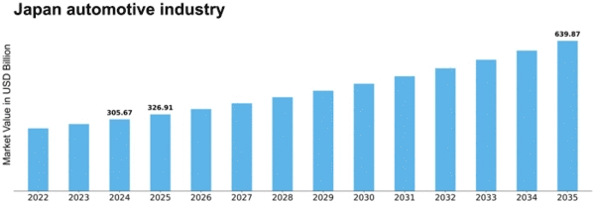
(Source: Market Research Future, 2026)

Appendix 2: UK Automotive Industry Growth
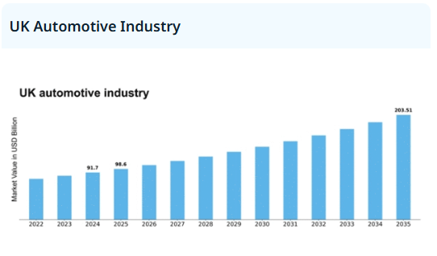
(Source: Market Research Future, 2026)

