Title page

Student name - Shzanur Rahman
Student ID - 1815228
Programme - MASTER OF BUSINESS ADMINITRATION
Module - Marketing Management
Module code - LCMB7001
Lecturer - Efua Adams
Assignment Title - Assessment 1

Table of contents

Title page 1
Table of contents 2
Introduction 3
A critical evaluation “Christos” marketing activities 4
A managerial implication on “Christos” marketing strategy 8
Recommendations as to how the Christos marketing strategy could be improved 10
References 11

Introduction
On this paper will be a critical analysis of Christos Greek and Cypriot restaurants marketing strategy, critically evaluating the different methods they are using as their marketing for their business, the use of SWOT model will be included, there will also be a section explaining how the marketing strategy of Christos is having a managerial implication, the GAPS model of service quality model will be included to relate with the management of Christos. Finally will be my own recommendations on how Christos management could improve their strategies for marketing, the use of the 4 P’s model of marketing will be used, this paper will be written with research and references.
“The marketing philosophy is a normative prescription for business managers; it proposes that the business focus on the consumer's needs and desires” McGee, L.W. and Spiro, R.L., 1988

A critical evaluation “Christos” marketing activities
All of these various marketing channels are related to a company's marketing concept. Then, what precisely is a marketing concept? A marketing concept is the philosophy that guides a company's decision regarding its marketing resources. A company's marketing strategy is determined by the marketing philosophy it adopts. With the help of a marketing concept, a company can explain to the rest of its employees how it intends to grow and increase sales. It also facilitates and harmonizes the marketing team's goal-setting. To ensure that decisions regarding the product, price, distribution, and company promotion are all in sync with one another, a company must choose and develop a marketing concept. “The marketing concept has been misunderstood and misused over the years. It is not obsolete nor is it the optimal managerial approach to marketing. The marketing concept is restated in a way that more clearly shows what it is and what it is not” Houston, F.S., 1986
Production - In this marketing concept, producing a product in large quantities is prioritized. It also emphasizes how inexpensive and convenient the product is for the customer. Its right here and reasonably priced, so why not buy it, the buyer might be thinking.
Product - The idea behind this concept is to update and improve the product's quality. In addition to providing features that are advantageous and have a significant impact on consumer appeal, these actions allow the product to be sold at a higher price. The consumer might think, "It's so unique; it's worth buying."
Selling - In order to convince as many customers to buy as possible, this idea relies on aggressive sales techniques. The needs of the customer are given less weight, and selling is given more weight. The consumer might have thought, "Ok, ok! You've convinced me. I will buy it.
Marketing - The idea of marketing is centred on the wants and needs of the consumer. Delivering a high-value product that satisfies the customer is the aim. The buyer may have the thought, "It's exactly what I need and want! It makes me happy to buy it”
Societal - Unlike the others, this concept emphasizes social responsibility in addition to financial gain. The purchaser may have the thought, "It feels good to buy what I want while improving the world. “Societal marketing emerged in the early 1970’s, promising a more socially responsible and ethical model for marketing” Crane, A. and Desmond, J., 2002
Upon research, I have found that Christos’ marketing strategy is very minimal and basic, they rely on a word of mouth from customers, have their own website which is very informative, also they have a Facebook page which is regularly updated with photos and videos of their functions, along with information of the restaurant such as their opening times, telephone number and email address.
Micromarketing and macro marketing are frequently thought of together. Micromarketing, in contrast to macro marketing, which focuses on society as a whole, concentrates on marketing goods or services to a small, highly targeted audience of customers who are chosen based on particular identifying characteristics, such as postcode code or job title. Because of this, businesses can target particular segments with their campaigns. The customization involved in micromarketing, which by definition lacks economies of scale, may make it more expensive to implement as a marketing strategy. However, since the purpose of this kind of customization is to more effectively reach potential customers or to sell a more expensive good or service, micromarketing frequently generates a profit.
“The emphasis in the mid-1960s on macromarketing issues was in one sense a culmination of work over many years in the functional, commodity, and institutional approaches to marketing” Layton, R.A. and Grossbart, S., 2006
Christos uses the micro marketing more than the macro, Montgomery says that customizing elements of the marketing mix at the store level is referred to as micromarketing. (Montgomery, A.L., 1997) As Christos specifically target the Greek community in and around Birmingham, as already mentioned, they rely hugely on word of mouth the be passed around within the local community to entice more new customers. The restaurant has their own website which is https://www.letsgochristos.co.uk/ upon entering this website, the logo of the restaurant looks very contemporary, and it is followed by an “about us” section which implies they are based within a Greek and Cypriot community within the west midlands, it also tells us the restaurant is a family run business which has been operating for 15 years, previously in Tamworth. It goes on to explain that the centre in which the restaurant is based in includes a Greek school, a church and also a coffee and games room with a Greek shop also. The continuous mentions of the Greek and Cypriot community implies that their target audience is clearly of these nationalities. From the information gathered through researching online, Christos has mainly social media accounts as a marketing tool, one of these is Facebook, which is a free form of marketing, in their account is details about the restaurant such as, the address, telephone number, email address, also they regularly post photos and videos of their customers and parties, where they could improve is their current reviews, as a very low number of people have left reviews, 3 to be precise, it is highly recommended the management push their customers to constantly leave reviews, whether they are positive or negative, then reply to them as a way of acknowledging feedback.
After continuous efforts to search and find more channels or methods Christos uses for communication and marketing, it is clear they are very limited to their own website and free social media platforms such as Facebook, they are on the Google search engine and have 30+ reviews and an overall rating of 4.7 out of 5*, which is definitely a positive for the business as it shows potential customers of their recent performances. After careful and intensive research of Christos’ marketing techniques, it is very clear they are far behind the required level of advertising their business, aside from the free social media platforms that has already been covered, and their own website, Christos does not have much else as of way of marketing, this is most definitely holding back the restaurant as they are not maximizing the potential growth because they are not being seen or heard of in a wider. “Social media has become the method of statement in the 21't century, enabling us to express our belief, ideas and manner in an absolute new way“ Saravanakumar, M. and SuganthaLakshmi, T., 2012
Christos as we now understand, predominantly use the free social media apps and word of mouth amongst Erdington’s Greek and Cypriot community, also they use the free social media platforms such as Facebook, Google search engine. One of the ways to measure the metrics of the pages is by seeing how many followers they have on their Facebook page, as it stands Christos have 712 followers, also they have 651 likes, which in comparison to their competitors, is not nearly enough. On Google, you must specifically search for Christos Erdington in order for the relevant restaurant to appear, it shows the star rating of 4.7 left by 30 users, again this is not enough or potential customers to become highly interested in visiting the restaurant, there are some photos of the exterior and interior of the business, showing groups of customers enjoying themselves. Under the reviews tab is a number of comments left by customers, most of which are positive, some negative but the eye catching part is the management does reply to their customers, even the low rating feedback is replied with, asking the customer how they can improve. Having thoroughly searched the methods of Christos marketing campaign, it is clear they are not up to date with their strategy, whilst the use of free social media apps is good, they must push the agenda to maximize being seen, this could be achieved by using a professional marketing company to produce a more high quality design of their webpage, Facebook account and also their Google advert, more professionally shot photos, including not only the customers, but also the owners, management team, staff and chefs to showcase the identity of the people behind the organisation. Christos must also push to entice more custom from outside the Greek and Cypriot community, as the cuisine they offer is of high demand, it would be advisable for them to offer Halal hmc approved meat and poultry, “Because of the economic significance of the Halal meat market” Fuseini, A., Hadley, P. and Knowles, T., 2021, many food business operators have started trading in Halal meat products. as Birmingham and the west midlands homes a variety of diverse backrounds of communities, the restaurant is certainly losing out on potential sales and exposure. The opening times of the restaurant is varied and on certain days requires advance bookings and deposits, this should be changed to a set time table as generally, customers would prefer to be able to walk into a restaurant when they feel like it, whilst it is the norm to take bookings and deposits for larger parties, the availability to accommodate walkers by for a diner is very important. One of the old fashioned way of marketing any business is by the use of leaflet distribution, this can be done by the management themselves, or by hiring leaflet distributors, this is a well-known method to directly post leaflets or in this case, menus door to door to potential local customers.
The contributions of Christos’ marketing activities is few and far between, on one hand they are targeting the local Greek and Cypriot community mainly in Erdington, becoming a place of not only authentic Greek food, but also a community centre of sorts as they have a Greek convenience store within the building where the restaurant is. However, where the marketing is falling short is the target audience is simply not broad enough, being in the 2nd city of the UK, the potential this restaurant holds being in a highly busy area which is also not too far from the city centre and motorways, is very high, the marketing isn’t advertising themselves to different communities, which is a loss for the organisation as they could be serving many more customers and increasing their sales significantly. “Over recent years, social media has grown to gain recognition as a pronounced and paramount marketing factor guiding the success of a product/service/business” Dwivedi, Y.K., Et al 2015
Whilst the use of platforms such as Facebook, Google etc. is pivotal in today’s digital world, there must be an element of pushing the agenda of exposure, this is impacting the restaurant as the results are not improving, if there were to be more customers visiting Christos, they would be open throughout the week at a set timetable, also the design of the restaurant should be invested in, creating a more authentic Greek feel for customers, the deco within the building should be renovated to be more contemporary.as a local restaurant, the strategy of customers of Christos spreading the good word about the experience is a key method to maintaining and expanding the customer base, as it is a local business, the support of the neighbouring community surely helps to become a pillar of any organisation which requires customers to take time out of their day to visit and spend their earnings on, having said that, where the marketing execution falls short on is the lack of range when including more nationalities than only the Greek and Cypriot, there should be a desire to pursue customers from all different backrounds and races, which will only help to ramp up the hype about Christos as they will become more known. With all this being said, it would be advisable for the restaurant to focus their marketing strategy now to groups outside of the regular customer base, as this would boost visits, sales and ultimately profits, from a personal point of view, the owners may be concerned that the mixture of non-Greek and Cypriot nationalities may deter the more regular customer base they already have in place, as they may the atmosphere of being within their own community being lost, but in any organisation, the main objective is to grow the business to its maximum, this does mean we disregard the loyal customer base that is already in place, but rather perform an assessment to pinpoint how to include both current and future customers with the idea to create a more diverse and blossoming restaurant and then use it as an advertisement for continuous marketing purposes, this can be done using a SWOT analysis.
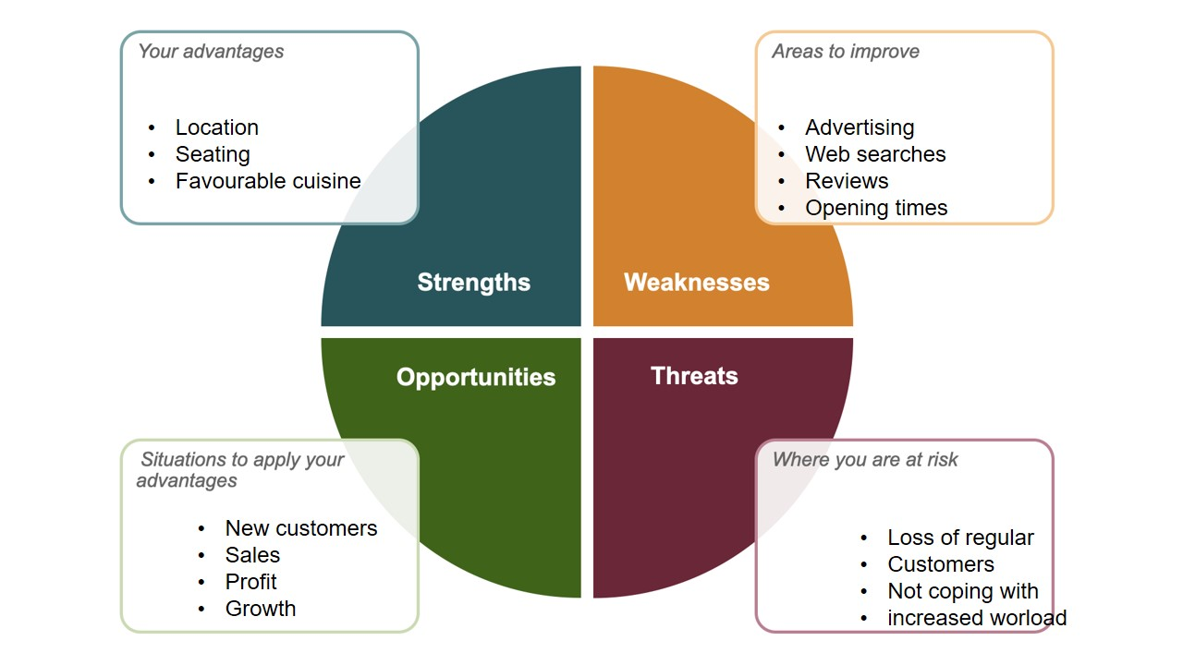
As you can see, the SWOT analysis shows the positives, negatives and potential problems that may occur with Christos expanding to a wider target with new marketing strategies.
According to Leigh, strength, weakness, opportunity, and threat analysis, or SWOT analysis, aims to pinpoint internal strengths and external opportunities that a company can take advantage of to achieve its goals while also attempting to mitigate internal weaknesses and external threats. (Leigh, D., 2009)

A managerial implication on “Christos” marketing strategy
Implementing a marketing strategy can boost profitability because it has an impact on all areas of the company's operations. The marketing strategy specifies the qualities of the product that are required to successfully meet customer needs, concentrating the organization's efforts on particular target market segments. With this focus, the company's operations are made more effective by eliminating marginal operations that don't support business growth. The main effect of a marketing strategy is its emphasis on meeting customer needs, which increases customer satisfaction. Once management has identified the target market and the characteristics of your targeted customers through surveys and market studies, they can focus on strategies to serve the customers better than their competition. Christos' market standing and customer perceptions both rise as a result of this focus. Such a marketing strategy aims to attract more customers as they improve their reputation. “Implementation pervades strategic performance. It is a critical link between the formulation of marketing strategies and the achievement of superior organizational performance” Noble, C.H. and Mokwa, M.P., 1999
As we know the current marketing strategy of Christos is to continue to prioritise the local Greek and Cypriot community, with such a strategy, the implications for the management is that they have become too comfortable in their operations, there is a steady income of sales, but not enough to attract a more variety of customers from different nationalities. How products are marketed and created is significantly influenced by marketing strategies. Management must determine whether the product's features meet the customers' needs after learning what they want, or change the design to include the required features. Instead of trying to convince customers to buy the product that Christos sell, they offer them the product they need with the features they want. A marketing strategy that emphasizes providing products that appeal to the target market has the two advantages of encouraging innovation and improving product quality. The marketing strategy then directs you to run commercials extolling the superiority and innovation of your products. Hmc approved halal meat and poultry is not currently on Christos’ menu, this implicates the management as not welcoming Muslim customers to their premises, quite possibly also having little to no knowledge of what halal is and why in a city such as Birmingham, where the Muslim community holds a high number in population, should be catered to by the management.
Social media is a tool that is on every mobile device in today’s world, all generations of any backround have access to the World Wide Web at their fingertips, so searching for places to eat, reading reviews is easier than ever before. The management of Christos actively uses the strategy of managing their social media accounts by replying to customers reviews, both the good and not so complimentary ones, however, the strategy is somewhat flawed as they simply do not have enough number of people visiting their pages, leaving ratings and reviews, which in turn doesn’t attract more newer customers for the management to increase sales and reputation. “It is generally believed that restaurant reviews can influence consumers' decisions in choosing a restaurant. A survey administered to a sample of 420 college faculty and staff members suggests that while most restaurant patrons may read reviews, they are not used as the sole selection criterion” Barrows, C.W., Lattuca, F.P. and Bosselman, R.H., 1989
The GAP model of service quality is a framework which helps to understand better the customer’s satisfaction, the model highlights the five key areas of customer satisfaction that businesses must close in order to meet expectations. A. Parasuraman, Valarie Zeithaml, and Leonard L. Berry first proposed the model in 1985. Customer satisfaction is largely a function of perception, according to the Gap Model of Service Quality. Customers will be satisfied if they believe that the service meets their needs. They'll be unhappy if not. One of the five customer service "gaps" listed below will be the cause of their dissatisfaction, if they have any, below is a GAP model diagram from the viewpoint of Christos. “Traditionally, the monitoring of a purchasing department's performance is primarily focused on cost analysis and the evaluation of suppliers rather than on internal service aspects” Large, R.O. and König, T., 2009
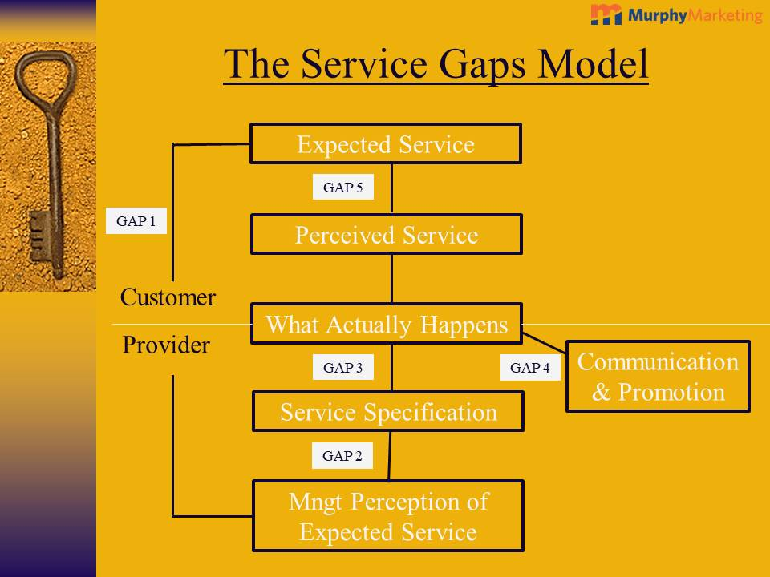
From the point of Christos, the expected service is fairly simple, authentic Greek cuisine served fresh and at an affordable price, the perceived service from the few number of reviews found online, is that it is a very friendly environment and service, with the quality of food is worth the price. What actually happens is that customers have to be aware of the opening times, book in advance to dine in on certain days, this can be done via telephoning or emailing the management, which covers the communication aspect, the promotion side is being left to desire as the reach of the current marketing strategy is not broad enough. The service specification is fairly basic as a restaurants priority is to offer quality food, with the required level of hygiene along with quality of service. The management’s perception of expected service is that the customers are booked in, with their tables reserved and prepared, also they would ideally want a smooth operation, in terms of timing of food arrival with the quality remaining high and ultimately, for the paying customers to be satisfied.
“A conceptual model known as the “Internal Service Quality Model” was designed based on the original “GAP Model” developed by Parasuraman” Frost, F.A. and Kumar, M., 2000

Recommendations as to how the Christos marketing strategy could be improved
Throughout this paper, the need for change and up to date marketing has been an echoing observation, there are numerous ways for Christos to improve their marketing strategy, one of these is maximizing their social media accounts, by creating a high standard of photographs/videos to post, then to actively request to follow accounts, preferably local people, businesses and marketplaces where the search for local cuisines will direct potential customers to Christos. Social media influencers are in all cities in today’s digital world, therefore the strategy to reach out to local influencers with a high following would be a fruitful acquisition. According to Freberg, a new class of independent third-party endorsers known as social media influencers (SMIs) use blogs, tweets, and other forms of social media to influence audience attitudes. Another recommendation would be for Christos to update their restaurants website, as it is quite outdated in terms of reviews, pictures and the welcome message speaking more to the Greek and Cypriot community, they should focus on inviting everyone and make it clear they do their best to accommodate customers from all nationalities, this will also have an effect on the Google search as customers should be encouraged to leave reviews which will hopefully be good, the higher positive reviews there are, the higher the likelihood of potential customers choosing to visit Christos, this applies to local search engines such as Trip advisor and food pages. The management of Christos should also aim to reach the whole area of Erdington, this could be achieved by posting their leaflets/menus through doors, and this guarantees their business getting exposure to their local communities, also included in the leaflet could be an introductory promotional offer to entice customers to try out their local restaurant.
A solid marketing plan requires extensive planning and development. The marketing team of a company needs to have a firm grasp of fundamental marketing principles, such as the 4 Ps of marketing, before they can dive into all the subcategories of marketing, such as digital marketing, email marketing, and so forth. The 4 Ps of marketing, which Neil Borden first popularized in the 1950s, assisted marketing teams in taking into account the actual obstacles that frequently prevented widespread adoption of a product. The fundamentals of marketing haven't changed much over the years, despite the development of many different Ps.
“Here, we build the foundation for strategic marketing efforts by discussing the 4 basic principles of marketing. Like any clever marketing effort, they themselves are well packaged, distinctive, and easy to remember. They are called the 4 P’s (some marketing gurus have come up with other letter schemes, but we stick with the classic for this discussion), and they constitute the core concepts of introductory marketing” Lexa, F.J. and Berlin, J., 2006

As you can see, above is a chart of the 4 P’s model of marketing, for Christos, the product primarily, is the authentic and quality of food served, the price should according to the community where the restaurant is based at, also comparable to local competing restaurants. The promotion needs a great deal of investment as they are behind on their name being a household name within the area of Erdington and Birmingham, this also transfers onto the place aspect, as potential customers should know where the restaurant is located, what times they open and what their cuisine consists of.

References
Barrows, C.W., Lattuca, F.P. and Bosselman, R.H., 1989. Influence of restaurant reviews upon consumers. Hospitality review, 7(2), p.10.
Crane, A. and Desmond, J., 2002. Societal marketing and morality. European journal of marketing.
Dwivedi, Y.K., Kapoor, K.K. and Chen, H., 2015. Social media marketing and advertising. The Marketing Review, 15(3), pp.289-309.
Freberg, K., Graham, K., McGaughey, K. and Freberg, L.A., 2011. Who are the social media influencers? A study of public perceptions of personality. Public relations review, 37(1), pp.90-92.
Frost, F.A. and Kumar, M., 2000. INTSERVQUAL–an internal adaptation of the GAP model in a large service organisation. Journal of Services Marketing.
Fuseini, A., Hadley, P. and Knowles, T., 2021. Halal food marketing: an evaluation of UK halal standards. Journal of Islamic Marketing, 12(5), pp.977-991.
Houston, F.S., 1986. The marketing concept: what it is and what it is not. Journal of marketing, 50(2), pp.81-87.
Large, R.O. and König, T., 2009. A gap model of purchasing's internal service quality: Concept, case study and internal survey. Journal of purchasing and supply management, 15(1), pp.24-32.
Layton, R.A. and Grossbart, S., 2006. Macromarketing: Past, present, and possible future. Journal of Macromarketing, 26(2), pp.193-213.
Leigh, D., 2009. SWOT analysis. Handbook of Improving Performance in the Workplace: Volumes 1‐3, pp.115-140.
Lexa, F.J. and Berlin, J., 2006. Strategic marketing, part 2: the 4 P’s of marketing. Journal of the American College of Radiology, 3(4), pp.274-277.
McGee, L.W. and Spiro, R.L., 1988. The marketing concept in perspective. Business horizons, 31(3), pp.40-45.
Montgomery, A.L., 1997. Creating micro-marketing pricing strategies using supermarket scanner data. Marketing science, 16(4), pp.315-337.
Noble, C.H. and Mokwa, M.P., 1999. Implementing marketing strategies: Developing and testing a managerial theory. Journal of marketing, 63(4), pp.57-73.
Saravanakumar, M. and SuganthaLakshmi, T., 2012. Social media marketing. Life science journal, 9(4), pp.4444-4451.

