The Changes in Police response over the past ten years, toward dealing with domestic violence in Cardiff.

Rhys Owen
2023882

BSc (Hons) Professional Policing Practice

Acknowledgements

Firstly, I’d like to take the time to thank my dissertation tutor, Fay, for all her help and continuous support throughout the process of writing this essay.

I would also like to give my sincerest thanks to all the training staff who helped me at the very start of my policing career, who showed me in a fun but professional manner how to become a confident and competent modern day police officer.

Declaration

This work has not previously been accepted in substance for any degree and is not being concurrently submitted in candidature for any degree.

Signed: R. OWEN Date: 04/10/2023

STATEMENT 1
This dissertation is being submitted in partial fulfilment of the requirements for the degree of BA.

Signed: R. OWEN Date: 04/10/2023

STATEMENT 2
This dissertation is the result of my own independent work/investigation, except where otherwise stated.
Other sources are acknowledged by footnotes giving explicit references. A bibliography is appended.

Signed: R. OWEN Date: 04/10/2023

STATEMENT 3
I hereby give consent for my dissertation, if accepted, to be available for photocopying and for interlibrary loan, and for the title and summary to be made available to outside organisations.

Signed: R. OWEN Date: 04/10/2023

STATEMENT 4
I hereby give consent for my dissertation, if accepted, to be available on the university’s IT system to those who have consent to use the system.

Signed: R. OWEN Date: 04/10/2023

Abstract

There is a vast amount of research material available surrounding the topic of domestic violence, however, very little that digs deeper into the aftercare available to victims of such crimes and the third-party agencies that are in place, to assist the police with providing that care.
The aim of this dissertation was the explore further into the perceptions of the officers who have been dealing with and investigating these crimes over the past ten years, in order to gain clarity on whether they feel that the overall action taken by the police, from the initial response to the 999 calls, to the aftercare and safeguarding of the victim following the offence.
The researcher of this dissertation conducted a critical analysis of the available academic material covering the topic of domestic violence, prior to conducting their own investigation, by way of a confidential survey, which was offered to any police officers in the Cardiff area specifically, that have been investigating domestic violence cases over the past ten years. The purpose of this was to gain their own opinion on how the force has progressed over this specific time frame and whether they think the care given to victims of these offences has become more effective.
The findings from this survey were then recorded, alongside a number of further recommendations by the researcher, in order to cover any discrepancies and gaps there were, in the overall outcome of whether these serving officers believed the police force had improved in this specific area.

Contents Table

Acknowledgements ……………………………………………………………………………………………………………………..… 2
Declaration …………………………………………………………………………………………………………………………………….. 3
Abstract …………………………………………………………………………………………………….…………………………………… 4
1. Chapter One: Introduction …………………………………………………………………………………………………………. 7
1.1 Background ……………………………………………………………………………………………………………………………… 7
2. Chapter 2: Literature Review ……………………………………………………………………………………………………… 8
2.1 Background ………………………………………………………………………………………………………………………………. 8
2.1.2 History …………………………………………………………………………………………………………………………………… 9
2.2 Aim of Research ………………………………………………………………………………………………………………………. 9
2.3 Discussion ………………………………………………………………………………………………………………………………… 9
2.4 Conclusion ……………………………………………………………………………………………………………………………… 12
3. Chapter 3: Methodology ………………………………………………………………………………………………………….. 13
3.1 Introduction …………………………………………………………………………………………………………………………… 13
3.2 Research question and aims……………………………………………………………………………………………………. 13
3.3 Sample …………………………………………………………………………………………………………………………………… 13
3.4 Research approach……………………………………………………………………………………………….………………… 13
3.5 Research method and sampling…………………………………………………………………………..………………….. 15
3.6 Ethical Considerations……………………………………………………………………………………………………………… 15
4. Chapter 4: Analysis of Results …………………………………………………………………………………………………… 16
4.1 Introduction ………………………………………………………………………………………………………….………………… 16
4.2 Data Analysis ………………………………………………………………………………………………………………………….. 16
4.3 Questionnaire Findings ………………………………………………………………………………………….……………….. 16
5. Chapter 5: Findings and Conclusion ………………………………………………………………………………………….. 19
5.1 Introduction ………………………………………………………………………………………………………………….………… 19
5.2 Objective Achievements ……………………………………………………………………………………………….………… 19
5.3 Main Findings ………………………………………………………………………………………………………….……………… 20
5.4 Recommendations and requirement for further research ………………..…………………………………….. 20
5.4.1 Recommendation One: Recruitment drive for specialist domestic violence teams ………………. 21
5.4.2 Recommendation Two: Greater funding support from government …………………………………….. 21
5.4.3 Recommendation Three: Awareness campaigns …………………………………………………………………. 21
5.5 Conclusion ……………………………………………………………………………………………………………………………… 22
6. Bibliography …………………………………………………………………………………………………………………………….. 22
7. Appendices ………………………………………………………………………………………………………………………………. 28
7.1 Appendix One. Questionnaire ………………………………………………………………………………………………… 28
7.2 Appendix Two. Consent and information form ………………………………………………………………………. 30
7.3 Appendix Three. Questionnaire results ………………………………………………………………………………….. 31
7.4 Appendix Four. Dissertation proposal …………………………………………………………………………………….. 35
7.5 Appendix Five. Ethics form …………………………………………………………………………………………………….. 38

- Chapter One: Introduction

This dissertation will look at the effectiveness of police response to domestic incidents in Cardiff, and whether that response has improved over the past ten years. The factors that may have an impact on these results will include the willingness of members of the public reporting such incidents and the improved technology that the police now have direct access to.
Research suggests that domestic abuse is still a very common occurrence that is dealt with daily by the police, and the purpose of this dissertation is to investigate whether serving officers feel that these types of incidents are being dealt with more effectively and efficiently now, than what they were ten years ago.

1.1: Background
Domestic abuse is, sadly, nothing new. According to Shipway (2004), "domestic violence" refers to a broad spectrum of violent and abusive acts performed by one family member against another.
Although there is ample proof that domestic violence has existed since Roman times, the history of violence between intimate partners from the late eighteenth century to the present is complicated (Godfrey and Lawrence 2014).
Domestic abuse victims are generally thought of as being exclusively women, which has led to the classification and social construction that they are the ideal victims (Tsui, 2014). In the words of Strobl (2010) and Tsui (2014), ideal crime victims have weak, innocent, and pure personalities who are strengthened by someone physically stronger than them.
By the end of the nineteenth century, the establishment of prosecution organisations like the National Society Prevention of Cruelty to Children and the Associate Institution for Improving and Enforcing the Laws for the Protection of Women had contributed to the prosecution of more cases. The possibility for both criminal and civil actions in regard to domestic abuse on behalf of women (and children) had also become apparent by the turn of the century.
Against the backdrop of the political, social, and cultural changes generated during the 1960s, the 1970s marked the beginnings of wider concerns about violence against women (and children). The death of Maria Colwell in 1973 at the hands of her stepfather was one moment in which the tide began to turn against viewing the private domain as not a place for public intervention (Walkate, Godfrey and Richardson, 2021).
The first Rape Crisis Centre was established in London in 1972 and the first Women’s Refuge in Chiswick in 1977. Notably, the 1970s prepared the ground for the emergent and subsequent focus by many in the feminist movement on invoking the criminal more to be both more effective, and better implemented in tackling domestic abuse (Goodmark, 2018).
The most reliable estimates of the extent of domestic violence come from the Crime Survey for England and Wales (CSEW) formerly the British Crime Survey (BCS). People are asked by the CSEW about their experience as victims. This survey tends to pick up more crime than the official police figures with it being a household survey, as not all crimes are reported to the police.
The UK government has been called upon to pass laws that provide improved protection for domestic violence victims as a result of mounting pressure over the years. Domestic abuse was redefined by the Home Office in 2012 to include 16 and 17-year-olds, and the language was updated to include coercive control (Home office, 2013).

- Chapter 2: Literature Review

  - Background

    - History
Dating all the way back to 1969, South Wales Police, particularly in Cardiff, have a long history of investigations related to Domestic Violence. When South Wales Police was formed as its own separate Constabulary (College of Policing), the subject of domestic violence has remained a key investigative topic for the police until today.
The 1960s saw a change begin in this issue, as women became fed up with being mistreated and abused (Robinson and Tregidga, 2007). Meetings and protests regarding the issue were held in an attempt to attract public attention. Women were also beginning to air their opinions and expressing their rights to gender equality. Eventually, creating the anti-rape and anti-battery movements (Poskin, 2006), aided in securing their right to equality with men by later in this decade. Wife-beating was, until recently, a common practice in many cultures (Office for National Statistics, 2015). In the 1960s, there was a ‘battered women's’ movement (Gale, 2023), that contributed to the establishment of shelters for abused women. A pattern in these cases over the years would suggest that because they were worried about their future safety if they ever tried to flee from their abuser, they were reluctant to do so (Home Office, 2019). It has also been suggested that due to the men generally earning more money back then, the female may not have the financial means to support herself or her children if she were to leave.

  - Aims of Research
There are many different ways in which loved ones can fall victim during a relationship, such as being forced to engage in non-consensual sexual acts, any behaviours that will endanger them physically, such as a physical assault by beating, or even by being neglected of basic needs, such as food and water. Some victims are made to feel isolated, by not being allowed to engage with or make any form of contact with their friends or family members. Controlling behaviour is also a very common choice of abuse demonstrated by aggressors, such as limiting the person’s ability to make their own decisions, keeping a close eye on them, dictating what they should wear or how they should dress, or even using their children as a means of leverage.
Victims of domestic violence may experience serious psychological and financial repercussions due to the types of trauma that they have been through. However, there are few mental health interventions designed specifically for victims of domestic violence (Su et al., 2021).
This literature review is aimed at discovering whether serving officers feel that the police in Cardiff’s response toward domestic violence has improved, and whether victims of these offences are more willing to engage with the police now, than they used to be.

2.3 Discussion
A very important case that has happened in the force’s recent history is that of ‘Michael v Chief Constable of South Wales Police 2015’ (The Supreme Court, n.d.). This is a case of a known repeat domestic violence perpetrator, who had attended the address of his partner, and as a result, the woman called 999 in fear for her life'. This call was made at 02:29 hours, however, unfortunately, was transferred through to Gwent Police in error, due to an issue with the nearby telephone mast. Gwent transferred this through to South Wales, whereby the call was requested by the handler to be attended as a matter of urgency, however, failed to advise officers whilst passing the call out that the female had significantly stated that she felt the male was going to kill her. There was a total of two phone calls made by the female on this evening, the second of which being predominantly her screaming for help.
Attending South Wales officers arrived at her home address at 02:51 hours, exactly 22 minutes after she had made the first call, to find that she had unfortunately been murdered by her ex-partner. The call handlers from both forces received disciplinary action for the way in which the calls were dealt, and Judge Jarman QC, found that the victim’s human rights had been breached. This for me is a key piece of case law, as it is a perfect starting point for the research I am going to be looking into, in order to prove or disprove that the force has bettered the way in which domestic related incidents are dealt with from start to end, by asking how they think that the police performance in responding to domestic violence over the last eight years could be rated.
Domestic violence is a serious threat to those who utilise mental health services, but these threats are frequently missed by these providers.
A qualitative investigation has taken place with 18 mental health service consumers and 20 mental health practitioners in a socioeconomically disadvantaged area of south London, UK. Participants for individual interviews were chosen through a purposeful sampling of community mental health service users and mental health professionals. The dominating and supporting themes were identified through thematic analysis. These were then turned into conceptual maps with illustrative quotations in addition (Rose et al., 2011).
These service users listed several obstacles to reporting domestic violence to professionals, including: the violence's hidden nature; the perpetrator's actions; and feelings of shame. Other barriers to reporting domestic violence to professionals included fear of the consequences, including fear of Social Services involvement and subsequent child protection proceedings, fear that disclosure would not be believed, and fear that disclosure would lead to further violence. Role boundaries, competency, and confidence were the primary topics for professionals. The medical assessment and therapy model, with its focus on symptoms, may function as a barrier to inquiry and disclosure, according to service users and clinicians. A helpful and trustworthy relationship between the person and the professional reportedly made inquiry and disclosure easier (Rose et al., 2011).
The police are primarily the ones able to identify the vast majority of domestic violence cases. We must keep broadening the pool of people who can be considered victims of domestic violence. Numerous victims refrain from calling the police due to the fear of the repercussions (Johnson, 2006). It seems crucial to locate every perpetrator of domestic violence as soon as possible. Early perpetrator discovery could save lives. It will stop any additional damage from occurring, protect children, and get families moving faster towards rehabilitation and getting their lives back. The goal is that the overall number of families facing domestic violence will decline and that the number of cases of victims being subjected to multiple incidents will eventually start to fall also.
There are many complicated reasons why a victim who has reported abuse to the police could not go through with a prosecution, including love, shame, guilt, isolation, process fear, and language hurdles (Brown, 2020). These crimes can be challenging to prosecute because of the degree of victim attrition. To enhance the experience and offer further safety for these victims and their children, the CPS and the criminal justice system are working extremely hard together. I believe that there are strategies that have been put in place in order to help safeguard a victim during the prosecution stage of the investigation, such as allowing them to give evidence in court from behind a divider, or by means of a live video link. However, I believe that there is a lot more that can be put in place for victims, in order to hopefully interject and prevent them from becoming ‘repeat victims’.
Women experience higher rates of repeated victimisation and are much more likely to be seriously hurt (Walby & Towers, 2017; Walby & Allen, 2004). Further to that, they are more likely to experience higher levels of fear and are more likely to be subjected to coercive and controlling behaviours (Dobash & Dobash, 2004; Hester, 2013; Myhill, 2015; Myhill, 2017).
Every age group has been affected by the public health crisis of domestic violence (Kumar, 2020), which has caused mortality and severe morbidity. Multidisciplinary treatments may quickly offer domestic abuse victims useful remedies in addition to highlighting the mental health issues they have experienced to the general public, in order to increase awareness of the problem (Su et al., 2021a).
Some cultural beliefs often see the male partner believing that they naturally have power over their female counterpart, therefore, may perceive any of the above behavioural patterns as acceptable (Godbee, 2022). It is apparent that there is help in place for victims of these offences, by means of third parties that are often utilised by the Police. Parties such as Live Fear Free, Men’s Advice Line and Women’s Aid are just some examples of parties that have a regular involvement with repeat victims of domestic abuse. I will also be looking to discover the answers to what I believe is missing from the current system.
There are also other forms of abuse that are not quite as common as some of the above in certain areas, such as emotional control, whereby the perpetrator will look to target any insecurities or vulnerabilities that they know their victim has and look to completely brainwash them into believing that what they are going through is normal.

2.4 Conclusion
Results of studies into the police response to domestic violence in the UK show that, compared to other violent crimes, domestic violence cases had a disproportionately low rate of arrests, charges, and prosecutions (15% of male domestic violence cases were not prosecuted compared to 7% of other male violence cases). It has been suggested that the reason for this unequal treatment is the reliability or witness disengagement. However, identical issues occur in other forms of assault cases, thus prosecution is not based on a witness's decision to recant (Feder, 2006).

As a serving police officer, I am fully aware that it is still very much a common occurrence and that victims of this offence are often subjected to instance after instance of abuse. I am aware that there is help available for victims of domestic violence via many different means, such as being better safeguarded, and also with helping them move on from any toxic relationships that they have been involved in. Perpetrators of DV often become repeat perpetrators. Survivors need help and support to become safe and stay safe from such people. It is often a case where perpetrators in these sorts of crimes are the main money earner in the relationship and know that their partner relies on them.
Perpetrators often see this as empowering and almost like it gives them a sense of entitlement over their partner.
I have decided to conduct research into the topic of domestic related violence, as it is something that I have had to deal with a lot since joining the Police. I also have a lot of interest in this matter, as there is such a high volume of it in the areas in which I do my policing. More specifically, I am interested in speaking with colleagues who have been in the job over the course of the last decade, who may be able to shed some light on how the force has adapted to its victim’s needs, and whether the response given to victims of this offence by the force has improved. I have dealt with many cases of domestic related violence and have seen a brief version of how both parties are dealt with as a result of the incident taking place. I have made many arrests of perpetrators of domestic violence and have seen the immediate aftermath of their arrest, such as the custody, interview and bail or remand process. However, as a response officer, I have very little knowledge of any help they may receive or at least be offered in order to try and negate any re-offending on their part. I have also seen a large blind spot regarding the aftercare of domestic violence victims. Front-line response officers’ attend a lot of calls of this nature, however, only deal with the primary safeguarding of any parties involved, such as securing the arrest of the perpetrator and making sure the victim is left safe and well, usually with a friend or family member for the immediate future. I am intrigued to speak with the afore mentioned, longer-serving colleagues, in order to get their opinions on whether they think that there is sufficient help in place for our victims of these types of offences, and also whether South Wales Police as an organisation, are heading in the right direction in terms of meeting our victim’s needs.

3. Chapter Three: Research Methodology

3.1: Introduction
To attain and analyse the goals and objectives of this research, this chapter will establish the best methodological technique. Specific methods and procedures used to locate and evaluate data related to the study topic are referred to as research methodology. The methodology section enables the reader to critically evaluate validity and reliability of the research by ascertaining two main questions; How was the data collected? How was the data analysed? (Wilkinson, 2019).

3.2: Research Question and Aims
The question I will be looking to gain clarity on is, over the past ten years, has the police response to domestic violence cases, particularly in the Cardiff area, improved or not?.

3.3: Sample
In order to try and get clarification on this topic, I will be looking to speak with serving members of the force, who have been dealing with domestic abuse incidents for a minimum of ten years, to gain their opinions on the matter. I feel it is important to single out these potential candidates, as ten years is a very long time to be dealing with such incidents and would enable them to give a fair and accurate opinion on the progress over the past decade, based on the amount of experience that comes with this.

3.4: Research approach
Researchers usually follow one of three popular styles of research. These are known as the ‘Quantitative’, ‘Qualitative’ and ‘Mixed’ research techniques.
Quantitative research utilises numerical analysis derived from systematic observation and also self-response surveys. In this, measurement or experimentation is used and relied upon. Survey results, observational data and cross-sectional data are a few examples of quantitative evidence (Arch and Drew, 2023). Quantitative research is often expressed in numbers and/or graphs, as it looks to test hypotheses. This is often then analysed through math and statistical analysis. In order to collect quantitative data, a researcher may wish to survey somebody either online, over the phone or in person. They may also wish to conduct their own experiments.
Qualitative research on the other hand is expressed in words. It usually has a smaller sample size. As the qualitative approach is often more word based, a researcher may prefer to conduct a more informal, or unstructured interview of a person or even a group of people in what’s called a focus group. Both of these styles would allow for a more free-flowing conversation, whereby more of an opinion is able to be understood.
‘Quantitative’ research tests hypotheses to understand the root cause or correlated link between variables, whereas ‘Qualitative’ research utilises interviews and observation, to further understand a phenomenon in its real-world context. Both methods of research have worth, some study topics are more suited to one than the other (Godbee, 2022). This is usually due to some points needing to be elaborated further than others, and for the researcher to need to delve further into the reasoning behind the answers being given by a participant for example. Some forms of research require more structured and mathematical reasoning than others.
In order to gain a deeper knowledge of the study question, the 'mixed method' research approaches combine quantitative and qualitative methods.
According to researchers Schoonenboom and Johnson, the mixed method research is:
"The type of research in which a researcher or team of researchers integrates elements of qualitative and quantitative research approaches... for the general purposes of breadth and depth of understanding and corroboration." (Schoonenboom & Johnson, 2007).

During this research exercise, I will be utilising both the quantitative and qualitative methods, as I will be surveying members of the police service, all of whom have over ten years’ experience in dealing with domestic violence cases. Ten years is a long time to be dealing with such cases and will give the participants a legitimate opinion on the progress that they feel is being made, particularly over the past decade. I will be setting out a series of questions to ask them, the results of which will remain anonymous. They will each have time to think about the answers they are giving to each question, so that I am able to gather as much information as possible from them.
I will be conducting the survey on a well-known and established website called ‘Pollfish’ (Pollfish, n.d.) This website will allow me to create a custom-made survey, relevant for my target audience, by personally writing out the questions which I wish to ask them. I will then be able to collect and analyse the data received from my respondents, by utilising tools that will allow me to break down the data and give a clearer picture of these results.

3.5: Research Method and Sampling
The research that I am going to be conducting is by means of a questionnaire survey (See appendix 1), which will be aimed at colleagues who have been dealing with and investigating the complex topic of domestic abuse over the last decade, in order to get their opinion on whether the overall police response to these types of incidents has improved. This questionnaire will be completely anonymous. Although their opinion is not the be all and end all, the experience that they have accumulated does make them ‘experts’ in the field of domestic abuse, however, the length of time in which they have been in a role that deals with such a vast number of cases, should have naturally allowed them to gain a much broader knowledge of the subject. Whilst asking these questions of these colleagues, I will be looking to gain some clarity on their opinion of how the system that is currently in place could be improved, in order to assist victims of these types of crimes and by putting them in touch with third-party agencies, in order to assist them with moving forward in their lives. It will be interesting to learn whether they feel the overall police response to such calls is moving in a positive or negative direction, compared to how it was ten years ago. I will also be inviting them to share any evidence that they may have, such as stories that they have, without going into any detail such as personal data, that could back up any of these suggestions.

3.6: Ethical Considerations
The research I am conducting will follow the requirements of the General Data Protection Regulation and also the University policy. To be sure that all possible candidates are properly informed before their consent is given, a consent form and information sheet (see Appendix 2) is going to be attached to the survey for easy viewing. These documents will make sure that the participants are aware of the purpose of the study and how their information will be collected, processed, and stored. The participants will remain anonymous to ensure that their identities and protected. The data will be safely protected and deleted later, to ensure data security.

4. Chapter 4: Analysis of Results
4.1 Introduction
During this study, serving police officers who have been in the job for ten years or more, were specifically targeted to answer the above set of questions.
The set of questions were designed to allow participants to answer both open and closed styled questions, with an aim for them to elaborate on certain points, by giving an opinion.
The questionnaire evidently was not something that officers seemed to be overly keen to participate in, however, eventually ten participants were found and had replied to the survey, which was sent out via a link that could be followed. Once participants clicked on this link, they were able to enter a landing page, where they could view participant information and consent to taking part. Following this, they were then able to get straight into the questions, without inputting any personal data whatsoever.

4.2 Data Analysis
Without over speculating just yet about the findings, each question has been broken down in the order they were asked during the survey.
Out of the twenty questions that were asked during the survey, the ten participants gave the following answers, and all answered every question.

4.3 Questionnaire Findings
In question 1, participants were asked how long they had been working with South Wales Police, to which all ten participants answered ten years or more.
In question 2, participants were asked whether their role involves investigating domestic abuse cases, which 100% answered ‘Yes’.
Question 3, 4 and 5 asked participants their age bracket, gender and ethnicity respectively. This was felt necessary due to the interest of how officers of different age, gender and ethnic background might possibly perceive the topic of domestic abuse and how it is being dealt with currently by the police service. All of these 3 questions gave participants the option to not provide this answer.
At question 6, participants were asked whether they believe the police response toward domestic violence cases has improved over the past ten years. Interestingly, and quite positively, 100% of the ten participants answered ‘Yes’ to this.
Question 7 gave participants the multiple-choice option of whether they believe that the police are now better equipped to deal with such cases, to which 100% answered ‘Yes’. I consider this to be down to the technology that the police now have available, and the ever-growing number of brilliant third-party agencies that they are now able to work alongside. This question gave me slightly more return than the closely similar question 6, as it was more specifically targeting why the participants believe the police are now better equipped to be more effective, as opposed to just simply the effort that is put in, as perceived by the public.
In question 8, participants were asked rather a more leading question of whether they personally feel the number of domestic violence cases has decreased over the past decade. This was a quite overwhelming result where a large majority of the ten participants stated ‘No’.
Question 9 asked participants whether they believe that the police have become more successful in securing a prosecution for domestic violence perpetrators over the past ten years. This saw 70% in favour that they are now seeing more successful results from the arrests that they have made, getting a charge from the CPS.
In question 10, participants were asked whether the police have, in their opinion, progressed with initially responding to reports of domestic violence quicker. 100% answered yes to this. This means that officers are satisfied that them and their colleagues are attending calls of domestic incidents more promptly, meaning that there is more chance of the perpetrator still being present at the location, enabling them to secure the arrest.
For question 11, participants were asked whether they feel that victims of domestic violence now have more support than they did ten years ago. All answered ‘yes’ to this.
80% of the participants stated in question 12 that they feel the police are taking a more proactive approach to preventing domestic abuse than they were ten years ago.
At question 13, 60% of the participants answered that they do not feel the police are better helping to reduce the risk of domestic abuse by having a more significant presence in the community.
Question 14 saw participants answer’s split when asked whether the public education awareness over the past ten years, such as in schools and workplaces, has been effective in preventing, or reducing domestic violence, to which 50 percent answered ‘somewhat’.
90 percent of the participants answered question 15 as ‘yes’, when they were asked whether domestic abuse victims engage with the police more than they did ten years ago.
Question 16 has found that repeat victims tend to engage with the police less than first time victims, with 70% answering ‘less’ to this leading question.
All participants answered ‘yes’ to question 17, which asked whether they had ever dealt with a repeat victim of domestic violence.
30 percent of the participants said they think they would take a different approach to a domestic violence case, if it were involving an individual that they had never dealt with before, whereas 60 percent answered ‘No’ and 10% answering ‘Unsure’.
Question 19 was an open-ended question, asking for officers to detail whether they feel that dealing with domestic violence cases can have a detrimental effect of an officer’s own mental health. This saw some interesting answers which suggests that it can often play a role in affecting an officers own mental health state somewhat, when dealing with such cases. Some of the answers here cover the officers stating that they have sometimes found it hard to switch off when they have got home after some shifts, with others contradicting this, stating they have never felt that work affects their quality of life outside of the job.
And lastly, in question 20, which was an open-ended question, participants were asked to elaborate on whether they feel South Wales Police, could improve on anything when it comes to dealing with domestic violence cases, to which a large percent stated that there should be some sort of permanent domestic violence team in place, to take the strain off response officers who are attending the initial call. It is acknowledged that there is already something like this in place, however, the general consensus is that there is not sufficient cover put in place by the force, enabling individuals in this role to fulfil their duties. Officers on response are still feeling the strain of keeping a domestic violence case from the initial attendance, all the way through to the file of evidence, which they have also compiled themselves, making it to the CPS, in the hope that a positive result will come of it, which is not always the case.
The results of the questionnaire lean quite strongly towards there being an improvement in the way that the force respond to and deal with these cases, and this will be discussed in the next section.

5. Chapter 5: Findings and Conclusion
5.1 Introduction
This dissertation has covered the investigation into whether the Police response to domestic violence cases in Cardiff has improved over the past decade, whilst following the introduction, research, planning and analysis phases. Serving officers were invited to partake in an anonymous survey, in order to give their input on the above matter, with the results of this survey then being analysed. This chapter will cover these results and groupings and suggest recommendations, which could help to negate any future discrepancies regarding the way in which the police respond to and investigate these reports. Finally, this chapter will also present a conclusion subsection, which will highlight the findings and summarise which direction these participants feel the police response is moving in.

5.2 Objective achievements
The main aims of this project were to investigate the topic of domestic abuse cases in Cardiff and gain the insight of police officers that have been handling such cases over the past ten years. The investigative study has completed the following objectives:
- Review readily available and relevant literature regarding the police response toward domestic abuse cases over the past ten years.
This was accomplished by conducting a thorough examination of the available literature with an emphasis on finding data and research addressing the difficulties that victims of domestic violence faced while reporting their experiences. The current research investigation tried to assess how the public perceived the overall police response and effectiveness when investigating these matter.

- Identify themes regarding the topic in order to build a bigger picture of what sort of questions should be put to prospective participants.
This objective was achieved by reviewing the same literature as stated in subsection one, whilst also taking into consideration any works giving an insight into victim’s opinions of their own personal experiences with the police following these reports.

- To collate data by asking serving police officers their opinion on how the police in Cardiff respond to reports of domestic violence now, compared to ten years ago.
This third objective was achieved by producing an anonymous survey and inviting serving officers the opportunity to give their views by answering a set series of questions, specifically designed to gain a further insight into the subject. This enabled the collection of data for analysis. The data was then compared and reviewed to see if there were any patterns forming, and if there was any connection with what had previously been probed.

5.3 Main findings
The primary research conducted in this investigation has shown that there is still not enough support for victims of domestic abuse, causing them to fall into a vicious cycle of repeat abuse.
Unfortunately, only ten prospects agreed to participate in the survey, however, of these ten, a more in-depth insight was gained, from officers who have been dealing with these incidents over the past decade.
The research found that officers who are currently investigating domestic abuse incidents are confident that the results that victims are getting from the police are more positive now compared to ten years ago. The results have also indicated that some officers find dealing with domestic abuse cases more detrimental on their own mental health, than others.
There did not appear to be any discrepancies in the way that these cases were dealt with based on the officers age, gender or ethnic background.

5.4 Recommendations
The perspectives derived from the different discoveries and results obtained while performing the study project served as the foundation for the following recommendations. The participants answering the survey during this investigation provided a consensus that the rate of domestic violence cases over the past ten years has increased and that they still appear to be dealing regularly with repeat victims. It is apparent that the best way to try and negate these victims having to endeavour similar incidents multiple times is for them to have more tailored support, based on their own specific needs. This could be achieved through:

5.4.1 Recommendation One: Recruitment drive for specialist domestic violence teams
According to an HMIC report from 2014, victims of domestic violence felt let down by the general police reaction to these crimes, which led to a lack of trust, confidence, and reporting on their part. This is due to the primary investigators in these crimes being officers who, prior to attending the calls, are not given any specific training in the matter. To regularly execute training programmes for police officers on domestic violence would be a positive step in the right direction, as they would have more of an understanding of the 'Gold Model' standard that is expected of the police when attending and investigating such incidents. The current domestic violence team within the police force should have more involvement in the initial stages of the investigation, rather than it be left to officers, who, not for lack of interest or motivation, have a limited knowledge in the subject.

5.4.2 Recommendation Two: Greater funding support from government
More money could be allocated by the government to hostels, safe houses, and drop-in centres that are specifically for victims of domestic abuse. It has been noted that the majority of domestic abuse support services are not able to be tailored to the victim's specific needs and as a result do not work exclusively for them, putting them at risk of harm when losing interest or faith in the project, leaving them liable to continue being victims of domestic abuse.

5.4.3 Recommendation Three: Awareness Campaigns
There are limited awareness efforts for victims of domestic violence, however the few that are readily available currently are primarily aimed at women. This just serves to support the idea that domestic violence solely affects women, whereas it now also commonly affects men. To increase public awareness of victims of domestic violence, more awareness efforts are required. According to (Hester and Westmarland, 2005), awareness programmes work best when they make the message relatable to the audience and make it obvious what the issue is and what the victims should do in order to solve it. Additionally, it can point people in the direction of services and resources for additional support and address any hurdles or stigmas that may be present.

5.5 Limitations
In most research studies, there are often certain weaknesses and limitations that the researcher is unable to manage. There is no perfect way of managing and handling data. Due to the study only being limited to 10,000 words, there are of course certain limitations that come with this, due to only being able to cover so much material. Another limitation that a researcher will be faced with is deadlines. Deadlines often limit the prospect of reaching a certain number of prospective participants, as there is less time to find them.
Although there are some papers and case studies readily available relating to the general topic of this investigation, there is very little material available from the point of view of officers that have investigated domestic abuse cases. Due to this, it has proven difficult to compare the literature reviewed online with the results of this survey.
The above points can all have an impact on the overall results of the research and should be considered.
The quantitative data that has been collected during this research has been useful, however, qualitative data may have proven move accurate for comparing results, by such means as conducting interviews with officers and victims of domestic abuse, as long as it were dealt with in a way that causes no ethical issues.

5.6 Conclusion
In conclusion, it has become apparent after reviewing and comparing the primary research with the academic literature, that serving officers feel the overall police response to domestic reports currently, is better than it was ten years ago, and that it has improved partly since they are now much better equipped to be dealing with these types of incidents. There still appears to be a lack of sufficient support for victims based on the officer’s feedback relating to dealing with repeat victims of the abuse. The recommendations that have been made above, have been considered, based on the responses given by the survey participants and seem a fitting way of making any aftercare for abuse victims that bit more personal. As everybody has their own different needs, and have their own coping mechanisms, it is always going to prove difficult to fully tailor the aftercare to each specific person, however, by considering the above recommendation, it is felt that this is something that could be achieved going forward, making victims of these horrible incidents feel they can fully rely on the police to do their job of safeguarding them, to the fullest of their capability.

6. Chapter 6: Bibliography
Barrow-Grint, K., Sebire, J., Turton, J. and Weir, R. (2022). Policing Domestic Abuse. Taylor & Francis.
Carlson, B.E. and Worden, A.P. (2005). Attitudes and Beliefs About Domestic Violence: Results of a Public Opinion Survey. Journal of Interpersonal Violence, 20(10), pp.1197–1218. doi:https://doi.org/10.1177/0886260505278530.
Chen, J., Neil, J.A., Tan, J.P., Rudraraju, R., Mohenska, M., Sun, Y.B.Y., Walters, E., Bediaga, N.G., Sun, G., Zhou, Y., Li, Y., Drew, D., Pymm, P., Tham, W.H., Rossello, F.J., Nie, G., Liu, X., Subbarao, K. and Polo, J.M. (2023). A placental model of SARS-CoV-2 infection reveals ACE2-dependent susceptibility and differentiation impairment in syncytiotrophoblasts. Nature Cell Biology, [online] pp.1–12. doi:https://doi.org/10.1038/s41556-023-01182-0.
Cho, J. (2017). Evaluating Qualitative Research. Oxford University Press.
Clive Wilkinson (2019). The Theatre of Work. Amsterdam: Frame Publishers.
Coker, D. (2016). Domestic Violence and Social Justice. Violence Against Women, 22(12), pp.1426–1437. doi:https://doi.org/10.1177/1077801215625851.
College of Policing (2014). Code of ethics : a code of practice for the principles and standards of professional behaviour for the policing profession of England and Wales. [online] Coventry: College of Policing Limited. Available at: https://assets.college.police.uk/s3fs-public/2021-02/code_of_ethics.pdf.
Domestic Violence against Men. (2016). International Journal of Science and Research (IJSR), 5(1), pp.1193–1196. doi:https://doi.org/10.21275/v5i1.nov153023.
Feder, G.S. (2006). Women Exposed to Intimate Partner Violence. Archives of Internal Medicine, 166(1), p.22. doi:https://doi.org/10.1001/archinte.166.1.22.
Feder, G.S. (2006). Women Exposed to Intimate Partner Violence. Archives of Internal Medicine, 166(1), p.22. doi:https://doi.org/10.1001/archinte.166.1.22.
Femi-Ajao, O., Kendal, S. and Lovell, K. (2018). A qualitative systematic review of published work on disclosure and help-seeking for domestic violence and abuse among women from ethnic minority populations in the UK. Ethnicity & Health, 25(5), pp.1–15. doi:https://doi.org/10.1080/13557858.2018.1447652.
Flick, U. (2011). Designing Qualitative Research. Los Angeles ; London ; New Dehli ; Singapore ; Washington Dc ; Melbourne: Sage.
Gale (2023). Second Wave Feminism Primary Sources & History | Gale. [online] www.gale.com. Available at: https://www.gale.com/primary-sources/womens-studies/collections/second-wave-feminism#:~:text=The%20second%20wave%20feminism%20movement [Accessed 30 May 2023].
Godfrey, B.S. and Lawrence, P. (2015). Crime and justice since 1750. London: Routledge, Taylor & Francis Group.
Goodmark, L. (2018). Decriminalizing domestic violence : a balanced policy approach to intimate partner violence. Oakland, California: University of California Press.
Goodwin, L.D. (2020). Qualitative Vs. Quantitative Research or Qualitative and Quantitative Research? Nursing Research, 33(6), pp.378–384.
Gower, J.C., Le Roux, N.J. and Gardner-Lubbe, S. (2016). Biplots: qualititative data. Wiley Interdisciplinary Reviews: Computational Statistics, 8(2), pp.82–111. doi:https://doi.org/10.1002/wics.1377.
Her Majesty's Inspectorate Constabulary (2023). His Majesty’s Inspectorate of Constabulary and Fire & Rescue Services. [online] His Majesty’s Inspectorate of Constabulary and Fire & Rescue Services. Available at: https://hmicfrs.justiceinspectorates.gov.uk/ [Accessed 7 Oct. 2023].
Hester, M. and Westmarland, N. (2006). Domestic violence perpetrators. Criminal Justice Matters, 66(1), pp.34–35. doi:https://doi.org/10.1080/09627250608553400.
Home Office (2019). The economic and social costs of domestic abuse. [online] GOV.UK. Available at: https://www.gov.uk/government/publications/the-economic-and-social-costs-of-domestic-abuse [Accessed 30 May 2023].
Home Office (2019). The Home Office. London: Home Office.
Johnson, M.P. (2006). Conflict and control: Gender symmetry and asymmetry in domestic violence. Violence against Women, 12(11), pp.1003–1018. doi:https://doi.org/10.1177/1077801206293328.
Johnson, R.B., Russo, F. and Schoonenboom, J. (2017). Causation in Mixed Methods Research: The Meeting of Philosophy, Science, and Practice. Journal of Mixed Methods Research, 13(2), pp.143–162. doi:https://doi.org/10.1177/1558689817719610.
Kumar, A. (2020). COVID-19 and Domestic Violence: a Possible Public Health Crisis. Journal of Health Management, [online] 22(2), pp.192–196. doi:https://doi.org/10.1177/0972063420932765.
Myhill, A. (2017). Measuring domestic violence: context is everything. Journal of Gender-Based Violence, [online] 1(1), pp.33–44. doi:https://doi.org/10.1332/239868017x14896674831496.
Office for National Statistics (2015a). Crime Survey for England & Wales. [online] Crimesurvey.co.uk. Available at: https://www.crimesurvey.co.uk/en/index.html [Accessed 30 May 2023].
Office for National Statistics (2015b). Women most at risk of experiencing partner abuse in England and Wales - Office for National Statistics. [online] Ons.gov.uk. Available at: https://www.ons.gov.uk/peoplepopulationandcommunity/crimeandjustice/articles/womenmostatriskofexperiencingpartnerabuseinenglandandwales/yearsendingmarch2015to2017 [Accessed 30 May 2023].
Orchowski, L.M. and Berkowitz, A.D. (2022). A brief history of the science and practice of engaging boys and men in sexual assault prevention. Elsevier eBooks, pp.1–27. doi:https://doi.org/10.1016/b978-0-12-819202-3.00020-1.
Paphitis, S.A., Bentley, A., Asher, L., Osrin, D. and Oram, S. (2022). Improving the mental health of women intimate partner violence survivors: Findings from a realist review of psychosocial interventions. PLOS ONE, 17(3), p.e0264845. doi:https://doi.org/10.1371/journal.pone.0264845.
Pollfish (n.d.). Real Consumer Insights | Pollfish Survey Tools. [online] www.pollfish.com. Available at: https://www.pollfish.com/?campaignid= [Accessed 6 Sep. 2023].
Poskin, P. (2006). A Brief History of the Anti-Rape Movement. [online] Resource Sharing Project. Available at: https://resourcesharingproject.org/resources/a-brief-history-of-the-anti-rape-movement/ [Accessed 30 May 2023].
Robinson, A.L. and Tregidga, J. (2007). The Perceptions of High-Risk Victims of Domestic Violence to a Coordinated Community Response in Cardiff, Wales. Violence Against Women, 13(11), pp.1130–1148. doi:https://doi.org/10.1177/1077801207307797.
Rose, D., Trevillion, K., Woodall, A., Morgan, C., Feder, G. and Howard, L. (2011). Barriers and facilitators of disclosures of domestic violence by mental health service users: qualitative study. British Journal of Psychiatry, 198(3), pp.189–194. doi:https://doi.org/10.1192/bjp.bp.109.072389.
Rose, D., Trevillion, K., Woodall, A., Morgan, C., Feder, G. and Howard, L. (2011). Barriers and facilitators of disclosures of domestic violence by mental health service users: qualitative study. British Journal of Psychiatry, 198(3), pp.189–194. doi:https://doi.org/10.1192/bjp.bp.109.072389.
Schoonenboom, J. and Johnson, R.B. (2017). How to Construct A mixed Methods Research Design. KZfSS Kölner Zeitschrift Für Soziologie Und Sozialpsychologie, [online] 69(2), pp.107–131. doi:https://doi.org/10.1007/s11577-017-0454-1.
The Supreme Court (2019). The Supreme Court. Thousands Oaks, California: Cq Press, A Division Of Sage.
The Supreme Court (n.d.). Michael and others (FC) (Appellants) v The Chief Constable of South Wales Police and another (Respondents) - The Supreme Court. [online] www.supremecourt.uk. Available at: https://www.supremecourt.uk/cases/uksc-2013-0043.html [Accessed 30 May 2023].
Tsui, E.K. and Santamaria, E.K. (2015). Intimate Partner Violence Risk among Undergraduate Women from an Urban Commuter College: the Role of Navigating Off- and On-Campus Social Environments. Journal of Urban Health, 92(3), pp.513–526. doi:https://doi.org/10.1007/s11524-014-9933-0.
Walby, S. and Towers, J. (2017). Measuring violence to end violence: mainstreaming gender. Journal of Gender-Based Violence, 1(1), pp.11–31. doi:https://doi.org/10.1332/239868017x14913081639155.
Walklate, S., Godfrey, B. and Richardson, J. (2021). Changes and continuities in police responses to domestic abuse in England and Wales during the Covid-19 ‘lockdown’. Policing and Society, [online] 32(2), pp.1–13. doi:https://doi.org/10.1080/10439463.2021.1896514.
Wilkinson, E. and Ortega-Alcázar, I. (2019). Stranger danger? The intersectional impacts of shared housing on young people’s health & wellbeing. Health & Place, 60, p.102191. doi:https://doi.org/10.1016/j.healthplace.2019.102191.

7. Chapter 7: Appendices

7.1 Appendix 1: Questionnaire

- How long have you worked for South Wales Police?

- Is part of your role investigating Domestic Abuse cases?

- What age bracket are you? (e.g. 20-30 / 31-40 / 41-50 / 50+

- What is your self-defined gender?

- What ethnicity do you class yourself?

- Do you feel the police response towards domestic violence cases has improved over the past ten years?

- Do you feel the police are now better equipped to deal with domestic violence cases?

- Do you believe that the number of domestic violence cases in Cardiff has decreased over the past ten years?

- Do you feel the police have become more successful in prosecuting domestic violence perpetrators?

- Do you feel the police have become more effective with responding to domestic violence cases quicker?

- Do you feel that domestic violence victim’s are better supported in Cardiff now than they were ten years ago?

- Do you feel that the police are taking a more proactive approach to preventing domestic violence?

- Do you feel that the presence of the police in the community has helped reduce the number of domestic violence cases?

- Do you think that public education and awareness initiatives around domestic-related violence have been effective over the past ten years?

- Do you feel victim's of domestic violence now engage with the police more than they did ten years ago?

- Do you feel that 'Repeat Victim's' engage with the police more or less than first time victim's?

- Have there been cases where you have dealt with ‘Repeat Victims’ of domestic abuse?

- Do you think you would take a different approach to a domestic abuse case if it involved people that you had not dealt with before?

- Do you find that dealing with domestic abuse cases can be detrimental to your own mental health?

- Do you feel that South Wales Police could improve on anything regarding how they deal with Domestic Abuse? (If so, how?)

7.2 Appendix 2: Consent and information form

The Changes in Police response over the past ten years, toward dealing with domestic related violence in Cardiff.
(INFORMED CONSENT FORM FOR PARTICIPANTS)

The purpose and details of this study project have been explained to me in full. I understand that this study is designed to gather knowledge and that all procedures have been approved by University of Wales Trinity St’ David’s.
I have read and understood this consent form.
I have asked all questions that I wanted to clarify prior to agreeing to participate.
I understand that I am under no obligation to take part in this study.
I understand that I reserve the right to withdraw my participation in this study and that I will not be required to state any reason in which I wish to withdraw from it.
I understand that the information I provide will be treated in accordance with Data Protection Regulations and that this survey is anonymous and confidential to the researchers.

I agree to participate in this study.

Name: ____________________________________________________

Signature: _________________________________________________

Signature of Researcher: _____________________________________

Date: _____________________________________________________

7.3 Appendix 3: Questionnaire results

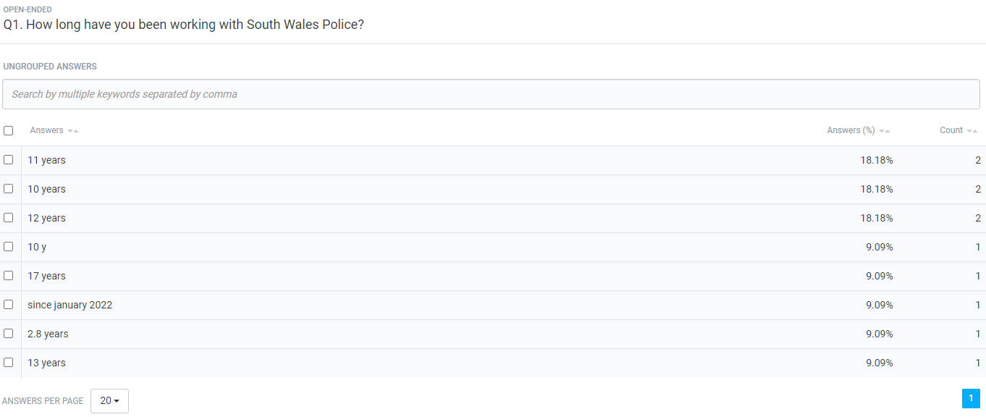
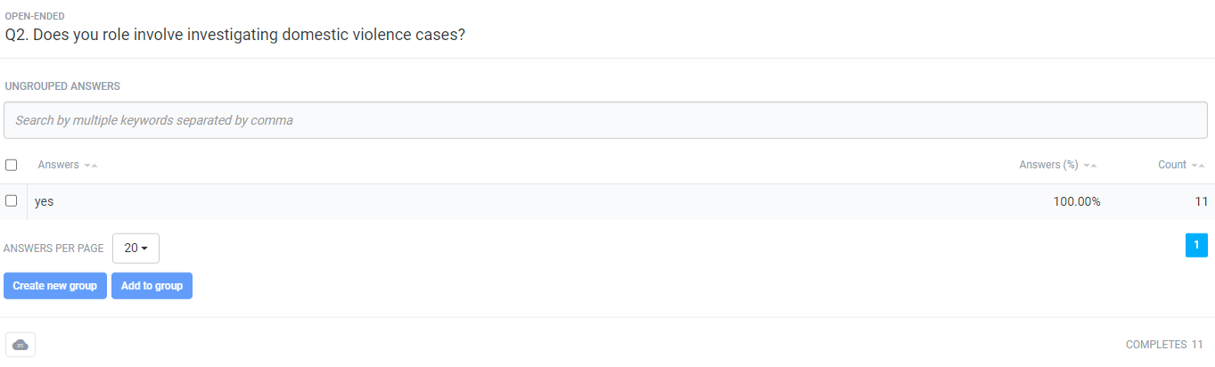
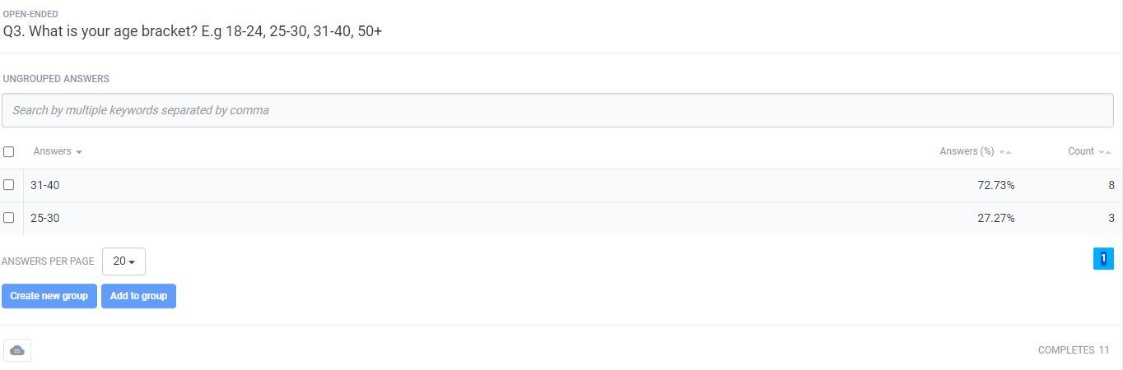
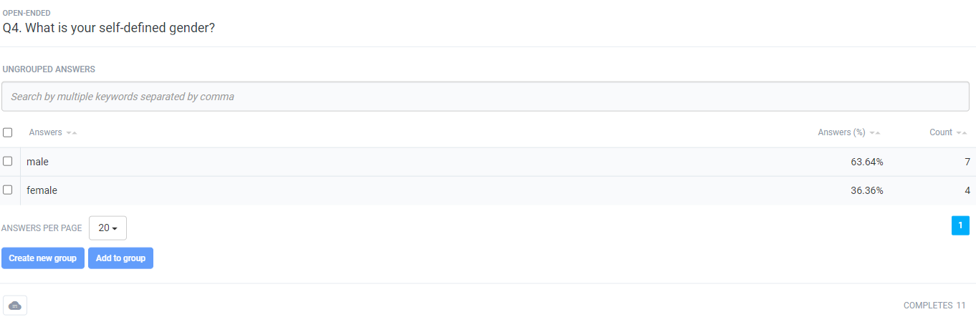
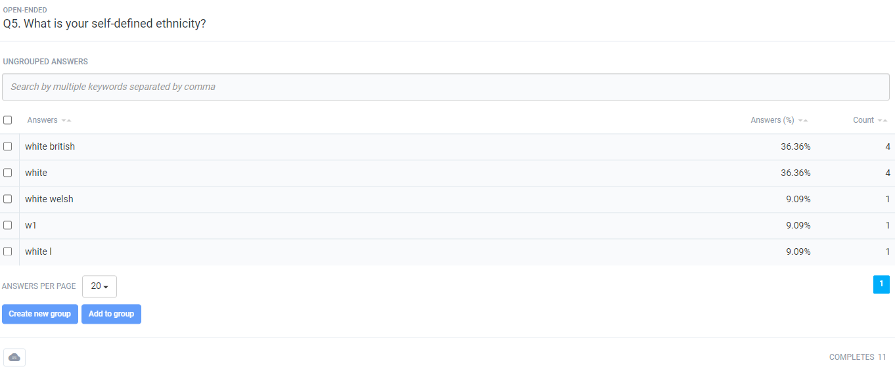
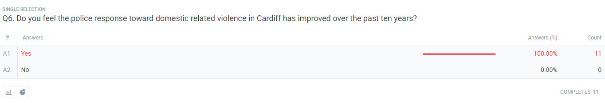
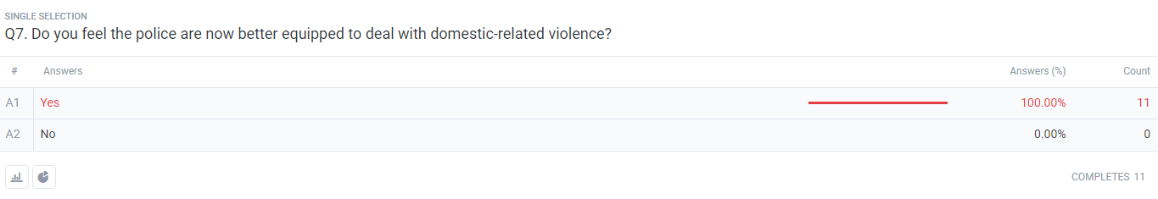
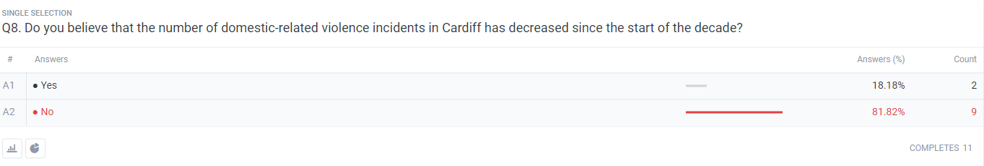
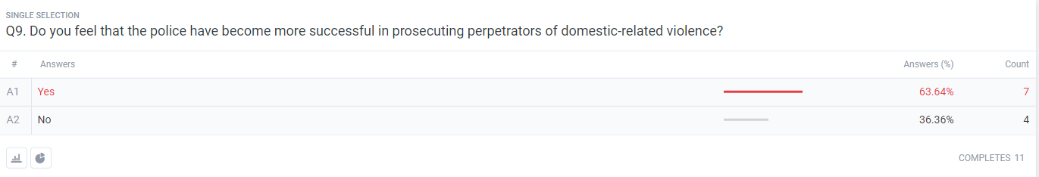
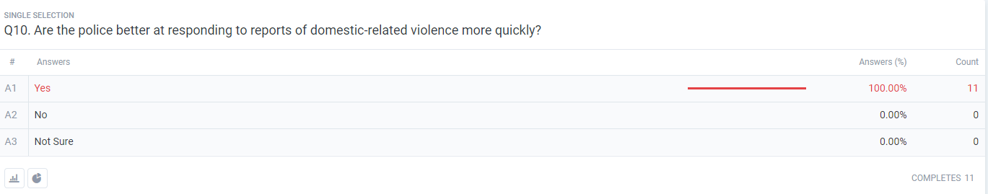
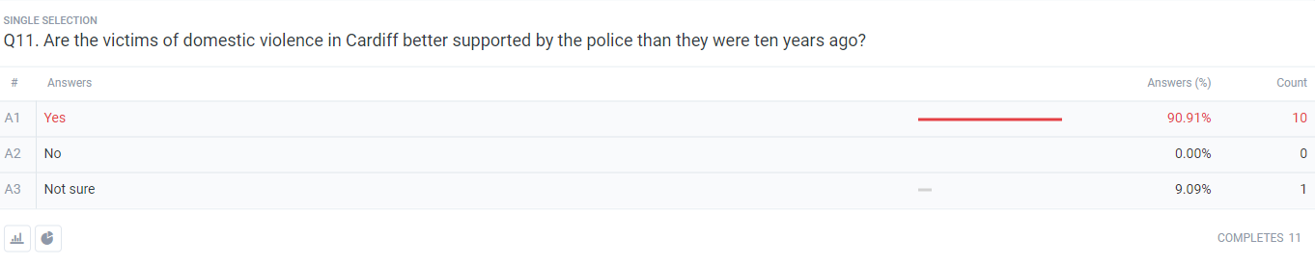
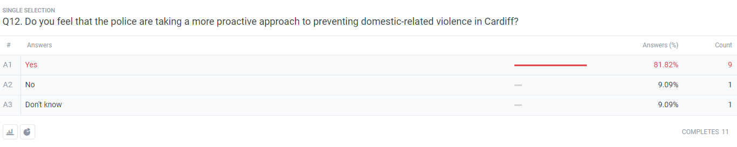
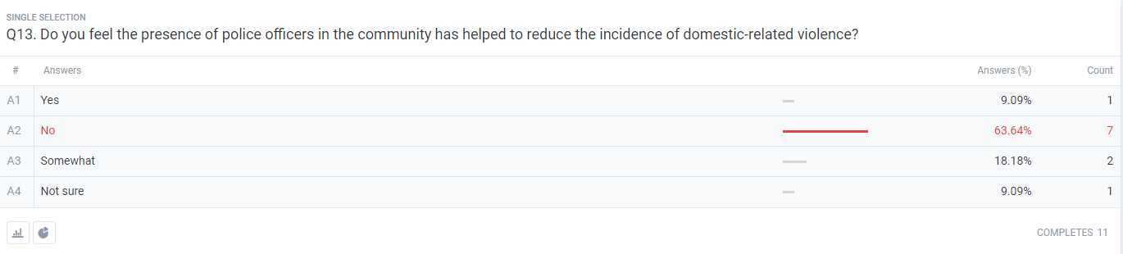
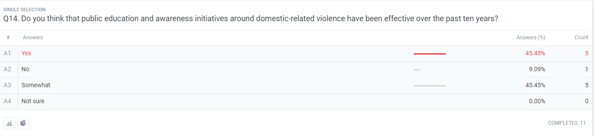
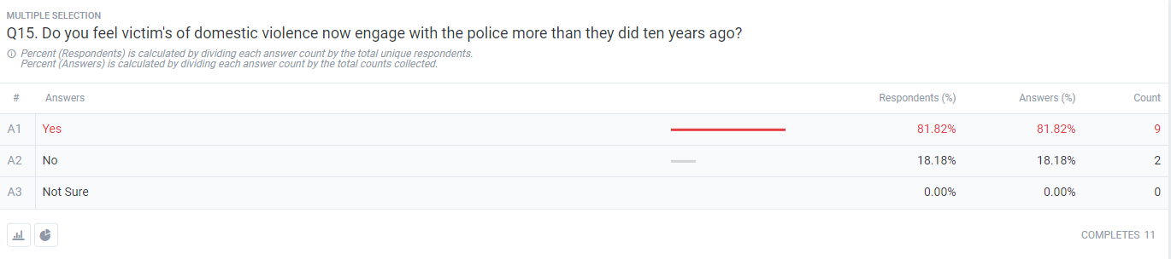
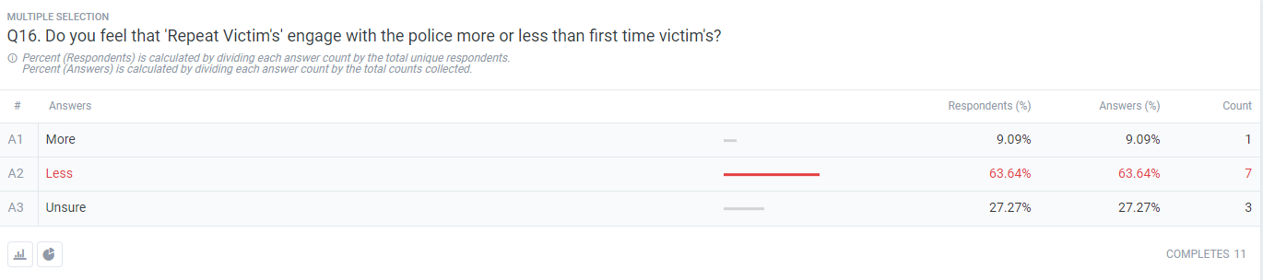
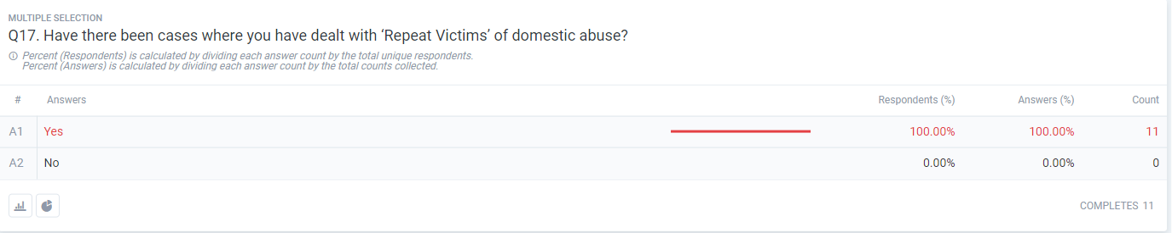
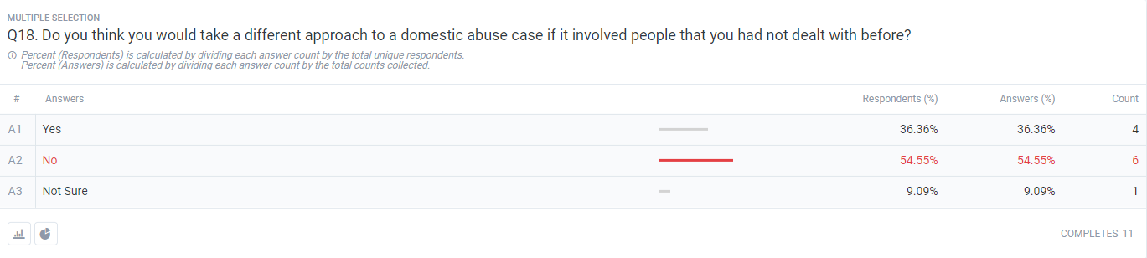
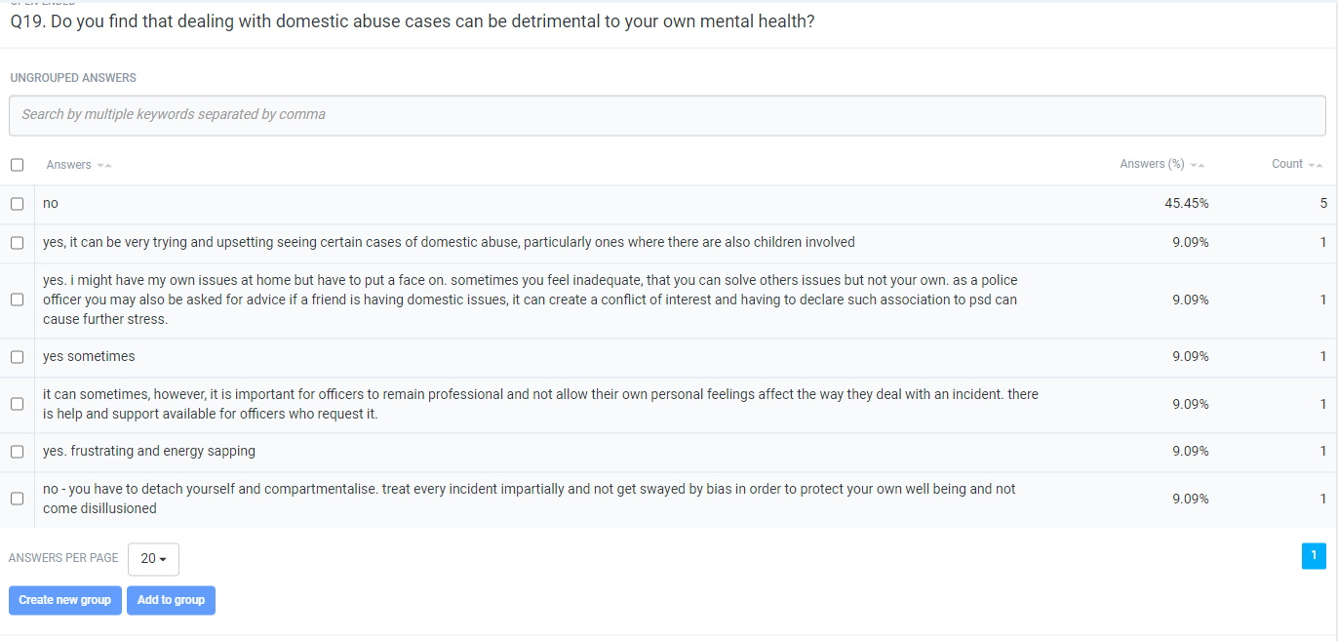
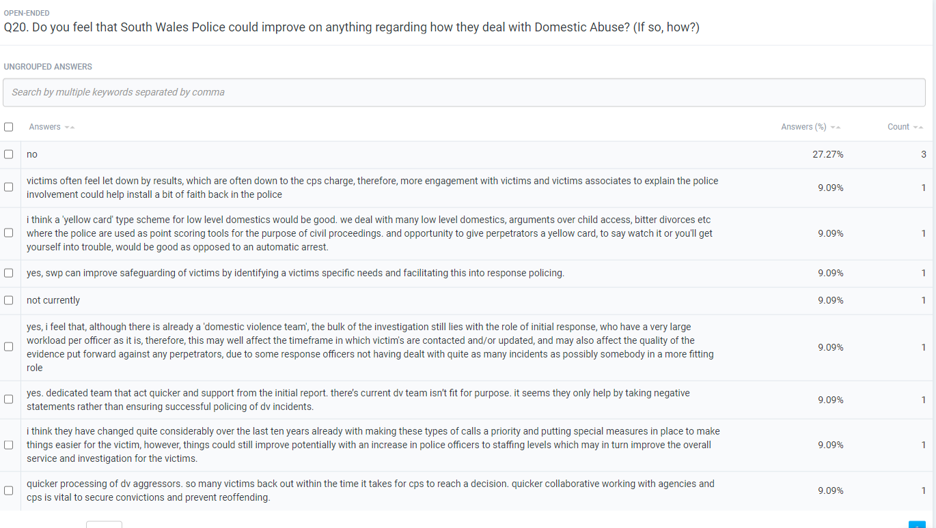
7.4 Appendix 4: Dissertation proposal

The Changes in Police response over the past ten years, toward dealing with domestic related violence in Cardiff.

INTRODUCTION:

The reason for this topic is to explore the changes that have been made over the past decade to improve the overall way that the police service deal with domestic violence.

The rate of domestic violence reports is rapidly increasing, which could have a number of contributing factors. Domestic violence is now far more recognised, which has encouraged more victims to come forward, however, the gap between victims reporting, and victims supporting any sort of positive police action, is still wide.

Domestic related violence can involve several attributes, including physical, emotional, mental and financial. It is important to recognise what type of abuse is being conflicted on the victim to ensure the correct support is given.

I will investigate how policing has improved toward dealing with domestic violence.

SUMMARY OF RESEARCH OBJECTIVES:

The information that I want to collect whilst I am researching this topic is:

• Have police responses to domestic violence calls become more effective, in the opinions of the investigating officers and the feedback they have had from the victims/survivors.
• What are police and other agencies doing to reduce the risk of further domestic violence related calls?

The steps that I am going to be taking to research the key points of my question will be, to review and compare any relevant literature relating to domestic related incidents that have been dealt with by the police.

I will also be exploring the work that is undertaken by third party agencies, such as, Women’s Aid, and also the use of the Police ‘Victim Referral System’.

Also, I will be referring to the Public Protection Notification (PPN) service that is put in place by the police, and why it is good practice to implement this after attending a domestic violence related incident.

LITERATURE REVIEW:

Throughout, I will be referring to the relevant websites that involve UK policing and domestic related incidents. I will compare and analyse the material found within other forces within the UK to explore how other police forces manage and deal with domestic incidents, and what support they offer.

I will also use relevant Journals and articles to support my research and findings within my research.

I will consider Government reports and will refer to the relevant legislation and how it has changed to meet the current demand of domestic incidents.

I will include relevant research that will support the theory of the gap between victims reporting domestic related incidents, and victims not supporting, or withdrawing a police prosecution. I will also explore factors that contribute to this.

SUMMARY OF RESEARCH –SURVEY METHOD:

I will be using two main types of research methods.

One being the ‘Quantitative’ method, which will allow me to measure and compare the statistics involving domestic incidents rising, compared to how many are supporting with a police prosecution. I will also use Quantitative data to compare the number of domestic violence incidents within different forces within the UK and discuss why these are different.

The other research method I will use is a ‘Qualitative’ method, where I will involve experience-based research, in the form of a survey, which will ask serving members of the police who have dealt with a number of domestic related cases, what their opinions are of how the police’ attitude towards dealing with these incidents has progressed and whether they feel it has become more effective. This will then allow me to investigate the subject in more detail.

SUMMARY OF SAMPLING FRAMEWORK:

The target sample I will use will be serving members of the Police, who have over ten years’ worth of experience in dealing with these types of incidents. This may also give me an insight into their own personal experiences. Speaking with these officers will also give me understanding of their opinions and views of whether they believe the police response to these types of incidents has become more effective and efficient.

ETHICAL ISSUES:

I believe that I should be able to keep any ethical issues to a minimum whilst completing this survey and essay, as I will be liaising only with serving members of the Police, who will have a wealth of experience in the field of domestic related incidents.

I will ensure that all research and writing is my own and all information gathered is anonymous.

TIME SCALE:

I am to finish all work ahead of designated deadlines, leaving myself ample opportunity to make any amendments needed. I believe all research will be conducted in 2 – 3 months. All research gathered will be used to create this essay which will take a further 2 – 3 months.

7.5 Appendix 5: Ethics form

APPLICATION FOR ETHICAL APPROVAL

In order for research to result in benefit and minimise risk of harm, it must be conducted ethically. A researcher may not be covered by the University’s insurance if ethical approval has not been obtained prior to commencement.

The University follows the OECD Frascati manual definition of research activity: “creative work undertaken on a systematic basis in order to increase the stock of knowledge, including knowledge of man, culture and society, and the use of this stock of knowledge to devise new applications”. As such this covers activities undertaken by members of staff, postgraduate research students, and both taught postgraduate and undergraduate students working on dissertations/projects.

The individual undertaking the research activity is known as the “principal researcher”.

Ethical approval is not required for routine audits, performance reviews, quality assurance studies, testing within normal educational requirements, and literary or artistic criticism.

Please read the notes for guidance before completing ALL sections of the form.

This form must be completed and approved prior to undertaking any research activity. Please see Checklist for details of process for different categories of application.

Delete the Guidance Notes at the end of the form BEFORE submitting your application

SECTION A: About You (Principal Researcher)
Full Name: |  | Rhys David Owen
Tick all boxes which apply: |  | Member of staff: | ☐ | Honorary research fellow: | ☐
Undergraduate Student | ☒ | Taught Postgraduate Student | ☐ | Postgraduate Research Student | ☐

Institute/Academic Discipline/Centre: | IMH
Campus: | SWANSEA
E-mail address: | 2023882@student.uwtsd.ac.uk
Contact Telephone Number:
For students:
Student Number: | 2023882
Programme of Study: | BSc (Hons) Professional Policing Practice
Director of Studies/Supervisor: | Fay Cosgrove

SECTION B: Approval for Research Activity
Has the research activity received approval in principle?  (please check the Guidance Notes as to the appropriate approval process for different levels of research by different categories of individual) |  | YES | ☒ | NO | ☐
 |  |  |  | Date
If Yes, please indicate source of approval (and date where known): Approval in principle must be obtained from the relevant source prior to seeking ethical approval | Research Degrees Committee |  | ☐
 | Institute Research Committee |  | ☐
 | Other (write in) |  | ☒ | Fay Cosgrove

SECTION C: Internal and External Ethical Guidance Materials
Please list the core ethical guidance documents that have been referred to during the completion of this form (including any discipline-specific codes of research ethics, and also any specific ethical guidance relating to the proposed methodology). Please tick to confirm that your research proposal adheres to these codes and guidelines.
UWTSD Research Ethics & Integrity Code of Practice | ☒
UWTSD Research Data Management Policy | ☒
 | ☐

SECTION D: External Collaborative Research Activity
Does the research activity involve collaborators outside of the University? |  | YES | ☐ | NO | ☒
If Yes, please provide the name of the external organisation and name and contact details for the main contact person and confirmation this person has consented to their personal data being shared.as part of this collaboration.
Institution
Contact person name
Contact person e-mail address

Has this individual consented to sharing their details on this form? |  | YES | ☐ | NO |  |  | ☐
Are you in receipt of a KESS scholarship? |  | YES | ☐ | NO |  |  | ☐
Is your research externally funded |  | YES | ☐ | NO |  |  | ☐
Are you specifically employed to undertake this research in either a paid or voluntary capacity? | Voluntary | YES | ☐ | NO |  | ☐
 | Employed | YES | ☐ | NO |  | ☐
Is the research being undertaken within an existing UWTSD Athrofa Professional Learning Partnership (APLP) | If YES then the permission question below does not need to be answered. | YES | ☐ | NO |  |  | ☐
Permission to undertake the research has been provided by the partner organisation | (If YES attach copy)  If NO the application cannot continue | YES | ☐ | NO |  |  | ☐

Where research activity is carried out in collaboration with an external organisation
Does this organisation have its own ethics approval system? | YES | ☐ | NO | ☐
If Yes, please attach a copy of any final approval (or interim approval) from the organisation

SECTION E: Details of Research Activity
Indicative title: | The Changes in Police response over the past ten years, toward dealing with domestic related violence in Cardiff.
Proposed start date: | 04/01/2023 | Proposed end date: | 23/10/2023
Introduction to the Research (maximum 300 words)
Ensure that you write for a Non-Specialist Audience when outlining your response to the three points below:
- Purpose of Research Activity
- Proposed Research Question
- Aims of Research Activity
- Objectives of Research Activity
Demonstrate, briefly, how Existing Research has informed the proposed activity and explain
- What the research activity will add to the body of knowledge
- How it addresses an area of importance.
Purpose of Research Activity

This research addresses the case of domestic related violence, and what adverse changes have been made over the last decade in order for police and their relevant third party agencies to offer a more effective service to victims.

(this box should expand as you type)
Research Questions

Q1. Have the police and third-party agency responses to domestic violence calls become more effective?

Q2. What are police and other agencies doing to reduce the risk of further domestic related violence calls (repeat victims)?

Q3. What are the main causes of domestic related assaults?

(this box should expand as you type)
Aims of Research Activity

The reason for this topic is to explore the changes that have been made over the past decade to improve the overall way that the police service and relevant third-party agencies deal with domestic violence.

The rate of domestic violence reports is rapidly increasing, which could have a number of contributing factors. Domestic violence is now far more recognised, which has encouraged more victims to come forward, however, the gap between victims reporting, and victims supporting any sort of positive police action, is still wide.

Domestic related violence can involve several attributes, including physical, emotional, mental and financial. It is important to recognise what type of abuse is being conflicted on the victim to ensure the correct support is given.

I will investigate how policing has improved toward dealing with domestic violence, and what type of support is now available for and offered to victims.

(this box should expand as you type)
Objectives of Research Activity

The information that I want to collect whilst I am researching this topic is:

- Have police and third-party agency responses to domestic violence calls become more effective?
- What are police and other agencies doing to reduce the risk of further domestic violence related calls?
- What are the main causes of domestic related assaults?

The steps that I am going to be taking to research the key points of my question will be, to review and compare any relevant literature relating to domestic related incidents that have been dealt with by the police.

I will also be exploring the work that is undertaken by third party agencies, such as, Women’s Aid, and also the use of the Police ‘Victim Referral System’.

Also, I will be referring to the Public Protection Notification (PPN) service that is put in place by the police, and why it is good practice to implement this after attending a domestic violence related incident.

(this box should expand as you type)
Proposed methods (maximum 600 words)
Provide a brief summary of all the methods that may be used in the research activity, making it clear what specific techniques may be used. If methods other than those listed in this section are deemed appropriate later, additional ethical approval for those methods will be needed.
I will be using two main types of research methods.
One being the ‘Quantitative’ method, which will allow me to measure and compare the statistics involving domestic incidents rising, compared to how many are supporting with a police prosecution. I will also use Quantitative data to compare the number of domestic violence incidents within different forces within the UK and discuss why these are different.

The other research method I will use is a ‘Qualitative’ method, where I will involve experience-based research, which will allow me to investigate the subject in more detail. I will also be looking at case studies to support this research.

(this box should expand as you type)

Location of research activity
Identify all locations where research activity will take place.
Throughout, I will be referring to the relevant websites that involve UK policing and domestic related incidents. I will compare and analyse the material found within other forces within the UK to explore how other police forces manage and deal with domestic incidents, and what support they offer.

I will also use relevant Journals and articles to support my research and findings within my research.

I will consider Government reports and will refer to the relevant legislation and how it has changed to meet the current demand of domestic incidents.

I will include relevant research that will support the theory of the gap between victims reporting domestic related incidents, and victims not supporting, or withdrawing a police prosecution. I will also explore factors that contribute to this.

(this box should expand as you type)
Research activity outside of the UK
If research activity will take place overseas, you are responsible for ensuring that local ethical considerations are complied with and that the relevant permissions are sought. Specify any local guidelines (e.g. from local professional associations/learned societies/universities) that exist and whether these involve any ethical stipulations beyond those usual in the UK (provide details of any licenses or permissions required). Also specify whether there are any specific ethical issues raised by the local context in which the research activity is taking place, for example, particular cultural and/or legal sensitivities or vulnerabilities of participants.
(this box should expand as you type)
Use of documentation not in the public domain: Are any documents NOT publicly available? | NO | ☒
 | YES | ☐
If Yes, please provide details here of how you will gain access to specific documentation that is not in the public domain and that this is in accordance with prevailing data protection law of the country in question and England and Wales.

(this box should expand as you type)

SECTION F: Scope of Research Activity
Will the research activity include: | YES | NO
Use of a questionnaire or similar research instrument? | ☒ | ☐
Use of interviews? | ☐ | ☒
Use of diaries? | ☐ | ☒
Participant observation with their knowledge? | ☐ | ☒
Participant observation without their knowledge? | ☐ | ☒
Use of video or audio recording? | ☐ | ☒
Access to personal or confidential information without the participants’ specific consent? | ☐ | ☒
Administration of any questions, test stimuli, presentation that may be experienced as physically, mentally or emotionally harmful / offensive? | ☐ | ☒
Performance of any acts which may cause embarrassment or affect self-esteem? | ☐ | ☒
Investigation of participants involved in illegal activities? | ☐ | ☒
Use of procedures that involve deception? | ☐ | ☒
Administration of any substance, agent or placebo? | ☐ | ☒
Working with live vertebrate animals? | ☐ | ☒
Other primary data collection methods, please explain in this box  For example, ‘focus groups’. Please indicate the type of data collection method(s) in this box and tick the accompany box. | ☐ | ☒
Details of any other primary data collection method:  (this box should expand as you type) | ☐ | ☒
If NO to every question, then the research activity is (ethically) low risk and may be exempt from some of the following sections (please refer to Guidance Notes).

If YES to any question, then no research activity should be undertaken until full ethical approval has been obtained.

SECTION G: Intended Participants
Who are the intended participants: | YES | NO
Students or staff at the University? | ☐ | ☒
Adults (over the age of 18 and competent to give consent)? | ☒ | ☐
Vulnerable adults? | ☐ | ☒
Children and Young People under the age of 18? (Consent from Parent, Carer or Guardian will be required) | ☐ | ☒
Prisoners? | ☐ | ☒
Young offenders? | ☐ | ☒
Those who could be considered to have a particularly dependent relationship with the investigator or a gatekeeper? | ☐ | ☒
People engaged in illegal activities? | ☐ | ☒
Others (please identify specifically any group who may be unable to give consent) please indicate here and tick the appropriate box. | ☐ | ☒
Other – please indicate here:  (this box should expand as you type) | ☐ | ☒

Participant numbers and source
Provide an estimate of the expected number of participants. How will you identify participants and how will they be recruited?
How many participants are expected? | Due to this being a questionnaire only research method, I am aiming to target 20 participants.  (this box should expand as you type)
Who will the participants be? | The target sample I will use will be serving members of the Police, who have had over ten years’ experience of dealing with Domestic related incidents. I am hoping that the information they are able to / willing to share with me will give me an insight into their personal experiences, as well as how they feel their work impacted the victim(s) of the cases they dealt with.  (this box should expand as you type)
How will you identify the participants? | I will identify the appropriate participants for this investigation by firstly looking at the departments who are predominantly dealing with domestic related incidents, such as response, The ‘HUB’ and CID. I will then look to single out officers who have over ten years’ worth of policing service, as they will be the more likely group of officers to be able to shed light on the collection of experiences they have had throughout their time in the job.  (this box should expand as you type)

Information for participants: | YES | NO | N/A
Will you describe the main research procedures to participants in advance, so that they are informed about what to expect? | ☒ | ☐ | ☐
Will you tell participants that their participation is voluntary? | ☒ | ☐ | ☐
Will you obtain written consent for participation? | ☒ | ☐ | ☐
Will you explain to participants that refusal to participate in the research will not affect their treatment or education (if relevant)? | ☒ | ☐ | ☐
If the research is observational, will you ask participants for their consent to being observed? | ☐ | ☐ | ☒
Will you tell participants that they may withdraw from the research at any time and for any reason? | ☒ | ☐ | ☐
With questionnaires, will you give participants the option of omitting questions they do not want to answer? | ☒ | ☐ | ☐
Will you tell participants that their data will be treated with full confidentiality and that, if published, it will not be identifiable as theirs? | ☒ | ☐ | ☐
Will you debrief participants at the end of their participation, in a way appropriate to the type of research undertaken? | ☒ | ☐ | ☐
If NO to any of above questions, please give an explanation
(this box should expand as you type)

Information for participants: | YES | NO | N/A
Will participants be paid? | ☐ | ☒ | ☐
Is specialist electrical or other equipment to be used with participants? | ☐ | ☒ | ☐
Are there any financial or other interests to the investigator or University arising from this study? | ☐ | ☒ | ☐
Will the research activity involve deliberately misleading participants in any way, or the partial or full concealment of the specific study aims? | ☐ | ☒ | ☐
If YES to any question, please provide full details
(this box should expand as you type)

SECTION H: Anticipated Risks

Outline any anticipated risks that may adversely affect any of the participants, the researchers and/or the University, and the steps that will be taken to address them.

If you have completed a full risk assessment (for example as required by a laboratory, or external research collaborator) you may append that to this form.
Full risk assessment completed and appended? |  | Yes | ☐
 |  | No | ☒
Risks to participants
For example: emotional distress, financial disclosure, physical harm, transfer of personal data, sensitive organisational information
Risk to Participant:  As I will only be surveying serving police officers about their experiences of dealing with domestic related incidents, although I appreciate some incidents may have an effect on, or impact officers in certain ways, I am hoping that there will be very low risk to all participants, as the survey will not be detailing any events whereby, they had any involvement other than an investigator.  (this box should expand as you type) | How will you mitigate the Risk to Participant  The participants will be briefed before giving written consent to participate about the topics that are concerned during the survey. I am hoping that this will give them enough of an understanding as to what to expect, so that nothing would take them by surprise or cause any alarm.  Any participant will be advised that if they have ever experienced anything that has been discussed that they did not feel comfortable sharing, there are a number of third-party agencies available that could offer them help.  (this box should expand as you type)
If research activity may include sensitive, embarrassing or upsetting topics (e.g. sexual activity, drug use) or issues likely to disclose information requiring further action (e.g. criminal activity), give details of the procedures to deal with these issues, including any support/advice (e.g. helpline numbers) to be offered to participants. Note that where applicable, consent procedures should make it clear that if something potentially or actually illegal is discovered in the course of a project, it may need to be disclosed to the proper authorities
(this box should expand as you type)
Risks to investigator
For example: personal safety, physical harm, emotional distress, risk of accusation of harm/impropriety, conflict of interest
Risk to Investigator:  As previously mentioned, I am hoping that by giving the participants a brief outline of what to expect within the survey prior to beginning, that this will negate any chances of causing the participant any alarm or distress during the process.  (this box should expand as you type) | How will you mitigate the Risk to Investigator:  I will do this by advising the participants prior to beginning the survey, the brief contents of the survey and what sort of questions they will be required to answer.  (this box should expand as you type)
University/institutional risks
For example: adverse publicity, financial loss, data protection
Risk to University:  Due to me keeping this investigation in-house, by only surveying actively serving police officers, there should be no risk of anything along the lines of adverse publicity, financial loss or any data protection concerns.  (this box should expand as you type) | How will you mitigate the Risk to University:  As mentioned, I will have no concerns of any risk to the university being caused as a result of this survey, as I will be surveying serving colleagues, who will understand the necessity of the survey being conducted, therefore, causing no upset or alarm to anybody involved.  (this box should expand as you type)

Disclosure and Barring Service
If the research activity involves children or vulnerable adults, a Disclosure and Barring Service (DBS) certificate must be obtained before any contact with such participants. | YES | NO | N/A
Does your research require you to hold a current DBS Certificate? | ☐ | ☐ | ☒

SECTION I: Feedback, Consent and Confidentiality
Feedback
What de-briefing and feedback will be provided to participants, how will this be done and when?
Once the investigation is complete and I have surveyed all twenty individuals as planned, I will look to have a de-brief with all of the individuals that have taken part in order to assess whether they may need any help with any coping mechanisms as a result of anything that they have disclosed. I see no risk with sharing the findings with the participants who wish to know any collective data, as there will be no sensitive data collected.

(this box should expand as you type)
Informed consent
Describe the arrangements to inform potential participants, before providing consent, of what is involved in participating. Describe the arrangements for participants to provide full consent before data collection begins. If gaining consent in this way is inappropriate, explain how consent will be obtained and recorded in accordance with prevailing data protection legislation.
No sensitive data such as addresses or dates of birth will be collected from any participants during this process. However, I will address any potential participants in person, and if they are willing to partake, I will then take their name and a signature of informed consent.

(this box should expand as you type)
Confidentiality / Anonymity
Set out how anonymity of participants and confidentiality will be ensured in any outputs. If anonymity is not being offered, explain why this is the case.
All participants in this process will be approached face to face and any written consent to participate will be collected separately, leaving the survey itself totally anonymous.

(this box should expand as you type)

SECTION J: Data Protection and Storage
In completing this section refer to the University’s Research Data Management Policy and the extensive resources on the University’s Research Data Management web pages (http://uwtsd.ac.uk/library/research-data-management/).
Does the research activity involve personal data (as defined by the General Data Protection Regulation 2016 “GDPR” and the Data Protection Act 2018 “DPA”)? | YES | NO
“Personal data” means any information relating to an identified or identifiable natural person (‘data subject’). An identifiable natural person is one who can be identified, directly or indirectly, in particular by reference to an identifier such as a name, an identification number, location data, an online identifier or to one or more factors specific to the physical, physiological, genetic, mental, economic, cultural or social identity of that natural person. | ☐ | X
If YES, provide a description of the data and explain why this data needs to be collected:
(this box should expand as you type)
Does it involve special category data (as defined by the GDPR)? | YES | NO
“Special category data” means sensitive personal data consisting of information as to the data subjects’ –  (a) racial or ethnic origin,  (b) political opinions,  (c ) religious beliefs or other beliefs of a similar nature,  (d) membership of a trade union (within the meaning of the Trade Union and Labour Relations (Consolidation) Act 1992),  (e) physical or mental health or condition,  (f) sexual life,  (g) genetics,  (h) biometric data (as used for ID purposes), | ☐ | X
If YES, provide a description of the special category data and explain why this data needs to be collected:
(this box should expand as you type)
Will the research activity involve storing personal data and/or special category data on one of the following: | YES | NO
Manual files (i.e. in paper form)? | ☐ | ☒
University computers? | ☐ | ☒
Private company computers? | ☐ | ☒
Home or other personal computers? | ☐ | ☒
Laptop computers/ CDs/ Portable disk-drives/ memory sticks? | ☐ | ☒
“Cloud” storage or websites? | ☐ | ☒
Other – specify: | ☐ | ☒
For all stored data, explain the measures in place to ensure the security of the data collected, data confidentiality, including details of password protection, encryption, anonymisation and pseudonymisation:
(this box should expand as you type)
All Data Storage
Will the research activity involve any of the following activities: | YES | NO
Electronic transfer of data in any form? | ☐ | ☒
Sharing of data with others at the University? | ☐ | ☒
Sharing of data with other organisations? | ☐ | ☒
Export of data outside the European Union or importing of data from outside the UK? | ☐ | ☒
Use of personal addresses, postcodes, faxes, emails or telephone numbers? | ☐ | ☒
Publication of data that might allow identification of individuals? | ☐ | ☒
Use of data management system? | ☐ | ☒
Data archiving? | ☐ | ☒
If YES to any question, please provide full details, explaining how this will be conducted in accordance with the GDPR and DPA (and/or any international equivalent):
N/A

(this box should expand as you type)
List all who will have access to the data generated by the research activity:
Myself only

(this box should expand as you type)
List who will have control of, and act as custodian(s) for, data generated by the research activity:
Myself only

(this box should expand as you type)
Give details of data storage arrangements, including security measures in place to protect the data, where data will be stored, how long for, and in what form. Will data be archived – if so how and if not why not.
Data will only be collected and stored on university approved device and again, no personal or sensitive data will ever be collected.

(this box should expand as you type)
Please indicate if your data will be stored in the UWTSD Research Data Repository (see https://researchdata.uwtsd.ac.uk/ ). If so please explain. (Most relevant to academic staff)
N/A

(this box should expand as you type)
Confirm that you have read the UWTSD guidance on data management (see https://www.uwtsd.ac.uk/library/research-data-management/) | YES | ☒
 | NO | ☐
Confirm that you are aware that you need to keep all data until after your research has completed or the end of your funding | YES | ☒
 | NO | ☐

SECTION K: Declaration
The information which I have provided is correct and complete to the best of my knowledge. I have attempted to identify any risks and issues related to the research activity and acknowledge my obligations and the rights of the participants.

In submitting this application I hereby confirm that I undertake to ensure that the above named research activity will meet the University’s Research Ethics and Integrity Code of Practice which is published on the website: https://www.uwtsd.ac.uk/research/research-ethics/
Signature of applicant: | RHYS DAVID OWEN | Date:  26/02/2023

For STUDENT Submissions:
Director of Studies/Supervisor: |  | Date:
Signature: |  | Date:

For STAFF Submissions:
Academic Director/ Assistant Dean: |  | Date:
Signature: |  | Date:

Checklist: Please complete the checklist below to ensure that you have completed the form according to the guidelines and attached any required documentation:
☒ | I have read the guidance notes supplied before completing the form.
☒ | I have completed ALL RELEVANT sections of the form in full.
☒ | I confirm that the research activity has received approval in principle
☒ | I have attached a copy of final/interim approval from external organisation (where appropriate)
☐ | I have attached a full risk assessment (and have NOT completed Section H of this form) (where appropriate) ONLY TICK IF YOU HAVE ATTACHED A FULL RISK ASSESSMENT
☒ | I understand that it is my responsibility to ensure that the above named research activity will meet the University’s Research Ethics and Integrity Code of Practice.
☒ | I understand that before commencing data collection all documents aimed at respondents (including information sheets, consent forms, questionnaires, interview schedules etc.) must be confirmed by the DoS/Supervisor, module tutor or Academic Director.
☒ | I have deleted the guidance notes before submitting the PG2 for consideration

RESEARCH STUDENTS AND STAFF ONLY
All communications relating to this application during its processing must be in writing and emailed to pgresearch@uwtsd.ac.uk , with the title ‘Ethical Approval’ followed by your name.
You will be informed of the outcome of your claim by email; therefore it is important that you check your University and personal email accounts regularly.

STUDENTS ON UNDERGRADUATE OR TAUGHT MASTERS PROGRAMMES should submit this form (and receive the outcome) via systems explained to you by the supervisor/module leader.

This form is available electronically from the Academic Office web pages: https://www.uwtsd.ac.uk/academic-office/appendices-and-forms/

Application Process

All staff research projects and all research students must submit the Ethical Approval Form to the University Research Ethics Committee via the Academic Office (pgresearch@uwtsd.ac.uk). Staff research directly in relation to personal study for taught undergraduate or Masters programmes should be submitted via the Institute procedures explained below.

Taught masters and taught undergraduate research Ethical Approval Forms are considered within Institutes. Institutes will provide details of the specific processes for this. Where the Ethical issues within any single ethical application are of particular concern the Institute will refer these to the University Research Ethics Committee. Any student activity that involves the collection of primary data needs to undergo Ethical approval, this includes assignment work as well as dissertations.

