

University of Wales Trinity Saint David

School of Computing

Title of Coursework
GPUs and the Development of Games Graphics

Academic writing
M4X01498

Name
Osvaldas Stanelis
Student no
1802408

Date
02/05/2019
Contents
Introduction 3
Research 4
Discussion 6
Conclusions 8
References 9

Introduction

To start talking about GPU's and how they impacted our modern days, we must look back on our history and see that we’ve always played games, from board games of the Egyptians, chess in medieval times, cards in the court of Versailles, Blackjack in saloons of the Wild West and Pac-Man in arcades worldwide during 1980s. Games were and are an important part of our life’s, but how did it change and why in recent decades?

Research

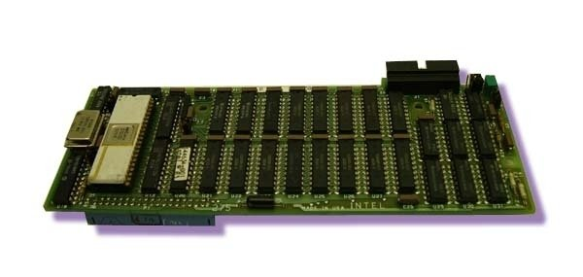
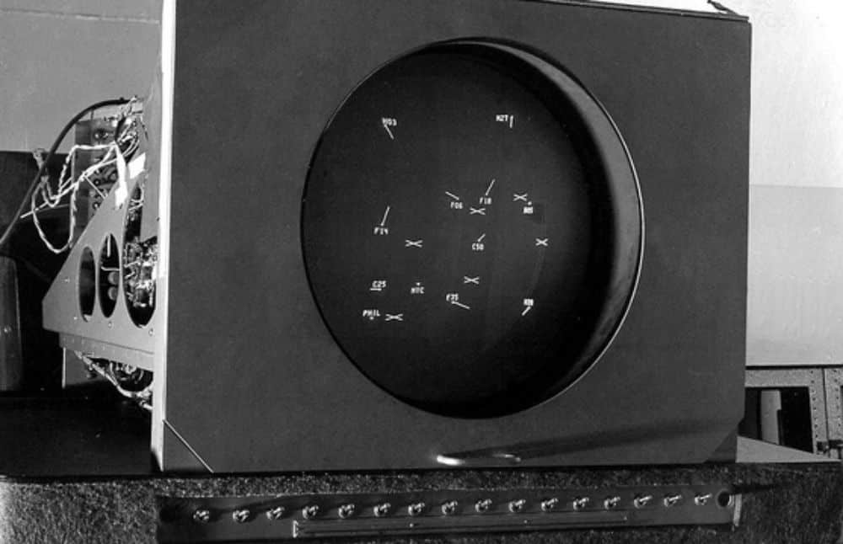
To start off we have to talk about why the word ‘’Video’’ which is stated before the word ‘’game’’ is present. It`s because of the revolution of technology and how it had the capability to display visual information for the user. The earliest evidence of a video game in the 20th century dates back to a patent filed in 1947 by Thomas T Goldsmith fora Cathode ray tube amusement device using vector-drawn dots inspired by radar display technology. But the technology used to create it was not sufficient enough to create even more complex visual information like 3D, so the GPU came into existence for graphical purpose and overall performance. The base of today’s GPU’s was started in mid-70s, it was called video shifters and video address generators. They carried out information from central processor to the display. In 1981 company IBM started using monochrome and a colour display adapter (MDA/CDA) it was used to display video. At first, it was 80 columns by 25 lines of text characters or symbols. ISBX 275 Video Graphics Controller Multimodule Board, released by Intel in 1983, was the next revolutionary device.
ISBX 275 Video Graphics Controller Multimodule Board
Cathode ray tube
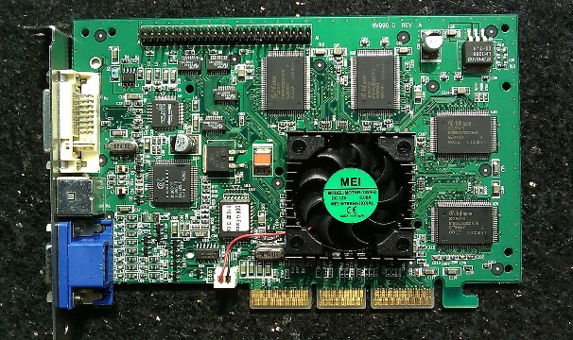
It was able to display eight colours at a resolution of 256x256 or monochrome at 512x512. Overall, the early 1990s was the time when a lot of graphics hardware companies were found, and then acquired or ousted out of business. Among the winners founded during this time was NVIDIA. The next revolution for GPU's where the introduction of the first 3D add-in cards in 1995, previously the industry was focused on 2D and non-PC architecture, and graphics cards were mostly known by alphanumeric names and huge price tags. Finally, the world’s first GPU’s came in 1999! This is how Nvidia promoted its GeForce 256. Nvidia defined the term graphics processing unit as a single-chip processor with integrated transform, lighting, triangle setup/clipping, and rendering engines that is capable of processing a minimum of 10 million polygons per second. Talking about more recent times the era of the general-purpose GPUs began in 2007 and had been packing up graphics cards with ever-more capabilities. The most impactful is the evolution from 3D to fourth dimension as virtual reality is about to transform experiences forever.
Nvidia GeForce 256

Discussion

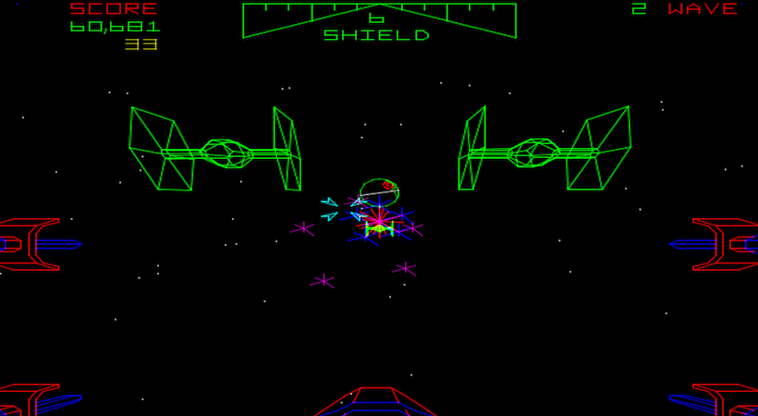
So as the GPU's evolved trough time so did games from early 2D games to now very popular 4D virtual reality. Even though the early games where created on 2d GPU's there were ways that developers could trick gamers into thinking they were viewing 3D graphics, but these still didn’t hold a candle to the graphics of today. Thinking back to the 3D vector graphics games, the best example is the 1983 Star Wars arcade game. While the game featured lines of different colours, there were no textures.
Star Wars arcade game
When games moved into the 16-bit era, things got even more exciting. Colour pallets were expanded, and sprites were able to show more detail than before.
Final fantasy
Later on, around early-to-mid 90’s the 32/64-bit era began, and the games companies turned to 3D graphics the most use of this got the game console, PlayStation, Sega, Nintendo. Games where graphics where in 3D and looked completely different from the old 2D games. That brings us to where we are today the graphics have leapt forward in great ways. Games are now HD and often run at higher frame rates than developers could dream of even two decades ago and it’s all because the GPU's kept evolving.
Witcher 3
The next step for game graphics and overall experience is the VR also known as Virtual reality 4D which breaks the boundaries of life and games.

Conclusions

Today, graphics processing units are not only for graphics. They have found their way into fields as diverse as machine learning, oil exploration, bitcoin mining, scientific image processing, statistics, linear algebra, 3D reconstruction, medical research and even stock options pricing determination. The GPU technology tends to add even more programmability and parallelism to a core architecture that is ever-evolving towards a general-purpose CPU-like core.

References

[1] “The Evolution of Video Game Graphics,” 18-Jan-2018.
[2] S. Inc, “The evolution of the graphics card,” The Spiceworks Community. [Online]. Available: https://community.spiceworks.com/topic/1060359-the-evolution-of-the-graphics-card. [Accessed: 02-May-2019].
[3] “History of GPUs | XOTIC PC.” [Online]. Available: https://www.xoticpc.com/history-of-gpus. [Accessed: 02-May-2019].
[4] “History of GPUs | XOTIC PC.” [Online]. Available: https://www.xoticpc.com/history-of-gpus. [Accessed: 02-May-2019].
[5] “https://www.si.edu/spotlight/the-father-of-the-video-game-the-ralph-baer-prototypes-and-electronic-games/video-game-history,” Smithsonian Institution. [Online]. Available: https://www.si.edu/spotlight/the-father-of-the-video-game-the-ralph-baer-prototypes-and-electronic-games/video-game-history. [Accessed: 02-May-2019].
[6] “GeForce 256,” Wikipedia. 21-Feb-2019.
[7] “History of the Modern Graphics Processor, Part 2,” TechSpot. [Online]. Available: https://www.techspot.com/article/653-history-of-the-gpu-part-2/. [Accessed: 02-May-2019].
[8] “History of the Modern Graphics Processor, Part 4,” TechSpot. [Online]. Available: https://www.techspot.com/article/659-history-of-the-gpu-part-4/. [Accessed: 02-May-2019].

