

Student Name: Rutavikaben Dave

Student ID: 2427109

Module Name: International marketing- Principles and Practices

Module Code: LCMB7026

Lecturer’s Name: Dr.Tushara Balendran

Submission Deadline: 19/12/2025

Word Count: 5000+

Table of Contents
1.Introduction 3
2.Company overview 3
3.The macro environment (PESTEL) of country of japan and country brazil 4
3.1 Political Factors 4
3.2 Economic Factors 4
3.3 Social Factors 5
3.4 Culture factors (Hofstede’s culture dimension) 5
Power distance 5
Individualism 6
Motivation towards achievement and success 6
Uncertainty Avoidance 6
Long term Orientation 6
Indulgence 6
3.5 Technological Factors 8
3.6 Legal Factors 8
3.7 Environmental Factors 8
4. STP 10
4.1 Segmentation 10
4.2 Demography 10
4.3 Geography 10
4.4 Psychographic AIOL model 11
4.5 Behavioural 12
4.6 Targeting 13
4.7 Positioning 14
5. Perceptual map 15
6.Coca-Cola: 7P Marketing Mix – Japan and Brazil 16
6.1 Product 16
6.2 Price 17
6.3 Place 18
6.4 Promotion 21
6.5 People 22
6.6 Process 24
6.7 Physical Evidence 25
7. Ethical and Unethical Marketing: Coca-Cola Analysis 28
8. Conclusion 32
References 33

1.Introduction
This document investigates Coca-Cola’s activities in Japan and Brazil, examining the ways the company tailors its approach to different cultural, economic, and social contexts (Kotler and Keller, 2016) Through the use of PESTLE analysis, (Johnson et al., 2017)STP and VALS segmentation, (Solomon, 2020),Hofstede’s cultural dimensions, (Hofstede, 2011), and the 7Ps of marketing, (Booms and Bitner, 1981) this report evaluates how Coca-Cola modifies its strategies to align with local tastes while upholding a robust global brand. (Coca-Cola Company, 2023) It emphasizes the equilibrium between standardisation and localisation, demonstrating how Coca-Cola secures a competitive edge by being culturally aware and responsive to market demands. (de Mooij, 2019).

2.Company overview

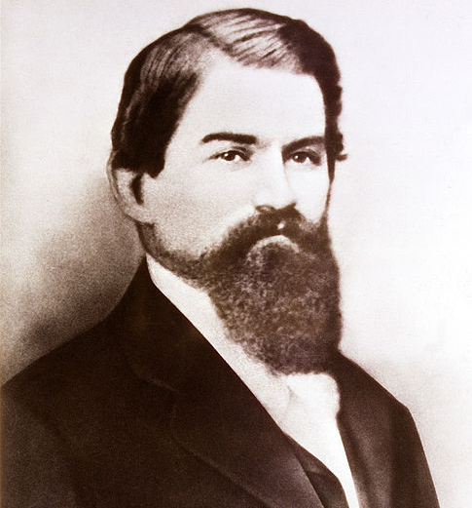
Figure 1https://www.coca-cola.com/in/en/about-us/history
The Coca-Cola Company is a global beverage enterprise based in Atlanta, Georgia, USA (Coca-Cola Company, 2023). It was established by Dr. John Stith Pemberton in 1886 when he developed the initial Coca-Cola syrup and later became incorporated by Asa Griggs Candler in 1892, who turned it into an international brand (Pendergrast, 2013). Currently, Coca-Cola operates in over 200 nations, providing a diverse array of non-alcoholic drinks, including soft drinks, juices, teas, coffees, and bottled water (Coca-Cola Company, 2023).

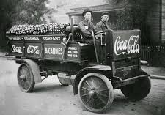
Figure 2https://www.linkedin.com/pulse/origin-coca-cola-sip-history-akram-ahmad-phd
The mission of the company is “to refresh the world and inspire moments of optimism and happiness through our brands and actions,”
vision is “to craft the brands and choice of drinks that people love, to refresh them in body and spirit, and to create a more sustainable business and better shared future that makes a difference in people’s lives, communities, and our planet(The Coca-Cola Company, 2023).
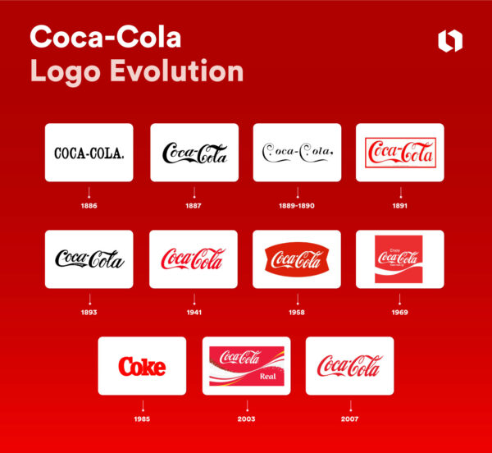

With its signature red-and-white branding, Coca-Cola remains one of the most identifiable and valuable brands worldwide, fueled by innovation, excellent marketing, and a dedication to sustainability and community welfare.

Figure 3https://looka.com/blog/coca-cola-logo/

Figure 4https://looka.com/blog/coca-cola-logo/

3.The macro environment (PESTEL) of country of japan and country brazil

PESTEL analysis is a strategic tool utilized to assess six external macro-environmental elements Political, Economic, Sociological, Technological, Environmental, and Legal that can influence an organization. It assists companies in comprehending their external environment to make better strategic choices, recognize possible threats and opportunities, and enhance their business model.
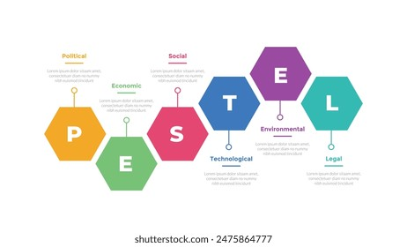
Figure 5https://www.shutterstock.com/search/pestle-diagram?dd_referrer=https%3A%2F%2Fwww.google.com%2F

3.1 Political Factors

Japan – Favourable:
Japan maintains a very stable political atmosphere, characterized by dependable business legislation and clear regulations that enable Coca-Cola to function effectively. The government's robust commitment to sustainability resonates with Coca-Cola's environmentally friendly initiatives; for instance, its "I LOHAS" brand utilizes lightweight, recyclable PET bottles that align with Japan's environmental objectives (The Coca-Cola Company, 2023).
Brazil – Moderately Unfavourable:
Brazil undergoes political changes and periodic adjustments in policy that may influence import tariffs, labor expenses, and taxation. However, the government actively encourages foreign investment and aids manufacturing through programs that have benefited Coca-Cola’s bottling associates (Reuters, 2022).
For instance, Coca-Cola FEMSA made significant investments in local production facilities in São Paulo and Minas Gerais to bolster supply amid political fluctuations (Coca-Cola FEMSA, 2023).

3.2 Economic Factors
Japan Neutral to Unfavourable:
Japan’s economy is well-established, characterized by slow GDP growth and an aging demographic, which constrains beverage consumption. However, Coca-Cola has leveraged Japan’s substantial purchasing power by introducing premium functional drinks, including Coca-Cola Plus, a fiber beverage certified as FOSHU (The Coca-Cola Company, 2018).
Brazil – Favourable:
Brazil’s expanding middle class and young demographic offer Coca-Cola a significant market for budget-friendly beverages. In 2021, Coca-Cola made investments in reusable glass bottles and refillable PET packaging to address inflation and the need for economical products among consumers (Coca-Cola Brazil, 2021).
Country | GDP (nominal) | GNP
Japan | US $4.03 trillion in 2024(2024, IMF estimate). | GNP US $4.90 trillion in 2023.
Brazil | US $2.18 trillion in 2024(2024, World Bank data). | GNP US $509 billion (USD) for Q4 2024.

3.3 Social Factors

Japan – Favourable:
Japanese consumers prioritize quality, innovation, and health, leading Coca-Cola to develop localized, low-calorie drinks and region-specific flavors like Sakura-flavored Coke and Ayataka green tea (Coca-Cola Japan, 2022). Seasonal packaging also showcases Japan’s appreciation for aesthetics and tradition.
Brazil – Favourable:
Brazilian social culture revolves around festivals, football, and shared celebrations. Coca-Cola capitalizes on these occasions for emotional marketing by sponsoring events like the FIFA World Cup and Carnival, utilizing campaigns such as “Juntos somos mais” (“Together We’re More”) to enhance brand loyalty (Coca-Cola Brazil, 2022).

3.4 Culture factors (Hofstede’s culture dimension)
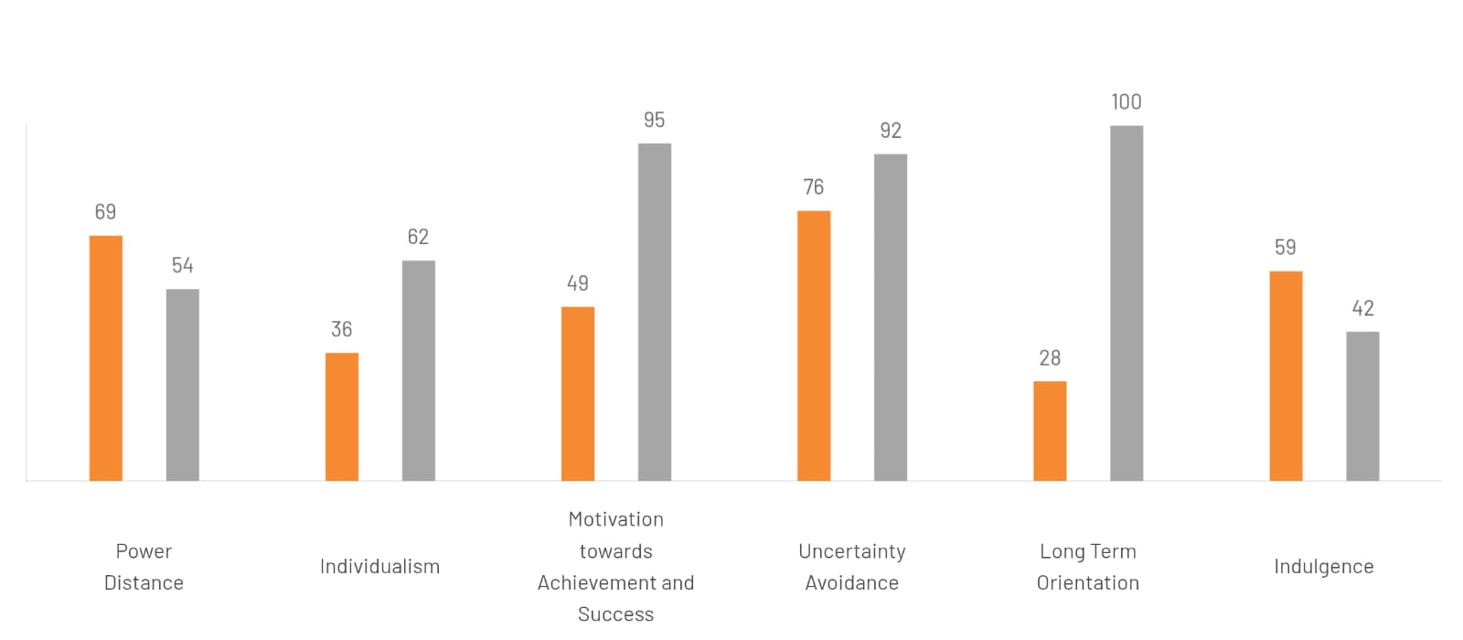

Power distance

Brazil’s high power distance (score of 69) means hierarchy and inequality are accepted as normal. People respect authority and elders, and social status is shown through visible symbols of power. In workplaces, the boss holds full responsibility and decision-making power. Moderately favorable.
Japan’s moderate power distance (score of 54) reflects a balance between hierarchy and equality. While people respect rank and follow formal decision-making processes, authority is shared and based on consensus. Japan values meritocracy anyone can succeed through hard work rather than just status or position. Neutral to favorable.

Individualism

Brazil’s low individualism score (36) shows it is a collectivist society where family and close relationships are central. Loyalty and trust are highly valued, both personally and professionally. In business, relationships come before tasks, and communication is warm, personal, and rich in context. Favorable
Japan’s individualism score of 62 reflects a moderately individualistic society. People prioritize personal choice and responsibility, show loyalty to their chosen companies rather than extended family, and maintain privacy and reserved behavior. Family ties are narrower, and in-groups are situational rather than lifelong. Neutral

Motivation towards achievement and success

Brazil’s intermediate score of 49 on achievement motivation indicates a balanced cultural approach: people neither strongly prioritize personal success and competition nor entirely de-emphasize it, showing a moderate focus on achievement. Neutral
Japan’s very high masculinity score (95) shows a decisive, achievement-oriented society. Competition is strong, especially between groups, and excellence, perfection, and hard work are highly valued. This drive shapes work culture, product quality, and social behavior, though it also contributes to long working hours and limited career advancement for women. Favorable

Uncertainty Avoidance

Brazil’s high uncertainty avoidance score (76) reflects a society that relies heavily on rules, laws, and bureaucracy to reduce uncertainty. People seek security and structure, but also value relaxation, socializing, and expressive, passionate interactions. Moderately favorable
Japan’s extremely high uncertainty avoidance score (92) reflects a society that seeks predictability and structure in all aspects of life. From strict rituals and detailed etiquette to careful planning in business, Japanese people prepare extensively to minimize risk and ensure stability, making change slow and deliberate. Neutral to unfavorable

Long term Orientation

Brazil’s low long-term orientation score (28) reflects a normative culture that values tradition, seeks quick results, and focuses less on long-term planning or saving for the future. Neutral
Japan’s maximum long-term orientation score (100) reflects a society focused on perseverance, long-term planning, and sustainable growth. Life and business are guided by virtues, practical examples, and investments in the future, prioritizing lasting value over short-term gains. Favorable

Indulgence

Brazil’s high indulgence score (59) reflects a society that values enjoyment, optimism, leisure, and personal freedom, with people freely pursuing desires and pleasures. Favorable
Japan’s low indulgence score (42) reflects a restrained culture where people control desires, show less emphasis on leisure, and feel that indulging themselves is limited or socially inappropriate, often leading to a more cautious and disciplined lifestyle. Neutral to unfavourable
- Advantages of the Hofstede Cultural Dimensions Model
Cross-cultural awareness:
Helps individuals and organizations understand cultural differences, improving communication and reducing misunderstandings in international contexts (Hofstede, Hofstede and Minkov, 2010).
Framework for comparison:
Provides a structured and systematic method for comparing national cultures using measurable dimensions (Hofstede, 2001).
Business application:
Widely used by multinational companies in management, marketing, negotiation strategies, and human resource practices (Minkov and Hofstede, 2011).
Research-based foundation:
Developed from extensive empirical research, notably the IBM study involving thousands of employees across multiple countries, enhancing its reliability and credibility (Hofstede, 1980).
Predictive insights:
Assists in anticipating cultural behaviors related to leadership styles, decision-making processes, and workplace expectations (Hofstede et al., 2010).
Educational tool:
Commonly applied in academic and training settings to teach cultural differences and international business practices (Brewster, Sparrow and Vernon, 2016).

- Disadvantages of the Hofstede Cultural Dimensions Model
Overgeneralization:
Assumes cultural homogeneity at the national level, ignoring individual, regional, and subcultural differences (McSweeney, 2002).
Static perspective:
Treats culture as relatively fixed, failing to adequately reflect cultural change over time (Fang, 2003).
Limited contextual scope:
Focuses primarily on organizational and workplace behavior, overlooking broader social, political, and historical factors (Holden, 2002).
Potential stereotyping:
Rigid application of the model may reinforce cultural stereotypes and overlook exceptions (McSweeney, 2002).
Methodological bias:
Based on data collected from IBM employees during the 1960s–1970s, which may not represent wider populations or modern global contexts (Hofstede, 1980).
Oversimplification of culture:
Reduces complex cultural characteristics to numerical scores, potentially leading to an overly simplistic interpretation of human behavior (Fang, 2003).

3.5 Technological Factors

Japan – Highly Favourable:
The advanced technological landscape in Japan enables Coca-Cola to implement AI-driven vending machines, utilize data analytics, and offer the Coke ON app, which links digital rewards with in-person purchases (The Coca-Cola Company, 2021). These advancements improve customer convenience and enhance engagement.
Brazil – Moderately Favourable:
Brazil's expanding social-media environment benefits Coca-Cola's promotional efforts. Initiatives like “Coca-Cola FanFeat,” which enabled fans to cast votes online for music collaborations, effectively utilized mobile and social platforms (Fernanda Sousa, 2020). Nevertheless, the infrastructure and logistics technology in Brazil are not as advanced as those in Japan.

3.6 Legal Factors

Japan – Favourable:
Japan has rigorous yet clear food and beverage regulations. Coca-Cola takes advantage of consistent safety and labeling laws, fostering trust among consumers. Adhering to FOSHU health standards for products like Coca-Cola Plus enables the company to reach health-aware customers (FOSHU Council, 2020).
Brazil – Mixed:
Brazil’s intricate tax framework and administrative regulations can hinder operations. Nevertheless, Coca-Cola’s longstanding adherence to environmental and labor laws enhances its reputation. Legal demands for sugar reduction have prompted the company to broaden its range of low- and no-sugar products (Euromonitor, 2023).

3.7 Environmental Factors

Japan – Favourable:
Coca-Cola connects with Japan’s environmentally conscious consumer culture through its "World Without Waste" initiative, which has set a goal of achieving 100% recyclable packaging by 2030 (The Coca-Cola Company, 2023). Offerings like the I LOHAS bottles, created with less plastic, attract eco-friendly consumers.
Brazil – Moderately Favourable:
In Brazil – Moderately Favourable: Environmental challenges such as deforestation and water shortages present risks, but Coca-Cola has initiated significant water replenishment projects and systems for returnable bottles to minimize waste. In 2020, the company managed to reuse over 45% of its bottles within Brazil’s local supply chain (Coca-Cola Brazil, 2020).
- Similarities Between Japan and Brazil
Both countries promote sustainability initiatives and encourage domestic and foreign investment (OECD, 2023; World Bank, 2022).
Japan and Brazil show strong consumer demand for non-alcoholic beverages, driven by health awareness and lifestyle changes (Euromonitor International, 2023).
Brands in both markets focus on building emotional connections with consumers to strengthen loyalty (Kotler and Keller, 2022).
Digital tools are widely used in both regions to foster customer engagement and relationship management (Statista, 2023).
Both nations enforce strict labeling requirements and consumer protection regulations to ensure transparency and consumer safety (OECD, 2023).
Sustainable practices such as recycling and environmental responsibility are promoted in both markets (World Bank, 2022).
- Differences Between Japan and Brazil
Political environment
Japan benefits from political stability, enabling long-term planning and consistent business strategies (OECD, 2023).
Brazil’s evolving political and regulatory environment can introduce uncertainty for investors (World Bank, 2022).
Market growth potential
Japan is a mature market with limited growth opportunities.
Brazil offers strong expansion potential due to a growing population and rising consumption levels (Euromonitor International, 2023).
Economic risks
Japan experiences low inflation and currency stability.
Brazil faces higher risks related to inflation and currency volatility (IMF, 2023).
Brand communication and culture
Japanese branding emphasizes innovation, wellness, and product functionality.
Brazilian branding focuses on togetherness, music, sports, and social connection (Kotler and Keller, 2022).
Digital engagement strategies
Japan excels in automation, robotics, and vending machine technology.
Brazil leverages high social-media usage and interactive digital platforms to engage consumers (Statista, 2023).
Legal and administrative processes
Japan’s regulatory and approval processes are efficient and predictable.
Brazil’s administrative procedures can be complex and time-consuming (OECD, 2023).
Sustainability priorities
Japan prioritizes packaging innovation and waste reduction.
Brazil focuses more on water conservation and circular reuse initiatives (World Bank, 2022).

4. STP

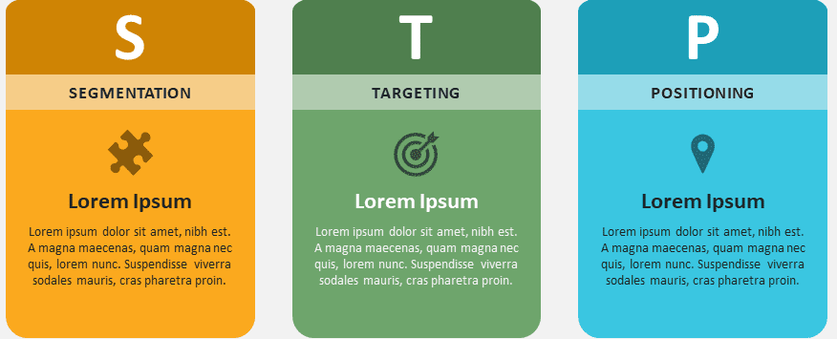
Figure 6 https://www.presentationgo.com/presentation/stp-marketing-model-template-powerpoint-google-slides/

4.1 Segmentation

4.2 Demography

Demographic Factor | Japan | Brazil
Age | 13–50 (teenagers, young adults, adults) | 13–50 (teenagers, young adults, families)
Gender | Male & Female; slightly higher consumption among males for functional drinks | Male & Female; fairly balanced consumption
Race/Ethnicity | Predominantly Japanese | Mixed-race (Pardo), Afro-Brazilian, White, Indigenous
Marital Status | Single & married adults | Single, married, families with children
Income | Middle to upper-middle income | Middle-income majority
Education | High school to university graduates | High school to university graduates
Occupation | Students, office workers, professionals | Students, working adults, homemakers
Table 1Adapted from World Bank (2023); Statista (2023); Euromonitor International (2023).

4.3 Geography

- Japan
Urban areas (Tokyo, Osaka, Yokohama): A high concentration of convenience stores and vending machines provides frequent access to Coca-Cola products. Seasonal and region-specific promotions, like Sakura Cherry Blossom Coke or limited-time flavors, capture attention and enhance sales (Coca-Cola Company, 2023; Pendergrast, 2013).

Suburban regions (smaller cities/towns): Availability is average, primarily through local supermarkets and retail shops. Products are typically offered in 500 ml bottles, catering to the needs of individuals or small households(Euromonitor, 2022).

Rural areas (countryside): Coca-Cola is less readily available, mainly found in supermarkets, with limited promotional activities. Standard 1.5 L bottles are common for family consumption, reflecting a lower frequency of consumption and marketing efforts (Coca-Cola Company, 2023).

- Brazil
Urban regions (São Paulo, Rio de Janeiro, Brasília): Extensive availability in supermarkets and convenience stores, coupled with high visibility through advertising and events. For instance, the “Share a Coke” campaign featuring personalized names and Coca-Cola partnerships during Carnival or FIFA events effectively targets urban consumers (Coca-Cola Brazil, 2022).

Suburban areas: Moderate availability in local shops; larger bottles, such as 2 L, are sold to accommodate family consumption and group meals (Euromonitor, 2022).

Rural regions: Limited product access, focusing on 2–3 L bottles for home gatherings. Advertising is sparse and straightforward, emphasizing practical everyday use rather than promotional activities (Euromonitor, 2022).

4.4 Psychographic AIOL model

Table 2Euromonitor International (2023) Consumer Lifestyles and Beverage Consumption in Japan and Brazil. London: Euromonitor International.
Hofstede, G. (2001) Culture’s Consequences: Comparing Values, Behaviors, Institutions and Organizations Across Nations. 2nd edn. Thousand Oaks, CA: Sage.
Hofstede, G., Hofstede, G.J. and Minkov, M. (2010) Cultures and Organizations: Software of the Mind. 3rd edn. New York: McGraw-Hill.
Kotler, P. and Keller, K.L. (2022) Marketing Management. 16th edn. Harlow: Pearson Education.

AIO-L Dimension | Japan | Brazil | Example
Activities | Trend-followers, tech-savvy, enjoy shopping and dining out; frequent convenience stores and vending machine purchases | Socializing with friends/family, attending festivals, watching football, going to parties | Japan: Buying limited-edition seasonal flavors at convenience stores Brazil: Sharing Coca-Cola during Carnival or football match gatherings
Interests | Health-conscious individuals interested in functional beverages; enjoy seasonal novelty and digital experiences | Enjoy fun, entertainment, sports, music, cultural events, and social experiences | Japan: Coca-Cola Plus for health benefits; personalized bottles with QR codes for digital interaction Brazil: Limited-edition Coke cans themed for Carnival or football teams
Opinions | Value innovation, convenience, and quality; prefer brands that adapt to trends | Value social connection, family bonding, cultural pride, and celebration; prefer brands that reflect joy and togetherness | Japan: Positive perception of functional beverages like Coca-Cola Plus; excited about seasonal flavors Brazil: Coca-Cola associated with happiness, social connection, and festive events
Lifestyle | Urban, modern, busy lifestyle; frequent consumers on-the-go; enjoy novelty products | Outgoing, social, family-oriented, festive lifestyle; enjoy beverages during gatherings and meals | Japan: Young professionals buying Coke in vending machines during work breaks Brazil: Families and friends drinking Coca-Cola during social events, parties, or meals

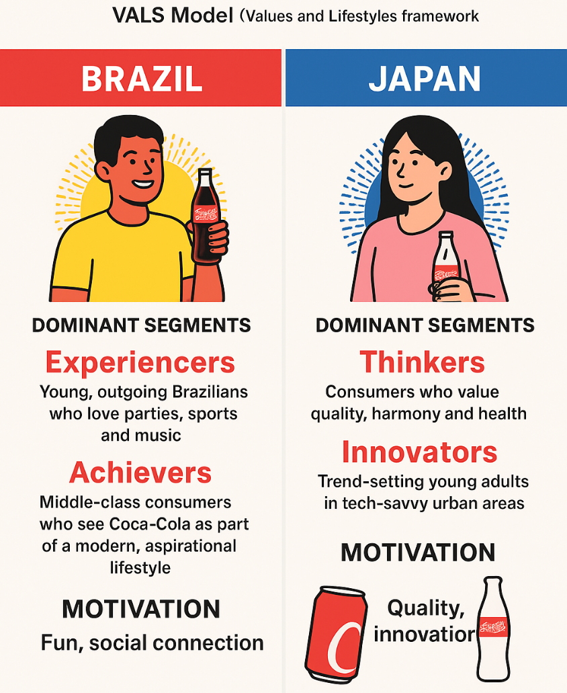
- Life Style Notes
Figure 7created by my self in canva
In Brazil, individuals engage in social lifestyles that emphasize family, friends, and celebrations. Coca-Cola seamlessly integrates into this culture of enjoyment, warmth, and connection, frequently enjoyed at meals, gatherings, and sporting events (de Mooij, 2019; Coca-Cola Brazil, 2022). Brazilians prioritize emotionally resonant brands and are responsive to marketing that highlights joy, music, and togetherness (Kotler and Keller, 2016).

In Japan, lifestyles are characterized by structure, harmony, and a focus on innovation. Consumers value quality, aesthetics, and convenience, often selecting Coca-Cola products from vending machines or incorporating them into their modern, fast-paced routines (de Mooij, 2019; Euromonitor, 2022). The brand resonates through limited editions, health-conscious choices, and a sleek aesthetic, aligning with Japan's emphasis on quality and contemporary living (Coca-Cola Company, 2023).

4.5 Behavioural

Behavioral Factor | Japan | Brazil | Example
Benefits Sought | Refreshment, functional benefits (e.g., fiber-enriched drinks), enjoyment of limited-edition flavors | Refreshment, happiness, social enjoyment, sharing with family and friends | Japan: Coca-Cola Plus for health-conscious adults; seasonal flavors like Melon or Sakura Cherry Blossom Coke Brazil: Sharing Coca-Cola during Carnival or football matches to enhance social enjoyment
Usage Rate | Frequent consumers of ready-to-drink beverages; often daily from vending machines or convenience stores | Heavy users, especially during meals, parties, and social gatherings | Japan: Office workers buying Coke during lunch breaks or commuting Brazil: Families buying 2L bottles for weekend gatherings
Brand Loyalty | Moderate loyalty; consumers often try limited-edition or new products | High loyalty; Coca-Cola is the preferred soft drink for social and family occasions | Japan: Trying seasonal flavors or Coca-Cola Plus alongside regular Coke Brazil: Preferring Coca-Cola over other brands during parties and family meals
Purchase Occasion / Usage Situations | Daily refreshment, office breaks, convenience store purchases, seasonal events | Social gatherings, meals, festivals, sports events, holidays | Japan: Sakura Cherry Blossom Coke sold during spring season Brazil: Coca-Cola cans with football team branding during World Cup matches

4.6 Targeting

1. Concentrated Strategy
Definition: Directing marketing efforts towards a single specific segment or market niche(Kotler and Keller, 2016).
Brazil: During major events such as Carnaval or the FIFA World Cup, Coca-Cola focuses on the youth and sports enthusiasts, making substantial investments in sponsorships and festival promotions(Coca-Cola Brazil, 2022).
Japan: Coca-Cola zeroes in on office workers via its Georgia Coffee brand a targeted strategy aimed at a specific lifestyle group (busy, on-the-go professionals) (Coca-Cola Company, 2023).

2. Niche Strategy
Definition: Catering to very small, specialized markets that have distinct needs(Kotler and Keller, 2016).
Brazil: Coca-Cola has limited niche targeting but occasionally introduces local limited-edition flavors or packaging that reflect regional culture (e.g., Amazon-themed editions) (Coca-Cola Brazil, 2022).
Japan: Coca-Cola excels in niche marketing with seasonal offerings like Sakura Coke (cherry blossom flavor) or clear Coca-Cola, targeting collectors and trendsetters(Euromonitor, 2022).

4.7 Positioning

- Benefit Positioning
Benefit positioning highlights the advantages a consumer receives from a product, both in practical terms and emotionally (Kotler and Keller, 2016).

Brazil:
In Brazil, Coca-Cola is regarded as a representation of joy and social interaction. It is commonly enjoyed during celebrations, family events, and football matches. The brand emphasizes emotional happiness and a spirit of festivity (Coca-Cola Brazil, 2022; de Mooij, 2019).
Practical benefit: refreshment, which is particularly essential in Brazil’s warm climate.
Example: Coca-Cola’s “Open Happiness” campaigns in Brazil feature friends and family sharing a Coke at Carnival or a football game, linking the product to joyful moments.

Japan:
In Japan, Coca-Cola focuses on refreshment tailored to a hectic, urban lifestyle.
Practical/health-oriented benefit: Japanese consumers are mindful of sugar and calorie intake, so Coca-Cola promotes low-calorie or functional drinks, such as Coca-Cola Zero Sugar and Coca-Cola Plus (which contains added dietary fiber) (Euromonitor, 2022).
Emotional/lifestyle benefit: Coca-Cola connects with contemporary trends and seasonal pleasures (for instance, a limited-edition cherry blossom flavor in spring) (Coca-Cola Company, 2023).

- Product Positioning
This pertains to how the product is presented to consumers (Kotler and Keller, 2016).
Brazil:
Classic Coca-Cola: The original, invigorating cola for social gatherings.

Variants: Coca-Cola Zero (targeting calorie-conscious individuals), distinctive flavors (such as Guaraná mix) to cater to local preferences (Coca-Cola Brazil, 2022).

Japan:
Classic Coca-Cola: A premium, refreshing drink suitable for all age groups.
Variants: Diet Coke, Coke Zero, seasonal flavors like cherry blossom or citrus, and Coca-Cola Plus for added health features.
Product positioning in Japan frequently highlights innovation, novelty, and functional advantages, in contrast to the more emotional positioning seen in Brazil (Euromonitor, 2022; de Mooij, 2019).

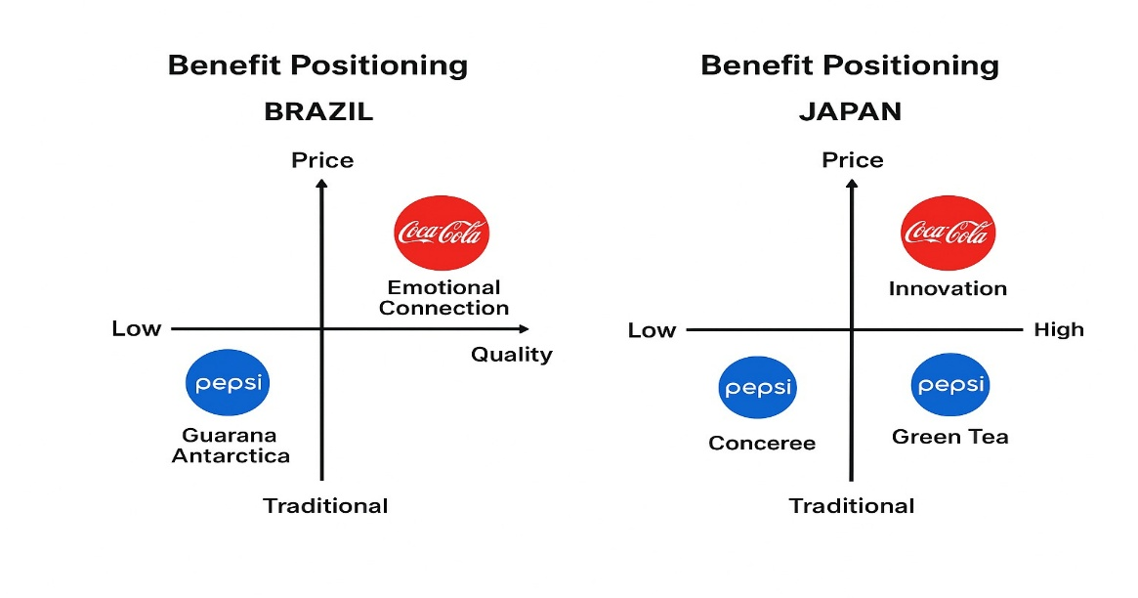
Figure 8created by my self in canva

5. Perceptual map

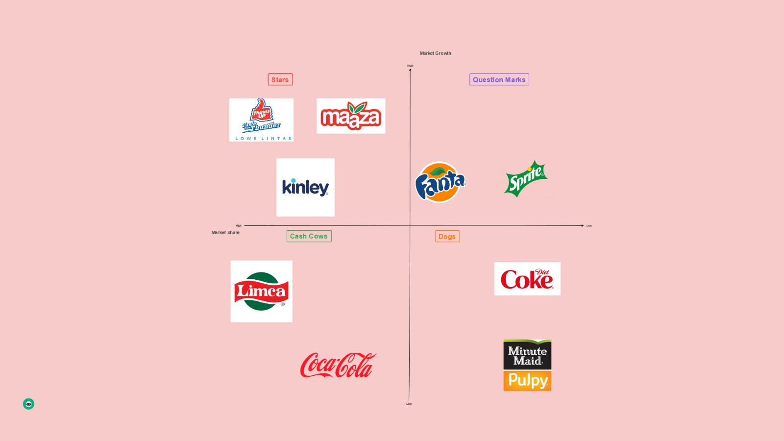
1. Definition of a Perceptual Map
A perceptual map, often referred to as a positioning map, is a graphical tool utilized in marketing to illustrate how consumers view various brands or products in comparison to one another. It generally employs two axes, such as market growth and market share (like in your illustration), to assist businesses in comprehending their market standing and competitive environment(Kotler and Keller, 2016; Solomon, 2020).
Figure 9https://boardmix.com/examples/brand-perceptual-map-examples/

2. Coca-Cola’s Placement on the Map
In the accompanying image (which utilizes the BCG Matrix concept):
Coca-Cola is located in the “Cash Cow” section.
This indicates that Coca-Cola holds a significant market share while functioning in an industry with low growth potential (Kotler and Keller, 2016; Johnson et al., 2017).
Implication:
Coca-Cola produces considerable and consistent revenue(Coca-Cola Company, 2023).
The brand leads in established markets(Euromonitor, 2022).
The emphasis is on preserving market share and optimizing profitability instead of pursuing aggressive growth(Kotler and Keller, 2016).

6.Coca-Cola: 7P Marketing Mix – Japan and Brazil

6.1 Product
- Japan
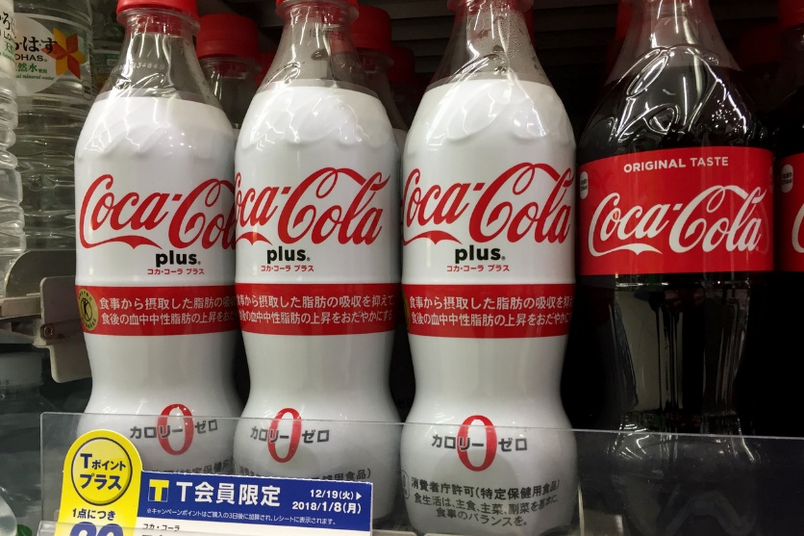
Coca-Cola not only provides its traditional cola beverage but also a diverse selection of drinks tailored to local preferences a perfect example being the “Georgia” canned coffee range, which originated in Japan.
Additionally, Japan features unique variations: for instance, “Coca-Cola Plus” (or “Coca-Cola Fiber+”), which includes added dietary fibwer and has received FOSHU functional beverage approval in the country.
When it comes to variety, Coca-Cola offers numerous packaging sizes (cans, bottles, vending formats) and flavors, including limited editions. A notable example is Japan's “Coca-Cola Clear,” a transparent variant of the classic drink.
Figure 10https://www.wsj.com/articles/things-go-better-with-coke-laxative-edition-1515354223

- Branding strategy, Coca-Cola upholds a global brand identity (logo, red color, “Open Happiness,” etc.) while making local adjustments. Research indicates that Coca-Cola employs an “Adapt-Stand” approach, balancing global standardization with local customization in its global strategy.

In japan,the company focuses on premiumization (higher price points, smaller sizes) as the market is well-established and consumers anticipate innovation.
example, in Japan, Coca-Cola's products are available in nearly a million vending machines and are supported by extensive consumer insights.

- Brazil

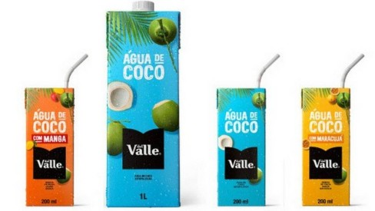
The beverage market is extensive and growing; CocaCola presents a diverse range of products, including soft drinks, juices, waters, sports drinks, and teas.
Figure 11https://extra.globo.com/economia-e-financas/coca-cola-entra-no-mercado-de-agua-de-coco-no-brasil-23088785.html
For example: “In Brazil, the company operates across nine segments refrigerantes (soft drinks), sucos (juices), lácteos (dairy), bebidas vegetais (plant-based drinks), água, águas especiais, água de coco, bebidas esportivas, and chás – featuring over 200 products.”

Branding approach: While the global Coca-Cola brand is prominent, there is significant local adaptation: flavors tailored to local tastes, packaging sizes suited to the region, and affordable options, along with localized marketing campaigns. They also function through a franchise/bottler model, which allows adjustments to local market dynamics.
Depth: there are numerous flavor variations, options without sugar, and regional packaging sizes (such as 2 liters, 1.25 liters, and smaller bottles). Given that Brazil represents a large market, having a wide variety is crucial.
Width:
The product line in Brazil spans multiple beverage categories, including carbonated drinks, juices, bottled water, and sports drinks, catering to diverse consumer preferences and occasions in a large, varied market (Kotler and Keller, 2022; Euromonitor International, 2023).

6.2 Price

The pricing aspect involves the strategies and tactics utilized to determine the monetary value of the product, taking into account consumer perception, costs, competition, and market conditions (Kotler & Keller, 2016).

• Japan

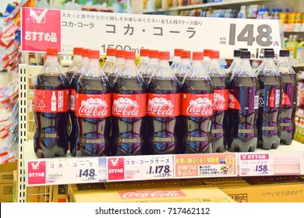
CocaCola's bottler, Coca-Cola Bottlers Japan Holdings Inc. (CCBJH), has adopted both premium and value-oriented pricing strategies.
The company announced a price adjustment effective from October 1, 2025: suggested retail prices will increase by +4.8% to +23.0% (for instance +¥20 – ¥30) across various product categories, attributing this to rising costs of raw materials and energy.
Alongside inflation-driven hikes, CCBJH employs differential pricing based on distribution channels: for instance, items sold through vending machines and convenience stores might be priced higher than those in retail supermarkets, leveraging strong brand recognition and convenience.
Figure 12https://www.shutterstock.com/image-photo/okinawa-japan-july-22-2017-coca-717462112
As a result, their pricing strategy is based on value and aims to protect margins in a mature market: the focus is on profitability rather than solely on volume growth.
Strategy type: Premium/Value mix they establish prices above costs, capitalizing on brand strength and convenient channels while addressing price sensitivity through smaller package sizes or channel differentiation.
• Brazil
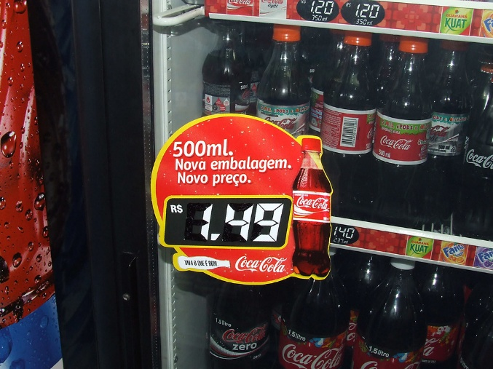
CocaCola's pricing strategy is influenced by inflation, changes in pack sizes, and competition from more affordable local brands.
During the Brazilian market period from January 2021 to June 2022, the unit price per liter for CocaCola rose by approximately 22% for certain single-serve SKUs (such as the 220 ml pack) in response to inflationary pressures on input costs.
CocaCola also implements a “price ladder” strategy, which involves offering various pack sizes and price ranges to keep products accessible for budget-conscious consumers while still maintaining profit margins.
- Strategy type: Value/penetration mix The brand ensures that lower-priced, smaller packages remain available for affordability, while managing cost increases through price adjustments where feasible, ensuring widespread market presence.
Figure 13https://www.flickr.com/photos/roitberg/517930065

6.3 Place

The place element pertains to the distribution of a product and its availability to consumers, encompassing both direct and indirect channels, logistics, and market entry strategies (Kotler & Keller, 2016).

• Japan

CocaCola primarily relies on an indirect distribution model while also incorporating some direct to consumer avenues.
Products are supplied through bottlers to convenience stores, supermarkets, vending machines (approximately 1.2 million units nationwide), restaurants, and cafes.
CocaCola additionally utilizes online and app based ordering via the Coke ON app to engage directly with consumers. 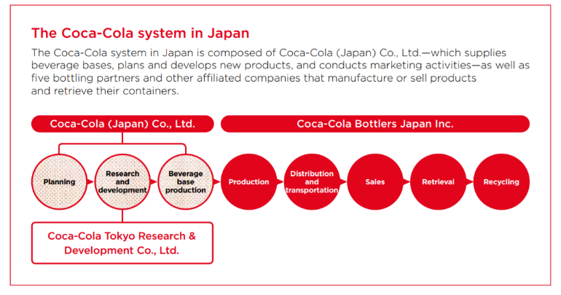
Figure 14https://en.ccbji.co.jp/corporate/activity/

- Market entry approach: Japan’s distribution network was established through licensing agreements and partnerships with bottlers, rather than through operations owned directly by the company.
- Market entry strategy: Acquisitions of existing bottlers along with partnerships with local distributors enabled rapid penetration into the market.

- Rationale: This indirect approach facilitates extensive coverage in a densely populated market characterized by high retail and vending density, while delegating operational complexities to skilled bottlers.
- Rationale: Entering through acquisitions provides immediate access to well-established production and distribution networks and local expertise.

- Advantages
Broad geographic coverage, reaching urban and rural consumers effectively.
Access to local market knowledge and insights from experienced bottlers.
Cost-efficient logistics and reduced operational burden on Coca-Cola corporate.
Rapid scale-up through acquisitions of existing bottlers.
Flexibility to adjust product offerings to regional preferences.
Enables focus on brand-building, marketing, and innovation rather than day-to-day operations.
Direct-to-consumer channels (Coke ON app) allow engagement and data collection for targeted marketing (Coca-Cola Company, 2023).
- Disadvantages
Reduced control over in-store execution, merchandising, and pricing.
Shared profit margins with bottlers and distributors.
Potentially slower market feedback and response times.
Risk of inconsistent service quality or brand experience across regions.
Dependency on bottlers’ operational efficiency and financial health.
Complexity in coordinating promotions, product launches, or seasonal campaigns across multiple partners.

• Brazil

Coca-Cola in Brazil adopts a hybrid distribution model that combines direct, indirect, and franchised bottler channels
Products are distributed through local bottlers, retail chains, small kiosks, supermarkets, and food service venues.
- Market entry strategy: Acquisitions of existing bottlers along with partnerships with local distributors enabled rapid penetration into the market.
- Rationale: Entering through acquisitions provides immediate access to well-established production and distribution networks and local expertise.
- Advantages: Instant presence in the market, quicker scaling opportunities, and access to local connections.
- Disadvantages: Higher investment costs, risks related to integration, and potential mismatches in culture or operations. 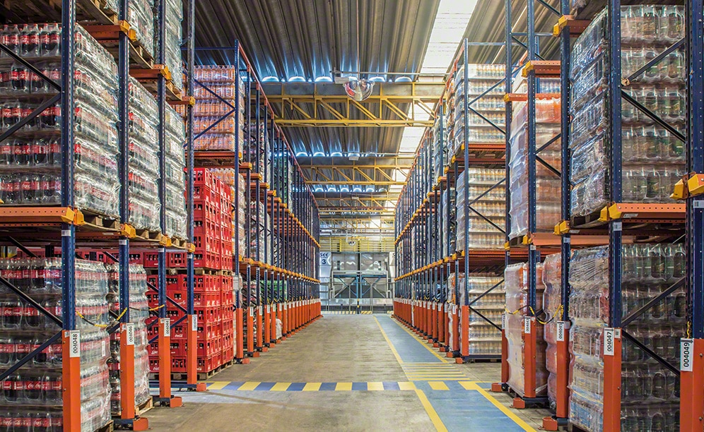
Figure 15https://www.mecalux.co.uk/case-studies/coca-cola-drinks-refrescos-bandeirantes-brazil

Example: In Japan, a vending machine in Tokyo (an indirect channel) permits consumers to purchase Coca-Cola directly, while in Brazil, a 2-liter bottle at a neighborhood grocery store may be part of a local bottler acquisition network.

6.4 Promotion

Promotion encompasses the communication tactics utilized to inform, convince, and engage consumers regarding a brand or product, which includes advertising, sales promotions, sponsorship activities, and experiential marketing (Kotler & Keller, 2016).

• Japan

CocaCola Japan focuses on integrated marketing communication (IMC), blending traditional media with experiential initiatives and digital engagement.
- Mass media: Television ads and print promotions spotlight the launch of new products (e.g., Coca-Cola Plus, Coca-Cola Clear).
- Experiential marketing: Campaigns featuring vending machines and the Coke ON app offer interactive interactions with consumers.
- Sponsorship: Partnerships with events such as seasonal festivals and sports activities.
- Chosen strategy: Mass media + experiential marketing
- Given Japan’s substantial media usage and extensive vending machine network, merging awareness (TV/print) with interactive elements enhances engagement and loyalty.
- Example: Coca-Cola Clear promotions that are time-limited, featuring unique vending machine packaging and rewards through the app. 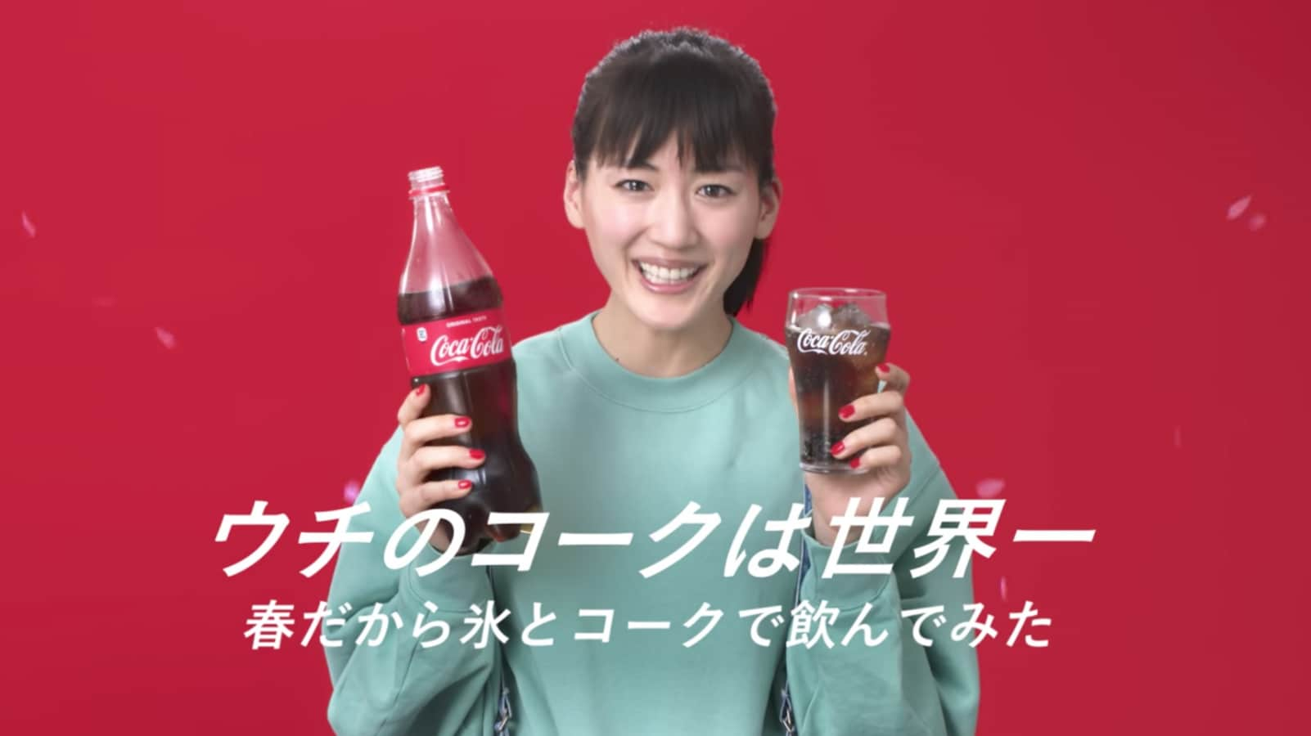
Figure 16https://allabout-japan.com/en/article/5305/

• Brazil

promotion emphasizes event driven marketing and cultural engagements alongside in store campaigns (Kotler and Keller, 2022; Euromonitor International, 2023).
- Event sponsorship: Engagement in significant football tournaments and music competitions, such as Coca-Cola Fan Feat, to connect with the youth audience.
- Point-of-sale: In-store promotions, discounts, and promotional displays to reach the mass-market retail sector.
- Outdoor advertising: Billboards and posters placed in urban areas to ensure brand visibility.
- Focusing on local cultural interests and high-traffic retail locations optimizes visibility and fosters emotional connections.

- Example: Sponsorship of football events paired with in-store promotions that provide free branded merchandise with Coca-Cola purchases. 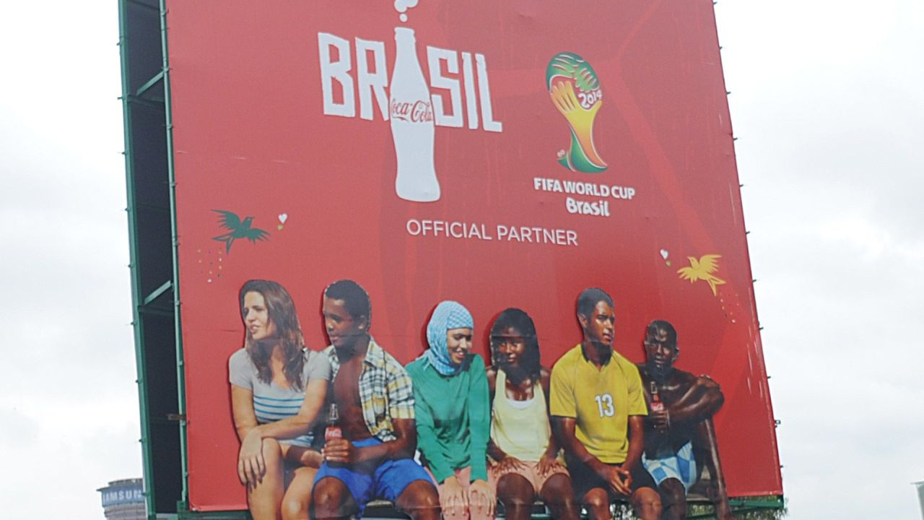
Figure 17https://edition.cnn.com/videos/business/2014/06/13/wbt-world-cup-sponsors-ceo-interbrand.cnn

6.5 People

The people aspect includes all individuals engaged in providing the product or service, such as employees, management, and customer service representatives, all of whom impact customer experience and satisfaction (Booms & Bitner, 1981; Kotler & Keller, 2016).

• Japan

As of December 2024, CocaCola Bottlers Japan Holdings Inc. has a workforce of 14,084 employees.
The staff comprises production workers, logistics personnel, marketing teams, and employees involved in vending machine operations.
Employee training focuses on maximizing efficiency, ensuring quality, and upholding customer service standards, especially in vending machine maintenance and partnerships with retailers. (Coca-Cola Company, 2024; Euromonitor International, 2023; Statista, 2023).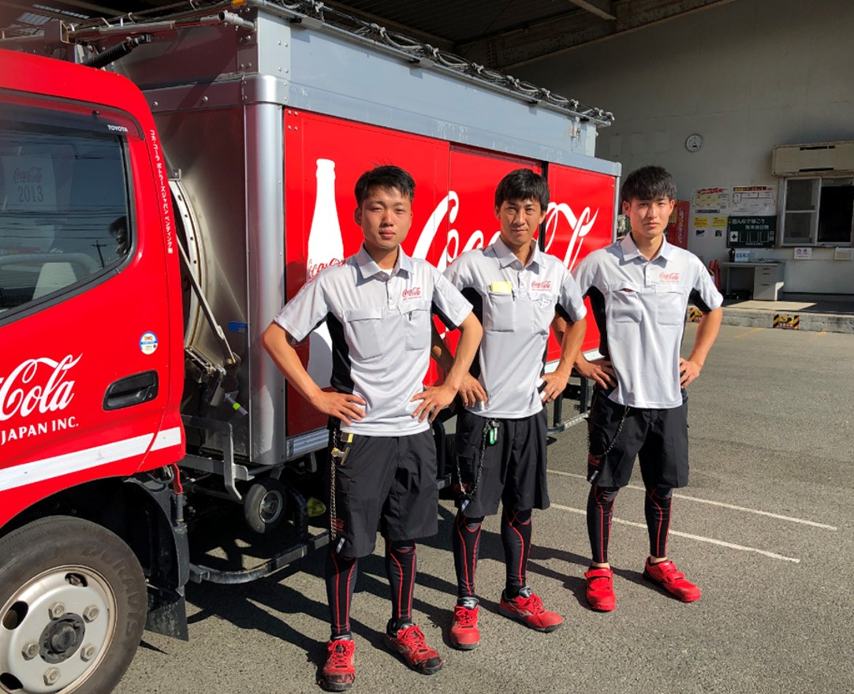
Source:Figure 18https://en.ccbji.co.jp/blog/summer-style-en/
Example: Well trained personnel make certain that vending machines are consistently stocked and in good working order, which helps maintain brand reliability and fosters consumer trust. 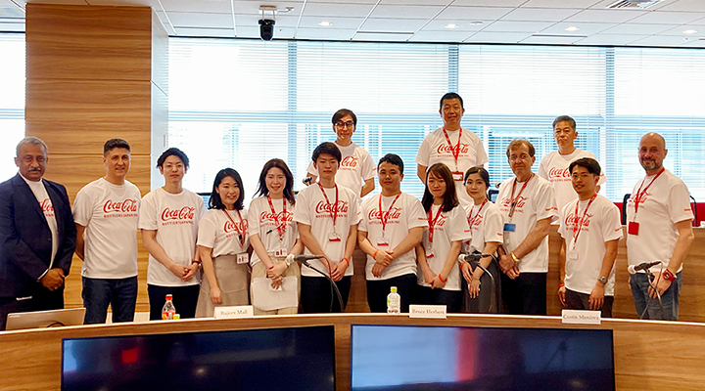
Figure 19https://en.ccbji.co.jp/blog/joined-the-company_2022-en/

• Brazil

Sistema Coca Cola Brasil has around 57,100 employees, which includes personnel involved in bottling and distribution networks.
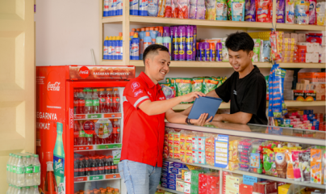
The workforce covers various roles in production, distribution, retail relations, sales, marketing, and customer service.
Figure 20https://www.cocacolaep.com/news-and-stories/meet-the-teams-field-sales/
Training emphasizes operational efficiency, responsiveness to market demands, and customer engagement within a culturally diverse environment.
Example: Local sales teams work together with neighborhood stores to enhance product placement and marketing efforts.

6.6 Process

The term "process" encompasses the procedures, systems, and sequence of actions involved in delivering a product to the consumer, including aspects such as ordering, logistics, and addressing complaints (Kotler & Keller, 2016).

• Japan

CocaCola Japan implements a well organized ordering and logistics framework through its bottler network:
Retail orders can be made through distributors or the Coke ON app for digital engagement.
The restocking of vending machines follows a planned logistics strategy to ensure that products are available in both urban and rural locations.
Customer complaints are addressed via dedicated service lines, feedback through the app, and call centers managed by bottlers.
Example: A customer can report a malfunctioning vending machine through the Coke ON app, which prompts a quick service response. 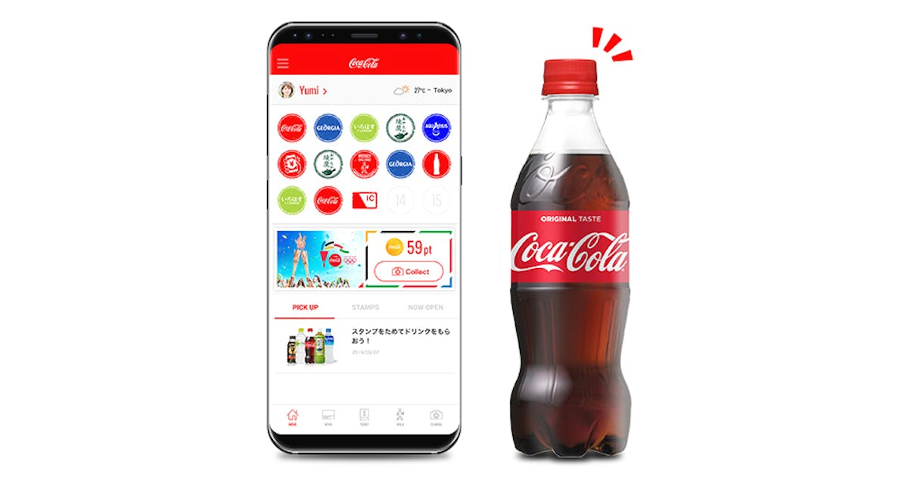
Figure 21https://www.vendingmarketwatch.com/technology/mobile-payment-systems/news/21231759/coke-on-app-in-japan-surpasses-28-million-downloads

• Brazil

Coca Cola Brazil functions through its franchise bottler and distributor network, ensuring a cohesive approach to ordering and logistics:
Retailers submit orders to local bottlers, who then organize deliveries to shops, kiosks, and restaurants.
Extensive logistics systems are in place to cover Brazil's large geographical expanse.
Customer complaints are locally resolved by bottlers through call centers or follow ups at the stores.
Example: A kiosk owner in São Paulo reaches out to a local bottler to arrange for delivery and report any product quality concerns, which are typically handled within 24–48 hours. 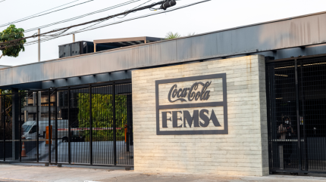
Figure 22https://www.just-drinks.com/news/coca-cola-femsa-invests-in-brazil-factory/

6.7 Physical Evidence

Physical evidence refers to the tangible elements of a product or service that help strengthen the brand, ensure quality, and influence consumer perceptions (Booms & Bitner, 1981; Kotler & Keller, 2016).

• Japan

Coca-Cola Japan employs creative packaging, advanced vending machines, and app integration to improve the physical experience:
- Packaging: Unique offerings such as Coca-Cola Clear or Coca-Cola Plus, practical drink labels, and seasonal designs.
- Vending machines: Branded units featuring interactive functions connected to the Coke ON app, which enhance convenience and user engagement.
- Retail presence: Highly visible in supermarkets and convenience stores with cohesive branding and display aesthetics.
- Example: A limited-edition Coca-Cola Clear in a vending machine in Tokyo, linked to app rewards, fosters a tangible and memorable experience for consumers. 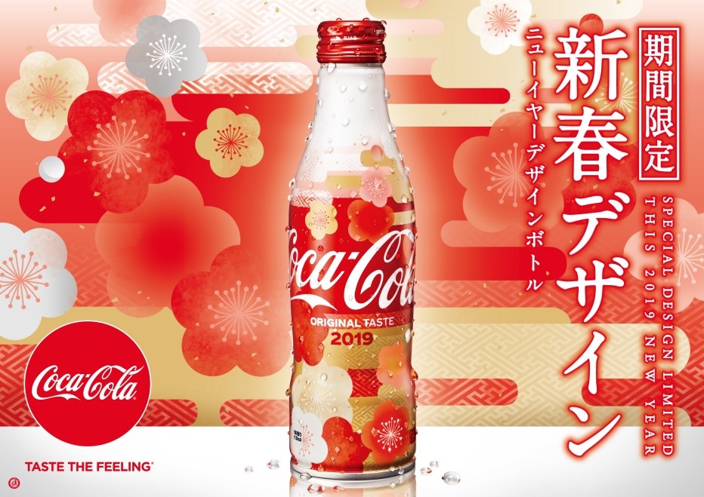
Figure 23https://soranews24.com/2018/11/30/coca-cola-japan-unveils-special-new-years-kimono-bottle-for-2019-with-hidden-boar-on-the-packaging/
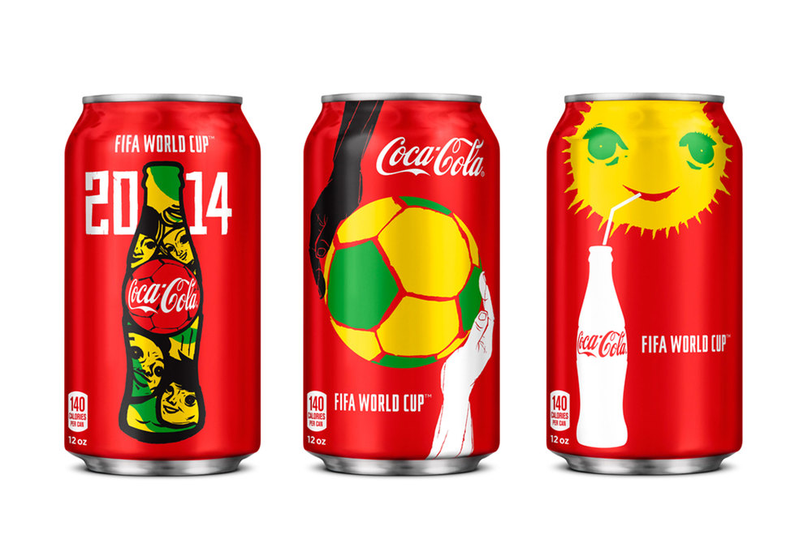
Figure 24https://creativepool.com/magazine/inspiration/packaging-gallery-brazil-2014---the-official-sponsors.2997

• Brazil

physical evidence highlights packaging diversity, retail presence, and sponsorship visibility
- Packaging: Various sizes and price-point bottles (250 ml, 600 ml, 2 L) tailored to accommodate different income levels.
- Point-of-sale branding: Eye-catching displays, posters, and outdoor signage across urban and suburban retail spaces.
- Event sponsorship: High visibility at football games, music festivals, and cultural events enhances brand recognition.
- Example: Coca-Cola’s 2 L bottles set up in a supermarket in São Paulo adorned with event branding and promotional stickers provide a tangible interaction with the brand. 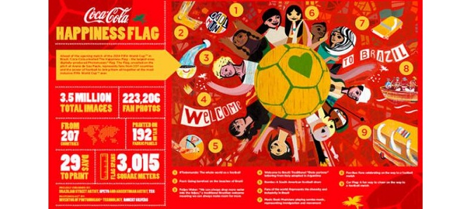
Figure 25https://www.globalbrandsmagazine.com/coca-cola-invites-the-world-to-the-opening-match-of-the-2014-fifa-world-cup-with-unveil-of-the-happiness-flag/
- Similarities Between Japan and Brazil (Coca-Cola Marketing Mix)
Element | Similarity | Example / Notes
Product | Both uphold the global Coca-Cola core brand while adapting flavors, packaging, or functional options to local preferences | Japan: Coca-Cola Plus; Brazil: Kuat (guaraná-based beverage) (Euromonitor International, 2023; Coca-Cola Company, 2023)
Price | Pricing strategies consider local market dynamics, balancing brand perception and consumer affordability | Premium in some segments, accessible for mass-market products
Place | Both use multiple distribution channels including retail, convenience stores, and vending/point-of-sale systems | Ensures wide product availability (Kotler and Keller, 2022)
Promotion | Both invest in culturally relevant advertising and integrated marketing via mass media, events, and experiential campaigns | Japan: TV & interactive vending; Brazil: Events & in-store promotions (Euromonitor International, 2023)
People | Emphasis on trained personnel to maintain operational efficiency, product availability, and quality service | Japan and Brazil train staff for vending, retail, and customer service (Coca-Cola Company, 2023)
Process | Well-structured ordering and complaint management systems ensure timely delivery and responsiveness | Online and app-based ordering in Japan; bottler-managed in Brazil (Statista, 2023)
Physical Evidence | Packaging, POS displays, and branded locations enhance consumer perception and engagement | Point-of-sale branding and packaging adaptations (Euromonitor International, 2023)

- Differences Between Japan and Brazil (Coca-Cola Marketing Mix)
Element | Japan | Brazil
Product | Focus on depth and uniqueness (functional beverages, seasonal limited editions) | Focus on breadth and variety (different sizes, local flavors)
Price | Premium/value pricing leveraging brand strength and convenience | Competitive/penetration pricing to compete with low-cost domestic brands
Place | Primarily indirect distribution via bottlers and vending machines | Mixed distribution: retail, convenience, bottler acquisitions for wider reach
Promotion | Mass media combined with interactive vending experiences | Event sponsorships, in-store promotions, and culturally relevant campaigns
People | ~14,084 employees, smaller scale | ~57,100 employees, larger geographic coverage
Process | Direct interaction via vending machine apps | Bottler-managed distribution and complaint resolution
Physical Evidence | Innovative packaging, interactive vending machines | Variety in packaging, visibility at retail points and events

7. Ethical and Unethical Marketing: Coca-Cola Analysis

Ethical marketing refers to the promotion of products and services in ways that are consistent with moral principles, demonstrate social accountability, and prioritize honesty, fairness, and transparency in all marketing communications (Crane and Matten, 2016). Murphy et al. (2005) suggest that ethical marketing takes into account the welfare of consumers, society, and the environment alongside profit generation, making sure that marketing strategies do not exploit vulnerable populations or deceive customers.

JAPAN - Example of Unethical Marketing

Product: Coca-Cola Plus advertised as a "healthier" option with fat-blocking effects despite a lack of substantial scientific backing.

STP: Targeted at health-minded professionals in Tokyo aged 25-40, marketed as a functional health drink.

Key Issues:

- Misleading "fat-blocking" health assertions lacking solid validation, categorized as deceptive by Smith and Quelch (2017).
- Insufficient disclosure of potential side effects from artificial sweeteners.
- Premium pricing (¥158) implying unverified health benefits.
- Marketing preying on consumer health concerns (Ferrell and Fraedrich, 2015).

JAPAN - Example of Ethical Marketing

Product: "I LOHAS" bottled water featuring eco-friendly packaging and transparent sourcing.

STP: Aimed at environmentally aware consumers aged 20-45, marketed as genuinely sustainable.

Key Strengths:

- Open communication regarding reduced plastic use and sourcing from Japanese springs, in line with principles highlighted by Ferrell and Fraedrich (2015).
- Clear recycling collaboration and guidance.
- Fair pricing that mirrors real environmental investment.
- Legitimate initiatives for forest conservation in collaboration with environmental groups.

BRAZIL - Unethical Marketing Example

Product: The "Coca-Cola Zero" campaign appealing to children using cartoon characters and partnerships with gaming.

STP: Targeting young audiences aged 8-16 through educational institutions and digital channels, presented as a "fun" choice.

Key Issues:

- Marketing directed at minors, contradicting WHO guidelines a practice Crane and Matten (2016) characterize as exploiting vulnerable demographics.
- Sponsorship of school sports creating brand connections during formative periods.
- Social media influencer campaigns lacking proper disclosure.
- Minimizing the potential risks of artificial sweeteners for children (Smith and Quelch, 2017).

BRAZIL - Ethical Marketing Example

Product: The "Coletivo" initiative aimed at aiding local micro-entrepreneurs and fostering community growth.

STP: Focusing on socially aware consumers aged 25-50, branded as a responsible corporate entity.

Key Strengths:

- Honest reporting on community investments, consistent with what Murphy et al. (2005) describe as "stakeholder value creation."
- Authentic partnerships with favela communities providing business training.
- Equitable labor practices with commitments to diversity.
- Clear nutritional labeling on all products.
- Water replenishment initiatives and real partnerships with NGOs (Crane and Matten, 2016).

Recommendations

Japan:
- Eliminate unverified health claims unless supported by clinical evidence (Ferrell and Fraedrich, 2015).
- Offer detailed ingredient information at the point of sale.
- Secure third-party verification for health-related assertions (Smith and Quelch, 2017).

Brazil:
- Stop marketing to children under 16, in line with WHO guidelines (Crane and Matten, 2016).
- Ensure full disclosure of all influencer collaborations.
- Remove price promotions near educational institutions (Murphy et al., 2005).

Both Markets:

According to Crane and Matten (2016), companies transitioning to ethical marketing should:
- Acquire independent ethical certifications like B Corp status.
- Perform annual ethical marketing evaluations with public reporting.
- Create mechanisms for consumer feedback showing genuine responsiveness (Murphy et al., 2005).
- Implement thorough employee training concerning ethical marketing practices.

8. Conclusion

This analysis of Coca-Cola’s international marketing in Japan and Brazil highlights its ability to balance global brand consistency with local adaptation. Japan’s market emphasizes innovation, health-conscious products, and advanced distribution, while Brazil focuses on emotional connections, mass-market accessibility, and cultural celebrations. Through tailored product, pricing, distribution, and promotion strategies, Coca-Cola aligns with local values while maintaining core brand identity. Ethical concerns, such as unverified health claims in Japan and marketing to children in Brazil, require attention. To sustain competitive advantage, the company should enhance ethical compliance, deepen localization, leverage digital transformation, and advance sustainability initiatives. Overall, successful international marketing depends on cultural understanding, operational excellence, and authentic local engagement.

References

Coca-Cola Brazil (2020) Environmental Sustainability in Latin America. Available at: https://www.coca-cola.com.br/ [Accessed 4 Nov 2025].
Coca-Cola Brazil (2021) Returnable Packaging Initiative. Available at: https://www.coca-cola.com.br/ [Accessed 4 Nov 2025].
Coca-Cola FEMSA (2023) Annual Report 2023. Available at: https://www.coca-colafemsa.com/ [Accessed 4 Nov 2025].
Coca-Cola Japan (2022) Local Product Innovation and Sustainability. Available at: https://www.coca-cola.co.jp/ [Accessed 4 Nov 2025].
The Coca-Cola Company (2018) Coca-Cola Plus: Japan’s Functional Beverage. Available at: https://www.coca-colacompany.com/ [Accessed 4 Nov 2025].
The Coca-Cola Company (2021) Digital Transformation with Coke ON App. Available at: https://www.coca-colacompany.com/ [Accessed 4 Nov 2025].
The Coca-Cola Company (2023) World Without Waste Initiative. Available at: https://www.coca-colacompany.com/sustainability/world-without-waste [Accessed 4 Nov 2025].
Fernanda Sousa (2020) Coca-Cola FanFeat Campaign. Available at: https://fernandasousa.works/project/coca-cola-fanfeat [Accessed 4 Nov 2025].
FOSHU Council (2020) Functional Foods in Japan. Available at: https://www.foshu.jp/ [Accessed 4 Nov 2025].
Euromonitor International (2023) Soft Drinks in Brazil Report. Available at: https://www.euromonitor.com/ [Accessed 4 Nov 2025].
Reuters (2022) Brazil Political and Economic Outlook. Available at: https://www.reuters.com/world/americas/ [Accessed 4 Nov 2025].
Coca-Cola Company (2023) Annual report and sustainability overview. Available at: https://www.coca-colacompany.com (Accessed: 11 November 2025).
Coca-Cola Japan (2022) Innovation and product portfolio. Available at: https://www.coca-cola.co.jp (Accessed: 11 November 2025).
Kotler, P. and Keller, K. (2016) Marketing Management. 15th edn. Pearson Education.
Silva, R. and Pereira, M. (2021) ‘Marketing strategies and cultural adaptation in Brazil: The Coca-Cola case’, Journal of International Marketing Studies, 12(3), pp. 45–58.
Tanaka, Y. (2020) ‘Cultural adaptation of global brands in Japan’, Asian Business Review, 9(1), pp. 22–33.
Kotler, P., Keller, K. L., Ancarani, F., & Costabile, M. (2022). Marketing Management (16th ed.). Pearson Education.
Coca-Cola Company. (2024). Annual Report 2024. [online] Available at: https://www.coca-colacompany.com
Statista. (2024). Soft drink market share in Japan. [online] Available at: https://www.statista.com/
Euromonitor International. (2024). Soft Drinks in Japan. [online] Available at: https://www.euromonitor.com/
Yano Research Institute. (2024). Japanese Beverage Market Overview 2024. Tokyo: Yano Research.
Coca-Cola Company, 2023. Annual Report 2023. Atlanta: The Coca-Cola Company. Available at: https://www.coca-colacompany.com/reports [Accessed 17 November 2025].
Pendergrast, M., 2013. For God, Country, and Coca-Cola: The Definitive History of the Great American Soft Drink and the Company That Makes It. 2nd ed. New York: Basic Books.
Hofstede, G., 2001. Culture’s Consequences: Comparing Values, Behaviors, Institutions, and Organizations Across Nations. 2nd ed. Thousand Oaks: Sage Publications.
Hofstede, G., Hofstede, G.J. and Minkov, M., 2010. Cultures and Organizations: Software of the Mind. 3rd ed. New York: McGraw-Hill.
Hofstede, G., 2011. Dimensionalizing Cultures: The Hofstede Model in Context. Online Readings in Psychology and Culture, 2(1), pp.1–26. Available at: https://doi.org/10.9707/2307-0919.1014 [Accessed 17 November 2025].
Minkov, M. and Hofstede, G., 2011. The Evolution of Hofstede’s Doctrine. Cross Cultural Management, 18(1), pp.10–20.
Coca-Cola Company, 2023. Annual Report 2023. Atlanta: The Coca-Cola Company. Available at: https://www.coca-colacompany.com/reports [Accessed 17 November 2025].
Coca-Cola Brazil, 2022. Marketing Campaigns and Local Initiatives. São Paulo: Coca-Cola Brazil.
Euromonitor International, 2022. Soft Drinks in Japan and Brazil. London: Euromonitor International.
Pendergrast, M., 2013. For God, Country, and Coca-Cola: The Definitive History of the Great American Soft Drink and the Company That Makes It. 2nd ed. New York: Basic Books.
Coca-Cola Brazil, 2022. Marketing Campaigns and Local Initiatives. São Paulo: Coca-Cola Brazil.
Coca-Cola Company, 2023. Annual Report 2023. Atlanta: The Coca-Cola Company. Available at: https://www.coca-colacompany.com/reports [Accessed 17 November 2025].
de Mooij, M., 2019. Global Marketing and Advertising: Understanding Cultural Paradoxes. 5th ed. London: Sage Publications.
Euromonitor International, 2022. Soft Drinks in Japan and Brazil. London: Euromonitor International.
Kotler, P. and Keller, K.L., 2016. Marketing Management. 15th ed. Harlow: Pearson.
Coca-Cola Brazil, 2022. Marketing Campaigns and Local Initiatives. São Paulo: Coca-Cola Brazil.
Coca-Cola Company, 2023. Annual Report 2023. Atlanta: The Coca-Cola Company. Available at: https://www.coca-colacompany.com/reports [Accessed 17 November 2025].
Euromonitor International, 2022. Soft Drinks in Japan and Brazil. London: Euromonitor International.
Kotler, P. and Keller, K.L., 2016. Marketing Management. 15th ed. Harlow: Pearson.
Coca-Cola Brazil, 2022. Marketing Campaigns and Local Initiatives. São Paulo: Coca-Cola Brazil.
Coca-Cola Company, 2023. Annual Report 2023. Atlanta: The Coca-Cola Company. Available at: https://www.coca-colacompany.com/reports [Accessed 17 November 2025].
de Mooij, M., 2019. Global Marketing and Advertising: Understanding Cultural Paradoxes. 5th ed. London: Sage Publications.
Euromonitor International, 2022. Soft Drinks in Japan and Brazil. London: Euromonitor International.
Kotler, P. and Keller, K.L., 2016. Marketing Management. 15th ed. Harlow: Pearson.
Kotler, P. and Keller, K.L., 2016. Marketing Management. 15th ed. Harlow: Pearson.
Solomon, M.R., 2020. Consumer Behavior: Buying, Having, and Being. 13th ed. Harlow: Pearson.
Booms, B.H., & Bitner, M.J., 1981. Marketing strategies and organization structures for service firms.
Kotler, P., & Keller, K.L., 2016. Marketing Management. 15th edition. Pearson.
Coca-Cola Bottlers Japan Holdings Inc., 2024. Corporate Overview. [online] Available at: https://en.ccbj-holdings.com/corporate/overview/?utm_source=chatgpt.com
Scribd, 2025. Coca-Cola Japan Pricing Strategy. [online] Available at: https://www.scribd.com/presentation/95073398/Coca-Cola-Japan-Pricing?utm_source=chatgpt.com
Euromonitor, 2022. Coca-Cola Pricing Dynamics in Brazil. [online] Available at: https://www.euromonitor.com/video/using-the-soft-drinks-price-tracker-to-explore-pricing-dynamics-spotlight-on-coca-cola-in-brazil?utm_source=chatgpt.com
WARC, 2021. Coca-Cola Price Ladder Strategy Brazil. [online] Available at: https://www.warc.com/content/feed/coca-cola-focuses-on-its-price-ladder-amid-high-inflation/en-GB/7416?utm_source=chatgpt.com
MMAGlobal, 2020. Coca-Cola Fan Feat Campaign Case Study. [online] Available at: https://www.mmaglobal.com/case-study-hub/case_studies/view/50482?utm_source=chatgpt.com
ResearchGate, 2005. Coca-Cola’s Marketing Challenges in Brazil: The Tubainas War. [online] Available at: https://www.researchgate.net/publication/230088627_Coca-Cola%27s_marketing_challenges_in_Brazil_The_Tubainas_war?utm_source=chatgpt.com
Crane, A. and Matten, D. (2016) Business Ethics: Managing Corporate Citizenship and Sustainability in the Age of Globalization. 4th edn. Oxford: Oxford University Press.
Ferrell, O.C. and Fraedrich, J. (2015) Business Ethics: Ethical Decision Making and Cases. 10th edn. Stamford: Cengage Learning.
Murphy, P.E., Laczniak, G.R., Bowie, N.E. and Klein, T.A. (2005) Ethical Marketing. Upper Saddle River: Pearson Prentice Hall.
Smith, N.C. and Quelch, J.A. (2017) Ethics in Marketing. Homewood: Irwin.
Brewster, C., Sparrow, P. and Vernon, G. (2016) International Human Resource Management. 4th edn. London: Chartered Institute of Personnel and Development.
Fang, T. (2003) ‘A critique of Hofstede’s fifth national culture dimension’, International Journal of Cross Cultural Management, 3(3), pp. 347–368.
Hofstede, G. (1980) Culture’s Consequences: International Differences in Work-Related Values. Beverly Hills, CA: Sage.
Hofstede, G. (2001) Culture’s Consequences: Comparing Values, Behaviors, Institutions and Organizations Across Nations. 2nd edn. Thousand Oaks, CA: Sage.
Hofstede, G., Hofstede, G.J. and Minkov, M. (2010) Cultures and Organizations: Software of the Mind. 3rd edn. New York: McGraw-Hill.
Holden, N. (2002) Cross-Cultural Management: A Knowledge Management Perspective. Harlow: Pearson Education.
McSweeney, B. (2002) ‘Hofstede’s model of national cultural differences and their consequences’, Human Relations, 55(1), pp. 89–118.
Minkov, M. and Hofstede, G. (2011) ‘The evolution of Hofstede’s doctrine’, Cross Cultural Management: An International Journal, 18(1), pp. 10–20.

