Developing a Penetration Testing Framework to Improve Cybersecurity for Small Businesses


Student name: Ehsan Samiee
Student ID number: 2419475
Assignment Title: Assignment 2 Project Management & Innovation
Lecturer: Dr Osman Elgawi

Contents
Introduction 3
Task 1 – Project Management 4
1.1 Project Overview 4
1.2 Project Scope 4
1.2 Proposed Solution 4
1.3 Proposed Solution 5
1.4 Technologies and Resources 5
1.5 Project Timeline and Schedule 6
1.6 Project Constraint 6
1.8 Development Method 7
Task 1 – Q2 Project Design 8
2.1 Requirements Specification 8
2.2 Penetration Testing Framework Flowchart 9
Task 2 – Enterprise & Innovation 10
Introduction 10
2.1 PEST Analysis – Cisco Systems 10
2.2 SWOT Analysis – Cisco Systems 11
2.3 Legal and Ethical Considerations 11
2.4 Proposed Tech Start-up 11
2.5 Business Strategy 13
2.6 Funding Opportunities 13
Task 3 – Project Reflection 14
Introduction 14
3.1 Developing New Skills 14
3.2 Contribution to Society, Positive Impact on Society 14
3.3 Risks, Challenges and Mitigation 14
Conclusion: 15
References 16

Introduction

Project management is an essential part of developing successful computing and cybersecurity solutions. It provides a structured approach for planning, organising, and controlling project activities to ensure that objectives are achieved within the available time and resources. Effective project management also helps identify potential risks, allocate appropriate technologies and resources, and monitor progress throughout the project lifecycle.
This task presents the project management plan for the proposed project, "Developing a Penetration Testing Framework to Improve Cybersecurity for Small Businesses." It outlines the project scope, proposed solution, required technologies and resources, project timeline, schedule, constraints, development methodology, and project design. Together, these elements provide a clear plan for developing a practical penetration testing framework that supports small businesses in improving their cybersecurity posture and reducing security risks [1], [4].



Task 1 – Project Management

1.1 Project Overview
This project focuses on the development of a penetration testing framework to improve cybersecurity for small businesses. As organisations increasingly rely on digital systems and online services, they face a growing number of cybersecurity threats, including malware, phishing attacks, ransomware, and unauthorised access. Small businesses are particularly vulnerable because they often have limited financial resources, fewer IT specialists, and less mature security practices. The purpose of this project is to design a practical framework that helps small businesses identify vulnerabilities, assess security risks, and implement appropriate security controls. The project will be based on recognised cybersecurity standards, penetration testing methodologies, and industry best practices [1], [2].

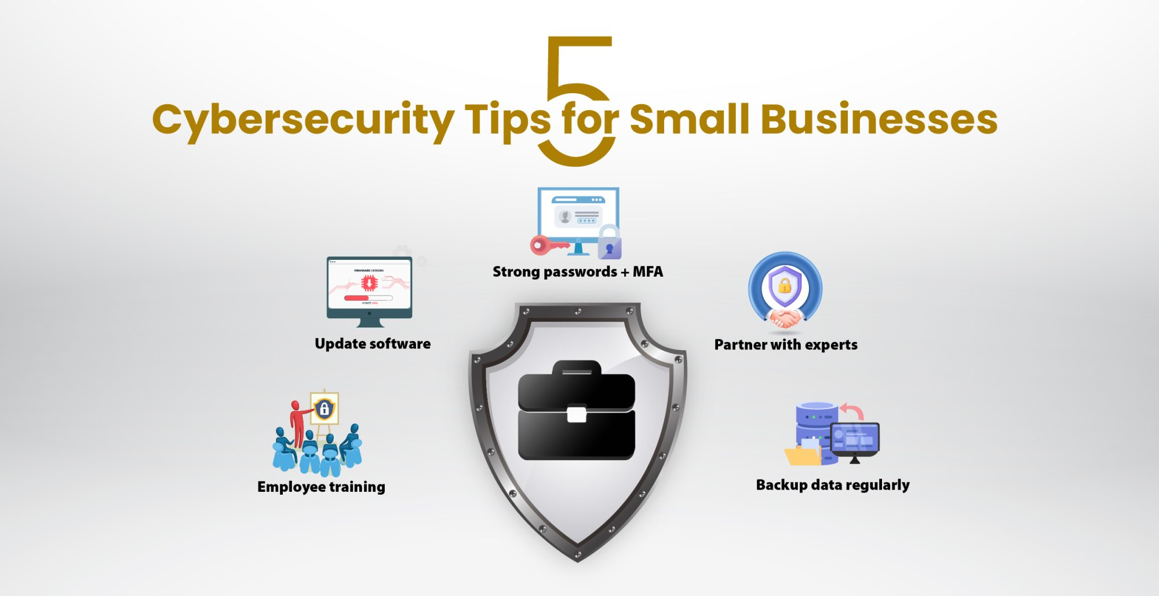

1.2 Project Scope
The project aims to design and document a structured penetration testing framework for small businesses to enhance their cybersecurity. It will outline each stage of the process—planning, information gathering, vulnerability assessment, testing, reporting, and security recommendations—focusing on framework design and documentation rather than actual penetration tests or commercial software development. The outcome will provide a practical guide that organisations can follow to identify weaknesses within their IT systems and reduce cybersecurity risks [2].

1.2 Proposed Solution

The proposed solution is to design a structured penetration testing framework specifically for small businesses. The framework will outline the key stages of penetration testing, including planning, information gathering, vulnerability identification, exploitation, reporting, and recommendations for improving security. The framework will also recommend suitable open-source penetration testing tools and provide guidance on implementing cybersecurity best practices [2], [5]. By following the framework, small businesses can identify weaknesses in their systems and reduce the likelihood of successful cyberattacks.



1.3 Proposed Solution
The proposed solution is to develop a structured penetration testing framework specifically designed for the needs of small businesses. The framework will combine recognised penetration testing methodologies with freely available cybersecurity tools and best practice guidance. It will provide organisations with a step-by-step process for identifying vulnerabilities, analysing security risks, documenting findings, and implementing suitable security improvements. The framework aims to improve cybersecurity awareness while remaining practical and affordable for organisations with limited resources [1], [3].

1.4 Technologies and Resources
Several technologies and resources will be required during this project. The penetration testing framework will be based on industry-standard tools including Kali Linux, Nmap, Wireshark, OWASP ZAP, and Metasploit, which are widely used for vulnerability assessment and network security testing. Academic research will be obtained from IEEE Xplore, Google Scholar, and university library databases to ensure that the framework is supported by reliable and up-to-date research. Microsoft Word will be used to produce the project documentation, while Draw.io will be used to create technical diagrams and Microsoft Excel will be used to produce the project schedule and Gantt chart [3].

1.5 Project Timeline and Schedule
Effective project management is essential to ensure that the project is completed within the available academic timeframe. The project has been planned over a twelve-week period and divided into several stages. The initial stage focuses on literature review and requirements gathering to understand cybersecurity challenges affecting small businesses. The second stage involves designing the penetration testing framework and selecting suitable tools. The third stage focuses on documenting the framework and evaluating its effectiveness. The final stage includes report writing, reviewing the project, and preparing the final submission.
Project Schedule
Stage | Duration
Literature Review | Weeks 1–2
Requirements Gathering | Week 3
Framework Design | Weeks 4–5
Tool Investigation | Weeks 6
Framework Development | Weeks 7–8
Testing and Evaluation | Weeks 9–10
Documentation | Week 11
Final Review | Week 12

1.6 Project Constraint
Several constraints may impact the project's completion, including limited time from the university assessment period and restrictions on commercial penetration testing tools, necessitating the use of open-source alternatives. Ethical considerations prevent testing real systems without permission, requiring research and simulations instead. Additionally, limited financial resources and access to specialised equipment may hinder practical testing. Careful planning and time management, along with free resources, can help mitigate these challenges.

1.7 Gantt Chart

Task | W1 | W2 | W3 | W4 | W5 | W6 | W7 | W8 | W9 | W10 | W11 | W12
Literature Review
Requirements Gathering
Framework Design
Tool Investigation
Framework Development
Testing and Evaluation
Documentation
Final Review
Project Gantt Chart

1.8 Development Method
The Agile development methodology was chosen for this project due to its flexibility, focus on continuous improvement, and regular evaluation throughout the lifecycle. By breaking the project into smaller stages, Agile allows for ongoing review and refinement of research findings, framework design, and documentation. This iterative approach helps identify issues early, reduces risks, and ensures that the final penetration testing framework aligns with project objectives and current cybersecurity best practices. Agile is widely used within software development and cybersecurity projects because it encourages collaboration, adaptability, and incremental improvement [3].



Task 1 – Q2 Project Design

2.1 Requirements Specification

The first stage of designing the penetration testing framework is identifying project requirements, which define the framework’s goals and features. It should offer a structured process for small businesses to identify vulnerabilities and enhance cybersecurity. Requirements are categorised into functional and non-functional to address both technical and operational needs.

Functional Requirements
ID | Requirement
FR1 | The framework shall provide a step-by-step penetration testing process.
FR2 | The framework shall include a vulnerability assessment stage.
FR3 | The framework shall recommend suitable penetration testing tools.
FR4 | The framework shall produce a security report with recommendations.
FR5 | The framework shall follow recognised cybersecurity best practices.

Non-Functional Requirements
ID | Requirement
NFR1 | The framework should be easy for small businesses to understand.
NFR2
  The framework should use freely available security tools where possible.
NFR3 | The framework should follow ethical and legal guidelines.
NFR4
  The framework should be scalable for different business sizes.
NFR5 | The framework should be easy to update as cybersecurity threats evolve.

2.2 Penetration Testing Framework Flowchart

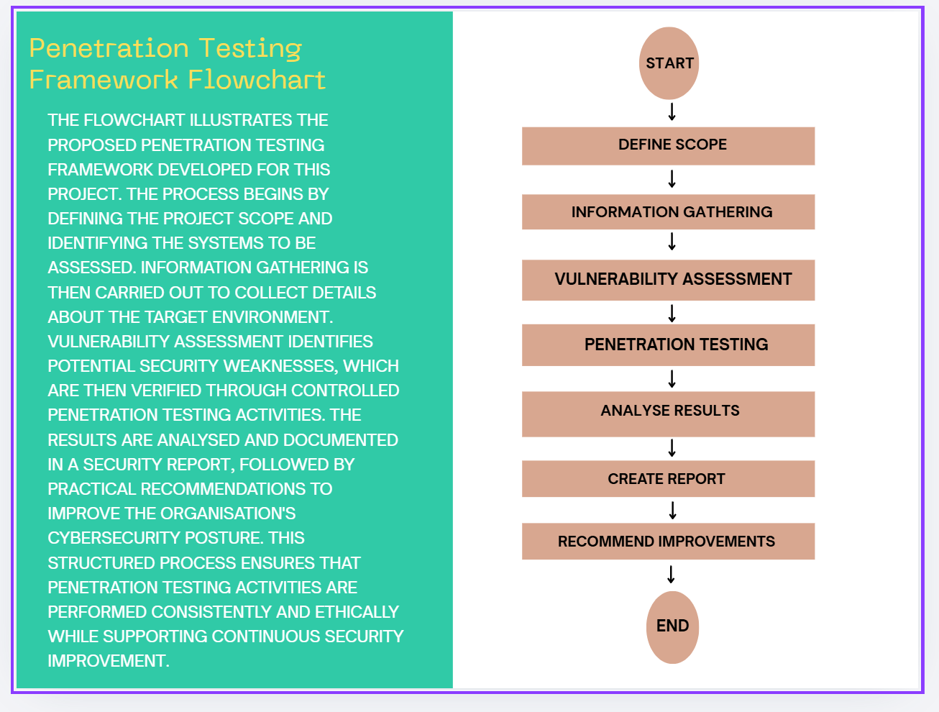
Penetration Testing Framework Flowchart

Task 2 – Enterprise & Innovation

Introduction

Enterprise and innovation play an important role in transforming technical ideas into practical business solutions. Successful technology companies combine innovation, strategic planning, and effective business management to deliver products and services that meet customer needs. This task examines the external and internal business environment of a technology company using PEST and SWOT analysis. It also presents a potential cybersecurity start-up based on the proposed penetration testing framework, including its business strategy and possible funding opportunities [4], [5].

2.1 PEST Analysis – Cisco Systems

Factor | Considerations
Political | Cybersecurity regulations, government security policies, international trade restrictions.
Economic | Global demand for cybersecurity services, inflation, IT spending by businesses.
Social | Increased awareness of cyber threats, remote working, growing need for digital trust.
Technological | Artificial intelligence, cloud security, penetration testing, emerging cyber threats.

A PEST analysis helps organisations understand the external factors that influence business performance. Cisco operates within a rapidly changing technology environment where government regulations, economic conditions, customer expectations, and technological innovation all influence business decisions. Continuous investment in cybersecurity research and innovation enables Cisco to remain competitive while responding to evolving cyber threats [7], [8].

2.2 SWOT Analysis – Cisco Systems

(S)Strengths | (W)Weaknesses | (O)Opportunities | (T)Threats
Global leader in networking and cybersecurity. | High product and service costs. | Growing demand for cybersecurity solutions. | Increasing sophistication of cyberattacks.
Strong brand reputation and customer trust. | Complex products requiring specialist knowledge. | Expansion of cloud security services. | Rapid technological changes.
Continuous investment in research and development. | Strong competition from other cybersecurity companies. | Artificial intelligence and automation. | Global economic uncertainty and competition.

A SWOT analysis evaluates the internal strengths and weaknesses of an organisation alongside the external opportunities and threats it faces. Cisco's strong reputation, extensive cybersecurity expertise, and continuous investment in innovation provide significant competitive advantages. However, the company operates in a highly competitive market where rapidly evolving cyber threats and technological changes require continuous development of new security solutions. Understanding these factors helps organisations make informed strategic decisions and remain competitive within the cybersecurity industry [8], [9].

2.3 Legal and Ethical Considerations
Technology companies must adhere to legal and ethical standards in cybersecurity. This includes safeguarding customer data, following privacy regulations like the UK GDPR, and conducting penetration testing only with proper authorization. Ethically, they should protect confidential information, report vulnerabilities responsibly, and prevent the misuse of security tools.Following recognised standards and ethical guidelines helps organisations maintain customer trust and supports responsible cybersecurity practices [1], [2].

2.4 Proposed Tech Start-up

- Company Name:
SecureShield Cyber Solutions Ltd


SecureShield Cyber Solutions Ltd logo

A proposed technology start-up, SecureShield Cyber Solutions Ltd, would focus on affordable penetration testing, vulnerability assessments, cybersecurity consultancy, and security awareness for small and medium-sized businesses. The goal is to enhance cybersecurity by identifying vulnerabilities before attackers can exploit them.

- Business Type:

The proposed business would operate as a Private Limited Company (Ltd), offering limited liability protection for owners and facilitating growth and investment. This structure is popular among UK technology start-ups due to its flexibility, legal protection, and expansion opportunities.

2.5 Business Strategy
The business strategy of SecureShield Cyber Solutions Ltd is to provide affordable and practical cybersecurity services specifically designed for small businesses. The company will focus on delivering penetration testing, vulnerability assessments, cybersecurity awareness training, and security consultancy using recognised industry standards and open-source security tools. Customer satisfaction, continuous improvement, and professional ethics will form the core values of the business. The company will also maintain strong relationships with clients through regular security assessments and ongoing technical support [4], [7].

2.6 Funding Opportunities
Several funding opportunities could support the development and growth of SecureShield Cyber Solutions Ltd. Initial funding could be obtained through personal investment, government start-up grants, and university entrepreneurship programmes. As the business grows, additional funding could be secured from angel investors, business loans, crowdfunding platforms, or venture capital organisations. These funding sources would help finance equipment, marketing activities, software licences, staff recruitment, and future business expansion [4], [5].

Task 3 – Project Reflection

Introduction
Reflection is an important part of project development because it allows individuals to evaluate their learning, identify areas for improvement, and consider the wider impact of their work. This reflection discusses how developing a penetration testing framework can support my personal and professional development, contribute positively to society, and identify potential risks and challenges that may affect the successful completion of the project [3].

3.1 Developing New Skills
This project offers a valuable chance to enhance my technical and professional skills for a cybersecurity career. By researching and designing a penetration testing framework, I'll deepen my understanding of vulnerability assessment, ethical hacking, and network security. I also aim to gain hands-on experience with tools like Kali Linux, Nmap, Wireshark, and OWASP ZAP.
Additionally, the project will bolster my research, critical thinking, problem-solving, and project management abilities, helping me manage tasks and communicate technical information effectively. These skills will be valuable both during my final-year project and in my future career as a cybersecurity professional [1], [3].

3.2 Contribution to Society, Positive Impact on Society
Cybersecurity is crucial as businesses and individuals rely on digital technologies. Small businesses are frequent targets for cybercriminals due to limited security. A penetration testing framework can help identify vulnerabilities, reducing the risk of cyberattacks and protecting sensitive information.
By improving cybersecurity awareness and encouraging the adoption of recognised security practices, the framework has the potential to contribute positively to society. Better cybersecurity can increase customer trust, reduce financial losses, protect personal data, and support business continuity. The knowledge and skills gained from this project may also enable me to contribute to future cybersecurity initiatives and help organisations create safer digital environments [1], [4].

3.3 Risks, Challenges and Mitigation
This project faces challenges like the constantly changing cybersecurity threats, requiring ongoing research for framework relevance. There are concerns about gaining practical experience with penetration testing tools within the timeline. Ethical and legal considerations are essential, as testing must be conducted with proper permissions. To reduce risks, the project will utilize authorized learning environments, virtual machines, and publicly available practice platforms instead of real business systems.
Effective time management, regular supervision meetings, and continuous review of academic literature will help minimise project risks. Following recognised cybersecurity standards and professional ethical guidelines will ensure that the project is completed responsibly and produces a practical framework that could be applied by small businesses [1], [6].

Conclusion:

This report presents a project proposal to develop a penetration testing framework to improve cybersecurity for small businesses. It has demonstrated how effective project management, technical design, enterprise planning, and personal reflection contribute to the successful development of a cybersecurity project. The proposed framework aims to provide practical guidance that helps organisations identify vulnerabilities and improve their security practices. Completing this project will strengthen my technical knowledge, research skills, and project management abilities while supporting my long-term goal of pursuing a career in penetration testing and cybersecurity [1], [3].

References

[1] National Institute of Standards and Technology (NIST), "The NIST Cybersecurity Framework (CSF) 2.0," Gaithersburg, MD, USA, 2024.

[2] OWASP Foundation, "OWASP Top 10: The Ten Most Critical Web Application Security Risks," 2021.

[3] M. Saunders, P. Lewis and A. Thornhill, Research Methods for Business Students, 8th ed. Harlow, U.K.: Pearson Education, 2019.

[4] IBM Security, Cost of a Data Breach Report 2024. Armonk, NY, USA: IBM Corporation, 2024.

[5] W. Stallings and L. Brown, Computer Security: Principles and Practice, 5th ed. Harlow, U.K.: Pearson, 2020.

[6] National Cyber Security Centre (NCSC), Small Business Guide: Cyber Security. London, U.K.: NCSC, 2023.

[7] Cisco Systems, Cisco Cybersecurity Readiness Index 2024. San Jose, CA, USA: Cisco Systems, 2024.

[8] European Union Agency for Cybersecurity (ENISA), ENISA Threat Landscape 2024. Heraklion, Greece: ENISA, 2024.

[9] Microsoft Security, Microsoft Digital Defence Report 2024. Redmond, WA, USA: Microsoft, 2024.

[10] Verizon, 2024 Data Breach Investigations Report (DBIR). New York, NY, USA: Verizon Business, 2024.

