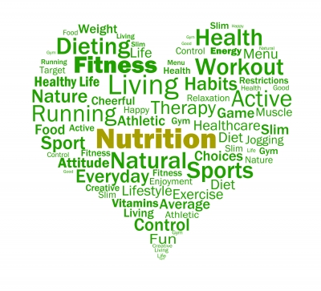

Promoting Health and Wellbeing

Workbook

Student name: | Vicki Jennings
Student number: | 2316677

Promoting Health and Wellbeing
Unit Code: PA94CY001
Level: Four
Credit Value: 10
Unit ID: CDN190
LDCS: PA9
Sector: 1.3
Last registration date: 31/10/2024
Purpose and Aim
This unit will enable the learner to develop an understanding of the theory of self-management and remaining well. It also covers co-production and promoting public health and examples of these principles applied within Therapy Assistant Practitioner practice.

The workbook must include citations within every task within the main body content of the work (a minimum of 8 credible sources); there is a section at the end of the booklet to compile a corresponding reference list.
Appendices can include any evidence to support content for each task, and are not compulsory.

Task One: Understand the meaning of health and wellbeing.
  - Explain the meaning of the terms health and wellbeing:
Department of health (2014) explores the relationship between health and wellbeing, explaining that it is a two way relationship. Although each are independent entities, the one can directly influence the other, a view shared by The World Health Organisation (2025). Patients can be in good health but have poor wellbeing, feeling stressed or glass half empty. This would lead them to conclude they are in poor health, despite the presence of any disease. On the other hand a patient can have good wellbeing being, live a fulfilled life and have a positive outlook, even with a poor health prognosis.
Callahan (1973) explores The World Health Organisation’s (WHO) early definition of health in 1948 “Health is a state of complete physical, mental and social well-being and not merely the absence of disease or infirmary”. Huber et al (2011) criticises this definition and argues it is counterproductive to label people as definitely ill and does not allow for a human’s ability to cope with ever changing emotions and physical elements. While Schramme (2023) defends the criticism of WHO definition and argues that the interpretation does in fact include all the holistic dimensions of health and well-being.
If health is described as the absence of disease or illness, then it can be objectively measured with scientific tests such as blood test, X-rays or magnetic resonance imaging (MRI). Within therapies these tests can appear in the form of physical special tests through our knowledge of anatomy, physiology and kinesiology. Therapists can ascertain if structures like ligaments, tendons and muscle are reacting the way they would expect.
Wellbeing on the other hand is harder to quantify, as this is more subjective. This can be influenced by individual factors, such as a person’s mental health and emotion regulation, social factors like relationship and support networks and environmental factors, what is the patients social norms, culture or background. There has been a lot of research attempting to set out blue prints and collating data, in a hope to produce a definitive measure of well-being. Searle, Pykett and Alfaro-Simmonds (2021) and Ruggeri et al (2020) have collated data from various research journals. They concluded that due to wellbeing’s multidimensional nature, it is difficult to create a cohesive measurement for individual well-being. However Rath and Harter (2010), have identified five elements of well-being that matter in life. They believe by strengthening career, social, financial, physical and community well-being, we can impact positively on our day to day life. They also suggest that all these elements are within our control and are things we can change or influence.
Patients with a poor wellbeing are at risk of more chronic conditions and decreased life span (Fig1). Diener and Chan (2011) concludes that there is strong evidence that a positive wellbeing can add 4-10 years to life, compared to those with a negative wellbeing. Although he does acknowledge the need for more research into this subject and what level of positive wellbeing is required to produce the health benefits required.

1.2 Outline the components of both the Medical Model and Health Belief Model of health, then explain any similarities and differences:
The Medical model is a complex mechanism that champions treating symptoms, with different types of medical intervention. The model focuses primarily on our biology and relies on science to diagnose and treat medical conditions. This tool is heavily used by primary care clinicians where diagnosis tools such as x-rays, blood test and MRI’s are used to produce accurate and quick diagnosis and treatment paths. In secondary care the patient is treated more as a whole and address the underlying source and not just the bodily symptoms.
The criticism of the medical model by Engel (1977) and Wade and Halligan (2004) calls for a change to this model. Claiming it only focuses on the measurable biological variables and is a basic scientific discipline, leaving no room for human dimensions and lacks patient centred care. Elements such as social, psychological or behavioural reactions to illness are neglected within the medical model and the model was and is purely for the diagnosis of disease. Leading to an inconsistency of patients given a positive diagnosis of illness, but indeed feel quite well, while others may feel ill but all medical tests are negative.(Farre and Rapley, 2017)
The health belief model focuses more on individual’s beliefs around their health condition, their perceived barriers and behaviours around the individual management. Champion and Skinner (2008) explore the key factors that influence these health behaviours. Perceived susceptibility or an individual’s belief of their own risk of developing a certain health conditions. Patients perceived severity can become a barrier to clinicians when treating patients, when they over or under estimate the seriousness of their condition. This feeds in to their perceived benefits, if a patient has a prefixed conception of a treatment plan they want and will make them better. This can influence their decision making and motivation to comply with the treatment discussed. This in itself is a barrier to treatment and can be challenging to overcome. But treatment should remain patient centred and to inspire self-efficacy, the art of giving the patient the confidence in their physical, emotional and social abilities to succeed in the agreed goal set. The final component is cues to action, the clinician should be calling on their active listening skills and motivational interviewing to inspire change and implement behavioural changes that need to addressed, to overcome barriers to change.
Although these two models ultimately are aimed at providing high quality patient care, the medical model seem focused mainly on scientific diagnostic and treatment of the symptoms of said condition. While the health belief model is more patient centred and treats the patient as a whole. Exploring the social, physiological and emotional elements. It also allows clinicians to explore how factors such as, education, employment, social networks and housing impact on our health and wellbeing.

1.3 Describe a minimum of five determinants of health and provide examples of the impact of these determinants upon a person’s health and wellbeing:
There has been much research and discussion around definitions of health and wellbeing, being a result of genetics, behaviours, beliefs and medical care. There are other factors that contribute towards people’s quality of life, such as social, environmental and economic. In 1991 Dahlgren and Whitehead devised a model to outline the main determinants of health. This has now become one of the most widely used models in healthcare and encourages clinicians to look beyond the health setting and explore the social determinants and the environment of their demographic. Thus treating people as a whole. This model also helps with implementing strategies, as it encourages co-production between different specialities to achieve a common goal. (Dahlgren and Whitehead, 2021), (Fig 2).
There are elements on the model that are out of anyone’s control such as genetics. These are inherited genes that can make you predisposed to certain health conditions. For example Sickle cell disease is inherited if both parents carry the gene and can vary in degree of severity dependant on certain genetic factors. While other inherited conditions such as diabetes, high blood pressure or cardiovascular disease can be influenced to a certain degree, with diet, exercise, stress management and smoking. (Hernandez and Blazer, 2006). Living with the constant worry or waiting on an impending condition to occur, can be very stressful for the individual. This is obviously dependent on the person’s beliefs or coping behaviours, as to how this is displayed. Some attitudes can be towards prevention, doing everything they can to reduce the chance or delaying the onset of an inherited disease. While some see the glass half empty and simply accept that this is their future and worry constantly about the impact on their lives.
Sex or gender can be a controversial subject, dependant on the person, situation and topic being discussed. Biological science and genetics suggests that there are medically two sexes female XX and male XY. This simple definition is used more in medical diagnosis and treatment. Males and females are biologically and anatomically different and need to be treated as such, in the application of medication or clinical diagnostics. While gender represents more the patient’s social and behavioural norms, which influence their thoughts, feelings and how a person perceives one’s self. (Mauvais-Jarvis et al, 2020) There has been a shift in gender that goes beyond the man, woman stereotypes. Patterson, Sepulveda and White (2020) have explored the relationship between the LGBTQI+ population and the impact their wellbeing. They conclude that there is no single path to gender affirmation, both psychosocial and biological factors can influence this identity. By feeling happy in their lives, being accepted by family and society can all feed into their wellbeing and sense of belonging. It is part of healthcare’s role to accept these gender diversities and treat everyone as equals, with no prejudice or preconceptions.
Education has been a hot topic in the health sector for many years and the desire to create the expert patient. It is suggested by Zajacova and Lawrence (2019) and Cutler and Lleras-Muney (2010) that those patients with a lower education, have a higher risk of obesity, diabetes, shorter life span and are more likely to heavily drink or smoke. Although this may not have a big impact on a person’s wellbeing, it will have implications on their health. Increasing risks of developing conditions associated with these diseases. Shahid et al (2022) study does contradict this view. They conclude that patients had a higher probability of visiting emergency departments, if you have a low health literacy but a high education. The health sector is always striving to create the expert patient and educate people around their health and wellbeing. Enabling and empowering the patient to self-manage their condition and improve quality of life and in turn reducing the strain on the health services offered.
Employment can have a big impact on people’s health and wellbeing. Spending on average 37-40 hours per week in you place of employment. On the whole being employed is seen as being good for mental and physical health. Providing wages and skills, whilst the social interactions and contribution to society can boost people’s wellbeing. If you’re not happy in the workplace, this can be very stressful and cause related health issues. Unemployment can contribute towards long term medial conditions and children growing up in an unemployed household are less likely to reach their potential. (Public Health England, 2018)
The determinants of employment and education, can have a direct link to housing and the affordability to live outside of deprived areas. Buck and Gregory (2018) report on behalf of The Kings fund, claim that poor housing conditions costs the NHS 1.4 billion per year, due to issues with delayed hospital discharge and overcrowding in houses. Whilst damp, mould and falls, contribute to health relate issues such as asthma, heart disease, hypothermia, diabetes and infectious diseases. Schemes by the government, charities and the health service are looking to improve living conditions, support people in their own homes to prevent hospital admissions and reduce community contracted illness. Dealing with these poor housing conditions and the risk to their health, will also impact mentally. Stress of repetitive illness, worry of eviction and cost of living can cause anxiety on a daily basis.
A lot of the determinants are intertwined and directly impact on each other and a person’s general health and wellbeing. When clinician treat patients all these factors should be considered throughout all of their interactions and any treatment being applied.

Task Two: Understand the benefits of self-management for people and approaches that empower them to improve their health and wellbeing.
2.1 Describe the concept of empowerment and the benefits to individuals when empowered to manage their own health:

The healthcare system is under a lot of pressure with an aging population, increased chronic conditions and raising costs. Therefore patient empowerment has been at the forefront of patient lead invites. We can create an expert patient through providing patients with the tools, to manage their own health and wellbeing. Providing patients with the knowledge, coping skills, confidence, self-awareness, decision making and attitude to embrace change and create a patient centred care approach. (Hickmann, Richter and Schlieter, 2022)
There are a few key elements where a clinician, patient and advocates can work together to equip individuals with the skills needed to self-manage and feel empowered over their condition. Providing patients with all the information required and checking their understanding of the options, improves the ability of the patient to make good informed decisions regarding their future. Having an open and honest conversation with the patient will encourage co-production and allow the patient to ask questions. By including them in the decision making process we are more likely to improve engagement in treatment, resulting in greater motivation and adaption of healthy behaviours.
These healthy changes to their lifestyle will inevitably improve their quality of life, create more energy, give them a purpose and improve wellbeing. Ultimately providing them with the autonomy over their own health and enable patients to take the initiative in making decisions around their health to improve their quality of life. Rather than be a passenger and simply complying with decision that others have made on their behalf. Long term this will encourage compliance with treatment plans and lend itself to a successful outcome.

2.2 Explain two theories of behaviour change, and include the skills required to promote behavioural change in others:
In healthcare one of the most basic but perhaps the most widely used tool for behaviour change is the cycle of change. The need for a cycle of change was first identified and developed by Prochaska and DiClemente (1983), this has slowly evolved into the cycle we are all familiar with today. (Fig 3) It provides the user with a visual map of the typical patient journey to a healthy change for long term condition management. The patients journey throughout the cycle is ever changing and can enter at any stage not just stage 1 and can also go into relapse at any stage not just in the final stages.
Stage 1 is the precontemplation phase, at this point patients may not be acknowledging that there needs to be a change. They tend to defend their behaviour and feel this is not something they can do anything about. There will be a distinct lack of motivation and a denial that there is a problem. Stage 2 is contemplation this is where the patient starts to become aware of the need for change and the consequences of remaining on the same path. Although they will still seem ambivalent and reluctant to make a change. Both these stages requires good active listening skills from the clinician, so they can fully understand the barriers to change and normalise the patient’s feelings. The clinician should be empathetic towards the patient’s situation and aim to build a trusting co-productive environment.
Stage 3 is preparation, the patient at this stage should be ready to start making decisions on what changes need to be made and how to go about it. The changes at this point should be small, achievable and patient centred. The clinician at this point should be going over SMART goals with the patient. These should be patient lead and patient centred to increase motivation and enhance compliance. Stage 4 is to put the treatment plan into action and stage 5 is to maintain the treatment longer term. This can come in the form of individual or group sessions. The clinician could provide the patient with external support groups or exercise groups for social interaction. This will also give them a support network and provide them with self-coping skills. This is the point it is important to acknowledge the patients achievements and celebrate the small wins. Encouraging the patient to identify their achievements will help maintain motivation and empower the patient to continue with self-management.
There is always a chance of stage 6, which is relapse. Unfortunately relapse is a very real possibility despite the patients and the clinician’s best efforts. We have to address that this is normal, understand why and restart with the cycle of change. The clinician should be supportive and help the patient reengage with treatment and not blame or shame for the relapse. (Cherry, 2024)
Another tool that a clinician can use to promote a positive change to behaviour, is applying the social norm theory. This theory can be broken down into two areas, descriptive norm, which is how you think people actually behave and injunctive norm is how you think people feel towards a behaviour. (Fig 4) Berkowitz (2005) explores this evidence-based approach to health promoting. He describes social norms as individuals misunderstanding the behaviours and attitudes of others, then perceive them as being different from their own, but in fact they are not. The suggestion is that what others do and what we see on a daily basis becomes our normal behaviour and our perception is that this behaviour is normal and accepted. Childhood teachers, parents, grandparents or peers influences or beliefs and attitudes, which shape our behaviours as adults. An example of this is if we are brought up in a household that unemployed, this is our ‘norm’ then we are more likely to become unemployed as adults. A more recent examples of this is despite any evidence people believed that Covid-19 injections did not work, caused health issues and that the government were using them to microchip chip people. This belief would have been greatly influenced by the people around you and social media. Both of which can be non-evidence based and have no foundation of truth.
This is a difficult area for clinicians to influence, as these beliefs and attitudes are deep routed and the patient is not even aware that this is an unhealthy situation. The clinician needs to approach this with sensitivity, but also with an evidenced based approach to try and make the patient more informed on the subject being discussed. This way the patient has all the information and has the tools to make informed decisions on their health patterns.
Tang et al (2021) also suggests that the social norms of healthcare and healthcare support workers needs to be modified and that a change of clinical behaviour can have a positive effect on a patient’s health outcome. An example of this would be challenging the challenging the normal practice of leaving patients in bed We know through Kortebein et al (2008), that patients experience a substantial loss to muscle strength, aerobic capacity and physical activity with just 10 days in bed. But yet this seems to be a norm in healthcare that goes relatively unchallenged.
There are however people that beak from the norm and break away from what their social standing or demographic predict. For a clinician it is having the ability to recognise and acknowledge the patients belief and attitudes, without labelling them due to the social factors we learn through our assessments.

2.3 Please describe two examples of where your health board, or local authority, support the health and wellbeing of their employees:
Aneurin Bevan University Health Board (ABUHB) provide various services that staff can access to help with their health and wellbeing. These are provided over various platforms, allowing the member of staff to access the most appropriate for their personality. One of the group sessions offered to staff is the Schwartz round. This is a structured group based forum, where staff are encouraged to discuss both the emotional and social aspects of working in healthcare. These shared experience sessions comprise of a panel of mixed staff, both clinical and non-clinical, who share their accounts of a case study or a particular theme. Then following on from this short discussion, the floor is opened to all attending, to share their thoughts and reflections around the topic.
The purpose of these sessions is to explore the intrinsic challenges and rewards of providing healthcare. The rounds have proven to help staff feel supported and data gathered from these sessions has shown that staff feel less stressed and isolated, but also provided them with a better insight of other roles within the trust. A qualitative study by Ng et al (2023) supports ABUHB’s claims and concludes that Schwartz rounds provide staff with opportunities to process emotions associated with healthcare jobs.
Frontline 19 is an independent charity funded nationwide service, aimed at supporting the mental health of NHS and frontline staff. Originally set up to support staff through Covid-19 to help with the mental health, but due to the overwhelming success of the support clinics are still running today. The lasted figures published on their website frontline 19 (2025), state they see 9,000 staff on average per week and have helped 1 million since starting the service at the start of Covid-19. This is a vital service that matches individuals with qualified professional counsellors, who will arrange between 8-12 sessions with you. Again the latest figures show that 97% of the people they counsel, say they felt better on completion of their sessions. Briggs (2022) endorses this services and investigates the importance for nurses to help with mental health, wellbeing, burnout and feelings of isolation and overwhelmed emotions
Having services like these available to staff to help maintain a healthy wellbeing is vital to the continuing services and pressures on the NHS. The services are easy to access confidential and their success has been well documented.

Task Three: Be able to use a person centred approach when promoting population health.

3.1a Reflect on an example of a person centred approach you have used within your workplace, to promote health and wellbeing of either individuals or groups. Ensure you use a recognised model for reflection and make recommendations for improvement.
The Gibbs refection tool is a framework that can assist learning from experiences and give us the ability to reflect on situations in a structured way. Gibbs reflection cycle is broken down into sub headings of description, feelings, evaluation, analysis, conclusions and action plan.(Gibbs, 1988) The below refection will used these breakdowns to explore an example of a patient centred approach, within a physiotherapy setting.

Description
Tyler was referred to physiotherapy by Noah’s Ark Children’s Hospital following an extensive scoliosis correction. According to the British Scoliosis Society (2025) a scoliosis of the spine is where the spine develops and abnormal lateral curve, that leave the trunk and shoulders no longer being symmetrical. Tyler was first diagnosed with the condition at the age of 10 using diagnostic imaging, firstly with x-rays and then Magnetic Resonance Imaging (MRI) as the severity progressed. The scoliosis had progressed to the point where he was struggling with his breathing, due to the lung being compressed and required the correction to improve his quality of life and prevent any further deterioration to his breathing. Tyler also has a neurodevelopmental disorder Autism, which can influence how people interact, think, feel or communicate. It can also alter in severity or symptoms, depending where on the spectrum they are. (National Autistic Society 2025) This was displayed in being deficient with social communication, such as poor eye contact and struggling to engage with sessions.
His mother was present at all appointments and was astringed from his father. Discussions with the patient’s mother, revealed that the patient can be engaged with conversation around football. This was implemented and the patient was fully compliant with all sessions within the department. Unfortunately, this did not carry over with independent exercise and he would openly admit to not completing exercises due to poor mental health.
Physiotherapy have access to a number of services that would be helpful to Tayler such as Disability Sport Wales to facilitate return to football and Woking Rights to provided apprenticeships for people with disabilities. Again unfortunately, Tayler declined to participate with any services offered. Eventually through discussions with the patient and family, it was mutually agreed the patient was not ready for intervention at this time and discharged.
Feelings
The experience was a very stressful and frustration time. It was difficult on times to engage with Tayler and he would spend the whole session with his hood up and not engage in any conversation. On other times he was fully engaged complete all exercises with energy and enthusiasm. Interactions became very frustrating, knowing that physiotherapy would help him and that the external organisations could improve his overall quality of life physically, socially and well-being, but that he was not willing to participate. Although sometimes we have to acknowledge that we come into patients’ lives at the wrong time and they are not ready to make changes at this point.
Evaluation
The patient was treated as an individual and his full wants and goals were listened to and acted upon. Treatment during the sessions were engaging and appropriate to both rehabilitate the condition and help achieve goals. The family were very impressed with the treatment provided to Tayler and had nothing but positive feedback on their journey through physiotherapy.
It was difficult to encourage him to be compliant with his home exercise plan and eventually this became a barrier to treatment which we were unable to overcome at this point.
Analysis
In this instance co-production was extremely important. Due to the nature of Tayler’s autism he was able to understand and process information, so could give informed consent. But his social skills made communication and engagement difficult on times, so his mother and family then became vital to treatment and discussion around his long term management. The sessions were very flexible and was able to adapt dependent on patient’s state of mind and willingness to participate at any given time.
We learned to stay patient and adaptable during this process, accept Tayler’s behaviour and react accordingly. Not all patients with autism have the same presentation of symptoms, so everyone needs to be treated individually and try not to have any preconceptions of how to interact with the patient.
Conclusion
The sessions were on the whole successful, his breathing returned to normal, he had good movement patterns and had minimal pain from his spine. He did benefit from the sessions whilst within the department, the main issue was compliance with independent management. Even though Tayler is outside of the age to be treated by Paediatrics, we could have liaised with them as to strategies to improve compliance. Although this may not have affected the outcome of the treatment.
Action Plan
If this situation arose again I would try and arrange to treat the patient in the community, alongside members of our National Exercise Referral Scheme (NERS). They provide vital access to gyms, classes and swimming for patients that need help with long term condition management.(Public Health Wales, 2024) This could have given Tayler the confidence to exercise away from the hospital setting, introduced him to the instructors taking the course and made him familiar with the surroundings, giving him confidence.

3.1b Reflect on a second example of a person centred approach you have used within your workplace, to promote health and wellbeing with either individuals or groups. Ensure you use a recognised model for reflection and make recommendations for improvement.
The Gibbs refection tool is a framework that can assist learning from experiences and give us the ability to reflect on situations in a structured way. Gibbs reflection cycle is broken down into sub headings of description, feelings, evaluation, analysis, conclusions and action plan.(Gibbs, 1988) The below refection will used these breakdowns to explore an example of a patient centred approach, within a physiotherapy setting.

Description
Joyce 61 had suffered with Osteoarthritis (OA) in bilateral hips for 5-6 years. She had recently had bilateral total hip replacements and was struggling with general function. Prior to surgery she had reduced mobility and walked with the aid of two elbow crutches for the last eight months. The nature of OA means that the hip joint becomes painful radiating into the groin or down the leg, with reduced movement and an adapted trendelenburg gait pattern. (Versus Arthritis, 2025) Joyce admits she was never the ideal weight for her height, but since her mobility had been decreasing her weight had slowly been increasing and now had a body mass index (BMI) of 43. This has led to an increase in Joyce’s anxiety in not wanting to go out and depression due to social isolation. Joyce has been advised by the consultant to lose weight to help with the longevity, reduce complications and improve quality of life following her surgery, this is supported by the systematic review performed by Haynes, Nam and Barrack (2017).
Joyce has a past medical history of pulmonary embolisms (PE) and believes this is the reason behind her shortness of breath (SOB). A report from a Pulmonologist show that her lung capacity tests and other indicators, suggest the lungs have fully recovered from the PE and her SOB is purely due to deconditioning and increased BMI. Joyce is struggling to come to terms with this diagnosis and has refused a referral to adult weight management or to the National Exercise Referral Scheme (NERS) to assist in weight loss and improve her general conditioning. The barriers were explored using open and honest conversation and motivational interviewing, but again the Joyce offered little to no input to the collaboration process.
Joyce unfortunately did not attend three appointments in a row so was ultimately discharged from physiotherapy.
Feelings
This patient was particularly challenging, every week going over the same subjects and exploring the same barriers to why she was rejecting all overs of help. Every week seeing the patients name on the clinic list and your heart would sink. Knowing that you would be leaving the sessions feeling frustrated and irritated, as the patient had a condition that could be fully resolved with some professional help. Yet, she had no desire or motivation to do what was needed. Towards the end of the patients treatment the sessions became quite repetitive and uncomfortable, trying to find different ways of addressing the same issues
Evaluation
The most positive aspect of this situation, was that the patient’s hip replacements were successful and she was pain free for the first time in years. She had slightly better function and improved sleep.
What didn’t go well was the limited improvement to conditioning, stamina and daily activities. Even though the barriers were attempted to be addressed, the patient’s reluctance to change remained defiant. Meaning that that the benefits from surgery are not what would be expected and the impact on her quality of life is still sizable.
Analysis
All the resources available at the time were investigated and discussed with the patient. Things to assist with conditioning like the National Exercise referral Scheme, Good Boost (2004) and Age UK (2024) for over 60’s sessions. To aid with reducing her BMI options of self-referral to adult weight management. Alternatively the National Health Service (NHS) currently has a partnership with Sliming World, to allow 6 weeks of free membership to promote health habits and lifelong weight-loss success. (Slimming Word, 2020).
Jack et al (2010) has explored the barriers to treatment adherence in physiotherapy and has identified reduced activity at baseline, anxiety depression and poor social support as some of the contributing factors. All of which could be applied to Joyce
Conclusion
The learning from this situation was, you can have all the evidence based information and have a patient centred treatment plan, but the patient needs to be ready to engage. They have to be prepared and motivated to make the changes needed. At some point in the future Joyce will be ready to take on the advice given. She has all the information need to take the next step and can always reinstate if she requires more guidance. Personal development from this situation would include working on motivational interviewing, to be able to explore barriers more effectively. There may also be an element of patient, client relationship issues. Although I thought there was a good relationship with the patient, would they have responded better if another clinician had also discussed the treatment options with her.

Action Plan
The only thing that I would have done differently with this patient and in this situation, would be to provide the patient with a second opinion. Sometimes hearing the information from another person, in a different way or tone can trigger a different response.

3.1c Reflect on a third example of a person centred approach you have used within your workplace, to promote health and wellbeing with either individuals or groups. Ensure you use a recognised model for reflection and make recommendations for improvement.
The Gibbs refection tool is a framework that can assist learning from experiences and give us the ability to reflect on situations in a structured way. Gibbs reflection cycle is broken down into sub headings of description, feelings, evaluation, analysis, conclusions and action plan.(Gibbs, 1988) The below refection will used these breakdowns to explore an example of a patient centred approach, within a physiotherapy setting.

Description
Mark was referred by trauma and orthopaedics following his Total Knee Replacement (TKR). Mark is 38 years old, so young to be receiving replacement surgery. The average age for a knee replacement in the UK according the National Joint Registry (2022), is 70.55. A systemic review by Evans et al (2019), suggests that a knee replacement in 82.3% of patients last 25 years. Mark was made aware that he may require revision surgery by his consultant prior to surgery, but due to his pain level he was willing to proceed with the knee replacement. Mark initially injured his knee playing football at the age of 18, which resulted in him needing an Anterior Cruciate Ligament Reconstruction (ACLR) and a medial meniscectomy. Studies have shown that ALCR and meniscus injuries predisposed Mark to developing osteoarthritis and requiring a TKR at a young age. (Khan et al, 2019)
Even though Mark was fully aware of the long term treatment plan and fully consented to the surgery, he was struggling to live the reality of having a knee that no longer had full range of movement and restricted his daily activity. He was focusing on all the negatives of his future life living with an artificial knee, rather than the positives of being pain free and that his function would improve over the next 18 months. To try and provide Mark with a sense of perspective and to break down his barriers to long term success, he agreed to participate in our arthroplasty rehabilitation class. Stevens et al (2021) concludes that class based exercise can protect against depression and improve general mental health and this could help Mark overcome his negativities. Following a 6 week course in the arthroplasty class being around 7-8 other patients who had undergone replacement surgery, Mark felt far more positive about his future living with an artificial joint. He realised he could still need a full and happy life, with a few adaptations which would have very little impact on his overall health and wellbeing.

Feeling
Throughout the sessions I would feel very empathetic towards Mark and his situation. Mark is slightly younger than me and I put myself in his shoes and thought how I would feel having major surgery that could potentially affect my quality of life. This gave me a little more motivation to help pull him out of his negative thoughts and enable him to achieve the life he desires. I am very happy that Mark decided to take the class and it gave me a huge satisfaction when discharging him that he was in a better place.
Evaluation
The thing that worked well with Mark’s treatment journey was that I identified the benefits the class could provide. The patient’s interactions in the class had an overall positive impact on Mark’s outlook and improved his wellbeing, around long term prognosis and quality of life. Although the actual exercise and treatment would have been the same if he had continued individual sessions, being around people living and experiencing the same symptoms as you can be comforting and motivational.
Analysis
The treatment was successful because I run the classes, I was aware of the benefits patients get from being in the class setting. Also I was aware of what patients were in the class and knew they were all very happy, positive and chatty, so would welcome and reassure Mark. Mark comes from a team setting from playing football, so I knew he would enjoy the class setting and the camaraderie the class would provide. Although studies by Salmon et al (2001) and Coulter, Weber and Scarvell (2009) conclude there is minimal benefit to class based exercise over individual settings on the overall function of patients. I would argue in my experience if you get the right patient, they get far more from the class setting than one to one treatment.
Conclusion
This interaction taught me to ensure that patients are treated individually, as I would not automatically put younger total knee replacements in a class with mainly over 65’s. In this case the group setting was used as a tool for behavioural change and a motivational aid. Also given his background in team sports, he enjoys and thrives in group setting. Even though there is not strong evidence to choose class over 1 to 1, sometime we have to trust our instincts and draw on our past experiences to provide to the best care for patients.
Overall this was a very positive interaction and there is nothing I feel I would change, if I were in the same situation again.
Action plan
The age of patients being referred following joint replacement surgery seems to be reducing and a lot of the services offered tend to be aimed at the 65 and over age bracket. Going forward it would be good to look at how we can accommodate the younger demographic. Do we need a different skill set, do we need to offer a wider range of services to include those that work. These are all areas we could develop and change to provide a more rounded service.

Task Four: Know how to use a co-production approach when promoting health and wellbeing.

4.1 Outline the principles of co-production (explain a minimum of 2 of these in-depth)
Co-production occurs when multiple parties engage in meaningful conversations around the development of healthcare and treatment. Co-production has the ability to revolutionise healthcare by making it truly patient centred and inclusive. Allowing the outcome to represent the wants and needs of the patients, demographic or trust, whilst remaining evidence based. The process requires active collaboration, mutual respect, transparency and open honest dialogue. This process should be used with both patient facing and non-patient facing interactions. Focusing on how to improve the healthcare interventions being offered and enhance the outcomes for the demographic being treated. Using the co-production approach with patients will promote confidence, participation and motivation leading to higher quality interactions and increased patient satisfaction. (Turakhia and Combs, 2017)
The Social Care Institute for Excellence (2022) outlines the principles of co-production as accessibility, diversity, equality and reciprocity. Equality is one of the corner stones of co-production, as it promotes inclusivity and treats all participants as equals. Each individual will have vital varying skills or abilities that will be an assets to the co-production process. Healthcare professionals will bring the evidence based knowledge, the professional skills and the legislations around change. While patients will bring the vital lived experience, the barriers they experience, their practical based knowledge on day to day struggles and shared experience of living with illness. Both areas are equally as important when planning treatments, service improvements or introducing new legislations. If co-production breaks down, it builds barriers between patient and clinician. This creates an equality imbalance leaving the patient feeling dictated too and out of control of their own health. The patient will then disengage and any intervention will be unsuccessful.
Eriksson (2021) explores the concept of equality from more of a public sector context. Stating that equality is fundamental in public health and expenditure, ensuring that all individuals have the same access and same rights to services no matter their demographic or postcode.
When engaging in co-production it is important to embrace the diversity within your group, to facilitate a 360 perspective and draw on areas of expertise when making decision or creating service designs. Within the task group there may be health professionals, member of local government, representatives from charities or members of the general public. Each member will attack the task from their own unique angle and have new or innovative ideas on how to move forward. Rafaqat et al (2022) suggests that a diverse workforce is significantly related to performance and can be more creative. With this in mind when looking at developing new services or creating policies, having a diverse team would facilitate a more positive outcome.

Task Five: Understand the role of public health in promoting health and wellbeing..

5.1 Describe the 3 domains of contemporary public health practice:
Public Health Wales (PHW) is a national agency tasked with protecting and improving the health and well-being of the people in Wales. They work collaboratively with other organisations such as the National Health Services (NHS) and the Wales Government to reduce health inequalities and provide expert advice in developing any services or strategies.
Drawing on multiple businesses and agencies allows for different skill sets, experiences and views. Working off the basis that public health is everyone’s responsibility, we therefore require some common elements. Thorpe (2007) outline three domains of public health, Health Improvement, Health Protection and Healthcare Public Health.(Fig 5)
Health Improvement
This area focuses on addressing the underlying causes of health problems within their demographic. Public health implement promotion campaigns based around improving well-being through social and environmental interventions. Campaigns such as vaccinations, awareness of healthy living such as 5 a day fruit and veg or 150 minutes of exercise per week. Health improvement also focuses on areas such as education and poor living conditions, where they provided government funded apprenticeships or enforce legislations on landlords to ensure the standard of accommodation meets basic human needs.
Ultimately aiming to reduce health inequalities and improve the overall health and well-being of the demographic it serves.
Health Protection
This area of public health focuses more on the prevention of acute threats to health. Providing strategies for natural or environmental disasters. Putting together emergency plans for critical incidents within the NHS, chemical spills, major road traffic collisions or even disease outbreaks. Recently PHW, the Welsh Assembly and the NHS worked collaboratively over covid-19 restrictions and policies, to help protect the population from an infectious disease outbreak. PHW also work with food suppliers to ensure that food is safe, prepared correctly and sustainable. Following outbreaks with things like salmonella, eggs now have the British Lion Mark to show the hens have been vaccinated. (British Egg Industry Council, 2025)
Healthcare Services
This domain focuses more on the quality of services and the safety of the patients while accessing those services. Any Allied Health Professional (AHP) already works off a heavily evidence based practice. But PHW also uses this practice to focus on safety, implementing protocols to reduce hospital acquired infections, provide guidance for medication prescription and promote effectiveness. This can been seen in the hospital setting with Clostridium difficile management and the hand washing protocols.

5.2 Select one piece of current legislation and explain how it helps to improve public health:
The Public Health (Wales) Act 2017 was introduced to address what was perceived to be the main hurdles to good health and well-being in Wales. This Act would mostly focus on reducing the levels of obesity, introduce restrictions on tobacco and nicotine, enforce businesses carrying out procedures such as piercing and tattooing to be licenced, pharmaceutical services must apply to be added to the health boards pharmaceutical list, reassessing the need for public toilets and baby changing in their localities and enforcing elements of food safety such as the hygiene rating and issuing penalties for those who do not comply. (Watkins, 2017)
One of the main legislations from Public Health Wales (PHW) at the moment is Healthier Wales. The Working Together for a Healthier Wales strategy is a long term plan to improve the health and well-being of the Welsh public, co-produced with PHW, NHS and the National Assembly of Wales. It sets out the vision for achieving longer lives, healthier lives and provide equal access to services to enable this, to all people regardless of background, education or social class. Within this strategy they have produced six main priorities influencing the wider determinants of health, promoting mental and social well-being, promoting health behaviours, supporting the development of a sustainable health and care system focused on prevention and early intervention, delivering excellent public health services to protect the public and maximise population health outcomes and tackling the public health effects of climate change. (Public Health Wales, 2023) (Fig 6)
PHW have examined how their priorities can be achieved. Promoting healthy behaviours includes investigating the social, environmental and economic factors that feed into poor health and wellbeing. When we look into the risk factors of health such as smoking, alcohol intake, diet and activity levels. These creates conditions such as heart issues, cancers, circulatory and respiratory disease and is the leading cause of early death in Wales and a large proportion of these can be avoided if we address these issues. The National Health Service (NHS) also has this as one of its priorities and has introduced Making Every Contact Count (MECC) as part of the initial patient assessment in secondary care. MECC assists clinicians to ask, address and promote interventions to patients that want help with weight management, stop smoking and decrease their alcohol intake. Staff are provided with extra training to help facilitate these difficult conversations and helps the clinician explore the barriers to changing. (NHS England, 2016)
With an aging population, health inequalities and the rise in the cost of living huge pressure has been put on the NHS and is rising waiting lists, reducing access to services and potentially causing patients harm. So shifting the focus more to prevention and early intervention, will reduce the amount of people being referred onto services for treatment. Physiotherapy has developed a number of services in the community away from the hospital setting, to facilitate health promotion and decrease the prevalence of long term chronic conditions. Schemes such as ESCAPE-pain, is one example of this. ESCAPE-pain is a community based exercise and education class aimed at patients with knee and hip pain. They attend two weekly sessions with an educational and exercise element, over a period of six weeks. The class has shown to reduce pain, increase quality of life, improve wellbeing and participants accessed the NHS less after the classes. Saving £326.16 per participant. (Hurley and Thompson, 2023)
Health inequalities is still a big issue within Wales and PHW want to address this issue, by insuring that all residents in Wales have equal access to services and opportunity for good health. The main areas identified to advocate for the wellbeing of future generations, is education, housing, government spending, economic development and transport. PHW hope that improvements in these areas will create better health literacy, reduction to poverty, which will help with healthier diets and improved living conditions. All these elements feed into not only a person’s physical health, but their mental health. Empowering them and improving their quality of life, which in turn enhances wellbeing and life satisfaction.

5.3 Outline how public health policies and strategies can help you as a practitioner to promote health and wellbeing in your workplace.
The most recent polices relating to health and wellbeing in the workplace was the Covid -19 restrictions, policies and guidance, which was aimed at keeping staff, patients and the general public safe. When Covid-19 was first reported the world had very little information on contamination, incubation periods, personal protection against contracting or immunisation. Following the first reported cases, experts from the Welsh Government, NHS and PHW collaborated on restrictions and polices for both NHS staff and the general public to follow. Firstly was the campaign to ‘Catch it, Bin it, Kill it’ and the emphasis on hand washing to reduce the spread of the infectious disease. The NHS have a strict hand hygiene policy (Aneurin Bevan University Health Board, 2024) and the clinician would promote this within the work place by adhering to the policy and encouraging or challenging others to maintain a safe environment. The levels and enforcement with Personal Protection Equipment (PPE), seemed to change on a daily basis. (Seneddu Cymru, 2020) The clinician was expected to attend a morning briefing on the changes and challenges for that day, then adhere to and promote those restrictions throughout the day. Leading by example and using the correct mask in the correct situation or clinical area, sets a standardisation of care that others will follow. This keeps patients and staff safe from contracting the disease. When patients see staff completing all the correct procedures and donning the correct PPE, it inspires trust within the clinical relationship and promotes professionalism.

Reference List:
Age UK (2024) I want to get more active but I’m not sure where to start. Available at: https://www.ageuk.org.uk/information-advice/health-wellbeing/exercise/exercises-for-older-adults/. (Accessed 20 April 2025).

Aneurin Bevan University Health Board (2024) Infection Prevention and Control Policy: Hand Hygiene Policy. Available at: https://nhswales365.sharepoint.com/sites/abb_Pulse_Policies/Infection%20Prevention%20and%20Control/. (Accessed 20 April 2025).

Berkowitz, A. D. (2005) ‘An overview of social norms approach’, in Lederman, L. C., Stewart, L., Goodhart, F. and Laitman, L. (Eds) Changing the Culture of College Drinking: A Socially Situated Prevention Campaign. New York: Hampton Press.

Briggs, V. (2022) ‘What kind of practical support is available for your mental health?’, Emergency Nurse, 30(6), pp. 12-14. Available at: https://doi.org/10.7748/en.30.6.12.s5.

British Egg Industry Council (2025) Our History. Available at: https://britisheggindustrycouncil.com/history/. (Accessed 21 April 2025).

British Scoliosis Society (2025) Scoliosis overview: What is Scoliosis?. Available at: https://britscoliosis.org.uk/Scoliosis-Overview. (Accessed 13 April 2025).

Buck, D. and Gregory, S. (2018) The Kings Fund. Housing and health: Opportunities for sustainability and transformation partnerships. Available at: https://assests.kingsfund.org.uk/f/256914/x/2d50adb238/housing_and_health_2018.pdf. (Accessed 23 March 2025).

Callahan, D. (1973) ‘The WHO Definition of ‘Health’’, The Hastings Center Studies, 1(3), pp. 77-87. Available at: https://doi.org/10.2307/3527467.

Champion, V. L. and Skinner, C. S. (2008) ‘The Health Belief Model’, in Glanz, K., Rimer, B. K. and Viswanath, K. (Eds) Health Behaviour and Health Education: Theory, Research, and Practice. (4th Ed.) San Francisco: Jossey-Bass.

Cherry, K. (2024) The 6 Stages of Change: Change can be *so* hard, but understanding the process may help. Available at: https://www.verywellmind.com/the-stages-of-change-2794846. (Accessed 27 March 2025).

Coulter, C. L., Weber, J. M. and Scarvell, J. M. (2009) ‘Group Physiotherapy Provides Similar Outcomes for Participants After Joint Replacement Surgery as 1-to-1 Physiotherapy: A Sequential Cohort Study’, Archives of Physical Medicine and Rehabilitation, 90(10), pp. 1727-1733. Available at: https://doi.org/10.1016/j.apmr.2009.04.019.

Cutler, D. M. and Lleras-Muney, A. (2010) ‘Understanding differences in health behaviours by education’, Journal of Health Economics, 29(01), pp. 1-28. Available at: https://doi.org/10.1016/j.jhealeco.2009.10.003.

Dahlgren, G. and Whitehead, M. (2021) ‘The Dahlgren-Whitehead model of health determinant: 30 years on and still chasing rainbows’, Public Health, 199, pp. 20-24. Available at: https://doi.org/10.1016/j.puhe.2021.08.009.

Department of health (2014) The relationship between wellbeing and health: A compendium of Factsheets: Wellbeing Across the Lifecourse. Available at: https://assets.publishing.service.gov.uk/media/5a7baa00ed915d4147621d62/The_relationship_between_wellbeing_and_health.pdf. (Accessed 06 March 2025).

Diener, E. and Chan, M.Y. (2011) ‘Happy People Live Longer: Subjective Well-Being Contributions to Health and Longevity’, Applied Psychology: Health and Well-Being, 3(1), pp. 1-43. Available at: https://doi:10.1111/j.1758-0854.2010.01045.x.

Evans, J. T., Walker, R. W., Evans, J. P., Blom, A. W., Sayers, A. and Whitehouse, M. R. (2019) ‘How long does a knee replacement last? A systematic review and meta-analysis of case series and national registry reports with more than 15 years of follow-up’, The Lancet, 393(10172), pp. 655-663. Available at: https://doi.org/10.1016/S0140-6736(18)32531-5.

Engel, G.L. (1977) ‘The need for a new medical model: A change for biomedicine’, Science, 196(4286), pp. 129-136. Available at: https://doi:10.1126/science.847460.

Eriksson, E. (2021) ‘Coproduction and inclusion: A public administrator perspective’, International Public Management Journal, 25(2), pp. 217-240. Available at: https://doi.org/10.1080/10967494.2021.1969486.

Farre, A. and Rapley, T. (2017)’The New Old (and Old New) Medical Model: Four Decades Navigating the Biomedical and Psychosocial Understandings of Health and Illness’, Healthcare (Basel), 18(5), pp. 88. Available at: https://doi:10.3390/healthcare5040088.

Frontline 19 (2025) Confidential Psychological Support Service. We know how hard our NHS and frontline staff work and understand the pressure they are under. Available at: https://frontline19.com. (Accessed 27 March 2025).

Gibbs, G (1988) Learning by doing: A guide to teaching and learning methods. Oxford: Further Education Unit, Oxford Polytechnic.

Good Boost (2024) Move More Have Fun: Transforming any space into a therapeutic place. Available at: https://www.goodboost.ai. (Accessed 20 April 2025).

Haynes, J., Nam, D. and Barrack, R. L. (2017)’Obesity in total hip arthroplasty: does it make a difference?’, The Bone & Joint Journal, 99, pp. 31-36. Available at: https://doi.org/10.1302/0301-620X.99B1.BJJ-2016-0346.R1.

Hernandez, L. M. and Blazer, D. G. (2006) Genes, Behaviour, and the Social Environment: Moving Beyond the Nature/Nurture Debate. Washington: National Academies Press.

Hickmann, E., Richter, P. and Schlieter, H. (2022) ‘All together now – patient engagement, patient empowerment, and associated terms in personal healthcare’, BMC Health Services Research, 22(1116). Available at: https//doi.org/10.1186/s12913-022-08501-5.

Huber, M., Knottnerus, J.A., Green, L., Van Der Horst, H., Jadad, A.R., Kromhout, D., Leonard, B., Lorig, K., Lourerio, M.I., Van Der Meer, J.W. and Schnabel, P. (2011) ‘ How should we define health?’, BMJ, 343. Available at: https://doi/10.1136/bmj.d4163.

Hurley, M. and Thompson, F. (2023) ‘Community-based care for people with chronic knee and hip pain: Preliminary clinical outcomes and healthcare utilisation for ESCAPR-pain’, Musculoskeletal Care, 22(1), pp. 1847. Available at: https://doi.org/10.1002/msc.1847.

Jack, K., McLean, S. M., Moffett, J. and Gardiner, E. (2010) ‘Barriers to treatment adherence in physiotherapy outpatient clinics: A systematic review’, Manual Therapy, 15(3), pp. 220-228. Available at: https://doi.org/10.1016/j.math.2009.14.004.

Khan, T., Alvand, A., Prieto-Alhambra, D., Culliford, D. J., Judge, A., Jackson, W. F., Scammell, B. E., Arden, N. and Price, A. J. (2019) ‘ ACL and meniscal injuries increase the risk of primary total knee replacement for osteoarthritis: a matched case-control study using the Clinical Practice Research Datalink (CPRD)’, British Journal of Sports Medicine, 53(15), pp. 965-968. Available at: https://doi.org/10.1136/bjsports-2017-097762.

Kortebein, P., Symons, T. B., Ferrando, A., Paddon-Jones, D., Ronsen, O., Protas, E., Conger, S., Lombeida, J., Wolfe, R. and Evans, W. J. (2008) ‘Functional Impact of 10 Days of Bed Rest in Healthy Older Adults’, The Journal of Gerontology, 63(10), pp. 1076-1081. Available at: https://doi.org/10.1093/gerona/63.10.1076.

Mauvais-Jarvis, F., Merz, N. B., Barnes, P. J., Brinton, R. D., Carrero, J. J., DeMeo, D. L., De Vries, G. J., Epperson, C. N., Govindan, R., Klien, S. L., Lonardo, A., Maki, P. M., McCullough, L. D., Regitz-Zarosek, V., Regensteiner, J. G., Rubin, J. B., Sanberg, K. and Suzuki, A. (2020) ‘Sex and gender: modifiers of health, disease and medicine’, The Lancet, 396(10250), pp. 565-582. Available at: https://doi:10.1016/S0140-6736(20)31561-0.

Nansubuga, E. (2022) (IMAGE) Widening Participation Medics Network: So, you want to be a Public Health Consultant? Part 1/3. Available at: https://www.wpmedicsnetwork.com/post/so-you-want-to-be-a-public-health-consultant-part-1-3. (Accessed 22 April 2025).

National Autistic Society (2025) What is autism?. Available at: https://www.autism.org.uk/advice-and-guidence/what-is-autism. (Accessed 13 April 2025).

National Joint Registry (2022) Age and gender of primary knee replacement patients (table). Available at: https://reports.njrcentre.org.uk/knees-primary-procedures-patient-characteristics/K07v1NJR. (Accessed 23 April 2025).

NHS England (2016) Making Every Contact Count (MECC): Consensus statement. Available at: https://www.england.nhs.uk/wp-content/uploads/2016/04/making-every-contact-count.pdf. (Accessed 20 April 2025).

Ng, L., Schache, K., Young, M. and Sinclair, J. (2023) ‘Value of Schwartz Rounds in promoting the emotional well-being of healthcare workers: a qualitative study’, BMJ Open, 13(4). Available at: https://doi.org/10.1136/bmjopen-2022-064144.

Patterson, C. J., Sepulveda, M-J. and White, J. (2020) Understanding the Well-Being of LGBTQI+ Populations. Washington DC: The National Academies Press. Available at: https://doi.prg/10.17226/25877.

Prochaska, J. O. and DiClemente, C. C. (1983) ‘Stages and processes of self-change of smoking: toward an integrative model of change’, Journal of consulting and clinical psychology, 51(3), pp. 390-395. Available at: https://doi.org/10.1037/0022-006x.51.3.390.

Public Health England (2018) Chapter 6: wider determinants of health. Available at: https://www.gov.uk/goverment/publications/health-profile-for-england-2018/chapter-6-wider-deterninants-of-health. (Accessed 23 March 2025).

Public Health Wales (2023) Working Together for a Healthier Wales: Our Long-Term Strategy 2023-2035. Available at: https://phw.nhs.wales/about-us/working-together-for-a-healthier-wales/. (Accessed 21 April 2025).

Public Health Wales (2024) Wales National Exercise Referral Scheme. Available at: https://phw.nhs.wales/services-and-teams/wales-national-exercise-referral-scheme. (Accessed 17 April 2025).

Rafaqat, S., Rafaqat, S., Rafaqat,S. and Rafaqat, D. (2022) ‘The Impact of Workforce on Organizational Performance: A Review’, Journal of Economics and Behavioural Studies, 14(2), pp. 39-50.

Rath, T. and Harter, J. (2010) Wellbeing: The Five Essential Elements. New York: Gallup Press.

Ruggeri, K., Garcia-Garzon, E., Maguire, A., Matz, S. and Huppert, F.A. (2020) ‘Well-being is more than happiness and life satisfaction: a multidimensional analysis of 21 countries’, Health and Quality of Life Outcomes, 18(192). Available at: https://doi.org/10/1186/s12955-020-01423-y.

Salmon, P., Hall, G. M., Peerbhoy, D., Shenkin, A. and Parker, C. (2001) ‘Recovery from hip and knee arthroplsty: Patients’ perspective on pain, function, quality of life, and well-being up to 6 months postoperatively’, Archives of Physical Medicine and Rehabilitation, 82(3), pp. 360-366. Available at: https://doi.org/10/1053/apmr.2001.21522.

Schramme, T. (2023) ‘Health as Complete well-Being: The WHO Definition and Beyond’, Public Health Ethics, 16(3), pp. 210-218. Available at: https://doi.org/10.1093/phe/phad017.

Searle, B.A., Pykett, J. and Alfaro-Simmonds, M. J. (2021) ‘Chapter 1: Introduction to wellbeing’, in Modern Guide to Wellbeing Research. Cheltenham: Edward Elgar Publishing. Available at: https://doi.org/10.4337/9781789900163.

Senedd Cymru (2020) Coronavirus timeline: Welsh and UK Governments response. Available at: https://senedd.wales/media/fuxfujhf/coronavirus-timeline-040121.pdf. (Accessed 20 April 2025).

Shahid, R., Shoker, M., Chu, L. M., Frehlick, R., Ward, H. and Pahwa, P. (2022) ‘Impact of low health literacy on pateints’ health outcomes: a mulicenter cohort study’, BMC Health Services Research, 22(1148). Available at: https://doi.org/10.1186/s12913-022-08527-9.

Sliming World (2020) Slimming World launches new membership offer as of part of NHS Better Health: Better Health LET’S DO THIS. Available at: https://www.slimmingworld.co.uk/press/slimming-world-launches-new-nhs-btter-health-offer. (Accessed 20 April 2025).

Social Care Institute for Excellence (2022) Co-production: what it is and how to do it. Available at: https://www.scie.org.uk/co-production/what-how. (Accessed 28 March 2025).

Stavrova, O., Schlosser, T. and Fetchenhauer, D. (2011) (IMAGE) ‘Are the Unemployed equally unhappy all around the world? The role of the social norms to work and welfare state provision in 28 OECD countries’, Journal of Economic Psychology, 32(1), pp. 159-171. Available at: https://doi.org/10/1016/j.joep.2010.11.002.

Stevens, M., Lieschke, J., Cruwys, T., Cardenas, D., Platow, M. J. and Reynolds, K. J. (2021) ‘Better together: How group-based physical activity protects against depression’, Social Science & Medicine, 286. Available at: https://doi.org/10.1016/j.socscimed.2021.114337.

Tang, M. Y., Rhodes, S., Powell, R., McGowan, L., Howarth, E., Brown, B. and Cotterill, S. (2021) ‘How effective are social norms interventions in changing the clinical behaviours of healthcare workers? A systematic review and meta-analysis’, Implementation Science, 16(8). Available at: https://doi.org/10.1186/s13012-020-01072-1.

The OAD Clinic (2025) (IMAGE) The Cycle of Change. Available at: https://www.theoadclinic.com/the-cycle-of-change. (Accessed 27 March 2025).

Thorpe, A., Griffiths, S., Jewell, T. and Adshead, F. (2007) ‘The three domains of public health: An internationally relevant basis for public health education?’, Public Health, 122(2), pp. 201-210. Available at: doi:10.1016/j.puhe.2007.05.013.

Turakhia, P. and Combs, B (2017) ‘Using the principles of co-production to improve patient care and enhance value’, American Medical Association Journal of Ethics, 19(11), pp. 1125-1131. Available at: https//doi.org/10.1001/journalofethics.2017.19.11.pfor1-1711.

Versus Arthritis (2025) Osteoarthritis (OA) of the hip. Available at: http://www.versusarthritis.org/about-arthritis/conditions/osteoarthritis-oa-of-the-hip. (Accessed 17 April 2025).

Wade, D.T. and Halligan, P.W. (2004) ‘Do biomedical models of illness make for good healthcare systems?’, The British Medical Journal, 329(7479), pp. 1398-1401. Available at: https://doi.org/10.1136/bmj.329.7479.1398.

Watkins, P. (2017) National Assembly for Wales: Research Briefing Public Health (Wales) Act 2017. Available at: https://senedd.wales/media/kzpf2cn0/17-025-web-english.pdf. (Accessed 21 April 2025).

World Health Organisation (2025) Health and Well-Being. Available at: https://www.who.int/data/gho/major-themes/health-and-well-being. (Accessed 11 March 2025).

Zajacova, A and Lawrence, E. M. (2019) ‘The relationship between education and health: reducing disparities through a contextual approach’, Annual Review Public Health, 39, pp. 278-289. Available at: doi:10.1146/annurev-publhealth-031816-044628.
Appendix

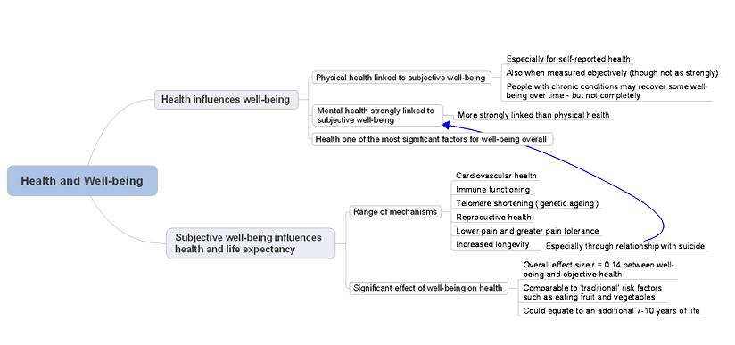
Fig 1 (Department of Health, 2014)

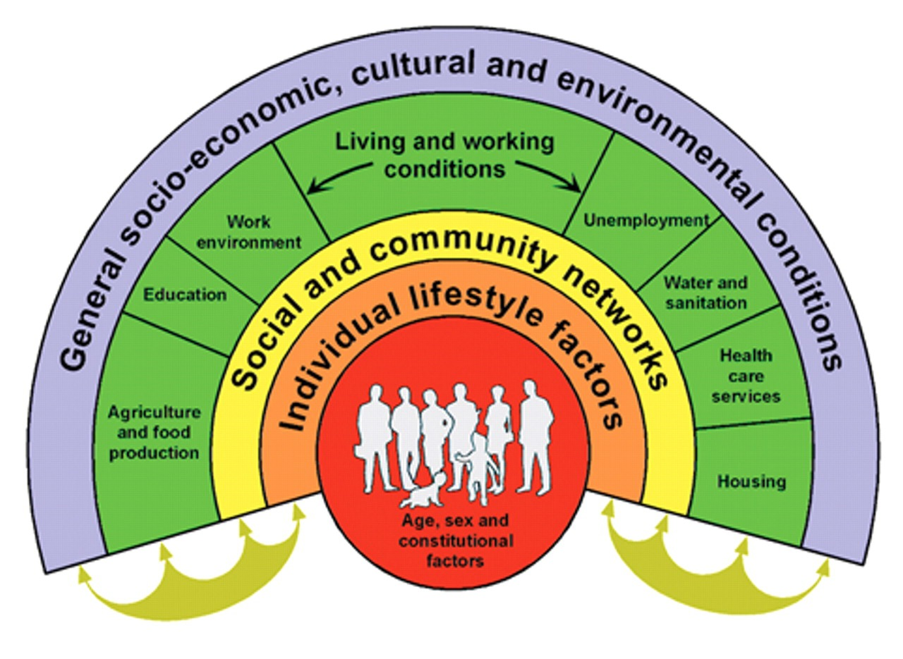
Fig 2 (Dahlgren and Whitehead, 2021)

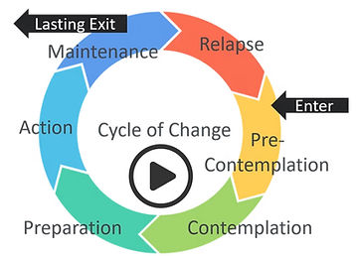
Fig 3 (The OAD Clinic, 2025)

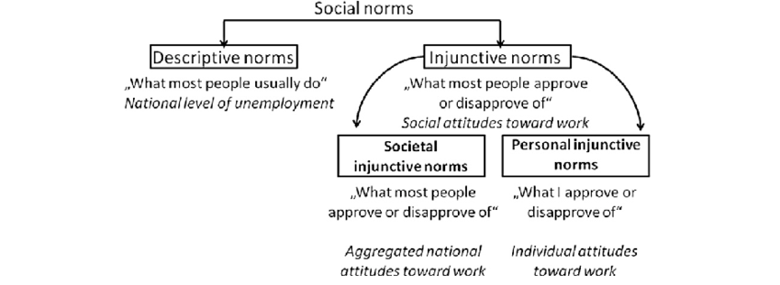
Fig 4 (Stavrova, Schlosser and Fetchenhauer, 2011)

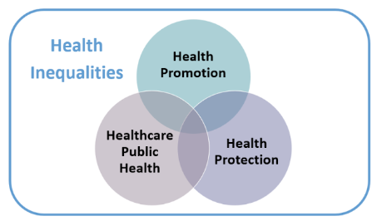
Fig 5 (Nansubuga, 2022)

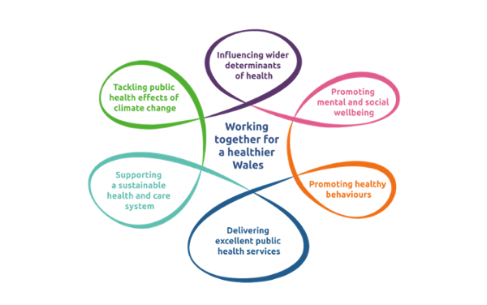

Fig 6 (Public Health Wales, 2023)

