

Database Design (The Book Store)
  - Information Engineering
  - Module Lecturer: Beverly Holland
  - Module no. accb4013
Ruzy Aktar | 1708215 | 5/05/19

Introduction
For this assignment the author has been asked to produce systems specifications and use them appropriately in the development of database design model. The author will also be generating a database solution which includes problem solving techniques to create a prototype application.
The task for this report is to help Dylan’s book store, they are a well-known bookstore in Swansea which have a high success rate. There are customers from all over the area including English, Scottish and Irish fans. But their working procedures need an update this is because currently they use their own intuition on what books they need to order from their suppliers for their customers. Rare editions such as ‘Milkwood, kill a mocking bird etc. are collectables which is hard to get.
Another one of their procedures are using mail order service for individuals outside of Swansea, furthermore, they hand out newsletters once every three months which includes current interest on their stocks’ Lastly they have a small computer that is used for word processing which is technically used as a data base.
However, Dylan’s book store has been very popular recently due to a famous welsh author which have been increasing the numbers at the store, to be able to withhold all the information Dylan’s book store has decided to upgrade their company information retrieval and processing. This means they have decided to be modern and use technology and computerise.
In order to complete the task the author for this report will be creating a database system that should be menu driven. The design for the record structure will be the choice of the authors. Dylan’s book store would like to use the system query information for customer seeking out specific titles in particular the classic to the rarest first editions and generate relevant reports on availability.
However, despite the fact that this is a standard stock plus mail order system, Dylan’s book store would like to preserve their friendly service and customer care that has helped then withhold their reputation, Dylan’s book store are eager for the system will allow for this adaptability.
Below are features of what will be included for the system;
- User has the ability to add or delete information from any table.
- User should be able to view, on screen, Book, stock, order and customer details.
- User should be able to view ongoing customer orders.
- User should be able to query the system and print out relevant reports.

Task 1
An Entity Relationship Diagram/ Documentation
For Dylan’s book store the author has created an Entity Relationship Diagram. These types of diagrams show a relationship of entity sets gathered in a database. An entity is an object, an element of data, they have similar entities and wide range of collections. These entities have attributes that characterizes its properties.
By going in depth with these entities, their attributes and physically showing the relationships relating, an (ERD) diagram summarizes the logical structure of databases.
Overall an (ERD) is a simple sketch of a database a company, personal business, school can use. It is very simple to make.’ ER diagrams are used to model and design relational databases, in terms of logic and business rules (in a logical data model) and in terms of the specific technology to be implemented (in a physical data model.) In software engineering, an ER diagram is often an initial step in determining requirements for an information systems project’ [1]
Entity
This can be a person, object, concept or event which has data stored. Such as a customer, student, car or product. Typically shown as a rectangle.
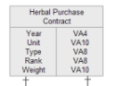

Entity type
A group of things you need to define, e.g. a person, singer, teacher, author.

Entity set
‘Same as an entity type, but defined at a particular point in time, such as students enrolled in a class on the first day. Other examples: Customers who purchased last month’[2].

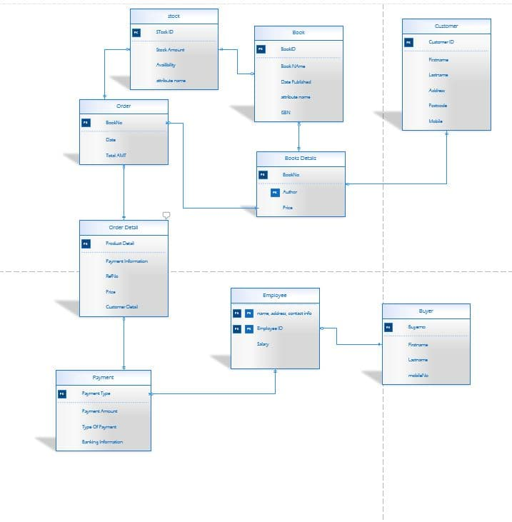
below the author has created an (ERD) this shows a simple sketch of Dylan’s book store, how every attributes links and builds a relationship. Dylan’s book store has a very old-fashioned way of searching for books and contacting their customers. To make this easy it is all planned out and ready to make. If you look carefully all components to make the book store successfully and easy to look up has been added to make the data base.

Database
Data bases are used to organize a huge collection of data. on the other hand, to put in in a simpler term, a database is an electronic based system that lets data to be easily viewed and accessed, changed, and updated. Data bases are usually used for business, schools. This is a modern way to store data and can always be backed up if it was to crash or get lost. Modern databases are managed using a database management system (DBMS).
‘Software programmers are well acquainted with database concepts through relational databases like Oracle, SQL SERVER and MySQL, etc. Typically, a database structure stores data in a tabular format’ [3]
For Dylan’s book store the author has created a series of forms, reports an queries to organize their system to be menu driven. Their old system was to use a small computer that was used for word processing and basically used as a data base
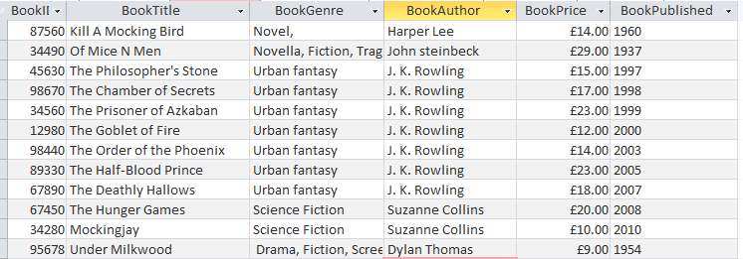
This new data base is much bigger and can be opened up easily everything has their own section. Firstly, the author used Microsoft Access to create the table below is an example of what the author did for each section

Here all the books titles, author, price as well as when it was published with the book ID. These makes it tidy and appealing to the eyes.

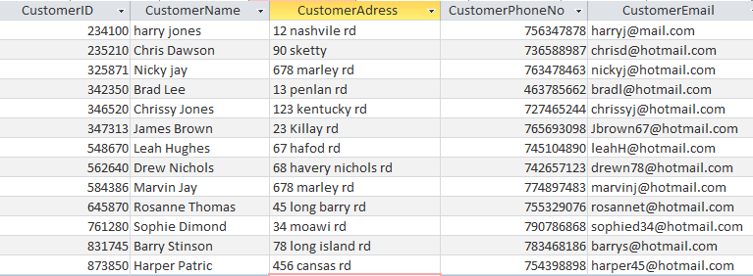

Here are the customer details. All of their customers have been put into one section of the data base you can easily see their names, addresses, email, phone number and even their book store ID has been put down. So, if they would like to reach out of customers out of Swansea, they can now easily get their email up to contact instead of doing it the old-fashioned way.

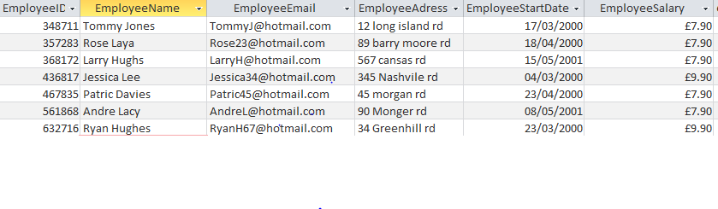

This is section of the bale is for all their employees, they can easily find colleagues details , this won’t take time to look up as it’s all been put on here , their employee name , work ID, email , address , their start date and how much salary they are on.
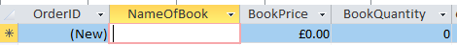

Here we have an organized way of seeing orders this is then not cluttered.

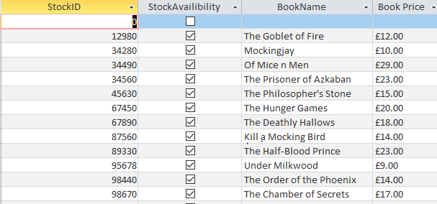

Here is all the stock information to see what is available, the book titles and price the tick boxes mean what books are available to purchase. This is an easy way of knowing what needs to be ordered if Dylan’s bookstore needed books that were out of stock.
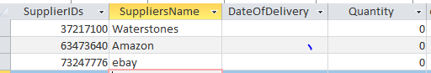

these are the supplies to show where the books are coming from and who they get delivered by
Queries
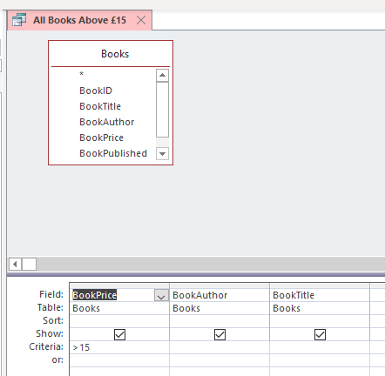
Dylan’s book store manager if he or she would want to see a certain part of the business such as books that cost above £15 then a query is good to do this below is an example for Dylan’s book store. Below you can also greater that 15 under book price.

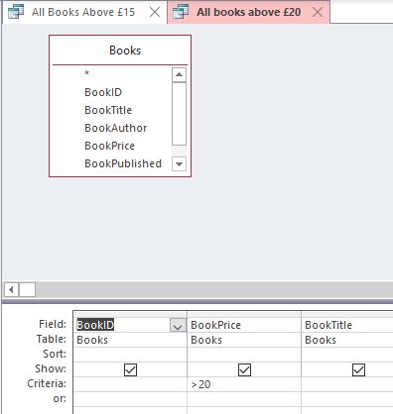
Here is also another query to show greater than £20, and they all show with the book title, price and author.

Forms
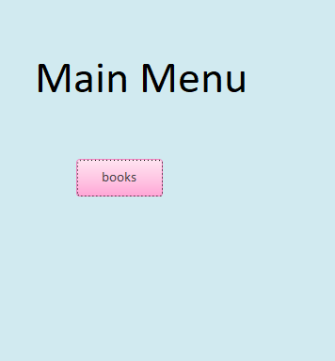
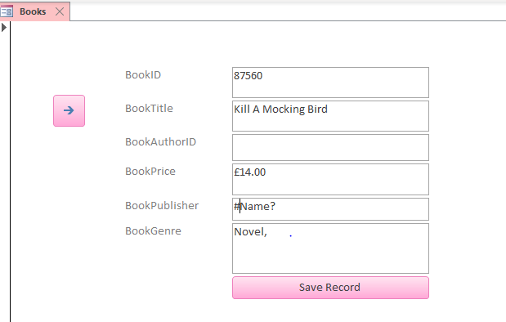

This allows the worker in Dylan’s book store input new books or search for a book by using the menu button.
Report
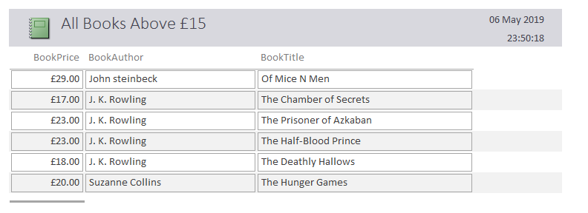

A report is to show what they have or to summarize something.

Forms
‘make that data available on the screen. With a form, you can view and edit the data, display it nicely, sort it, add to it, delete it and so on. Forms let you work with your data. They don’t hold any data – they are just a tool for viewing the data in your table’[4].
Reports
‘Also display your data, but on paper. Unlike Forms, Reports don’t allow you to edit the data – they are designed to be static. After all, once you’ve printed your data on paper (or as a PDF) it’s going to be pretty static, so Reports reflect that’[5]
Queries
‘Extract and link the data. Think about Amazon’s database. It has (maybe) a million products, a hundred million customers and a billion orders. The odds are that you’re not going to want to move this data across the internet very often – it would just take too long, and most of it would be irrelevant to what you’re actually wanting to find out. So the job of a query is to extract just the information you need for you to work with’[6].

Tables
‘Store data. Nothing else, no formatting, no sorting, no filtering, no calculating, just storing. The most basic, fundamental task of a database is to store data for easy retrieval and management’[7].

Refrences
- https://www.lucidchart.com/pages/er-diagrams
- https://www.lucidchart.com/pages/er-diagrams
- https://www.techopedia.com/definition/1185/database-db
- https://theitservice.co.uk/microsoft-access-objects/(4.5.6.7)

