

Assessment- 2 Design and
Deploy a Web Application for
UWTSD
ACCA5025_BIRM
University of Wales Trinity Saint David, Birmingham
Student Name: Cristian-Constantin Paraschiv
Student ID: 2026077

Contents
Introduction 3
Scenario: 3
Features 4
1. Auto Scale 4
2. Easy Deployments 4
3. Language Choice 5
4. Security 6
Create a web application: 6
Build and deploy new repository 11
Deployment of the application 14
Conclusion 15
References 16

Assessment- 2 Design and Deploy a Web Application for UWTSD

Introduction
A prototype cloud-based enables "ubiquitous, so forth, as well as handy internet connectivity to a sharable pool of configurable resources, such as networks, data centres, stockpiling, software, and facilities, which are quickly procured and published with little proper coordination or managed service interplay" [1]. An infrastructure solution that offers expandable, proxy on demand services that accessed from the Internet is known as cloud technology [2]. Using cloud technology, assets shared online. The cloud storage supplier's technology used to distribute these capabilities. The user including on, remuneration access to tools that are flexible and available anywhere. A degree of separation seen between necessary virtual resources and the supporting infrastructure, which includes the storing, connectivity, and applications, made possible by cloud - based software [2]. The user, computer host, as well as the three key delivering service types are all included in cloud applications. Any software or physical overlay layers that is employed to access to cloud storage is known as a cloud consumer. The three major delivering services kinds are provided by the cloud platforms using machines. Nevertheless, " Platform-as-a-Services (PaaS)\Infrastructure-as-a-Service (IaaS)\Software-as-a-Service (SaaS)” are the three main forms of delivering services (SaaS). A public cloud company's architecture used by PaaS to offer a desktop workstation for user usage [3]. Consequently, this essay will discuss how to create and implement a software platform. According to earlier research on high-performance computing (HPC) on public cloud, private clouds also could not match with specialized ensembles for HPC workloads, mostly because of poorer connection speeds [4] [5]. Cloud computing systems, on the other hand, are already providing additional example kinds optimized for high - performance, incorporating characteristics such new connection, greater memory, or quicker CPUs. Customers having increasingly demanding operations including big data, multimedia transcoding, and material environmental targeted by these examples [6]. Regarding HPC systems that use the client - server interaction framework for interaction, this research assesses the equipping new classes.

Scenario:
Among the most popular Azure tools that allows everyone to deploy any web applications on Azure is Web Apps. It could also contain a background function like something of a WCF Service and Web APIs in addition to a user-friendly application. Consumers may take use of Microsoft Azure's strength by using Web Apps to create versatile, very expandable, secure communications, and readily available telecommunication technologies or IoT services. All we must do in order to maintain the new website alive is deploy out proposal into it. Azure Server would take care of the remaining tasks. The main benefit of employing a webpage seems to be that we do not have to be concerned out about infrastructural architecture that needed to run the program. In the case of conventional hosted services, we must confirm that IIS is operational, the OS is current, and the server is online. However, inside the case of website apps, Azure App Fabric ensures that the software application allotted with the proper tools and processing power.

Features

Auto Scale
Within the SLA for web applications, Azure claims up to 99.9 percent reliability. We may scale out or scale up the web applications instances to manage the load to provide consumers with a flawless encounter including during periods of heavy request. Additionally, based on measurements such Processor, Memory use, users may establish auto-scale to web browsers (Figure 1).
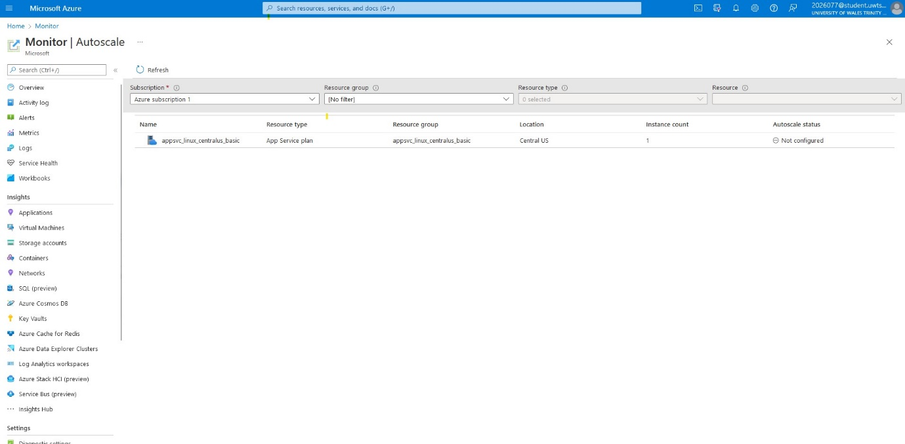
Figure 1: Auto-scale

Easy Deployments
Using the DevOps functionality, we may launch such programs straight using system software repositories such:
- Visual Studio Team Services
- Git Hub,
- Bitbucket, while developing web application (Figure 2).
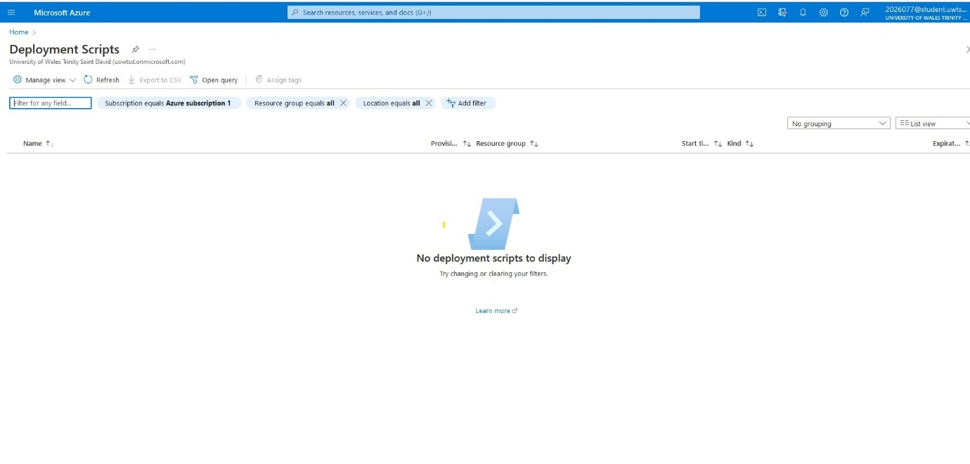
Figure 2: Easy Deployments

Language Choice
Applications created using ASP.Net and other languages and frameworks supported by web applications:
- Java
- PHP
- Python
- Net Core
- Node.js
High - level programming technologies and tools supported by the Azure development tools, among of the most popular ones. One may also use Shell and other specific applications or compiled code as foreground processes (Figure 3).
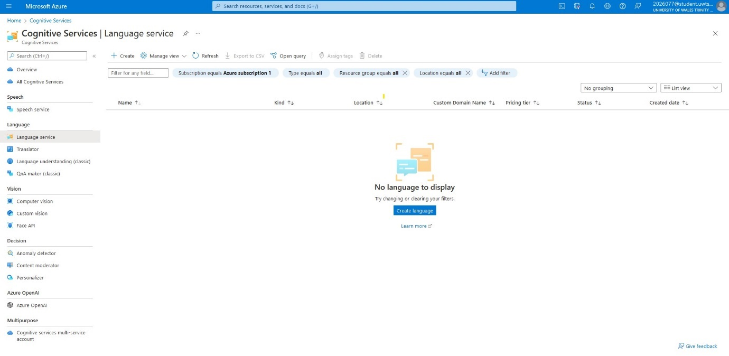
Figure 3: Cognitive Service

Security
Manufacturers could improve the functionality of online forms by integrating identity - based designation. Azure Ads may use, as instance, to keep track of an existing account, authorized access, and authorisation. This same security feature is quite good because the Windows azure organisation and its clients with security protocols like:
- ISO
- SOC
- PCI

Create a web application:
First register an account, which is free for testing and trial purposes, in order to design and edit a site using Microsoft Azure, as it has been shown in Figure 1. As we already indicated, a payment required, though it is completely free to try it out.
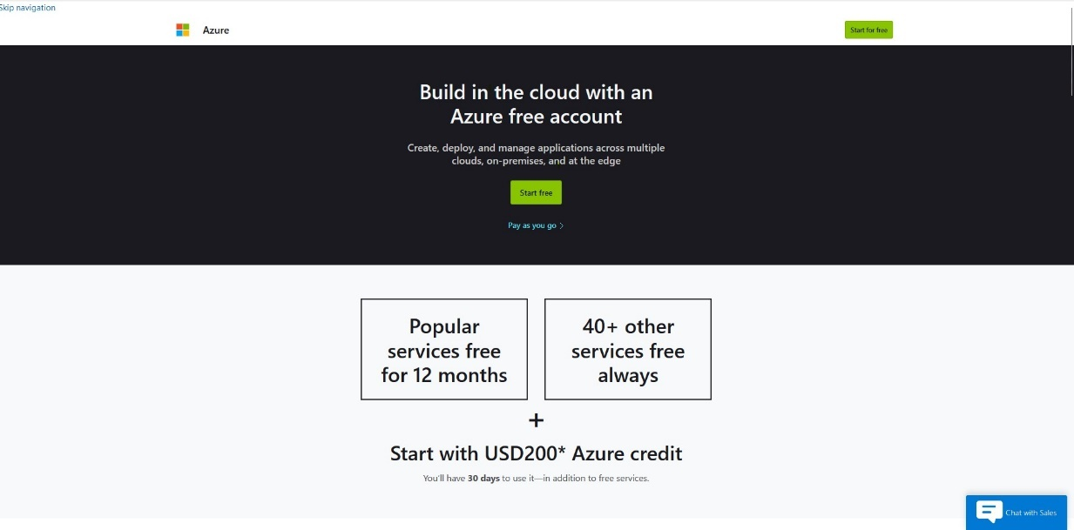
Figure 4: Azure account
The platform’s configurations modified to suit their personal tastes. This same Options button, located in the upper right corner of the worldwide ’s main, contains most preferences. A root folder gateway allows users to toggle between and modify categories inside the directories area. Whenever users log in to the site, users have the option of selecting the memberships which is implemented. Assuming users operate with such a main subscriber database however sometimes get other, this might be useful, further information in Figure 5. 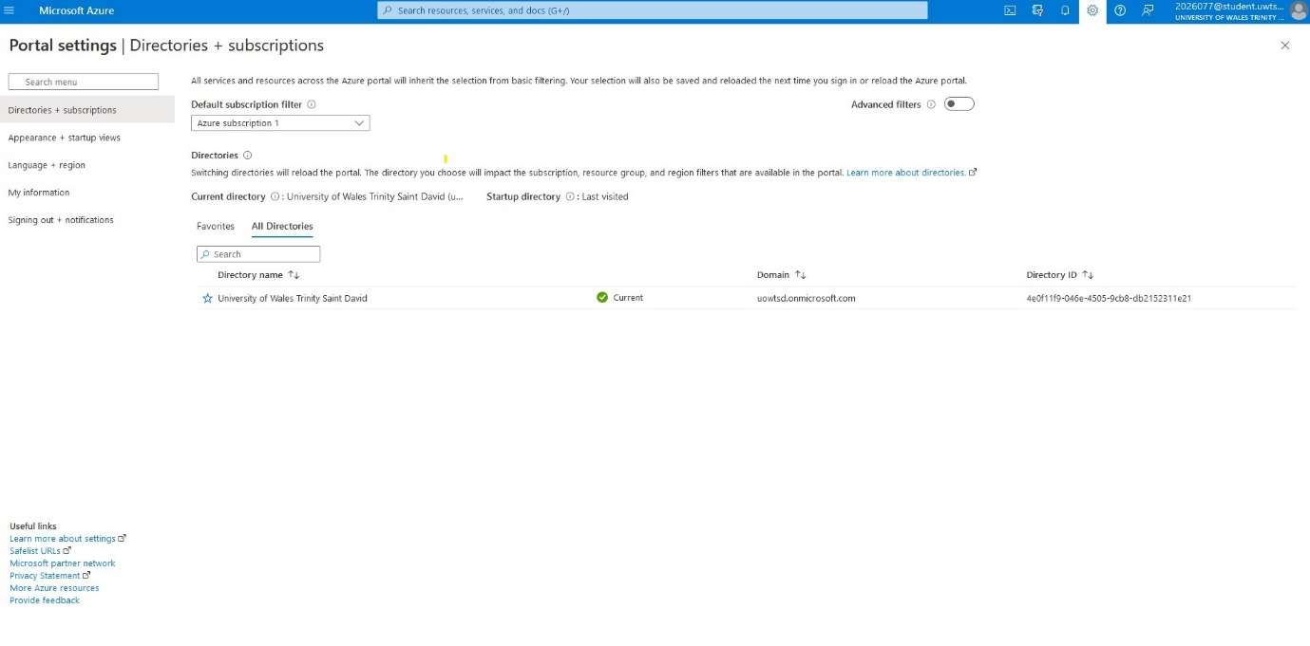
Figure 5: Settings
Users may examine in-depth details on capabilities from all existing Azure memberships using the Azure site. This story illustrates knowledge filtering and using viewpoints to aid you to better comprehend your assets. This display seen in the accompanying snapshot (Figure 3), titled "All resources," is indeed the article's subject matter. Various choices are available on panels for specific types of resources, such like VMs, including the option to begin and terminate a VMs. There are only these few features in the interface.
When utilising categories to concentrate on a portion of your assets, begin by investigating the whole of available assets. The limiting on support agencies in the next attached file selects two of something like the subscription's few support agencies. As seen in the accompanying example, you may mix criteria, including based on textual queries. Under this instance, the findings limited to materials belonging to one of the pre-selected two production categories which contains the term "SimpleWinVM." Pick "Manage view" and then modify or edit sections to modify a point's row inclusions. From such a view, you may download the asset data. to download data in CSV format. Additional locations where you might download data found as users navigate the site, like a specific resource group (Figure 6).
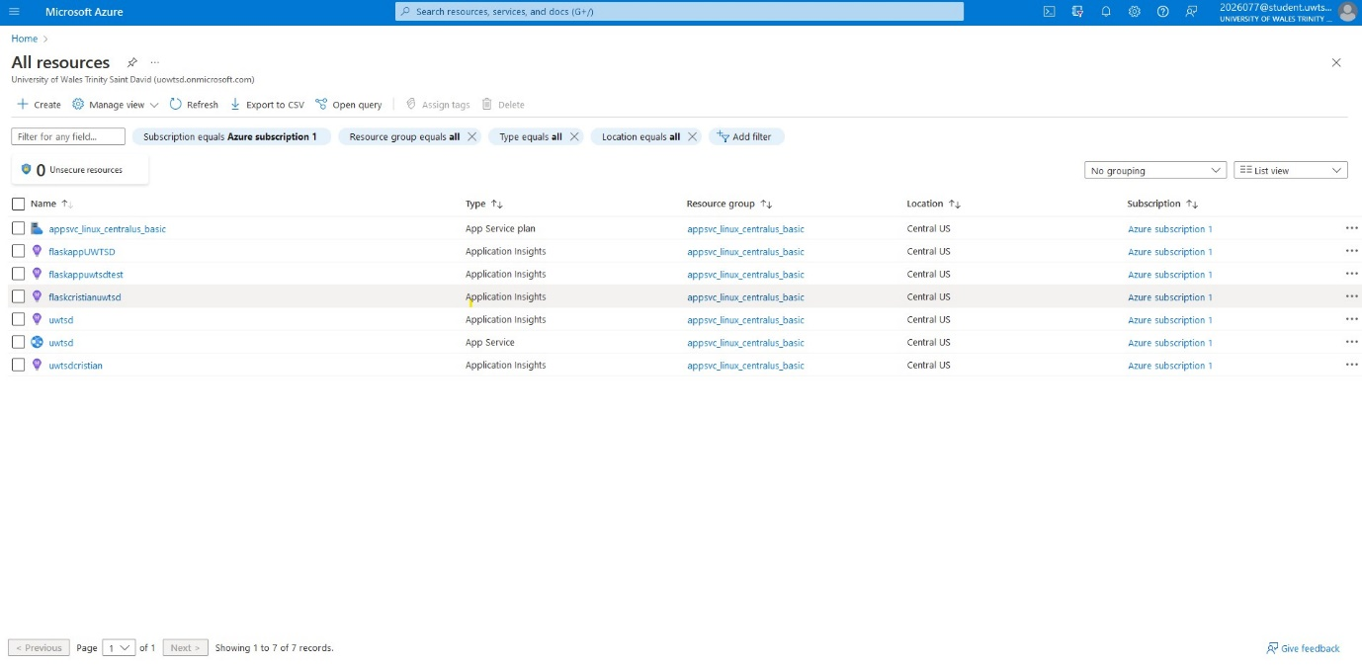
Figure 6: Resources menu
As earlier mentioned, when you click the "Create" button, sent to a gateway that directs you to the options we should choose based on your requirements. In this instance, we choose the "Web App" option. The gateway has a variety of choices that could acces inside the frequency of usage, further details within Figure 7.
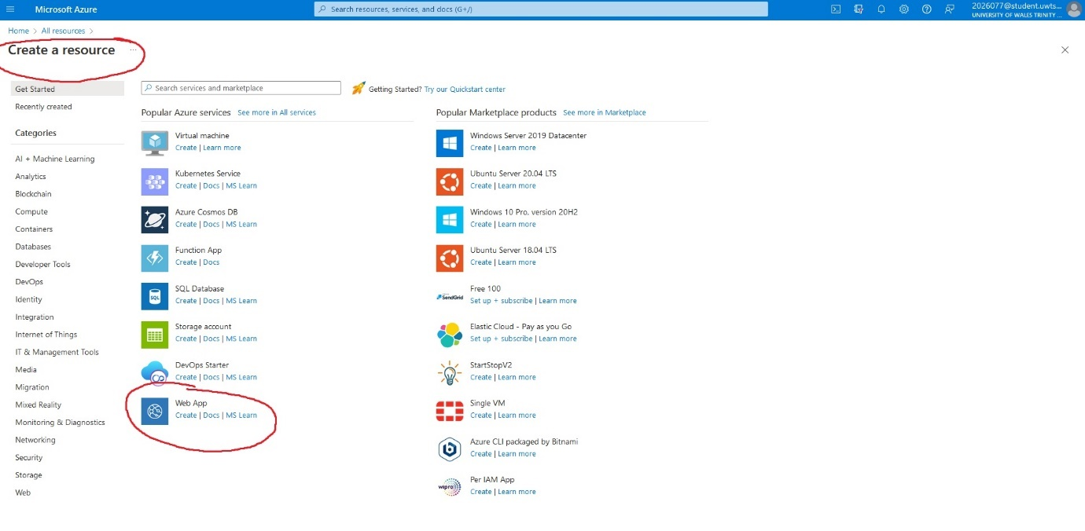
Figure 7: How to create a web app

Every next phase of the program is to choose whatever sort of membership you are using in the gateway and capacity category once the "Web App" inside the gateway has indeed chosen. For example, in order to create the names for our URL website, we must choose the identity of our program. The following alternative, however, depends on what needed but also what fits inside the constraints. Python serves as my application's execution layer (Figure 8).
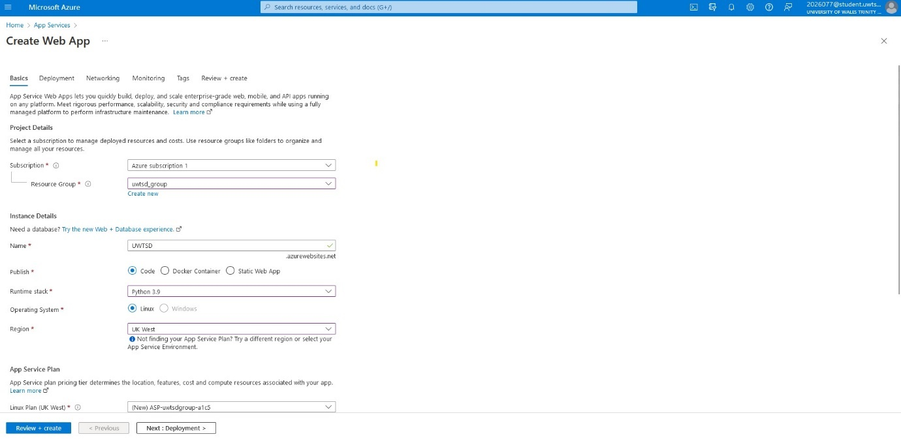
Figure 8: How to create a web app
Currently installation is the final stage of building inside the interface. In order to rapidly configure the application within Git and allowing Git activity upon installation. So originally signed up for a unique account on the Git domain so to be able to view the gateway's documents. (Figure 9).
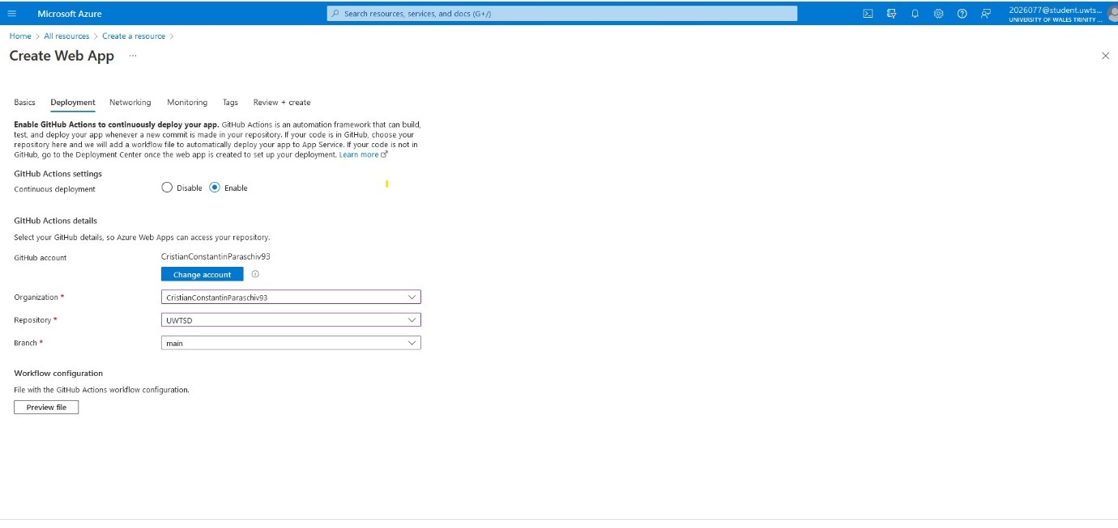
Figure 9: Deployment for web app by GitHub

Evaluate and creating the previous choice made represent the final steps. It would be the result of the subsequent Git phase, provision. The creation and temporary abandonment of it are the only steps left (Figure 10).
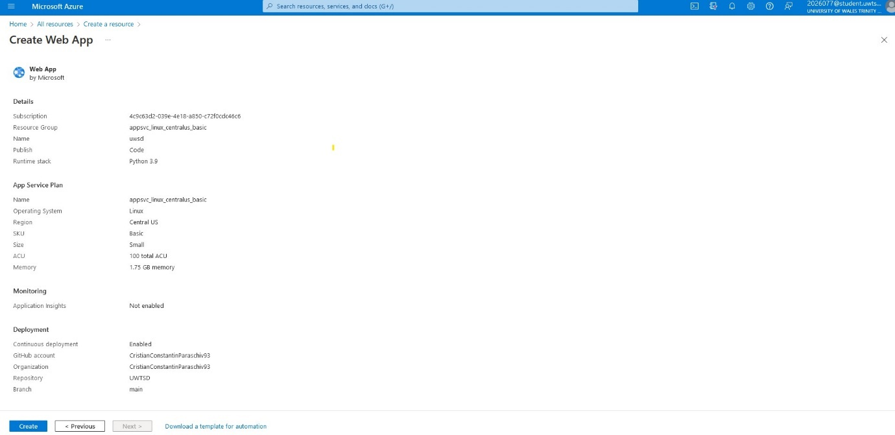
Figure 10: Review of the app
In the preceding phase, after selecting the generate option, we would have to take time for the site to react with the items we had generated and chosen (Figure 11).
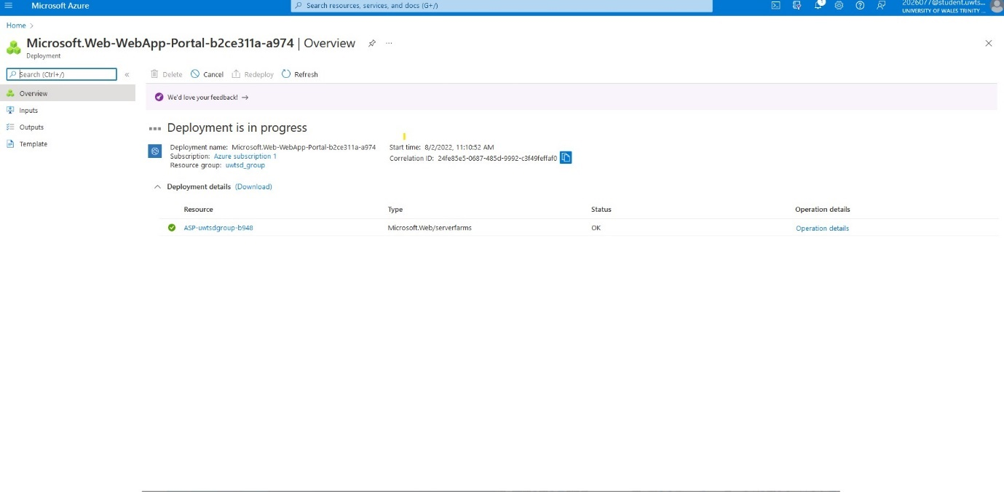
Figure 11: Deployment in progress
If this is the initial occasion publishing through Git, choose to authenticate then adhere to the authorisation instructions. Select Change Account if you wish to publish from another person's repository. Once connected, Git login to Azure account, choose the organizational, source, and branches users want to set up CI/CD services. Perhaps may require allowing extra Git privileges when users did not spot an organisation or repository. Both Application layer and Edition selection menus let choose the process document users want when Git Activities chosen as the building supplier. To manage building and deployment duties, Azure pushes this procedure file to the Git repository user chosen (Figure 12).
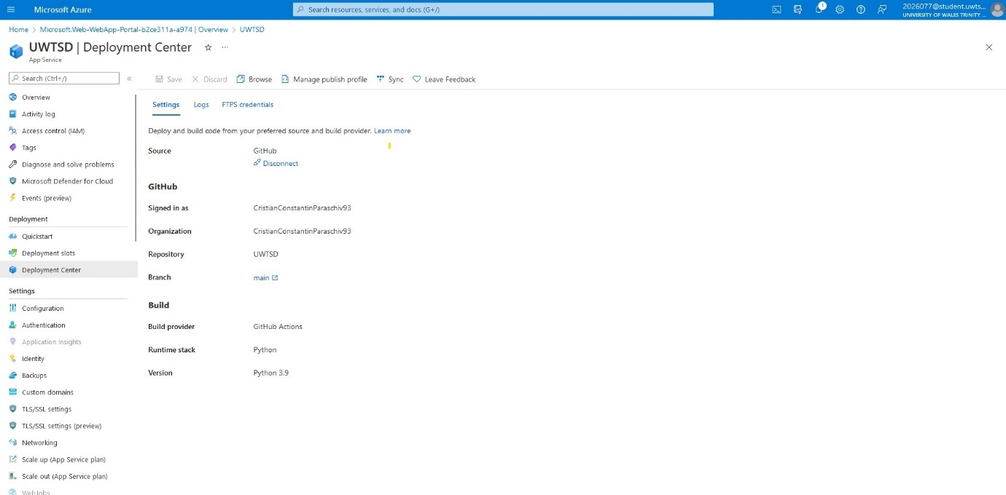
Figure 12: UWTSD Deployment Centre

Build and deploy new repository
Programs are among the types of tasks you may keep in Git repositories. Anyone may exchange code to create stronger, safer dependable technology using free software initiatives. Repositories may use to monitor personal activity, interact with everyone, and discover something about open - sourced initiatives. Should use fall box in the crossbar of any webpage to select Options source. For repositories, enter a succinct, special name. For illustration, "UWTSD." Users may also include a repository descriptor. For illustration, "flasappUWTSD." Decide on the repository accessibility. Choose "Create a README during repository start-up (Figure 13). In order to access the services offered by GitHub, customers also must register a particular account on their page.
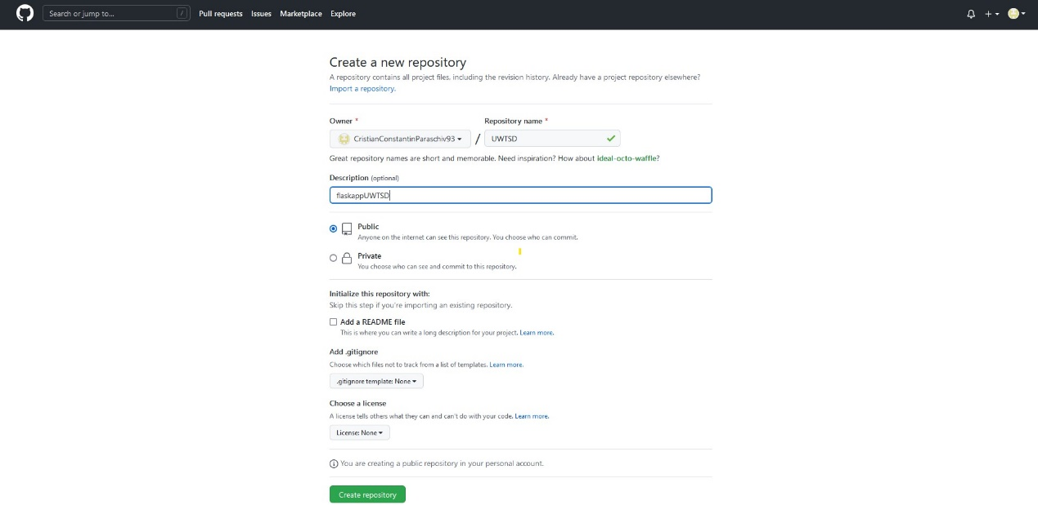
Figure 13: GitHub repository
Create a new folder or transfer an old one to get going(Figure 14).
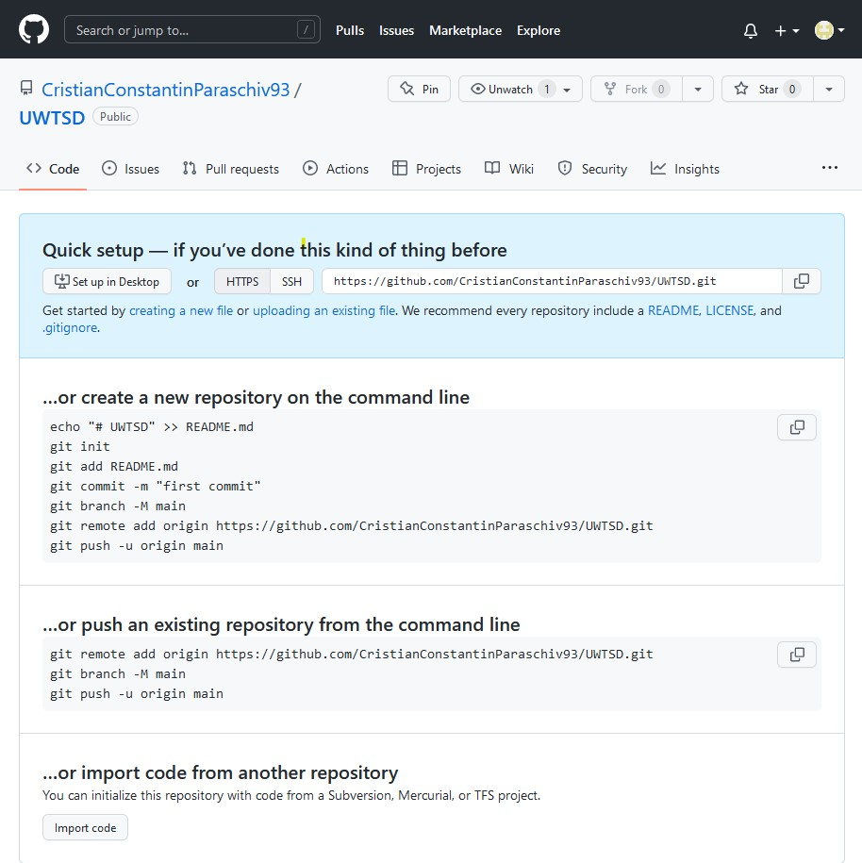
Figure 14:Setup files for repository
Next phase entails dragging and dropping the Git data that we possess from the website (Figure 15).
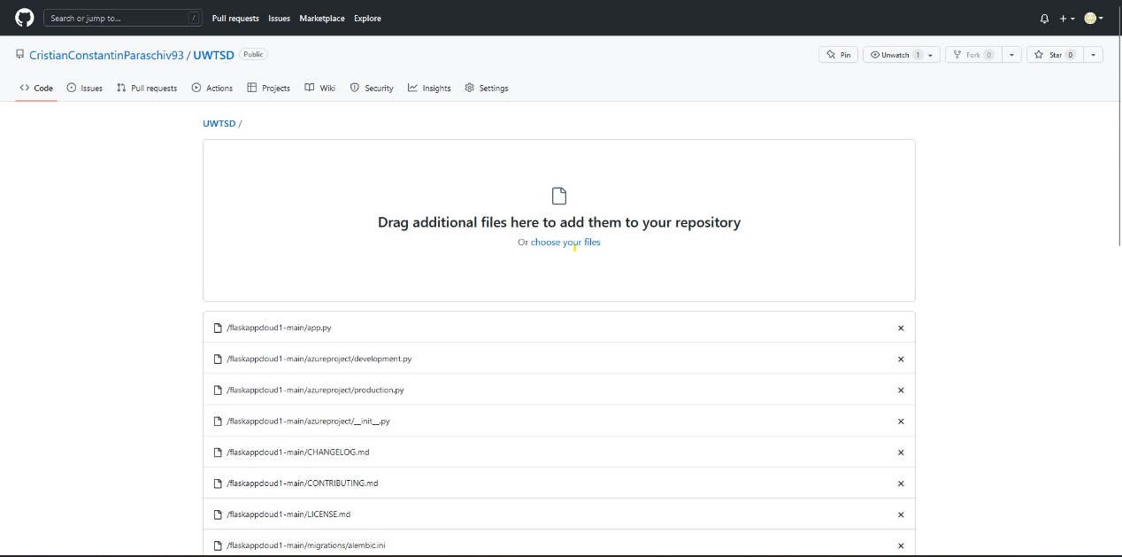
Figure 15: Drag and drop Git file
This procedure demonstrates that documents have really processed (Figure 16).
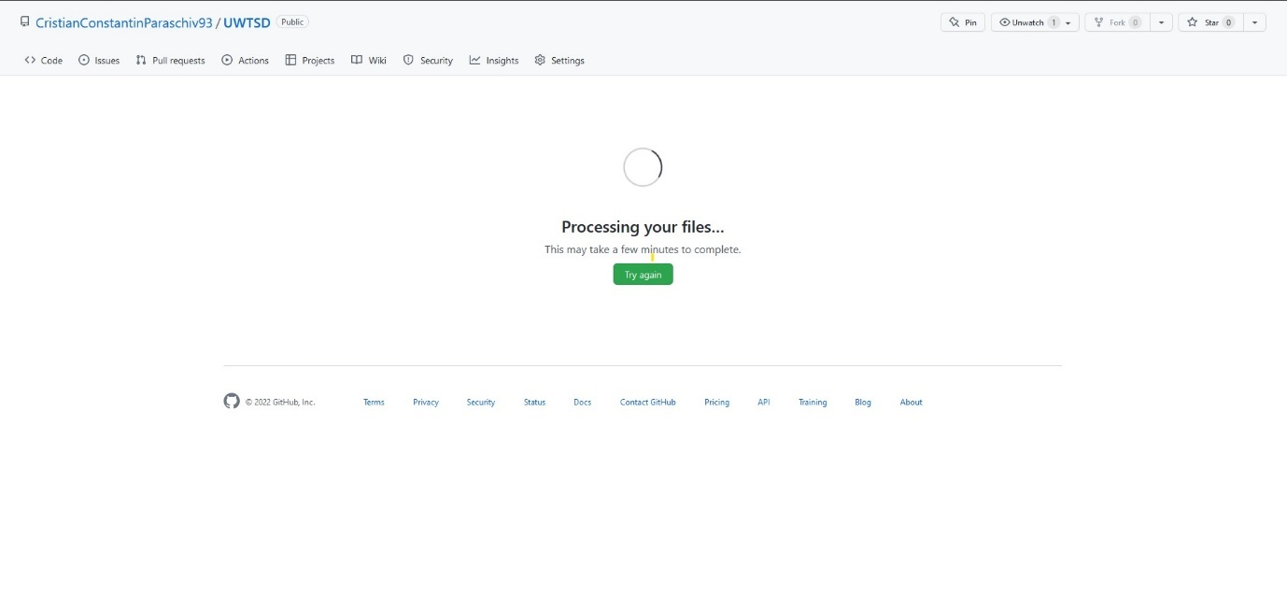
Figure 16: Uploading files
To leverage and set up the environment for Azure web apps, we must construct and publish from the customer viewpoint to action (Figure 17,18).
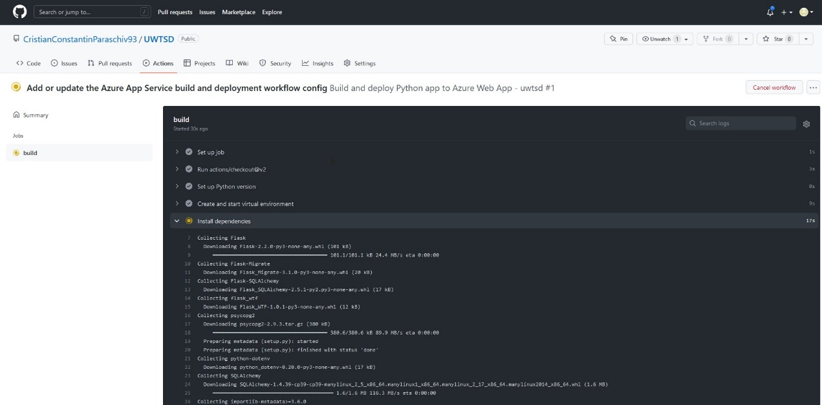
Figure 17: Action
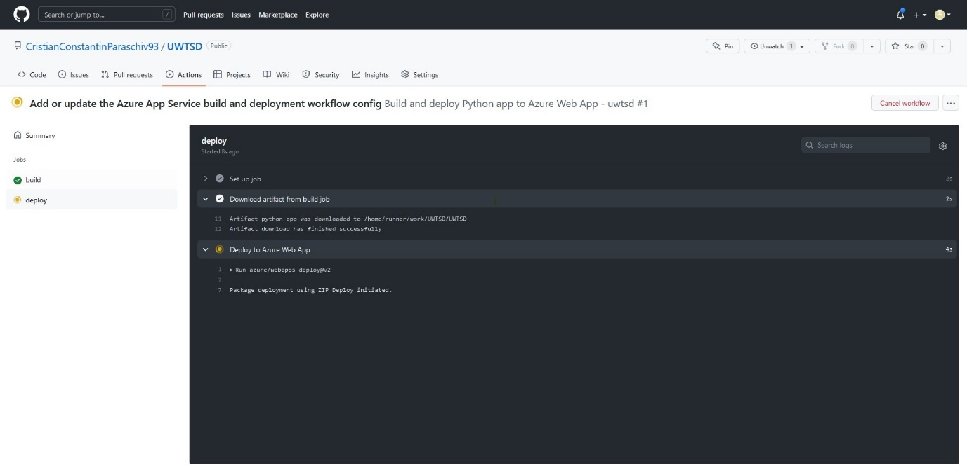
Figure 18:Deploy

Git has reached its conclusion; all tasks successfully completed, and the web application is now ready for deployment (Figure 19).
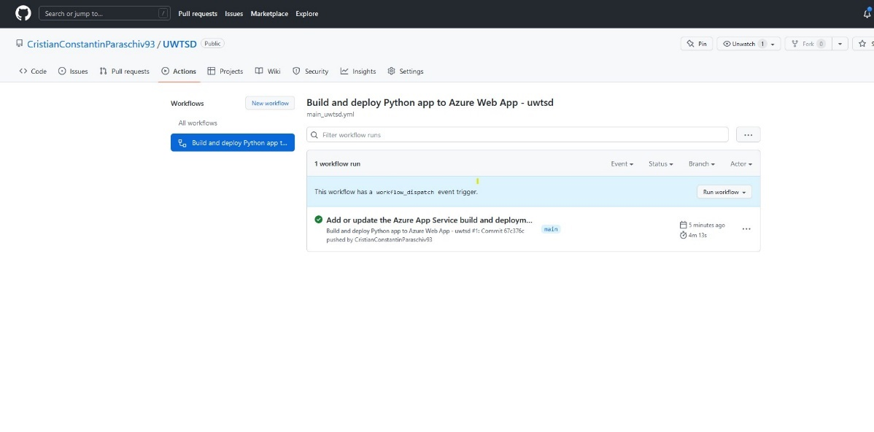
Figure 19: App deployed into Azure

Deployment of the application
Everything has successfully implemented, which is evidence that it was because the programme was up and running and error-free (Figure 20).
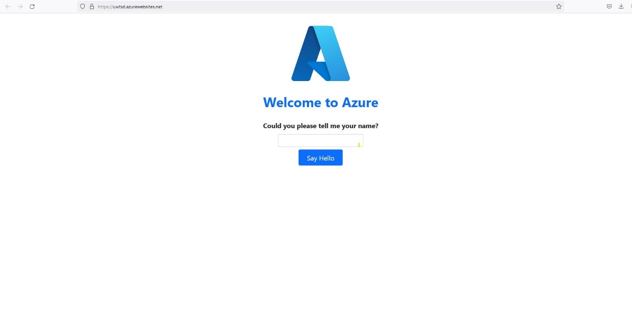
Figure 20: User testing

Conclusion
It has been determined from the research how cloud technology gives businesses, or consumers accessibility to expandable, on-demand assets wherever they are and whenever they need them. Customers of the internet do not have to always concern well about technology costs associated with internally creating candidates. Applications and flexible engagement options offered by the cloud's structure. According to a poll taken, businesses spend the most money on SaaS, and cloud infrastructure usage predicted to grow faster than virtual private usage in the future. Having decided on such a set of established principles, an organization should subsequently record and distribute to relevant management and users the procedures, strategies, regulations, and regulations which complement those policies. It is also crucial to have a backup strategy in place in case the system fails or there is a calamity.

References
[1] P. Mell and T. Grance, “The NIST Definition of Cloud Computing Recommendations of the National Institute of Standards and Technology,” Natl. Inst. Stand. Technol. Inf. Technol. Lab., vol. 145, p. 7, 2011.
[2] F. Hu et al., “A review on cloud computing: Design challenges in architecture and security,” Journal of Computing and Information Technology, vol. 19, no. 1. pp. 25–55, 2011.
[3] M. Ali, S. U. Khan, and A. V Vasilakos, “Security in cloud computing: Opportunities and challenges,” Inf. Sci. (Ny)., vol. 305, pp. 357–383, 2015.
[4] K. R. Jackson, L. Ramakrishnan, K. Muriki, S. Canon, S. Cholia, J. Shalf, H. J. Wasserman and N. J. Wright, "Performance Analysis of High Performance Computing Applications on the Amazon Web Services Cloud," in 2nd IEEE International Conference on Cloud Computing Technology and Science, Indianapolis, IN, USA, 2010.
[5] P. Mehrotra, J. Djomehri, S. Heistand, R. Hood, H. Jin, A. Lazanoff, S. Saini and R. Biswas, "Performance Evaluation of Amazon EC2 for NASA HPC Applications," in Proceedings of the 3rd Workshop on Scientific Cloud Computing, Delft, The Netherlands, 2012.
[6] Amazon Web Services, "Amazon EC2 Instance Types," 2017. [Online]. Available: https://aws.amazon.com/ec2/instance-types/

