An Analysis-Led Approach to
Advanced Persistent Threats

Julie Millard | P150865

Supervising Lecturer: Dr Carlene Campbell

Lecturer: Dr Mabrouka Abuhmida
BSc (Hons) Computing Portfolio
Project Management and Research Methods | ACDA5004

Table of Contents

Introduction 4
Background 4
Rationale 4
Literature Review 1 5
“How Advanced Persistent Threats Exploit Humans” [6]. 5
Summary 5
Evaluation 5
Conclusion 6
Literature Review 2 6
“Advanced Persistent Threats: Behind the Scenes”[7] 6
Summary 6
Evaluation 7
Conclusion 7
Project Aims and Objectives 8
Expected Outcomes 8
Research and Development 8
Resources and Planning 9
Risks 9
Gantt Chart Part 1 10
Gantt Chart Part 2 10
Mind Map 11
Bibliography 12

Table of Figures
Figure 1: Research Onion [8] 8
Figure 3: Gantt Chart Part 1 10
Figure 4: Gantt Chart Part 2 10
Figure 2: Mind Map 11

Introduction
This proposal aims to outline the steps taken to analyse an Advanced Persistent Threat (APT). Advanced Persistent Threats are long-term, targeted, cyber-attacks. They are aimed at governments, health care professions, high-profile people or companies. They involve many steps, are usually well-funded, and remain undetected for long periods of time. The analysis of an APT is important to be able to answer questions such as: What was the intention of the attack? What files were compromised? What programs were exploited? What tools were employed in the attack? Was the attack successful? How to protect from future attacks that use similar means and methods [1], [2].

Background
The aim of an APT is to gain unauthorised access to a network, move stealthily through the network, gather information and remove information while staying undetected. In 1998 an intrusion was detected in the US Department of Defense, Pentagon and NASA networks [1]–[3], this intrusion was later code named Moonlight Maze. It is thought to have lasted over two years and is one of the earliest recorded APTs. It was attributed to the Russian Government [4], [5]. The full extent of that APT has not yet been made general knowledge.

Rationale
Underlying reasons for analysing an advanced persistent threat are:
- To understand how the network was compromised so that future attacks that employ the same or similar techniques are thwarted.
- To find out what parts of the network were compromised and find ways to improve the network security.
- To study where the attacker was headed. Why did they choose this direction?
- To locate what the attacker removed (if anything.) Are there any large files exiting the system?
- To find if files were deleted or manipulated.
- To understand the motive of the attack. Was it for proprietary knowledge?
- To examine if there was any malware introduced to the network. If so, remove it.
- To determine if any passwords were compromised.
.

Literature Review 1

“How Advanced Persistent Threats Exploit Humans” [6].

Summary
The following literature review covers a paper on how APTs exploit humans. The paper is split into seven sections. The introduction elucidates how large the threat of APTs are and how it was posited APTs originated from Governments spying on other Governments although this cannot be proved. It added that APTs are no longer limited to Governments. Section two explains an APT and expands on the points examined. The third and fourth sections of the paper is where the discussion surrounding how APTs exploit humans. Section five evaluates the significance of a successful APT while section six gauges security awareness in organisations. The conclusion surmises the only way an APT occurs is through human exploitation. It touches upon the negative effects of a successful APT and suggests future research into addressing APT attack vectors.

Evaluation
Included in the introduction is the reference to an organisation’s survey on how organisations ranked APTs. It states the survey found APTs to be the third security threat. It is unclear what the survey asked for. Was it a closed-ended question such as: Choose from the following and rank in order of threat? Or an open-ended question such as: What does your organisation think are the top three security threats, in order of importance? Furthermore, the sources provided contradict each. The writer states as fact that manipulation and wilful participation are the cause of most APTs without justification. The writer then mentioned a document review. It would have been useful if the documents covered in the review were noted or put into the bibliography.
2.2 briefly comments on network scanning and mapping mechanisms but does not go into any detail on what they are. 2.3 uses a graph to show methods used to penetrate networks. There is no source for where the graph information came from and there is no mention of the network scanning and mapping mechanisms mentioned in 2.2. This seems biased towards a lack of security awareness of end users and the writer’s main objective which is to create a networking security model for APTs.
Section 3 refers to section 2 regarding APTs being successful because of human exploitation. As section two appears biased, it cannot be relied upon as a reference for section 3. Table 1 gives an example of 8 successful attacks, however, there was only one known willing participant which does not lend itself to convincing the reader to the validity of the writer’s premise of employees willingly participating in APTs.
Section 4 explains the background to social engineering and pinpoints reasons humans can be manipulated. One reason being trust – regarding e-mails. The perceived trust is exploited and e-mails with attachments are downloaded. As the writer is not examining other reasons, such as were the company’s policy and procedures adhered to or updating said policies and procedures to exclude the ability to download attachments, it is difficult for the outcome to be anything other than manipulation. If policy and procedures were not adhered to it would then be disregard for company rules and not manipulation. Therefore, this reasoning is considered biased.
Section 5 contradicts the introduction, stating here that most APTs are created by governments. In the introduction it states that this has never been proven. The writer then digresses and starts talking about cyber war and how that could turn into a war.
Section 6 is based on literature studies but does not state what studies and recommends focus on awareness campaigns. Is this because the user is planning to create a technical model to alleviate human exploitation in connection with APTs?

Conclusion
While the paper was about human exploitation regarding APTs, this reader was not convinced the paper was unbiased. The writer used sources that contradict themselves, and even contradicted their own writing. The writer used generalised sweeping statements, facts that were not validated and sources that appear biased due to the very nature of their business. There were no limitations set out, and the main purpose of the paper seems to be promoting the writers further research on developing a technical model to address human exploitation.

Literature Review 2

“Advanced Persistent Threats: Behind the Scenes”[7]

Summary
Literature review two focuses on techniques used to carry out APTs. It consists of five sections. The first section describes the main objective of APTs and states that not all activities of an APT are found. There is no validation for this statement. Commonalities found in different stages of the attacks was also discussed. Section two looked at related work, includes life cycles of APT attacks and touches on preventative measures for APTs. Section three discusses different phases of APTs and the paper is limited to analysing three main phases. The fourth section discusses the different ways APT campaigns work and proposes a detection approach and suggests the possibility of lateral movement detection. The final section concludes the paper and suggests focusing on threat actors service providers and domain registrars along with detection and prevention approaches.

Evaluation
The paper discusses how APTs are implemented and compares different beliefs as to what steps are taken. It is limited to the initial compromise, lateral movement and command and control. It also focuses on Windows as the attacks exploited this program to conduct the APTs. The paper discusses analysed reports of four campaigns from two different sources but does not mention if the campaigns are the same. When talking about countermeasures, several works are reviewed and found only general approaches were proposed. The writer then proposes different approaches but does not discuss them here. Section three discusses analysing twenty-two well know APTs and examines what is considered the original means of access. The writer effectively described the common attacks and then explains the lateral movement. This again is successfully written. The table is appropriately presented, with suitably cited data. The writer gives an unbiased overview of the APTs analysed. It is suggested the HTTP and HTTPS was used as communication channels due to companies allowing access to these ports to their employees. Section five explains why bogus activities are difficult to distinguish. The writer re-iterates the generic countermeasures already suggested and hints at a better approach. The writer proposed using Microsoft Enhanced Mitigation Experience Toolkit. The writer focused on showcasing this product and its uses for APTs. When discussing standard tools, the writer again focuses on a Microsoft product as Windows was the program exploited. The conclusion mentions the campaigns covered, the proposed prevention techniques and future work.

Conclusion
Overall the paper was well written, covering the different steps of an APT. It explained why APTs are difficult to detect and proposed ways to impede APT attacks using Microsoft Enhanced Mitigation Experience Toolkit. As it was mentioned that the writer was focusing on Windows it does not appear to be a biased paper.

Project Aims and Objectives
The overarching aim of the proposal is to investigate Advanced Persistent Threats in an analysis-led approach. How to analyse an APT will be achieved by the following:
- Research literature reviews into APT approaches and critically analyse them.
- Logically analyse an APT.
- Identify social engineering methods used in APTs.
- Develop a small-scale experiment utilizing APT strategies.
- Evaluate the result.

Expected Outcomes
A literature review will have been made of APT approaches and an analysis will have been made of an APT. Social engineering methods will be identified. An experiment using the learnt strategies will be made and the results will be evaluated.

Research and Development
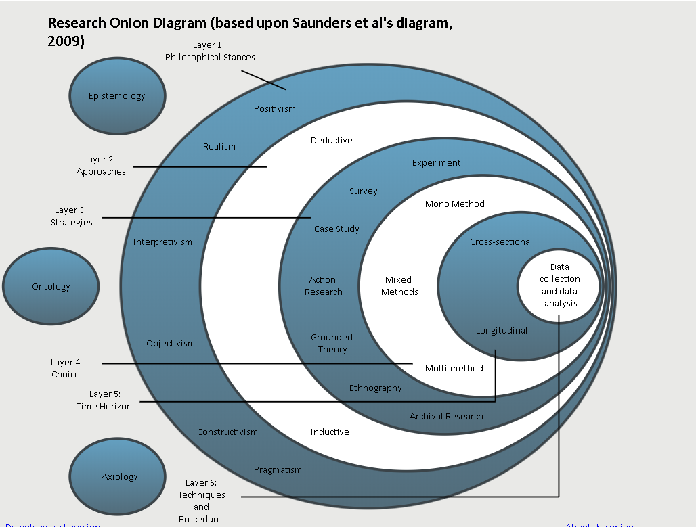
Figure 1: Research Onion [8]
A research onion was used to identify the research and development methods.
- Positivism will be the philosophy used as it relies on scientific verification, exact or valid proof [9].
- The approach is deductivism as an experiment will be run [10].
- The strategy will be an experiment.
- Mono method is being utilized as only one experiment will be conducted.
- The experiment will be cross-sectional due to time constraints.
- It is unclear at this time if the experiment used would be generalizable [11].
- “Validity in data collection means that your findings truly represent the phenomenon you are claiming to measure”[12]. The experiment aims to provide valid data.
- Reliability recreates an experiment that is able to reproduce the same results.

Resources and Planning
To be able to achieve the aims and objectives the following will need to be addressed:
- An APT scenario to be analysed.
- Compare the findings of the analysis to how the APT was purportedly conducted.
- A planned experiment to infiltrate a network and exfiltrate data.
- Access to software such as Metasploit.

Risks
- Time constraints to conduct an APT. Please see Gantt Charts 1 and 2.
- An APT is available to be analysed.
- A suitable network is available for the experimental APT attack.
- Legal issues addressed (performing a hack).

Gantt Chart Part 1
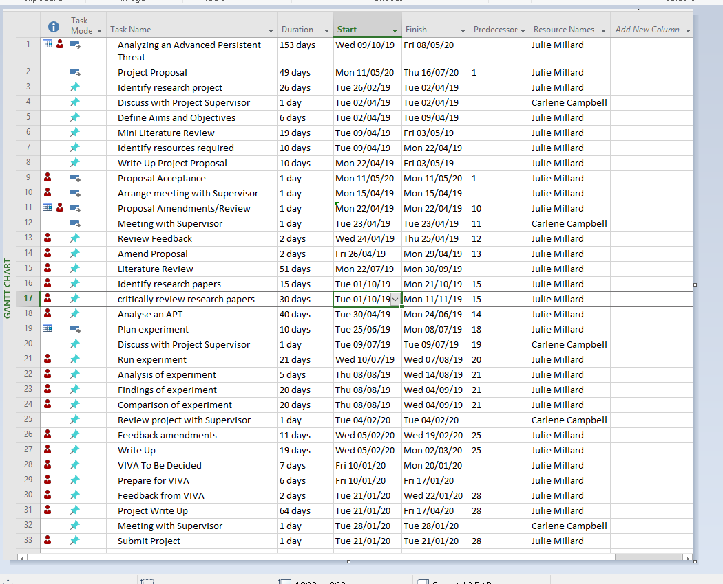
Figure 3: Gantt Chart Part 1

Gantt Chart Part 2
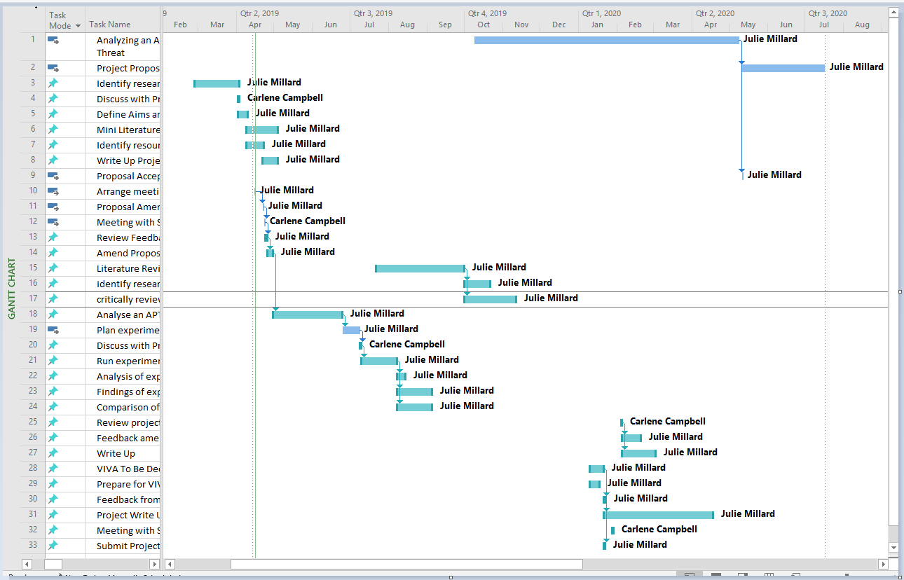
Figure 4: Gantt Chart Part 2

Mind Map
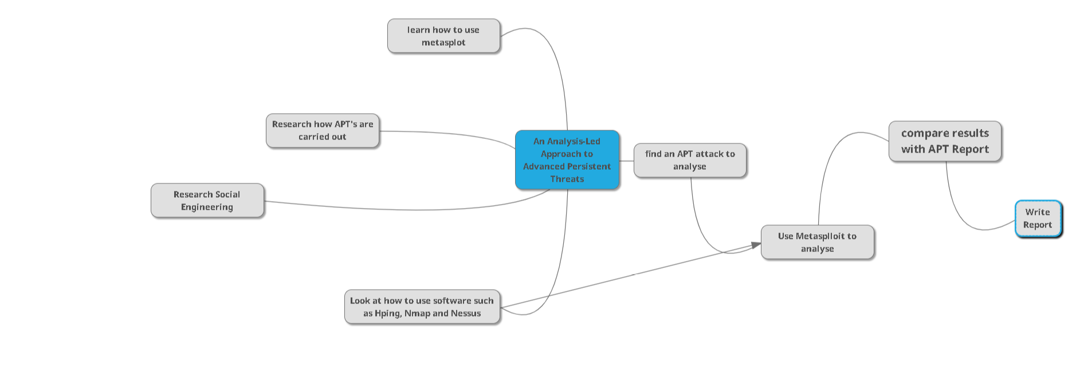
Figure 2: Mind Map

Bibliography
[1] A. S. Kapto, “Cyberwarfare: Genesis and doctrinal outlines,” Her. Russ. Acad. Sci., vol. 83, no. 4, pp. 357–364, Jul. 2013.
[2] C. Brown, D. Lee, C. Scott, D. Strunk, J. Goldsmith, and H. Law, “American Cyber Insecurity: The growing danger of cyber attacks Introduction and Statement of Problem.”
[3] S. Panguluri, W. Phillips, and P. Ellis, “Cyber Security: Protecting Water and Wastewater Infrastructure,” in Handbook of Water and Wastewater Systems Protection, New York, NY: Springer New York, 2011, pp. 285–318.
[4] “New Evidence Links a 20-Year-Old Hack on the US Government to a Modern Attack Group - Motherboard,” 2019. [Online]. Available: https://motherboard.vice.com/en_us/article/vvk83b/moonlight-maze-turla-link. [Accessed: 21-Apr-2019].
[5] “PENQUIN’S MOONLIT MAZE.”
[6] K. Krombholz, H. Hobel, M. Huber, and E. Weippl, “Advanced social engineering attacks,” J. Inf. Secur. Appl., vol. 22, pp. 113–122, Jun. 2015.
[7] M. Ussath, D. Jaeger, Feng Cheng, and C. Meinel, “Advanced persistent threats: Behind the scenes,” in 2016 Annual Conference on Information Science and Systems (CISS), 2016, pp. 181–186.
[8] Saunders et al, “Research Onion.” [Online]. Available: https://onion.derby.ac.uk/. [Accessed: 09-Apr-2019].
[9] C. Dictionary, “POSITIVISM | meaning in the Cambridge English Dictionary,” 2019. [Online]. Available: https://dictionary.cambridge.org/dictionary/english/positivism. [Accessed: 16-Apr-2019].
[10] C. Dictionary, “DEDUCTIVE | meaning in the Cambridge English Dictionary,” 2019. [Online]. Available: https://dictionary.cambridge.org/dictionary/english/deductive. [Accessed: 16-Apr-2019].
[11] The Writing Studio, “Guide: Generalizability and Transferability,” 2019. [Online]. Available: https://writing.colostate.edu/guides/guide.cfm?guideid=65&fbclid=IwAR3EhSZ3fKoEA8B5JNUKyfEsosVXW9vZuJ5QpLHiwkdZlg8f_Y4IllueajU. [Accessed: 16-Apr-2019].
[12] “RESEARCH METHODS: PLANNING: VALIDITY.” [Online]. Available: http://linguistics.byu.edu/faculty/henrichsenl/ResearchMethods/RM_2_18.html. [Accessed: 16-Apr-2019].

