Alphus Nformi Ngwani (2517800)
LONDON CAMPUS
Assignment 2
Learning in the Digital Era
Video Link: https://youtu.be/P_5ZZ6mhsqI

Module Name: Learning in the Digital Era
Module Code: ACCA 4025

Student Name: ALPHUS NFORMI NGWANI
Student ID:2517800
Group:2

Lecturer’s Name: Koushik Modak

Table of Contents
Introduction 2
Main Body 2
Conclusion 9
References 9

Introduction
This work will be all about the module name Learning in the Digital Era assignment 2 that consists of 3 tasks, task 1 self-Evaluation, task 2 will be about professional development plan or SMART goal , task 3 becoming a lifelong learner, we are going to see also about Gibbs’ reflective cycle that is use in so many profession in life like in education, healthcare and business and this cycle is made of six stages which are Description, feelings, evaluation, analysis, conclusions and action plan and finally we are going to talk about traits gained from the self-reflection.

Main Body
I will be discussing about learning in the digital era assignment 2 that consist of 3 main tasks. Task 1 which will be based on my self-evaluation, task 2 discussing about the professional development plan or smart goals and task 3 about becoming a lifelong learner and I will be talking about Gibbs’ reflective cycle, which is made up of six stages, how the reflective cycle is of great use to us in our life.
Video Link: https://youtu.be/P_5ZZ6mhsqI

Slide 1 COVER PAGE
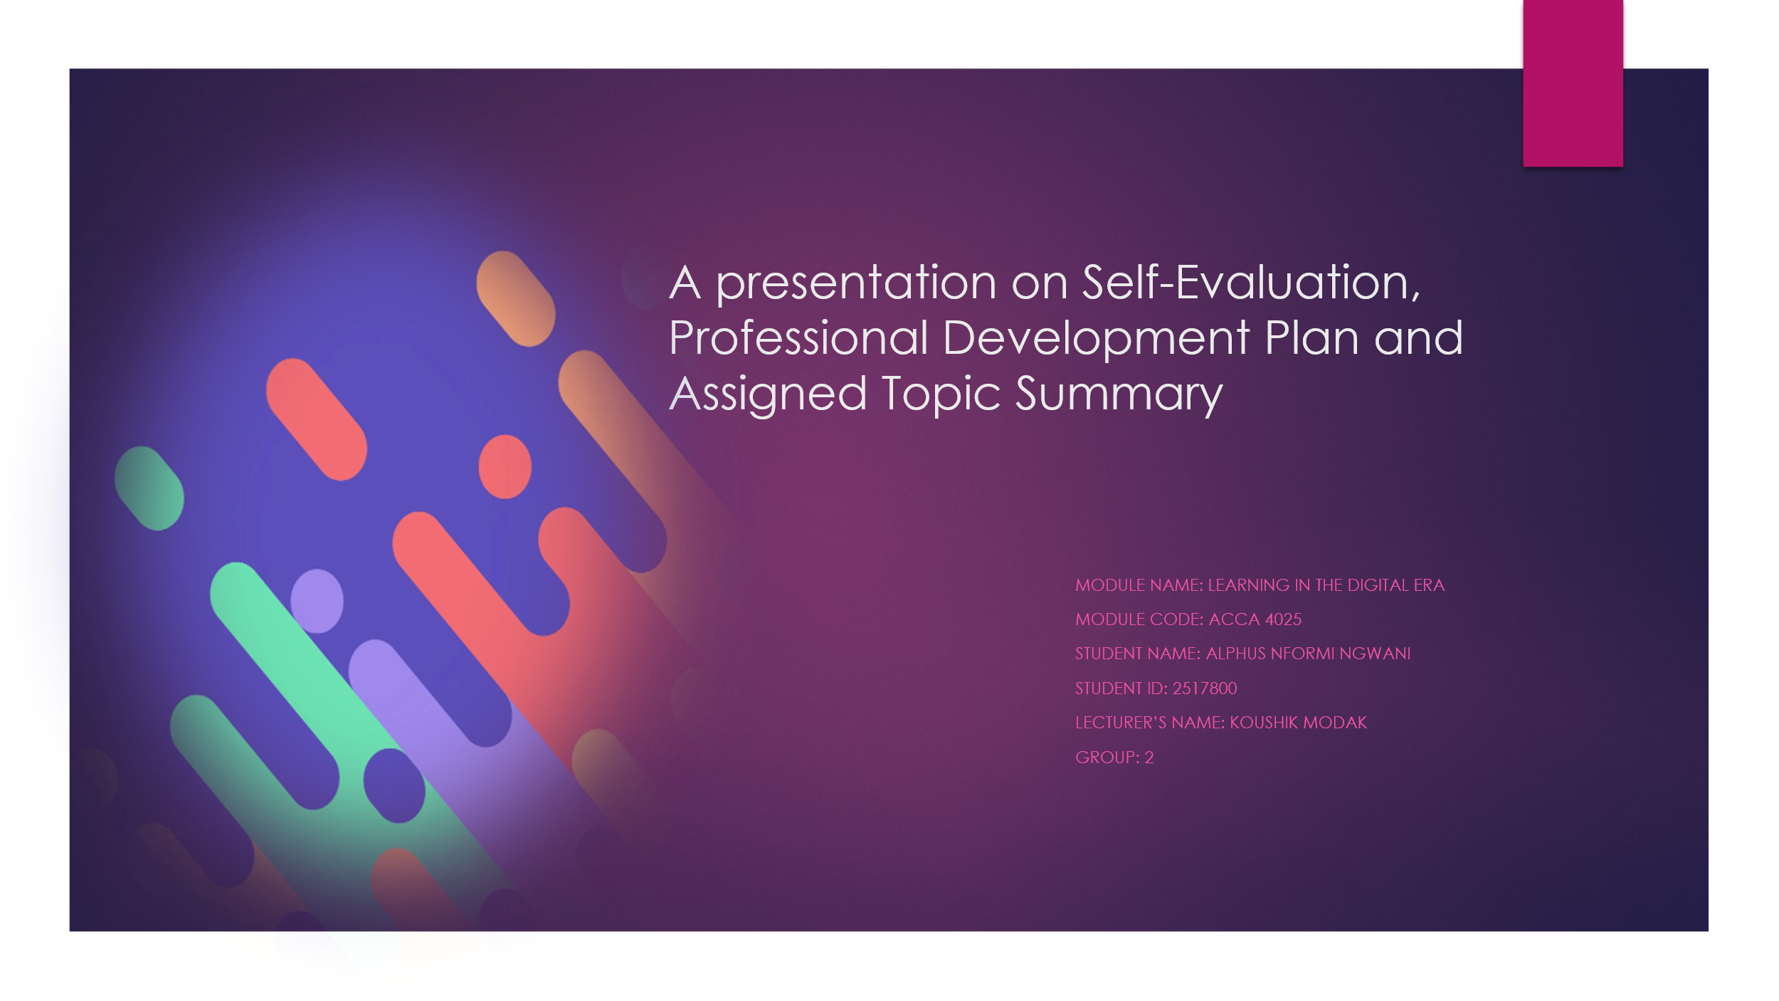
A presentation on self-evaluation, professional development plan (PDP) assigned topic summary.
Module Name: Learning in the Digital Era
Module Code: ACCA 4025
Student Name: ALPHUS NFORMI NGWANI
Student ID: 2517800
Lecturer’s Name: KOUSHIK MODAK
Group:2

Slide 2 CONTENTS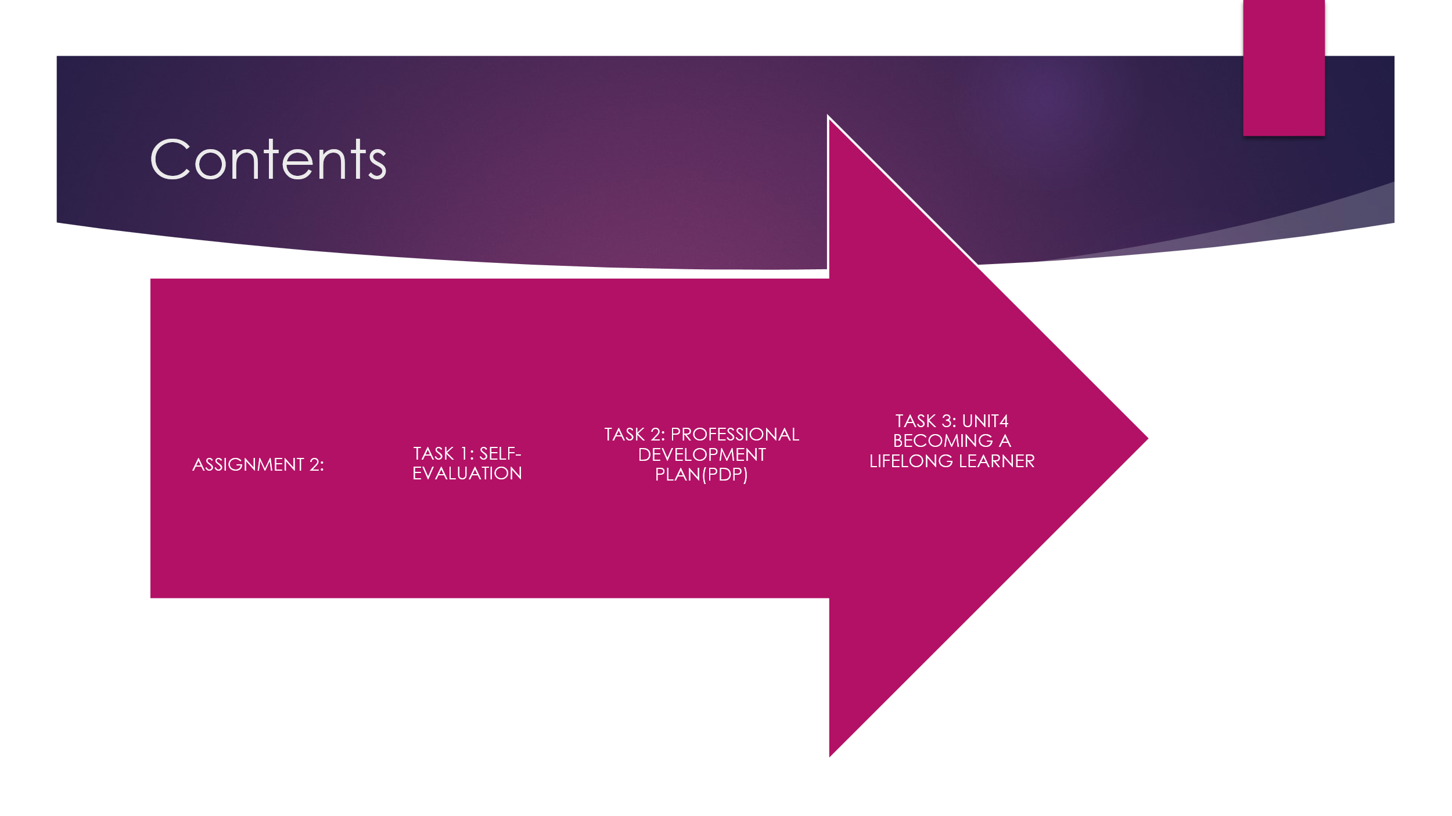
Slide 3 INTRODUCTION
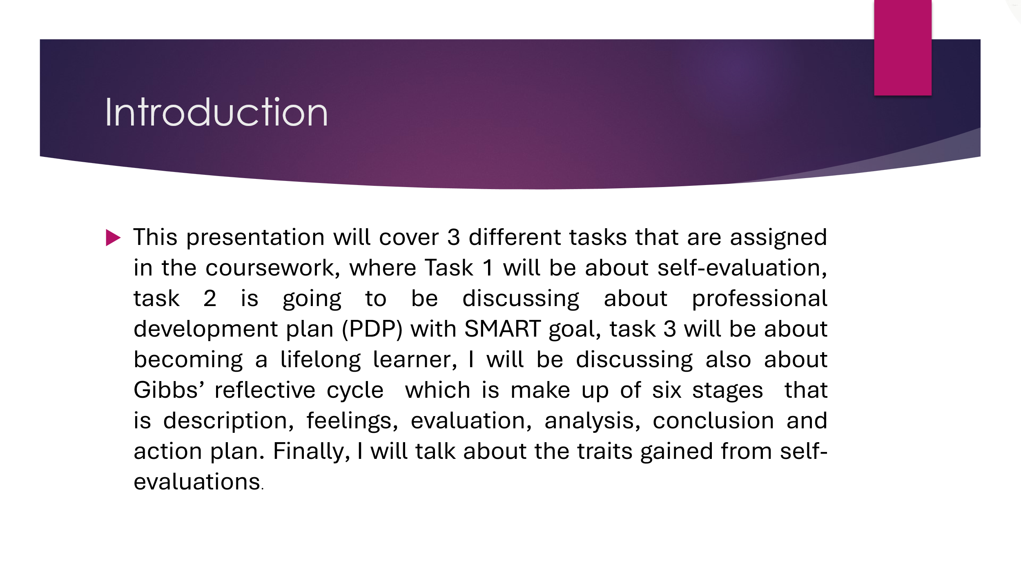
- This presentation will cover 3 different tasks that are assigned in the coursework, where task 1 will be about self-evaluation, task 2 is going to be discussing about professional development plan (PDP) with SMART goal, task 3 will be about becoming a lifelong learner, I will be discussing also about Gibbs’ reflective cycle which is make up of six stages I that is description, feelings, evaluation, analysis, conclusion and action plan. Finally, I will talk about the traits gained from the self-evaluations.

Slide 4 MAIN BODY 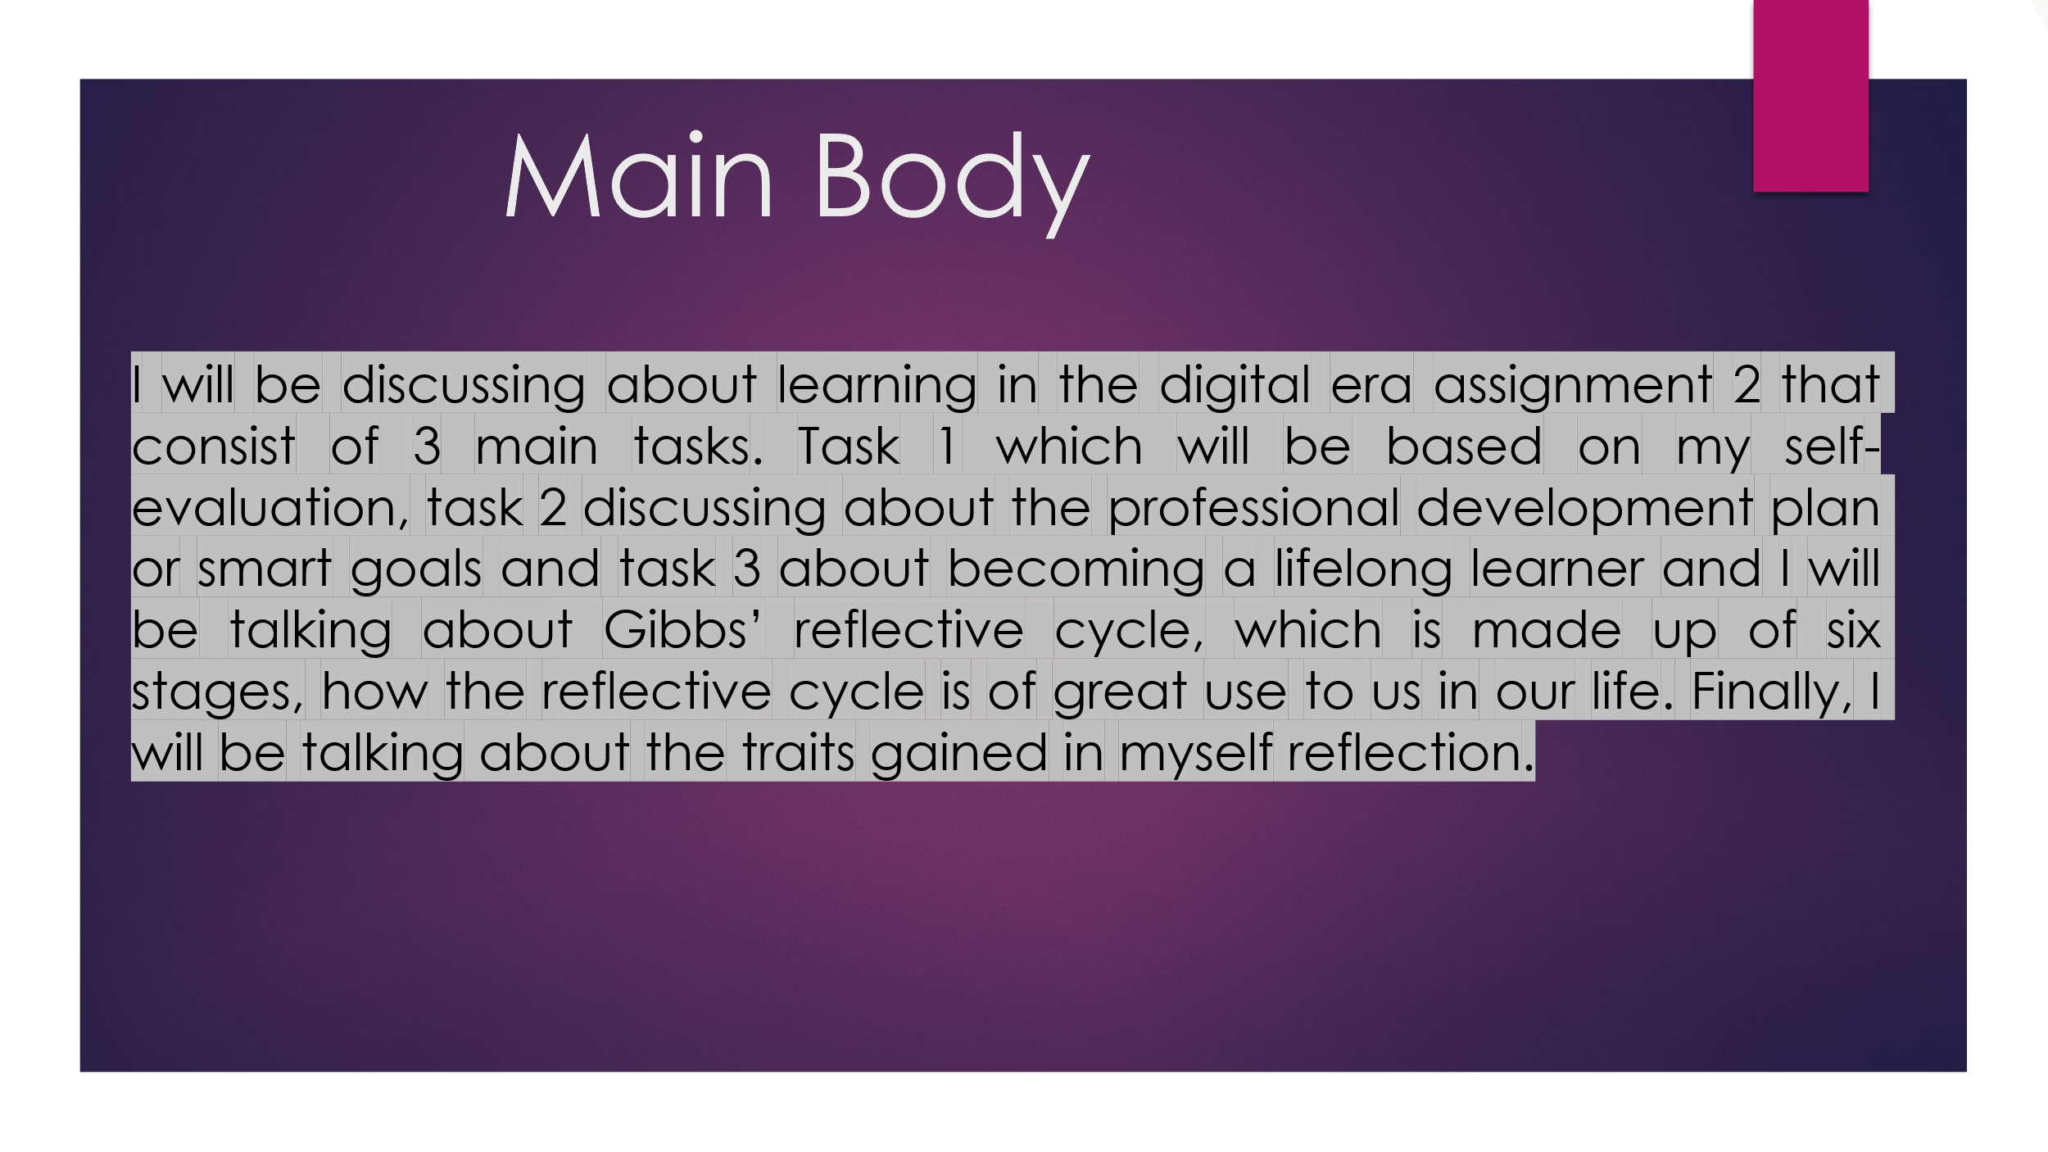
I will be discussing about learning in the digital era assignment 2 that consist of 3 main tasks. Task 1 which will be based on self-evaluation, task 2 discussing about the professional development plan or smart goals and task 3 about becoming a lifelong learner and I will be talking about Gibbs’ reflective cycle, which is made up of six stages, how the reflective cycle is of great use to us in our life. Finally, I will be talking about the traits gained in myself reflection.

Slide 5 GIBB’s REFLECTIVE MODEL
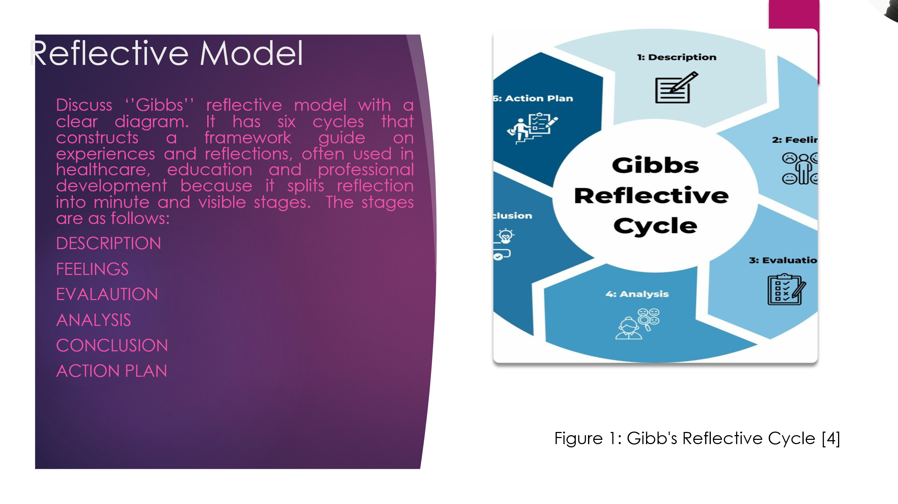

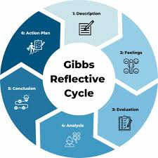
Gibbs' reflective cycle is made up of six stage cycle that is used to explain and learning from experiences. The six stages of Gibbs reflective cycle are: Description, Feelings, Evaluation, Analysis, Conclusion and Action plan. It gives a framework that is made up of explaining a situation by describing how the event took place, the person that was involved in the scene and how did it end, the feelings you had during and after the event it maybe emotional or intellectual feelings, evaluate what you witness about the event both the good and the bad things and what was right and wrong, analyse what you gain from what you witnessed and also look for ways to try to understand why things happened that way they happened, Conclude by bringing out a brief summary of what you gained or what was not good from the event that you witnessed. What did you gain and what you could have done in a separate way apart from the way it happened, make an action plan of what you will do in a different way when next a similar event take place, and this last stage is talking specifically about the future actions. I will use Gibbs’ reflective model to present my assignment by describing what the assignment is all about with the various outcomes about the assignment, I will talk about my thoughts and my intellectual feelings of this assignment, I will evaluate both the positive and negative aspects of this assignment to me of which for me this assignment is mostly made up of the positive aspects I have not seen any negative aspect of this assignment, I will analyse what I have learned from this assignment, I will summarise what I have learned from this assignment as a whole and make a plan to tackle the same assignment if a similar assignment like this will be given to me again in the near future [1].

Slide 6 TASK 1: SELF EVALUATION
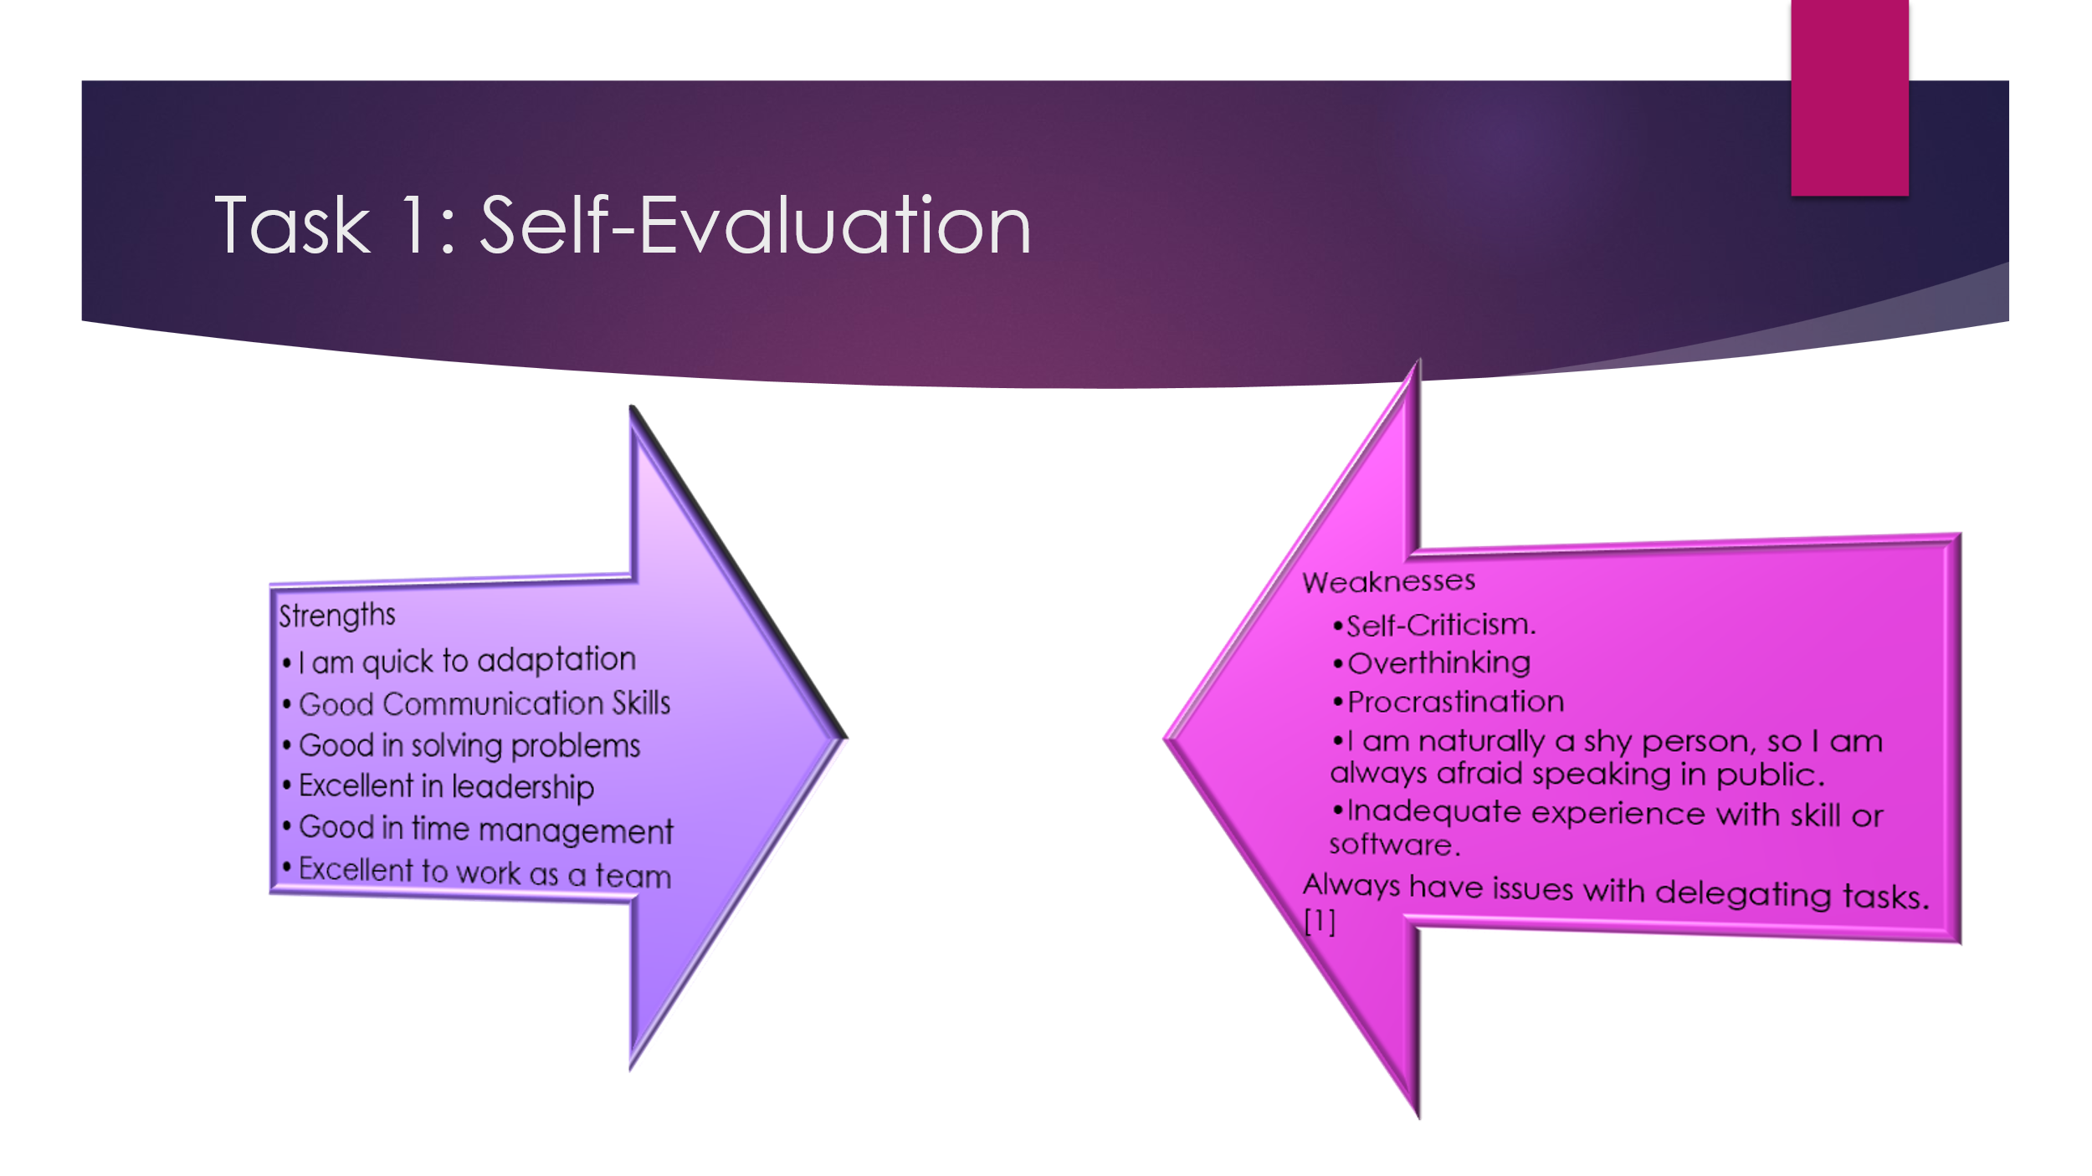
Strengths are positive inner factors that you have while weaknesses are negative inner factors of you. I have some strengths and weaknesses, and they are as follows:
STRENGTHS
- Quick to adaption
- Good communication skills
- Very good in time management
- Excellent to work as a team
- Excellent in solving problems
- A very good leader

- - WEAKNESSES
  - Self-Criticism.
  - I am naturally a shy person, so I am always afraid speaking in public.
  - Inadequate experience with skill or software.
  - Always have issues with delegating tasks.
  - Overthinking
  - Procrastination [2]

Slide 7 TRAITS GAINED FROM THE SELF EVALUATION
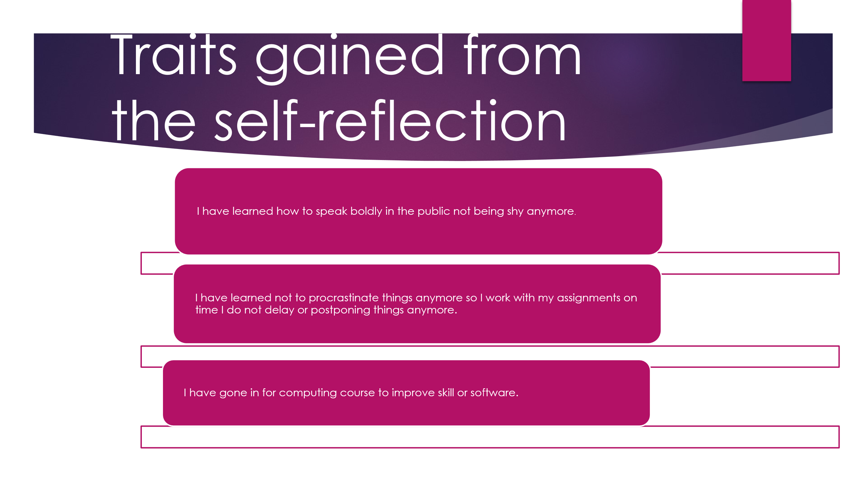
Self-evaluation is a very strong process contribute to your personal and professional growth, taking place to the various positive traits and skills. The most important traits achieved can be group into self-perception, behavioural skills, and professional competencies. I have also gained some traits by not being shy to speak in the public, by not overthinking and learning computing skills. [1]
Slide 8 PROFESSIONAL DEVELOPMENT PLAN
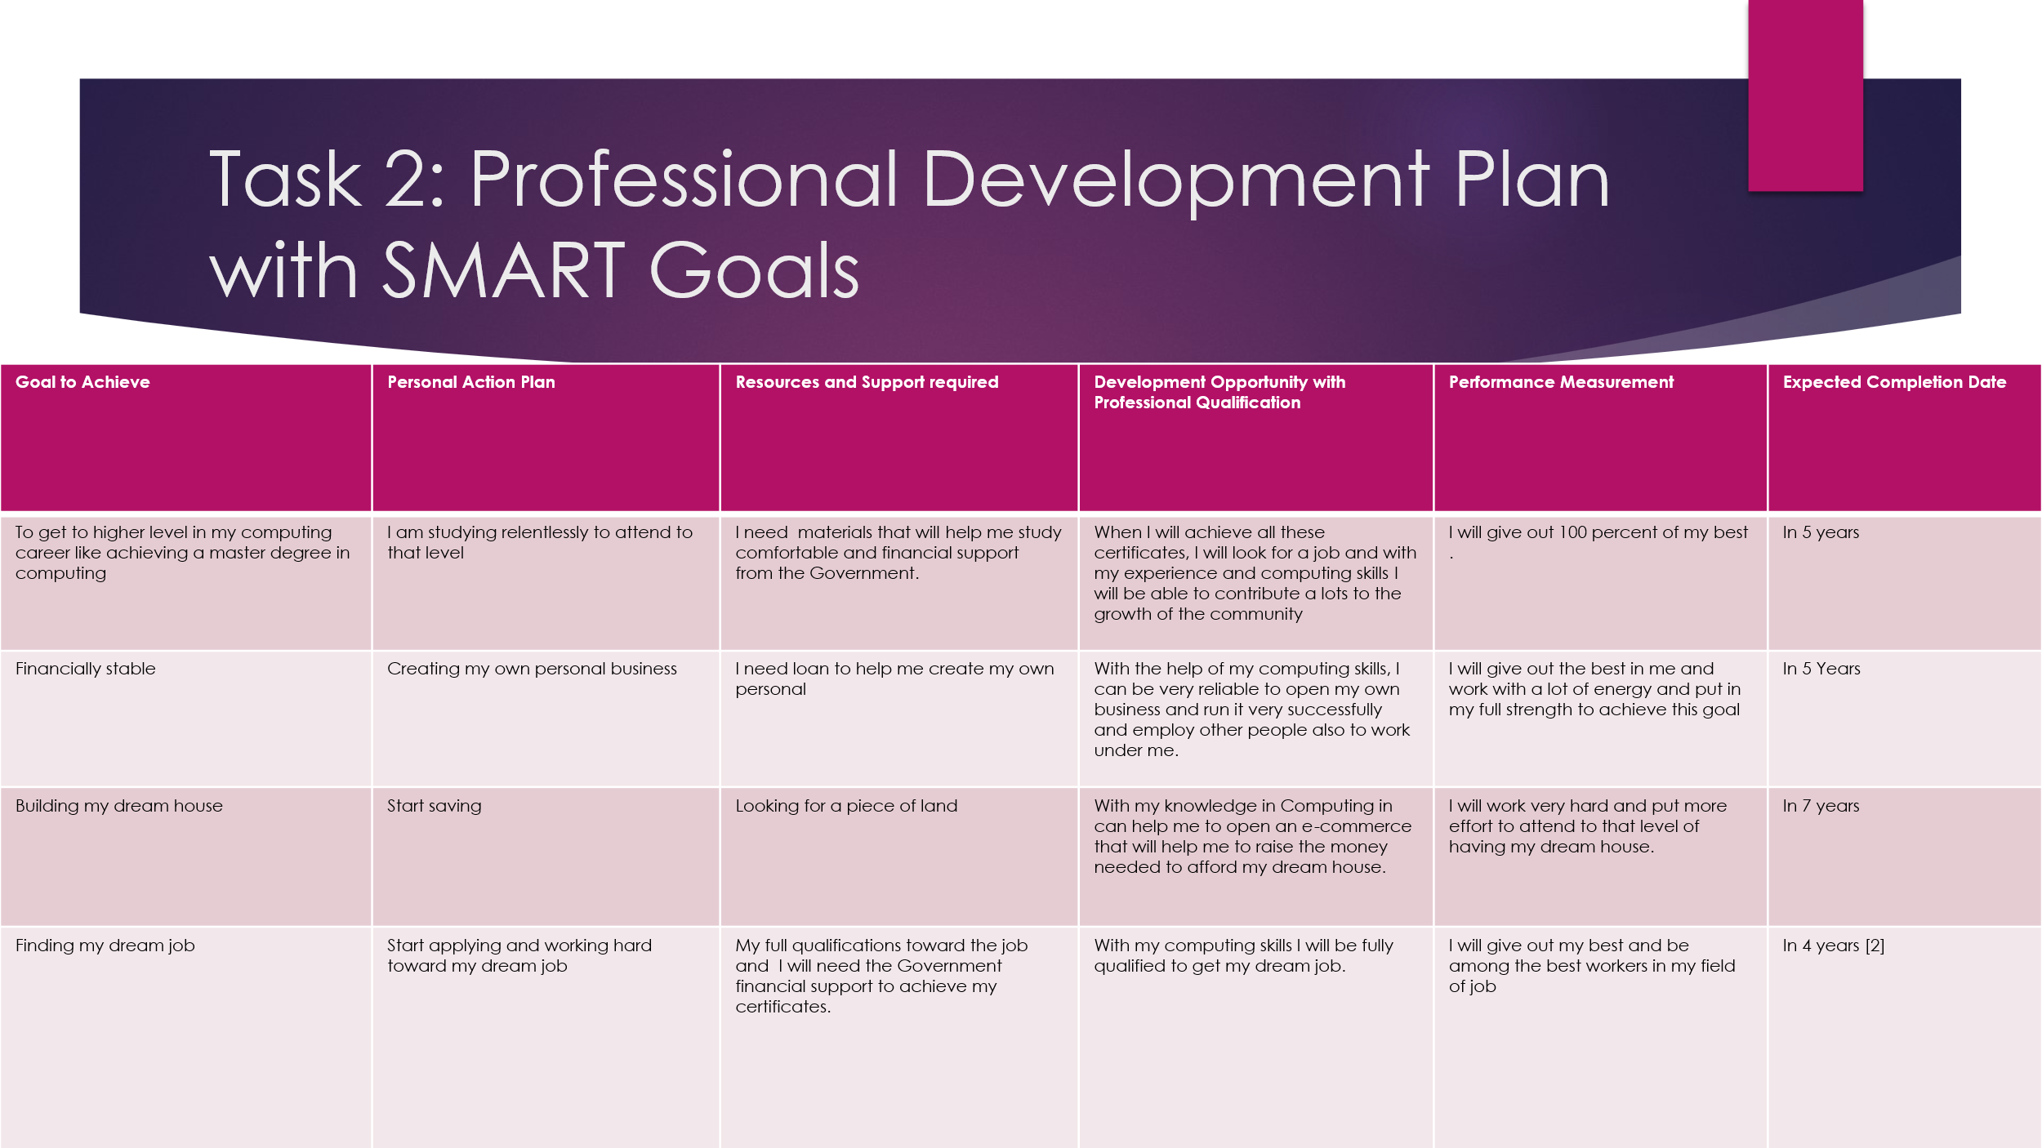
Making a professional development plan with SMART goals include putting in place goals that are Specific, Measurable, Achievable, Relevant, and Time bound. To make these goals mention what you want to do, how you will want the progress, make sure the goal is realistic, ensure it works together with your career path, and put a specific time interval you want to achieve this goal. [2]

Slide 9 UNIT 4 TOPIC SUMMARY
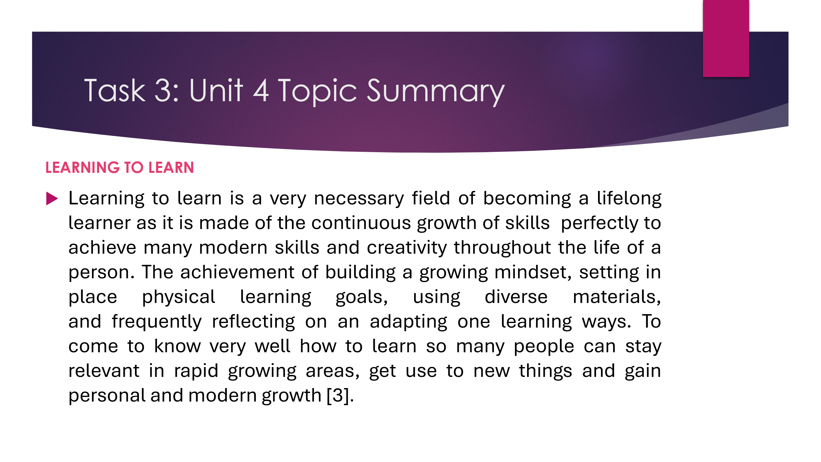Learning to learn is a very necessary field of becoming a lifelong learner as it is made of the continuous growth of skills and perfectly to achieve many modern skills and creativity throughout the life of a person. The achievement of building a growing mindset, setting in place physical learning goals, using diverse materials, and frequently reflecting on an adapting one learning ways. To come to know very well how to learn so many people can stay relevant in rapid growing areas, get use to new things and gain personal and modern growth. [3]

Slide 10 CONCLUSION
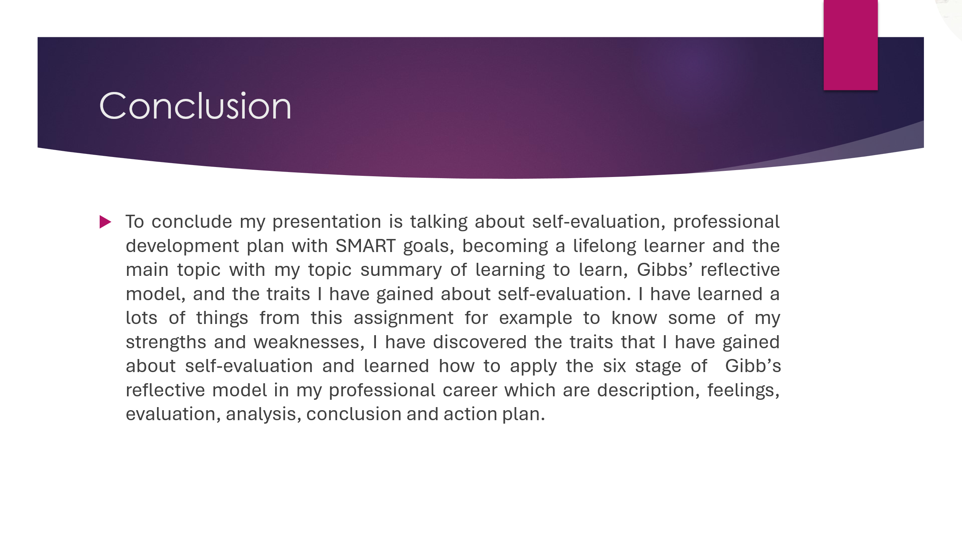
To conclude my presentation is talking about self-evaluation, professional development plan with SMART goals, becoming a lifelong learner and the main topic with my topic summary of learning to learn, Gibbs’ reflective model, and the traits I have gained about self-evaluation. I have learned a lots of things from this assignment for example by using Gibbs reflective cycle to know some of my strengths and weaknesses and I have discovered the traits that I have gained about self-evaluation by applying Gibbs’ reflective cycle. Learned how to apply the six stages of Gibb’s reflective model in my professional career which are description, feelings, evaluation, analysis, conclusion and action plan.

Slide 11
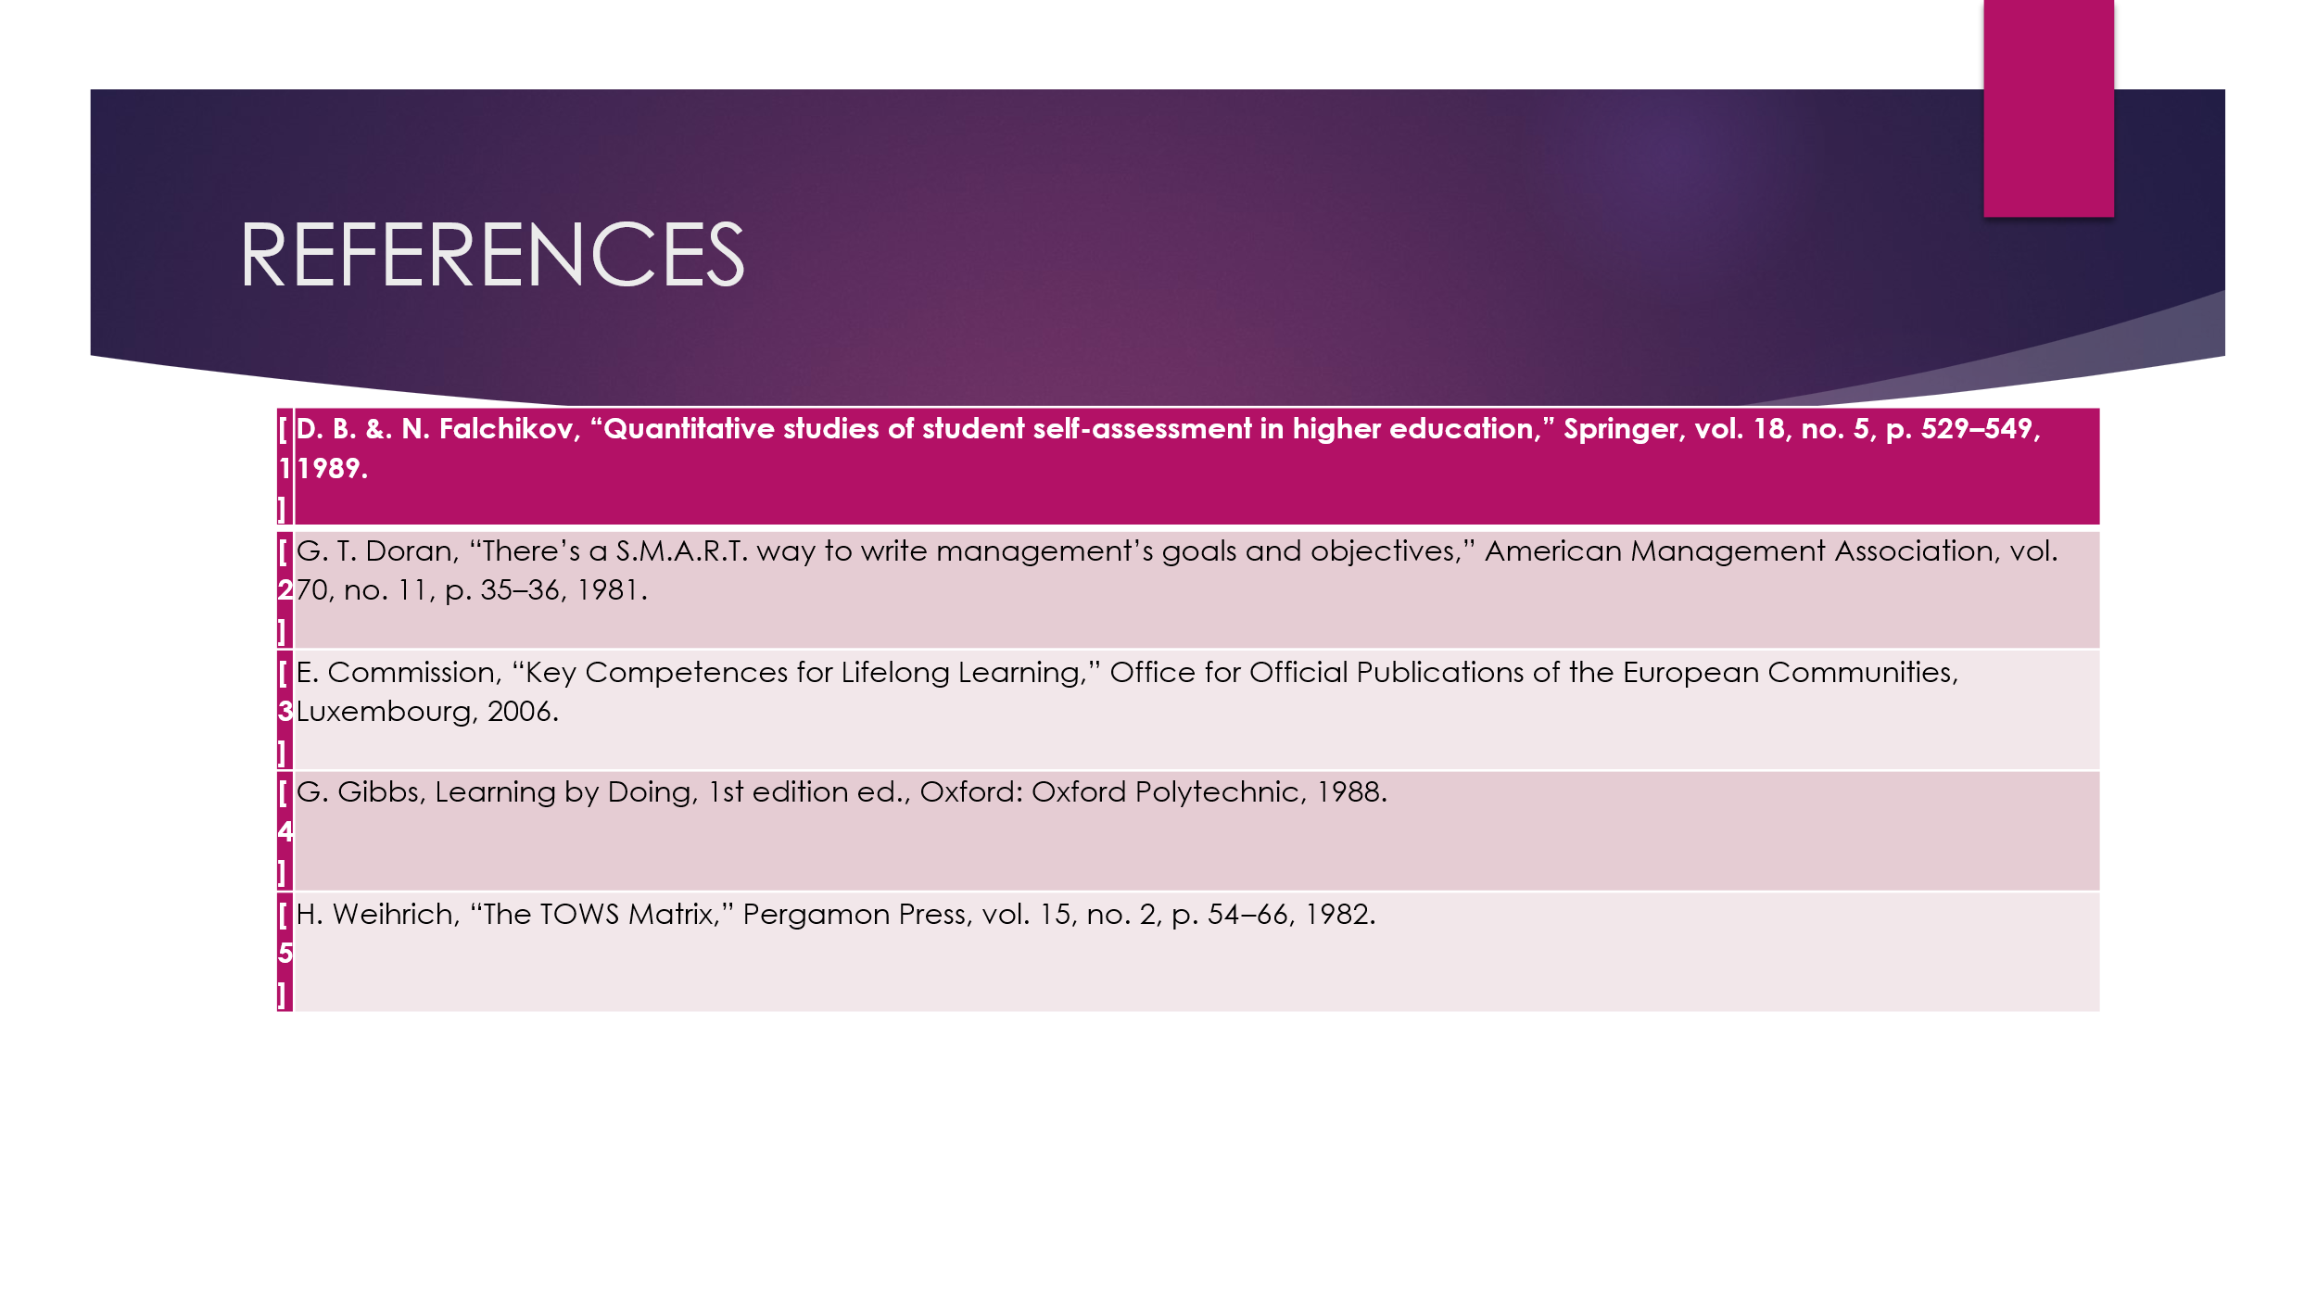

Conclusion
This word document is showing a brief reflection about my presentation and it is also talking about the 3 tasks of my assignment 2 which are task 1 self-evaluation, task 2 professional development plan, task 3 becoming a lifelong learner, of the module learning in the digital era which is the content, the introduction of the topics, the main body of this assignment the overall conclusion, the references and citations of this assignment.

References

[1] | D. B. &. N. Falchikov, “Quantitative studies of student self-assessment in higher education,” Springer, vol. 18, no. 5, p. 529–549, 1989.
[2] | G. T. Doran, “There’s a S.M.A.R.T. way to write management’s goals and objectives,” American Management Association, vol. 70, no. 11, p. 35–36, 1981.
[3] | E. Commission, “Key Competences for Lifelong Learning,” Office for Official Publications of the European Communities, Luxembourg, 2006.
[4] | G. Gibbs, Learning by Doing, 1st edition ed., Oxford: Oxford Polytechnic, 1988.
[5] | H. Weihrich, “The TOWS Matrix,” Pergamon Press, vol. 15, no. 2, p. 54–66, 1982.
[6] | H. Weihrich, “The TOWS Matrix,” Pergamon Press, vol. 15, no. 2, p. 54–66, 1982.

