

PROGRAMME: | BA (HONS) LEADERSHIP AND MANAGEMENT SKILLS FOR THE WORKPLACE
MODULE: | DEVELOPING AND MANAGING INDIVIDUALS AND TEAMS
MODULE CODE: | LCLM5002
MODULE LEADER: | Doreen Nyaa Amundam
ASSIGNMENT TITLE: | COMPONENT 2- INDIVIDUAL REPORT

Student Name: Nicoleta Busu
Student ID: 2331652
Executive summary
Leadership and management are interrelated with each other as it helps to develop guidelines related with HR management. It is required to deal with the challenges observed and gain reliable outcomes in terms of value creation. Dealing with the issues observed in team management and creation of success can become easier. This report has shown that exertion flexibility also improves motivation levels and reduces burnout and increases productivity.

Table of Contents
1. Introduction 4
2. Factors related to business transformation, digital technology trends and working arrangements 4
3. Evaluation of different HR practices 5
4. Role of managers in urgent implementation of contemporary practices 8
5. Conclusion and recommendations 9
References 11

1. Introduction
Leadership and management skills are two notable components to gain success at the workplace with focus upon contemporary practices. Professionals in the Human Resource (HR) Department of London-based companies need to understand the strategy to manage cultural sensitivity with focus on diversity inclusion in Aviva Investors. The aim of the report is to evaluate the business transformation, digital technology trends and working arrangements with focus on contemporary practices by Aviva Investors. Managers tend to focus on urgent implementation of contemporary practices to increase departmental coordination. The purpose is to identify the number of grievances and incorporate authentic measures for long-term progress.

2. Factors related to business transformation, digital technology trends and working arrangements
Business transformation
Crucial factors observed in terms of business transformation include visionary leadership, adaptability, agile process implementation and encouraging strategy of collaboration. Practice of management is associated with incorporation of relevant measures and increasing strategic efficiency can become helpful (Karamchand, 2024). The HR Department is aimed at creating reliable measures and Aviva Investors observe implication in increasing authentic outcomes. Additionally, tech-driven process assistance can help to simplify the strategy of decision-making and accomplish success in transformation. Thus, it is required to improve administrative collaboration and accomplish scope of progress with understanding of barriers observed.
Digital technologies help in development of flexible work arrangements and developing the required framework of support is necessary to access success. Predicting the administrative trend, future prospects and cultural coordination are crucial factors to deal with the obstacles observed (Zils et al. 2025). Additionally, it requires adoption of progressive measures and consequences are observed in increasing processing resilience. Inclusion of authentic human resource practice is the pillar of business transformation and addition of value in this process can be helpful in Aviva Investors. Therefore, it requires adoption of reliable measures and implication is observed in accessing scope of success.
Digital technology trends
Aviva Investors tend to focus on increasing internal coordination to access success in practical application. AI-based technological application helps in accomplishment of success in human resource management practice (Prihatiningsih et al. 2025). Agile digital transformation requires to be adopted practically in order to deal with the barriers observed by Aviva Investors. Furthermore, it has been observed that transformation in HR practice and determination of reliable outcome is required. Application of AI increases authenticity and transformation is observed in creation of reliable outcomes in administration. Henceforth, accomplishment of success in decision-making and determination of scope of value creation can become helpful for Aviva Investors.
Quality and safety are two notable factors to determine opportunity of progressive outcome in HR practice. Technological assistance creates space to simplify opportunities of practical administration and increasing outcomes can become successful (Kusdinar, 2025). Aviva Investors focus on AI-based safety management in order to increase coordination in the framework and development of adequate output can become successful. Furthermore, it can be stated that conflict management is the most notable part to apply digital technology and access progress in long-term benefits. Thus, it is necessary to simplify administrative measures and accomplish progress in long-term goals in Aviva Investors.
Flexible working arrangements
Aviva Investors prioratise on ensuring well-being of team members with focus on collaboration, communication. Flexible work arrangements help in accomplishment of coordination and team members feel connected with vision (Ardi et al. 2024). It has been evident in Aviva Investors that coordination in decision-making strategy helps in development of success in managing team members. Specific factors focused by Aviva Investors to enhance flexibility of work arrangement are time management, communication and conflict resolution. Diversification of responsibility among team members is a vital part to enhance scope of coordination in Aviva Electronics. Diversification of responsibility among team members is necessary to increase performance efficiency (Buick et al. 2024). HR practice of Aviva Investors helps in dealing with the conflict observed in the team. It is required to create adequate focus on dynamism and increasing scope of progress can be helpful. Therefore, it is required to enhance the opportunity of better coordination among team members along with the strategy of planning. .

3. Evaluation of different HR practices
Different HR practices incorporated are strategic planning, decision-making, conflict management and inclusion of transformative measures. Aviva Investors focus on increasing transparency in the process of administration and consequences are observed in the managing team (Aviva, 2025). Transparency and collaboration are two notable factors to enhance efficiency of approach in case of people management. In reference to contemporary practices, it is required to understand the obstacles observed and determine scope of success. Additionally, it requires transparency in policy in order to thrive in a competitive environment and consequences are observed in planning. It requires adoption of relevant measures and consequences are observed in case of success. Therefore, it is necessary to increase efficiency of HR practices and improve opportunities for reliable output.
Comparison of several contemporary HR Practice.
The modern HR practices are promoted, where organisations can effectively respond to business change, digital change and greater need to work flexibly. Aviva Investors practices are very aligned with the strategic priorities of the company, that is, inclusion, resilience, and sustainable growth.
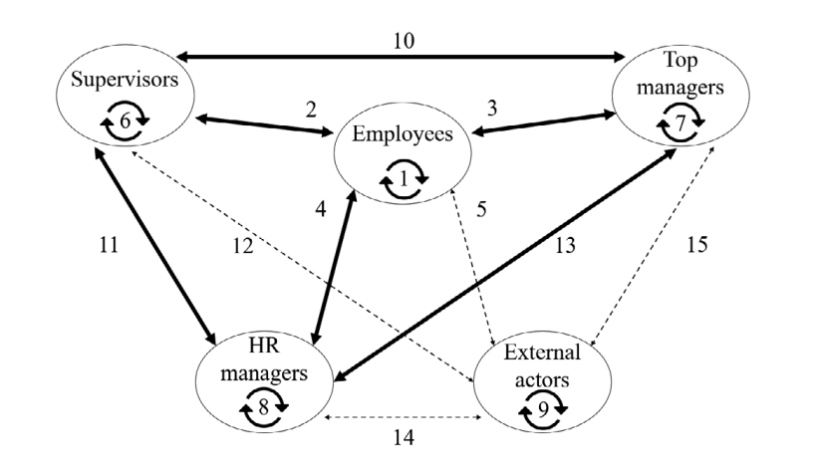
Figure 1: Relationship with HRM
(Source: Bannya et al. 2023)
Health and Involvement of the employees
Aviva Investors recognises the fact that successful organisational change is founded on the well-being of employees. This diversity, equity, and inclusion (DE&I) are part of the HR strategy of the company so that all those within it feel valued and motivated. As an illustration, Aviva investors observes that there is a need to break down barriers to underserved groups of individuals, particularly, employees with disabilities, who are likely to face systemic challenges in hiring and advancing employees in their professional areas. By eliminating these barriers, Aviva Investors compared with increasing equity along with improving interaction and retention (Avivainvestors, 2025). This practice will ensure that a business change is a structural, as well as a cultural one, and that the employees feel at ease and that the change will be a long-term positive change.
Flexible Work Model
A flexible working model is one of the most significant HR practices that can react to the shifts in employee expectations and to the digital transformation. Aviva Investors has embraced a prudent and flexible operational framework that provides the employees with an opportunity to determine where, when and how they work. This plan builds trust and independence in the employees and empowers them to resolve professional and personal causes. Research has shown that exertion flexibility also improves motivation levels and reduces burnout and increases productivity. Digital tools can be involved with flexible provisions to ensure Aviva Investors become more cooperative and the continuity of its professional in a highly dynamic environment is guaranteed (Avivainvestors, 2025). The trend reflects a broader trend towards adaptive employed cultures, which puts the resilience and operative satisfaction in the centre.
Performance Management
It has also changed the performance management in an attempt to keep abreast with organisational change. Aviva Investors has performance systems which are transparency-driven, accountability-driven and inclusivity-driven. Rather than focusing solely on the traditional performance measures such as output, employees are evaluated on their teamwork, creativity and culture contribution (Buick et al. 2024). The performance of the individual is linked with the performance of the organisation in this modern methodology, and this allows fairness and will motivate the employees to make long term plans. By a fit between inclusive practices and appraisal, Aviva Investors will also ensure that the performance management will be productive besides the employee well-being and engagement (Avivainvestors, 2025). The modern practices of HR in Aviva Investors is a comprehensive approach to the contemporary issues. The company is health-conscious and interested in engagement and the essential incorporation of flexibility and the application of inclusive performance management systems, which forms a sustainable approach to HR that allows changing the workflow, capitalizing on digital opportunities, and supporting the needs of the evolving workforce.

4. Role of managers in urgent implementation of contemporary practices
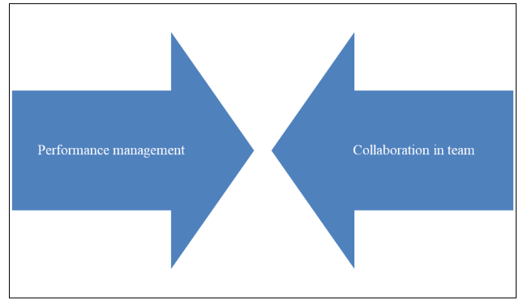Figure 2: Crucial areas of focus
(Source: Self-developed)
Strategic planning
Managers of Aviva Investors tend to adopt proactive measures in terms of administration and consequences are observed in development of progress. Conflict management can turn out to be easier with the help of transparency in communication. Improvement of coordination is necessary to deal with the challenges and consequences observed in case of success (Bhuiyan et al. 2025). Communication with stakeholders is the most vital part in development of adequate scope of success in conflict resolution. Aviva Investors focuses on conflict management and implication is observed in creation of success to develop stable guidelines. Contemporary HR practices in Aviva Investors are linked with improvement in administration and consequences are observed in success. Active participation of team members can ensure progress and dealing with the challenges of decision-making can become possible. Henceforth, it is necessary to address barriers of communication and accomplish progress in decision-making strategy followed by Aviva Investors.
Workforce management
Managers play a vital role in workforce management and consequences are observed in dealing with the administrative barriers in Aviva Investors. Improvement of strategic collaboration is necessary to increase opportunity for reliable decision-making (Porkodi and Cedro, 2025). Additionally, it has been observed that inclusion of effective managerial action helps in dealing with the performance gap and improvement of efficiency in decision-making can enhance scope of HR practices. Managers with adoption of transparency can apply contemporary practices of HR and collaboration effect is observed on overall outcome. AI-based technological assistance helps in process collaboration and consequences are observed in the process of administration. Aviva Investors focus on collaboration and consequences are observed in creation of progress. Therefore, it is important to increase coordination and gain optimal results in case of performance planning.
Ensuring compliance
Regulatory compliance in policy mechanisms is required in Aviva Investors to deal with the market gaps and consequences are observed in value creation. Managerial actions are linked with the strategy of administration and improvement of efficiency in planning can turn out to be possible (Zhao et al. 2025). Flexible work model along with active engagement of team members is required to address the challenges observed in performance management. Aviva Investors need to address gaps observed in managerial actions and increasing performance efficiency can determine long-term value. Aviva Investors need to deal with the transparency and consequences are observed in creation of adequate value. Thus, it is necessary to enhance efficiency of HR practices and implication is observed in decision-making along with improvement of administrative efficiency.

5. Conclusion and recommendations
It can be concluded from the above evaluation that identification of appropriate factors of digital transformation is required to develop stable organisational progress. Application of different contemporary HR practices help in creation of reliable outlook and consequences are observed in decision-making. Active participation of managers helps in dealing with the process gaps and implementation of reliable measures can become easier. Departmental managers focus on increasing collaboration among team members and increasing efficiency of performance planning can be helpful in Aviva Investors. Bringing required modification in work arrangements provides an opportunity to increase efficiency of administrative measures with diversification of network. Therefore, it is necessary to increase opportunities for performance management and develop success.
It is recommended to focus on transition observed in improvement of administrative measures and ensure active participation of everyone. Application of digital technology needs to create opportunities to increase decision-making and consequences are observed in case of success in Aviva Investors. It is suggested that departmental managers need to increase coordination in the process of strategic planning. Active participation of the HR Department helps in enhancing efficiency and consequences are observed in value creation. Conflict management is the integral part to accomplish progress in terms of managing balance in a team and determining efficiency of progress. It requires adoption of relevant measures to enhance efficiency of success in HR management and effect is observed in administration. It helps to develop stable guidelines and consequences are observed in decision-making of administration. Thus, the requirement is to increase understanding the principles of conflict management and gain progress by Aviva Investors.

References
Ardi, A., Cahyadi, H., Meilani, Y.F.C.P. and Pramono, R., (2024). Talent attraction through flexible work anytime from anywhere. Journal of Infrastructure, Policy and Development, 8(3), p.2998.
Aviva (2025) Aviva Investors. Available at:https://www.avivainvestors.com/en-gb/ [Accessed 3rd October 2025]
Avivainvestors (2025). Delivering the outcomes that matter most to you. Available at: https://www.avivainvestors.com/en-gb/ (Accessed: 03 October 2025)
Avivainvestors (2025). A workplace where you can shine. Available at: https://careers.avivainvestors.com/life-at-aviva-investors/culture-and-values/ (Accessed: 03 October 2025)
Avivainvestors (2025). Disability inclusion in the workplace. Available at: https://www.avivainvestors.com/en-gb/views/aiq-investment-thinking/2023/09/taking-down-the-barriers/ (Accessed: 03 October 2025)
Bannya, A.R., Bainbridge, H.T. and Chan‐Serafin, S., (2023). HR practices and work relationships: A 20 year review of relational HRM research. Human Resource Management, 62(4), pp.391-412.
Bhuiyan, M.M.H., Dey, K.N., Saha, P., Sarker, P.K., Halimuzzaman, M. and Biswas, M.T., (2025). Exploring the role of artificial intelligence in transforming HR practices. International Journal of Business Management and Economic Review, 8(1), pp.98-110.
Buick, F., Blackman, D.A., Glennie, M., Weeratunga, V. and O’Donnell, M.E., (2024). Different approaches to managerial support for flexible working: Implications for public sector employee well-being. Public Personnel Management, 53(3), pp.377-405.
Buick, F., Blackman, D.A., Glennie, M., Weeratunga, V. and O’Donnell, M.E., (2024). Different approaches to managerial support for flexible working: Implications for public sector employee well-being. Public Personnel Management, 53(3), pp.377-405.
Karamchand, G.K., (2024). Scaling New Heights: The Role of Cloud Computing in Business Transformation. International Journal of Digital Innovation, 5(1).
Kusdinar, R., (2025). Digital Leadership: Trends, Practices, and Future Directions. TWIST, 20(3), pp.329-337.
Porkodi, S. and Cedro, T.L., (2025). The ethical role of generative artificial intelligence in modern HR decision-making: A systematic literature review. European Journal of Business and Management Research, 10(1), pp.44-55.
Prihatiningsih, T., Panudju, R. and Prasetyo, I.J., (2025). Digital advertising trends and effectiveness in the modern era: A systematic literature review. Golden Ratio of Marketing and Applied Psychology of Business, 5(1), pp.01-12.
Zhao, F., Lu, Y., Zhang, P. and Wang, J., (2025), March. How employees perceive work–family balanced HR practices: a moderated mediation analysis with psychological capital and differentiated leader–member exchange. In Evidence-based HRM: a Global Forum for Empirical Scholarship. Emerald Publishing Limited.
Zils, M., Howard, M. and Hopkinson, P., (2025). Circular economy implementation in operations & supply chain management: Building a pathway to business transformation. Production Planning & Control, 36(4), pp.501-520.

