EVIDENCE OF LEARNING (E-PORTFOLIO)
Name of the student: Valentin Dan Simion
Name of the university: University of Wales Trinity Saint David’s
Student’s ID: 2222011
Executive summary
Academic writing is an important part of academic development for students because it is related to the way in which academic papers are developed in a particular academic setting. The study has focused on understanding the importance of academic writing for students and the ways in which the skills related to academic writing can be improved. The concept of critical analysis in academic writing within the educational setting has been critically evaluated to understand the ways in which it can support in the development of academic writing skills for students. The study has also focused on discussing about two of the most important concepts related to academic writing which are the sense of place and sense of identity. The outcomes of the study have stated the ways in which sense of place and sense of identity can be developed by students to achieve academic success.
Contents
Introduction 4
Purpose of the study 4
Academic writing 4
Critical analysis 5
Presentation on the sense of place and identity 6
Background of the study 6
Sense of place 7
Sense of identity 8
Importance of sense of place 9
Importance of a sense of identity 10
Ways to develop a sense of place 11
Ways to develop a sense of identity 12
Conclusion 14
References 15

Introduction
Academic writing and employability skills are considered to be highly important for the development of individuals to achieve personal and professional success. This particular study will focus on the development of an e-portfolio that will evaluate the importance of academic writing skills and why it is important for students to focus on the development of those skills to achieve continuous personal development. The primary focus of the study Understanding why critical analysis in academics is considered to be important. The sense of place and identity would be an important part of the study that will be represented through the presentation within this particular e-portfolio.

Purpose of the study
The purpose of the study is to develop an effective understanding of academic writing and why is it important for students to develop the skills of academic writing. It is important to understand the ways in which individuals can develop their academic writing skills through which academic performance can be improved and continuous personal or professional development can be achieved (Strobl et al., 2019). The purpose of the study is to understand the importance of critical analysis for students and how the sense of place and identity can be used to obtain effective academic development. The study can be considered to be important because it will help in developing effective employability skills that can be used to obtain professional success.

Academic writing
Academic writing definition
Academic writing can be described or defined as a style of writing that includes a formal tone (Poe, 2022). It is usually described as the means of producing, evaluating, codifying, renovating, teaching or learning knowledge as well as ideologies in a discipline related to the academic environment.
Importance of academic writing:
Academic writing is considered to be highly important and essential for individuals especially at their academic level because it develops the opportunity for disciplinary learning and critical thinking among students to achieve academic success. It has been studied that the development of academic writing skills can be an important way to develop a logically organised flow of ideas among individuals (Bush, 2021). It can be effectively used to achieve success in academics by ensuring that the ability of the students to develop the proper structure of writing can be developed. Academic writing can be used to achieve professional as well as personal success by ensuring that the right decision-making capabilities and time management skills can be implemented to achieve different goals related to academic writing activities.

Critical analysis
Definition of critical analysis:
Critical analysis can be defined as the process by which different topics can be evaluated an analyst in the most critical manner to achieve accuracy and efficiency. There are different stages and steps that are present in the process of critical analysis that can be used to achieve accurate results (Maloney, 2019). These steps might include listening, reading, and analysing the topics of academics to understand a point of view that can be used for critical evaluation.
Importance of critical analysis
Critical analysis is considered to be highly important because it helps in achieving and developing positive results while analysing particular topics. There are 3 primary stages present in the process of critical analysis which include describing, analysing and evaluating. The importance of the process of critical analysis is present in all these stages because the stage of describing helps in ensuring that a particular topic can be described with maximum efficiency (Poe, 2022). The describing stage enhances the quality of work because it ensures that all the necessary information can be critically presented to the readers or the individuals related to the academic. The stage of analyse can be considered to be important for the development of academic work because it helps in analysing the way in which the information and data are presented. The last stage of evaluation can be considered to be highly effective and important because it helps in ensuring that the data is critically evaluated in the most efficient manner to obtain the right information and conclusions that are related to the topic of discussion.

Presentation on the sense of place and identity


Background of the study
Academic writing is important for the development of the students in their academic environment with which they can achieve personal and professional success. According to a number of studies it has been observed that there are different ways in which the skills of academic writing can be enhanced. Two of the most important factors that are related to the development of academic writing skills among students include a sense of place and a sense of identity. This particular presentation will focus on evaluating the impact of the sense of place and sense of identity on the academic writing competencies of individuals and how they can enhance the personal and professional development of individuals.
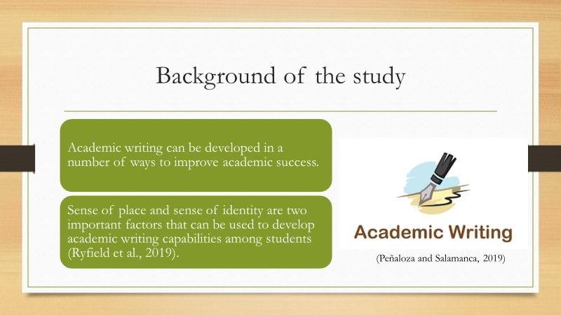

Sense of place
The development of academic writing is dependent on a number of factors among which a sense of place is considered to be an important part. According to different discussions and analytics, it has been studied that sense of writing is the concept which is used to ensure that the readers of particular information within the academic setting can imagine the position in which the information was initially developed. The sense of place is critically used to ensure that the readers of particular academic information can understand whether that particular set of data is related to the past, present or future.


Sense of identity
Sense of identity can be considered to be an important part of academic writing because it is the process of developing the ownership of an individual over the intellectual work that they are developing. According to different authors and researchers, it is defined as the sense that a particular individual has while developing writing. It is the perception of the writer to consider themselves as the author and develop the textual identity while constructing their writing. In academics, the sense of identity helps in the development of the credibility of intellectual property which can be effective in addressing the factors related to plagiarism.
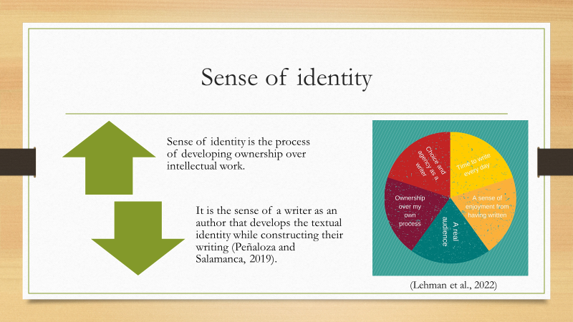

Importance of sense of place
Sense of place is considered to be an important part of academic writing because it helps in the development of an effective intellectual connection between the readers and the authors. When students focus on developing academic papers and content in the position of an author, it helps them develop a better relationship between the perceptions of the authors and the readers which can be an effective part of achieving academic success. It has been observed that the sense of place is a competency that can work as a bridge between the students and the professors while they are developing the academic content which can create a better level of understanding between the two parties.
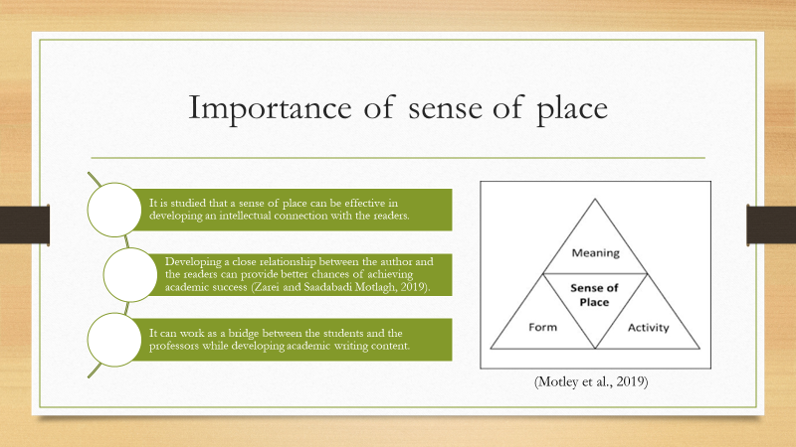

Importance of a sense of identity
A sense of identity is considered to be very important in terms of academic writing because it can help in the development of an author's personality. The individuals who are developing the academic content are able to develop the writer's perspective in their academic writing as an author. It can be used to effectively address different types of issues related to credibility and plagiarism. It can therefore be stated that the sense of identity can be used to develop better academic success as it can be effective in developing better academic integrity in the Academic environment.
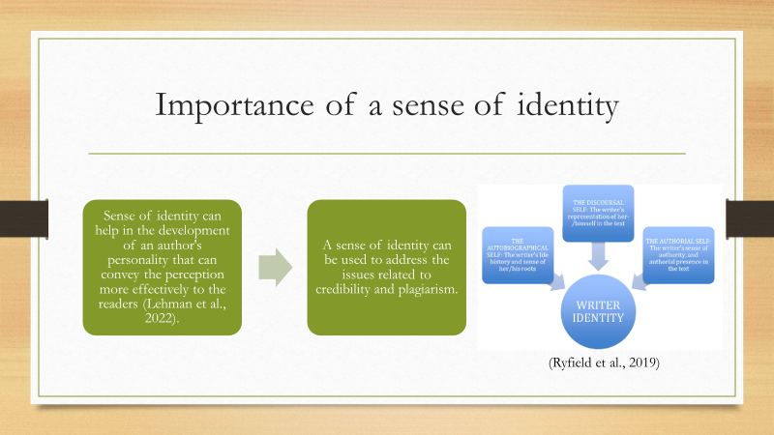

Ways to develop a sense of place
There are a number of ways in which the sense of place can be developed in academic writing by students that can be critically influential in achieving academic success. The development of critical thinking skills among students can be one of the most effective ways to develop a sense of place because it can enhance the thinking capabilities of the writers to understand what type of environment they need to develop while developing the academic content. It has been observed that critical thinking is one of the most important aspects to understand a particular set of writing needs to be in the past, present or future environment to provide the maximum emphasis on the type of information that has been written. Another significant way of developing a sense of place among the individuals who are working as writers is by developing research skills. Research skill is important to understand the environment in which a particular type of information is supposed to be placed and analysing different research papers can provide a better understanding of how other authors have used their sense of place in their academic writings. Understanding different authors can be an important part of developing the sense of place among individuals to achieve better quality in their academic writing while keeping in mind the concept of academic sense of place.
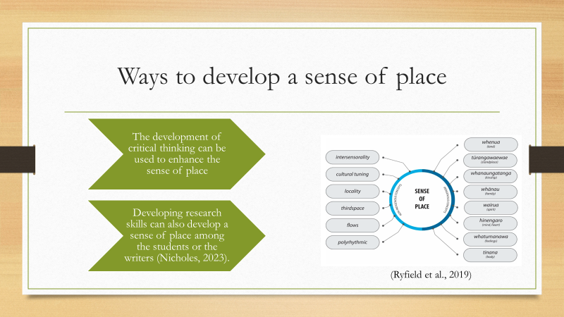

Ways to develop a sense of identity
The sense of identity is an important part of developing academic writing skills because it can help in providing a better perception of the authors. Conducting research and analysing the work of different authors can help in understanding the way in which different writers focus on developing their sense of identity to promote the efficiency with which they develop their writing. Hence one of the most effective ways of developing a sense of identity is analysing the different works of other authors and accordingly developing a process with which the sense of identity can be implemented in the academic writing contents. It is also important for the writers to practice acceptance as it can help in developing their sense of identity which can be effectively influential in achieving academic success.
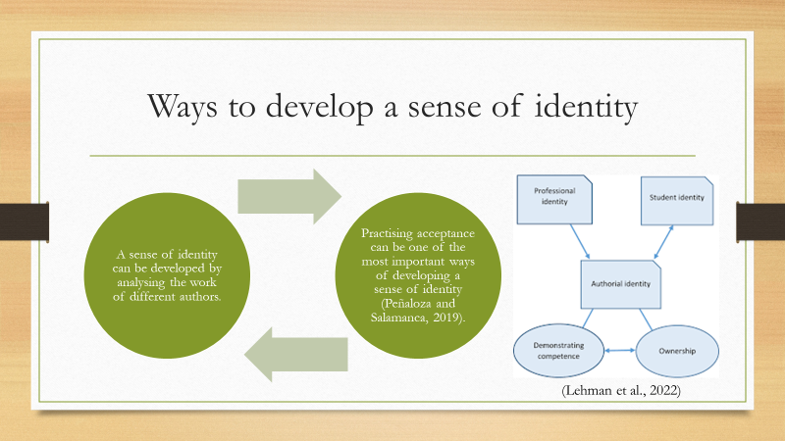



Conclusion
It can be concluded from the overall study that academic writing is an important part of academic success because it provides students with the capability to achieve success. Some of the major factors related to the concept of academic writing include critical analysis, a sense of place and a sense of identity. The implementation and development of all the concepts can result in achieving better success as an academic writer. There are different ways in which a sense of identity and sense of place can be developed by writers which can contribute to their competencies as academic writers while developing an effective relationship with the perception of the readers. It can be concluded that individual performing arts students must focus on addressing their confidence by developing their sense of place and sense of identity which can provide them with a better opportunity of achieving higher success at their academic level.

References
Bush, J.C., (2021). Using screencasting to give feedback for academic writing. Innovation in Language Learning and Teaching, 15(5), pp.473-486.
Maloney, I., (2019). The place of creative writing in an EFL university curriculum. Bulletin of Nagoya University of Foreign Studies, 4, pp.229-251.
Poe, M., (2022). Learning to unlearn the teaching and assessment of academic writing. Discourse and Writing/Rédactologie, 32, pp.161-190.
Strobl, C., Ailhaud, E., Benetos, K., Devitt, A., Kruse, O., Proske, A. and Rapp, C., (2019). Digital support for academic writing: A review of technologies and pedagogies. Computers & education, 131, pp.33-48. Youtube Presentation Link : https://youtu.be/cnHpd9tybHY

