Ana Carden-Coyne, ‘Wounded Visionaries,’ The Guardian, November 13 2008 (http://www.theguardian.com/world/2008/nov/13/first-world-war-artists-writers-modernism; accessed October 28 2015)
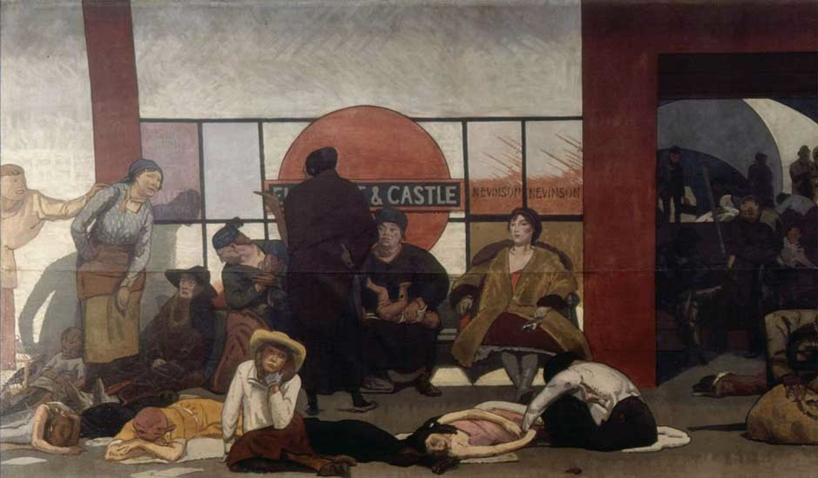
Walter Bayes: The Underworld. Photograph: Imperial War Museum Imperial War Museum

Art and literature paint the First World War as shockingly brutal and disillusioning. Many artists and writers were involved in the war as soldiers, medics and auxiliary personnel. They witnessed suffering, narrated and visualised modern, industrial violence. Some were injured physically or psychologically, and when convalescing in rehabilitation institutions drew on these experiences as inspiration for some of their best work.
In 1914, modernism – an avant-garde claim to originality, autonomy and rupture – dominated debates about art, literature and music. Violent experiment was one radical desire that made the prospect of war seem thrilling, a fulfilment of the theory that to build a new world the old one had to be demolished. War would be cleansing, purifying the corruption of bourgeois taste. The Italian poet FT Marinetti’s Futurist Manifesto (1909) declared that no masterpieces were created without aggression; Russian futurist poet Vladimir Maiakovskii called for the destruction of all culture; and the expressionists yearned for art to be swept aside by life. Masculine fortitude would pulsate with the dynamic energy of war machines. Alongside radicalism, war also excited patriotism and romanticism. Chivalric language and the deeds of heroic warriors – expressed by Rupert Brooke’s self-sacrifice in “a foreign field / That is for ever England” – were ideals shared across nations.
The reality of war altered this enthusiasm. Gory descriptions, caustic language and the shrill protest of hyperbole became strategies of communication. Ironic imagery was just one way of articulating the tragedy of war, and was not as “modern” as has been assumed. At Craiglockhart hospital, in Edinburgh, Siegfried Sassoon and Wilfred Owen captured the sights and sounds of war, and its moral conundrums. The “shrill, demented choirs of wailing shells” in Anthem for Doomed Youth became a paean for victims. Owen spoke for “men whose minds the Dead have ravished” (in Mental Cases) and amputees living “a few sick years in institutes” (in Disabled), while Sassoon’s Survivors could barely “stammer”, overcome by “dreams that drip with murder”.
Ford Madox Ford, son of a German immigrant and later invalided out with shellshock after the Battle of the Somme, penned Antwerp (1915). Despite the “doom” of brave men, “it is not for us to make them an anthem”; TS Eliot thought this the greatest war poem. In Ford’s series of modernist novels, Parade’s End (1924–28), the war provided the context for deeper psychological and social reflections. By the late 1920s – a period of strikes, unemployment and social conflict – Sassoon, Robert Graves and Edmund Blunden were speaking for the despair of ex-servicemen. Yet the patriotic verse of Brooke, who found “Nobleness” in the “rich Dead”, continued to be enjoyed. Still, Sassoon felt that if Brooke had not died, he would have interpreted the “international slaughterhouse” with the “bitterest satirical verse”. Warriors were undone, as Richard Aldington showed in Death of a Hero (1929), which mocks public school and military culture for the false ideals of Edwardian masculinity.
Laid bare
The drive to express and protest was not confined to men. As nurses and volunteer aides, Edwardian middle-class women such as Ellen LaMotte, Mary Borden, Vera Brittain, Enid Bagnold and Irene Rathbone, once naive to men’s bodies, now witnessed them reduced to raw, naked pain. As never before, women found new visual languages to describe the sights and sensations of the suffering that gripped their gazes. Writing atoned for an acute moral dilemma: they healed in order to return men to the front. Rose Macaulay, devastated by Rupert Brooke’s death, views the impact of a zeppelin raid in The Shadow: “Are the spilt brains so keen, so fine, crushed limbs so swift, dead dreams so sweet? / There is a Plain where limbs and dreams and brains to set the world a-fire / Lie tossed in sodden heaps of mire ... Crash!”
In the aftermath of war, women’s voices were often forgotten, despite the fact that they conjured up some of its most powerful emblems. Rose Macaulay’s Non-Combatants and Others (1916), Rebecca West’s The Return of the Soldier (1918), and Virginia Woolf’s whirling stream-of-consciousness narrative Mrs Dalloway (1925) exposed the plight of shellshocked soldiers. Women writers – and their heroines – demolished distinctions between the home front and frontline, and resisted assumptions about femininity, asserting that life was “Not So Quiet” for the “Stepdaughters of war” (Helen Zenna Smith’s novel about a female ambulance corps, which ricochets from Erich Maria Remarque’s All Quiet On the Western Front).
Modernism may have been predisposed to traumatic rupture, but the shockwaves of war neither shattered traditions nor limited innovation to modernists. Woolf praised Sassoon’s realism, whereas the critic John Middleton Murry reviled its modern “chaotic sensations”. Immediate experience, heightened awareness of time, confrontation with the body, and common vernacular are hallmarks of the modern, and yet they merged with Victorian convention in some war poetry. The distinction between modernist experiment, realism and tradition was at times difficult to distinguish. Although war art and literature were interpreted as truth-telling, they were artforms – intended to dramatise, heighten, politicise and catapult direct experiences into aesthetic imagination.
The end of patriotism?
TS Eliot, Ezra Pound and James Joyce were non-combatants (Ulysses was written in Zürich), yet their modernist dismantling of literary tradition struck a chord with the view that patriotism was the outmoded convention of an older generation’s lies. Eliot’s The Waste Land (1922) chimed with the mood of postwar chaos and the subsequent nostalgia for a lost world; The Hollow Men (1925) spoke for masculinity’s “paralysed force”: both became symbols of disenchantment. DH Lawrence was harassed and humiliated during the war: accused of being a spy and rejected as medically unfit for service. His novels, however, convey the physical sensations of work, lust and gentle touch: it is the war victim’s impotence that propels the contravention of class and fidelity in Lady Chatterley’s Lover (1928). Industrial violence had rendered the body fragile, humbling writers with its intimate sensations: Oliver Mellors recalls “the courage of physical tenderness” in the trenches.
In France, Henri Barbusse’s Le Feu (or Under Fire in English translation, 1916) conveyed the common cultural trope of apocalypse. War is more than the “glittering” bayonet or bugle’s “call to the sun”; it is “frightful and unnatural weariness, water up to the belly. Mud and dung and infamous filth ... [an] endless monotony of misery, broken by poignant tragedies.” The German expressionist poet Gottfried Benn persisted with the theme of decay. The Austrian Georg Trakl was traumatised by serving in a medical unit without anaesthetics during the battle of Grodek (the title of his masterpiece). His rapid decline ended in suicide, but not before elucidating the nightmares of his suffering:

At evening the woods of autumn are full of the sound
Of the weapons of death, golden fields
And blue lakes, over which the darkening sun
Rolls down; night gathers in
Dying warriors, the wild cries
Of their shattered mouths ...

Ernst Toller also broke down in the war, but wrote the play Transformation (1919) about a soldier who becomes a pacifist. Writers struggled against the silent pain of trauma, even when overwhelmed. In 1936, Edmund Blunden was still writing haunted poems, such as The Survivor’s Ghosts:

Of which, at the instance
Of sound, smell, change and stir,
New-old shapes for ever
Intensely recur.

Blunden conveyed the traumatic condition: painful repetition brought about by memory triggers. Yet his memoir Undertones of War (1928) is a pastoral ode to the beauty and destruction of landscape, a theme he reiterated for the Imperial War Graves Commission. The paradox of mourning and recovery lay in the contrast between the “chaos and oblivion” of the front and the “harmonious grace and dignity” of the cemeteries.
Alongside the need for healing, violence was both a mode of communication and form of entertainment. RC Sherriff’s play, Journey’s End (1928), cultivated gritty realism that consoled audiences and instilled pride. But some critics rebuked its representation of alcoholism, cowardice and shellshock. Like Remarque’s All Quiet On the Western Front (1929), it crossed over into film, breaking boundaries between elite and popular culture. Fear, disablement and wasted youth (as pitiful as a butterfly’s short life) were treated with dramatic candour, while breaking box-office records.
Musicians, too, had seen war service – notably Ravel, Schoenberg, Berg and Vaughan Williams. Commissioned by the war-disabled pianist Paul Wittgenstein, Ravel’s Piano Concerto for the Left Hand crescendos into tragedy. Yet Vaughan Williams, student of Ravel and stretcher-bearer in the Royal army Medical Corps, composed the lyrical, meditative elegy A Pastoral Symphony (1922), before continuing with more innovative syncopations. His friend, the composer George Butterworth, was killed at Pozières. Edward Elgar, meanwhile, felt his own “Pomp and Circumstance” marches too nationalistic for the catastrophe of the war.
In Russia, as elsewhere, the music of Mozart and Beethoven was forbidden to be played at concerts, but artists, for the most part, were ambivalent. Symbolists felt there was “wisdom in silence”, and the avant-garde sustained the advance of abstraction. In Switzerland, Igor Stravinsky read Russian folk tales to rouse his patriotism. From the minimalism of The Soldier’s Tale (1917), though, he turned to cool classicism in the 1920s – a common response to the war. Patriotic verse had its role, as with other nations, but after 1917 Russians were less concerned with war literature than with the meaning of revolution.
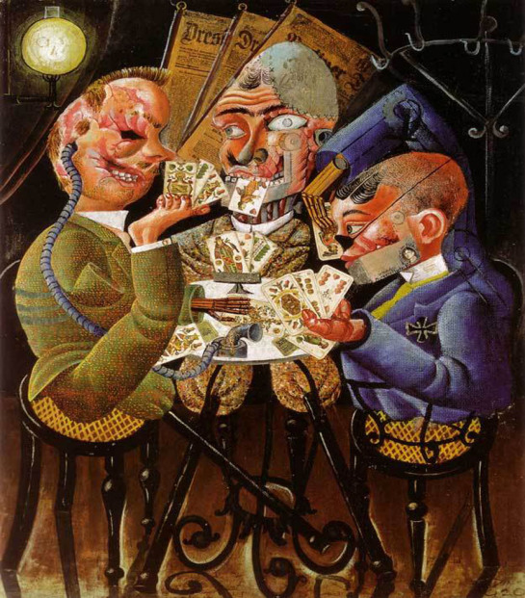
Disabled War Veterans Playing Cards – Otto Dix. Photograph: The Art Archive The Art Archive
Paint it black
The complexities of victory and defeat also shaped the symbolism. At the 1920 Berlin Dada fair, the savage cruelty of war featured in Otto Dix’s War Cripples (1920) and George Grosz’s Grey Day (1921). Prematurely aged men, amputees and grotesque mutilations formed the Weimar artists’ attack on the glorification of war and the myth of bodily sacrifice. The “new objectivism” offered biting commentaries on humanity, devoid of emotions and fleshy sensations: Heinrich Hoerle’s Monument to the Unknown Prosthesis (1930) sacralised prosthetics and presented the next generation as faceless machines. While for Sigmund Freud, whose three sons were drafted, science had lost its “passionless impartiality” as gasses and shells delivered a new degree of viciousness, he also saw man becoming a “prosthetic God”.
At one end of the cultural spectrum were objectified bodies; at the other were ghosts rising from burial grounds, as in Abel Gance’s film J’accuse (1919) – where soldiers’ bodies formed those damning words – or Stanley Spencer’s mural, Resurrection of the Soldiers (Sandham Memorial Chapel, Burghclere, 1928-1932). Paul Nash described the western front as “unspeakable”, “one huge grave” that becomes “invisible to sight”. Yet Nash was compelled by its destruction, painting trees broken as limbs (The Menin Road, 1919).
In the struggle to find meaning in the war, modernism continued as a viable language. Newspapers hailed the “modern revolution” in portraying “the horror”, and celebrated the work of Vorticist Wyndham Lewis, who served at Ypres and was an official Canadian war artist: “you can almost see and hear the shells” descending with “powerful ... material force”, wrote one critic. In 1919, the British War Art Collection travelled to the US, where Vanity Fair applauded its “emotional and imaginative appeal”. Many troubling images were included: anguished faces in William Roberts’ The First German Gas Attack at Ypres (1918); a stretcher-bearer’s posture shrinking in empathy with his patient in Eric Kennington’s Gassed and Wounded (1918); a wounded man groaning in agony in CRW Nevinson’s The Doctor (1916).
Although the ministry of information censored Nevinson’s dead tommies (Paths of Glory, 1917), there was scope for artists to portray war with ingenuity. War art was neither propaganda nor simply personal memories on canvas. Audiences connected with and reacted against their visual narratives. When Canadian war surgeon Sir William Osler, whose son died in the war, saw John Singer Sargent’s Gassed (1918–19) – blinded soldiers pathetically parading across a noxious landscape – he shuddered: “It haunts the mind like a nightmare.”
Artistic differences
Although the war forced artists and writers to confront the carnage, the response of some avant-garde artists and ideologues was ambivalent. Marinetti wanted “words to explode like shells, or ache like wounds”. By 1930, cultural narratives shifted between surrealist André Breton’s “convulsive beauty” and what Australian-born writer Frederic Manning called “convulsive agonies” (Her Privates We, 1930). With so many artists either killed or injured, heroic fantasies were translated into victimhood. Yet Breton’s Surrealist Manifesto (1924) transformed his hospital work analysing soldiers’ nightmares into a new consciousness expressed in “automatic writing”. Reality had collapsed into dream; the rational and irrational realms were indistinguishable; desire and sexual transgression were to be enacted, not sublimated.
Others, however, reinvented familiar aesthetic codes such as classicism. Just before his death in 1918 (in the influenza pandemic that cost millions of lives), the French poet Guillaume Apollinaire defined the new spirit of modernism as seeking social harmony, aligning classicism with hopes for a unified society. Picasso depicted joyous life, tranquil scenes and maternal figures (Mother and Child, 1921). Across Europe, war had heightened fears of depopulation, and now women appeared as the bearers of the future race. Utopia was an artistic and political dream in the inter-war period; out of catastrophe, civilisation would be reborn.
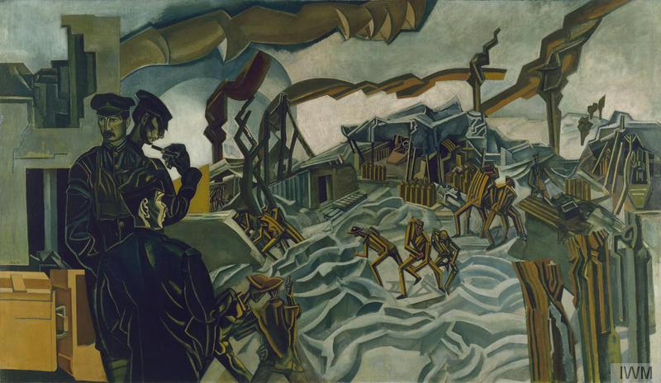
A Battery Shelled, 1919 by Percy Wyndham Lewis (1882-1957). Photograph: Imperial War Museum/Bridgeman Art Library
Concerned with universal laws and certainties, Wyndham Lewis replaced the jagged dynamism of war and the brutality of mass conflict (A Battery Shelled, 1918) with a distinctly sombre, classical quality combined with linear figuration (Girl Reclining, 1919; Portrait of Edith Sitwell, 1923–1935). In the 1920 Seven and Five exhibition at Walker’s Gallery, Lewis’s group aimed “merely to express what they feel in terms that shall be intelligible, and not to demonstrate a theory nor to attack a tradition”. Depressed by sculptor Henri Gaudier-Brzeska’s death in service, Lewis refused to find any redemptive value in war.
Recovering from the effects of gas at Verdun, Fernand Léger painted injured and mechanical soldiers (Le Blesse, 1917; The Card Players, 1917), but later found monumental humanity in grand figuration (Three Comrades, 1920; The Mechanic, 1920). Constructivists recoiled from the horrors of war. “The days of destroying, laying siege and undermining lie behind us,” said the Russian constructivist El Lissitzky. Sculptor Naum Gabo now admired the Winged Victory of Samothrace for its “imaginary forward movement”, when earlier the Greek sculpture had incited futurist disdain. Traditionalists and modernists alike believed culture could generate human unity and contribute to world peace. How could suffering arouse such visions of utopia?
Embedded in the search for meaning was a painful tension between mourning and moving on, between remembering and forgetting the horror. Rudyard Kipling’s biblical phrase “Their Name Liveth for Evermore” was carved into Edwin Lutyens’ “Stones of Remembrance”, beautifully devoid of figure or fact. Kipling was a patriot, but one grief-stricken by his son’s death. The phrase suggests this haunting, as it beckons society to remember. Henri Barbusse wrote of men as “forgetting machines”, since “there’s only the names left”. In Aftermath, Siegfried Sassoon turned this call into a desperate provocation: “Have you forgotten yet? ... Look down, and swear by the slain of the War that you’ll never forget.” In The Tenth Armistice Day, American poet S Gertrude Ford responded with deep irony: “And yet, so short the memories of men.”
This was literary licence. Far from forgotten, the war was continually elaborated upon within the arts. Yet the relation between war and cultural production is never as straightforward as cause and effect. Two decades after the Armistice, loss and grief continued to mix with social rejuvenation and personal re-evaluation. Those writing and painting the war’s violence also participated in commemoration, which often sanitised death. Classicism cleansed the reality of blood and mutilation. Traditions persisted in sacred and romantic gestures; modernism became identified with consumption and mass culture; abstract designs – once radical – now permeated magazines and shopfront windows. For some the war was the substance of their art; yet many other artists left it behind. Nevertheless, the First World War’s violent nights remain with us as the hallucinations of “cultural memory”, and through its narrative spectacles we inscribe our own values on to the visionaries of the past.

Ana Carden-Coyne is lecturer in war and conflict studies at the Centre for the Cultural History of War, University of Manchester. Her forthcoming book, Reconstructing the Body: Classicism, Modernism and the First World War, will be published by Oxford University Press [Note: this book is available as an eBook via the UWTSD Library].

