

BA Leadership and Management
LEVEL 5
People Management
BMSW5010
Module Lead: Rebecca Francis Davies
email: r.francis-davies@uwtsd.ac.uk
Submission Date: 12/12/2025

Executive Summary

This report examines the people-management challenges facing BrightWave Services, a rapidly growing facilities management company operating across South Wales. Despite securing several major public sector contracts, BrightWave is experiencing rising turnover, inconsistent service performance, low employee engagement, and cultural issues that limit communication, recognition, and staff development. These challenges are compounded by a managerial skills gap, as many supervisors have been promoted based on technical expertise rather than people-management capability.
Using a range of established management and HR theories including Herzberg’s Two-Factor Theory, McGregor’s Theory X and Y, the Psychological Contract, Situational Leadership, and High-Performance Work Practices, the report critically analyses how managerial behaviour, organisational culture, and performance management processes have shaped current outcomes. The findings highlight a predominantly task-driven culture, limited feedback and recognition practices, unclear progression pathways, and a lack of structured induction and performance systems.
The report concludes with evidence-based recommendations aimed at strengthening managerial capability, improving performance management frameworks, fostering a more people-centred and collaborative culture, and enhancing staff engagement and retention. Implementing these actions would enable BrightWave to improve workforce motivation, service quality, and long-term organisational performance.

Table of Contents
1 Introduction 4
2 Roles and Skills Required by Managers to Effectively Manage Performance at BrightWave 5
2.1 Key Managerial Roles 5
2.2 Essential Managerial Skills 7
3 Applying Relevant Theories and Models of People Management to BrightWave 9
3.1 Herzberg’s Two-Factor Theory 9
3.2 McGregor’s Theory X and Theory Y 9
3.3 The Psychological Contract 10
3.4 Situational Leadership (Hersey and Blanchard) 10
3.5 High-Performance Work Practices (HPWPs) 10
4 Influence of Organisational Culture on People Management Practices 11
4.1 Task-Driven Culture 11
4.2 Resistance to Innovation 11
4.3 Fragmented Working and Limited Collaboration 11
4.4 Consequences for People Management 11
5 Evidence-Based Recommendations 12
5.1 Strengthen Managerial Capability 12
5.2 Improve Performance Management Systems 13
5.3 Enhance Organisational Culture 14
5.4 Improve Engagement and Retention 14
5.5 Strengthen Collaboration and Innovation 15
6 Conclusion 16
7 References 17

Introduction
BrightWave Services Ltd is a medium-sized facilities management company operating across South Wales, employing approximately 350 staff across three divisions: building maintenance, cleaning services, and workplace support. The organisation experienced rapid growth after securing a series of public-sector contracts, which significantly expanded its operational responsibilities and workforce. However, this growth has exposed underlying weaknesses in its managerial capacity, people-management processes, and organisational culture. Staff concerns regarding fairness, recognition, communication, and progression, alongside rising turnover rates, indicate that current approaches are no longer sustainable.
As organisations scale, the role of managers in shaping the employee experience becomes increasingly critical. Results showed that stronger people and HR management practices enhance the positive link between employee engagement and work performance, highlighting the importance of investing in skilled manager and employees (Othman & Mahmood, 2019). For BrightWave, where frontline teams deliver essential public services, the ability of managers to guide, motivate, support, and retain staff is directly linked to client satisfaction and contract reliability. This report therefore evaluates the managerial roles and skills required at BrightWave, applies relevant theories and models to its current context, assesses the influence of organisational culture on people management, and finally proposes evidence-based recommendations aimed at enhancing performance, engagement, and organisational effectiveness.

Roles and Skills Required by Managers to Effectively Manage Performance at BrightWave
Effective management plays a crucial role in improving engagement and productivity (Othman & Mahmood, 2019). At BrightWave, frontline managers hold particular importance due to dispersed teams, a task‑driven culture, and strong client expectations. Managing performance effectively requires managers to set clear expectations, monitor progress, provide constructive feedback, support development, and intervene when performance standards are not met.

Key Managerial Roles
Henry Mintzberg’s research on the nature of managerial work offers a comprehensive framework for understanding the roles required of managers at BrightWave. His studies highlight that managerial work is fast-paced, fragmented, and centred on people rather than systems, making his model especially relevant for frontline supervisors managing dispersed teams and frequent operational pressures at BrightWave. (Kumar, 2015) (Mintzberg, 1973)
Mintzberg (1973) groups managerial responsibilities into interpersonal, informational, and decisional roles, all of which are essential for effective people management.
- Interpersonal Roles
Managers act as:
  - Figureheads, representing the organisation formally and modelling expected standards.
  - Leaders, responsible for motivating staff, providing guidance, and shaping team climate particularly important given BrightWave’s low recognition and unclear expectations.
  - Liaisons, maintaining relationships across teams and external partners; a key need at BrightWave where collaboration is currently weak.

- Informational Roles
Managers must:
  - Monitor team performance, staff concerns, and client needs, addressing current issues of poor communication.
  - Disseminate information clearly so staff understand priorities, workloads, and changes.
  - Act as spokespersons, communicating team needs and performance issues to senior leaders and clients.

- Decisional Roles
Managers also make critical decisions by:
  - Acting as entrepreneurs, identifying improvements and supporting innovation which is important in overcoming BrightWave’s resistance to new ideas.
  - Serving as disturbance handlers, addressing conflicts and performance problems promptly.
  - Allocating resources, such as workloads and schedules, which is vital in resolving concerns about unfair task distribution.
  - Negotiating with staff and clients to maintain service quality and manage expectations.

Using Mintzberg’s framework demonstrates that BrightWave managers must balance leadership, communication, problem-solving, and relationship management—not just administrative tasks. Strengthening these roles would help address inconsistent performance, low engagement, and limited collaboration within the organisation.

Essential Managerial Skills
In this section we discuss the main skills needed by managers in BrightWave in order to transform it to a more efficient and productive organisation:
Communication and Active Listening: Emerson (2021) believed clear and effective communication is every manager’s most critical skill. Given BrightWave’s low engagement levels, managers must encourage two‑way dialogue and build trust through active listening.
Coaching Skills: Coaching tools such as the GROW model (Goal, Reality, Options, Will) help managers structure developmental conversations.
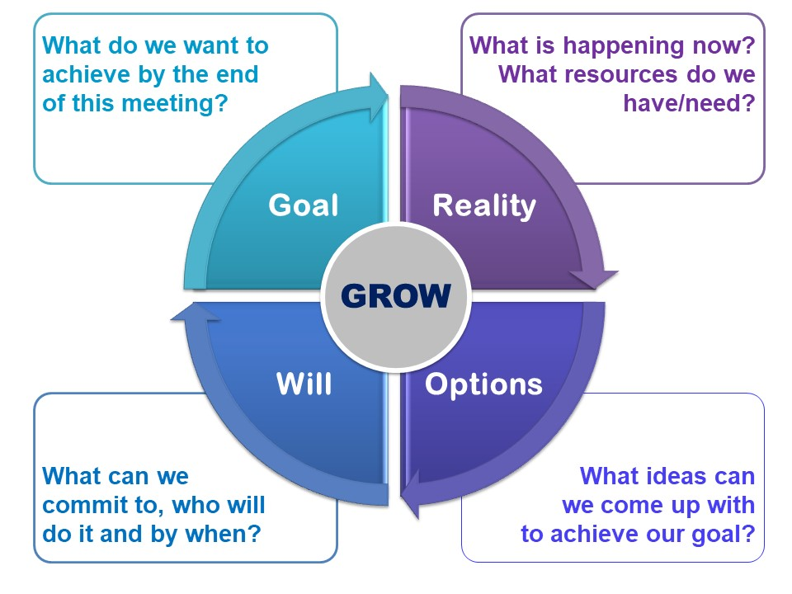
Figure 1 - GROW Model (Wilson, 2020)
Whitmore (2017) highlights that although the model does not need to be used in strict order, goal-setting should be the starting point.
Emotional Intelligence (EI): EI enables managers to understand emotions, tailor communication styles, and build strong relationships—especially important in low-paid or high-turnover roles where morale may be fragile.
Performance Management Skills: These include setting SMART objectives, conducting fair appraisals, and documenting performance appropriately.
Motivation Skills: Herzberg’s motivators such as recognition, achievement, and responsibility can significantly impact satisfaction and engagement. Their absence at BrightWave contributes to dissatisfaction.
Fairness and Ethical Leadership: Perceptions of unfair workload distribution and unequal access to development opportunities suggest a breakdown in both procedural and distributive justice at BrightWave. Kim and Lee (2024) highlight that fairness and ethical leadership directly shape organisational culture by fostering integrity, trust, and ethical behaviour across all levels of the organisation. Therefore, managers must demonstrate ethical leadership through transparent decision-making, consistent application of rules, and open communication about how tasks and opportunities are allocated.

Applying Relevant Theories and Models of People Management to BrightWave
This section explores how key people management theories apply to BrightWave’s current situation and inform potential improvements.

Herzberg’s Two-Factor Theory
Herzberg (1959) distinguishes between hygiene factors (e.g., pay, working conditions) and motivators (e.g., recognition, development) as it is illustrated in figure 2.
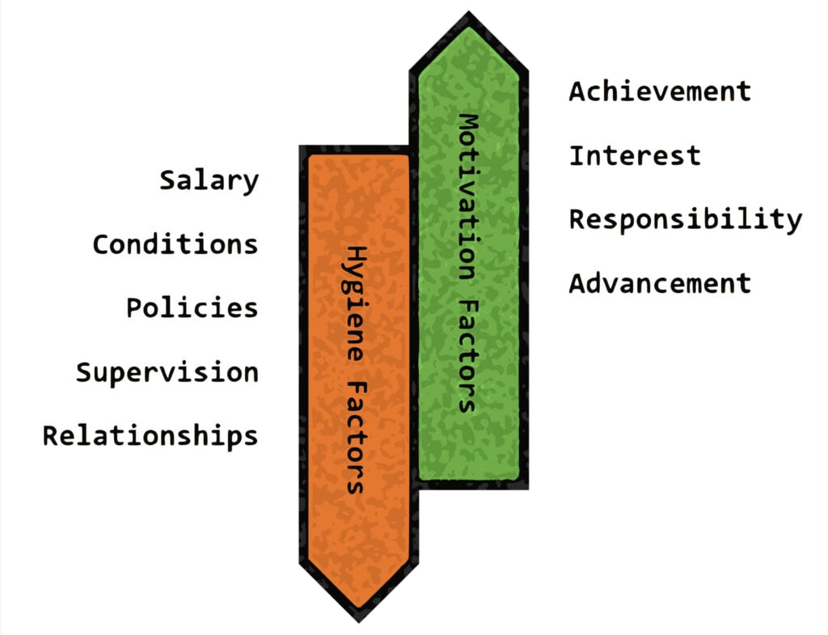
Figure 2 - Herzberg's Theory (Nickerson, 2025)
BrightWave performs poorly on both. High turnover and dissatisfaction stem from unpredictable workloads, low recognition, and no clear career paths. Improving both hygiene factors and motivators is essential for building engagement and retention.

McGregor’s Theory X and Theory Y
Theory X assumes employees dislike work and require close supervision, whereas Theory Y views employees as self-motivated and capable of autonomy (Channell, 2021).
BrightWave’s current approach reflects a Theory X mindset, contributing to rigidity, low empowerment, and minimal innovation. Moving towards Theory Y would lead to improved employee engagement, reduced turnover and significant enhancements in cross-functional team collaboration (Miftari, 2024).

The Psychological Contract
The psychological contract describes unwritten expectations between employees and employers (Rousseau, 1989). At BrightWave, perceived breaches such as lack of fairness, poor communication, and no development opportunities have lowered commitment and trust. Rebuilding the psychological contract requires improved communication, support, and visibility from managers.

Situational Leadership (Hersey and Blanchard)
Situational Leadership suggests that leadership style should vary according to employee competence and motivation (Campbell, 2024). The four styles—Telling, Selling, Participating, and Delegating—help leaders provide the right balance of direction and support (Hersey and Blanchard, 1977).
Due to lack of training, many BrightWave managers use a one-size-fits-all approach, creating disengagement. Adopting situational leadership would allow managers to support new recruits more effectively while empowering experienced staff.

High-Performance Work Practices (HPWPs)
HPWPs emphasise high-quality service delivery through an engaged, skilled, and empowered workforce (Tamkin, 2004). Practices such as structured training, employee involvement, recognition systems, and transparent progression pathways could significantly improve performance and retention at BrightWave.

Influence of Organisational Culture on People Management Practices
Organisational culture shapes values, behaviour, and hidden beliefs among the employees which can influence decision making, recruitment, retention, and performance (Miron, Erez and Naveh, 2004). At BrightWave, cultural characteristics significantly influence peoplemanagement practices.

Task-Driven Culture
BrightWave prioritises efficiency and cost control. While beneficial for meeting client commitments, this results in limited focus on people-development activities. Managers prioritise administrative and logistical tasks over coaching, recognition, and engagement.

Resistance to Innovation
The organisation is described as conservative and sceptical of new ideas. This reduces willingness to implement wellbeing initiatives or trial flexible scheduling, hindering progress.

Fragmented Working and Limited Collaboration
Teams "stick to their bit," resulting in poor collaboration and weakened organisational identity. Managers receive limited exposure to alternative management styles, reinforcing inconsistency.

Consequences for People Management
These cultural characteristics create several challenges:
- Avoidance of Feedback: Difficult conversations are perceived as disruptive, reinforcing avoidance.
- Low Recognition: Recognition is not culturally embedded, leaving managers unsure how to acknowledge good performance.
- Limited Development: Development pathways are unclear, contributing to disengagement and turnover.
- Inconsistency: Cultural ambiguity leads to varied managerial practices, creating performance gaps.

Evidence-Based Recommendations
This section outlines practical and evidence-based actions that BrightWave can implement to address current organisational challenges. Recommendations focus on improving managerial capability, strengthening performance management systems, shaping a more positive organisational culture, and increasing engagement, collaboration, and retention.

Strengthen Managerial Capability
To build a more capable and confident management team, BrightWave must invest in structured development initiatives. Evidence shows that providing line and middle managers with formal training and development significantly enhances their impact on team performance and organisational outcomes (Barends, Rousseau & Janssen, 2023).
People-Management Training Programme: A comprehensive training offer should include modules on performance conversations, coaching techniques, conflict resolution, emotional intelligence, and effective communication. Recent research demonstrates that managerial coaching competencies directly contribute to improved team performance and higher employee motivation (Nyfoudi et al., 2022). Therefore, these skills are crucial given the current avoidance of difficult conversations and limited recognition practices.
Regular Managerial Development Workshops: Peer learning workshops, where supervisors share challenges and best practices, encourage reflective practice and help standardise managerial behaviour across dispersed teams. Such development structures are linked to higher managerial effectiveness and consistency in leadership practice (Barends, Rousseau & Janssen, 2023).
Improved Decision-Making Skills: One of the core managerial competencies is high-quality decision making.
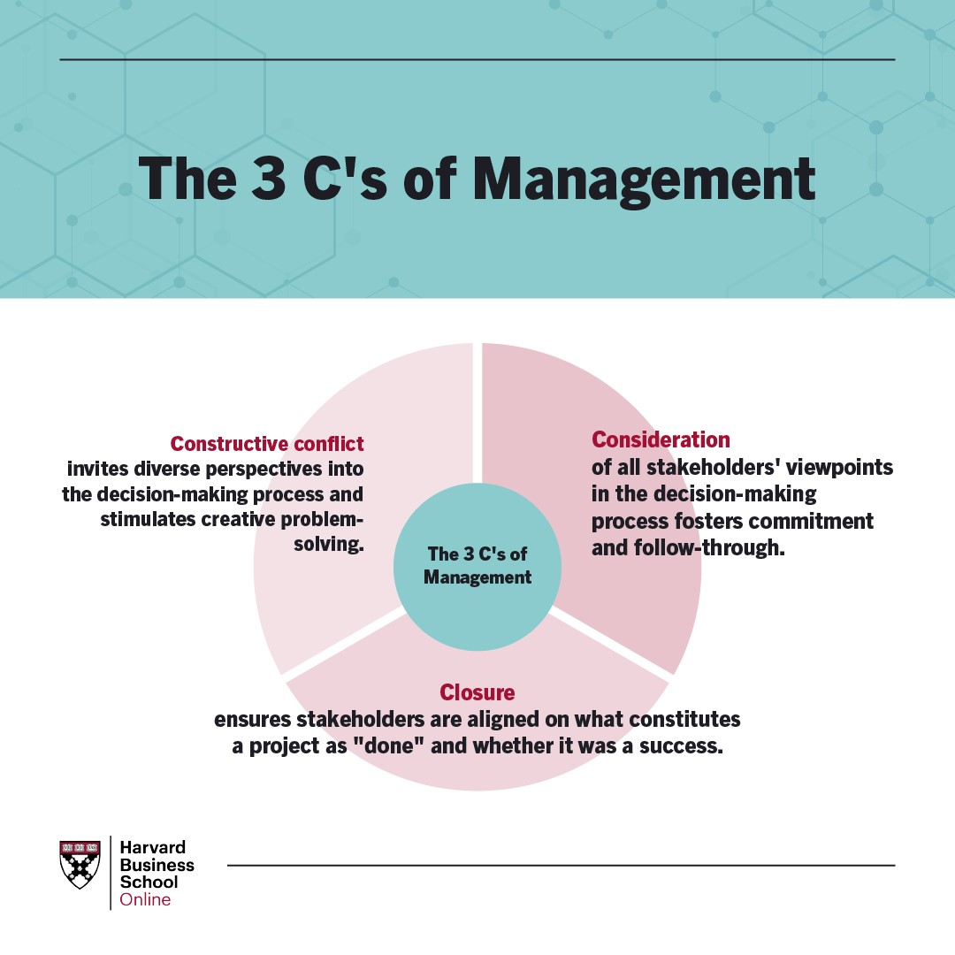
Figure 3 – The 3 C’s of Management (Gavin, 2020)
Improved Decision-Making Skills:
Decision making is a fundamental managerial competency. As illustrated in figure 3 the 3Cs framework, BrightWave managers could adopt the following to enhance decision quality:
- Constructive Conflict: Encouraging diverse opinions and inviting staff contributions leads to more robust decisions.
- Consideration: Ensuring all voices are heard fosters trust, fairness, and psychological safety during decision-making.
- Closure: Clearly defining expectations, timelines, and responsibilities strengthens accountability and reduces ambiguity. (Gavin, 2020)
Using structured decision-making approaches can improve managerial confidence, reduce inconsistency, and enhance overall capability.

Improve Performance Management Systems
A strong performance management system clarifies expectations, guides behaviour, and supports development.
Clear Expectations and Values-Based Standards: BrightWave should ensure all employees understand performance standards aligned with organisational values and client requirements.
Structured Performance Reviews: Implement quarterly check-ins using SMART objectives to provide feedback and development support. However, researchers warn that SMART should be used flexibly; tasks involving qualitative judgement or creativity may require alternative evaluation approaches (CIPD, 2025).
Standardised Induction Processes: A clear induction checklist outlining expectations, safety guidance, and career pathways helps new recruits integrate confidently.
Feedback Culture: Managers should provide regular informal feedback. Templates or conversation prompts can support supervisors who lack confidence in giving constructive feedback.
While strengthening performance systems is essential, BrightWave must ensure processes do not overwhelm staff or reduce focus on frontline work. As CIPD (2025) highlights, performance systems should support and not obstruct daily tasks.

Enhance Organisational Culture
Employees spend an estimated 90,000 hours, nearly one-third of their lives, at work (Harvard University, 2025). A positive workplace culture is therefore vital for wellbeing, belonging, productivity, and retention.
Shift from Task-Driven to People-Centred Values: Leaders must demonstrate visible commitment to fairness, recognition, and development. This includes communicating a clear cultural vision and modelling the behaviour expected of managers.
Recognition Programmes: Simple initiatives such as monthly appreciation messages, team shout-outs, and recognition boards can significantly improve morale and reinforce positive behaviours.
Employee Voice Mechanisms: Regular listening groups, suggestion schemes, and action-focused surveys allow employees to contribute to decisions and feel valued.
A more people-centred culture would directly address many of BrightWave’s current challenges, including high turnover and disengagement.

Improve Engagement and Retention
Many employees leaving BrightWave cite lack of appreciation, unclear progression, and a negative working environment, issues commonly associated with disengagement (Perkbox, 2022).
- Clear Career Pathways: BrightWave should create transparent progression routes for cleaning and maintenance staff, including supervisory apprenticeships or specialist roles.
- Wellbeing Initiatives: Small scale initiatives such as wellbeing days, flexible scheduling, or peer support groups can strengthen psychological commitment and reduce burnout.
- Fair Work Practices: Ensuring consistent workload allocation, equitable treatment, and reliable communication aligns with client expectations and enhances trust.
- Improving retention not only reduces recruitment costs but also increases service quality and team stability.

Strengthen Collaboration and Innovation
Collaboration is strongly linked to performance. Top-performing employees spend around 45% of their time collaborating, and collaborative environments lead to 17% higher employee satisfaction on average (Boskamp, 2022).
Cross-Team Projects: Encouraging teams from different divisions to work together on service improvements or operational challenges can strengthen problem-solving and improve consistency across sites.
Internal Communication Platforms: Digital tools can help staff share updates, celebrate achievements, and stay informed about organisational developments.
As illustrated in Figure 4, strong collaboration can positively influence service quality, customer satisfaction, and organisational performance.

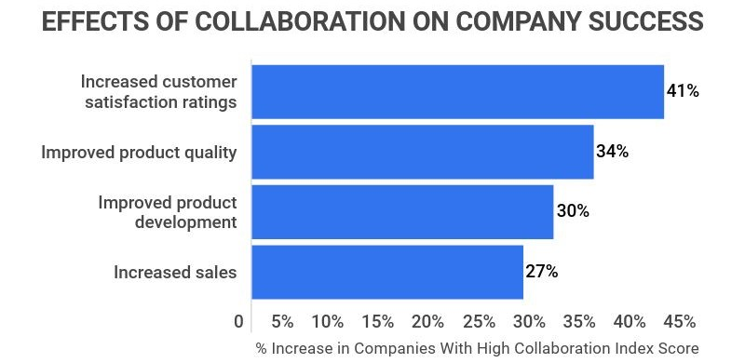
Figure 4 - Collaboration Effects on Company Success (Boskamp, 2022)

Conclusion
BrightWave Services is at a critical point where rapid organisational growth has revealed significant weaknesses in managerial capability, performance management processes, and organisational culture. The analysis shows that many of the company’s current challenges including high turnover, low engagement, inconsistent performance, and declining service quality, stem from a task-driven culture and a lack of structured support for frontline managers. Applying relevant theories such as Herzberg’s Two-Factor Theory, McGregor’s Theory X and Y, the Psychological Contract, Situational Leadership, and High-Performance Work Practices highlights that BrightWave must shift towards a more people-centred and development-focused approach to unlock sustainable improvement.
The evidence based recommendations presented in this report emphasise the need for strengthened managerial training, clearer performance systems, and a cultural shift that prioritises communication, recognition, fairness, and collaboration. Improving engagement and retention through transparent career pathways, wellbeing initiatives, and fair work practices will also support workforce stability and improve client satisfaction.
Ultimately, by investing in people-management capability and addressing the cultural barriers that limit innovation and communication, BrightWave can create a more motivated and committed workforce. This will not only enhance service quality and employee experience but also improve long term productivity, organisational reputation, and profitability. A strategic focus on people is therefore essential for BrightWave to meet growing client demands and remain competitive within the facilities management sector.

References
Barends, E., Rousseau, D. and Janssen, B. (2023) People managers: An evidence review. Scientific summary. London: Chartered Institute of Personnel and Development.
Boskamp, E. (2022). 37 Detailed Workplace Collaboration Statistics [2021] – Zippia. [online] Zippia. Available at: https://www.zippia.com/advice/workplace-collaboration-statistics/ [Accessed 1 Dec. 2025].
Campbell, J. (2024). Situational leadership theory | EBSCO. [online] EBSCO Information Services, Inc. | www.ebsco.com. Available at: https://www.ebsco.com/research-starters/social-sciences-and-humanities/situational-leadership-theory [Accessed 30 Nov. 2025].
Channell, M. (2021). McGregor’s Theory X Vs Theory Y: How to Increase Performance in Your Team. [online] TSW Training. Available at: https://www.tsw.co.uk/blog/leadership-and-management/mcgregors-theory-x-vs-theory-y/ [Accessed 1 Dec. 2025].
CIPD (2025). CIPD | Performance Management | Factsheets. [online] CIPD. Available at: https://www.cipd.org/uk/knowledge/factsheets/performance-factsheet/#two [Accessed 2 Dec. 2025].
Emerson, M.S. (2021). 8 Ways You Can Improve Your Communication Skills. [online] Professional Development | Harvard DCE. Available at: https://professional.dce.harvard.edu/blog/8-ways-you-can-improve-your-communication-skills/ [Accessed 10 Dec. 2025].
Gavin, M. (2020). 7 Strategies for Improving Your Management Skills | HBS Online. [online] Business Insights - Blog. Available at: https://online.hbs.edu/blog/post/how-to-improve-management-skills [Accessed 1 Dec. 2025].
Harvard University (2025). Why Workplace Culture Matters. [online] Professional Development | Harvard DCE. Available at: https://professional.dce.harvard.edu/blog/why-workplace-culture-matters/ [Accessed 1 Dec. 2025].
Hersey, P. and Blanchard, K.H. (1977). Management of Organizational Behavior: Leading Human Resources. New Delhi: Pearson India Education Services.
Herzberg, F. (1959). The Motivation to Work. 2nd ed. New York: John Wiley & Sons.
Kim, D. and Lee, M.J., 2024. The role of ethical leadership in enhancing organizational culture and performance. International Journal of Management, Business, and Economics, 1(2).
Kumar, P., 2015. An analytical study on Mintzberg’s framework: Managerial roles. International Journal of Research in Management & Business Studies, 2(3), pp.12-19.
Miftari, F., 2024. THE IMPACT OF MODERN MANAGEMENT THEORIES. UTMS Journal of Economics, 15(1).
Mintzberg, H. (1973). Henry MINTZBERG, The Nature of Managerial Work (1973) & Simply Managing: What Manager Do - And Can Do Better (2013). M@n@gement, 18(2), p.186. doi:https://doi.org/10.3917/mana.182.0186.
Miron, E., Erez, M. and Naveh, E. (2004). Do personal characteristics and cultural values that promote innovation, quality, and efficiency compete or complement each other? Journal of Organizational Behavior, 25(2), pp.175–199. doi:https://doi.org/10.1002/job.237.
Nickerson, C. (2025). Herzberg’s two-factor theory of motivation-hygiene. [online] Simply Psychology. Available at: https://www.simplypsychology.org/herzbergs-two-factor-theory.html [Accessed 1 Dec. 2025].
Nyfoudi, M., Shipton, H., Theodorakopoulos and Pawan Budhwar (2022). Managerial coaching skill and team performance: How does the relationship work and under what conditions? Human Resource Management Journal, [online] 33(2). doi:https://doi.org/10.1111/1748-8583.12443.
Othman, S.A. and Mahmood, N.H.N., 2019. Linking employee engagement towards individual work performance through human resource management practice: From high potential employee’s perspectives. Management Science Letters, 9(7), pp.1083-1092.
Perkbox (2022). The Importance of Employee Retention: 5 Factors | Perkbox. [online] Perkbox. Available at: https://www.perkbox.com/resources/blog/importance-of-employee-retention [Accessed 30 Nov. 2025].
Rousseau, D. (1989). Psychological and Implied Contracts in Organizations. Employee Responsibilities and Rights Journal, [online] 2(2), pp.121–139. doi:https://doi.org/10.1007/BF01384942.
Tamkin, P. (2004). High Performance Work Practices. IES Research Network, [online] pp.1–2. Available at: https://www.employment-studies.co.uk/system/files/resources/files/mp36.pdf [Accessed 1 Dec. 2025].
Whitmore, J. (2017). Coaching for performance: The principles and practice of coaching and leadership. 5th ed. London: Nicholas Brealey.
Wilson, C. (2020). The GROW model. [online] Culture at Work. Available at: https://www.coachingcultureatwork.com/the-grow-model/ [Accessed 1 Dec. 2025].

