

Effective Team Working and Communication

Module N°BMSW4002_LON

Lecture Name Christopher Mafuva

Student Number 1906501

Student Name Anthony Jheff Portaro Colqui

Table Of Contents

- Introduction

2. Types of communication.

2.1. Verbal communication

2.2. Non-verbal communication

- Theories of communication

3.1. Shannon Weaver communication model

3.2. Berlo communication model

3.3. Schramm communication model

- Conclusion

5. Appendices

- INTRODUCCION

- Teamwork means that a group of people agree and perform a task together and in harmony.
The explanation of teamwork for me is a working model of a group of people with the same purpose.

- TYPES OF COMMUNICATION

- There are four main types of communication that we use frequently and that means we use them daily, such as: verbal, nonverbal, written and visual. Let's take a look at each of these types of communication, why they are important and how you can improve us to achieve our goals.

2.1 VERBAL COMMUNICATION

- Verbal communication for me means the use of sounds and words to express themselves in a direct way, especially in contrast to the use of gestures and the use of body language (non-verbal communication)

- https://www.yourdictionary.com/verbal-communication

2.2 NON-VERBAL COMMUNICATION

- Nonverbal communication refers to gestures, facial expressions, tone of voice, eye contact (or lack thereof), body language, posture and other ways in which people can communicate without using verbal language and only with the use of language of the body.

- https://www.thebalancecareers.com/nonverbal-communication-skills-2059693

3.0 THEORIES OF COMMUNICATION

- Mechanistic - The mechanistic view point says that communication is simply the transmission of information from the first party to the second party. The first party being the sender and the second party being the receiver.

- Psychological - According to the psychological view point, communication is simply not the flow of information from the sender to the receiver but actually the thoughts, feelings of the sender which he tries to share with the recipients. It also includes the reactions, feelings of the receiver after he decodes the information.

- Social - The social view point considers communication as a result of interaction between the sender and the receiver. It simply says that communication is directly dependent on the content of the speech. “How one communicates” is the basis of the social view point.

- https://www.managementstudyguide.com/communication-theory.htm

3.1 SHANNON-WEAVER MODEL OF COMMUNICATION

- This model breaks the sender and receiver model it seems communication in a practical way. It is not a traditional model.
It can happen within our self or two people; each person acts as both sender and receiver and hence use interpretation. It is simultaneously take place e.g. encoding, interpret and decoding.

- https://www.communicationtheory.org/shannon-and-weaver-model-of-communication/



3.2 BERLOS MODEL OF COMMUNICATION

- Berlo’s model follows the SMCR model. This model is not specific to any particular communication.

Berlo’s model includes a number of factors under each of the elements:
Source: The source is situated where the message originates.

Communication skills – It is the skill of the individual to communicate. For example, the ability to read, write, speak, listen etc.

Attitudes – This includes attitudes towards the audience, subject and towards oneself. For example, for the student, the attitude is to learn more and for teachers, it is to help teach.
Knowledge– Communicating also means that the person needs to be knowledgeable about the subject or topic. For e.g. a teacher needs to know about the subject in detail that he or she teaches so that they can communicate properly such that the students understand here.

- https://www.communicationtheory.org/berlos-smcr-model-of-communication/



3.3 SCHRAMMS MODEL OF COMMUNICATION

- It is a Circular Model, so that communication is something circular in nature

Encoder – Who does encoding or Sends the message (message originates)

Decoder – Who receives the message

Interpreter – Person trying to understand (analyses, perceive) or interpret

Note: From the message starting to ending, there is an interpretation goes on. Based on this interpretation only the message is received.

- https://www.communicationtheory.org/osgood-schramm-model-of-communication/

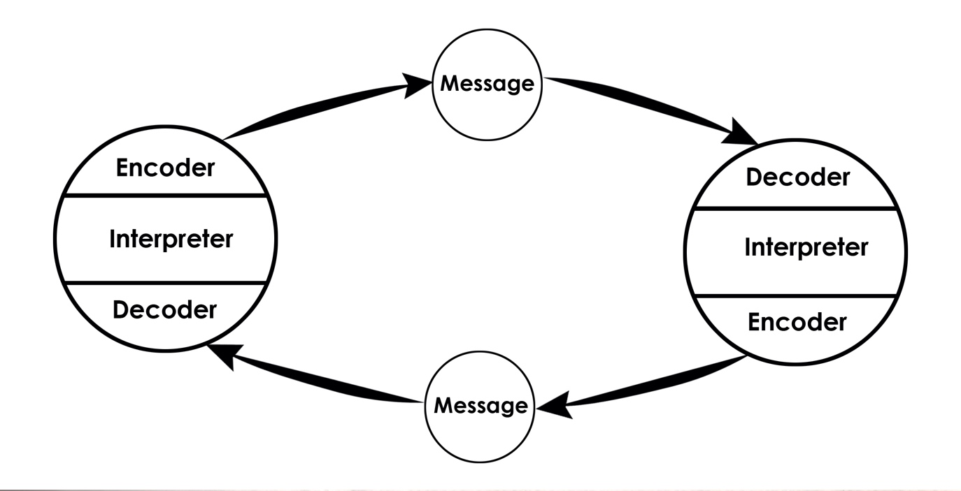

4.0 CONCLUSION

I write this to show my work and show you that this whole term has been very helpful for me to develop my report. All communication models are important to be able to perform well in my work.

