Task four- Guidance document (performance management and reward)

- The purpose and typical components of performance management. (AC 4.1)
The purpose of performance management is to drive employees towards achieving performance goals. If the business provides consistent feedback of performance, it sets clear expectations for the outset and employees are more likely to understand what is required from them (IMD). Performance management makes sure that employee’s personal objectives are aligned with the overall goals of the organisation. Businesses with effective performance management benefit from higher employee retention, a more positive workplace culture and greater employee engagement. (van Vulpen).
The key components of performance management are reflected in Herzberg’s Motivational Theory, developed by Fredrick Herzberg and his associates through interviews with two hundred individuals. The aim was to identify the factors people consider essential for achieving goals and avoiding undesirable conditions in the workplace. These are known as motivational factors:
- Achievement.
- Recognition.
- Responsibility.
- The work itself.
- Advancement.
- Personal growth. (GeeksforGeeks).

- Two factors that need to be considered when managing performance. (AC 4.2)
There are many factors to consider when managing performance, one of these is capability and whether the employee has the necessary level of ability to carry out their role productively. Only by ensuring this can the performance be managed in a fair and meaningful way. Capability issues are often something which is completely out of the individual’s control, this could be due to neurodiversity, an illness or a disability. To ensure employees are assessed fairly when performing their duties employers should refer to the organisation’s employee capability and performance management procedures and, where appropriate, make necessary reasonable adjustments to support the employee. (Acas). Another factor to consider is the clarity of the organisation’s goals. When employees clearly understand them, they are more likely to feel that they, individually, play a crucial role in the direction of the business. This fosters a sense of unity between the organisation and its employees but also increases motivation, makes employees feel valued and increases employee engagement. A study conducted by McKinsey & Company in 2024 involved a performance management survey with over one thousand employees. It found that 72% of participants considered goal setting to be a strong motivator in the workplace. Equally as important, during this survey, they found was the feedback regarding how these goals are set. Employees perceived the performance management approach as fair when they were actively involved in the goal setting process. The survey highlighted the importance of clarity around organisational goals with respondents saying they felt most motivated when their goals were a balance of individual and business objectives. (Komm et al.a).
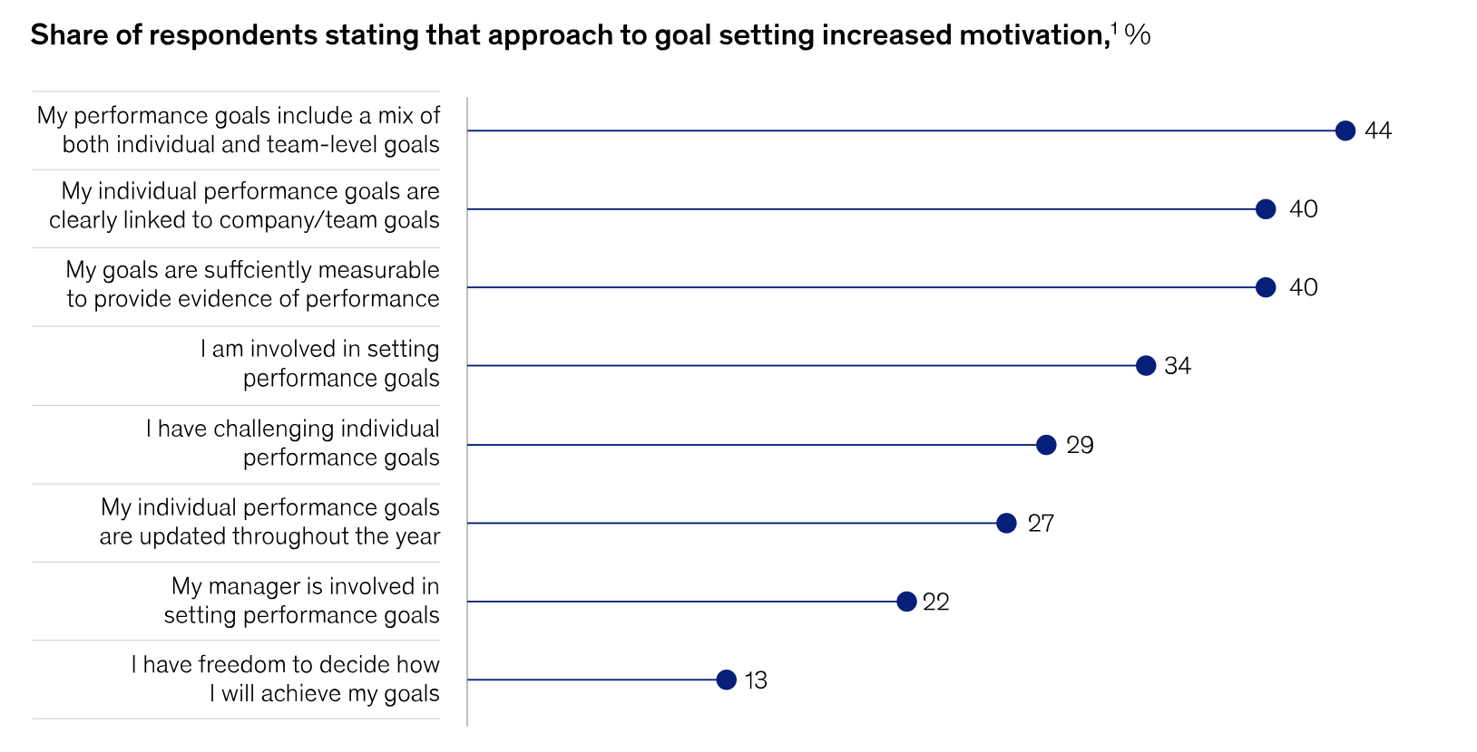
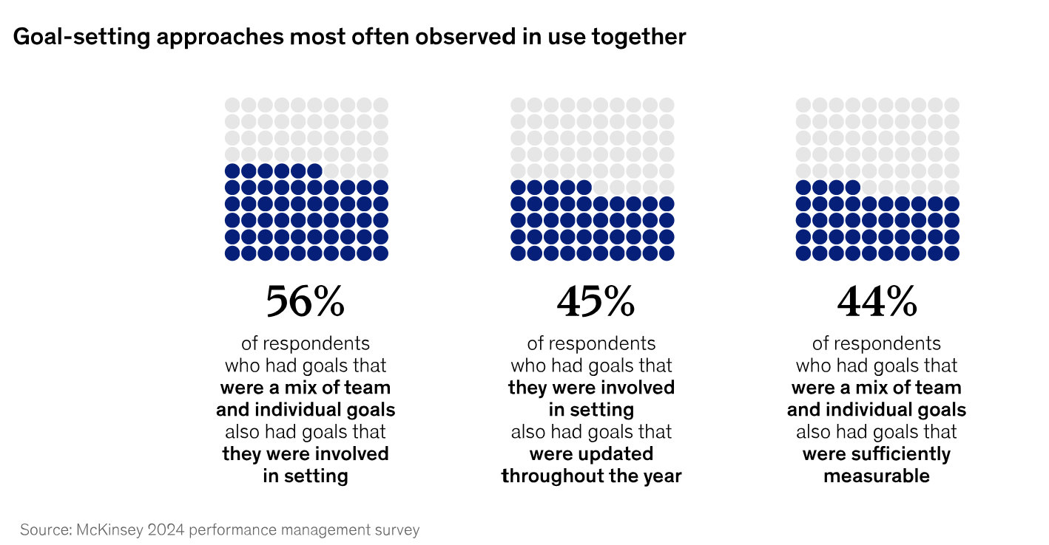

(Komm et al. b).
- Different methods of performance review. (AC 4.3)
There are many ways to review performance. The method that is chosen will depend on many different factors such as the type of information you wish to review, the goals you are aiming to achieve, the size of the organisation, your overall business culture and whether the information you are assessing is business wide, departmental or focused to a specific individual. (People and Lance).
Self-Assessment- This method of performance review involves the individual and gives them the opportunity to reflect on their own performance. This may include self-assessment of goals they have achieved, targets they have reached, accomplishments and overall work performance. Commonly, this process is completed using a template in which the employee rates their own performance and submit it to their manager prior to the review meeting. There are some disadvantages to this method. Some individuals find it difficult to assess themselves accurately and may be overly self-critical, which would result in feedback that does not accurately reflect their performance. Other individuals can feel uncomfortable highlighting their achievements whilst others may struggle to identify their weaknesses. An advantage of this method is that it gives employees the opportunity to voice their opinions. This can make employees feel empowered and helps individuals feel that their views are valued. It is also an effective way to set goals collaboratively. (Editor).
Peer-Assessment- This method of performance review is assessed by individuals of a similar employment status within the organisation, such as team members or colleagues an individual has worked closely with. It is carried out in a similar way to the self-assessment process, where an individual reviews their colleague’s performance and provides constructive feedback. (Indeed editorial team). The disadvantages of this method of performance review include the potential for biased feedback due to personal relationships and office politics. Colleagues at the same level as the individual being assessed may also lack the experience needed to provide valuable criticism. This approach can also lead to conflict within a team and may negatively impact team dynamics if the feedback is perceived as unfair. The advantages of this method are that it gives employees the opportunity to have their efforts recognised by their peers and removes the self-critical element found within the self-assessment method. It can also help build trust and stronger team ethic, especially if the feedback is positive, this, in turn, can strengthen professional relationships and support within the team. (GeeksforGeeks).
- Key components (financial and nonfinancial) that are required to achieve an effective total reward system. (AC 5.1)
Total reward refers to the complete package of financial and non-financial rewards that an organisation provides to its employees. This package includes a combination of policies, processes, recognition, bonuses, perks, team events and other benefits. (Garrett). This is done with the aim of developing a motivated work force and increasing employee satisfaction, positively impacting employee retention. It can also help attract top talent into the business and position the organisation as an employer of choice within its industry. (Gardner). There are a range of financial rewards offered to employees. These may include competitive rates of pay, performance-based bonuses, access to private medical care, pension schemes as well as shares within the organisation all of which contribute to the overall financial package. As well as financial rewards, non-financial can be as equally motivating to employees. This can include flexible working arrangements, employee recognition schemes, learning and development opportunities and team-based events. (CIPD).
For a total reward system to be effective it must offer clear and achievable goals while also being flexible and inclusive. Employees need a clear understanding of what is expected of them and having realistic targets will motivate them. If they are not achievable, it will do the opposite and demotivate them. Recognising diversity within an organisation is essential as what motivates one individual may not appeal to another. By offering a range of rewards that cater to different needs and preferences the organisation will create a more engaged and productive workforce. (Kazi).

- How reward can motivate employees to perform. (AC 5.2)
Reward can help employees perform as it is a great motivator but, as stated in an article written by Mirza Hadi Baig, it fulfils the human need for recognition and appreciation. When employees feel valued, they are more likely to want to improve their performance. Rewards also boost morale and job satisfaction making employees more committed to their role. Motivation can be divided into intrinsic and extrinsic types. Intrinsic motivation comes from within and includes personal growth, finding purpose in work and having autonomy. Extrinsic motivation involves external rewards like bonuses, pay rises or organisational perks. The most effective approach is to balance both intrinsic and extrinsic motivators. By providing appropriate awards organisations can motivate employees more effectively and maintain high performance levels. (Baig).

- At least two reasons for treating employees fairly in relation to pay. (AC 5.3)
Treating employees fairly in relation to pay is essential for both the success and reputation of the organisation and to also guarantee legal compliance.
Fair pay is required by law and employers must comply with regulations ensuring that employees are treated fairly in terms of reward and recognition. This includes equal pay for equal work and gender pay gap reporting. The Employment Rights Bill and the Equality Bill is making ethnicity and disability pay reporting compulsory for organisations. If an organisation fails to comply it, not only would immensely affect the reputation, the business would face legal consequences. (CIPD, “CIPD | Pay Fairness & Pay Reporting | Factsheets”). Secondly, fair pay improves employee satisfaction, loyalty and retention. When staff feel they are compensated fairly, it increases morale. Fair and transparent pay helps attract top talent and keeps existing employees engaged. Employees who feel they are treated fairly are more likely to remain within the organisation, perform better and contribute to innovation. Fair pay practices help build trust, foster loyalty and promote a positive and inclusive work culture. (Cornejo).

Word Count: 1,322 words.

References
Acas. “Conduct and Capability Procedures When Managing Performance.” Acas, 2 Sept. 2022, www.acas.org.uk/capability-procedures. Accessed 28 July 2025.
Baig, Mirza Hadi. “Discover How Understanding the Psychology of Rewards Can Help Organizations Boost Motivation, Engagement, and Productivity by Using Effective Reward Strategies.” Linkedin.com, 7 Oct. 2024, www.linkedin.com/pulse/psychology-rewards-understanding-what-motivates-employees-baig-m3s3f/. Accessed 1 Aug. 2025.
CIPD. “CIPD | Pay Fairness & Pay Reporting | Factsheets.” CIPD, 25 Oct. 2024, www.cipd.org/uk/knowledge/factsheets/pay-fairness-reporting-factsheet/. Accessed 1 Aug. 2025.
---. “CIPD | Reward | Factsheets.” CIPD, 27 Feb. 2024, www.cipd.org/uk/knowledge/factsheets/reward-factsheet/#totalearnings. Accessed 1 Aug. 2025.
Cornejo, John. “The Importance of Pay Fairness and Organizational Transparency - Attorney Aaron Hall.” Attorney Aaron Hall, 7 Oct. 2023, aaronhall.com/the-importance-of-pay-fairness-and-organizational-transparency/. Accessed 1 Aug. 2025.
Editor. “10 Best Performance Appraisal Methods | 360-Degree Feedback.” Datalligence, 21 Dec. 2021, datalligence.ai/blogs/performance-appraisal-methods/. Accessed 1 Aug. 2025.
Gardner, Rhonda. “What Is a Total Rewards Strategy? A Practical Guide.” AIHR, www.aihr.com/blog/total-rewards-strategy/. Accessed 1 Aug. 2025.
Garrett, Connor. “17 Types of Employee Rewards (2023 Guide).” SnackNation, 9 May 2023, snacknation.com/blog/types-of-employee-rewards/. Accessed 1 Aug. 2025.
GeeksforGeeks. “Herzberg’s Two Factor Theory of Motivation.” GeeksforGeeks, 10 Apr. 2023, www.geeksforgeeks.org/hr/herzbergs-two-factor-theory-of-motivation/. Accessed 27 July 2025.
IMD. “What Is Performance Management and Why Is It Important?” Www.imd.org, 20 Feb. 2024, www.imd.org/blog/management/what-is-performance-management/. Accessed 27 July 2025.
Indeed editorial team. “What Is a Peer Assessment? A Definitive Guide.” Indeed Career Guide, 2024, www.indeed.com/career-advice/career-development/what-is-peer-assessment. Accessed 1 Aug. 2025.
Kazi, Afsah. “8 Key Components for Effective Employee Reward Programs.” HRMS Insights | Global Online Content Publishers, 9 Jan. 2024, www.hrmsinsights.com/news/8-key-components-for-effective-employee-reward-programs/. Accessed 1 Aug. 2025.
Komm, Asmus, et al. “What Employees Say Matters Most to Motivate Performance.” McKinsey & Company, McKinsey & Company, 21 Aug. 2024, www.mckinsey.com/capabilities/people-and-organizational-performance/our-insights/what-employees-say-matters-most-to-motivate-performance.
People, People Managing, and Liz Lockhart Lance. “16 Types of Performance Appraisal and How to Use Them.” People Managing People, 21 May 2025, peoplemanagingpeople.com/performance-management/types-performance-appraisal/. Accessed 30 July 2025.
Van Vulpen, Erik. “What Is Performance Management? A Full Guide.” AIHR, 2019, www.aihr.com/what-is-performance-management/. Accessed 27 July 2025.

