
Module Name: Entrepreneurial Innovation
Module Code: BMBM4011
Assignment Name: Developing a Venture Plan for Sustainable Delivery and Longevity
Topic: Business Innovation
Student Name: Dylan Thomas
Student Number: 2513722
Lecturer: Robyn Griffiths
Deadline: Friday, 24th of April- 23:59

Word Count- 3228
Venture Plan for Longevity and Sustainability: MFPSupport

Executive summary
MFPSupport is a business support services group designed to offer high quality services for competitive pricing. The report begins with the organisational overview and context, discussing the goals and values aimed to achieve and how we differ from our competitors in the support services group market. A strong, clear strategy for longevity is provided, focusing on sustainable growth, the formation of colleague and client relationships and the organisational adaptability implemented in order to achieve a sustainable business. The inclusion of a Business Model Canvas provides a wider overview of our key partners, activities, resources, customer relationships, customer segments, channels, cost structure, revenue streams, and most importantly the value proposition we provide to achieve our organisational goals. The viability of our organisation is explained along with our finances and needed resources in order to demonstrate the practicality and potential success of the business. The implementation plan and learning loop details the initial formation of the organisation and discusses how we aim to support the development and improvement of the organisation through the consistent learning loop. The plan concludes with necessary recommendations to ensure the organisational goals are met, the longevity and sustainability of the business is achieved, and the overall plan demonstrates a clear approach to providing a realistic and successful business support services group, focused on client satisfaction and enables the sustainability of MFPSupport.

Overview and context
MFPSupport will be a service providing a variety of specialised business support departments focused on Marketing, financial management and production. The range of services allows us to suit the needs of small to large organisations or business startups, and offers countless role opportunities for employees wanting to develop skills in specialised areas through actively working with us on multiple projects, or for freelancers who would like to assist in the support of individual projects. Our goal is to provide active support at a high standard for new or existing organisations in order to strengthen their financial performance, and marketing/production strategies in order to provide them with an edge in highly competitive markets. By providing multiple services which are crucial for a working organisation, we offer essential support for organisations which are either having difficulty in specific areas, or simply want to increase the effectiveness and efficiency of their current business functions, leading to longevity and sustainability for all organisations involved.
The ever-growing digital business environment has resulted in businesses facing major challenges in ensuring quality content and product, maintaining financial services, and capitalising on their targeted customer segment through their chosen marketing strategies. This has led to the failure of the maximisation of profits in successful companies and created issues for smaller organisations due to their lack of ability, resources and experience to react and adapt to these changes. The creation of MFPSupport is intended to support these organisations in all essential business functions to assist in brand growth and success by using our experience in specialised departments. The rise in demand for external business support means that by providing a range of services, we leverage our business opportunities of working with different brands and secure ourselves a share of the business support service market, with the goal to aid and support other organisations at a high quality standard.

Strategy for Longevity
The strategy for longevity will begin from leveraging the collaborative partners and customers from the SBS in order to raise awareness for the services, and quality provided by MFPSupport. By using our multiple services across a variety of events, it opens up the opportunity to build rapports with new clients in order to ensure increased brand awareness, and allows us to capitalise on future clients who can assist in the sustainability and the growth of the organisation. I aim to provide my services for the SBS for the remainder of my period in UWTSD, which will be a further 3 years. This provides a substantial amount of time to push the brand name to an array of business experts whilst working in various events, and enables the collaboration with fellow students in order to leverage the services of one another. Collaboration has proven to be a factor in highly effective strategies for longevity and Hmioui et al (2023), explains collaboration can enable shared “resources, information, and expertise, leading to improved efficiency”, and can aid in organisational sustainability.
I also aim to help organisational growth through working with family and friends who work in a variety of professional fields. This can lead to increased brand awareness and provide a wider customer base for the organisation, helping with sustainable growth for MFPSupport. The organisation will begin with services mainly focused on production, financial services and marketing. As it will be a multidisciplinary organisation, it capitalises on the potential profit available by offering multiple essential business services, and Velden (2022), states that this typically leads to greater long-term success by widening the potential customer base and gives an organisation options if one of their many services is proving unsuccessful. During the organisational growth, the goal is to slowly implement a variety of new, specialised service areas of business to aid organisations in their business functions through using freelancers to assist with projects by providing us with their expertise. Using freelancers can be highly beneficial for an organisation as it allows existing employees not to be overworked when introducing new services, and it can provide experience and quality for projects in specialised areas. Caristi et al (2025), supports the use of freelancers in business as unlike full-time employees, they don’t have to be provided with “paid vacation” or “sick days”, allowing the organisation to benefit from high quality work with “less benefits” having to be provided.
The use of Freelancers also enables the possibility of collaboration and Michael (2024), believes it allows network expansion, experience and skill development, and supports the increased possibility of collaboration opportunity. As explained, from the beginning of MFPSupport we will be leveraging customers and partners through the SBS in order to create our initial customer base. In order to retain customers, continue organisational growth, and ensure longevity, we will offer referrals and specialised service bundles to new and existing customers to keep our competitive pricing strategies, and offer incentives to entice customers to not only use our services, but to provide awareness of our offers to friends, family and colleagues. Incentives can positively affect a business and provide a competitive edge in its market and Sprott et al (2019), researched into its benefits and explains it boosts customer engagement and can significantly increase purchase intent of the services you provide.
One of the most vital parts to our organisational sustainability will be the satisfaction and expansion of the workforce, and the development of the work environment. The majority of the expenditure during the growth of the organisation will be for the employees and the work facilities. I aim to provide a suitable wage for my employees with the possibility of bonuses based on workload and quality. As the organisational goal is to provide essential services with a high quality standard, consistency will be rewarded and Phillips (2024), agrees that performance based rewards can provide a strong, productive culture and ensures employees are more likely to keep their loyalty to your organisation. The figures below show the effects of incentives on employee performance in organisations. By investing heavily into the work locations to ensure departments work around each other, it also works into the culture by increasing employee collaboration, and effective communications.
Investing into the work equipment provides ease of work for employees and can provide a competitive edge for the organisation by keeping up to date with current technology. With the rise of AI, technology development is key to organisation success and Ashraf (2023), explains its need for organisational development and to keep consistent quality to compete against your competitors. The charts below will display how organisational factors are impacted by incentive offerings and the effectiveness of keeping up with technological advancements. Find the Business Model Canvas below also.

Key Partners  Will leverage the SBS in regards  to the services provided.  Attempt will be made to work  with different departments whose  activities will be used in my  created service e.g-  - Social Media Team  - Marketing team  - Sponsorship team  Leveraging the SBS can help ensure  my intended high quality standard  of service through specialised  departments is attained with  minimal risk. The opportunities  acquired through the SBS  can also ensure  potential future customers  who already have experience  with, and knowledge of, my  Services. | Key Activities  Providing a wide range of high quality services for customers at competitive prices. The services will include:  - Marketing  - Data collection.  - Finance  - Editing and production  I also intend to leverage customers through existing customers by making referral offers as an attempt to promote my services, reach new markets and customer segments, and provide customers with the opportunity of reduced service costs. I aim to provide existing customers with service updates and new opportunities through social media pages and emails with weekly communications and updates. I also intend to keep up to date with my customers’ ongoings in order to build relationships and offer my services when needed. | Value Proposition  Hard working and reliable  service, focused on customer  satisfaction.  Consistent quality to ensure  returning customers.  I will ensure the task is  completed and up to the  customer’s standards without  causing additional stress or  concern for them.  I’ll be offering a video  production/editing product  along with future sponsorship  Acquisition, marketing, data collection and financial  services in order to have the  ability to provide multiple  services in order to gain a  wider customer base, targeting multiple customer segments. Keeping the quality standards high through using specialised departments will ensure customers will come to me for multiple services as it’s easier and more reliable than going to another person/business for individual services. The competitive pricing and potential service deals will also provide a competitive edge for my services.
Customer Relationships  Rapport will be built with customers through weekly, personalised communications, dependent on their field of work, through social media, email, or calls and texts. We will also provide personalised offers on services already used and bundle possibilities, integrating unused services to boost sales. | Customer Segments  My customer base would  predominantly be businesses, but will target all customer segments to begin with.  The initial target would be local  with the intention to expand  nationally, and further globally as  this line of work can be done  for businesses anywhere, from  anywhere.  The target audience will  respond to a personalised  service, depending on the  customers’ needs and the  particular line of work the  service will be for. Offering different services opens up the possibility of a wider customer base and more targeted customer segments, leading to more potential profit.  I would like to see the work I  provide being used in local  businesses to promote my  service and then expand as  much as possible to gain as  much of a customer base as  possible. | Key Resources  - Using my own personal tech initially, eventually expanding to on site workplaces with needed assets (wifi, computers).  - The rest of the SBS for different departments’ services and customers.  - Promoting my services through the business events in the DTC and various collaborations through SBS (rally team, esports).
Channels  As my service is tech based, I’ll  be focused more on this type of  communication for my service  In the latter stages as through providing referrals for existing customers, my services’ awareness will greatly benefit from this. But, initially it will be through networking in person through events and shops. This will ensure all types of customers will be aware of the service and ensure the most cost effective way of  doing so. | Cost Structure  Tech, rent and utility will be the most apparent cost in the business, but being a business built from myself through leveraging services through the SBS, the cost will be at a minimum to begin with as it’s one and done with current required purchases and a lot of the needed resources are things used daily and already accessible. Further down the line, in order to expand I would like a small team of producers/editors, a marketing and data collection team who will focus on company expansion and promotion, and will aid with customer communication through social media, emails a.s.o, and a finance department. I will begin by offering and focusing on the more sought after services, capitalising on potential profit in order to build my initial customer base, whilst keeping costs at a low. Costs will gradually increase as the customer base and profit grows, as more money will be invested into hiring for the formation of specialty departments, and workplaces will be made available. The majority of cost will go into employment for employee satisfaction, with bonuses being made available for quality standards and workload, and future profit being invested into tech advancements for an organisational competitive edge, and work locations to maximise on work output and potential department collaboration, improving workplace culture and aiding in the success of my organisational goals and values. | Revenue Streams  The way I will price my services will use a variety of pricing structures with the various services using customer segment as not every service will require the same amount of  workload and potential gain for the customer. I will use fixed pricing for certain  Services, such as the financial services, as not much will change in workload from each  Customer, but if it’s a significant load then an additional charge will be discussed with  the customer to ensure the work is done for the right price. The production/editing  services will be value dependent as from business to business there will be a great  difference in the needs of the customer. For promotional videos there will be a set  charge for certain running times but exceeding certain timeframes will mean value  dependent pricing and this will also rely on the magnitude of the  customer’s business and the potential gain for themselves. I will also work with the  pricing for the larger scale businesses as through providing a service for them, having  our work promoted by them can potentially provide us with substantial exposure, raising  awareness and customer knowledge for what we do and the quality standards we reach.

Chart Compiled From Case Studies of Employee, Customer and Organisational Behaviour/Performance pre, and during incentive offerings.
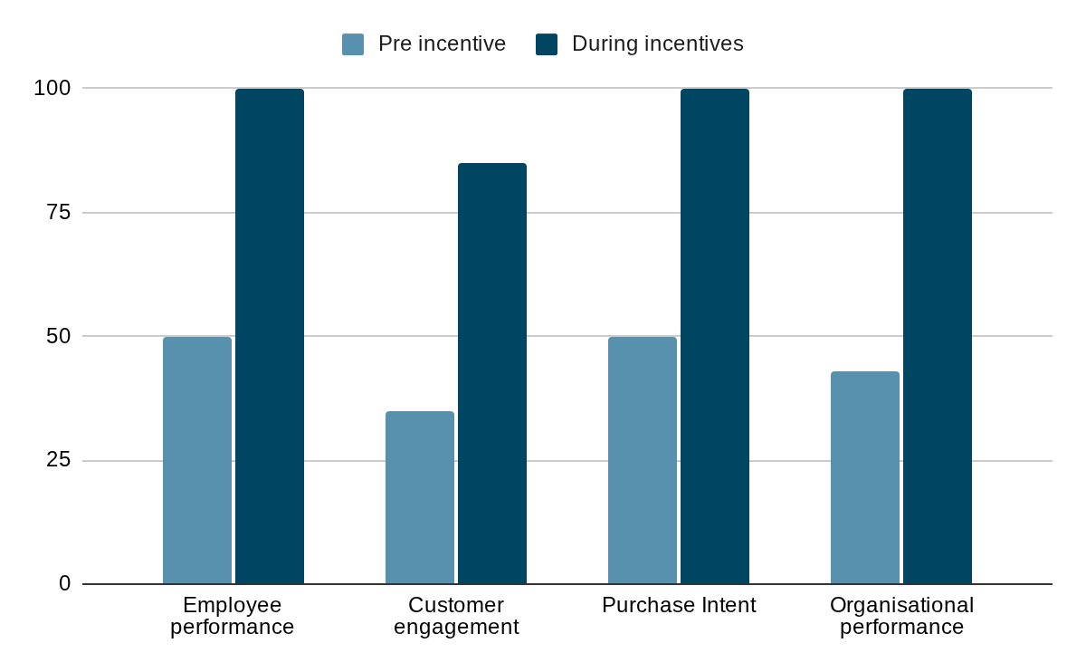

Chart Compiled From Case Studies Showing Factors Affected by Technological Advancements
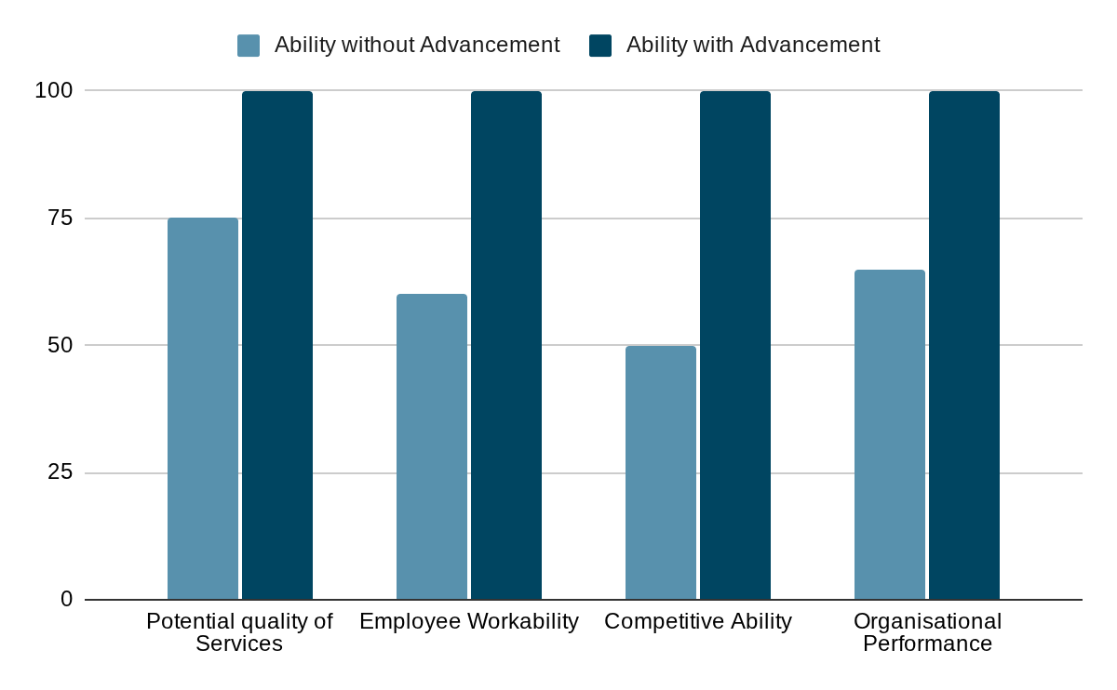
Viability, Finance and Resources

Business support is essential in order to achieve organisational success. As explained, MFPSupport will focus on essential business operations to support existing and new organisations, which ensures the consistent need for our services, and enables a constant flow of work for the organisation. Providing our goal of a high quality work standard with competitive pricing and optional offers and incentives with a variety of needed services, makes us stand out amongst our competitors and enables MFPSupport to be the potential leader of the business support services market. There are many examples of business support services who have achieved success, but the majority of these services are unlike what we aim to provide. We aim to provide external services which will work internally on the operations of our customers. Examples such as Ertan (2021), and Entrepreneur Press (2007), although some time apart, both show the services in which organisations typically provide, explaining that outsourcing staff is a main service and business support consultation is their main operation. Unlike the majority, as explained, we will work directly within organisations by taking on workloads and providing our expertise in these specialised departments, rather than providing consultation in order to assist in their services. This provides us with a substantial competitive edge in our market, enabling us to thrive in our business sector.

The finance and resources for the organisation will begin at the bare minimum. I aim to use the equipment available to me through the SBS and UWTSD, and I aim to collaborate with other members of the SBS to leverage each other's services in order to gain experience, build new relationships and attain our starting customer base. Therefore, the costs for the organisation will be little to none at the beginning and the goal will be to develop new skills and experience by working on events, begin new relationships and source potential colleagues, and eventually begin acquiring paid roles. Throughout my time working with the SBS, any income acquired will be kept aside for the growth of the organisation, and income from my employment outside of the organisation will be used as capital to assist in its organisational growth. I hope to open an official MFPSupport workplace towards the end of my work within the SBS, and this will be funded by the capital invested into the organisation. Resources will include equipment, such as computers, tables, and chairs which will once again be funded with invested capital. Employees will have a base salary which will be department dependent and as previously mentioned, bonuses will be available through consistency and workload. We will charge for our services upfront, and employee salary will be paid monthly, ensuring employees will be consistently paid on time through the income of the organisation.

Implementation and Learning Loop

The implementation of MFPSupport will begin through the events and collaborations with the SBS. The aim for the initial implementation will be to gain the necessary experience and skills required, whilst building relationships with potential clients, and to seek out possible key personnel in order to cause growth for the brand. By using these services at the SBS events, it offers the possibility to receive direct feedback from attendees and colleagues on the given services in order to see if the organisational goals are being achieved. Following the use of MFPSupport at events and through collaborations, we will provide services outside of the SBS with our targeted market being focused on previously satisfied attendees of the business events in order to secure further projects and to build strong customer relationships.

In order to expand and cause organisational growth, we will offer referral discounts to our customers with the goal of increasing brand awareness, and we will offer personalised bundle deals to new and existing customers to provide our competitive edge and secure our brand reputation of quality services for quality pricing. We will actively view feedback from our customers through client surveys, and our employees through weekly staff meetings in order to implement improvements to our services and organisational functions when needed. As we aim to provide quality services, there will be regular review cycles implemented to view the quality consistency being delivered from each department. Indama (2026), explains this will ensure our employee productivity will be at a constant high, learning and improving will be an ongoing practice, and the organisation will be providing business support services to its best ability, all of which aimed at providing organisational sustainability and longevity.

Conclusion and Recommendations

In conclusion, the organisation has the capability to deliver sustainable values and services through a client focused approach. It’s recommended that we continue to achieve our goal by providing a high quality standard in our services whilst achieving competitive prices and providing incentives for staff and customers. We should continuously review our feedback in order to enable constant improvement, whilst ensuring organisational growth, customer satisfaction and respected brand values.

Reference List

Ashraf. I (2023) The Rise of Artificial Intelligence in the Workplace: Exploring the Pros and Cons of AI and its Impact on Employment, Amazon Digital Services LLC - Kdp.

Caristi. D et al (2025) Communication Law: Practical Applications in the Digital Age, Taylor & Francis.

Entrepreneur Press (2007) Start Your Own Office and Administrative Support Service: Your Step-By-Step Guide to Success.

Ertan. S (2021) 28 Company Book- BUSINESS SUPPORT SERVICES, ERP Destekli Butce Danismanligi A.S.

Hmioui. A et al (2023) Integrating Intelligence and Sustainability in Supply Chains, IGI Global.

Michael. J (2024) How to Make Money Online With Freelancing, John Michael.

Phillips. J (2024) Human Resource Management: An Applied Approach, SAGE Publications.

Sprott. D et al (2019) Handbook of Research on Customer Engagement, Edward Elgar Publishing.

Velden. M (2022) Interdisciplinary Research for Sustainable Business: Perspective of Women Business Scholars, Springer International Publishing.

Indama. A (2026) Reimagining Administrative Theory for Modern Governance, Yawman Book Publishing House.

