BMIH5003
Foreign Languages and Cultural Awareness
Module Lead: Lisa Bassler
Student name:Bianca Mihu
Student id:2231047

Table of Contents

- Introduction 3
- Main body 3
  - Culture overview 3
  - GLOBE Project analysis: 3
  - Challenges: 5
  - Conclusion: 5
- Recommendations: 6
- References: 7

- Introduction
This report focuses on the differences in culture and customs between England and Italy. The headquaters of the 5-star Inclusivity Hotel & Spa is in Italy but the business also operates in England. This report will aid in assessing the differences and similarities in both cultures. There is a significant difference in the lifestyle of the people of Italy and England. Differences in their culture, family, greetings, dining, food, and drinks. This report analyzes and compares the cultural and leadership traits of both countries. Cultural and leadership traits are compared with the help Globe Project. It will also discuss the challenges faced in intercultural leadership within the hospitality industry. It also includes recommendations for the hotel management to improve their services.
- Main body

Culture overview
There is a significant difference in the culture of both the countries Italy and England (Del et al., 2017). Italy is believed to be known for its love and importance to their families, whereas English people consider their families as an unavoidable fact in their lives. In England, there is a very big difference in their greeting style. Usually, handshakes and pats on the back are preferred whereas in Italy they mostly greet each other by giving a peck in the cheeks. Their eating styles are also different. There are different practices observed in the hospitality industry of each country. For the effective performance of the hotel, the hotel must provide their employees with the training to understand the needs and demands of people from diverse backgrounds. Welcome inclusive practices and use the policies that will create a culture of respect and understanding for all the communities.

GLOBE Project analysis:
The GLOBE Project (Global Leadership and Organizational Behavior Effectiveness) is used to analyze Italy and England's culture and leadership (Osland, 2017). The goal of the project is to critically analyze the relationship between the countries. With respect to their cultural difference, the practices of their organizations, and the effectiveness of their leadership skills (Osland, 2017). The projects develop and exceed the 6 measures for leadership and consist of 9 domains of culture. It helps in understanding the differences in business by comparing their values, practices, and beliefs with 62 countries. Helps in identifying how the businesses are effective according to their culture and help in reducing cultural misunderstandings. The cultural practices in Italy are very sensitive and considered important. They give high importance to their values and customs. To increase the satisfaction of the customers from Italy it is very important to consider their cultural practices. Using the same tone and practices of cultures will be positive for them to observe. Providing them with the services that are loved and respected. Considering their traditions and needs, provide training to the employees according to their preferences (Abo-Murad, and Abdullah, 2019).
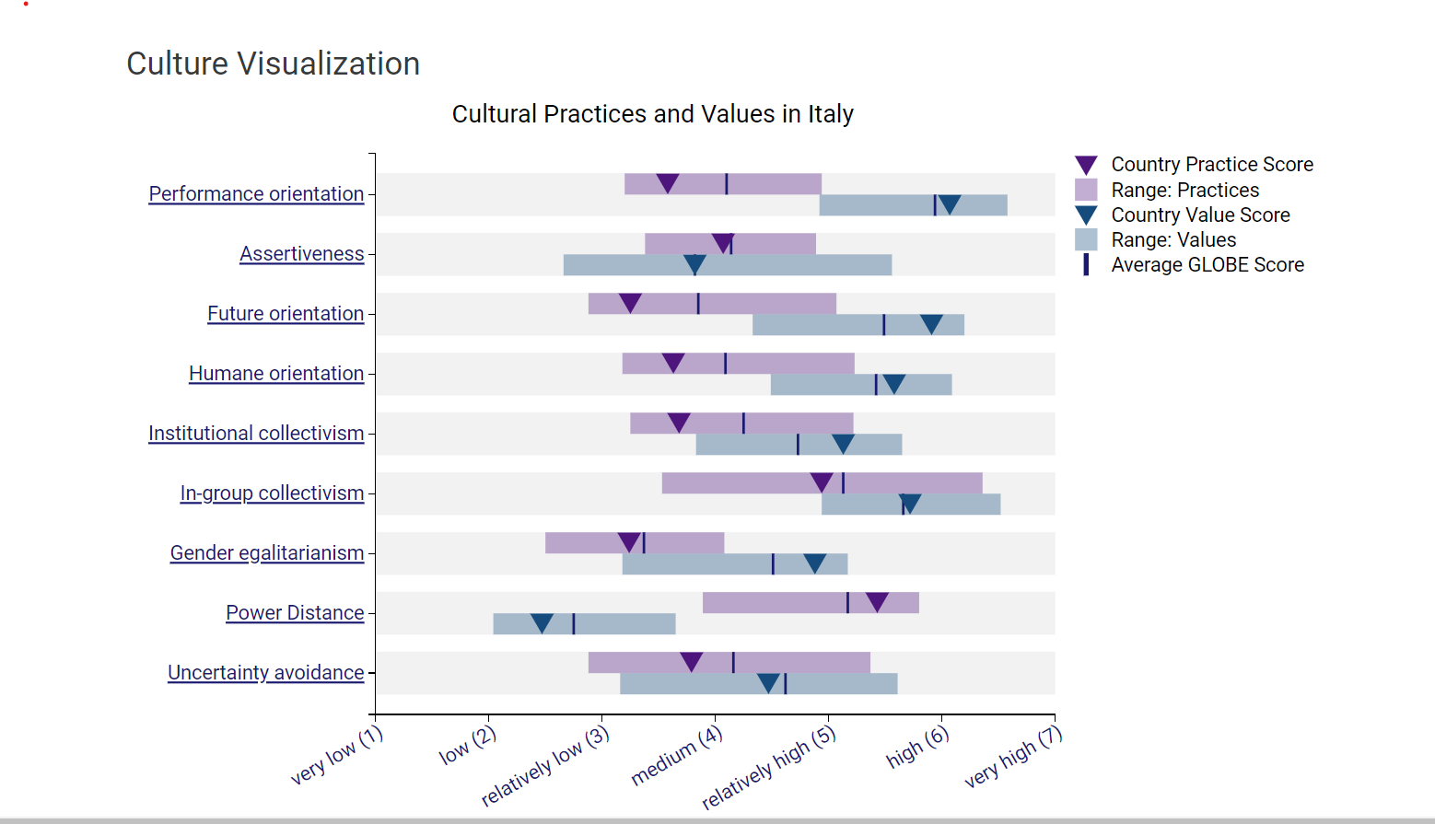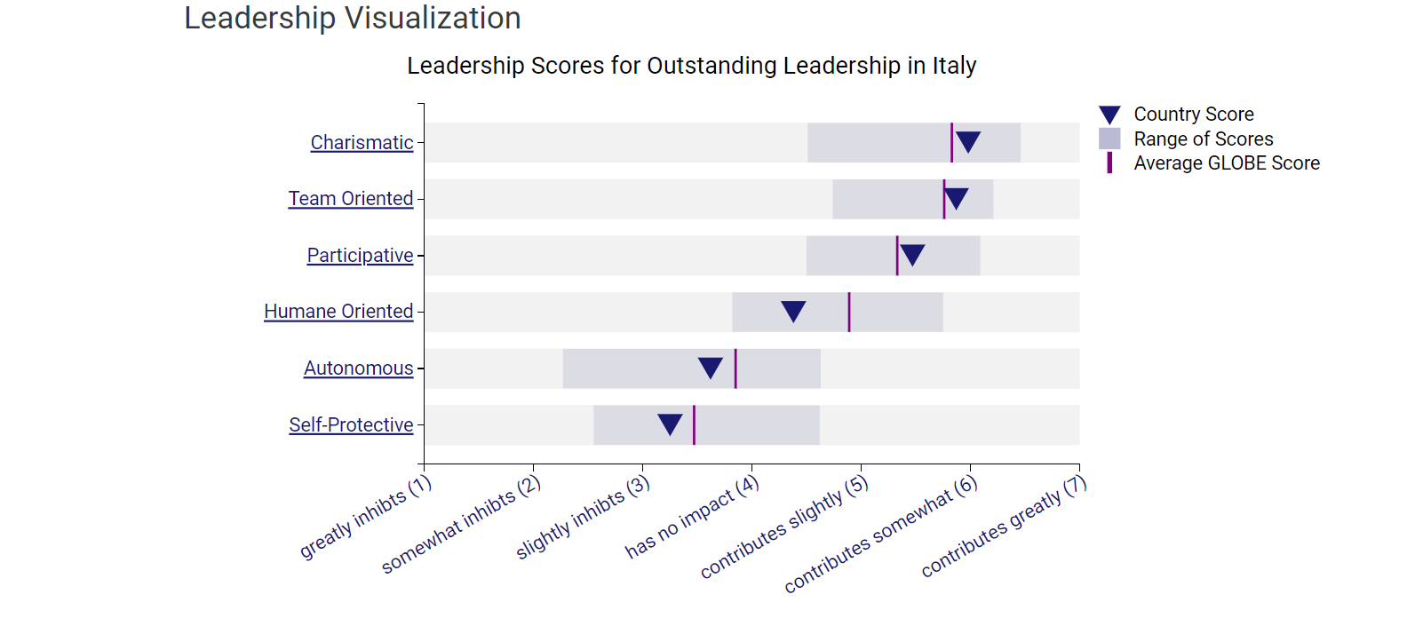

Challenges:
There are great ni no challenges faced due to cultural differences in the hospitality industry (Beer et al., 2019). To solve these issues the organizations must provide their employees with culture-sensitive programs for all the team members so they do not face any challenges due to cultural misunderstandings (Abo-Murad et al., 2019). They should provide proper training regarding the concept of respect and understanding regarding different leadership styles (Bhardwaj et al., 2023). It is important as the study proves that there is a major difference in the culture of England and Italy. For example, greetings, if the same style is used in both countries will prove to be rude for the other countries as both countries prefer different styles. This includes the use of different languages as there can be a lot of misunderstanding so the employees must be trained properly to understand the cultural differences from different backgrounds. Language barriers can create misunderstandings and affect the performance of the employees. Impacting their productivity which will ultimately affect the satisfaction level of the guests. As discussed in the study there are many changes faced in the hospitality industry when working with people of diverse backgrounds (Tanveer et al., 2024.). Especially when considering face-to-face contact. The cultural difference makes it challenging for the employees to understand the customer's demands (Nazarian et al., 2017). The other challenges include the stereotypes that affect the performance of the employees. As it creates an understanding regarding the customers from different backgrounds. Lack of understanding causes suspicions and creates some type of negative impact on the minds of the individuals (Baradarani and Kilic, 2018.). The managers should maintain healthy relationships with the country's representatives to understand the demands of people of diverse backgrounds. It will help prevent any misunderstanding. Must not create any preferences due to cultural differences. Rather should work on improving their services and improve their innovative methods. And welcome the individuals from diverse backgrounds. Putting significant efforts to understand their preference and refrain from creating any misunderstandings.Creating and welcoming a culture of respect for all.

Conclusion:
This report discusses in detail the differences in culture between England and Italy. It analyzes the difference in culture in Italy with the help of the GLOBE project which compares the values and customs of multiple cultures and creates the average percentage regarding the culture and leadership traits. It helps in identifying the relationship between cultural practices and how they can impact the performance of different countries. It gives recommendations for the management to solve the challenges faced in the tourism industry due to cultural practices. Critically analyzes the challenges faced by the management team in the hospitality industry. In the end, gives a recommendation for the management team to follow to face those challenges effectively.
- Recommendations:
The recommendations for how the Hotel management of 5-star Inclusivity Hotel & Spa can improve their performance and overcome the challenges faced in the hospitality industry are as follows. It will help the hotel to understand the needs of people from different backgrounds, Welcome inclusive practices, Having an open mindset to accept challenges and face problems with critical thinking.
- The first recommendation for the management is to provide proper training to all the team members. Including the modules to understand and respect different leadership styles.
- The other recommendation is to provide awareness regarding the culture of different countries. These will help to understand the behavior of the people and refrain from creating misunderstandings.
- The next recommendation encourages the implementation of policies that are inclusive.

- References:

Del Giudice, M., Khan, Z., De Silva, M., Scuotto, V., Caputo, F. and Carayannis, E., 2017. The microlevel actions undertaken by owner‐managers in improving the sustainability practices of cultural and creative small and medium enterprises: A United Kingdom–Italy comparison. Journal of Organizational Behavior, 38(9), pp.1396-1414.
Beer, A., Ayres, S., Clower, T., Faller, F., Sancino, A. and Sotarauta, M., 2019. Place leadership and regional economic development: a framework for cross-regional analysis. Regional studies, 53(2), pp.171-182.
Osland, J.S., 2017. An overview of the global leadership literature. Global leadership, pp.57-116.
Van Dierendonck, D., Sousa, M., Gunnarsdóttir, S., Bobbio, A., Hakanen, J., Pircher Verdorfer, A., Cihan Duyan, E. and Rodriguez-Carvajal, R., 2017. The cross-cultural invariance of the servant leadership survey: A comparative study across eight countries. Administrative Sciences, 7(2), p.8.
Nazarian, A., Atkinson, P. and Foroudi, P., 2017. Influence of national culture and balanced organizational culture on the hotel industry’s performance. International Journal of Hospitality Management, 63, pp.22-32.
Abo-Murad, M., Abdullah, A.K. and Jamil, R., 2019. Effect of the organisational culture on crisis management in hotel industry: A qualitative exploration. International Journal of Entrepreneurship, 23(2), pp.1-18.
Baradarani, S. and Kilic, H., 2018. Service innovation in the hotel industry: culture, behavior, performance. The Service Industries Journal, 38(13-14), pp.897-924.
Abo-Murad, M. and Abdullah, A.K., 2019. Turnover culture and crisis management: Insights from Malaysian hotel industry. Academy of Strategic Management Journal, 18(2), pp.1-14.
Bhardwaj, B., Kalia, N., Chand, M. and Sharma, D., 2023. Engaged Organizational Culture as a precursor to job performance: An evidence from the hospitality industry of Himachal Pradesh. International Journal of Hospitality & Tourism Systems, 16(4).
Tanveer, M.I., Yusliza, M.Y. and Fawehinmi, O., 2024. Green HRM and hospitality industry: challenges and barriers in adopting environmentally friendly practices. Journal of Hospitality and Tourism Insights, 7(1), pp.121-141.
GLOBE Project, 2024. Italy[Online] Available at <https://globeproject.com/results/countries/ITA%3Fmenu=list.html#list> [Accessed on 24th February 2024]

