Tutor: Christopher Wilkin
Name: MD Jaglu Uddin
Student ID: 2209549
Winter Gastronomy Festival
A Culinary Journey Through Local Flavors
BMIH6007
International Meetings Management for the Hotel Industry
Name: MD Jaglu Uddin
Student ID: 2209549
Winter Gastronomy Festival
A Culinary Journey Through Local Flavors
BMIH6007
International Meetings Management for the Hotel Industry
A vibrant celebration that blends the rich flavors of local cuisine with the unique atmosphere of the winter season.
Winter Gastronomy Festival
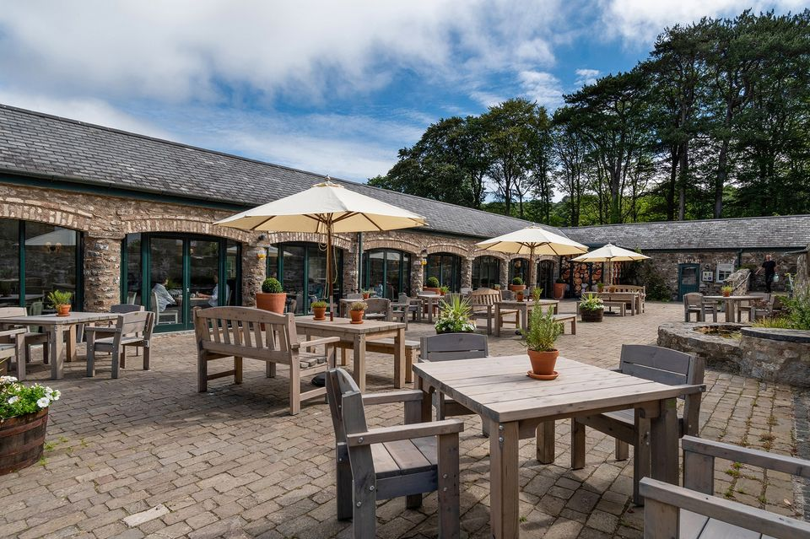
Venue: Bodnant Welsh Food Centre
Attendees will enjoy a variety of activities, from live cooking demonstrations by top Welsh chefs to food tastings that showcase the best of winter flavors
Event Details
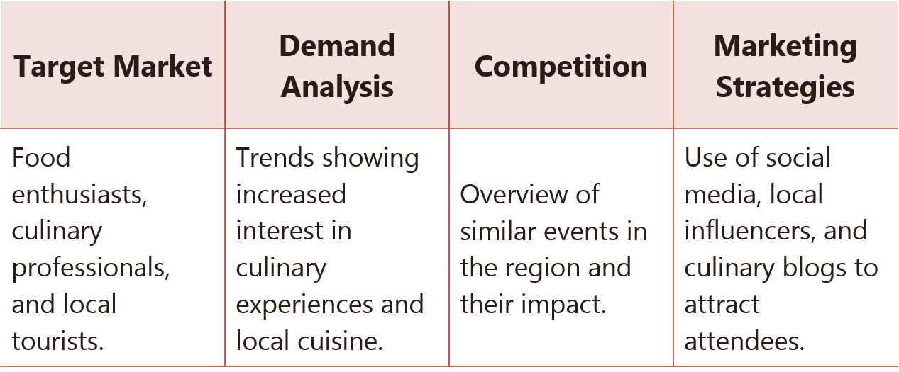
Market Factors
Staffing Requirements:
- Event Management: Staff skilled in organizing and running large-scale public events, with expertise in coordination, guest services, and emergency management.
- Catering: Professional chefs and kitchen staff experienced with large event catering and knowledgeable about local cuisine.
- Hospitality: Trained hospitality staff to manage guest relations, accommodations coordination, and on-ground attendee support.
Resource Allocation:
- Catering
- Lighting
- Seating
- Parking
Operational Factors
Proposed Location: Bodnant Welsh Food Centre in Wales.
- Advantages: The venue offers a picturesque setting that aligns perfectly with the festival's theme, enhancing the overall attendee experience.
- Logistical Considerations: Easy access via major roads, nearby accommodations for guests traveling from afar, and available space for all planned activities.
Venue Availability and Suitability:
- Availability: The venue needs to be booked well in advance, especially if aiming for a peak time like a weekend.
- Suitability: The venue includes indoor and outdoor areas suitable for cooking demonstrations, workshops, and exhibitions.
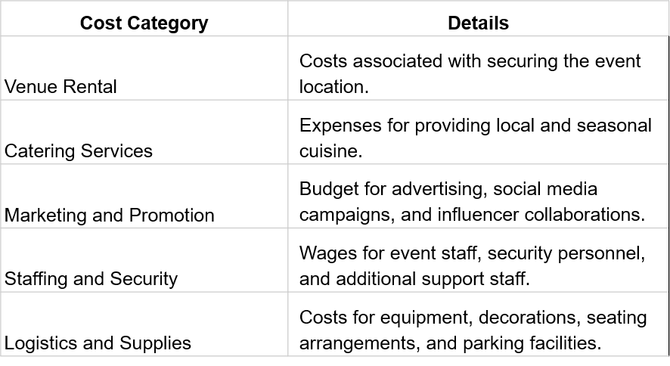
Financial Factors - Costs
Additional Experiences
Vendor Fees
Ticket Sales
Sponsorships
Premium packages for exclusive workshops or tastings.
Potential sponsors from culinary and lifestyle brands.
Charges for exhibitors and food vendors to participate.
Pricing strategy and sales targets.
Financial Factors - Revenue Streams
Predicted Financial Overview

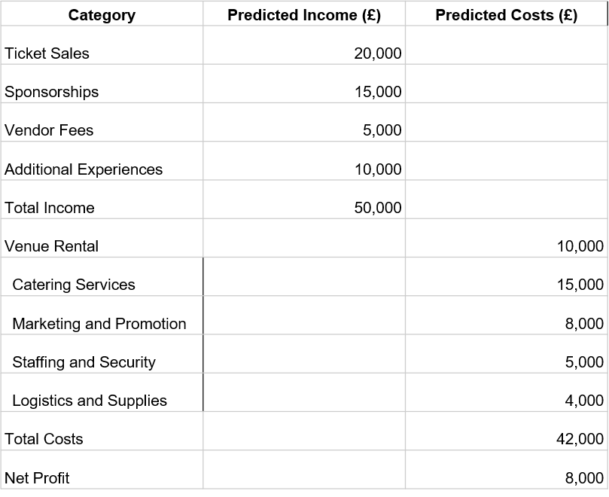
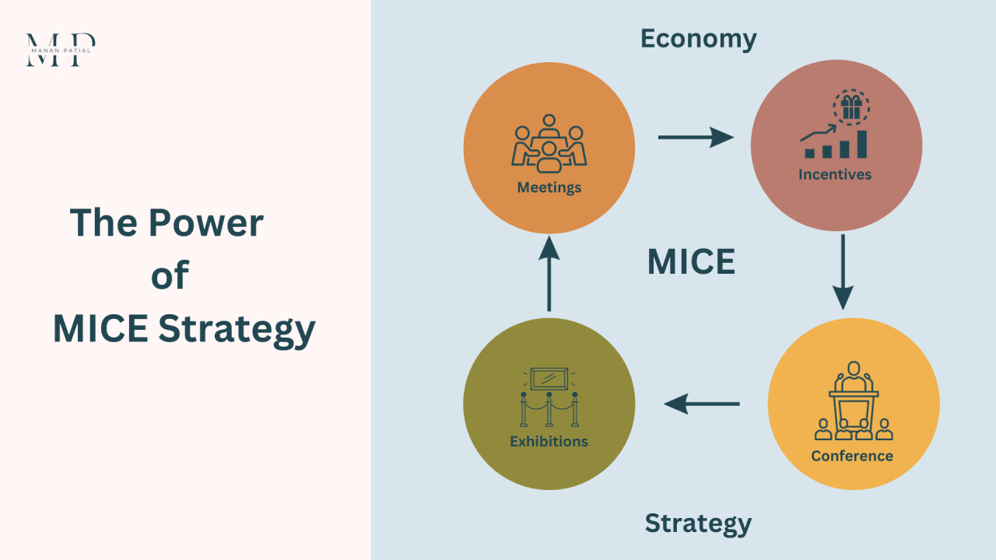
This festival not only taps into the growing trend of experiential and culinary tourism within the MICE industry but also champions the local culture and cuisine, bringing authentic local flavors to the forefront.
Strategic Alignment
Winter Gastronomy Festival is poised to be a transformative event within the MICE industry, spotlighting local cuisine and fostering cultural appreciation through culinary experiences.
The strategic alignment with current market trends and local culture, combined with our solid financial projections, underpin the festival's feasibility and potential for success.
In Conclusion…
- Getz, D., 2012. Event Studies: Theory, research and policy for planned events. Routledge.
- Hall, C.M. and Sharples, L., 2003. The consumption of experiences or the experience of consumption? An introduction to the tourism of taste. In Food Tourism Around The World.
- Long, L.M., 2004. Culinary Tourism. University Press of Kentucky.
- Welsh Government, 2021. Food and drink in Wales: A strategy for growth. [online] Available at: https://gov.wales/food-and-drink
- Jones, E. and Haven-Tang, C., 2005. Tourism SMEs, service quality and destination competitiveness. CABI.
- Richards, G., 2002. Gastronomy: An essential ingredient in tourism production and consumption?. In Tourism and gastronomy.
- Roberts, S., 2008. Sustainable development and social justice: Spatial priorities and mechanisms for delivery. Sociologia Ruralis.
- George, R., 2007. Managing Brand Equity. Journal of Brand Management.
- Bodnant Welsh Food Centre, 2022. About Us. [online] Available at: https://bodnant-welshfood.co.uk/about-us/
- Eventbrite, 2023. How to Organize a Food Festival: Top Tips. [online] Available at: https://www.eventbrite.com/blog/
- Mintel, 2020. UK Lifestyle Tourism Report. [online] Available at: http://www.mintel.com/uk-lifestyle-tourism-report
- Visit Wales, 2021. Discover the Flavours of Wales. [online] Available at: https://www.visitwales.com/info/food-and-drink
- Sharples, L., 2008. The role of gastronomy in cultural and heritage tourism in Australia and New Zealand. In Food and Wine Festivals and Events Around the World.
- Tourism Research and Marketing, 2005. Tourist Consumption Behaviour: Review and Research Agenda. Journal of Vacation Marketing.
- Welsh Culinary Association, 2023. Culinary Competitions and Events. [online] Available at: http://www.welshculinaryassociation.com
- BBC Food, 2022. Welsh Recipes. [online] Available at: https://www.bbc.co.uk/food/cuisines/welsh
- Wales.com, 2023. Food and Drink. [online] Available at: https://www.wales.com/about/culture/food-and-drink
- Food Festival Finder, 2023. Upcoming Food Festivals in Wales. [online] Available at: http://www.foodfestivalfinder.co.uk
- Business Wales, 2022. Event Planning Guide. [online] Available at: https://businesswales.gov.wales/event-planning-guide
- Culinary Institute of America, 2021. Trends in Culinary Tourism. [online] Available at: https://www.ciachef.edu/culinary-tourism-report/
References

