

Student name: Mihaela Marcela Bakos
Student ID: 2325464

Module name: Introduction to Physiology
Module code: BMHP5023
Lecturer name: Shaila Hussain

Assessment: Understanding Diabetes and the Role of Physiology, Monitoring, and Lifestyle in Effective Management

1. Introduction
The nurse working in a GP surgery have become aware through clinics that many patients have a limited understanding of their condition. In this essay i will explain how different type of diabetes works. Enhancing patients' knowledge of diabetes physiology, blood glucose monitoring, and lifestyle factors that drive metabolic health can significantly improve engagement with care plans and reduce long-term complications (NICE, 2022).
Diabetes mellitus is a chronic metabolic condition marked by persistent hyperglycaemia due to abnormalities in insulin production, insulin action, or both (NICE, 2022). Insulin is produced by beta cells in the islets of Langerhans in the pancreas, and its major purpose is to regulate blood glucose levels by enabling glucose uptake into tissues such as skeletal muscle, adipose tissue, and the liver (Diabetes UK, 2023). In Type 2 diabetes mellitus (T2DM), which accounts for roughly 90% of all diabetes cases, the body becomes insulin-resistant, and with time, pancreatic beta-cell activity diminishes (NICE, 2022). This results in increased blood glucose levels beyond the usual physiological range of roughly 4–7 mmol/L.
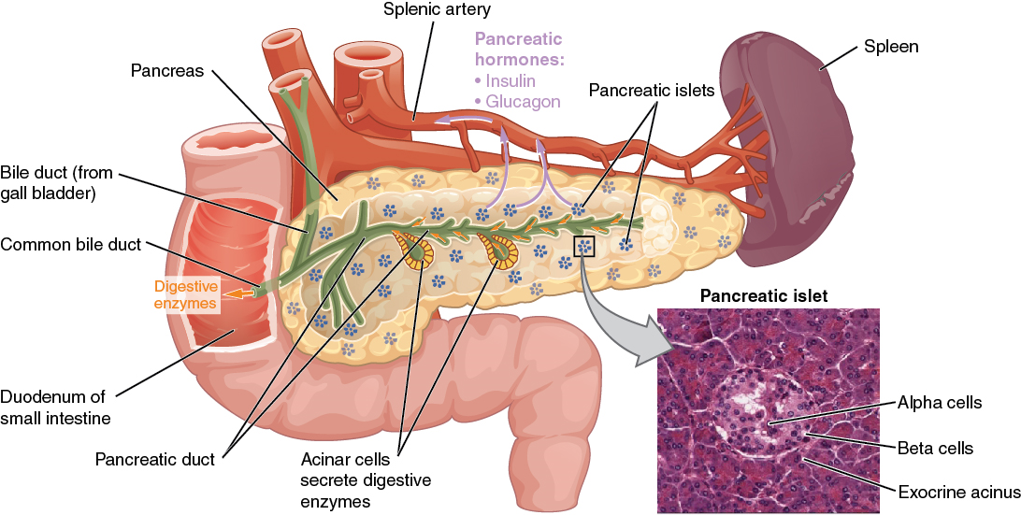This picture explains the pancreas.
This Photo by Unknown Author is licensed under CC BY

Risk factors for T2DM include both modifiable and non-modifiable factors. Modifiable factors include sedentary lifestyle, excessive body weight, central obesity, smoking, unhealthy diet, and excessive alcohol consumption (WHO, 2020). Non-modifiable risks include increasing age, family history of diabetes, ethnicity (higher risk in Black African, Caribbean, and South Asian groups), and previous gestational diabetes (Diabetes UK, 2023).
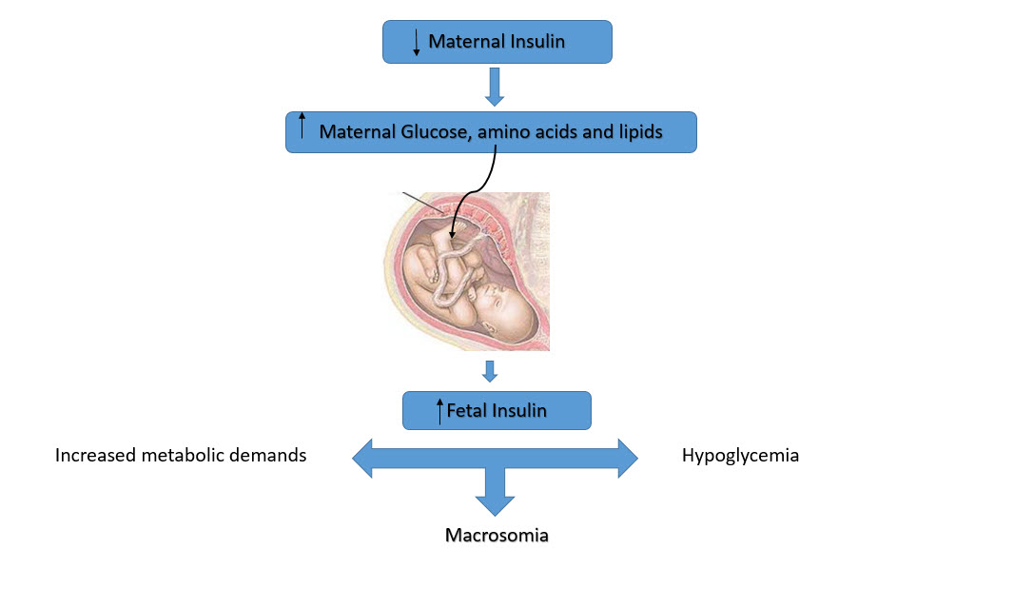
This Photo by Unknown Author is licensed under CC BY-SA
In this picture is describes the complications of gestational diabetes mellitus (GDM)

2. Blood Sugar Regulation
Maintaining Safe and Effective Blood Glucose Levels
Blood glucose homeostasis relies on coordinated interactions among the endocrine, digestive, circulatory, and musculoskeletal systems. The pancreas is the central organ involved (Diabetes UK, 2023).
Hormonal Regulation by the Pancreas
The islets of Langerhans contain several cell types with distinct functions:
- Beta cells – produce insulin
- Alpha cells – produce glucagon
- Delta cells – produce somatostatin
- PP cells – produce pancreatic polypeptide
After a meal, rising blood glucose stimulates beta cells to release insulin. Insulin binds to receptors on target cells, activating intracellular pathways that allow GLUT-4 transporters to move to the cell membrane and permit glucose entry (NICE, 2022). In the liver, insulin promotes glycogenesis (the storage of glucose as glycogen), while in muscle and fat tissue, it facilitates glucose uptake for energy or storage.

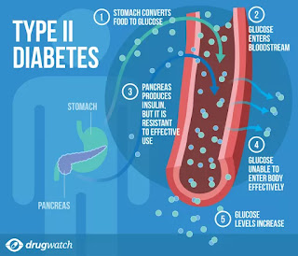
This Photo by Unknown Author is licensed under CC BY-SA-NC
This picture explains how glucose run in the veins from the pancreas.

When blood glucose levels drop (e.g., overnight or during fasting), glucagon is released from alpha cells. Glucagon stimulates glycogenolysis (breakdown of glycogen to glucose) and gluconeogenesis (production of glucose from non-carbohydrate sources) in the liver (WHO, 2020).

This negative feedback system maintains glucose within a tight physiological range necessary for normal body function.
In T2DM, cells become insulin-resistant, meaning insulin cannot effectively trigger glucose uptake. The pancreas makes up for this by making more insulin, but eventually beta cells run out,leading to persistent hyperglycaemia (Cleveland Clinic, 2023).
Poorly controlled diabetes results in microvascular and macrovascular complications, including kidney disease, neuropathy, cardiovascular disease, and retinopathy (Diabetes UK, 2023).
Understanding this helps patients appreciate why medication adherence, diet, physical activity, and monitoring are central to diabetes management.

3. Cellular Metabolism
How Oxygen and Glucose Produce Energy Through Cellular Metabolism
Glucose is a fundamental energy source for cells, and oxygen is required for efficient energy production. This process occurs through cellular respiration, a multi-stage metabolic pathway that takes place within the cytoplasm and mitochondria. Cellular respiration allows the body to convert nutrients into adenosine triphosphate (ATP), the molecule that powers all physiological functions, including muscle contraction, nerve transmission, and tissue repair. (Anon,2021)
Stages of Cellular Respiration
1. Glycolysis
This first stage occurs in the cytoplasm, where glucose is broken down into two molecules of pyruvate, generating a small amount of ATP and NADH (Estruch et al., 2018). Importantly, glycolysis does not require oxygen, allowing cells to produce limited energy even in oxygen-poor conditions.
2. Krebs Cycle (Citric Acid Cycle)
If oxygen is present, pyruvate enters the mitochondria and is converted to acetyl-CoA. It then enters the Krebs cycle, producing NADH, FADH₂, and carbon dioxide as by-products. NADH is a molecule that carries electrons with high energy to the electron transport chain, where it aids in the synthesis of ATP, producing on average about 2.5 molecules of ATP per NADH. These molecules carry high-energy electrons needed for the next stage. (Gnaiger, 2024)
3. Electron Transport Chain (ETC)
This final stage occurs along the inner mitochondrial membrane. NADH and FADH₂ deliver electrons to the ETC, creating a proton gradient that drives ATP synthesis. Oxygen is essential, acting as the final electron acceptor to form water, allowing the chain to continue (Estruch et al., 2018). Without oxygen, ATP production drops dramatically.
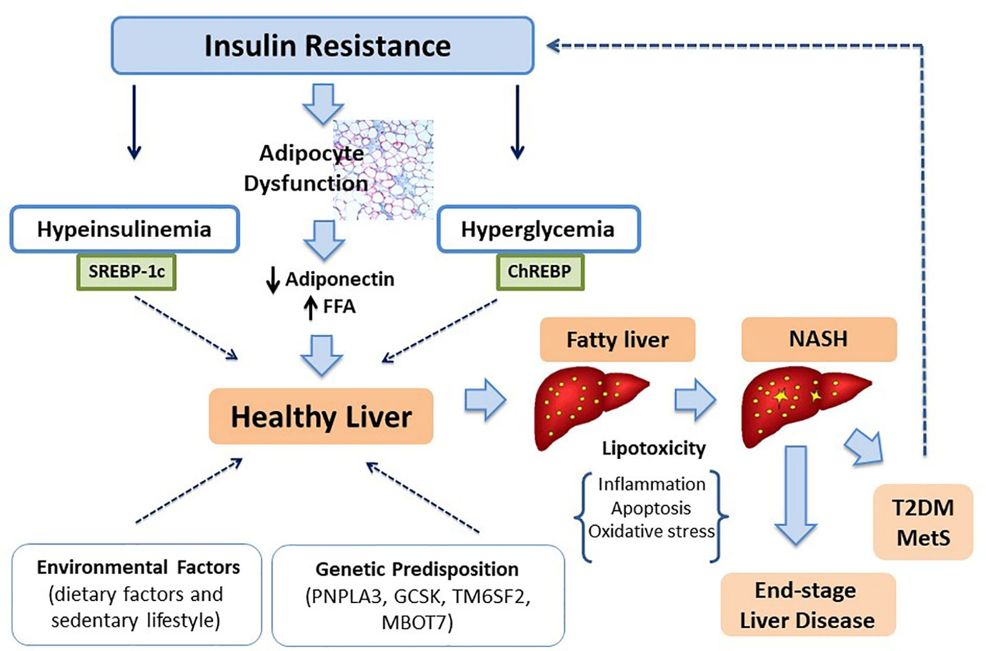
This Photo by Unknown Author is licensed under CC BY
This picture explains the insulin resistance.

Relevance for Diabetes
In Type 2 diabetes, insulin resistance prevents glucose from entering muscle and fat cells efficiently, meaning mitochondria cannot access their primary fuel source. As a result, ATP production is reduced despite elevated blood glucose levels. This mismatch between available glucose and cellular energy production contributes to symptoms such as persistent fatigue, muscle weakness, and decreased exercise tolerance. Over time, impaired cellular metabolism can also contribute to weight gain, lipid imbalance, and worsening insulin resistance, creating a cycle that worsens glycaemic control. (Lean et al., 2018).

4. Recording and tracking blood sugar levels for type 2 diabetes
How Tracking Blood Sugar Helps Individuals Manage Type 2 Diabetes
Routine data collection is vital in health and social care, especially for long-term conditions. For diabetes, ongoing monitoring supports safe decision-making and helps individuals understand how daily behaviours influence their glucose levels. Lifestyle factors, dietary patterns, medication adherence, stress, and sleep quality all significantly impact type 2 diabetes management. Regular monitoring provides real-time, personalised feedback, enabling individuals to identify triggers and behavioural patterns that contribute to glucose fluctuations. This insight helps people become more proactive, increasing their confidence in managing their condition independently while strengthening long-term self-management skills.

In addition, consistent monitoring enhances communication between patients and healthcare professionals. It allows clinicians to review accurate, up-to-date information, which can inform medication adjustments, dietary planning, and lifestyle recommendations. Digital tools such as smartphone apps, continuous glucose monitors (CGMs) and connected glucometers further support this process by offering automatic data recording, trend analysis, and alerts for dangerously high or low readings. These technologies can improve engagement and reduce the risk of complications by promoting early intervention.

Routine Data Collected in Primary Care

* Capillary blood glucose readings
* HbA1c (reflects average glucose over 8–12 weeks)
* Blood pressure (diabetes increases cardiovascular risk)
* BMI and waist circumference (markers of central obesity)
* Lipid profile
* Kidney function tests (eGFR, urine albumin)
* Smoking status, alcohol intake, and medication adherence

These data points inform personalised care planning and ensure alignment with national standards such as NICE NG28 (NICE, 2022). They also allow clinicians to monitor disease progression and adjust treatments safely.

Why Monitoring Matters
Tracking blood sugar allows individuals to:
* Recognise how meals, stress, medication, activity, and sleep affect glucose patterns
* Prevent hypo- and hyperglycaemia
* Adjust behaviours accordingly
* Reduce long-term complications (Diabetes UK, 2023)
* Participate in shared decision-making with clinicians

Monitoring also helps detect early warning signs of deterioration. For example, consistently high morning readings may indicate dawn phenomenon or poor medication adherence. Sudden drops in glucose may signal over-medication, excessive exercise, or inadequate food intake. Recognising these trends enables timely adjustments to avoid severe events such as diabetic ketoacidosis (DKA) or hyperosmolar hyperglycaemic state (HHS), both of which are medical emergencies. Furthermore, regular monitoring encourages accountability and provides reassurance, helping individuals maintain stable glycaemic control over time.


This Photo by Unknown Author is licensed under CC BY-NC
CGM, Continues glucose monitor.

Consequences of Not Tracking
If an individual does not monitor their glucose levels, dangerous fluctuations can go unnoticed. Lack of monitoring increases the risk of chronic hyperglycaemia, leading to long-term complications such as neuropathy, nephropathy, vision loss, and cardiovascular disease. It also reduces the effectiveness of care plans because clinicians lack accurate data to guide treatment decisions. Without self-monitoring, individuals may continue behaviours that worsen glycaemic control, reinforcing poor outcomes and increasing hospital admissions.
Furthermore, the absence of regular tracking can delay early detection of infections, dehydration, or acute metabolic disturbances, which are more common in poorly controlled diabetes. Individuals may also feel less engaged in managing their health, resulting in reduced motivation and lower adherence to medication or lifestyle advice. Regular tracking, therefore, plays a critical role in empowering people with Type 2 diabetes to manage their condition safely and independently.

5. Recommendations
Lifestyle modification is one of the most effective interventions for Type 2 diabetes. Evidence shows that changes in diet, physical activity, smoking cessation, alcohol moderation, and weight management significantly improve glucose control. These behavioural changes not only support day-to-day management but also reduce long-term risks such as cardiovascular disease, neuropathy, and kidney impairment.
1. Diet
A balanced dietary approach that supports stable blood glucose includes:
• Increasing fibre intake to at least 30 g/day
• Choosing low-glycaemic index (GI) foods
• Reducing refined or avoiding carbohydrates and sugary drinks
• Prioritising whole grains, vegetables, lean proteins, and healthy fats
The Mediterranean diet has strong evidence for reducing HbA1c and improving cardiovascular outcomes. It emphasises olive oil, nuts, legumes, fish, whole grains, and vegetables. Consistency in meal timing and portion control further helps prevent glucose spikes and supports better metabolic stability. (Estruch et al., 2018).
2. Physical Activity
Physical activity increases insulin sensitivity and promotes glucose uptake independent of insulin. Recommended guidelines include:
• At least 150 minutes per week of moderate-intensity aerobic activity
• Strength training two or more days per week
• Reducing sitting time and incorporating movement throughout the day (WHO, 2020)
Regular activity also improves mood, reduces stress, and supports weight control, all of which indirectly enhance diabetes outcomes. Exercise can reduce HbA1c by up to 1% (WHO, 2020).

3. Smoking Cessation
Smoking worsens insulin resistance, damages blood vessels, and accelerates diabetic complications. Stopping smoking substantially reduces cardiovascular risk and improves circulation. Behavioural support combined with nicotine-replacement therapy can significantly increase success rates. (Durlach et al., 2022)

4. Weight Management
Weight loss of 5–10% can significantly improve insulin sensitivity and may lead to diabetes remission when substantial and sustained. Structured interventions, such as NHS Diabetes Prevention Programmes, have demonstrated significant improvements in glucose regulation. Long-term weight maintenance is strengthened by ongoing peer support, monitoring, and personalised goal-setting. ( Miles Pharmacy, n.d.)

5. Alcohol Moderation
Alcohol affects glucose levels unpredictably and adds excess calories. NHS guidelines recommend limiting intake to 14 units per week (Alchool change UK,n.d). Choosing low-sugar options and avoiding drinking on an empty stomach can also help reduce glucose fluctuations.

6. Conclusion

To conclude, effective diabetes management requires an understanding of the underlying physiology of glucose regulation, the role of insulin and glucagon, the importance of cellular metabolism, and how lifestyle factors influence the endocrine and metabolic systems. Monitoring blood glucose and collecting routine health data enables individuals and healthcare professionals to identify patterns, reduce risk, and tailor interventions. This physiological awareness also helps patients interpret their own results more accurately, allowing them to recognise when changes in diet, stress, or activity levels may be contributing to abnormal readings.
Evidence consistently shows the benefits of lifestyle changes such as healthy eating, increased physical activity, smoking cessation, weight management, and alcohol moderation. These interventions work synergistically to enhance insulin sensitivity, reduce inflammation, and support more stable metabolic functioning. Supporting patients with accessible information empowers them to take an active role in their care, improving outcomes and reducing the likelihood of complications. Education delivered in a clear, person-centred manner allows individuals to make informed choices and feel confident in adjusting daily behaviours.
The practice nurse job is ensuring patients understand the relationship between their behaviours, body systems, and disease processes is essential for promoting long-term self-management and safety. Providing ongoing support, reinforcement, and opportunities for patients to ask questions fosters trust and encourages adherence. Ultimately, empowering individuals with the knowledge and tools needed to manage their diabetes contributes to better glycaemic control and overall well-being.

References

- Diabetes UK (2023) Type 2 diabetes. Available at: www.diabetes.org.uk (Accessed: 24 November 2025).

- Estruch, R. et al. (2018) ‘Primary prevention of cardiovascular disease with a Mediterranean diet supplemented with nuts or extra-virgin olive oil’, New England Journal of Medicine, 378(25), pp. 2441–2452.(Accessed: 27 November 2025).

- Anon, (2021). How is Glucose Used for Energy? | The Science Blog. [online] Available at: https://www.reagent.co.uk/blog/how-is-glucose-used-for-energy/(Accessed: 27 November 2025).

- World Health Organisation (2020) Guidelines on physical activity and sedentary behaviour. Geneva: WHO.(Accessed: 28 November 2025).

- Miles Pharmacy (n.d.) How to Control Diabetes Through Weight Management? [online] Miles Clinic. Available at: https://milesclinic.co.uk/blog/how-to-control-diabetes-through-weight-management/ (Accessed: 28November 2025).

- Cleveland Clinic (2023). Hyperglycemia (High Blood Sugar). [online] Cleveland Clinic. Available at: https://my.clevelandclinic.org/health/diseases/9815-hyperglycemia-high-blood-sugar.(Accessed: 24 November 2025).

- NICE (2022) Type 2 diabetes in adults: management (NG28). Available at: www.nice.org.uk (Accessed: 1 December 2025).
- Gnaiger, E. (2024) ‘Complex II ambiguities — FADH₂ in the electron transfer chain’, Journal of Molecular Biology, Vol(issue) if provided, article S0021925823024985. (Accessed: 1 December 2025).

- Durlach, V., Vergès, B., Al-Salameh, A., Bahougne, T., Benzerouk, F., Berlin, I., Clair, C., Mansourati, J., Rouland, A., Thomas, D., Thuillier, P., Tramunt, B. And Le Faou, A.-L. (2022). Smoking and diabetes interplay: A comprehensive review and joint statement. Diabetes & Metabolism, [online] 48(6), p.101370. doi:https://doi.org/10.1016/j.diabet.2022.101370. (Accessed: 1 December 2025).

- Lean, M. et al. (2018) ‘Remission of type 2 diabetes after weight loss’, The Lancet, 391(10120), pp. 541–551. (Accessed: 29 November 2025).

- Alcohol Change UK. (n.d.). Alcohol and diabetes. [online] Available at: https://alcoholchange.org.uk/alcohol-facts/fact-sheets/alcohol-and-diabetes. (Accessed: 1 December 2025).

