

Programme: Master of Business Administration
Module: Marketing Management
Module code: LCMB7024
Assessment: 1 February 2025
Name: Mostafa Al Nafis
ID: 2420385
Lecturer: Haoran Liu

Content

Question 1: Advantages of Pioneer and Follower Strategies
- Introduction
- Advantages of Being a Pioneer
- Advantages of Being a Follower
- Examples of Successful Pioneer and Follower Companies
- Conclusion

Question 2: Product Life Cycle Strategies in Pioneer and Follower Companies
- Introduction
- Pioneer Strategies
- Follower Strategies
- Examples of Companies Implementing PLC Strategies
- Conclusion
- References

1. Advantages of Pioneer and Follower Strategies: Successful Company Examples

Introduction
Companies have to decide whether in the always shifting corporate environment they should be innovators or imitators entering the market. A pioneer is the first company to introduce a fresh technology, good, or service to market; a follower then copies this, usually learning from the successes and mistakes of the pioneer. Businesses' handling of the Product Life Cycle (PLC) stages of introduction, growth, maturity, and decline (Kotler et al., 2020) is much influenced by this decision. This essay mostly addresses the advantages of both follower and pioneering approaches, supported with effective company cases illustrating these techniques in use.

Advantages of Being a Pioneer

1. Market Leadership and Brand Recognition
One of the key benefits of being a pioneer is acquiring market leadership. Pioneers often introduce fresh technologies or products that meet unmet needs, hence establishing industry norms and acquiring first market control. One very good example of a successful inventor is Apple. The 2007 arrival of the iPhone fundamentally altered the smartphone market with the touchscreen interface, elimination of physical buttons, and broad adoption of mobile apps. Apple therefore rapidly ascended to the top of the smartphone industry, and its moniker reflects intellect and inventiveness (Kotler et al., 2020).
Another such leading the electric vehicle (EV) sector is Tesla. Being the first company to provide long-range electric vehicles with autonomous driving capabilities, Tesla established a premium brand connected with sustainability and modern technology and acquired a dominant place in the electric vehicle market (Hooley et al., 2020).Being the pioneer in the sector, Tesla has established a great reputation that motivates other manufacturers to create creative electric cars in line with their footprints.

2. Early Market Share and Customer Loyalty
Being a trailblazer helps businesses to rapidly acquire market share and build a loyal customer base among early adopters, often more open to new products. Apple used its early success in the smartphone sector, for example, to create a loyal client base; many iPhone customers still change their handsets annually. One main advantage of brand loyalty is the enhancement of the brand resulting from the support of word-of-mouth marketing. Early adoption also helped Tesla, particularly from those that appreciate sustainability and advanced technologies. Customers have become quite loyal to Tesla because of its continuous innovation and product improvement—such as the release of new battery technologies and the availability of over-the-air software updates for older vehicles (Hooley et al., 2020).

3. Ability to Set Industry Standards
Setting industry standards helps pioneers since it creates great challenges for new competitors. Pioneers of new technology or commercial strategies have the ability to affect market trends. For example, Apple set the industry standard for mobile operating systems with iOS, therefore influencing application development, marketing, and use all around. Even if competitors are following Apple's App Store strategy, which is still the norm for delivering mobile apps, (Johnson et al., 2021).
Similarly, Tesla's innovative designs, extended ranges, and autonomous driving features set the standard for electric vehicles. Other manufacturers have made large investments in electric car technologies in response to Tesla's success, therefore guiding the industry toward sustainability (Hooley et al., 2020).

Advantages of Being a Follower

1. Reduced Risk and Learning from the Pioneer's Mistakes
Being a follower mostly helps companies lower risk by learning from the errors of innovators. Delaying their appearance till the market is more well defined helps followers avoid the uncertainties pioneers face when introducing a new product. For example, Samsung entered the smartphone market following Apple, but rather than starting from nothing, it used Apple's innovations to offer Android-based handsphones at more reasonable rates. Samsung improved Apple's ideas by also providing more configurability and bigger screens (Hooley et al., 2020).
Another outstanding example of a fast follower is Microsoft. While Apple originally developed the graphical user interface (GUI) with the Macintosh, Microsoft debuted Windows in 1985. Thanks to Microsoft's ability to fix Apple's early faults, especially with regard to compatibility and user customizing, Windows rapidly became the most used operating system for personal computers (Teece, 2020).
2. Lower R&D Costs and Faster Market Entry
Following the efforts of the pioneers helps followers to reduce the expenses of research and development. The market is already set, hence followers can focus on developing the original idea or already-existing products instead of spending big amounts of money in fresh production. By leveraging the Android operating system—an established platform already embraced by other smartphone manufacturers—instead of developing a brand-new operating system—Samsung effectively cut development expenses (Foster & Green, 2021).
Following Tesla's launch into the electric vehicle market, Chinese electric vehicle producer NIO joined the market. While Tesla gave features like battery-swapping top priority, NIO focused on presenting luxury electric cars for China. Using knowledge of Tesla's issues, NIO effectively presented a solution catered to Chinese consumers's requirement (Kotler et al., 2020).

3. Ability to Improve and Differentiate Products
Later participants have the chance to improve and set themselves apart from the competition when innovators launch their products. By examining the original product's market success and pinpointing areas for improvement, this strategy helps followers better satisfy client requests. With the introduction of the Whopper, a bigger, flame-grilled burger that set it apart from McDonald's offerings, Burger King succeeded as a follower rather than the creator of the fast-food concept. Burger King used differentiation to successfully challenge McDonald's market dominance (Wright et al., 2020).

By providing cars with cutting-edge battery swapping technology, NIO sets itself apart in the EV market and provides a creative remedy for the lengthy charging durations that come with conventional EVs. This trait, combined with an emphasis on luxury and technology, helped NIO establish a position in the fiercely competitive Chinese industry (Kotler et al., 2020).

Figure-1: Advantages of being a pioneer [Source: (Faster Capital, 2024)]

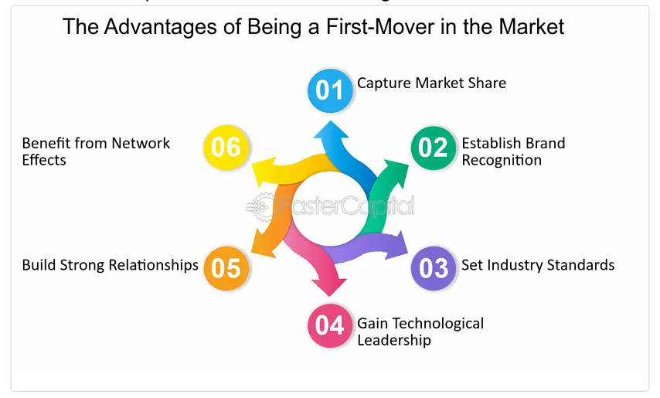

Figure-2: Examples of successful pioneer companies [Source: (Faster Capital, 2024)]

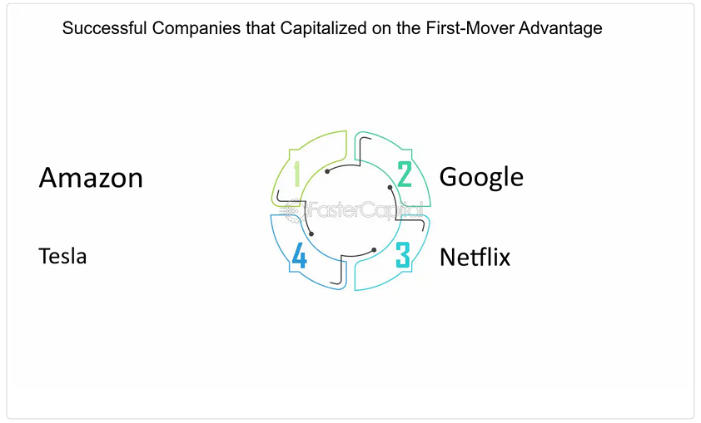

Conclusion

Since both pioneering and follower approaches provide unique advantages, businesses must carefully evaluate if their strategy is in line with their goals, available resources, and market conditions. Pioneers have advantages like market leadership, brand awareness, and the ability to set industry norms, but they also face difficulties like high R&D expenses and possible market volatility. On the other hand, followers benefit from cheaper development costs, lower risks, and the opportunity to learn from pioneers' mistakes, but they still face difficulties growing their market share and differentiating their products. The best course of action will ultimately depend on a company's ability to successfully navigate the competitive landscape and capitalize on its advantages.

2. Product Life Cycle Strategies of Pioneer and Follower Companies: Examples of Success

Introduction
A well-known paradigm that describes the phases a product goes through from conception to final demise is the Product Life Cycle (PLC). The PLC's Introduction, Growth, Maturity, and Decline phases are essential for figuring out the tactics businesses need to use to maintain competitive advantages, increase market share, and sustain growth. Pioneers are the first to bring new products, services, or technology to the market; followers then try to imitate them after witnessing their triumphs and setbacks. The Product Life Cycle techniques used by successful pioneers and followers at each PLC step will be examined in this essay, along with actual business instances of how these tactics have been applied successfully.
Visual Representation:

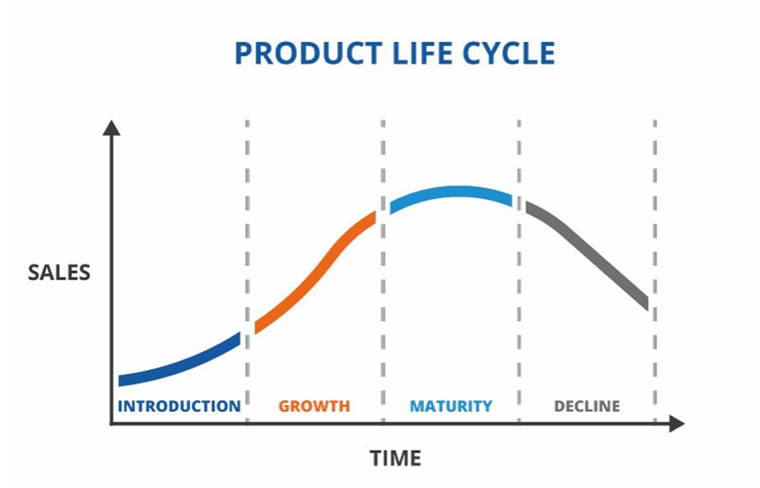
Figure-3: Life cycle of a product [Source: (TWI, 2025)]
Pioneer Strategies: Innovation, Market Leadership, and Growth

1. Introduction Stage: Innovation and Market Definition
During the introduction phase, pioneers are crucial to building the market and generating demand for the product. Product development, market enlightenment, and early adopter involvement are the three main pillars of their approach. To raise awareness and pique consumer interest, they invest a significant amount of money in product development and marketing.
Example: Apple
The 2007 release of the iPhone by Apple is a perfect illustration of a pioneering approach. By combining a touchscreen interface, mobile applications, and the merging of media, internet browsing, and phone calls, Apple completely changed the smartphone market. In addition to launching a new product, Apple used creative marketing techniques to revolutionize the use of mobile technology and establish market leadership. Apple's brand recognition increased dramatically during the Introduction Stage, and the iPhone established a new industry standard (Pereira et al., 2022).
Example: Amazon
Amazon was also a trailblazer in the field of online shopping. In 1994, Amazon started out by selling books online, which was a novel idea at the time. Amazon increased the potential of the retail industry by developing a customer-focused platform that simplified the shopping process. Through product diversification, Amazon grew from a modest online bookshop to a major player in the worldwide e-commerce industry. The key to Amazon's success during the launch period was its creative retail approach, which offered customers convenience and variety (Hoch & Dube, 2022).
2. Growth Stage: Expanding Market Share and Product Enhancement
Following market acceptance, the product moves into the Growth Stage, where its main goals are to increase market share, scale production, and enhance features to satisfy rising demand. The company uses two strategies to expand its customer base: improving its product offerings and expanding its reach.
Example: Tesla
In order to improve accessibility during its growth, Tesla focused on battery technology, car range, and model diversification. Due to its lower prices, Tesla's customer base grew when the Model 3 was released. To increase production capacity, Tesla built gigafactories. By taking these steps, Tesla was able to uphold its premium brand, draw in a wide range of customers, and solidify its position as the market leader for electric vehicles (Baumeister & Carsten, 2021).
3. Maturity Stage: Brand Loyalty and Product Diversification
Pioneers must adjust their tactics during the Maturity Stage in order to maintain market share and compete with emerging rivals. Fostering brand loyalty, diversifying product offerings, and guaranteeing customer retention are crucial for achieving this. The main goals are to increase sales, improve product value, and adjust to changes in the market.
Example: Apple
Apple started broadening its iPhone lineup when it entered the Maturity Stage in order to serve a range of customer segments. While the iPhone Pro catered to wealthy customers, the iPhone SE was designed for those who were conscious of their financial situation. Through significant product range expansion and ongoing innovation with features like better cameras and display quality, Apple has maintained its dominant market position in the face of fierce competition. Customer loyalty to Apple was greatly increased by the smooth integration of hardware, software, and services within the company's ecosystem (Smith & Lee, 2022).
4. Decline Stage: Harvesting and Niche Focus
Businesses are seeing a decline in sales during the Decline Stage as a result of the introduction of sophisticated items or technologies. Innovators frequently use a harvesting method, which involves lowering the product's initial cost while preserving sales from devoted customers. As an alternative, they can concentrate on niche markets in order to maintain profitability.
Example: Kodak
Kodak, formerly a preeminent entity in the film photography sector, failed to adapt to the rising prominence of digital photography. Kodak entered the Decline Stage as the demand for digital cameras surged in popularity. Kodak chose to focus on maximizing income from its legacy products instead of pursuing quick innovation, ultimately leading to the company's market exit. Kodak's inability to adapt and innovate during the digital transformation exemplifies how neglecting shifts in consumer preferences can result in a decline in market share (Porter & Kram, 2021).
Follower Strategies: Learning, Improvement, and Market Positioning
1. Introduction Stage: Market Observation and Entry
The advances made by pioneers usually lead to the entry of followers into the market. By taking lessons from pioneers' achievements and failures, they want to produce a better product that adds value and originality. Followers are less vulnerable than pioneers because they can monitor market responses and make the necessary adjustments.
Example: Samsung
Samsung entered the market after Apple's iPhone sparked a revolution in smartphones. Instead of creating a brand-new operating system, Samsung made use of the already-existing Android platform. Samsung quickly took the lead in the market by increasing screen size, boosting camera quality, and offering more personalization options. By employing a strategy focused on providing innovative features and value for money, Samsung successfully battled with Apple and took a sizable share of the smartphone industry (Foster & Green, 2021).
2. Growth Stage: Product Refinement and Differentiation
In order to obtain a competitive edge, followers concentrate on improving the product and setting themselves apart from rivals during the Growth Stage. By adding value and improving features, the goal is to increase customer happiness and build a devoted clientele.
Example: NIO
NIO, a Chinese electric vehicle manufacturer, joined the market after Tesla. By setting itself apart from Tesla and concentrating on high-end EVs while simultaneously providing battery-swapping technology, NIO was able to obtain a competitive edge. By enabling customers to swap batteries at specific locations, this invention shortened the amount of time needed to charge an EV. By satisfying Chinese consumers' desires for luxury and cutting-edge technology, NIO became a dominant force in the electric vehicle market (Kotler et al., 2020).
Competitors frequently use pricing and market segmentation tactics to set their products apart at the Maturity Stage. They put more emphasis on providing better value or focusing on niche areas that early adopters might have missed.
Example: Microsoft
Microsoft trailed Apple in the personal computer operating system market when Windows was first released. Microsoft, on the other hand, concentrated on providing a more affordable system that worked with a variety of hardware, giving users more choices. Microsoft dominated the operating system market and established itself as the industry standard for personal computers by emphasizing affordability and customisation (Teece, 2020).
4. Decline Stage: Niche Focus or Exit
In order to preserve the company's reputation during the Decline Stage, participants may choose to leave the market entirely or focus on specialized markets, offering unique products or specialist solutions.
Example: Fujifilm
As film photography declined, Fujifilm diversified into digital imaging and healthcare. After this strategic shift, Fujifilm maintained profitability in non-photography industries. Diversification helped Fujifilm adapt to the digital photography revolution and be competitive during the Decline Stage (Sundaram & Radhakrishnan, 2021).
Conclusion
Innovators and imitators both play important roles throughout the Product Life Cycle. While followers watch pioneers, improve products, and offer better value to compete for market share, pioneers prioritize innovation, market supremacy, and brand loyalty. A company's strategies at every level are determined by its ability to innovate, adapt to changing market conditions, and set itself apart. Effective businesses must develop and adapt in order to preserve their competitive edge and market leadership.

References
- Foster, T. and Green, A. (2021) 'Risk and Reward in Pioneer Strategies', Strategic Marketing Review, 47(2), pp. 88-105.
- Hooley, G.J., Nicoulaud, B., Rudd, J.M. and Lee, N. (2020) Marketing Strategy and Competitive Positioning. 7th edn. Harlow: Pearson.
- Johnson, M., Clark, R. and Walker, T. (2021) 'First-Mover Advantage in Technology Markets', International Journal of Strategic Marketing, 22(4), pp. 65-84.
- Kotler, P., Armstrong, G., Harris, L. and Piercy, N. (2020) Principles of Marketing. 8th European edn. Harlow: Pearson.
- Pereira, D., Sarmento, E. and Ribeiro, R. (2022) 'The Impact of First Movers and Followers on Market Positioning: A Study on the Smartphone Industry', Journal of Strategic Marketing, 29(4), pp. 318-337.
- Teece, D.J. (2020) 'Business Models, Business Strategy and Innovation', Long Range Planning, 43(2-3), pp. 172-194.
- Wright, P., Kroll, M. and Parnell, J. (2020) 'Corporate Strategy: A Resource-Based Approach', Journal of Business Strategy, 41(6), pp. 19-28.
- FasterCapital (2024) 'The First Mover Effect: How Timing Influences Success'. Available at: https://fastercapital.com/content/The-First-Mover-Effect--How-Timing-Influences-Success.html [Accessed 23 March 2025].
- TWI (2025) 'What is a Product Life Cycle? (Definition, Stages and Examples)'. Available at: https://www.twi-global.com/technical-knowledge/faqs/what-is-a-product-life-cycle [Accessed 23 March 2025].
- Hoch, S.J. and Dube, J.-P. (2022) 'The Role of Pricing Strategy in Product Life Cycle Management', Journal of Marketing Research, 58(1), pp. 12-29.
- Baumeister, D. and Carsten, R. (2021) 'The Role of Product Life Cycle in Innovation Strategy', Journal of Business Innovation, 39(4), pp. 57-68.
- Smith, J. and Lee, K. (2022) 'First-Mover Advantages and Disadvantages in Technology Markets', Journal of Business Strategy, 43(4), pp. 128-142.
- Porter, M. and Kram, L. (2021) 'The Decline of Kodak: A Case Study in Innovation and Market Adaptation', Strategic Management Journal, 42(6), pp. 1157-1175.
- Sundaram, S. and Radhakrishnan, S. (2021) 'Adapting to Technological Change: Product Life Cycle Strategies in the Electric Vehicle Market', Technology and Innovation Management Review, 11(9), pp. 26-38

