Stratergic management



University of Wales Trinity Saint David

Lecturer – Jayne Williams

Jaliya Jeevantha De Silva- 1803778
MBA – Tourism Management
18 December 2020

Executive Summary

The hospitality industry in the UK has already been rising with the growing market for services and increased numbers of both locals and foreigners. Organizations of service delivery firms, including hotels, have chosen strategies to maximise customer offerings as a central instrument for market competition. Many Novotel hotels in the UK experience shortfalls due to insufficient methods of client fulfilment and other external factors, such as COVID-19.
This research, therefore, aimed to find out the impact on results in the hospitality industry of customer service practices. The study focused primarily on customer relations and customer care facilities and how they impact Novotel Hotels' market efficiency. The study found that Novotel hotels had a positive and important impact on policy of customer relations and customer care services. The finding on the correspondent of the variables showed that customer relationships have the strongest positive performance relationship, followed by customer care services that also have a strong positive performance hotel relationship with the implementation of service quality strategy and service guarantee tool. Based on the analysis, the study recommended that hotel managers consider implementing and strengthening customer relationships and customer care facilities in the hotels, as this will increase customer satisfaction and improve business efficiency.

Table of Contents

1 Executive Summary 1
2 Introduction 3
2.1 Customer service, facilities for customer care, and efficiency of hotels 3
2.2 The hospitality industry in Great Britain 4
2.3 Internal Factors 6
2.4 External Factors 7
2.5 Statement of the problem 7
3 Introduction to Novotel Hotels. 10
3.1 TOWS analysis of Novotel Hotels 10
3.2 General Objective 11
3.3 Detailed goals 11
3.4 Research Questions. 11
4 LITERATURE REVIEW 12
4.1 Theoretical review 12
4.2 Relationship marketing theory 12
4.3 Social Exchange Theory 13
5 Conceptual Framework Figure 14
5.1 Customer Relation 14
5.2 Customer Care Service 15
5.3 Hotel Performance 16
5.4 TripAdvisor Customer reviews on Novotel Hotels 17
6 Observations and Results 18
6.1 Implementation of Service Quality Strategy for Novotel Hotels 19
6.2 The Service Guarantee tool at a mid-scale Hotel Chain (Novotel) 20
7 Conclusion 22
8 Recommendations 23
Reference: 24

Introduction

Customer service, facilities for customer care, and efficiency of hotels

The drastic growth surrounding organizations have altered the way business is conducted in its entirety. The service industry continues to experience challenges induced by high customer awareness and access towards more information. By shaping service distribution approaches for competitive advantage, service providers have to separate themselves and aim to be as close as possible to guests. This has contributed to the development of customer relationship initiatives, customer support, and the development service strategies to adapt to market circumstances (Evans, 2015). A service strategy is a unique methodology that an organization uses to provide its consumers with useful services (Kleban et al.,2019). Service strategies include differentiation, cost leadership, personnel management which improves resource capacities and skills; Optimal customer care; uniformity of facilities to provide greater esteem Towards Clients AND Existing Products; strategic positioning; and acceptable reaction strategies to overcome threats and opportunities, such as the differentiation of services to broader geographic areas. There are several companies in the profession of client care and service delivery, both internally and externally., face significant issues today. Combined with high consumer expectations, the constant shift in demographics is making companies rethink their customer service strategies (“Buchichi, A. N. (2013). Organizations need to evaluate how their organisations have worked efficiently and objectively in preparing and executing a customer-focused service approach. In most markets, consumers in their supply chains have become more mature and demanding. Purchasers that offer customer-defined goods with the highest quality products, pricing and quick order turnaround will outperform their competitors and gain significant more market share in the future as customers continue to advocate for more. For leadership, the observable objective must be a greater level of service quality. It is sufficient to characterize the provision of service to customers before and after a transaction as user experience. According to Turban et al. (2002), customer service is a collection of procedures aimed at increasing the degree of customer satisfaction, which is the feeling that even a product or service has met the customer's expectations. Customer satisfaction plays a critical role in the capacity of a corporation to deliver revenue and earnings (Selden P. H (1998). Customer care should be included, from that point of view, as part of the overall solution to structural change. A customer service experience can change the entire view of the organisation that a customer has. The change in the provision of services has coincided with the advent of modern organizational technologies. A key tool for competitive advantage among service delivery firms has been the emphasis on innovation and technology. Each organization is working towards effectiveness and performance as well as cost reduction.

The service sector in Great Britain
The hospitality sector is a wide segment of service industry businesses, including hotels, event planning, theme parks, transportation, cruise ships, and other tourism industry sectors. This industry includes several types of facilities: hotels, restaurants or any leisure facility. The majority of these facilities offer an intangible product: a welcoming environment. It's an industry that is growing at a rapid pace, with demand for their offerings increasing everywhere. During 2018, the UK hospitality industry reached a value of more than EUR 100 billion (Figure-1) ("UK growth analysis of the hospitality industry for 2019," 2019).

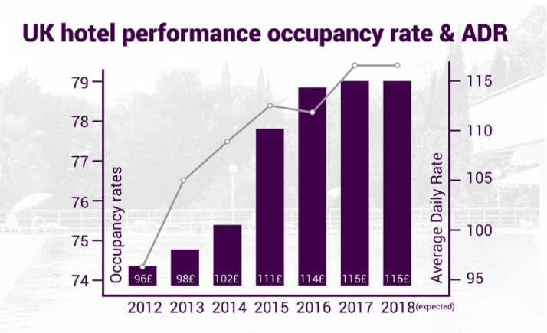

Figure -1 Source - (“Where is the UK hospitality industry going?,” 2020)

The hospitality industry's primary priorities are three-fold. For guests to feel deeply welcomed, the first objective is. This encourages the staff members in the facility to have a professional style and a friendly atmosphere. Furthermore, to ensure that all of the service's programmes operate for guests. A client expects to find everything secure and running in this business. A facility thus requires a continuous schedule of maintenance and control. Finally, facilities need to reach this degree of quality within their budget in order to prosper (Fatima and Elbanna, 2020). A diverse area of work is the UK hospitality industry. When you set up a hotel or restaurant, a particular gender, color, socioeconomic class or nationality is rarely the target audience. As anyone doing business in this field, you have to know that every corner of the world is reached by the hospitality industry. To provide a lucrative facility with a good reputation, it must uphold an international level of quality (Boisen et al., 2018).

If you look more closely at the main factors influencing the hospitality market, you will find out that this dynamic sector encompasses a wide range of facilities, employment, places and events. In addition, each division has its unique influencing factors. However in general, those who work in this sector need to focus on two kinds of variables, internal and external. As follows, the main concerns are.

Internal Factors
Facility management | Will the leadership team match the guests' requirements with their financial goals?
Employees | Are all team members qualified enough and empowered enough to provide the highest level of support?
Place and accessibility | Has your location been well-selected? Is the facility open, and are there ways in which accessibility can be improved?
Form of services supplied | Do you have the facilities expected by visitors? Do you respond to trends that are fresh?

External Factors
Environmental factors | Is the location of your property beneficial for its use, including the local climatic conditions? It will be seasonally to use it?
Technological variables | In order to ensure tourists get the best possible experience, how would you use technology?
Social factors | What are the surrounding region's demographics? Is the facility intended for local residents to use or is it reliant on overseas travellers?
Economic Factors | What is the average salary for your sector's workforce? In the local area, how much does construction work or repair work cost? How can this also be influenced by the budget?
Political factors | How do the local communities see the facility? Will it get government backing at local or higher levels? Is there government support for the kind of organisation that you want to develop?

Statement of the problem
The world could not be more different from the international travel barriers to the less tangible emotional barriers that had to overcome in some way this year 2020. The accommodation market, which saw bookings plunge to just 3.95% of last year's World Hotel Index levels on April 29, In modern times, their lowest. Less than three months before that, 98.77 percent of the same duration last year was booked (Elshamly, 2020). While COVID-19 financially affected two-thirds of those surveyed, their appetite for travel remains high, with more than half (52 percent) of those surveyed planning to travel locally this year.(Çevrimkaya et al., 2020).

With a degree of continuing confusion, however, and with the rapid onset of the initial lockdown bringing dissatisfaction to the many expected non-refundable trips, it is perhaps unsurprising that the opportunity to freely cancel and change a booking is more important than ever; it is the deciding factor for 37 percent of the population surveyed as they think about where to stay (Jiang and Wen, 2020).

Competition in the market world has called for all firms to participate in strategic management activities in order to stay competitive in the industry. (Johnson et al., 2011). Service management administrators have focused on service delivery initiatives to optimize customer service. The UK hospitality industry has undergone rapid growth internationally, offering an increased number of classified hotels with current innovations (Arden, T & Edward, S. 2009). The positive growth was due to the country's strategic location and tourist destination. This rise has brought the entry of new players into the market, hence the derivation of quality service rivalry. However, a crucial internal consideration has been the facet of strategic management and quality of services. According to the British Hospitality Association, many British hotels operate in losses due to COVID- 19 pandemic and poor service delivery, among other factors.(Jiang and Wen, 2020) It was also a point of concern for managers to launch on such a service plan to invigorate the sector to its original market position.
Numerous researches have been carried on the influence of service strategies on a company's efficiency, including Mwangi (2010). Halimi et al. (2011) claimed that companies should concentrate on habitué and personalise them using their intimate details such as call by their name, remember their likes and dislikes; strategic tactical reactions between constant and rapid restaurants.
In order to maintain the loyalty between the hotel and its guests, integration is the process of gathering customer information that allows the company to develop services and products that perfectly meet the wants and needs of the user. Cost leadership and differentiation techniques have had a beneficial impact on efficiency. Recent analysis, with a direct emphasis on the practical nature of customer service, has focused on systemic approaches and strategic management techniques.

Introduction to Novotel Hotels.
With more than 4,800 hotels worldwide, AccorHotels is a global leader in hotel management, constantly searching for new ways to connect with their customers and provide them with the ultimate customer experience (Angeles Boot - Academia.edu,” 2015.) Novotel, along with other mainstream competitors such as Sofitel, Mercure, and Ibis, is one of the mid-scale hotel chains of the Accor Group. In general, Novotel provides a fresh and creative framework for future travel by providing a reliably high level of accommodation, operation and services to business and leisure travelers in prime locations and at a highly affordable price. In the truest sense, Novotel were businessmen, implementing creative new ways of delivering services that had previously appeared to be set in stone. To begin with, instead of using porters to clean their customers' shoes, they invented the first-ever shoe-polishing system! Their management style was highly flexible, using a hands-on approach that kept their fingers on the pulse and empowered them to respond rapidly to customer needs (Parsons, 1995). The Novotel Group is the industry leader in Europe and has over 3,700 hotels in 92 countries worldwide, with 480,000 rooms in total
TOWS analysis of Novotel Hotels
The TOWS analysis has been done by the author based on the research literature reviews and other available sources of Novotel Hotels.
Strength
- Excellent guest services
- Eco-friendly, Novotel also draws consumers through its sustainability policy, which works by reducing fuel and water usage to green their supply chain.
- Personal communications
- Google organic search
- Constructing more hotels by expanding into new locations,

Weaknesses
- Since they are a large-scale business, there would be more regulations to comply with, which may make their operations difficult to carry out in certain regions.
- Despite the international expansion, the domestic market focus remains heavily dependent on Europe, making Accor Hotels vulnerable to the shifting fortunes of its domestic market.
Opportunities
- Internet growth is currently spent on Facebook for over 25 percent of online time, so by Accor creating a social media game, this will allow them to draw more customers.
- At some of its hotels, approximately 69 electric vehicle charging stations are accessible and ready for use, increasing the number of electric vehicles available..
- Portfolio growth, by expanding to new markets abroad.
Threats
- COVID -19 pandemic and economic downturn
- Brexit bills
- As the country faces a wave of militancy from militant sanctuaries in the country's frontier tribal areas, political and security instability is rising..

Overall Aim
The basic aim of the analysis would be to evaluate the impact of guest service operations on results in the hotel industry.

Detailed goals
- Determine the influence of guest relationships of Novotel hotel
- Results Evaluation of the effects of customer care on the efficiency of Novotel hotels

Research Questions.
- What is the impact of the relationship between clients on the output of Novotel hotels before and after Pandemic?
- How does the performance of Novotel hotels impact customer service?

LITERATURE REVIEW

Theoretical review
This study adopted theories: Relationship marketing theory and Social Exchange Theory.

Relationship marketing theory
The finding was supported by the relationship marketing theory (RM), which builds on the defined transaction - oriented business model. by (Lian C, Chen H, Wang W 2008). as the preparation and implementation process for the design, pricing, promotion and dissemination of products and ministration for ideas to create exchanges that meet individual satisfaction and organisational objectives. Furthermore, the guest is viewed as an apathetic body that could either obtain or rebuff the product or service. “In turn, (Kotler, P. 2000), defines relationship marketing as a paradigm shift from transactional to relational marketing, " defines customer relationships as a paradigm shift from transactional to relational marketing. Partnership network interrelationship, which is a paradigm shift from transactional to relational marketing. Transactional marketing focuses on consumer transactions based on the identification of the needs of consumers and the procurement of the services needed. On the other hand, a modern approach to customer engagement or a loyalty programme provides relational marketing.

Social Exchange Theory
Thus the theory of social exchange seeks to explain what encourages people to act as they do (Mintzberg H., Lampel J. & Quinn J, 2002.).From a cost-benefit viewpoint, The theory of social exchange is similar to an economic exchange approach to interpersonal relations, apart from the fact that social exchange deals with the exchange of intangible social costs and benefits (respect, integrity, friendship and compassion) and is not controlled by strict rules or agreements. Social exchange, like economic transaction, implies that people only engage in transaction when they anticipate benefits to justify the expense of engaging in it (Bailey, 2008). The theory suggests that a relationship's ultimate purpose is intimacy. On this principle, the variable consumer orientation is based, as the theory is mainly based on the social cost benefit of each customer's intimacy.

Conceptual Framework Figure

Independent Variable Dependent Variable
Customer Relation

- Familiarity of guests
- Personalization
- Engagement

Hotel Performance

- Guests retention
- New Guests.
- Growth Profit

Customer Care service

- Specialized service system
- Free Service
- Feedback Channel for guest

Source - ("Where is the UK hospitality industry going?" 2020)

Customer Relation
McDaniel C. Jr., & Gates, R., explains customer relations management (CRM). (1996) as an organisational strategy that enables companies to use internal resources to manage customer relationships to create a competitive edge and increase an organization's productivity (i.e. technology, staff, and processes). Undoubtedly, getting close to the customers has been one of the greatest achievements of relationship management. Konusuke Matsushita, the legendary Matsushita electronics group founder, told his sales team to take the skin temperature of the customer every day (Eshuis et al., 2013). The bonds of trust that grow up between a business and its core clients are focused primarily on a close and personal relationship.

Customer Care Service
Customer care is an operation that ensures that goods, facilities, and aftercare relevant to meeting customer requirements at least meet and surpass standards in most cases (Eshuis et al., 2013) Besides, states that customer service is a way for a company to change by encouraging consumers to comment on the products and their use. Because of the above customer service is an essential topic. It is easier to retain current customers than to find new ones and the use of the library would be encouraged by happy customers (Kassinis and Soteriou, 2015) Unhappy users are distributing the bad news and weakening the hotel organization. A hotel should therefore have the highest possible customer service level and always strive for excellence. Customer care is also a customer experience that involves a set of actions intended to increase customer satisfaction, i.e., the impression that the product or service met customer standards (Cooper D. R. & Schindler P. S.2003). This means that satisfaction requires a service/consumer product's assessment to decide whether it matches up to the desired level. According to Chen JI, Popovich K (2003), a business should develop long-term relationships with its mutually beneficial and strategically important customers. The acquisition and operation of certain consumers are literally costly. To assess which customers are most profitable, companies need to segment their customers. The outcome that businesses should strive for is the realization of their target consumer base. Hotels are also eager to search for efficient and effective activities that can recognize, choose, acquire, develop, and continue to grow loyal and profitable clientele (Yi & Ku, 2008).

Hotel Performance
In terms of productivity and efficiency, performance can also be characterized or analyzed through the perspectives provided in various frameworks, such as the Balanced Scorecard (financial, customer, internal process and learning and growth) or the Performance Prism comprising stakeholder satisfaction, strategies, processes, skills, and contribution from stakeholders. Performance can relate to actual results or outputs of certain activities, how the activity is carried out, or the potential for the activities, according to (Johnson et al., 2011), It is possible to separate output into three domains: financial performance, business performance, and organizational efficiency. Business performance includes metrics such as short-term or short-term and long-term financial requirements, financial and qualitative criteria (strategic, marketing, and social), and comparative assessment (Elshamly, 2016). The performance results differ based on how the performance of a business is described, such as return on investment, improving revenue, market share, and the settings studied, such as service companies, industrial companies, and manufacturing firms. Today, the hotel industry's success is subjective to consumer attention, and delivering an outstanding service that responds to customer demands and generates higher customer value. (“Deloitte Looks at the Future of Hospitality Post-Pandemic,” 2020), asserted, Consumers are constantly conscious of the environment, which poses the hotel industry with more challenges. The rationale for the implementation of service strategies focuses on building sustainable competitive advantage. Companies operating according to the marketing principle produce profit through consumer satisfaction, according to Kotler (2003), The definition of marketing as a business strategy is that superior business performance is seen as the result of being more efficient in anticipating and meeting customer needs than competitors.

TripAdvisor Customer reviews on Novotel Hotels

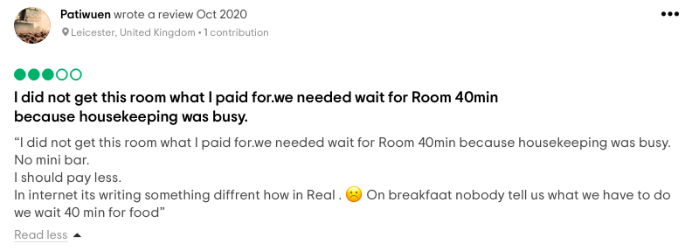
(Figure -3) Source - (“NOVOTEL LONDON CANARY WHARF - Updated 2020 Prices, Hotel Reviews, and Photos,” 2020)
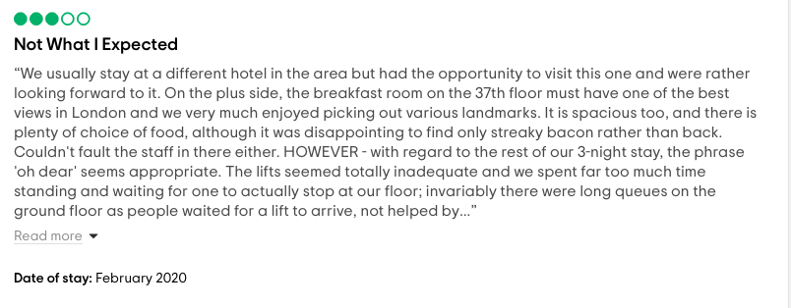

(Figure – 4) Source - (“NOVOTEL LONDON CANARY WHARF - Updated 2020 Prices, Hotel Reviews, and Photos,” 2020)

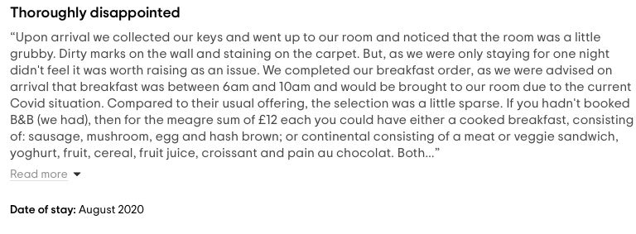
(Figure 5 Source) - (“NOVOTEL CARDIFF CENTRE - Updated 2020 Prices, Hotel Reviews, and Photos,” 2020)

Observations and Results

Observations were made at Novotel London and Cardiff Hotels during the author's past career and personal experiences, Properties, however, noted that there are frameworks and methods for branding and service quality. Therefore, supporting the proof acquired through online analysis. More precisely, the findings revealed limitations in applying the ethos of quality of service as follows:
- Severe absence of a service quality policy which contributes to management capable of matching brand standards with quality of service.
- Failure of employee/guest training in terms of service quality implementation. Therefore, staff and customet lack ownership of the systems in position
- Strategic misalignment in which strategic priorities are at conflict with those of middle management. For example, Although it is the corporate strategy for team members to proactively include the service assurance, studies have shown that it is resisted by management and openly discourages refunds as it hits revenues based on its benefits. The results therefore show that managers act to the detriment of service quality in order to gain their rewards.
- The management meeting agendas and action plan focused primarily on sales and cost reduction to the detriment of service quality.
- Total absence of team briefings during service delivery and de-briefings. Team briefings and de-briefings are important factors in ensuring flawless service and enhancing the level of service to satisfy and sustain patronage, but they are clearly missing from the author's personal experiences during his employment at those hotels.

Implementation of Service Quality Strategy for Novotel Hotels
The key drivers of providing service consistency are brand standards instead of service quality thus, implementation of a quality strategy would be highly beneficial. While still critical, supplies of brand standards were considered insufficient to separate the mid-scale hotel bid from the competition to drive customer loyalty and repeat custom. In addition, the mid-scale hotel chain needed a clear service strategy to produce and promote culture and behaviours that:

“Make sure that every employee takes personal responsibility to guarantee that every tourist has a 'WOW' experience and wants to come back again and again... And separate us from the contest”

In this statement, the qualitative strategic factors that drive the organisation to concentrate on service quality are concisely captured and articulated. After comprehensive research on customer loyalty strategies used in famous hotel chains such as Shangri la Hotels, the brand will operate on a Quality Guarantee programme as a basic strategy to drive service excellence (Evans, 2015).

The Service Guarantee tool at a mid-scale Hotel Chain (Novotel)
The motive for implementing the Service Guarantee tool
- It differentiates a hotel from rivals in a unique way.
- It reflects the devotion of the hotel to high service quality and the obsession with providing word class service
- It induces and drives greater loyalty to brands
- It gives guests a convenient and simple method for communicating their issues
- It makes teams proactive in a fixing crisis - encouraging teams to make decisive decisions on the spot without a manager being referred to
- It eliminates complaints from guests by increasing
In principle, the service guarantee reflects the hotel's commitment to high service standards and ensures that the hotel will meet and surpass guest expectations (Kleban et al.,2012.). And if the hotel fails to stick to its word, guests will unconditionally get their cash back.

Establishing and achieving a sustainable strategic advantage over rivals is the main goal of the guarantee programme. The explanations for the service that the pledge provides are summarised above. This tool can be perceived as a major 'wow for the visitor that ensures that discrepancies are quickly corrected. It is possible to see management as the assurance of the service as:
"A great tool for teams to use to prevent certain issues from ever happening again, sometimes even before guests realized that there were issues."

In addition, the corporate data may draw attention to the fact that the promise was not about refunds, but about an integral contribution to the quality of service and a determination to provide visitors with complete satisfaction. It seems that the most significant aspect of the guarantee is its ability to introduce some tangibility into hotel facilities, thus reducing the risks associated with the purchasing of services. These findings reflect, at face value, hotels committed to the guarantee of quality of service.

However, it is not enough to predict guest needs and include things to provide the best personal service. Guests will inevitably inquire. It is also critical that the interactions of guests with employees are equally personalized and Compensating. For this reason, every day at Novotel-hotel needs to initiate with guest-facing front line staff. Therefore, in the form of a small booklet, it is important to list all expected guests, their duration of stay, and the number of previous stays at The Novotel, as well as a list of previous expectations and comments/action items observed.

The goal of the regular recognition of guests is to allow any employee who is likely to come into contact with Guests to be able to communicate with them on a personal level properly.

Conclusion
The service sector is becoming more efficient. Challenges for the sector are global expectations and technical advances. Rather than being a company, consumers are loyal to the services. The programs must be re-evaluated and the most current deals must be made. The best companies in the world believe in beating their own expectations and making creative goods to serve and win the hearts of consumers.

The article states that the productivity of hotels is influenced by customer relationships in the UK. The findings that the customer relationship had a positive effect on hotel performance were good indicators that promoted better hotel performance in the United Kingdom to enhance In addition, managers need to introduce quality and performance techniques aimed at measuring and researching their effectiveness, rather than paying lip service to guest-related concerns, as service quality and business efficiency are becoming central components of business practise. To the detriment of long-term drivers of service quality and efficiency improvements, as managers focus on short-term profitability to increase their incentives and shareholder dividends, conflicts of interest between shareholders, customers and employees tend to be resolved in favour of shareholders. The study thus concluded that in hotels, the customer service network facilitates the achievement of strategic objectives, hotels have specific customer service channels, customer service platforms lead to improved service delivery, and finally, the customer service network is multi-directional.

Recommendations
Since these customer relationships have indeed been identified to be a determinant of the success of hotels, Novotel in the UK should keep an eye on improving customer relationships. Therefore, it needs to come up with more creative ways to strengthen their customer relationship between the management teams of hotels. Since the findings showed that the customer relationship made it easier for the hotels to perform better, these hotels should establish ways and metrics to help them perform better. The customer service variable was found to be a determinant of the success of hotels, and stakeholders in the UK should keep track of improving customer service for Novotel hotels. Therefore, it needs to come up with more creative ways to enhance its corporate customer support among stakeholders in hotels. In terms of the customer service network, these hotels should come up with ways and metrics that help them perform better. Management should make an effort to ensure that customer service is reliable and successful in the company by removing any obstacles that could hinder customer service. Therefore, 100% staff pride & happiness, zero customer difficulty and 100% customer satisfaction are success standards to be set by Novotel Hotels for performance excellence. The road map generated by strategic planning, human resource management, processes & systems, customer attention, knowledge & review, eventually market results for performance excellence.

Reference:
(3) (PDF) Accor hotel case study | Angeles Boot - Academia.edu, 2018.

Boisen, M., Terlouw, K., Groote, P., Couwenberg, O., 2018. Reframing place promotion, place marketing, and place branding - moving beyond conceptual confusion. Cities 80, 4–11. https://doi.org/10.1016/j.cities.2017.08.021

Buchichi, A. N. (2013). Customer service improvement strategies at CFC Stanbic Bank Kenya Limited. International Journal of Social Sciences and Project Planning Management, 1 (1), 19-40., n.d.

Çevrimkaya, M., Işkın, M., Zengin, B., Sarıışık, M., Şengel, Ü., 2020. The Effects of Novel Coronavirus (COVID-19) on Hospitality Industry: A Case Study. jotags 8, 1646–1667. https://doi.org/10.21325/jotags.2020.626

Cooper D. R. & Schindler P. S. (2003) Business Research Methods. New York. McGraw-Hill Companies Inc.,

Deloitte Looks at the Future of Hospitality Post-Pandemic, 2020. . Eastern Hotelier 12, 15–15.

Elshamly, A.B.M., n.d. Developing a strategic framework in small and medium-sized enterprises (SMEs) 420.

Eshuis, J., Braun, E., Klijn, E.-H., 2013. Place Marketing as Governance Strategy: An Assessment of Obstacles in Place Marketing and Their Effects on Attracting Target Groups. Public Admin Rev 73, 507–516. https://doi.org/10.1111/puar.12044

Evans, N., 2015. Strategic management for tourism, hospitality and events, Second edition. ed. Routledge | Taylor & Francis Group, London ; New York.

Fatima, T., Elbanna, S., 2020. Balanced scorecard in the hospitality and tourism industry: Past, present and future. International Journal of Hospitality Management 91, 102656. https://doi.org/10.1016/j.ijhm.2020.102656

Jiang, Y., Wen, J., 2020. Effects of COVID-19 on hotel marketing and management: a perspective article. IJCHM 32, 2563–2573. https://doi.org/10.1108/IJCHM-03-2020-0237

Johnson, G., Whittington, R., Scholes, K., 2011. Exploring strategy, 9. ed. ed. Financial Times Prentice Hall, Harlow.

Kassinis, G.I., Soteriou, A.C., 2015. Environmental and quality practices: using a video method to explore their relationship with customer satisfaction in the hotel industry. Operations Management Research; New York 8, 142–156. http://dx.doi.org/10.1007/s12063-015-0105-5

Kleban, S., Silvhagen, M., Onn, G., 2014. Culture in Service Quality Management at the Ibis hotels 32.

Kotler, P. (2000) Marketing Management. New Jersey: Prentice-Hall.

Mintzberg H., Lampel J. & Quinn J, (2002). The Strategy Process, Concepts, Contexts. Cases, (4lh Edition), Pearson Education Limited.

Novotel Cardiff centre - Updated 2020 Prices, Hotel Reviews, and Photos [WWW Document], 2020. . Tripadvisor. URL http://www.tripadvisor.co.uk/Hotel_Review-g186460-d211571-Reviews-Novotel_Cardiff_Centre-Cardiff_South_Wales_Wales.html (accessed 11.26.20).

Novotel London Canary Wharf - Updated 2020 Prices, Hotel Reviews, and Photos [WWW Document], 2020 . Tripadvisor. URL http://www.tripadvisor.co.uk/Hotel_Review-g186338-d11621939-Reviews-Novotel_London_Canary_Wharf-London_England.html (accessed 11.26.20).

Parsons, G., 1995. Empowering employees – back to the future at Novotel. Managing Service Quality: An International Journal. https://doi.org/10.1108/09604529510796458

Selden P. H. (1998). “Sales Process Engineering: An Emerging Quality Application”. Quality Progress: 59–63.

UK hospitality industry growth analysis for 2019 [WWW Document], 2019. . PlanRadar. URL https://www.planradar.com/uk-hospitality-industry-growth/ (accessed 11.25.20).

Where is the UK hospitality industry going? Key impacts on the growth of the hotel sector. – aryxe.com, n.d. URL https://aryxe.com/hotel-industry-uk/ (accessed 11.25.20).

