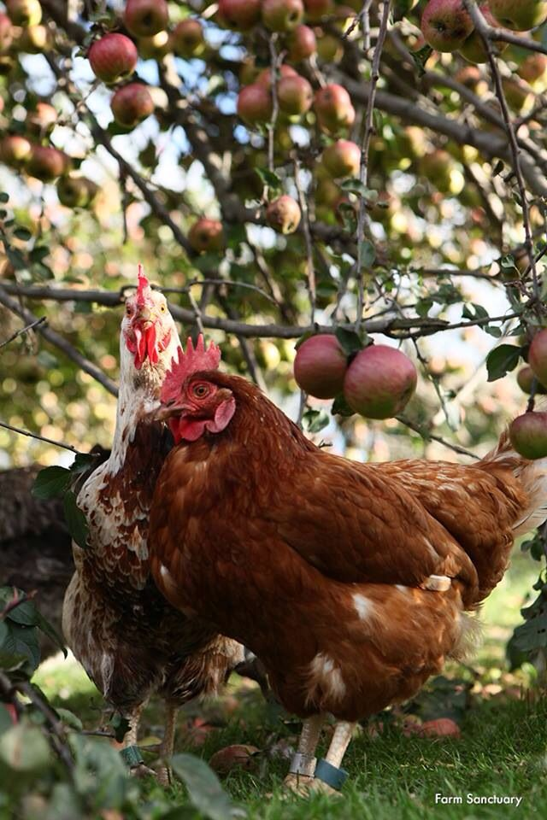
STUDENT NUMBER: | 1604705
NAME: | DAMALIE KAJUMBULA
EMPL10: | PATHWAY PROJCT 2
LECTURER: | ANITA NAN
REFLECTIVE REVIEW PP2 FARMING

TABLE CONTENT……………………………………………………………………………………………. PAGE 2
INTRODUCTION………………………………………………………………………………………………PAGE 3
EXPERIENCE AND CHALLENGES:
PERSONAL…………………………………………………………………………………………………………. PAGE 4
AS TEAM LEADER………………………………………………………………………………………………. PAGE 4-5
LEARNING FOR FUTURE USE………………………………………………………………………………. PAGE 5
CONCLUSION……………………………………………………………………………………………………… PAGE 6
APPENDIX:
REFERENCES………………………………………………………………………………………………………. PAGE 7

INTRODUCTION:
“Self-reflection allows an increased awareness of problematic performance traits and the ability to develop solutions on how to adjust those aspects of your leadership style” (Beth Miller, 2013). In a broader sense, this reflective review will enable us to express our perceived performance and expectations from our farming project, and the lessons learnt from the experiences and challenges faced while undertaking this project. In this report, I am going to discuss the challenges faced in our project, explain my own role in the team, problems faced in this role and my contribution towards achieving the goals set for our project. By looking back and analysing our activities during our project, and our knowledge as well as the feelings after the completion of our project, I have learnt how reflection is important in enabling us to identify our weaknesses. The project was about farming and I came up with the idea of the title of our presentation as MDD Farm Limited which was accepted by the group members.

EXPERIENCES AND CHALLENGES:
Personal:
I was excited about our topic for the project and was expecting it to be very interesting because it was about farming which was relevant to me because I have a major interest in farming. The rest of the group members also liked the topic so we all had lofty expectations of an interesting project. In a team of three members, I was chosen as the team leader and it was my role to communicate and collaborate with the team on time management, support the team with the research work and ensure everyone understands the concept of the project we worked on to be able contribute something.
The experience I had had before with team members was not good, so I was feeling very nervous when it came to choose the team. As it was a term of the integrative core meetings I met with other group members who were all new to me. I had been with them in the same group, but we never worked together as a team. So, we asked each other if we can make a team. I had some other group mate I with last term, they wanted to work with them again but due to what happened last term in the group, I decided this time to be careful when choosing a group not to make the mistake I did last term. After reflecting on these happenings, with reference to what Beth Miller (2013) says that, “Self-reflection allows an increased awareness of problematic performance traits and the ability to develop solutions on how to adjust those aspects of your leadership style”, I have learnt not to look at problems from my personal point of view but to instead point out my own weaknesses and find ways to overcome them.
As Team leader:
There were some disputes in our group because some members had their own issues which they brought in the group and the whole group was messed up as they did not like each other. It was real difficult as a group and to me as the team leader because It came to a point when everything was left for me to do it. Which I tried and did what I could do but still things did not go the way we expected them to be. Yet our group was the strongest group and the Lecturer had higher expectations from our group but being disorganised made us fail. Again, with an in-deep reflection on these happenings, I realised my weaknesses in leadership skills and learnt that for a team to achieve its goals for the project there must be a good spirit teamwork to avoid divisions in the team.
I decided to take caution and avoided to be a team leader as the last two terms I made a mistake on submission of our assignment by loading all the assignment in one turn in yet there was another link which I did not see when submitting the work which resulted in marking only the report and missing out the power point presentation. When we raised the concern, the assessment teams said, we did not submit the work, yet we did submit, checked the similarities and the receipt was issued. This caused chaos as each group member blamed me for making them fail yet from the bottom of my heart, I never intended to make anyone fail but it was a mistake which can happen to anyone which made me to hate being a team leader. But what I learnt from this experience was that this time I must be careful, read every line before submitting the work.
Although I tried my best to take cautions and avoided to be a team leader, but still I found myself as one for another time. So, what was meant to be had to be. I had no choice but to lead again but with caution. However, we were a group of five, but we ended up remaining three of us. One of our group mates dropped off and never came back to class, the second one attended for couple of weeks and she joined another group, from there she also disappeared.
As we sat in our first meeting, we were asked to choose a task of business and make a business plan of which I came up with farming and presented it to my colleagues. They welcomed the idea and were happy to try it. However, none of them had a clue about farming and this led to me becoming a group leader as I had a background in farming from my family and being a farm manager on my own farm before coming to the UK.
I have experience in research which enabled me to get all the relevant information that was needed for the project and the experience, Knowledge and skills that I gained from the previous farm. We worked together as a group, but I found out that my group mates had no experience in research. Most of the information used in or assignment was based on my skills and knowledge that I had in research. Had to do the research, find the information, bring it in, explain it and then use it in our assignment to ensure everybody understood and got the knowledge and idea of what we were doing.
Although we were given individual task, I ended up doing most of the work from introduction to management apart from marketing. However, each team member did what they were able to do for example one did the slides while the other one did the Gantt chat and typing the part that was researched and written for him. Generally, we were not cooperating as we should have, and this made us not to support one another as a team. However, I took the lead and went to the Denise’s house to support her as we were running out of time and made sure everything was done.
John W. Gardner (1993) describes management as’ “The process of persuasion or example by which an individual or team induces a group to act”. I followed this definition and did not allow what happened last term to happen again despite the misunderstandings. I made sure meetings took place and talked to my team mates about the issues as they were neither going to take us anywhere nor benefit the group. We had to work together, support each other to do the work and be consistent to achieve our goals instead of having differences. We were able to manage our differences, used our strengths to overcome the weaknesses and did what we were supposed to do as a group which led us into coming up with good presentation. It was hard and challenging but rewarding.
Based on the qualities of good leadership according to John C. Maxwell (1999) and after reflecting on my experiences and challenges as a team leader I have stated above, I have learnt not only to be a good leader, but also some of the leadership qualities such as: being firm, calm, consistent, creative, adaptable, patient, a good listener, understanding, and the ability to communicate and collaborate with a good sense of humour. When I recalled the time when everything was on my shoulder and had to speak up my feelings for the group. Also, being supportive to each other when one of the team member was not well and I had to go to her house to make sure her slides were done, I realise the importance of having good leadership skills. Whenever I did research and found any information even if it was not for my task as everyone had their task, I passed it to the group talked about it with my colleagues and use it on our assignment. Later, all went on well and everybody was happy after the presentation.
LEARNING FOR FUTURE USE:
I have learnt the qualities of a good leader that I can be able to apply on future projects. In addition, I have also learnt the benefits of sharing ideas among group members such listening to a different people’s opinions. Finally, is the skill of both time management and presentation skills because we had to make a presentation on our project on a specific date.

CONCLUSION:
I have managed the team in both PP1 and PP2 which was not easy, but the good thing was that every team member was determined to ensure the work is done. What I liked most was that after understanding the root that was causing trouble, everybody became responsible and put our heads together day by day and the job was done. I enjoyed working with my team and wished if we could be together next year. I see this project as practical experience from which I have learnt several lessons for both my personality and future projects.

Appendix:

References:

- https://www.executive-velocity.com/benefits-of-self-reflection/

- John C Maxwell (1999) Learning the 21 irrefutable laws of leadership.
- John W. Gardner (1993) On Leadership

