UWTSD Session Planner
Venue: LC |  |  | Age group: 7-8  Number Attending: 15-20
Date: 2nd December |  |  | Start time:  Finish time:
Equipment: Cones, bibs, basketballs

Nearest Telephone: On person | 1st Aid bag: Reception behind desk
Risk Assessment completed: | Additional Hazards and actions taken:
Learning from previous session: |  | Personal action points from previous session:
Goals for the session:
Improve dribbling and passing ability

.
Introduction and warm-up;
Stuck in mud for 5 minutes

Main Content/Game:  - Pair passing- Players are paired up and face one another about 8 feet apart. They then pass back and forth, making sure that they step toward their partner to pass and step to the ball to receive. Coach calls the type of pass to be thrown.  - Sharks- Pick 2-5 players to be ‘sharks’ starting at the halfcourt line. The rest of the team - the ‘minnows’ will be spread out on the baseline. All the minnows have basketballs. On ‘go’ the minnows will all attempt to dribble from one end to the other while the sharks try to knock their balls away. If a player has their ball knocked away by a shark, they join the shark team. The players will reset and then attempt to go end to end once again, continuing until all players have become sharks. (British bulldogs with basketballs)  - Have the players get in a line and assign each player a number. Have the even numbers line up on one sideline, and the odd numbers line up on the opposite side. The coach will stand right in the middle of the court with a basketball. Assign one basket for each team.  - Call out an even number and an odd number and lob the ball up into the middle of the court.  - Those two players will then break for the ball, with the first player to get the ball on offense.  - The offensive player tries to score on his team’s basket.  - The players will then play one on one, with the round ending when one of the players has scored. |  | 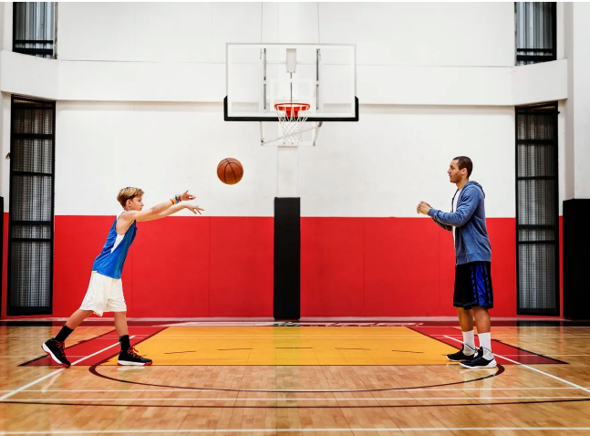  Organisation/diagram:  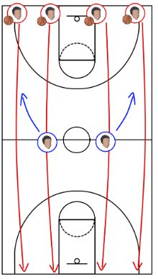  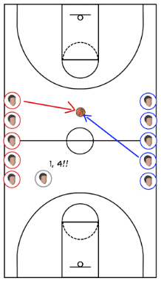
Ideas for Development (progression / regression):  - Pair passing- Gradually, partners move further apart as they are comfortable and accurate.  - Add time limit  - Multiple people battle for the ball on each side, until everyone is on the court. |  | Diagram for activity

5Cs to be included in this session | Select 2 of the 5 and apply to session  HOW?
Competence

Confidence:

Connection:

Character and caring:

Creativity:

Cool-down:

Comments on session:

Review of your Coaching Session and Personal Action Plan
For each session you deliver you need to complete a Coaching Session Review and Evaluation plus a Personal Coaching Action Plan.

Practical: Coaching Session Review and Evaluation (Individual Reflection)
Were the aims of the session achieved?  Identify which ones were achieved and which if any, were not. | Before the session, we had identified passing, dribbling and shooting as skills which we wanted to develop, we came up with 3 different drills and were satisfied with the general outcome
What factors helped ensure that your aims were achieved?  (Reflect upon organisation, appropriateness of activities, coaching styles.) | We worked efficiently within the allocated time per session, delivered instructions loud and clear in a noisy environment and made the most of our area provided. Also happy with how the 3 of us worked together and split the children up into smaller groups to ensure they were all active during the entire session
What were the reasons for you not achieving your aims? (Reflect upon organisation, appropriateness of activities, coaching styles. | Our first session was not great, as none of us have ever played basketball before we had to use trial and error in our first one and make adaptations to make sure the next 3 were better
What changes (if any) did you make to your session that were not in your plan and why? | We substituted one of the drills we planned to do for another drill, as we did not have 2 baskets to shoot in, meaning that our 3rd planned drill was not possible. Instead, we divided the groups into subgroups and had them compete in different tasks at the same time.
Would you do anything differently if you were to deliver the session again? | After the adaptations we made we were satisfied so would not change anything from our 2nd session onwards
What have you learnt about your coaching from this session? | It is more difficult than anticipated to get this age group of school pupils to be paying full attention when they are excited and with their friends in what can be an overwhelming atmosphere
Personal Action Plan
Using the information above, what changes will you make to your planning, coaching delivery and organisation in future sessions?

Name of Coach: Ben, Max, Jay |  | Venue: LC2 | Date: 02/12/24

Risk Assessment (Complete Individually)

Ref | Hazard / Task / Activity  Area of Concern | Persons at Risk | Existing Controls | Describe Any Further Controls / Actions Needed | Actions By Whom | Action By When
1 | Spillages on the floor | Students and coaches | Designated area of sports hall for drink breaks |  | Coaches | Prior to activity
2 | Running into walls | Students | Stop the play area with a big enough distance from the wall |  | Coaches | Prior to activity
3 | Falling over balls | Students | Put all the balls away in the designated area when they are not in use |  | Coaches | Prior to activity
4 | Falling over cones | Students | Use lines on floor instead of cones |  | Coaches | Prior to activity
5 | Curtains | Students | Cut off the area with a safe gap from the curtains |  | Coaches | Prior to activity

