
Business Inquiry and research bmsp 5007 Assignment 1 Part 1 and 2
Tutor: Dr Roisin Mullins

May 14, 2021
Katarzyna white
1905801

Assignment 1 Part 1
Qualitative exercise

"What was your experience and perception of working during the Covid-19 pandemic in Wales?"

Contents

- Introduction | Page 2
- Procedure | Page 3
- Data Presentation and Findings | Page 3
- Conclusion | Page 5
- References | Page 6

Introduction
This report presents the study of participant's experience and perception of working during the Covid-19 pandemic in Wales. This particular topic was chosen due to the current affairs brought by the Covid-19 pandemic in Wales and across the globe and researchers interest in this field. During the review of the existing literature, the researcher acknowledged the vast number of studies performed on similar subjects; however, none were discovered concerning the employment of different types of jobs in Wales specifically. Some of them include the study conducted by Felestead and Reuschke (2020) concerning "Homeworking in the UK: Before and During the 2020 Lockdown" and another study regarding "Impact of COVID-19 on working lives" performed by the Chartered Institute of Personnel and Development (CIPD) 2021. Both studies focus on the main topic, which is employment during the pandemic; however, they differ from this study in terms of locations and types of performed jobs.
The positionality stand adopted by the researcher can be described as a full-time university student, currently unemployed; however, the researcher has years of experience in the working environment. The researcher has experienced the effects of the pandemic while studying, which has sparked their interest in finding out more about the effects that the Covid-19 had on people employed during that time. The researcher was keen to explore different experiences that participants had; therefore, each participant was chosen based on their various understanding of the topic, which allowed a broader insight into the study.
According to Crotty (1998), ontology is the study of being. Ontology focuses on what exists, what is real; therefore, researchers have to take a stand on their perception of the world around them. The ontological position for this study is subjective as the researcher is heavily involved in creating the qualitative research, which is interviews. Subjectivism can be observed through the choice of topic, types of questions and interpretation of data.
Epistemology is the theory of knowledge, especially how we can create knowledge, its methods and its origin (Cohen et al., 1998). The epistemology position for this study is interpretivism. According to Carson et al. (2001), the interpretivists prefer a more relaxed and personal approach to research. They try to understand and interpret the meanings, motives and reasons. The interpretivist approach focuses on the collection of data through interviews and observations.
As mentioned earlier, the chosen method of data collection was interviews performed with three participants. The interviews were conducted via a messenger app and recorded with the recorder. Later, the audio from the interviews was transcribed into a word document, which allowed further analysis of the topic. This research methodology is phenomenology, a research paradigm that describes an individual's experiences, views, and feelings and looks for patterns and themes. Holloway (1997) states that phenomenology is "the internal experience of being conscious of something", and for Giorgi, the operative word in phenomenology research is describe (Groenewald, 2004).
The analysis approach for this study was inductive thematic analysis, which is widely used in qualitative research. The thematic analysis allows recognise and find themes within the data (Braun & Clarke, 2006).

Procedure
For this study, the qualitative research method was used to obtain the data on working during the Covid-19 pandemic. Qualitative research involves gaining non-numerical data such as texts and audio. The data is usually obtained through primary research, for example, interviews, focus groups or observation. The main focus of qualitative research is to acquire a better understanding of participants feelings, experiences and opinions (Pathak, Jena & Karla, 2013). The primary method of conducting this research was interviews with three participants. The type of interview was semi-structured, which enable the researcher to gain a deeper understanding of the social phenomena (Silverman, 2000). Participants were chosen through purposive sampling, allowing the researcher to choose the most suitable candidates for the interview. Each participant was asked the same set of questions, the interviews were recorded and then transcribed, ready for the analysis. The participants were given the participant consent form, which was signed and returned to the researcher. The researcher also prepared the ethics form, which assured the ethical and privacy issues were not violated.
Nevertheless, the transcribed interviews were analysed, and common themes across all three were established, named and interpreted.

Data Presentation and Findings
As mentioned earlier, the thematic analysis was used to examine the data, and the following themes were created.

Theme 1 Initial feelings about the lockdown

"It was quite scary to be in the store, cause there are a lot of people." (A)

" So we were all a bit excited about the prospect of working from home." (B)

"We were worried about the spread of the Covid-19 cause we were working all the way up until the lockdown. We didn't know what was going to happen" (C)

It seems that uncertainty and lack of knowledge about the Covid-19 spread were among the main concerns for participants A and C. It could be assumed this was because their jobs involved working with other people, and they could not work from home. However, participant B was embracing the changes and looked forward to working from home.

Theme 2 Workload

"Just busier, just different challenges, so we have never seen shelves emptying as quickly as it did. So replenishing was just mad." (A)

"So I work for the fraud department, and we get new referrals on cases that are suspected to be fraud, so they kinda shut off some other referrals that we would have to look at previously. So it meant workload decreased as well." (B)

"So obviously that affected our job in the fact that we could not go out and pick up or reclaim these books for resale in the warehouse…there was no driving job, and then when we went back to the warehouse, there was no work for people in there either." (C)

Two of the participants experienced a decrease in their workload. Participant B was working from home, and their management decided to put on hold new cases, so the employees would not feel under pressure while adjusting to new circumstances. It appears that participant C, due to their nature of the job (driver), was unable to make the regular collections of books to keep the warehouse going, resulting in being furloughed. In contrast, participant A was under immense pressure as their amount of work and responsibilities increased, resulting in them being stressed and overworked.

Theme 3 Support
"They were on the shop floor with us, so they didn't hide, they didn't just push us forward, so I think they do a lot of support." (A)

"I have spoken to my manager pretty much every day…they have set up a lot of staff to help you deal with any mental health issues that occurred because of the lockdown." (B)

"But as far as management, they only did the bare minimum." (C)

It appears that participants A and B had a similar perception of their management in terms of support. Especially, participant B received much support regarding well-being and mental health, which can be assumed that it helped to deal with such unprecedented time. Unfortunately, this can not be said about participant C, which had a negative experience with its management and did not feel supported enough during the Covid-19 pandemic.

Theme 4 Work-life balance
"For being a mum, work-life balance was perfect really." (A)

"More family time, I could help with the home schooling with the children…and the jobs around the house." (C)

"Much, much better. No commuting, saved loads of money. I don't rely on my parents as much." (B)

Even though the Covid-19 pandemic was very testing at the time, all three participants agree that their work-life balance has been perfect. During the pandemic, they focused on their families and have a more active role in the households.

Conclusion
In conclusion, the main limitation of this study was the small number of participants. The researcher had an open mind when it came to the analysis and interpretation of the data; however, it has to be noted that different researcher might have a different take and interpretation of the findings. In order to gain objective data, the researcher could have prepared a quantitative survey allowing her to be detached from the research and not have a personal bias. Although gaining a deeper understanding of participants' feelings and opinions was very beneficial, it allows the researcher to feel connected with the participants, which would not be possible with the quantitative study.

References

Braun, V., Clarke, V. (2006). Using thematic analysis in psychology. Qualitative Research in Psychology, 3, 77–101. doi:10.1191/1478088706qp063oa
CIPD, (2020). Impact of COVID-19 on working lives. Available at: https://www.cipd.co.uk/knowledge/work/trends/goodwork/covid-impact#gref
Cohen, L., Manion, L., & Morrison, K. (2007). Research methods in education (6th Edition). London: Routledge.
Crotty, M. (1989). The foundations of social research. London: Sage
Felstead, A. & Reuschke, D. (2020). Homeworking in the UK: Before and During the 2020 Lockdown. Wales Institute of Social and Economic Research and Data. Available at: https://wiserd.ac.uk/publications/homeworking-uk-and-during-2020-lockdown
Groenewald, T. (2004). A phenomenological research design illustrated. International journal of qualitative methods, 3(1), 42-55.
Holloway, I. (1997). Basic concepts for qualitative research. Oxford: Blackwell Science.
Pathak, V., Jena, B., & Kalra, S. (2013). Qualitative research. Perspectives in clinical research, 4(3), 192. https://doi.org/10.4103/2229-3485.115389
Silverman D. (2000). Doing qualitative research. London: Sage Publications.

Assignment 1 Part 2
Quantitative exercise

"Alcohol consumption during the Covid-19 pandemic"

Contents

Introduction | Page 8
Procedure | Page 8
Data Presentation and Findings | Page 9
Conclusion | Page 14
References | Page 15

Introduction
This report presents the study of alcohol consumption during the Covid-19 pandemic. The subject for this study was chosen based on the researcher interest in the topic. The researcher was keen to discover if alcohol consumption increased during the pandemic. One study shows that over a quarter of participants agreed that their alcohol consumption increased during the Covid-19 pandemic (Alcohol Change UK, 2020). Another study discovered that half of the participant had not changed their drinking habits, 30% of participants have increased drinking, and 20% reported drinking less (Oldham et al., 2021).
This research is quantitative. The method used to collect the data was via the online survey.
Ontology stand for this study is objective. This study aims to gather and analyse numerical responses. The researcher is involved in creating the survey; however, once the survey goes live, the researcher is detached from it and does not consider itself a vital variable (Tuli, 2010). The epistemology for quantitative research is positivist. According to Tuli (2017), positivists researchers "explain behaviour through measurable data" by using methods such as surveys and specifically worded tests.
The non-probability convenient sampling method was used for this research, as it was the easiest way to engage participants with the survey (Showkat et al., 2017). This sampling method is also not representative of the entire population, as it highly depends on who chooses to participate. The analysis approach for this study is deductive. Wilson (2010) states that the deductive approach focuses on developing a hypothesis based on what is already known and then constructing research to test this hypothesis.

Procedure
As mentioned earlier, the chosen research method is quantitative research. Quantitative research obtains data in raw numbers, which are expected to be turned into meaningful information. Examples of the analysis performed to achieve desired output include the range, the variance, the standard deviation, crosstabulation, correlation and the chi-square test. The main objective of quantitative research is to test the hypothesis, to either support them or reject them.
It was decided that for this study on alcohol consumption during the Covid-19 pandemic best approach will be to create an online survey consisting of ten questions with multiple answer choice. The survey was designed via the SurveyMonkey platform. The link to the survey was posted on the researcher Facebook page, where potential participants were asked to participate. As the researcher used a free version of the survey, only 39 responses were available for analysis. The questions were designed to enable the researcher to determine if alcohol consumption amongst participants increased during the pandemic.
Microsoft Excel and SPSS statistical software were used to perform the analysis. The SPSS is the IBM Statistical Package for Social Sciences that helps understand the data and see trends by performing statistical procedures (IBM, 2021).
After the survey came to a close, the results were extracted onto the Excel spreadsheet, and every text data was given a numerical value. Secondly, the SPSS was used to import the coded spreadsheet to be ready to work on. Once the SPSS software was loaded, the researcher switched to the variable view wherein the values tabs every variable was defined. For example, for variable gender, number 1 was inputted with corresponded "female", then number 2 with "male" and so on for every variable.

Data Presentation and Findings

Frequency distribution analysis

GENDER

Statistics
What is your gender?
N | Valid | 39
N | Missing | 0

What is your gender?
 |  | Frequency | Percent | Valid Percent | Cumulative Percent
Valid | Female | 28 | 71.8 | 71.8 | 71.8
Valid | Male | 11 | 28.2 | 28.2 | 100.0
Valid | Total | 39 | 100.0 | 100.0

This table shows that there were 28 females and 11 males that participated in the survey. The ratio between the gender is uneven, as the majority of the participants were women. It can be assumed that the data drawn from the survey is not equally representative amongst the population.

AGE

What is your age?
 |  | Frequency | Percent | Valid Percent | Cumulative Percent
Valid | 18-24 | 2 | 5.1 | 5.1 | 5.1
Valid | 25-34 | 5 | 12.8 | 12.8 | 17.9
Valid | 35-44 | 15 | 38.5 | 38.5 | 56.4
Valid | 45-54 | 11 | 28.2 | 28.2 | 84.6
Valid | 55-64 | 4 | 10.3 | 10.3 | 94.9
Valid | 65+ | 2 | 5.1 | 5.1 | 100.0
Valid | Total | 39 | 100.0 | 100.0

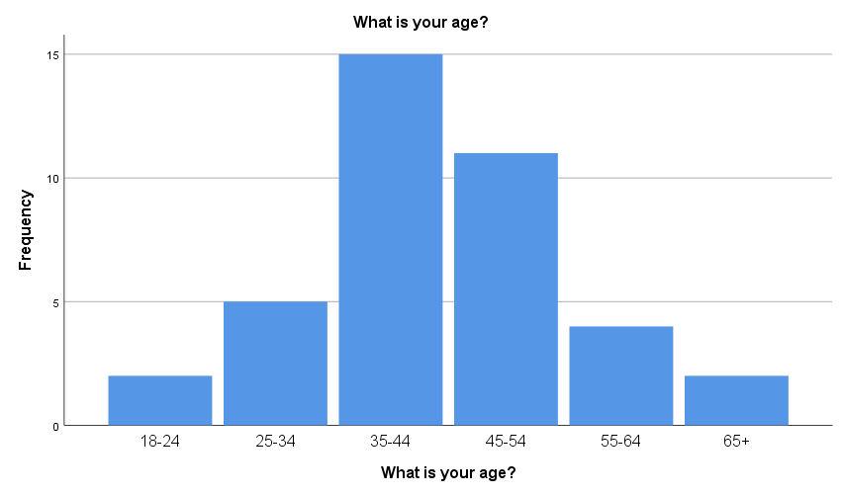

This chart shows that the two most prominent age groups were 35-44 and 45-54, which made up 26 participants, over half of the total sample number. However, there is representation in every age group listed on the survey; therefore, there is data available for further analysis.

The arithmetic mean (average) analysis.
The average alcohol consumption across every age group.

Descriptive Statistics
 | N | Minimum | Maximum | Mean | Std. Deviation
How many drinks do you have during those times? | 39 | 1 | 5 | 2.26 | 1.312
Valid N (listwise) | 39

The table shows that average or mean alcohol consumption for all the participants is 2.26 drinks.

What is your gender? * Would you agree/ disagree that your alcohol consumption increased during the Covid- 19 pandemic? Crosstabulation
Count
 |  | Would you agree/ disagree that your alcohol consumption increased during the Covid- 19 pandemic? |  |  |  |  | Total
 |  | Strongly agree | Agree | Neither agree or disagree | Disagree | Strongly disagree | Total
What is your gender? | Female | 4 | 9 | 6 | 7 | 2 | 28
What is your gender? | Male | 2 | 3 | 2 | 2 | 2 | 11
Total |  | 6 | 12 | 8 | 9 | 4 | 39

Crosstabulation analysis

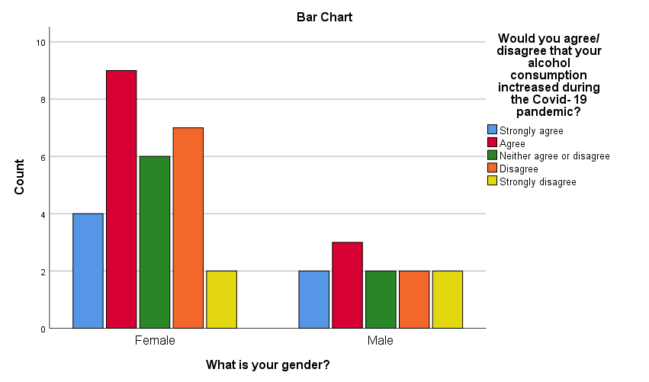

The table and chart show that both females and males agree that their alcohol consumption increased during the Covid-19 pandemic. "Strongly agree" and "Agree" responses amongst both females and males make almost half of the total sample size to be exact 18 out of 39.

The Chi-square test.

Is there a relation between gender and the main reason for alcohol consumption pre-Covid 19 pandemic?

What is your gender? * What was the main reason for your alcohol consumption pre-Covid-19 pandemic? Crosstabulation
Count
 |  | What was the main reason for your alcohol consumption pre-Covid-19 pandemic? |  |  |  |  | Total
 |  | Coping mechanism | Boredom | Form of relaxation | Socialising | Other | Total
What is your gender? | Female | 1 | 2 | 10 | 14 | 1 | 28
What is your gender? | Male | 0 | 1 | 2 | 7 | 1 | 11
Total |  | 1 | 3 | 12 | 21 | 2 | 39

Chi-Square Tests
 | Value | df | Asymptotic Significance (2-sided)
Pearson Chi-Square | 1.963ª | 4 | .743
Likelihood Ratio | 2.262 | 4 | .688
Linear-by-Linear Association | 1.040 | 1 | .308
N of Valid Cases | 39
a. 7 cells (70.0%) have expected count less than 5. The minimum expected count is .28.

The analysis shows that the asymptotic significance (2-sided) is 0.743; therefore, it can be assumed that the p-value is not statistically significant as it is higher than 0.05; therefore, no relationship exists between the two variables. The null hypothesis can be rejected. It is also worth noting that the footnote states that seven cells have an expected count of less than five; therefore, this test result can not be used.

Correlation test
Is there a relationship between age and how often people consume alcoholic drinks?

Correlations
 |  | What is your age? | How often do you drink alcohol?
What is your age? | Pearson Correlation | 1 | .308
What is your age? | Sig. (2-tailed) |  | .056
What is your age? | N | 39 | 39
How often do you drink alcohol? | Pearson Correlation | .308 | 1
How often do you drink alcohol? | Sig. (2-tailed) | .056
How often do you drink alcohol? | N | 39 | 39

The test results show a low positive correlation between the two variables at 0.308, which is significant at the 0.056 level. The threshold for significance is 0.05; everything more than that is classed as significant. In other words, this test can be seen as marginally significant. It can also be assumed that with bigger sample size, the significance might increase. However, it is hard to judge as the significance is only slightly above the threshold. There is also a possibility that with a more considerable sample size, significance can decrease. Although, at this moment, the results show that there is a chance that age and how often people drink alcohol is a true hypothesis.

Conclusion
In conclusion, this study has answered the researcher question and assumption that alcohol consumption during the Covid-19 has increased in almost 50% of participants. However, upon further reflection, the researcher encountered a few flaws in the research method. Firstly, the chosen platform for designing the survey and secondly, the small sample size.
SurveyMonkey was used to design the survey, which proven to be very efficient and quick; however, the main limitation was uncovered when obtaining results and the analysis. Because the researcher used a free version of the survey, the responses available to the researcher were limited to 40. Also, the researcher was unable to export the results in the form of an Excel file; an upgrade was needed for that function, which would be very costly. In the event of creating another survey, another platform will be chosen to design the survey, such as Google Forms, where the number of responses is unlimited and exporting survey results via an Excel file comes as a standard.
Similarly, due to a cap on the number of responses available for the analysis, the sample size was relatively small. The researcher believes that some of the results of the tests would have been more accurate with a bigger sample size.

References:

Alcohol Change UK, (2020). Research: drinking in the UK during lockdown and beyond. Available at: https://alcoholchange.org.uk/blog/2020/drinking-in-the-uk-during-lockdown-and-beyond
IBM, (2021). IBM SPSS software. Available at: https://www.ibm.com/uk-en/analytics/spss-statistics-software
Oldham, M., Garnett, C., Brown, J., Kale, D., Shahab, L., & Herbec, A. (2021). Characterising the patterns of and factors associated with increased alcohol consumption since COVID‐19 in a UK sample. Drug and alcohol review.
Showkat, Nayeem & Parveen, Huma. (2017). Non-Probability and Probability Sampling.
Tuli, F. (2010). The basis of distinction between qualitative and quantitative research in social science: Reflection on ontological, epistemological and methodological perspectives. Ethiopian Journal of Education and Sciences, 6(1).
Wilson, J. (2010) "Essentials of Business Research: A Guide to Doing Your Research Project" SAGE Publications, p.7

