

Internet Protocols
BSc Cloud Computing

University of Wales Trinity Saint David

IPv6

Benefits and deployment issues
Tsvetelina Tsoneva-Duz | 1914026 | April 2020

Table of content :

1.Introduction
2.IPv4 vs IPv6 and benefits of using IPv6
3.IPv6 addresses
4.IPv6 addressing modes
5.Ipv4 to IPv6 transition
5.1 Tunneling
5.2 Dual-stack
5.3 NAT
5.4 NAT64
6.IPv6 subnetting
7. Neighbor Discovery Protocol
7.1 Neighbor Solicitation
7.2 Duplicate Address Detection (DAD)
7.3 Neighbor Advertisement
8.IPv6 issues
9.References

1.IPv6 Introduction

According to Technopedia "The internet protocol is a set of rules guidelines for communicating data. Rules are defined for each step and process during communication between two or more computers."( 2020,Technopedia.com, definition )

IPv6 Protocol is the new Internet Protocol called Internet 2, and like its predecessor, IPv4 works on the Network Layer 3.

1.1 Why a new IP version?
The IPv4 was developed in the early 80s.
Since it was first developed, IPv4 has become very popular and has been much improved and expanded. The reason for this was due to increased popularity. IPv4 is 32 bits long and offers address space that was considered more than enough that time. In 2006 Amazon successful realise the first Cloud product. With the cloud-basic private or public services like Amazon, Google, Dropbox and many other companies, the Internet needs more addresses. In 2011 IPv4 started to run out. This is the primary reason why a new Protocol was required to be deployed - the Protocol to replace IPv4 as IPv6. (According to Wikipedia, there was a version 5 of the Internet Protocol. However, this protocol was never got implemented.) Have vital points that played a crucial role in the birth of IPv6 - the Internet has grown, security, quality of service, etc.
Draft Standard from December 1998, IPv6 was ratified as Internet Standard on July 14th, 2017.
2. IPv4 vs IPv6 and benefits of using IPv6
IPv4 – Use a decimal number to identify computers and devices. Address size is 32-bits with limited to approximately 4.3 billion combinations. IPv4 is used by 99% of networks. IPv4 supports DHCP and manual configuration. IPv4 is not provided with encryption and authentication. Security is dependent on the application.
IPv6 – Use a hexadecimal number system. Address size is 128-bits and can produce enough of network addresses. IPv6 has an auto-configuration ability simplified header formats and more efficient routing. IPSEC is inbuilt in the IPv6 protocol. Other benefits of using IPv6 are the elimination of duplicate and encryption. IPv6 addresses are compatibles with more mobile networks.

According to Cisco Ipv6 have a lot of advantages like “providing an increased number of multicast addresses, simplified header format for efficient packet handling, the larger payload for increased throughput and transport efficiency, hierarchical network architecture for routing efficiency, autoconfiguration and plug-and-play, support for widely deployed routing protocols, etc.”

(Rou) (2020, Routing and Bridging Guide vA5(1.0), Cisco ACE Application Control Engine - Overview of IPv6, Cisco ACE Application Control Engine Module)

3. IPv6 Address
The mine difference is that the IPv4 uses 32-bit addresses, while IPv6 uses 128-bit addresses. IPv6 started in the late 90s, and today it is estimated that over 25% of the Internet is using the IPv6 protocol. According to Google - 49 counties use more than 5% of traffic over IPv6 and 24 countries with more than 15%. Top countries over IPv6 are India – 61%, Belgium – 58%, USA – 57%, Greece and Germany – 47%, UK – 34%. IPv4 is the 32-bit numeric address, IPv6 is the 128-bit hexadecimal address with both numbers and alphabets in the address. This made up of 8 sets of 16 bits with the eight sets separated by colons. Each hexadecimal character represents 4 bits. IPv6 can produce unbelievable number addresses and its more than enough for the foreseeable future.
  - 4. IPv6 Addressing Modes
IPv6 addresses are Unicast, Anycast and Multicast.
Like IPv4 classes A, B, C, each unicast address identified a single receiver, one-to-one connection. Unicast address has several types : Loopback, Link-Local, Global Unicast, Unspecified, Site-Local, IPv4 compatible.
Hosts with IPv4 addresses need a broadcast communication if they don't know the receiver's address. Broadcast is IPv4 type of communications where on the same network all other devices can hear messages from a single sender IP. In IPv6 there is no broadcast address or a broadcast domain. Multicast is one remaining type of communications. A Multicast address has a Unicast source address and can never be the source address. IPv6 has different types of Multicast addresses for various purposes like Well-known, Solicited-Node, Transient, etc.

Anycast is the other type of IPv6 addresses. Anycast is one-to-nearest association. Anycast address also can be assigned from the unicast address. Routers typically use it, and Anycast address can be configured to a group of routers with some configuration commands. Multiple routers can have same or different Anycast address. Summary Ipv6 Unicast is one-to-one, Multicast is one-to-many, and Anycast is a one-to-anyone type of communications. (February 2006) RFC 4291, IP Version 6 Addressing Architecture

5. IPv4 to IPv6 transition
Many techniques have to transition.
They are summarised into three categories - Dual-stack, Tunnelling and Network Protocol Translation (NAT).

5.1 Tunnelling transition
Have a few tunnelling technologies, example manual and automatic 6to4 tunnelling.
6to4 tunnelling can automatically connect to multiple IPv6 Networks over one tunnel. The tunnelling method is a point point-to-point or point-to-multipoint connection.

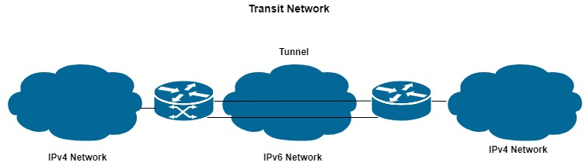

5.2 Dual-stack transition
This method is when the server is installed and configured with both IPv6 and IPv4 addresses. Dual-Stack Router help to server to speak with hosts on IPv4 or IPv6 networks.
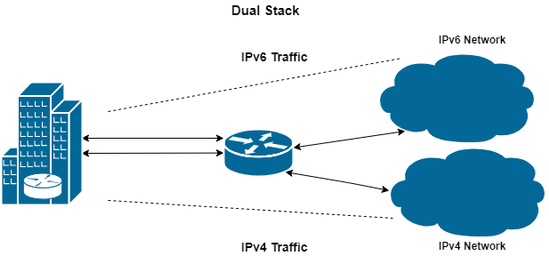

  - 5.3 Network Protocol Translation (NAT)
NAT protocol translation method is with the help of a NAT-PT device (Network Address Translation - Protocol Translation).
NAT-PT device can help with communication between IPv4 and IPv6.
When the IPv6 server response comes to the IPv4 server, then the router contrariwise.

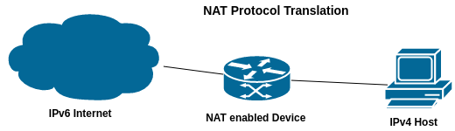
5.4 NAT64 is another protocol translation method. NAT64 have three components - prefix, DNS64 server, NAT64 router. NAT64 router performs the translation between the IPv6 only networks and IPv4 only networks. The DNS64 is the key in this process. NAT-PT is made to operate in dominated IPv6 Internet, NAT64 is formed to work in dominated IPv4 Internet.

6. IPv6 Subnetting
IPv6 is using Hexadecimal number system. The Hexadecimal number system has 16 digits in range 0-9, A-F. There are sixteen unique combinations of four bits, which is half of a byte and it is also known as a nibble. Each hexadecimal digit can represent 4 bits. Two hexadecimal digits can represent a single byte. IPv6 addresses have 128 bits in length and written as a string of hexadecimal digits. Every 4 bits are represented by a single hexadecimal digit for a total of 32 hexadecimal values - (4*32=128). IPv4 addresses are created in different classes. When we subnet IPv4 address, we can play with the default mask. Also we can borrow host bits to be used as subnet bits and we can have multiple subnets with N-numbers hosts per subnet. IPv6 uses 128 bits and include bits for subnetting. Sixty-four bits or the second part of the address is used for hosts. Autoconfiguration requires 64 bits and its recommended that 64 bits should always be used for addresses.

7. Neighbor Discovery Protocol
Compare to IPv4 in IPv6 there are no broadcast mechanisms, and it is not a must host who obtain the IP address from DNSP. IPv6 can autoconfigure own IP. The Address Resolution Protocol (ARP) in IPv4 has replaced by Internet Control Message Protocol (ICMPv6). In the IPv6 networks, the host can autoconfigure with a unique link-local address. When the host gets this IPv6 address, it joins some multicast groups. All communications who are related to this segment take place only on those multicast address. A host is going through a few states, which are: Neighbor Solicitation, Duplicate Address Detection (DAD), Neighbor Advertisement.

7.1 Neighbor Solicitation (The host sends a Neighbor Solicitation message for all IPv6 addresses to know that no one occupies the same IPv6 address)
7.2 Duplicate Address Detection (DAD) (The host does not listen to from anything from the segment regarding its Neighbor Solicitation message, meaning that no duplicate addresses)
7.3 Neighbor Advertisement "The host again sends out advertisement message, telling all other hosts on the segment, that it has assigned those IPv6 address."(2020)IPv6 - Communication - Tutorialspoint
When the host is ready with its IPv6 address configuration, it does the following steps: Router Solicitation, Router Advertisement, Redirect.

8. IPv6 Issues

The biggest challenge is migration from IPv4 to IPv6. Most of the network services support both IPv4 and IPv6 protocols, and most of them share the same infrastructure for dual-stack. Regarding to the IETF "Internet Transition plan has three phases for transitioning the Internet from a predominantly IPv4-based model to a predominantly IPv6-based connectivity model: Preparation phase (July 2008- December 2009), Transition phase (January 2010-December 2011), Post-transition phase (January 2012 to the future)”.( 2008 ) J. Curran: An Internet Transition Plan, IEFT
Now in 2020, the process of transition from IPv4 to IPv6 has not been finished yet. Maybe this will take a lot of time to move all services and to fix all issues - dual-stack related, header manipulation, mobility, software-related, IPv6 migration cost.

REFERENCES:
1.(2008) J. Curran: An Internet Transition Plan, online, IEFT
https://tools.ietf.org/html/rfc5211
2.Routing and Bridging Guide vA5(1.0), Cisco ACE Application, online, https://www.cisco.com/c/en/us/td/docs/interfaces_modules/services_modules/ace/vA5_1_0/configuration/rtg_brdg/guide/rtbrgdgd/ipv6.htm
3.(2020)Tutorialspoin, online, IPv6 Communication, https://www.tutorialspoint.com/ipv6/ipv6_communication.htm

4. (February 2006) RFC 4291, IP Version 6 Addressing Architecture

5.(2020) Protocol definition, Techopedia.com, online

Table of content :

- Design scheme
- IP addressing scheme
- References

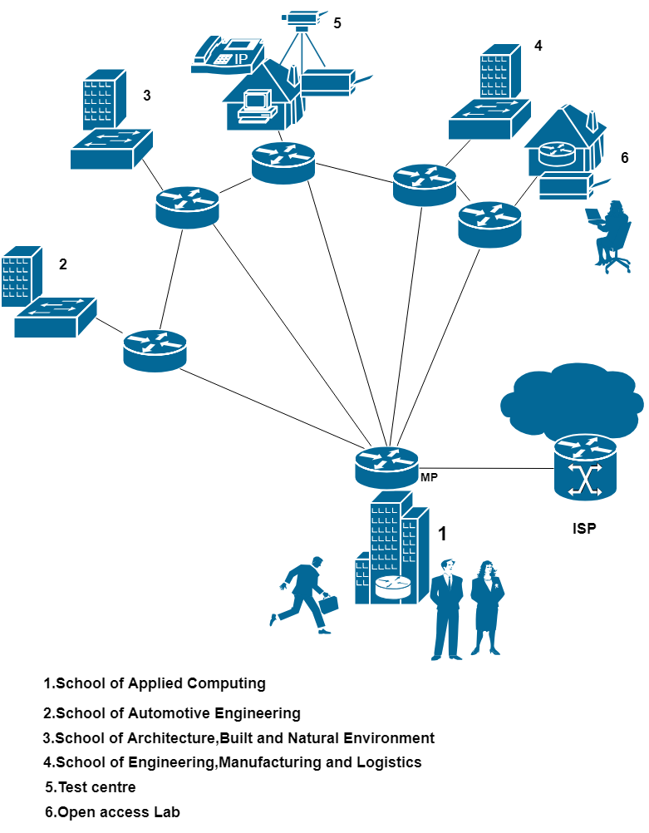

IP addressing scheme

Lab | Network address | First IP address | Last IP address | Broadcast address | Subnet mask

1.School
Lab 301 /50/ | 172.17.1.192/26 | 172.17.1.193 | 172.17.1.254 | 172.17.1.255 | 255.255.255.192
Lab 302 /30/ | 172.17.2.192/27 | 172.17.2.193 | 172.17.2.222 | 172.17.2.223 | 255.255.255.224
Lab 303 /30/ | 172.17.2.160/27 | 172.17.2.161 | 172.17.2.190 | 172.17.2.191 | 255.255.255.224
Lab 305 /20/ | 172.17.3.0/27 | 172.17.3.1 | 172.17.3.30 | 172.17.3.31 | 255.255.255.224
Lab 306 /40/ | 172.17.2.0/26 | 172.17.2.1 | 172.17.2.62 | 172.17.2.63 | 255.255.255.192
Lab 308 /120/ | 172.17.1.0/25 | 172.17.1.1 | 172.17.1.126 | 172.17.1.127 | 255.255.255.128
Lab 411 /30/ | 172.17.2.128/27 | 172.17.2.129 | 172.17.2.158 | 172.17.2.159 | 255.255.255.224
Lab 410 /60/ | 172.17.1.128/26 | 172.17.1.129 | 172.17.1.190 | 172.17.1.191 | 255.255.255.192
Lab 412 /36/ | 172.17.2.64/26 | 172.17.2.65 | 172.17.2.126 | 172.17.2.127 | 255.255.255.192
Staff /25/ | 172.17.2.224/27 | 172.17.2.225 | 172.17.2.254 | 172.17.2.255 | 255.255.255.224

2.School
Lab 101 /25/ | 172.17.7.32/27 | 172.17.7.33 | 172.17.7.62 | 172.17.7.63 | 255.255.255.224
Lab 102 /35/ | 172.17.6.192/26 | 172.17.6.193 | 172.17.6.254 | 172.17.5.255 | 255.255.255.192
Lab 103 /30/ | 172.17.7.0/27 | 172.17.7.1 | 172.17.7.30 | 172.17.7.31 | 255.255.255.224
Lab 205 /20/ | 172.17.7.96/27 | 172.17.7.97 | 172.17.7.126 | 172.17.7.127 | 255.255.255.224
Lab 206 /55/ | 172.17.6.128/26 | 172.17.6.129 | 172.17.6.190 | 172.17.6.191 | 255.255.255.192
CAD Lab /20/ | 172.17.7.64/27 | 172.17.7.65 | 172.17.7.94 | 172.17.7.95 | 255.255.255.224
Lab 301 /80/ | 172.17.6.0/25 | 172.17.6.1 | 172.17.6.126 | 172.17.6.127 | 255.255.255.128
Staff /20/ | 172.17.7.128/27 | 172.17.7.129 | 172.17.7.158 | 172.17.7.159 | 255.255.255.224

3.School
Lab 201 /54/ | 172.17.4.64/26 | 172.17.4.65 | 172.17.4.126 | 172.17.4.127 | 255.255.255.192
Lab 202 /25/ | 172.17.5.160/27 | 172.17.5.161 | 172.17.5.190 | 172.17.5.191 | 255.255.255.224
Lab 203 /30/ | 172.17.5.64/27 | 172.17.5.65 | 172.17.5.94 | 172.17.5.95 | 255.255.255.224
Lab 205 /28/ | 172.17.5.96/27 | 172.17.5.97 | 172.17.5.126 | 172.17.5.127 | 255.255.255.224
Lab 404 /35/ | 172.17.4.192/26 | 172.17.4.193 | 172.17.4.254 | 172.17.4.255 | 255.255.255.192
Lab 408 /28/ | 172.17.5.128/27 | 172.17.5.129 | 172.17.5.158 | 172.17.5.159 | 255.255.255.224
Lab 409 /60/ | 172.17.4.0/26 | 172.17.4.1 | 172.17.4.62 | 172.17.4.63 | 255.255.255.192
Lab 410 /45/ | 172.17.4.128/26 | 172.17.4.129 | 172.17.4.190 | 172.17.4.191 | 255.255.255.192
Staff /32/ | 172.17.5.0/26 | 172.17.5.1 | 172.17.5.62 | 172.17.5.63 | 255.255.255.192

4.School
Lab 101 /35/ | 172.17.8.192/26 | 172.17.8.193 | 172.17.8.254 | 172.17.8.255 | 255.255.255.192
Lab 102 /30/ | 172.17.9.0/27 | 172.17.9.1 | 172.17.9.30 | 172.17.9.31 | 255.255.255.224
Lab 103 /30/ | 172.17.9.32/27 | 172.17.9.33 | 172.17.9.62 | 172.17.9.63 | 255.255.255.224
Lab 105 /25/ | 172.17.9.64/27 | 172.17.9.65 | 172.17.9.94 | 172.17.9.95 | 255.255.255.224
Lab 206 /50/ | 172.17.8.128/26 | 172.17.8.129 | 172.17.8.190 | 172.17.8.191 | 255.255.255.192
Lab 208 /90/ | 172.17.8.0/25 | 172.17.8.1 | 172.17.8.126 | 172.17.8.127 | 255.255.255.128
Staff /18/ | 172.17.9.96/27 | 172.17.9.97 | 172.17.9.126 | 172.17.9.127 | 255.255.255.224
5.Test Centre | 172.17.10.0//27 | 172.17.10.1 | 172.17.10.30 | 172.17.10.31 | 255.255.255.224
6.Open Lab 245 | 172.17.0.0/24 | 172.17.0.1 | 172.17.0.254 | 172.17.0.255 | 255.255.255.0

1. The chosen address is 172.17.0.0/20, Class B, private, Broadcast 172.17.15.255, Subnet Mask 255.255.240.0

2. Sub in 5 Networks :

a/ School 1 and Open Lab - 172.17.0.0/22

b/School 2 - 172.17.6.0/23

c/ School 3 – 172.17.4.0/23

d/School 4 – 172.17.8.0/23

e/ Test Centre – 172.17.10.0/27

Subnetting a subnet:
- School 1 and Open Lab from 172.17.0.0/22 – 11 subnets, 1 for Open Lab, 9 for every Lab in the school, 1 for the Staff
- School 2 - 172.17.6.0/23 – 8 subnets for 7 Labs and 1 for Staff
- School 3 – 172.17.4.0/23 – 9 subnets, 8 labs and 1 for Staff
- School 4 – 172.17.8.0/23 – 7 subnets, 6 for Labs and 1 for Staff

3.IPv6 address for the link between MP and ISP

According to RFC 4291, “an IPv6 Unicast address refers to a single interface. Since each interface belongs to a single node and Unicast addresses may be used as an identifier for the node. All interfaces are required to have at least one Link-Local unicast address." (February 2006) RFC 4291, IP Version 6 Addressing Architecture

Example for possible address is : 2001:db8:0:2::30/64 Global - Unicast

4. IPv6 address for 6 servers located at the University building. The servers are DNS, Email, Finance, Registry, File server and a Print server.

According to RFC 7094, an Anycast address is allocated from the unicast space. If the unicast addresses are assigned to more than one interface makes this unicast addresses anycast addresses, but nodes must be configured to recognise that an address is an anycast.

According to Cisco CCNA/CCENT ,The IT team can configure for six servers in the school anycast addresses from the unicast address by

“using the IP address <address>/<prefix> anycast command in the interface and example commands:

company# configure terminal

company(config)# interface Fastethernet0/0

company(config-if)# ipv6 address

example address…./64 anycast”

(2009) Dale Liu, Brian Barber, Luigi DiGrande, Cisco CCNA/CCENT Exam 640-802,640-822,640-816, Preparation Kit, Pages 385-444, Chapter 10

References:

1. (February 2006) RFC 4291, IP Version 6 Addressing Architecture
RFC 4291 - IP Version 6 Addressing Architecture. https://tools.ietf.org/html/rfc4291

2.(January 2014)RFC 7094, Architectural Consideration of IP Anycast

3.(2009) Dale Liu, Brian Barber, Luigi DiGrande, Cisco CCNA/CCENT Exam 640-802,640-822,640-816, Preparation Kit, Pages 385-444, Chapter 10

