LEVEL 4 ASSESSMENT SPECIFICATION

Student Name: Malado Fall
Student ID: 2526130
Programme: CertHE Computing skills for Workplace
Module: Software Solutions for Business
Module Code: ACCA4026
Lecturer: Martin Svejda,Osman Elga
University name: University of Wales Trinity Saint David
Submission Deadline: March 25, 2026, 2:00PM

1.INTRODUCTION 2
2.Task 1. e-Commerce Website builders/software solutions (Approx. 500 words) 3
2.1 Shopify 3
2.2WooCommerce 4
2.3Conclusion, 4
References (IEEE Style) 4
3.Task2: Mind Map of Contemporary Software Applications 5
3.1An explanation of mind mapping 5
3.2Benefit of mind map 5
3.3 Make a mind map of modern software programs that help with daily company and organizational activities. 6
3.4References (IEEE Style) 7
4Task 3. Office Applications for creating, storing, presenting, and analysing information/data (Approx. 2000 words). 7
4.1Description of four office software programs (MS Word, MS PowerPoint, MS Excel, and MS Access) for business activities, emphasizing their salient characteristics, advantages, and drawbacks (if any). Along with text, you can use some images (around four out of five sources) 7
4. 2Microsoft Word 8
4,3. Microsoft PowerPoint 9
4.4 Microsoft Excel 9
Pivot table and if function tested in the following activity 10
4.5. Microsoft Access 12
4.6Conclusion 13
4.7References (IEEE Style) 14
5.Task 4 – Communication and Collaboration Applications 14
5.2 WhatsApp, a contemporary communication app 15
5.2. Google Docs is an online collaboration tool. 16
5.3Conclusion 17
5.4IEEE References 17

1.INTRODUCTION
This evaluation examines the ways in which various software tools can improve corporate operations. Task 1 outlines the features of two e-commerce website builders. In Task 2, a visual mind map of business software is included along with an explanation of mind mapping. With real-world examples, Task 3 examines office programs like Word, Excel, PowerPoint, and Access. Task 4 looks at communication and teamwork technologies and demonstrates how to use them at work.

2.Task 1. e-Commerce Website builders/software solutions (Approx. 500 words)
explanation of two modern e-commerce software programs and website builders (about two out of three sources).
E-commerce website builders are software platforms that allow businesses to create online stores and sell products or services on the internet. They provide tools for website design, product management, payment processing, and order tracking. Such platforms are widely used because they help businesses reach customers online without needing technical or programming knowledge.
Shopify and WooCommerce are two modern e-commerce software programs.

2.1 Shopify
Shopify is a cloud-based system that enables businesses to quickly build professional online stores. In addition to facilitating order administration, inventory tracking, secure payment processing, and product management, it offers editable pre-made themes. Shopify also works with social media, marketing tools, and analytics software to help companies boost sales and customer engagement. One of Shopify is key benefits is its scalability, which makes it suitable for both small and growing organizations. However, a monthly membership is required, and paid apps may be needed for some additional features. [1][2].
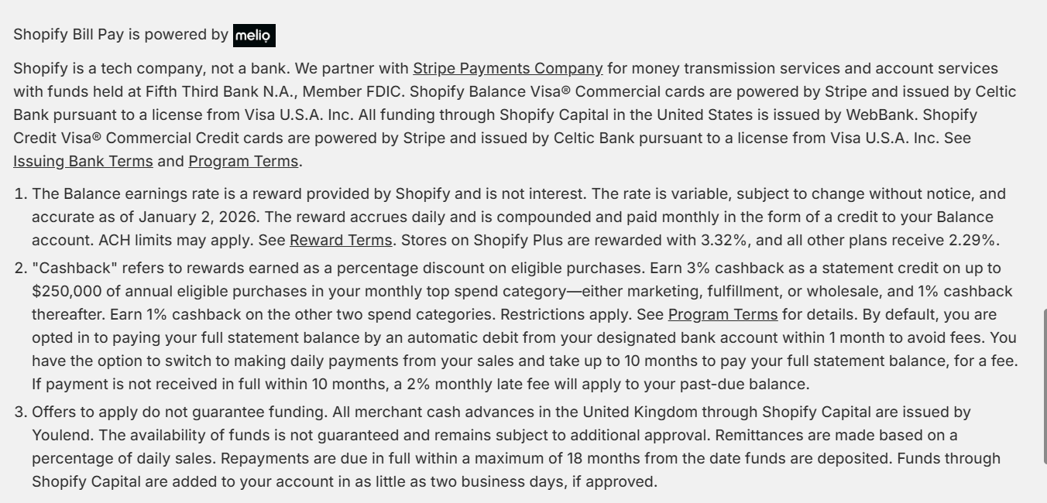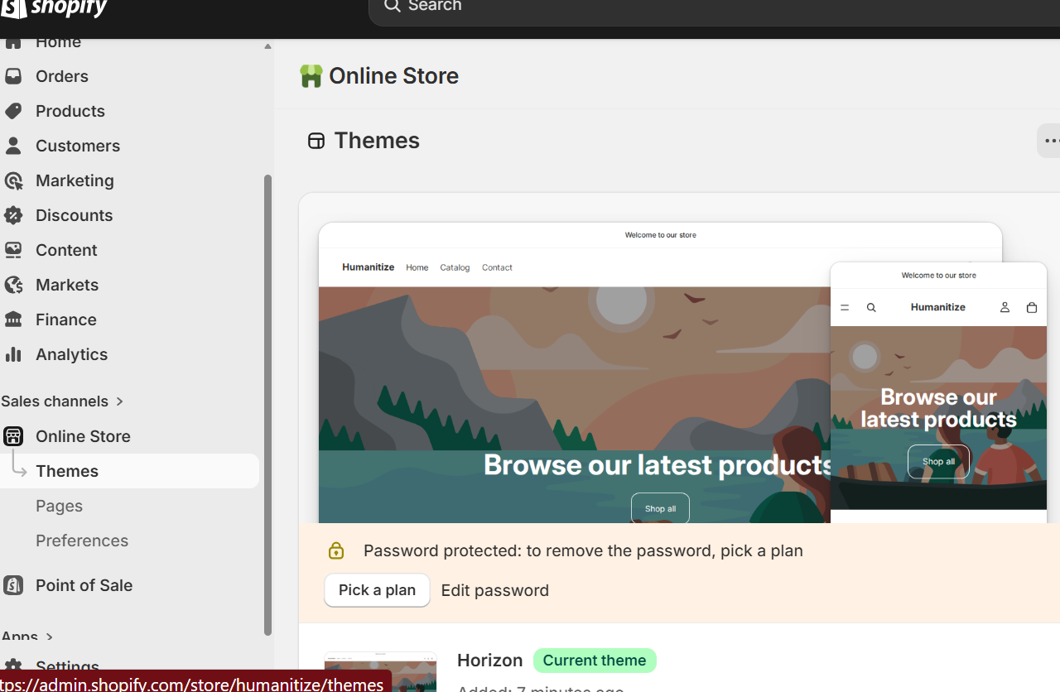

2.2WooCommerce
WooCommerce is an open-source WordPress plugin that turns a simple WordPress website into a fully functional online store. Product listings, safe payments, order tracking, and shipping management are all supported. Because WooCommerce is open-source, developers may add plugins and extensions, making it incredibly flexible and customizable. Small and medium-sized businesses favor it because of its flexibility and low setup costs. One disadvantage is that it takes a lot of technical know-how to manage hosting, plugins, and customizations. [1][3].
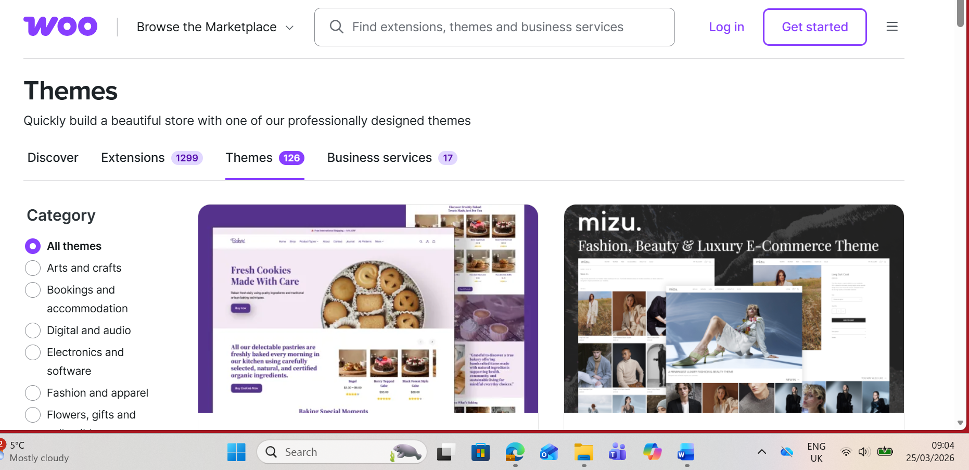

2.3Conclusion,
Shopify and WooCommerce are two contemporary e-commerce software applications that help businesses create and manage online stores. Shopify provides a user-friendly, fully hosted platform, whereas WooCommerce's open-source nature permits freedom and customization. Both platforms allow businesses to successfully sell products online; the choice is determined by the business's operational needs and technical capabilities

References (IEEE Style)
[1] “E-commerce: Business. Technology. Society. Kenneth C. Laudon and Carol Guercio Traver: book review,” MFSA Journal of Marketing, vol. 9, no. 6. Future Publishing, p. 58, January 1, 2003.
[2] M. Stansfield, “Internet marketing: strategy, implementation and practice: Dave Chaffey, Richard Mayer, Kevin Johnston and Fiona Ellis-Chadwick, FT, Prentice-Hall, Englewood Cliffs, NJ, second edition 2003, 484p, ISBN 0-273-65883-2, price £34.99 ($68.50),” International Journal of Information Management, vol. 24, no. 1. Elsevier Ltd, pp. 108–110, 2004. doi: 10.1016/j.ijinfomgt.2003.09.009.

3.Task2: Mind Map of Contemporary Software Applications
Explain mind mapping and its advantages for business operations (about two out of three sources).

3.1An explanation of mind mapping
A visual technique for arranging and displaying data around a main subject is mind mapping. Subtopics branch forth from the main idea, which is positioned in the center of the diagram. Keywords or succinct remarks illustrating linkages or hierarchies are included in each branch. This structure makes complex information easier to comprehend and retain by reflecting the way the brain naturally associates concepts. Professionals can make digital, shareable mind maps for project management, planning, and brainstorming using programs like MindMeister, XMind, and Coggle [1].

3.2Benefit of mind map
Organizations can benefit from mind mapping in a number of ways. By graphically presenting tasks, projects, and procedures, it first increases clarity and aids teams in comprehending dependencies and priorities [2].
It also encourages problem-solving and creativity. Exploration of alternate answers and connections that might not surface through linear notetaking is encouraged by the radial style [1].
Third, teamwork is improved via mind maps. By fostering a shared visual picture of goals, roles, and procedures, cooperation is enhanced and miscommunication is decreased [2].
Mind mapping also makes things more efficient. During meetings or planning sessions, teams can efficiently organize information and record thoughts without depending on extensive paperwork [3].
Finaly, it facilitates the transfer of knowledge and memory. Employees are better able to recall information when pictures and keywords are combined, which is advantageous for training and interdepartmental knowledge transfer [1].

3.3 Make a mind map of modern software programs that help with daily company and organizational activities.
The center node of a mind map of software used in day-to-day business activities is called "Business Software," and it branches into several important categories: Slack, Google Workspace, and Microsoft Office 365 are examples of productivity tools. BigCommerce, WooCommerce, and Shopify are e-commerce platforms.
Customer relationship management systems include HubSpot CRM, Zoho CRM, and Salesforce.Software for accounting and finance: Sage, Xero, and QuickBooks.
Marketing and Analytics: Google Analytics, Mailchimp, SEMrush; Project Management and Collaboration: Asana, Trello, Monday.com.File sharing and cloud storage options include Dropbox, Google Drive, and OneDrive.

Businesses can rapidly understand whether software supports particular tasks, spot gaps or overlaps, and make tool selection decisions thanks to this organization. Mind maps also make onboarding easier by giving a visual summary of key tools and how they work.

Mind map of contemporary business software applications (simulation)”

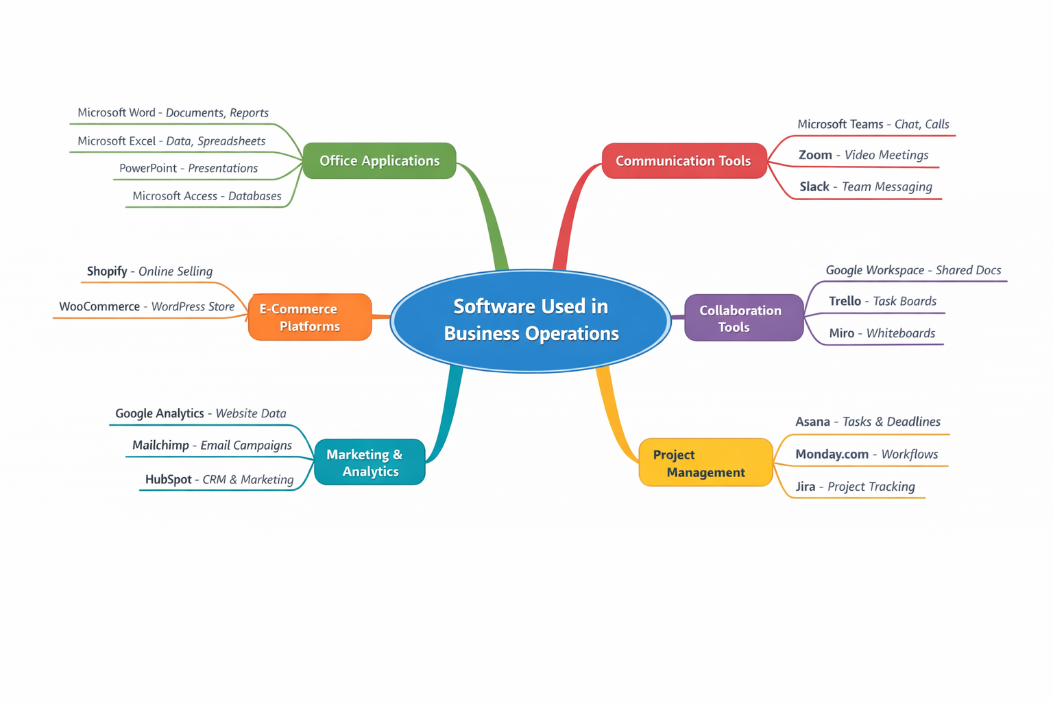
“This mind map visually represents key software applications used to support day-to-day business operations.”

3.4References (IEEE Style)
[1] Irman Irman, “THE EFFECTIVENESS OF MIND MAPPING TECHNIQUES IN COUNSELING OF ENHANCEMENT ABILITY MEMORY STUDENTS IN LEARNING,” Ta’dib, vol. 22, no. 2, pp. 131–140, Dec. 2019, doi: 10.31958/jt.v22i2.1424.
[2] M. J. Eppler, “A Comparison between Concept Maps, Mind Maps, Conceptual Diagrams, and Visual Metaphors as Complementary Tools for Knowledge Construction and Sharing,” Information visualization, vol. 5, no. 3, pp. 202–210, Sept. 2006, doi: 10.1057/palgrave.ivs.9500131.

4Task 3. Office Applications for creating, storing, presenting, and analysing information/data (Approx. 2000 words).

4.1Description of four office software programs (MS Word, MS PowerPoint, MS Excel, and MS Access) for business activities, emphasizing their salient characteristics, advantages, and drawbacks (if any). Along with text, you can use some images (around four out of five sources)

Office software is crucial to the efficient management, presentation, and analysis of information in modern organizations. Document production, data analysis, database management, and presentations are just a few of the tools that Microsoft Office offers to make corporate operations easier. The four main Microsoft Office programs—Word, PowerPoint, Excel, and Access—are examined in this job with an emphasis on their features, business uses, advantages, drawbacks, and useful examples. Additionally, Excel features like Goal Seek, VLOOKUP, IF Function, and Pivot Tables are shown to highlight their usefulness in corporate settings. [1],[2],[4]

4. 2Microsoft Word
Key Features: Microsoft Word is a popular word processing program used to create business letters, reports, contracts, and meeting minutes, among other professional documents. Important traits include:
• Advanced Formatting Tools: Word supports the use of headings, styles, headers, and footers in structured documents.
• Templates: Time is saved and consistency is maintained with pre-made templates for reports, correspondence, and forms.
• Proofreading Tools: Spell, grammar, and readability checks guarantee precision and expertise.
• Collaboration Features: Group editing is made easier with Track Changes and comments, which do not permanently alter the original document.
• Mail Merge: This feature uses a data source to automatically create customized mailings or forms.
Business Benefits: By offering consistent formatting guidelines and improving document display, Word enhances organizational communication. While collaborative technologies allow several people to efficiently review and edit papers, templates assist expedite typical administrative work. Additionally, the program improves cross-platform compatibility by enabling exporting to multiple formats, including PDF [1], [2].

Limitations: Word can have trouble with really large documents or files that contain high-resolution photos, despite its versatility. Additionally, relational database management and extensive data analysis are not appropriate uses for it. Lastly, when advanced formatting is shared between Word versions, it may result in inconsistent layouts [1].
Useful Applications Writing agreements and contracts Making agendas and minutes for meetings Making brochures and marketing ideas; producing structured reports with templates [2]

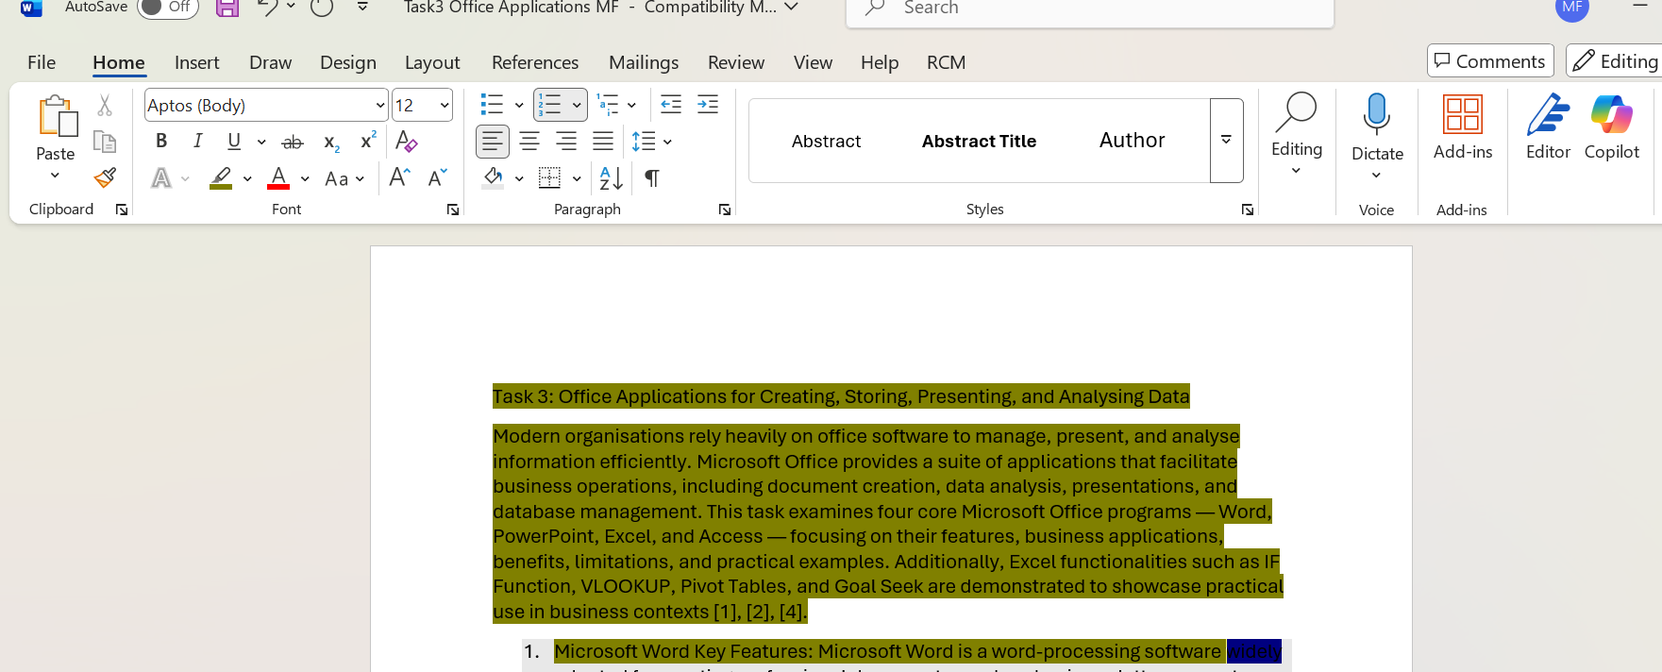

4,3. Microsoft PowerPoint
Microsoft PowerPoint Key Features: PowerPoint is frequently used in business meetings, training sessions, and client presentations. It is made for producing visually captivating presentations. Its attributes consist of: • Slide Master and Templates: Makes sure that every slide is consistent. • Multimedia Integration: Enables embedding of charts, SmartArt diagrams, pictures, audio, and video. • Transitions and animations: Improve clarity and visual appeal. • Presenter View: Gives the presenter access to timing tools and notes while the audience only sees slides. • Excel integration: Makes it possible to import data in real time for dynamic reports [3].
Business Benefits: PowerPoint helps stakeholders grasp difficult subjects by converting written and numerical data into visual material. Presentations are convincing and educational when data is effectively summarized using charts and diagrams. Real-time reporting is made possible by its Excel interoperability, which improves decision-making and company communication [3].
Limitations: Excessive animation may cause viewers to get distracted and less professional. Delivery of presentations might be hampered by technological issues since they also depend on gear and software. Additionally, Word or Excel are better suited for presenting extensive textual data than PowerPoint [3].
Useful Applications Financial or operational performance reports; training seminars and workshops; marketing pitches and product demos; corporate presentations for stakeholders [2]
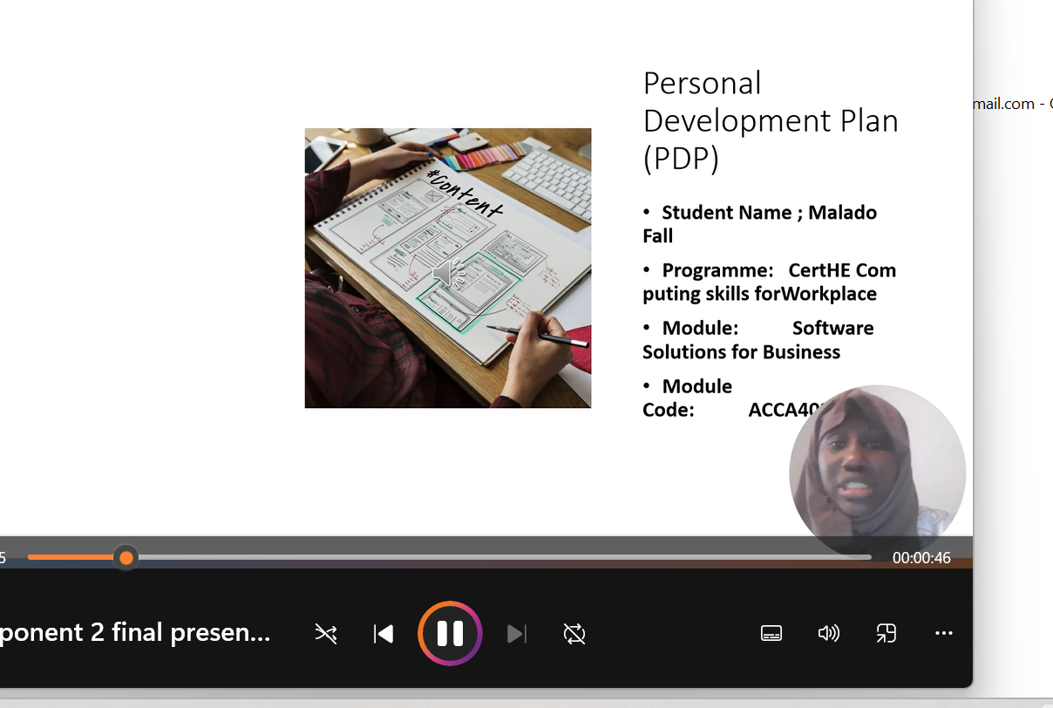

4.4 Microsoft Excel
Microsoft Excel Key Features: Excel is a spreadsheet program used for textual and numerical data organization, calculation, and analysis. Business analytics and operational decision-making depend on it. Important features include of: • Functions and Formulas: Use IF, VLOOKUP, SUM, COUNT, and other formulas to automate computations. • Data Organization: Use tables to arrange, filter, and organize datasets. • Pivot tables: Effectively summarize big datasets. • Conditional formatting and charts: show important data patterns and visualize trends. • Scenario Analysis: Predictive analysis for decision-making is made possible by tools such as Goal Seek [4].
Business Benefits: Excel improves accuracy by lowering calculating errors made by hand. It is frequently used for financial reporting, payroll, forecasting, and budgeting. The capacity to conduct "what-if" studies aids managers in evaluating various situations and coming to well-informed conclusions. Because of Excel's flexibility, companies can modify spreadsheets to meet their operational needs [4].
Limitations: Technical expertise is necessary for advanced Excel use. Results can be greatly impacted by formula mistakes. Extremely big datasets may cause Excel's performance to deteriorate, making it unsuitable for very large-scale enterprise databases [4].



Pivot table and if function tested in the following activity
- IF_Function
The if function is important because it helps us to make decision inside our spreadsheet instead of just storing numbers. Exemple in my screnshot below, we can see regroup all the fail and pass ed project with the if function used

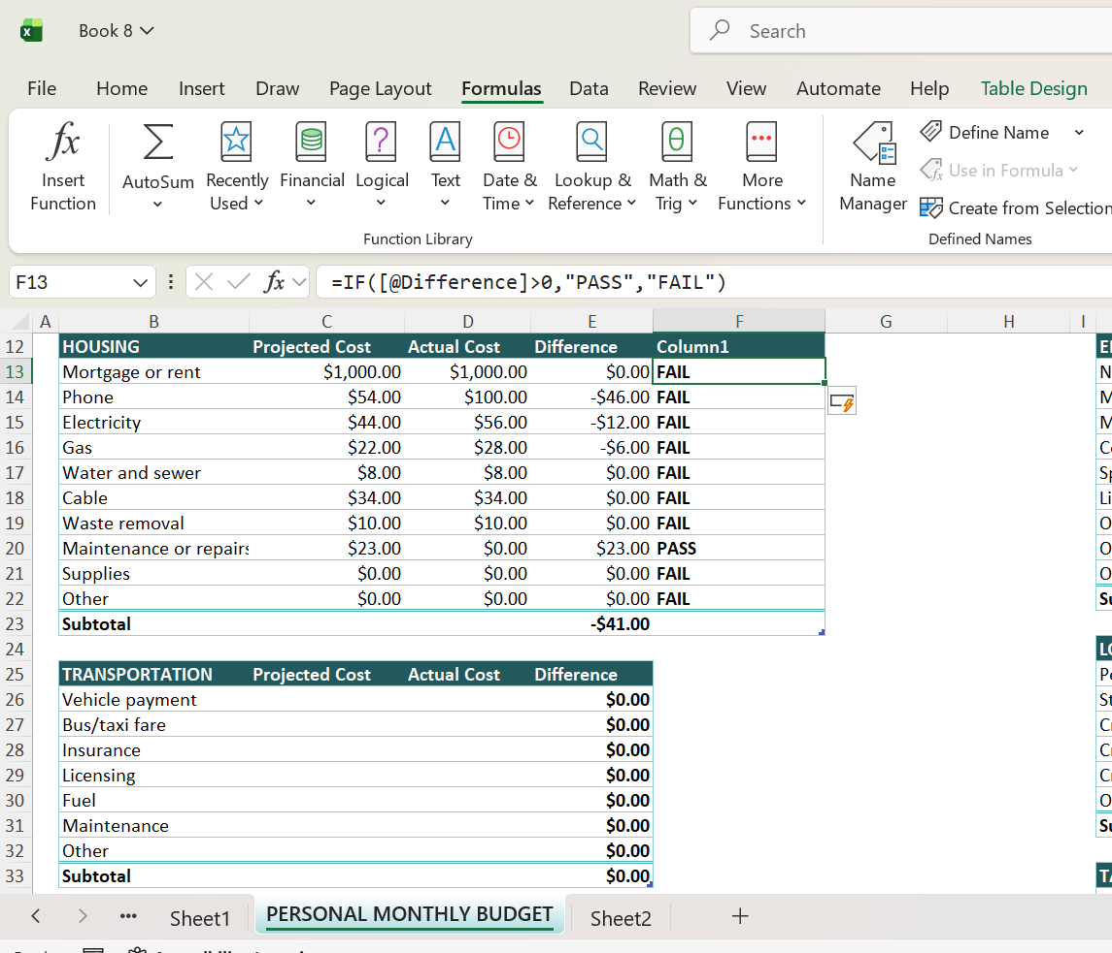

- Pivot_Table
A pivot table can be really helpful, for example in my excel file below who already summarize the total housing, and I can read in another way by creating a new table where i store the data by choosing what i really want to read. In the screenshot bellow, I can easily read the actual cost and all the house details into the rows and the read the information separately and easily
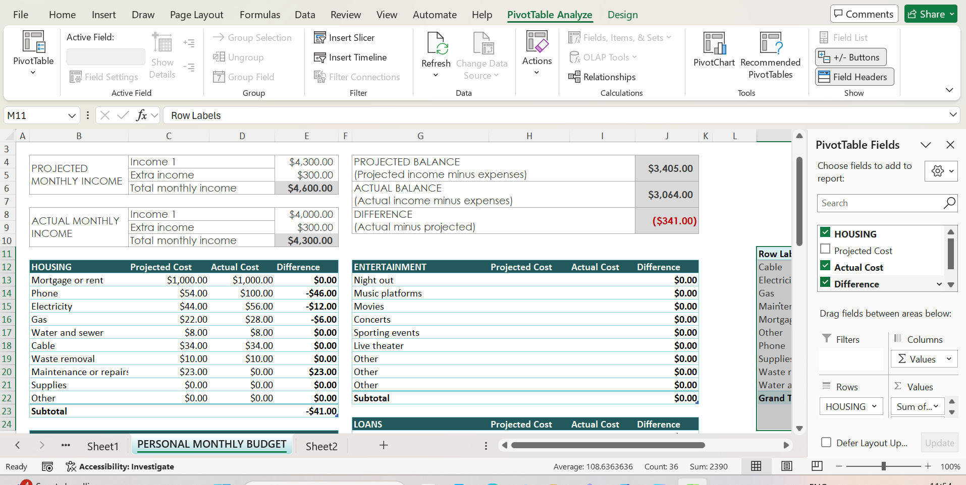
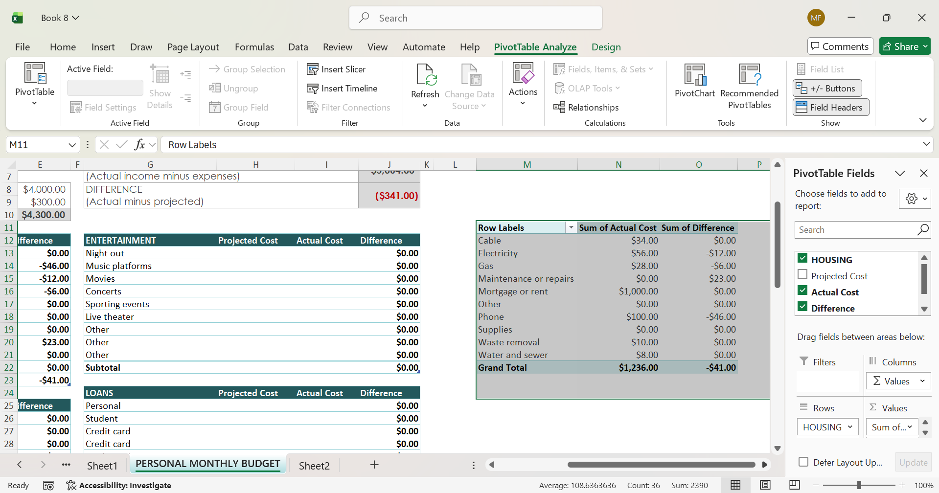

4.5. Microsoft Access
4. Access from Microsoft Key Features: Microsoft Access is a relational database management system designed to store organized data. Among its attributes are: • Tables and Relationships: Use primary and foreign keys to arrange data. • Queries: Effectively obtain particular data. • Forms: Make data entry interfaces easy to use. • Reports: Produce organized results for printing or sharing [5].
Business Benefits: By centralizing datasets, Access enhances data integrity and minimizes redundancies. Internal management systems, customer databases, and inventory monitoring all benefit greatly from it. Relationships and queries speed up the retrieval of information and aid in decision-making [5].
Limitations: Access is less appropriate for cloud-based multi-user setups or particularly big enterprise systems. Scalability is constrained in comparison to enterprise-level solutions, and it also necessitates knowledge of database design principles [5].

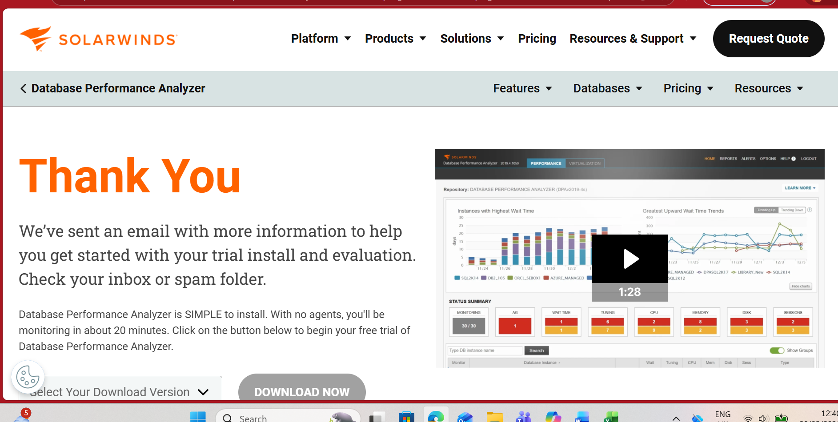

4.6Conclusion
In summary, office applications are essential to modern corporate operations. Each of Microsoft Word, PowerPoint, Excel, and Access makes a distinct contribution to the production, presentation, storage, and analysis of information. When applied properly, their benefits greatly exceed their drawbacks, notwithstanding their limitations.

Excel improves operational efficiency and facilitates well-informed decision-making, as demonstrated practically by the IF Function and Pivot Tables. Understanding these instruments' theoretical and practical elements is crucial for professional competency in business settings at Level 4 academic education.

4.7References (IEEE Style)
[1] J. Lambert and C. Frye, Microsoft Excel step by step : (Office 2021 and Microsoft 365). London, England: Pearson Education, Inc., 2023.
[2] A. Sabharwal and B. Selman, “S. Russell, P. Norvig, Artificial Intelligence: A Modern Approach, Third Edition,” Artificial Intelligence, vol. 175, no. 5. Elsevier B.V, pp. 935–937, 2011. doi: 10.1016/j.artint.2011.01.005.
[3] A. S. Rifaioglu, H. Atas, M. J. Martin, R. Cetin-Atalay, V. Atalay, and T. Doğan, “Recent applications of deep learning and machine intelligence on in silico drug discovery: methods, tools and databases,” Briefings in bioinformatics, vol. 20, no. 5, pp. 1878–1912, Sept. 2019, doi: 10.1093/bib/bby061.
[4] Global Healthcare Business Intelligence Market Report 2021: Query and Reporting Tools, On-Line Analytical Processing OLAP and Visualization Tools, and Performance Management/Monitoring Alerts - ResearchAndMarkets.com. NewsRX LLC, 2021, p. 131.
[5 N. K. Mandal, A. K. Azad, and M. G. Rasul, “On students learning experience of fluid power engineering – Impact of simulation software,” International journal of mechanical engineering education, vol. 52, no. 2, pp. 143–156, Apr. 2024, doi: 10.1177/03064190231176133.

5.Task 4 – Communication and Collaboration Applications
Organizational collaboration and communication have been profoundly altered by digital transformation. Online platforms are essential for modern firms to handle projects effectively, coordinate work, and rapidly communicate information. While collaboration tools enable numerous users to collaborate in real time on shared content, communication programs facilitate quick communication between people and teams. This study examines Google Docs, an online collaboration tool, versus WhatsApp, a modern communication software. With the use of pertinent scholarly and technical references, it assesses their salient characteristics, advantages, and drawbacks. Each application's practical testing of a single feature is also recorded.

5.2 WhatsApp, a contemporary communication app
WhatsApp is a popular messaging app that lets users send documents, audio notes, images, videos, and text messages via the internet. It is widely used in both personal and professional settings due to its familiarity and accessibility [1].
Important characteristics.
1. Instantaneous Messaging
When there is internet access, messages are sent to individuals or groups instantly.
2. Audio and Video Conversations
allows for remote meetings using high-quality voice and video calls without the need for extra software.
3. Group Discussions
To promote group communication, users can form departmental or team groups.
4. Sharing Files
During conversations, images, spreadsheets, PDFs, and other documents can be swiftly shared.
5. Complete Encryption
protects critical corporate information by ensuring that conversations stay private and safe [1].
Benefits for Companies • Compared to email, quick message exchanges improve internal communication. • Project updates and team communication are enhanced by group conversations. • Employees can stay connected even while they're not in the office thanks to mobile access.
Restrictions • WhatsApp is not intended to be a formal business platform. • In active groups, message saturation might lower output. • Fewer choices for record-keeping, process monitoring, and file management than business systems.

5.2. Google Docs is an online collaboration tool.
Using a web browser, several users can create, edit, and collaborate on documents using Google Docs, a cloud-based word processing program [2].
Important Features
1. Co-authoring in real time
The same document can be edited concurrently by many people, and all collaborators can see the changes right away.
2. Integration of Cloud Storage
Data loss is less likely because documents are automatically saved to Google Drive.
3. Suggestion and Commenting Mode
Comments and recommendations can be made by users without permanently changing the source document.
4. History of Versions
Transparency and accountability can be ensured by restoring earlier document versions.
5. Control of Access
To control security and document access, permissions can be set as Viewer, Commenter, or Editor.
Benefits for Companies • Increases efficiency by removing the need for repeated document modifications via email. • Collaboration in real time minimizes redundant work. • In collective projects, version history enhances accountability.
• cloud storage allows access from different places, it facilitates remote and hybrid work [2].
Requirements • For optimal performance, internet access is necessary. • Complex or large papers with a lot of formatting may take longer to complete. • Some user training could be necessary for advanced functions.

5.3Conclusion
In conclusion, current company processes depend heavily on communication and collaboration software. Google Docs enables organized and transparent teamwork, while WhatsApp offers quick and easily accessible communication channels. Despite their drawbacks, both apps greatly increase productivity, flexibility, and the ability to work remotely. These technologies improve operational efficiency and enable digital transformation within organizations, as demonstrated by the actual testing.

5.4IEEE References
[1] Meta Platforms Inc., WhatsApp Security and Features Overview, 2023. [Online]. Available: https://www.whatsapp.com/security
[2] Google LLC, Google Docs Help Centre, 2023. [Online]. Available: https://support.google.com/docs

6.Conclusion
Digital tools have revolutionized corporate operations, communication, and teamwork. Office software, mind mapping, e-commerce platforms, and collaboration technologies like Google Docs and WhatsApp facilitate teamwork, increase productivity, and expedite procedures. In a contemporary business setting, organizations can maintain efficient communication, increase productivity, and make well-informed decisions by integrating various technologies.

