Site Investigation Case Study - Assignment
Julia James
Student No: 0251098

Contents
- Introduction …………………………………………………………..2-3
- Site area
- Site location

- Site Walk Over ………………………………………………………3-6

- Site Investigation ………………………………………………………6

- Desktop Study ……………………………………………………...6-23
- Historical background of the site
- Contamination
- Health and Safety
- Swansea during World War 2
- Further investigations
- Geology and soil type
- Bore Hole data

- Soil Sampling ……………………………………………………..23-25
- Recommended sampling methods

- Foundation Design ……………………………………………….26-28
- Raft foundations
- Section plan of raft foundation
- Floor plan of raft foundation

- References ………………………………………………………..30-31
Bibliography

8. Appendix …………………………………………………………..32-38

- Introduction
The pictures below illustrate the location of the parcel of land being considered for a one storey commercial development. The site is situated in SA1 to the left of the South Port Marina in a seafront position between the Mariott Hotel and the Civic Centre specifically the carparking areas of both properties.

Site area

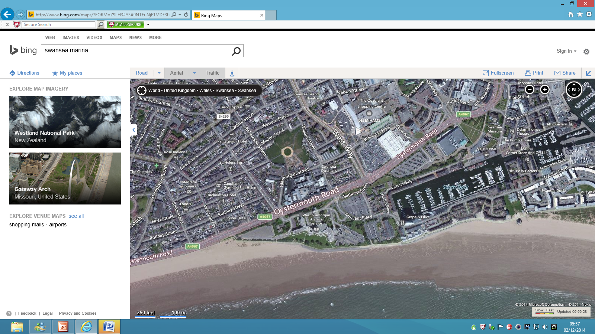

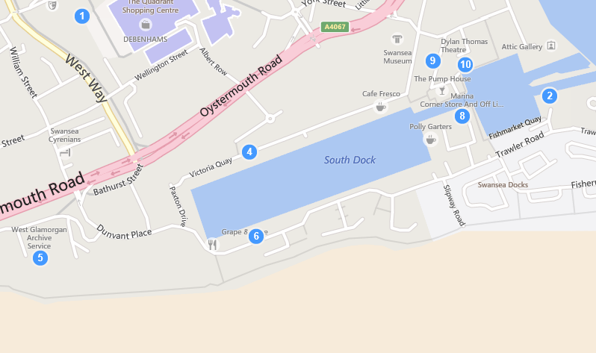
(Nantel, Site Investigation Assignment , 2019)

Site location
(Nantel, Site Investigation Assignment , 2019)

- Site Walk Over
The potential site is located on the seafront in Swansea (Appendix A) so it will experience a direct flow of wind/wind forces (Appendix B), rain and salt from the sea which will need to be considered in the initial study of the soil type, structure, soil testing, the correct use of machinery, the fencing of the site for safety and the decisions taken of the materials to use in the foundations, structure and the finish of the building.

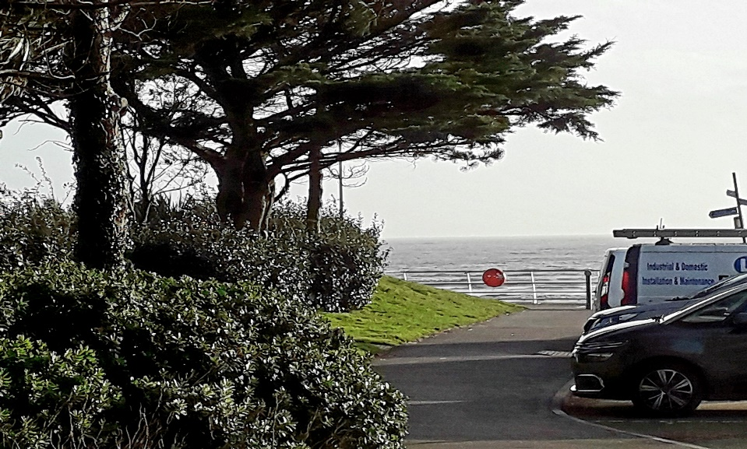
(James, 2019)
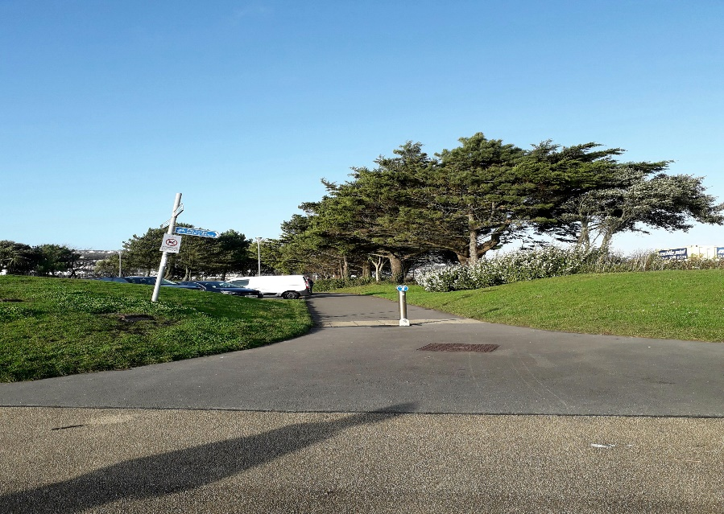
(James, 2019)
The topography of the site has raised levels of banks on the perimeter area facing the sea, these could be man-made and erected to protect the area from the affects of the weather, sea and blown sand.

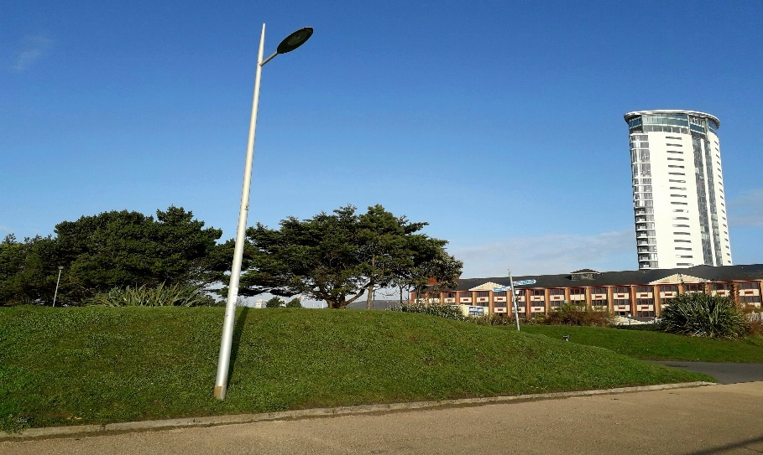
(James, 2019)
The area slopes downwards to the roads (Appendix E) with the Mariott area being at a slightly raised level to the adjacent Civic Centre area, there is a raised bank inbetween the car parks which is landscaped with trees.

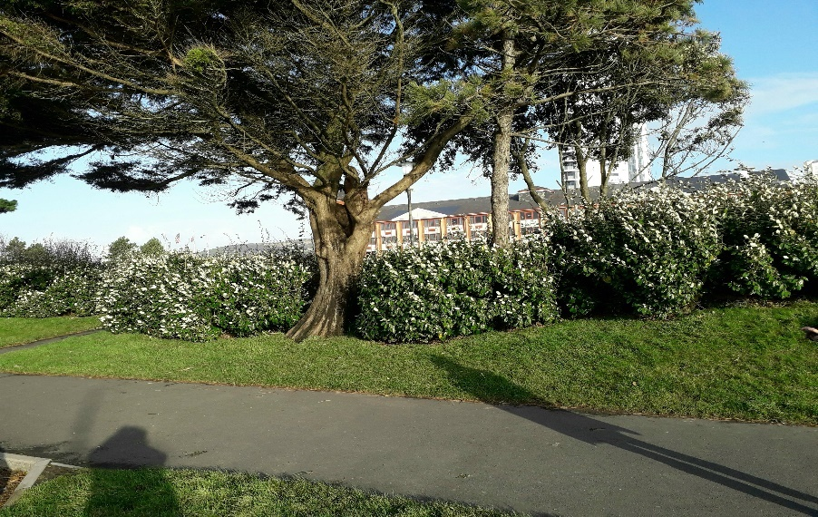
(James, 2019)
On viewing from the road you can see the slope and elevated position of the site approx. 1m above the road area. Natural drainage of surface water could flow down into the road area. Manholes and drains can be seen in this area (Appendix C).

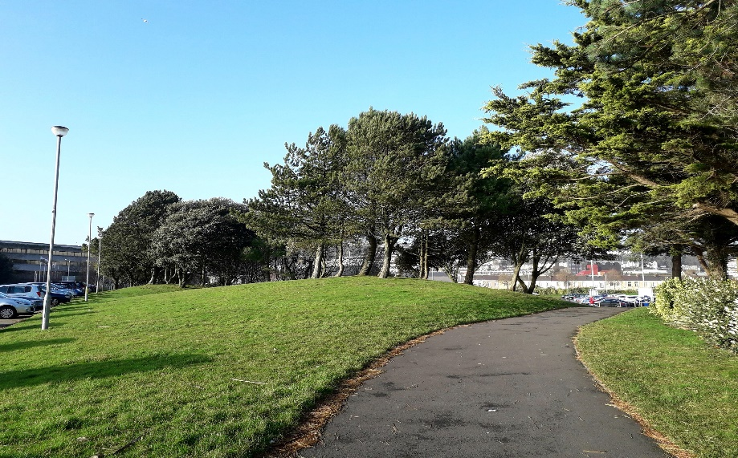
(James, 2019)
The site is located next to a busy Council Office and Hotel and the main access road into the South Marina area (Appendix D). A traffic plan will need to be prepared with clear access to the site noted. There is a main pedestrian walkway infront of the site which is also used by tourists. The sensitivities of the site will need to be considered in terms of access and consideration to working hours, noise and pollution in line with the Considerate Constructors Scheme https://www.ccscheme.org.uk/ .

The type of construction combined with the lack of space for storage of materials and machinery on this site will need to be considered. The construction to comply with the Building Regulation Approved Document A.
An approach could be made to the Council for possible temporary use of the adjacent land.Building Regulation Approved Document A

- Site Investigation
A site investigtion will need to be carried out to BS 5930 : Code of practice for site investigations (2015) , it will examine the site in detail and consider remedial actions needed for the build to go ahead safely, the information will also provide a sound basis for deciding the type of further physical investigations and in detail how the building will be constructed from the foundations upwards.

‘Site Investigation is undertaken during the early stages of project development’ (Riley & Cotgrave, 2018, p. 27)

‘The purpose of an investigation may be summarised as follows:
-To assess the grounds composition and characteristics
-To ensure that a foundation is chosen which is compatible with the load to be carried and the strength of the ground
-To ensure safety, efficiency and economy in the design of the building’ (Riley & Cotgrave, 2018, p. 28)

- Desktop Study
The first stage of our investigation is to carry out a desktop study ‘the desktop study can supply useful background information on the site, such as may be obtained from maps and historical records about the site’ (Riley & Cotgrave, 2018, p. 28)

Historical backgound of the site
By visiting the Civic Centre Archives in Swansea on 29th October and 19th November and the website https://maps.nls.uk the following maps were sourced. By examining these maps the changes of land use can be seen. We are looking for changes to the ground by contamination through use and possible manmade ‘Anthropogenic ground – deposits which have accumulated through human activity’ (Nantel, Codes Of Practice For Ground Investigation 1, 2019)

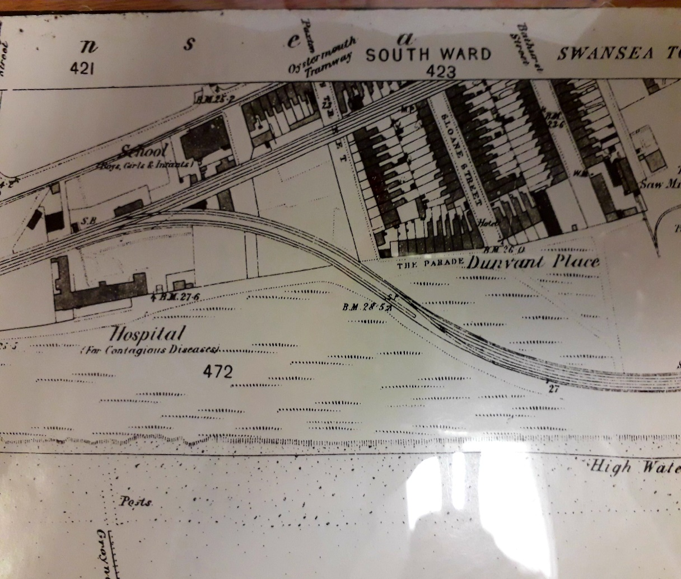
(Swansea Town Map South Ward, 1800)

The land is shown as a mainly greenfield site on the coast, no buildings with rail tracks running through the area, there are residential houses behind, a saw mill to the right and a hospital for contagious diseases further to the left of the area.
The area is largely depicted by sandunes on this map which was confirmed by the Archivist, these sandunes run along this coastal area.
Initial conclusions can be drawn that the soil type is sandy and there could be remnants of rail tracks in the area.

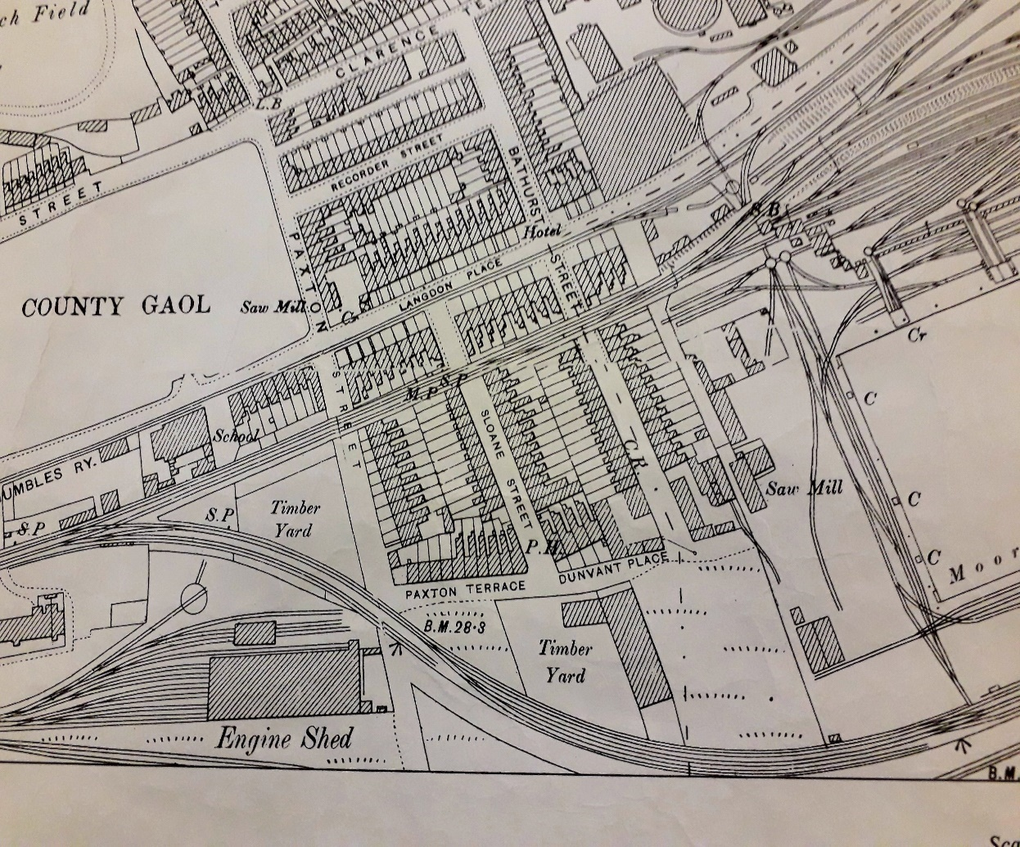
(The Centre of Swansea, 1897)

The land use shown in this later map has changed to a brownfield site with a timber yard now being situated where previously there were only sandunes. The train tracks continue to run through the area, the saw mill to the right still exists and there are substantail engine works areas and sheds shown now to the left of the area.

Conclusions could be drawn that the site may now have remnants of foundations and building structures in the area as well as train tracks and contaminants from the railway works. The timber yard could have used chemicals for treatment.

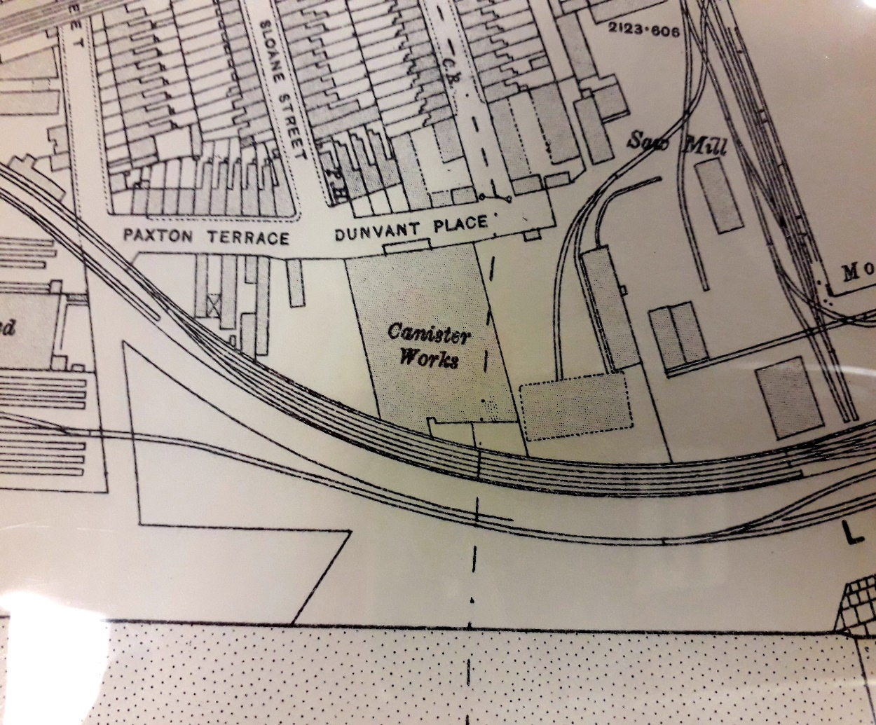
(Brown, 1919)

By 1919 the timber yard has been replaced by a canister works and a selection of other smaller buildings surrounding it. On investigations of this works only speculative ideas to its use have been gained from opinions of the Archivists at the Civic Centre in Swansea and Ian Smith the Senior Curator of Industry at Swansea Museum. Ideas range from empty canisters for general use to munitions canisters, Swansea is also known for tin plate works. The saw mill still exists to the right of the area and the engine shed and railway works can still be seen to the left of the area.

Further to the areas previous use we can add in assumptions of possible further contaminants and wastage from tin plate manufacture and further building foundations, an additional railway line and an expansion of the railway works/sidings.

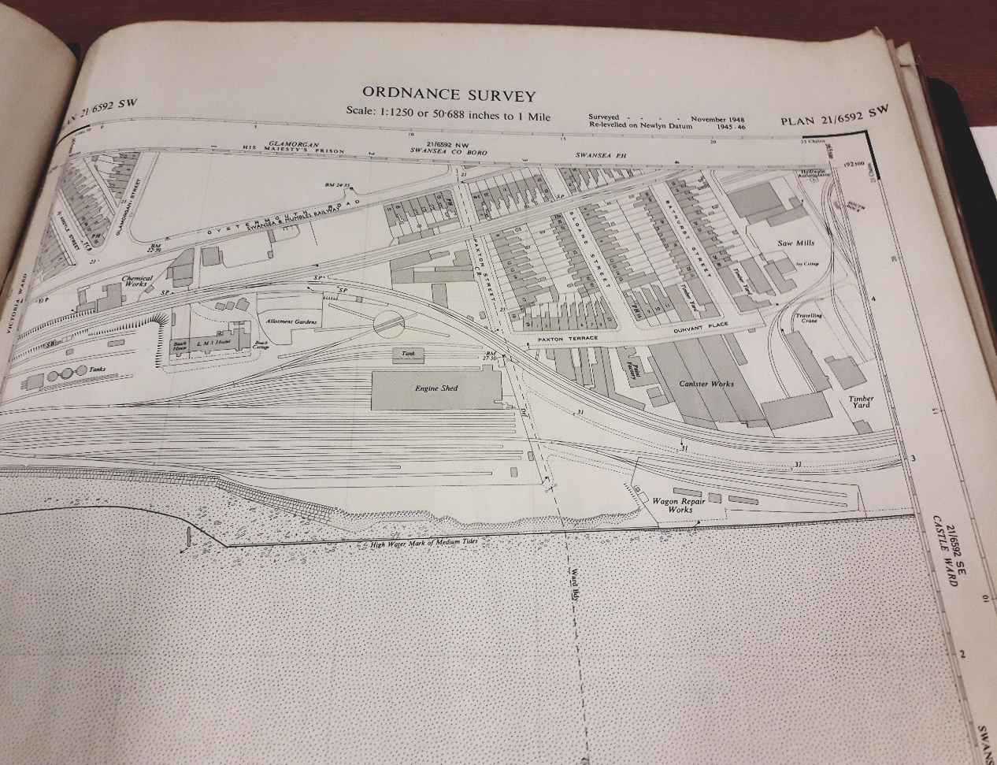
(Swansea County Borough, 1948)

This map published in 1948 shows some additional buildings, there is a paint factory alongside the canister works and many additional buildings. There is a wagon repair works in front of the canister works. To the left of the site in addition to previous detail there are 4 tanks marked and a chemical works.

Contamination
Brownfield sites due to previous use could contain contaminants.

‘The forms that contaminants take are extensive and include:
- Chemicals – processing chemicals in particular
- Heavy metals such as mercury and lead
- Fibrous materials linked to respiratory problems, such as asbestos
- Explosives
- Nuclear waste
- Natural radioctivity, such as caused by radon gas
- Landfill gases, such as methane
- Liquids, such as petroleum’ (Riley & Cotgrave, 2018, p. 33)

‘The name given to remedying contaminated land is remediation’ (Riley & Cotgrave, 2018, p. 33)

A remediation strategy specific to each site will need to be put in place once contaminants have been identified.

Regulations and British Standards to be applied:
- Building Regulations Approved Document C, Site preparation and resistance to contaminants and moisture (2004)
- BS 10175: Investigation of potentially contaminated sites. Code of Practice (2011)
- BRE Digests related to site investigation: 318, 348,381,83,411,412,427.

The following table illustrates possible affects of the areas previous use:
ON OR NEAR SITE USE | POSSIBLE IMPLICATIONS | POTENTIAL CONTAMINANTS/WASTE
Residential area | Buiding waste | Larger stones, rubble, timber, nails, foundations, asbestos
Residential area | Domestic waste | General household waste, oil, gas, landfill gas, asbestos
Hospital | Hospital waste | Chemicals & medicines
Railway | Buried rail tracks, waste from engines, loss from transported materials | Coal, Coke, Copper waste, Tin plate waste, Engine Oil
Engine Shed | Multiple rail tracks and sidings, buried oil tanks, building foundations | Oil, coal, coke, petroleum
Saw Mill (Greggors) | Discarded timber, foundations of out buildings | Chemicals from timber production/storage
Canister works (shown on maps up until 1948) | Foundations of building, remnants from building demolition, discarded products | Chemicals used in production and processing, waste materials
Paint Factory | Foundations, waste materials from manufacture | Chemicals, heavy metals like lead, mercury
Wagon Repair Works | Rail tracks, sidings, foundations, materials | Oil, gas

Further findings from discussions with Mr Ian Smith Senior Curator at Swansea Museum:
ON OR NEAR SITE USE | POTENTIAL CONTAMINANTS/WASTE
Residential houses were demolished in Bathurst Street | Demolition waste and foundations, domestic waste, utilities, asbestos.
Copper Works at Hafod | Copper slag waste was used as infill under all areas of Swansea including the SA1 area, under roads, pavements, buildings, the red coloured ash waste was seen to be spread throughout the area. The chemical gas from dipping the copper plates into arsenic to clean them filled the air and was deposited throughout the soil in the area, it also fell as acid rain.
Gas Works at South Dock | Air pollutants
Sponge Works (artifical viscose and sponge) | Reported as a ‘dirty’ production process with a strong smell given off and waste materials blown onto surrounding areas including the beach area.
Oil Refinery (University Bay Campus Area Fabian Way) | Air and water pollutants, petroleum
Overhead Railway Lines / Road ways | Created to avoid the sand blocking road and rail tracks. Major train route, the lines went as far as Scotland. Foundations of structures, bridges etc may still exist, businesses operated out of the tunnels underneath the bridges and lines which could have left waste.
Mumbles Train (First passenger railway in 1807) | Tracks running along coastal areas, this train began as horse drawn and progressed to coal/steam and then electric.
Cobble roads / walkways | New roads and structures were built on top of these, when areas are excavated eg. Mumbles Road the original cobble roads were found intact and a layer of household waste of glass bottles lay beneath this.

Natural contamination in the form of Methane or Radon gas can occur and this will need to be tested for and remediation put in place.

Below is a photograph of a piece of Copper slag waste provided by Mr Ian Smith Senior Curator Swansea Museum:

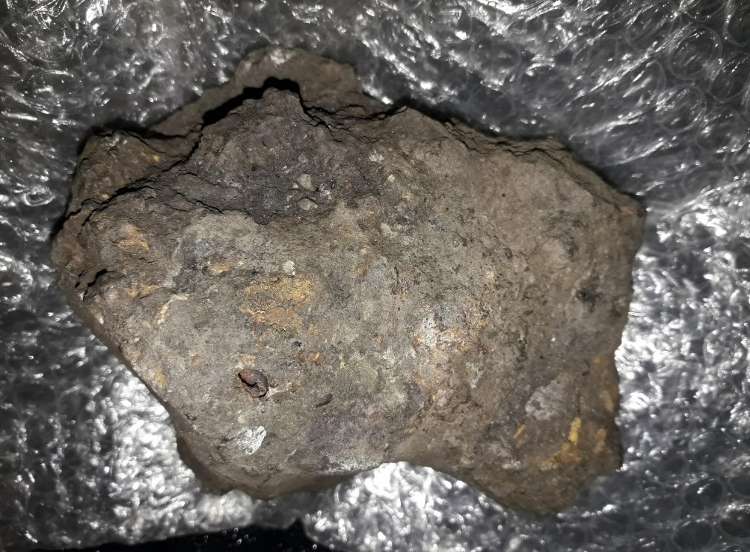

Health and Safety

‘In order to fully assess the potential for contamination to pose a risk to the development and to people or eco-systems, a structured approach to risk assessment is necessary.
- Hazard identification: preliminary site assessment based on desktop study and walkover
- Hazard assessment: more detailed investigation to assess potential pollutants and linkages
- Risk estimation: estimating scale of risk and possible consequences
- Risk evaluation: assessing whether risk is acceptable or not acceptable’ (Riley & Cotgrave, 2018, p. 34)
The British Standards of BS10175 and BS8576 are applicable.

Health and Safety and quality systems will be an integral part of the whole construction process and build, full details can be found at:
https://www.hse.gov.uk/construction/index.htm
https://www.hse.gov.uk/construction/cdm/2015/index.htm

Swansea during World War 2
A Buried Unexploded Ordnance (UXO) survey will need to be carried out by a Specialist Ordnance Consultant to CIRIA guidelines.

Swansea was targeted in WW2 and many bombs were dropped on the area devastating the city centre. The aim was to hit the industry, transport and docks areas along the coastline and the oil refinery in Llandarcy. The below map was provided by the Archivist in the Civic Centre, the map is a German version of a British map with the target bombing locations marked onto it:

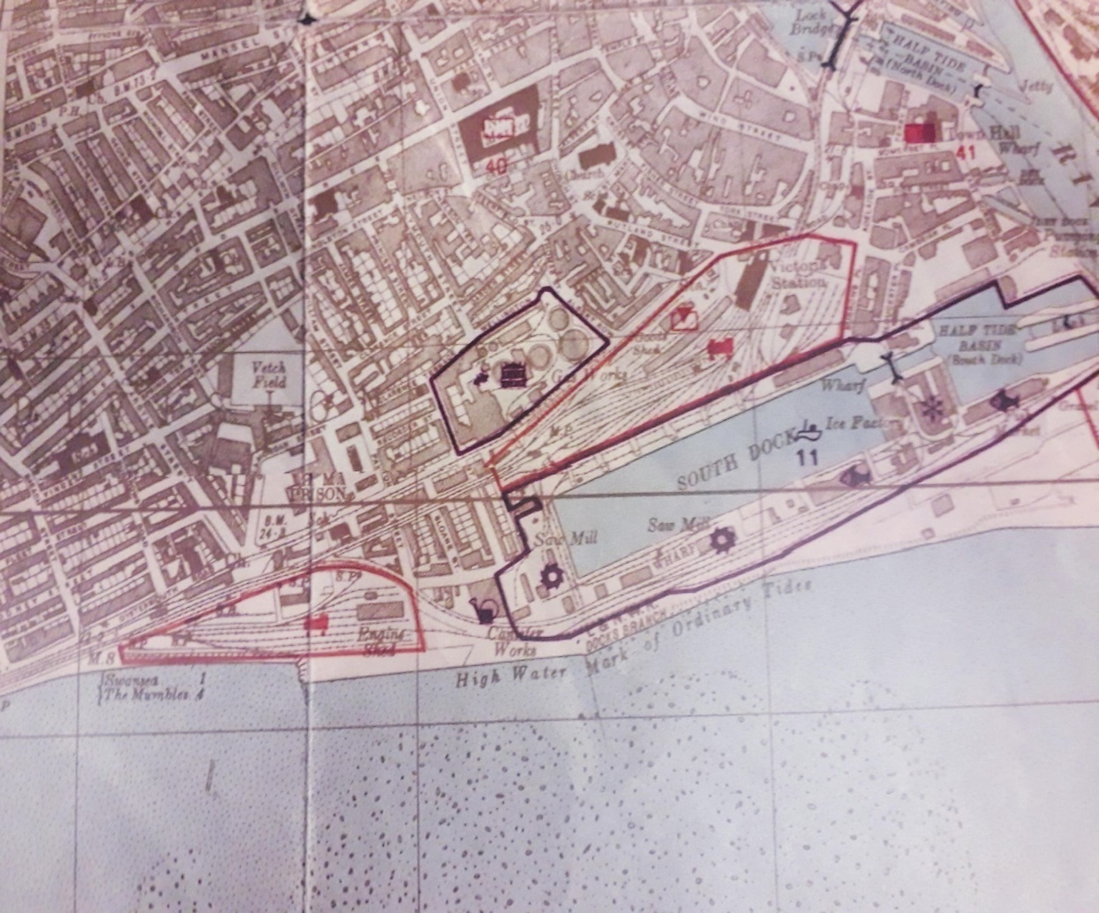
(Stadtplan Swansea, 1941)

The German Luftwaffe have taken a specific interest in our site and marked the canister works, along with the south docks area and engine sheds either side of our site to target.

‘Swansea Docks were heavily bombed by the Luftwaffe during World War Two, particularly during the Swansea Blitz of February 1941. Reference to UXO risk maps available on-line suggests that the area is a ‘High’ risk region with regards to the risk from buried unexploded ordnance’ (Earth Science Partnership, 2017). See Appendix F for a photo of Swansea after the Blitz.

Further Investigations Recommended:

Investigation Type | Reasons for Investigation
Mining Survey | Identify previous mining, soil type and structure, voids, abandoned pits or tunnels  https://www.gov.uk/check-if-property-is-affected-by-coal-mining
Groundwater Hydrological Survey | Current levels, tidal events and effects of weather conditions across all seasons http://www.largeimages.bgs.ac.uk/iip/hydromaps.html?id=south-wales.jp2
Drainage Survey | Natural drainage, consideration to SuDS, existing drainage system, easements and scope for new connections
Flood Survey | Identify if site is in a flood or tidal risk area  https://naturalresources.wales/evidence-and-data/maps/long-term-flood-risk
Infrastructure Survey | Identify existing pipes, cables, tunnels
Utilities & Telecommunications | Identify existing services, overhead, underground, electric, gas, water, telecom. Identify if existing connections can be utilised – is there enough future capacity for the build, temporary adjustments during build.
Sites of Special Scientific Interest (SSSI) | https://www.gov.uk/guidance/protected-areas-sites-of-special-scientific-interest
Battlefields and conservation areas | https://www.gov.uk/guidance/conserving-and-enhancing-the-historic-environment
Ecological Survey / Environmental Impact Asessment (Appendix H) | Identify any protected flora/fauna/animals, impact and mitigation, seasonal constraints https://naturalresources.wales/guidance-and-advice/business-sectors/planning-and-development/advice-for-developers/environmental-assessment/?lang=en

Geology and Soil Type
The Desktop Study will also involve the consultation of Geological, Soil and Hydrological Maps to ascertain soil type and conditions.

The Geology of Britain Viewer website shows the Superficial Deposits in the area are classed as ‘Marine Beach Deposits – Sand and Blown Sand, medium to fine grained materials’.

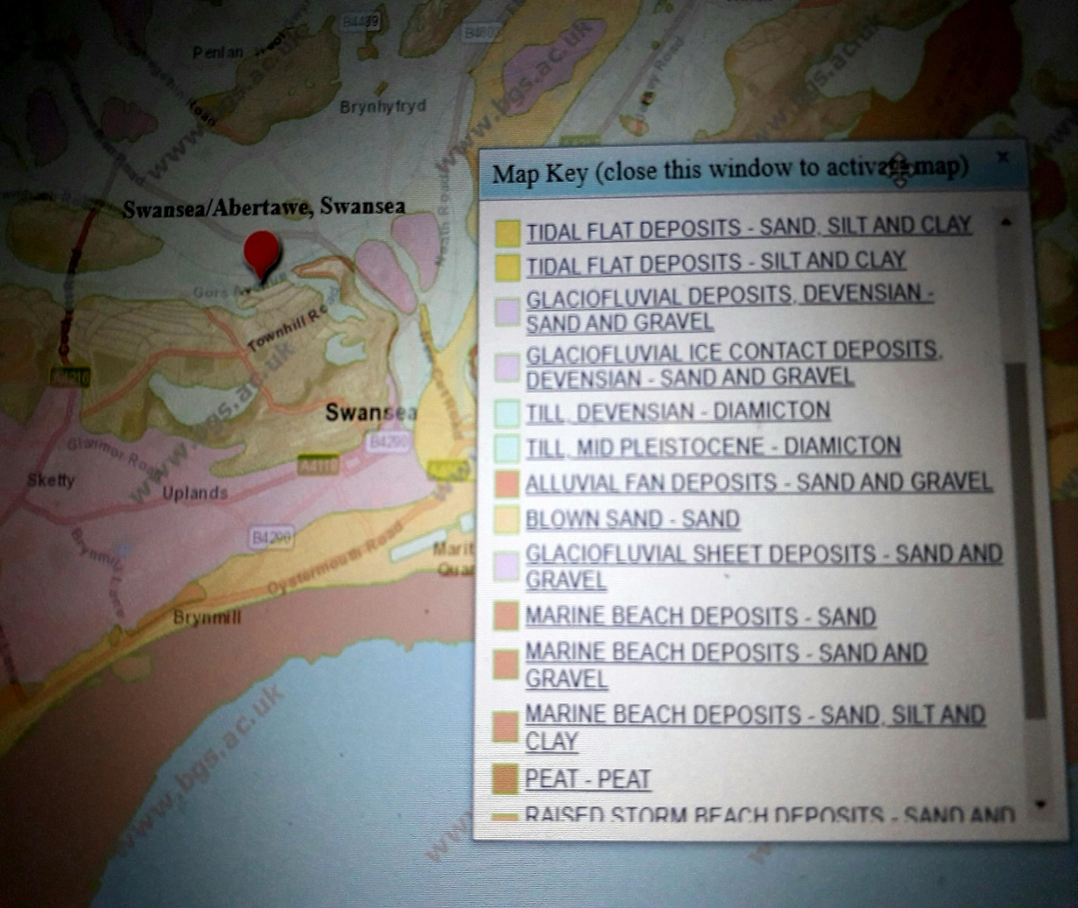

‘Superficial Deposits formed up to 3 million years ago in the Quaternary Period. Local environment previously dominated by wind blown deposits. They rest on older deposits or rocks referred to as bedrock. (Geology of Britain Veiwer, 2019)

The Bedrock or Parent Material is shown as ‘South Wales Middle Coal Measures Formation – Mudstone Siltstone and Sandstone’.

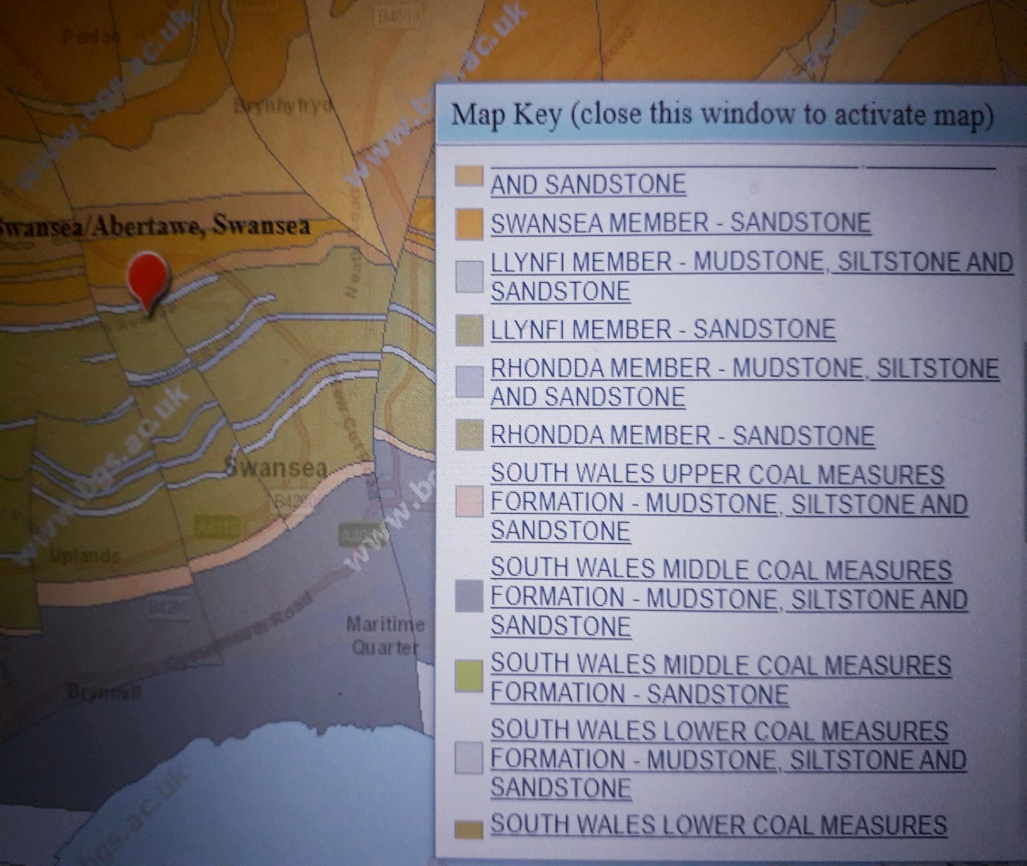

‘Sedimentary Bedrock formed approximately 310 to 318 million years ago in the Carboniferous Period. Local environment previously dominated by swamps, estuaries and deltas’.

‘Bedrock geology is a term used for the main mass of rocks forming the earth and present everywhere, whether exposed at the surface in outcrops or concealed beneath Superficial Deposits or water. The bedrock has formed over vast lengths of geological time ranging from ancient and highly altered rocks of the Proterozoic, some 2500 million years ago or older, up to the relatively young Pilocene, 2.6 million years ago’. (Geology of Britain Veiwer, 2019)

To obtain a more accurate picture of the soil type and strata layers and depth, physical investigations would need to be carried out in the form of bore holes. This will also identify if the soil has any man-made fill/made ground.

‘Soil – assemblage of mineral particles and/or organic matter which can be separated by gentle mechanical means and which includes variable amounts of water and air and sometimes other gases’ (Nantel, Codes Of Practice For Ground Investigation 1, 2019)

Bore Hole Data

Bore Hole Data from the Proposed County Hall was obtained via www.mapapps.bgs.ac.uk/geologyofbritain/home.html and illustrates the soil type and strata in the area ref: BGS ID:370246 BGS Ref 55695E345

Depth m | Description of Strata | Thickness
0.50 | Made Ground consisting of ashes | 0.50m | Made Ground
1.50 | Made Ground consisting of loose light grey fine medium sand | 1.00m | Made Ground
2.55 | Made Ground consisting of grey sand with layers of soft sandy clay | 1.05m | Made Ground
3.50 | Made Ground consisting of soft red-brown sand clay with brick shale | 0.95m | Made Ground
4.95 | Made Ground consisting of dense bricks, ashes, sand and clay | 1.45m | Made Ground
7.00m | Very dense brown sandy gravel with traces of sandy clay | 2.05m
7.95 | Very dense brown sand with some gravel | 0.95m
11.00 | Stiff grey brown gravelly boulder clay | 3.05m
18.60 | Very stiff grey gravelly boulder clay | 7.60m
22.00 | Grey mudstone (drillers description) | 3.40m

The information obtained from the Archivist at Swansea Civic Centre is that the site consists of sand and boulder clay, which is also shown in the above data. Further information obtained from the Curator at Swansea Museum, Ian Smith is that there would be a depth of made ground at the site including building materials, bricks, ash and red-brown copper slag waste which are shown above.

Site investigation data from sampling at sites in Trawler Road and Langdon Road, Swansea showed similar results in soil type and contamination and relate to the previous use at the sites.

- Soil Sampling

Soils have different properties, strengths and permeability, seasonal changes and surrounding elements like trees can also affect the soil conditions.

Previous Site Investigations and exploratory bore hole data can also provide information on soil type and strata.

The soil type identified is classed as Type C soil - gravel, sand and loamy sand which is the least stable (Appendix G). The consistency of the soil type is non-plastic and non-cohesive which means it has ‘no sheer strength if no confinement’ (Nantel, Code Of Practice For Ground Investigations 2, 2019)

Type C soil will dictate the physical sampling used and the type of foundations selected.

Safety during excavations is paramont and BS 8008 standards must be followed.

Undisturbed or disturbed soil samples are taken to identify the following:
- The soil type, strata and depth of each layer
- Any voids, fractures, weaknesses in the strata
- The strength of the different strata levels
- The stiffness of the strata (indicate settlement levels)
- The particle size, plasticity, cohesiveness, permeability of the strata, its ability to hold/lose water (accounting for seasonal changes, freezing i.e soil movement/affects of landscape changes trees etc.)
- The depth of solid bedrock
- The water table level (accounting for seasonal changes/tidal changes)

From this information we can ascertain the strength of the different layers of strata and identify the level which can provide the sufficient load bearing and settlement levels required for the building and its foundations.
ng
‘The points of investigation, e.g. geophysical measurements, boreholes, probing, pits, sampling or measurements, should be so located that a general geological view of the whole site can be obtained, providing details of the engineering properties of the ground and groundwater conditions.’ (Nantel, Site Investigation Assignment , 2019)

Various sampling methods can be used to gain an overview of the geology across the site.
Investigation points should be spaced in accordance with BS EN 1997-2:2007Annex B (Nantel, Code Of Practice For Ground Investigations 2, 2019)

The sample findings will inform the planning of the works, the design of the building and will be monitored throughout the construction. It will form an integral part of the safety systems used from site investigation through to the completion of the build.

Recommended Sampling Methods

Prior to sampling, exisiting services will be mapped, investigation points identified and trial pits with shoring boxes excavated.

Open Hollow Stem Auger method is suited to uncohesive soil with less strength and supports the sample using a casing allowing disturbed and undisturbed samples to be taken including under the water table.
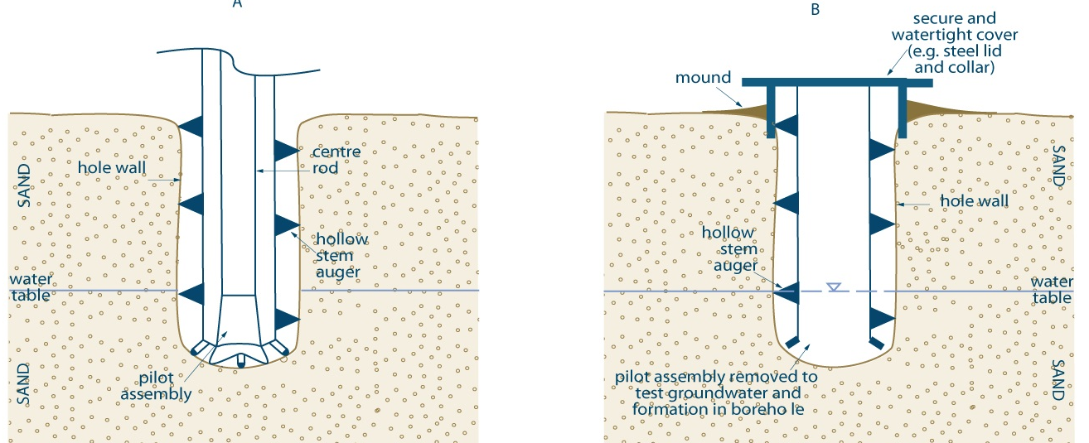
(Ontario, 2019)
As the soil type changes with depth a coring method or rock core drilling could be considered providing undisturbed samples at depth depicting the Rock Quality Designation (RQD), the percentage of solid rock, disturbed or fractured rock.

It is important to note in the previous example of bore hole data, it notes Open Hole drilling was used from a depth of 18m due to pebbles falling into the hole therefore coring was not possible.

Static Cone Penetration Testing would also be recommended and was used in the previous Bore Hole Data up to a depth of 18m only.

BS 1377:Methods of test for soils for civil engineering purposes (2016) and
BRE Digest 64:Soils and foundations to be applied.

- Foundation Design

‘The bearing capacity of the soil is one of the most useful pieces of information as far as the design of the foundation is concerned. Designers need to review the likely load from the building (typically not more than 30 kN/m run of external wall for a two-storey house) and the bearing capacity of the soil, and create a foundation area of transmission which can safely transmit the building load to the ground without exceeding the grounds capacity while providing also for a factor of safety.’ (Riley & Cotgrave, 2018, p. 31)

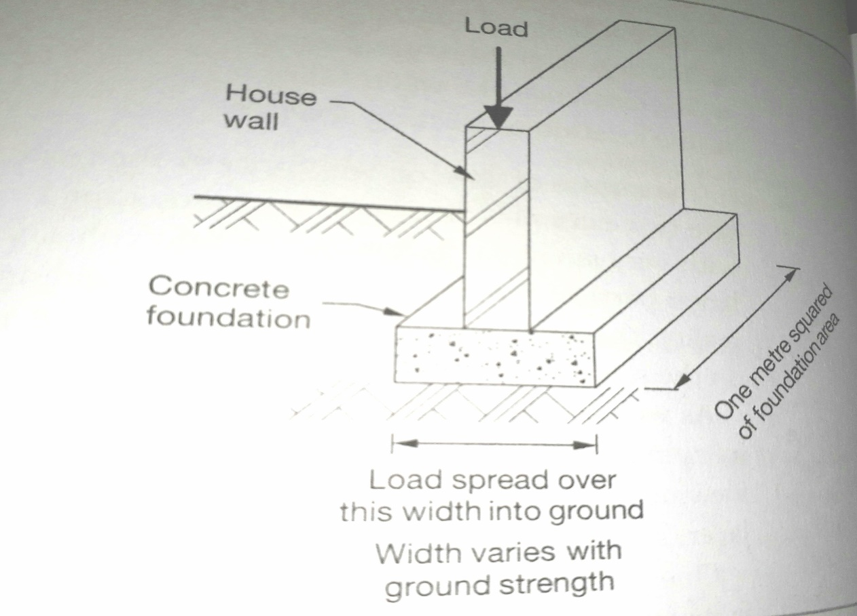
(Riley & Cotgrave, 2018, p. 32)

As the site has been identified as Anthropogenic ground with sandy soil type which has no shear strength, low bearing capacity and will be subject to differential settlement the following foundation type has been recommended:

Raft Foundations, these would be made of reinforced concrete and could cover the area of the entire building footprint ‘the loadings from the building are spread over a large area and avoid over stressing the soil’. (Riley & Cotgrave, 2018, p. 109)

Floor Plans of Raft Foundations
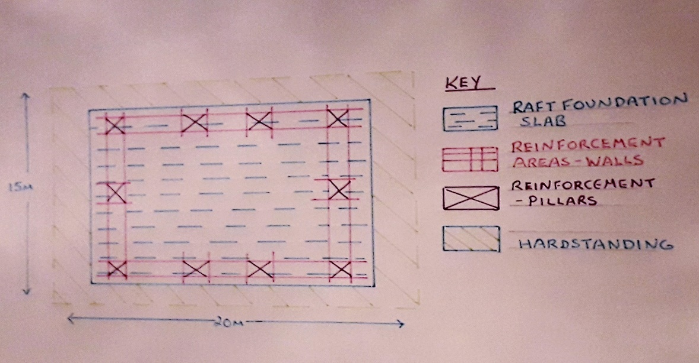
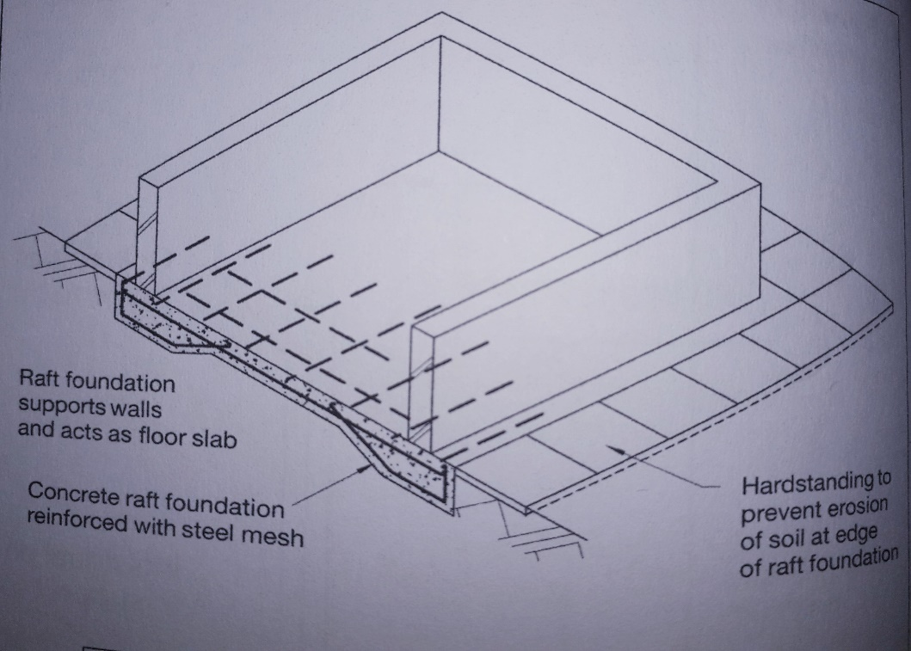
(Riley & Cotgrave, 2018, p. 110)
Additional strengthening would be required in the external wall areas to include extra beams to increase the buildings load bearing capacity, ‘the raft is thickened at these locations and/or is provided with extra reinforcement’ this also has a ‘function in preventing erosion of the supporting soil at the raft edges’. (Riley & Cotgrave, 2018, p. 111) This site could be subject to higher levels of erosion due to its sea front position, soil type and high wind forces. Any steel used in the build would need to be protected from salt water corrosion.

Section Plan of Raft Foundations
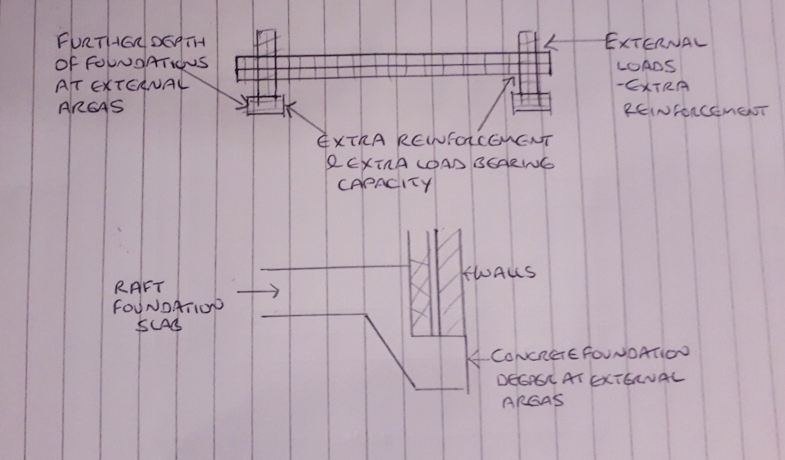
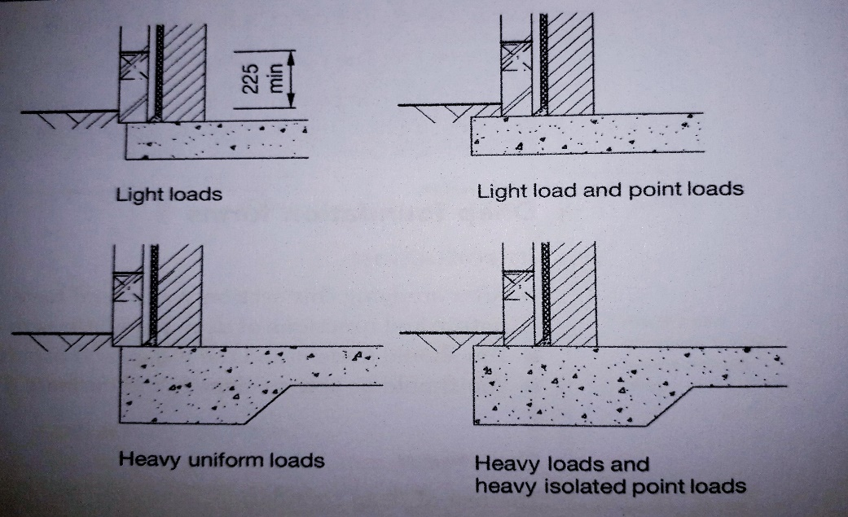
(Riley & Cotgrave, 2018, p. 111)

The Earth Science Partnership report for site E3B ‘The Sidings’ Langdon Road in Swansea used piled foundations in combination with raft foundations, the piled foundations provided extra support to a depth of 24m. This could be a consideration for this build although piled foundations are more costly and may not be necessary for a single storey buiding.

British Standards to be applied:
BS 8004: Code of practice for foundations (2015)
BS 6399 Part 1: Loadings for buildings. Code of Practice for dead and imposed loads (1996)
BS 8103 – 1:Structural design of low-rise buildings (2011)

References
Brown, D. (1919). Swansea Union Map
Considerate Constructors Scheme. (2019, November 28) <https://www.ccscheme.org.uk>
Geology of Britain Veiwer. (2019, November 30) <www.mapapps.bgs.ac.uk/geologyofbritain/home.html>
Nantel, A. (2019, July). Code Of Practice For Ground Investigations 2.
Nantel, A. (2019, July). Codes Of Practice For Ground Investigation 1.
Nantel, A. (2019). Site Investigation Assignment .
National Library of Scotland. (2019, October 29). Retrieved from National Library of Scotland: https://maps.nls.uk
Ontario (2019, December 6th). Test holes and dewatering wells
Riley, M., & Cotgrave, A. (2018). Construction Technology 1 House Construction. London: Palgrave.
Earth Science Partnership (2017) Site Investigation E3B Swansea - Pobl
Stadtplan Swansea. (1941).
Swansea County Borough. (1948). Ordnance Survey Map.
Swansea Town Map South Ward. (1800). Swansea Town Map.
The Centre of Swansea. (1897). Ordance Survey.

Bibliography
Geology of Britain Veiwer: www.mapapps.bgs.ac.uk/geologyofbritain/home.html
Brown, D. (1919). Swansea Union .
(2017, October). Earth Science Partnership. Site Investigation E3B Swansea - Pobl
(2013, June). Earth Science Partnership. Site Investigation Trawler Road Swansea Marina - Pobl
Nantel, A. (2019, July). Code Of Practice For Ground Investigations 2.
Nantel, A. (2019, July). Codes Of Practice For Ground Investigation 1.
Nantel, A. (2019). Site Investigation Assignment .
National Library of Scotland. (2019, October 29). Retrieved from National Library of Scotland: https://maps.nls.uk
Riley, M., & Cotgrave, A. (2018). Construction Technology 1 House Construction. London: Palgrave.
Stadtplan Swansea. (1941).
Swansea County Borough. (1948). Ordnance Survey Map.
Swansea Town Map South Ward. (1800). Swansea Town Map.
The Centre of Swansea. (1897). Ordance Survey.
City & County of Swansea Contaminated Land Inspection Strategy 2005
Face to face meeting with Archivists at Swansea Civic Centre
Face to face meeting with Ian Smith Curator at Swansea Museum
https://naturalresources.wales/guidance-and-advice/business-sectors/planning-and-development/advice-for-developers/environmental-assessment/?lang=en
http://www.largeimages.bgs.ac.uk/iip/hydromaps.html?id=south-wales.jp2
https://www.gov.uk/guidance/protected-areas-sites-of-special-scientific-interest
https://www.gov.uk/guidance/conserving-and-enhancing-the-historic-environment
www.gov.uk-landcontaminationriskmanagement
https://www.walesonline.co.uk/
https://www.ontario.ca/document/test-holes-and-dewatering-wells-requirements-and-best-management-practices/6-constructing-hole-casing-covering-test-hole-or-dewatering-well
www.geologyofbritain/home.html

Appendix
Appendix A – Swansea Beach
Directly adjacent to the site.

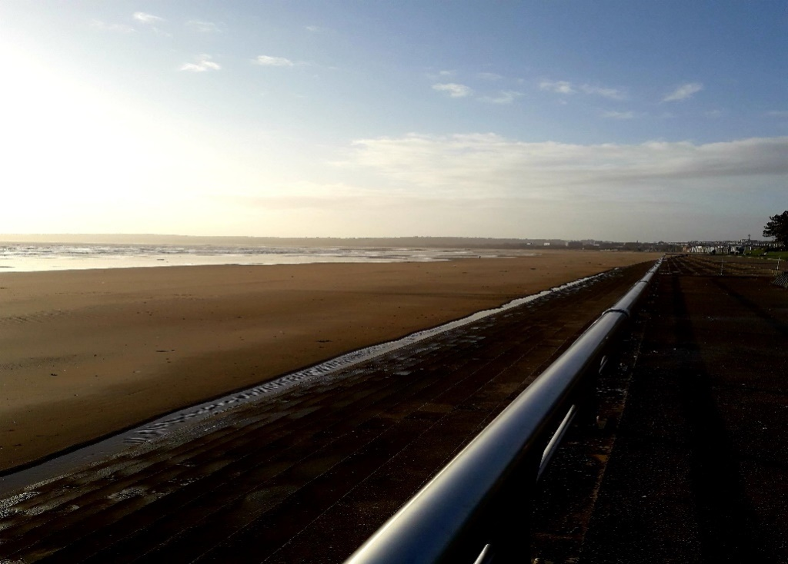
(James, 2019)

Appendix B – Wind Damage
The site shows signs of direct wind flow and damage to the trees
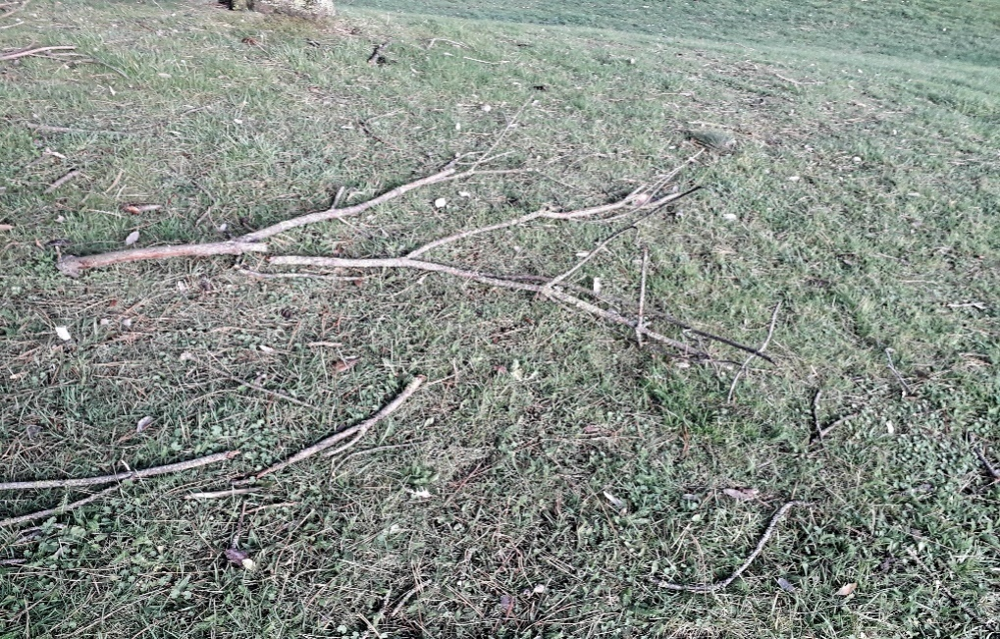
(James, 2019)

Appendix – C
Area where two manholes and a drain were located

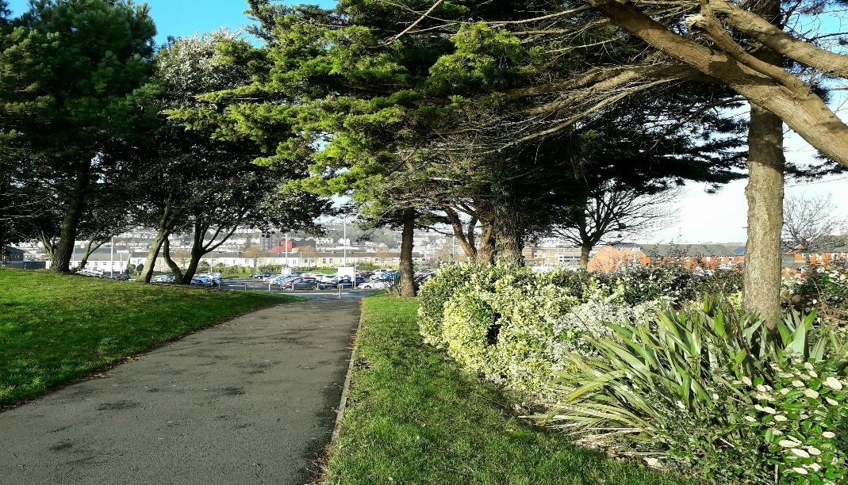
(James, 2019)

Appendix – D
Road leading into the South Marina area, considerations for a Traffic Management Plan

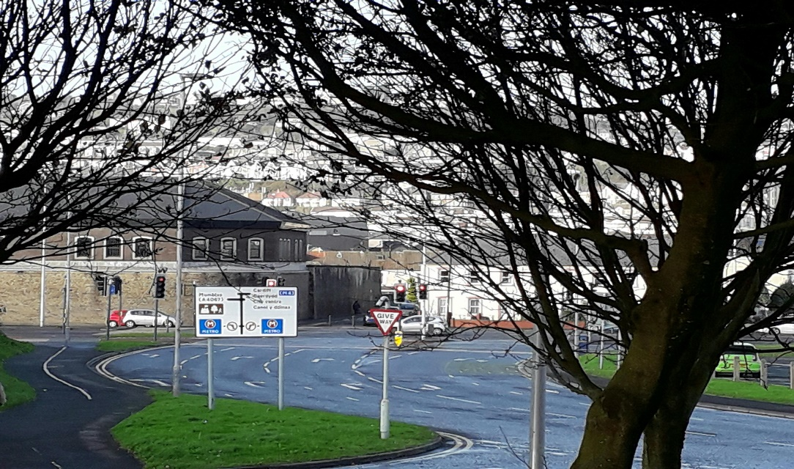
(James, 2019)

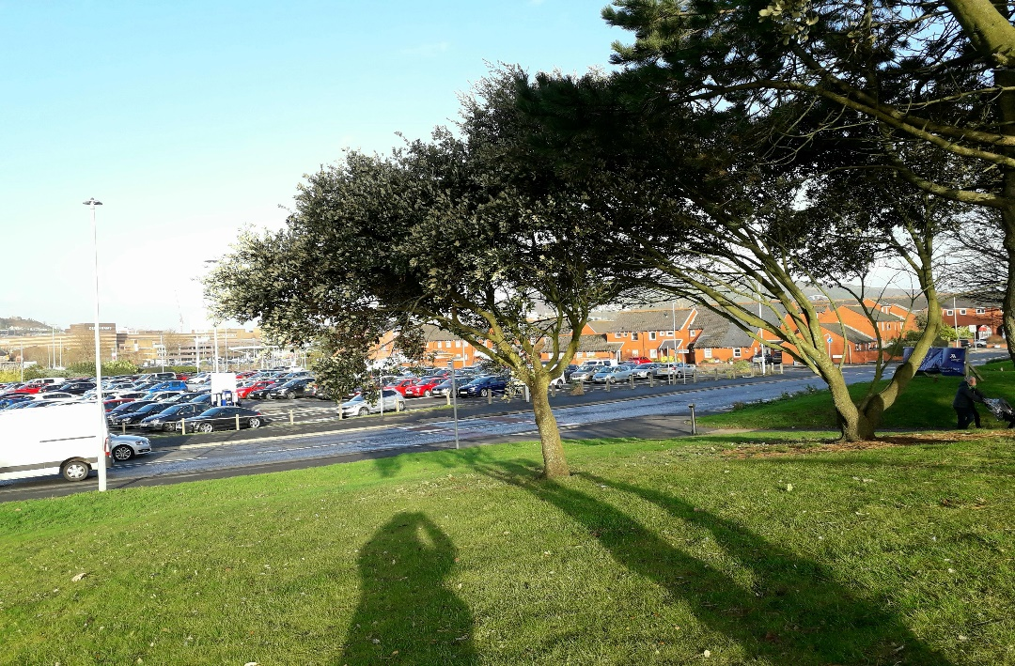
(James, 2019)

Appendix – E
Raised landscaped areas next to the road

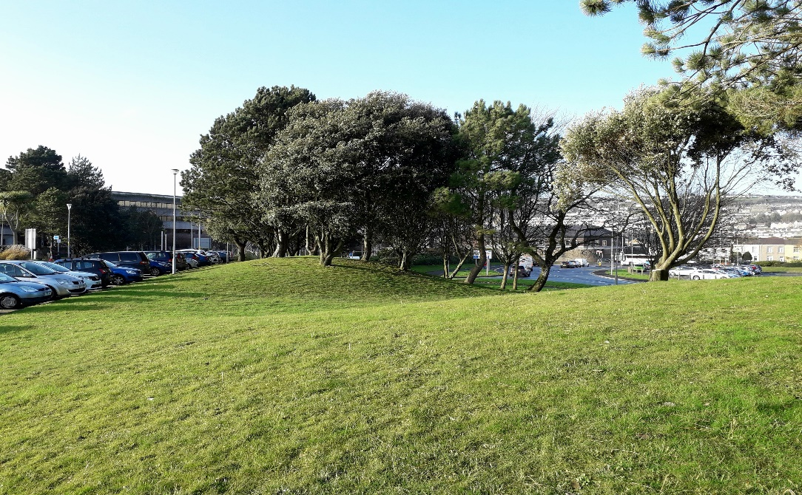
(James, 2019)

Appendix – F
Swansea after the Blitz

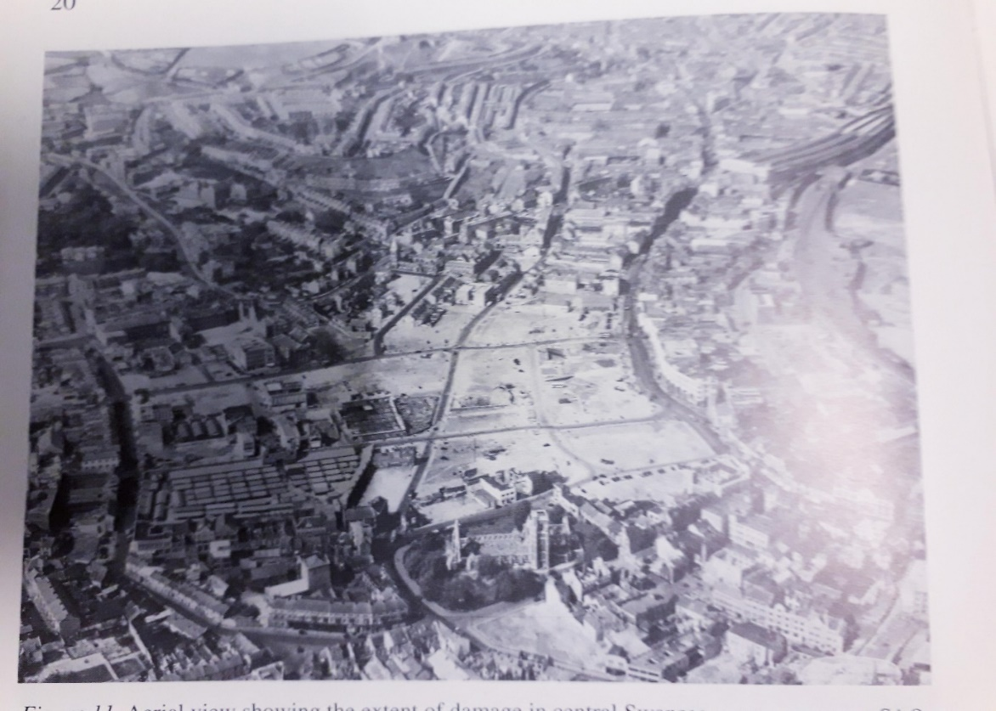
The ‘Three Nights’ Blitz - County Borough of Swansea Fire Service Report
Swansea City Archive Office

Appendix – G
Soil Classification (Nantel, Code Of Practice For Ground Investigations 2, 2019)
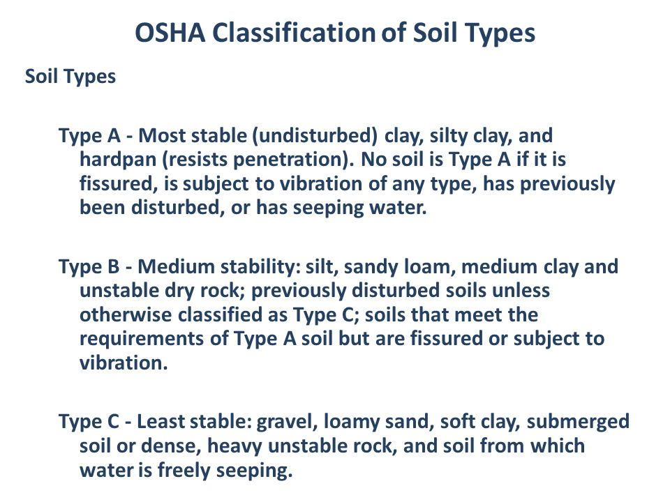
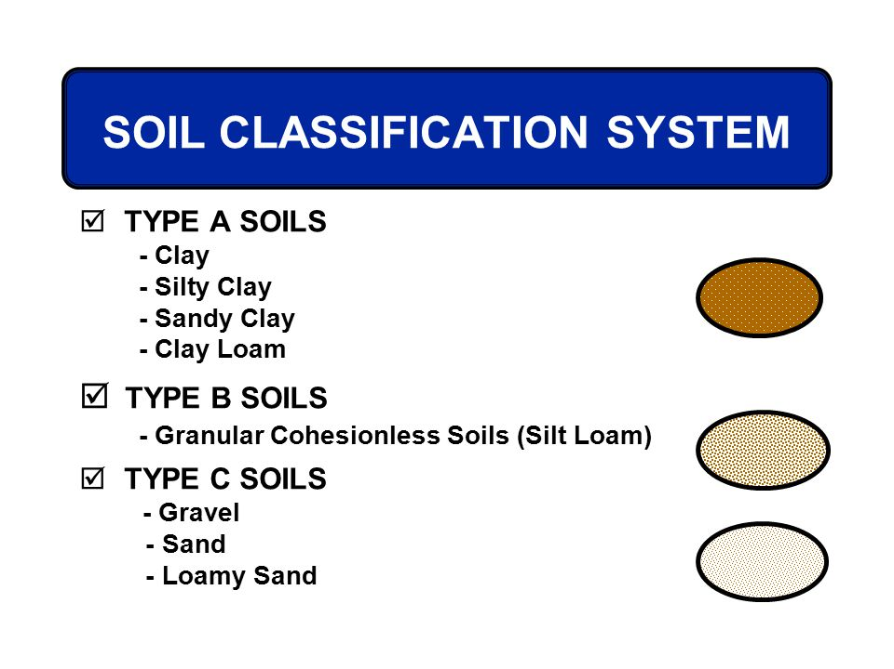

Appendix – H

Environmental Impact Assessment (EIA)
What? EIA is a process for identifying the positive and negative environmental effects of proposed developments. It applies to projects which are likely to have significant effects on the environment because of their nature, size or location. The developer submits the EIA report along with the proposal to the decision makers (e.g. the local planning authority if planning permission is needed), and the decision makers consider the EIA along with the plan when deciding whether to grant consent.
Why? This allows the developer to consider and develop means to avoid, reduce or remedy any adverse environmental effects. It also makes the decision makers more aware of the predicted effects of the proposed project before granting consent for development.
Who is responsible for doing an EIA? The developer or project proponent.
Where to find out more about this?
For further information on EIA in Wales, see the Welsh Government’s Environmental Impact Assessment webpage
https://naturalresources.wales/guidance-and-advice/business-sectors/planning-and-development/advice-for-developers/environmental-assessment/?lang=en

