SOFTWARE DEVELOPMENT
ASSESSMENT 2
Module Code: ACCC4006
Student Name: VERZHINIA ILIEVA
Student ID: 1912496

TABLE OF CONTENTS
1.0. INTRODUCTION 3
2.0. PART A (UNDERSTANDING) 3
2.1. DEFINE ARRAYS AND EXPLAIN THE IMPORTANCE OF ARRAYS IN PROGRAMING. GIVE RELEVANT EXAMPLES TO SUPPORT YOUR ANSWER. 3
2.2. IN OOP DEFINE INHERITANCE, USE SUITABLE CODING EXAMPLES TO DEMONSTRATE YOUR ANSWER. 6
3.0. PART B (TESTING) 9
3.1. WRITE A SHORT ESSAY ON TESTING. 9
4.0. PART C (IMPLEMENTATION) 10
4.1. CONSTRUCT A PROGRAM USING OOP CONCEPT, FOR THE PURPOSE REPRESENTING A CAR 10
5.0. CONCLUSION. 11
REFERENCES. 12

INTRODUCTION
Over time, C# has become a more efficient and effective programming languages mainly due to its features and capabilities that supports object-oriented programming. C# allows the use of single variables and reuse of the source code over and over again across different programs and applications. It is therefore very effective and efficient to use in the implementation and application of OOP concepts discussed in this report shortly. The application of these OOP concepts in C#, reduces the workload of developers and unnecessary coding. This is attributed to its ability to support use of single variables and inheritance. This report will first focus on arrays and how they are implemented by developers using C#. The report will also discuss the concept of inheritance and how it is achieved in C#. Finally, it will look at the methods available for program testing in C# and how the concepts of OOP can be applied in constructing viable programs.

PART A -UNDERSTANDING

ARRAYS AND THEIR IMPORTANCE IN PROGRAMING.
Arrays are simply represented by a single variable name and contains a set of uniform data elements encapsulated by square brackets. These elements can be accessed individually by use of the variable names and either by one or several indexes (individual data elements) encapsulated by the square brackets. Suppose, “Array” represents the name given to the set of data elements and “3” to represent the index, this can be expressed as string EmployeeName = Array [3]. Array represents the name given to the data elements encapsulated by the square brackets while 3 represents the individual data elements (index). The data elements in the square brackets are mostly of the same type i.e., can be, for instance, a set of names or random numbers etc.
According to (Solid and Schrotenboer, 2018) arrays are dimensional and can be grouped depending on the nature or formation of the data elements i.e., they can either be unidimensional (vectors) or multidimensional (matrices).
In C#, arrays are of two types, unidimensional or multidimensional. Multidimensional arrays can either be rectangular or jagged depending on how the elements appear in the arrays i.e., a rectangular array is made up of sub-arrays each containing data elements enclosed in a single set of square brackets regardless of the number of dimensions they take. For example, int x = Array [2][2] that indicates a 2x2 matrix.
jagged arrays are made up of independent sub-arrays with different lengths with each sub-array enclosed in separate square brackets. For example, jagArray[2][6][8].
Arrays are applied in mathematics when it comes to working with complex vectors and matrices which is achieved through the use of multidimensional matrices like 2x2 matrices (Nakov and Kolev, 2013). The following example illustrates how we can use arrays to find the sum of a 2x2 matrix.
using System;
public class Example
{
public static void Main()
{
int i, j, n;
int[,] array1 = new int[10, 10];
int[,] array2 = new int[10, 10];
int[,] array3 = new int[10, 10];
// setting matrix row and columns size
n = 3;
Console.Write("Enter elements in the first matrix:\n");
for (i = 0; i < n; i++)
{
for (j = 0; j < n; j++)
{
array1[i, j] = Convert.ToInt32(Console.ReadLine());
}
}
Console.Write("Enter elements in the second matrix:\n");
for (i = 0; i < n; i++)
{
for (j = 0; j < n; j++)
{
array2[i, j] = Convert.ToInt32(Console.ReadLine());
}
}
Console.Write("\nFirst matrix is:\n");
for (i = 0; i < n; i++)
{
Console.Write("\n");
for (j = 0; j < n; j++)
Console.Write("{0}\t", array1[i, j]);
}
Console.Write("\nSecond matrix is:\n");
for (i = 0; i < n; i++)
{
Console.Write("\n");
for (j = 0; j < n; j++)
Console.Write("{0}\t", array2[i, j]);
}
for (i = 0; i < n; i++)
for (j = 0; j < n; j++)
array3[i, j] = array1[i, j] + array2[i, j];
Console.Write("\nAdding two matrices: \n");
for (i = 0; i < n; i++)
{
Console.Write("\n");
for (j = 0; j < n; j++)
Console.Write("{0}\t", array3[i, j]);
}
Console.Write("\n\n");
}
}
The application of arrays in programming is seen in the formation of such data structures as lists and strings. Arrays form an important component of these data structures. In the computing industry, the designing of high-speed computer processors and storage devices are programmed using these concepts. For instance, the memory of a computer is a one-dimensional array with their indices representing the memory address spaces. These arrays are used to optimize the limited resources in the computing industry as seen in the designing of processors and storage devices like hard drives. Also, given that the data structures are formed by array elements that mostly holds data types of the same size and of same data types, this makes arrays very resourceful in the computing industry because their element indices can be executed/computed during the runtime process. This is made possible since arrays allows for single iterative statements hence ability to process numerous elements of arrays of unspecified value or content. For example, through indexing, an array element can be easily accessed by using the array name i.e., assuming an element e is enclosed in a set of elements (same square brackets) of an array we can easily access it by only referring to the name given to the array as follows, wage increase = allowances [3];

IN OOP DEFINE INHERITANCE, USE SUITABLE CODING EXAMPLES TO DEMONSTRATE YOUR ANSWER.
According to (Rashed, 2006), inheritance in OOP refers to a situation where the characteristics or actions of a parent object or class are picked up or obtained and passed on to its child class or child object. In C#, the child class is referred to as the derived class while the parent class is referred to as the base class. This process enables OOP to achieve such concepts as code reusability and expansibility. That simply means that a code can be used more than once and in many different applications without any alterations or manipulation of the original source code while expansibility can be simplified as the ability of a system module to be expanded or advanced to adapt to changes in requirements or functionality of the module should the need arise.
Reusability in OOP is attained as a result of reduced instances of repetition between different classes while expansibility through a process called sub-classing where a class passes on its properties or behaviors to a subclass. Also known as inheritance. In C#, inheritance is denoted by a full colon operator i.e., Organization: HRM this implies that HRM acquires all the attributes of the class organization.
In C#, inheritance can take different forms. It can be single-level, multi-level or hierarchical or multiple inheritance. In single-level inheritance, we can use the following example to demonstrate.
Suppose we have a class SalesPersonnel which happens to have a sub-class AssistantSales assigned different brackets of wages. This can be well demonstrated by the example below.
using System;
public class SalesPersonnel
{
public double salary = 450.25;
}
public class AssistantSales: SalesPersonnel
{
public double commission = 125.25;
}
class ShowInheritance
{
public static void Main(string[] args)
{
AssistantSales s = new AssistantSales();

Console.WriteLine("Salary for AssistantSales: " + s.salary);
Console.WriteLine("Commission for AssistantSales " + s.commission);
}
}

Putting into considerations the example provided above, there are two categories of wages for the AssistantSales, normal pay and bonuses. But because already we know what the AssistantSales earns from the SalesPersonnel class, the sub-class wages can be ascertained by inheriting the wages of the SalesPersonnel and thus avoiding redefinition of the AssistantSales class which simply tells us how much the assistant earns as shown below;
Ouput:
Salary for AssistantSales: 450.25
Commission for AssistantSales 125.25

When it comes to multi-level inheritance, a given class acquires its attributes from yet another class that has acquired its attribute from another class as shown by the example below;
using System;
public class Animal
{
public void origin()
{
Console.WriteLine("Originates from Amazon forest");
}
public class CatFamily:Animal
{
public void runningability()
{
Console.WriteLine("Runs fastest");
}
public class Jaguar:CatFamily
{
public void canCatch()
{
Console.WriteLine("Can catch a squirrel monkey");
}

class Inheritance
{
public static void Main(string[] args)
{
Jaguar j = new Jaguar();
j.origin();
j.runningability();
j.canCatch();

}
}

}
}
}
In the above example, we can clearly see that canCatch is inheriting its attributes from class CatFamily which in turn inherits from class Animal and hence a multi-level inheritance. The final output will be as follows;
Originates from Amazon forest
Runs fastest
Can catch a squirrel monkey

PART B (TESTING)

WRITE A SHORT ESSAY ON TESTING.
During the entire programming stages, testing forms the most important stage that has to be undertook with great accuracy. Testing is meant to ensure that the program in question is doing exactly what the developer intents it to do. It is during this stage that we can determine if our program is complete, effective and efficient in its functionalities. According to (Saunois, 2016), there are various types of testing that can be used to achieve all these. Some of which are black box, grey box and white box.
The first type is testing is the black box testing where emphasis is put on the functionalities of the system in question rather than its internal design and structure. The focus is mainly put on the system functionality – does the system output or perform what it was intended to do? Black box testing is thus recommended at the final stages of system development.
White box testing on the contrary, focuses on the functioning of the system with reference to its internal design and structure. It reviews and tests all the internal modules and their functionalities and determines if the components or modules making up the system are doing exactly that what they were designed to do. It is at this stage where the source code of the modules making up the system are checked line by line and requires good programming knowledge to carry out this type of testing on a system.
Gary box on the other hand, it is a combination of the previous two (white and black box testing). It focuses on both the internal designs and structures of the modules making up the system, their functionalities and the overall performance and functioning of the entire system. Here, the tester is required to have a good understanding of the system its internal components and good programming knowledge.

PART C (IMPLEMENTATION)

CONSTRUCT A PROGRAM USING OOP CONCEPT, FOR THE PURPOSE REPRESENTING A CAR
Code
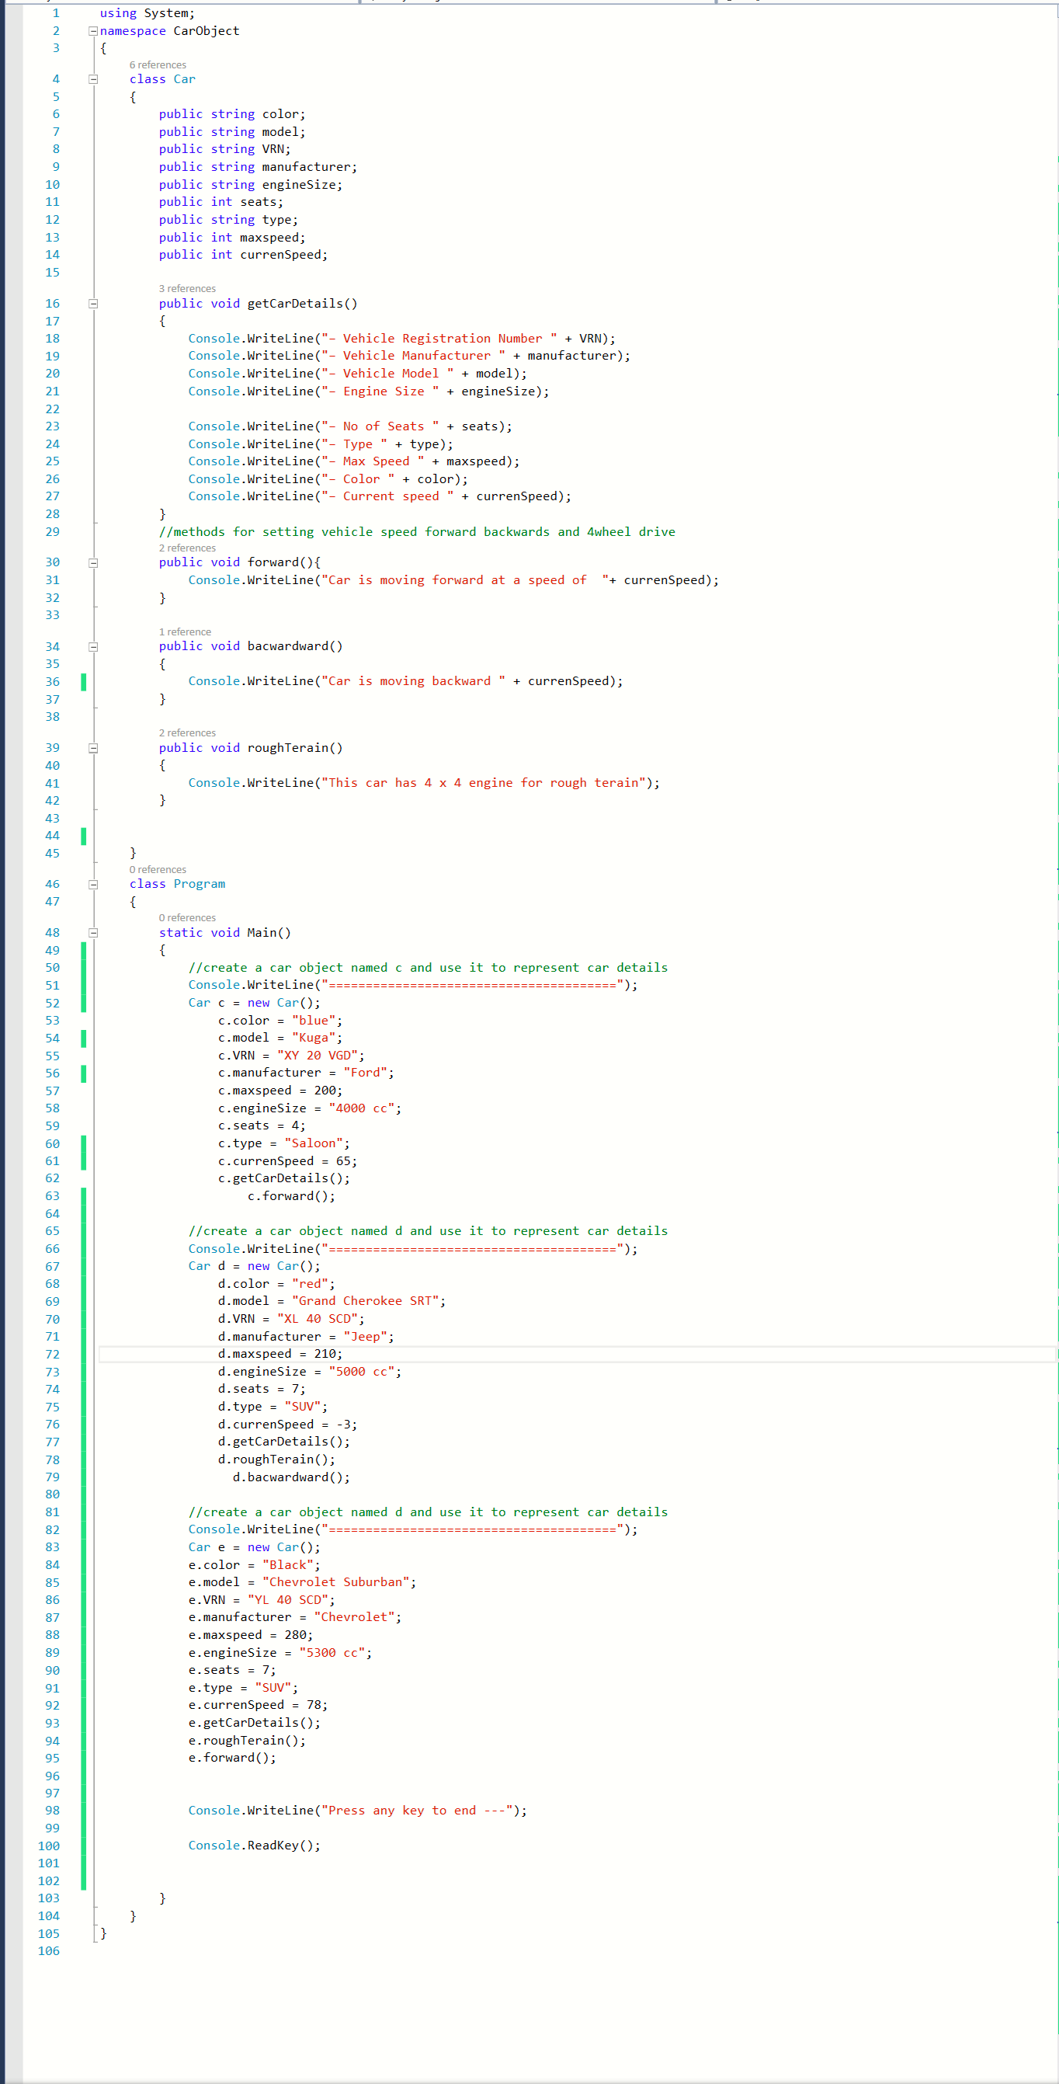
Output
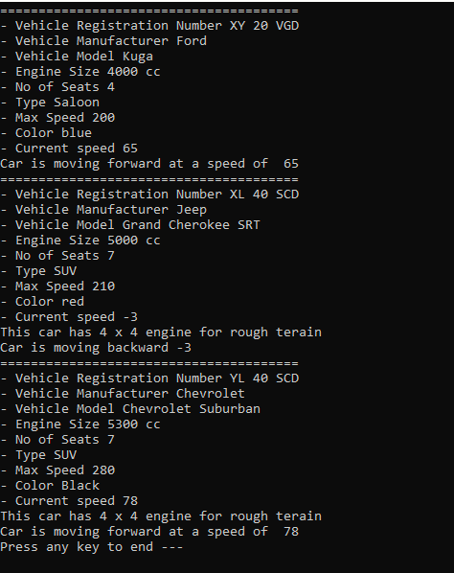

CONCLUSION.
The application of C# in OOP and its concepts, really simplifies the entire program development process as it enables the use of such concepts as arrays implementation and inheritance. This feature has given C# as a programming language, great capabilities when it comes to complex programming problems. For instance, through the use of arrays, it has helped solve complex mathematical problems like matrices containing significant amounts of data. Arrays also plays a very big role in the computing industry. It has enabled computer engineers to design computers with high processing speeds and effective storage devices that take less installation space – made possible by use of arrays since they can be accessed easily and processed faster. Code reusability and expansibility has greatly encouraged inheritance which becomes an important component of C# data structures which in turn makes program coding and development easier, faster and efficient. We have also seen that testing of the programmes we develop during or at the final stages is very key as it helps us ascertain if the systems, applications and programs we develop are functioning properly according to the intended purpose with efficiency, durability, effectiveness and precision.

REFERENCES.
Nakov, S. and Kolev, V. (2013). Fundamentals of Computer Programming with C#. Sofia, Bulgari: Svetlin Nakov & co.
Rasheed, F. (2006). Programming Heaven. Fuengirola: Synchron Data S L.
Saunois, L. (2016). Black box, grey box, white box testing: what differences?. [online] Available at: https://www.nbs-system.com/en/blog/black-box-grey-box-white-box-testing-what-differences/ [Accessed 16 Aug 2020].
Solis, D. and Schrotenboer, C. (2018). Illustrated C# 7, 5th ed. New York: Springer.

