The impact of the Romans and Greeks on the Celts in Italy- Specifically by examining statues. How Romanised and Hellenicized is Celtic sculpture?

Hellenicize
(British Hellenicize)
verb
- with object: To make Greek; to Hellenize.

Romanize
(British Romanise)
verb
[with object]
- historical Bring (a region, people, etc.) under Roman influence or authority.
‘romanized buildings’

(Oxford Online Dictionary)

It is difficult to know how much impact the Romans and the Greeks had on the Celts, for whilst there is information on the pre-Roman Celts, in comparison to what we know that is Romanised and what may have been Hellenized there is a lack in information.
In looking at impacts other cultures and civilisations have had on the Celts, it is clearly the Romans who are most known for impacting and changing the Celtic culture and civilisation as a whole - most prominent being the change from the Druidic traditions to Christianity that the Romans brought. The impact of the Greeks is less public and will not be the main focus of this essay, as the Romans are far more interesting here.

Our basic comprehension of Roman and Greek sculpture brings to mind the statues of carved, clear marble or some such stone, that has been cleanly shaped. Much of the figures presented by this means are deities or leaders - mostly male with the occasional female (goddess). There is also a marked display of nudity. The influence of the Greeks on Celtic sculpture matches largely with that of the Romans. Furthermore, the Greek interference with the Celts comes later in the 1st-3rd Centuries, which is not the focus of this assignment.
Beyond this basic understanding of what the Greeks and the Romans used their sculpture to present, it is likely that they used sculptures and their other artwork as a means of propaganda. They promoted their leaders, their gods and their victories in a public way that held more subtlety and would likely have a longer lasting impact than propaganda speeches would. Using image as a means of propaganda is certainly pervasive, but can also be considered a non-forceful means of promoting oneself. Open attempts to change people’s opinions and cultures such as speeches, marches are less intrusive than the subtlety of artwork.
Celtic sculpture, on the other hand, is different as it uses metals, abstract shapes and focuses on animals instead. It is used to depict not the whole human form, but the head - either in a detailed display or an ambiguous shape. Even the smaller works are generally abstract or aniconic before the definite First century B.C.
One might say, that the two art types (Celtic and Roman) are incompatible (Cunliffe, 1993). It seems as though, whilst there are Celtic goods from the pre-Roman years, Roman art and culture took over that of the Celts once they had control of them.

An unfortunate issue in examining the Romanization of Celtic sculpture is in the fact that very little Celtic wood art and datable stone survived to be examined, and any that has survived tend to appear crude due to decay and/or weathering. Metalwork has been found but it does not provide us a full understanding of Celtic sculpture (Vermule, 1977).

In the sense that Roman, Greek, and Celtic art has some focus on head and/or bust works, there are some similarities. However, Celtic heads and busts in comparison to Roman and Greek ones, there is a marked difference in the detail and focus. The Celtic head is less clear and chiselled than those produced by the Greeks and Romans. The protruding the eyes and noses to a point of exaggeration are a marked difference. In comparison to a Roman bust, it looks less like a human head. However, both are unrealistic representations of a human head. The Roman sculptors remove all of the human imperfection from their heads to be genuine, and the Celtic head is disproportionate to a typical head - except possibly a male teen going through puberty! Interestingly enough, whilst much of Celtic culture was Romanised, the art - specifically sculpture - that I have found appears to be largely unchanged. This, however, may be due to the fact that this essay focuses on the earlier years of Roman control of the Celts.
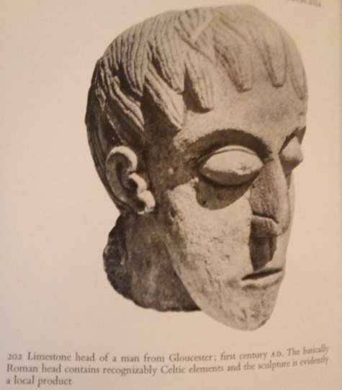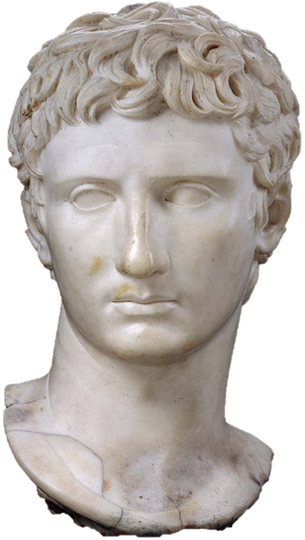
(Cunliffe, 1993) (Augustus, 2018)

There have been many Greek and Roman excavations where notes have been improperly or not taken at all concerning where and when sculptures can be placed. This leads to a number of ‘lost’ sculptures (Vermule, 1977). This does not, however, make the archaeological evidence any harder to interpret, as there is evidence to be extrapolated, regardless of any vagaries.

Craftsmen, sculptors, leaders and immigrants, to name a few, were by and large responsible for the Romanization of the Celts. Craftsmen and sculptors, whilst they did have a large impact on Celtic culture and style, were not considered to be forceful. Any force put forward was by the Roman conquerors and leaders (Champion, 2003). Regardless of any force used, the influx of new types of craftsmen and sculptors would have given the Celtic craftsmen and sculptors a new angle of looking at and doing their work. Ideas would have been shared, and a mutual influence in art would begin. The cultural diversity that occurred upon the introduction of another way of life and the new ideas it brought is typically unsurprising, as humanity in itself and as a people are adaptable.

An important point of note when discussing the spread and growth of Roman sculpture, is that the Romans managed to create a system of standardisation and mass-production of their works. This was achieved by means of a series of markings on a rough statue base that, once properly understood, followed and carved, led to a near-replica of the original work (Champion, 2003). The image below shows the idea in use on a basic bust.
A basic explanation of the process brings attention to the points noted on the busts below- these lumps or marks show the distances and areas for sculpting. Basic carving could be done by eye, but more accuracy was attainable through callipers. The more marks there were, the more of an exact copy of the original could be produced. The tombstone to the right in this picture contains images of all the tools of the trade needed for this. (the tombstone itself likely belonged to a craftsman or sculptor) (Champion, 2003).
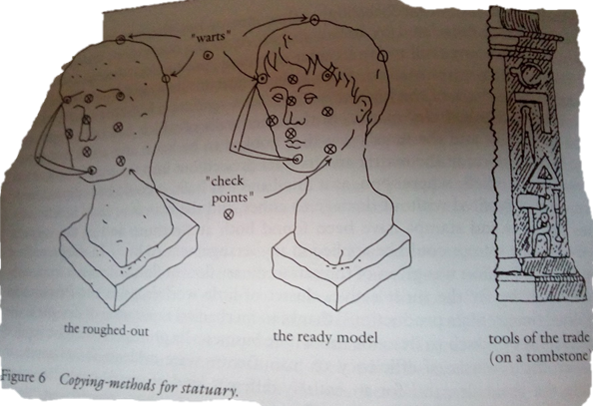 (Champion, 2003)

This was a new concept to many cultures, not just the Celts, and many took the idea and did their best to adapt it. This new system was the first push towards any form of the industrial culture we know today. It would also have lowered the price of sculptures, as less work was needed to create them. In terms of the impact this would have had on the Celts, the statues and sculptures would have a larger number available to use as propaganda.

Celtic sculpture in itself is neither Hellenicized nor Romanised. This is due to the fact that, Celtic sculpture is that which was created before the control of the Romans and the influx of the Greeks. This changes when one moves from the Celtic times to the Romano-Celtic times, wherein things begin to change for the Celts. The fact that there is Celtic sculpture remaining either indicates the ability of the Celts to preserve their works, or that the Romans were not entirely interested in taking over the culture of the people they conquered.

Word Count: 1253

Source List:

Anon, Hellenicize | Definition of Hellenicize in English by Oxford Dictionaries. Oxford Dictionaries | English. Available at: https://en.oxforddictionaries.com/definition/hellenicize
[Accessed February 4, 2019].

Anon, Romanize | Definition of Romanize in English by Oxford Dictionaries. Oxford Dictionaries | English. Available at: https://en.oxforddictionaries.com/definition/romanize
[Accessed February 4, 2019].

Anon, 2018. Augustus. Museum of Fine Arts, Boston. Available at: https://www.mfa.org/collections/object/augustus-151325
[Accessed February 4, 2019].

Bradley, G. et al., 2008. Ancient Italy: regions without boundaries, Exeter: University of Exeter Press.
Chapters 3 & 11

CHAMPION, 2003. Roman Imperialism: Readings and Sources, Oxford: Blackwell Publishers.

Cunliffe, B.W., 1993. The Celtic world, New York: St. Martins Press.

Vermule, 1977. Greek Sculpture And Roman Taste, University of Michigan.

Wheeler, M., 2011. Roman art and architecture, London: Thames and Hudson.
Pg 216

