UNIVERSITY OF WALES
TRINITY SAINT DAVID

Introducing the Modern Workplace
ASSESSMENT II
RYANAIR
ORGANISATION

Students: Claudia Ion (1916922)
Cristian Ghiburcea (1916923)
Marius Negoescu (1917715)

Lecturer: Dr. Gregory Cowan

Contents

Introduction 3
Aim and objective of the research: 4
Ryanair - history and background: 4
Ryanair – low-cost business model: 5
Ryanair - organizational behavior: 7
Ryanair - leadership: 9
Ryanair – culture: 11
Conclusion 12
References 14
Appendix 15

Introduction

In the last decades, the air transport industry was in a continuous stage of development, firstly due to the debut low-cost companies. These companies made travelling by a plane an activity you do for professional and personal purposes.
The term 'low-cost', was introduced for the first time by the company Southwest Airlines Co. in 1917, USA, which adopted a series of crucial changes that later resulted in a highly increased profit over a long term. In Europe, this financial strategy spread very late, in the '90s, by Ryanair and Easy Jet. These companies made a major series of changes such as decreasing the level of comfort to a certain degree compared to their rivals, but also changing certain services which were free up until then. Besides these, they started to put secondary airports in use and reduce to amount of employees as much as possible, making the ones left have stable roles. Also, they created an online seat booking system to make the purchase of the tickets easier but also to quit collaborations with other companies.
Initially, these changes were looked upon by many airlines as they were going to be put in use in the following years so they do not lose the number of customers to low-cost airlines. A good example in this case would be British Airways Company; they ignored rivals such as Ryanair and Easy Jet to later then be forced to establish a low-cost side of the company. There are also companies which made furthermore changes, introducing a certain number of low-cost tickets per flight. Therefore, the majority of these companies' rivals had to adapt to these changes by even cancelling certain flights to Europe, mostly long-haul flights, therefore conceding victory to low-cost companies.

Purposes of the research:

In this assessment, the company Ryanair LTD will be meticulously analyzed. Some important objectives of the research are pointed below:
- Brief description of the company and its history;
- How the company functions and their many long-term and short-term goals;
- The main contributing factors to low-cost airlines increasing over the last few years.
- Identifying some crucial methods created by Ryanair in reducing price strategy and determining if they have been changed during this time;

Ryanair – history and background:

Ryanair is an Irish, low cost company, founded by the Ryan family in 1985, with a share capital of £1 and a staff of 25 people. The company became public in 1987 and initially only doing short flights throughout the United Kingdom. In the following years, there was an extensive process of expansion. As of now, this company owns 470 aircrafts, creates bonds between approximately 200 destinations and 40 different countries. It transports approximately 149 million people every year with more than 2500 flights everyday. It forms the largest part of the Ryanair Holdings family of airlines, and has Ryanair UK, Buzz, Malta Air and Lauda as sister airlines.
Initially, Ryanair was an airline with all different types of services, 2 classes for seats and 3 types of aircrafts. This gave them an annual increase to the number of passengers. However, in 1990, the company went through a massive dispute between the 5 chief executives, leading to a loss of approximately 20 million pounds. Due to decreased profits, a restructuring of the company occurred in the same year, copying the idea of new low-cost model made by Southwest Airlines. The company became the first low-cost airline in Europe (Nortilli, 2014).
A new, fresh team, with revolutionary ideas, led by Michael O'Leary helped Ryanair transform in the leader of air transport in Europe in present. In 1997, the European Union air transport deregulation allowed the airline for the first time to open up new routes to continental Europe with over 3 million passengers on 18 routes carried. The first new routes which allowed passengers to travel outside the United Kingdom were: Stockholm, Oslo, Paris and Bruxelles. In 2000, they launched 10 new European routes, allowing the company to develop financially. In the same year, the company launched the biggest website of booking tickets as of that time, www.ryanair.com, which in the course of 3 months, took over 50.000 reservations weekly. Therefore, Ryanair continued its activity and still doing today, with a significant increase in the number of passengers every year, the company having a clear objective, offering the lowest prices on the market (Tran et al. 2015).

Ryanair – low-cost business model:

Considering the fact that Ryanair started their activity in 1985, having only 25 employees and one airship, later becoming the biggest European operator, having destinations in more than 40 countries and a team of over 5000 employees, we can say that their strategy has been a continuous success.

From the start, Ryanair had an approach to many direct sales. In 2007, they claimed to have more than 90% of their sales through the Internet (Diaconu, 2012). This made the situation easier for both the company and the customers. Internet selling is obviously their biggest asset and the most effective strategy that they introduced. Selling direct to market also allowed the company to have information regarding their buyers. These are also being put at an advantage, as they can compare these prices with others on the market.
There are 6 contributing factors to Ryanair cutting costs: the staff spending, the aircrafts used, the productivity and the costs with the advertising of the company, sub-contracting some costly operations, the elimination of some services offered traditionally free of charge and the airport charges and the flight policies (Barrett, 2004).
The staff from Ryanair's spending strategy is to put emphasis on low costs by minimizing, command and control of employees. These employees might be forced to pay their own food, uniforms, training and sometimes applications for interviews. This is why, Ryanair are currently confronted with issues regarding complaints made for staff members.
Regarding the aircrafts used daily, we can see that in 1999, they started a program to replace and improve them, which cost around 17 billion pounds. The last modernization process took place in 2012, when the old aircrafts Boeing 737 were replaced with 272 new Boeing 737-800 Next Generation aircrafts, which were far more effective. This shows that Ryanair is mindful of not only the profit they make but also the safety and quality of the flights.

Ryanair – organizational behavior:

The management of the company rules over one objective, to keep their annual increase in customers. For this to happen there is a continuous progress regarding the conditions in the flight as much as the safety of both customers and employees during the flight.
Despite the fact that Ryanair has in increase in income every year, they have a weak reputation regarding the services offered to their clients as well as their staff. This can have a negative effect over their success over a long term. The problems in the way the company is ruled, which can transform this successful business in a failure are:
- High turnover of inexperienced staff:
To maintain their low costs, the company prefers the make zero hours contracts with the inexperienced staff or with not enough experience to have the life of their passengers in their hands, in every trip. The employed pilots are bound to pay courses of approximately 25.000 pounds as they start to fly alongside others that are more experienced without being paid. Furthermore, over this period of studies, the future pilots must pay their own stay and food. These factors can suggest a lack of loyalty towards their future staff as well as a wish in working with inexperienced staff.
- Lack of employee benefits or motivation:
Over the course of years, the company realized that their own employees are their biggest investment. Due to this happening, they are not offered any benefits. Therefore a gap between leaders and staff had been created, a situation which can easily become dangerous enough to offer professional services with one experienced staff. Unlike other companies, there can be many factors that show the lack of benefits given to their own staff such as the lowest salaries in comparison to rival airlines, lack of meals and drinks for staff during their work, shifts cu 6 flights per day for 6 to 7 days a week, as well as lack of trust given to their own personnel (Kasten, 2016).
All these conditions of work can determine employees to be unpleased, exhausted and stressed at their own job. Besides from pressure, which can be seen as a positive factor towards improving their performances, stress can only have negative effects because this feeling appears when people have too many requests or responsibilities in too little time, therefore creating an overload. Employees of Ryanair have a higher risk in gaining health problems caused by stress, such as anxiety, depression or decrease of self-esteem. Furthermore, other negative effects of stress can have serious causes over customers, through bad quality services, which results from the unfriendliness and frustration of workers during the flight (Gleave, 2015).
- Brand perception:
Over the last few years, Ryanair has been in a massive development stage customer-wise but also financially. This was due firstly to the safe and low-priced travels. With all these aside, this company has had increasingly poor performance in many surveys. The public categorized the company as having very little interest in their customers, very frequent delays and little to no comfort.
Ryanair has been rated as the worst airline for the sixth consecutive year by Which?, with the consumer group claiming the Dublin-based carrier is still catching out passengers with hidden costs. This survey however, was only made for short-haul airlines and the main things looked upon were boarding, hospitality, seating comfort, food and drink and cabin environment. Other British airlines such as British Airways and EasyJet had far more superior places, each having strong points to attract their customers.
While Ryanair consider themselves the leaders with the lowest prices on the European market, ancillary tariffs seem to contradict them. Many changes of prices such as choosing your seats, handbags or larger luggage and changing the dates of your tickets can change the price considerably, questioning their status of 'cheapest airline'.
As the company develops and consolidates its position as the leader in short-haul European flights, this statement becomes less and less secure as many customers decide to not pick Ryanair, due to unpleasant experiences.

Ryanair – leadership:

The year 1990 gave the company a person which came with several changes in the management team, therefore creating another face for the company. Michael O'Leary is a lucid figure and a key personality in Ryanair management. He owns a style of leadership which is positively aggressive and innovative. Also, he introduced an autocratic approach characterized by a rigorous control of employees often through threats of reducing their benefits or even dismissing them, to therefore stimulate their activity.
In this autocratic leadership style, all interactions in the organization get through to the manager, and the employer controls decision-making process, defining policies and methods to achieve objectives, work activities, relationships and also decides compensations. This is relevant in the company. The organization tries to underline these things to all new staff, specifying from the beginning the splitting of tasks (Sharjeel, 2002).
In reference to McGregor's Theory X-Y, the nature of human beings can be expressed by managerial practice and he divided individuals in two competing theories which dominate the managerial thought-world. First, Theory Y suggests that people are more active especially when they are looking for progress in their professional life; they wish to grow and to take responsibilities. The second one, Theory X, claims that human beings are lazy; not looking forward to make changes and the lack of ambition makes them prefer to be told how to do their job.
To concentrate on reducing the cost as much as possible, this being the main goal of the company, they gain a very strict control over their personnel, the employees therefore having characteristics mentioned in Theory X (Nortilli, 2014). To make a comparison between Southwest Airlines, who's management was fully copied, the leadership and the way they organize things is completely different in both companies, as the American company concentrates on an approach based on frequent communication between all groups of employees, each with well-held positions and a lot of mutual respect. Unlike this, the staff at Ryanair is bound to only follow and do their own duties without mixing them around, being watched strictly by their managers at all time.
Another issue regarding the style of leadership made by Michael O'Leary is the lack of implication from the employees in decision-making and in the process of problem-solving. This lack of implication of the whole team creates problems and an unsatisfactory psychological situation. On a personal plan, the employees at Ryanair take their job as a routine and a source of income, not as an evolution of their career in which they can invest their abilities.

Ryanair – culture:

The culture of an organization is its personality and character. Organizational culture is made up of commonly shared values, beliefs and assumptions about how people should behave and interact, how decisions should be made and how work activities should be carried out. Key factors in an organization's culture include its history and environment as well as the people who lead and work for it. And understanding of organizational culture is essential for effective leadership. Leaders and managers will be better placed to implement strategy and achieve their goals if they understand the culture of their organization.
Each organization has a unique culture which can be influenced by various factors. Ryanair is an important concept in organizational studies, because it influences every aspects of an organization, such as: development, economic performances, employees' reward and control systems, customer service.
An interesting thing in the history of Ryanair is the fact that in their first 5 years, despite the increasing number of customers, had no profit. The company reached considerable profits and growth when the new CEO, Michael O'Leary, has joined the team. Ryanair then became the biggest low-cost airline in Europe (Kasten, 2016).
This success was due to them adapting the leading style of the rival company Southwest Airlines. With all these, the model of the American organization was based on providing low-cost fares along with a high standard of customer service, which could not be fully copied to Ryanair. Thus, their mission became more difficult.
Therefore, Michael O'Leary is highly bonded to the culture of Ryanair. He has his own rules which must be applied. Even though he is a great business man who generates innovations through his brilliant ideas, Ryanair would need a leadership that aims to keep the organization connected and promote the idea of working together.

Conclusion

The European market is characterized by their low tariffs and higher costs which usually result from increased taxes for airports and fuels. Also, airlines operators are confronted with the issue that some airports are too overcrowded. This forces them to use secondary airports more and more often. The most important factor determined by the apparition of low-cost European airlines is the disorder of some aspects in known airlines. Over the time, this factor encouraged airline companies to diversify their methods and strategies which they used, to maintain or improve profits. Therefore, the original model of low-cost companies has been adapted and developed into newer versions over the years.
Ryanair is the leader in Europe's low cast airline market. They have the lowest operation cost in comparison to others. Though, Ryanair has been suggested a couple of times to consider taking customer service more into account, to gain more customer loyalty. Furthermore, they could reduce prices to attract even more customers. The majorities of passengers have responded positively to low prices and accept to losing many offered services by other airlines, just for the prices.
Ryanair has a dominant position in the industry of low-cost airlines, however, the company is confronted with many issues that could decrease their reputation in the future, either for the employees that looking for a place of work or as an air transport provider for customers. Although the Irish airline has the highest profit among lost-cost companies in Europe, it's unlikely to achieve good results in the future unless organizational approaches change.
To sum up, Ryanair’s culture and its low-cost strategy had a major impact on airlines, the tourism industry and society lifestyle. Power and market cultures identified in the airline have not changed since its establishment. The company’s success depended on one other factor: adoption of Southwest Airlines’ low-cost leadership model. A cost-cutting technique was implemented in every aspect of the organization. However, Southwest Airlines’ model’s core idea: to provide low-cost fares along with the highest standard of service was not considered.

References

Barrett S.D., 2004. The sustainability of the Ryanair model. Department of Economics, Trinity College, Dublin.
Diaconu L., 2012. The evolution of the European low-cost airlines’ business models. Ryanair case study. Alexandru Ioan Cuza University of Iasi. Romania.
Gleave S. D., 2015. Study of employment and working conditions in air transport and airports.
Kasten L., 2016. Human Resources in Ryanair.
Nortilli A., 2014. A case analysis of the organisational Behavior of Ryanair and its impact. University of Verona
Sharjeel A., 2002. A personality analysis of Michael O’Leary, CEO of Ryanair.
Tran N. B., Perkinson J., Sinnenberg C., Tarica L., Harrison J. S., 2015. Ryanair Holdings. Robins School of Business, University of Richmond.
https://corporate.ryanair.com/about-us/history-of-ryanair/ , Accessed on 28th August 2020.

Appendix

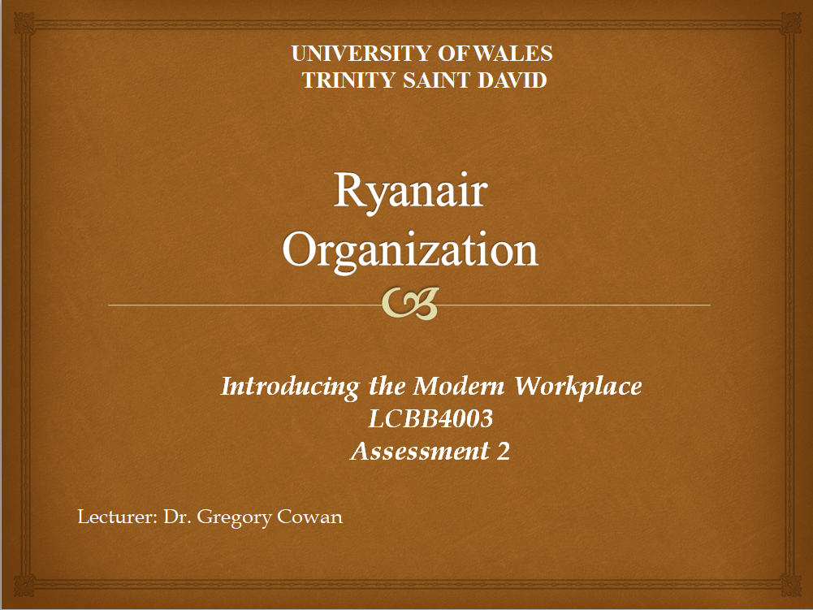
SLIDE 1
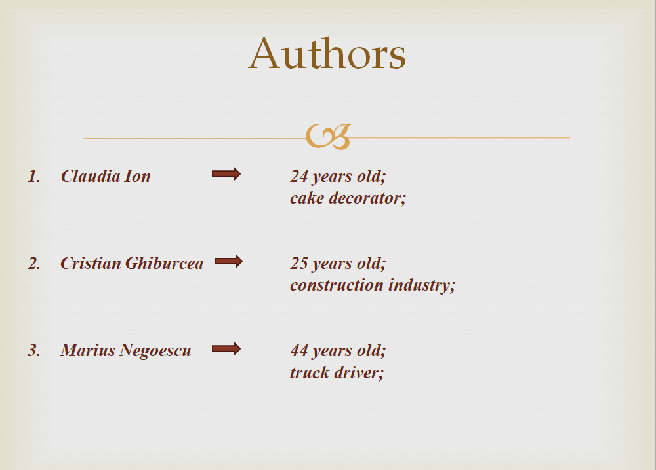
SLIDE 2

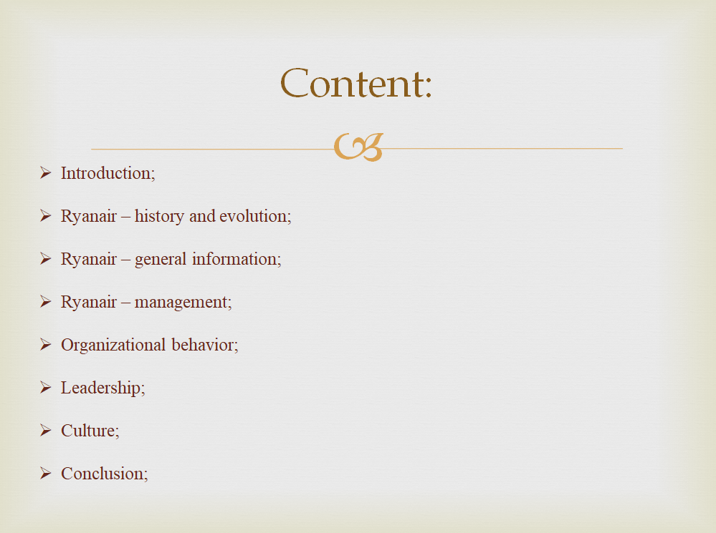
SLIDE 3

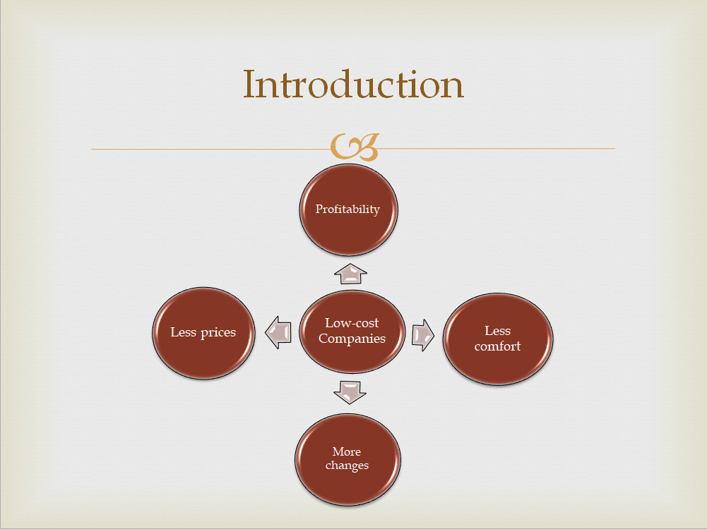
SLIDE 4

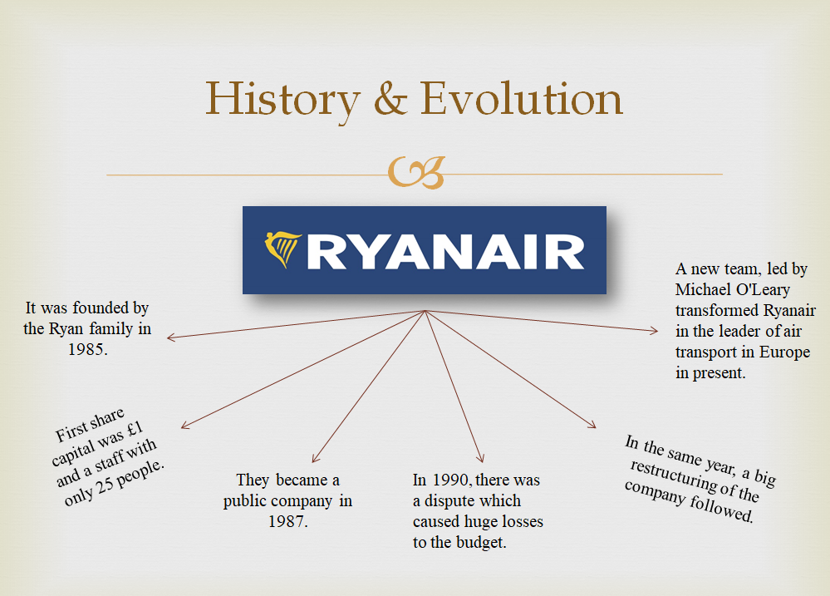
SLIDE 5

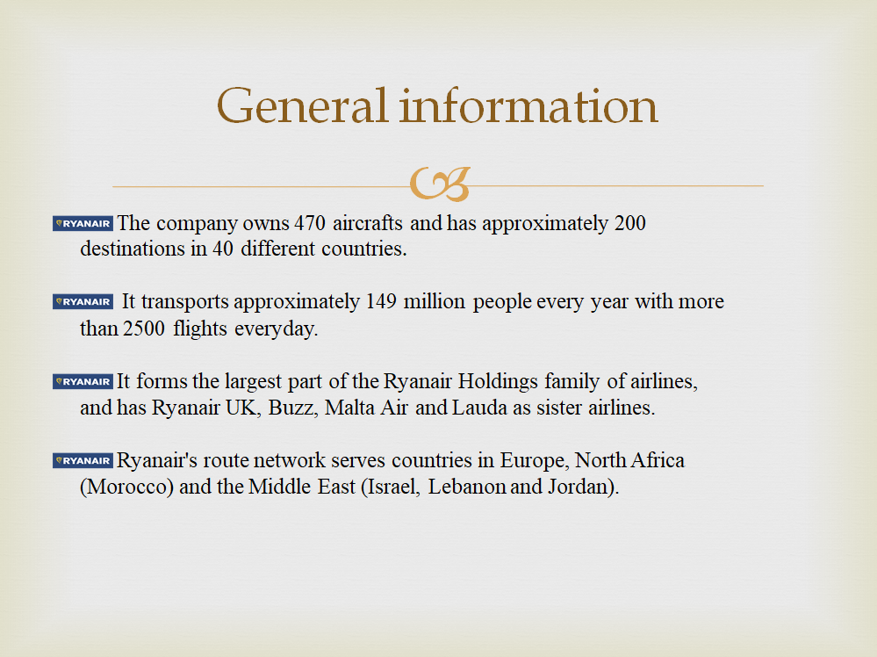
SLIDE 6

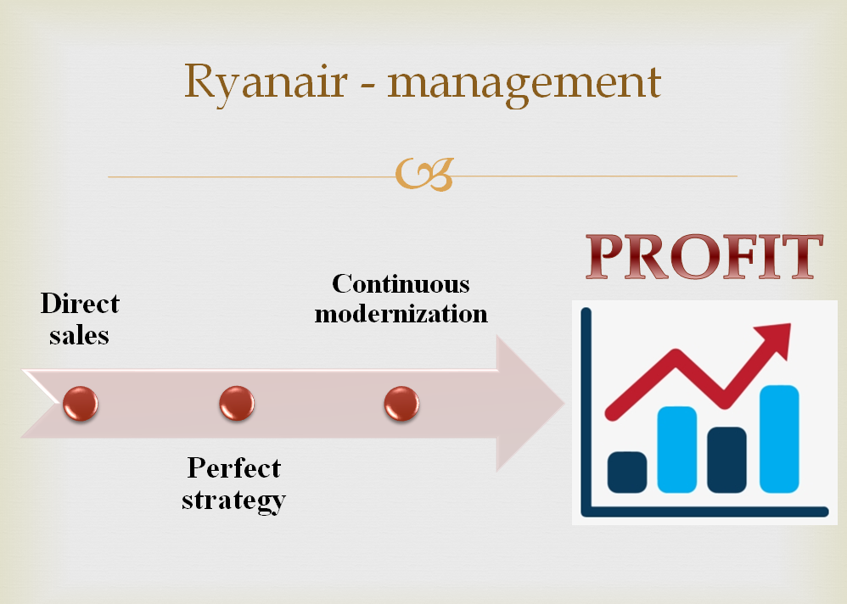
SLIDE 7

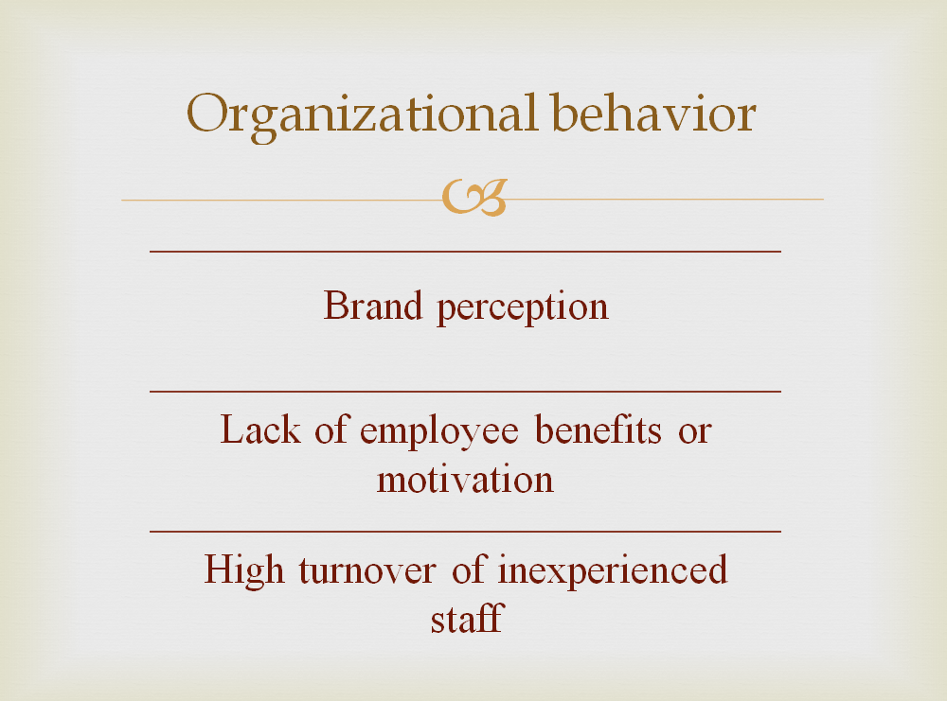
SLIDE 8

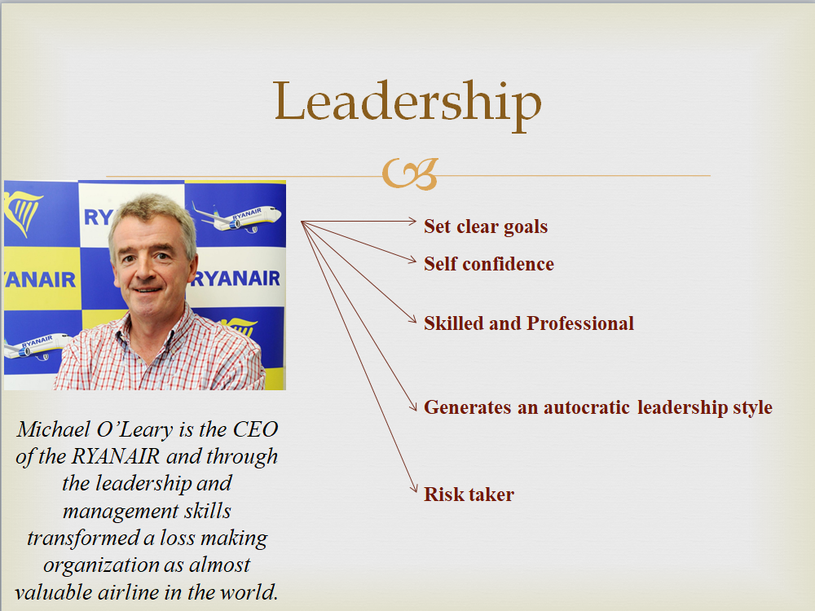
SLIDE 9

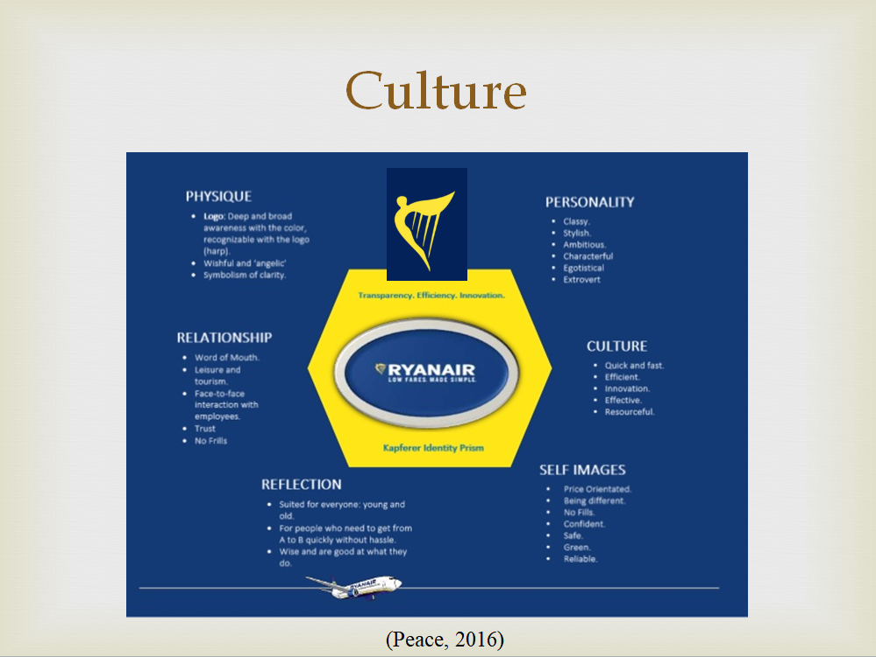
SLIDE 10

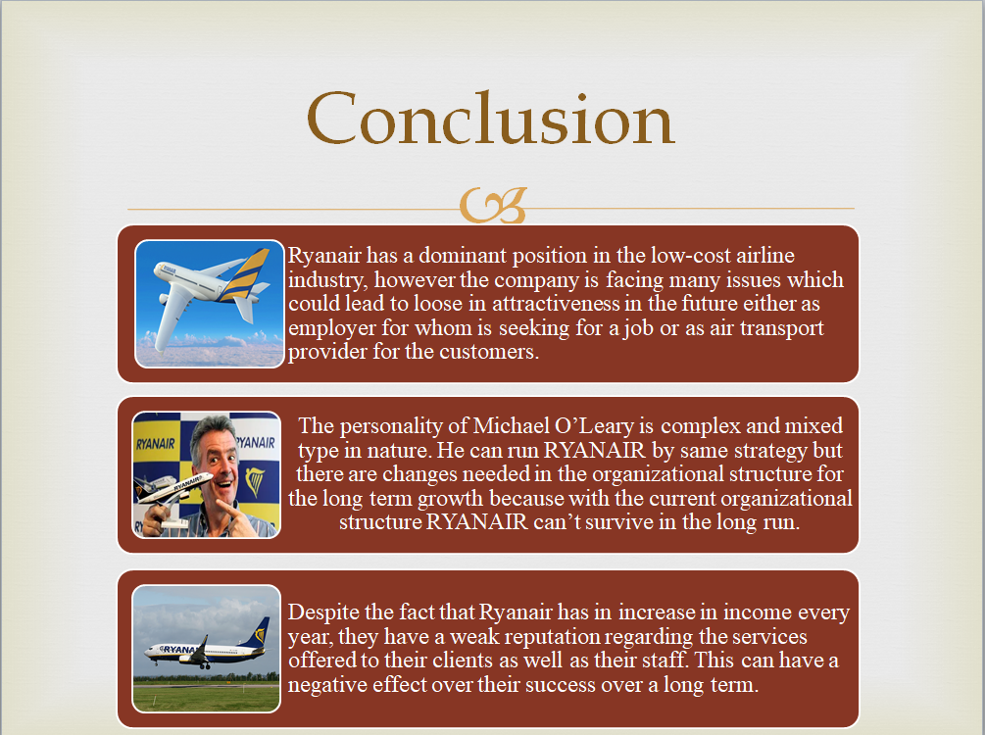
SLIDE 11
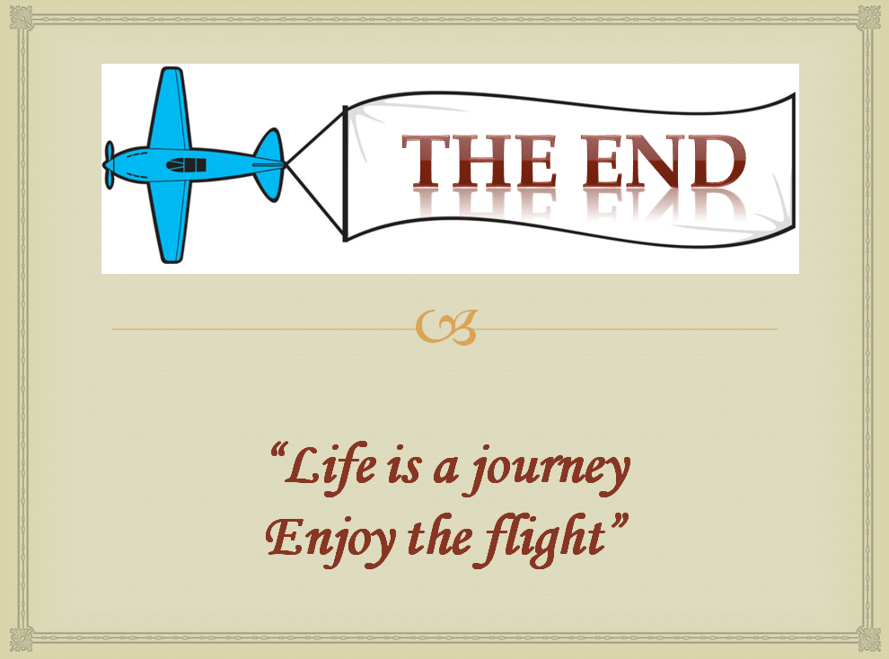
SLIDE 12

