

IMPACT OF TRANSFORMATIONAL LEADERSHIP ON EMPLOYEE PERFORMANCE DURING COVID-19:

A STUDY BASED ON THE HOTEL INDUSTRY OF THE UK

Student Name:- Professor Name+:-
Apurva Jignesh Parmar (2211066) Dr.Rexon Nting


Master’s Degrees by Examination and Dissertation
Declaration Form.
1. This work has not previously been accepted in substance for any degree and is not being concurrently submitted in candidature for any degree.
Signed:- Apurva Jignesh Parmar
Date:- 20/10/2023

2. This dissertation is being submitted in partial fulfilment of the requirements for the degree of Master in Business Administration.
Signed:- Apurva Jignesh Parmar
Date:- 20/10/2023
3. This dissertation is the result of my own independent work/investigation, except where otherwise stated.
Other sources are acknowledged by footnotes giving explicit references.
A bibliography is appended.
Signed candidate:- Apurva Jignesh Parmar
Date:- 20/10/2023

4. I hereby give consent for my dissertation, if accepted, to be available for photocopying, inter- library loan, and for deposit in the University’s digital repository
Signed (candidate):- Apurva Jignesh Parmar
Date:- 20/10/2023
Supervisor’s Declaration.
I am satisfied that this work is the result of the student’s own efforts.
Signed:- Rexon Nting
Date:- 20/10/2023

Acknowledgement
I am very thankful to my professor _ for showcasing their patience and supporting my research. The continuous investment of time and support has helped me accomplish the work efficiently without making any mistakes. I am overwhelmed to have such an amazing research advisor who has provided indefinite valuable feedback that has helped my research to be accomplished with effectiveness. I am also very thankful towards my friends and family for their guidance and encouragement which have helped me to increase my motivation when I became low during the research procedure. The suggestions and advice provided by them have helped me in making such a unique work.
Thank you and Regards

Abstract
Leadership has been given significance in the business environment with the rise of the pandemic situation. The Global impact of Covid-19 has had a great impact on the UK hotel industry where it was necessary to investigate the transformative leadership style and its impact on employee performance. The primary aim of the research is to find the link between the two aspects so that exploration of different subsidiary factors can be made to fulfil the focus of the research. Flexibility of the leadership style with effective adaptation techniques helps in upgrading the overall performance results by creating a dynamic link between the two factors.
In the literature review section, different literature has been evaluated related to the research topic the main aim of the research is to identify the impact of transformational leadership on the employee performance of the hotel industry. In the literature review section, the impact of the leadership style on employee motivation satisfaction level and employee performance has been identified. The chapter defines the review of the arguments that the authors have stated previously which is strongly related to this topic. The earlier findings about transformational leadership and employee performance have been analyses by examining the existing literature. The situation of the hotel industry during the COVID-19 situation has been critically discussed through analysing the existing articles. However, a potential gap has been identified during the analysis of the literature related to this significant topic. A conceptual framework has also been developed to identify the dependent and independent characteristics of the research.
The research has also integrated the use of survey analysis primary decoration method by including the quantitative strategy with the selection of 100 individuals. The selection of the positivist research philosophy in deductive research approach and cross-sectional Research design has been integrated so that a quantitative strategy to collect primary data can be easily applied by maintaining all the ethical standards and research timeline. Moreover, the limitation of the research has been identified with the future scope. Apart from this due to the identification of different challenges presented in the research work, it was necessary to provide suggestive outlines for which a few recommendations have been stated that are significant to apply by the hotel business in the UK that are related to the topic.

Table of Contents
Chapter 1: Introduction 9
1.1. Introduction 9
1.2. Rationale for the Research 9
1.3. Aims of the Research 10
1.4. Research Questions 11
1.5. Context and Significance 12
1.6. Conclusion of the Introduction 13
Chapter 2: Literature Review 15
2.1 Introduction 15
2.2 Concept of Transformational Leadership 15
2.3 Impact of transformative leadership on employee performance in the UK hotel business during the COVID-19 16
2.4 Impact of transformative leadership on employee motivation in the hotel industry 17
2.5 Impact of Transformational leadership on work satisfaction in the hotel business 18
2.6 The Influence of Transformational Leadership in the Hotel Sector 19
2.7 Link between Transformative Leadership and Employee Performance within the UK’s Hotel Industry during the Pandemic 20
2.8 Impact of Transformational Leadership on motivating employees within the UK’s Hotel Industry 21
2.9 Issues that Influenced Employee Performance in the Hotel Industry of the UK during COVID-19 22
2.10 Identifying the Components to Enhance Employee Performance and Resilience within the Hotel Sector 24
2.11 Theoretical Underpinning 24
2.12. Conceptual Framework 27
2.13 Literature Gap 28
2.14 Summary 28
Chapter 3: Methodology 29
3.1 Introduction 29
3.2 Research Onion 29
3.3 Research Philosophy 30
3.4 Research Approach 32
3.5 Research Design 32
3.6 Research Strategy 33
3.7 Sampling Technique 34
3.8 Data Collection and Analysis 35
3.9 Ethical Consideration 35
3.10 Research Timeline 36
3.11 Summary 37
Chapter 4: Key Findings and Discussion 38
4.1 Introduction 38
4.2 Primary quantitative analysis (Survey analysis) 38
4.3 Discussions 46
4.4 Summary 49
Chapter 5: Recommendations and Conclusion 49
5.1 Conclusion 49
5.2 Linking with Objectives 51
5.3 Recommendation 52
5.4 Limitations 53
5.5 Future Scope 53
Reflection 53
Reference list 55
Appendix 1: Survey questions 69

List of Figures
Figure 2.1: The Hierarchy of Needs 25
Figure 2.2: The Elements of the Transformational Leadership Model 27
Figure 2.3: Conceptual Framework 28
Figure 3.1: Research Onion Framework 30
Figure 4.1: Age 38
Figure 4.2: Gender 39
Figure 4.3: Work function 40
Figure 4.4: Work experience 40
Figure 4.5: Importance of critical thinking skill 41
Figure 4.6: Empathy Enhancing Employee Engagement 41
Figure 4.7: Motivation with clear communication and support 42
Figure 4.8: Customer satisfaction can increase competitive advantage 43
Figure 4.9: Increasing the employee turnover rate 43
Figure 4.10: Employee retention dependent on the work satisfaction level 44
Figure 4.11: Benefit of transformational leadership style 45
Figure 4.12: Productivity rate vs. a proper vision and goal 45

List of Tables
Table 3.1: Research Timeline 37

Chapter 1: Introduction

Introduction
The global impact of COVID-19 has had a tremendous influence on businesses throughout the world, particularly the hospitality sector, with the UK hotel industry experiencing considerable issues (Hadi, Naeem and Karim, 2022). This chapter establishes the context for investigating how transformative leadership relates to employee performance in this industry during the pandemic.
The problems of the UK hotel business during the pandemic highlight the importance of transformative leadership in driving enterprises (Foroudi, H. Tabaghdehi and Marvi, 2021). The ability of such leadership to encourage personnel during times of turmoil warrants more examination (Lai and Cai, 2022).
This study has four primary objectives:
- Analysing transformational leadership expressions
- Measuring effects on motivation and job satisfaction
- Investigating the role of psychological well-being, and
- Discovering effects on employee performance.
Specific study questions coincide with these goals to guide empirical exploration into transformative leadership under the pandemic's challenges. The findings are significant for the UK hotel sector as well as for broader crisis leadership insights.
The importance is underscored by the hotel industry's contribution to the UK economy. Effective leadership has the potential to influence rehabilitation and future growth (OECD, 2020). This chapter offers issues for further investigation, laying the groundwork for understanding the influence of transformative leadership on the UK hotel business during the pandemic.

Rationale for the Research
This study was inspired by the unusual obstacles that the UK hotel business has experienced as a result of the COVID-19 outbreak. The hospitality industry, particularly hotels, has been hit hard by economic and operational problems (Dabo, 2023). The sector is particularly vulnerable to pandemics because to its labor-intensive and customer-centric nature. Leadership, particularly transformative leadership, is critical for survival and recovery in this circumstance (Wroten, 2023).
Employees are inspired to innovate and be motivated by transformational leadership. Given the pandemic's unique problems, it provides direction and solidarity (Scriven, 2023). A motivated staff is critical to the resurgence of the UK hotel business. Transformational leadership may improve employee motivation, work satisfaction, and well-being by empowering them, reducing stress, and cultivating resilience (Abolnasser et al., 2023).
This study is important for crisis management and leadership development. Its findings can help the UK hotel business and leaders in other industries. This study seeks fresh insights by investigating pandemic-specific aspects of transformative leadership.
In summary, this study looks at how transformational leadership in the UK hotel business affected employee performance, well-being, and organizational resilience throughout the pandemic. These findings are intended to improve leadership practices, employee results, and rehabilitation in both the hospitality and crisis-affected industries.

Aims of the Research
This study is motivated by a series of broad goals that seek to shed light on the complicated link between transformative leadership and employee performance in the UK hotel business during the chaotic COVID-19 epidemic. The following are the study's objectives:
Primary Goal
To explore and comprehend the influence of transformative leadership on employee performance in the UK hotel business in the face of the COVID-19 epidemic.
Secondary Aims
- To analyse the extent to which hotel managers in the UK displayed transformational leadership characteristics during the COVID-19 epidemic.
- To assess the impact of transformative leadership on employee motivation and work satisfaction in the hotel business in the United Kingdom.
- The purpose of this study is to investigate the influence of transformational leadership in improving psychological well-being among hotel sector personnel during the pandemic.
- To identify particular components of transformative leadership that contribute to enhanced employee performance and resilience in the UK hotel business as a result of the pandemic.
Research Questions Alignment
These objectives are closely related to the research questions guiding the examination of the influence of transformative leadership on staff performance in the UK hotel business during the COVID-19 epidemic. This study strives to give a thorough knowledge of the delicate link between leadership techniques and employee outcomes in a crisis-driven context by addressing each of these goals.
In summary, the goals of this study are to investigate the impact of transformational leadership on multiple dimensions of employee performance, well-being, and resilience in the UK hotel business in the face of unprecedented challenges posed by the COVID-19 epidemic. The study's goal is to add to the body of research about leadership behaviours and their influence on organizational results during times of crisis.

Research Questions
To fulfil the research's multifarious goals, a set of specific research questions has been developed to guide the examination of the influence of transformative leadership on employee performance in the UK hotel business during the COVID-19 pandemic.
During the COVID-19 epidemic, how did hotel managers in the United Kingdom display transformative leadership?
This question tries to elicit the precise actions, communication methods, and motivating approaches used by hotel managers in the United Kingdom to demonstrate transformational leadership during the pandemic. Insights on leaders' flexibility and inventiveness are critical to understanding their role in steering their teams through uncertainty.
What was the performance of hotel personnel in the UK during the epidemic, and how did they deal with the challenges?
This topic seeks to elucidate the particular issues experienced by hotel personnel during the pandemic, such as disrupted operations, health concerns, and financial uncertainties. The investigation will focus on employees' adaptation techniques, coping mechanisms, and overall performance results in the face of unusual conditions.
What is the link between transformative leadership and employee performance in the UK hotel business during the pandemic's challenges?
The dynamic link between transformative leadership and employee performance is explored in this question. It aims to investigate how transformational leadership methods affect employee engagement, job satisfaction, and performance indicators in the context of pandemic-induced problems.
Which transformative leadership behaviours and circumstances had the greatest influence on employee performance in the UK hotel business during the pandemic?
This question seeks to identify and prioritize the main elements of transformative leadership that have the greatest impact on employee performance. The research seeks to give practical insights for hotel managers wanting to enhance their leadership techniques by isolating these specific behaviours and variables.
The study aims to investigate the subtle relationships between transformative leadership and employee performance in the UK hotel business during the COVID-19 epidemic using these research questions. The research intends to give nuanced insights that contribute to a fuller understanding of effective leadership practices during times of crisis by analysing the sector's particular difficulties and leadership tactics. The findings have the potential to enlighten not only the hotel sector but also larger conversations about leadership effectiveness in volatile situations.

Context and Significance
This study focuses on the UK hotel business in the midst of the unprecedented challenges given by COVID-19. Hotels, which are an important element of the wider hospitality sector, faced complex disruptions including travel restrictions and changing consumer behaviour as a result of the epidemic, putting industry resilience to the test (Hahang, Bayraktar and Jiménez, 2022).
The importance of understanding transformative leadership in this setting cannot be overstated. For starters, as a cornerstone of the UK economy, disturbances in the hotel business rippled across the value chain, affecting both revenue and jobs (Gov.UK, 2021). Recovery can be aided by effective leadership.
Second, the hotel industry's labour-intensive and customer-centric orientation prioritizes employee well-being for service excellence. The power of transformational leadership to inspire and motivate is critical for employee morale and consistent service (Inversini, 2023).
The repercussions of the epidemic go beyond the immediate operations. Effective crisis leadership may affect recovery and future growth (Spyridonidis, 2021). This research contributes to resilience and innovation strategies by investigating the influence of transformative leadership.
Beyond hospitality, pandemic leadership ideas provide insights into crisis management across sectors. Real-world crisis scenarios help to improve leadership theories (D’Auria and De Smet, 2020).
Finally, the UK hotel industry's pandemic challenges highlight the importance of the research (Shapoval et al., 2021). The industry's economic importance and operational intricacies justify investigating the impact of transformative leadership (Japutra and Situmorang, 2022). The findings might help not only the hotel industry but also other industries in crisis situations.

Conclusion of the Introduction
Finally, this introductory chapter has established the framework for a more in-depth investigation of the influence of transformative leadership on employee performance in the UK hotel business during the COVID-19 epidemic. The global financial crisis created unprecedented difficulties for the hospitality industry, with the UK hotel business particularly vulnerable. As a result of the pandemic's emphasis on the vital role of leadership in managing uncertainty, the notion of transformational leadership emerges as a beacon of possibility in guiding enterprises through turbulent times.
The research's logic, which is firmly rooted in the industry's particular challenges and the transformational power of leadership, emphasizes the importance of this study. The defined objectives and research questions provide a systematic framework for researching the complex link between leadership practices and employee performance in the context of a crisis-affected industry. Because of the sector's economic contributions and worker dependency, the study's chosen backdrop of the UK hotel industry emphasizes its significance.
This research attempts to shed light on how transformational leadership emerges, its impacts on employee performance, and its consequences for organizational recovery as succeeding chapters go into empirical inquiry, literature evaluation, and analytical methods. This research seeks to give insights that transcend beyond the constraints of the UK hotel business during the pandemic by investigating these dynamics inside the confines of the industry itself, informing leadership strategies and crisis management methods across varied sectors.

Chapter 2: Literature Review

2.1 Introduction
The main purpose of this section is to review different literature related to the research topic. The research aims to identify the impact of transformational leadership on employee performance during the pandemic situation. The researcher has been using a case study of the hotel industry to identify the impact of transformational leadership. The impact of transformational leadership is extremely crucial in increasing employee performance and work motivation. The following section has identified the concept of transformational leadership. Along with the concept the following section has identified the impact of transformative leadership on the employee performance of the UK hotel business. The following section has identified the impact of transformative leadership on increasing employee motivation in the hotel industry. Along with these transformative leadership also has a critical impact on increasing work satisfaction in the hotel business as well. This has been also identified by the researcher using different literature

2.2 Concept of Transformational Leadership
Transformational leadership style is one of the leaderships that mainly focuses on motivating their followers and team members. The transformative leaders have the full potential to exceed their expectations and influence the full team. As mentioned by Abu-Rumman, (2021), this transformative leadership concept was introduced by MacGregor in the year 1978. There are different characteristics of a transformational leader. First of all the main criteria or characteristic of these types of leaders is that they often have qualities that can inspire or captivate their followers or team members. They communicate clear and structured visions for the future and are also inspired by the different missions of their team member. On the other hand, Asbari, (2020), stated that vision and strategic thinking are other characteristics of this type of leadership. This means that the leaders will define a vision for the future. They also can strategically plan and can achieve the plan according to the objective of a particular organization. Intellectual stimulation is another characteristic of this type of leadership. Transformational leaders always encourage creativity and innovation within their teams. For developing proper creativity critical thinking is encouraged among the followers. They give challenges promote Innovation and also increase the problem-solving ability of the team members. As argued by Ardi et al. (2020), emotional intelligence is one of the major criteria of this transformational leadership style. The leaders who are following the transformative leadership are emotionally intelligent. This means that they are understanding the emotions of the team members. They are extremely empathetic and also can connect to the individual on a personal level. This is one of the main reasons that take and motivate easily to their team member easily. In summer it can be easily said that transformational leadership is a leadership style of motivating and inspiring the overall team to achieve a particular set of objectives for an organization.

2.3 Impact of transformative leadership on employee performance in the UK hotel business during the COVID-19
The transformative leadership style is always a crucial factor for increasing employee performance in every industry including the hotel business located in the United Kingdom. During the COVID-19 epidemic situation, it is extremely important to increase employee performance within the hotel industry to make the customer satisfied consistently. The financial situation of the hotel industry was extremely poor and the health status of the country hampered the motivation of the employees. Adaptation of transformative leadership by the hotel industry is one of the strategic decisions of the hotel industry of the UK. According to Buil et al. (2019), a transformational leader always gives emotional support to every employee of the organization. Empathetic behaviours were extremely crucial during the COVID-19 epidemic for every employee of the organization. The transformational leader gives emotional support to the employee in times of anxiety and maintains the employee morale during this time. The employee who is facing trouble due to health conditions can also get support from the transformative leaders. On the other hand, Yang et al. (2020), stated that In this way, the employees can feel motivated by their work and productivity will also increase. The transformational leadership style also has a direct impact on employee motivation. During the COVID-19 epidemic, it has been extremely hard for employees to get motivated every time to give consistent productivity in the hotel industry. As in the hotel customer satisfaction is the key thing to achieving success, So to bring the highest customer satisfaction it is extremely important to give a consistently high productivity rate.
However, according to Wang, (2022), transformational leadership is an extremely important factor for adaptability and inspiration. During the COVID-19 epidemic, it is important to increase adaptability as the situation is continuously evolving for the hotel industry. The transformational leader is giving a strategic vision to the employees according to the changing situation in the hotel business in the UK. Along with this, transformational leaders are also giving innovative solutions to every problem that comes during the epidemic situation. This innovative solution of the transformative leader is an improvement of the overall process and also gives high customer satisfaction levels in the hotel industry in the UK. As argued by Anshori et al. (2020), Communication is another important factor that is fulfilled by the transformational leadership style. Effective communication is extremely important during a crisis in the industry. Good communication has been increasing the motivational level of those employees who were going through a health crisis. Along with this good communication can also keep informed to the employees regarding different decisions and changing strategies of the organization of the hotel industry. According to Susanto et al. (2023), another impact of the transformational leadership style is to increase the trust of the employees. Especially during a crisis like the Covid 19 epidemic, the employee should get enough trust from their management and leaders that their job is secure. On the other hand during the crisis, the employees need strong decisions according to the changing situation of the business. Thus the employees are empowered by the leaders also.

2.4 Impact of transformative leadership on employee motivation in the hotel industry
One of the important advantages of the transformational leadership style is that it helps in increasing employee motivation levels. Especially during the time of the COVID-19 pandemic, it is extremely important for employees to feel motivated to give their best productivity rate. According to Gom et al. (2021), first of all, the main motive of transformational leaders is to give a clear vision and objective for the employees. During the pandemic situation business environment for the hotel and hospitality industry is continuously evolving. Leaders must give and convey an objective for every new business situation. So that the employees think that the organization is also trying to co-operate with them during the crisis. This can also increase the bond and trust of employees for the management. On the other hand, Escortell et al. (2021), stated that the transformational leadership style gives recognition and feedback to every employee of the organization. To enhance the motivation level both appreciation and feedback are equally important for employees. During a crisis, transformative leaders give feedback from time to time to the employees to identify their strengths and weaknesses. Strength identification helps in enhancing the confidence level in a crisis. On the other hand weakness identification helps adapt proper strategy for fulfilling the areas of improvement. Transformational leadership helps empower employees by showing emotional intelligence. It is extremely important to become empathetic with the employees during a crisis. As argued by Gurmani et al. (2021), transformational leaders are trying to become personal with the employees so the employees are also sharing their problems with the leaders. On one hand, this enhances their relationship on the other hand the employees also feel motivated. Fostering innovation and creativity is another way of increasing the motivation of employees. Especially in the hotel industry, it is extremely important to increase creativity and critical thinking skills as it helps in giving innovative solutions. However transformational leadership is always focused on giving ethical and responsible leadership within the organization. During a crisis, it is essential to maintain that ethical way of leadership. As opined by Shah et al. (2020), they practice ethical behaviour and maintain corporate social responsibility. Especially in the case of the hotel industry corporate social responsibility helps maintain the sustainability of the business in this way the customers and the employees can trust the overall organization. Employee engagement can also be increased by adopting the transformational leadership style. During a crisis, the hotel industry needs to increase employee engagement. If the leaders are trying to engage employees then they also feel motivated that they are job is secure in this insecure situation of the country.

2.5 Impact of Transformational leadership on work satisfaction in the hotel business
Along with employee motivation and employee performance transformational leadership also has a direct impact on the job satisfaction of the employee. According to Nguon, (2022), work satisfaction in the hotel business is extremely important as it helps in achieving the highest customer satisfaction level. This type of leadership style helps in achieving the full potential of the employees. It helps in increasing the employee engagement for the company. The leaders are creating a positive and inspiring work environment within the organization. This positive and inspiring environment within the organization helps increase engagement. In the case of the hotel setting the employees are more friendly with their customers. This is a way to create a level of work satisfaction for them. On the other hand, Widarmanti et al. (2021), stated that transformational leaders always try to motivate the employees by creating a positive environment in the organization. They are using techniques like high expectations of providing support and recognition to the Employees. This has been promoting a shared vision with the employees and the members.
The practice can motivate the hotel staff to their full potential and give effort to achieve a high level of customer service along with this promotion of the share value helps them to make a bond with the leaders which these them high work satisfaction within the organisation. During a crisis like the pandemic situation, it is extremely important to communicate properly about the values of the organisation. Another important factor of this leadership is communication. As opined by Sobaih et al. (2022), The leaders always listen to employees after listening to the employees the leaders provide constructive feedback to confirm that they understand the goal of the organisation during the changing business situation of the hotel industry. On the one hand, communication is creating relationships among the leaders and the employees. This communication helps in clarifying the overall work and creates job satisfaction for the employees as well. Transformational leaders are known for their responsibilities and commitment towards the employees. This means that they are continuously trying to grow and develop employee's personalities. As argued by BOZDOĞAN and AKSOY, (2020), for this reason, they provide different opportunities for the skin development and career development of every employee. During the crisis time, this will help in creating trust within the employees. Along with personal development also creates work satisfaction levels for the employees. Due to the positive impact of this leadership style, the employee turnover rate has also decreased for every organisation in the hotel industry. And organisation with higher efficiency. Good work satisfaction is making less turnover rate for the hotel industry during the crisis.

2.6 The Influence of Transformational Leadership in the Hotel Sector
Transformational leadership is an important aspect for the hotel industry to follow as well as adapt to the changes to achieve continuous growth across the global market. According to Xu et al. (2022), transformational leadership has a direct influence on the perspectives of employee performance specifically after the COVID-19 situation. In addition, the indirect impacts on variables such as openness and communication in the workplace have been observed due to the influence of transformational leadership. It has been observed that transformational leadership is recognised as the key strategy that helps the hospitality industry achieve success in the competitive edge. In addition, the interaction can be grown with the employees through sharing effective bonds towards following transformational leadership. On the other hand, Yücel, (2021) has argued that transformational leaders mainly focus on inspiring as well as motivating employees towards working hard to achieve their personal and professional goals. It has been noticed that the leaders through following transformational practices strengthen the relationship with the workforce and motivate them to provide a high level of performance within the workplace.
As per the analysis of Çop et al. (2021), transformational can be referred to as the idea that leaders can bring changes in the behaviour of employees towards establishing a positive workplace environment in the hotels. For example, Horst Schultze is the former president and COO of the Ritz-Carlton Hotel. He is recognised for following a transformational leadership style to motivate the employees after the COVID-19 situation (Horstschulze, 2023). It has been observed that the Pandemic has created a challenge for hotels around the globe to recover business due to the global lockdowns. According to the statistics, around 342000 people have lost their jobs and 81% of them are in the accommodation and food service sectors (Gov. uk, 2023). In addition, COVID-19 has also created a negative impact on employee performance as well as the entire management structure. In 2021, the market size of the UK hotel industry has fallen by around 72% due to the pandemic situation (Statista, 2023). However transformational leadership has been followed by the higher management to adapt to the changes to survive in these critical circumstances. It has been observed that transformational leaders have the ability to determine the importance of changes in the workplace that can provide both employee motivation as well as success. In this context, transformational leaders have the power of resilience that helps to sustain the disruptive situation within the work environment for supporting the employees in order to establish success.

2.7 Link between Transformative Leadership and Employee Performance within the UK’s Hotel Industry during the Pandemic
The leadership is primarily connected with the behaviour as well as the performance of the employees within the hotel industry. According to the analysis of Gomes et al. (2022), the employees and the leaders have addressed certain difficulties related to the high turnover of employees, rising costs of raw materials, hiring staff and operational issues that have negatively impacted the business of the hospitality industry during the pandemic situation. It has been observed that leaders have a strong connection with the employees and influence their behaviour within the organisation. It has also been observed that the higher authorities have faced challenges related to the high turnover rate of employees within the hotel industry. For example, Premier Inn, one of the reputed hotels across the UK have been facing a labour shortage during the situation of Covid-19 (Ambrose, 2021). However, the management has to pay around 20 million pounds to increase the salaries of the labourers to reduce the rate of employee turnover. However, Virgiawan et al. (2021) have argued that transformational leadership can be effective in demonstrating the high standards of morals that encourage employees to perform better within the organisation.
It has also been observed that effective leadership has the ability to emphasise maintaining the authenticity of the work process. In addition to this, the transformation has a strong link with understanding the concerns that are faced by the employees within the work environment. It also has the power to resolve conflicts and encourage collaboration and cooperation among the workforce. As per the analysis of Ashok et al. (2021), transformational leadership also allows the employees to make effective decisions and it also allows them to participate in identifying the strategies that improve the workplace culture. The leaders also create a work environment that has clear and strategic values, priorities and high standards of ethics and morals to influence the employees to provide better work value. In this context, transformational leaders also use strategies related to the motivation for increasing employee engagement which also reduces the high turnover rate in the hotel industry. As per the statement of Rivaldo and Nabella, (2023), leaders with transformative characteristics can provide learning opportunities to employees to pursue higher career objectives through organising training. Communication is one of the key aspects that improve the bonding between the employees and the leaders. As stated by Gradinaru et al. (2020), the CEO of Amazon Jeff Bezos has the transformational leadership quality that has influenced the employees towards improving their performance in a continuous way for upgrading the level of the business.

2.8 Impact of Transformational Leadership on motivating employees within the UK’s Hotel Industry
The boost in employee anticipation and associated improvement in customer satisfaction has been recognised as a crucial factor in the hospitality sector, hence playing a vital role in the economic landscape of the United Kingdom. This phenomenon is attributed to the influence of transformational leadership and has achieved new heights during the pandemic within the hospitality industry of the United Kingdom. The study conducted by Al Harbi et al. (2019) revealed a significant positive correlation between the implementation of transformational leadership practices and enhanced levels of employee motivation. The study revealed the manner in which managers with attractive and inspiring qualities created a work atmosphere that motivated their employees to exceed aspirations in their professional efforts. For example, Premier Inn, a renowned hotel chain in the UK, gained recognition for cultivating a work climate that is both empowering and motivating (Annualreports.com, 2023). The management consistently emphasises the significance of employee creativity and initiative in delivering exceptional customer service. According to Labrague et al. (2020), the impact of transformational leadership practises on employee motivation indicated the presence of a reflex resulting from transformational leadership practises. Transformational leaders have been found to promote a culture that emphasises gratitude, empowerment, and continuous learning, resulting in a significant enhancement of worker motivation.
Furthermore, the research revealed a notable increase of 20% in levels of employee engagement compared to the previous time. For instance, the employees working at Marriott hotels in the UK are widely recognised for their exceptional motivation in providing excellent service to guests. The leadership style employed by the organisation can be described as transformative due to its notable focus on fostering employee development and ensuring their contentment (Iide.co, 2023). Furthermore, Shafi et al. (2020) revealed that a comparative analysis of transformational and transactional leadership was conducted which revealed that hotels led by transformational leaders experienced a noteworthy 25% rise in employee motivation, resulting in an average gain of 15% in customer satisfaction. This demonstrates the considerable impact of transformational leadership on both these performance indicators. Mention may be made that the leadership team at Hilton within the United Kingdom prioritises the development of a caring, open-minded, and motivating work environment (Libardolambrano.medium.com, 2020). The objective is to encourage the growth of transformative leaders who possess the ability to motivate and empower their teams by implementing a range of activities focused on employee engagement and the development of leadership.
The research conducted by Schiuma et al. (2022) presented a different viewpoint which suggests that the effectiveness of transformational leadership in promoting employee loyalty may diminish over time, hence requiring the adoption of a more diverse management approach. The study uncovered the significance of employing transformational leadership strategies in generating a work atmosphere that fosters employee commitment towards continuous improvement and fosters a sense of value among them.

2.9 Issues that Influenced Employee Performance in the Hotel Industry of the UK during COVID-19
The COVID-19 pandemic had a significant influence on the hotel industry in the United Kingdom, leading to a significant decrease in worker productivity. During this challenging period, a multitude of significant issues emerged, which subsequently affected the operational dynamics of hotel employees.
Lack of Job Security
Temporary closures and lower demand for hotel stays occurred as a result of the pandemic's unpredictability. In the opinion of Ntounis et al. (2022), many hotel workers were therefore threatened with dismissal or reduced hours. Employees' morale and productivity suffered as a result of the uncertainty they felt about their future with the business. Employees' engagement and productivity may suffer if they stress about losing their jobs.
Behaviour of the Guests
The COVID-19 pandemic had a significant impact on the productivity of hotel employees in the United Kingdom, primarily due to the actions of guests. As opined by Labrague et al. (2020), the employees faced consumers who potentially demonstrated non-compliance with safety procedures, expressed dissatisfaction with service reductions, and displayed increased concerns regarding the spread of the virus. The successful management of guest expectations, issues, and sometimes disputes needs exceptional levels of patience, effective communication abilities, and the ability to defuse tense situations. The job satisfaction of hotel employees was adversely impacted by this issue, requiring their acquisition of new strategies to maintain professionalism and ensure the satisfaction of visitors, even when confronted with challenging circumstances.
Reduced Employee Number
Hotels within the UK regularly reduced their employee numbers in response to lower occupancy rates and to save money. This means that the existing team had to take on more responsibilities, which might result in frustration and a general decline in productivity. Employees have to be versatile and open to new challenges because of the reduced workforce.
Reduced Working Hours and Shift Cancellations
As a result of travel and event restrictions, fewer people needed the services provided by hotels. Labrague et al. (2020) also stated that several employees had their hours reduced or had their shifts cancelled as a result. The decrease in working hours directly contributed to a decline in both employee satisfaction and efficiency due to the financial difficulties experienced by the employees. The potential effects of irregular work schedules and sudden changes in shifts on employees' capacity to maintain an appropriate work-life balance should not be neglected.
Health and Safety Concerns
Andeobu et al. (2022) underpinned that due to the widespread spread of the COVID-19 pandemic, hotels had to implement strict health and safety measures, such as greater sanitation processes, the requirement of PPE kits and isolation from society. These precautions were necessary to ensure the safety of both guests and workers, but also resulted in additional work for staff and posed certain health hazards to those staff members. Stress and anxiety brought on by worries about getting the virus could negatively affect their productivity.

2.10 Identifying the Components to Enhance Employee Performance and Resilience within the Hotel Sector
Leadership in the Hotel industry of the UK has to prioritise communication, accountability, and support to solve these difficulties and reduce their impact on employees' performance. Job security information, mental health services, health and safety training, and methods for keeping employees engaged and motivated in difficult situations were all part of this. However, Paais and Pattiruhu, (2020) have stated that the effectiveness of transformational leaders in motivating employees may be dependent upon factors such as organisational culture and individual characteristics. It has been found that work environment as well as empowerment with salary have created a significant influence on employee performance within the hotel sector. In addition to this, the value of determination and correlation between the work environment can bring positivity to employee performance. On the other hand, Miceli et al. (2021) have stated that resilience is one of the most important aspects that helps to identify the ability of the organisation to integrate economic value under critical circumstances regarding the changes in supply and demand. It has been identified that the management of the hotel industry must analyse the metrics of the performance in a frequent way to provide feedback to the employees for better performance. In this context, the management should offer incentives as a reward system for uplifting employee engagement with the work process.

2.11 Theoretical Underpinning
2.11.1 Maslow’s Hierarchy of Needs
The renowned psychologist Abraham Maslow formulated his well-known Hierarchy of Needs Model in 1943 which provides a hierarchical framework consisting of five levels that represent various categories of human needs (Numonjonovich, 2022). This model is often portrayed as a pyramid structure and it is necessary to fulfil fundamental needs prior to addressing higher-level desires.
The Physiological Needs, situated at the foundational level of the pyramid, are considered to be the most basic and essential requirements for sustaining life. Food, beverage, housing, apparel, and repose are all illustrative instances and the individuals' attention is primarily focused on obtaining the goal until their physiological requirements are satisfied. Once individuals have satisfied their immediate physiological needs, they shift their focus towards attaining a sense of safety and security. Numonjonovich (2022) stated that this includes the elimination of immediate danger and the capacity to reside in a state of ease and without concern for one's well-being or financial security. To fulfil the Safety Needs, a significant number of individuals need stable employment, convenient availability of healthcare services, and a secure residential environment.
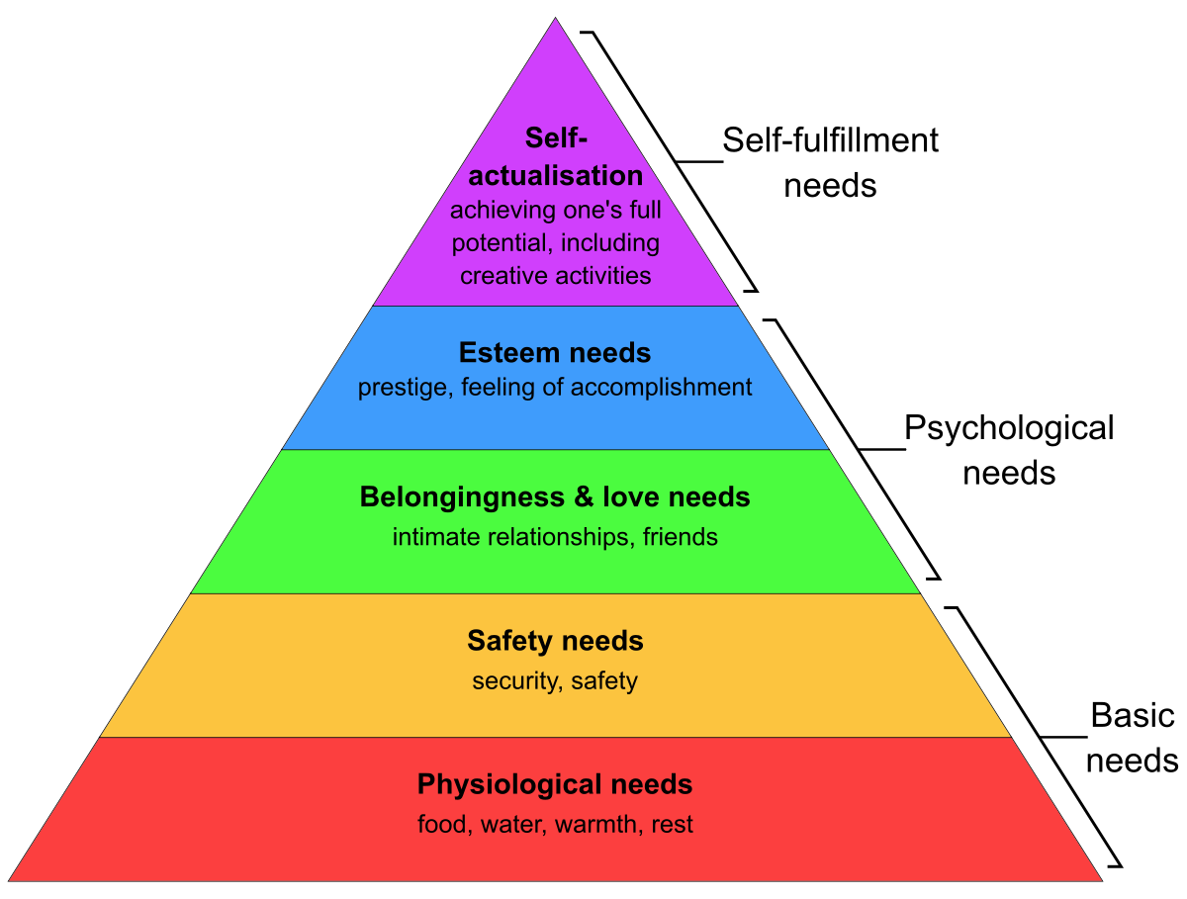

Figure 2.1: The Hierarchy of Needs
(Source: Numonjonovich, 2022)
The concept of belonging and love needs refers to the fundamental human desire for social connection and affectionate relationships. Hopper (2020), underpinned that this psychological construct, proposed by Abraham Maslow in his hierarchy of needs theory, suggests that individuals have the third layer of needs that aligns with social requirements, including the desire for intimate companionship and a sense of belongingness. The category includes the development of social, family-related, and romantic connections. Individuals actively pursue relationships that are distinguished by affection, acceptance, and a sense of being part of something to fulfil their inherent needs.
In the opinion of Hopper (2020), there are two distinct categories of esteem demands which are the esteem of others and self-esteem. Self-esteem includes a combination of self-admiration, confidence in one's capabilities, and contentment with one's overall life circumstances. The concept of others' esteem refers to the gathering of respect, admiration, and recognition from individuals. An individual's self-esteem and self-assurance are enhanced when these requirements are fulfilled. Self-actualization, the highest phase of need, signifies the aspiration to cultivate and manifest one's complete capabilities, attain one's greatest creative and intellectual aptitude, and fulfil one's entire personal potential. At this moment, individuals have discovered their purpose in life, attained personal satisfaction, and optimised their talents and capabilities.
2.11.2 Transformational Leadership Model
In 1978, James MacGregor Burns introduced the concept of "transformational leadership" as a managerial approach that prioritises the cultivation of a work environment where subordinates are motivated to beat expectations and excel in their performance. As opined by Purwanto et al. (2020), the leaders inside these businesses are individuals who possess inspiring qualities and demonstrate a distinct sense of purpose. Transformational leaders often demonstrate exceptional behaviour, serving as role models for their followers and cultivating an atmosphere of trust, respect, and empowerment. In the views of Asbari (2020), due to its significant effect on employee motivation, work satisfaction, and organisational effectiveness, this particular leadership style presents itself as a subject for further research. The investigation of the impact of transformative leadership in the UK hotel industry during the COVID-19 pandemic is of utmost importance within the broader framework of the research.
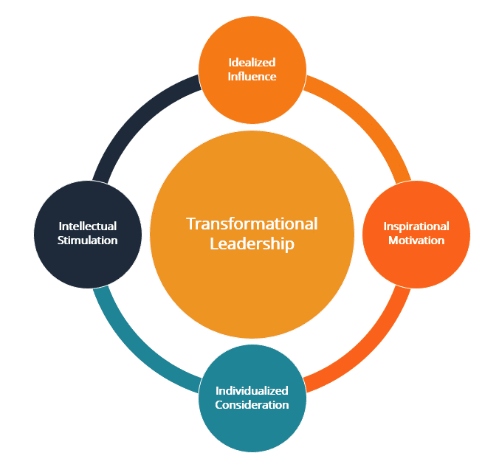

Figure 2.2: The Elements of the Transformational Leadership Model
(Source: Asbari, 2020)
Transformational leadership is highly beneficial in times of crisis, like the COVID-19 pandemic, due to its ability to assist people in effectively managing uncertainty and adapting to new challenges. Purwanto et al. (2020), also stated that transformational leaders possess the capability to inspire and encourage their staff, encouraging a willingness to embrace change, maintain a favourable perspective, and exceed expectations to ensure the satisfaction and well-being of their consumers. Transformational leaders may also inspire employees to stay engaged and committed during job insecurity, workforce restructuring, and health concerns. However, Asbari (2020) argued that transformational leadership in the hotel business may help hotels survive difficult circumstances. Establishing a workplace that empowers, recognises, and advances employees can achieve this and researchers as well as professionals in the hospitality area must analyse the significance and effects of transformational leadership in the hotel industry during the pandemic.

2.12. Conceptual Framework
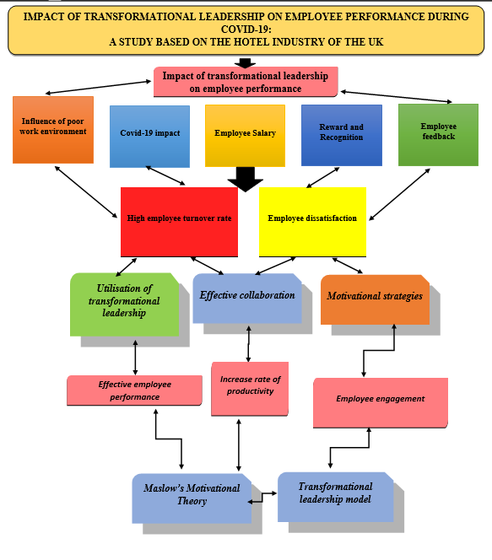

Figure 2.3: Conceptual Framework
(Source: Self-developed)

2.13 Literature Gap
There is a need for further study on the subject of transformational leadership in the hospitality sector in the United Kingdom during the COVID-19 pandemic. This research should be more context-specific, taking into account the dynamic nature of the situation, and should also consider many levels of analysis. This will help address the existing gap in the literature as the existing literature sometimes reveals a deficiency in comprehensively understanding the impact of several factors, such as sector-specific dynamics, different stages of a pandemic along the role of transformational leaders, on outcomes that extend beyond mere employee motivation. Furthermore, it is essential to conduct comparative evaluations of various leadership styles and conduct a deeper investigation of employee perspectives in order to obtain a holistic understanding of this essential connection. Such efforts would yield valuable insights for researchers as well as professionals in the field of business.

2.14 Summary
This chapter mainly focuses on the influence and connection of transformational leadership with the employees' performance. Employee behaviour is strongly dependent upon the leadership styles of the hotel industry. In this context, the COVID-19 situation has created critical challenges such as a high turnover rate of employees along with rising cost of raw materials and other issues that reduce the business performance of hotel industries. However, transformational leadership has the ability to boost employee morale inside the organisational environment. To achieve a thorough understanding of the relationship between the two variables, it is essential to do additional research that is temporally sensitive and encompasses several levels. Moreover, comparative studies and an in-depth exploration of employee perspectives are necessary to address the existing gaps.

Chapter 3: Methodology

3.1 Introduction
The impact of the global pandemic increased different challenges in the UK hotel industry that highlighted the significance of transformative leadership during the situation. In the methodology chapter, the experience of the hotel staff in the UK has been acknowledged with the application of different methods and strategies. These methods and strategies have helped in aligning with the objectives by understanding the practical opinions so that a concrete result on promoting a healthy and productive work environment can be acknowledged. Moreover, the utilised techniques and strategies have been useful in evaluating the contribution that each data has made to understand the different insights of the influence of transformative leadership on employee performance in the UK hotel industry.

3.2 Research Onion
The adaptation of the research onion framework is noted to be suitable as the details of different layers are useful in understanding the incorporation of the various strategies satisfying the objectives of the research. The impact of transformational leadership on the performance of the employees during the pandemic in the hotel industry of the UK has been understood effectively with the incorporation of different methods. The selection of the research methodology is made by understanding the complications of the research problem that has been illustrated. It has been observed as Saunders et al. (2007) stated that all the layers of the research onion model are interdependent on each other. They are also interrelated. Influences occur at any layer impact The other layer which in turn influences the methodological choice. This brings different changes within the development of knowledge and the influence of interpreting the findings by selecting the appropriate method.
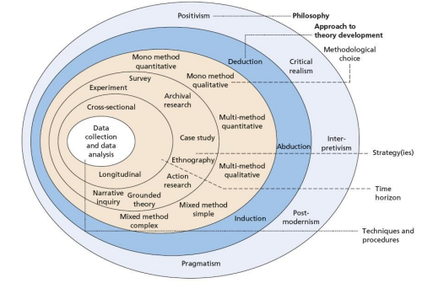

Figure 3.1: Research Onion Framework
(Source: Mardiana, 2020)
There are different layers within the research onion framework that have been elaborated in the figure. These are noted to be the research philosophy, strategy, approach, design, data collection and analysis method and time horizon (Mardiana, 2020). The adaptation of this model has been beneficial as it helps in adding more transparency and clarity within the structure. Moreover, throughout the methodological findings, the conclusion of the research is strongly supported by the adopted strategies that have been aligned with the research principles. Due to the appropriate adaptation of the research onion framework, the systematic accommodation of the data with comprehensive evaluation has been a focus that has helped in obtaining a good grasp of the research topic by satisfying every research objective that has been formulated.

3.3 Research Philosophy
As per Tamminen and Poucher, (2020), research philosophy is defined to be the set of beliefs and different assumptions that help in developing knowledge. It is important to understand the different assumptions so that the whole research procedure is explained appropriately which helps in supporting the findings and its credibility. Two different categories are there in which the assumptions are categorised which are the epistemology and ontology (Muhaise et al. 2020). It is noted that epistemological assumptions are dependent upon human perception by gaining knowledge so that legitimacy and acceptance are maintained. On the other hand, the ontological assumptions depend upon the realities of nature.
These categories are segregated into four main types of research philosophies that are incorporated within a research which are positivism, interpretivism, realism and pragmatism. According to the perception of Alharahsheh and Pius, (2020), positivist research philosophy is a scientific method that helps in obtaining the numerical understanding by providing appropriate explanations and maintaining the objectives. Interpretivism research philosophy focuses on obtaining narratives or perceptions to develop new understanding. On the other hand, Kelly and Cordeiro, (2020) noted that pragmatism research philosophy is based on truth or reason knowledge to find the relevance whereas realism is based on historical knowledge and accumulating external independent explanation. With the consideration of every definition, the research has been accomplished with the integration of positivist research philosophy that helps in obtaining accurate knowledge by maintaining the objectivity of the study.
Justification
The incorporation of the positivist research philosophy has been made as it has been noted with the findings of Park et al. (2020) that positivist research philosophy is responsible for providing external reality rather than human experience. The methodical practice of appropriate measurement and examination of the objective reality is presented with the help of this philosophical paradigm. The research procedure depends upon this philosophy as it is important to understand an individual's journey to develop specific knowledge on a new field or research area so that new theories answering them can be adopted. The selection of a positivist research philosophy has been beneficial for the study to reveal the underlying patterns and connection with the use of different methods and quantitative strategies for collecting the data for the research work (Hammersley, 2019). The investigation would remain incomplete if this philosophical notion was not adopted as the positivist alignment has made it easier to focus on collecting the numerical resources to understand the concept of transformational leadership in the hotel industry of the UK to gain the impact on employee engagement.
The selection of interpretivism research philosophy has not been considered to be suitable as it has been found by Nickerson, (2022) that the subjectivity of the research context is explained with the help of interpretivism. This was not required to understand the impact of the transformational leader on employee engagement in the hotel industry of the UK. Moreover, subjective findings to develop different conclusions using the qualitative data had been realised to increase the complexities of different data for which the selection of the positivist research philosophy has been more suitable.

3.4 Research Approach
The research approach is the second layer of the research onion framework which is suitable for acquiring and analysing the required data with relevant techniques. This relevancy is required to be maintained within research so that descriptions can be appropriately outlined by highlighting the major data that is the most suitable version for the work. There are three types of research approaches such as inductive, deductive and abductive research approaches. As per Chandra et al. (2019), the inductive research approach is very useful for creating general conclusions that are possible and probable. On the other hand, Okoli, (2023) noted that the deductive research approach starts from the general context and moves towards more specificity to maintain certainty. The abductive research approach is used to find a plausible conclusion beginning from incomplete data with possible explanations. By considering the definition, the selection of deductive research approaches has been incorporated so that the strongest arguments can be raised for finding accepted facts.
Justification
The incorporation of the deductive research approach has been proven to be very effective as it helps to start with a theory by testing different aspects relevant to the research method. As opined by Pandey, (2019), the deductive approach is known to be appropriate as it helps to create new theories or develop existing ones. This has helped to understand the existing theory on transformational leadership that has impacted work engagement in the hotels of the UK. The incorporation of the deductive framework has helped in forming a deductive argument so that the demonstration of different knowledgeable data can be focused on by developing it appropriately. Determination of different perspectives has also been illustrated by developing interference from the bottom-up approach. The inclusion of the inductive research approach has not been considered to be quite effective as it is noted by Zaman, (2020) that the inductive research approach specifically targets to obtain generalized conclusions. Moreover, the inductive approach begins with observation and has limited scope. For this reason, the selection of deductive research approaches has been made over an inductive approach so that the conclusions yielded are useful in expanding the implications and making certain conclusions.

3.5 Research Design
Research design is another layer of the onion modern that helps in understanding the significance of the appropriate laying out of data after the selection of relevant approaches and philosophy. It is evident that addressing the Research question is necessary to help in understanding the different concepts. This helps in improving the consistency within the structure of the research. There are different types of research designs including descriptive, explanatory, exploratory, cross-sectional, correlational and experimental research designs (Asenahabi, 2019). In this research, the integration of cross-sectional research design has been selected for its numerous benefits.
Justification
The integration of cross-sectional research design has helped in obtaining different insights so that the current research topic can be understood by acquiring relevant information. With the integration of the cross-sectional research design, purposeful meaning has been acquired that has helped in fulfilling the significant function that was required in the research study. As different hotel staff from different hotels around the UK have been focused on selecting therefore appropriate current knowledge available is required to be noted that has been integrated in the research. On the other hand, Rogers and Revesz, (2019) opined that the experimental research design has not been included as it was focused on identifying different variables by manipulating the sample population. Again correlational research design has also not been suitable as Seeram, (2019) stated that this type of research design seeks to establish the degree of association. Therefore, cross-sectional research design has been the most beneficial in acquiring different insights from the collected information that was important to understand.

3.6 Research Strategy
As per the opinions of Clark and Causer, (2020), research strategy is known to be the segmented planning procedure that helps in giving direction to the perception within the research so that it can be conducted systematically. The inclusion of an appropriate research strategy helps in detailing the plan in a timely manner that provides general direction so that it can be carried out usefully. As per Bloomfield and Fisher, (2019), the quantitative research strategy is used to test theories whereas the qualitative research strategy is used to develop the theories. To support this, the selection of the quantitative research strategy has been proven to be more useful than the qualitative one as each has helped in selecting the appropriate data within the research so that a meaningful conclusion can be achieved upon the completion of the work.
Justification
According to Sileyew, (2019), a quantitative research strategy helps in collecting numerical facts and figures to produce objective and empirical data. These are required to be analysed by understanding the numerical pattern. Identification of patterns is also provoked by the utilisation of this research strategy. The quantitative research strategy has also been beneficial by demonstrating the appropriate relation with the research questions by putting emphasis on testing the theory. On the other hand, Maxwell, (2021) opined that the qualitative research strategy involves collecting non-numerical data for the evaluated so that the different concepts can be analysed and understood with subjective opinions. This was not suitable to understand the impact on the employees of the UK hotel industry about the engagement with the use of transformational leaders. Moreover, qualitative research strategy explores the patterns and things whereas quantitative research strategy helps in exploring the statistical relationship to find the objectivity per factual knowledge by observation. Therefore, the selection of the quantitative research strategy has been the most suitable that helps in exploring the statistical relationship by taking specific approaches to test theories rather than developing them.

3.7 Sampling Technique
The sample size is obtained from a larger population in research. There are two types of sampling techniques such as probability and non-probability sampling methods. As per Campbell et al. (2020), the probability sampling method indicates a chance of getting selected from every member of the population whereas non probability sampling technique has non-random criteria. In this research, the integration of a non-probability sampling technique has been included which is stratified random sampling. In this sampling technique, the population group is divided into many discrete units called strata.
With the use of the stratified random sampling method, based on the shared behaviours and characteristics the research population is divided. With the use of the stratified random sampling technique, the research work has become very simplified as it was not possible to reach every individual belonging to the hotel industry in the UK. Convenience sampling was not included as Stratton, (2021) stated that it would be focused on obtaining the most accessible individuals selected for the data collection procedure so that additional inputs to reach all the employees can remain as the principal strategy. With the application of this technique, 150 hotel employees at various segments in the hotel around the UK have been asked to participate from which only 100 individuals agreed to participate in the survey. These individuals were then divided into different strata so that the shared behaviours and other characteristics could remain the same. Moreover, different sizes and types of hotels were considered while selecting the research sample where biasness has been avoided with the help of this sampling technique.

3.8 Data Collection and Analysis
The data collection procedure is noted to be one of the most effective techniques that are incorporated within research to make it more meaningful. Within the two types of data that is primary and secondary, the inclusion of primary data has been made with the combination of quantitative research strategy. This has been beneficial as these have allowed conducting the survey analysis to extract different data about the effect of transformational leadership on employee engagement in the hotel industry of the UK. The survey method has been very effective as it has helped the research work to collect the data rapidly (Nayak and Narayan, 2019). Several criteria have been maintained to form the survey questionnaire.
Close-ended questionnaires have been therefore formed for the online survey method. Google Forms have been utilised to create these questions and have been distributed to the research sample through emails. The research sample has been chosen from the hotel industry of the UK so that a wide variety of knowledge can be acquired. Moreover, Karim et al. (2019) stated that emails have helped in automatic data entry lowering the possibility of creating mistakes. The collected data was then analysed using descriptive analysis in Excel sheets. Different graphs and charts have been acquired about employee engagement during COVID-19 and the impact of transformational leaders. Descriptive analysis has helped in simplifying the quantitative information that has been gathered by making it interpretable and relevant. Moreover, the graphical representations have helped in improving the quality of the findings for the study and communication of different results that have been acquired by recognising by using the most possible manner of Data collection.

3.9 Ethical Consideration
Ethical standards are required to be maintained so that different information that is acquired can maintain their quality and flexibility to obtain error-free conclusive statements (Mohajan, 2020). In this case, the research has been accomplished by maintaining different ethical standards so that the rights of the participants along with their privacy and psychological well-being are preserved. The participants in the research have been provided with informed consent forms so that they can know every detail and can select their participation. The willingness of these participants matters for which these consent forms and participation sheets have been distributed so that they can be fully aware of the scope of the survey and provide their consent before participating. The collected demographic information from the participants has been stored accurately so that these data can remain anonymous and absolutely confidential. These data have been stored within the storage device by providing password protection so that only authorised researchers can have access. This has helped in maintaining the secrecy and anonymity of the candidates by dealing with honesty and transparency by maintaining the integrity of the research work.

3.10 Research Timeline
Activity | Week 1 to 2 | Week 3 to 4 | Week 5 to 6 | Week 7 to 8 | Week  9 to 10 | Week  11 to 12 | Week 13 to 14
Selection of the research topic
Identification of appropriate aims and objectives
Demonstration of research rationale and background
Evaluation of appropriate literature review
Identification of particular method and application
Demonstration of the importance of primary data collection method
Identification of appropriate descriptive analysis
Justification regarding provided recommendations
Identification of future scope and limitation
Submission of the research study

Table 3.1: Research Timeline
(Source: Self-developed)

3.11 Summary
It can be identified from the above chapter that the quantitative strategy has been incorporated to obtain primary data from the research sample of 100 hotel staff from different hotels in the UK. This has helped in acquiring the experience of the individuals about the impact of transformational leadership on employee engagement during the pandemic situation in the hotel industry of the UK. The inclusion of positivist research philosophy and deductive research approach with correlational research design has helped in completing the work. Moreover stratified random sampling technique has been incorporated to acquire the sample size for the survey that has been conducted over Google Forms and has been sent through emails. This has been done by maintaining standards for collecting primary data using the quantitative strategy so that accuracy can be maintained along with transparency.

Chapter 4: Key Findings and Discussion

4.1 Introduction
The chapter on findings and discussion is the ocean of a dissertation where the result of the research is found by using the relevant data collection method that has been identified in the methodological chapter. The chapter has been accomplished with the use of 100 hotels from distinct hotels all around the UK so that survey analysis can be incorporated. Although 150 sample size was considered previously, 100 hotel staff agreed to participate in the survey for which 12 close-ended questionnaires have been created over the Google forms that have been distributed through emails. This helped in the extraction of different data about the impact of transformational leadership on employee engagement in the hotel industry can be acknowledged. Moreover, descriptive analysis in the Excel sheets has been also selected to elaborate the graphical representations that have been obtained.

4.2 Primary quantitative analysis (Survey analysis)
Question 1
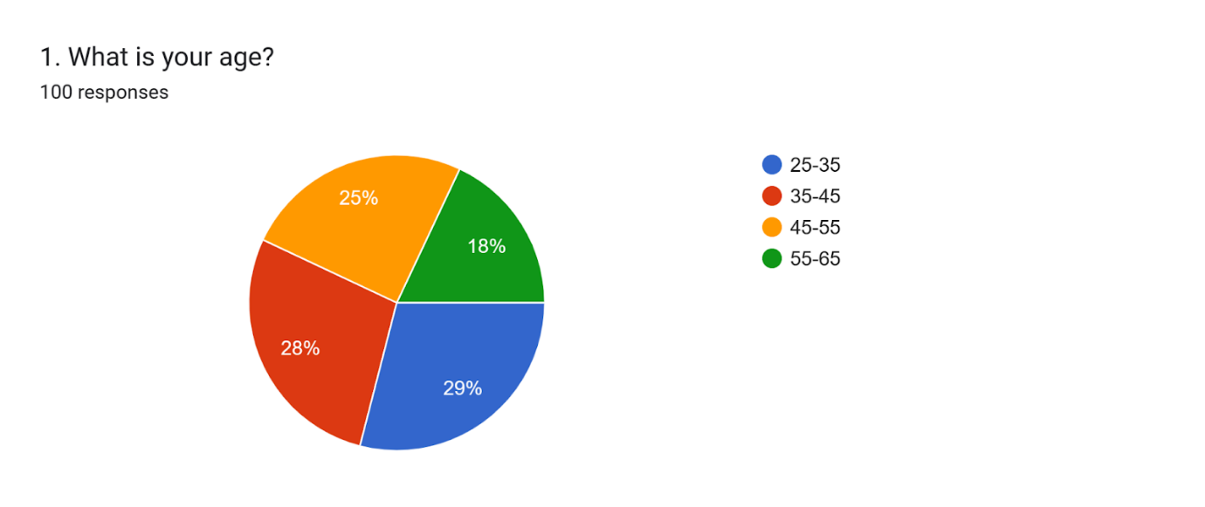

Figure 4.1: Age
(Source: Google Forms)
The first survey question focused on revealing the age of the participants. From the graphical representation, it can be observed that 29% of them belong from 25 to 35 years, 28% belong to 35 to 45 years whereas 25% belong from 45 to 55 years of age group. Only 55 to 65 years of age 4 is present by 18% in the survey. It is common in the hotel industry to have elderly people in higher positions whereas employee groups are of the younger population (Goh and Baum, 2021). It can be therefore assumed that the hotel industry in the UK prefers young staff more than elderly ones.
Question 2
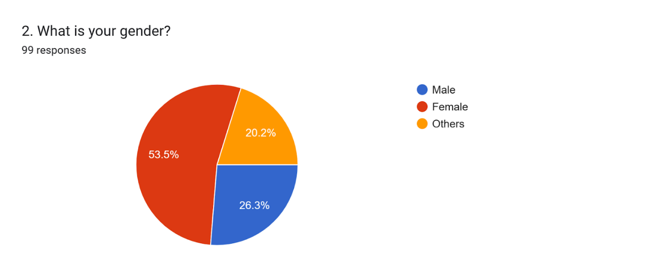

Figure 4.2: Gender
(Source: Google Forms)
From the second question, the gender of the participants has been from which it can be understood that the maximum of the hotel staff who participated in the survey was female as 53.5% selected the option. 26.3% selected mail and 20.2% selected others. From this, it can be realised that the UK hotel industry has provided women with the empowerment that they anticipate (Atan et al. 2021). Moreover, it can be realised that women or females were more interested in participating in the survey and providing their opinions on the topic rather than the male population. This has made the viewpoints come with different perspectives as females tend to think and provide relevant answers rather than the male population.
Question 3
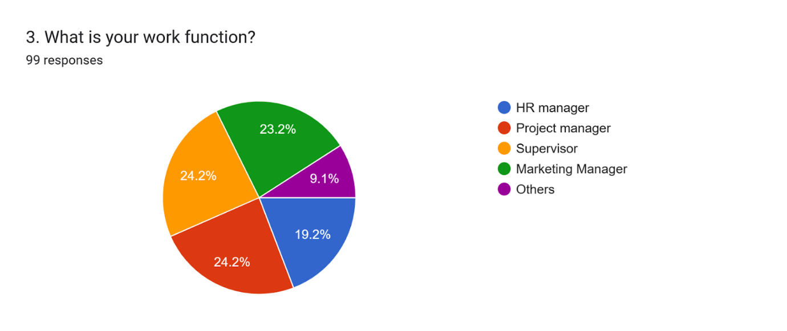

Figure 4.3: Work function
(Source: Google Forms)
The third question of the survey also helps in understanding the work function of the participants from the hotel industry in the UK. 24.2% each was found to be project managers and supervisors whereas 23.2% belong to the marketing manager group and 19.2% belong to HR managers. Only 9.1% selected the other options. From the graphical representation, it can be, therefore, summarised that the project managers and supervisors were more interested in participating than the other segments. Moreover, the female population is significantly distributed in all the categories.
Question 4
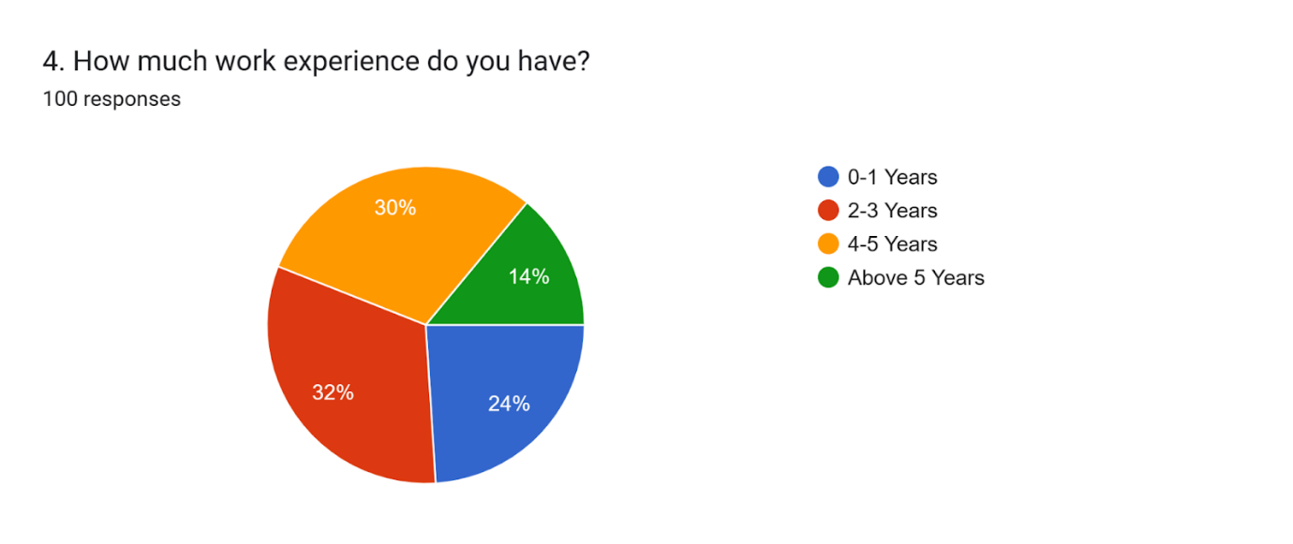

Figure 4.4: Work experience
(Source: Google Forms)
The fourth question was dedicated to focusing on the aspects of work experience wear 32% were noted to have 2 to 3 years of work experience and 30% had 4 to 5 years of work experience. 24% belong from 0 to 1 year and only 14% belong from above 5 years of working experience. From this analysis, it can be proposed that the UK hotel industry recruits individuals who are freshers and experienced. But more preferences are given to the category of individuals having 2 to 3 years of experience and also today individuals having 4 to 5 years of experience. Experienced candidates help an organisation grow and build a reputation in a competitive marketplace (Prasetio et al. 2019). For this preferences are provided towards the experienced candidates in the hotel industry of the UK.
Question 5
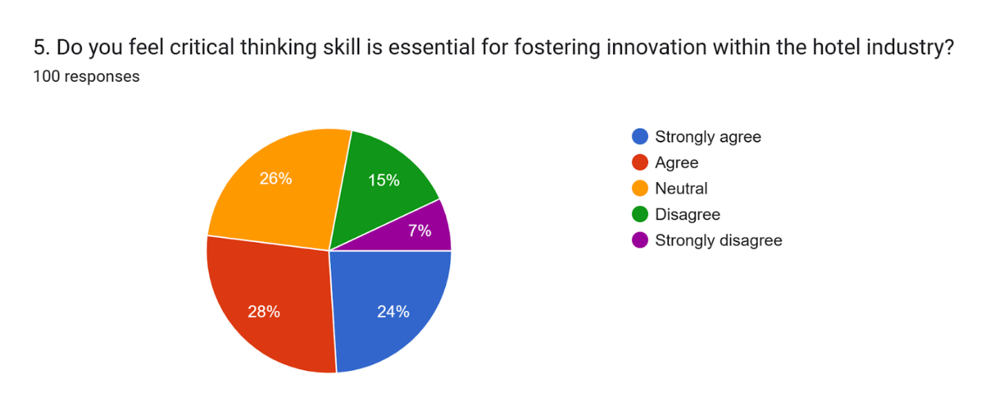

Figure 4.5: Importance of critical thinking skill
(Source: Google Forms)
The fifth question deals with the significance of critical thinking skills so that innovation can be indulged within the hotel industry. The maximum population selected the positive response by 24% and 28% whereas 26% remained neutral. On the other hand, only 15% and 7% selected the negative option which made it clear that critical thinking skill is quite an important element to foster innovation in the hotel industry. With the use of critical thinking skills, transformational leaders can encourage creativity among their teammates (Khan et al. 2020). This helps in promoting promotion for which the staff within the industry selected the positive options as their response.
Question 6
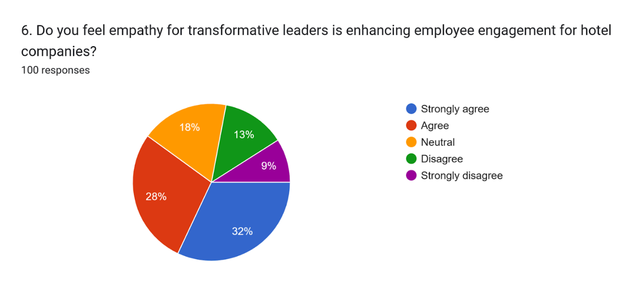

Figure 4.6: Empathy Enhancing Employee Engagement
(Source: Google Forms)
The sixth question of the survey helps in understanding the importance of empathy for transformative leaders to enhance employee engagement in the hotel industry. Maximum of the population that is 32% and 28% have provided positive responses whereas only 18% provided neutral responses. 14% and 9% provided negative responses. Leaders are required to remain empathetic so that emotional dedication can be showcased by influencing work engagement (Rabiul and Yean, 2021). From the analysis, it can be understood that empathy helps to enhance employee engagement as it is used as a motivating factor.

Question 7
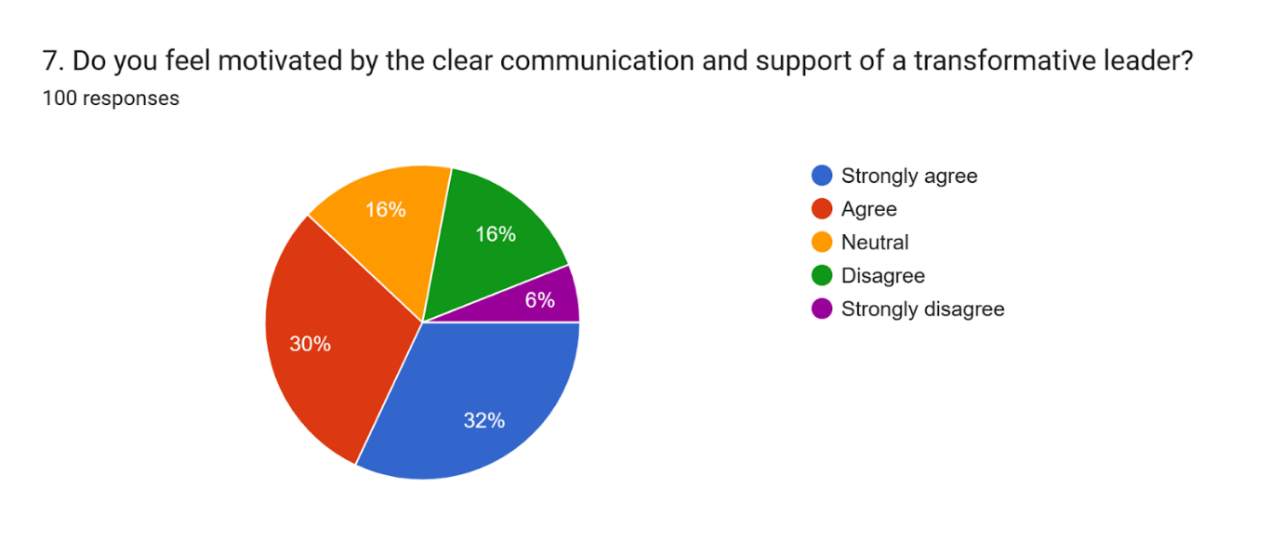

Figure 4.7: Motivation with clear communication and support
(Source: Google Forms)
The seventh question of the survey concentrated on providing responses about motivation that is obtained with clear communication and support by a transformative leader. Maximum responses have been obtained from the positive options by 32% and 30% whereas only a small percentage of 16% and 6% have received the negative responses. Only a small percentage of 16% selected the neutral option. From this analysis, it is clear that clear communication and support motivate the working members for which leaders are required to showcase such skills.
Question 8
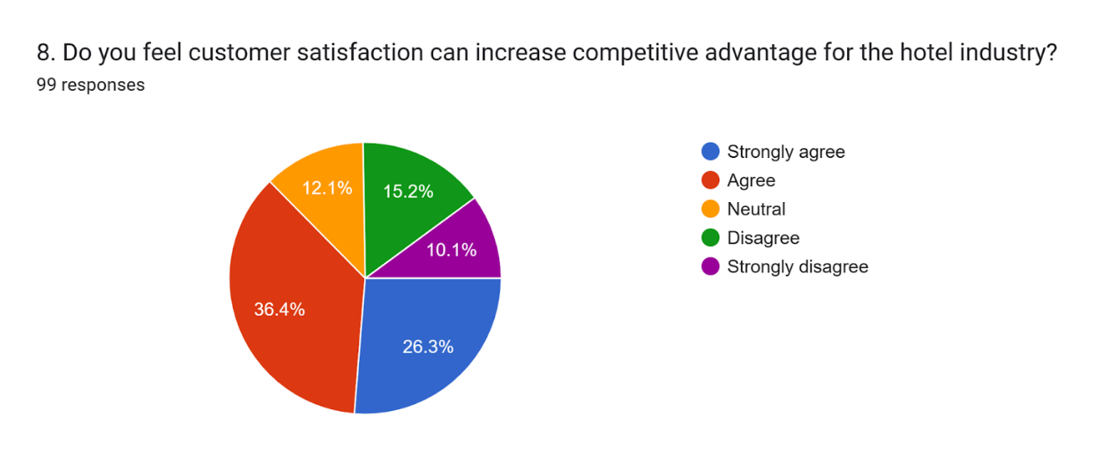

Figure 4.8: Customer satisfaction can increase competitive advantage
(Source: Google Forms)
The eighth question of the survey obtained a maximum percentage of 36.4% and 26.3% with positive responses but 15.2% and 10.1% with negative responses. 12.1% have selected the neutral option from which it is very clear that customer satisfaction has the potential of increasing competitive advantage for the hotel industry. The perception of the consumers is required to be fulfilled so that profitability can be enhanced with satisfaction (Syakur et al. 2020). For this reason, hotel staff are focused on providing satisfaction to its consumers to increase the competitive benefit.
Question 9
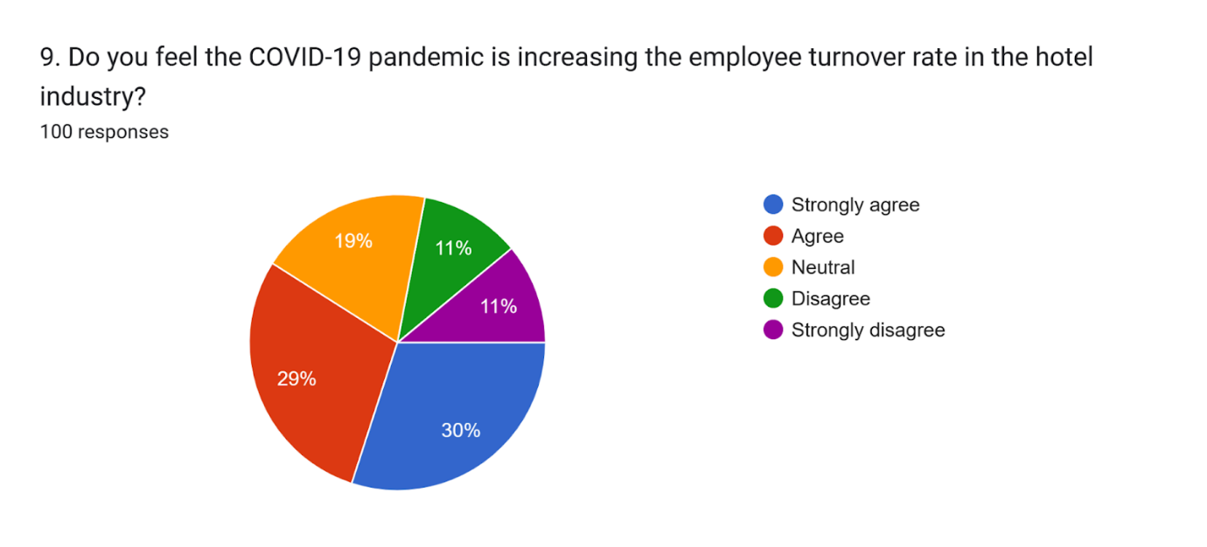

Figure 4.9: Increasing the employee turnover rate
(Source: Google Forms)
The ninth question in the survey concentrated on collecting responses to understand the increasing employee turnover rate during the pandemic in the hotel industry. In this question, 29% and 30% of the respondents provided positive responses, only 11% each provided negative responses and 19% selected neutral. The increased turnover rate in the hotel industry of the UK during the COVID-19 pandemic was due to restricted mobility facilities and a decline in salary offerings that made it hard for individuals to continue with their daily requirements (Kim and Liu, 2022). This has cleared the confusion about the increasing employee turnover rate in the hotel industry during the pandemic.
Question 10
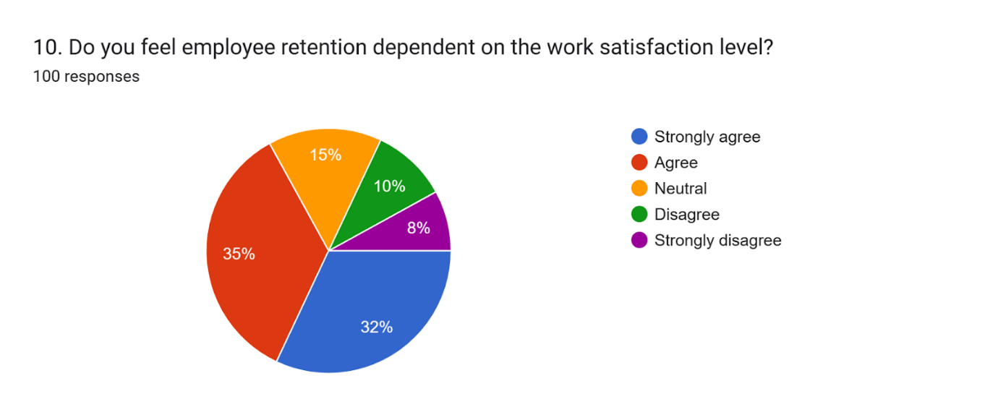

Figure 4.10: Employee retention dependent on the work satisfaction level
(Source: Google Forms)
The tenth question of the survey has helped in understanding the employee retention rate which is dependent on the work satisfaction level. This has acquired a maximum of positive responses that is 35% and 32% which means that employees are mostly satisfied if their perceptions are understood by the leaders which also impacts the retention rate. On the other hand, 15% remained neutral and 10% and 8% provided negative responses on the question.
Question 11
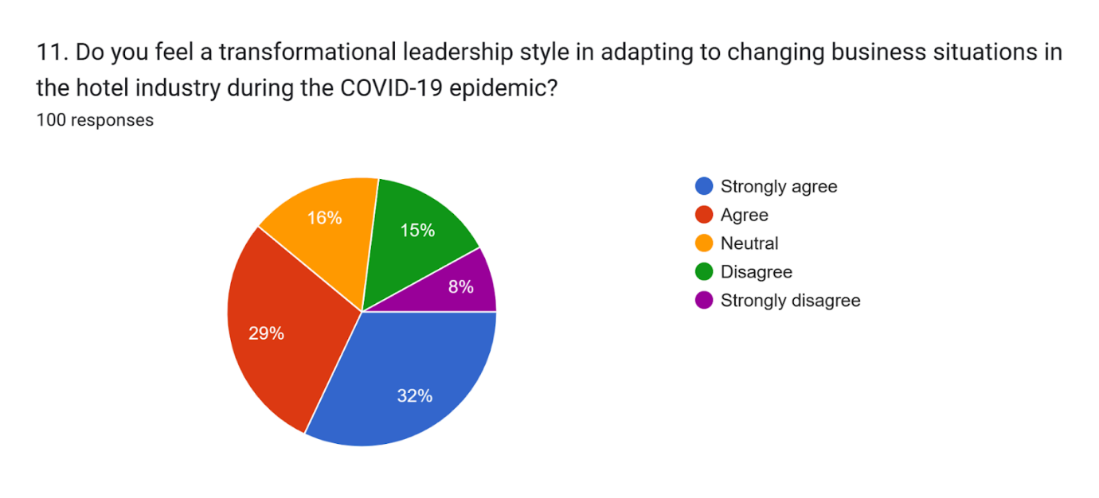

Figure 4.11: Benefit of transformational leadership style
(Source: Google Forms)
The eleventh question helps in understanding the benefit of the transformational leadership style. 29% and 32% selected positive responses, 15% and 8% selected negative responses and 16% only selected neutral. From the graphical representation, it has been understood that the maximum population believes that this type of leadership style helps in adapting to the changing circumstances in a business. The COVID-19 pandemic created massive disruptions in the hotel industry where the transformative leaders helped make the working population change with the business situation (Keogh-Brown et al. 2020). Several benefits can be realised with this leadership style.
Question 12
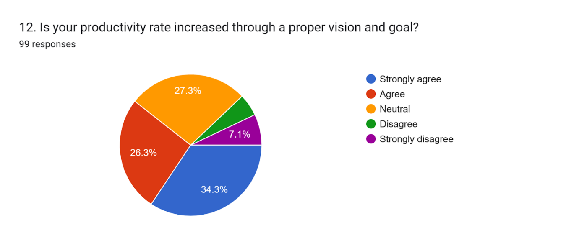

Figure 4.12: Productivity rate vs. a proper vision and goal
(Source: Google Forms)
The twelfth question discussed the productivity rate and the connection between proper vision goals. This has obtained maximum positive responses by 34.3% and 26.3% whereas 27.3% selected neutral and very less people selected the negative responses. This has helped in understanding that proper vision and goals are required to increase the productivity rate as each motivates the working population so that objectives can be achieved without any hassle.

4.3 Discussions
Importance of empathy and encouragement by leaders in enhancing employee engagement
It has been stated by Hougaard et al. (2020), that empathy is very important for a successful leader. An empathic leader can understand the needs of their employees and act accordingly. Thus, this helps to enhance employee engagement. Moreover, the empathy of leaders is also related to the performance of the employees in the workplace. Managers need to be good listeners to be empathic. They should be able to carefully listen to what their team members have to say and act accordingly. Participants who mainly belong from 25 to 35 years and 35 to 45 years majorly of the female category and having the work function as project managers and supervisors in the hotel industry of the UK have realised that it is important for the leaders to be empathetic as it helps in increasing the motivation. These individuals also realise the fact that it is important for the members of the organisations to feel motivated as it helps in working collaboratively and brings up the reputation of the company. However, if the satisfaction of the job is not provided to the working population productive level also lessens decreasing employee engagement in an organisation. Therefore remaining empathetic towards the team members helps in visualising the circumstances by developing a great bond between the members within the organisation and leaders.
As stated by Tran et al. (2020), empathy by leaders helps to have more effective communication between the employees and the leaders. Leaders in the present generation need to solve complex challenges and bring solutions but at the same time, they should have compassion and empathy for their employees. Leaders need to put themselves in the place of their team members and visualize the situation before reacting to it. This makes the team members feel valued and heard which in turn increases the employee engagement with the leaders. Thus, it deals with connecting with the emotions of the employees and the team members rather than making decisions based on what the leaders feel. It has been stated by Men et al. (2022), that empathy helps to develop a sense of trust between the leaders and the employees. Job satisfaction of employees is also found to have a direct connection with employee engagement by leaders. It has been observed that in a situation when employees feel that their efforts are being recognised and their perspectives are being heard, they tend to put more effort into their work. Empathy in leaders allows them to understand what is the root cause behind the indifferent behaviours of employees. It is also every team member's expectation that their leader will pay attention to them and give them time. Therefore, empathy is very important for leaders.

Role of leadership in work satisfaction and employee retention
Employee retention and leadership practices in an organization are highly correlated with each other. According to Fana et al. (2020), it can be understood that employees stay loyal to their organization and prefer to stay there for longer periods only when they feel valued and heard. Employee satisfaction is a very important factor that influences the loyalty of an employee towards their organization. There are multiple factors that in turn determine the satisfaction levels of employees. They are whether the employees are recognized for their efforts or not by their leaders, whether their leaders value and consider their viewpoints while making decisions and whether motivation and encouragement are obtained from the leaders.
It has been stated by Syakur et al. (2020) that it is the sole responsibility of the leadership to ensure that every member of the team is satisfied with their work and has good communication between them. Clear communication by leaders is also very important for employee satisfaction. It is not possible for the employees to understand what the leaders expect from them or vice versa without having proper and clear communication. It is equally important for the Leadership to treat every member with equal respect. The rules of the organization should be the same for everyone. Employees should not feel that the leadership is making biased decisions for some employees which impacts employee satisfaction. As stated by Contreras et al. (2020), team leaders are the ones who should encourage and motivate the employees. The employees should be able to go to their leaders in any situation if they feel demotivated. They should not think that their leaders are not approachable. It is observed that any form of doubt or discomfort in the minds of employees related to working in their workplace impacts employee satisfaction which in turn influences employee retention. Thus, employees with lower employee satisfaction are seen to quit their organization at an early stage.

Relation between proper vision and productivity rate
Proper vision is very important to assess the performance of an organization. In the absence of proper vision, an organization will not be able to judge its progress or perform a comparison with its competitors to understand where it currently stands in the market. As stated by Duggan et al. (2020), vision serves as a guideline following which an organization operates. It can be understood that initially the vision of an organization is developed and employees of an organization work together to accomplish that particular vision. This, it's the guiding factor of each employee in the organization.
It has been stated by (Paais and Pattiruhu, 2020), that vision has a significant influence on the performance of the organization. Multiple stakeholders are associated with an organization including the employees. Therefore it is important to make them aware of the purpose of the organization. This is being done using the vision of an organization. It is noted that the better the employees have about the vision of an organization, the better they can implement the strategies and enhance the performance of the organization. It has been stated by (Van Ruler, 2020), that vision helps in the process of strategy development. The success and failure of the strategies can be decided with the help of this vision. Thus, it acts as a parameter to measure the performance of an organization and decide its market position. Vision helps the employees to focus on what is important for the success of the organization. Therefore, since the focus of the employees increases, their efforts also increase and thus the productivity is enhanced. In the absence of vision, it has been observed that employees become reactive and not proactive. Thus, to set priorities within the organization, vision is important.

Role of critical thinking in innovation and enhancing customer experience
Critical thinking is very important for innovation to take place. In the absence of critical thinking, it is very difficult to analyse the outcome that is obtained from customer service and analyse them. It has been stated by Tang et al. (2020), that the presence of critical thinking skills helps customer representatives to provide innovative ideas to customers related to an issue that they are facing. In recent times, issues of customers are not restricted to some particular questions only. There are a variety of complex situations that the customers face and they expect a solution from the customer service of the organization. Moreover, if the customer representatives learn scripts to answer the questions of the customer, then solutions to all problems will not be achieved.
As stated by Alzoubi et al. (2022), innovation is very important for enhancing customer experience. The expectation of the customer is always that they will find some unique solution to their problem, even if the issue is complex. Thus, this is not possible if the representatives do not have critical thinking skills present. Therefore to think of out-of-the-box solutions for customers, it is important that issues are being thought critically and solutions are developed and provided to the customers. Enhanced customer experience is possible only when they are satisfied with the services provided by the company and customer service is an integral part of that. It has been stated by Zeithaml et al. (2020), that in case of any issues, customer service agents are the first that are approached to solve the problem. This has particularly become true in these times of digitized platforms such as e-commerce websites, hotel booking websites etc. Therefore, in a situation where the customer faces any kind of challenges related to room booking payment issues or any other kind of problem, customer agents are their first line of help.

4.4 Summary
Several findings have been extracted from the chapter that displayed different results. The 12 close-ended questionnaires were asked to 100 hotel staff present in the hotel industry around the United Kingdom. This has helped in extracting different opinions from different age groups of people that help in analysing the overall benefit of transformative leaders in the hotel industry. Moreover, the study has presented the significance of different factors which are important in an organisation for a leader to maintain so that work engagement can be increased. Descriptive analysis has also been presented through discussions of the findings so that detailed analysis can be presented that would be beneficial to get concrete results.

Chapter 5: Recommendations and Conclusion

5.1 Conclusion
The impact of transformational leadership on the UK hotel sector during the pandemic created a chaotic situation that impacted the work engagement rate with employee performance. The innovation and motivation that were disrupted during such a situation are important to understand so that leadership style can be integrated appropriately to overcome the unprecedented challenges. The effect on employee performance has created several disruptions and repercussions that went beyond the immediate operation of the hotel industry which required it essential to integrate crisis management across the sector with the use of appropriate leadership style. The dissertation has presented great details about the aim that has been formulated. These details have helped in understanding the concept of a transformative leader who is a potential candidate who helps in influencing the team with clear communication and support by inspiring them to achieve clear and structured visions for the business.
Different skills are identified within a transformative leader where communication and intellect have been given the most priority. Along with this, critical thinking, creativity, emotional intelligence with empathy and strategic planning nature are also given importance by the individual showcasing a transformative leadership style. Maintaining employee morale and handling anxiety had been the two most practical areas during such a situation as this impacted the productivity rate. To understand the situation the issues have been elaborated with the impact of adding transformative leadership on employee motivation in the hotel industry of the UK. Work satisfaction has also been highlighted which helps in increasing engagement by promoting the shared vision. The literature gap has also been found in the research study where the deficiency in understanding the impact of different factors by understanding the dynamics has been not presented which would have helped in understanding great levels of analysis. The conceptual Framework has also been presented based on the existing literature work so that the establishment of the important aspects can be understood by understanding all the theory or model that has been presented. Theories and models are the national hierarchy of needs and the transformational leadership model.
The work has also included the use of the primary data collection method so that different data can be extracted to understand the benefits of having transformative leadership within the hotel industry in the UK. The multitude of significant challenges faced by the hotel staff was also analysed by considering 100 individuals so that the objective can be understood in greater detail. The inclusion of research onion Framework has been included in the method section where positivist research philosophy and deductive research approach with cross-sectional research design have been included. The quantitative strategy has been applied so that the survey analysis can be carried out to collect the primary data. Stratified random sampling has been included which is part of the non-probability sampling technique. 12 closed-ended questionnaires have been formed with the use of Google Forms that have been distributed through email. Apart from this, descriptive analysis in the Excel sheet has been presented so that the different findings can be understood in greater detail. A few recommendations have also been provided to understand the limitations and future scope of the research paper.

5.2 Linking with Objectives
Linking with Objective 1
This portion has been linked with 2.2 and 2.3 sections of the literature review where the characteristics of the transformative leaders have been focused and the impact of it within the hotel industry in the UK has been represented. In this section, it has been found that transformational leaders have different characteristics that the hotel managers in the UK are required to have so that they can inspire the team members with different missions and clear visions provided by the organisation. This would help in upgrading the reputation of the organisation and achieving the set of particular objectives that are said by that organisation.
Linking with Objective 2
This objective has been linked with the 2.4 and 2.5 portion of the literature review where the impact of transformative leadership on employee motivation and work satisfaction has been aligned. From this portion, it has been understood that motivation levels are upgraded by appreciation and feedback. It is important for managers in the hotel industry to identify strengths and weaknesses so that employees can be empowered by maintaining corporate social responsibility and trust within the working environment. Apart from this work satisfaction also helps in promoting the shared value so that unity can be maintained with the leaders by sharing the responsibilities and understanding the job roles that are provided.
Linking with Objective 3
This objective has been linked with the 2.6 portion of the literacy review where the influence of transformative leadership in improving the psychological well-being of the working population during the pandemic has been represented. After the completion of this section, it has been understood that it is important to improve the psychological well-being of the individuals working in the hotel industry so that their performance can be managed by maintaining the entire management structure. Due to the heavy impact rated by the pandemic situation determination of transformations is required to be understood so that they can sustain through the disruptive situation by maintaining psychological well-being.
Linking with Objective 4
This objective has been linked with the 2.10 portion of the literature review where different components have been identified that help enhance employee performance and resilience within the hotel sector. This section also has great importance as it helps in identifying the different components that are required to be prioritised such as communication accountability and support given by the transformative leadership to maintain job security as well as satisfaction. It is important to maintain the influencing factors so that positivity can be introduced to the working population which would increase employee performance.

5.3 Recommendation
Several challenges have been faced by the hotel industry of the UK during the pandemic that is required to be enhanced by using appropriate strategies. Therefore, some recommendations have been made by considering the issues that impacted employee performance during the pandemic.
To develop training opportunities to increase the safety and security of the employees by the transformative leaders: As per Satata, (2021), employee satisfaction improves engagement within the organisations that are required to be maintained by every organisation working in the competitive environment. The hotel industry in the UK is also required to make their employees feel secure and safe by responding to potential hazards. This can be done by providing them with safety and security training so that emergency responses can be given to them by understanding the situation. This can be easily done with the use of a transformative leadership style that would help in bringing a more diverse training approach by fostering employee commitment towards continuous improvement.
To integrate the use of different skills of a transformative leader to bring up the positive working environment and culture of the hotel business: With the use of transformational leadership, the culture of an organisation in the hotel industry can be increased appropriately. This would be useful in influencing the performance of the employee and also bring positivity to employee performance by managing different situations. According to Eliyana and Ma’arif, (2019), transformational leaders provide extreme support to the working population by sharing the stress and anxiety that have been introduced by unforeseen situations affecting their productivity. With their help and capabilities productivity would be easily enhanced by handling the frustrations that have been introduced by the pandemic in the UK hotel industry. Giving priority to the communication ability of transformative leaders with supportiveness and motivation would reduce the turnover rates of the employees that occurred during the pandemic and enhance the satisfaction rate which would help in gaining the reputation of the industry in the UK market.

5.4 Limitations
The dissertation has uniquely aligned and presented every aspect related to transformational leadership and its importance on employee performance. However, it has only focused on collecting the primary data by integrating the utilisation of survey analysis. With the collection of primary data, a lack of depth is found within the research work as different individuals present different aspects which becomes very difficult to analyse. Moreover, accuracy can be present as dishonest responses can be also provided by the individuals participating in the survey. Different mistakes can also occur while constructing and implementing the survey that can impact the result. Another major limitation of the research is that it has only considered the UK economy and has not compared with other Nations. Other nations’ hotel industry was also impacted during the pandemic which has limited the research for this dissertation topic.

5.5 Future Scope
The future scope of the study is to select an alternative Data collection method to increase the scope of the research. The secondary data collection method can be integrated by future researchers within the dissertation so that different theoretical knowledge can be presented along with the practical observations that are acquired from primary data collection. This would help the research work in making more reliable findings and summarizing concrete results with accurate meaning and supportive resources. Moreover, it is also required to compare and contrast other Nations’ hotel industries with the UK’s so that more data and facts can be acquired. This would help in making the work more related and appropriate and would be also advantageous to understand the benefits of having transformative leaders within an organisation to bring up productivity and work engagement during turmoil situations.

Reflection
My journey in completing the work
The dissertation that was provided to me was based on the impact of transformational leadership on employee performance during the pandemic in the UK hotel industry. I have been successful in formulating the aim of the objective which was to highlight the significance of the presence of transformative leadership in the hotel industry of the UK by illustrating their benefits. I have understood from the study that leadership plays a very important role in employee engagement and satisfaction as well. Moreover, in the absence of satisfaction, employees will be reluctant to give their best efforts in their workplace which will in turn impact the productivity of the organization. I have also observed that the vision of an organization also influences the performance of the organization as it guides the employees to work towards a common goal. In customer service, customer experience is an integral part. It is possible to provide the customers with enhanced customer experiences only when the representatives can critically think about issues and provide solutions to the customers.
Key skills developed during the process of research
After the completion of the overall research procedure, different types of skills have been developed as the topic has provided different knowledge that was required. Firstly the resources help me in enhancing my creativity skills to elaborate my thinking capability. With the enhancement of creativity, I have noted that I have surveyed in a great manner. My critical thinking skills also developed along with problem-solving capability as different types of challenges were confronted during the survey but I have dealt with them effectively by using these skills. Moreover, my communication skills developed extraordinarily as during the survey I had to approach different hotel staff all around the UK which made me capable of becoming a good communicator along listener. If anybody had any confusion, I helped them to clear it out without any hesitation.
Key challenges encountered
Different challenges contracted by me majorly while conducting the survey. As the data collection technique involved the primary data collection, it was required to be done very methodically. Formulation of meaningful and topic-oriented questions was the most difficult part of creating the survey questionnaire. Moreover, I had to use all the knowledge that I had gained from the literature review which made the overall process very complicated. Due to time limitations and budget considerations, I had to complete the survey so that I could find meaningful results. Another major challenge was my decision-making capability which hindered me from making any decisions while collecting the sample size for the survey.
Key considerations for personal development as a researcher
I need to work on my decision-making capability by participating in different online activities so that I can make quick and strong decisions that would be fruitful for my future work. I also need to be more collaborative and punctual so that I can remain motivated and disciplined at the same time. These are the main considerations that I would like to undertake to develop my personality as a researcher.

Reference list
Abolnasser, M.S.A., Abdou, A.H., Hassan, T.H. and Salem, A.E. (2023). Transformational Leadership, Employee Engagement, Job Satisfaction, and Psychological Well-Being among Hotel Employees after the Height of the COVID-19 Pandemic: A Serial Mediation Model. International Journal of Environmental Research and Public Health, [online] 20(4), p.3609. doi: https://doi.org/10.3390/ijerph20043609 .
Abu-Rumman, A., (2021). Transformational leadership and human capital within the disruptive business environment of academia. World Journal on Educational Technology: Current Issues, 13(2), pp.178-187. doi: https://doi.org/10.18844/wjet.v13i2.5652
Al Harbi, J.A., Alarifi, S. and Mosbah, A., (2019). Transformation leadership and creativity: Effects of employees psychological empowerment and intrinsic motivation. Personnel Review, 48(5), pp.1082-1099. https://www.researchgate.net/profile/Aissa-Mosbah/publication/333905739_Transformation_leadership_and_creativity_Effects_of_employees_pyschological_empowerment_and_intrinsic_motivation/links/5d4a3e3d299bf1995b6aa109/Transformation-leadership-and-creativity-Effects-of-employees-pyschological-empowerment-and-intrinsic-motivation.pdf
Alharahsheh, H.H. and Pius, A., (2020). A review of key paradigms: Positivism VS interpretivism. Global Academic Journal of Humanities and Social Sciences, 2(3), pp.39-43. DOI: 10.36348/gajhss.2020.v02i03.001
Alzoubi, H., Alshurideh, M., Kurdi, B., Akour, I. and Aziz, R., (2022). Does BLE technology contribute towards improving marketing strategies, customer satisfaction and loyalty? The role of open innovation. International Journal of Data and Network Science, 6(2), pp.449-460. Available at: http://m.growingscience.com/beta/ijds/5238-does-ble-technology-contribute-towards-improving-marketing-strategies-customers-satisfaction-and-loyalty-the-role-of-open-innovation.html
Ambrose, J., (2021). Premier Inn warns over staff shortages as hotel bookings recover. Available at:https://www.theguardian.com/business/2021/oct/26/premier-inn-staff-shortages-hotel-salaries-bonuses#:~:text=The%20chain%20said%20it%20faced,stay%20beyond%20the%20summer%20months. [Accessed on: 2.10.2023]
Andeobu, L., Wibowo, S. and Grandhi, S., (2022). Medical waste from COVID-19 pandemic—a systematic review of management and environmental impacts in Australia. International journal of environmental research and public health, 19(3), p.1381. https://www.mdpi.com/1660-4601/19/3/1381
Annualreports.com (2023). Rest easy with - Premier Inn [Online]. Available at: https://www.annualreports.com/HostedData/AnnualReports/PDF/LSE_WTB_2022.pdf [Accessed on: 01.10.2023].
Anshori, M.Y., Karya, D.F., Muslihah, N. and Herlambang, T., (2020). Analysis of transformational leadership style for employee performance with job satisfaction as intervening variable. International Journal of Advanced Science and Technology, 29(9s), pp.3967-3973. Available at: https://www.bbejournal.com/index.php/BBE/article/download/92/37
Ardi, A., Djati, S.P., Bernarto, I., Sudibjo, N., Yulianeu, A., Nanda, H.A. and Nanda, K.A., (2020). The relationship between digital transformational leadership styles and knowledge-based empowering interaction for increasing organisational innovativeness. International Journal of Innovation, Creativity and Change, 11(3), pp.259-277. Available at: https://ijicc.net/images/vol11iss3/11322_Ardi_2020_E_R.pdf
Asbari, M., (2020). Is transformational leadership suitable for future organizational needs?. International Journal of Social, Policy and Law, 1(1), pp.51-55. Available at: https://www.ijospl.org/index.php/ijospl/article/download/17/9
Asbari, M., (2020). Is transformational leadership suitable for future organizational needs?. International Journal of Social, Policy and Law, 1(1), pp.51-55. https://www.ijospl.org/index.php/ijospl/article/download/17/9
Asenahabi, B.M., (2019). Basics of research design: A guide to selecting appropriate research design. International Journal of Contemporary Applied Researches, 6(5), pp.76-89. http://ijcar.net/assets/pdf/Vol6-No5-May2019/07.-Basics-of-Research-Design-A-Guide-to-selecting-appropriate-research-design.pdf
Ashok, M., Al Badi Al Dhaheri, M.S.M., Madan, R. and Dzandu, M.D., (2021). How to counter organisational inertia to enable knowledge management practices adoption in public sector organisations. Journal of Knowledge Management, 25(9), pp.2245-2273. http://dx.doi.org/10.1108/JKM-09-2020-0700
Atan, A., Ozgit, H. and Silman, F., (2021). Happiness at work and motivation for a sustainable workforce: evidence from female hotel employees. Sustainability, 13(14), p.7778. DOI: https://doi.org/10.3390/su13147778
Bloomfield, J. and Fisher, M.J., (2019). Quantitative research design. Journal of the Australasian Rehabilitation Nurses Association, 22(2), pp.27-30. Available at: https://search.informit.org/doi/epdf/10.3316/informit.738299924514584
BOZDOĞAN, S.C. and AKSOY, A., (2020). Effect of transformational leadership on job performance and job satisfaction. Osmaniye Korkut Ata Üniversitesi İktisadi ve İdari Bilimler Fakültesi Dergisi, 4(1), pp.56-67. Available at: https://dergipark.org.tr/en/download/article-file/1180211
Buil, I., Martínez, E. and Matute, J., (2019). Transformational leadership and employee performance: The role of identification, engagement and proactive personality. International journal of hospitality management, 77, pp.64-75. doi: https://doi.org/10.1016/j.ijhm.2018.06.014
Campbell, S., Greenwood, M., Prior, S., Shearer, T., Walkem, K., Young, S., Bywaters, D. and Walker, K., 2020. Purposive sampling: complex or simple? Research case examples. Journal of research in Nursing, 25(8), pp.652-661. DOI: https://doi.org/10.1177%2F1744987120927206
Chandra, Y., Shang, L., Chandra, Y. and Shang, L., (2019). Inductive coding. Qualitative research using R: A systematic approach, pp.91-106. DOI: https://doi.org/10.1007/978-981-13-3170-1_8
Clark, J. and Causer, G., (2020). Introduction: Research strategies and decisions. In Handbook for research students in the social sciences (pp. 163-176). Routledge. Available at: https://www.taylorfrancis.com/chapters/edit/10.4324/9781003070993-17/introduction-research-strategies-decisions-jon-clark-gordon-causer
Contreras, F., Baykal, E. and Abid, G., (2020). E-leadership and teleworking in times of COVID-19 and beyond What we know and where do we go. Frontiers in Psychology, 11, p.590271. Available at: https://www.frontiersin.org/articles/10.3389/fpsyg.2020.590271/full
Çop, S., Olorunsola, V.O. and Alola, U.V., (2021). Achieving environmental sustainability through green transformational leadership policy: Can green team resilience help?. Business Strategy and the Environment, 30(1), pp.671-682. DOI: 10.1002/bse.2646
D’Auria, G. and De Smet, A. (2020). Leadership in a crisis: Responding to coronavirus | McKinsey. [online] www.mckinsey.com. Available at:https://www.mckinsey.com/capabilities/people-and-organizational-performance/our-insights/leadership-in-a-crisis-responding-to-the-coronavirus-outbreak-and-future-challenges.
Dabo, M. (2023). UK hotels still grappling with post-Covid challenges. [online] Hotel Management Network. Available at: https://www.hotelmanagement-network.com/features/uk-hotels-still-grappling-with-post-covid-challenges/ [Accessed 28 Aug. 2023].
Duggan, J., Sherman, U., Carbery, R. and McDonnell, A., (2020). Algorithmic management and app‐work in the gig economy: A research agenda for employment relations and HRM. Human Resource Management Journal, 30(1), pp.114-132. Available at: https://onlinelibrary.wiley.com/doi/abs/10.1111/1748-8583.12258
Eliyana, A. and Ma’arif, S., (2019). Job satisfaction and organizational commitment effect in the transformational leadership towards employee performance. European Research on Management and Business Economics, 25(3), pp.144-150. DOI: https://doi.org/10.1016/j.iedeen.2019.05.001
Escortell, R., Baquero, A. and Delgado, B., (2020). The impact of transformational leadership on the job satisfaction of internal employees and outsourced workers. Cogent Business & Management, 7(1), p.1837460. doi: https://doi.org/10.1080/23311975.2020.1837460
Fana, M., Milasi, S., Napierala, J., Fernández-Macías, E. and Vázquez, I.G., (2020). Telework, work organisation and job quality during the COVID-19 crisis: a qualitative study (No. 2020/11). JRC Working Papers Series on Labour, Education and Technology. Available at: https://www.econstor.eu/handle/10419/231343
Foroudi, P., H. Tabaghdehi, S.A. and Marvi, R. (2021). The gloom of the COVID-19 shock in the hospitality industry: A study of consumer risk perception and adaptive belief in the dark cloud of a pandemic. International Journal of Hospitality Management, [online] 92(102717), p.102717. doi: https://doi.org/10.1016/j.ijhm.2020.102717 .
Goh, E. and Baum, T., (2021). Job perceptions of Generation Z hotel employees towards working in Covid-19 quarantine hotels: the role of meaningful work. International Journal of Contemporary Hospitality Management, 33(5), pp.1688-1710. DOI 10.1108/IJCHM-11-2020-1295
Gom, D., Lew, T.Y., Jiony, M.M., Tanakinjal, G.H. and Sondoh Jr, S., (2021). The role of transformational leadership and psychological capital in the hotel industry: a sustainable approach to reducing turnover intention. Sustainability, 13(19), p.10799. doi: https://doi.org/10.3390/ su131910799
Gomes, C., Malheiros, C., Campos, F. and Lima Santos, L., 2022. COVID-19’s Impact on the Restaurant Industry. Sustainability, 14(18), p.11544. https://doi.org/10.3390/su141811544
Gov. uk, (2023). Hospitality strategy: reopening, recovery, resilience. Available at: https://www.gov.uk/government/publicatio/hospitality-strategy-reopening-recovery-resilience/hospitality-strategy-reopeningns-recovery-resilience#:~:text=Across%20the%20economy%2C%20between%20February,the%20Coronavirus%20Job%20Retention%20Scheme. [Accessed on: 2.10.2023]
Gov.UK (2021). Hospitality strategy: reopening, recovery, resilience. [online] GOV.UK. Available at: https://www.gov.uk/government/publications/hospitality-strategy-reopening-recovery-resilience/hospitality-strategy-reopening-recovery-resilience .
Gradinaru, C., Toma, S.G., Catana, S. and Andrisán, G., (2020). A view on transformational leadership: The case of Jeff Bezos. Manager, (31), pp.93-100. https://www.researchgate.net/profile/Stefan-Catana-3/publication/349380465_A_view_on_transformational_leadership_The_case_of_Jeff_Bezos/links/602d907792851c4ed57bf413/A-view-on-transformational-leadership-The-case-of-Jeff-Bezos.pdf
Gurmani, J.K., Khan, N.U., Khalique, M., Yasir, M., Obaid, A. and Sabri, N.A.A., (2021). Do environmental transformational leadership predicts organizational citizenship behavior towards environment in hospitality industry: using structural equation modelling approach. Sustainability, 13(10), p.5594. doi: https://doi.org/10.3390/su13105594
Hadi, D.M., Naeem, M.A. and Karim, S. (2022). Impact of COVID-19 on the Connectedness across Global Hospitality Stocks. International Journal of Hospitality Management, p.103243. doi: https://doi.org/10.1016/j.ijhm.2022.103243.
Hahang, E., Bayraktar, S. and Jiménez, A. (2022). Early evidence of leadership skills and strategies in managing the impact of COVID-19 pandemic in the hospitality industry. Cross Cultural & Strategic Management, ahead-of-print(ahead-of-print). doi: https://doi.org/10.1108/ccsm-03-2021-0041 .
Hammersley, M., (2019). From positivism to post-positivism: Progress or digression?. Teoria Polityki, (3), pp.175-188. Available at: https://www.ejournals.eu/TP/2019/Nr-3/art/14196
Hopper, E., (2020). Maslow’s hierarchy of needs explained. ThoughtCo, ThoughtCo, 24, pp.1-3.http://www.christianworldmedia.com/client/docs/603_1585079540_17.pdf
Horstschulze, (2023). About Horstschulze. Available at: https://horstschulze.com/ [Accessed on: 2.10.2023]
Hougaard, R., Carter, J. and Hobson, N., (2020). Compassionate leadership is necessary—but not sufficient. Harvard Business Review. https://hbr. org/2020/12/compassionate-leadership-is-necessary-but-not-sufficient. Available at: https://onlinelibrary.wiley.com/doi/abs/10.1111/jocn.15520
Iide.co (2023). Detailed Marketing Strategy of Marriott International | IIDE [Online]. Available at: https://iide.co/case-studies/marketing-strategy-of-marriott-international/ [Accessed on: 01.10.2023].
Inversini, D.A. (2023). The path towards customer-centricity in hospitality. [online] hospitalityinsights.ehl.edu. Available at: https://hospitalityinsights.ehl.edu/customer-centricity-in-hospitality .
Japutra, A. and Situmorang, R. (2022). The hotel industry was hit hardest during the pandemic. We should learn from their experiences to devise future strategies. [online] The Conversation. Available at: https://theconversation.com/the-hotel-industry-was-hit-hardest-during-the-pandemic-we-should-learn-from-their-experiences-to-devise-future-strategies-185446 .
Karim, A., Azam, S., Shanmugam, B., Kannoorpatti, K. and Alazab, M., 2019. A comprehensive survey for intelligent spam email detection. IEEE Access, 7, pp.168261-168295. Available at: https://ieeexplore.ieee.org/stamp/stamp.jsp?arnumber=8907831
Kelly, L.M. and Cordeiro, M., (2020). Three principles of pragmatism for research on organizational processes. Methodological innovations, 13(2), p.2059799120937242. DOI: https://doi.org/10.1177/2059799120937242
Keogh-Brown, M.R., Jensen, H.T., Edmunds, W.J. and Smith, R.D., (2020). The impact of Covid-19 associated behaviours and policies on the UK economy: A computable general equilibrium model. SSM-population health, 12, p.100651. DOI: https://doi.org/10.1016/j.ssmph.2020.100651
Khan, N.A., Khan, A.N., Soomro, M.A. and Khan, S.K., (2020). Transformational leadership and civic virtue behaviour: Valuing act of thriving and emotional exhaustion in the hotel industry. Asia Pacific Management Review, 25(4), pp.216-225. DOI: https://doi.org/10.1016/j.apmrv.2020.05.001
Kim, Y.R. and Liu, A., (2022). Social distancing, trust and post-COVID-19 recovery. Tourism Management, 88, p.104416. DOI: https://doi.org/10.1016%2Fj.tourman.2021.104416
Labrague, L.J., Nwafor, C.E. and Tsaras, K., (2020). Influence of toxic and transformational leadership practices on nurses' job satisfaction, job stress, absenteeism and turnover intention: A cross‐sectional study. Journal of Nursing Management, 28(5), pp.1104-1113. https://www.academia.edu/download/87088087/jonm.1305320220606-1-nkpi8.pdf
Lai, Y.-L. and Cai, W. (2022). Enhancing post‐COVID-19 work resilience in hospitality: A micro-level crisis management framework. Tourism and Hospitality Research, 23(1), p.146735842210751. doi: https://doi.org/10.1177/14673584221075182 .
Libardolambrano.medium.com (2020). A Brief History of the Corporate Culture Transformation at Hilton | Part 1 : The People, Chris Nassetta [Online]. Available at: https://libardolambrano.medium.com/a-brief-history-of-the-corporate-culture-transformation-at-hilton-part-i-chris-nassetta-37194f0a32e9 [Accessed on: 01.10.2023].
Mardiana, S., (2020). Modifying Research Onion for Information Systems Research. Solid State Technology, 63(4), pp.5304-5313. https://www.researchgate.net/profile/Siti-Mardiana/publication/359542575_Modifying_Research_Onion_for_Information_Systems_Research/links/62432dc07931cc7ccf033406/Modifying-Research-Onion-for-Information-Systems-Research.pdf
Maxwell, J.A., (2021). Why qualitative methods are necessary for generalization. Qualitative Psychology, 8(1), p.111. DOI: https://psycnet.apa.org/doi/10.1037/qup0000173
Men, L.R., Qin, Y.S. and Jin, J., (2022). Fostering employee trust via effective supervisory communication during the COVID-19 pandemic: Through the lens of motivating language theory. International Journal of Business Communication, 59(2), pp.193-218. Available at:https://journals.sagepub.com/doi/abs/10.1177/23294884211020491
Miceli, A., Hagen, B., Riccardi, M.P., Sotti, F. and Settembre-Blundo, D., (2021). Thriving, not just surviving in changing times: How sustainability, agility and digitalization intertwine with organizational resilience. Sustainability, 13(4), p.2052. https://doi.org/10.3390/su13042052
Mohajan, H.K., (2020). Quantitative research: A successful investigation in natural and social sciences. Journal of Economic Development, Environment and People, 9(4), pp.50-79. https://mpra.ub.uni-muenchen.de/105149/
Muhaise, H., Ejiri, A.H., Muwanga-Zake, J.W.F. and Kareyo, M., (2020). The Research Philosophy Dilemma for Postgraduate Student Researchers. International Journal of Research and Scientific Innovation, 7(4), pp.2321-2705. Available at: https://www.academia.edu/download/63208983/201-20420200505-22028-l1wryj.pdf
Nayak, M.S.D.P. and Narayan, K.A., 2019. Strengths and weaknesses of online surveys. technology, 6(7), pp.0837-2405053138. DOI: 10.9790/0837-2405053138
Nguon, V.,(2022). Effect of transformational leadership on job satisfaction, innovative behavior, and work performance: A conceptual review. International Journal of Business and Management, 17(12), pp.75-89. doi: https://doi.org/10.5539/ijbm.v17n12p75
Nickerson, C., (2022). Positivism in sociology: definition, theory & examples. Simply Psychology. https://www.simplypsychology.org/positivism-in-sociology-definition-theory-examples.html
Ntounis, N., Parker, C., Skinner, H., Steadman, C. and Warnaby, G., 2022. Tourism and Hospitality industry resilience during the Covid-19 pandemic: Evidence from England. Current Issues in Tourism, 25(1), pp.46-59. https://www.tandfonline.com/doi/pdf/10.1080/13683500.2021.1883556
Numonjonovich, M.M., (2022). Economic Development and The Role of Maslow’s Hierarchy of Needs. Web of Scientist: International Scientific Research Journal, 3(7), pp.5-10. https://api.scienceweb.uz/storage/publication_files/2154/5594/63ca3c1eb7de0___ECONOMIC%20DEVELOPMENT%20AND%20THE%20ROLE%20OF%20MASLOW%E2%80%99S%20HIERARCHY%20OF%20NEEDS.pdf
OECD (2020). The Territorial Impact of COVID-19: Managing the Crisis across Levels of Government. [online] OECD. Available at: https://www.oecd.org/coronavirus/policy-responses/the-territorial-impact-of-covid-19-managing-the-crisis-across-levels-of-government-d3e314e1 /.
Okoli, C., (2023). Inductive, abductive and deductive theorising. International Journal of Management Concepts and Philosophy, 16(3), pp.302-316. Available at: https://www.researchgate.net/profile/Chitu-Okoli/publication/350143318_Inductive_Abductive_and_Deductive_Theorizing/links/634c5004ff870c55ce2a8943/Inductive-Abductive-and-Deductive-Theorizing.pdf
Paais, M. and Pattiruhu, J.R., (2020). Effect of motivation, leadership, and organizational culture on satisfaction and employee performance. The Journal of Asian Finance, Economics and Business, 7(8), pp.577-588. doi:10.13106/jafeb.2020.vol7.no8.577
Paais, M. and Pattiruhu, J.R., (2020). Effect of motivation, leadership, and organizational culture on satisfaction and employee performance. The Journal of Asian Finance, Economics and Business, 7(8), pp.577-588. Available at: https://koreascience.kr/article/JAKO202026061031735.page
Pandey, J., (2019). Deductive approach to content analysis. In Qualitative techniques for workplace data analysis (pp. 145-169). IGI Global. DOI: 10.4018/978-1-5225-5366-3.ch007
Park, Y.S., Konge, L. and Artino Jr, A.R., (2020). The positivism paradigm of research. Academic medicine, 95(5), pp.690-694. DOI: 10.1097/ACM.0000000000003093
Prasetio, P., Partono, A., Wulansari, P., Putri, S.T., Ramdhani, R. and Abdullah, A., (2019, May). The mediation of job satisfaction in the relation of work stress and turnover intention in the hotel industry. In 1st international conference on economics, business, entrepreneurship, and finance (ICEBEF 2018) (pp. 608-612). Atlantis Press. Available at: https://www.atlantis-press.com/article/125908144.pdf
Purwanto, A., Kusumaningsih, S.W. and Prasetya, A.B., (2020). Did Transformational Leadership Elitist and Antidemocratic? A Literature Review. International Journal of Social, Policy and Law, 1(1), pp.1-11.https://www.ijospl.org/index.php/ijospl/article/download/1/2
Rabiul, M.K. and Yean, T.F., (2021). Leadership styles, motivating language, and work engagement: An empirical investigation of the hotel industry. International Journal of Hospitality Management, 92, p.102712. DOI: https://doi.org/10.1016/j.ijhm.2020.102712
Rivaldo, Y. and Nabella, S.D., (2023). Employee Performance: Education, Training, Experience and Work Discipline. Calitatea, 24(193), pp.182-188. DOI: 10.47750/QAS/24.193.20
Rogers, J. and Revesz, A., (2019). Experimental and quasi-experimental designs. In The Routledge handbook of research methods in applied linguistics (pp. 133-143). Routledge. https://discovery.ucl.ac.uk/id/eprint/10091265/7/Revesz_Rogers%20Revesz_Experimental%20design%20book%20chapter.pdf
Satata, D.B.M., (2021). Employee engagement as an effort to improve work performance: literature review. Ilomata International Journal of Social Science, 2(1), pp.41-49. Available at: https://ilomata.org/index.php/ijss/article/download/152/136
Saunders, M., Lewis, P.H.I.L.I.P. and Thornhill, A.D.R.I.A.N., (2007). Research methods. Business Students 4th edition Pearson Education Limited, England, 6(3), pp.1-268. https://www.researchgate.net/profile/Mark-Saunders-10/publication/330760964_Research_Methods_for_Business_Students_Chapter_4_Understanding_research_philosophy_and_approaches_to_theory_development/links/5c53056f299bf12be3f0e2cf/Research-Methods-for-Business-Students-Chapter-4-Understanding-research-philosophy-and-approaches-to-theory-development.pdf
Schiuma, G., Schettini, E., Santarsiero, F. and Carlucci, D., (2022). The transformative leadership compass: six competencies for digital transformation entrepreneurship. International Journal of Entrepreneurial Behavior & Research, 28(5), pp.1273-1291. https://www.researchgate.net/profile/Francesco-Santarsiero/publication/351567932_The_transformative_leadership_compass_six_competencies_for_digital_transformation_entrepreneurship/links/63e68bd8e2e1515b6b8763bd/The-transformative-leadership-compass-six-competencies-for-digital-transformation-entrepreneurship.pdf
Scriven, A. (2023). Hospitality sector focused on ramping up operations and planning for growth. [online] Deloitte United Kingdom. Available at: https://www2.deloitte.com/uk/en/pages/consumer-business/articles/hospitality-sector-focused-on-ramping-up-operations-and-planning-for-growth.html .
Seeram, E., (2019). An overview of correlational research. Radiologic technology, 91(2), pp.176-179. http://www.radiologictechnology.org/content/91/2/176.extract
Shafi, M., Lei, Z., Song, X. and Sarker, M.N.I., (2020). The effects of transformational leadership on employee creativity: The moderating role of intrinsic motivation. Asia Pacific Management Review, 25(3), pp.166-176. https://www.sciencedirect.com/science/article/pii/S1029313218305530
Shah, S.H.A., Sultana, A., Gul, A., Sajjad, S., Aziz, S., Basit, A. and Qadir, A., (2020). Transformational leadership influence on innovation directly and indirectly through affective commitment in hotel industry of Malaysia. International Review of Management and Marketing, 10(6), p.22. doi:10.32479/irmm.10761
Shapoval, V., Hägglund, P., Pizam, A., Abraham, V., Carlbäck, M., Nygren, T. and Smith, R.M. (2021). The COVID-19 pandemic effects on the hospitality industry using social systems theory: A multi-country comparison. International Journal of Hospitality Management, [online] 94(102813), p.102813. doi: https://doi.org/10.1016/j.ijhm.2020.102813 .
Sileyew, K.J., (2019). Research design and methodology. Cyberspace, pp.1-12. DOI: 10.5772/intechopen.85731
Sobaih, A.E.E., Gharbi, H. and Abu Elnasr, A.E., (2022). Do you feel safe here? The role of psychological safety in the relationship between transformational leadership and turnover intention amid COVID-19 pandemic. Journal of risk and financial management, 15(8), p.340.doi: https://doi.org/10.3390/jrfm15080340
Spyridonidis, D. (2021). How has COVID-19 changed leadership? [online] Warwick Business School. Available at: https://www.wbs.ac.uk/news/how-has-covid-19-changed-leadership/.
Statista, (2023). Market size of the hotel industry in the United Kingdom from 2013 to 2022, with a forecast for 2023. Available at: https://www.statista.com/statistics/1364712/hotel-industry-market-size-uk/ [Accessed on: 2.10.2023]
Stratton, S.J., 2021. Population research: convenience sampling strategies. Prehospital and disaster Medicine, 36(4), pp.373-374. DOI: https://doi.org/10.1017/S1049023X21000649
Susanto, P.C., Agusinta, L., Setyawati, A. and Panjaitan, A.R.P., (2023). Determinant Organization Commitment and Development Organization: Analysis Servant Leadership, Transformational Leadership, Transactional Leadership. Formosa Journal of Multidisciplinary Research, 2(3), pp.541-558. doi: https://10.0.218.119/fjmr.v2i3.3356
Syakur, A., Susilo, T.A.B., Wike, W. and Ahmadi, R., (2020). Sustainability of communication, organizational culture, cooperation, trust and leadership style for lecturer commitments in higher education. Budapest International Research and Critics Institute (BIRCI-Journal): Humanities and Social Sciences, 3(2), pp.1325-1335. Available at: https://pdfs.semanticscholar.org/6c28/973e09c1799465e5daafb55c714bdc931e6c.pdf
Tamminen, K.A. and Poucher, Z.A., (2020). Research philosophies. In The Routledge international encyclopedia of sport and exercise psychology (pp. 535-549). Routledge. Available at: https://www.taylorfrancis.com/chapters/edit/10.4324/9781315187259-39/research-philosophies-katherine-tamminen-zo%C3%AB-poucher
Tang, T., Vezzani, V. and Eriksson, V., (2020). Developing critical thinking, collective creativity skills and problem-solving through playful design jams. Thinking Skills and Creativity, 37, p.100696. Available at: https://www.sciencedirect.com/science/article/pii/S187118712030170X
Tran, H., Hardie, S. and Cunningham, K.M., (2020). Leading with empathy and humanity: Why talent-centred education leadership is especially critical amidst the pandemic crisis. International Studies in Educational Administration (Commonwealth Council for Educational Administration & Management (CCEAM)), 48(1), pp.39-45. Available at:http://cceam.net/wp-content/uploads/2020/07/ISEA-2020-Vol-48-No.-I.pdf#page=45
Van Ruler, B., (2020). Communication theory: An underrated pillar on which strategic communication rests. In Future Directions of Strategic Communication (pp. 39-53). Routledge. Available at: https://www.taylorfrancis.com/chapters/edit/10.4324/9780429295638-4/communication-theory-betteke-van-ruler
Virgiawan, A.R., Riyanto, S. and Endri, E., (2021). Organizational culture as a mediator motivation and transformational leadership on employee performance. Academic Journal of Interdisciplinary Studies, 10(3), pp.67-79. https://doi.org/10.36941/ajis-2021-0065
Wang, C.J., (2022). Exploring the Mechanisms Linking Transformational Leadership, Perceived Organizational Support, Creativity, and Performance in Hospitality: The Mediating Role of Affective Organizational Commitment. Behavioral Sciences, 12(10), p.406. Doi: https://doi.org/10.3390/ bs12100406
Widarmanti, T., Prasetio, A.P. and Luturlean, B.S., (2021). The role of employees job satisfaction in the relationship between transformational leadership and affective commitment at roof-tile manufacturing company. International Journal of Human Resource Studies, 11(1), pp.306-319. doi: https://doi.org/10.5296/ijhrs.v11i1.18124
Wroten, B. (2023). Reflections on Leadership: How COVID-19 Changed Hoteliers Personally and Professionally. [online] CoStar. Available at: https://www.costar.com/article/789767367/reflections-on-leadership-how-covid-19-changed-hoteliers-personally-and-professionally [Accessed 28 Aug. 2023].
Xu, L., Mohammad, S.J., Nawaz, N., Samad, S., Ahmad, N. and Comite, U., (2022). The role of CSR for de-carbonization of hospitality sector through employees: A leadership perspective. Sustainability, 14(9), p.5365. https://doi.org/10.3390/su14095365
Yang, C., Chen, Y., Zhao, X. and Hua, N., (2020). Transformational leadership, proactive personality and service performance: The mediating role of organizational embeddedness. International Journal of Contemporary Hospitality Management, 32(1), pp.267-287. doi : 10.1108/IJCHM-03-2019-0244
Yücel, İ., (2021). Transformational leadership and turnover intentions: the mediating role of employee performance during the COVID-19 pandemic. Administrative Sciences, 11(3), p.81. https://doi.org/10.3390/admsci11030081
Zaman, N., (2020). The use of the inductive and deductive approaches in classrooms. Available at: https://dspace.bracu.ac.bd/xmlui/bitstream/handle/10361/14472/17303023_ENH.pdf?sequence=1
Zeithaml, V.A., Jaworski, B.J., Kohli, A.K., Tuli, K.R., Ulaga, W. and Zaltman, G., (2020). A theories-in-use approach to building marketing theory. Journal of Marketing, 84(1), pp.32-51. Available at: https://journals.sagepub.com/doi/abs/10.1177/0022242919888477
Appendices

Appendix 1: Survey questions
1. What is your age?
- 25-35
- 35-45
- 45-55
- 55-65
2. What is your gender?
- Male
- Female
- Others
3. What is your work function?
- HR manager
- Project manager
- Supervisor
- Marketing Manager
- Others
4. How much work experience do you have?
- 0-1 Years
- 2-3 Years
- 4-5 Years
- Above 5 Years
5. Do you feel critical thinking skill is essential for fostering innovation within the hotel industry?
- Strongly agree
- Agree
- Neutral
- Disagree
- Strongly disagree
6. Do you feel empathy for transformative leaders is enhancing employee engagement for hotel companies?
- Strongly agree
- Agree
- Neutral
- Disagree
- Strongly disagree
7. Do you feel motivated by the clear communication and support of a transformative leader?
- Strongly agree
- Agree
- Neutral
- Disagree
- Strongly disagree
8. Do you feel customer satisfaction can increase competitive advantage for the hotel industry?
- Strongly agree
- Agree
- Neutral
- Disagree
- Strongly disagree
9. Do you feel the COVID-19 pandemic is increasing the employee turnover rate in the hotel industry?
- Strongly agree
- Agree
- Neutral
- Disagree
- Strongly disagree
10. Do you feel employee retention dependent on the work satisfaction level?
- Strongly agree
- Agree
- Neutral
- Disagree
- Strongly disagree
11. Do you feel a transformational leadership style in adapting to changing business situations in the hotel industry during the COVID-19 epidemic?
- Strongly agree
- Agree
- Neutral
- Disagree
- Strongly disagree
12. Is your productivity rate increased through a proper vision and goal
- Strongly agree
- Agree
- Neutral
- Disagree
- Strongly disagree

University of Wales: Trinity Saint David

E-Thesis Deposit Agreement

Details of the Work
I would like to deposit the following item in the digital repository maintained by the University, and/or in any other repository authorized for use by the University:

Title
Exploring the Impact of Transformational Leadership on Employee Performance in the UK Hotel Industry Amidst the COVID-19 Pandemic

This item is a product of my own research endeavours and is covered by the agreement below in which the item is referred to as “the Work”. It is identical in content to that deposited in the Learning Resources Centre, subject to point 4 below.

I agree that the University of Wales: Trinity Saint David may electronically store, copy or translate the Work to any approved medium or format for the purpose of future preservation and accessibility. The University is not under any obligation to reproduce or display the Work in the same formats or resolutions in which it was originally deposited.

UW: TSD Digital Repository
I understand that work deposited in the digital repository will be accessible to a wide variety of people and institutions, including automated agents and search engines via the World Wide Web.

I understand that once the Work is deposited, the item and its metadata may be incorporated into public access catalogues or services, such as national databases of electronic theses.

I agree as follows:
- That I am the author or have the authority of the author/s to make this agreement and do hereby give the University of Wales: Trinity Saint David the right to make available the Work in the way described above.
- That the electronic copy of the Work deposited in the digital repository and covered by this agreement, is identical in content to the paper copy of the Work.
- That I have exercised reasonable care to ensure that the Work is original, and to the best of my knowledge, does not breach any laws including those relating to defamation, libel and copyright.
- That I have, in instances where the intellectual property of other authors or copyright holders is included in the Work, gained explicit permission for the inclusion of that material in the Work, and in the electronic form of the Work as accessed through the open access digital repository, or that I have identified and removed that material for which adequate permission has not been obtained and which will be inaccessible via the digital repository
- That University of Wales: Trinity Saint David does not hold any obligation to take legal action on behalf of the Depositor, or other rights holders, in the event of a breach of intellectual property rights, or any other right, in the material deposited.
- That I undertake to indemnify the University of Wales: Trinity Saint David against all actions, suits, proceedings, claims, demands and costs occasioned by the University in consequence of any breach of this agreement

Signature:- Apurva Jignesh Parmar

Date:- 20/10/2023

