10/31/2025
User Requirements and Prototype
Usability Engineering ACCB 6017

Component 1

LECTURE: Dr Nassir Ibrahim

Name: Vera Karakoleva
ID:2232348

Survey link: https://docs.google.com/spreadsheets/d/1OCCgX8VyoGsNpeLTsagbCa06gCLayZbZh3CRRIpYeyQ/edit?usp=sharing

Contents
Abstract 2
Introduction 2
Game Context and Design Implications 3
Defining and Applying the Target Audience 3
The target audience 3
A focus group 3
User Personas, Scenarios, and Experience Requirements 4
Methodology 4
Survey Refinement and Key Questions 4
User Personas and Design Priorities 7
Persona 1 7
Sam Student 7
Persona 2 8
David, 47, Staff 8
Persona 3 9
Persona 4 10
Summary of the UX requirements 11
ILO3 & ILO4: Inclusive Design and Reasoned Presentation 12
Wireframe Storyboards and Interaction Design 12
Interaction Flow and Mobile Format 12
Applying Norman Design Principles 13
Visual Processing Principles and Spatial Clarity 13
Applying Schneiderman’s Eight Golden Rules 14
Accessibility and Inclusive Design 14
Emotional Engagement and Narrative Flow 15
Final Wireframes 15
User Feedback 17
Conclusion 17
References: 18
Appendix 20
‌A MoSCoW Prioritisation Based on User Research 20

Vera Karakoleva
AD 22323

Abstract
This report presents a user-centred design study for a campus-based mystery game, combining survey data, persona development, wireframe prototyping, and usability testing. Participants were recruited from university networks and provided informed consent in compliance with GDPR. The study applied UX principles from Norman and Shneiderman to address accessibility, emotional engagement, and cognitive clarity. Key findings informed a MoSCoW prioritisation framework, guiding interface decisions such as clue tracking, mobile responsiveness, and multilingual support. The final design reflects inclusive, theory-driven solutions tailored to diverse user needs.

Introduction

This report outlines the initial steps in designing a computer game based on the board game Cluedo, adapted for the University of Wales Trinity Saint David (UWTSD). In this version, the game takes place across university campuses, and players must solve the mystery of who murdered the Vice-Chancellor. The goal of this report is to show the early design ideas, including research with real users, the creation of user profiles (called personas), and simple wireframe sketches of the game interface. It also includes feedback from users who tested the early designs. A full-colour version of the game design will be developed in the next stage of the project.

Game Context and Design Implications

Cluedo is a popular choice among casual and family gamers, thanks to its clear mystery theme, simple rules, and social interaction. Players enjoy the feeling of solving a crime in a classic mansion setting, especially when playing with children or nostalgic adults. However, many users report frustration with outdated mechanics, such as dice-based movement and limited strategic depth. These issues reduce replayability and engagement for experienced players. From a design perspective, this feedback is consistent with principles from GOMS analysis, which highlights task inefficiencies such as unnecessary steps that slow down gameplay[1],[2]. Additionally, user persona mapping and scenario-based design reveal that Cluedo is most appealing to low-pressure social players who value theme over mechanics[3]. For deeper engagement, modern alternatives like Mysterium or Betrayal at House on the Hill offer a richer narrative and cooperative gameplay. These insights are gathered through player feedback on platforms such as Reddit and IGN, and reflect broader patterns in game usability and player motivation [4], [5].

Defining and Applying the Target Audience

The target audience
It is a defined segment of users who share specific characteristics, such as age, interests, and behaviour, and for whom a product is purposefully designed [6],[7]. Understanding this audience is crucial, as it shapes the game's design, features, and marketing with accuracy.
For the digital version of Cluedo, the target audience consists of adults over 18 who enjoy strategy, mystery, and board games. This conclusion is based on several factors: The game’s genre (strategy, puzzle, and deduction) is appealing to players who are cognitively engaged. Furthermore, platform data indicates that Cluedo is played primarily on Steam, mobile, and console platforms, which are dominated by users aged 18 to 45[8]. The game’s core themes, murder mystery investigation, deduction, and role-playing elements, require abstract reasoning and narrative understanding, aligning with adult cognitive profiles. Minors under the age of 18 are excluded from this defined target group to comply with ethical and legal data restrictions.

A focus group
This is a small group of people from the target audience. They participate in structured sessions to provide feedback on how a product looks, how easy it is to use, and how it feels to play [9],[10]. For example, when creating a game like Cluedo, the group might consist of adults aged 18 to 45 who already enjoy playing mobile or strategy games. Focus groups are not used to define an audience, but to validate design decisions and uncover usability issues. They are especially valuable in iterative design, where feedback leads to refinements in layouts, interactions, and storytelling.

User Personas, Scenarios, and Experience Requirements

This section presents four detailed user personas, along with their associated interaction scenarios. These personas are based on real-world user data and reflect a variety of needs, motivations, and accessibility considerations.

The data for their construction was collected through structured focus groups and online questionnaires created in a Google Form Survey. This method is preferred over interviews and observation for several reasons. Surveys have the advantage of facilitating rapid access to a large, diverse, and anonymous sample, thus significantly increasing the reliability of the results obtained [11]. Participants were 18 years of age and older, with a variety of gaming habits and accessibility profiles.

Methodology
The study aimed to identify players’ preferences, accessibility considerations, and expectations regarding a mystery-based game. Participants were recruited from university networks, ensuring diversity in terms of age, gaming experience, and cognitive styles. It is important to note that generative AI tools were intentionally excluded from the persona creation process. While such tools can simulate user profiles, they risk producing generic or biased results that lack a contextual basis. In contrast, data collected from real users ensures that each persona is associated with an authentic experience. The questionnaire included both closed-ended and open-ended questions. The responses were analysed thematically and quantitatively to determine user experience (UX) requirements, following best practices in survey-based UX research and prioritisation frameworks such as MoSCoW [12],[13],[14]. This method classifies requirements into four categories: Must, Should, Can, and Don’t, helping teams focus on what is essential for user satisfaction and project success[12].A full breakdown of the experience requirement is provided in Appendix A.

Survey Refinement and Key Questions
Following the initial survey analysis, the questionnaire was updated with additional questions to better understand player motivations, accessibility needs and story engagement, allowing for more detailed persona development. The following figures (1–5) illustrate the general framework of the survey.

The diagram in Figure 1 illustrates the diversity of respondents, including undergraduate and postgraduate students as well as academic staff, ensuring a balanced representation of different user perspectives.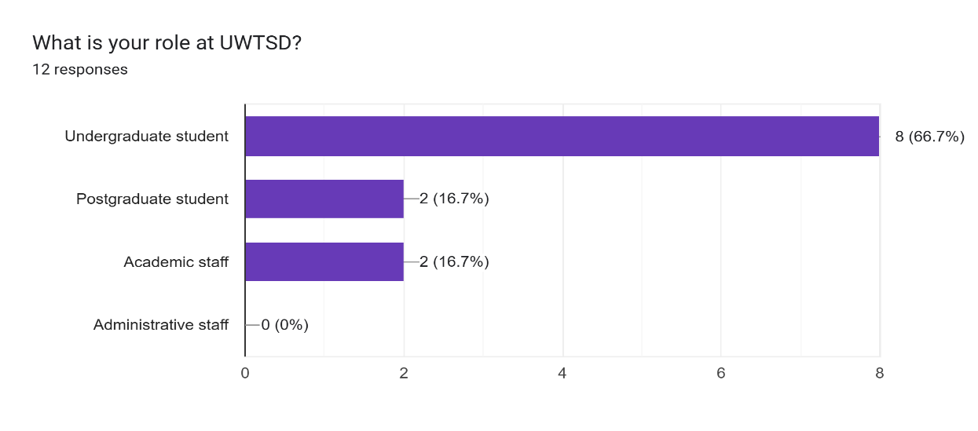
Figure 1. Distribution of survey participants by role at UWTSD.

In addition to the diversity in participant roles, the survey reached individuals from a range of age groups, as shown in Figure 2. This age variation reflects the university’s broad demographic and helps capture differences in digital experiences, accessibility awareness, and gameplay preferences [15].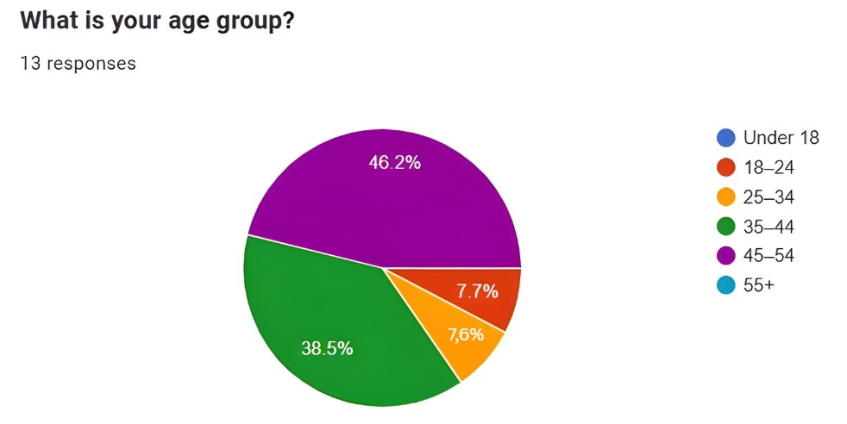
Figure 2. Age distribution of survey participants.

Figure 3 indicates that while the majority of respondents (75%) reported no accessibility needs affecting their use of digital games or apps, a notable portion (25%) identified specific requirements such as dyslexia, colour vision deficiency, and other conditions. This highlights the importance of considering accessibility features during the design process to ensure inclusivity[16].
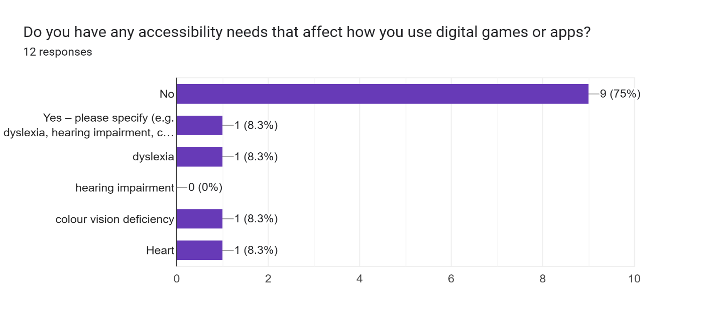
Figure 3. Accessibility needs reported by participants.
Figure 4 demonstrates that most respondents (66.7%) stated that they do not require any accessibility features, while 33.3% indicated a preference for high contrast.

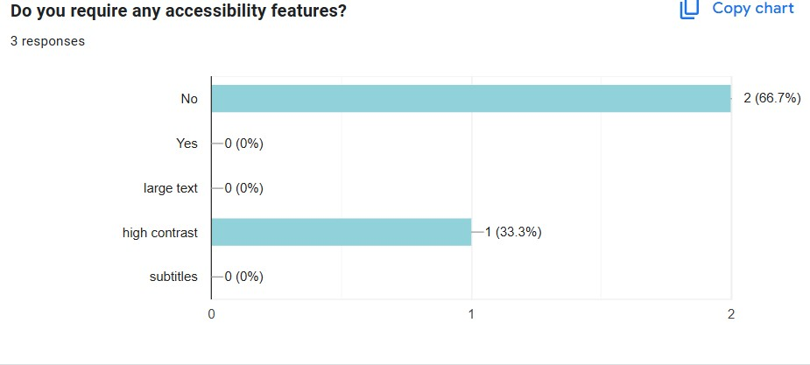
Figure 4. Requirement of accessibility features
Figure 5 is presented: The results show that mobile phones are the most commonly used gaming devices among respondents (100%), followed by PCs (33.3%), with no participants using consoles or tablets.
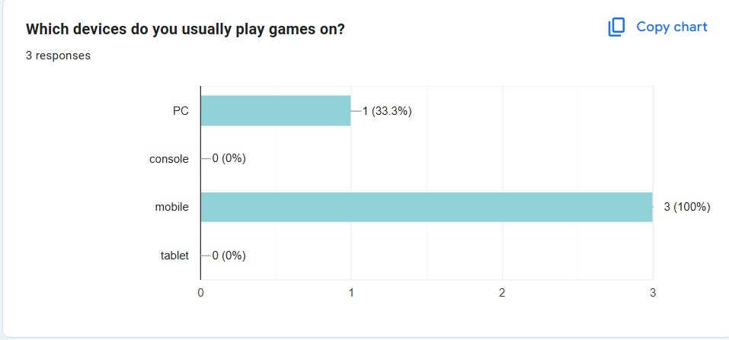
Figure 5. preferable devices for games

The survey results enabled us to define distinct user groups based on their goals, frustrations, device usage patterns, and gaming preferences. These insights are consistent with persona development frameworks, which emphasise basing personas on real user data rather than assumptions[17].

User Personas and Design Priorities
To ensure the UWTSD Cluedo game works well for all types of players, four user profiles were created. These profiles represent different types of people at the university, considering their roles, accessibility needs, and preferred play styles. Each profile helps guide how the game’s design and features should be built to give everyone a good experience.

Persona 1

Sam Student
Sam is a student with dyslexia who prefers mobile games with icons and simple navigation. She plays during short breaks and needs low-pressure gameplay with clear feedback. Her accessibility needs, like larger text and reduced reading guide key design choices, ensure the game is inclusive and easy to use. Sam’s profile helps prioritise visual clarity, responsive design, and cognitive support in the UWTSD Cluedo game. These design choices align with accessibility heuristics from Nielsen Norman Group and WCAG 2.1 guidelines, which emphasise visual clarity, simplified language, and adaptable layouts for users with cognitive and sensory needs[18],[19]. The Persona 1 is presented in Figure 6.
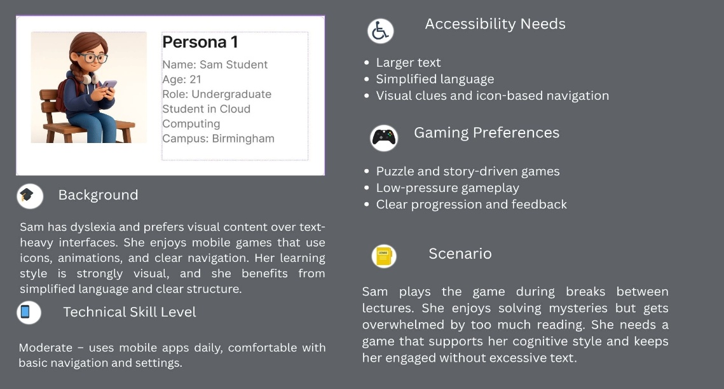
Figure 6: Persona 1 Card created by Figma
To clarify which features are most important for Sam Student, we used the MoSCoW prioritisation method. This helped turn her needs into design priorities, ensuring the interface supports her accessibility requirements and gameplay preferences. The analysis shows which elements are essential, desirable, optional, or unsuitable for her experience and is presented in Figure 7.
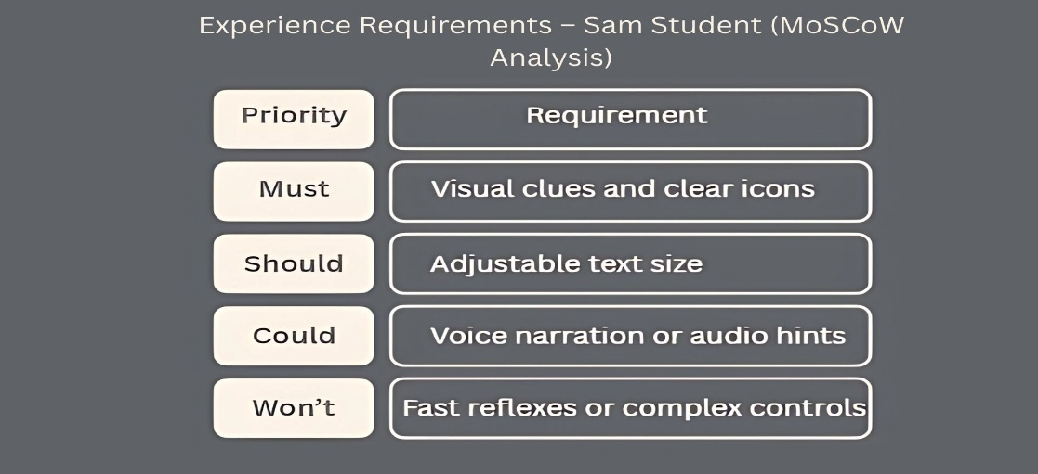
Figure 7: Persona 1 MoSCoW Analysis

Persona 2
Following Sam Student’s mobile-first and accessibility-focused profile, the second persona offers a contrasting perspective shaped by professional routines and social preferences.

David, 47, Staff
Works in student services at the London campus and plays casual, social games during lunch breaks. He values humour, teamwork, and intuitive design, preferring clean layouts and readable fonts. With basic tech skills and no accessibility needs, his profile highlights the need for low-effort, collaborative experiences. This aligns with Salminen et al. (2022), who emphasise the role of personas in designing for diverse user groups[20]. David’s persona card is presented in Figure 8.
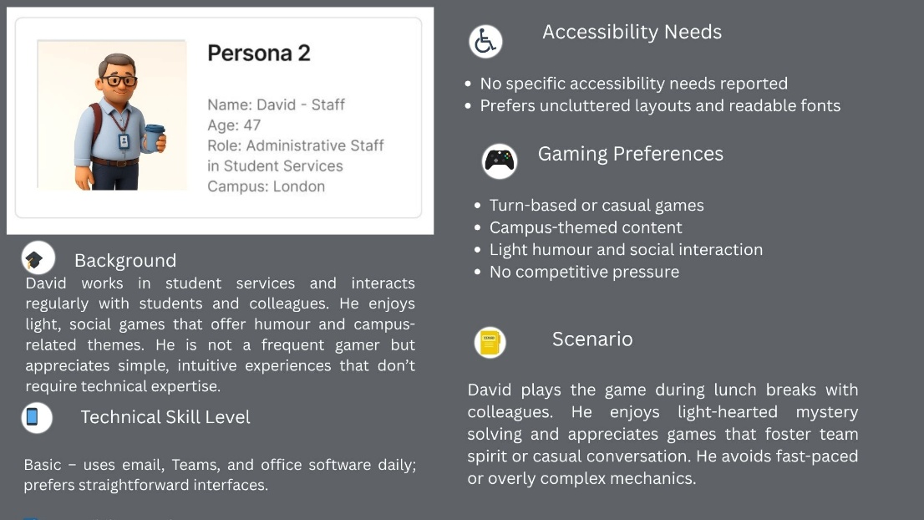
Figure 8: Persona 2 Card created by Figma
To translate David’s preferences into actionable design decisions, the MoSCoW method. This analysis is shown in Figure 9.
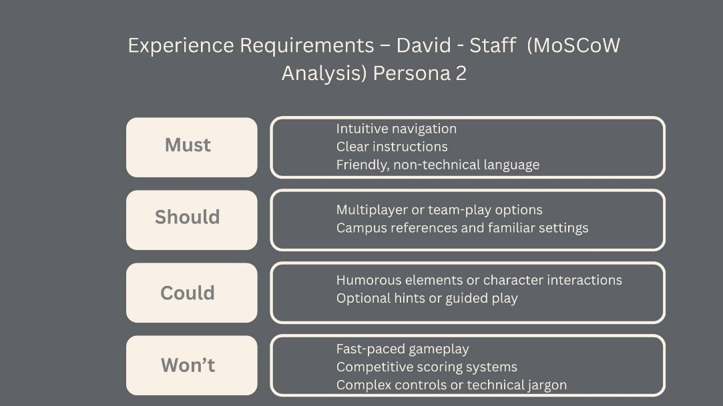
Figure 9: Persona 2 MoSCoW Analysis

Persona 3
Persona 3 is Leila, 26. She is an international student in Business who uses games to explore campus and connect with other students. Highly digitally literate, she favours visually focused interfaces, clear language structure, and culturally inclusive content. Her profile highlights the need for accessible navigation, visual storytelling, and a light-hearted gameplay pace. Leila is presented in a persona card in Figure 10.
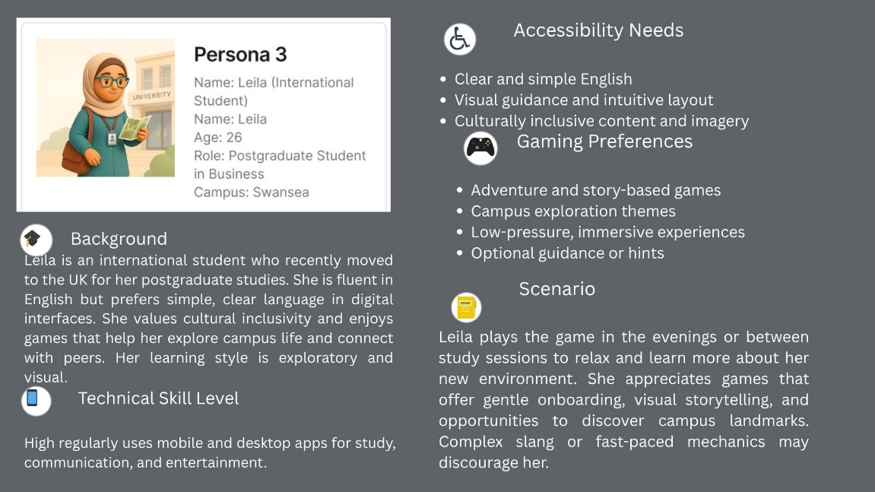
Figure 10: Persona 3 Card created by Figma
For this persona, a MoSCoW analysis as well which is also presented in Figure 11.

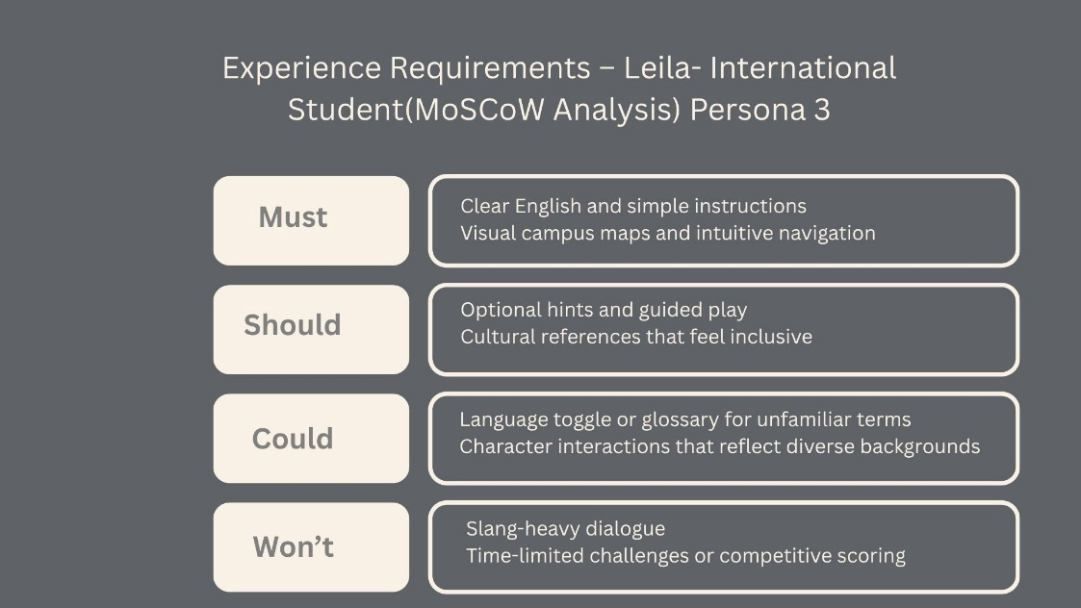
Figure 11: Persona 3 MoSCoW Analysis
This method helped identify which features best support her exploratory play style, language needs, and cultural inclusivity.

Persona 4
Dr Marcus, 52, is a senior lecturer in scripting and programming at the Birmingham campus. He enjoys exploring game mechanics and using games in teaching. With advanced technical skills, he values logical structure, customisation, and tools that support experimentation. His accessibility needs include keyboard-friendly navigation and the ability to skip repetitive content. Dr Marcus looks for games that support learning, offer strategic depth, and allow flexible interaction. This aligns with Nguyen’s (2025) findings, which highlight how UX improvements in educational games, especially those teaching programming, can enhance engagement, clarity, and learning outcomes[21]. His profile highlights the need for clear systems, modular design, and educational potential. Dr Marcus is presented in the Persona card in Figure 12.
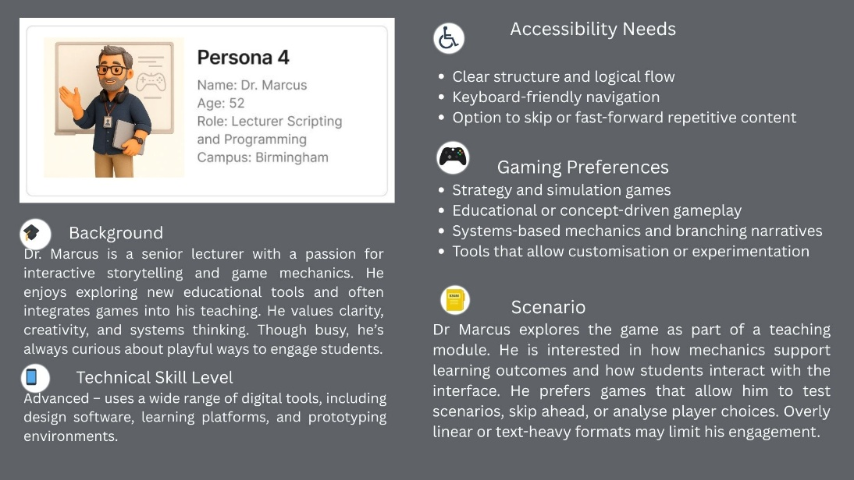
Figure 12: Persona 4 Card created by Figma
To align Dr Marcus’s goals with the game’s design, we used the MoSCoW method, which is presented in Figure 13.
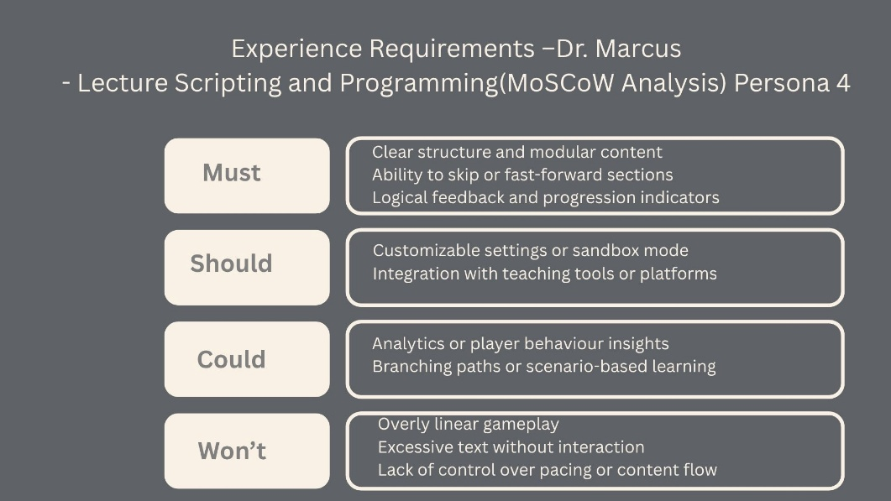
Figure 13: Persona 3 MoSCoW Analysis

Summary of the UX requirements
derived from the persona research and analysis:
Visual clarity and readability (Sam, Leila)
Mobile-centric and responsive design (Sam, David)
Collaborative and easy-to-use gameplay (David)
Culturally inclusive content and intuitive navigation (Leila)
Modular structure and educational depth (Dr Marcus)
Accessibility features such as high contrast, larger text, and keyboard navigation (Sam, Marcus)
Narrative flexibility and exploration mechanics (Leila, Marcus)

ILO3 & ILO4: Inclusive Design and Reasoned Presentation
To achieve the ILO3 and ILO4 learning outcomes, inclusive design principles were embedded throughout the R&D process. ILO3, which focuses on applying UX theories to diverse user needs, is addressed by integrating accessibility heuristics (e.g., WCAG 2.1) [19] and persona-specific requirements. ILO4, which emphasises critical and evidence-based design decisions, is reflected in the use of MoSCoW prioritisation, research data, and theoretical frameworks such as Norman’s Principles and Schneiderman’s Rules[22], [23]. These approaches ensure that design decisions are not only inclusive but also based on validated UX methodologies.
The Proposed Structure for Deeper Analysis is provided in Appendix B.

Wireframe Storyboards and Interaction Design

This section presents the visual and interactive structure of the mobile game Cluedo: Shadows Over UWTSD, with a focus on usability, accessibility, and cognitive clarity. The storyboards illustrate five main screens: the home screen, character selection screen, campus map, clue interface, and accusation screen. These screens are designed for mobile devices and follow a consistent interaction flow that supports both casual and strategic players.

Interaction Flow and Mobile Format

The game begins with a start screen offering language selection and accessibility settings. Players then choose a character, each linked to a unique scenario. From there, they enter the campus map, where they can explore rooms, collect clues, and interact with suspects. The clue screen updates dynamically based on player choices, and the final accusation screen allows users to submit their conclusions. Arrows between screens in the storyboard show how users move through the game, ensuring clarity and reducing confusion.
Buttons and icons are placed within thumb-friendly zones, and key actions remain within the central 30-40° visual angle to reduce eye strain and improve accessibility across age groups [24].

Applying Norman Design Principles

Don Norman’s principles of interaction design, affordance, feedback, and visibility are central to the wireframe logic [25].
Affordance: Buttons use shadows, rounded edges, and icons (e.g., a magnifying glass for “Search”) to suggest interactivity. This helps users like Sam, who benefit from intuitive navigation due to cognitive load challenges.
Feedback: When players tap a room on the map, it highlights and zooms in. When clues are collected, the clue screen updates with animations and sound cues. These responses reinforce user actions and support emotional engagement.
Visibility: Important options like “Accuse” or “Hint” are always visible. Clue status is shown with icons and progress bars, reducing memory load and supporting strategic players like Dr Marcus.

Visual Processing Principles and Spatial Clarity
To support perceptual accuracy and reduce interface confusion, visual processing principles were applied to avoid misleading depth cues. Specifically, the design avoids layouts that mimic Müller-Lyer and Ponzo illusions, which can distort spatial perception and lead users to misjudge distances or element sizes[26].
- Müller-Lyer illusion: Identical lines appear unequal due to arrowhead orientation. In interface design, this can cause buttons or containers to seem larger or smaller than they are, affecting user interaction accuracy.
- Ponzo illusion: Lines appear different in length due to converging background lines. This can mislead users when scanning for navigation paths or interpreting map layouts.
To prevent these effects, the wireframes use parallel alignment, consistent spacing, and neutral background gradients, ensuring that visual context does not distort perception. These principles are especially important for users with visual processing sensitivities, such as Sam and Marcus, and reinforce Norman’s emphasis on visibility and clarity [25].

Figures 14 and 15 illustrate these illusions and their relevance to interface design.

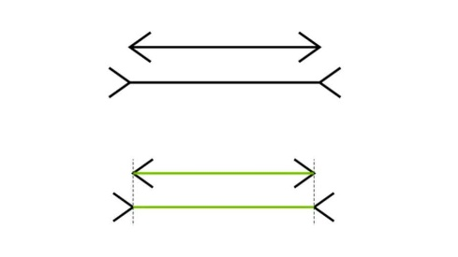
Figure 14 Muller-Lyer illusions Figure 15 Ponzo illusions
identical lines appear unequal due identical lines appearing different
to arrowhead orientation in length due to converging lines

Applying Schneiderman’s Eight Golden Rules

Ben Shneiderman’s rules for interface design were used to refine the wireframes and ensure usability across diverse user profiles [23].
Consistency: All screens use the same layout grid, font family, and icon style. This helps users like David, who prefer low-effort interactions.
Reduce memory load: Clues are automatically logged and categorised. Tooltips and visual cues guide next steps, supporting users with cognitive or language challenges.
Informative feedback: Every action triggers a visual or auditory response. For example, when a player accuses a suspect, the screen flashes and a confirmation message appears.
Closure and reversibility: Each module ends with a summary screen (e.g., “Clue Found”), and users can undo their last move or revisit previous rooms.

Accessibility and Inclusive Design

The wireframes incorporate inclusive design principles aligned with WCAG 2.1 standards and ILO3/ILO4 learning outcomes. Multilingual support is built into the start screen, allowing users to choose their preferred language with flag icons and simplified labels. Visual cues (✓ and ✕) are used alongside colour to ensure clarity for users with colour vision impairments.
Colour-safe palettes were tested using Coblis and Adobe Contrast Checker [27], [28]. Buttons include text labels and icons to support users like Leila, who value visual clarity and cultural inclusivity. Progressive disclosure and semantic simplification ensure that instructions are short, jargon-free, and easy to follow.

Emotional Engagement and Narrative Flow

Jesse Schell’s theory of game design emphasises thematic consistency and player agency [29]. In our wireframes, each screen maintains a consistent visual theme, dark academia with high-contrast elements and supports meaningful choices. The clue screen allows players to choose how to interact (e.g., “Observe”, “Ask”, “Accuse”), reinforcing agency and immersion.
The suspect selection screen is designed using principles from Kuang & Fabricant [30], who advocate for emotionally engaging interfaces. Characters are presented with expressive portraits, short bios, and interactive animations.

Final Wireframes

Figures 16 and 17 present the wireframes and interaction flow for Cluedo: Shadows Over UWTSD, demonstrating how theory and practice come together to support diverse user needs.

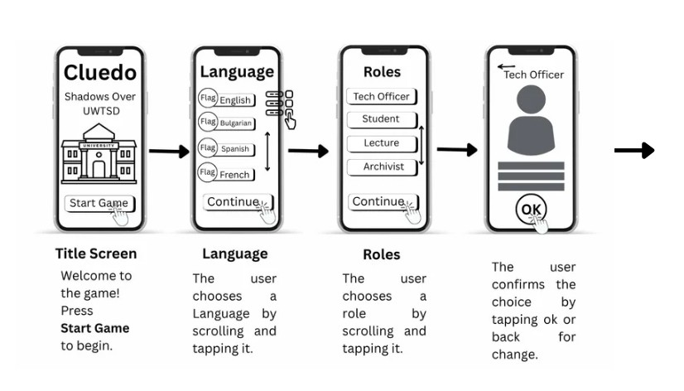
Figure 16 Screen shots of Wireframe Design for the Game Interface of Cluedo: Shadows Over UWTSD/Part 1

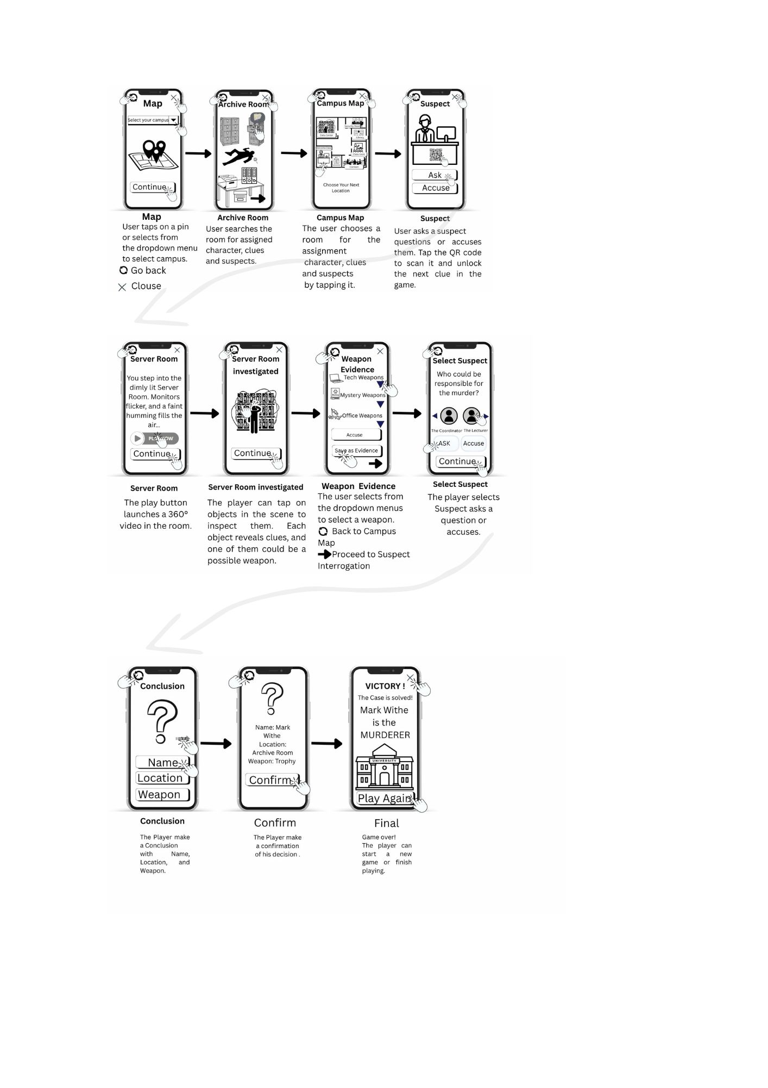

Figure 17 Screen shots of Wireframe Design for the Game Interface of Cluedo: Shadows Over UWTSD/Part 2

User Feedback

User feedback was collected through a live Microsoft Teams session with computer science students, who were selected to reflect the diversity of the personas defined earlier. All survey participants received a Participant Information Sheet (PIS) and a Consent Form, both of which were embedded in the Google Form as required checkboxes at the start. Focus group participants received the same documents via DocHub, either by email or shareable link, and signed them digitally. Screenshots of both onboarding formats are included in Appendix C.
The usability test focused on navigation, clarity, and visual orientation. Participants reviewed the wireframes and provided feedback on interface flow, emotional engagement, and accessibility. Positive feedback highlighted the clarity of clue tracking and character selection. However, several users requested a pause button, multiplayer mode, and a tutorial screen for onboarding. They also suggested adding confirmation prompts for critical actions (e.g., “Are you sure you want to accuse?”), which aligns with Shneiderman’s rule to prevent errors [23].
This process supports ILO2, which requires students to “evaluate user feedback and apply it to improve design decisions.” The feedback directly informed interface revisions and validated the emotional and cognitive needs of each persona. As Nielsen notes, usability testing reveals not only functional gaps but also emotional responses that shape user satisfaction [17],[18].
Future improvements will include adaptive tutorials, expanded accessibility settings, and collaborative gameplay features to support both casual and strategic users.

Conclusion

This study explored the user experience of a campus-based mystery game through structured surveys, persona development, wireframe design, and usability testing. By combining real user data with established UX frameworks such as Norman’s principles and Shneiderman’s rules, the project ensured that design decisions were both inclusive and evidence-based. The integration of accessibility features, multilingual support, and cognitive-friendly layouts reflects a strong commitment to ethical research and user diversity.
The use of MoSCoW prioritisation helped translate participant feedback into clear design priorities, while the wireframes demonstrated how theory can be applied to practical interface solutions. Usability testing confirmed the relevance of the personas and revealed opportunities for improvement, including the addition of a pause button, tutorial screen, and confirmation prompts.
Ethical considerations were addressed through GDPR-compliant consent procedures, ensuring transparency and participant autonomy.

References:

[1] S. K. Card, The Psychology of Human-Computer Interaction. CRC Press, 2018.
‌[2] Tareq Ahram, W. Karwowski, and Darko Etinger, Human Systems Engineering and Design (IHSED 2025): Future Trends and Applications. AHFE Conference, 2025.
[3] J. Pruitt and T. Adlin, The Persona Lifecycle : Keeping People in Mind Throughout Product Design. Burlington: Elsevier, 2006.
‌[4]“Reddit - The heart of the internet,” Reddit.com, 2020. https://www.reddit.com/r/boardgames/comments/guoi7w/has_anyone_played_cluedo_and_would_you_recommend/ (accessed Oct. 23, 2025).
[5]“Cluedo,” IGN India, Aug. 10, 2023. https://in.ign.com/cluedo/191023/review/cluedo-review
[6] UserSense Knowledge Base, “Target Group Definition,” UserSense UX Research Update, 2024. [Online]. Available: https://www.usersense.io/knowledge/target-group-definition
[7] D. Boone, “How to Identify Your Game’s Target Audience: A Practical Guide,” TyrAds, Jan. 2, 2025. [Online]. Available: https://tyrads.com/game-target-audience/
[8]Operon Design d.o.o, “Clue/Cluedo stats, graphs, and player estimates | PlayTracker Insight,” Playtracker.net, 2023. https://playtracker.net/insight/game/89647 (accessed Oct. 29, 2025).
[9]Solsten, “How to Identify Your Game’s Ideal Target Audience,” Solsten, Aug. 01, 2023. https://solsten.io/blog/identify-your-target-audience
‌[10]“What are Focus Groups?,” The Interaction Design Foundation. https://www.interaction-design.org/literature/topics/focus-groups
‌[11]B. Holtom, Y. Baruch, H. Aguinis, and G. A Ballinger, “Survey Response rates: Trends and a Validity Assessment Framework,” Human Relations, vol. 75, no. 8, pp. 1560–1584, Feb. 2022, doi: https://doi.org/10.1177/00187267211070769.
[12]Interaction Design Foundation, “Making Your UX Life Easier with the MoSCoW,” The Interaction Design Foundation, Nov. 18, 2015. https://www.interaction-design.org/literature/article/making-your-ux-life-easier-with-the-moscow
[13]B. Williams, “Prioritising with MOSCOW: AI-Assisted Qualitative Analysis for Requirements Gathering - Insight7 - AI Tool For Interview Analysis & Market Research,” Insight7 - AI Tool For Interview Analysis & Market Research, Jun. 10, 2024. https://insight7.io/prioritizing-with-moscow-ai-assisted-qualitative-analysis-for-requirements-gathering/ (accessed Feb. 24, 2025).
[14]Z. Baker, “MoSCoW Prioritisation Explained: Implementation Steps, Examples & Free Template,” Edstellar.com, 2025. https://www.edstellar.com/blog/moscow-prioritization (accessed Feb. 11, 2025).
[15]M. Sourbati and E. F. Loos, “Interfacing age: Diversity and (in)visibility in digital public service,” Journal of Digital Media & Policy, vol. 10, no. 3, pp. 275–293, Sep. 2019, doi: https://doi.org/10.1386/jdmp_00003_1.
[16]A. Miller, “Accessibility, Disability, and Inclusive Instrument Design: A Critical Literature Review Interrogating the User Experience of Online Surveys and Interviews,” The International Journal of Information, Diversity, & Inclusion (IJIDI), vol. 9, no. 1/2, pp. 87–114, 2025, doi: https://doi.org/10.33137/ijidi.v9i1/2.43997.
[17]Lene Nielsen, Personas - User Focused Design. London Springer, 2013.
‌[18]J. Nielsen, “10 Heuristics for User Interface Design,” Nielsen Norman Group, Apr. 24, 1994. https://www.nngroup.com/articles/ten-usability-heuristics/
[19]W3C, “Web Content Accessibility Guidelines (WCAG) 2.1,” W3.org, May 06, 2025. https://www.w3.org/TR/WCAG21/
[20]J. Salminen, K. Wenyun Guan, S.-G. Jung, and B. Jansen, “Use Cases for Design Personas: A Systematic Review and New Frontiers,” CHI Conference on Human Factors in Computing Systems, pp. 1–21, Apr. 2022, doi: https://doi.org/10.1145/3491102.3517589.
[21]H. Nguyen, “Improving accessibility in educational serious games through UX design,” Theseus.fi, 2025, doi: https://www.theseus.fi/handle/10024/894160.
[22]D. A. Norman, Design for a better world: meaningful, sustainable, humanity-centred. Cambridge, Massachusetts: The MIT Press, 2023.
[23]E. Wong, “Shneiderman’s Eight Golden Rules Will Help You Design Better Interfaces,” The Interaction Design Foundation, 2021. https://www.interaction-design.org/literature/article/shneiderman-s-eight-golden-rules-will-help-you-design-better-interfaces
‌[24]W. Lidwell, J. Butler, and K. Holden, Universal Principles of Design: 125 Ways to Enhance Usability, Influence Perception, Increase Appeal, Make Better Design Decisions, and Teach Through Design. Quarto Publishing Group USA, 2010.
[25]D. A. Norman, The design of everyday things. New York, New York: Basic Books, 2013.
[26] S. Coren and L. M. Ward, Sensory and Perceptual Processes, 6th ed., Lawrence Erlbaum Associates, 2007.
[27]Colblindor, “Coblis — Colour Blindness Simulator – Colblindor,” Colour-blindness.com, 2016. https://www.color-blindness.com/coblis-color-blindness-simulator/
[28]Adobe.com, 2025. https://color.adobe.com/rast-Checker-2-color-theme-19812400/ (accessed Oct. 24, 2025).
[29] J. Schell, The art of game design: a book of lenses. Boca Raton, FL: CRC Press LLC, 2020.
[30]C. Kuang and R. Fabricant, User Friendly. MCD, 2019.
‌

Appendix

‌A MoSCoW Prioritisation Based on User Research
Based on the survey results, persona profiles, and user feedback sessions, a MoSCoW prioritisation framework was developed to guide interface design decisions. The Must requirements include a clear clue tracking system, a mobile-first responsive layout, and a language selector with flag icons to support multilingual users. High-contrast visuals and accessible navigation were essential for participants with dyslexia and colour vision deficiencies, while confirmation prompts for critical actions (e.g., “Are you sure you want to accuse?”) were added to prevent errors, aligning with Shneiderman’s rule of error prevention [23]. Ethical compliance was ensured by embedding the Participant Information Sheet and Consent Form directly into the onboarding process, fulfilling ILO2 by demonstrating how user feedback informs design improvements.
Should features include a pause button, tutorial screen, and visual feedback for all actions? These elements were requested during usability testing and support Norman’s principles of visibility and feedback [25]. Cultural inclusivity in character bios was also prioritised to enhance emotional engagement, particularly for international students like Leila.
Features such as multiplayer mode, adaptive difficulty settings, and optional voice narration were suggested by users but are not essential for core gameplay. These may be considered in future iterations to expand functionality and support strategic depth.
Finally, Won’t include console or tablet optimisation, as no participants reported using these devices, and complex 3D animations, which may increase cognitive load and reduce accessibility. This prioritisation ensures that the design remains focused, inclusive, and grounded in real user needs and validated UX theory.

B Proposed Structure for Deeper Analysis:
For each persona, UX requirements were further validated using Norman’s design principles and Schneiderman’s eight golden rules:

Sam Student
- Visibility: Clear icons and feedback support her cognitive needs
- Accessibility: Buttons and navigation elements are visually intuitive
- Memory Load Reduction: Minimal text and consistent layout reduce cognitive strain
- Consistency: Uniform design across all screens supports ease of use

David
- Feedback: Immediate reactions to actions enhance social gameplay
- Consistency: Familiar layouts and legible fonts reduce friction
- Accessibility: Game elements clearly suggest their function, supporting intuitive gameplay

Leila
- Visibility: Visual storytelling and clear structure support exploration
- Cultural inclusiveness: Matches the emphasis of Norman on User Empathy
- Consistency: Language and interface remain consistent across contexts

Dr. Marcus
- Accessibility: Customisation tools are clearly presented
- Feedback: Strategic depth is supported by adaptive systems
- Reduced memory load: Modular design allows users to focus on one concept at a time.

C All participants were provided with a Participant Information Sheet outlining the study’s purpose, procedures, and data handling practices. Informed consent was obtained before participation, either through a checkbox embedded in the Google Form survey or via a digitally signed Consent Form distributed through DocHub. The study complies with GDPR by ensuring that all personal data was collected anonymously, stored securely, and used solely for academic research purposes. Participants were informed of their right to withdraw at any time without consequence, and no identifiable information was retained. These measures align with institutional ethical standards and ensure transparency, autonomy, and data protection throughout the research process. Figure 18 presents the Google survey Participant information sheet and Consent form, and Figure 19 Screenshot of the DogHub Participant information sheet and Consent form.

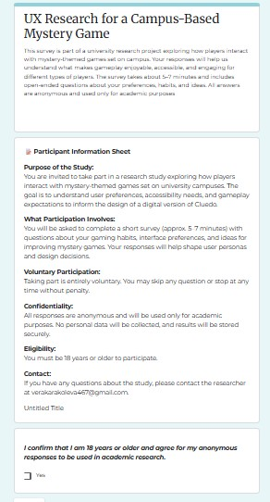
Figure 18 Screenshot of Google survey Participant information sheet and Consent form
‌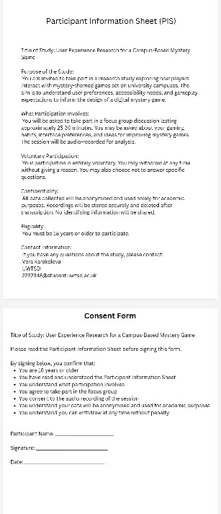

Figure 19 Screenshot of DogHub Participant information sheet and Consent form

‌

‌

‌

‌

‌

‌

‌

‌

‌

‌‌

‌

‌

