Looking into the video “An intense day on Crib Goch” (brave Dave, 2020) specifically I will critically explore the decisions made, actions taken as well as the behaviour seen post-incident. The video has four main participants, these will be called: the leader; the individual who filmed and posted the video who is a qualified mountain leader and originally was walking the route with, Participant one. Participant one was brought up Crib Goch by the leader and had little experience in the hills but on the walk, they met, Participant two. Participant two was one of two people the leader and Participant one met on Crib Goch who along with their walking buddy was prepared to head off the ridge due to the high winds, the final person in the video shall be called the victim. The victim was walking with Participant two when they were found by the leader and Participant one who offered to talk them down an escape route down the south face of Crib Goch (Figure 1). After making this choice and starting to descend the victim quickly lost their footing and began to uncontrollably slide down the face eventually stopping 50-100 meters on the south face about 100-200 meters away from the pyg track Figure 2) this moment may be referred to as the incident thorough out this paper.
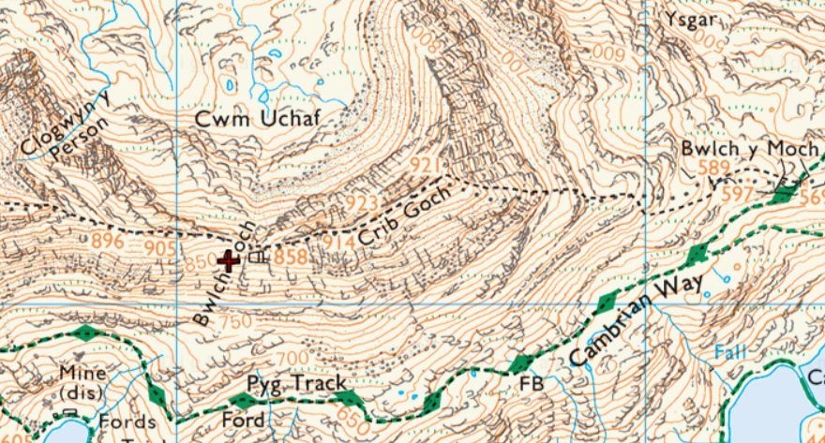
Figure 1
This point is where the incident begins and my critical review will start, as by this point the victim has now sustained, unbeknown to the team at the time, several major injuries from the fall including a broken femur, wrist, nose, back, a double break on their neck and major bleeds across their body. The victim did leave the hillside alive and did make a full physical recovery post-incident. They did however require multiple blood transfusions whilst being treated in hospital
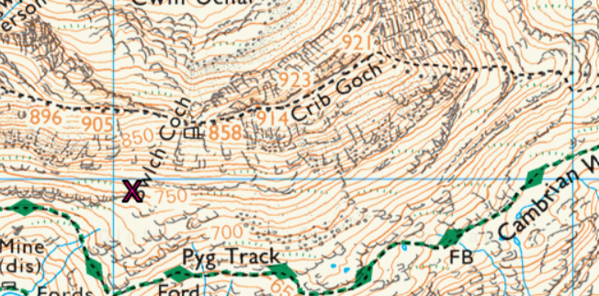
Figure 2
The incident happened on March 7th, 2020, in Snowdonia National Park on Crib Goch which is described by the British Mountaineering Council (BMC) as “This thrilling Grade 1 scramble in Snowdonia is one of the country’s most popular ridges” (2016). However, the weather on the day made the whole experience very different. The Mountain Weather Information Service made a report on the day stating the winds on the ridge got up to 30 mph, with rain and drizzle being on and off across the day. The air temperature was 3 ºC but would feel as low as -11 ºC in the south-westerly wind with a blanket of fog covering the hill (Mountain Weather Information Service, 2020). These conditions, as well as a good helping of snow, are all seen and mentioned in the video (bravedaveempire, 2020) making helping the victim even more of a challenge for the leader and participants. With these conditions in mind, the actions of the leader, once the group had reached the victim, made a lot of sense. The leader immediately got layers both on and under the victim attempting to keep the victim as warm as possible bundling spare clothes from the leader as well as both other participants onto the victim. Insulation is key when trying to keep warm we use roll mats under us when we sleep outside as a part of this. Cotswolds (2022) states how essential a roll mat is to keep warm as the ground conducts heat away from the body much more than the air, meaning by lying only on the floor a majority of body heat is lost, this loss of heat is called an R-Value and the bigger the R-Value the more heat lost to the ground unnecessarily (Cotswold Outdoor, 2022). This choice to try and lower the R-value on the victim is what Mountain Training (MT) says to do as part of dealing with hypothermia to prevent further heat loss (Mountain Training, 2022). A critique of this, however, one that will be looked deeper into in this essay, is how the leader gives all the spare clothing the party is carrying to the victim and this opens them all up to the risk of hypothermia which goes against BMC and MT’s training towards the incident, which states you should always make sure that both yourself and the group are as safe as possible and are out of any furthers dangers (Mountain Training, 2022, British Mountaineering Council, 2022). Taking away these spare layers from the others who were then waiting around with the victim until rescue arrived does put the leader and other participants directly at risk from the dangers of hypothermia.
As soon we see the victim fall in the leader’s video we see them stepping up into their leadership role. They start talking to the whole group trying to keep track of where Participants one and two are. The leader instantly starts to follow the victim trying to find out where they are laying, this following is uncontrolled by the leader as we do see them also sliding down the grassy bank uncontrollably, even stopping to brace one of the participants who is also falling. This decision to take the group straight after the victim again goes against BMC good practice of keeping yourself, then the group safe (British Mountaineering Council, 2022). The use of an uncontrolled descent of the hill face conducted by the leader was a brave choice however this choice led the party directly into the SW winds as well as leaving the higher area that was providing the stronger phone signal as shown in Figure 3. This map provided by Vodafone UK (2022) shows how the stronger phone signal, shown by the darker squares, is found higher on the ridge whereas we can see the route down the face has less signal, making a 999-phone call less reliable. The leader, as soon as they saw the victim fall, may have wanted to think about the calm and collected approach that the BMC promotes as best practice when dealing with a critical interest in the hills, this approach would have looked very different to the one seen in the leader’s video. Taking a minute to call 999 at the top of the ridge, due to the better signal, also could have allowed the leader to check up on the participants as well as given the leader much-needed thinking time to try to develop a safer more controlled approach to descending the slippery slope.
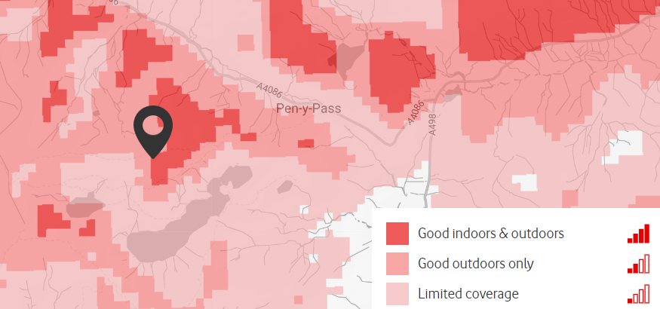
Figure 3 (Vodafone UK, 2022)
The leader, whilst they did find the victim, did not use any type of search technique. The use of search techniques is paramount to Mountain rescue, and Buxton Mountain Rescue (2021) talks about their training and covers how almost all of their training sessions they are covering different types of search tactics for different areas, forest, and hillside mountainous, for example. In the leader’s situation whereby, the victim has been seen falling straight down the side of a grassy slope, a zigzag search style would have been a good choice.
SmarterEveryDay (2022), is a YouTuber whose content aims to educate people about a variety of subjects. One such video focuses on the zigzag search style and how effective it is as a part of coastal-based search and rescue efforts. In the video SmarterEveryDay (2022) it shows how, when you know the estimated area for the rescue, the zigzag approach allows for everyone to cover a section keeping the party involved in the search process whilst also covering ground in an effective way looking for evidence of the victim’s route. This of course is not the only pattern that the leader could have used with Participant one and two however I believe this to be the easiest one to implement in their situation with the people they had. Wollan (2004) evaluated search patterns used by rescue teams after considering that teams in Scotland were too self-reliant and not using the air support as an effective part of the search process. This matches the situation the leader found himself in as the group did not receive any air support in their situation, further showing the importance of using an effective search pattern not the uncontrolled descent used by the leader.
Gibbons (2019) a first responder talks about the mindset of a first responder, saying how whom we think of as first responders are nearly never the ones there first, as shown in the video of events being evaluated. Gibbons (2019) brings up how important the mindset, actions, and language used by the true first responder, who, in this instance is the leader, and the casualty they are helping, referred to in this report as the victim. We see the leader in our video running and sliding over to the victim, after only moments before telling the participants about how the victim must be dead. This mindset is negative the leader is showing little hope toward the victim’s current state whilst also enforcing this mindset into the two other participants. Gibbons (2019) would arguably be very displeased as they talk about how important a positive mindset is in any critical situation as well as the impacts it can have on the situation. The first word the leader says to the victim after seeing their state include swearing and comments regarding how the leader thought the victim was dead, these comments carry on through the victim’s situation and even continue into the leader’s post-situation overview (bravedaveempire, 2020). Miller et al (2020) studied ethics for medical professionals and first responders in light of the COVID-19 Pandemic, and unsurprisingly they focus on the use of words and language and the effect it has on the people they are helping. This study finds how swearing and comments highlighting the severity of the casualties’ situation do have a negative impact on the casualties as well as portray those first responders in a more negative light. Miller et al (2020); Gibbons (2019); and St Johns Ambulance Cymru (2022) all state the importance of mindsets within life-saving situations and how as the primary helper they should stay in the moment, which the leader under review did do very well. With regard to keeping calm and collected, this is where the leader could have done better as they clearly gave in to the stress of the situation. Taking a moment away from the victim may have helped calm the leader’s mind and possibly prevented such a negative start so that when the victim was first assessed the leader could have been seen as someone “in control” of the whole situation.
After the leader first got to the victim there was no primary survey (St Johns Ambulance Cymru, 2020) instead the leader as previously mentioned tried to lower the victim’s R-value by getting them off the ground. The primary survey is essential to rescue and first responders all over the world, with (St Johns Ambulance Cymru saying “a quick way to find out how to treat any life-threatening conditions a casualty may have in order of priority” (2020). The fact the leader did not conduct one means they may have missed identifying injuries which were not visible.
Once the victim was seen by the leader and Participant one called mountain rescue all the party could do now was wait. The leader takes it upon themself to run between the victim’s spot and the pyg track, during this time footage is limited however we do still see Participant one and two sitting close to the victim but looking very cold. The leader does seem to be warmer however, this I believe is due to his actions of running back and forth. Group management by the leader after the incident becomes very weak as Participants one and two are left to keep themselves warm and safe whilst also looking after the victim. Their coldness may be attributed to when the leader took all the spare layers to keep the victim warm. The leader could have delegated roles to Participants one and two as this may have kept the party more focused as well as helped keep Participants one and two warmer by giving them things to do.
Everly Jr et al (2000) wrote about looking at stress during critical incidents, and by reviewing several other papers focused on stress effects on people during these incidents. They cover a lot of the symptoms stress takes during times such as the incident seen in the video. This does show how the leader was under major stress during the incident. This may seem obvious as anyone would be stressed in such a situation, however, outdoor leaders are perceived as someone who is always on top of every situation, Dickson and Dolnicar (2004) looked into the perceived risk of adventurer tourism, and found by having some who is perceived as higher skilled, in our case the leader, the other party members tend to start to slip focus and sit back in a group. This may have had a part in the victim’s fall however we do see in the video the leader takes on this role putting even more stress on the leader during the incident as wishing to still look in control of the situation towards participants one and two.
Drawing this paper to a conclusion. After seeing the leader’s action in dealing with the victim as well as Participants one and two, I have developed a deeper thinking with regard to critical incidents in the outdoors. This video shows the importance of carrying the correct equipment as a mountain leader (Mountain Training, 2022). The leader seen in the video did everything they knew to do in their situation, a major takeaway from the video is how quickly these critical incidents can happen in the hills. McLean et al (2020) looked at how the outdoor adventure scene is one of a few that these indents can happen and change so quickly, this creates leaders in the outdoors who are able to think fast on their feet as well as stay cool and collected under the pressure of the situation. These are aspects in which the leader should reflect on and evaluate how to make improvements. Indeed, considering this event has allowed me to reflect on my skills and has allowed me to realise the importance of upskilling and preparedness when in the outdoor adventure scene. The leader’s group management is a key area where they let themselves and the group down. I believe this to be the leader’s biggest failing in their leadership as at points we saw Participants one and two were not engaged with the situation and a result, were getting colder and colder. Everything we see the leader do after the critical moment is based around the victim, this fixation on the immediate dangers to the victim limits the leader’s views on the wider situation (British Mountaineering Council, 2022). My concluding thoughts are if I wish to be a better leader then group awareness, staying calm, and carrying the right equipment is key. In all of these areas the leader shows underdevelopment however they still managed to keep the victim alive and if the leader was not on the hill that day at that time then the situation may have been very different.

References
bravedaveempire (2020) An intense day on Crib Goch (feat. Llanberis Mountain Rescue), YouTube. YouTube. Available at: https://www.youtube.com/watch?v=CRf7CnhOzXY&app=desktop%3Fredirect%3D1 (Accessed: December 3, 2022).
bravedaveempire (2020) Revisiting Ed's slope: A follow up to "an intense day on Crib Goch", YouTube. YouTube. Available at: https://www.youtube.com/watch?v=OmpWzwBTvXY (Accessed: December 6, 2022).
British Mountaineering Council (2022) BMC - GB Climbing 2022 Events Emergency procedures , BMC Events Emergency procedures . Available at: https://www.thebmc.co.uk/media/files/2022%20selection%20appeals%20process%205_1_2022.pdf (Accessed: December 13, 2022).
the British Mountaineering Council (2016) How to scramble: Crib Goch, The BMC. Available at: https://www.thebmc.co.uk/how-to-scramble-crib-goch (Accessed: December 5, 2022).
Buxton Mountain Rescue (2021) How do mountain rescue train and learn new skills, YouTube. YouTube. Available at: https://www.youtube.com/watch?v=5yzwoXM90Bs (Accessed: December 8, 2022).
Cotswold Outdoor (2022) Choosing a sleeping mat, Cotswold Outdoor. Available at: https://www.cotswoldoutdoor.com/the-knowledge/camping/choosing-a-sleeping-mat.html (Accessed: December 6, 2022).
Dickson, T. and Dolnicar, S. (2004) “No risk, no fun: The r No risk, no fun: The role of per ole of perceived risk in adv ed risk in adventure tourism,” Adventure Tourism, pp. 183–198. Available at: https://doi.org/10.4324/9780080469812-18.
Everly Jr, G.S., Flannery Jr, R.B. and Mitchell, J.T., 2000. Critical incident stress management (CISM): A review of the literature. Aggression and violent behavior, 5(1), pp.23-40.
McLean, S., Finch, C., Coventon, L. and Salmon, P.M., 2020, December. Incidents in the Great Outdoors: A systems approach to understanding and preventing led outdoor accidents. In Proceedings of the Human Factors and Ergonomics Society Annual Meeting (Vol. 64, No. 1, pp. 1740-1744). Sage CA: Los Angeles, CA: SAGE Publications.
MOUNTAIN WEATHER INFORMATION SERVICE (2020) “MOUNTAIN WEATHER INFORMATION SERVICE Snowdonia National Park.” Available at: https://www.mwis.org.uk/ (Accessed: December 5, 2022).
Mountain Training (2022) Hypothermia, Mountain Training. Available at: https://www.mountain-training.org/help/articles/hypothermia (Accessed: December 6, 2022).
Mountain Training (2022) Mountain leader, Mountain Training. Available at: https://www.mountain-training.org/qualifications/walking/mountain-leader (Accessed: December 8, 2022).
Miller, R.D., Sulmasy, D.P. and Sotomayor, C.R., 2020. Catholic Ethics and the Challenge of COVID-19-Part 2: Rationing Criteria and Ventilator Eligibility/Preferential Treatment for Medical Personnel and First Responders.
SmarterEveryDay (2022) Why this zig-zag coast guard search pattern is actually genius - smarter every day 268, YouTube. YouTube. Available at: https://www.youtube.com/watch?v=aoXJfuPaFF8 (Accessed: December 8, 2022).
St Johns Ambulance Cymru (2020) Primary survey, St John Ambulance Cymru - Wales' leading first aid charity. Available at: https://www.sjacymru.org.uk/en/page/primary-survey?gclid=Cj0KCQiAqOucBhDrARIsAPCQL1YOahzByTc-Y08SvvHQIXbmAxIWlUvLLg2ov6Aa8WwHO823yFH3EgYaAsxtEALw_wcB (Accessed: December 9, 2022).
St Johns Ambulance Cymru (2022) St john ambulance Cymru - Wales' leading First Aid Charity. Available at: https://www.sjacymru.org.uk/en/page/home (Accessed: December 7, 2022).
Gibbons , S. (2019) The first responder mindset: The life you save may be your own | Sean Gibbons | TEDxOshkosh, YouTube. YouTube. Available at: https://www.youtube.com/watch?v=knhHzvESQ_M (Accessed: December 8, 2022).
Vodafone UK (2022) Network status checker: Check your signal, Vodafone. Available at: https://www.vodafone.co.uk/network/status-checker (Accessed: December 7, 2022).
Wollan, H. (2004) Incorporating Heuristically Generated Search Patterns in Search and Rescue, I. Available at: https://www.aiai.ed.ac.uk/project/ix/ (Accessed: December 14, 2022).

