

A Project Report on

Project Planning and Management in the workplace adapting to the impact of the Coronavirus outbreak on Information Services and Systems Team

For Module

BMSW5104 Project Planning and Management in work place

Submitted To

Dr Shehla Khan

In Partial Fullfillment of Two Years Full Time
BA (Hons) Degree In Leadership and Management Skills in the Workplace

Submitted By

YenYen Lai (1710668)
4th September 2020

At

University of Wales Trinity Saint David Business School

Acknowledgments

I would like to express my sincere gratitude to the Study Skills Support team members Beth Downing, Clare Rees, and Ian Showell for providing guidance and suggestions which helped me in the format planning and materials used in this assignment.

Thank you to my classmate Nelly Myles for the emotional support and kind words.

Finally, to my supportive partner Chris Evans. I could not have accomplished this assignment without your encouragement, allowing me time off to research and write. Also by encouraging me to perform to the best of my ability, and to continue improving my study and writing skills

Executive Summary

When the first human case of ‘viral pneumonia’ was reported in December 2019 in Wuhan City, China (WHO, 2020a) and was later identified as COVID-19, Swansea University’s (SU) Board of Directors acted quickly. The Swansea-Wuhan sister cities partnership links have brought a lot of students from Wuhan to Swansea, so SU planned its response to the outbreak early, as there was increasing concern that a whole country lockdown may occur. The “response to COVID-19” project aim is early implementation of adaptation to continue providing teaching and learning opportunities for all lecturers and students, with remote customer services for all areas. The ISS Team manager was appointed as Project manager and selected a team to assist manage this complex project. The author investigates the use of the Project Life Cycle Framework method by the project manager to initiate and manage this project. The Project manager used the spiral four phases structure (see Figure 0) to divide the project into four phases and applied the project management tools and techniques discussed.

Due to the planning and implementation phases were well in place before the government lockdown announcement, hence the project was delivered on schedule, most importantly the aims of keeping students and employees safe, continuous provide services remotely have been met. A temporary end date for the project was used for the scheduling of the project. The SU will gradually re-open the Library and public areas with a new project and will invite all Head of colleges to participate.

Table of Contents
Acknowledgements
Executive Summary 2
Introduction 4
- Project Initiation phase 6
1.1 Project Quad Chart 6
1.2 Belbin Team Roles and Motivation 6
1.2 Stakeholders Analysis 7
- Project Planning phase 8
2.1 Iron Triangle Constraint 9
2.2 Risk Assessment Risk Analysis Grid 9
2.3 PESTLE Analysis Grid 10
2.4 Work Breakdown Structure 10
2.5 Gantt Chart 10
2.6 Network Diagrams and Critical Path 11
- Project Execution phase and Mid-term Evaluation 12
3.1 Mid-term Evaluation 12
- Project Closure phase 14
4.1 Refelction on Project Manager skills set 14
Conclusion 15
Recommendations 16
- What went wrong 16
- What need to improve 16
Appendices 17
References 29

Introduction

When the first human case of ‘viral pneumonia’ was reported in December 2019 in Wuhan City, China (WHO, 2020a), it alerted Swansea University (SU) to this infectious disease. Later, it was identified as COVID-19 which spread across Asia in January 2020 (WHO, 2020b, p.2). Lessons from a previous SARS outbreak had been learned and the Board of Directors acted quickly. The Swansea-Wuhan sister cities partnership links have brought many students from Wuhan to Swansea, so SU planned its response to the outbreak early, as there was increasing concern that a whole country lockdown may occur.

The university has eight colleges across two campuses, employing about 3,290 staff and has nearly 20,620 students (SU, 2020c). The focus from the start was on the safety of staff and students when establishing a specific “response to COVID-19” project. In this report, the term “Project” is referring to the achievement of a specific objective with a start and end date, which involves a series of activities and tasks which consume resources (Munns and Bjeirmi, 1996, p.81). Situation Report-94 (WHO, 2020b, p.2) stated scientists found that COVID-19 is closely related to SARS and would infect millions across the world before it fizzled out or vaccine was developed (Ries, 2020). The aim of the “response to COVID-19” project is early implementation of adaptation to provide online teaching and learning opportunities for all lecturers and students, supported by remote customer services teams. The project plays an important role in the planning and implementation of a series of activities for delivering change in the ways of working and teaching across the university. The outcomes of the changes will benefit SU in the long term, even after the project has ended. Based on these facts, the “Response to Covid-19” project fulfills all the characteristics of a project as defined above.

On the 6 January, SU appointed the ISS Team manager as Project manager to proceed with the “response to COVID-19” project. The project manager needed to ensure all essential planning and implementation phases were completed in a very short time period. Initially these processes, allocation of tasks and control of resources was part of project management. Munns and Bjeirmi (1996, p.81) defined project management as the process of controlling the achievement of the project objectives. Utilising the existing organisational structures and resources, it seeks to manage the project by applying a collection of tools and techniques, without adversely disturbing the routine operation of the organisation. The success of a project is dependent upon the success of planning and the allocation of tasks to committed team members, identifying correct information to communicate to the right team members or stakeholders, utilitising adequate tools and techniques to achieve project objectives, completion within budget, along with schedule and quality standards at the end of the project (Munns and Bjeirmi, 1996, p.82). Project management involves applying skills and capabilities to enable the project to flow through its life cycle effectively. It is short term and all activities will cease after the fulfilment of the project (PMI, 2013, p.47).

The author has been requested to produce a report to assess the planning of project activities, examine the project management tools and techniques used, the ability to adapt the workplace to the impact of the lockdown, and analyse and evaluate whether the project met the expectations of stakeholders or organisational values. The report is required by the end of project, and should reflect on personal and organisational gain, and outline any lessons learned by the organisation.

The author investigated the use of the Project Life Cycle Framework method by the project manager to initiate and manage the project. Selvin and Pinto (1987, quoted in Patanakul, Lewwongcharoen and Milosevic, 2010, p.45) advise that “Project Life Cycle is an effective project management tool which provides a useful framework for looking at project dynamic over time”. Generally numbered and in sequential overlapping phases of cycles, each phase requires the project manager to utilise project management tools and techniques to deliver outcomes moving forward until closure. There are a variety of project life cycle models can be used to manage a project, the Project manager has used the spiral four phases structure (see Figure 0) to divide the project into four phases, and applied the following project management tools and techniques:

- Project Initiation phase – Quad chart, Project scope, Stakeholders analysis.
- Project Planning phase – Risk assessment, Boston Chart, Work Breakdown Structure (WBS), Gantt chart, Network Diagrams, Critical Path analysis.
- Project Execution phase and Mid-term Evaluation – Hard evaluation, Soft evaluation (qualitative and quantitative).
- Project Closure - Feedback questionnaire, Delta evaluation, recommendation, lesson learned.

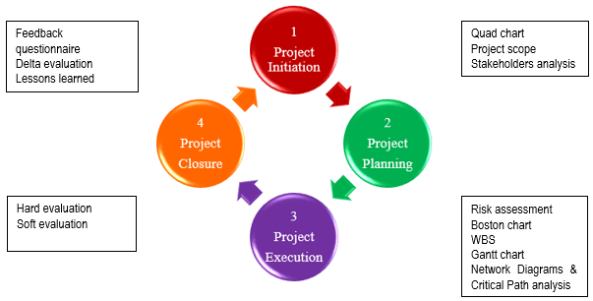

Figure 0 Project Life Cycle

- Project Initiation phase

Firstly, the Project manager must ensure the whole project team understand the aim and purpose of the project and recognise the requirements for delivering changes to the workplace to adapt to better operations during lockdown. It was necessary to develop a blueprint of the project which allowed the Project manager to regularly assess its progression. This included: a list of project activities, monitoring and controlling the overall progress of the project, identifying resource, the scope of the project, quality standards, approved budgets, risk analyses and measurement of success at the end of the project (Roberts, 2011, p.5).

  - Quad Chart

The Project Manager needed to decide when and how to deal with changes and still be able to meet the expectations of stakeholders. For this purpose, the Quad Chart (Appendix A) is a powerful, one-page picture that allows the project manager to visualize the aim, map manageable steps for the structure of the project, ensure control over the project scope, and define desired outcomes at the end of the project. The end date for this project is under on-going review, so it was set at July 2020 being the end of academic semester. The “response to COVID-19” project specified deliverable aims (box 1) such as early implementation of adaptation to provide online teaching and learning opportunities for all lecturers and students, with remote customer service support. The objectives of this project are to upgrade internal software, installing and setting up remote teaching apps, providing virtual online support and systems, and providing equipment before lockdown occurred. The desired Project outcomes/ deliverables at box 3 are the completion of software installation, all teaching classes conducted online successfully, and remotely providing customer services. Students and staff have gained secondary benefits while learning online or working from home, such as improved digital skills, online access and adaptive software making it easier for disabled students, and reduced stress and more time for outside interests as people no longer had to travel to the university.

Peter Landau (2017) defined the project scope as an important part of the planning process for a project, as it determines and documents the project goals, deliverables, tasks, costs and deadlines. At this initial phase, the whole team should be involved in determining and agreeing on tasks to be performed which align with the list of deliverables, desired outcomes, deadlines, milestones, progress reports (delivery to which group of stakeholders) and risk assessments from the Quad Chart above (Bridges, 2018a). Team members must collect all the requirements that define the project and document what the stakeholders want. Once the team understand what the stakeholders need and expect, it is critical to be able to define and documents these requirements, so that the adaptation made will be able to meet the expectations. Different stakeholders desire different outcomes, therefore it is dependent on the Project manager’s negotiation skills to agree them with Senior management/Trustees, and for them to sign off the final agreed budget and schedule document for the project.

  - Belbin Team Roles and Motivation

The Belbin Team Roles method is one of the more practical ways of acquiring specific team member for the necessary project roles and tasks. Each project role and responsibility can be designed once identified and documented, including required skill sets, reporting relationships and the generation of a staffing management plan (PMI, 2013, p.255). Dr Belbin (2020) defined Team Roles as “a tendency to behave, contribute and interrelate with others in a particular way” (Mind Tools, 2020). The project manager completed the Belbin Team Roles test, and the feedback report shows that the project manager’s own role assessment result was a Completer-Finisher (CF) (Appendix C). Being a CF means the project manager will see that the project is completed thoroughly to a high standard, ensuring no details are missed and ensuring all tasks are finished on time (Belbin, 2020).

The project manager led a team consisting of the Registrar and Chief Operating Officer, Estates and Facilities manager, Customer Services Manager, IT Team Manager, IT Services Coordinator and Customer Services Coordinator. The project manager utilized the Belbin Team Roles to assign project roles according to each person’s skills set and authority level.

  - Stakeholders Analysis

Roberts (2011, p. 45) stated that Stakeholders are a pool of individuals (or groups) who will have an interest in the project, either because they will be affected by it or because they may affect the project itself. The best way to analyse stakeholders is to complete a power/interest matrix which helps to build a communication plan, and recognise who the most influential stakeholders in this project are (Stakeholder map, 2020).

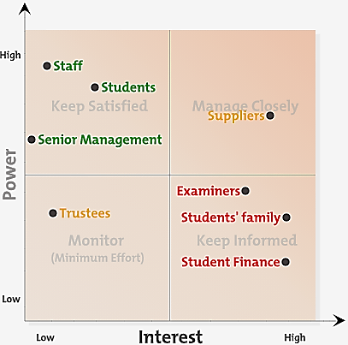

Figure 1.2.1 Project Power/Interest Matrix

A Stakeholder Analysis (Appendix D) is a systematic way to analyse stakeholders by their power and interest. Primary stakeholders are key players who are ultimately affected and will gain or lose while adapting to a new environment. Secondary stakeholders are considered external supporters and observers (Stakeholder map, 2020). The staff and students have the highest interest as work and learning are both affected most during the lockdown period. The project team could be divided into four different groups according to the power/interest matrix for the communication plan, which provides different levels of project information corresponding to high interest and low interest. For example, the team should keep Primary stakeholders (staff, students and Senior Management) in constant communication to satisfy their interest, remain in close contact with Supporters (Suppliers), and keep the external audience (Examiners, Student’s family, Student Finance) well informed. Team members could invite stakeholders to join in forums, workshops, surveys, group meeting, send emails, and marketing publications.

At this initiation phase, the team have a clear mind set on the project’s aim, objectives, stakeholders and communication plan. SU goals are planning and implementation in advance, resulting in a successful smooth change into the implementation phase when the Prime Minister announced whole country moving into lockdown on 23 March 2020 (Prime Minister’s Office, 2020).

- Project Planning phase

2.1 Iron Triangle Constraint

To help identify risk for the project, the Project manager needed to examine what was the most important criteria for measuring the success of this project. Would the project deliver the aims and objectives if one of the criteria: time, cost, quality or scope needed to change due to various concurrents (Caccamese and Bragantini, 2012). The Iron Triangle (see Figure 2.1) is a popular metaphor that illustrates the relationship between these three constraints that must be managed in project delivery (Stakeholdermap, 2020). Any changes in the criteria will have an immediate impact on the other two and affect the risk level. It is the Project Manager’s ability to establish and maintain balance for the constraints within these interrelated criteria. As mentioned in the introduction, SU intended to complete all planning and implementation in a very short time due to the uncertainty surrounding the spread of COVID-19, but the quality of customer services and support should not be compromised. The scope which are the deliverables replace quality, and quality has moved to the centre (Stakeholdermap.cpm, 2020), to balance the short of time with the other two points, the Project manager was required to ensure financial resource was sufficient for the cost, and approved by the Senior management/Trustees.

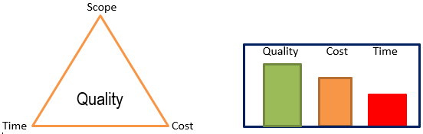

Figure 2.1 Iron Triangle Constraint

2.2 Risk Assessment Risk Analysis Grid

To avoid failure, the project manager needed to identify potential risks to reduce the impact on this project. A Risk Analysis (Appendix C) included INTERNAL and EXTERNAL environmental factors, the types of constraint, and mitigating actions to minimise negative effects on the project.

Risk identification is the first step of four in risk management. The second step is evaluation using risk analysis, this gives insight for the project manager to decide whether the project is too large, and needs to downsize for a better success rate. Due to the risk of an unknown end date for lockdown, the project team agreed to create a different project for preparation to re-open the campuses. A Boston Chart is a very simple brain storming risk analysis. Often it evaluates risk factors against each other rather than on their own. It does not give as much details of risk as the Risk Analysis Grid, but it can be perform stand alone for example for a product marketing risk analysis. The Project Familarity Grid analyses risk with a product that we are familiar with or not. It can help identify what is and what is not familiar by using this risk identity grid. This brings into question whether there is a need to bring in new team members that are familiar with the product or change to another product that we are familiar with. However, this Project Familarity Grid is unable to identify potential risks for the “response to COVID-19” project, due to quality of services being the team’s first priority.

2.3 PESTLE Analysis Grid

Bush (2019) stated that a PESTLE Analysis (Appendix D) is a business tool that involves identifying and evaluating political, economic, sociocultural, technological, legal, and environmental factors that affect a business. It can be useful to identify potential external environmental risks as part of the risk management process. The project manager can use brainstorm sessions during the planning stage, to find out business threats that may have been missed, review the risks and what actions can be taken to mitigate them, and follow up these actions during the whole lifecycle of the project.

2.4 Work Breakdown Structure

The ISS Team have been involved from the beginning of the project, because SU was concerned that the virus would reach Swansea sooner than expected. The Work Breakdown Structure (WBS) (Appendix G) timeline was set as the appointment date of the project manager. The WBS was created using a bottom-up approach (using Brainstorming) where team members were asked to list out all the low-level tasks that needed to be completed for this project (Project-Management.com, 2018). A Work Breakdown Structure is a deliverable orientated hierarchical structure that shows a breakdown of the work that needs to be “executed” by the team to achieve the project objectives and produce the deliverables.

Project managers use WBS for the following:
- Assist with accurate project organisation.
- Helps with assigning responsibilities.
- Show the control points and project milestones.
- Allows for more accurate estimation of cost, risk and schedule.
- Helps explain the project scope to stakeholders (Devi and Reddy, 2012, p.683).

The project manager needs to extract a task list from the Quad Chart at the Initiation phase process, then identify the deliverables, sub deliverables and activities tasks. Globerson (1994, p.323) summarized that the Work Breakdown Structure is the backbone of the proper planning, execution and control of a project. Knowing the project scope, schedule and cost will drive the project to complete on-time.

2.5 Gantt Chart

Gantt Chart (Appendix H) is commonly used to monitor timelines of a project and show interdependencies which exist in the chart. This chart was devised by Henry Gantt in 1910. Having a Gantt Chart drawn out early is crucial where you need to collaborate with different teams. It allows everyone involved to be proactive, interactive with room to change schedule, but still be able to track the progress of the project. It will have a start date and end date, and the task lists are transferred from the project’s work breakdown structure
.

2.6 Network Diagrams and Critical Path

Network Diagrams (Appendix I) are flow charts which illustrate dependencies between the project tasks in an orderly form and what needs to be done. The diagram comprises of three elements: Project Events which are also called milestones, activity which means work required to move from one event to another, and span time which is the actual time required to complete an activity.

Critical Path (Appendix I) is a project modeling technique that is used by the project managers to find the important deadlines and deliver a project on schedule. In a project, the critical path is the longest distance between the start and finish, including all the tasks and their duration (Project Manager.com, 2020b). There are a few benefits in finding the Critical Path, such as better understanding the time constraints for each task, setting the baseline to keep the project on schedule which lead to better estimates of the timeline for the next project, or review the current task baseline again. Because the critical path shows the longest time to complete a task, it actually helps the Project team to realise not all tasks are needed on the diagrams.

- Project Execution phase and Mid-term Evaluation

Once all the required analysis and project activities are put into action, project managers can proceed with executing processes by reviewing the project management processes.

Project team meetings are a good way of gathering all the team members in one place, reviewing each team member role and identifying which tasks are completed, or if there is problem affecting the task progress. The Project manager should obtain a project progress report and inform the team to get ready to celebrate success.

3.1 Mid-term Evaluation

Monitoring is the regular and systematic collection, analysis, reporting and use of information about the project and its services (Winderl, 2017). Monitoring the project is an ongoing process and is crucial to ensure the project can be completed by the deadline. This monitoring exercise is conducted internally, either by the project manager or a project member that is directly involved in the implementation process. It is to ensure team members take responsibility for what they should complete, take accountability, and meet the stakeholders expectations in meeting the deadline date. Due to the uncertainty of the COVID-19, the initiating and planning process for this project needed to be completed in a very short time. Therefore, weekly status reports, trackers and monthly status reports (see Figure 3.1) helped to push forward the project to the expected dates. For example, the first monitoring exercise should be parallel with the Gantt chart – initiating process.

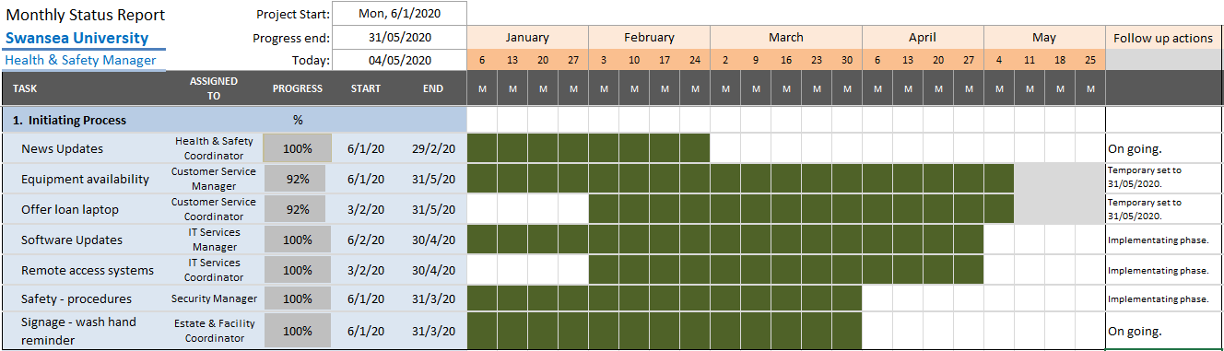

Figure 3.1 Project Monthly monitoring status report

Limitations of the report – end date for the project subject to how long the virus infected local community. To keep all university user safe and continue provide services, consider a new project look into how to gradually re-open library and university to the public established.

As the project progresses into each phase, the monitoring responsibilities and deadline will be altered accordingly. The monitoring exercise allows the management to make swift changes during the project once an issue has been identified or missed, or there is a delay in completing the task due to unforeseen circumstances. Most of the time monitoring is quantitative, in other words it can be measured.

Winderl (2017) defined evaluation as systematic and impartial assessment of expected and achieved accomplishments. Evaluation (Appendix J) is carried out by an external or independent evaluator or through a collective survey externally to ensure unbiased judgement (Winderl, 2017). The evaluation can be quantitative and qualitative too. There are several channels the university can gather evaluation data from:
- Staff Annual Survey.
- Student Satisfaction Survey.
- Customer Service questionnaire/complaints.
- Wellbeing support request feedback.

As an educational institution, the project manager is more concerned about the quality of the objective, because this can attract more prospective students to come to study with Swansea University. The Project manager can measure the quality/value of the activity or package at the mid-term of the project and adjust any changes to meet the expectations and quality of services provided.

- Project Closure phase

Post implementation review give insights of the management size and personnel that involved could have included head of colleges at the initiating process. The scope of the project and the deadline were delivered on time, most importantly the aims of keeping students and employees safe, continuous provide services remotely have been met. By collecting feedback from the Customer Service Questionnaires and Staff Annual Survey, the Project Manager could draw a new list of tasks for future improvement.

The two-formative information from soft outcomes will be carry forward to next Re-open Campus project, to improve the employee and public user satisfaction score.

4.1 Reflection on the project manager’s skills set

Based on the Project Manager’s self-perception feedback, the Project Manager may not be the best candidate to lead this complex project, but her personal strength of demanding high standards in her work means the project achieved a very high stakeholders satisfaction rate. Belbin’s Feedback and Development suggestions for the Project Manager are that she could perform better at the end of a project than at the beginning. A project manager should use different levels of hard and soft skills, but communication and strategic planning are crucial personal skills for any manager that leads a large complex project.

Conclusion

Early indication shown that the “response to COVID-19” project was a success, because of the planning and implementation phases were well in place before the government lockdown announcement.

The project team have successfully delivered the project objectives by dividing the project into four phases from the Project Life Cycle framework, applied appropriate project management tools and techniques according to each phase requirement. Success was measured from student feedback that they were satisfied and able to continue learning and attending classes online, and that the total numbers of students completing their courses had increased. Lecturers continued teaching session through online teaching apps, staff felt more confident as they were equipped with improved IT skills, and learned to set up remote working systems on personal devices to aid working from home.

The project has delivered the necessary adaptations in the workplace on time and within budget, and met the expectation of stakeholders.

Recommendations

Based on the soft outcomes from the evaluation report, the author makes the following recommendations to the Project manager and Registrar and Chief Operating Officer:

- What went wrong – Review on “Employees felt they not given enough warning before the building lockdown”, this means a lack of internal communication, or that messages either didn’t distribute to all staff or did not pass on to those have no access to the internet on campus. The Project team needs to review the communication plan that was established at the Project Initiation phase. To take mitigating action to ensure effective engagement and improve communications.

The Project manager also received approaches from Heads of Colleges about their disappointment at not been invited to participate in this project. They felt they had not been given the chance to represent their colleges and input their specialist skills to make it a success project.

- What need to improve – ISS Team manager applied to attend Leadership training to strengthen her communication skills and strategy planning skills. The project manager has learned from the previous project what her failing are, and will ensure she does not repeat the same mistakes. Her personal skills set for leading a complex and large project have revealed her inexperience in strategic planning.

Appendices

Appendix A: “response to COVID-19” Quad Chart

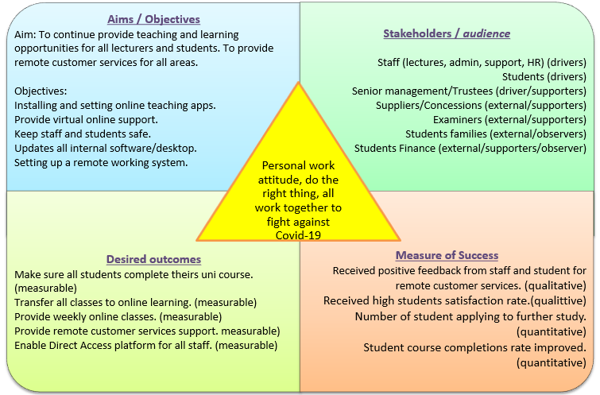
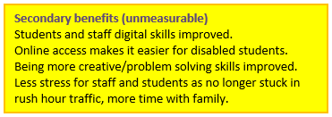

Appendix B: Belbin Team Roles

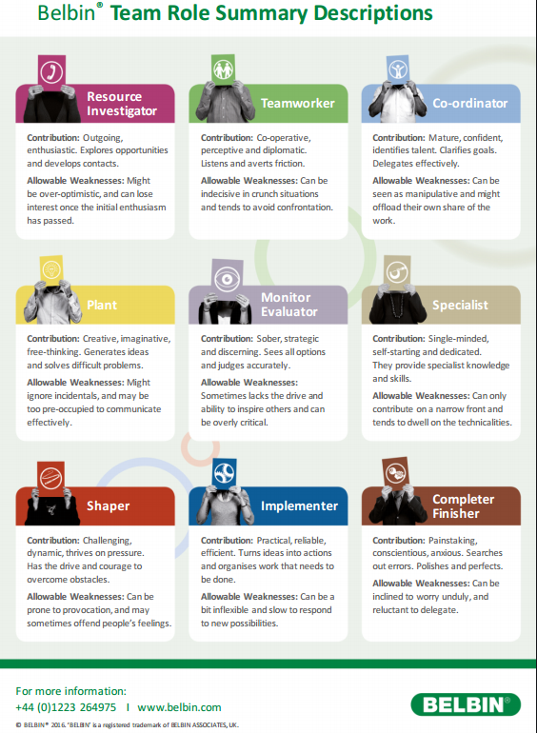

Appendix C: Project Manager’s self-perception – Team Role Feedback

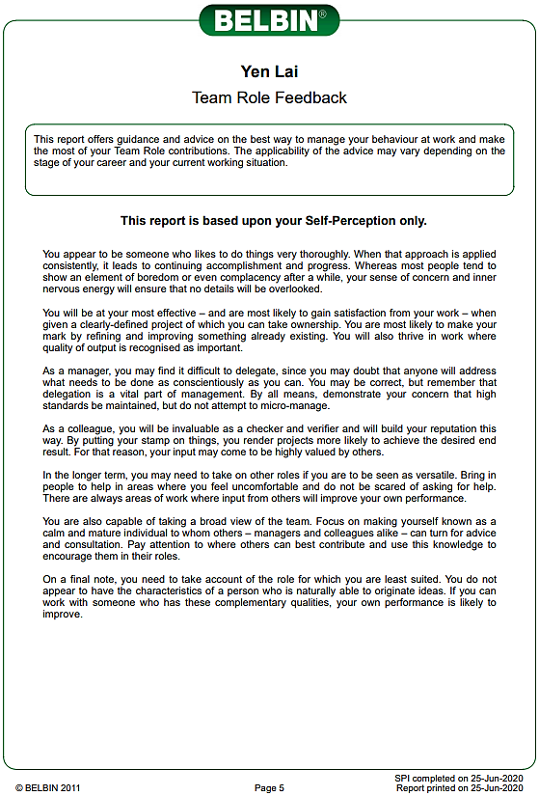

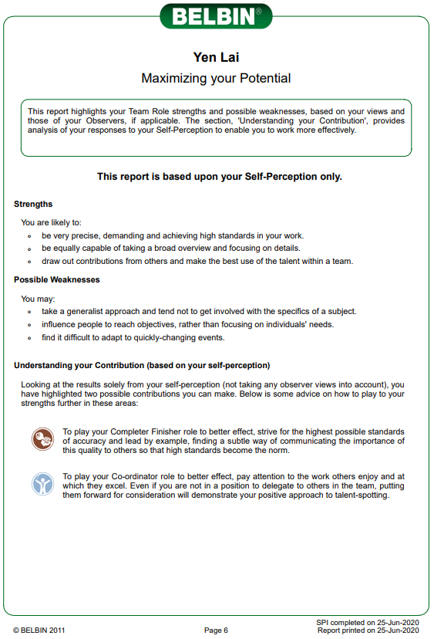

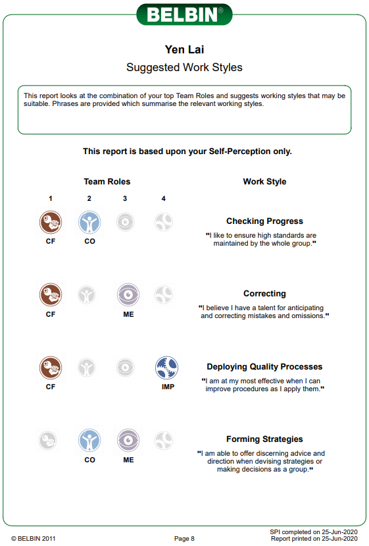

Appendix D: Project Stakeholders Analysis

Stakeholders Analysis
Priority  H/M/L | Stakeholders | Stakeholder’s  Perspective | Action
H | Staff (lecturers) | Delivering weekly online classes and providing one to one support to students. | Pre-recorded class video, remote working platform and software, online training, and line management support to deliver classes.
H | Staff (admin, support, HR) | Dealing with incoming/outgoing information and providing admin support to other colleagues. | Install and update remote working platform at home, setting resource availability, communication channel for others.
H | Students | Engaging, participating, and contributing to weekly classes and working towards completion of the course by submitting assignments. | Provide support, resources, wellbeing help and encouragement to complete the course.
M | Suppliers/Concessions | Regular communication, updating of changes, conducting risk assessments for the estate or delivery areas. | Implementing Social distancing, safety measures such as face masks and gloves.
L | Examiners | Regular communication, updating each situation change via intranet. | Keep informed, examination timetable.
H | Senior Management/Trustees | Receive full support from the senior management team and board of trustees, keep informed as decision making to close the university rests with them. | keep informed, request decision making, gain full support from the board.
L | Students’ families | Engaging, updating website with latest information, keep informed. | keep informed, provide support when required.
L | Student Finance | Engaging, coordinate student enrolment information, student course progress. | keep informed, coordinating when required.

Appendix E: Project Risk Assessment Risk Analysis Grid

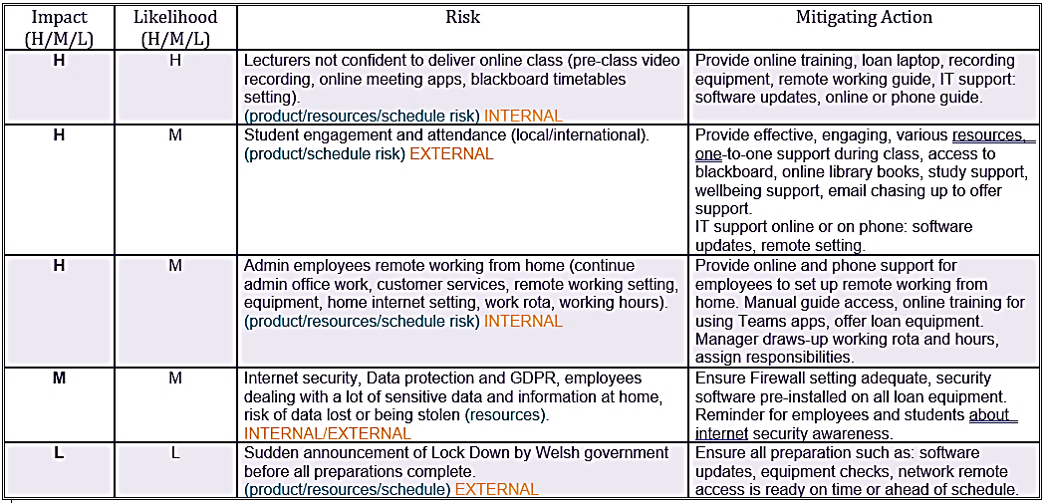

Appendix F: Project PESTLE Analysis Grid

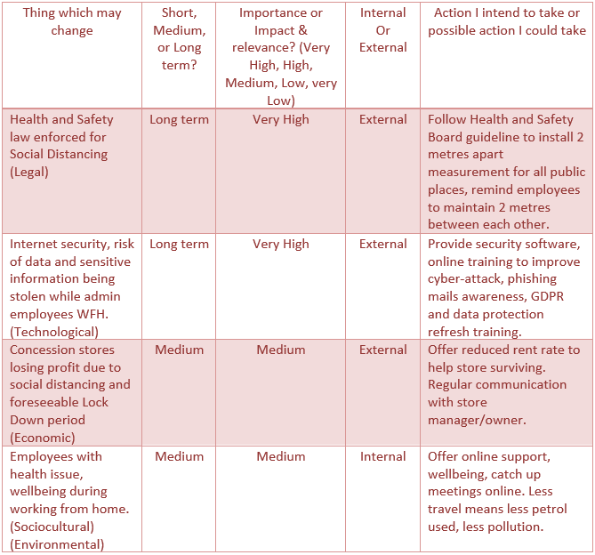

Appendix G: Project Work Breakdown Structure

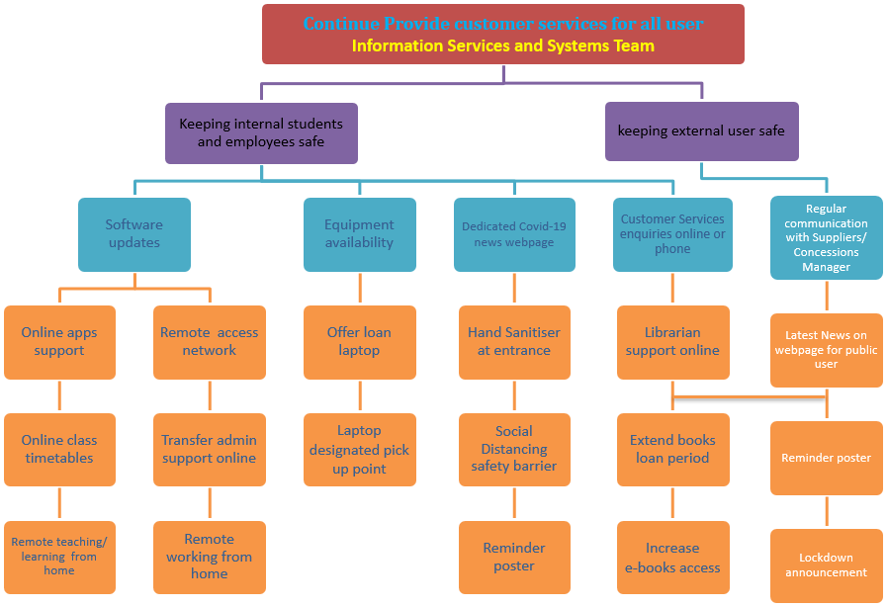

Appendix H: Project Gantt Chart

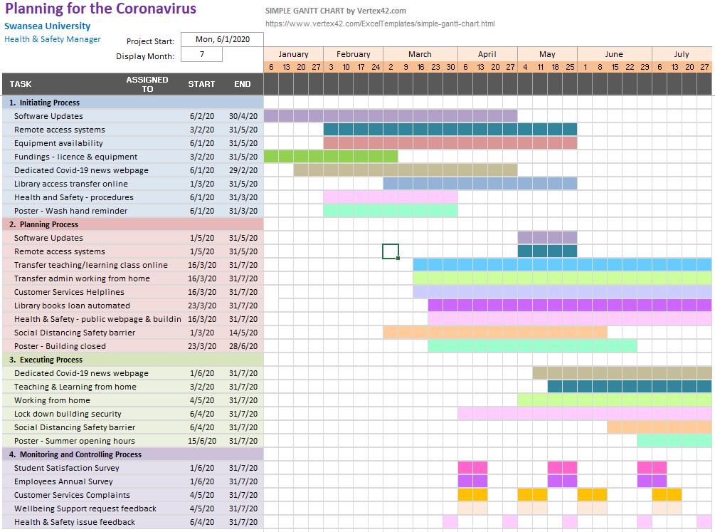

Appendix I: Project Network Diagrams and Critical Path Analysis

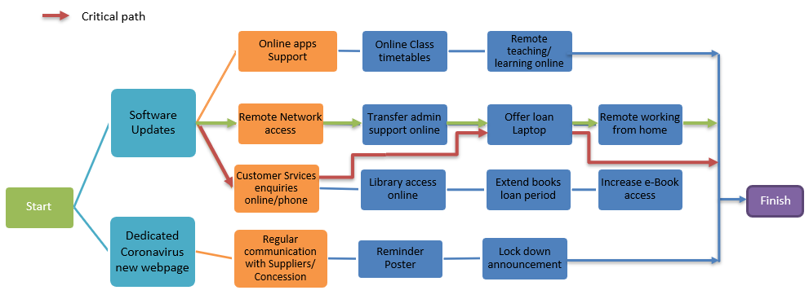

Appendix J: Project Evaluation Analysis

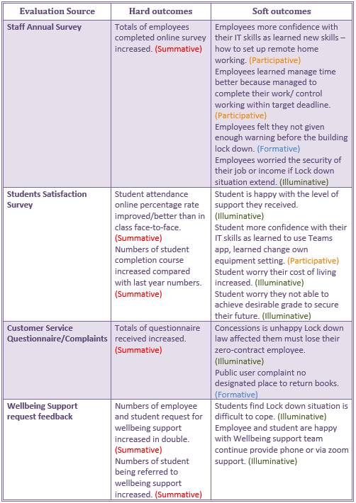

References

BBC News (2020) ‘New coronavirus ‘preventable and controllable’, China says’, BBC News, 19 January. Available at: https://www.bbc.co.uk/news/health-51168333 (Accessed: 18 May 2020).

Belbin Associates (2020) The Nine Belbin Team Roles. Available at: https://www.belbin.com/about/belbin-team-roles/ (Accessed: 18 August 2020)

Bridges, J. (2018a) How to Write a Scope of Work Document-Project Management Training [video]. Available at: https://www.youtube.com/watch?v=oacSSamqP6s (Accessed: 15 August 2020).

Bridges, J. (2018b) Risk Analysis How to Analyse Risks on Your Project [video]. Available at: https://www.youtube.com/watch?v=r5ZrPeQW8HQ (Accessed: 06 June 2020).

Bridges, J. (2019) How to Monitor Daily Progress as a Project Manager [video]. Available at: https://www.youtube.com/watch?v=E2Qahnv1j1g (Accessed: 15 June 2020).

Bush, T. (2019) PESTLE Analysis in Risk Management. Available at: https://pestleanalysis.com/pestle-analysis-in-risk-management/ (Accessed: 07 June 2020).

Caccamese, A. and Bragantini, D. (2012) ‘Beyond the iron triangle: year zero’, PMI Global Congress 2012. EMEA, Marsailles, France. Newtown Square, 9th May. PA: Project Management Institute.
Available at: https://www.pmi.org/learning/library/beyond-iron-triangle-year-zero-6381 (Accessed: 06 June 2020).

Dean, D. (2011) Top 5 Project Tracking & Monitoring Tips for Project Managers [video]. Available at: https://www.youtube.com/watch?v=r5ZrPeQW8HQ (Accessed: 13 June 2020).

Devi, T. R., & Reddy, V. S. (2012) Work Breakdown Structure of the Project. International Journal of Engineering Research and Applications, 2(2), pp.683-686.

Globerson, S. (1994) Impact of various work-breakdown structures on project conceptualization. International Journal of Project Management, 12(3), pp.165-171.

Jones, L. (2020) ‘Coronavirus: Business adapting to life under lockdown’, BBC News, 22 April. Available at: https://www.bbc.co.uk/news/business-52321761 (Accessed: 18 May 2020).

Mario Brčić, & Danijel Mlinarić. (2018) Tracking Predictive Gantt Chart for Proactive Rescheduling in Stochastic Resource Constrained Project Scheduling. Journal of Information and Organizational Sciences, 42(2), pp.179-192.

Mind Tools (2020) Belbin’s Team Roles. Available at: https://www.mindtools.com/pages/article/newLDR_83.htm (Accessed: 15 August 2020).

Munns, A.K. and Bjeirmi, B.F. (1996) ‘The role of project management in achieving project success’, International Journal of Project Management, 14(2), pp. 81-87.

Landau, P. (2017) ‘Project Scope 101’ Project Manager.com [blog]. 20 June. Available at: https://www.projectmanager.com/blog/project-scope (Accessed: 15 August 2020)

Patanakul, P., Iewwongcharoen, B., & Milosevic, D. (2010) ‘An empirical study on the use of project management tools and techniques across project life-cycle and their impact on project success’, Journal of General Management, 36(3), pp. 41-65.

Pestle Analysis.com (2020) Pestle Analysis in Risk Management. Available at: https://pestleanalysis.com/pestle-analysis-in-risk-management/ (Accessed: 07 June 2020).

Prime Minister’s Office (2020) Prime Minister’s statement on coronavirus (COVID-19): 23 March 2020. Available at: https://www.gov.uk/government/speeches/pm-address-to-the-nation-on-coronavirus-23-march-2020 (Accessed: 15 August 2020).

Project Manager.com (2020b) Critical Path Method. Available at: https://www.projectmanager.com/critical-path-method (Accessed: 31 August 2020).

Project Manager.com (2011a) Step-by-Step Project Planning, Available at: file:///D:/Yen/UWTSD%20folder/Skills%20for%20Workplace_Level5/2019%20Leve%205/BMSW5104%20Managing%20Projects/Reading%20materials/3%20-%20Step%20by%20Step%20Project%20Planning.pdf (Accessed: 03 June 2020).

Project-Management.com (2018) Work Breakdown Structure (WBS): Top-down or Bottom-up? Available at: https://project-management.com/work-breakdown-structure-wbs-top-down-or-bottom-up/#:~:text=In%20this%20approach%2C%20the%20WBS,projects%20or%20lower%2Dlevel%20tasks.&text=The%20bottom%2Dup%20approach%20on,needed%20to%20complete%20the%20project. (Accessed: 19 August 2020).

Project Management Institute (2013) A guide to the project management body of knowledge (PMBOK guide), 5th edn. Pennsylvania, USA: Project Management Institute.

Raftery, J. (2003) Risk Analysis In Project Management. 2nd edn. London, New York: Taylor & Francis e-Library.

Rastogi, N. I. T. A. N. K. and Trivedi, M. K. (2016) PESTLE technique–a tool to identify external risks in construction projects. International Research Journal of Engineering and Technology (IRJET), 3(1), pp. 384-388.

Ries, J. (2020) ‘Here’s How COVID-19 Compare to Past Outbreaks’, Healthline, 12th March. Available at: https://www.healthline.com/health-news/how-deadly-is-the-coronavirus-compared-to-past-outbreaks (Accessed: 13 August 2020).
Roberts, P. (2011) Effective project management. London, Philadelphia: Kogan Page.

6.Stakeholdermap.com (2020) Project Management Triangle. Available at: https://www.stakeholdermap.com/project-management/project-triangle.html (Accessed: 07 June 2020).

7.Stakeholdermap.com (2020) Stakeholder Analysis. Available at: https://stakeholdermap.com/stakeholder-analysis.html (Accessed: 27 May 2020).

Swansea University (2020c) Academic Colleges. Available at: https://www.swansea.ac.uk/the-university/colleges/ (Accessed: 18 May 2020).

Swansea University (2020d) Coronavirus: Guidance for Swansea University. Available at: https://www.swansea.ac.uk/the-university/history/ (Accessed: 18 May 2020).

Swansea University (2020e) Libraries and Archieves. Available at: https://www.swansea.ac.uk/library/ (Accessed: 18 May 2020).

Thayer School of Engineering at Dartmouth (2014) Project Management Across the Project Life Cycle [video]. Available at: https://www.youtube.com/watch?v=CSGYIT1HuYw (Accessed: 14 May 2020).

Totem Consulting (2017) What is a Gantt Chart. [video] Available at: https://www.youtube.com/watch?v=zwseLrxkKKE (Accessed 03 June 2020).

Wittwer, J. (2019) Gantt Chart Template for Excel. Available at: https://www.vertex42.com/ExcelTemplates/excel-gantt-chart.html (Accessed 04 June 2020).

Winderl, T. (2017) What is the difference between monitoring and evaluations? [video]. Available at: https://www.youtube.com/watch?v=X2ZzpuE1us4&t=14s (Accessed: 15 June 2020).

World Health Organization (2020a) Timeline: WHO’s COVID-19 response. Available at: https://www.who.int/emergencies/diseases/novel-coronavirus-2019/interactive-timeline#! (Accessed: 13 August 2020).

World Health Organization (2020b) Coronavirus disease 2019 (COVID-19) Situation Report – 94. Available at: https://www.who.int/docs/default-source/coronaviruse/situation-reports/20200423-sitrep-94-covid-19.pdf#:~:text=The%20first%20human%20cases%20of,%2C%20in%20December%202019.
(Accessed: 13 August 2020).

