

LEVEL 4 ASSESSMENT SPECIFICATION

Student name: | Sian Nunnery | Student ID number: | 2015844
Programme: | HNC Electrical/Electronic Engineering
Module: | Programmable Logic Controllers
Module code: | PCEE4005 | Contribution to Overall Module Assessment (%): | 50%
Lecturer: | Jason Pointer | Internal Verifier: | Lance Rutherford
Assignment Title: | Introduction to PLC Systems & Program Design | Word count (or equivalent): | 2000
Submission deadline: | 20/01/22 | Return date of provisional marks & written feedback: | 10/02/22
Submission method: | All written assessments, where practical and possible, must be submitted via Turnitin unless otherwise instructed by the Lecturer. (Please DO NOT put this assessment specification into Turnitin or it will match many similarities with other students’ submissions.)  Alternative submission method (if applicable):  Late submission of the assessment will result in a late penalty mark. Penalties for late submission: Up to one week late, maximum mark of 40%. Over one week late, 0%. Only the Extenuating Circumstances Panel may approve a change to submission dates.
Academic honesty / referencing: | Academic honesty is required. In the main body of your submission you must give credit to authors on whose research and ideas your work is based. Append to your submission a reference list that indicates the books, articles, etc. that you have used, cited or quoted in order to complete this assessment.

Module Learning Outcomes
(from module syllabus)
- Demonstrate an understanding of the concepts of process control using an industry standard PLC.
- Undertake basic PLC system design and implementation processes, comparing theoretical expectations to actual outputs ensuring correct operation and consideration of maintenance and reliability.

Student FEEDBACK FORM

This section details the extent to which the assessment criteria are demonstrated by you, which in turn determines your mark. The marks available for each category of skill are shown. Lecturers will use the space provided to comment on the achievement of the task(s), including those areas in which you have performed well and areas that would benefit from development/improvement.

Generic Assessment Criteria | Marks available | Marks  awarded
1. Engagement with Literature Skills  . | 15 | 7.5
Engagement with a wide range of literature sources, including sources retrieved independently but very few textbooks are included in the list. Generally sound referencing, with no real inaccuracies or inconsistencies.

2. Knowledge and Understanding Skills | 25 | 17.9
Task 1 achieved 65%.
Task 2 achieved 84%,
Task 3 achieved 66%.
Competent knowledge of the basic underlying concepts and principles for each task. Exhibits very good understanding the PLC type and the logic systems.
3. Cognitive and Intellectual Skills | 10 | 6.8
Sound evaluation of the underlying concepts and principles applied to the construction of the motor controller.

4. Practical Application Skills | 40 | 32.4
Task 4 achieved 82%.
Task 5 achieved 80%.
An excellent application of the software to produce fully functional programs to cover the requirements of Task 4 and 5. Required very little support in the development of these programs and was able to show full operation.

5. Transferable Skills for Life and Professional Practice | 10 | 5.8
Mostly coherent, organised and accurate work, in a suitable structure and is for the most part clearly expressed.
Assessment Mark (Assessment marks are subject to ratification at the Exam Board. These comments and marks are to give feedback on module work and are for guidance only until they are confirmed.) | Late Submission Penalties (tick if appropriate) |  | 70%
 | Up to 1 week late (40% Max) |  | 70%
 | Over 1 week late (0%) |  | 70%

Induction to PLC Systems and Program Design
jason pointer
HNC electrical and electronic engineering & instrument engineering – programmable logic controllers
Sian Nunnery

Contents
Introduction 2
Task 1 - Programmable Logic Controller Types 3
Task 2 – Logic Diagrams and Truth Tables 8
Task 3 – Timers 12
Task 4 – Programming Problems 15
Task 5 – Dual Fan Controller 17
References 19
Bibliography 20

Introduction

Within this assignment different types of PLCs will be addressed, as well as discussing different components that make up the PLC. Also, the prevention of electrical overload on PLCs. Next, I will develop an understanding of logic functions in the form of a truth table and Karnaugh map, that will allow me to create a Boolean expression from a circuit provided. Discuss the attributes of on / off delay timer and pulse timers, as well as cascade and sequence timers. Lastly for the last two task I will develop different programme by using functions blocks to create a washing machine cycle, a coin counting sequence and a dual fan controller.

Task 1 - Programmable Logic Controller Types

- Through your own research, describe in detail the two types of PLCs available. Include in your answer the specifications that define each type, possible applications and any considerations that need to be assessed when selecting a specific PLC type.

Modular
Modular PLC consists of various types of modules that can all be run together. The functionality of the modules allows the user to operate the best combination of the system that they require. The operation of the modular PLC is extremely variable by the inputs and outputs being altered, additional inputs and outputs can be added by connecting them to the DIN rail and plugged into the processor. Modular PLCs are mainly used within the manufacturing industry to control process lines. A large amount of programs are typically rack mounted as this is a more suitable option, as when expanding Modular PLCs, are large volume of the unit becomes unorganised and cluttered. “Typically, a base module contains core functions such as electrical power regulation, the computer processor, and input connections. Additional modules, including analogue to digital signal converters or additional outputs, can be added to this core unit as needed. This modular design allows a PLC to be customized and changed easily.” [Types of PLC, n.d.]

Unitary
One of the more simplified types of PLC is a unitary PLC, this allows simple applications to be run off the PLC. A unitary PLC only consist of basic components such as the processor that runs the software, as well as terminals for inputs and outputs, the components are based in a single housing. Unitary PLCs are used for applications where it does not require a large amount of inputs and outputs, this allows it to be used for specified applications and/or component, the unitary PLC is directly fitted to the programmed device in order to operate. The number of inputs and outputs cannot exceed the amount of terminals in the PLC, also the unitary PLC cannot be expanded. The unitary PLC is commonly used for standalone systems. When selecting a unitary PLC, the main aspect to consider is ensuring that the inputs and output required for the program, does not exceed the limits of the PLC.

Rack Mounted
Rack mounted PLCs are designed to allow the modules to be operated either separately or combined throughout the rack system built within a control cabinet, the connection within the rack mounted PLC is through a network. Rack Mounted PLCs are commonly used within the process industry, similar to modular PLCs, but it also has the capacity to be able to talk to other systems. Benefits of the rack mounted PLC are that they are easily modified / extended, if an element of the PLC fails then only that certain element as to be changed which saves on cost, as well as they have additional I/O detail in comparison to other PLC types. A disadvantage of a rack mounted PLC is the initial cost of the PLC is more expensive than a unitary or modular PLC.

- Explain with the aid of a diagram the main components within a PLC and show the appropriate connections to and from the outside world.

The main components within a PLC are a power supply, CPU (Central Processing Unit), communication card, I/O modules (digital input, digital output, analogue input and an analogue output).

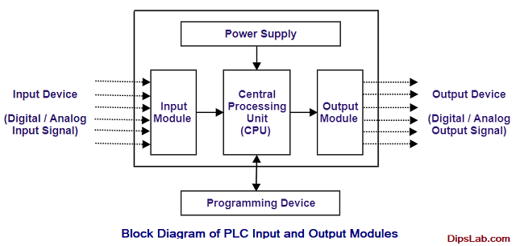
Figure 1 - (Chaudhari and Chaudhari, n.d.)

The power supply of a PLC is used to convert the mains input power of AC (Alternating Current) to a low DC (Direct Current) voltage, this is essential for the I/O (Input/Output) circuits within the interface modules of the PLC.
The CPU contains a microprocessor that allows the storage of programs as well as any memory required. The microprocessor also allows the performance of programmes installed to allow the user to carry out control functions and computations, including the interpretation of input signals and output signals to allow any actions needed to be carried out within the PLC. “The processor unit or central processing unit (CPU) is the unit containing the microprocessor and this interprets the input signals and carries out the control actions, according to the program stored in its memory, communicating the decisions as action signals to the outputs.” [Bolton W. Programmable Logic Controllers].
The communication module in the PLC allows data to be transferred digitally between the PLC itself to any other systems connected, for example SCADA, HMI or another PLC. Communication modules are commonly used for Modbus communication or serial communication. Modbus communication is where information is transmitted over “serial lines between electronic devices. The device requesting the information is called the Modbus Master and the devices supplying information are Modbus Slaves. In a standard Modbus network, there is one Master and up to 247 Slaves, each with a unique Slave Address from 1 to 247. The Master can also write information to the Slaves.” [What is Modbus and How does it work?, 2013]
I/O (Input / Output) Module allows the PLC to be connected to/from the processor to the field devices and/or control panel. Field devices that are commonly connect to the PLC are pressure transmitters, control valves, flow transmitters, level transmitter, as well as many other various devices.

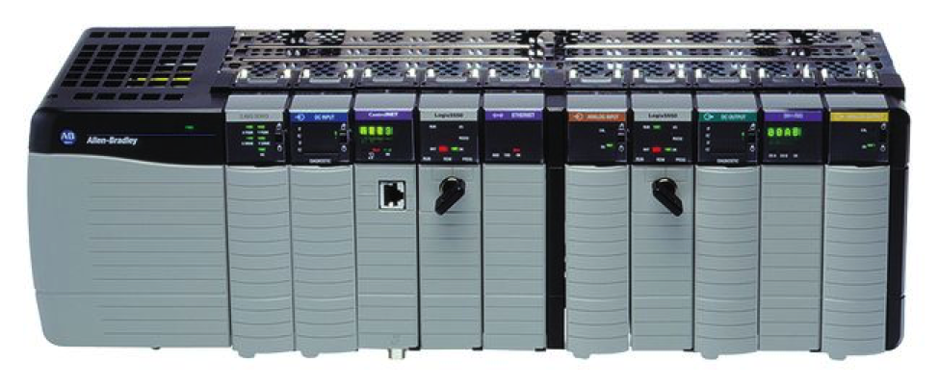
Figure 2 [Automation?, n.d.]

- Identify methods of protecting a PLC input/output interface from potential electrical overloads or fault conditions that may occur in the field devices and explain how they are incorporated into the input and output interface.

Methods of protection that can be used to protect the PLC inputs/outputs from potential electrical overloads or fault conditions. There are various types of output units used for PLCs such as transistors, relays or triac.

Methods of overload protection within a PLC interface are overload protection relays, this helps to prevent damage by breaking the circuit when electrical overload occurs, or phase failure is identified. A protective relay is a device where it receives an input, makes a comparison to the set point that are pre-set, then provides a corresponding output.

An opto-isolator is an electrical device within a PLC that allows the transfer of electrical signal without an electrical current to transmit between two electrical circuits, an opto-isolator typically use a light (LED) to convert the electrical input signal into the corresponding light indication. The opto-isolator only allows flow through in one direction but not in the opposite direction. Opto-isolators act as a layer of protection for devices from high voltage / electrical overloads by blocking any high voltages or electrical overloads getting further into the system and damaging any further components within the PLC. There are various types of opto-isolators such as resistive opto-isolator, diode opto-isolator, transistor opto-isolator, opto-isolator SCR and opto-isolated triac.
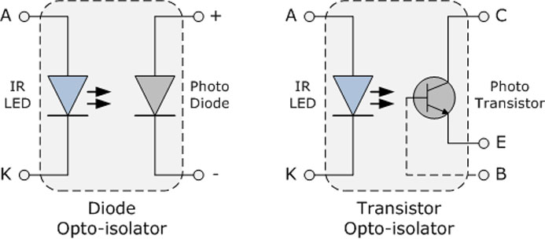
Figure 3 (Optoisolator, 2019)

A Triac is a semi-conductive device which is used for controlling the current from an AC source. “Specifically designed to operate as a switch in an alternating current power system, the advantages of the Triac are its noiseless operation, its ability to be controlled at anytime and without rebounds, its automatic turn-off when the current reaches zero after the control has been removed, and its ability to stand up to an unlimited number of operating cycles wear.” (Controlling a Triac with a phototriac, 2020). Triacs allow the control of both halves of the alternating current cycle, which allows them to control large amount of flow.

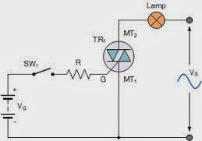
Figure 4 (Bhatt, 2018)

Task 2 – Logic Diagrams and Truth Tables

There are many control situations that require actions to be initiated when a certain combination of conditions are realised. Such situations can involve the use of logic gates to produce an output when certain input conditions are met.
- Produce a truth table and the Boolean equation for the logic circuit shown below (figure 1). Comment on the circuit output with respect to the inputs, noting any issues that may arise when using this configuration of logic gates.
E
F
J
G
H
I
Inputs |  |  | Gate Outputs |  |  |  |  |  | Output
A | B | C | E | F | G | H | I | J | Q
0 | 0 | 0 | 0 | 0 | 1 | 0 | 1 | 0 | 0
0 | 0 | 1 | 0 | 0 | 0 | 0 | 1 | 0 | 0
0 | 1 | 0 | 1 | 1 | 0 | 0 | 0 | 0 | 0
0 | 1 | 1 | 1 | 1 | 1 | 0 | 0 | 1 | 1
1 | 0 | 0 | 1 | 0 | 1 | 1 | 1 | 0 | 1
1 | 0 | 1 | 1 | 0 | 0 | 1 | 1 | 0 | 1
1 | 1 | 0 | 1 | 1 | 0 | 0 | 0 | 0 | 0
1 | 1 | 1 | 1 | 1 | 1 | 0 | 0 | 1 | 1

$$Q = \overline{A}.B.C + A. \overline{B}. \overline{C} + A. \overline{B}.C + A.B.C$$
$$Q = B.C(\overline{A}+A) +A.\overline{B}.\overline{C }+ A.\overline{B}.C$$
$$Q = B.C + A.\overline{B}(\overline{C}+C)$$
$$Q= B.C + A.\overline{B}$$

 | BC
A |  | 00 | 01 | 11 | 10
 | 0 | 0 | 0 | 1 | 0
 | 1 | 1 | 1 | 1 | 0
- Simplify the Boolean equation and produce the ladder logic diagram for the circuit and simulate using suitable software and confirm function

$$Q= B.C + A.\overline{B}$$

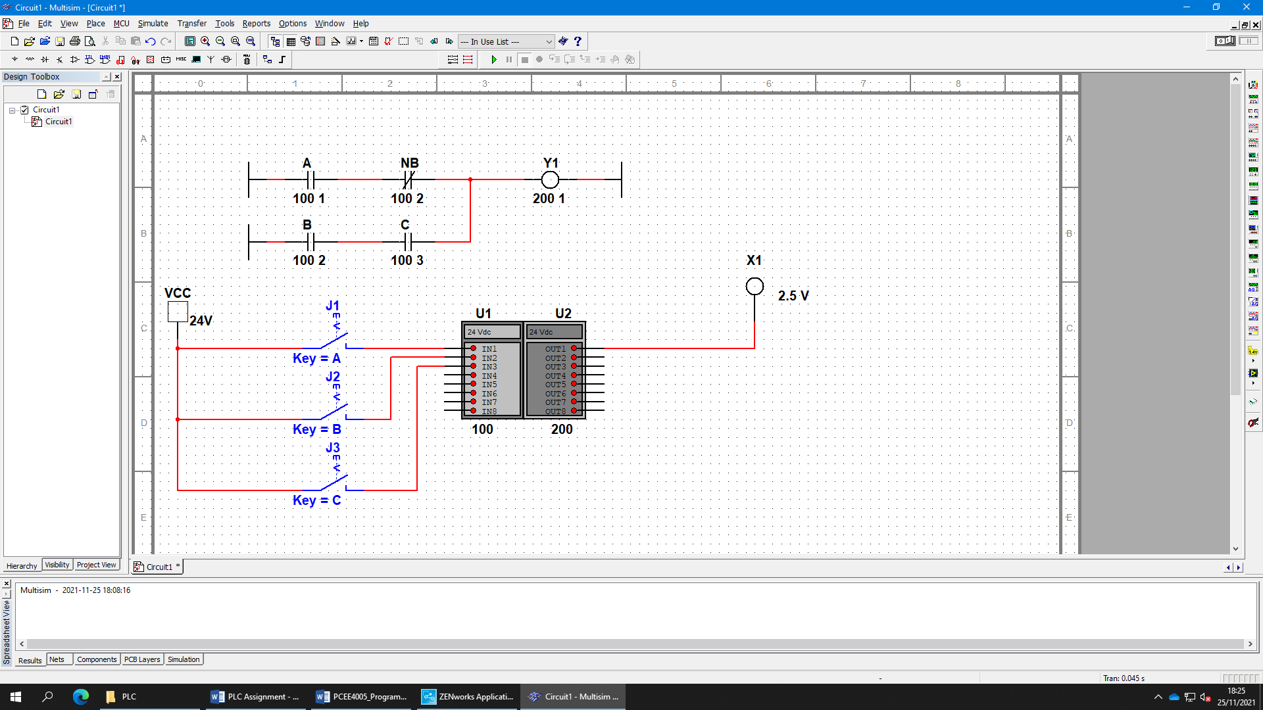
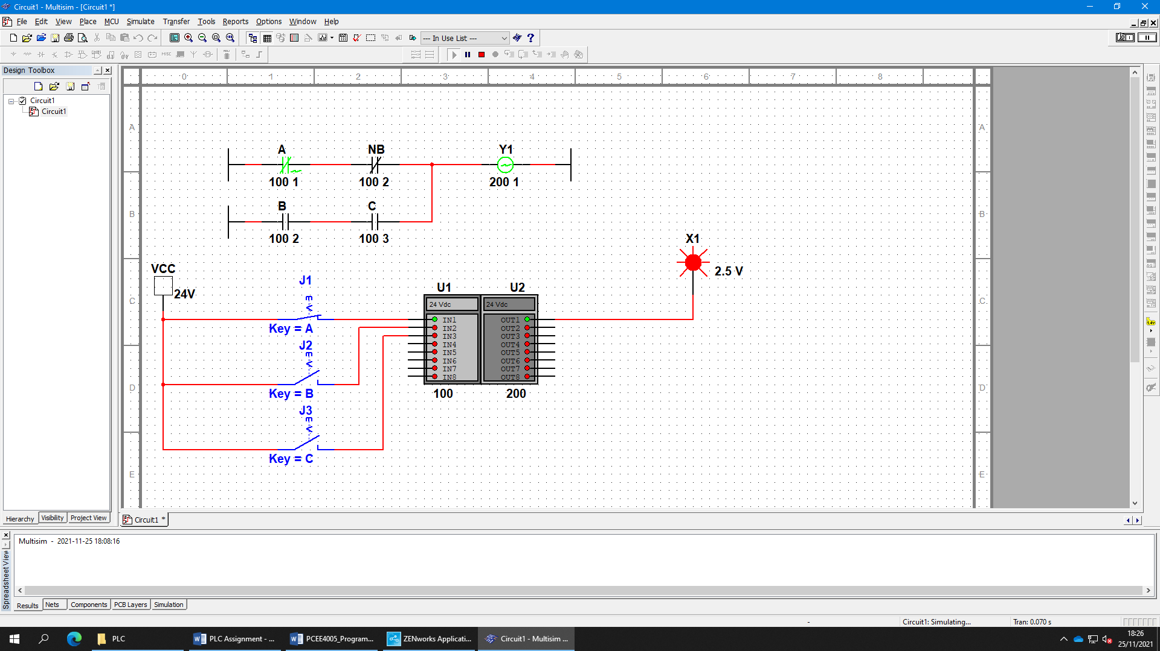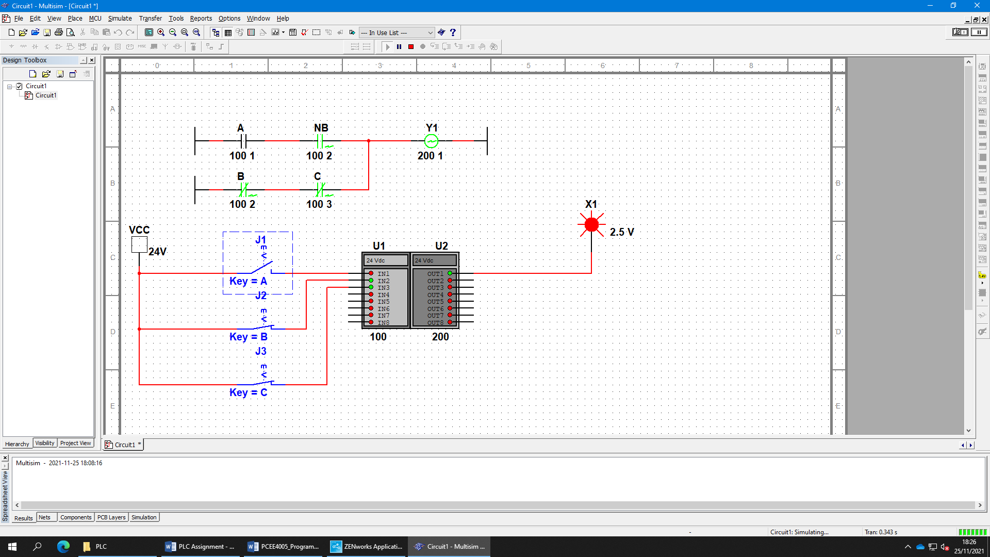

Above shows the full testing of the ladder logic, it shows everything working as worked out in the calculations above.
The truth table results were produced first that shows the logic functions provided in the assignment. Once this was produced, this allowed the development of the truth table, Boolean expression that represent the required components in order to provide a functional circuit. A Karnaugh map was then produced which produced a simplified version of the Boolean expression. This allows the program to produce the same function of the circuit but in a much simpler format, which consequently results in a smaller program therefore meaning more available space within the PLC.

Task 3 – Timers
In many control tasks there is a need to apply timing constraints to a process operation. For example, a motor might need to be controlled to operate for a particular interval of time, or perhaps be switched on after some time interval. PLCs thus have timers as built-in devices.

a) With the aid of suitable timing diagrams explain the operation of each timer type listed below:
- On-delay timer
- Off-delay timer
- Pulse timer.

On-delay timer
An on-delay timer works where a signal is sent after a set time delay in the circuit that has been specified within the set up. Bolton defines this by “These are timers which come on after a particular time delay.” [Bolton W. Programmable Logic Controllers]. This works by a supply voltage being applied when the delayed timer is over, the contact position changes, for example, the motor is delayed by 10 secs and when the voltage is applied the motor then switches on. When the switch position then changes back to its first position, then the motor would switch off.
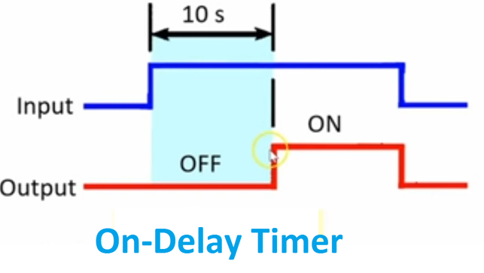
Figure 5 - On Delay Timer | Off Delay Timer Working Principle | Electrical4u, n.d.)

Off-delay timer
An off-delay timer works in the opposite way to an on-delay timer. An off-delay timer works where a device is switched on and is switched off after a specified amount of time has passed. When the device is switched on, the contact position engages and the supply voltage is applied, for example a timed light switch, where the light is initially switched on and after a certain amount of set time the light switches off, where the contact position on the switch would go back to its original position and the supply voltage would break down.
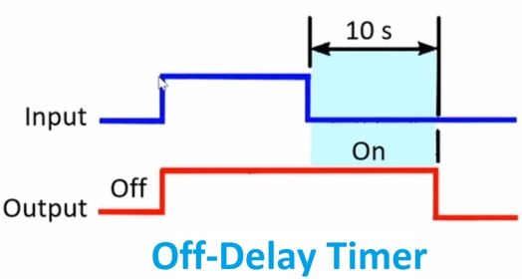
Figure 6 - On Delay Timer | Off Delay Timer Working Principle | Electrical4u, n.d.)

Pulse timer
A pulse timer is where a timer received a supply voltage at a set input and enables the output for as long as the pre-set value of the timer. The intermission between the ‘pulses’ or on / off states of the pre-set time periods, when the timer is activated or deactivated in either state no matter the input, it will operate until it reaches the pre-set value.
Once a parameter is defined for the pulse of timer, the output will be carried out for the pre-set amount of timer and then will be switched off again. The pulse timer is not dependant on the input, all it relies on is the pre-set values of the signal at the input to allow for the pulse timer to work.
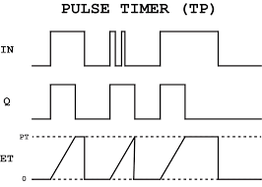

Figure 7 - (Timers in PLC Programming | PLC Academy, 2018)

- Explain how they can be used for sequences outputs and cascaded timers.

Sequence Outputs
A sequence timer can be energised by a trigger input signal, once energised the sequence of multiple timers that has been pre-set will be energised and de-energised in order over a period of time.

Cascaded Timers
Cascade timers works where the timers are locked together, when one timer is complete then the next timer will start, this pattern carries on for as many timer that have been put in place. An example of this could be traffic lights where the green light is on for a set amount of time, then once that has been complete the green light switches off and the orange light is switch on for a set amount of timer and so on. The purpose of a cascade timer is to carry out a sequence of timed events.

Task 4 – Programming Problems

- For part of a washing machine cycle, a water supply pump is required to run for 40 seconds. It is then to be switched off and a heater switched on for 25 seconds. The heater should then be turned off and a drain pump run for 15 seconds to remove the water. The cycle should be started using a momentary ‘on’ switch, run automatically and terminate once the drain pump has stopped. Indicator lights should be used to inform the user of each stage of the cycle.

By using the Mitsubishi Alpha Software, the following washing machine cycle PLC program was created by using function blocks.

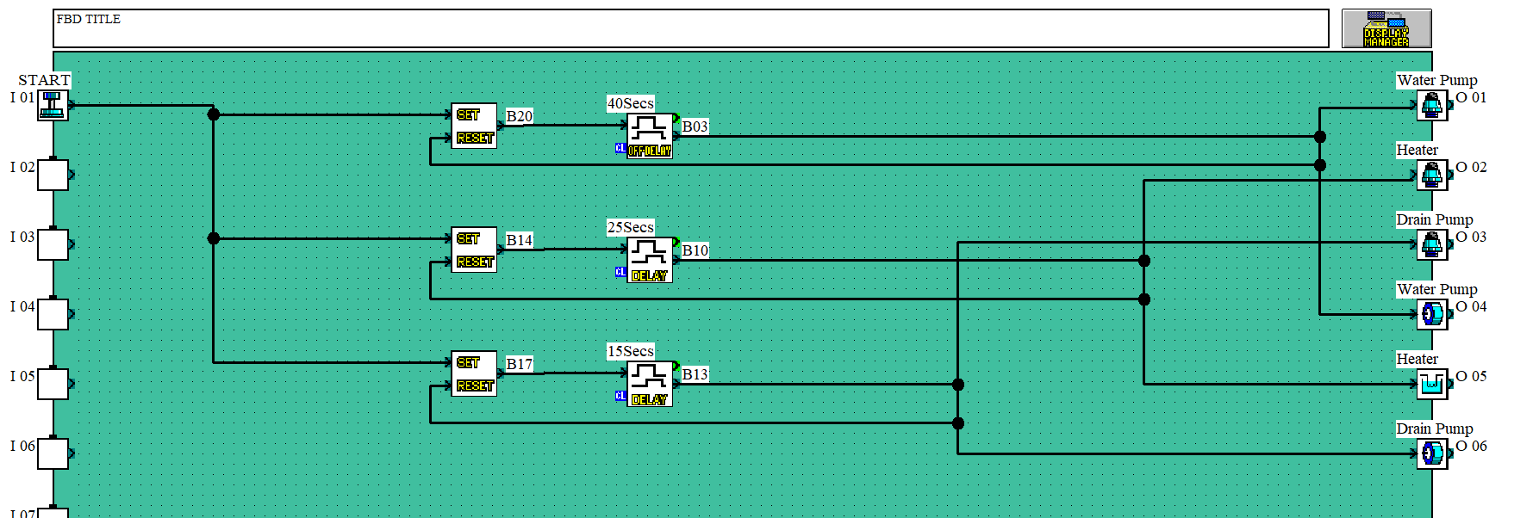
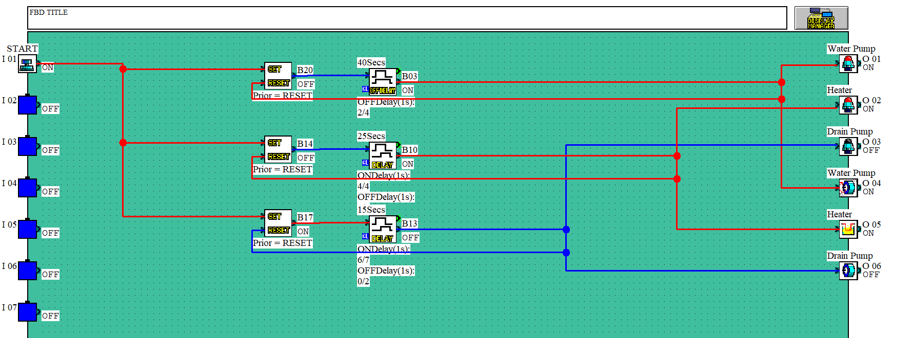

The above screenshots illustrate the washing machine cycle, a combination of resets and delay timers where used to simulate the cycle of the washing machine.

- A coin counting system is required to determine the totals of 5, 10 and 20 pence coins. Each time a coin reaches the total of a pound a different colour light will come on for each coin total. Also, a running total of every pound will be monitored and a final light will come on when the total has reached 10 pounds.

Please see provided below screenshot of the coin counting system PLC program using function blocks of multiple coin counters as well as an accumulative counter of the individual counters.

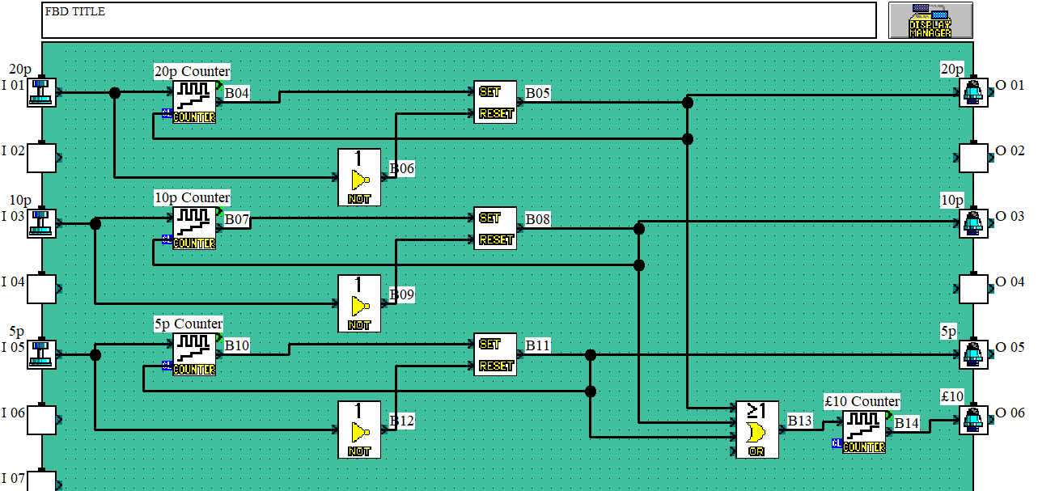
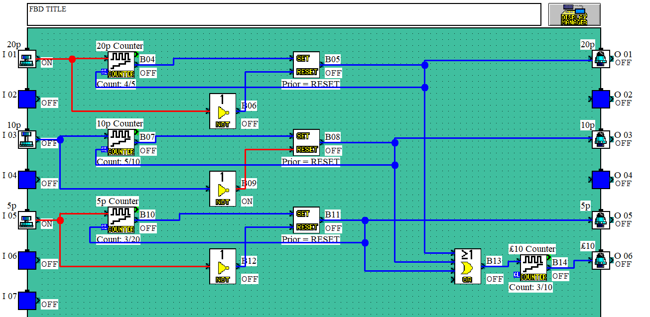

Task 5 – Dual Fan Controller
For this task you are required to develop a PLC program using functional blocks to control a dual fan system.
Control system specification:
Motor Control: Start switches to turn the motors on and stop switches to turn the motors off. Note: All switches should be press and release types.
Fan Monitor: Lamps to show the fans are off and lamps to show the fans are running.

Please see provided below screenshot of the dual fan controller PLC program using function blocks of a dual fan controller.
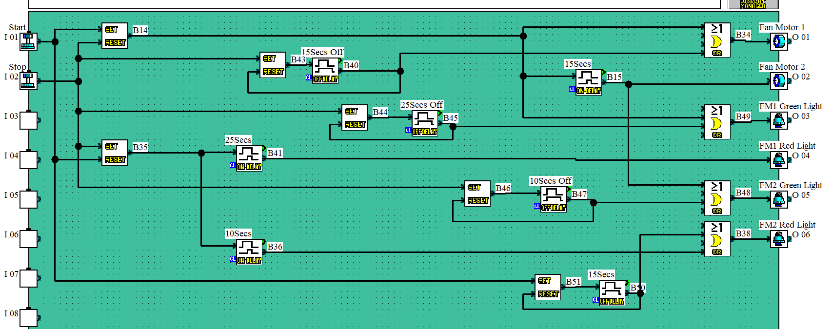
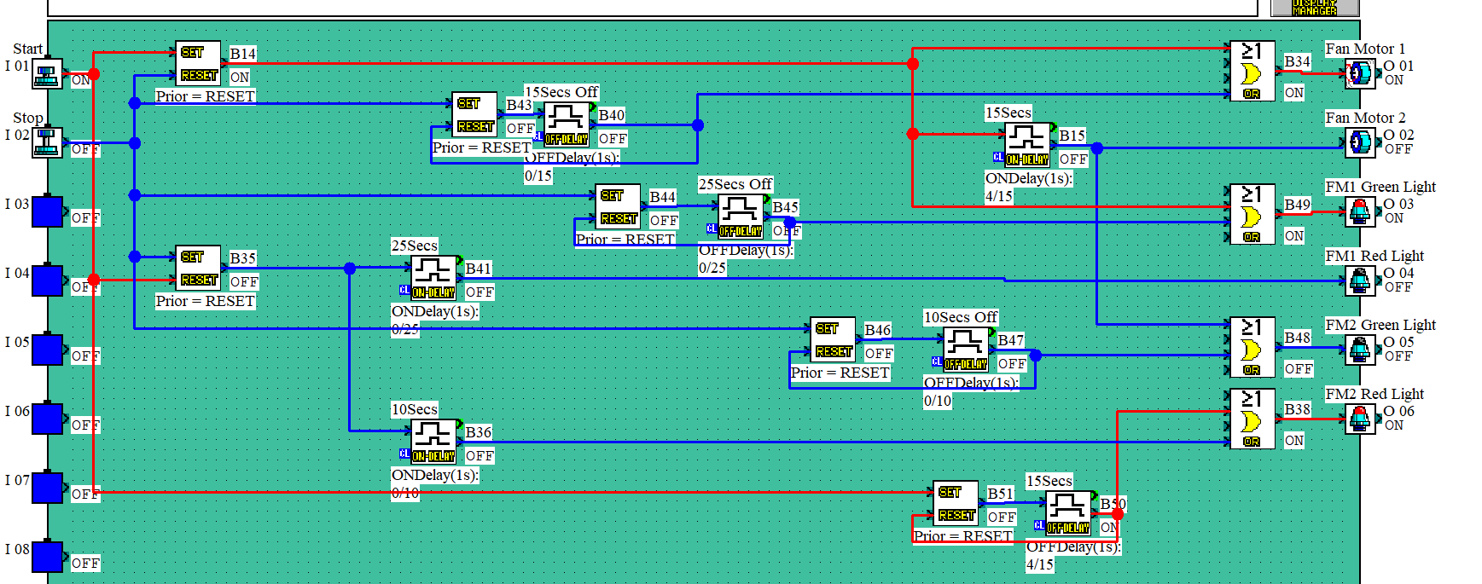
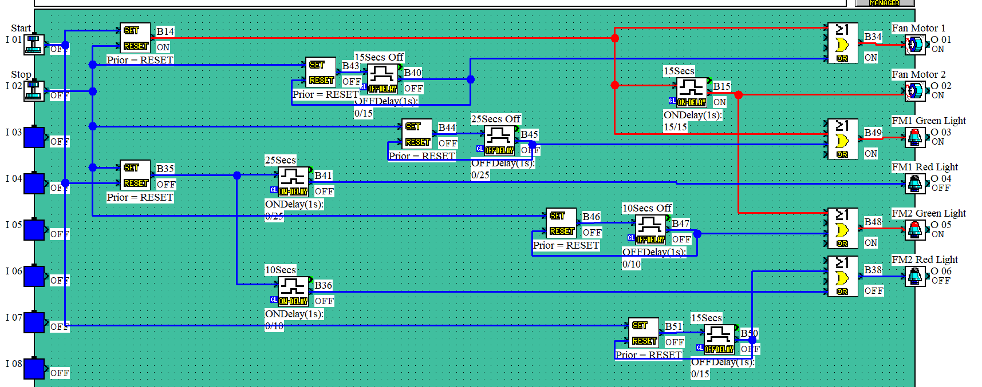
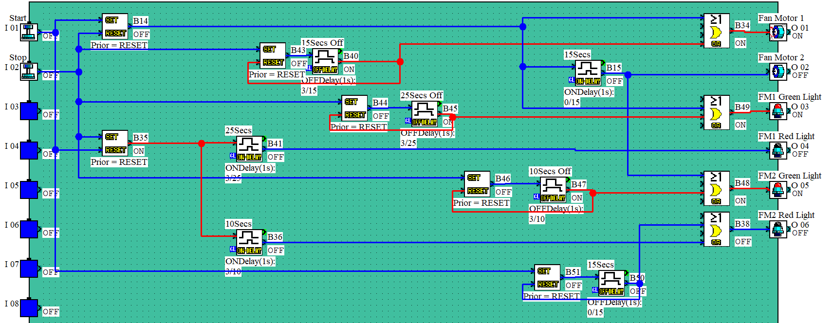
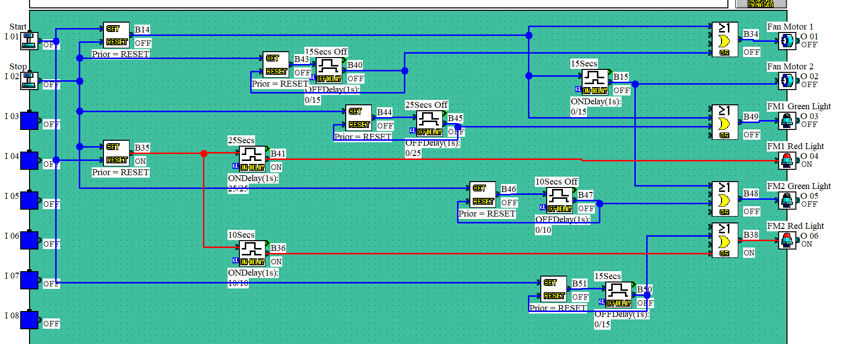

In conclusion of the dual fan controller program, the program has successfully worked according to the required specification. The benefit of this set up is that timers can be easily altered if required. However, the disadvantage is the program cannot be expanded as all of the outputs have been used by the two motors and four LEDs that have been used for on/off indication.

References

Bolton W. Programmable Logic Controllers, 6th Edition. Elsevier Science & Technology. ISBN: 9780128029299 [Published: 2015] [Accessed: 20 January 2022]

techwalla. n.d. Types of PLC. [online] Available at: <https://www.techwalla.com/articles/the-types-of-plcs Unitary> [Accessed 20 January 2022].
https://www.techwalla.com/articles/the-types-of-plcs

Chaudhari, D. and Chaudhari, D., n.d. PLC Input and Output Modules | Block Diagram | Examples. [online] DipsLab.com. Available at: <https://dipslab.com/plc-input-output-modules-2/> [Accessed 20 January 2022].
https://dipslab.com/plc-input-output-modules-2/

Se.com. 2013. What is Modbus and How does it work?. [online] Available at: <https://www.se.com/us/en/faqs/FA168406/> [Accessed 20 January 2022].
https://www.se.com/us/en/faqs/FA168406/

Automation?, 0., n.d. What is PLC Programming and Automation? | Innovative Automation. [online] Innovativeautomation.com. Available at: <https://www.innovativeautomation.com/plc-programming-automation/> [Accessed 20 January 2022].https://www.innovativeautomation.com/plc-programming-automation/

Sunpower UK. 2019. Optoisolator. [online] Available at: <https://www.sunpower-uk.com/glossary/what-is-an-optoisolator/> [Accessed 20 January 2022].
https://www.sunpower-uk.com/glossary/what-is-an-optoisolator/

St.com. 2020. Controlling a Triac with a phototriac. [online] Available at: <https://www.st.com/resource/en/application_note/dm00451014-controlling-a-triac-with-a-phototriac-stmicroelectronics.pdf> [Accessed 20 January 2022].
https://www.st.com/resource/en/application_note/dm00451014-controlling-a-triac-with-a-phototriac-stmicroelectronics.pdf

Bhatt, A., 2018. Introduction to TRIAC. [online] Engineers Garage. Available at: <https://www.engineersgarage.com/introduction-of-triac-2/> [Accessed 20 January 2022].
https://www.engineersgarage.com/introduction-of-triac-2/

Electrical4u. n.d. On Delay Timer | Off Delay Timer Working Principle | Electrical4u. [online] Available at: <https://www.electrical4u.net/basic-accessories/on-delay-timer-off-delay-timer-working-principle/> [Accessed 20 January 2022].
https://www.electrical4u.net/basic-accessories/on-delay-timer-off-delay-timer-working-principle/

PLC Academy. 2018. Timers in PLC Programming | PLC Academy. [online] Available at: <https://www.plcacademy.com/plc-timers/> [Accessed 20 January 2022].
https://www.plcacademy.com/plc-timers/

Bibliography
Phillips, R., n.d. What are the different types of PLC? - PLC Basics. [online] PLC Basics. Available at: <https://basicplc.com/different-types-of-plc/> [Accessed 20 January 2022].
https://basicplc.com/different-types-of-plc/

Phillips, R., n.d. What are the different types of PLC? - PLC Basics. [online] PLC Basics. Available at: <https://basicplc.com/different-types-of-plc/> [Accessed 20 January 2022].
What are the different types of PLC? - PLC Basics (basicplc.com)

Unitary PLC, R., n.d. Unitary PLC, Rack-Mounted PLC and Modular PLC. [online] StudyBay. Available at: <https://studybayhelp.co.uk/blog/unitary-plc-rack-mounted-plc-and-modular-plc/?ref=1d10f08780852c55> [Accessed 20 January 2022].
https://studybayhelp.co.uk/blog/unitary-plc-rack-mounted-plc-and-modular-plc/?ref=1d10f08780852c55

Electrical 4 U. 2021. Programmable Logic Controllers (PLCs): Basic Types & Applications. [online] Available at: <https://www.electrical4u.com/programmable-logic-controllers/> [Accessed 20 January 2022].
https://www.electrical4u.com/programmable-logic-controllers/

The Engineering Knowledge. 2021. Introduction to the Central Processing Unit (CPU) of PLC - The Engineering Knowledge. [online] Available at: <https://www.theengineeringknowledge.com/introduction-to-the-central-processing-unit-cpu-of-plc/> [Accessed 20 January 2022].
Introduction to the Central Processing Unit (CPU) of PLC - The Engineering Knowledge

Staff, E., 2021. PLC Components - Programmable Logic Controllers. [online] Inst Tools. Available at: <https://instrumentationtools.com/components-of-plc/> [Accessed 20 January 2022].
Components of PLC - Programmable Logic Controllers (instrumentationtools.com)

automation.com. 2017. A Beginner's PLC Overview, Part 2 of 4: PLC Processors (CPUs). [online] Available at: <https://www.automation.com/en-us/articles/2017/a-beginners-plc-overview-part-2-of-4-plc-processor> [Accessed 20 January 2022].
A Beginner's PLC Overview, Part 2 of 4: PLC Processors (CPUs) (automation.com)

Global Electronic Services. 2021. Guide to Common Causes of PLC Failures. [online] Available at: <https://gesrepair.com/programmable-logic-controller-failure/> [Accessed 20 January 2022].
https://gesrepair.com/programmable-logic-controller-failure/

Products, E. and Timer relay: Working principle, A., 2021. Timer relay: Working principle, Applications | All details!. [online] Electricalterminology. Available at: <http://www.electricalterminology.com/time-relay/> [Accessed 20 January 2022].
http://www.electricalterminology.com/time-relay/

Staff, E., 2021. Pulse Timer Instruction in PLC Programming - Instrumentation Tools. [online] Inst Tools. Available at: <https://instrumentationtools.com/pulse-timer-instruction-in-plc-programming/#:~:text=When%20Timer%20receives%20positive%20pulse,value%20set%20for%20the%20timer.&text=Timer%20will%20run%20as%20long,as%20the%20timer%20is%20running.> [Accessed 20 January 2022].
https://instrumentationtools.com/pulse-timer-instruction-in-plc-programming/#:~:text=When%20Timer%20receives%20positive%20pulse,value%20set%20for%20the%20timer.&text=Timer%20will%20run%20as%20long,as%20the%20timer%20is%20running.

Phenix Controls, I. and Timers, P., 2020. Phenix Controls - Sequential Timer. [online] Phenixcontrols.com. Available at: <http://www.phenixcontrols.com/Timers/Sequential_Timer/#:~:text=A%20sequential%20timer%2C%20also%20referred,at%20a%20time%20in%20order.> [Accessed 20 January 2022].
http://www.phenixcontrols.com/Timers/Sequential_Timer/#:~:text=A%20sequential%20timer%2C%20also%20referred,at%20a%20time%20in%20order.

Electrocom.in. n.d. Sequence Timer and Sequence controller are available with multiple and advance feature to suit any application in industy|SEQUENCE TIMER Controller|Sequence Timer Controller|Sequnce Programmer|Sequential Timer , Automation. [online] Available at: <https://www.electrocom.in/Sequence-Timer.htm> [Accessed 20 January 2022].
https://www.electrocom.in/Sequence-Timer.htm

TW Controls. 2021. RsLogix 500 - Sequencing Machine Steps Part 3 - Cascading Timers — TW Controls. [online] Available at: <https://twcontrols.com/lessons/rslogix-500-sequencing-machine-steps-part-3-cascading-timers> [Accessed 21 January 2022].
https://twcontrols.com/lessons/rslogix-500-sequencing-machine-steps-part-3-cascading-timers

Plctechnician.com. 2022. The Basics of PLC Programming - Part 2. [online] Available at: <https://www.plctechnician.com/news-blog/basics-plc-programming-part-2> [Accessed 20 January 2022].
https://www.plctechnician.com/news-blog/basics-plc-programming-part-2

Elsevier.com. 2009. Topics - ScienceDirect | Elsevier Solutions. [online] Available at: <https://www.elsevier.com/solutions/sciencedirect/topics> [Accessed 20 January 2022].
Optical Isolator - an overview | ScienceDirect Topics

Harris, M., 2021. Microsoft OneDrive - Access files anywhere. Create docs with free Office Online.. [online] Onedrive.live.com. Available at: <https://onedrive.live.com/> [Accessed 20 January 2022].
Which Types of Opto-Isolators Are Right For Your Signal? | Blog | Altium Designer

Tung, M., What is an Optocoupler and how it works. Available at: https://www.jameco.com/Jameco/workshop/Howitworks/what-is-an-optocoupler-and-how-it-works.html [Accessed January 20, 2022].
What is an Optocoupler and How it Works (jameco.com)

