The purpose of the following report will showcase the implementation steps of certain techniques and libraries which were used throughout the project.
The areas that will be discussed and techniques used within them are:
- Database
- Website
- PHP

Database

Connecting to the Database
When starting my project, I began by constructing a database on which I would be able to store the credentials to access the web interface and an area on which sensor data will be inputted into. Figure one demonstrates the commands used to create a private and certification for SSL to be enabled. [1] Figure 1 &2.
Once Windows, Apache, MySQL, and PHP (WAMP) was installed I began to secure the web server by enabling Secure socket layer (SSL). This technique stablishes an encrypted link between the server and a client.
Possible improvements to this could have been a higher bit key, but as the system is only a local project, I used 2048bit encryption to deliver a fast authentication yet safe. 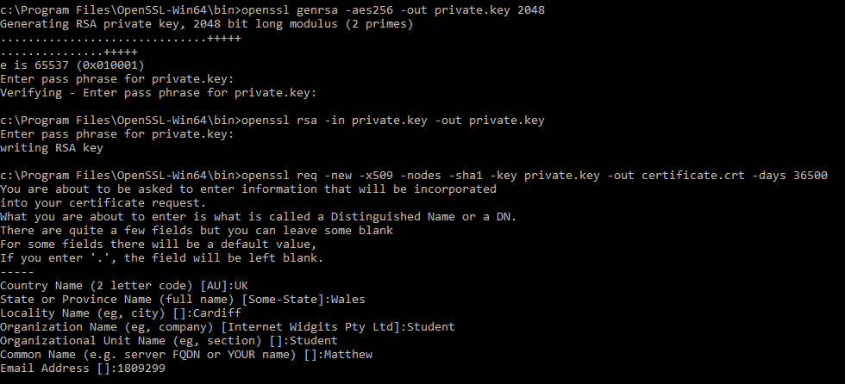
Figure 1 - Configuring Private Key and Certification
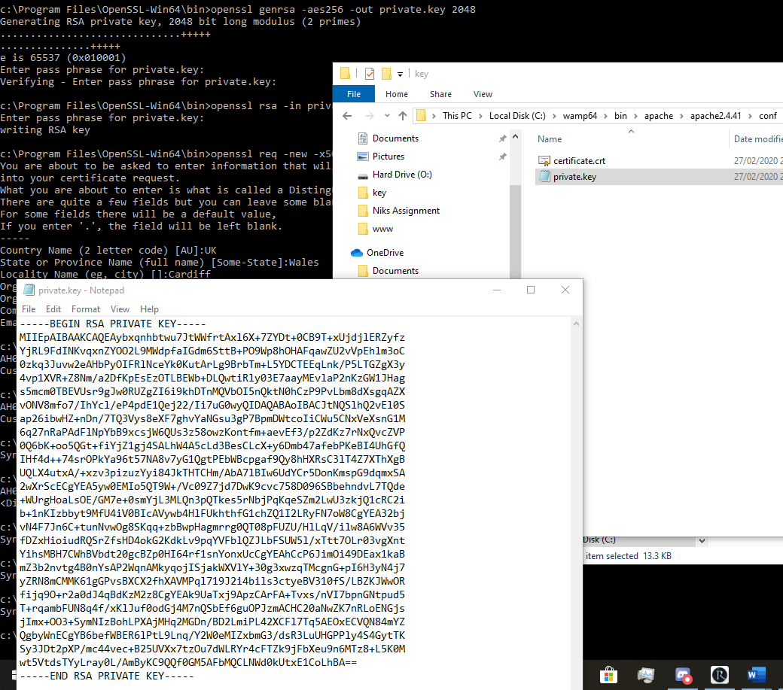
Figure 2 - Private key

Database validation
While constructing the Database it is best practice to limit the sizes of fields for a multitude of reasons.
- Limiting the Field range, this assists when inputting information into a database. An example of when this should be used is with numerical data that can only be positive. As such you would not allow the information that is being entered to be under ‘0’ as this information would be wrong.
- Primary keys, Within a database primary keys are used to make a field unique, no other value within this column can be the same as any other within this column, this allows you to check the contents of a particular field to ensure that information is not being entered twice, and example of this within the database is a user’s ID.
I have implemented these two validations, but many other validations could have been used within the database. These validations can bee accessed within the ‘WAMP’ Maria database.
Improvements to the database could have been made to ensure that these as well as other areas of the database were validated correctly and securely to prevent tampering, this further increase the protection against SQL injection attacks.

Connection information:
Connecting to the database was a tedious task and when using the same lines of code to enter the database as shown in Figure 3. I decide that it was best used in a function would be called (included) into another file. I have named this ‘Conninfo2’ and using the ‘link’ variable I can connect to the database without needing to write down each configuration setting as I have before. This was very useful as I did not need various line to use this but only one to include. I do not believe there is any additional security or functionality concerns while using this method as such I would use the same approach in future projects.
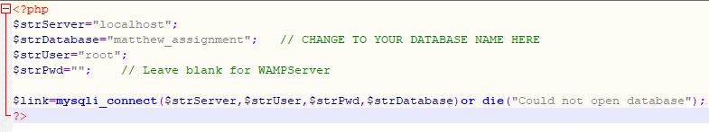
Figure 3 - Connection information

3. Website

3.1 Cascade Style Sheets
Cascade Style sheets are used within website development as a separate file to configure the presentation of a website. I use it within my project to minimize the file sizes of html, php and script code within the main file documents. Using the code within figure 4 I was able to link the Bootstrap CSS file to my document which adjusted my websites image.
I do not believe I would change this decision if the project would have been larger/change in scope, Cascade Style Sheets are the standard to manage websites presentations as one of the core technologies needed for building web pages. [2]
Figure 4 -Cascade Style Sheet Link

4. Logging into the Website
While creating the login system, there were various methods I could have considered.
- Standard login using an SQL query
- Using Access control lists
- Client certificates
Realistically, these options can be implemented but it would be very hard to justify for various reasons such as security, ease of access and prior information known about the user.
After the considerations I choose to use a prepared statement login system. Prepared statements allow extra security over the system. The main threat to most login systems are SQL injection. On which a user can manipulate SQL queries to extract, alter or delete information held within the database. Prepared statement only allows the user to enter information into prepared fields which are very hard to tamper with as the creator has given the SQL query specific instruction that these fields can only access and query the relevant tables and pull the relevant information. [3]

PHP

Graph selection and presentation
When implementing the Graphs, there were a variety of choices, I began by implementing
Dashboard
Graph search for information / Graph change

