

GENDER-BASED HEALTH INEQUALITIES AND THE EPIDEMIOLOGICAL BURDEN OF ALZHEIMER’S DISEASE: A PUBLIC HEALTH ANALYSIS

Name: Krishaben Mukeshbhai Ahir
Student ID: 2527055
Module Name: Social Epidemiology and Public Health Development
Module Code: LCHS7000
Lecturer’s Name: Dr. Hamdi Hussain
Course Name: Master Of Science in Public Health and Social Care in practice
Date: 23 March 2026

Table of Contents
Task 1: Gender and Health Inequalities 3
Introduction 3
Higher Rates of Chronic Diseases 3
Mental Health Inequalities 3
Gender Differences in Healthcare Access 3
Gender Roles and Health-Seeking Behaviour 4
Socioeconomic Inequalities and Gender 4
Healthy Ageing and Gender Inequality 4
Conclusion 5
Task 2: Epidemiological Analysis – Alzheimer’s Disease 5
Introduction 5
Public Health Measures: Prevention, Protection and Promotion 5
Determinants and Risk Factors 6
Population at Risk 6
Monitoring and Surveillance Systems 6
Public Health Impact 7
Intervention Programme 7
Evaluation of Intervention 7
Strengths and Limitations of Epidemiological Approaches 8
References 9
References for Task 1 9
References for Task 2 10

Task 1: Gender and Health Inequalities
Introduction
Gender and health inequalities are systematic differences in health outcomes, access to care and vulnerability to health risk between men and women. These differences are affected by biological, social and economic factors that drive health behaviours, disease patterns, and healthcare utilisation (Cabral and Dillender, 2021). Although women usually live longer than men, they often suffer more years of ill health and disability (Di Lego et al., 2025). For example, globally women live 4 to 5 years longer, yet spend roughly 25 percent of their later life in poor health (WHO, 2023). Social determinants like education, income, employment and cultural expectations have also contributed to these inequalities. Addressing these disparities is important to improving population health outcomes. UK policies such as the NHS Long Term Plan are aimed at reducing health inequalities and promoting fair access to healthcare services.
Higher Rates of Chronic Diseases
There is a definite gender difference regarding the prevalence and the health outcome of chronic diseases. Research indicates that women tend to get more prevalence of some chronic diseases like arthritis, depression or autoimmune complications whereas men die more due to cardiovascular diseases (Bhatia et al., 2025). In the UK, about 45% of women say they live with a long-term condition compared with 41% of men (ONS, 2024).
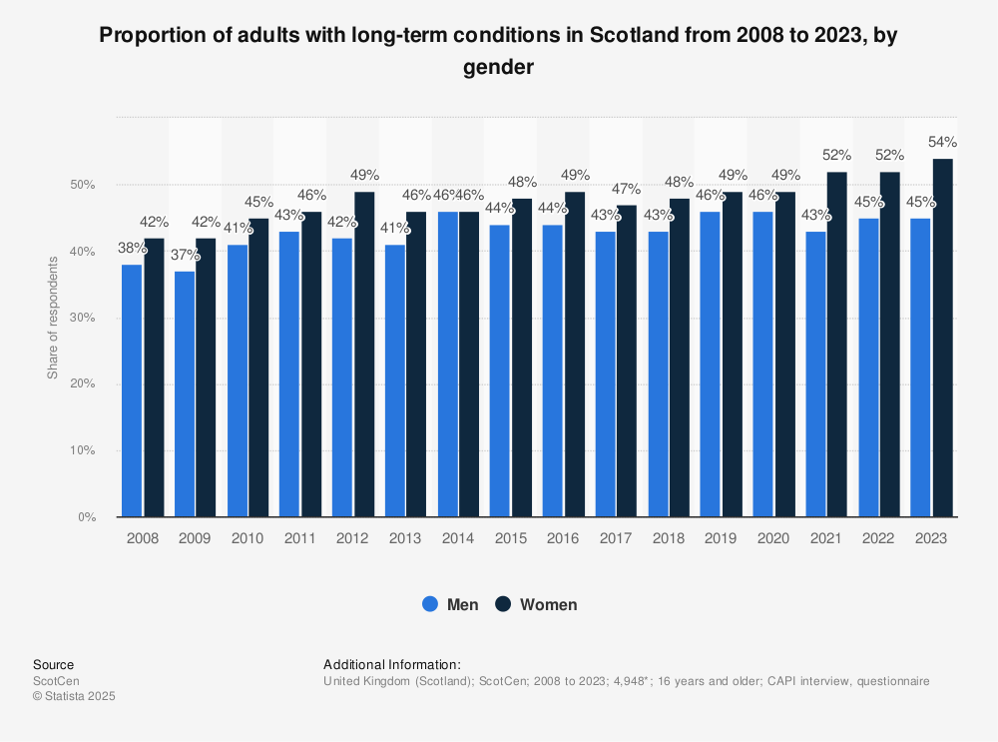
Figure 1: Proportion of adults with long-term conditions in Scotland from 2008 to 2023, by gender
(Source: Statista, 2025)
A study looking at the ageing populations has shown a link between gender variations to biological factors and social factors such as lifestyle and access to health care (Perianayagam, 2024). Longer life decades with never-ending sicknesses and incapacity tend to drive scientific inequality in healthy life expectancy (Di Lego et al., 2025). Such disparities call for gender-sensitive healthcare solutions for prevention, early diagnosis and management. A solution is to promote NHS Health Checks and lifestyle interventions. Charities such as Age UK help the elderly people who have chronic diseases with community care and support services.
Mental Health Inequalities
Mental health is one area where there is a large disparity between men and women. Evidence exists that women are affected more by depression and anxiety and men by suicide. In the UK, women are nearly twice as likely to be diagnosed with anxiety disorders and about 75% of suicide deaths are caused by men (Mental Health Foundation, 2024). The causes of gender inequalities in mental healthcare are closely linked to social pressures, caregiving duties and financial deprivation (Milner et al., 2021). During the time of the Covid-19 pandemic, women were more psychologically distressed because of their increased caregiving responsibilities (Qu, 2025). Social expectations and stigma also keep people from seeking help. To improve these disparities, there is a need to increase gender sensitive mental health services. UK initiatives such as NHS Talking Therapies and charities like Mind are leading the way in helping everyone access support and awareness in order to reduce stigma and promote healthier mental wellbeing.
Gender Differences in Healthcare Access
Healthcare services are unequally realised by both genders. Research has shown that females are more susceptible to making use of preventive services while men tend to delay seeking treatment (Rata Mohan et al., 2025). Statistics show that men are also roughly 20% less likely to go to a GP than women in the UK (NHS Digital, 2023). These differences are influenced by the social norms, work patterns, and perceived health needs. In some cases, the healthcare systems might exhibit gender bias in terms of diagnosis and treatment (Cabral and Dillender, 2021). Socioeconomic factors such as income and education also impact access to healthcare services (Singh and Singh, 2023). To address these mentioned issues, equal healthcare policies are required to improve access and encourage preventive behaviour. Solutions include flexible GP appointments, digital health and awareness campaigns. Organisations such as the Men's Health Forum UK encourage men to be 'health seeking'.
Gender Roles and Health-Seeking Behaviour
Gender roles affect health behaviours and healthcare system interactions. Men may not seek medical attention because of cultural expectations of strength, while women may seek medical attention earlier (Rata Mohan et al., 2025). These behaviours can contribute to delayed and negative health outcomes in men. Women, on the other hand, are often given less priority to care for themselves and more vested are in caring for their children (Milner et al. 2021). Gender roles are therefore a contributing factor to health risks inequality and access to care. Addressing this needs public health education and behaviour change strategies. UK campaigns like "Better Health" encourage healthier lives and encourage people to seek timely care.
Socioeconomic Inequalities and Gender
Socioeconomic inequality is a large component of differences between men and women in health outcomes. Women often have less income, fewer opportunities to work, which means that access to healthcare and healthy living conditions are limited (Zodpey and Negandhi, 2020). In the UK, women are estimated to earn about 13.1% less than men, which contributes to health inequality (ONS, 2024). Economic disadvantage can limit access to healthy food, safe housing and healthcare services. Studies indicate that cost-related inequalities are resulting in poorer health outcomes of disadvantaged populations (Wang and Costa-Font, 2025). Policy and research gaps could also be a contributing factor to unequal treatment and knowledge gap (European Parliament, 2025). To reduce these inequalities a number of policies, including the UK Equality Act 2010 and support from organisations such as Women's Aid, play an important part in promoting gender equity.
Healthy Ageing and Gender Inequality
There is a significant gender difference in healthy ageing and long-term health outcomes. Women lived longer than men, but had more years with disability and chronic disease (Deng et al., 2025). Compared to men in the UK, women live 20 years in poor health compared to 16 years for men (ONS, 2023).
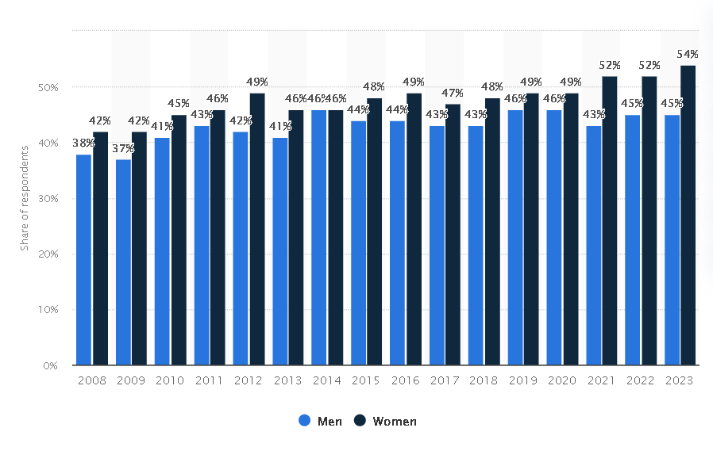
Figure 2: Health Expectancies at Birth and at Age 65 in the United Kingdom – years in ‘Not Good’ health and ‘Good’ health (HLE) by gender
(Source: Statista, 2025)
These differences are based on social inequalities, economic disadvantage and burdens of caregiving (Khaledian et al., 2025). Gender-sensitive policies are needed to ensure equal access to healthcare and support healthy ageing. Services like NHS elderly care programmes and organisations like Age UK offer important support to help improve the quality of life for older people.
Conclusion
Gender and health disparity is an ongoing public health matter that affects the disease patterns, access to healthcare, and health outcomes. Differences are seen in the areas of chronic disease, mental health, healthcare utilisation and socioeconomic status. Studies confirm that biological and social determinants such as education, income and gender roles make a difference in health outcomes. The solution is comprehensive public health policies which promote gender equity and improve access to healthcare. Strengthening of UK policies, raising awareness and ensuring that vulnerable populations are supported through organisations can have a hugely positive effect on reducing gender-based health inequalities.

References for Task 1
Bhatia, M., Dwivedi, L.K., Maurya, P., Dawoodi, S., Ahmed, W., Jana, S. and Dixit, P., 2025. Gender and Age Differentials in Prevalence and Pattern of Nine Chronic Diseases Among Older Adults in India: An Analysis Based on Longitudinal Ageing Study in India. The Journal of Clinical Hypertension, 27(5), p.e70069. https://pmc.ncbi.nlm.nih.gov/articles/PMC12064934/
Cabral, M. and Dillender, M., 2021, May. Disparities in health care and medical evaluations by gender: a review of evidence and mechanisms. In AEA Papers and Proceedings (Vol. 111, pp. 159-163). 2014 Broadway, Suite 305, Nashville, TN 37203: American Economic Association. https://pmc.ncbi.nlm.nih.gov/articles/PMC10732547/
Carnall Farrar (2024) Investing in the dementia age: UK dementia prevalence projections. Available at: https://www.carnallfarrar.com/investing-in-the-dementia-age/ (Accessed: 18 March 2026).
Chang, A.Y., Hawkes, S., Buse, K. and Zarulli, V., 2025. Is ‘gender equality in health’the right goal? Exploring issues of definition and measurement. BMJ Global Health, 10(4). https://gh.bmj.com/content/bmjgh/10/4/e017900.full.pdf
Deng, J., Kong, L. and Li, W., 2025. Gender disparities in healthy ageing in China: current status and future prospects. Frontiers in public health, 13, p.1587922. https://www.frontiersin.org/journals/public-health/articles/10.3389/fpubh.2025.1587922/full
Di Lego, V., Nepomuceno, M.R. and Turra, C.M., 2025. Gender gaps in healthy life expectancy as indicators of inequality for disability and chronic disease: cross-sectional evidence from 24 countries, years 2014–2019. BMJ open, 15(11), p.e096968. https://pmc.ncbi.nlm.nih.gov/articles/PMC12636968/
European Parliament, 2025. Gender inequalities in medical research, drug development and access to care.
https://www.europarl.europa.eu/RegData/etudes/STUD/2025/778519/IUST_STU(2025)778519_EN.pdf
Khaledian, Z., Tajvar, M., Takian, A., Yaseri, M., Hajizadeh, M. and Olyaeemanesh, A., 2025. Addressing gender inequalities in health: a comprehensive framework for policy and practice. Discover Social Science and Health, 5(1), p.107. https://link.springer.com/article/10.1007/s44155-025-00266-6
Milner, A., Kavanagh, A., Scovelle, A.J., O'Neil, A., Kalb, G., Hewitt, B. and King, T.L., 2021. Gender equality and health in high-income countries: a systematic review of within-country indicators of gender equality in relation to health outcomes. Women's Health Reports, 2(1), pp.whr-2020.
https://liebertpub.com/doi/full/10.1089/whr.2020.0114
Perianayagam, A., 2024. Gender disparities in health and wellbeing of older population in India. npj Women's Health, 2(1), p.44. https://www.nature.com/articles/s44294-024-00044-w
Qu, C., 2025. Female versus viral: Understanding the UK gender health inequalities during the Covid-19 pandemic using e-archives. Social Science & Medicine, 366, p.117589. https://www.sciencedirect.com/science/article/pii/S0277953624010438
Rata Mohan, D.S., Jawahir, S., Manual, A., Abdul Mutalib, N.E., Mohd Noh, S.N., Ab Rahim, I., Ab Hamid, J. and Amer Nordin, A., 2025. Gender differences in health-seeking behaviour: insights from the National Health and Morbidity Survey 2019. BMC Health Services Research, 25(1), p.900. https://link.springer.com/article/10.1186/s12913-025-13020-0
Singh, H. and Singh, R.A., 2023. Gender and inequality in access to healthcare facilities in India: evidence from NSSO’s 75th round on health. Millennial Asia, p.09763996231195663. https://journals.sagepub.com/doi/10.1177/09763996231195663
Statista (2025) Proportion of adults with long-term conditions in Scotland from 2008 to 2023, by gender. Available at: https://www.statista.com/statistics/1476055/scotland-long-term-conditions-by-gender/ (Accessed: 18 March 2026).
Wang, W. and Costa-Font, J., 2025. Unequal care, unequal health care? Gender differences in health care use after adult care access. Social Science & Medicine, p.118833. https://www.sciencedirect.com/science/article/pii/S0277953625011645
Zodpey, S. and Negandhi, P., 2020. Inequality in health and social status for women in India-a long-standing bane. Indian Journal of Public Health, 64(4), pp.325-327. https://journals.lww.com/ijph/fulltext/2020/64040/inequality_in_health_and_social_status_for_women.1.aspx

Task 2: Epidemiological Analysis – Alzheimer’s Disease
Introduction
Alzheimer disease is a neurodegenerative progressive disease which is manifested by memory losses, cognitive and behavioural impairment. It is the most common cause of dementia in the world, and a major public health problem. The illness is more common in older people and is closely linked to an ageing population. The prevalence of Alzheimer disease is continually increasing because of the factors of increased life expectancy and demographic transition. There are over 55 million people worldwide who are suffering from dementia, and it is estimated that 60-70% of them are experiencing Alzheimer's disease (Alzheimer's Association, 2024). Recent estimates show that this number is likely to rise to 78 million by 2030 and 139 million in 2050, revealing a rapidly growing global burden (WHO, 2023). By the year 2025, approximately 7.2 million people aged 65 years and older were living with Alzheimer's Dementia in the United States (Alzheimer's Association, 2025). In the UK, around 944,000 people are living with dementia now, and the number will rise to over 1.6 million by 2040 (Alzheimer's Society UK, 2024).
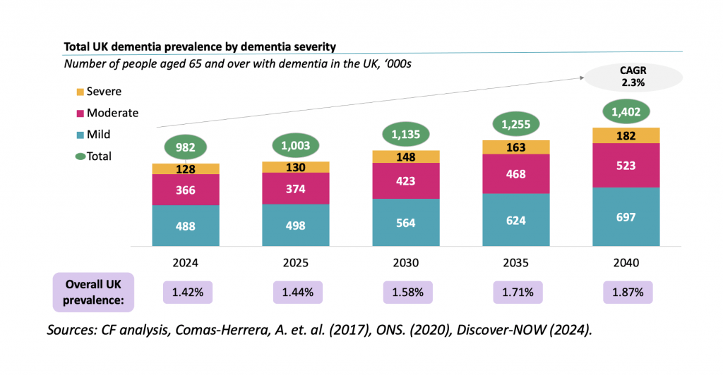
Figure 1: Total UK dementia prevalence by dementia severity – Number of people aged 65 and over with dementia in the UK
(Source: Carnall Farrar analysis, Comas-Herrera et al. 2017, ONS 2020, Discover-NOW, 2024)
These trends highlight the need for effective public health strategies. UK policies such as the National Dementia Strategy and NHS Long Term Plan are to help improve the early diagnosis and dementia care services.
Public Health Measures: Prevention, Protection and Promotion
Public health strategies for Alzheimer disease are aimed at prevention, protection and health promotion strategies to limit the incidence and delay the course. Prevention programmes are aimed at modifiable risk factors including physical inactivity, smoking, unhealthy diet and low education levels (Zhang et al., 2021). Studies show that as many as 40% of dementia cases could be avoided if we could manage the modifiable risk factors (Lancet Commission, 2020). Cognitive and physical activity: Interventions that promote regular physical activity, balanced diet and cognitive activity enhance brain health. Protection strategies include early diagnosis and clinical management. Advances in diagnosis tools, including biomarkers and neuroimaging, enable earlier diagnosis (Korologou-Linden et al., 2025). Early intervention leads to better outcome and long-term care planning. Health promotion programmes raise awareness and decrease the stigma associated with dementia (Parums, 2024). In the UK, programmes like the NHS memory clinics and public awareness programmes by Alzheimer's Society help in early diagnosis and community education. To overcome these challenges, strengthening of preventive healthcare, bettering screening services and promoting healthy ageing programmes is critical.
Determinants and Risk Factors
Alzheimer disease is affected by biological, environmental and lifestyle factors. Age is the greatest risk factor as the risk after 65 years is significantly higher. Genetic predisposition also plays a role, with genes associated with the formation of amyloid plaques being one of the most prominent (Cacabelos, 2025). In addition, risk factors that can be modified such as hypertension, diabetes, obesity and cardiovascular diseases account for a higher likelihood of developing Alzheimer disease (Safiri et al., 2024). Globally, people with diabetes have approximately a 50% greater risk of developing dementia than people without (WHO, 2023). Socio-economic factors are also important. Low education and lack of access to health care can make individuals generally more vulnerable due to both lower cognitive reserve and delayed diagnosis (Rahman et al., 2025). Lifestyle factors such as smoking, sedentary behaviour and poor mental health contribute even more to the progression of these diseases (Zhu et al., 2025). In the UK, we know there is a higher prevalence of dementia in deprived communities reflecting the inequalities in health related to income and education (Public Health England, 2023). Addressing these risk factors requires integrated policies focusing on education, lifestyle improvement and equitable healthcare access.
Population at Risk
Epidemiological evidence indicates that older people are the main population at risk, especially those aged over 75 years of age. Prevalence is much higher as one ages. Women more likely to get alzheimer disease than men because of greater longevity and biological differences (Xu et al., 2025). Two out of three people living with dementia worldwide are women (Alzheimer's Association, 2024). In fact, people with a family history of dementia or genetic predisposition are also more at risks. Geographic variations reveal increasing higher prevalence in ageing populations, especially in Asia and developing regions (Zhang et al., 2025). In the UK, the most common age of prevalence is over the age of 85, where nearly 1 in 6 people are affected by dementia (Alzheimer's Society, 2024).
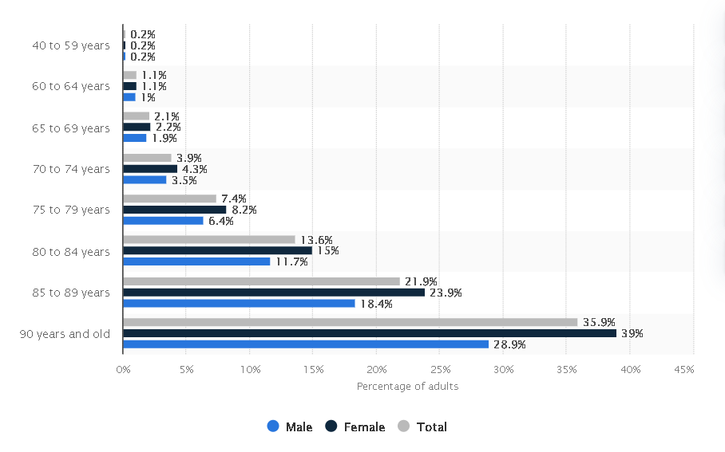
Figure 2: Prevalence of dementia among adults aged 40 years and older worldwide as of 2019, by gender and age
(Source: Statista , 2026)
Targeted interventions focusing on high-risk groups, including the elderly populations and socioeconomically disadvantaged groups, is essential in order to reduce disease burden. Organisations such as Age UK offer support services to vulnerable elderly persons.
Monitoring and Surveillance Systems
Monitoring Alzheimer disease requires reliable surveillance systems to monitor prevalence, incidence and rates of mortality. Data is gathered from national health databases, clinical registries and international studies such as Global Burden of Disease (GBD) Study. These systems help to identify trends and to provide information for public health planning. According to the Global Burden of Disease Study (2021), dementia is one of the leading causes of disability and dependency among older people in the world (GBD, 2021). Long-term epidemiological studies indicate a huge rise in the number of people living with Alzheimer's disease because of ageing populations and better diagnosis (Dumurgier and Sabia, 2020). Surveillance systems also assess the efficiency of preventive strategies and healthcare interventions. In the UK, data from NHS Digital and Public Health England are used to support data for monitoring and planning of dementia services. Strengthening surveillance systems and developing better methods of data collection are necessary to increase early detection and resource allocation.
Public Health Impact
Alzheimer disease has major health, social and economic impacts on individuals, families and healthcare systems. The disease causes progressive cognitive deterioration that affects memory, communication and daily functioning. In later disease stages, patients need constant care and monitoring. This leads to a greater death toll and a less desirable quality of life. The economic cost of Alzheimer disease is significant. Healthcare Costs Medication Healthcare expenses such as medical treatment, long-term care and caregiver support Globally the cost of dementia is estimated to be over $1.3 trillion per year (WHO, 2023). In the UK dementia costs the economy around 25 billion pounds per year and it's forecast to increase (Alzheimer's Society, 2024). In addition to financial burden, caregivers are stress emotionally, depressed and less employment opportunities (Safiri et al. 2024). To address these impacts, policies should focus not only on supporting the caregivers, but also in expanding healthcare services and in improving social care systems. UK charities such as Alzheimer's Society and Carers UK do an important job, providing support services.
Intervention Programme
Interventions for Alzheimer disease focus on prevention, early diagnosis and management. Screening programmes can be used to identify people with a very early stage of cognitive impairment and for them to be referred for further care. Early diagnosis enables early treatment and planning. Pharmacological treatments are aimed to control the symptoms and delay the progression of the disease (Wu and Fuh, 2025). Non-pharmacological interventions such as cognitive stimulation therapy and lifestyle interventions have improved quality of life (Parums, 2024). Example of own intervention programme: A community-based "Healthy Brain Programme" can be created in the UK as a programme for adults aged 60+. This programme would include: regular memory screening at local GP centres, weekly physical activity sessions, nutritional counselling and cognitive training workshops. Digital tools and mobile apps could be used for monitoring cognitive health. Partnerships with organisations such as Age UK and NHS community services can help to support implementation. This intervention is focused on early detection, prevention and community engagement. Such programmes can help to reduce risk factors, improve the diagnosis rate at an early stage and improve the quality of life of elderly persons.
Evaluation of Intervention
Evaluation of Alzheimer interventions is through measures of outcomes such as diagnosis rates, progression of disease and quality of life. Epidemiological data and clinical trials are used for assessing the effectiveness (Zhang et al., 2024). Example of evaluation: The effectiveness of the "Healthy Brain Programme" can be evaluated through pre- and post-intervention data, scores on cognitive assessment, number of early diagnoses as well as participant health behaviours. Surveys can be used to measure the satisfaction of patients and caregivers, while NHS data can be used to track decreases in hospital admissions. Continuous monitoring helps policymakers to be better in their strategy and resource allocation. Evaluation findings can be used to inform evidence-based decision-making and lead to better public health interventions in the future.
Strengths and Limitations of Epidemiological Approaches
Epidemiological studies are vital for the understanding of distribution of disease, risk factors and impact on population. They constitute important data for the identification of high risk groups and the formulation of public health policies. However, there are limitations, such as underdiagnosis during the early stages and the differences in diagnostic criteria according to the geographical region. Despite these limitations, epidemiological evidence is still important as a guide to informing global and national health strategies, especially through large-scale research such as in the Global Burden of Disease. Increasing the accuracy and standardisation of data can enhance future research and policy work.

References for Task 2
Altuna, M., Rodríguez, E., Núñez, M., Trueba-Saiz, Á., Lizan, L. and Díaz-Cerezo, S., 2026. A Systematic Literature Review of the Epidemiological, Diagnostic Workup, Humanistic, and Economic Burden of Alzheimer’s Disease in Spain. Cureus, 18(1).
https://pmc.ncbi.nlm.nih.gov/articles/PMC12905630/
Alzheimer’s Association, 2024. Alzheimer’s disease facts and figures.
https://pmc.ncbi.nlm.nih.gov/articles/PMC11095490/
Alzheimer’s Association, 2025. Alzheimer’s disease facts and figures 2025.
https://pmc.ncbi.nlm.nih.gov/articles/PMC12040760/
Cacabelos, R., 2025. “New Trends in Alzheimer’s Disease Research: From Molecular Mechanisms to Therapeutics: ”. International Journal of Molecular Sciences, 26(15), p.7175. https://pmc.ncbi.nlm.nih.gov/articles/PMC12346564/
Dumurgier, J. and Sabia, S., 2020. Epidemiology of Alzheimer's disease: latest trends. La Revue du praticien, 70(2), pp.149-151. https://europepmc.org/article/med/32877124
Korologou-Linden, R., Middleton, L., Majeed, A., Nicholls, D., Robinson, O. and Hayhoe, B., 2025. Preparing the way for novel blood-based biomarkers and disease-modifying treatments for Alzheimer’s disease in the NHS in the UK. Journal of the Royal Society of Medicine, 118(3), pp.78-81. https://europepmc.org/article/med/39873535
Parums, D.V., 2024. A review of the current status of disease-modifying therapies and prevention of Alzheimer’s disease. Medical Science Monitor: International Medical Journal of Experimental and Clinical Research, 30, pp.e945091-1. https://pmc.ncbi.nlm.nih.gov/articles/PMC11097689/
Rahman, M., Tabassum, A., Sultana, S., Saha, T., Nayeem, M.A.J., Jahan, I., Hasan, I., Hayat, S., Papri, N. and Islam, Z., 2025. Epidemiology and risk factors of Alzheimer’s disease and related dementias in South and Southeast Asia: a systematic review and meta-analysis protocol. BMJ open, 15(8), p.e105955. https://pmc.ncbi.nlm.nih.gov/articles/PMC12374626/
Safiri, S., Ghaffari Jolfayi, A., Fazlollahi, A., Morsali, S., Sarkesh, A., Daei Sorkhabi, A., Golabi, B., Aletaha, R., Motlagh Asghari, K., Hamidi, S. and Mousavi, S.E., 2024. Alzheimer's disease: a comprehensive review of epidemiology, risk factors, symptoms diagnosis, management, caregiving, advanced treatments and associated challenges. Frontiers in Medicine, 11, p.1474043.
https://pmc.ncbi.nlm.nih.gov/articles/PMC11682909/
Statista (2025) Health expectancies at birth and age 65 in the United Kingdom, by gender. Available at: https://www.statista.com/statistics/1263829/healthy-life-expectancy-uk-by-gender/ (Accessed: 18 March 2026).
Statista (2026) Prevalence of dementia among adults aged 40 years and older worldwide, by gender and age. Available at: https://www.statista.com/statistics/1342008/prevalence-of-dementia-worldwide-gender-age/ (Accessed: 18 March 2026).
Wu, C.K. and Fuh, J.L., 2025. A 2025 update on treatment strategies for the Alzheimer’s disease spectrum. Journal of the Chinese Medical Association, 88(7), pp.495-502. https://pmc.ncbi.nlm.nih.gov/articles/PMC12637128/
Xu, L., Wang, Z., Li, M. and Li, Q., 2025. Global incidence trends and projections of Alzheimer disease and other dementias: an age-period-cohort analysis 2021. Journal of Global Health, 15, p.04156. https://pmc.ncbi.nlm.nih.gov/articles/PMC12100573/
Zhang, J., Zhang, Y., Wang, J., Xia, Y., Zhang, J. and Chen, L., 2024. Recent advances in Alzheimer’s disease: Mechanisms, clinical trials and new drug development strategies. Signal transduction and targeted therapy, 9(1), p.211.
https://www.nature.com/articles/s41392-024-01911-3
Zhang, Q., Deng, Y., Xue, M., Ni, Z., Luo, G. and Tian, K., 2025. Global trends in Alzheimer’s disease and other dementias in adults aged 55 and above (1992–2021): An age-period-cohort analysis based on the GBD 2021. PLoS One, 20(8), p.e0331204. https://pmc.ncbi.nlm.nih.gov/articles/PMC12396692/
Zhang, X.X., Tian, Y., Wang, Z.T., Ma, Y.H., Tan, L. and Yu, J.T., 2021. The epidemiology of Alzheimer's disease modifiable risk factors and prevention. The journal of prevention of Alzheimer's disease, 8(3), pp.313-321. https://europepmc.org/article/med/34101789
Zhi, N., Ren, R., Qi, J., Liu, X., Yun, Z., Lin, S., Hu, Y., Li, H., Xie, X., Wang, J. and Li, J., 2025. The China Alzheimer Report 2025. General Psychiatry, 38(4), p.e102020.
https://pmc.ncbi.nlm.nih.gov/articles/PMC12336476/
Zhu, Y., Liu, H., He, M., Xu, Z., Sun, L., Wu, Z., Niu, X., Huang, S., Wang, J. and Ran, X., 2025. Epidemiology and Risk Factors Characteristics of Alzheimer’s Disease in Southwestern China: A Cross-Sectional Study. Clinical Interventions in Aging, pp.2685-2704. https://pmc.ncbi.nlm.nih.gov/articles/PMC12751288/

