
LAB 2: NETWORKS AND CYBERSECURITY ESSENTIALS (ACCA4024)

October 9, 2020
StudenT ID: 2003845

Step 1: Open a Windows command prompt window
Right-click on the Start button and select Command Prompt.
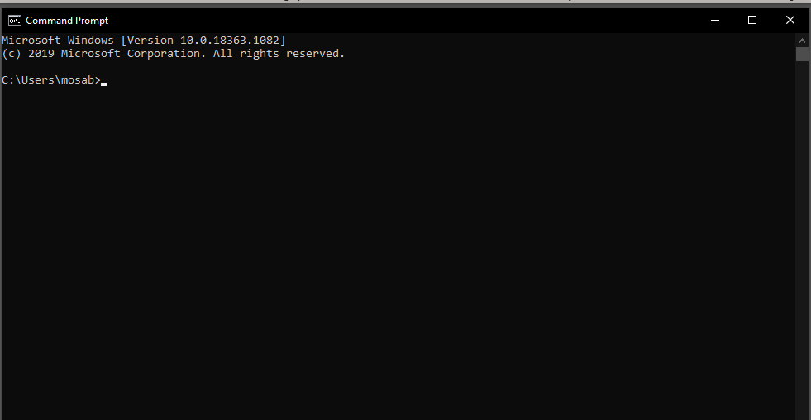
Step 2: Use the ipconfig /all command
Enter the ipconfig /all command at the command prompt. Press Enter. (Typical results are shown in the following figure, but your computer will display different information.)
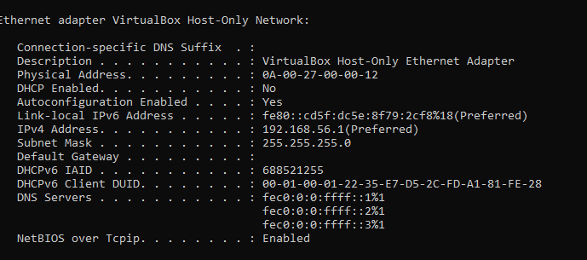
Step 3: Locate the MAC (physical) address(es) in the output from the ipconfig
/all command
Use the table below to fill in the description of the Ethernet adapter and the Physical (MAC) Address:
Description | Physical Address
VirtualBox Host-Only Ethernet Adapter | 0A-00-27-00-00-12

How many MAC addresses did you discover in your PC?
I have found one MAC address
Task 2: Analyzing the Parts of a MAC Address
Step 4: List MAC addresses discovered by you in Part 1.
List the 3-byte Manufacturer OUI and the 3-byte unique interface identifier. You will fill in the Vendor name in Step 2.
Manufacturer OUI | Unique Identifier for the Interface | Vendor Name
0A-00-27 | 00-00-12 | 00:00:12 Information Technology Limited

Step 5: Lookup the vendors who are the registered owners of the OUI that you listed in the table.
Wireshark.org provides an easy to use lookup tool at https://www.wireshark.org/tools/oui-lookup.html. Use this tool, or use the Internet to search for other ways to identify an OUI.
- Use the information that you found to update the vendor column in the chart in
Step 1. How many different vendors did you discover?
I have found only 1 vendor.

- Why might a computer have more than one MAC address?
The reason is that the MAC address is a hardware and could have different network properties.
- Try connecting and disconnecting the network cable(s) to your network adapter(s) and use the ipconfig /all again. What changes do you see? Does the MAC address still display? Will the MAC address ever change?
I have noticed that there is no physical address number and most of the ethernet adapter isn’t there also.
- What are other names for the MAC address?
MAC Address usually consists of six groups of two hexadecimal digits. MAC Address or media access control address is a unique ID assigned to network interface cards.

Task 3: Wired and Wireless Network Connection.
Step 6: Open the Network Connections window by right-clicking the Windows Start button > Network Connections.
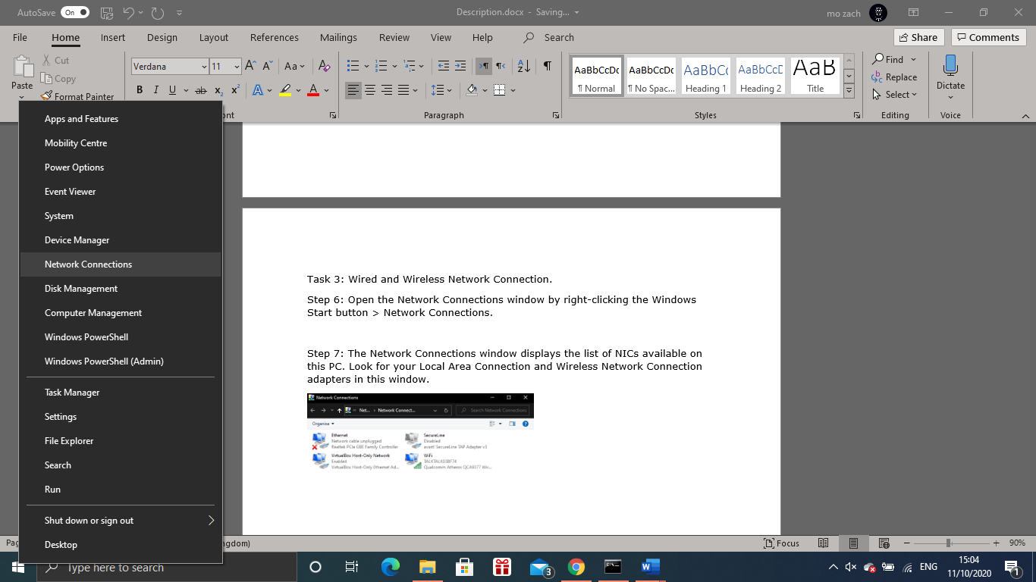
Step 7: The Network Connections window displays the list of NICs available on this PC. Look for your Local Area Connection and Wireless Network Connection adapters in this window.
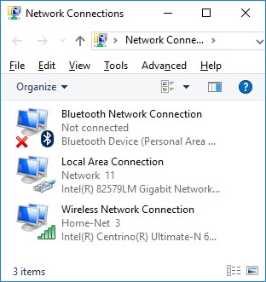
Step 8: Select the Wireless Network Connection option. Right-click on it to display a drop-down list. The first option displays if your wireless NIC is enabled or disabled. Currently, this NIC is enabled which is why the Disable option is displayed. If your wireless NIC is disabled, you will have an option to Enable it.
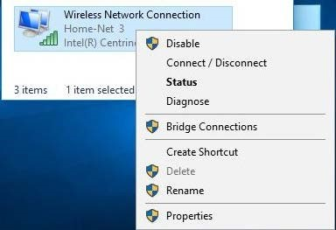

Step 9: Click Status to open the Wireless Network Connection Status window.
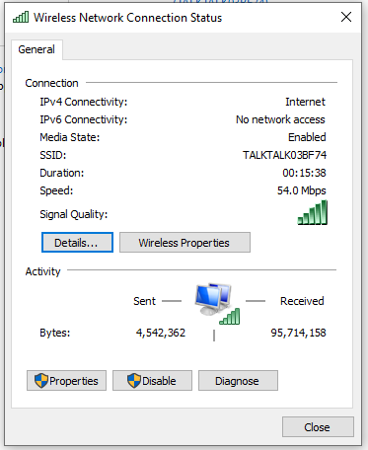

What is the Service Set Identifier (SSID) for the wireless router of your connection?
TALKTALK03BF74
What is the speed of your wireless connection?
54.0 Mbps

Step 10: Click Details to display the Network Connection Details window.
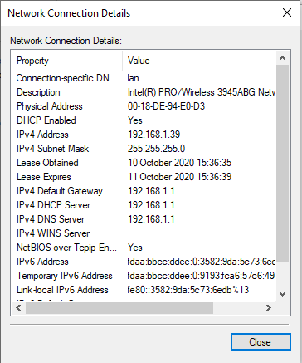
What is the MAC address of your wireless NIC?
00-18-DE-94-E0-D3

Step 11: Open a command window prompt and type ipconfig /all.
C:\Users\Bob> ipconfig /all

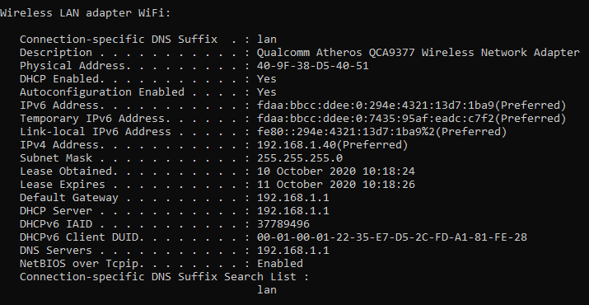
Step 12: Return to the Wireless Network Connection Status window. Click Wireless Properties to open the Wireless Network Properties window of the Home-Net network.
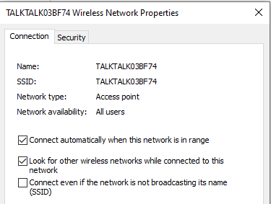
Step 13: You should always use wireless security whenever available. To verify (or configure) the wireless security options click on the Security tab.
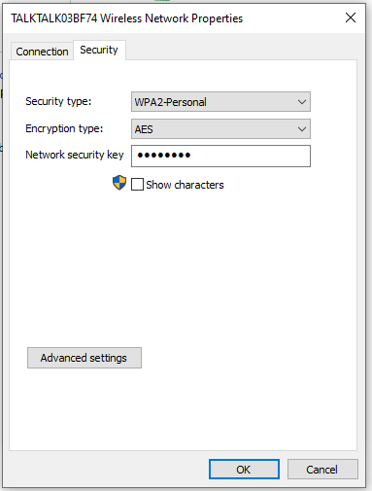
Step 14: Open the Network Connections window by right-clicking Windows Start > Network Connections.

Step 15: Select and right-click the Local Area Connection option to display the drop-down list. If the NIC is disabled, enable it.
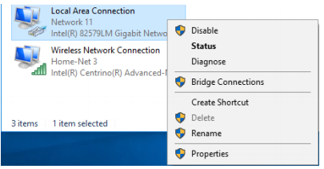
Step 16: Click the Status option to open the Local Area Connection Status window. This window displays information about your wired connection to the LAN.
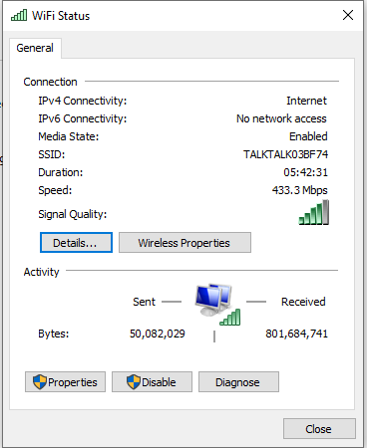
Step 17: Click Details… to view the address information for your LAN connection.
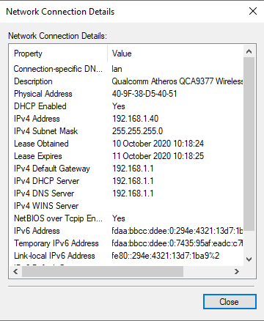
Step 18: Open a command window prompt and type ipconfig /all. Find your Local Area Connection information and compare this with the information displayed in the Network Connection Details window.
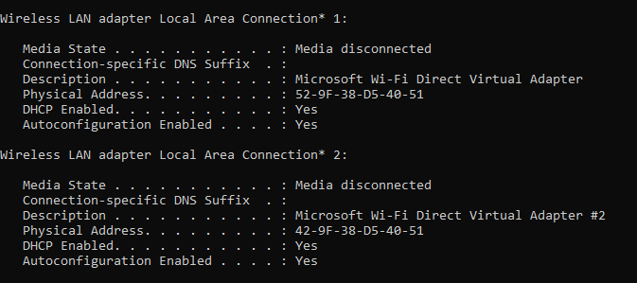
Step 19: Close all windows on your desktop
Step 20: The bottom right-hand corner of the Windows 10 screen contains the system tray. Move your mouse to display the system tray as shown.
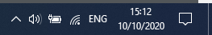
Step 21: In this example, the 3rd icon from the left is the wireless network icon. If you hover over it, it displays the currently connected networks.
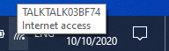
Step 22: Click the wireless network icon, and it displays the wired and wireless network SSIDs that are in range of your wireless NIC.
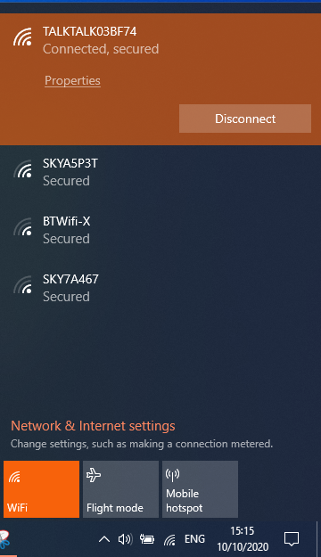
Step 23: Right-click the wireless network icon, and it displays a troubleshooting option and to open the Network and Sharing Center window.
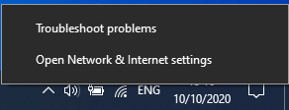
Step 24: Click on the Open Network and Sharing Center option.
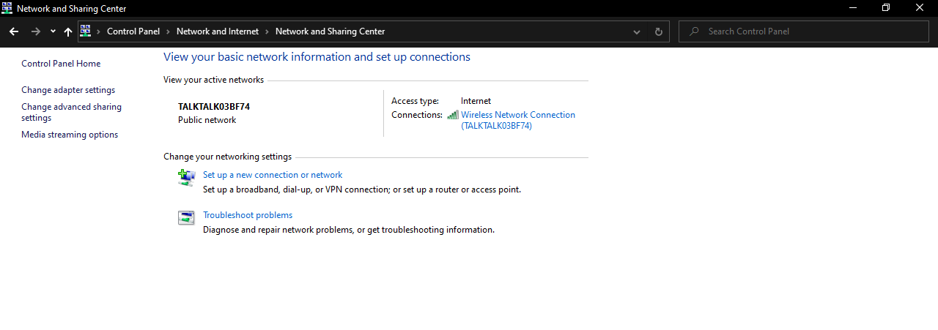
Step 25: The Network and Sharing Center is a central window that displays information about the active network or networks, the network type, the type of access.
Record your Reflection
Why would you activate more than one NIC on a PC?
It depends on how many NICs can be used when having multiple path which is needed for the PC. For example a PC can be used as a Proxy Server.
Step 26: Download Wireshark
- Wireshark can be downloaded from www.wireshark.org.
- Click Download.


c. Choose the software version you need based on your PC’s architecture and operating system. For instance, if you have a 64-bit PC running Windows, choose Windows Installer (64-bit).

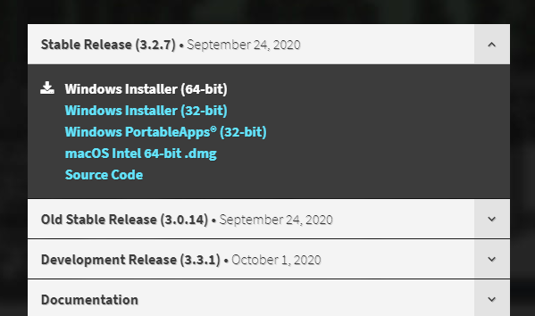
- After making a selection, the download should start. Click Save File if prompted. The location of the downloaded file depends on the browser and operating system that you use. For Windows users, the default location is the Downloads folder
Step 27: Install Wireshark.
- The downloaded file is named Wireshark-win64-x.x.x.exe, where x represents the version number. Double-click the file to start the installation process. It is version 2.0.5 in this example.
- Respond to any security messages that may display on your screen. If you already have a copy of Wireshark on your PC, you will be prompted to uninstall the old version before installing the new version. It is recommended that you remove the old version of Wireshark prior to installing another version. Click Yes to uninstall the previous version of Wireshark.

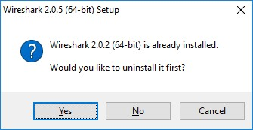
- If this is the first time to install Wireshark, or after you have completed the uninstall process, you will navigate to the Wireshark Setup wizard. Click Next.

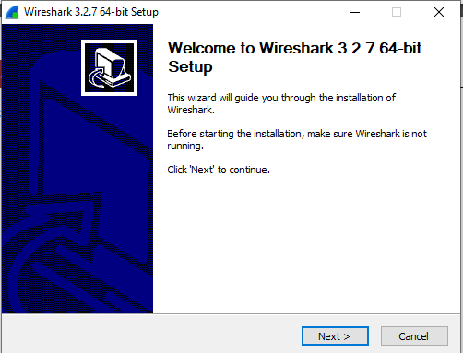
- Continue advancing through the installation process. Click I Agree when the License Agreement window displays.
- Keep the default settings on the Choose Components window and click Next
- Choose your desired shortcut options and click Next.
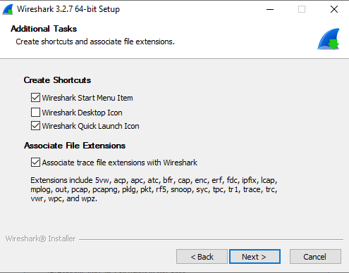
- You can change the installation location of Wireshark, but unless you have limited disk space, it is recommended that you keep the default location.
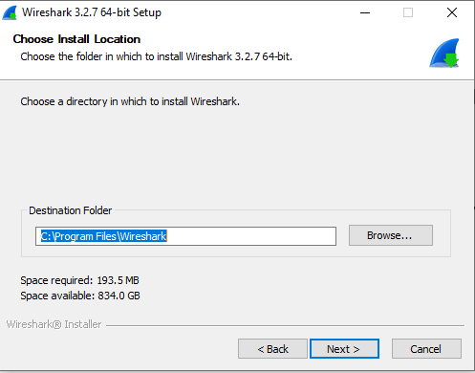

- To capture live network data, WinPcap must be installed on your PC. If WinPcap is already installed on your PC, the Install check box will be unchecked. If your installed version of WinPcap is older than the version that comes with Wireshark, it is recommend that you allow the newer version to be installed by clicking the Install WinPcap x.x.x (version number) check box.
Finish the WinPcap Setup Wizard if installing WinPcap
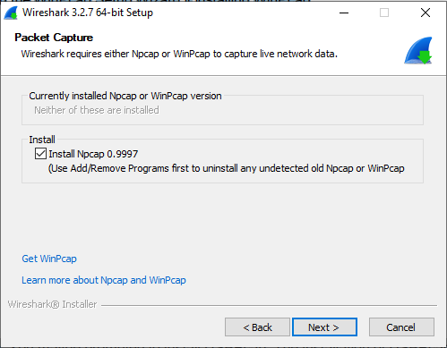
- Wireshark starts installing its files and a separate window displays with the status of the installation. Click Next when the installation is complete.
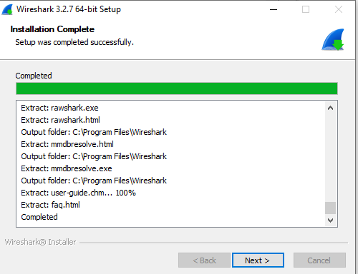
- Click Finish to complete the Wireshark install process.
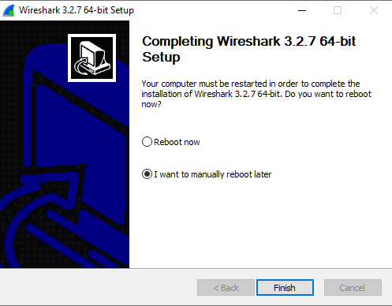

Capture and Analyze Local ARP Data in Wireshark
You will ping another PC on the LAN and capture ARP requests and replies in Wireshark. You will also look inside the frames captured for specific information. This analysis should help to clarify how packet headers are used to transport data to their destination.

Step 28: Retrieve your PC’s interface addresses.
For this lab, you will need to retrieve your PC’s IPv4 address and the MAC address.
o. Open a command window, type ipconfig /all, and then press Enter.
- Note which network adapter that the PC is using to access the network. Record your PC interface’s IPv4 address and MAC address (Physical Address).

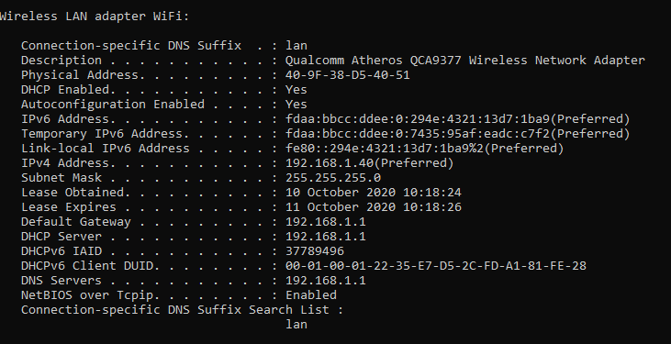

Step 29: Start Wireshark and begin capturing data.
- On your PC, click Start and type Wireshark. Click Wireshark Desktop App when it appears in the search results window.
Note: Alternatively, your installation of Wireshark may also provide a Wireshark Legacy option. This displays Wireshark in the older but widely recognized GUI. The remainder of this lab was completed using the newer Desktop App GUI.
- After Wireshark starts, select the network interface that you identified with the ipconfig command. Enter arp in the filter box. This selection configures Wireshark to only display packets that are part of the ARP exchanges between the devices on the local network.

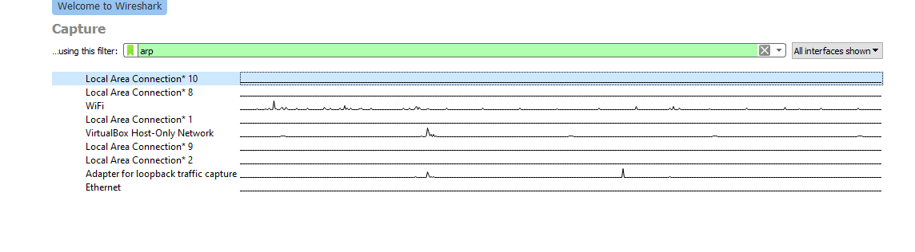
- After you have selected the correct interface and entered the filter information,
Click Start to begin the data capture. Information will start scrolling down the top section in Wireshark. Each line represents a message being sent between a source and destination device on the network
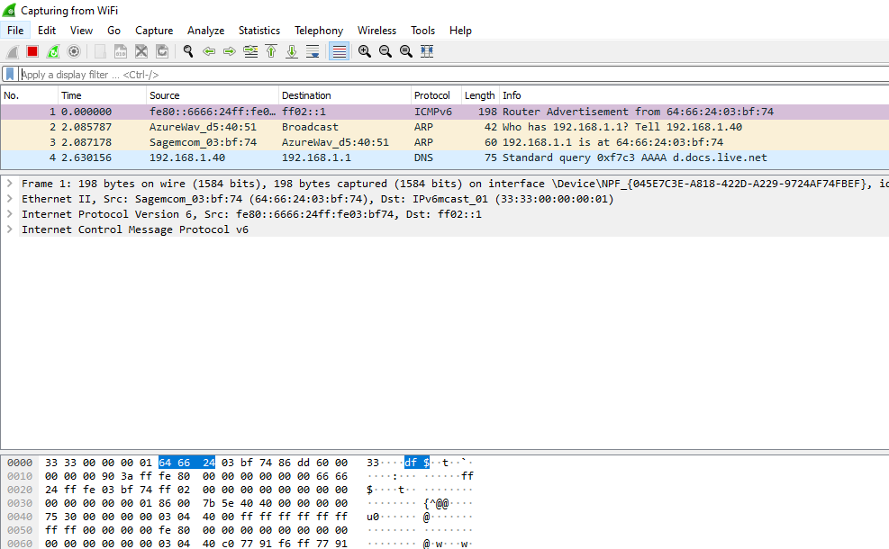
- Open a command prompt window. Use the ping command to test connectivity to the default gateway address that you identified in Part 2, step 1c
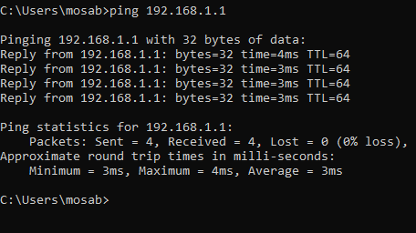
- Stop capturing data by clicking Stop Capture
Step 30: Examine the captured data.
In Step 3, examine the data that was generated by the ping requests, Wireshark data is displayed in three sections:
  - The top section displays the list of PDU frames captured with a summary of the IPv4 packet information listed.
  - The middle section lists PDU information for the frame selected in the top part of the screen and separates a captured PDU frame by its protocol layers.
  - The bottom section displays the raw data of each layer. The raw data is displayed in both hexadecimal and decimal form.

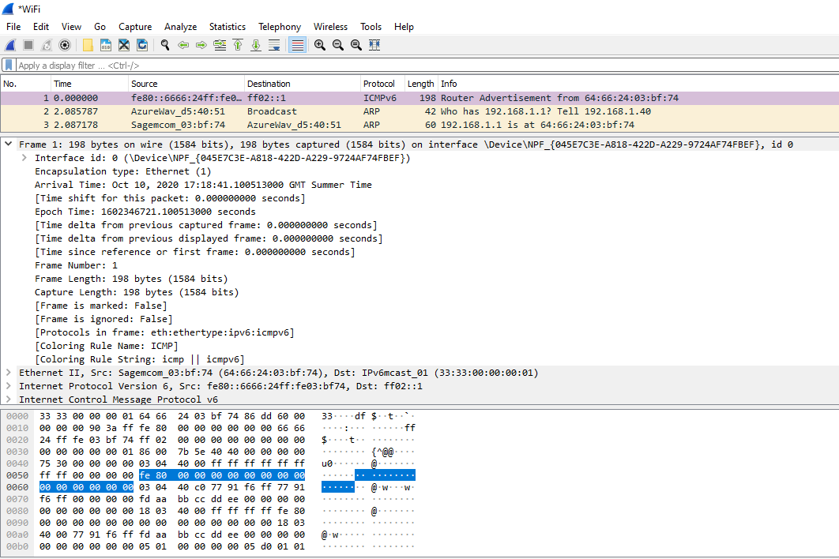
- Click one of the ARP frames in the top section that has your PC MAC address as the source address in the frame and “broadcast” as the destination of the frame.
- With this PDU frame still selected in the top section, navigate to the middle section. Click the arrow to the left of the Ethernet II row to view the Destination and Source MAC addresses.

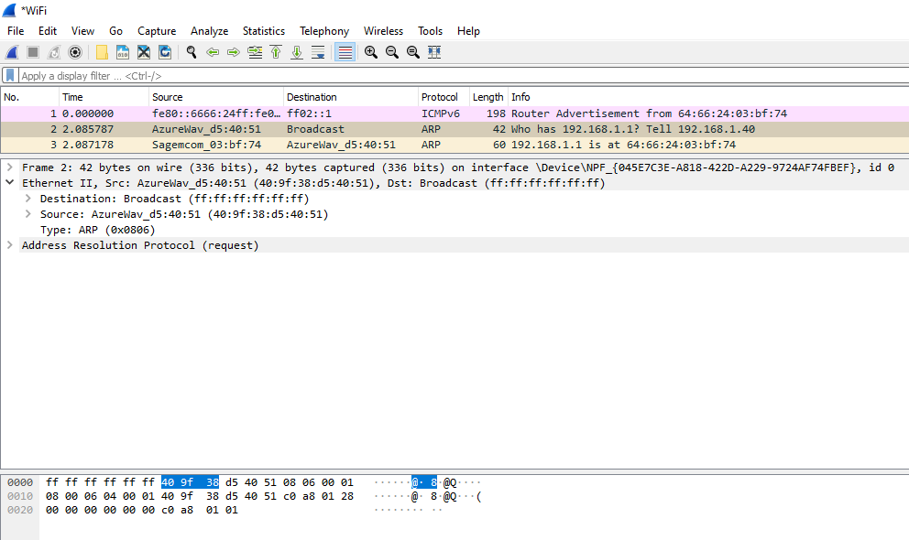
Does the Source MAC address match your PC’s interface?
Yes the Source MAC address does match my PC’s interface.
- Click the arrow to the left of the Address Resolution Protocol (request) row to view the content of the ARP request.

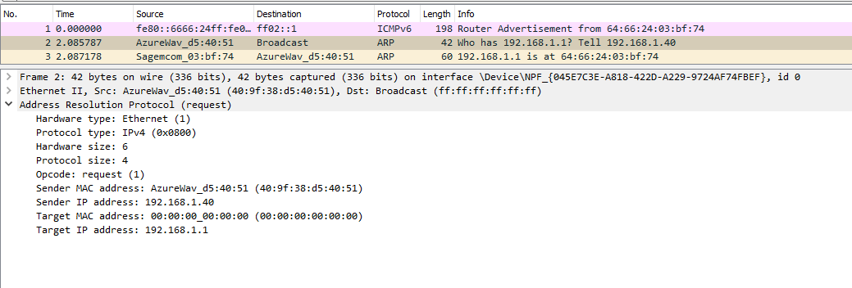
Step 31: View ARP cache entries on a Windows PC.
- Open a command prompt window on the PC. At the prompt, enter arp –a and press enter.
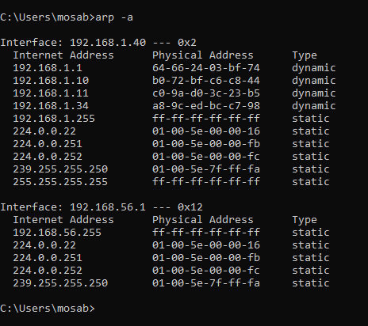
What is the result of executing the arp –a command on your PC?
The result shows that the cache is a simple mapping of the IP addresses to MAC addresses. But the command list the known MAC to IPv4 address bindings.
- The arp command on the Windows PC has another functionality. Enter arp /? at the command prompt and press enter. The arp command options enable you to view, add and remove ARP table entries if necessary
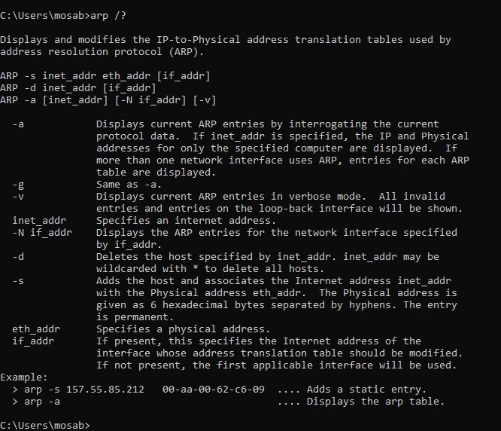
Which option deletes an entry from the ARP cache?
The option deletes an entry from the ARP cache is arp -d.
What would be the result of issuing the arp –d * command?
The result of issuing the arp –d * command is that it will clear the ARP cache content.
What is a benefit of keeping ARP cache entries in memory on the source computer?
As a main purpose of ARP cache is to store the IP to MAC there is no need sending traffic to the same host because we already have it in the cache.
If the destination IPv4 address is not located on the same network as the source host, what MAC address will be used as the destination target MAC address in the frame?
The PC or a laptop will use the MAC address for the default gateway.

