By nicola pearce

Synthesize a solution to a potential real life scenario

Contents
introduction 2
BYOD 2
Appropriate Use Policy 3
Devices and Support Policy 3
Refund Policy 4
Security Policy 4
Liabilities and Disclaimers policy 5
Hyper-fort uses cloud services which has an advantage of low cost, quick assess for customer. But also has disadvantages as well, data being lost, hackers, viruses 5
Cloud Policy 6
▪ Policy 6
▪ To use the cloud service this must be approved by an I.T. manager 6
▪ If terms and conditions are asked for on the cloud this must be approved by an I.T. manager. 6
Retained Data 7
Data leakage 8
Advantages of BYOD 9
Heightened Efficiency 9
More Flexibility 10
Cost Employers save money when employees use their own devices as: 10
Disadvantages 11
Mobile device management software 12
Intune 12
IBM’s MaaS360 13
Cisco Meraki 13
AirWatch MDM 14
SAP Mobile Secure 14
Trend Micro 15
XenMobile 16
BlackBerry Enterprise Mobility Suite 16
Findings 17
AirWatch MDM 17
Bibliography 18

Introduction

BYOD
Hyper-fort allows all staff to bring their own devices to use in work place. Hyper-fort has the right to remove this entitlement if users do not obey the company policies.
These policies are implemented to protect confidential information and security of Hyper-fort.

All Hyper-fort employees must sign the terms and conditions in this policy in order to be permitted to connect their devices to the company network.

Appropriate Use Policy
- Devices can be used for Hyper-fort business use

- personal use on company time as reasonable and limited personal communication or recreation, such as reading or game playing.

- Employees will be blocked from logging on to certain websites such as private internet providers, Facebook, pornography sites, eBay, twitter, you tube, during work hours through the Hyper-fort network. Blocked sites can be modified at any time by Hyper-fort.

- camera phones must me disabled when on company property.

- Hyper-fort staff are permitted to log in to mobile device to access the following company email, calendars, contacts, documents, etc. [1]

Devices and Support Policy
- Smartphones including iPhone, Android, Blackberry and Windows phones are allowed (the list should be as detailed as necessary including models, operating systems, versions, etc.).
- Tablets including iPad and Android are allowed (the list should be as detailed as necessary including models, operating systems, versions, etc.).
- Connectivity issues are supported by IT; employees should/should not contact the device manufacturer or their carrier for operating system or hardware-related issues.
- Devices must be presented to IT for proper job provisioning and configuration of standard apps, such as browsers, office productivity software and security tools, before they can access the network. [1]

Refund Policy
- Hyper-fort will not pay towards any device purchased by any staff member to bring to work.
- Hyper-fort will not refund any money to staff for any data, call charges etc when using a personal device. [1]

Security Policy
- To defend against unapproved access, all devices will require password protection.
to log in to Hyper-fort network.
- Passwords requirements should consist of six characters including of capital letters, numbers and special characters. Hyper-fort passwords will expire every 3 months.
- Your devices are required to use the built-in security lock when the device has been inactive for 5 minutes. The devices are required to have a pin or password to unlock the devices.
- The device will be inaccessible after 5 unsuccessful password attempts. I.T. will be able to give you access once you contact them
- It is prohibited to have Rooted (Android) or jailbroken (iOS) devices on the Hyper-fort network.
- Unapproved apps are electronically blocked by the security system.
- Unapproved devices that don’t appear of the Hyper-fort list of supported devise are banned from joining Hyper-fort network.
- Employees’ will have restricted entry to the network. This will be based on the employee job title and needs for Hyper-fort.
- devices will be electronically wiped if:
- device has been lost or stolen
- Or the employee contract has been dismissed / left the company
- Or a breach of company data
- Or a virus
- That is a danger to Hyper-fort network. [1]

Liabilities and Disclaimers policy
- An individual that uses their own device on the network should have a backup system in place for any person information on the devices. It is not Hyper-fort responsibility if the device would be electronically wiped and personal data lost, such as personal contacts and emails etc.

- Hyper-fort is justified to terminate or immobilize any devices or software without notification.

- Employees are required to record to management in 24 hours window any lost or stolen devices

- all costs identified with a personal device is the employee responsibility.

- Hyper-fort has the authorization to proceed in a punishable procedure which could also involve the end of the employee contract for nonfulfillment of this policy. [1]

Hyper-fort uses cloud services which has an advantage of low cost, quick assess for customer. But also has disadvantages as well, data being lost, hackers, viruses

Cloud Policy
- Employees are forbidden from opening cloud accounts
- Employees can only access the cloud with permission from I.T managers.

- This policy applies to all employees in all departments of Hyper-fort, no exceptions.
- If you are not sure whether a service is cloud-based or not, please contact the IT department.
- Policy
- To use the cloud service this must be approved by an I.T. manager
- If terms and conditions are asked for on the cloud this must be approved by an I.T. manager.
- When using cloud services all other Hyper-fort policies should be adhered to.

- User name and passwords and not to be share.

- Personal data, financial data or anything owned by Hyper-fort must be managed by all laws and regulations.
- Storage to the cloud will be set by the I.T. manager only.

- Data is not to be stored on employees’ personal cloud services [2]

Retained Data

Data retained from the Hyper-fort network could include the following:
- Ssid or wireless network names
- User name and passwords
- Dns records
- Server names and network locations
- Data stored in cookies and temp files
- Mobile devices could have files copied from the network on them

Data leakage
Data leakage is a large worry for companies. It can damage a company’s trustworthiness, its trademark, and the customer, employee’s data. Reasons for data leakage could include:
- Documents or internet pages left open on the devices when the device was connected to the network.
- Leakage could happen in emails
- Webpages forms
- File transfers
Data has been leaked to the public for many years and the more technology we get the harder it is to prevent the hackers from getting hold of confidential data. Companies use security measures like information showing security policies and protection software and firewalls., This is just a few companies that has fallen under attack of data leakage.

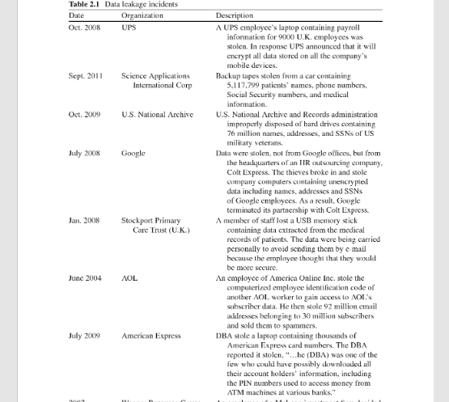
[3]

Advantages of BYOD

Heightened Efficiency
Companies have discovered that allowing employees to use their own devices such as laptops, tablets and smartphone, at work are more efficient.
Employees stated that they were more productive on their own devices, as there were more familiar with the technology and layout.
A Cisco study reported that U.S. workers saved an average of 81 minutes per week by using their own devices. This infographic from Syntonic also shows how BYOD increases productivity. [4]
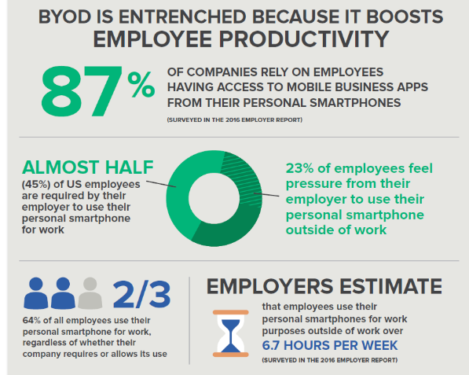

More Flexibility
Working on your own devices bring more flexibility to the work place. You can work from anywhere in the world depending on what job you do. If your empoyees have children and they are sick, or on school holidays, the employer could offer the employee to work from home.

Cost
Employers save money when employees use their own devices as:
- They don’t need to repair or maintain the equipment
- They do not provide the devices
- Soft wear is already on the devices
- Employee look after their own equipment, because they spent the money on it.

Disadvantages
The largest disadvantage to bring your own device to work is security.
Some risks to the company include:
- Lost or stolen devices especially if they were not password protected. Company information is at risk
- hackers, malware, spyware, virus, scams and bogus apps

security becomes even more relevant when you consider the statistics [4]

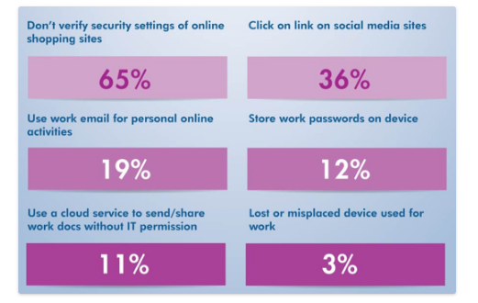

From looking at the diagram companies would need to take this into consideration when writing their policies.
Employees may not want to or be in a position to buy the devices to use in work.
It could cause a lot of legal issues.

Mobile device management software

When using your own device in work the company’s use mobile device software to observe, maintain and safe guard the devices. [5]
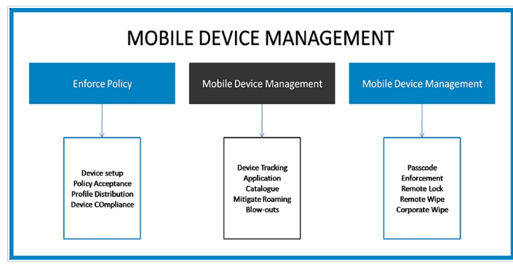

Intune specifications are
Supports:
iOS
android
windows
mac OS
It also helps you safeguard company data with or without device enrolment by creating app protection policies, as well as achieve IT efficiencies in the cloud so you don’t have to maintain on-premise servers
Highlights:
- Mobile device & app management
- Advanced Microsoft Office 365 data protection
- Integrated PC management
- Integrated on-premises management
- Identity & access management
- Information protection
- Identity-driven security
[5]

IBM’s MaaS360 specifications are
multiple OS support from one console, giving you the ability to cover endpoints securely and productively whether you are dealing with
- Apple
- Android
- Windows devices
IoT devices that use APIs for management
Highlights:
- Powered by Watson engine
- Multi OS and platform security
- Supports IoT devices
- Supports ruggedized Android devices & apps
- Supports Windows 10 to Windows 7 legacy PCs
- Provides secure container to store corporate content [5]

Cisco Meraki specifications are
- mobile devices
- Macs
- PCs
- and the entire network from a centralized dashboard. It gives you the means to enforce device security policies, deploy software and apps, and perform remote, live troubleshooting on thousands of managed devices. The unified multi-device management platform provides OTA centralized management, diagnostics, and monitoring for the mobile devices managed by your organization including iPads, Androids, Macs and PCs.
- Its Systems Manager monitors each of your organization’s devices, displaying useful metrics such as client hardware/software information and recent location. Offering a robust security policy enforcement across mobile devices administered by your organization, it can protect devices and their data, control their usage with fine-grained passcode policies, and restrict access to the app store, gaming, and content. Pricing is quite-based depending on your organization’s requirements.
Highlights:
- Scalable endpoint configuration
- On-device content management
- Secure support for BYOD initiatives
- Automatic device classification
- Automatically apply network policies by device type
- Analyse network activity with automatic reporting [5]

AirWatch MDM specifications are

- offers protection through device security and data loss prevention policies
- It utilizes device-level encryption
- data encryption
- hardware security policies
- preventing data loss from app sharing permissions
- copy/paste restrictions
- geo-fencing policies
- monitor malware threats
- jailbroken devices
- automatically remediate with a remote lock
- device wipe
- device quarantine controls.
Highlights:
- Quick configuration
- Open architecture and scalable system
- Flexible integration
- Automatic upgrades and same day support
- Device level encryption
- Real-time MDM deployment [5]

SAP Mobile Secure specifications are
protect and manage mobile devices and apps.
- Integrated tools for MDM
- BYOD security
- mobile application management (MAM)
- app-level security policies
- i.t can deliver fixes
- upgrades
- refreshes
- prevent data loss for mobile users
- configure mobile app
Highlights:
- Mobile device and app management
- Policy compliance
- Simple self-service
- Enterprise app store
- Streamline app deployment and customization
- Frictionless mobile user experience [5]

Trend Micro specifications are

- support Windows
- Android
- iOS devices
- Windows 10
- Windows 7
- Mac OS X 10.10 or higher
- Android 4.2 and higher
- iOS 9.0+
- protected against loss
- data theft
- viruses
- other online threats.
- phishing scams
- identity theft
- fraudulent websites
- enables browsing without being tracked to safeguard your privacy on social media.
- manage and encrypt passwords
Highlights:
- Protection against web threats
- Password manager to handle site logins
- System tune-up
- Privacy protection on social media
- Smart protection network
- Mobile app reputation technology [5]

XenMobile specifications are
- supports mobile devices
- operating systems
- iOS
- Android
- Samsung KNOX
- Windows phones.
- enables centralize and streamline mobile devices traditional desktops, laptops, and IoT through a single platform.
- permits you to get control on your BYOD workforce
- enforce policies procedures and technologies to protect corporate data regardless of where it resides or is accessed from.

Highlights:
- Unified endpoint management
- Mobile device, app & content management
- Secure network gateway
- Enterprise-grade mobile productivity apps
- Office 365 integration
- Mobile control hub [5]

BlackBerry Enterprise Mobility Suite specifications are
- protect your business data on premise or the cloud or both
- secure and manage all the intelligent endpoints in your company
- flexible deployment options
- mobility uptime
- technical support
- mobilize your critical workflows
- apps including Microsoft Office 365.
- set of third party and custom-built apps
- access your business files from SharePoint, OneDrive, Box
- You can secure files even outside the firewall

Highlights:
- End-to-end-security
- Mobile device & app management
- Cross platform support
- Flexible deployment options
- Digital rights management protection [5]

Findings

I would recommend Hyper-fort use Airwatch software to manage bring your own devices.

AirWatch MDM specifications are

- offers protection through device security and data loss prevention policies
- It utilizes device-level encryption
- data encryption
- hardware security policies
- preventing data loss from app sharing permissions
- copy/paste restrictions
- geo-fencing policies
- monitor malware threats
- jailbroken devices
- automatically remediate with a remote lock
- device wipe
- device quarantine controls.
Highlights:
- Quick configuration
- Open architecture and scalable system
- Flexible integration
- Automatic upgrades and same day support
- Device level encryption
- Real-time MDM deployment [5]

Bibliography

[1] | “IT manager daily,” [Online]. Available: http://www.itmanagerdaily.com/byod-policy-template/.
[2] | “IT MANAGER DAILY,” [Online]. Available: http://www.itmanagerdaily.com/cloud-computing-policy-template/.
[3] | A. Shabta, “A Survey of Data Leakage Detection and Prevention Solutions,” [Online]. Available: https://books.google.co.uk/books?hl=en&lr=&id=VgX4kRno-_8C&oi=fnd&pg=PR5&dq=potential+data+leakage&ots=-c9RiOaF5R&sig=oEdUdEGZLpZv1sfmngdWlfheo8s#v=onepage&q&f=false. [Accessed 1st january 2019].
[4] | “EZ computer solutions,” [Online]. Available: https://www.ezcomputersolutions.com/blog/the-pros-cons-of-byod/. [Accessed 1st january 2019].
[5] | “finances online,” [Online]. Available: https://financesonline.com/mobile-device-management/.

marking criteria and Student FEEDBACK

This section details the assessment criteria. The extent to which these are demonstrated by you determines your mark. The marks available for each criterion are shown. Lecturers will use the space provided to comment on the achievement of the task(s), including those areas in which you have performed well and areas that would benefit from development/improvement.

Common Assessment Criteria Applied (Assignment 1) | Marks available | Marks  awarded
1. Research-informed Literature
Extent of research and/or own reading, selection of credible sources, application of appropriate referencing conventions.
Only website referencing utilised. Need to use credible peer reviewdd articles (Grade mark: 33.33%) | 15 | 5
2. Knowledge and Understanding of Subject
Extent of knowledge and understanding of concepts and underlying principles associated with the discipline.
Basicly demonstrated the underlying concepts and principles (Grade mark: 33.33%) | 15 | 5
3. Analysis
Analysis, evaluation and synthesis; logic, argument and judgement; analytical reflection; organisation of ideas and evidence
All areas covered but uses mainly bullet points instead of discussing and analysing the concepts and findings More need to be done. (Grade mark: 40.00%) | 40 | 16
4. Practical Application and Deployment
Deployment of methods, materials, tools and techniques; application of concepts; formulation of innovative and creative solutions to solve problems.
A very basic working design implementation. Security measures considered. (Grade mark: 50.00%) | 20 | 10
5. Skills for Professional Practice
Attributes in professional practice: individual and collaborative working; deployment of appropriate media; presentation and organisation.
Good presentation format but mainly bullet points. (Grade mark: 40.00%) | 10 | 4

Assignment Mark (Assessment marks are subject to ratification at the Exam Board. These comments and marks are to give feedback on module work and are for guidance only until they are confirmed. ) | Late Submission Penalties (tick if appropriate) |  | 40%
 | Up to four weeks late |  | 40%
 | First Attempt? |  | 40%

