Data Warehousing
Svetoslav Anastasov Ivanov (2322727)
ACCA6026 - Data Warehousing & Data Mining
08.07.2026

Table of Contents
Enhancing National Healthcare Performance with Data Analytics: A Strategic Data Warehousing Solution for NHS England - 2 -
Introduction - 2 -
TASK 1 - 2 -
1.1 Online Transaction Processing (OLTP) Systems versus a Data Warehouse - 2 -
1.2 Data Warehouse Architecture and ETL Process - 3 -
1.3 Data Marts for Management Decision-Making - 4 -
1.4 OLTP Normalisation vs. Data Warehouse Dimensional Modelling - 6 -
TASK 2 - 7 -
2.1 Source System Identification - 7 -
2.2 Star Schema Design - 8 -
2.3 Data Marts and Their Schemas - 10 -
2.4 ETL Implementation Plan - 10 -
2.5 Data Quality and Governance - 11 -
Conclusion - 11 -
References: - 12 -

Enhancing National Healthcare Performance with Data Analytics: A Strategic Data Warehousing Solution for NHS England

Introduction
NHS England uses various healthcare systems that generate large amounts of data. These systems operate independently, creating fragmented information that hampers the organisation's ability to monitor patient flow, manage capacity, optimise workforce deployment, control costs, and assess care quality. With rising healthcare demands from an ageing population and chronic diseases, NHS England needs an integrated analytical platform for better decision-making. This report proposes a strategic enterprise data warehouse to centralise operational data through ETL processes, improving reporting, analytics, efficiency, patient outcomes, and sustainability.

TASK 1

Online Transaction Processing (OLTP) Systems versus a Data Warehouse
NHS England relies on several Online Transaction Processing (OLTP) systems, including Electronic Patient Record (EPR) systems, Patient Administration Systems (PAS), workforce management, finance, laboratory information, and clinical applications, to support daily healthcare operations. These systems are designed to handle large volumes of routine transactions swiftly and accurately. For instance, when a patient arrives at the emergency department, the PAS records admission details, the EPR captures clinical observations and diagnoses, and workforce systems log staff rotas and attendance. Speed, reliability, and data accuracy are prioritised because they directly impact patient care and hospital functions [1].
While OLTP systems play a vital role in healthcare delivery, they aren't designed for strategic analysis. Data is often stored within individual organisations or departments, making it challenging to get a complete national picture of healthcare performance. Creating reports across multiple hospitals or Integrated Care Systems usually requires manual data extraction and reconciliation, which can cause delays and result in inconsistent data.
A data warehouse overcomes these issues by consolidating data from various operational systems into a single central repository tailored for analysis and reporting. By analysing historical data, NHS England can better understand trends in patient demand and elective procedures. care waiting times, workforce shortages, hospital occupancy, treatment costs, and clinical outcomes. Unlike OLTP systems, the data warehouse is optimised for complex analytical queries rather than routine transactions [2].
For NHS England's Chief Executive and Board, investing in a data warehouse would create a dependable, organisation-wide source of information that supports informed decision-making. Senior leaders would gain access to near-real-time insights into operational performance, enabling them to proactively manage patient flow, resource allocation, financial health, and service quality across the healthcare system.

Data Warehouse Architecture and ETL Process
NHS England is working to improve the country's healthcare by creating a centralised data warehouse that seamlessly gathers information from different operational systems. This thoughtful design keeps clinical services running smoothly by separating operational and analytical tasks. Hospitals and healthcare providers can continue delivering excellent patient care while their data is collected efficiently in the background [3].
Figure 1: Proposed NHS England Data Warehouse Architecture
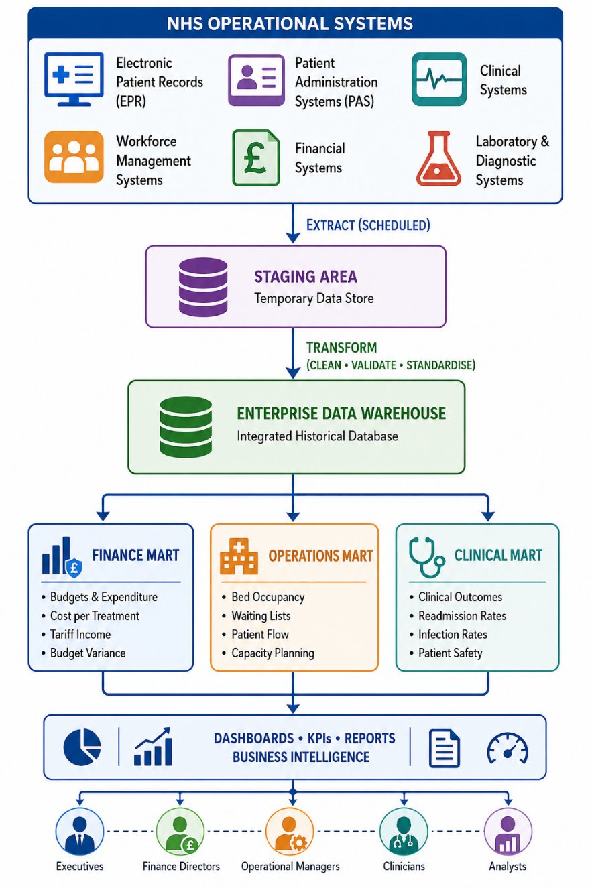

The Extract, Transform, and Load (ETL) process consolidates data from multiple NHS operational systems into the data warehouse.
During the Extract phase, data is gently copied from source systems like EPR, PAS, workforce, laboratory, and finance. This extraction is scheduled at convenient times, such as overnight or every few hours, ensuring minimal disruption to daily operations. Since data is copied rather than moved, clinicians and administrative staff can continue using their applications seamlessly [4].

The extracted data is first moved to a staging area, where we create temporary copies for easier processing. During the Transform phase, we work to fix any inconsistencies before loading everything into the warehouse. We remove duplicate patient records, standardise date formats, identify missing values, validate diagnosis codes against ICD-10 standards, align hospital identifiers across organisations, and reconcile financial records to ensure consistency.
Once validated, the data is seamlessly loaded into the enterprise data warehouse, creating a rich archive of historical records that support long-term insights. Instead of replacing existing operational systems, the warehouse beautifully complements them by offering a single, clear version of organisational truth.
This thoughtful architecture allows NHS England to explore patient journeys, bed occupancy, workforce utilisation, elective waiting lists, treatment costs, and clinical performance across different regions. Senior leaders receive timely and trustworthy information, empowering them to make informed decisions. Meanwhile, frontline healthcare systems stay fully operational and focused on patient care, ensuring that analytical processes never interfere with vital clinical activities [5].

Data Marts for Management Decision-Making
An enterprise data warehouse provides NHS England with a unified, comprehensive repository of healthcare data, making it easier to access and analyse information. Since each member of the executive team has unique information needs to fulfil their role, data marts serve as focused subsets of the main warehouse, tailored to specific functions such as management, finance, or clinical operations (Figure 2). By developing separate data marts for these areas, NHS England can deliver information more quickly and simplify reporting, ultimately supporting better decision-making and efficiency [6].
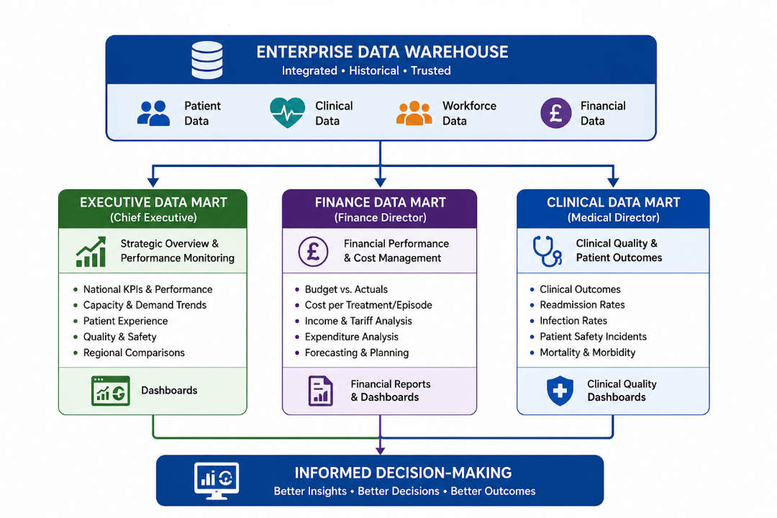
Figure 2: Executive Data Mart Structure

Chief Executive Data Mart
The Chief Executive requires a strategic overview of healthcare performance across England. The Executive Data Mart would consolidate key performance indicators (KPIs) from multiple operational areas into a single dashboard.
Typical measures would include:
- Emergency department performance against the four-hour standard
- Referral-to-Treatment (RTT) waiting times
- Bed occupancy rates
- Hospital admission and discharge trends
- Elective care backlog
- Patient satisfaction scores
- Regional performance comparisons

This information enables the Chief Executive to identify national trends, monitor policy implementation, allocate resources effectively, and respond quickly to operational pressures.
Finance Director Data Mart
The Finance Director needs detailed financial information to keep track of spending and ensure we're getting good value for money across NHS England. The Finance Data Mart will bring together data from various systems like financial management, activity coding, and operations to give us important insights such as:
- Cost per patient episode
- Budget versus actual expenditure
- National tariff income
- Departmental spending
- Agency staff costs
- Overtime expenditure
- High-cost specialist treatments

Interactive dashboards help the Finance Director spot overspending, plan for upcoming expenses, and understand how operational choices affect finances.
Medical Director Data Mart
The Medical Director is dedicated to enhancing patient outcomes and ensuring high-quality care. The Clinical Data Mart would bring together patient records, diagnostic details, treatment information, and quality metrics to support this goal.
Key performance measures include:
- Readmission rates
- Hospital mortality indicators
- Infection rates
- Patient safety incidents
- Length of stay
- Treatment outcomes
- Compliance with national clinical standards

The Medical Director has the opportunity to observe differences in how hospitals perform clinically, assess treatment effectiveness, and track patient safety efforts. These activities help improve healthcare quality and ensure patients are well cared for [7].
Together, these data marts ensure that each senior leader receives information tailored to their roles, while sharing data from the same enterprise data warehouse. This approach helps ensure consistency, reduces duplicate reports, and enables faster, evidence-based decisions throughout NHS England.

OLTP Normalisation vs. Data Warehouse Dimensional Modelling
Operational systems across NHS England are built with carefully structured, normalised databases. This approach arranges data into interconnected tables, which helps reduce redundancy and keeps data accurate during everyday transactions. For instance, details about patients, admissions, diagnoses, treatments, and staff are stored in separate tables linked by keys. This thoughtful design enhances data consistency and efficiently handles the thousands of transactions that occur in hospitals every day [8].
While normalised databases excel at operational processing, they can be less ideal for analytical reporting. Creating management reports often involves joining many tables, which can make queries more complex and slow down performance, especially when working with millions of healthcare records.
A data warehouse overcomes this challenge by using a warm, easy-to-understand approach called dimensional modelling, often set up with a star schema. Instead of many complicated, highly normalised tables, a star schema has a main fact table that records measurable business happenings, surrounded by several related dimension tables that give details about those events. This setup makes it easier to run queries and quickly analyse healthcare performance from different angles.
For NHS England, the central fact table might include patient activities like admissions, length of stay, treatment costs, and health outcomes. The surrounding dimension tables would describe the patient, hospital, doctor, treatment, diagnosis, and the time period linked to each activity. This way, decision-makers can analyse performance by region, hospital, speciality, diagnosis, or time without needing to perform complicated database joins.
Therefore, while normalised OLTP databases remain vital for delivering healthcare services, dimensional models offer the speed, simplicity, and flexibility needed for business insights, trend tracking, and senior management reports.

TASK 2

2.1 Source System Identification
The proposed NHS England enterprise data warehouse will bring together data from various operational systems that each currently operate independently across hospitals, community providers, and Integrated Care Systems (ICSs) [9]. These systems provide essential operational, clinical, workforce, and financial information that supports strategic decision-making and enables a comprehensive view of the system as a whole.
Table 1: Internal Data Sources for the NHS England Data Warehouse
Source System | Data Collected
Electronic Patient Record (EPR) | Patient demographics, diagnoses, procedures, clinical notes
Patient Administration System (PAS) | Admissions, discharges, referrals, appointments
Clinical Systems | Laboratory results, radiology, theatre utilisation, medications
Workforce Management System | Staff details, shifts, overtime, sickness absence, agency staff
Finance System | Budgets, expenditure, tariffs, invoices, treatment costs
Bed Management System | Bed availability, occupancy, transfers
Incident Reporting System | Patient safety incidents, complaints, risk events

Table 2: External Data Sources for the NHS England Data Warehouse
Source | Data Collected
Office for National Statistics (ONS) | Population and demographic statistics
UK Health Security Agency (UKHSA) | Disease surveillance and public health alerts
NHS Digital Reference Data | Organisation codes, postcode files, NHS reference datasets
National Tariff Payment System | Healthcare reimbursement tariffs

By bringing together these data sources, NHS England can create a complete picture of healthcare performance. This helps with better operational planning, financial management, and understanding the population's health needs.

2.2 Star Schema Design
To meet NHS England’s analytical needs, the data warehouse is designed using a friendly star schema. This approach groups healthcare data into clear, measurable events called fact tables, alongside detailed descriptive context tables called dimension tables. Such a setup makes it easy for senior managers to quickly analyse performance across different time periods, hospitals, regions, service types, diagnoses, staff groups, and patient categories.
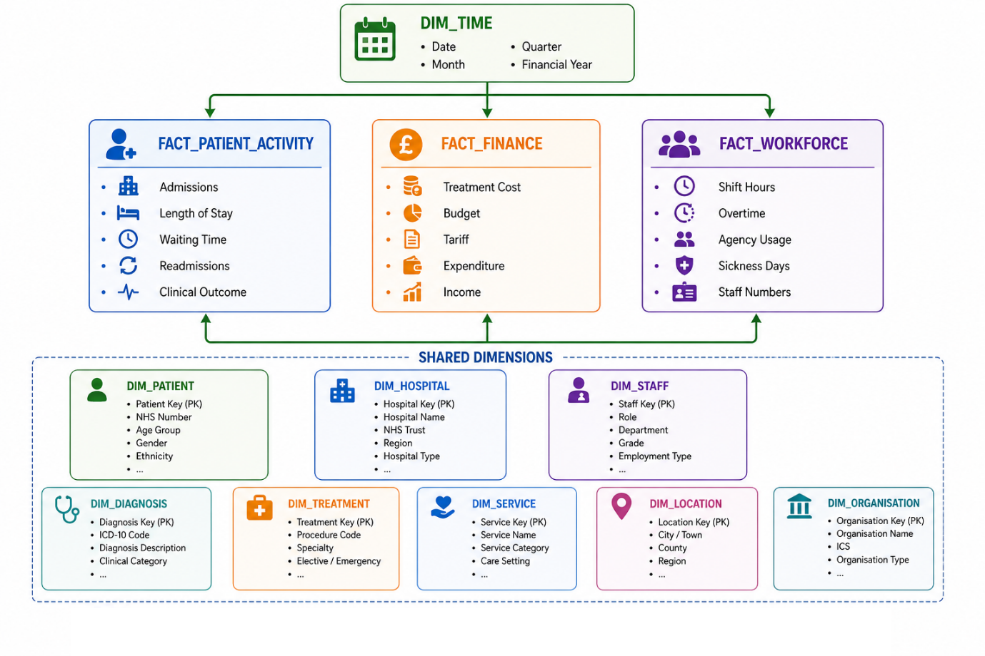
Figure 3: Enterprise Star Schema
For NHS England, relying on a single fact table is not sufficient, as healthcare performance depends on multiple interconnected processes. That's why a fact constellation, or galaxy schema, is a great choice. This approach includes several fact tables that share common dimensions, helping to capture a comprehensive picture. In this setup, you'll find key fact tables such as Fact_Patient_Activity, Fact_Finance, and Fact_Workforce, which together represent patient care activities, financial health, and staffing capacity, giving a clear and detailed overview.
The Fact_Patient_Activity table is designed to record key clinical and operational events, helping NHS England keep a close eye on patient flow and hospital performance. It includes important measures like admissions, waiting times, length of stay, bed days, readmission flags, and clinical outcome scores. By tracking these, NHS England can spot bottlenecks, understand trends, and work on reducing elective care backlogs, ensuring a smoother experience for patients.
The Fact_Finance table helps track important financial information related to patient care and service delivery. It includes details like treatment costs, tariff income, budget allocations, expenditures, cost per episode, and budget variances. Having this data makes it easier to understand financial health, identify overspending, and evaluate value for money across different regions and service areas.
The Fact_Workforce table is all about understanding staffing and capacity. It covers staff hours, overtime, sick days, agency use, vacancies, and staff-to-patient ratios. Having this information is quite important because workforce availability directly influences waiting times, bed capacity, theatre utilisation, and the overall quality of care.
These fact tables, which share conformed dimensions such as Dim_Time, Dim_Hospital, Dim_Staff, Dim_Service, and Dim_Location, help create a consistent and organised data structure. Having a conformed dimension means each one is used uniformly across all fact tables, making data comparison much easier. For instance, Dim_Time enables comparisons of patient activity, financial data, and workforce information by day, month, quarter, or financial year. Similarly, Dim_Hospital allows NHS England to effortlessly compare performance between hospitals, NHS Trusts, Integrated Care Systems, and regions. This structure not only streamlines data analysis but also helps in gaining clearer insights.
Adding extra dimensions enriches analysis, like Dim_Patient with age, gender, ethnicity, postcode, and long-term conditions to identify patient profiles. Dim_Diagnosis organizes ICD-10 codes and clinical categories. Dim_Treatment covers procedure codes, treatment types, specialties, and elective or emergency status. Dim_Service classifies activities into categories like acute care, outpatient, mental health, community care, specialist services, and public health, improving understanding of service distribution.
The warehouse should include essential master data like NHS numbers, organisation codes, staff identifiers, ICD-10 codes, OPCS procedure codes, and NHS Trust codes. This helps ensure that data from different hospitals and systems can be matched consistently, making your data integration smoother. Additionally, storing metadata such as the source system, ETL load date, data owner, refresh frequency, and data quality status is very helpful. It not only supports auditability but also strengthens data governance, providing a clearer, more organised data management process.
Aggregate tables should be created to improve reporting performance. Examples include monthly hospital performance reports, monthly financial summaries, regional workforce summaries, and national quality dashboards. These tables reduce the need to calculate results from millions of detailed records every time a dashboard is opened.

Table 3: Examples of Aggregate tables
Aggregate Table | Example Measures
Monthly Hospital Performance | Admissions, discharges, occupancy
Monthly Finance Summary | Budget vs expenditure
Regional Workforce Summary | Vacancies, sickness, overtime
National Quality Dashboard | Readmissions, mortality, RTT performance

Overall, this star schema design offers NHS England a scalable and adaptable framework for exploring healthcare performance. It facilitates national reporting and makes it simple to delve into details at the hospital, service, workforce, financial, and clinical levels, providing a thorough view that supports more informed decision-making.

2.3 Data Marts and Their Schemas
The Enterprise Data Warehouse stores all healthcare data, but departments need specific info. Data marts offer focused views, helping users quickly find relevant data. All data marts come from the same warehouse, ensuring NHS England maintains a consistent "single version of the truth" to promote alignment and inform the organization [11].
The Finance Data Mart is a valuable resource for financial planning, budgeting, and effective cost management. The Finance Director can easily check spending across hospitals, compare real expenses with budgets, spot high-cost services, and plan for future financial needs with confidence.
The Operations Data Mart is a valuable tool that helps with capacity planning and improving operational efficiency. It allows managers to spot bottlenecks, manage hospital capacity more effectively, reduce waiting times, and improve patient flow, making the whole process smoother for everyone.
The Clinical Quality Data Mart plays a vital role in supporting patient safety and ensuring good clinical governance. The Medical Director can rely on this information to assess treatment quality, compare performance across hospitals, track compliance with national standards, and identify new opportunities to improve services.
Together, these data marts help decision-makers access trusted information quickly and maintain consistency across NHS England.

2.4 ETL Implementation Plan
The ETL process is designed to run at scheduled times, helping to keep clinical services running smoothly. During quieter times, data will be carefully extracted from operational systems, transferred to a staging area, transformed into a consistent format, and then loaded into the enterprise data warehouse, ensuring everything stays organised and efficient [12].
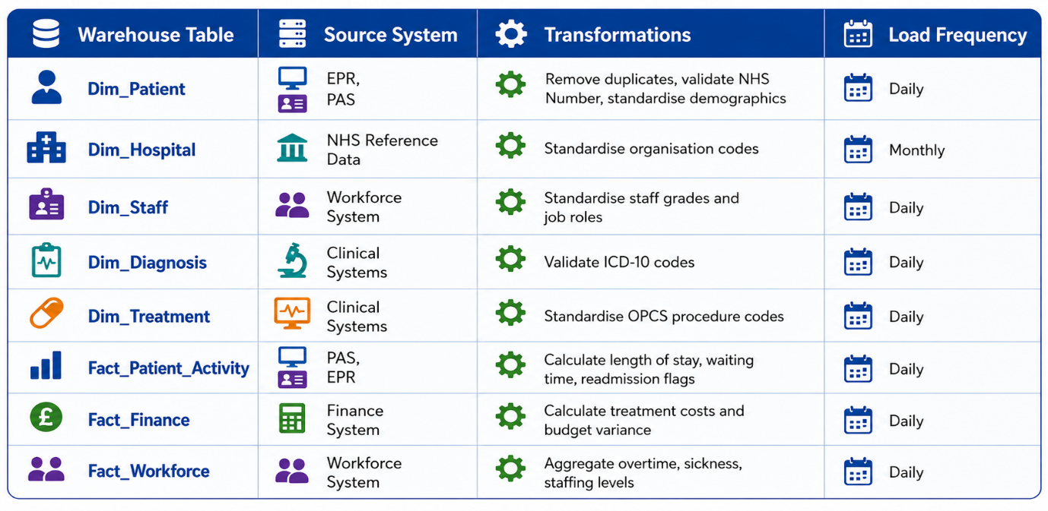
Table 4: Simplified ETL Plan
The staging area helps ensure that data is checked and verified before it gets loaded, so only accurate and complete records make it into the warehouse. Whenever possible, try to use incremental loading. This way, you can focus on processing only the new or changed records, making the whole process more efficient.

2.5 Data Quality and Governance
The success of NHS England's data warehouse relies on maintaining high standards of data quality and governance. During ETL, data should be validated for accuracy, completeness, consistency, uniqueness, and timeliness. Patient identifiers need to be carefully verified, duplicate records should be removed, and clinical coding must be standardised using nationally recognised standards like ICD-10 and OPCS [13].
To keep sensitive healthcare information safe, the warehouse needs to follow the UK General Data Protection Regulation (UK GDPR) and the Data Protection Act 2018. Access should be managed with role-based permissions, along with encryption, audit logs, and regular checks on data quality. Managing metadata, understanding data lineage, and clearly defining dataset ownership will help promote accountability, transparency, and regulatory compliance.

Conclusion
The proposed enterprise data warehouse offers NHS England a powerful and reliable way to unify operational, clinical, workforce, and financial data from various healthcare systems into a trusted and organised repository. Unlike OLTP systems designed for daily tasks, this platform supports historical analysis, organisation-wide reporting, and informed decision-making. By using a dimensional model with shared dimensions and fact tables, NHS England can gain insights into patient activity, workforce, finances, and outcomes across hospitals, Care Systems, and regions. Data marts provide customised information for leaders while ensuring consistency across datasets.
A well-managed ETL process carefully extracts, cleanses, transforms, and loads data, all without disrupting healthcare services. With strong governance, data quality controls, and adherence to UK GDPR and NHS standards, this solution creates a secure, adaptable analytical environment.
Ultimately, it aims to enhance efficiency, optimise resource use, improve patient care, and support sustainability through smarter, data-driven decisions.

References:

[1] U. Farooq Khattak, A. Alı, Hussein, and A. Hussein Al Naffakh, “Proposed framework for enhancing integrity technique using distributed query operation,” BIO web of conferences, vol. 97, p. 137, Jan. 2024, doi: 10.1051/bioconf/20249700137.
[2] D. Joiner et al., , "DW vs OLTP Performance Optimization in the Cloud on PostgreSQL (A Case Study)", in 2022 IEEE International Conference on Recent Advances in Systems Science and Engineering (RASSE), pp. 1–8.
[3] A. Walha, F. Ghozzi, and F. Gargouri, “Data integration from traditional to big data: main features and comparisons of ETL approaches,” The Journal of supercomputing, vol. 80, no. 19, pp. 26687–26725, Dec. 2024, doi: 10.1007/s11227-024-06413-1.
[4] F. de Assis Vilela, V. C. Times, A. C. de Campos Bernardi, A. de Paula Freitas, and R. R. Ciferri, “A non-intrusive and reactive architecture to support real-time ETL processes in data warehousing environments,” Heliyon, vol. 9, no. 5, Art. no. e15728, May 2023, doi: 10.1016/j.heliyon.2023.e15728.
[5] R. D. Thantilage, N.-A. Le-Khac, and M.-T. Kechadi, “Healthcare data security and privacy in Data Warehouse architectures,” Informatics in medicine unlocked, vol. 39, Art. no. 101270, 2023, doi: 10.1016/j.imu.2023.101270.
[6] A. Khalaf Hamoud, M. Abd Ulkareem, H. Noori Hussain, Z. Abdulkareem Mohammed, and G. Mustafa Salih, “Improve HR Decision-Making Based On Data Mart and OLAP,” Journal of physics. Conference series, vol. 1530, no. 1, p. 12058, May 2020, doi: 10.1088/1742-6596/1530/1/012058.
[7] I. A. Najm et al., “OLAP Mining with Educational Data Mart to Predict Students’ Performance,” Informatica (Ljubljana), vol. 46, no. 5, pp. 11–19, Mar. 2022, doi: 10.31449/inf.v46i5.3853.
[8] P. Sathyapalan, "Modernizing SAP Business Objects Using Enterprise Data Warehousing Principles", in 2026 14th International Symposium on Digital Forensics and Security (ISDFS), pp. 1–6.
[9] M. Lalani et al., “New Ways of Working to Manage and Improve Quality in Integrated Care Systems in England,” International journal of health policy and management, vol. 14, no. 1, pp. 8424–10, Jan. 2025, doi: 10.34172/ijhpm.8424.
[10] F. E. R. Rabelo Ferreira and R. do Nascimento Fidalgo, “A Performance Analysis of Hybrid and Columnar Cloud Databases for Efficient Schema Design in Distributed Data Warehouse as a Service,” Data (Basel), vol. 9, no. 8, p. 99, Aug. 2024, doi: 10.3390/data9080099.
[11] “Designing data marts for data warehouses,” ACM transactions on software engineering and methodology, vol. 10, no. 4, pp. 452–483, Oct. 2001, doi: 10.1145/384189.384190.
[12] G. Zarate et al., “Evolution of Extract-Transform-Load (ETL) processes towards data product pipelines,” in Proceedings of the 4th Eclipse Security, AI, Architecture and Modelling Conference on Data Space, New York, NY, USA: ACM, Oct. 2024, pp. 25–32. doi: 10.1145/3685651.3686662.
[13] R. Yadav, “Integrating Continuous Improvement Practices as an Innovative Strategy: An Application Model for Total Quality Managed Small and Medium Enterprises,” Sedme. Small enterprises development, management and extension journal, vol. 34, no. 3, pp. 87–94, Sept. 2007, doi: 10.1177/0970846420070308.

