Exploring Teachers’ Views, Roles, and Supports Needed in Providing a Quality Physical and Health Education Program

Submitted to the University of Wales Trinity Saint David
in fulfillment of the requirement for the degree of Master of Arts in Physical Education, Sport and Physical Literacy

By Megan Davis
University of Wales Trinity Saint David
Carmarthen, Wales
October 2023

Declaration


DECLARATION FORM

Master’s Degrees by Examination and Dissertation Declaration Form
- This work has not previously been accepted in substance for any degree and is not being concurrently submitted in candidature for any degree.
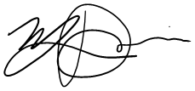
Signed:

Date: October 20, 2023

- This dissertation is being submitted in partial fulfilment of the requirements for the degree of MA in Outdoor Education.
Signed:

Date: October 20, 2023

- This dissertation is the result of my own independent work / investigation, except where otherwise stated. Other sources are acknowledged by explicit references. A bibliography is appended.
Signed (candidate):

Date: October 20, 2023

- I hereby give consent for my dissertation, if accepted, to be available for photocopying, inter-library loan, and for deposit in the University’s digital repository.
Signed (Candidate):

Date: October 20, 2023
Supervisor’s Declaration.

I am satisfied that this work is the result of the student’s own efforts.

Signed: 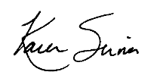

Dated: October 20, 2023

Abstract
This research explores the views of Physical and Health Education of generalist elementary and middle school (Kindergarten through grade 8) teachers through the lens of occupational socialization. Occupational socialization works to explain how and why people teach the way that they do based on their past experiences. This project is supported by the theory of Occupational Socialization put forth by Lawson (1983a, b) and further supported by the work of Richards, Templin, and Graber (2014). This research aims to explore how teachers feel teaching PHE and what they feel is needed to help them teach the curriculum better. It works to support the current literature in this field and also provide a mixed methods vantage point to the views and needs of generalist teachers in teaching PHE. Teachers are not only impacted by their biographies but also the condition of their teaching environment – be it the marginalization of the PHE curriculum in their school communities, or the lack of necessary equipment and space (DeCorby, Halas, Dixon, Wintrup, & Janzen, 2005; Morgan & Hansen, 2007).
This research explores the input from 106 teacher participants from the Coquitlam School district in British Columbia, Canada regarding their views and experiences teaching Physical and Health Education (PHE). The participants were generalist teachers that teach within the grade levels of kindergarten to grade 8. Data were collected through a mixed methods methodology that incorporated a questionnaire and focus group discussions. As a result, it was found that some teachers felt ill-prepared to teach the course and that most participants taught with a teaching orientation that focuses on the well-being of the students rather than a sport-specific focus in their lessons. While most participants (61.8%) reported having an overall positive experience in secondary school PE, only about half of them (51%) reported having had a course on teaching PHE yet three quarters (74.3%) of them had to teach it on their practicum which supports the notion of feeling unprepared to deliver the curriculum despite having relatively positive experiences as students. Participants identified a need for more professional development or collaboration with colleagues, PHE specialists in the schools, and resources to support their teaching of PHE.

Acknowledgements
I’d like to express my gratitude to all of those who supported me along this dissertation journey.
To Dr. Nalda Wainwright, thank you for your initial guidance in this journey. Your feedback and guidance while getting my project organized was greatly appreciated.
Thank you to Dr. Karen Sirna for supporting me in my academic writing. I truly appreciate all the time and effort you provided in helping me complete this dissertation. Your feedback and guidance were greatly appreciated; especially in those times I felt lost in my research. Thank you for being so understanding of my personal complications and continuing to support me in overcoming them. I couldn’t have done it without you.
Thank you to my family and friends for their continuous encouragement and support through this long journey. Thank you to all of you who helped in removing some of my distractions so I could focus.
To my husband, you are my biggest supporter, and I wouldn’t have persevered through it all if it weren’t for you. It’s been a long and tough journey but knowing you were there pushing me forward helped me succeed through this project and 2 maternity leaves.
When this journey began, Caiden you were 4 months old, and now as it comes to an end you are 2 and a big brother to Avery who is now 5 months old. You were both my internal motivation to finish my degree and not give up. I wanted to show you that we can do difficult things when we put our minds to it no matter what. To my boys – you make me stronger and better every day, so this is for you.
Contents
Declaration ii
Abstract iv
Acknowledgements v
Table of Figures viii
Chapter 1: Introduction 1
Background 1
Rationale 1
Research Objectives 2
Research methodology 3
Scope and Sequence 4
Chapter 2: Literature Review 6
Introduction 6
Conceptual Framework 6
Theoretical Framework 11
Connection to the Literature 16
Summary 17
Chapter 3: Methodology 19
Introduction 19
Research Paradigm 19
Research Design 20
Methods and Tools 21
Summary 24
Chapter 4: Findings and Discussion 26
Introduction 26
Biographies of the Participants 26
Findings – Quantitative Analysis 32
Findings – Qualitative Analysis 35
Stress and Anxiety as Students 36
Effects of Barriers and Flexibility in Teaching Styles 37
Importance of Participation and Movement 39
Supports Needed 41
Synthesis of Qualitative and Quantitative Findings 42
Teaching Rationales 42
Teacher Preparedness 43
Collaboration 44
Summary 45
Chapter 5: Conclusion 46
Introduction 46
Research Objective 1: Why do teachers teach PHE in certain ways? 46
Research Objective 2: What do generalist teachers need? 47
Summary 48
Recommendations 49
References 50
Appendices 53
Appendix A: Quantitative and Qualitative Survey 53
Appendix B: Supplementary Quantitative Data 61
Appendix C: Supplementary Qualitative Data 64

Table of Figures
Figure 1: During my secondary school years my PE experience was overall a positive one. 28
Figure 2: I had a course on how to teach PE during my training. 29
Figure 3: I taught PE on my practicum. 30
Figure 4: How important are extracurricular school sports to your school? 32
Figure 5: Participant views on coaching 33
Figure 6: Grades taught by participants 61
Figure 7: Total years taught by the participants 61

Table 1: Participant Coding System 22
Table 2: Timescale for Research 23
Table 3: Participant overall teaching experience 27
Table 4: Grades taught by participants 27
Table 5: Exposure to PE specialists as students 29
Table 6: Effects of COVID-19 on PHE practices 31
Table 7: Reasons for not coaching 33
Table 8: Correlation data between personal experiences and views on coaching 34
Table 9: Participants teaching situations 35
Table 10: Correlation data between teaching alone and collaboration 35
Table 11: Participant PE experience as students 36
Table 12: Evolution of Participants Teaching Styles 37
Table 13: Focus Group PHE Lessons 38
Table 14: Evidence of the Importance Participants place on Participation 39
Table 15: Evidence of the Importance Participants place on Movement and Skill Development 40
Table 16: BC Physical literacy curriculum outcomes 41
Table 17: Suggestions for the Supports Needed in Coquitlam Schools for PHE 41
Table 18: Need for Collaboration 44
Table 19: Additional Teacher Experiences as Students 62
Table 20: Additional Information based on Teacher Education Experience 62
Table 21: Current Teaching Experiences – Part 1 62
Table 22: Current Teaching Experiences - Part 2 63
Table 23: Current Teaching Experiences - Part 3 63
Table 24: Participant Experiences as Students 64
Table 25: Current Teaching Style and Focus 66
Table 26: Evolution of Teaching Styles 69
Table 27: Supports Needed 71
Table 28: Additional Comments 73

Chapter 1: Introduction
This chapter will explain the purpose of the research project and introduce some of the methodology and methods used in conducting the research.

Background
Physical literacy is the basis of how we develop fundamental skills, knowledge, and attitudes towards living a healthy lifestyle (Mandigo, Francis, Lodewyk, & Lopez, 2009; Wainwright, Goodway, Whitehead, Williams, & Kirk, 2018). Unfortunately, children are becoming more sedentary and losing their desire to foster their physical literacy (Cothran, Kulianna, & Garn, 2010). As children get older, they become more resistant to building these physical literacy strengths and skills (Cothran, Kulianna, & Garn, 2010). Physical and Health Education (PHE) provides an opportunity for teachers and students to explore and develop their physical literacy. The Government of British Columbia redesigned their curriculum and has made physical literacy a large part of Physical and Health Education (Government of British Columbia, 2022). The new curriculum that is in place in British Columbia aims to be more holistic and focus on bigger ideas within the curriculum and skill building making it more accessible to students rather than targeted outcomes (Government of British Columbia, 2022). Since children are becoming more sedentary even though physical literacy is a part of the curriculum, there may be some disconnect happening. This research aims to explore the teachers’ perspective of teaching PHE, their first-hand experience with the students, and what they feel is needed to better support their teaching of the PHE curriculum.

Rationale
Physical Education is a common core subject in many countries around the world meaning most people have had some experience as students with the course (Hardman & Marshall, 2000). Those experiences, whether positive, negative, or neutral, depend on the person. When it comes to teaching physical and health education (PHE) those personal experiences may guide a teacher to teach the curriculum with specific views and practices (Lawson, 1983 a, b, Richards, Templin, and Graber, 2014). This research aims to explore these connections to current teaching practices with the support of the theory of occupational socialization.
Occupational socialization is a theory put forth in terms of physical education by Lawson (1983a, b) and more recently Richards, Templin, and Graber (2014). The theory helps to explain why certain teachers interpret the curriculum in certain ways, making connections to their experiences as a student (acculturation), as a teacher candidate (professional socialization), and also as an experienced teacher (organizational socialization). Curtner-Smith has contributed many research studies to the conversation around occupational socialization and worked to put the theory into practice, many of which (2001, 2008, 2019, 2020, 2021) supported this research. The research of Curtner-Smith (2001, 2008, 2020) compares early career teachers, specialist teachers, and elementary specific teachers, whereas this work focuses specifically on generalist teachers at various points in their careers.
While past experiences are the basis of occupational socialization, there are other factors that play an important role in one’s perception of PHE. Hardman and Marshall (2000) found common themes in the marginalization of PE around the world. It was noted by Hardman and Marshall (2000) that while curriculum time was allotted to PE, many elementary teachers sacrificed that time for other subjects that were deemed more important (Xiang, Lowy, & McBride, 2002; Petrie & Hunter, 2011; Hardman & Marshall, 2000). There is a need to explore why there is a common notion of PE being less important than other core subjects.

Research Objectives
The research question for this study is ‘what factors influence teachers’ views and roles in teaching a quality physical and health education program and what supports are needed to aid in their success?’
My goal is to help provide some insight into how educators can feel more confident and provide a more positive space for children to be active and build their physical literacy. There are 2 objectives that this research aims to explore:
- Why do teachers teach PHE in certain ways? Exploring the “why” of teachers’ practices through the lens of occupational socialization
- What do generalist teachers need in order to feel more confident teaching PHE?
As a secondary level teacher specializing in the sciences, I entered into a middle school teaching position that included physical and health education with no prior knowledge of how to teach the curriculum. I have always been an active person and thoroughly enjoyed PE as a student, so I felt I had some knowledge to support my teaching but managing the curriculum outcomes were a new facet to me. I entered into teaching PHE unsure of how to teach it properly, so I sought out extra education through a graduate diploma. As my school’s head of Athletics for two years, I was responsible for the care and maintenance of our equipment and sports teams. In that role some colleagues approached me with questions around the PHE curriculum. Through my experiences of feeling ill-prepared and in my leadership role, I wanted to explore how my colleagues throughout the district felt as well since I knew I couldn’t be the only one feeling lost with a common core subject that required teaching strategies that are significantly different than those needed in the classroom. This research aims to guide my passion of Physical and Health Education in ways that I can better support my colleagues and educate my students in a more well-rounded and empathetic manner.

Research methodology
The pragmatic maxim is one that is based on the ideology that one’s actions are based on their past experiences (Onwuegbuzie, Johnson, & Collins, 2009). This connects to the theory of occupational socialization nicely because the theory focuses on explaining why certain teachers teach in specific ways based on their past experiences (Lawson, 1983a, b, Richards, Templin, & Graber, 2014). This connection leads to a mixed methods approach in this research because in the nature of teaching it is both subjective (dependent on the individuals’ perspective) and objective (dependent on the physical world) (Johnson & Onwuegbuzie, 2004). Mixed methods methodology is one that combines the strengths of both quantitative and qualitative methods dependent on the research in question; it is a flexible methodology aimed to combine quantitative and qualitative to provide a more in-depth analysis to the research being completed (Johnson & Onwuegbuzie, 2004). Mixed methods methodology supports the ability to gain different vantage points within the same results – allowing for both quantitative and qualitative analyses (Onwuegbuzie, Johnson, & Collins, 2009). This research uses a questionnaire that will provide both quantitative and qualitative results, and also focus group discussions that will provide richer qualitative data. Mixed methods allow for the triangulation of data, the convergence of quantitative and qualitative data to seek deeper connections, which can provide a deeper understanding of the results (Johnson & Onwuegbuzie, 2004). In terms of this research, both the quantitative and some of the qualitative data were collected concurrently with the follow up qualitative discussions occurring after the initial survey.
The questionnaire provided an access point that was easily attainable for the participants; they were able to provide feedback on their own time without having to interrupt a large portion of their day. The questionnaire was composed of a combination of Likert scale questions and long answer questions to collect both the quantitative and qualitative data. The focus group discussions were held online and organized by grade levels. The discussions were semi-structured group discussions where questions were presented when the discussion naturally welcomed them. These discussions were then analyzed in conjunction with the long answer questions from the questionnaire to provide a rich qualitative analysis.
There were 106 participants from the Coquitlam School district in British Columbia, Canada that consented to participate. The Coquitlam school district covers all schools in three different cities – Coquitlam, Port Coquitlam, and Port Moody. All three cities have a wide variety of socioeconomic levels within their catchment areas meaning most schools have a blend of all types of families (Government of Canada, 2023a; Government of Canada, 2023b). All teachers that taught at the elementary school and middle school grade levels (kindergarten through grade 8) at the time were invited to participate as these grades are most likely to be generalist teachers and not physical education specialists. Of those participants, 11 agreed to participate in the focus group discussions.

Scope and Sequence
Following this chapter will be a review of literature. The review of literature will critically explore the current educational issues within the realm of physical education, and the theory of occupational socialization. The critical analysis of the theory of occupational socialization will look at some of the work done by Lawson (1983a, b), Richards, Templin, and Graber (2014), Curtner-Smith (2001, 2008, 2019, 2020, 2021), and others. The critical analysis will work to explain and support the need and basis for this research. Following the critical analysis of the literature will be the Methodology.
The methodology chapter will outline the ontology and epistemology that guided this research. Through that exploration, the rationale for the methodology of mixed methods will be explained. The research process will then be explained with the specific tools that were used to conduct the research. This chapter will work to explain how and why the data was collected and analyzed. It will also provide insight to the ethical implications of the research and the participant selection. The findings and discussion will follow.
The findings and discussion chapter will aim to present and critically analyze the results from the research. Due to the mixed methods nature of the research, the findings and discussion were put together for a more complete analysis and synthesis of the quantitative and qualitative data. By combining the findings and discussion, it allowed for more authentic triangulation of the data. This chapter will aim to connect the findings of this research to the existing literature as well. The discussion will be guided by the two research objectives that were presented in the previous section. Once the analysis has been completed, the research will be concluded with an overall synthesis of information in the conclusion chapter.
The conclusion will work to tie all previous chapters together and make final connections to the existing literature. It will provide a short summary of the findings and discussion. The conclusion chapter will also conclude by providing recommendations for further research and connections to the value of the theory to research practice that this work has achieved.

Chapter 2: Literature Review

Introduction
This chapter will critically explore the existing research around the difficulties that are experienced while teaching elementary and middle school level Physical and Health Education, and the theory of Occupational Socialization as it pertains to teachers at those levels. Physical and Health Education (PHE) is commonly marginalized leaving PHE teachers feeling that the subject is less important than the other core subjects (Richards, Templin, & Graber, 2014; DeCorby, Halas, Dixon, Wintrup, & Janzen, 2005). The culture of a school is also a reflection of the socialization that has occurred with the staff which correlates to the marginalization that teachers feel towards physical education (Richards, Templin, & Graber, 2014). Where these two areas of research intersect in their conversations, is where my research is found. The goal of my research is to strengthen this literature junction and find what supports need to be implemented for teachers to feel more confident and successful in teaching Physical and Health Education.
The focus of my research is around what informs teachers’ individual teaching practices in Physical and Health Education. The aim is to explore the different views and roles generalist elementary and middle school teachers take in teaching Physical and Health Education, to determine the supports they need to strengthen their level of personal preparedness. In British Columbia, most elementary and middle schools require general classroom teachers who may not have had the necessary training to teach Physical and Health Education. My research focused on one specific school district in the province and aimed to gain a deeper understanding of their socializing factors and determine some of the supports that are needed for these generalist teachers to deliver a quality Physical and Health Education (PHE) program. It is important to note that the following research has occurred around the world where Physical and Health Education is simply referred to as Physical Education in some cases but represents the equivalent course for purposes of comparison.

Conceptual Framework
In order to explore what educational teaching aids teachers need in order to provide a pedagogically sound PHE program, there first needs to be an understanding of the current difficulties teachers face in teaching PHE. There has been research done to validate the importance of Physical and Health Education (DeCorby et al., 2005; Morgan & Hansen, 2007), but there is also evidence of teachers feeling that there is a lack of social and educational support, and insufficient training which leads to negative effects on teachers and students (Hardman & Marshall, 2000; Morgan & Hansen, 2007; DeCorby et al., 2005; Morgan & Bourke, 2008). This section will critically explore each of these interconnected issues.
In British Columbia, PHE is a required course up until grade 10, meaning all students have to participate for the majority of their adolescent education (Government of British Columbia, 2022). PHE provides students, from an early age, the opportunity to develop the necessary motor skills children need to be able to properly engage in physical activities (Morgan & Hansen, 2007). This is found to be reinforced in many countries around the world as physical education is a core feature of the school curriculum (Aijing, 2013; Kirk, 2013; Hardman & Marshall, 2000).
The condition of physical education around the world is deteriorating according to Hardman and Marshall (2000). It has been found that physical education, while recognized as important and implemented as core curriculum, is often pushed aside to make time and space for other, more academic, courses (Xiang, Lowy, & McBride, 2002; Petrie & Hunter, 2011; Hardman & Marshall, 2000). Hardman and Marshall (2000) breakdown the international survey put forth by the International Olympic Committee in 1998-9. The survey results indicated a participation from 126 countries but still indicated some similar issues from different regions which lead to global assumptions being made. The data was collected through a semi-structured survey and focused on the following areas: the legal status of physical education, curriculum time allocation, curriculum content, perceptions on actual implementation, subject status, material, ﬁnancial and personnel resources, physical education teacher education and future prospects of physical education in schools (Hardman & Marshall, 2000). Hardman and Marshall (2000) found that 92% of countries that responded had a legal requirement for PE, however only 71% of those countries are delivering the curriculum to the standards that were mandated for them. The legal requirements for the time allocated for PE were only minimum levels of activity that needed to be implemented (Hardman & Marshall, 2000). The time allocated for PE in the responding countries also varied, 56% had equal time allocation in each year of a student’s education while the remaining 44% had a varied amount time resulting in a more bell curve shaped distribution with the peak amount of time occurring around the middle years (ages 9-14) (Hardman & Marshall, 2000). While PE is mandated across the world, many of the respondents of the survey indicated a lower status of importance to the course (Hardman & Marshall, 2000). Hardman and Marshall (2000) found that 57% of respondents reported the actual status of the curriculum is significantly lower than the other academic courses even though they had similar legal status in terms of curriculum delivery. Furthermore, 37% of respondents viewed the curriculum as non-essential (Hardman & Marshall, 2000). The UNESCO Charter for Physical Education and Sport strongly suggests that teachers need to be adequately qualified to teach PE, however based on the results many countries struggle to employ the appropriate staff to do so (Hardman & Marshall, 2000). With that, it was noted that many universities are not providing enough to the teacher candidates for them to be properly qualified to deliver the curriculum as generalist teachers (Hardman & Marshall, 2000). The lack of confidence in teachers’ abilities to teach physical education stems from the minimal training in the teacher education programs (Xiang, Lowy, & McBride, 2002; Morgan & Bourke, 2008). A direct connection between a preservice physical education teachers’ perception of physical literacy and a higher teaching efficiency was reported indicating the importance of having a quality physical literacy methods course in the teacher training programs (Choi, Siu-Ming; Sum, Raymond Kim Wai; Wallhead, Tristan; Ha, Amy Sau-Ching; Sit, Cindy Hui-Ping; Shy, Deng-Yau; Wei, Feng-Min., 2021).
In line with being pushed aside due to time constraints, many teachers have also indicated that there is a lack of suitable equipment, and resources to support a quality program (DeCorby et al., 2005; Hardman & Marshall, 2000; Morgan & Bourke, 2008). DeCorby et al. (2005) explored the variations in programs delivered by generalist and specialist PE elementary school teachers in Manitoba. They took on two schools as part of their ethnographic research – one in which they interviewed the generalist teachers (grades 1-3) who deliver the curriculum, students, parents, and the principal and the other where a PE specialist was employed to deliver the curriculum (DeCorby et al., 2005). The researchers completed their observations and interviews with each school once a week for 6 months (DeCorby et al., 2005). A key barrier that was identified with generalist teachers teaching PE in the research done by DeCorby et al. (2005) was “lack of training and knowledge effects on developmentally appropriate teaching” to which the principal of the generalist teacher school noted that “[they] wouldn’t ask teachers to teach music, for example, with no training and, but yet, we do phys. Ed.” Teachers in the study shared their feelings of being inadequately prepared to teach PE due to their lack of specialist training (DeCorby et al., 2005). Along the same lines, planning as a whole school was negatively affected (DeCorby et al. 2005). The generalist school also happened to share the gym with the secondary school grades which created an additional barrier to planning since the needs for equipment, space, or even extracurricular activities were vastly different (DeCorby et al., 2005). The researchers identified gender as an issue in PE due to teachers unknowingly reinforcing gender stereotypes – boys are more aggressive but skilled and girls are more passive (DeCorby et al., 2005). Safety also became an inherent issue in their research with the generalist teachers due to unintentionally creating hazards in the gym rather than minimizing them (DeCorby et al., 2005). The barriers that were identified in the school with PE being taught by generalist teachers were minimized in the school where PE was taught by a specialist teacher. The specialist teacher was not only able to clearly provide well-developed lessons but also convey their knowledge of the educational theory through their teaching (DeCorby et al., 2005). Overall, the specialist teacher was also able to focus on physical development of their students but also their psychosocial development (DeCorby et al., 2005). The specialist teacher was able to focus on students fundamental movement skills, which are a major goal in primary physical education, more effectively than the generalist teachers (DeCorby et al., 2005). In terms of physical and health education, the course could influence teachers’ ability to make the necessary connections with students in their class as was noted with the specialist teacher in the research done by DeCorby et al. (2005) (Teraoka & Kirk, 2021). Due to the nature of specialized physical education teacher education programs, it shouldn’t be of any surprise that specialized teachers are able to deliver a higher quality program than generalist teachers due to the nature of their training (Xiang, Lowy, & McBride, 2002; Morgan & Bourke, 2008).
Morgan and Hansen (2008) identified two categories of barriers in their research as teacher-related and institutional. Institutional factors are those that teachers feel are out of their control compared to the teacher-related which are within their control (Morgan & Hansen, 2008). The institutional factors rely on funding from schools or governments which reflects the importance put on the course from those overseeing the curriculum implementation (Cothran, Kulianna, & Garn, 2010; DeCorby et al., 2005; Morgan & Hansen, 2008). Morgan and Hansen (2008) explored these factors through the lens of the theory of planned behaviour with a mixed-mode methodology. They used a quantitative questionnaire and followed it up with interviews (Morgan & Hansen, 2008). Morgan and Hansen (2008) provided participants with a questionnaire that had open-ended questions and Likert scale questions which was then followed up with semi-structured interviews. The primary schools were randomly chosen and then the interview participants were randomly selected based on the analysis of the questionnaire. Participants’ responses were selected to honour all bias aspects of the participants (age, positive versus negative experiences, urban versus rural areas, sex, and years of teaching experience). Through their analysis, it was found that the top five barriers of the nine that were identified were classified as institutional barriers (Morgan & Hansen, 2008). The ranking was based off the mean of the responses from the questionnaire from 1 being no barrier, 4 being a moderate barrier, and 6 being a major barrier in their teaching (Morgan & Hansen, 2008). The barriers were ranked and found that lack of time/crowded curriculum was the largest barrier that teachers identified (mean response of 4.93) followed by lack of departmental assistance/professional development (mean response of 4.11), lack of money (mean response of 3.81), inadequate facilities (mean response of 3.72), and class sizes too big (mean response of 3.67) as the institutional barriers (Morgan & Hansen, 2008). Following the institutional barriers were the teacher-related ones ranked as poor expertise/qualifications (mean response of 3.47), low levels of teaching confidence (mean response of 3.08), poor personal experiences in PE (mean response of 2.83), and low levels of personal interest/enthusiasm in PE (mean response of 2.62) (Morgan & Hansen, 2008). Based off the rankings of the barriers, since the largest ones are institutional barriers, teachers have a sense that a large part of their difficulties are beyond their control and in the hands of the higher-ups in education.
However, compared to the international analysis done by Hardman and Marshall (2000) and the work done by DeCorby et al. (2005), Morgan and Hansen (2007) completed more targeted research in the needs of teaching primary PE. As a result, Morgan and Hansen (2007) found similar issues. The research that was conducted by Morgan and Hansen (2007) in New South Wales explored the following research questions:
- Which components of PE program implementation (planning, programming, assessing, reporting, evaluating) do teachers complete appropriately?
- Which components of PE program implementation do teachers feel competent to perform in relation to PE? Why or why not?
- Are PE specialists, external providers, or both used (and desired) in primary schools and, if so, in what capacity?
- What specific professional learning needs do teachers have in relation to teaching PE?
- What are teachers’ perceptions regarding ways to improve the quality of PE?
Through a mixed-methods methodology, they explored and aimed to find strategies to aid teachers in improving their skills in teaching PE. The methodology was very similar between the two sets of research conducted by Morgan and Hansen (2007, 2008). Morgan and Hansen (2007) highlighted some of the common difficulties seen in various PE programs in their findings of their research such as:
- Teachers felt ill-prepared to appropriately assess PE
- A PE specialist would be a great benefit to their teaching even in a part-time consultative nature
- There is minimal accountability in the delivery of PE
- There is a need for more professional development for teachers in PE
Overall, Morgan and Hansen (2007) found that teachers needed more help with their level of comfortability and delivery of the PE curriculum. The lack of training for generalist teachers leads to their inabilty to properly plan for physical education and instead leaves them struggling to properly align the curriculum goals, assessment, and overall incorporating physical literacy (Edwards, Lowri C.; Bryant, Anna S.; Morgan, Kevin; Cooper, Stephen-Mark; Jones, Anwen; Keegan, Richard J., 2019).
Physical literacy has been incorporated into many physical education curriculums to better support students life-long ability of living a healthy lifestyle but teachers need to feel prepared to deliver and embody such an important concept to their pupils (Yilidizer & Munustrurlar, 2022; Wainwright et al., 2018). Physical education provides teachers the opportunity for students to develop their physical literacy meaning the students are able to apply knowledge and understanding of physical activity and be motivated to participate in activities for life (Choi, et al., 2021). Physical education can lead to not only achievement in a healthy lifestyle but also a wide range of other educational achievements for children (Morgan & Hansen, 2007; Kirk, 2013). Robinson, Randall, and Barrett (2018) found that generalist teachers were overall misguided and confused with the concept of physical literacy meaning they aren’t equipped with the proper knowledge to properly embody it in their lessons.
When there is a looming sense of unimportance around physical education, it makes it difficult for teachers to be able to properly encourage students to value physical activity and a healthy lifestyle (DeCorby et al., 2005). It is clear through the research discussed in this section that physical education is not being delivered to its best ability and as a result negatively affecting schools. It is a cycle that needs to be broken; schools need more support for physical education, teachers need more targeted training in delivering quality programs, and as a result students will become more aware of their physical literacy skills and live healthier lifestyles. In connection with this cycle, the theory of occupational socialization needs to be visited to also provide insight to how and why teachers deliver the physical education programs that they do.

Theoretical Framework
The way teachers interpret their own pedagogy can be explained through their personal biographies and sociocultural histories which can be supported through the lens of occupational socialization (Curtner-Smith, Hastie, & Kinchin, 2008; Prior & Curtner-Smith, 2020). Lawson (1983a, 1983b) used occupational socialization to explore physical education specialists and found that there are three stages of occupational socialization that informs their teaching practices. These stages are acculturation (begins at birth until the entry to a teacher education program), professional socialization (the time during teacher education training), and organizational socialization (in-service teachers) (Lawson, 1983a).
Acculturation refers to the impact a person’s experiences have on them and also their personal biographies that are formed during this stage have on the profession (Curtner-Smith, Kinchin, Hastie, & Brunsdon, 2021; Sirna, Tinning, & Rossi, 2010). The acculturation phase includes all aspects of physical activity a teacher experiences prior to entering a teacher education program: physical education classes, teachers’ perspectives and attitudes, parents’ perceptions, and coaches’ guidance, and may have the most impact on the type of physical education teacher someone becomes (Richards, Templin, & Graber, 2014; Curtner-Smith, Hastie, & Kinchin, 2008). This exposure provides potential recruits to the teaching profession some insight into how they perceive the occupational role of a physical education teacher (Richards, Templin, & Graber, 2014). As a result of this exposure, recruits into the teacher education programs enter with either an innovative, custodial, or somewhere in between orientation to teaching physical education (Richards, Templin, & Graber, 2014). Innovative orientations tend to be focused more on the teaching aspect whereas the custodial orientations tend to be focused more on the coaching aspects of the job (Curtner-Smith, Kinchin, Hastie, & Brunsdon, 2021). Lawson (1983a) found that these orientations occur as a result of the connection between the knowledge people gain and their learning styles.
The professional socialization phase is the shortest of the three phases and considered to be the weakest in terms of socializing teachers in their careers (Prior & Curtner-Smith, 2020). Lawson (1983) posited that personal biographies and past experiences carry more influence than what the teacher education training can provide. Rather, this phase tends to be a time that confirms a teachers’ values and beliefs about education rather than creating or modifying these beliefs (Curtner-Smith M. , 2001). Although, the influence of the socialization that occurs at this time was hypothesized by Lawson (as cited in Curtner-Smith M., 2001) to be more successful if it was taught by a physical education specialist with a more innovative or teaching orientation. However, those with a stronger coaching orientation are more likely to resist embodying the pedagogical practices that are taught during their education (Richards, Templin, & Graber, 2014). In the research done by Prior and Curtner-Smith (2020), it was found that higher quality programs can support and strengthen the beliefs of a teaching-oriented candidate whereas weaker programs have little effect or continue to support the ideologies of those with a stronger coaching orientation. It is during the teacher education programs where the professional socialization occurs – it is an opportunity for teacher candidates to learn and acquire the necessary skills to deliver quality physical education programs (Curtner-Smith, Hastie, & Kinchin, 2008).
Occupational socialization begins once the role of teacher has been claimed in the classroom (Richards, Templin, & Graber, 2014; Lawson, 1983a). This phase of socialization is based upon the effects that the workplace or school culture has on a teacher’s practice (Curtner-Smith, Hastie, & Kinchin, 2008). Departments, including physical education, within a school have a strong influence on a teacher’s professional identity development and their sense of belonging within the school (Sirna, Tinning, & Rossi, 2010). New teachers have a tendency to try and assimilate themselves into their respected departments in order to survive, however, this masquerade that new teachers face can be erased after two years assuming their teaching beliefs and values haven’t been washed out (Lawson, 1983b; Curtner-Smith, Hastie, & Kinchin, 2008). When new teachers assimilate to the school community, they are less likely to ask questions about the current system in place in the department and it results in them adopting those old practices which means the effect of the what they learned during their teacher education has been nullified (Richards, Templin, & Graber, 2014). To this extent, teachers have also resorted to adopting the expectations of not only their departments but also of their students further affecting their organizational socialization but also their student’s acculturation which tends to support the custodial practices (Richards, Templin, & Graber, 2014; Lawson, 1983b). Teachers are more likely to experience the effect of their teaching values being washed out in school cultures that do not align with their innovative orientation (Prior & Curtner-Smith, 2020; Richards, Templin, & Graber, 2014).
The review of research that Richards et al. (2014) produced, brought potentially outdated research more up to date. Lawson (1983b) identified that teachers entering the profession have two orientations of teaching – a custodial or innovative orientation. These orientations have further been adopted by Curtner-Smith (1999, 2001, 2008, 2021) as either coaching (custodial) or teaching (innovative) orientations. The coaching (custodial) orientation reflects teaching practices that perpetuate the use of traditional methodologies and maintains the current status quo of PE, whereas the teaching (innovative) orientation reflects teaching practices that aim to change the traditional methodologies and introduce more modern practices (Richards, Templin, & Graber, 2014). Further, Richards et al. (2014) view the orientations as two ends of the spectrum and recognize that it is a continuum. Within the continuum, if there are opposing orientations between the context (teacher education programs or school communities) and the teacher then there are more likely to be conflicts with teaching strategies and implementation of the curriculum (Richards, Templin, & Graber, 2014). While making connections to previous research, Richards et al. (2014) suggested that occupational socialization still stands to be supported in theory however with changing experiences and school cultures, the experiences and perceptions of pre-service and in-service teachers regarding PE will change. Richards et al. (2014) suggested, through their review of existing literature, that there needs to be more research done with quantitative and mixed methods designs as most have been solely focused on qualitative methods.
Curtner-Smith (1999) explored the “factors that influenced teachers’ interpretations and delivery of [their PE curriculum]” with the perspective of occupational socialization and the technological, ecological, and cultural perspectives on curriculum change. Curtner-Smith had 23 participants who worked in a variety of secondary schools in England and were considered PE specialists. The research was completed with qualitative methods such as passive participant observations, interviews, and document analysis (Curtner-Smith M. , 1999). Curtner-Smith identified 3 different categories of teachers (conservative, innovative, and eclectic) that emerged from the research which aligned with the orientation continuum that was presented by Richard et al. (2014). It was noted that the conservative teachers through the research of Curtner-Smith (1999) appeared to have little to no interest in adopting the new curriculum which aligns with the custodial end of the continuum. The innovative teachers were more willing to adopt and adjust to the curriculum which aligns with the other end of the continuum, and the eclectic group were found somewhere in the middle which supports the ideology of having a continuum of orientations. Curtner-Smith (1999) suggested that more experienced teachers are more likely to be of the custodial or conservative orientation and less willing to embrace change whereas newer teachers are more likely to be of the innovative or teaching orientation which is what the research found. The results were as expected, the more experienced teachers were less likely to embrace the new curriculum, because as occupational socialization suggests for organizational socialization the custodial orientations within a school are more difficult to overcome therefore over time they take over and shift teachers perspectives towards that end of the continuum (Curtner-Smith M. , 1999; Lawson, 1983b).
More recently, Prior and Curtner-Smith (2020) explored the effects of occupational socialization on elementary school teachers. The participants were 10 elementary teachers from a southeastern American state that had been recommended by physical education teacher education (PETE) faculty, administrators, or state officials (Prior & Curtner-Smith, 2020). Prior and Curtner-Smith (2020) employed a variety of qualitative methods over the span of one calendar in their data collection. It was not specified whether the participants were specifically PE specialists but there was a variety of backgrounds with the participants – rural vs suburban schools, ages ranging from 27-51 years old, experience ranging from 5-26 years, and conditions of their lessons (whether they taught alone, with others, or with a certified colleague) (Prior & Curtner-Smith, 2020).Through the analysis, they classified 10 participant teachers into 3 groups – nonteacher, conservative, and progressive and within those classifications also identified their orientation to teaching or coaching in terms of occupational socialization (Prior & Curtner-Smith, 2020). The nonteacher classification indicated that those participants focused more on supervising students playing and incorporated little instruction into their lessons, whereas the conservative teachers provided traditional teaching styles with traditional curriculum goals such as motor development or health-related fitness (Prior & Curtner-Smith, 2020). Finally, the progressive teachers provided a wider variety of objectives in their lessons and included more nontraditional content (Prior & Curtner-Smith, 2020). In terms of occupational socialization, they found that the nonteachers had similar socialization aspects – all of them had formed strong coaching orientations and had similar experiences in secondary school where they were taught by teachers with similar “nonteaching” styles (Prior & Curtner-Smith, 2020). Similarly, the conservative teachers had similar socializing aspects and had all formed moderate coaching orientations because they all had similar conservative type teachers and then entered into school cultures that further supported their views (Prior & Curtner-Smith, 2020). Conversely, the progressive teachers had different socializing aspects that helped to shape their teaching orientations (Prior & Curtner-Smith, 2020). Of the 3 progressive teachers, 1 teacher had an initial coaching orientation from their acculturation phase (love of sports, successful high school athlete, conservative teachers) however upon entering into a school with other progressive PE teachers they were inspired to change their teaching practices (Prior & Curtner-Smith, 2020). For this participant, it showed that the organizational socialization had the largest impact on their pedagogy compared to the impact of the acculturation phase on the nonteacher or conservative participants. The second progressive participant formed their innovative orientation based on their negative experiences as a student (Prior & Curtner-Smith, 2020). The third progressive participant had positive experiences as a student and was taught by more progressive teachers which helped form their teaching orientation (Prior & Curtner-Smith, 2020). Overall, it was noted that socialization profiles for the participants remained consistent and strongest in the acculturation phase for the nonteacher or conservative teachers but varied for the progressive teachers (Prior & Curtner-Smith, 2020). Prior and Curtner-Smith (2020) found and supported the claim the professional socialization may be the weakest form of socialization since in their research most participants’ orientations were unaffected by their teacher education.
Socialization is a continuous process that continues to shape teachers and inform their teaching practices based on their experiences up until that point (Richards, Templin, & Graber, 2014; Lawson, 1983a). The organizational socialization of teachers has an impact on their students since teachers’ beliefs and values are reflected in their teaching practice. While the professional socialization phase is seen as the weakest form of socialization, the strength that the school community has over the organizational socialization of teachers impedes the overall impact that teacher education can have on new teachers (Richards, Templin, & Graber, 2014). Unfortunately, with the significant impact that acculturation has on prospective physical education recruits, the cycle of occupational socialization continues to perpetuate through the generations and leads to students still learning in the same way, new teachers being taught in the same way, and experienced teachers continuing to teach in their way (Merrem & Curtner-Smith, 2019).

Connection to the Literature
The focus of my research is to help identify what informs teachers’ teaching practice in Physical Education. The aim is to explore the different views and roles generalist teachers take in teaching Physical Education in order to determine the supports they need to strengthen their level of personal preparedness. This inquiry has been narrowed down to the question of what factors influence teachers’ views and roles in delivering a quality physical and health education program and what supports are needed to strengthen their success. The theoretical lens that is being used to help identify these views and supports is the theory of occupational socialization. This theory, as noted in this chapter, indicates that how teachers approach teaching Physical Education is based on how they were taught and how they responded to such programs (Lawson, 1983a).
The research of Morgan and Hansen (2007) inquired about ways to improve Elementary physical education in Australia. Their (Morgan & Hansen 2007) methodology aligned with what this research is aiming to achieve – how can physical education improve for the benefit of the students; the difference is that this research also aims to discuss the socializing factors of the teachers as well. Within the pragmatist paradigm of this research, triangulation is one of the purposes of mixed methods (Onwuegbuzie, Johnson, & Collins, 2009). Triangulation allows for both quantitative and qualitative data to work together to strengthen the confidence of the results (Onwuegbuzie, Johnson, & Collins, 2009). This research aims to provide a different vantage point of the conditions of physical and health education taught by generalist teachers in one school district in British Columbia, Canada.
The research on occupational socialization presented in this literature review mostly focused more on the effects of socialization on specialist physical education teachers (Curtner-Smith, Hastie, & Kinchin, 2008; Curtner-Smith, Kinchin, Hastie, & Brunsdon, 2021; Curtner-Smith M. , 2001; MacPhail & Hartley, 2016). This research aims to connect how generalist teachers view and teach physical education due to their socializing factors. Prior and Curtner-Smith (2020) found that the view of physical education by the generalist teachers at the school was to provide “a break for classroom teachers” so having this research target generalist teachers will help to either support or negate that claim further to other schools. By exploring the generalist teachers’ experiences, it can provide some insight to what teachers view as being needed to provide a more pedagogically sound program supported by the curriculum.
Richards et al. (2014) suggests that research within occupational socialization may be outdated with a large amount of the work having been done in the 1980’s and 1990’s due to the advances in education recently. This research aims to provide some insight to how relevant the findings of researchers, like Lawson (1983), still are. Further, Richards et al. (2014) suggest that mixed methods or quantitative designs would provide an alternative view to the research which supports this research and its design. Finally, Richards et al. (2014) suggest that further research be done around the lived experiences of teachers and the effects of school politics on teachers and physical education. This research focuses on teacher input to target how their experiences in their schools and communities affect their physical education teaching philosophies.

Summary
Physical education is facing significant issues worldwide (Hardman & Marshall, 2000). Physical education is a prime opportunity to help form physically literate children who will be more successful in living a healthy and active life (Mandigo, Francis, Lodewyk, & Lopez, 2009). For some children, physical education is their only opportunity to try different sports and activities to find the ones that suit their preferences and needs. While there is support for its importance to the development of children and their learning, it continues to suffer in comparison to other core subjects (Richards, Templin, & Graber, 2014; Morgan & Hansen, 2007). The lack of support that physical education programs are facing is partially due to the socialization of those in charge – if it was viewed as not important during their acculturation then that socialization perpetuates through to their organizational socialization especially if they work closely with people with a similar viewpoint. The effects of physical education being marginalized within the context of the school are reflected in the teacher’s organizational socialization (Richards, Templin, & Graber, 2014).
A teacher’s socialization begins at birth in what is considered the acculturation phase, through to their teacher education training which is the professional socialization phase, and continues through their career as the organizational socialization phase (Richards, Templin, & Graber, 2014; Lawson, 1983a). Ultimately, occupational socialization is a lifelong process (Lawson, 1983a). Since teachers are role models for their students, their perceptions, beliefs, and values are subtly weaved into their teaching which has an effect on their students who are forming their own beliefs and values in their acculturation phases (Curtner-Smith, Kinchin, Hastie, & Brunsdon, 2021). This creates a cycle that is difficult to break, perpetuating the sport focused programs.
The following chapter will explore the methodology behind this research. Using the existing research as the backbone, it will explain the research paradigm that was used, the design, and the methods and tools used in conducting this piece of research.

Chapter 3: Methodology

Introduction
This chapter focuses on the methodology that supports this research and how it was implemented in this research project. The methodology used to support this research is rooted in the pragmatism paradigm with a mixed methods design. This allowed for easy access points for more participants to enter into the research and also for a deeper connection with those participants that were willing to commit to more meaningful conversations. This research focused on the input of general studies elementary and middle school teachers in the Coquitlam School District in British Columbia, Canada. The data were collected from 106 participants in the Coquitlam School District in British Columbia, Canada. The Coquitlam School District is comprised of 3 neighbouring cities within the Metro Vancouver area. Socio-economically, the School District has a wide range of areas from low to high income (Government of Canada, 2023a; Government of Canada, 2023b). In following the literature review, the focus was to connect this research to the work that has been previously done in this field. As noted in some of the works of Curtner-Smith (2001, 2008, 2020) the research exists to compare early teachers, specialist teachers, and elementary level teachers where this research provides insight to teachers at different stages in their careers and who are generalist teachers with limited training in Physical and Health Education.

Research Paradigm
The ontology that drove the inquiry was based on ideology that the nature of reality is a combination of relativism and realism (Cohen, Manion, & Morrison, 2013). Reality is based on the knowledge we gain and the ability to make objective judgements of the world, but there is also a level of subjectiveness to it which relies on the specific point of view one takes on a situation. (Cohen et al., 2013). Based on this ontology and the aim of the research, the epistemology that supported this research was both inductive and deductive. (Cohen et al., 2013). The theory of occupational socialization supports the ideology that teaching practices are based on the experiences of those teachers as students and the culture in which they’re teaching. That leads to the notion that teachers’ knowledge is based off both their experiences but also through their examination of their school culture (Cohen et al. 2013). As a result of the ontology and epistemology that was guiding the research question, this research was guided by the pragmatism paradigm and followed a mixed methods methodology. The pragmatic maxim is that the truth behind the research is based on both the physical and psychological aspects of the world (Johnson & Onwuegbuzie, 2004). The pragmatic paradigm supports the need for mixed methods in some research because it supports the ideology that there is a balance between the subjective and objective views. (Onwuegbuzie, Johnson, & Collins, 2009; Johnson & Onwuegbuzie, 2004). The philosophy behind the pragmatic paradigm in research is one that supports that actions can’t be separated from past experiences, meaning the reason some people act the way they do is rooted in their past which is what the theory of occupational socialization is based upon (Onwuegbuzie, Johnson, & Collins, 2009; Lawson, 1983a). There is an aspect of subjective views within the theory of occupational socialization since it supports that one’s actions are based on what they have experienced, however there is also an aspect of objectiveness in teaching since there is the opportunity to adjust and learn from others throughout the professional experience (Lawson, 1983a; Johnson & Onwuegbuzie, 2004). As such, the combination of subjective and objective views leads to a mixed methods methodology meaning a use of both quantitative and qualitative methods within the research (Johnson & Onwuegbuzie, 2004).

Research Design
This research was guided by the pragmatism paradigm. It followed a mixed methods methodology to grasp a deeper understanding of how the teachers in the Coquitlam school district teach physical and health education using the theoretical lens of occupational socialization. The research followed a quantitative and qualitative mixed methodology which had both types done concurrently with each other through the questionnaire and then followed by qualitative focus group discussions. The rationale behind it being that the questionnaire allowed for more participants to have a more accessible and low risk entrance to the research which then allowed for a more informed participation in the qualitative focus group discussions afterwards. Since the research revolved around teacher input, the survey allowed for more participants with minimal interruption to their already busy teaching loads. The mixed methods methodology that was chosen allowed for convergence of the quantitative and qualitative data for a more informed analysis (Johnson & Onwuegbuzie, 2004).

Methods and Tools
This mixed methods research used a questionnaire and focus group discussions to collect the data. The questionnaire contained both quantitative and qualitative data which was based off the research done by Morgan and Hansen (2007). Participants were invited to complete the survey through an email invitation sent to all elementary and middle school level teachers. Since this research focused on generalist classroom teachers who teach PHE, secondary school teachers were excluded due to the structure of their school and teacher arrangements where specialist PHE teachers are more likely to be teaching (University of British Columbia, 2023).
The quantitative data was collected through a series of 25 Likert scale questions that were broken up into categories – experiences as a student and prior to teacher education, during their teacher education, and throughout their teaching careers. The categories were chosen to align with the three parts of the occupational socialization theory – acculturation, professional socialization, and organizational socialization (Richards, Templin, & Graber, 2014; Lawson, 1983a). The Likert scale provided five options to provide ample options to suit potential responses. Those that chose not to respond were grouped in a sixth group during analysis – no response. The questionnaire also contained five long answer questions for participants to provide more detailed feedback as qualitative data. The initial survey was sent out to teachers in January 2022. The survey was available for teachers until March 2022, with monthly requests to participate. It was distributed to teachers through Microsoft Forms using the district provided Office 365 access. Once participants completed the survey, they were offered the opportunity to participate further in a focus group discussion.
The focus group discussions were semi-structured discussion to promote a more natural discussion rather than a rigid interview. The meetings occurred online using Microsoft Teams as COVID restrictions were still in place at the time. The online meetings also provided some ease for participants who may not have wanted to travel or meet others from other schools, but also made the meetings more accessible for those with busy schedules outside of school time. This allowed participants to feel more at ease when sharing their input. The discussions occurred in small groups from 1-5 participants depending on the availability of participants. The participants were organized by grade levels taught to provide some common ground between them if they were from different schools. The focus group meetings occurred in late March and April. In total, there were five focus group meetings with a total of eleven participants. Participants were contacted in March 2022 for their availability to meet in small groups. Focus group meetings occurred on Microsoft Teams in March and April 2022. Following each meeting, participants were offered to review the transcribed meeting dialogue, but each participant declined. Participants were offered the opportunity to review the dialogue as an additional step in the research process to ensure additional validity in the data collected during our discussions (Candela, 2019). Once the meetings concluded, they were transcribed using Otter.ai. Through the transcription, participants were kept anonymous through a coding system (see table 1 – Participant coding system).

Table 1: Participant Coding System
meetings | participants
Focus group #1 – (march 1, 2022) | R (researcher), FGP-1, FGP-2, FGP-3, FGP-4, FGP-5, FGP-6, FGP-7, FGP-8, FGP-9, FGP-10, FGP-11
focus group #2 – (March 10, 2022)
Open focus group (Elementary) – (March 29, 2022)
Open focus group (Middle) – (March 30, 2022)
FOcus Group #3 – (April 5, 2022)

The quantitative data were analyzed using statistical software IBM SPSS Statistics. The ordinal data were quantified using IBM SPSS Statistics as well to provide the percentages for each response which shows the nature of Physical and Health Education in the district based on the participants’ views. The quantitative data were being analyzed for correlation between the participants experiences in Physical and Health Education as a student, and their current teaching pedagogy in Physical and Health Education. Some of the quantitative data were analyzed to better understand the current philosophies of teaching Physical Education as it was being taught by this sample of teachers; for instance, showing how important extracurricular school sports are to their schools, views on coaching, and collaboration in teaching PE.
The qualitative questions and the transcribed focus group discussions were analyzed using NVivo (Release 1.7). This analysis provided this research a more in depth understanding of how teachers perceive and feel about PHE and help to identify the current effect of occupational socialization in these generalist teachers. This will provide some of the qualitative data for the research. In keeping the two research objectives in mind, the qualitative data were analyzed and coded based on common themes and responses that arose from the objectives. Across the survey and focus groups discussions, participants spoke mostly about how they keep students participating in PHE, skill and movement development, and what they would like to see change or made more available in their schools.
The participant identification numbers (numbers only) were assigned in the order the anonymous questionnaire was completed while the focus group participants (FGP-#) were assigned a specific code related to the interview to remain anonymous through this research process. In order to honour the anonymity, there may be overlap in participant responses between the questionnaire and focus group discussions since all focus group participants also completed the questionnaire.
The research was conducted and analyzed over a two-year timespan (2021-2023); table 2 shows a breakdown of when each aspect of the project was completed.
Table 2: Timescale for Research
Dissertation Section | Timeframe for completion
Research approval | November 2021
CLARIFY AIMS | January 2022
DATA COLLECTION | January – April 2022
METHODOLOGY | August – November 2022
DATA ANALYSIS | April 2022 – August 2023
LITERATURE REVIEW | May 2022 – February 2023
CONCLUSION | September 2023
INTRODUCTION | September 2023
COMPLETE DRAFT SUBMITTED | September 2023

In October 2021, ethical consideration for the project was granted through the University of Wales Trinity Saint David and approval to conduct research in the Coquitlam School district was granted in November 2021. Ethical risks for this research have been mitigated through careful design and consideration for the participants. The research was designed to keep all participants anonymous and was only to be completed on a voluntary basis since participants could choose to open the survey or not. The risks were minimal due to the fact that the participants were not considered a vulnerable population (i.e. students) and relied solely on teacher input about their practice and not their students’ achievements or behaviours. This research is meant to be informative and not evaluative of the teachers’ practice as was explained in the introductory invitation to participate in the survey. The survey was emailed to a general email list of all elementary and middle school teachers so there was no filtering of participants by the researcher. The digital survey was designed to only begin after consent to participate was given. The survey questions only became available to participants once they read the section on the consent to participate and if consent was not given it would end the survey immediately. While the email inviting teachers to participate also included the information about their consent to participate and their right to skip parts or quit the survey at any time, it was repeated at the beginning of the survey. It was important to keep participant information anonymous but contact information was needed in order to arrange the focus group discussions, therefore the survey was designed to collect contact email information only by those who agreed to participate in the focus group discussions. During the digital meetings, participants had the choice to leave their cameras on or off and were also informed prior to beginning the discussion that the meeting would be recorded for my research purposes. Participants were also made aware that they could omit any questions or leave at any time and participation was once again voluntary. As mentioned previously, all participants were kept anonymous and assigned a code, as seen in table 1, when disseminating the findings. In terms of physical risks, while the research was conducted during the COVID-19 pandemic, there was no option for participants to meet in person and all correspondence was done digitally.

Summary
This chapter outlined the methodologies and methods that support this research. As such, the connection to how this research fits into the existing research around occupational socialization in teachers teaching Physical Education is that this research provides some mixed methods points of view to supplement the already existing ample qualitative research discussed in the literature review section that preceded this methodology discussion. It also expands the teaching age groups to slightly older grades rather than just an elementary focus or a specialized secondary focus as has been seen in the research.
The research followed a mixed methods methodology within the pragmatic paradigm. It allowed for teachers to participate within their physical and emotional means through a pandemic by conducting the research virtually. Ethical considerations were made clear throughout the research and teachers participated on their own accord within their personal limits.
This section has outlined the steps taken throughout the research and how it is theoretically supported. The next chapter about findings and results will help to clarify the validity of this research and its contribution to the existing research dialogue.

Chapter 4: Findings and Discussion

Introduction
This chapter will present, analyse, and discuss the findings of my research based on the question of Exploring Teacher’s Views, Roles, and Supports Needed in Delivering a Quality Physical Education Program. The research was completed through a pragmatic paradigm and mixed methods methodology, as outlined in the previous chapter. The rationale for the mixed methods methodology for my research was to allow for a deeper understanding of the participants views and opinions through triangulation of the quantitative data of the questionnaire, qualitative data from the questionnaire, and qualitative focus group discussions.
This chapter aims to connect the participants’ input to the aspects of socialization as based on the research presented from Curtner-Smith (2001, 2008, 2020), Lawson (1983), and others presented in the review of literature, that may be present in their teaching experiences. This chapter will discus the following themes that were found in the questionnaire responses and interviews:
- Stress and anxiety they experienced as students
- The effects of barriers and flexibility in teaching styles
- The importance of participation and movement.
Following the themes, this chapter will also discuss the supports that the participants felt were needed to better support their teaching.

Biographies of the Participants
The questionnaire helped to provide some background information of the group of participants while keeping the individuals anonymous. Of the 106 participants of the questionnaire, 38.7% of them had been teaching for over 21 years and the rest were fairly evenly distributed through the 5-year increments, as seen in table 3 below. Table 4 shows the grade levels taught by the participants. The data table indicates only 105 participants in the grade levels taught because one participant did not specify their grade level. The pie charts, for more visual representation, that are associated with the following data tables can be found in Appendix B - Supporting Graphs and Results for Participant Biographies.

Table 3: Participant overall teaching experience
 | N | %
0-5 years | 13 | 12.3%
11-15 years | 17 | 16.0%
16-20 years | 19 | 17.9%
6-10 years | 16 | 15.1%
over 21 years | 41 | 38.7%
TOTAL: | 106 | 100.0%

Table 4: Grades taught by participants
 |  | Frequency | Percent | Valid Percent | Cumulative Percent
Valid | Grade 1 | 4 | 3.8 | 3.8 | 3.8
Valid | Grade 1/2 | 5 | 4.8 | 4.8 | 8.6
Valid | Grade 2 | 2 | 1.9 | 1.9 | 10.5
Valid | Grade 2/3 | 7 | 6.7 | 6.7 | 17.1
Valid | Grade 3 | 2 | 1.9 | 1.9 | 19.0
Valid | Grade 3-5 | 2 | 1.9 | 1.9 | 21.0
Valid | Grade 3/4 | 3 | 2.9 | 2.9 | 23.8
Valid | Grade 4/5 | 15 | 14.3 | 14.3 | 38.1
Valid | Grade 6 | 2 | 1.9 | 1.9 | 40.0
Valid | Grade 6-8 | 13 | 12.4 | 12.4 | 52.4
Valid | Grade 6/7 | 19 | 18.1 | 18.1 | 70.5
Valid | Grade 7 | 1 | 1.0 | 1.0 | 71.4
Valid | Grade 7/8 | 4 | 3.8 | 3.8 | 75.2
Valid | Grade 8 | 9 | 8.6 | 8.6 | 83.8
Valid | Grade K-5 | 7 | 6.7 | 6.7 | 90.5
Valid | Grade K/1 | 4 | 3.8 | 3.8 | 94.3
Valid | Grade K/4 | 1 | 1.0 | 1.0 | 95.2
Valid | Kindergarten | 5 | 4.8 | 4.8 | 100.0
Valid | Total | 105 | 100.0 | 100.0

The participants also shared their experiences of Physical Education as students and teaching PHE as teacher candidates (teachers completing their teacher education). The questionnaire collected the data as Likert scales where the information was transcribed in order to be analyzed appropriately. The options for the Likert scale were strongly disagree, disagree, neutral, agree, and strongly agree which were then assigned a numerical value, 1 for strongly disagree to 5 for strongly agree accordingly, for purposes of the quantitative analysis. Overall, most of the participants (57.5%) agreed that their PE experiences as students were positive ones as seen in Figure 1.
 | N | %
Agree | 61 | 57.5%
Disagree | 20 | 18.9%
Neutral | 18 | 17.0%
No Response | 2 | 1.9%
Not Applicable | 5 | 4.7%
TOTAL: | 106 | 100.0%
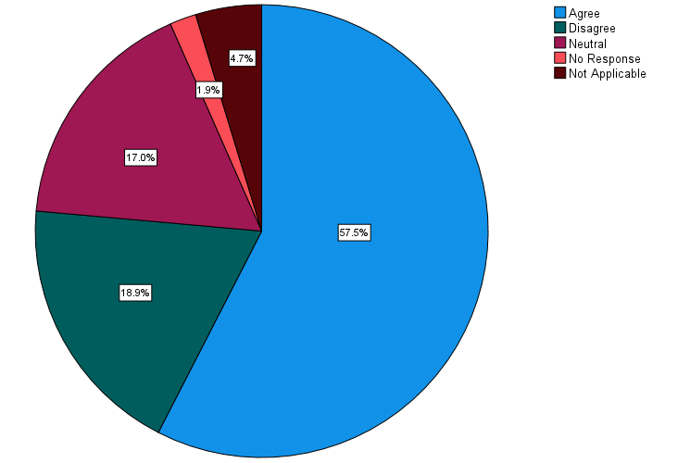
Figure 1: During my secondary school years my PE experience was overall a positive one.
Further to their experience, table 5 provides a breakdown of how many participants were exposed to PE specialists as students prior to secondary school.

Table 5: Exposure to PE specialists as students
In elementary school I had a specialist PE teacher support my teacher or lead PE completely. |  |  | In middle school I had a specialist PE teacher support my teacher or lead PE completely.
 | N | % |  | N | %
Agree | 21 | 19.8% | Agree | 51 | 48.1%
Disagree | 67 | 63.2% | Disagree | 19 | 17.9%
I don't remember... | 11 | 10.4% | I don't remember... | 4 | 3.8%
Neutral | 4 | 3.8% | Neutral | 1 | 0.9%
Not Applicable | 3 | 2.8% | Not Applicable | 30 | 28.3%
 |  |  | No Response | 1 | 0.9%
TOTAL: | 106 | 100.0% | TOTAL: | 106 | 100.0%

Figures 3 and 4 give some insight to the teacher education programs that the participants attended. About half of the participants (51.0%) noted that they had a course on how to teach Physical Education during their teacher education. Meanwhile, about three quarters (74.3%) of participants noted that they had to teach Physical Education on their practicum.
 | N | %
Agree | 51 | 48.1%
Disagree | 44 | 41.5%
I don't remember... | 3 | 2.8%
Neutral | 5 | 4.7%
No Response | 1 | 0.9%
Not Applicable | 2 | 1.9%
TOTAL: | 106 | 100.0%
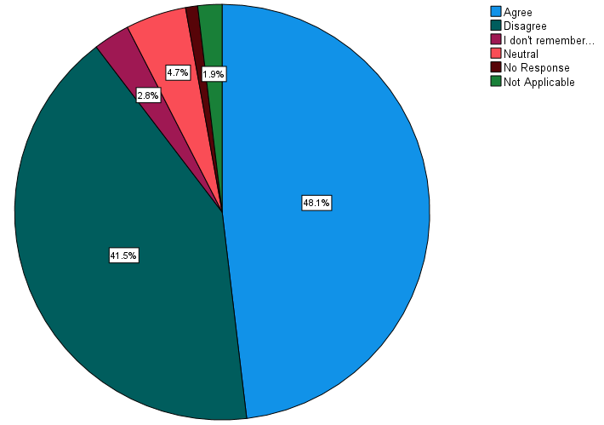
Figure 2: I had a course on how to teach PE during my training.

 | N | %
Agree | 75 | 70.8%
Disagree | 23 | 21.7%
I don't remember... | 1 | 0.9%
Neutral | 3 | 2.8%
No Response | 4 | 3.8%
TOTAL: | 106 | 100.0%
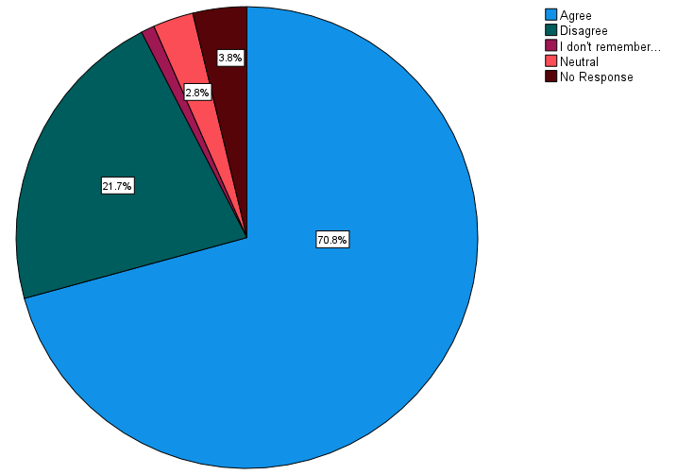
Figure 3: I taught PE on my practicum.

Also, some participants spoke of the barriers that COVID-19 restrictions had put on their accessibility and freedom when it came to teaching PHE during the 2021-2022 school year when the survey and focus group discussions were conducted, as seen below in table 6. However, the pandemic also provided an opportunity to improve or adjust their lessons to fit into the regulations.

Table 6: Effects of COVID-19 on PHE practices
Related Questions | Participant ID | Quote
How has your teaching style of PE changed over the course of your career and what has had the biggest impact on that change? | 4 | Of course, Covid changed PE in huge ways. As using the gym was either not allowed or time consuming (cleaning), I developed a program where we did skipping outside for shorter periods of time but more often. PE became a break from the demands of working in a Covid conscious classroom.
 | 42 | Our school growing and scheduling issues to get all the classes in the gym. Pressure to teach academic content- so gym is the first subject to miss/lose out on. Covid impacting how I teach and even if I teach gym
 | 43 | Although I have taught for a long time, I have done my best to avoid teaching gym. I have traded with other teachers so that I take their classes in art or french and they teach my gym. With Covid, I was no longer able to avoid it. So, I dived in and have been doing my best to make the gym a supportive and inclusive place for all.
 | 52 | Covid has had the biggest impact on my teaching style for PE. I have shifted away from simply teaching how to have fun and participate in physical activities. Now I emphasize the importance of overall health and well-being. It is more geared towards individuals learning how to push themselves to be more active, as opposed to how to have fun group experiences in PE games.
 | 91 | Covid has been a massive impact on PE. Due to restrictions I have been teaching PE outside for the last 2 years. We still try to focus on fundamental movement skills, but it has made some games more difficult and severely limited our available equipment.
 | 97 | Yes- mostly adjusted to ensure that there are alternate options for students that are injured or sick and meeting them where they are at. My first few years teaching, I didn't get to teach PE even though it was my major, so I have only started back into it in the past few years. During the pandemic we also had to shift to only 2 PE sessions per week since we can't share the gym. In some ways, this improves PE because we get the entire space to ourselves when we are there, but we don't get to learn from each other as much. We also shifted to two weeks per piece of equipment last year to limit touch points between classes. Although this minimizes the building of sport specific skills, it has really expanded the variety of activities that we are teaching. I think student engagement has increased, perhaps because they don't get bored of doing one activity for too long.
 | 100 | Only since the pandemic.
 | 103 | More emphasis placed on participation and less on skill development. Biggest impact has been COVID regulations. Not considering COVID it would lack of interest by students in participating in anything that involves physical activity.
 | 104 | Covid obviously has had the biggest impact. Only teaching P.E. one day a week (I'm part-time) and the lack of collaboration with my colleagues. Not having a school scope and sequence to follow.
How would you describe your current teaching style and focus when it comes to PE? | 15 | Lacking. I am passionate about physical activity in my personal life but struggle to bring it to life in my teaching practice. Covid restrictions and limitations make many activities difficult.
 | 22 | I follow the school expectations and units as Covid-19 makes it difficult to deviate.
 | 89 | My current style is driven by students needs and what's best for my lowest students as my needs for these students is quite high this year. We are also little learners in K and learning how to move our body safely. What's best for students is my motto right now under the COVID umbrella.
 | 100 | Before pandemic I was practicing a lot of sports.
 | 103 | With COVID restrictions, more of a participation focus rather than skill development.
Is there anything else you would like to add to help our understanding of your experiences in PE as a student or teacher? | 17 | Teaching PE during Covid produced challenges but I came of with alternative ways of playing games, new games, and moved PE outside more often. As a result, I think I improved my practice and my students had a great experience.
 | 42 | I think the attitude has shifted over the years about PE- the promotion of self regulation is so huge and teachers understanding that kids need to move more and have brain breaks. Covid has set that movement back in the classroom (increase of independent desk work). I think there needs to be continued effort to promote PE and physical literacy. As well as more support helping teachers see that gym time can be easy, engaging AND fun with simple and easy games to teach kids beyond Dr. Dodgeball. 😝
 | 100 | Under the circumstances of pandemic, PE has another meaning. First, between online and at school, the best option was that the students go back at school and don’t stay online. Now that being said, we have noticed that if the 380 students use the gym, some students go sick with Covid. A lot of teachers started to bring the students for our side games and long walk. In this moment, the social interaction is necessary as the students keep two meeting apart in the classroom and have their masks on, I don’t think it is very healthy to have a mask on during PE inside. I did select to bring the students on a daily basis for a walk. The students stop at the creek, play with leaves rocks and interact socially. If we go back normal, I will start back my regular list of sports that we did like dodgeball, soccer, hockey, basketball, volleyball, tennis, dance, gymnastic ect…. […]

These initial findings of the participants biographies will act as reference points to the discussion around the aspects of socialization in the following sections.
Additional supporting data tables around participants experiences as students, as teacher candidates, and current teachers can be found in Appendix B: Supplementary Quantitative Data.

Findings – Quantitative Analysis
Overall, there were a total of 106 responses to the research questionnaire regarding the participants’ opinions and experiences with PHE (as a student, teacher candidate, and as a career teacher). As mentioned in the Methodology section, the survey was optional and participants could choose to omit certain questions if they wanted; meaning some of the analyses will have less than 106 participant responses recorded. The quantitative analyses completed includes non-parametric correlations and frequencies of responses presented as percentages. Non-parametric analysis was done due to the nature of the data collected not necessarily following a normal distribution (Hoskin, 2012). Since the data is opinion based, the shape of the data is unknown and therefore best to use non-parametric analyses (Hoskin, 2012). Non-parametric correlations were found using the Spearman’s coefficient and the 2-tailed test for significance, where P represents the significance level, N is the number of participants that responded, and r is the correlation coefficient.
Participants indicated that overall extracurricular school sports were important to their school, as seen in figure 5. Responses were collected using a Likert scale with the options of extremely not important, somewhat not important, neutral, somewhat important, and extremely important. Figure 5 indicates that 69.8% of participants perceive that their school views the importance (extremely and somewhat important) in extracurricular sports.
 | N | %
Extremely important | 32 | 30.2%
Extremely not important | 6 | 5.7%
Neutral | 17 | 16.0%
No Response | 1 | 0.9%
Somewhat important | 42 | 39.6%
Somewhat not important | 8 | 7.5%
TOTAL: | 106 | 100.0%
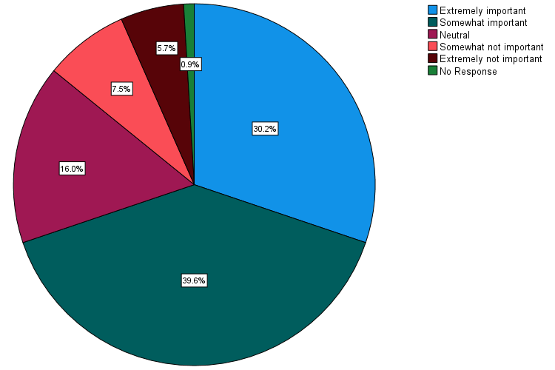
Figure 4: How important are extracurricular school sports to your school?
Comparatively, 47.2% of the participants indicated that they enjoy coaching and do it for the kids as seen in figure 6.

 | N | %
I do it for the kids and I enjoy it | 50 | 47.2%
I'll coach if it's needed but I don't seek it out | 22 | 20.8%
It's a requirement that I support an activity at the school | 3 | 2.8%
No Response | 2 | 1.9%
Not interested in coaching | 22 | 20.8%
Other | 7 | 6.6%
TOTAL: | 106 | 100.0%
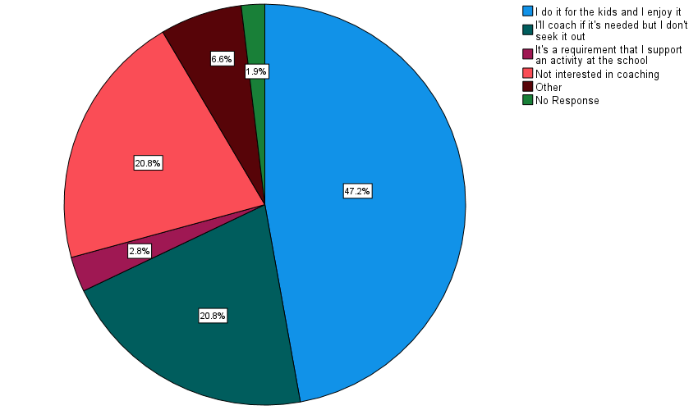

Figure 5: Participant views on coaching
The remaining 52.8% of participants indicated a less than enthusiastic response to coaching or omitted the question; those that responded with Other stated reasons for not coaching. The specifics for not coaching can be seen in table 9.
Table 7: Reasons for not coaching
ID | Response
9 | I teach part time and am not available to coach on the days that it is needed.
35 | There isn't much opportunity at the moment
39 | I did lots of 20 years and now with covid I am not sure
40 | I haven’t had a chance due to COVID. But I would definitely do it.
42 | We don’t have any coaching at our K-5 school
53 | I don't have time with raising two kids 6 and 10 and also recovering from a concussion.
102 | Due to the pandemic I have not been able to coach yet

While 57.2% of participants indicated their experience in secondary school PE was positive as students, however when compared to their views on coaching, it could indicate the effect of acculturation on this population. To further support this connection, it was found that there was a positive moderate correlation (P<0.01, N=99, r=0.340) between participants’ views on coaching and their experience in secondary school as seen in table 8. Curtner-Smith (2021) suggested that exposure to high-quality teachers in any subject, PE included, or those with poor experiences develop more innovative orientations in their teaching practice meaning that the coaching aspect is not as high of a priority as other aspects of their careers. The positive correlation may indicate the effect of acculturation that Curtner-Smith (2021) proposed, that based on their experiences they did in fact develop an orientation that does not place a high priority on coaching. The moderate strength correlation indicates that the connection between the two questions was fairly strong and may be dependent upon each other to an extent.
Table 8: Correlation data between personal experiences and views on coaching
Correlations
 |  |  | During my secondary school years my PE experience was overall a positive one.
Spearman's rho | What are your views on coaching? | Correlation Coefficient | .340**
Spearman's rho | What are your views on coaching? | Sig. (2-tailed) | <.001
Spearman's rho | What are your views on coaching? | N | 99
**. Correlation is significant at the 0.01 level (2-tailed).

The majority of participants (55.6%) indicated that they teach PHE alone in the gym, as seen in table 9. Of these participants, it was found that there is a moderate correlation (P<0.01, N=102, r=0.376) between teaching alone feeling isolated from their colleagues when it comes to teaching and planning PHE. The data used for the correlation can be seen in table 10.

Table 9: Participants teaching situations
I teach PE alone in the gym. |  |  | Teachers all teach PE in their own way and there is minimal collaboration in lesson planning.
 | N | % |  | N | %
Strongly Agree | 35 | 33.0% | Strongly Agree | 34 | 32.1%
Agree | 24 | 22.6% | Agree | 46 | 43.4%
Neutral | 10 | 9.4% | Neutral | 13 | 12.3%
Disagree | 27 | 25.5% | Disagree | 7 | 6.6%
Strongly disagree | 7 | 6.6% | Strongly disagree | 3 | 2.8%
No Response | 3 | 2.8% | No Response | 3 | 2.8%
TOTAL: | 106 | 100.0% | TOTAL: | 106 | 100.0%

Table 10: Correlation data between teaching alone and collaboration
Correlations
 |  |  | Teachers all teach PE in their own way and there is minimal collaboration in lesson planning.
Spearman's rho | Teachers all teach PE in their own way and there is minimal collaboration in lesson planning. | Correlation Coefficient | .376**
Spearman's rho |  | Sig. (2-tailed) | <.001
Spearman's rho |  | N | 102

Findings – Qualitative Analysis
Qualitative data were collected through the questionnaire and the focus group discussions. In order to protect the participants’ anonymity, participants from the questionnaire have been assigned a number and participants from the focus group have been assigned a code for purposes of the analysis. There were 11 focus group participants who have been assigned identifiers FGP-1 through FGP-11 to support their anonymity. Of the 11 participants, 3 were elementary school teachers while the remaining 8 taught in various middle schools at the time of our discussions. While the grade levels from kindergarten through grade 8 were represented, only 1 participant was a specialist middle school (grade 6-8) PHE teacher while the rest were classroom teachers. Appendix C – Supplementary Qualitative Data contains more detailed tables of participant responses per the questions from the questionnaire. The themes that arose from the data were stress and anxiety they experienced as students, effects of barriers and flexibility in teaching styles, and the importance of participation and movement.

Stress and Anxiety as Students
Table 11: Participant PE experience as students
Participant experiences
Participant ID | QUOTES
7 | I found that as I got into high school PE that it was no longer enjoyable. It was hard to be a self conscious student fitting gym in my day. Rushing to get there on time, change and then meet expectations felt like a lot of pressure. Despite being on sports teams outside of school and an active teen, P.E in high school was particularly stressful and made me feel out of place.
9 | My feelings were negative. I wasn't athletic, but I was fairly active as a kid. We rode bikes all the time, but that didn't translate to anything that was successful in PE class. It was competitive and humiliating.
10 | We used to get a check mark if we showered in middle school and they used to use the fat tester in front of the whole class.
28 | Being an unathletic kid, I hated PE. The teachers I had did little to engage students like me and instead focused more on students who already had the skills or could more easily pick up skills. Because sports and games were not my forte, I felt left behind and as I got further into high school, felt like PE and everything surrounding it was not for me.
37 | When I got into the upper intermediate grades, and early junior high, unfortunately, it sometimes felt, at least from my point of view at that age, that the emphasis became on excelled at a certain sport or skill set, and less about the fun of playing sports, bonding with peers, mentoring each other, and celebrating the effort, regardless of ability. Just as in any subject, some students picked up some skills quicker and more easily that others at first, and unfortunately at the school I was at, there didn't seem to be any model of scaffolding in place the development of the skills, from the way I remember it - you were briefly taught the skills, then lumped together as a team, and expected to perform. I can remember feeling a lot of anxiety when I wasn't able to quickly grasp a skill, or just didn't have the coordination or skill knowledge of a certain sport ... and other kids were more than happy to point it out when you missed the ball or lost a point for your team, and that would sometimes carry into the change room, where there were no teachers to call out such behavior. I loved shooting hoops outside of school with friends or my dad, enjoyed taking martial arts after school, etc. - but PE lost some of its 'fun' in those years ... and often, it became a focus of anxiety and peer pressure.
64 | I always felt like we played a lot of sports and games and did a lot of running (all things I was bad at and felt like I was being compared to peers not judged on whether I was putting in a good effort). Rare opportunities to do things like gymnastics that were a bit more my style were very much appreciated! I would have loved to do outdoor ed, swimming, and other things I enjoyed and was better at.
94 | Fitness tests with components that felt impossible and discouraging
106 | I was little and uncoordinated. At one time, I was told to play on the swings. By grade 5, if you didn't know how to play, no one taught you. I became determined to teach physical literacy and to teach girls not to be afraid of the ball and to embrace their own physicality.
FGP-2 | So I just kind of don't and, you know, like [FGP-3] said, you remember what PE was like, and those are deep cuts. I was a competitive swimmer until my coach stopped letting it be fun. Yeah, and I was a good competitor. I have very big feet but I was a very good swimmer. And I remember the kind of an L shape to the pool. And there was a big rope with a knot at the bottom. And it was always tied up off to the side. And we did all our laps here. And we every single time asked if we could go on there. And he said no every time. Why not after and I'm talking I was 10 when I quit. I wasn't a teacher. I was a kid. And everything was like no, if you want to have fun, we'll do like mock races. How is this fun!?
FGP-9 | And I think and I think that was the emphasis when we were kids was it was all sports related. Like when I was a kid for sure it was it was all about sports and performance. That was I think that's what was that caused some kids to lose interest in.

When asked about their experiences as students in PE, many recalled a variety of scenarios – favoritism towards athletes, lots of running, fitness tests, and a strong focus on sport specific skills and games. Table 11 shows a sample of some of the responses from participants, more responses can be found in Appendix C: Supplementary Qualitative Data. While some enjoyed these options, others indicated that their experiences were more outdated in that the methods they experienced as students would not be acceptable today. Many recalled the onslaught of fitness testing and badges that were earned, and one specifically recalls “We used to get a check mark if we showered in middle school, and they used to use the fat tester in front of the whole class.” (Participant 10) Those that recalled having negative experiences attributed feelings of stress and anxiety to PE because they felt that they lacked the necessary athletic skills. These feelings of stress and anxiety along with negative experiences may indicate that many of these participants may possess stronger innovative orientations rather than custodial orientations when it comes to PHE due to these acculturation factors (Curtner-Smith, Kinchin, Hastie, & Brunsdon, 2021; Richards, Templin, & Graber, 2014; Prior & Curtner-Smith, 2020). This is similar to the second innovative participant in the research done by Prior and Curtner-Smith (2020) who formed their innovative orientation to teaching PE from their negative experiences and wanted to teach differently than they were originally taught. To further add to this connection, Participant 43 stated that “I have used my terrible experiences as a guide of what not to do” which demonstrates the strong acculturation effect their experiences had on their teaching style in a very similar way to the participant in the research done by Prior and Curtner-Smith (2020).

Effects of Barriers and Flexibility in Teaching Styles
Table 12: Evolution of Participants Teaching Styles
Participant Teaching styles
id | QUOTES
7 | The big change was working on developing an approach that was inclusive of all students at all skill levels. This is when the focus shifted from athletic ability to safety, sportsmanship and participation.
14 | It has changed as I have watched other teachers to see what they do. I have adapted things I like from others and also found things that haven't been working.
30 | Handing it over to the students! I think at the beginning I needed this sense of control all the time, but now I realize how capable the students are and how much more valuable the learning is when it comes from them. I think levels is another key...so when teaching a new concept you need to have something easy that everyone can do, and then have levels that they can take it to depending on their skills (if that makes sense)?
44 | I don't think it has changed much, or as much as I'd like to. It feels like there's never enough time to teach about physical literacy in addition to playing fun games in gym.
71 | moved away from direct competitive games to more collaborative activities - still some competition but not the focus. do encourage students to participate in things like extra-curricular that they might not normally.
94 | I have become more flexible and guided by student interest. This is based on teaching experience - I find that this engages students and creates more positive experiences. It also builds on student strengths.
101 | I moved from in the gym to exclusively outside.
fgp-9 | Our new building has a larger gyms. So it seems like we can do more stuff together as two classes. We used to have to do it. One teacher took one class per unit, other teachers, other unit then switch, right because you've restricted space restricted equipment, but now we have a little more space in the school right.
fgp-8 | I think COVID has dramatically changed the way I do PE, in many ways, right? Like, I think before COVID, it just seemed to be more of a feel that you could structure things you could talk about academic or athletics and skills and stuff. But with the loss of, you know, ability to send students to change rooms. And, and change classes, like I know, there's sort of a sense that, of course, of all common spaces were dangerous, right, with COVID. less safe than a classroom. I think that actually led to the anxiety about being out of the classroom for students. So I really dial back, I do absolutely and [our athletic director] can share with you I quite liked his rubric. I do zero emphasis on anything athletic related abilities. And my entire focus is participating and getting along. So really, it's it's just a block of active SEL, if you want to call it that.
fgp-11 | And I think also as you know, strength is participation for me and kind of trying to make it a social, like it's I, I enjoy it a little bit, teaching PE in the sense, it's nice to see kids interact in a different way. So I try to emphasize that social connection, because I'll see some kids that will connect socially with others in the class, and they won't connect that way in the class in different subject areas. So I'm trying to, you know, try to bring that out and mix the groupings. And you know, I had badminton little scope practice, where I rotated and purposely put girls and boys together and sixes and sevens together. And so that's I definitely, I like, I'll feed off a little bit of the competitiveness of some of the kids.

Table 13: Focus Group PHE Lessons
Typical PHE lessons
id | QUOTES
fgp-1 | It probably looks like a warm up you know running in a circle a couple times and then if it were if there was like a sport involved let's say like basketball or soccer or something I would do all like skill based drills like passing and shooting and dribbling and all that kind of stuff but I would have at all costs avoid games.
fgp-3 | Okay, yeah, so we'll do like a middle school, we'll do like a, like a rotation of equipment. So like, this whole school will be doing volleyball for a set number of weeks just to like, minimize the setting up taking out on the nets, that kind of thing. So we'll have some kind of a plan, sort of as a school with some flexibility of, of who's what doing what unit when so like everyone, so anything that involves like communal equipment, like volleyball nets, or badminton nets or whatever, everyone's doing that at the same time, otherwise, kind of up to teacher discretion. So people will do, there's like suggested units, but nothing's really it's kind of did largely what teachers want to do. So quite often, we will have two classes in the gym at the same time.  So we'll team teach PE, just because we gym, we don't we have a limited gym time. So normally, I would start with some kind of a warm up activity. So whether that's just kind of like a, if it's a nice day, we might go for a short jog around the school a couple times, or sometimes it's a game or, you know, something just to get them moving, get their bodies warmed up, then we'll go into whatever the unit is we're doing. So usually it's kind of a progression, starting with the skill building, and then progressing into games, you know, short games, tournaments, that kind of stuff.
fgp-11 | Yeah, so typical, for me is just trying to have a little bit of, you know, settling in structure and then it's kind of been whatever the equipment has been available. I'll have some go to kind of go to games, I don't have a huge repertoire of things. So I'll do more of the traditional, traditional kind of volleyball, basketball, dodgeball, badminton whatever those things I don't have a repertoire of modern kind of fun games but yeah, so it's a little bit stale and boring. I do nature walks a lot which I enjoy but yeah, so it's not a lot of variety.
fgp-9 | So we usually do some sort of a warm up and then and then jump depends on how much to it's quite. It'll look can be quite restrictive and sometimes you can bypass the whole warm up and get right into the game because you only have like 30 minutes or something to get stuff done by the time.
fgp-4 | I'll start with a little bit of skill stuff, let them get used to using the equipment of whatever it is that we're using. And then I will move into not really traditional sports like basketball or volleyball, what I tend to do, like I start off with, I'm trying to think now, aiming games, and then I moved to we did net and wall games.
fgp-7 | But for the most part anyway, and right now, it depends on who has or what what is set out by [the Athletic Director] at our school and he sort of says, okay, I'm going to put the nets up for volleyball during this time. So then we work around that. Right now it's badminton. So we decided that because we can open we had a we have a curtain separating the two halves of the gym because we're allowed to open the curtain now. We will use all of the gym for badminton. So I decided that my partner will umm she she can do the badminton for her class and then I'll go outside do track and field right now and we'll either decide whether or not she wants to stay in and do badminton for another like about three, three weeks.

When discussing typical PHE lessons in the gym, there were very common approaches that were shared. Most indicated that they try to do a warm-up, followed by skill development, and end with a game however sometimes there were barriers that got in the way. Such barriers included the availability of the equipment (setting up and taking down), and time. These specific barriers were also mentioned as pieces that needed to be altered when asked about what supports were needed in their lessons. Morgan and Hansen (2008) and DeCorby et al. (2005) also identified these key barriers in their research as well indicating that the difficulties that the participants faced in their PHE lessons are similar to those identified in the supporting research. Middle school teachers spoke of team teaching with another teacher which meant more students in the gym at the same time; while having another teacher to work with was seen as a positive aspect having more students was more difficult to navigate in terms of planning and space. With the specific barriers that participants spoke of, they also spoke of their flexibility to adapt to certain scenarios and situations that may arise in their PHE classes.
Participants reflected on how they felt their teaching styles have changed or what has had the biggest impact on teaching PHE over the course of their careers. A number of participants felt that their styles hadn’t changed very much or that a large impact on their teaching was related to their comfort level and planning. These impacts on participants teaching styles may indicate the orientations of those participants to be more towards the custodial end of the spectrum of orientations because custodial orientations tend to avoid change and view it with a level of skepticism (Richards, Templin, & Graber, 2014). The level of comfort in teaching PHE represents a common barrier found with many generalist teachers (Morgan & Bourke, 2008). Compared to how the participants recalled their PE experiences as students, their current teaching styles represent a change in the socialization cycle in that teaching practices have evolved from more traditional practices to more progressive ones (Richards, Templin, & Graber, 2014). For example, Participant 94 stated “I have become more flexible and guided by student interest. This is based on teaching experience - I find that this engages students and creates more positive experiences. It also builds on student strengths” indicating that their focus is student engagement and adjusts accordingly for the benefit of the students. The negative experiences that participants recalled seemed to reflect more traditional PE programs (table 11) and in terms of socialization it may be predicted that these participants may teach choose to teach differently and adopt a more innovative focus which is what has been seen in the data collected (Prior & Curtner-Smith, 2020). While some participants felt they hadn’t changed their teaching style and that may connect to a more custodial orientation, the actual teaching practices that were shared represent a strong focus on their students well-being indicating an already innovative focus in which case they may have adopted the innovative orientation from early on and a change would represent a change back towards a custodial approach (Richards, Templin, & Graber, 2014; Prior & Curtner-Smith, 2020).

Importance of Participation and Movement
Table 14: Evidence of the Importance Participants place on Participation
Focus on Participation
id | QUOTES
fgp-3 | And but we have so we try to meet the needs of various like students, but Okay, we're gonna play these games, but we're also gonna play like basketball as a game as well, because some kids really enjoy that. So it's like, you know, or I'll divide the gym in half and half and half of them want to play a basketball game, and half of them want to just play horse or something like that will do that, too. You know. So it's, it's, it's like, it's really trying to meet as many kind of interests and ability levels as possible.
fgp-5 | I want kids to be comfortable. I want them to have fun. And I have three kids who who are proudly not athletic and would rather just sit out and today were having a great time with the basketball and, you know, trying to do their thing and shoot some hoops and and I'm like, Hey guys, this is awesome. So what if you're not athletic? Look at you, you’re moving, you're having fun. Success.
fgp-10 | we'll get into like a few skills to get them going. And then into the main activities and games. So yeah, trying to do some skill development still with each of the different units. But definitely like goal is don't have kids sitting down and to just like maximize their play time with the like their interaction with the equipment. That's why I don't try to do games all the time is because I think if like if basketball, if all they're doing is doing a game, they hardly actually actually get to touch the ball. So yeah.
8 | Less skills driven and more participation. Would love students to sample a little bit of everything.
13 | I try to focus primarily on participation and sportsmanship. I'm aware of the shift towards fundamental movement skills but personally lacking in knowledge of this. I would love to work on this as part of my ongoing learning, but don't know where to start.
28 | Focus on participation, having fun, trying your best and being okay with being vulnerable. Skills come with practice and the kids who are THE BEST are not necessarily getting the highest marks - participation, and acceptance of self and others' abilities are very important.
39 | In elementary, I focus more on participation, basic skills and leadership skills. It is a time where some kids can just burn off energy and play.
55 | Participation and willingness to try are the biggest factors. I focus a lot on cooperative games/skills compared to going through a list of sports.
57 | Evolved from less competitive to more participatory for Intermediate grades (grades 3-8), used to be a heavy emphasis on district wide tournaments with winners, now more 'fun' jamborees and score is not even recorded, basis components similar (ball skills -vball, bball, dance, gymnastics, track and field, with lots of equipment used for a stations approach and/or games for fitness for fitness/movement and enjoyment
73 | I am a big proponent of participation, effort and engagement. And finding something you enjoy and will continue to practice for the rest of your life. Being fit and healthy is unique to everyone. Variety of activity and making it fun!
91 | I try to teach fundamental movement skills that build toward different games and activities. We focus on participation and trying to improve ourselves.

The focus on participation that the participants have identified in their teaching practices suggest that they have a more progressive focus on their lessons rather than traditional focuses. Traditional focuses on the curriculum tend to focus more on the sport specific skills or sport only focus in PHE lessons (Prior & Curtner-Smith, 2020). As participants had mentioned in table 12, their focus is to have students enjoy their time in PHE and they are conscious of students’ well-being. This shift in the focus of PHE towards the students for these participants rather than a heavy reliance on sport-specific outcomes indicates a stronger innovative (teaching) orientation in their teaching practices (Richards, Templin, & Graber, 2014). In the research conducted by DeCorby et al. (2005) they found that PE specialists would be able to focus more on the physical and psychosocial development of the students, yet the participants of this research indicated a strong interest in their students’ well-being in their PHE lessons. While some participants felt ill-prepared (table 14) to teach PHE they were sharing some innovative teaching focuses in their PHE lessons that represent an evolution in PHE teaching practices (Richards, Templin, & Graber, 2014).
Table 15: Evidence of the Importance Participants place on Movement and Skill Development
Focus on Movement and Skill development
id | QUOTES
fgp-1 | if there was like a sport involved let's say like basketball or soccer or something I would do all like skill based drills like passing and shooting and dribbling and all that kind of stuff but I would have at all costs avoid games. They would all beg for them, constantly wanna play wanna play but I would do nothing but mopping up the puddles of tears because they were just so sad that they lost or someone didn’t pass to them or whatever. I was just so exhausted from dealing with it so I just stopped playing games and just only focused on the actual like athleticism of it versus the competition of it.
fgp-4 | I tend to do, like I start off with, I'm trying to think now, aiming games, and then I moved to we did net and wall games. And then we've just, we've just been doing invasion games, and we're going to move to sending and receiving. So I do lots of little games and skills within those games to build up those skills within. So for instance, when we did when we did the net and wall ones, we never used that we just use benches, or we use the walls, like hitting against it with the hands. We did it with partners where they use bats to hit and flip to come back off. We use benches with different size balls where they hit it over either with a racket like a almost like a pickleball racket, or they did it with the hands.
fgp-6 | I just said today is a field day. And I had just equipment options on the field. And I also said, And if none of these appeal to you, you can at the very least walk the field in a circle. Because when you go to the park, people go for a walk in the park, though, as long as you're doing something, but I wrestle with that, in my mind is that to me is not something that you can just do as a PE specialist or PE teacher, like really, I'm teaching them to be active and enjoy the outdoors. But am I teaching them sort of what I consider to be curriculum for this for PE
14 | Big focus on participation and students moving around. I don't spend much time talking or teaching lessons as we have very little time in the gym. Just try to get the kids moving and having fun!
31 | Skills based rather than performance at this age.. Participation and effort are what matter. I try to instill a life long love for being active.
61 | I want the kids moving and having fun. I want everyone involved. I teach transferable skills where everyone can be successful. I teach good sportsmanship and the importance of fitness as well.
67 | some skill development, mostly about moving and being active and involved.
79 | I do less sports units and more focus on the transferable skills that make up specific sports. I changed because 'sports' aren't specifically in the curriculum and I found that kids would disengage if they had the perception they weren't 'good' at a specific sport.
80 | I try to teach some fundamental skills (running, jumping, throwing) but I also focus on getting kids active and making sure they are moving for 30 min. I also often play games that I know students like so that they enjoy PE and are happy to go to the gym every time we have a PE block.
90 | I believe in getting all student moving and participating. Movement skills come first and then games and activities.
96 | Exploration of their abilities, skills. Unstructured, and children are individually drawn to practicing different skills

Similarly, to the focus on participation, participants indicated a strong focus on students’ movements. The goal that participants had shared (table 15) was to instill an enjoyment for being active. While there was a focus on skills, there wasn’t a traditional focus on them but rather skills being a benefit to their movement and activity. The curriculum focuses on skills but not sport-specific skills which means there should be a shift in how PHE is taught. On the positive side, many participants indicated this shift however a few still struggled with that focus. For instance, participant FGP-6 stated that “Because when you go to the park, people go for a walk in the park, though, as long as you're doing something, but I wrestle with that, in my mind is that to me is not something that you can just do as a PE specialist or PE teacher, like really, I'm teaching them to be active and enjoy the outdoors. But am I teaching them sort of what I consider to be curriculum for this for PE”. This point of view from participant FGP-6 may indicate a stronger custodial (coaching) orientation since it showed that they struggled with a change in the curriculum focus from the traditional sport-specific focus (Richards, Templin, & Graber, 2014). The BC PHE curriculum for Kindergarten through grade 8 does not formally specify specific games that need to played but more the general skills that should be practiced (Government of British Columbia, 2022). Table 16 shows the physical literacy outcomes that are suggested for the middle school grades (6-8) in British Columbia. All of the outcomes could be met with the freedom of choice activities which participants mentioned as part of their teaching styles. However, participant FGP-6 felt it may not align properly which may indicate a stronger drive for a more traditional or custodial approach to the curriculum. It should be noted that all 3 grade levels have identical physical literacy outcomes.
Table 16: BC Physical literacy curriculum outcomes
GRADE 6 | GRADE 7 | GRADE 8
- Develop, refine, and apply fundamental movement skills in a variety of physical activities and environments  - Develop and apply a variety of movement concepts and strategies in different physical activities  - Apply methods of monitoring and adjusting exertion levels in physical activity  - Develop and demonstrate safety, fair play, and leadership in physical activities  - Identify and describe preferred types of physical activity | - Develop, refine, and apply fundamental movement skills in a variety of physical activities and environments  - Develop and apply a variety of movement concepts and strategies in different physical activities  - Apply methods of monitoring and adjusting exertion levels in physical activity  - Develop and demonstrate safety, fair play, and leadership in physical activities  - Identify and describe preferred types of physical activity | - Develop, refine, and apply fundamental movement skills in a variety of physical activities and environments  - Develop and apply a variety of movement concepts and strategies in different physical activities  - Apply methods of monitoring and adjusting exertion levels in physical activity  - Develop and demonstrate safety, fair play, and leadership in physical activities  - Identify and describe preferred types of physical activity

Supports Needed
Table 17: Suggestions for the Supports Needed in Coquitlam Schools for PHE
Supports Needed in participants teaching practices
id | QUOTES
7 | It would be wonderful to have PE taken more seriously as the elementary level. At our school it is seen as a time when EA's can take breaks and in class supports aren't needed. I would argue the gym is when you need it most.
8 | Bring back PE Specialists!!!!!
9 | I think that adaptive and inclusive PE strategies are severely lacking in the schools I've worked in. Some adaptive PE has been available to select students, but I'd like to see a more universally accessible PE program for all students.
13 | Greater collaboration amongst staff and ongoing learning opportunities (not just one-off Pro-D sessions) to develop skills around teaching and developing functional movement skills.
17 | There used to be a district PE binder for k-7 in the district. 100's of lessons were included and units on major games and dance. I lent mine out years ago and never got it back. Something like this could be done electronically so that teachers can have access to quality lessons, and build physical literacy skills over time.
19 | I wish we had a more coherent school-wide curriculum scope and sequence available for less experience PE teachers. I would love to have more people share ideas for teaching PE, either within the team or the school. I believe a school wide focus on PE is important so that positive attitudes are developed amongst students that see the value of it even into high school.
20 | Every elementary and middle school should have a full-time PE Specialist.
27 | I'm trained in teaching PE and have played sports all my life; supporting teachers who are intimidated or don't see value in PE is crucial. Better yet, specialists in all schools; especially elementary schools.
34 | a PE specialist. Or platooning/team teaching PE
41 | Training/ProD.  PE specialists.  Incentives for further education (BCRPA/NCCP/NSCA/etc)
70 | A PE planning committee that agrees on scope and sequence to be covered yearly that include grading rubrics that everyone follows with personal variations that work for each participant.
73 | PE specialist and MORE pro-d. Many teachers are afraid to teach PE due to the unpredictability of behavior and lack of control. They need more practice early on and require MORE mentoring.
90 | Support and education around how to teach PE. The Health focus of the new curriculum needs much more time than before and so there is very little time left for movement skills.
FGP-1 | … its probably more that I just would like almost like a resource manual or something and grade specific because I feel like also I know a handful of games but are they always the games that kids in that age group are going to know like even with my music prep the music I can teach I’ve been teaching it to primary’s but now I have grade fours and fives and it's like oh OK well this is like I Can't Sing little clap along song you don't care so I don't really understand the level of engagement you know what I mean so I think from the PE side of it, it would be nice if there was a set of a dozen games and the equipment that is needed and some diagrams
FGP-2 | I think it would be great for I don't know how to make this happen, a resource for maybe the available through the district level that gives ideas kind of organized by what you have to do. Not just like, here are some things to do, because like, well, this is reading and this is work.
fgp-9 | Release time, obviously, we need to, I think we sometimes need some one, or maybe not release time, but we need we need. Yeah, sometimes like, we need an opportunity to be able to go down and see like, if there's a certain PE class we'd like to watch, we need somebody to be able to cover a class so that we can go down and meet with our colleagues and see opportunities, like if they say, I don't know how to do pickleball or something, it'd be nice to be able to see some, some little mini activities or variations that you can do on that activity. Umm… lessons on how to differentiate a certain sport, like if you're doing basketball, what are some different variations you can do on that for students in different different comfort levels, different abilities, that kind of stuff. Like, just like we would in a classroom, right? Like when we learn how to differentiate a reading lesson. How can you do that with a single lesson?
fgp-4 | I would like more equipment, I would like some. I would like to be able to spend a couple of $1,000 on some what I consider basic things. So markers, some new goals, like different different types of nets and goals and different markers for the kids to use. Just Yeah, a bit more of a variety of equipment, something that's a little bit more exciting than maybe what we've got. Yeah. And maybe some release time to, to go and teach other people's classes and let people see what can be done.

Some supports that the participants felt that are needed currently to help them improve their delivery of PHE are more collaboration time with colleagues, more accessibility to equipment, space, and time, the return of PHE specialists in some form, accessible resources, and additional opportunities to learn such as targeted training or professional development. Most responses were in favour of having PHE specialists in each school to help support the delivery of PHE. Additionally, the rationale behind specialists was also to ensure the equipment is well maintained, and consistency in planning and instruction. These suggestions were made by participants also align with those made by DeCorby et al. (2005), Morgan and Bourke (2008), and Hardman and Marshall (2000). The findings here suggest that the findings from DeCorby et al. (2005) and Hardman and Marshall (2000) are still relevant in some teaching situations. Suggestions for school-based professional development were made by participants as a way for colleagues to collaborate. Participant 10 suggested specifically for professional development “that [is] not intimidating for non athletes and a mind shift that PE is as important as any other subject.” While there are professional development opportunities, they can be intimidating for those who are already unsure of the subject area.

Synthesis of Qualitative and Quantitative Findings

Teaching Rationales
The participants of this research indicated that most of them (61.6%), see figure 2, had an overall positive experience as students taking PE, which may suggest that some of them continued to teach as they were taught – whether that be with a coaching orientation or a teaching orientation depending on their experience. Of those that did not have a positive experience, the theory of socialization suggests that they would teach with an opposite orientation to that of what they experienced (Curtner-Smith et al., 2021). Some participants in the latter group indicated that their experiences have been a driving factor of what not to do which would support the effects of socialization on their teaching practices (Prior & Curtner-Smith, 2020). For example, participant 37 on the survey shared, “Because of my own experiences in PE as a student, I think I try to consciously focus on helping those students who may be less comfortable in certain skills and try to help them and provide encouragement” while participant 43 stated “I have used my terrible experiences as a guide of what not to do.” Meanwhile, through the focus group discussions a few mentioned enjoying the movement that PE provided in the earlier years but lost interest or enjoyment when there was a switch to larger sport focus in their secondary years. FGP-2 shared their various adolescent experiences and attributed the shift in enjoying physical activity when “my coach stopped letting it be fun”. At some point there is a shift to a more competitive focus which caused some anxiety for some students. FGP-9 shared that they lost interest in PE around the same time because of the pressure to perform.
“And I think and I think that was the emphasis when we were kids was it was all sports related. Like when I was a kid for sure it was it was all about sports and performance. That was I think that's what was that caused some kids to lose interest in.” FGP-9

Teacher Preparedness
Xiang, Lowey, and McBride (2002) noted that some teacher education programs do not offer enough opportunities to learn how to teach PE which can impact a teacher’s confidence in teaching PE. Of the participants in the survey, 51% of them indicated they had a course on teaching PHE yet 74.3% of them had to teach PHE on their practicum as seen in figures 3 and 4. Participant 30 indicated that “When I first started teaching, I felt really unprepared/unaware at how to teach PE. It is a different skill set than classroom teaching. I developed my skills over time working with lots of different colleagues and finding a style that worked for me” while participant 4 stated that “PE has never been my strength so I often feel ill prepared; however, I do my best with what I have as I know it is valuable for the students.” From the focus group discussions, the need for more opportunities during the teacher education programs also arose. FGP-9 felt that more training in PHE is needed and even stated “We did like, like overall like a couple of weeks of different activities at PDP. And then that was it. That was all the training you were supposed to get. Right?”. The participants didn’t disclose where their teacher education was completed but similar feelings arose from multiple participants of not feeling prepared to teach PHE in elementary and middle school settings. Curtner-Smith (2001) suggested that during one’s teacher education, their beliefs about the profession, more specifically PE, are confirmed rather than modified because the time frame is significantly shorter than compared to the acculturation and organizational phases of socialization. Since many of the participants spoke of negative feelings towards PHE (see table 8 of participant experiences) and then entered into their teacher education program with negative feelings towards PE it makes sense that they continued to feel unprepared to teach the very same course because their feelings were reinforced during their teacher education.

Collaboration
Collaboration could provide opportunities for those that teach alone to feel less isolated and allow for teachers to improve their confidence in teaching PHE which was suggested by the correlation between teachers that teach alone and have opportunities to collaborate. Morgan and Bourke (2008) claimed that by improving teachers’ confidence to teach PHE it would also improve the quality of the programs they were teaching.
Table 18: Need for Collaboration
Collaboration for teachers
id | QUOTES
4 | It would be great to develop PE programs in the school as a team where the gym can be set up for use throughout the day for similar activities. When you have a 30 minutes block but need time to set up, clean, and put away, it leaves little time for the fun.
13 | Greater collaboration amongst staff and ongoing learning opportunities (not just one-off Pro-D sessions) to develop skills around teaching and developing functional movement skills.
15 | More collaboration and community feel towards PE and physical literacy.
19 | I wish we had a more coherent school-wide curriculum scope and sequence available for less experience PE teachers. I would love to have more people share ideas for teaching PE, either within the team or the school. I believe a school wide focus on PE is important so that positive attitudes are developed amongst students that see the value of it even into high school.
52 | I would like to see more cohesion and consistency in a school, in regard to the scope and sequence of the year and individual units; better guidance and direction - wherever that might come from, as many of us are not PE specialists, do not feel comfortable teaching PE, or simply feel like there is already too many subjects to teach and PE is not a priority in terms of quality lesson planning.
84 | Much more collaborative planning, and shared lesson plans

The focus group discussions also suggested some forms of collaboration through staff meetings or school-based professional development times. FGP-10 suggested to their school that time be set aside during their collaboration mornings to specifically focus on PHE. Collaboration needs were discussed through the survey and the focus groups indicating a strong need for more time incorporated into schools. As seen in table 7, 75.5% of participants felt that there is minimal collaboration happening for PHE and based on the comments made as well that the participants felt that there is a need for collaboration. Morgan and Hansen (2007) recognized the need for more professional development in general to support teachers in feeling more confident in their teaching of PHE, and one form of professional development is internal collaboration within a school.

Summary
Overall, the participants were of mixed grade levels, and teaching experience yet still shared common concerns with teaching PHE. Most of them were considered generalist teachers however a few made mention of having certain coaching or additional PHE courses completed. While there is always a variety of strengths within any profession, it seems that overall, most of the participants view the students’ well-being as being most important in PHE whether that’s through student participation or keeping them moving or building fundamental skills to keep them active. In terms of the overall research question, what factors influence teachers’ views and roles in teaching a quality physical and health education program and what supports are needed to aid in their success? Participants identified that their past experiences had an influence on how they approach teaching PHE. Participants also identified the need for collaboration, PHE specialists within the schools, and more resources to better support them in their teaching of PHE.

Chapter 5: Conclusion

Introduction
This chapter will connect the findings and literature to the research objectives to conclude this work and make recommendations for future work.
The condition of PE around the world has been deteriorating in the way that PE has been taught (Hardman & Marshall, 2000). Children are becoming more sedentary and more focused on technology leading to health concerns at younger ages (Cothran, Kulianna, & Garn, 2010; DeCorby et al., 2005). There is evidence and research that indicate that teachers feel unprepared to teach physical education, and PE continues to be marginalized with the sense that it is less important than other academic areas (Robinson, Randall, & Barrett, 2018; Yilidizer & Munustrurlar, 2022; Xiang, Lowy, & McBride, 2002; Petrie & Hunter, 2011). These issues begin to interfere with children’s experiences in PE, which in turn could then become reflected in their teaching should they choose a career in teaching as a result of their socialization (Lawson, 1983a, Richards, Templin, & Graber, 2014). In order to break the cycle of deteriorating programs, work must be done to provide teachers with the necessary supports to provide a pedagogically sound PHE program.
This research is based on the theory of occupational socialization put forth by Lawson (1983a,b) and Richards, Templin, and Graber (2014). The theory of occupational socialization suggests that one’s experiences as a student, teacher recruit, and teacher all have an influence in the way they approach teaching PE (Richards, Templin, & Graber, 2014; Lawson, 1983a,b).

Research Objective 1: Why do teachers teach PHE in certain ways?
While discussing teachers scope and sequence of their PHE curriculum, many spoke of focussing on keeping their students engaged and active during their lessons rather than a strict focus on sport-specific skill and abilities. This shift represents a shift from a traditional focus to a more innovative focus indicating that perhaps these participants approach PHE with a more innovative orientation (Richards, Templin, & Graber, 2014). When discussing their past experiences, several participants described negative experiences and use them as a guide of what not to do with their classes. In terms of the lens of occupational socialization, it makes sense that the past experiences of these participants played a role in how they teach their curriculum no matter how different each lesson may be (Richards, Templin, & Graber, 2014). Richards, Templin, and Graber (2014) suggested that the acculturation phase of one’s socialization may be the most potent and throughout the discussions there were many instances of participants referring to their experiences as students to what guides them in teaching PHE compared to their teacher education programs or teaching experiences. The findings support the evidence of acculturation on the participants and recognizes the conscious effort that they are making in their teaching practices to change how PHE is being taught. While the research suggests that occupational socialization is a cycle that is perpetuated by teachers’ experiences and school cultures, this research stands to suggest that maybe there is a change in that cycle that is attempting to be made (Lawson, 1983b; Richards, Templin, & Graber, 2014).
There was a moderate positive correlation (P<0.01, N=99, r=0.340) between participants’ views on coaching and if their experiences in PE during secondary school were overall positive. This correlation connects to the acculturation aspect of occupational socialization because those that enjoyed PE as students are more likely to enjoy coaching and seek out opportunities to do so (Richards, Templin, & Graber, 2014). The moderate correlation indicates that participants’ views on coaching have a stronger relationship to their past experiences; those that enjoyed sports in their adolescence continued to participate in and support sports in their school cultures. This further supports the effects of the acculturation phase of the participants because it shows a connection to their past experiences and how those experiences have impacted their PHE teaching philosophies (Richards, Templin, & Graber, 2014; Lawson, 1983a).

Research Objective 2: What do generalist teachers need?
Participants felt that in some cases they were ill-prepared to teach PHE and would rather have a PE specialist in their school to help support their teaching or to have more professional development opportunities to better prepare them. It was also noted that more time to collaborate with colleagues would be helpful and more reassuring when it came to their confidence teaching PHE. These suggestions and opinions also align with the research conducted by Morgan and Bourke (2008), Morgan and Hansen (2007, 2008), and DeCorby et al. (2005). Participants were cognizant of their difficulties and the gaps in the teaching of PHE. In order to support their request for development, changes need to be made by the schools either as groups of teachers or from administration to provide the time for the teachers to collaborate. From the questionnaire, 51.0% of participants indicated they had a course on how to teach physical education however 74.3% of participants indicated they had to teach physical education while on their practicum. This discrepancy in the number of people that had some prior education on how to teach the course versus the number of people who had to teach it on their practicum indicates that there is a gap in the preparation of teachers to teach such an important and vastly different core curriculum course. Participants also expressed a need for a resource with sample lessons or games that fit to the curriculum or variations that would be suitable for the different grade levels. Some participants had mentioned of previous resources being available for them so this would suggest that teachers may need to have updated resources made available to them.

Summary
This research aimed to find how teachers felt about teaching PHE and ways to support them in teaching the PHE curriculum. There were 106 participants that taught elementary and middle school grades from the Coquitlam School district, in British Columbia, Canada. Using a mixed methods approach, there were quantitative and qualitative data collected from the same questionnaire followed by focus group discussions. Some of the strengths of this research design were that the availability and accessibility of the questionnaire made it easy for people to participate and not dedicate a large amount of time. The questionnaire was only available online meaning participants could access it wherever they were most comfortable. The focus groups provided rich qualitative information and was also planned around the schedules of the participants to maximize the availability for participation. Mixed methods allowed for different analysis methods which provided different viewpoints to the data collected but also the opportunity to compare results from both types of data (Johnson & Onwuegbuzie, 2004; Onwuegbuzie, Johnson, & Collins, 2009). This triangulation of data allowed for more support in the findings rather than a single viewpoint or type of opinion (Johnson & Onwuegbuzie, 2004).
Some of the weaknesses of this research design were that only a small fraction of teachers within the school district participated which means input and data could be skewed due to sample size, and the scheduling conflicts for the focus groups. Also, only a third of the participants who offered to participate could participate (11/30) due to commitments that arose around the time of scheduling the meetings. With fewer participants that were able to participate, it meant fewer viewpoints were considered in the analysis. This is only a miniscule fraction of the teachers in the district meaning the findings may not be representative of the whole district but of only the small fraction of those that chose to participate.
While the research design focused on getting a deeper understanding of teachers’ views of Physical Education, there were limitations within this research. A limitation was the sample size and group within the quantitative analysis. The sample size was only a small portion of those in the district which may not have been representative of all teachers of the same grade levels in the district. This research only invited teachers at a specific school district in the province to participate. It was also dependent on the teachers that volunteer; this could skew the information as not all teachers are providing their insight.

Recommendations
The theory of occupational socialization provided a framework to support my research. It was the basis and guide through which I formulated my research question, designed the questionnaire, and analyzed my data. Occupational socialization allowed for connections to be made between the issues PHE is currently facing and why it has been so difficult to make improvements (Lawson, 1983a; Richards, Templin, & Graber, 2014). Overall, the theory of occupational socialization was significant and valuable in completing this research. Occupational Socialization stands to provide a cause-and-effect aspect to the research and would benefit future mixed methods research as it helps to bridge the gap between the subjective and objective viewpoints in research (Richards, Templin, & Graber, 2014; Cohen et al., 2013).
To further this research, it would be beneficial to explore school cultures, those with versus those without PE specialists, to gain a bigger perspective of the importance of PHE. To explore the school culture, it should include input from different types of members of that school – teachers, administrators, and students who may or may not spend time in the gym on a daily basis. Furthermore, expanding to the community outside of the school would also include beneficial input towards gauging the general public’s perception of the importance of PHE.

References
Aijing, J. (2013). Physical education curriculum reform in China: A perspective from physical education teachers. Physical Education and Sport Pedagogy, 18(1), 15-27.
Candela, A. (2019). Exploring the Function of Member Checking. The Qualitative Report, 24(3), 619-628.
Choi, S.-M., Sum, R. K., Wallhead, T., Ha, A. S.-C., Sit, C. H.-P., Shy, D.-Y., & Wei, F.-M. (2021). Preservice Physical Education Teachers' Perceived Physical Literacy and Teaching Efficacy. Journal of Teaching in Physical Education, 40(1), 146-156. doi:10.1123/jtpe.2019-0076
Cohen, L., Manion, L., & Morrison, K. (2013). Research Methods in Education (7th ed.). Routledge.
Cothran, D. J., Kulianna, P. H., & Garn, A. C. (2010). Classroom Teachers and Physical Activity Integration. Teaching and Teacher Education, 26(7), 1382-1388.
Curtner-Smith, M. (1999). The More Things Change the More They Stay the Same: Factors Influencing Teachers' Interpretations and Delivery of National Curriculum Physical Education. Sport, education and society, 4(1), 75-97. doi:10.1080/1357332990040106
Curtner-Smith, M. (2001). The Occupational Socialization of a First-Year Physical Education Teacher with a Teaching Orientation. Sport, education and society, 6(1), 81-105. doi:10.1080/13573320120033908
Curtner-Smith, M. D., Hastie, P. A., & Kinchin, G. D. (2008, February). Influence of occupational socialization on beginning teachers' interpretation and delivery of sport education. Sport, Education and Society, 13(1), 97-117. doi:10.1080/13573320701780779
Curtner-Smith, M., Kinchin, G. D., Hastie, P. A., & Brunsdon, J. J. (2021). “It’s a Lot Less Hassle and a Lot More Fun”: Factors That Sustain Teachers’ Enthusiasm for and Ability to Deliver Sport Education. Journal of teaching in physical education, 40(2), 312-321. doi:10.1123/jtpe.2019-0275
DeCorby, K., Halas, J., Dixon, S., Wintrup, L., & Janzen, H. (2005, March). Classroom Teachers and the Challenges of Delivering Quality Physical Education. Journal of Educational Research, 98(4), 208-221. doi:10.3200/JOER.98.4.208-221
Edwards, L. C., Bryant, A. S., Morgan, K., Cooper, S.-M., Jones, A., & Keegan, R. J. (2019). A Professional Development Program to Enhance Primary School Teachers' Knowledge and Operationalization of Physical Literacy. Journal of Teaching in Physical Education, 38(3), 126-135.
Government of British Columbia. (2022). Physical and Health Education. Retrieved from BC's Curriculum: https://curriculum.gov.bc.ca/curriculum/physical-health-education
Government of Canada. (2023a, February 1). Census Profile, 2021 Census of Population - Coquitlam-Port Coquitlam. Retrieved from Statistics Canada: https://www12.statcan.gc.ca/census-recensement/2021/dp-pd/prof/details/page.cfm?Lang=E&SearchText=Coquitlam%2D%2DPort%20Coquitlam&DGUIDlist=2013A000459008&GENDERlist=1,2,3&STATISTIClist=1&HEADERlist=0
Government of Canada. (2023b, February 1). Census Profile, 2021 Census of Population - Port Moody-Coquitlam. Retrieved from Statistics Canada: https://www12.statcan.gc.ca/census-recensement/2021/dp-pd/prof/details/page.cfm?Lang=E&SearchText=Port%20Moody%2D%2DCoquitlam&DGUIDlist=2013A000459023&GENDERlist=1,2,3&STATISTIClist=1,4&HEADERlist=0
Hardman, K., & Marshall, J. (2000). The State and Status of Physical Education in Schools in International Context. European physical education review, 6(3), 203-229. doi:10.1177/1356336X000063001
Hoskin, T. (2012). Parametric and nonparametric: Demystifying the terms. Mayo Clinic, 5(1), pp. 1-5.
Johnson, R., & Onwuegbuzie, A. J. (2004). Mixed Methods Research: A Research Paradigm Whose Time Has Come. Educational researcher, 33(7), 14-26. doi:10.3102/0013189X033007014
Kirk, D. (2013). Educational Value and Models-Based Practice in Physical Education. Educational Philosophy and Theory, 45(9), 973-986.
Lawson, H. A. (1983a). Toward a Model of Teacher Socialization in Physical Education: The Subjective Warrant, Recruitment, and Teacher Education. Journal of Teaching in Physical Education, 2(3), 3-16. doi:10.1123/jtpe.2.3.3
Lawson, H. A. (1983b). Toward a Model of Teacher Socialization in Physical Education: Entry into Schools, Teachers’ Role Orientations, and Longevity in Teaching (Part 2). Journal of Teaching in Physical Education, 3(1), 3-15. doi:10.1123/jtpe.3.1.3
MacPhail, A., & Hartley, T. (2016). Linking Teacher Socialization Research With a PETE Program: Insights From Beginning and Experienced Teachers. Journal of teaching in physical education, 35(2), 169-180. doi:10.1123/jtpe.2014-0179
Mandigo, J., Francis, N., Lodewyk, K., & Lopez, R. (2009). Physical Literacy for Educators. Physical and Health Education Journal, 75(3), 27-30.
Merrem, A. M., & Curtner-Smith, M. (2019). The occupational socialization of German physical education teachers. Sport, education and society, 24(1), 92-104. doi:10.1080/13573322.2017.1300880
Morgan, P. J., & Hansen, V. (2008). Classroom Teachers' Perceptions of the Impact of Barriers to Teaching Physical Education on the Quality of Physical Education Programs. Research Quarterly for Exercise and Sport, 79(4), 506-516.
Morgan, P., & Bourke, S. (2008). Non-specialist teachers' confidence to teach PE: the nature and influence of personal school experiences in PE. Physical education and sport pedagogy, 13(1), 1-29. doi:10.1080/17408980701345550
Morgan, P., & Hansen, V. (2007, November/December). Recommendations to Improve Primary School Education: Classroom Teachers' Perspective. The Journal of Educational Research, 101(2), 99-111. doi:10.3200/JOER.101.2.99-112
Onwuegbuzie, A. J., Johnson, R. B., & Collins, K. M. (2009). Call for mixed analysis: A philosophical framework for combining qualitative and quantitative approaches. International Journal of Multiple Research Approaches, 3(2), 114-139. doi:10.5172/mra.3.2.114
Petrie, K., & Hunter, L. (2011). Primary teachers, policy, and physical education. European Physical Education Review, 17(3), 325-329. doi:10.1177/1356336X11416729
Prior, L., & Curtner-Smith, M. (2020). Influence of Occupational Socialization on Elementary Physical Education Teachers’ Beliefs and Curricula. Journal of Teaching in Physical Education, 39(1), 9-17. doi:10.1123/jtpe.2019-0013
Richards, K., Templin, T. J., & Graber, K. (2014). The Socialization of Teachers in Physical Education: Review and Recommendations for Future Works. Kinesiology review (Champaign, Ill.), 3(2), 113-134. doi:10.1123/kr.2013-0006
Robinson, D. B., Randall, L., & Barrett, J. (2018). Physical Literacy (Mis)Understandings: What do Leading Physical Education Teachers Know About Physical Literacy. Journal of Teaching in Physical Education, 37(3), 288-298.
Sirna, K., Tinning, R., & Rossi, T. (2010). Social processes of health and physical education teachers' identity formation: reproducing and changing culture. British journal of sociology of education, 31(1), 71-84. doi:10.1080/01425690903385501
Teraoka, E., & Kirk, D. (2021). Exploring pupils’ and physical education teachers’ views on the contribution of physical education to Health and Wellbeing in the affective domain. Sport, education and society, 1-11. doi:10.1080/13573322.2021.1940917
University of British Columbia. (2023, September). Bachelor of Education Program. Retrieved from University of British Columbia - Teacher Education Office: https://teach.educ.ubc.ca/bachelor-of-education-program/
Wainwright, N., Goodway, J., Whitehead, M., Williams, A., & Kirk, D. (2018). Laying the foundations for physical literacy in Wales: The contribution of the Foundation Phase to the development of Physical literacy. Physical education and sport pedagogy, 23(4), 431-444.
Xiang, P., Lowy, S., & McBride, R. (2002). The Impact of a Field-Based Elementary Physical Education Methods Course on Preservice Classroom Teachers' Beliefs. Journal of Teaching in Physical Education, 21(2), 145-161.
Yilidizer, G., & Munustrurlar, S. (2022). Differences in perceived physical literacy between teachers delivering physical education in schools: classroom teachers vs physical education teachers. Physical Education and Sport Pedagogy, 27(6), 626-639.

Appendices

Appendix A: Quantitative and Qualitative Survey
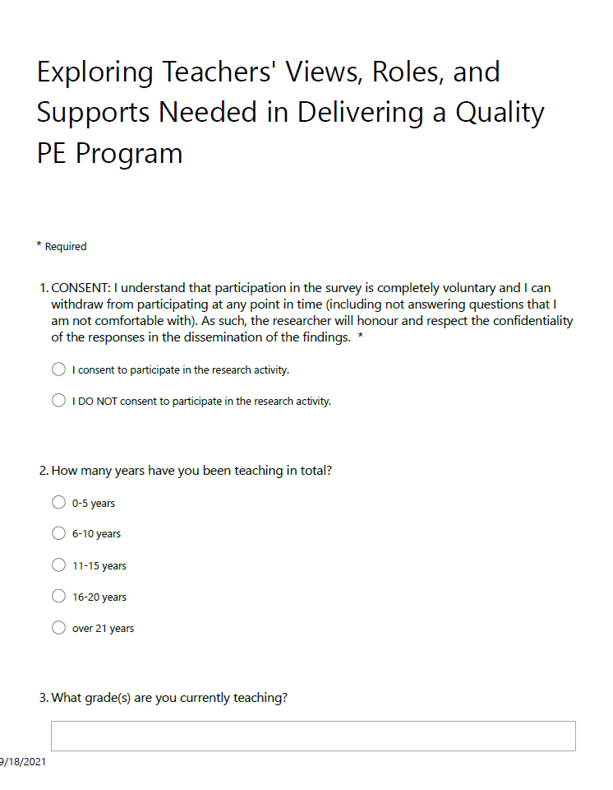
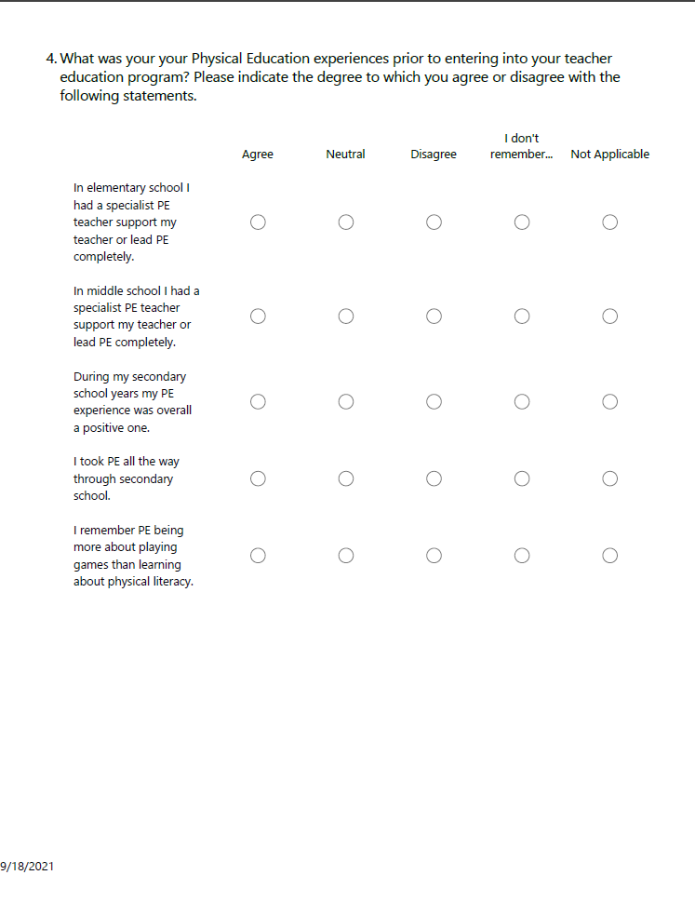

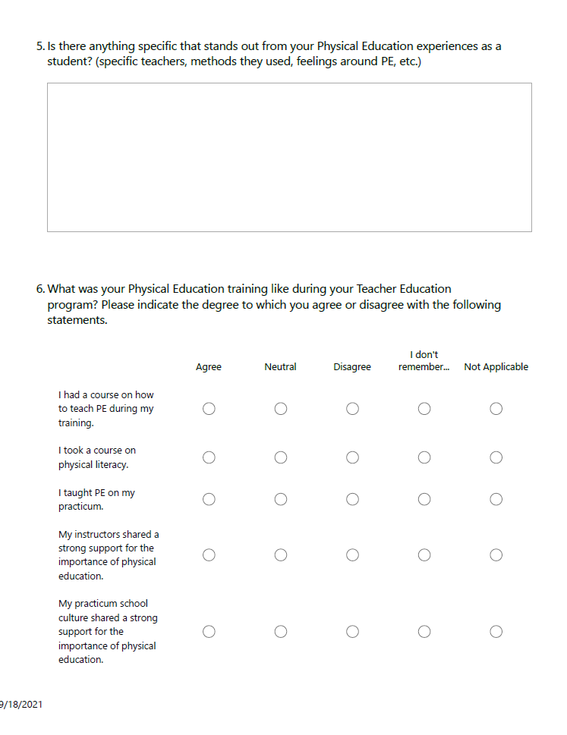

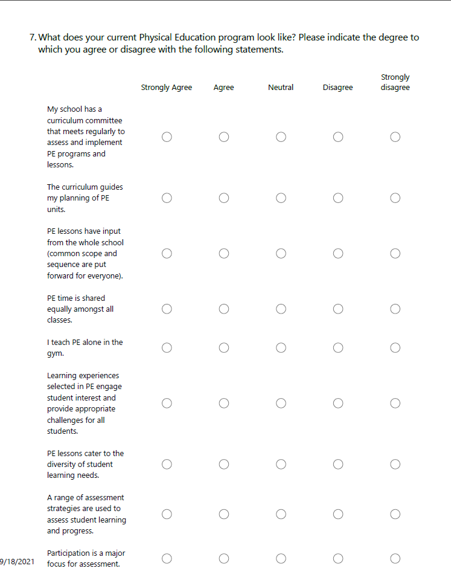

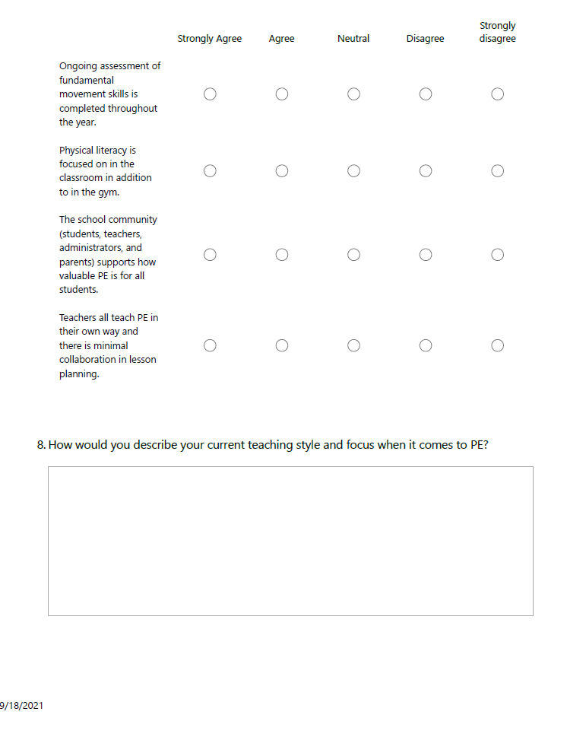

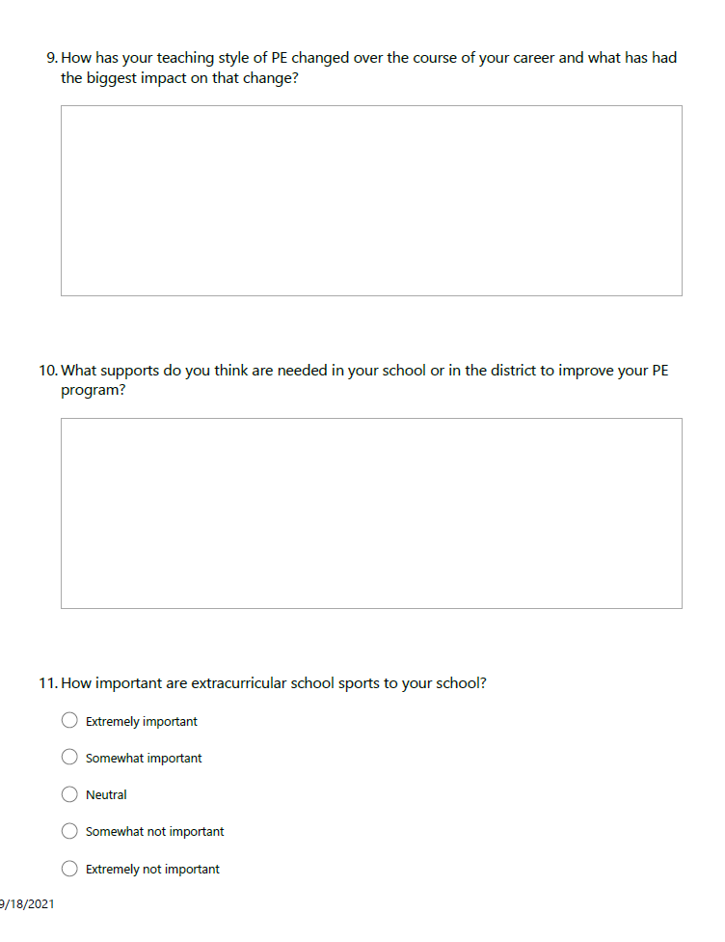

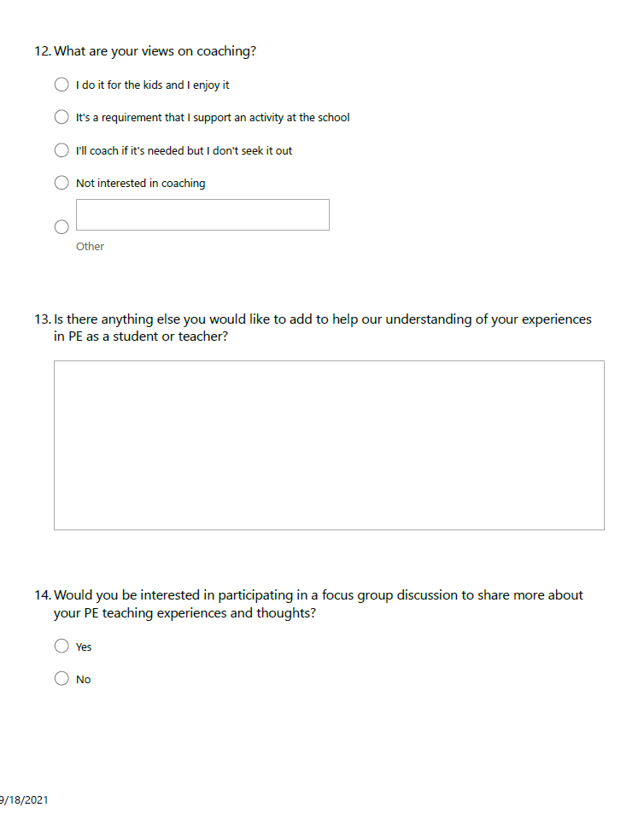



Appendix B: Supplementary Quantitative Data
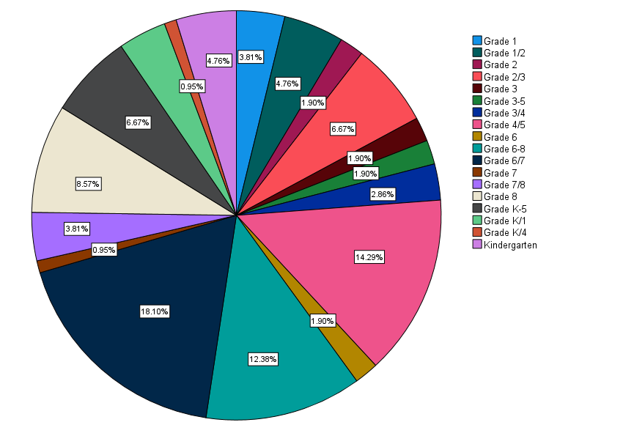

Figure 6: Grades taught by participants

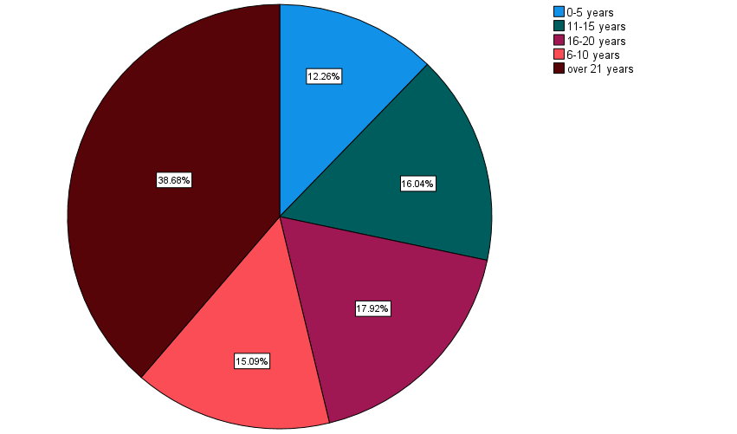

Figure 7: Total years taught by the participants
Table 19: Additional Teacher Experiences as Students
I took PE all the way through secondary school |  |  | I remember PE being more about playing games than learning about physical literacy.
 | N | % |  | N | %
Agree | 53 | 50.0% | Agree | 49 | 46.2%
Disagree | 47 | 44.3% | Disagree | 33 | 31.1%
I don't remember... | 1 | 0.9% | I don't remember... | 4 | 3.8%
Neutral | 1 | 0.9% | Neutral | 19 | 17.9%
No Response | 2 | 1.9% | No Response | 1 | 0.9%
Not Applicable | 2 | 1.9%

Table 20: Additional Information based on Teacher Education Experience
I took a course on physical literacy |  |  | My instructors shared a strong support for the importance of physical education. |  |  | My practicum school culture shared a strong support for the importance of physical education.
 | N | % |  | N | % |  | N | %
Agree | 24 | 22.6% | Agree | 33 | 31.1% | Agree | 37 | 34.9%
Disagree | 67 | 63.2% | Disagree | 34 | 32.1% | Disagree | 26 | 24.5%
I don't remember... | 3 | 2.8% | I don't remember... | 4 | 3.8% | I don't remember... | 8 | 7.5%
Neutral | 5 | 4.7% | Neutral | 34 | 32.1% | Neutral | 34 | 32.1%
No Response | 3 | 2.8% | No Response | 1 | 0.9% | No Response | 1 | 0.9%
Not Applicable | 4 | 3.8%

Table 21: Current Teaching Experiences – Part 1
My school has a curriculum committee that meets regularly to assess and implement PE programs and lessons. |  |  | PE lessons have input from the whole school (common scope and sequence are put forward for everyone). |  |  | PE time is shared equally amongst all classes.
 | N | % |  | N | % |  | N | %
Agree | 12 | 11.3% | Agree | 21 | 19.8% | Agree | 42 | 39.6%
Disagree | 59 | 55.7% | Disagree | 54 | 50.9% | Disagree | 3 | 2.8%
Neutral | 21 | 19.8% | Neutral | 16 | 15.1% | Neutral | 3 | 2.8%
Strongly Agree | 3 | 2.8% | No Response | 2 | 1.9% | No Response | 2 | 1.9%
Strongly disagree | 11 | 10.4% | Strongly Agree | 7 | 6.6% | Strongly Agree | 53 | 50.0%
 |  |  | Strongly disagree | 6 | 5.7% | Strongly disagree | 3 | 2.8%
Table 22: Current Teaching Experiences - Part 2
Learning experiences selected in PE engage student interest and provide appropriate challenges for all students. |  |  | PE lessons cater to the diversity of student learning needs. |  |  | A range of assessment strategies are used to assess student learning and progress.
 | N | % |  | N | % |  | N | %
Agree | 62 | 58.5% | Agree | 52 | 49.1% | Agree | 49 | 46.2%
Disagree | 4 | 3.8% | Disagree | 4 | 3.8% | Disagree | 15 | 14.2%
Neutral | 17 | 16.0% | Neutral | 26 | 24.5% | Neutral | 26 | 24.5%
No Response | 2 | 1.9% | No Response | 2 | 1.9% | No Response | 1 | 0.9%
Strongly Agree | 21 | 19.8% | Strongly Agree | 22 | 20.8% | Strongly Agree | 14 | 13.2%
 |  |  |  |  |  | Strongly disagree | 1 | 0.9%

Table 23: Current Teaching Experiences - Part 3
Participation is a major focus for assessment. |  |  | Ongoing assessment of fundamental movement skills is completed throughout the year. |  |  | Physical literacy is focused on in the classroom in addition to in the gym. |  |  | The school community (students, teachers, administrators, and parents) supports how valuable PE is for all students.
 | N | % |  | N | % |  | N | % |  | N | %
Agree | 39 | 36.8% | Agree | 35 | 33.0% | Agree | 36 | 34.0% | Agree | 45 | 42.5%
Disagree | 2 | 1.9% | Disagree | 24 | 22.6% | Disagree | 21 | 19.8% | Disagree | 11 | 10.4%
Neutral | 6 | 5.7% | Neutral | 25 | 23.6% | Neutral | 30 | 28.3% | Neutral | 34 | 32.1%
No Response | 2 | 1.9% | No Response | 2 | 1.9% | No Response | 2 | 1.9% | No Response | 3 | 2.8%
Strongly Agree | 57 | 53.8% | Strongly Agree | 17 | 16.0% | Strongly Agree | 17 | 16.0% | Strongly Agree | 13 | 12.3%
 |  |  | Strongly disagree | 3 | 2.8%

Appendix C: Supplementary Qualitative Data

Table 24: Participant Experiences as Students
Is there anything specific that stands out from your Physical Education experiences as a student? (Specific teachers, methods they used, feelings around PE, etc.)
ID | Quote | ID | Quote
3 | DIsliked it and made to run everyday was not "fun" | 56 | As I was training with Provincial teams by the time I reached Secondary School, it was sadly incredibly obvious that the theory and practice being used in my school PE curriculum was severely out of date. I stopped taking PE classes as soon as I could, as I kept getting injured in PE due to the lack of sport-specific knowledge and supervision from the teachers (they were PE specialist, by often were teaching sports they really knew nothing about) and it was having a very negative impact on my Provincial Team training. I was disappointed that this poor structure and overly fitness-metric focused approaches - grades primarily influenced by standardized fitness testing also drove away many of my friends who could really have used more physical activity in their late high school years. It was not about personal wellness, but about measuring up to some (out-dated) theoretical fitness standards.  Also unfortunately, my school counsellor never informed me that my Provincial team training counted for credits and I could have reduced my school schedule by a block or two each term and had a better balance in my daily routine.
4 | Once in High School, PE seemed to be focused on skills that as a dancer, I didn’t have. PE was a place where I was teased and there was no support for helping classmates understand that dance is an activity too. | 57 | wide variety of sports and skills taught,
5 | PE in elementary school was mostly fun and games and wasn't very competitive. I remember not really understanding the rules to games such as California Kickball and just following along, not really knowing what was going on. Once I got to High School, PE was split into boys and girls, that made me much more comfortable and PE became very enjoyable even though I was awful at it physically. I felt more supported by my peers once it was split. | 58 | I hated PE because I was never taught any skills and was always picked last for any games. Outside school I was not in soccer or baseball/softball, as many of my peers were so I did not have the skills they did. I swam, did gymnastics, a short stint in figure skating and was in music lessons.
6 | Lots of running (weekly mile run around the neighborhood). I only remember a hand-full of "tests" on theory. The rest of the mark seemed to be based on participation and enthusiasm. | 59 | I always felt inadequate and at times it was a source of worry. Definitely PE was tailored to more athletic types. Although as an adult I have had to learn to be active and the importance of that on my own.
7 | I found that as I got into high school p.e. that it was no longer enjoyable. It was hard to be a self conscious student fitting gym in my day. Rushing to get there on time, change and then meet expectations felt like a lot of pressure. Despite being on sports teams outside of school and an active teen, P.E in high school was particularly stressful and made me feel out of place. | 60 | High school was generally really well done with lots of activities both at school and in the community. We also had a volunteer component to fulfill. I generally liked sports but did not participate in many team sports in high-school as they were very competitive and somewhat intimidating in nature.
8 | The teachers in Elementary school that I remember seemed to enjoy what they were doing-  My PE department in High School was a fun group or teachers and coaches that modeled active living.  However, I was very active in sports and enjoyed challenging myself. | 61 | My gym experiences were based more on traditional sports, rather than enjoying being active or learning transferable skills
9 | My feelings were negative. I wasn't athletic, but I was fairly active as a kid. We rode bikes all the time, but that didn't translate to anything that was successful in PE class. It was competitive and humiliating. | 62 | I was fortunate to have had excellent PE teachers from elementary to secondary. Playing games, and using new equipment was always so exciting to me.
10 | We used to get a check mark if we showered in middle school and they used to use the fat tester in front of the whole class. That would not fly now! Lol | 63 | I wasn't into team sports as a child (or now :) I dreaded the competitiveness of those team sport units, but always participated and enjoyed the other units (tennis, running, dance, fitness testing...)
11 | Aerobics, running and step classes were the most memorable. I liked the competition aspect in running. I played a lot of after school school sports too. | 64 | I always felt like we played a lot of sports and games and did a lot of running (all things I was bad at and felt like I was being compared to peers not judged on whether I was putting in a good effort). Rare opportunities to do things like gymnastics that were a bit more my style were very much appreciated! I would have loved to do outdoor ed, swimming, and other things I enjoyed and was better at.
12 | I had PE teachers, coaches and instructors that I looked up to and admired. | 65
13 | I recall doing a quick skill practice then a game. | 66
14 | The games were always my favourite part. I didn't love learning about the different muscles and nutrition. | 67 | At junior high, it was purely skills based, with 'conventional sports' as the basis. I was unskilled and hated it. I did not feel like I had a chance to be successful, and I considered myself highly unathletic. It was not until years later, as an adult, that I realized that physical fitness and wellness takes many forms, and it's not all about team sports. I am much more active as an adult than I was as a teen.
15 | Feeling super uncomfortable in moments where all class attention was on myself only (kickball, softball, etc). Enjoying less "sporty" activities such as dance units, running, stretching, yoga, games. | 68 | I loved the focus on fitness and improvement at the high school level, especially the girls-only grade 9 class they had at high school. In elementary and middle school, I felt that my lack of ability and talent meant that I was not welcome in the PE class. Fortunately the positive secondary school experience greatly contributed to having a commitment to physical fitness in the rest of my life.
16 | In highschool we took units on different sports. I always enjoyed PE. | 69 | My teachers were a bit more old school. Student Captains picked teams and others were left feeling poorly when picked last. Non-athletic students did not enjoy PE. I personally loved it, but was often the only girl in the class during my senior classes.
17 | Enjoyed PE. Looked forward to class especially in middle and high school. | 70
18 | shame, fear, one positive experience, wrestling in Grade 10...we were taught the skills, practised them, and I became quite proficient, despite the negative expectations of my peers. | 71 | Only the strong survive! :) but we did get to try lots of things that haven't been done in recent years - regular swimming lessons in grade 5.
19 | We learned to do a lot of sports in elementary and junior high (gr. 8-10). We had lots of equipment brought in like gymnastics, archery, tennis. I hated the 12 minute run. I stopped taking PE in senior high as I only took "academic" classes. | 72 | Sandman Ball with Dave Sands (PE specialist at Como Lake back then)
20 | I was in elementary school during the late 80's into the 90's and I remember Participaction where we received bronze, silver, and gold badges for our performance in different physical activity challenges. We also did school wide aerobics led by a teacher in our elementary school. I don't know what kind of training she had other than being a regular classroom teacher. In junior high we had PE Specialists who taught skills and physical literacy. By grade 11 and 12, PE was an elective so the people who took it, including myself all just wanted to play rather than do skill progression. PE was always and still is my favourite subject. | 73 | It was pretty intense and strict. We had to participate and did MUCH more fitness-based testing than we do now. We were all engaged though and overall, I liked my PE teachers in junior & senior high.
21 | I remember going on a really long run in the neighborhood over some tough terrain, including climbing up a steep, muddy hill. It made a real impression in high school. | 74 | Not really differentiated. Athletic ones get more attention. The rest of them just stay there.
22 | Repetitive. Sam three sports all 5 years. Volleyball, Basketball, & Badminton. | 75
23 | Elementary: games, fun  Middle: running, wrestling, embarrassment  Secondary: some fun experiences, some "drill sergeant" strict teachers, some warm ups that felt like torture | 76 | In high school, PE was about how fit you were. I was pretty fit, but physical fitness benchmarks for letter grades was unreasonable in my opinion. We took PE because we had to and when I was allowed to stop, I did. It's not like I wasn't physically active in other ways - I went on runs and bike rides with my family and friends to get exercise. I just didn't enjoy that PE was about learning different sports for 2 weeks and that if I wasn't good at the sport, I got a bad grade, no matter my effort level.
24 | Fitness testing that awarded students badges  In elementary school I remember having to change into gym strip in the gym with boys on one side and girls on the other  Most of my fun memories are from community sports | 77 | We ran once a week/rain or shine! Every student learned how to ballroom dance (waltz, meringue) Preference/favortism was extremely apparent for athletes (football, basketball)
25 | I did everything I could to avoid running activities. | 78
26 | In my personal time I was a competitive gymnast, so I did not have time to try other sports as a child/teen. PE was my only introduction to most sports and for that I am thankful. | 79
27 |  | 80 | I remember having great PE teachers but I was an athlete and loved sports so I also enjoyed being in PE. Teachers in high school would each choose to teacher a different unit and you could choose which one you were most interested in to participate for a few weeks and then switch after about 6 weeks. I enjoyed units like beach volleyball and mountain biking, for example.
28 | Being an unathletic kid, I hated PE. The teachers I had did little to engage students like me and instead focused more on students who already had the skills or could more easily pick up skills. Because sports and games were not my forte, I felt left behind and as I got further into high school, felt like PE and everything surrounding it was not for me. | 81 | I remember the majority of my grade at secondary school being drawn from fitness testing, which was done at least once per term. You needed to be able to do x number of pushups, sit ups, and laps in a certain amount of time in order to get an A. It was miserable. They didn't teach anything about healthy living or nutrition. We played sports and they gave tests on the rules of different ones now and then. It was, overall, not an enjoyable experience.
29 | I loved the competition and the team sports | 82 | *Having a competent PE teacher at our elementary school who followed the curriculum and taught us more than the basics so we could play sports in middle & high school.  *Lunchtime Inter-murals  *District track meets
30 | Teachers would always get us to run laps and I hated it.  My favourite unit in PE was always the dance unit, but not when we had to line dance, only when we got to choreograph our own routines (I was a dancer).  I remember learning about weight training in high school and using the school's gym facilities by a teacher who used to be a body builder. I remember really enjoying this. | 83 | Not really but the activities that I participated in seemed to span all categories - from individual team to gymnastics, etc.
31 | The physical excellence testing where you earned the gold. silver, excellence badges. This was not a positive experience for anyone who remembers it. | 84 | It was impossible to do well “academically” in PE without being gifted in sports. I had this idea that I wasn’t “athletic” even though as an adult, I continue to work out, hike, play rec sports, etc.
32 | I took a year-long course called Socials Explorer in Grade 10 that combined the Social Studies and Physical Education curriculum. We did a lot of outdoor education and went on weekend backpacking, hiking, cross-country skiing, and canoeing trips. This stood out to me because my teacher did a lot of community building in the program and I enjoyed learning how to safely participate in outdoor activities that I still enjoy doing today. | 85 | I remember all my PE teachers throughout school. I was an agile, competitive student and they took an interest in my abilities and encouraged me.
33 | P.E. for me was about winning. I was part of the Canada Fitness generation where you had to do certain takes and were then awarded medals for your achievement. It was very hard for me and often humiliating. I do not feel I was taught the skills I needed. For example I was never taught how to catch a ball and it wasn't until I was an adult that someone told me you catch the ball by looking at it, not be looking at the ball. | 86 | I enjoyed PE but I had a lot of friends who were shamed in PE so didn't enjoy it.  My Junior High teachers were a lot of fun and made PE enjoyable and engaging. It was a long time ago so the methods were old school!
34 | I feel like it was more competitive in Jr. High. It motivated me to try harder. | 87 | I remember that fitness and skill level was very important in P.E. I went to a high school that had very competitive basketball and football teams and the coaches were the P.E. teachers, too. I was not very good at sports but I tried my best. I remember C+ and the occasional B was typical for me.
35 |  | 88 | Good variety
36 | My P.E. teachers in elementary school made P.E. fun. I did have a specialist teacher for a couple of those years. In Junior Secondary I had specialist teachers who did a variety of activities and discussed healthy lifestyles. In Secondary School I had two former C.F.L. football players as teachers. They were "old school" but excellent teachers who demanded our best efforts at whatever we did in P.E. | 89 | My PE teachers always stood out as some of my favorite people in the school. I loved to move as a youngster and to this day still do. Being a petite female under 5 feet I was always unseen in the hallways as a youngster however in the gym -I learned I was very agile, strong, fast and grasped strategy quickly bc I had teachers that supported me. It was in PE class where I believe I gained my confidence and grew a positive self image. I'm vert thankful for my past experiences in PE and those teachers. In fact I went on to become one myself.
37 | When I went through school, it was split into elementary school (K-7), Junior Secondary (Gr8-10) and Senior Secondary (Gr. 11-12). PE was mandatory until Grade 10.  I can remember enjoying PE quite a bit in my early grades, when it was very inclusive and everyone was just practicing the new skills; teachers in those early grades seem to be very good at encouraging and make everyone feel successful. I used to love school sports days, where we would have relays and games and activities outside of the traditional sports. Our playground also had obstacle courses, a zipline, etc. so physical activity was fun and engaging.  When I got into the upper intermediate grades, and early junior high, unfortunately, it sometimes felt, at least from my point of view at that age, that the emphasis became on excelled at a certain sport or skill set, and less about the fun of playing sports, bonding with peers, mentoring each other, and celebrating the effort, regardless of ability. Just as in any subject, some students picked up some skills quicker and more easily that others at first, and unfortunately at the school I was at, there didn't seem to be any model of scaffolding in place the development of the skills, from the way I remember it - you were briefly taught the skills, then lumped together as a team, and expected to perform. I can remember feeling a lot of anxiety when I wasn't able to quickly grasp a skill, or just didn't have the coordination or skill knowledge of a certain sport ... and other kids were more than happy to point it out when you missed the ball or lost a point for your team, and that would sometimes carry into the change room, where there were no teachers to call out such behavior. I loved shooting hoops outside of school with friends or my dad, enjoyed taking martial arts after school, etc. - but PE lost some of its 'fun' in those years ... and often, it became a focus of anxiety and peer pressure.  Looking back at those experiences from a teacher's lens, I realize part of it had to do with my own anxiety as a student - pressure I placed on myself to be 'good at everything', fit in, not let others down, etc. - unfortunately, that just came to be associated with PE class and some sports at that point in my young life. Part of it was climate of that particular school, and what the PE teachers may have chosen to emphasize, celebrate, and model in that time, but part of it was also that we never looked at anxiety and how to approach it with coping strategies in terms of PE or sports, or scaffolding or differentiating instruction, as is often emphasized in other subjects to meet the needs of a variety of learners...  In Grade 10, I had a really great PE teacher - he still works in our school district - and what I remembered about him was how he really emphasized just the fun of trying out a new sport or activity, regardless of how 'good' you were at it. I can distinctly remember how he spent time with the students who weren't the top athletes in the class ... he would subtly take you aside any work on a skill with you, and would outline where you were improving. When we played sports, he would divide up the class into different comfort zones, which I now realize was a way of scaffolding. I finally began to enjoy PE again that year.  Unfortunately, I think the damage was done, in terms of the pressure I associated with some team sports at that point. Once PE became optional in Grade 11, that was it for me. I pursued lots of other subjects and areas I loved, and have wonderful memories of secondary school. | 90 | Some students really looked forward to it and enjoyed it. Others dreaded it.
38 | Educated in England. Lots of fun in P.E. at elementary. Totally competitive at the Grammar school--not fun. | 91 | I remember in high school fitness testing and playing sports.
39 | 12 minute run  Basketball shooting techniques  I was athletic, but as a female held back. | 92
40 | Too much emphasis was placed on ability and not enough was placed on effort. | 93 | We were in gender-segregated PE in high school, and I recall that the health education involved heavy stereotyping / shaming of female students. Also, there was not sufficient "time" in my secondary school schedule to take PE in grades 11 and 12, as I was taking IB courses and preparing to enter a competitive academic program in post-secondary.
41 | I was a full time athlete by High School. I enjoyed all sports, I would say PE was fun and something I was good at. | 94 | Fitness tests with components that felt impossible and discouraging
42 | I hated those competition days in elementary school- I can’t remember what they were called- but a lot of us 80’s kids did them- and you placed bronze, silver, gold…. | 95 | In high school my PE was in french (I did immersion) and was Co-Ed, which was different to the English students. Although I enjoyed my PE experience overall, there were sometimes issues between students who enjoyed more aggressive play and those students who preferred healthy competition.
43 | Really negative feelings around PE. I remember being embarrassed by changing with the others, judged harshly because of my lack of knowledge of basic team games (volleyball, basketball, etc.). Other students remarked on my body when I was in shorts. I was expected to participate in sports with very little instruction so I never understood the rules and always made mistakes which were severely judged by peers and teachers. | 96 | I always enjoyed it. It was around having fun.
44 | Most of my PE teachers were basketball/volleyball coaches, so we mostly played those sports in PE. Since those were the sports I played on teams, I very much enjoyed PE, however, we rarely played any other sports so I didn't get to experience any variety. | 97 | I appreciated the teachers that taught more about technique as my PE advanced. These were the teachers and coaches that made me wat to pursue teaching PE. I was one of very few females in my PE 12 class (maybe the only one- female only fitness 12 option was brand new at the time)- I wish I had done that instead, as my PE 12 consisted primarily of floor hockey which was one of the few sports that I had little interest in.
45 | Yes I didn't like PE at all. I got C- in it except dancing and gymnastics. In Junior high it was awesome when they gave us 2 or 3 choices per term to do, so I learned how to skate, bowl, and play field hockey instead of the usual volleyball and basketball. | 98 | Not really.
46 | Was fun, competitive and I remember genders being separated for the most part. | 99 | having a specialist made the course more valid
47 | Focus on team sports instead of fitness | 100 | No the technics were the same that I was doing PRIOR to Covid-19
48 | As someone that loved sport, I really appreciated that the PE teachers I had were well versed in the activities they taught (including rock climbing, x-country skiing, & Golf). Learning the skills to play these activities has stayed with me and increased my enjoyment as an adult | 101 | The girls did a dance unit while the boys did rugby. An inadequate sports bra makes leads to a large gallery of boys watching you do hurtles. And lots of running. Like, just running around the neighbourhood. The words “milk run” come to mind but to this day I have no idea what that is.
49 | Overly focused on formal sports and rules than being active and healthy. | 102 | High school was the most enriching as we were able to try out sports or games that we never did previously. (Archery/Ping pong/ swing dance). That's not to say that the same thing didn't happen in middle school - it did, I was just more invested in it when I was older. However, I did not take PE all the way through as I ended up doing dance and dance in musical theatre class so I was still active but in a way that I enjoyed most.
50 | There was a lot of competition but it was fun most of the time. Sometimes, the boys took over, but it helped as we got older and girls were separate from boys and/or similar abilities/interests grouped together. | 103 | Physical Education was more about participation and attendance. Not really any skills assessment/testing either written or physically. Only testing was Canada Fitness Testing.
51 | I was never really good at hand-eye coordination, and most games were elimination based, so I never really found success (as those who were good stayed in the games longer and got more practice; therefore being a self-fulfilling prophecy of who were getting better at sports) | 104 | Too much testing throughout elementary and high school. I believe there is a time and place for some competition during P.E. It should not dominate P.E. at any level, especially individual activities.
52 | It was fun. The teachers in secondary school always encouraged good sportsmanship and inclusive play. Teachers gave students choice in which games/units they wanted to complete. | 105 | I loved PE and became a high school PE teacher before moving to elementary
53 | I remember having fun and I had good teachers but I was bullied in the changeroom in grade 8 by another student. I didn't do PE is secondary school. | 106 | I was little and uncoordinated. At one time, I was told to play on the swings. By grade 5, if you didn't know how to play, no one taught you. I became determined to teach physical literacy and to teach girls not to be afraid of the ball and to embrace their own physicality.
54 | It was a long time ago. Lots of stretching and silly exercises. | 107 | I remember doing a unit on health and fitness. I also remember trying to remember all of the rules for each of the sports we were introduced to (badminton, volleyball, basketball, soccer etc.).
55 | In elementary school grades were based on skill, so all the kids who were better at sports got the better grades. Once I got to high school (I grew up in Burnaby so no middle school), it was more based around your effort, so my grades were instantly higher. It didn't convince me to take it in grades 11 or 12 though. | 108

Table 25: Current Teaching Style and Focus
How would you describe your current teaching style and focus when it comes to PE?
ID | Quote | ID | Quote
3 | I believe PE and outdoor education is the most important aspects of a happy/healthy child. | 56 | I have always approached PE from a Sport for Life perspective. Standardized testing is the best way to drive down interest and participation in my experience. Focus on personal awareness and individualized goals is key to engaging hesitant individuals. Athlete who excel are encouraged to focus on leadership and mentorship/peer-coaching, rather than showing off and intimidating others.  Having input on the activities, especially with the mayhem of COVID restrictions on what we can do, has also always been important to me. Positive associations with physical literacy and exercise are critical for long-term healthy habits & engagement, and feeling bad about (overused) fitness testing scores does little to build positive connections.
4 | Games that develop skills for particular sports and other games that develop collaborative teamwork and sportsmanship. | 57 | I am the PE Prep relief teacher and teach 22 classes (K-Gr 5), variety of sports and skills taught in progression with participation and goals for improving fundamental movement skills for all ages, games and fun reinforcement activities important as follow-ups, need a soft start and warm-up to start every class
5 | Lots of team games, 4 corner soccer, handball type games. I'm focused on participation and having fun rather than skills. | 58 | I focus on a variety of fitness activities and teaching skills so that everyone can learn the skills and improve their fitness level. I also play inclusive games that enable everyone to take part and that do not focus on winning or losing or require specific mastery of skills in order to be successful. My goal is to show kids that they can all take part in fitness, no matter what their entry level. We do baseline testing and then test various times throughout the year to note improvement. I participate in most PE activities (always in fitness) to provide an example to the students of someone whose fitness level is not at top level, but can still participate and push myself at my level and see improvement. I focus on participation, sportsmanship and teamwork.
6 | A mix of skills ( frisbee toss, dance moves, ball skills) and games (tag, word games with actions) Often, it is a bit of skills mixed with a bit of free play | 59 | I want students to TRY and to feel safe while trying. I expect effort despite their abilities.
7 | When it comes to PE I focus on participation, safety and sportsmanship. Those are the elements that I highlight every lesson. From there we focus on key sports to support skills development (volleyball, basketball, soccer, track and field, km club). In addition we play games that allow students to work on teamwork. | 60 | Team teach whenever possible.
8 | Less skills driven and more participation. Would love students to sample a little bit of everything. | 61 | I want the kids moving and having fun. I want everyone involved. I teach transferable skills where everyone can be successful. I teach good sportsmanship and the importance of fitness as well.
9 | This year, I am only with my class on Team PE days, so I'm not really teaching PE itself. I am teaching the 'H' part as part of HACE. I'm concerned with healthy habits, daily activity, finding activities that are fun and motivating to keep kids moving. | 62
10 | We play games. If it’s nice weather I would rather take them outside. | 63
11 | we do a lot of stations and tag games | 64 | I try to focus on encouraging participation and present a variety of different activities, talk about fundamental movement skills and personal fitness, and give opportunities to connect with the outdoors in PE. That said, I do teach sport-based units as well!
12 | Instruction followed by (hopefully) full participation from everyone. Lead by example. Show skills, sometimes participate. | 65
13 | I try to focus primarily on participation and sportsmanship. I'm aware of the shift towards fundamental movement skills but personally lacking in knowledge of this. I would love to work on this as part of my ongoing learning, but don't know where to start. | 66
14 | Big focus on participation and students moving around. I don't spend much time talking or teaching lessons as we have very little time in the gym. Just try to get the kids moving and having fun! | 67 | some skill development, mostly about moving and being active and involved.
15 | Lacking. I am passionate about physical activity in my personal life but struggle to bring it to life in my teaching practice. Covid restrictions and limitations make many activities difficult. | 68 | I have a safety, participation and an good attitude and sportsmanship focus in my grade 4 class.
16 | I teach a variety of units and put forth ideas to other teachers. | 69 | I co-teach with someone who was a PHE specialist before, so I have been learning from him. We focus on positive participation, sportsmanship, effort, athletic leadership, and self-improvement.
17 | Students learn fundamental movement and skills through a variety of cooperative and competitive games | 70
18 | ecclectic, involving yoga, dance, sport core techniques and exercises, netball and baketball techniques and games, track and field, running, esp sprinting techniques and practises. My objective is to involve all my students in the movement activities and to develop awareness of their bodies, ie, limitations, injuries and how to prevent them, etc. | 71 | through the year trying to access interests and meet needs of all students as it relates to current curriculum
19 | I have only taught PE 3 times in 21 years. I can wing it and have a bit of a sense of the big ideas of the curriculum. I can lead a limited number of games and can teach some sports skills units. I focus on participation, attitude, and getting outdoors as much as possible. | 72 | Games, fun, and exercise are most important, especially during the pandemic
20 | I am the 0.6 PHE Specialist at my school so I work with many students and teachers in PHE. I try to be their resource supporting them in all ways. As a teacher, I try to make the PHE experience for my students as positive and diverse as possible so they are learning physical literacy as well as just enjoying the physical activity part of their day. | 73 | I am a big proponent of participation, effort and engagement. And finding something you enjoy and will continue to practice for the rest of your life. Being fit and healthy is unique to everyone. Variety of activity and making it fun!
21 | "I focus on 6 activities over the course of the year, 2 per term. This year it is: | 74 | Okay
22 | Term 1: Volleyball & Table Tennis | 75 | Use of games/activities that avoid downtime and avoid focus on score. Infinite games (where it runs itself and keeps going). Taking student suggestions to improve fairness and whole class engagement.
23 | Term 2: Dance & Basketball | 76 | I feel like PE is very difficult for me to plan effectively. I try to plan engaging activities for kids, especially ones that scaffold the learning of different physical skills. My focus on teaching PE is about physical safety and positive attitudes about the learning we are doing.
24 | Term 3. Badminton & Outdoor Games/Activities" | 77 | I will engage in suggested units but sometimes I let the students decide on the activity Emphasis is definitely on participation and less on skills The exception would be track and field
25 | I follow the school expectations and units as Covid-19 makes it difficult to deviate. | 78 | I teach physical literacy through a wide variety of games and sports.
26 | "Teaching sports in units, stressing participation and effort over individual skill. | 79 | We explore physical literacy and 'health' ideas in the curriculum and then I 'notice/name/nurture' while we are doing 'big body' learning in the gym
27 | Assessment also hangs on whether students can be kind to others and be ""good sports""." | 80 | I try to teach some fundamental skills (running, jumping, throwing) but I also focus on getting kids active and making sure they are moving for 30 min. I also often play games that I know students like so that they enjoy PE and are happy to go to the gym every time we have a PE block.
28 | Non competitive games that develop physical literacy like dodging, throwing, catching, running etc | 81 | I focus on getting my students to participate to the best of their abilities. I encourage them to approach all activities with a positive attitude.
29 | I just try to get the kids moving and not complaining. Less focus on direct skills and more on playing games. | 82 | Encouraging the students to try their best, try new things, to stay active, to join sports, to have fun in PE and focus on their personal improvement.
30 | As a 4/5 Team we try to coordinate what units we will do each month so it is somewhat collaborative but we each teach our own way. When it was no Covid, we would like to mix the classes together at the end of units such as volleyball so the students in Div 1 could play against Div 2 and such. My personal style focuses on 5 areas I mark on no mater what sport/activity we are doing 1 Participation, 2 Safety, 3 Sportsmanship 4 Listening/following instructions 5 Skill (I always list skill as last and explain to students that it is because someone who does good in the first 4 areas in my class can still get a Proficient or a B, even if they are not amazing at the sport) | 83 | I make sure that students have daily physical activity whether it is a scheduled time in the gym or not.
31 | "During the pandemic it is focussed on being safe. So having kids wear mask indoors inhibits me from challenging them physically to improve their fitness. | 84 | Focus on leadership and participation
32 | Games are still great, but including and building skill based movements is still important (how to manipulate their body fine or gross to compete a movement or skill)" | 85 | Focus on FMS within lessons while introducing  Games for understanding.
33 | Focus on participation, having fun, trying your best and being okay with being vulnerable. Skills come with practice and the kids who are THE BEST are not necessarily getting the highest marks - participation, and acceptance of self and others' abilities are very important. | 86 | I'm taking the PHE course at Douglas like you did so I'm using Physical Literacy in my lesson planning.
34 | encourage all students to participate and do their best in PE--I talk about the importance of physical activity--I talk about how they will be assessed---sportsmanship, attitude, skills, participation--I participate with them | 87 | I have learned how to teach P.E. from teachers who have a background in physical education. I try to emulate their style. I know that physical education is so important to students and it occurs both in the classroom and in the gym.
35 | Right now I am new to teaching outdoor ed, but prior to this year I taught PE for years at the middle school level. I always try to get student leadership/involvement for any sort of warm-ups or cool downs. Sometimes I would also get leadership students to 'teach' PE when it came to certain drills for sports they were confident in (ie get the soccer kids to demonstrate and explain a passing drill, etc). I found this worked well because the students who were more advanced enjoyed demo'ing in front of the class, they had more skills and knowledge then I did, it took away planning for me, and it gave some students who wouldn't normally stand out as leaders an opportunity to be one! | 88 | Relaxed
36 | Skills based rather than performance at this age.. Participation and effort are what matter. I try to instill a life long love for being active. | 89 | My current style is driven by students needs and what's best for my lowest students as my needs for these students is quite high this year. We are also little learners in K and learning how to move our body safely. What's best for students is my motto right now under the COVID umbrella.
37 | My current teaching style in PE is very laid-back. I like to incorporate a variety of physical activities that change day to day. I often take into account what students want to learn to that they have a positive mindset around health and movement. | 90 | I believe in getting all student moving and participating. Movement skills come first and then games and activities.
38 | A wing and a prayer. I focus on enjoying being physically active and teaching skills I feel will help contribute to the enjoyment of physical pursuits. | 91 | I try to teach fundamental movement skills that build toward different games and activities. We focus on participation and trying to improve ourselves.
39 | My current focus is to introduce skills first so all students have some 'background knowledge'. Then work towards playing the game intended (e.g. teach dribbling, passing, shooting before playing basketball) | 92
40 | It's my first year back as a classroom teacher so I'm finding my feet for what to teach and when. I don't yet have a plan for the entire year. I love teaching PE and am enthusiastic to help children become engaged and healthy. | 93 | This is not applicable to me as I am not currently teaching PE. I have in every previous school year, however.
41 | Time in the gym is limited so I do some instruction in the classroom prior to lessons on new activities. I mainly do high activity games but also teach skills in the context of those games. I also teach dance and gymnastics during the year although those have been challenging with Covid rules. My lessons are generally; individual space warm-up, introduce activity, maximize time with movement. Clean-up, conclude with mentioning two main goals which are always have fun, get some valuable exercise. I also take the time to debrief if there have been disagreements or heated discussions. I remind students of our goals, exercise and have fun. There is no prize money, reward, or championship trophy! | 94 | Teach base skills in a number of sports throughout the year. Blend in cardio fitness rotations and a unit on dance.
42 | I have many years of teaching PE, sometimes working and planning collaboratively with a teaching partner, sometimes teaching my own, depending on the needs of the year. Because of my own experiences in PE as a student, I think I try to consciously focus on helping those students who may be less comfortable in certain skills, and try to help them and provide encouragement. | 95 | I focus more on teamwork and inclusion rather than athletic performance. It is important that all students of varying levels feel comfortable and safe to explore physical activity without judgement or criticism.
43 | I don't get to teach P.E. very often, but when I do, I like to teach games for understanding | 96 | Exploration of their abilities, skills. Unstructured, and children are individually drawn to practicing different skills
44 | "participation, positive attitude including others, sportsmanship | 97 | I do my best to maximize active time in the gym, teach transferrable tactics and promote lifelong fitness. I was trained in tactical games approach to teaching PE, so I use the principles obtained from that. Also, I avoid elimination games (often adjusting them) and splitting competitions between "boys and girls." Instead, when it comes to games, we usually split into competitive and less competitive games. I also find getting a proper warm-up in prepares students to be active and engaged during our activities. Being a core teacher as well, we often work in movement breaks, walks and yoga into our day where we can. This year I have a few students who are not able to be as mobile though, so walks have been reduced.
45 | small games " | 98 | Safety, health, participation and fun!
46 | Trying to make the most of my time with minimal injuries. | 99
47 | Skill focused through game play. Hopefully they will acquire skills they will use outside of school/sport for fun and fitness. Participation is a major factor. | 100 | Before pandemic I was practicing a lot of sports.
48 | I love gym and 100% recognize the importance of it for our students! The excercise, the sportsmanship, team ship, sharing, turn taking, learning to win and lose….creating healthy habits, while having fun with games and moving our bodies….so important! I wing it and play games each block. I wish we had more time in the gym- but it is often a fight to schedule an equal amount of gym time for each class in our school. | 101 | I don’t take my class to the gym. We do an additional hour of outdoor play every day. We use the playground, grass and gravel fields, balls, frisbees, skipping ropes, bean bags, etc. sometimes it’s creative play, sometimes I target skills.
49 | I have used my terrible experiences as a guide of what not to do. I negate the competitive aspect of games entirely by refusing to calculate points and by reinforcing sportsmanship, leadership, and inclusion. I am still really intimidated by game rules and struggle to feel confident when I teach so I have directed lessons in ways that I feel more confident. I also study and review games every time before I talk to the class about them. I am always aware that students in the class know more than me so I invite them to be leaders when talking about technique and game rules. We practice the game rules and the game skills before we play so that everyone has at least a basic understanding before they play. Each student sets their own fitness goal and designs a workout that will help them in their goal. This includes the reasons for each movement and how to do it safely. Then we all do our individual workouts in the gym times. | 102 | I try to get the skill we are working on done and practiced as much as I can. Currently it goes as follows: Warm up (max 10 minutes) Skills (10-15 minutes) [floating if time to make sure students are understanding skill being practiced/taught] Game featuring skill (10-15 minutes).
50 | I choose activities that I know students can be successful in, even if there is a bit of a challenge. I also focus on sportsmanship first and individual skills later on. Sometimes, I change my plan depending on what I think the students need that day. | 103 | With COVID restrictions, more of a participation focus rather than skill development.
51 | I like to do PE with games and units. I'll focus on one sport or skill. | 104 | Over the years I have lost the desire to follow a scope and sequence, mainly because the school does not have one. I still like there to be structure with my lessons yet flexible so students are safe, participating and enjoying what activity they are doing while learning and developing skills.
52 | Focus on participation, learning new skills, and showing improvement over the unit being taught. | 105 | I’m using the curriculum but also creating / researching fun activities that are age appropriate and spark excitement around PE so kids in k/1 will have a love for physical activity further down the road- I enjoy doing cross curricular with science
53 | Focus on fun games that support teamwork and sportsmanship skills, as well as physical literacy. | 106 | Focus on fun, fundamental movement skills and adapted games.
54 | I like to still focus on units centered around sport activities as I still believe that learning some of these skills will stay with the students for many years (ex learning the basic skills for Volleyball might be the difference in them joining a Rec VB league when students are in their 30"s). That being said I put much less emphasis on grading them on their skill level and focus more on participation. | 107 | Each term we look at a different type of movement and then I plan games geared towards that movement. I also consider the varying abilities in my class.
55 | As a classroom teacher, I try to make this a positive, calm and relaxing time for students. | 108 | I love teaching gym. I took Human Kinetics at university because physical literacy and movement have always interested me. I provide a structured and safe program where students learn physical literacy as well as skills that will help the play sports in the future. I strongly believe gym should be about learning but also enjoyable and fun. I want everyone to progress and feel successful.

Table 26: Evolution of Teaching Styles
How has your teaching style of PE changed over the course of your career and what has had the biggest impact on that change?
ID | Quote | ID | Quote
3 | The school I teach at many kids do not have access to balls, hoola hoops, skipping ropes or after school programs due to socio economics. I am the only person teaching them soccer, lacrosse, basketball, fair play..... | 56 | My NCPP coaching training has had the biggest influence. Their philosophies and research on physical literacy learning is substantially better than the Provincial Physical Education Curriculum. The more certification I received from them, the more I updated how I delivered PE learning opportunities in my teaching.
4 | Of course, Covid changed PE in huge ways. As using the gym was either not allowed or time consuming (cleaning), I developed a program where we did skipping outside for shorter periods of time but more often. PE became a break from the demands of working in a Covid conscious classroom. | 57 | Evolved from less competitive to more participatory for Intermediate grades (grades 3-8), used to be a heavy emphasis on district wide tournaments with winners, now more 'fun' jamborees and score is not even recorded, basis components similar (ball skills -vball, bball, dance, gymnastics, track and field, with lots of equipment used for a stations approach and/or games for fitness for fitness/movement and enjoyment
5 | Being more comfortable with sports and rules of games. Knowing what i'm doing helps. | 58 | I did not always teach PE, as we had PE specialists when I taught overseas, and in the early years upon my return to BC. The biggest impact on me was two fold. One, at my first middle school were the games that the PE specialist had developed that were inclusive and met kids at multiple levels and did not focus on winning or losing. Also the availability of equipment for all students to use so that everyone could practice with a volleyball or basketball. Maybe these were available when I was in elementary school, but they certainly were not used. The second was at the second and current middle school where fitness, sportsmanship and supporting each other with PE units and teaching methods is a focus. I have learned so much from my colleagues and am very grateful for all the collaboration.
6 | I used to teach K/1, i had set units and it was structured, but also included the free play, games of choice etc. Now, i am struggling to develop units and lessons that meet the students at their skill level (ie. often, their skills surpass mine - not sure how to teach soccer when most of them already play by league rules) | 59
7 | The big change was working on developing an approach that was inclusive of all students at all skill levels. This is when the focus shifted from athletic ability to safety, sportsmanship and participation. | 60 | Crating access points for all activities to engage every learner in the room regardless of skill or ability.
8 | When I Graduated Middle Schools has PE Specialists- I was a Middle PE Cohort at UBC. Now I do not think a single middle school in the district has a specialist!!!  COVID SUCKS! Also student willingness to participate/effort is lacking. Not being expected to exert themselves. | 61 | I don't know that it has
9 |  | 62
10 | Embarrassed to say it hasn’t. | 63
11 | we work on teamwork, team spirit, being sportsmanlike and moving or bodies... less structure | 64 | More confidence to balance less "traditional" game-based lessons with different forms of physical activity, and using language around movement skills and fitness as goals
12 | Stayed pretty consistent | 65
13 | As a newer teacher, my PE course focused more on assessing effort, student self-assessment, and focus on participation. The shift is that this is different than my experience as a learner which was focused on our ability to do a skill. | 66
14 | It has changed as I have watched other teachers to see what they do. I have adapted things I like from others and also found things that haven't been working. | 67 | I didn't teach PE for the first ten years - I taught at middle and we had a PE specialist.
15 | New career teacher. | 68 | Just started my career so not much to say.
16 | Always been keen on teaching PE, and just finished my PB plus 15 in PE and health. | 69 | This is my first time teaching PHE.
17 | More focus on playing games and less on teaching specific skills in isolation. | 70
18 | more yoga...every day | 71 | moved away from direct competitive games to more collaborative activities - still some competition but not the focus. do encourage students to participate in things like extra-curricular that they might not normally.
19 | I am teaching PE only because I am on a new team and my new partner doesn't want to switch for French. My PE style is inspired by others who are more experienced at it than I am. I try to have my class orderly and value participation and positive attitude. | 72 | More use of fitness goal setting and assessments. Co-teaching with PE specialists over the years has helped inform this
20 | I used to keep track of who changed for PE, since COVID I do not force them to use the changeroom and change their clothes but I do encourage athletic clothes for PE. I have been trying to focus on the enjoyment of physical activity for improved overall health. I do my best to model being physically fit and active. I also make sure to teach health in the classroom so that their time in the gym is maximized. Finally, on my 2 classroom days, I take my class for a 30 minute walk. | 73 | I think adding more structure and routine has really helped me as a teacher and the students. We begin every day with attendance, warmup and then, the lesson or game we are doing that day. Learning from other teachers style and technique.
21 | I've worked in more alternate movement activities like dance. Also, I tend to find drills that maximize participation and I work hard to do formative assessment during drills. I tend to end units with competitive tournaments that allow students to compete to determine class and - sometimes - team champions. | 74
22 | Assessment is participation based rather than skill based. No one fails, or even gets a C anymore. | 75 | Depends on the school environment and spaces/equipment available. Used to use the outdoors and forests at certain schools a lot more for free play, but that's not as easily available currently.
23 | I have become more confident teaching the skills for individual sports (many of which I only ever played in my own K-10 PE classes) simply because I have done it many times now. | 76 | I haven't been teaching for very long. I think this is not one of my biggest priorities for professional development, because I've been working on early literacy skills.
24 | Focus more on participation, engagement and improvement than on skill and athletic abilities | 77 | I have moved away from timed runs towards a just get moving approach!
25 | I don't think it has changed very much. I tried to focus on skill development, but the students only wanted to play games. For example, when I tried to break down fundamental movements for volleyball (Setting, serving, bumping) the kids complained and wanted to get right into playing a game. I think they would be happiest playing dodgeball forever. I would be happy to never play it again. | 78 | Through coaching I have learned to give students as many touches as possible.
26 | It has not changed too much, as I was a coach for 10 years before becoming a teacher. The part that has changed is I have learned from other teachers on how to teach many of the sports I do not play myself. So my teaching ability is much stronger than when I started. The biggest impact is being willing to learn and improve and using colleagues, other coaches that come into school and parent volunteers as people who can help you become a better PE teacher yourself. | 79 | I do less sports units and more focus on the transferable skills that make up specific sports. I changed because 'sports' aren't specifically in the curriculum and I found that kids would disengage if they had the perception they weren't 'good' at a specific sport.
27 | Making sure kids try to focus on improving their own fitness with participation and effort. It's crucial for them to avoid comparisons (hard for some at this age to do). In essence competing against themselves. If it takes them 4 minutes to get around the track (when the rest are at a minute) what can we do to get them to 3 minutes, and have them see the improvement through tracking. | 80
28 | As this is my very first year teaching PE, I am very reliant on my teaching partner who comes with a wealth of experience. | 81 | Working with the experienced teachers at my school, I have become better equipped to plan more meaningful lessons that allow for all students to engage in the activity at a level that is appropriate to their abilities.
29 | I don't think it has changed that much | 82 | Moving for. The classroom into student services means I do not teach PE anymore, but I still coach
30 | Handing it over to the students! I think at the beginning I needed this sense of control all the time, but now I realize how capable the students are and how much more valuable the learning is when it comes from them. I think levels is another key...so when teaching a new concept you need to have something easy that everyone can do, and then have levels that they can take it to depending on their skills (if that makes sense)? | 83 | Yes! Fitness is a way of informing students of their levels, no longer a part of their mark. Also, make sure to give them some choice.
31 | Having children had made me more empathetic to different struggles. | 84 | Not sure
32 | The biggest impact on the way I teach PE is the age of the students I teach. When I taught high school PE, there was a lot of collaboration within the department and we followed a timeline of units that addressed specific competencies. Now that I teach middle school, I find that my main goal is to get the kids moving, playing, and finding fun ways to exercise as opposed to building up skills in specific activities and sports. | 85 | Changed from lots of skill based activities to skills within games.
33 | I really enjoyed having a shared gym time and learning from my colleagues. We don't do this anymore. | 86 | I've always thought of PE as an easy subject to teach but now with more thought and preparation, I'm focusing on FMS and integrating games based on the learning intentions and curriculum.
34 | I think students are less active than before. They are less eager to participate. I have also gotten older and less able to demonstrate skills. When I first starting teaching, there was a P.E. specialist. They helped design the lessons and units. It made teaching PE a lot easier. | 87 | I used to be more regimented with my lessons. Also, I divided up the boys and girls and taught them separately. I do not do that anymore. Primarily, that is due to Covid restrictions, but I most likely would teach the class as a whole anyway. I focus more on participation than skill improvement these days.
35 | I was a School Sports Co-ordinator in the UK prior to the London 2012 Games and it taught me so much about how to teach PE, engage students and run competitions between classes as well as schools using students as leaders. | 88 | Prep teachers often take my class for PE. I like it as gym is not an area I enjoy teaching.
36 | I went back and did my Post-baccalaureate diploma about 4 years into my career and P.E. was one of my areas of focus. I took several courses at university and learned a great deal that I still rely on today. | 89 | PE is one of my favourite subjects to teach and I bring enthusiasm and a belief the littles can learn to play "real" sports too.
37 | I used to draw up lesson plans for each gym class, have a written unit test at the end to assess students' knowledge of the rules of a sport, etc. the way I saw from my own PE teachers. I think my style of instruction has moved well beyond that, becoming much more student and social-emotional oriented now, focusing instead on how to help students feel successful in PE. I look much more at things like participation and effort, self-perceptions of their personal growth in fitness, goal-setting, etc. ... I still have a long way to go, but I try. As stated in the first section, I think of my Grade 10 PE teacher, and what it was he did and modeled for me as a student that positively changed my attitude towards PE class that year. | 90 | Learning about Fundamental Movement Skills has really changed the way I view sports.
38 | My style definitely changed after taking my P.B. 15 in P.E. via Douglas College---really good! | 91 | Covid has been a massive impact on PE. Due to restrictions I have been teaching PE outside for the last 2 years. We still try to focus on fundamental movement skills, but it has made some games more difficult and severely limited our available equipment.
39 | At middle school there was a big focus on teaching specific skills. I taught there for 20 years. In elementary, I focus more on participation, basic skills and leadership skills. It is a time where some kids can just burn off energy and play. | 92
40 | N/a | 93 | I have become more flexible and guided by student interest. This is based on teaching experience - I find that this engages students and creates more positive experiences. It also builds on student strengths.
41 | Addressing the diversity of athletic abilities.  Experience & Education. | 94 | It was a lot more games based when I taught elementary school.
42 | Our school growing and scheduling issues to get all the classes in the gym. Pressure to teach academic content- so gym is the first subject to miss/lose out on. Covid impacting how I teach and even if I teach gym | 95 | Coaching gymnastics for ten years allowed me to develop a passion for teaching growth mindset, self-regulation and positive self-esteem.
43 | Although I have taught for a long time, I have done my best to avoid teaching gym. I have traded with other teachers so that I take their classes in art or french and they teach my gym. With Covid, I was no longer able to avoid it. So, I dived in and have been doing my best to make the gym a supportive and inclusive place for all. | 96 | Yes, I have become a great deal less structured. I allow kids to explore on their own. I do not go to the gym, but go outside for P.E.
44 | I don't think it has changed much, or as much as I'd like to. It feels like there's never enough time to teach about physical literacy in addition to playing fun games in gym. | 97 | Yes- mostly adjusted to ensure that there are alternate options for students that are injured or sick and meeting them where they are at. My first few years teaching, I didn't get to teach PE even though it was my major, so I have only started back into it in the past few years. During the pandemic we also had to shift to only 2 PE sessions per week since we can't share the gym. In some ways, this improves PE because we get the entire space to ourselves when we are there, but we don't get to learn from each other as much. We also shifted to two weeks per piece of equipment last year to limit touch points between classes. Although this minimizes the building of sport specific skills, it has really expanded the variety of activities that we are teaching. I think student engagement has increased, perhaps because they don't get bored of doing one activity for too long.
45 | It hasn't changed much. | 98 | Becoming a primary teacher, has taken the focus off competitive sport.
46 | Focus more on the individual and their improvements and participation rather than a class rating scale. Doing your best might look different than someone elses. | 99
47 | More focused on physical literacy. | 100 | Only since the pandemic.
48 | I have reduced the importance on mastering skills and focus more on participation and students willingness to try to learn skills. As a school we seem to have completely gone away from having students change into PE attire for their classes, something that I am still struggling with. | 101 | I moved from in the gym to exclusively outside.
49 | I focus way less on formal sports and have way more outdoor games and explorations. | 102 | I'm very early in my career and it has not changed too much since I started a few years ago. I have done workshops/ classes about physical literacy in previous jobs so I try to make it my main focus.
50 | Taking a PE course during my PB +15 really helped, especially with safety (this was in my 6th teaching year). At one time in my career, I was the PE rep for our school and attending regular meetings at district level. We don't have this any more at elementary. Having mentors to help organize sports days, running clubs, sports teams etc. really helped too. At one time, I used to observe another teacher teach PE during my prep to learn how to teach volleyball - this was amazing pro d. Over the years, I have focused on participation, personal improvements, safety, and balancing "line" for novice and experienced players so kids are more comfortable. | 103 | More emphasis placed on participation and less on skill development. Biggest impact has been COVID regulations. Not considering COVID it would lack of interest by students in participating in anything that involves physical activity.
51 | I have got more confident to do what I'm comfortable with rather than go outside my comfort zone | 104 | Covid obviously has had the biggest impact. Only teaching P.E. one day a week (I'm part-time) and the lack of collaboration with my colleagues. Not having a school scope and sequence to follow.
52 | Covid has had the biggest impact on my teaching style for PE. I have shifted away from simply teaching how to have fun and participate in physical activities. Now I emphasize the importance of overall health and well-being. It is more geared towards individuals learning how to push themselves to be more active, as opposed to how to have fun group experiences in PE games. | 105 | The age that I’m working with. I found high school more challenging than I thought- and moved into outdoor education- motivating 15 year olds that were required to take PE wasn’t my gifting
53 | Team collaboration and ideas for teaching PHE has helped me. | 106 | learning about fms
54 | I focus more on cooperation and carefulness and watchfulness | 107 | I now have to teach PE every day. Previously, I was in a school that did not have daily access to a gym and going outside to participate in sport or exercise on cold or rainy days was not done.
55 | Getting used to the idea of teaching skills/sports that I myself am not skilled at (sports were never my thing as a kid) and breaking down the steps of skills when I teach them. Plus adapting to Covid regulations and getting the students' input on new games I've never heard about before. | 108 | I think I have more games, better classroom management and a broader depth to what I teach.

Table 27: Supports Needed
What supports do you think are needed in your school or in the district to improve your PE program?
ID | Quote | ID | Quote
3 | MONEY needs to be set aside for supplies and opportunities for children. | 56 | More in-service & professional development in PE for generalist teachers, especially those who do not pursue related training like NCPP outside of their teaching duties.
4 | It would be great to develop PE programs in the school as a team where the gym can be set up for use throughout the day for similar activities. When you have a 30 minutes block but need time to set up, clean, and put away, it leaves little time for the fun. | 57 | keep PE teacher for Prep relief for consistency, money to replace broken equipment, new equipment, easier to have all students participating in curriculum if taught by specialist
5 | A workshop on the basics of volleyball, basketball etc. rules, how to play etc. It would be great to learn how to teach skills for these sports and how to set up a unit for them. | 58 | Not sure.
6 | I'd love some collab efforts on developing units and lessons to use in upper grades. | 59 | I would love the opportunity for more info and collaborative planning.
7 | It would be wonderful to have PE taken more seriously as the elementary level. At our school it is seen as a time when EA's can take breaks and in class supports aren't needed. I would argue the gym is when you need it most. | 60 | More PE time daily would be great. We build it in when possible to make it up, but currently our middle school students only have 2-50min PE blks per week in their schedule.
8 | Bring back PE Specialists!!!!! | 61 | I love when we have experts come to the school. We had tennis lesson this year that were awesome and made all kids feel successful.
9 | I think that adaptive and inclusive PE strategies are severely lacking in the schools I've worked in. Some adaptive PE has been available to select students, but I'd like to see a more universally accessible PE program for all students. | 62
10 | Lots and lots of PE ProD that are not intimidating for non athletes and a mind shift that PE is as important as any other subject. | 63 | A new comprehensive curriculum resource would be great. I know a lot of teachers that still refer to the really old, type-written blue binders because there isn't anything more current that is so comprehensive.
11 | ? | 64 | support for teachers with less PE training/experience who end up teaching PE because of scheduling/teaming logistics, support for teachers used to a more traditional approach to engage with newer aspects of the PHE curriculum
12 | More focus on a common evaluation/feedback technique for students.  Greater variety of equipment  Greater variety of games/activities | 65
13 | Greater collaboration amongst staff and ongoing learning opportunities (not just one-off Pro-D sessions) to develop skills around teaching and developing functional movement skills. | 66
14 | More equipment and more spaces for physical activity. | 67 | not sure
15 | More collaboration and community feel towards PE and physical literacy. | 68 | Would like a PE focused pro-D, more sharing of resources at staff meetings between my colleagues, and more clear guidelines on the curriculum website with specific lesson examples per grade levels.
16 | PE should get more focus. | 69 | Pro-D Workshops for those new to teaching PHE. Easily accessible health ed resources.
17 | There used to be a district PE binder for k-7 in the district. 100's of lessons were included and units on major games and dance. I lent mine out years ago and never got it back. Something like this could be done electronically so that teachers can have access to quality lessons, and build physical literacy skills over time. | 70 | A PE planning committee that agrees on scope and sequence to be covered yearly that include grading rubrics that everyone follows with personal variations that work for each participant.
18 | space for dance | 71 | to be honest the biggest thing is time to include all the pieces of PE i would like to include - both physical and health literacy. working out integration with other subjects
19 | I wish we had a more coherent school-wide curriculum scope and sequence available for less experience PE teachers. I would love to have more people share ideas for teaching PE, either within the team or the school. I believe a school wide focus on PE is important so that positive attitudes are developed amongst students that see the value of it even into high school. | 72
20 | Every elementary and middle school should have a full-time PE Specialist. | 73 | PE specialist and MORE pro-d. Many teachers are afraid to teach PE due to the unpredictability of behavior and lack of control. They need more practice early on and require MORE mentoring.
21 | Equipment rentals / loans would be helpful. How about some netball jerseys with the letters on them, say. | 74 | PE prep with a specialist PE teacher
22 | Daily PE, Daily DPA, and fitness bins in all classes, not just sports equipment (balls). | 75 | Differentiated whole class games that allow kids of various athletic abilities to learn at their pace and not become over competitive/exclusive.  More equipment along with a quick pick manual of activities for teachers to choose from if they need.
23 | I think we need modern resources on nutrition and physical health that emphasize modern thinking on intuitive eating and health that will not cause harm to students in the long term (no tracking what you ate in a day!) | 76 | I think having guest presenters in is a highly motivating part of any gym program - for example martial arts experiences, tennis, gymnastics, etc.
24 | Helping teacher to introduce new age appropriate movement games using the equipment that the school has  Not a ton of set up and clean up since gym block is only 30 minutes for most k-5 | 77 | It would be great to have more experts come in to teach skills (tennis) Guest speakers to motivate students
25 | I would love a school culture where every class was doing the same unit at the same time. Where teachers were given a set of drills or exercises to promote skill building that were easy to explain and quick to do as a warm up. Behaviour management takes up so much of the gym block. Less instructions means more moving. | 78 | Specialist P.E. teachers to curate equipment and teaching and learning and to share it with schools and teachers across the district.
26 | I think some general elementary/middle school Pro D options with simple and clear names like "How to teach Basketball" or "How to teach Volleyball" would be helpful for many people. | 79 | More time in the gym, more resources.
27 | I'm trained in teaching PE and have played sports all my life; supporting teachers who are intimidated or don't see value in PE is crucial. Better yet, specialists in all schools; especially elementary schools. | 80 | I wish I had access to easy lesson plans that taught fundamental movements that I didn't have to find online.
28 | Pro-D for beginning teachers/non-athletic types like me! Awareness of programs that would benefit development of PE teaching; online Pro-D. | 81 | I think it is important the district continues to value physical education and physical literacy and that opportunities are offered to teachers to expand their knowledge and learn new techniques and activities. At our school, using collaboration times to do PE activities has been very helpful with this. It is also important that athletics receives enough funding at the school level to replace old and worn out equipment.
29 | more equipment | 82 | *Bring back PE Specialist, or PE prep teachers at the elementary level  *Update resources like the old PE binder to help guid teacher lessons
30 | Updated equipment and enough equipment for all.  Also a better storage system (paid time for someone to actually organize the equipment room in a way that utilizes use and people know what is available). | 83 | MOre time for activity.
31 | Team planning? | 84 | Much more collaborative planning, and shared lesson plans
32 | It's super challenging to teach PE when you don't have certain athletic skills yourself. For example, I've tried to teach basketball but I just cannot control the ball. I feel that I'm not able to teach students the necessary skills and will focus more on play and exploration since I'm not very confident in this. It's definitely helpful working in a school with a PE specialist to support you. | 85 | LST teachers similar to other subjects.
33 | A specialist and cheerleader. | 86 | We need someone to take leadership to promote more PHE especially at the elementary school level.
34 | a PE specialist. Or platooning/team teaching PE | 87 | I loved it when we had experts come in and teach the students things that we normally didn't like biking and tennis. I would love if that could happen again. I would also like to have the AD at our school teach us a new game every Pro D day or at the start of staff meetings.
35 | Time to sit down and collaborate to make a plan for each grade. | 88 | Resources and pro D
36 | Our District used to have a big P.E. focus. There was a District Curriculum package that all teachers got that had lesson plans, scope and sequence and was excellent. If a District wants to make P.E. a focus they need to dedicate the resources and support to it. Offering workshops for teachers would be helpful, especially beginning teachers. | 89 | Better equipment.
37 | When I was a student, and even when I began teaching, there was a PE specialist in many schools, even at the elementary and junior high school ... they were specially trained. In an ideal world, there would be funding for that, but with so many other areas of our schools desperately needing support, I can see why they defer PE to generalist teachers at the elementary and middle school levels...  However, I do think there needs to be more opportunities for teachers to gain knowledge in physical literacy, movement skills, etc. - those are certainly areas that I think I could use additional training in ...  As I said above, most importantly, I think there needs to be more training and professional development for teachers on how to differentiate and scaffold PE, just as in any subject where we recognize that we have a diversity of learners ... this is something that I feel sometimes goes less recognized in PE; teachers need to be given more opportunities to gain skills to do this sort of differentiation  I was very pleased when they began to link Health Ed with PE, because I think there is an important link between mental health, self-esteem, and physical education for some of our students. Sports anxiety and fear of negative peer judgement and 'being put on the spot' within a PE class is a very real thing for many students, just as much as when, in the old days of teaching, teachers used to have a student who struggled with reading read aloud to the whole class, or go up to the board and solve a math equation in front of all their peers. All are anxiety inducing for some of our students. I have done mindfulness training and other social emotional training in terms of a classroom, but would love to have more training in how to meet the social-emotional needs to many diverse learners within the environment of the gym, in terms of mental health and improving self-perception of the physical literacy and skills.  There should also be opportunities for students to engage in courses, club/team activities that emphasize sports and fitness activities outside the umbrella or traditional sports taught in school. They have some of these at the secondary level, but less so sometimes at middle school. | 90 | Support and education around how to teach PE. The Health focus of the new curriculum needs much more time than before and so there is very little time left for movement skills.
38 | More focus/education around physical literacy | 91 | I would like the district to do more to support extracurricular sports. Running leagues or setting up play days is something that other districts offer. Currently, so much falls onto the coaches.
39 | more equipment!!! | 92
40 | I don’t know. I just know it isn’t working. | 93 | Guidance around assessment practices and tools.
41 | Training/ProD.  PE specialists.  Incentives for further education (BCRPA/NCCP/NSCA/etc) | 94 | PE specialists
42 | Our school brings in a tennis instructor and hip hop instructor every year. Our teachers, students and parents love this! It builds community, is a great new gym unit to teach and Gives the students some new skills that most teachers don’t know how to teach! | 95 | A collection/ compilation of activities that help develop leadership, teamwork, and understanding safety that all teachers may use. Units developed to focus more on health, as well as units focused on athletic skills (i.e. throwing/catching, offensive/defensive skills, etc.), rather than sports based.
43 | Occasionally, the teachers who are comfortable with PE lead ProD opportunities for all teachers in the school. I am always really intimidated to take part but I do. When I get started, I find that it's actually kind of, a little bit fun. Through these ProD's, I have learned about disk golf, potato ball, and several other games. Doing it myself gives me a sense of how students feel and allows me to set up the games in an empathetic way. It also lets me learn through doing. One thing though- there is an assumption that everyone knows the rules of basic games like basketball so those are never done. Sometimes teachers get together after school to play volleyball or other sports. I never go because I don't know how to play and am worried about embarrassing myself. People assume that I have a basic level of competency with these games that I simply don't have. | 96 | We already have a covered area, but I would encourage even more. Outdoor toys that have children using upper body more.
44 | It would be great to have more specialist visits (we sometimes have a fantastic tennis teacher come in the spring). I think it would also be helpful to have resources or visitors that focus on physical literacy and teach kids about movement, strength, monitoring vitals (i.e. heart rate), and healthy eating habits. | 97 | I think having PE specialists would be helpful, but it doesn't fit into the structure for most middle schools. We do have PE collaboration activities at our school and shared files for people to use to brainstorm and mental heath activities have been shared consistently; however, fundamental movement skills and tactics are not something that we get a chance to share enough with non-specialists, especially in the past two years. Previously we would have some workshops for wrestling offered to staff and a meeting each term with coaches and PHE teachers, but not meeting in person impacts our ability to pass forward strategies. This survey is getting my gears turning on how to better support or staff with PE, it is just a matter of finding time and buy-in. PE is definitely about more than just hard skills as well, but transforming pedagogy takes times. I know that some great Pro-D's are available. I think staff may need to intentionally seek out growth in areas that they have less of a background in rather than what is in their comfort level.
45 | More equipment. | 98 | n/a
46 | PE Specialists in Middle School. | 99
47 | Pro-D options aimed at elementary/middle/secondary | 100 | We have a lot of support. Sometimes, if the teacher sees different behaviour , he must do an intervention.
48 | While I know that it is a very difficult thing to accomplish from an organizational standpoint, I believe all schools should still have a PE trained teacher leading the PE program in their schools, even if its not a 1.0 position. There are a number of teachers in our school that would love to not be teaching PE if they had the choice and having a trained teacher planning and leading our PE program would be a huge benefit for our students. | 101 | More outdoor equipment and structures to be active with/on
49 | Common planning time, support for equipment storage, purchase and maintenance. | 102 | pro d focus on physical literacy!!!!
50 | I think we need more common planning and sharing of ideas and strategies for teaching. In our school, we have some very competent PE teachers, but there is no time/opportunities for them to teach/share their expertise. It's a real challenge in elementary. | 103 | I would like to see a return of full-time PE coordinators in each school, especially in middle school. Program development would be enhanced and also facility and equipment maintenance would be better.
51 | Clear guidelines on when different sports are taught to which grades, and how much time each week/ month should be devoted to athleticism and cardio experiences vs. competitive games | 104 | Having a scope and sequence for the school would be ideal and more collaboration with teachers. Also putting more emphasis on mental health during gym time. Overall, for students to develop physical literacy. I would love there to be an Revised and Updated SD#43 P.E. Resource.
52 | I would like to see more cohesion and consistency in a school, in regard to the scope and sequence of the year and individual units; better guidance and direction - wherever that might come from, as many of us are not PE specialists, do not feel comfortable teaching PE, or simply feel like there is already too many subjects to teach and PE is not a priority in terms of quality lesson planning. | 105 | Having PE specialists like music. Not all teachers are great at teaching and motivating kids to learn PE. It is far more reflective to have a PE teacher in leu of a prep teacher doing crafts with your kids in 40 minute chunks
53 | More equipment, list of activities and games from the athletic director. | 106 | better teacher education. I was only taught adapted games but not how to build a scope and sequence for skills.
54 | Possibly PE field trips? Field hockey, netball/basketball courts | 107 | At our school, we are lucky that the PAC supports extra PE programs which allow experts to come in and teach gymnastics, dance etc.
55 | Having a school schedule on which activities/skills/sports we're doing would be helpful. I've been at a few schools in the last few years and it's not something that's discussed/planned on the regular unless there's a whole-school activity where special equipment is set up. And having a list of activities that uses various equipment (even the outside playgrounds) would be great too. | 108 | More equipment is always nice

Table 28: Additional Comments
Is there anything else you would like to add to help our understanding of your experiences in PE as a student or teacher?
ID | Quote | ID | Quote
3 | We are alone in teaching it. If we want supplies we have to beg (I've been asking for a ball pump for 2 months) | 56
4 | PE has never been my strength so I often fill ill prepared; however, I do my best with what I have as I know it is valuable for the students. | 57 | need to make 'being active' FUN!
5 |  | 58
6 |  | 59
7 | During my practicum the school I was at had a dedicated elementary level p.e. teacher. When I did my teacher training and university courses physical education courses were not required. I think it would be valuable to have it required during our teacher training.  Note: I have a transgender child in grade 9 who finds gym incredibly stressful. There seems to be little understanding or room for non-binary or transgender students. Dividing a class by gender or not having neutral safe spaces for transgender students to change is an ongoing problem. | 60
8 |  | 61
9 |  | 62
10 |  | 63
11 | no | 64
12 |  | 65
13 |  | 66
14 |  | 67 | n/a
15 |  | 68 | I do a lot of outside research and put the most planning into my lessons in PE due to safety and behavioural concerns. I am not a sporty person so this planning does not come easily to me, however I believe that my lessons are safe and participation in my class has increased.
16 |  | 69
17 | Teaching PE during Covid produced challenges but I came of with alternative ways of playing games, new games, and moved PE outside more often. As a result, I think I improved my practice and my students had a great experience. | 70
18 | It is paramount that all students develop a relationship and sensitivity towards their own bodies. The focus on team sports and on the students who excel in the extra-curricular sports activities can be very detrimental to those who have not had the extra-curricular instruction, with lasting negative repercussions onstudents developing a healthy self-confidence which affect maintaining a healthy mind and body well into adulthood. | 71 | having taught in K-7 schools and now in K-5 schools there is definitely less teacher interest in the extracurricular - not just sports but other clubs and activities such as choir, and teacher led interests like cartooning or chess. All of these contribute to a positive school culture. Years ago I wanted to do what you are doing - a study to determine the positive effects of all extracurricular activities on all the pieces that are now part of a school's APL. Have you been in contact with the SD43 Elementary Track and Field group?
19 |  | 72
20 | My positive PE experiences and jobs coaching tennis when I was younger led me to a HKIN degree and into teaching. I have always taught PE even before I was the PE Specialist at my school. In my first 3 years of teaching middle school, we had a full-time PE Specialist and then budgets changed so we lost them. I am thrilled to be the PE Specialist at my school even if it is not 1.0. | 73
21 |  | 74
22 | No | 75
23 | I've found a joy for teaching PE that I never really had as a child. I try to keep things fun and lighthearted. I downplay competition whenever possible because I believe that is where peer pressure and embarrassment can really become bad.  I coach every sport at every opportunity. | 76 | N/A
24 |  | 77
25 |  | 78 | I have coached for the past 20 years in schools. Getting to meet students not in my class and do something fun together is a real bonus for everyone.
26 | I was not and still am not very talented at most sports done in PE, but I enjoyed it as a student and enjoy teaching it as a teacher. | 79
27 |  | 80
28 | We need to be aware of the diversity of abilities and interests of kids. Jock culture cannot take over the PE class. | 81 | It was been difficult teaching PE in the current situation. While my class has the gym to ourselves for the first time in years, I find I miss team teaching with my colleagues. Even though, logistically, it is more difficult to run things in the gym with two classes, I really like having the opportunity to collaborate with the other teachers in my school.
29 | I love PE and I learn a lot about my students from observing them interact during PE | 82
30 | When I first started teaching, I felt really unprepared/unaware at how to teach PE. It is a different skill set than classroom teaching. I developed my skills over time working with lots of different colleagues and finding a style that worked for me. | 83
31 |  | 84
32 |  | 85 | My education was not within Canada and my degree was as a specialist PE teacher within elementary school. My experience of teaching PE was very different before I came to Canada. I also take my class outside regularly to develop FMS on different surfaces.
33 |  | 86 | We need to refocus attention on PHE for teachers who may need support with teaching PE.
34 | Even though I enjoy fitness and physical education, it is my least favorite subject to teach. | 87 | I feel that a dedicated teacher that organizes all sports at middle schools is a requirement. An athletic director is so important to ensure that P.E. is taught well, that equipment is well taken care of and that teachers get the support they need to teach P.E.
35 |  | 88
36 |  | 89
37 | See answers above - this is an important study! | 90
38 |  | 91 | I think that overall my experience as a student was positive, however, I never looked forward to fitness testing. I participated in sports and was "athletic", but the comparison was something I always hated.  I think that fundamental movement skills are severely lacking today and that there is not a lot of attention paid to them. Lots of colleagues dread the Gym, when it should be fun for teacher and students, and be a place for lots of development.
39 | I never disliked having gym. I just wish that the girls were treated more fairly by the boys so the girls have a chance to shine. I always think about that when I plan my gym classes. I was an athletic girl, but because I wasn't a showboat, I was not recognized for my abilities, fitness or contributions. | 92
40 | Teaching primary PE is very different from teaching PE in intermediate or Middle school. By the time, we get into the gym we have maybe 15mins to do something. And 5 of those are used up explaining what we are doing. | 93 | I find that PE is often the last thing that is planned, and that many elementary and middle school teachers (myself included) have little training or skill in this area.
41 | I coach professionally at the club team level and have coached at the collegiate level as well. Post Grad Diploma in S&C. NCCP etc. | 94
42 | I think the attitude has shifted over the years about PE- the promotion of self regulation is so huge and teachers understanding that kids need to move more and have brain breaks. Covid has set that movement back in the classroom (increase of independent desk work). I think there needs to be continued effort to promote PE and physical literacy. As well as more support helping teachers see that gym time can be easy, engaging AND fun with simple and easy games to teach kids beyond Dr. Dodgeball. 😝 | 95 | In high school my PE was co-ed. This has its positives, but I found the boy identifying students whom did high level sports had very poor self-regulation and teamwork skills. Even as a high level athlete myself, I found it frustrating and irritating. I always wondered if had they'd learned better inclusivity skills at an earlier age, then maybe Co-Ed PE would have been more enjoyable and exciting for everyone.
43 | I am trying my best. But I could really use some non judgmental support to make things better for me and my students. | 96 | In my grade it is very important that kids not be over instructed on how to use equipment. Children who have not had success in sports are often intimidated when they are among very athletic children. At this age it is important to make physical education successful for everyone and not to push them to do activities they are not ready for. This is why an invitation to use equipment etc is enough.
44 | If I wasn't athletic and had the experiences I've had around playing sports and coaching, I don't think I would even know where to begin when teaching gym. I know there are lots of written resources out there, but I think it would be so much more meaningful and helpful to have in-person support :) | 97 | PE shifting to PHE is more holistic, but I know people struggle to fit it all in without taking away movement time. What makes up the course is far more than just physical literacy.
45 | No | 98 | no thank you
46 |  | 99
47 |  | 100 | Under the circumstances of pandemic, PE has another meaning. First, between online and at school, the best option was that the students go back at school and don’t stay online. Now that being said, we have noticed that if the 380  Students use the gym, some students go sick with Covid. A lot of teachers started to bring the students for our side games and long walk. In this moment, the social interaction is necessary as the students keep two meeting apart in the classroom and have their masks on, I don’t think it is very healthy to have a mask on during PE inside. I did select to bring the students on a daily basis for a walk. The students stop at the creek, play with leaves rocks and interact socially. If we go back normal, I will start back my regular list of sports that we did like dodgeball, soccer, hockey, basketball, volleyball, tennis, dance, gymnastic ect….  Also, I have a boy with ADHD and he can not control himself during games. He basically needs to be on the bench or exclude to not injure others. I wrote a note to his paediatrician. This is a first time in my history of teaching. An unbalanced hormonal seems to arise more if this student plays sports. Usually, Students with ADHD calm down playing a sport. I need to accommodate my group this year, which is different than my others years of teaching. Even last year, it was easy to do sports and games.
48 |  | 101
49 | I'd prefer the health lesson removed from PHE curriculum and put into another area as it takes time away from active movement time. | 102 | Physical literacy starts so young, and so many kids miss out on it. It is so vital and important to our students now and for their future physical health/
50 |  | 103 | I think the PE experience of a teacher is often related to the experience that teacher had a student. Teachers who had a good experience in PE are the ones likely to enjoy teaching PE. With coaching, it is volunteer but often it is a small group that often does the bulk of the coaching of extracurricular activities. I don't think mandatory coaching should be a requirement of teaching, but the climate in the school needs to put in place so that teachers will want to coach.
51 | It is a big space and can be a hard management piece if you as an educator are lacking confidence. | 104 | I feel it is very important, especially during Elementary school, that students have many positive experiences with PE. So much happens during a gym class that transfers to daily life; confidence in self, fair play, sharing, taking turns, being inclusive, talking kindly, supporting classmates, success and defeat. Students need to experience all kinds of activities, group and individual.
52 |  | 105 | PE specialist provide higher quality programming- PE needs to be of greater value and importance in the school system
53 | I am a French Immersion secondary school teacher and I was placed in middle school and had never really taught any of the subjects except French, Socials Studies and a bit of PHE. I had never taught the other five subjects. | 106
54 | We had professional tennis coaches at great expense for the school but only for a few days a year. Kids loved it.  maybe teachers could get specific sports ProD coaching/workshops. | 107
55 | I wish there was more of a focus on it in the teaching programs. | 108

