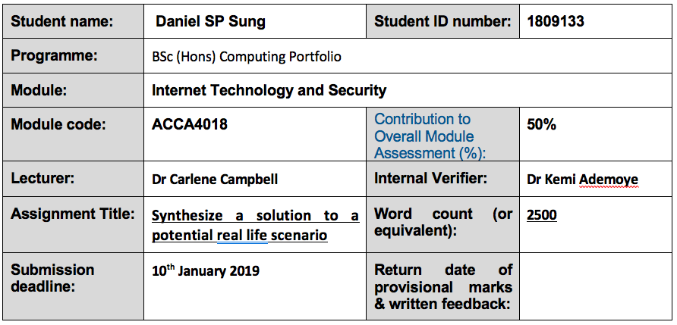
Table of Contents
Title |  | Page
Propose design and mitigate threats emanating from implementation of ……………. deploying BYOT at Hyper-fort |  | 1
Abstract
Introduction
Assumptions
Advantages and disadvantages of BYOT | ……………………………… | 2
Advantages of BYOT
Disadvantages of BYOT | ……………………………… | 3
Select a Mobile Device Management Software for your BYOT and explain the …….. rationale for your choice. |  | 4
Unified Endpoint Management
Core functions of UEM
BYOT implement processes | ……………………………… | 6
Mitigate other potential risks or user BYOT device lost ……………………………… |  | 7
Network diagram | ……………………………… | 8
Reference Cited | ……………………………… | 9

Propose design and mitigate threats emanating from implementation
of deploying BYOT at Hyper-fort

Abstract

As electronics, storage devices and miniaturisation technologies advanced, electronic computers become smaller, faster and more processing power, where general users can afford. These comes with different device preference from users. On top of companies are encourage to be more environmental responsible, Bring Your Own Device/Technology (BYOD/T), have become an option for many companies, to reduce their Carbon Footprint, such as, encourage employee to use public transports instead of driving their cars to work, to better waste recycling.
The following report is proposing a design and mitigate threads from implementation of deploying BYOT a large staff and customer base consultancy company specialised in the energy sector.

Introduction

Hyper-fort has a large present globally as a specialised energy sector consultancy company, much of their IT infrastructure is cloud based services, with 95% of their network is wireless.

Assumptions
From investigations of energy sector consultancy firms, they all have commons in:
- Global organisations, have branches in many sites across regional Head Quarters (HQ) in different Continents
- Staff maybe energy specialists in their field in each site.
- Provides consultancy, developments and Implementation of new business models [1].
- Runs collaboration with their customers to develop new strategies and improves operating models [2].
- Provide solution towards IT strategy with uses of software monitoring and Internet of Things (IoT) [1] [3]
- Runs training programs after implementation for customer staff
- Hyper-fort main core research data are stored offsite by sub-contractor in a Data Farm
- Company’s emails and some staff and clients/students/collaborators data stored in the Cloud by sub-contractor
- There are already network and server infrastructure in place for user access application and data services

Advantages and disadvantages of BYOT

According to document from IBM “Ten rules for bring your own device (BYOD) [4], there is no one size fit all with IT equipment for staff. A research analyst may require a more processing hungry computer/device than an admin staff. A well suite device will reduce staff to discover how to operate the new or unfamiliar device. A new starter may not have the eligibility for the type of device he required or takes time to “get used” an equivalent device the company offered. Furthermore, Hyper-fort, may have many collaboration clients or customers may prefer to use their own devices when they are working in Hyper-fort offices’.

Example :
Fife Council saves £20m through flexible mobile working solution [5]
Fifi is Scotland third largest council estimated to save £20m by introducing BOYT.

Advantages of BYOT

- Staff have unlimited access to their own device
Device belongs to staff, be it at home or office. These offer staff mobility and work from anywhere at anytime

- Familiarity with device increase staff productivity
Staff familiar with their own settings of the device, rather than jumble with 2 or more devices at office or home to get work done. These will increase staff productivity

- Reduced company’s IT procurement cost
Company no need to purchase the device for staff

- Reduced Warrant and cost of recycling devices
Company have asset management system to keep track of IT devices, with BYOT will required to assure the devices working by purchasing extra covers for the device.
Also, reduced IT staff time to keep track of assets of old redundant devices. Furthermore, reduced cost is obligation to ensure the redundant devices are disposed in environmental manner

- Reduced time in support new devices and training
Often IT staff wasted time to search for devices for staff. Also, time wasted for staff to obtain the device from IT department. Since Staff are familiar with their personal device, hence less training with the device.

Disadvantages of BYOT

- Security with staff personal device
Staff may be accessing sensitive company information using their personal devices. Ensuring their device is free from Malware infection and managing the staff Internet access are difficult with personal devices. Whereas, with company owned devices, the company ensure the devices are protected from malicious applications. Also, it will have company’s group policy applied to restrict/control the devices in accessing Internet sites.

- Supporting various devices
Company owned devices have a limited range of made of IT devices to support, with well tested hardware and software deployments. Also, controllable software updates, so that it will not conflict with the company’s infrastructure systems.
Whereas, BYOT, will depends on individual staff to ensure their devices hardware and software up-to-date, and OS has the latest or patched properly.
Extra time required for IT staff to learn different hardware and software to support staff.
- Increase monitoring of Information and network security
It staff will required to spend more time in monitoring staffs’ personal device network and data traffics to ensure the company’s information and infrastructure not compromised
- Data control
if staff log in to company data centre from a compromised device with key loggers or other malware, then the employee and the device both are as harmful as a hacker.

Select a Mobile Device Management Software for your BYOT and explain the rationale for your choice.

Introducing BYOT bring other challenges to company, especially with regards to security. normally company will have a “mobile policy” in address this concern. It will be required staff to install certain antivirus program or certain software staff installed in their device that is blacklisted. Also, occasionally when staff need IT support to certain application in the staff BYOT, it might require remoting into staff own BYOT, which means the IT engineer can access to the staff non-work personal data.

Mobile device management software is a security application that enable IT department to manage, monitor and secure staff’s BYOT across the company and deployment to different operating systems and any networks [6].
Also, together with other tools such as, mobile application management (MAM) to form a complete enterprise mobility management (EMM).

Citrix Unified Endpoint Management (UEM) is chosen, because it manages “endpoints” devices, it combines traditional client management tools (CMT) with enterprise mobility management (EMM) to provides a single platform to manage and secure devices and operating systems, any laptops, smart phones, tablets or any other device [7] [8].

Unified Endpoint Management

Laptops
and desktops
Smart phones tablets
All device types
CMT
Traditional Client Management Tools
EMM
Enterprise Mobility
Management Tools
UEM
Combined systems built on EMM platform

Core functions of UEM

MDM
Mobile Device
Management
MAM
Mobile Application Management
IDM
Identity
Management
CMT
Content
Management

Containment

together its offers:
- Consistency across different OS platforms
can implement a single set of enterprise management and security policies across all devices

- Mobile friendly management
staff can acquire a device with the vendor configuration operating system and applications and use the enterprise EMM portal and configuration app to enrol the configure their device themselves over the wireless according to the corporate settings and policies

- Containerisation
using wrapping, encryption types of methods, IT staff can separate corporate and personal applications and data on the device, so interaction between them are disabled or restricted according to the enterprise security policies.

BYOT implement processes

Staff/client(users) working in office with their BYOT, connected to their given wireless network. Depends on their access rights and assigned to specific virtual network with access rights. If the device is new to the company, users can download the Citrix receiver application and run the application. the application is compatible for most portable devices, such as, laptops to tables. It will ask the users to sign on, using their own company user name and password. Citrix receiver will load with a pre-configured platform, from which users can add and reconfigure the desktop to suit them.
This will address the problem with different brands of devices. also, because Citrix receiver application is platform independent, it will run on most of the operating systems (OS). from Microsoft Windows OS, Apple macOS to most of the mobile devices OS.

One of the way company allows BYOT is to employ containerisation.
Containerisation stop both potential data leakage and malware infection. Personal and enterprise applications and divided/walled off from each other, any malware downloaded from personal applications has no impact in the containerised enterprise environment applications. Also, it will not able to transmit to the enterprise network when the device is connected to the company’s network.

Most of the operating systems API allows IT department to configure and enforce a number of policies that stop users from ability to “cut and paste data from enterprise to personal area, transfer enterprise data or files to personal email messages or print company files may contains sensitive data.

For general admin staff, the normal platform will be suffice, but for the research staff who might need to access more company’s sensitive data or development applications. They will need to connect via Virtual Private Network (VPN) to another server to allows them use sensitive data or writing development programs. Also, data that deemed high classified, the user might need to FTP from Data Centre to a holding area for them the user to run analytical process.

Because Hyper-fort provides consultancy, developments and Implementation works. Some staff’s BYOT may not have the processing power to run some of the applications, such as, SAS “Statistical Analysis System” application to perform complex statistical data mining process. the company can process more powerful laptops or computers in office for staff to use. Users can log in to the computers and run the Citrix receiver application will load the user’s own profile.

For more application/data sensitive research or specific group of users would like to access to directly classified data. A separate office only accessible using physical mifi id locks. Inside is contains separated cubical with privacy screen protector, so other users cannot see the information on the screen when passing.

Hyper-fort also, collaborate with other companies and provides training. Using Citrix receiver, the guests/clients can use their own company mobile devices, such as, laptops, tablets or mobile phones, download the Citrix receiver application and log in using Hyper-fort provide user accounts to access teaching materials and coloration works.

Mitigate other potential risks or user BYOT device lost
Potential breach can be in the form of
- disgruntled employee
- staff leaver
- external company collaborate work completed
- external trainees/students course completed
- staff participating device lost, stolen or not working

disgruntled employees
disgruntled employees occasionally to leads to “whistle-blower” with malice intends to discredit the company. They can steal company sensitive date and research and pass it on to competitors. Citrix receiver runs a virtual desktop platform with containerisation. It can block users from transfer/copied company data or applications to removable media, such as, USB flash drives or CD even printing.
However, there are danger of user taking mobile pictures of the screen display with sensitive data.

Staff Leaver
when employee left the company, their account will be backed up and deleted. Once their account is disabled or password changed, it will not be able to run the Citrix receiver application. Even though the application is installed in the leaver BYOT, but it will failed to authenticate with the company active directory (AD).

External company collaborate work completed
Users from external company accounts will be treated as Leaver, will be processed via company Leaver procedure

External trainees/students course completed.
Most of the training material stored in a separate virtual server with non real-life data. Once the users completed their course it be treated as Leavers.

Staff Participating device lost, stolen or not working
Citrix Unified Endpoint system separate the staff personal desktop with the company’s desktop environment, through virtual desktop platform. If the device is lost or stolen there are no data and application stored/installed in the staff device. Also, if the device is not working, it no need to recover any company data from the device. The staff can use another working device, install Citrix receiver and login to the company virtual desktop, it will load the staff personal desktop.

Network diagram

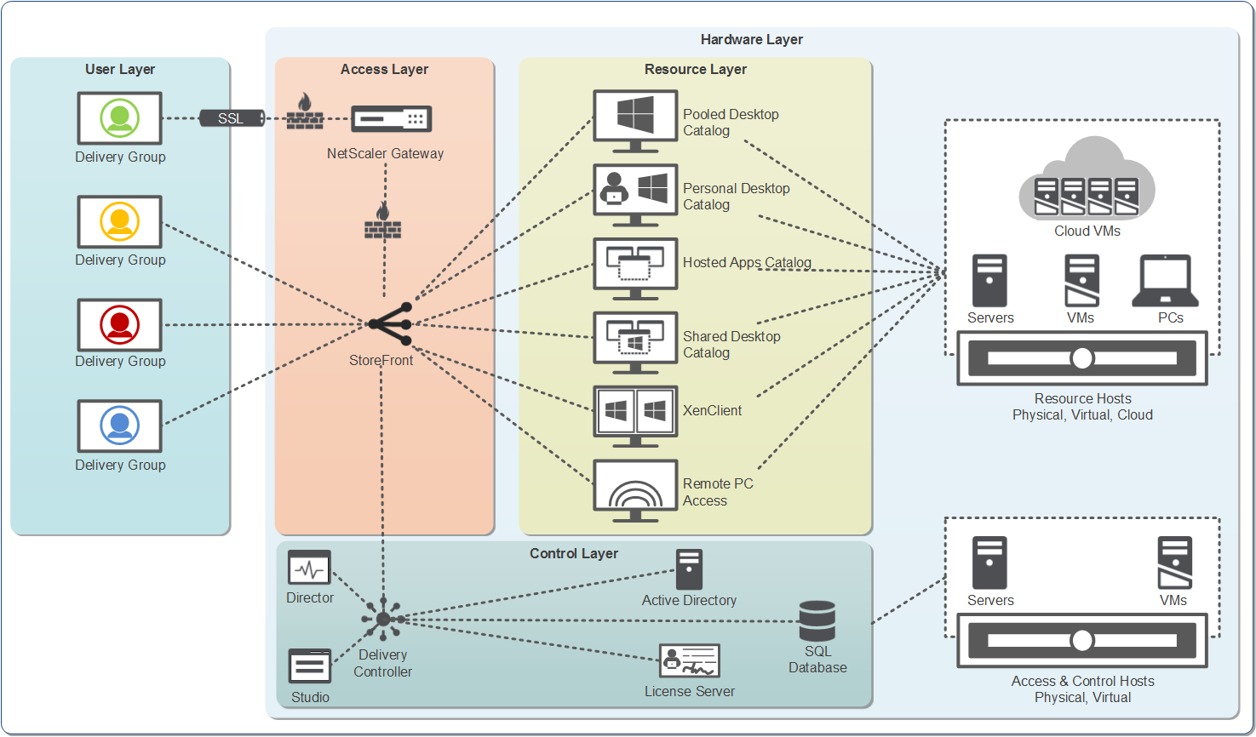
fig: conceptual architecture diagram of XenApp and Xen desktop [9]

Reference Cited

[1] | Capgemini, "New technologies empower energy and utility leaders," Capgemini, 02 2018. [Online]. Available: https://www.capgemini.com/industry/utilities/#. [Accessed 05 01 2019].
[2] | PwC, "Energy, utilities & resources," PwC, 18 01 2011. [Online]. Available: https://www.pwc.com/gx/en/industries/energy-utilities-resources.html. [Accessed 05 01 2019].
[3] | PwC, "Power & utilities," PwC, 06 01 2017. [Online]. Available: https://www.pwc.com/gx/en/industries/energy-utilities-resources/power-utilities.html. [Accessed 05 01 2019].
[4] | IBM, "BYOD: Bring your own device - Learn why you should adopt BYOD," IBM, 01 2018. [Online]. Available: https://www.ibm.com/mobile/bring-your-own-device. [Accessed 05 01 2019].
[5] | C. Baldwin, "Fife Council saves £20m through flexible mobile working solution," ComputerWeekly.com, 14 11 2013. [Online]. Available: https://www.computerweekly.com/news/2240209032/Fife-Council-simplified-and-saves-through-flexible-mobile-working-solution. [Accessed 05 01 2019].

marking criteria and Student FEEDBACK

This section details the assessment criteria. The extent to which these are demonstrated by you determines your mark. The marks available for each criterion are shown. Lecturers will use the space provided to comment on the achievement of the task(s), including those areas in which you have performed well and areas that would benefit from development/improvement.

Common Assessment Criteria Applied (Assignment 1) | Marks available | Marks  awarded
1. Research-informed Literature
Extent of research and/or own reading, selection of credible sources, application of appropriate referencing conventions.
The research lacks strength, only five references are identified within the report. The sources are all online resources and have no journals, articles or white papers. The IEEE referencing format is however deployed for the five sources. (Grade mark: 60.00%) | 15 | 9
2. Knowledge and Understanding of Subject
Extent of knowledge and understanding of concepts and underlying principles associated with the discipline.
As the depth of the research is limited the report itself is poorly structured and lacks context for the reader to be confident in the report. (Grade mark: 46.67%) | 15 | 7
3. Analysis
Analysis, evaluation and synthesis; logic, argument and judgement; analytical reflection; organisation of ideas and evidence
The analysis of the BYOT is well presented but lacks in academic sources to justify the points discussed, the implementation whilst being discussed has no point of reference as there is no simulation to relate to, along with no conclusion. (Grade mark: 50.00%) | 40 | 20
4. Practical Application and Deployment
Deployment of methods, materials, tools and techniques; application of concepts; formulation of innovative and creative solutions to solve problems.
As no simulation was uploaded to the Moodle link and no reference is made to it within the report this section has not been marked. (Grade mark: 0.00%) | 20 | 0
5. Skills for Professional Practice
Attributes in professional practice: individual and collaborative working; deployment of appropriate media; presentation and organisation.
The report is poorly laid out without the use of proper numbered sections which makes it difficult to identify from the table of contents. Justifying the text will also allow for the reader to focus their attention. (Grade mark: 40.00%) | 10 | 4

Assignment Mark (Assessment marks are subject to ratification at the Exam Board. These comments and marks are to give feedback on module work and are for guidance only until they are confirmed. ) | Late Submission Penalties (tick if appropriate) |  | 40%
 | Up to four weeks late |  | 40%
 | First Attempt? |  | 40%

