Advanced RF Assignment

Cameron Paul Fitze
University of Wales Trinity St David
Course Number:
Course Name: BEng Embedded Electronic Systems



Abstract
Radio frequency (RF) antennas are a means of taking an electrical signal from its source, and transmitting it through a medium to a receive antenna. The design of these antennas affects the way the electromagnetic (EM) wave transits across a medium, known as propagation, to the destination receive antenna.
This report critically examined various types of antenna design including Patch, Cylindrical Dipole, Folded Dipole, Horn, and Helix, and modelled and simulated them on using the software packages: MATLAB or Ansys.

Contents
1. Introduction 5
1.1 Aim 5
1.2 RF antennas 5
2. Methodology 6
3. Background Research 7
2.1 Antenna Types and Propagation Patterns 7
2.3 Antenna Lobes 8
4. Results 9
4.1 Task 1 – Microstrip (Patch) Antenna 9
3.1.1 Design 9
3.1.2 Simulation Results 12
4.2 Task 2 13
4.3 Task 2 A – Cylindrical Dipole 13
4.4 Task 2 B – Horn Antenna 16
4.5 Task 2 C – Folded Dipole 21
5. Conclusions 25
5. Recommendations 26
References 27

Table of Figures
Figure 1 - Antenna Lobes 8
Figure 2 - Patch Antenna Design 11
Figure 3 - Patch Antenna Design - side-on view 11
Figure 4 - Patch Antenna S11 – result 1 12
Figure 5 - Cylindrical Dipole Design 13
Figure 6 - Cylindrical Dipole S Parameters 14
Figure 7 - Impedance results for Cylindrical Dipole 14
Figure 8 - Cylindrical Dipole 3D Pattern 15
Figure 9 - 2D Radiation for Cylindrical Dipole 16
Figure 10 - Horn Antenna Design 16
Figure 11 - Horn Antenna Impedance Results 17
Figure 12 - Horn Antenna S Parameters 18
Figure 13 - Horn Antenna 3D Radiation Pattern 19
Figure 14 - Horn Antenna 2D Radiation Pattern (Azimuth) 20
Figure 15 - Folded Dipole Design 21
Figure 16 - Folded Dipole Impedance 22
Figure 17 - Folded Dipole S Parameters 22
Figure 18 - Folded Dipole 3D Radiation Pattern 23
Figure 19 - Folded Dipole 2D Radiation Pattern (Azimuth) 24

List of Tables

Table 1 - Patch Antenna Design Information 12

Introduction
This assignment is produced for the L6 Advanced Radio Frequency (RF) module as part of the BEng Embedded Electronic Systems Course at the University of Wales Trinity St David (UWTSD).

Aim
The aim of this assignment is to design, simulate and analyse various RF (radio frequency) antennas using the software Ansys High-Frequency Structure Simulator (HFSS) .

RF antennas
RF antennas are used to take an electrical signal and convert it to an electromagnetic (EM) wave for transmission across a medium. This transmission is known as propagation, and the way in which EM waves propagates vary depending on the antenna design.
This report examines the affect various types of antenna designs have on an EM wave’s propagation characteristics.

Methodology
This project comprises of the following stages:
- Background research (see section 3)
- Results, including antenna designs, for all tasks (see section 4)
  - Task 1 (see section 4.1)
  - Task 2 (see section 4.2)
- Conclusions (see section 5)
- Recommendations (see section 5)
The background research uses information sourced from various internet sources to ascertain what information is currently know, specifically regarding RF antennas and propagation, and information personally obtained from university lectures.
The antenna design, modelling, and simulation stage involves the use of the software packages Ansys and MATLAB. The design on Naysays involves creating the antenna from scratch, whereas, MATLAB’s antenna wizards will be used for Task 2, where it draws the antenna once frequency data is input.
The antennas are then simulated, with the following results obtained for analysis:
- S Parameters
- Impedance
- 3D radiation
- 2D radiation (Azimuth)

Background Research
Antennas are a means of taking transporting an electrical signal from its source to its destination as a radio wave, via transmit and receive antennas. The behaviour of the propagating electromagnetic (EM depends upon the design of the antenna.
The antenna designs explored within this assignment are as follows:
- Patch antenna – Task 1
- Cylindrical Dipole – Task 2 A
- Folded Dipole – Task 2 B
- Horn Antenna – Task 2 C
- Helix antenna – Task 2 D

2.1 Antenna Types and Propagation Patterns
A patch antenna is an antenna that can be printed onto a printed circuit board (PCB). It consists of a the main antenna with a feed line going from the edge of the substrate to the edge of the patch. Patch antennas are know for their narrow band propagation [1]. Patch antennas are directional.
A Cylindrical Dipole is an omnidirectional antenna. Its length is equal to,$\frac{λ}{2}$ , where $λ$ is the wavelength (in metres). Dipoles are used in Terrestrial Television applications.
A Folded Dipole is a type of loop antenna that is used as a feeding element in antennas such as a Yagi-Uda antenna, or a parabolic antenna. Its radiation pattern is omnidirectional.
A Horn antenna is a directional antenna that uses a waveguide, the horn, to direct the radio waves in a beam. They are used in microwave-frequency applications.
A helical (helix) antenna is used is satellite-based applications. It experiences maximum directivity along its axis where it radiates a circular polarized signal [2]. Helical antennas must have at least 3 turns in order to achieve circular polarization.
Antennas propagate in a direction as determined by their design. The propagation patterns are known as follows:
- Omnidirectional – this is where the antenna propagates in two predetermined directions, as found in a dipole antenna
- Directional – this is where the antenna propagates in one predetermined direction, as found in a Yagi-Uda antenna
- Isotropic – this is where an antenna would propagate perfectly in all directions with a gain of 0dB – this is not possible in the real world and is used as a reference when measuring the performance of an antenna, hence the unit decibels relative to isotropic (dBi) .

2.3 Antenna Lobes
Figure 1 shows a diagram of the lobes that appear as a results of an antennas radiation. The size of the lobe is proportional to the signal strength, or gain (in dB), in that particular direction.
[3]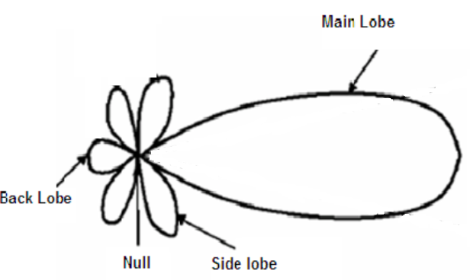
Figure 1 - Antenna Lobes
The Main lobe is the main direction of the signal being transmitted, where the antenna gain is highest.
Side Lobes are areas of radiation where a signal is still being transmitted or received in directions other than that of the main lobe.
The Back Lobe is energy being radiated in the direction opposite to that of the main lobe. This is usually due to RF reflection, and the higher the back lobe, the less gain will be experienced in the main lobe, thus degrading antenna performance.
Nulls are areas where there is no radiation.

Results
This section details the results from the evaluation of each antenna evaluated as part of this assignment. This section also encompasses the antenna design/ modelling information.
The dimensions of the antennas were determined using the following equations:
- $C=Fλ$, where$C \left(the speed of light\right)=3x{10}^{8}m/s$,$F=resonant frequency (Hz)$ and$λ=wavelength (m)$.
- $L= \frac{λ}{2}$, for dipoles, where $L=antenna length (m)$

Task 1 – Microstrip (Patch) Antenna

3.1.1 Design

3.1.1.1 Equations
Task 1 involves an evaluation of a patch antenna. For the patch, the desired centre frequency was the $first digit of student ID x second digit of student ID$, so for this assignment that was $2*1 (GHz)=2GHz$.
The width of the patch was calculated as follows:
$$w= \frac{c}{2(fr)√\frac{ε_{r}+1}{2}}$$
Where w = width, c = speed of light, $fr$ = resonant (centre) frequency, $εr=$ relative permittivity (of FR4 for this task)
For this assignment:
$fr=2.1 x {10}^{9}$Hz
$$ε_{r}=4.4$$
C = $3 x {10}^{8}$m/s
$$w= \frac{3 x {10}^{8}}{2(2.1 x {10}^{9})√\frac{4.4+1}{2}}=0.04347m$$

The length of the antenna feed is calculated using the following equation:
$$ε_{reff= \frac{ε_{r}+1}{2}+\frac{ε_{r}-1}{2}(\frac{1}{\sqrt{1+12\left(\frac{H}{W}\right)}})}$$
Where:
$ε_{r}=relative permitivitty of FR4$, given in the task description as 4.4
$$H=height of substrate, given in the task description as 1.6 x {10}^{-3}m$$
$$W=width of patch, which was calculated in the previous equation as 0.04347m$$
Therefore:
$$ε_{reff= \frac{4.4+1}{2}+\frac{4.4-1}{2}\left(\frac{1}{\sqrt{1+12\left(\frac{1.6 x {10}^{-3}m}{43.47 x {10}^{-3}m}\right)}}\right)=4.116 }$$

Now, the length extension can be calculated, using the following equation:
$$ΔL=0.412h\left(\frac{{(ε}_{reff}+0.3)(\frac{w}{h}+0.264)}{{(ε}_{reff}-0.258)(\frac{w}{h}+0.8)}\right)$$
And now, the actual length can be determined, using the following equation:
$${L=L}_{eff}-2ΔL$$
$$L= \frac{c}{2f_{r}\sqrt{{(ε}_{reff}}}-0.824h\left(\frac{{(ε}_{reff}+0.3)(\frac{w}{h}+0.264)}{{(ε}_{reff}-0.258)(\frac{w}{h}+0.8)}\right)=7.401x{10}^{-4}m$$
$$L= \frac{3x{10}^{8}}{2x2.1x{10}^{9}\sqrt{4.116}}-0.824(1.6x{10}^{-3})\left(\frac{\left(4.116+0.3\right)\left(\frac{0.04347}{1.6x{10}^{-3}}\right)+0.264)}{\left(4.116-0.258\right)\left(\frac{0.04347}{1.6x{10}^{-3}}\right)+0.8)}\right)=0.03368m$$

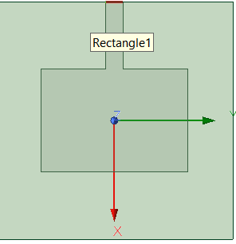
Figure 2 - Patch Antenna Design
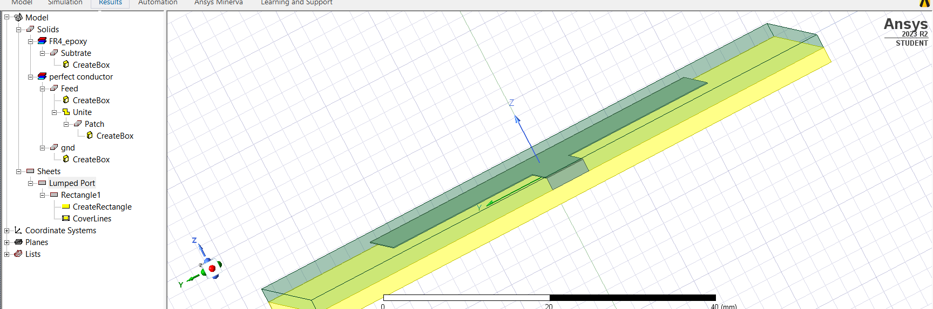
Figure 3 - Patch Antenna Design - side-on view
Figure 2 shows the patch antenna design. This is a top-down view on Ansys, and shows the general shape of the antenna. There is the main patch in the centre, with a feed connecting from the edge of the substrate, which both the feed and patch sit on.
Figure 3 shows the model view but from a side on perspective, enabling vision of the physical dimensions/ footprint of the antenna in the Z axis.
The antenna design information can be found in Table 1.
Model | Material | Width (m) | Length(m) | Height (m)
Substrate | FR4 | $$70x{10}^{-3}$$ | $$70x{10}^{-3}$$ | $$1.6x{10}^{-3}$$
Feed | Perfect Electrical Conductor (PEC)
Lumped Port | N/A | $$70x{10}^{-3}$$ |  | $$1.7x{10}^{-3}$$
Ground Plane | PEC | $$70x{10}^{-3}$$ | $$70x{10}^{-3}$$
Patch | PEC | $$43.47x{10}^{-3}$$ | $$33.68x{10}^{-3}$$ | 0.1
Table 1 - Patch Antenna Design Information

3.1.2 Simulation Results
Once the antenna design was complete, it needed to be simulated. Once the simulation had been run on Ansys, various results can observed. The task was to observe the radiation pattern and resonant frequency of the antenna.

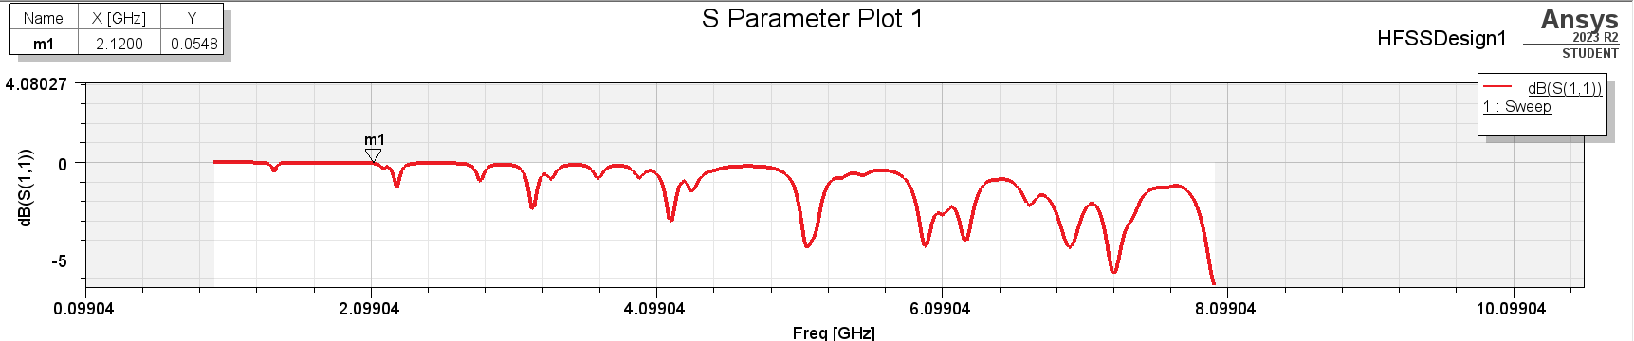
Figure 4 - Patch Antenna S11 – result 1
Figure 4 shows the s11 parameters of the preliminary patch antenna. As observed, the gain at the target frequency of 2.1GHz is -0.0548dB, which is very poor, in fact, this antenna at this stage is not really operating at this frequency. This therefore required some modifications to the design in order to resolve this issue, which will involve, as one observes the S parameter plot, moving a trough to the target frequency, with a value ideally of around -20dB.
The next iteration of this antenna included modifications to its size. This antenna, as shown in Figure 4, was resonating at much higher frequencies than was required. The equation,$C=Fλ$, shows that an EM signal’s wavelength is inversely proportional to its frequency, and as $λ$ is proportional to length, $L$, it can be deduced that the higher the frequency, the lower the wavelength, and thus the smaller the length of the antenna. It was therefore decided to reduce the length of the antenna in order to bring the resonant frequency down as close to the desired resonant frequency as possible.

Task 2

Task 2 A – Cylindrical Dipole
Task 2A was involved the design, simulation and analysis of a dipole cylindrical antenna.

Design
For the Cylindrical Dipole, the desired centre frequency was the second digit of the student ID (in GHz), so for this assignment, that was $1Ghz.$ The antenna length was calculated using the equation $c=fλ, then, \frac{λ}{2} ,$ as this is a dipole antenna. This resulted in a length of 1.35m.
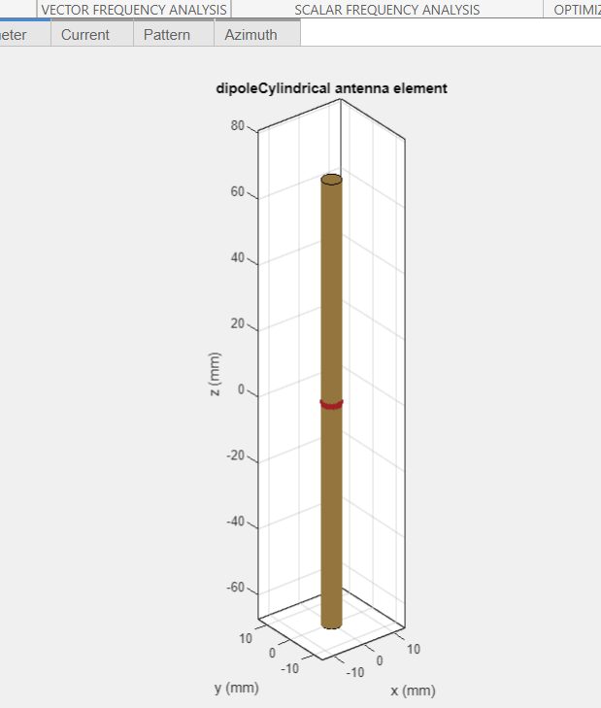
Figure 5 - Cylindrical Dipole Design
Figure 5 shows the Cylindrical Dipole model on MATLAB. This is a view from the corner, or where the x and y axis’ meet.

Results

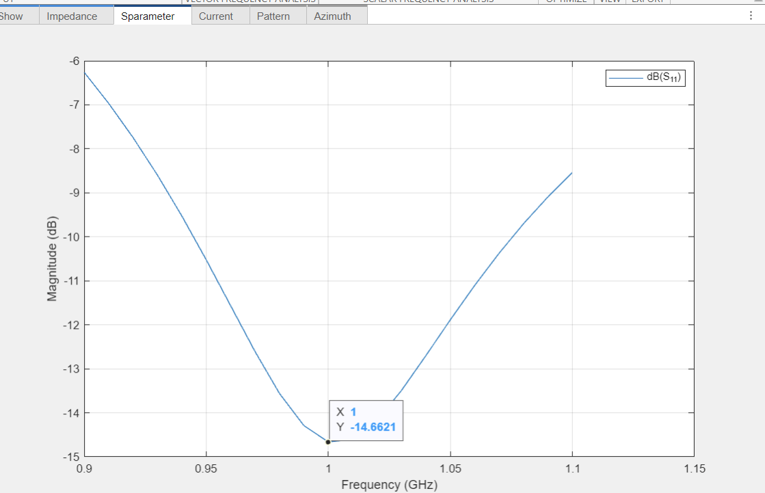
Figure 6 - Cylindrical Dipole S Parameters
Figure 6 shows the S Parameters for the dipole. These are actually fairly good, with a figure of -14.6GHz at resonance (1GHz).
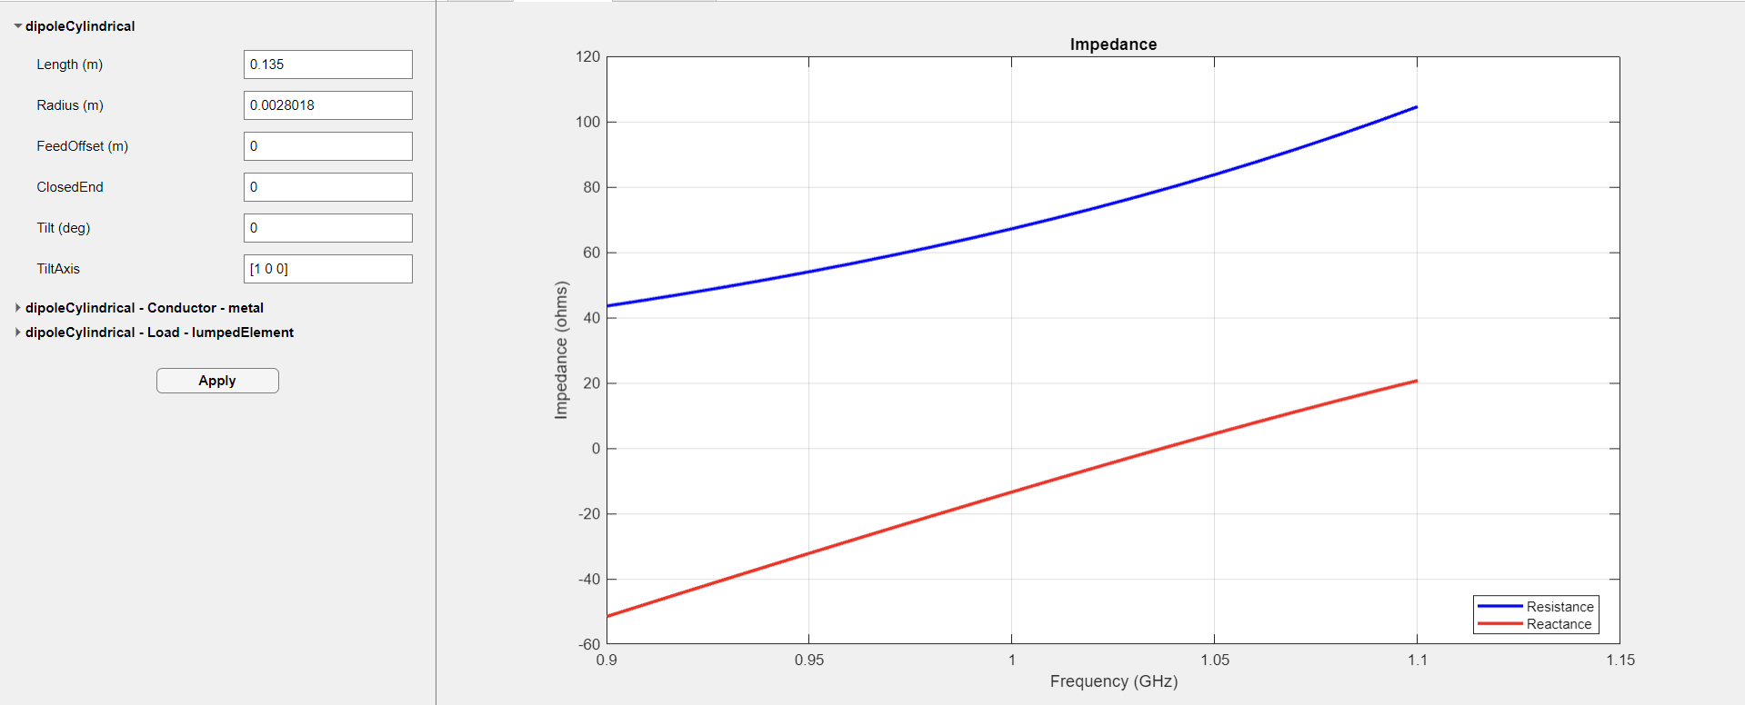
Figure 7 - Impedance results for Cylindrical Dipole
Figure 7 shows the impedance results for the cylindrical dipole. As observed, impedance is approximately 64Ω. Interestingly, when the antenna length was decreased slightly from 0.135 to 0.127, this moved the 50Ω impedance to the 1GHz frequency. However, this moved the resonant frequency higher up the frequency range, and thus left the gain at 1GHz at approximately -8dB.
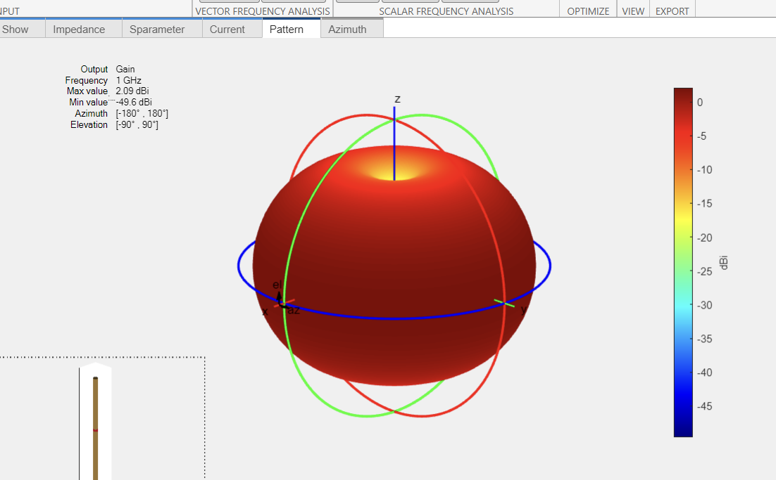
Figure 8 - Cylindrical Dipole 3D Pattern
Figure 8 shows the 3D radiation pattern of the dipole. The dipole is omnidirectional at the top and bottom, so this image is not the best to represent the radiation pattern of the cylindrical dipole. This is better observed in a 2D radiation plot, or Azimuth.
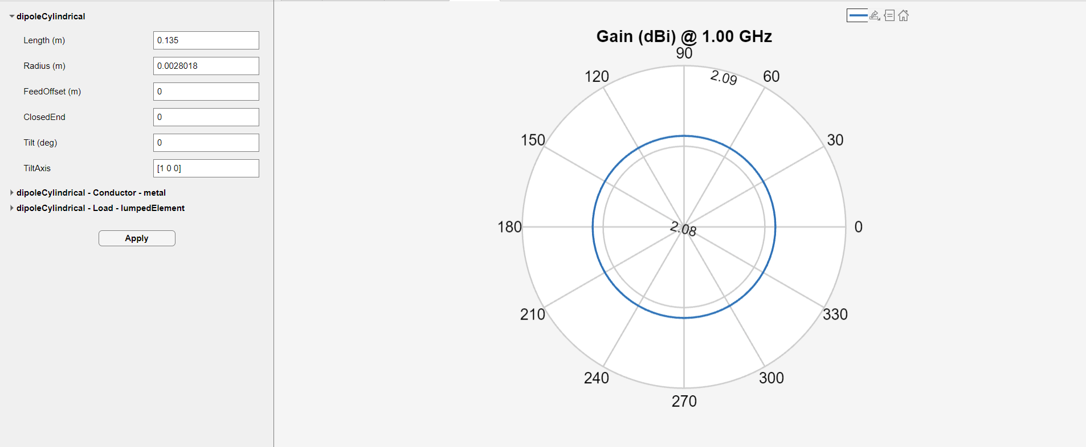
Figure 9 - 2D Radiation for Cylindrical Dipole
Figure 9 shows the 2D radiation plot for the cylindrical dipole. As observed, the cylindrical dipole is radiating in an omnidirectional manor.

Task 2 B – Horn Antenna

Design
For the Horn antenna, the desired centre frequency was (Third and Fourth digits of student ID)/2, so for this assignment that was $\frac{17}{2} GHz, so f_{r}=8.5GHz.$
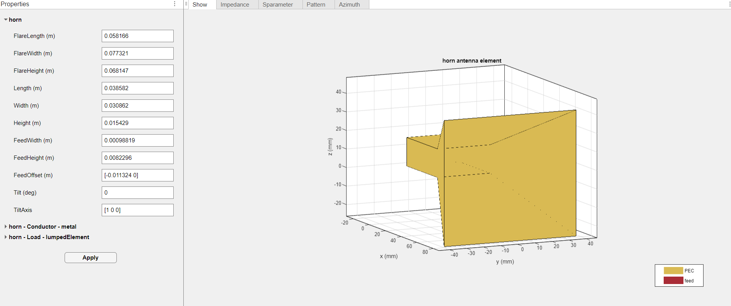
Figure 10 - Horn Antenna Design
Figure 10 shows the Horn Antenna model on MATLAB. There are various types of Horn antenna that could have been chosen, including a corrugated horn. Once the frequency was inputted, the software calculates the correct dimensions that should enable it to resonate at the desired frequency.

Results
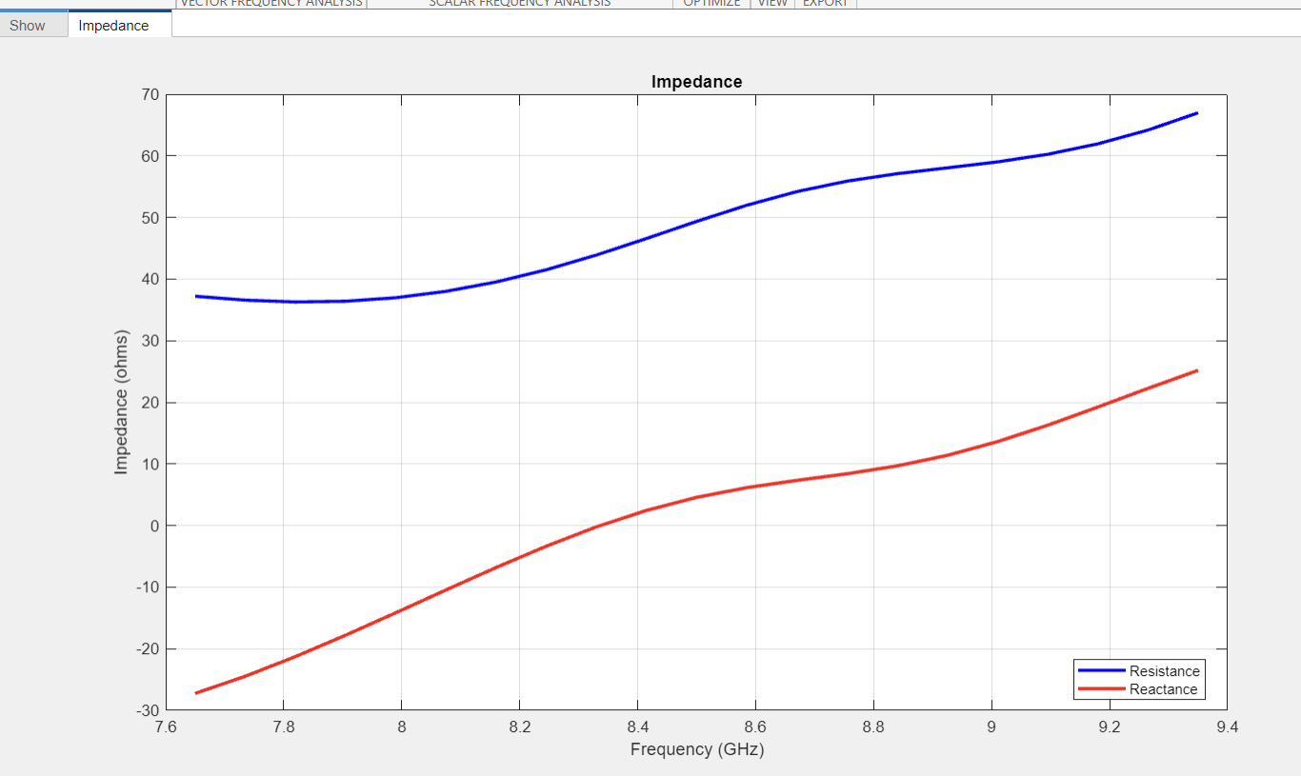
Figure 11 - Horn Antenna Impedance Results
Figure 11 shows the impedance results for the Horn antenna. As shown, at the resonant frequency of 8.5GHz, impedance (Z) is approximately 50Ω. This shows that the antenna is almost perfectly matched.
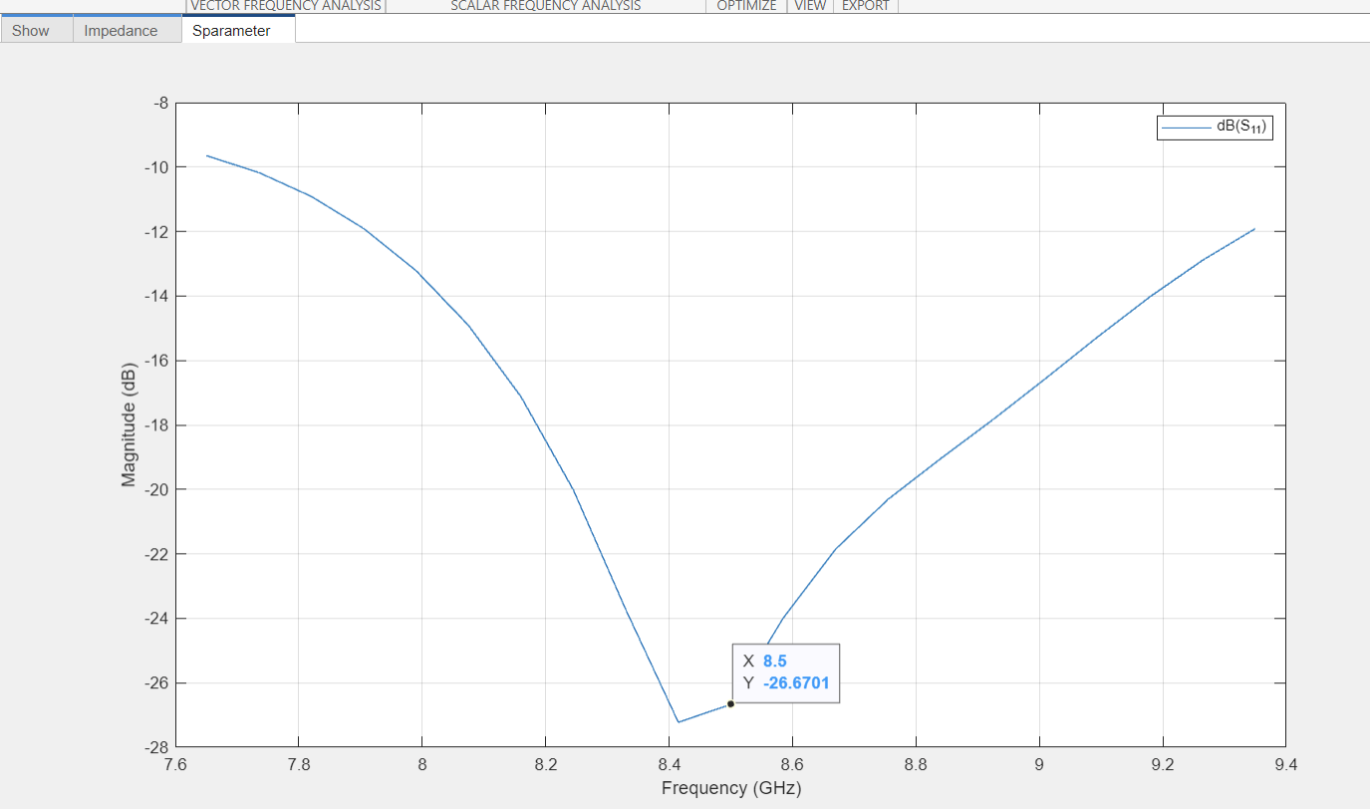
Figure 12 - Horn Antenna S Parameters
Figure 12 shows the S parameters for the Horn Antenna. As shown, the antenna is resonating fairly close to the desired 8.5GHz, with a gain of -26dB at $f=8.5GHz.$
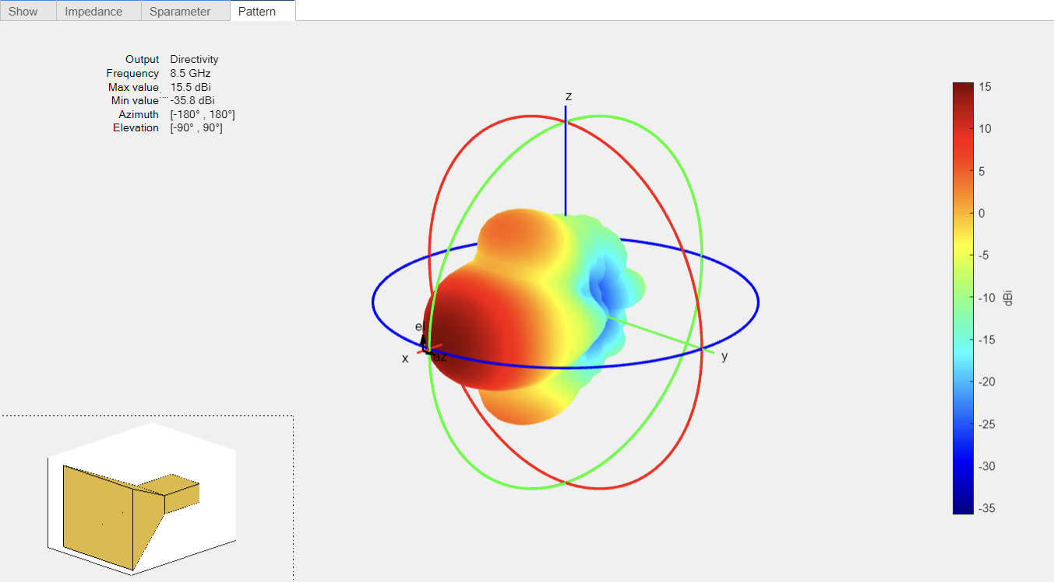
Figure 13 - Horn Antenna 3D Radiation Pattern
Figure 13 shows the 3D radiation patter for the Horn Antenna. As show, it is radiating most of its energy in a directional manor through the horn’s aperture. Horn antennas are used for applications that require directionality, so this particular antenna is performing as expected.
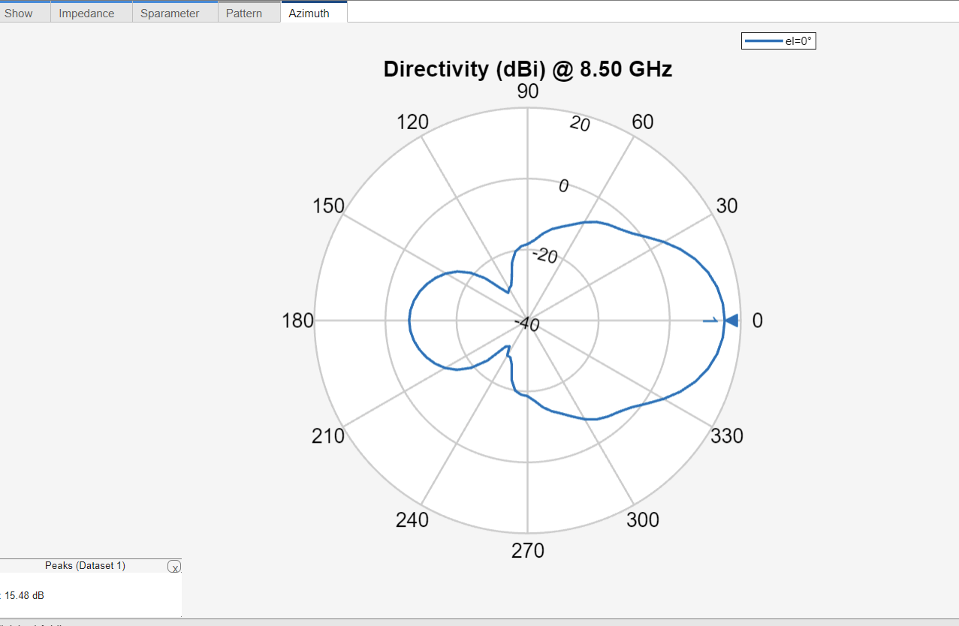
Figure 14 - Horn Antenna 2D Radiation Pattern (Azimuth)
Figure 13 shows the horn antenna’s Azimuth (2D radiation pattern). This shows that the peak gain is at 0°, which further shows its radiation directionality. There is a slight back lobe, which shows that there is some reflection in this antenna, and there are no nulls.

Task 2 C – Folded Dipole

Design

For the folded dipole, the desired centre frequency was $\frac{First three digits of student ID}{2}$, so for this assignment that was $\frac{211}{2}MHz=105MHz$.
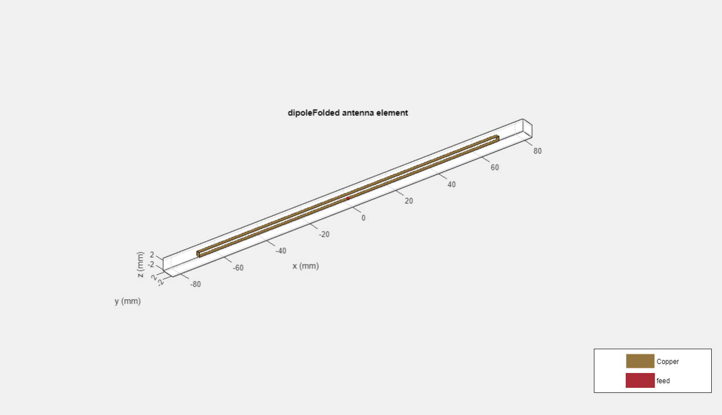
Figure 15 - Folded Dipole Design
Figure 15 shows the folded dipole design. The length was calculated as $1.42m.$

Results
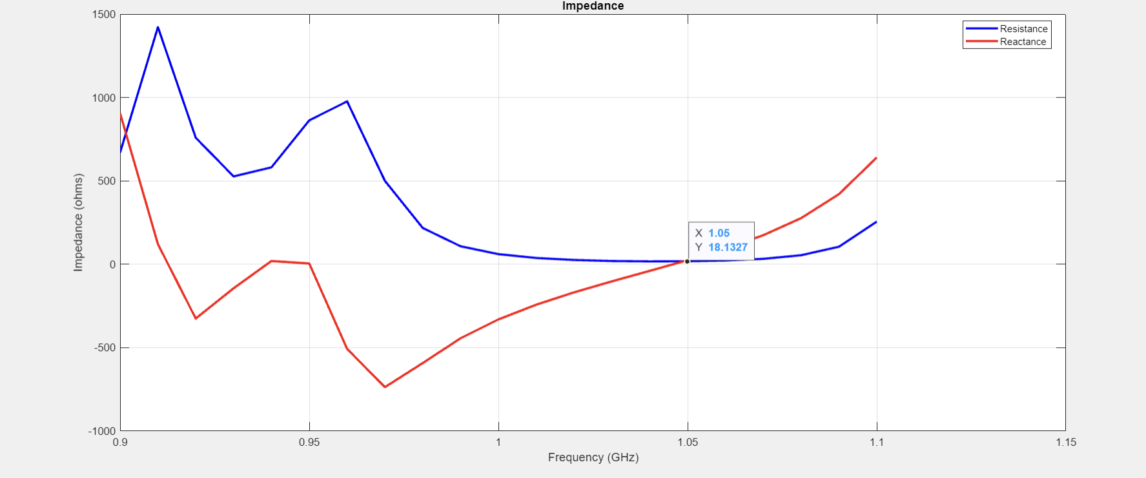
Figure 16 - Folded Dipole Impedance

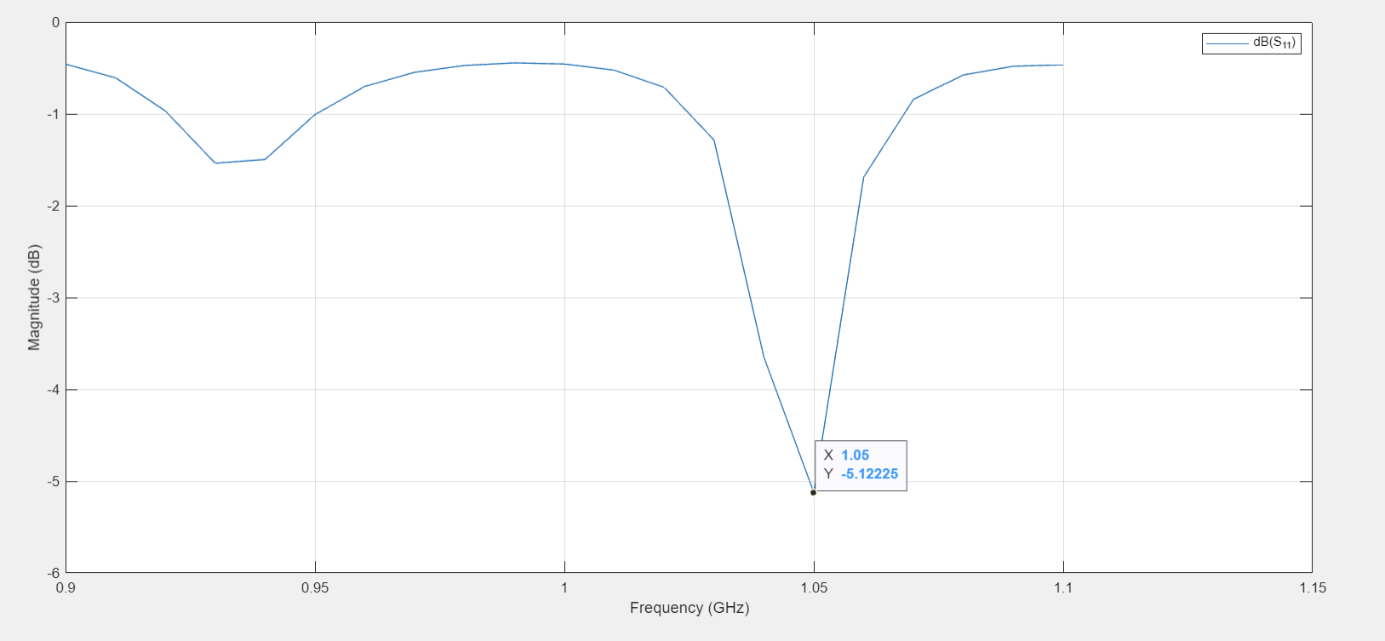
Figure 17 - Folded Dipole S Parameters
Figure 17 shows the folded dipole S Parameters. As one can observe, the best antenna gain is right on the resonant frequency. However, the overall antenna gain of -5.1dB is rather poor, considering the -3dB is a loss of half power, this suggests that there is a lot of loss with this antenna in its current state.

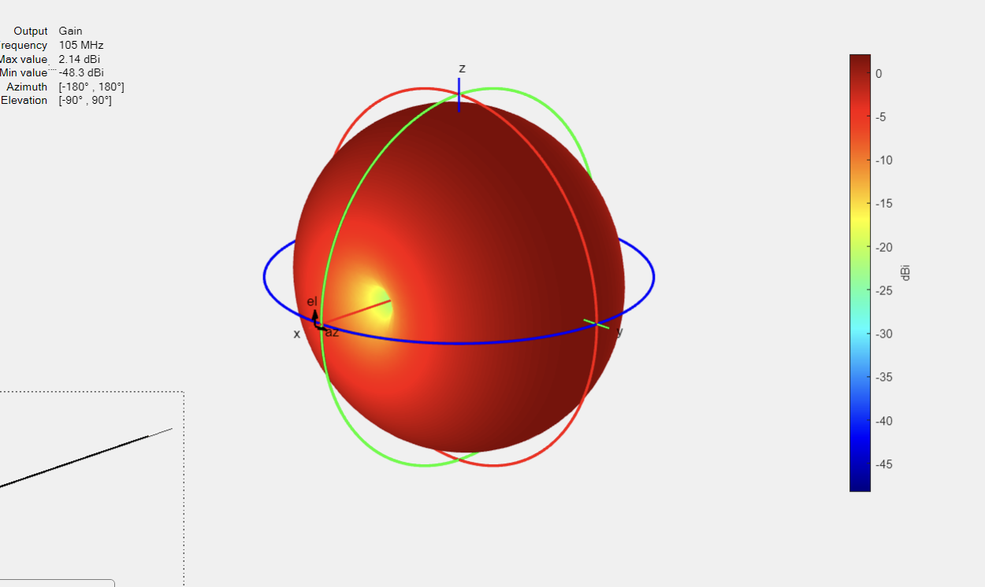
Figure 18 - Folded Dipole 3D Radiation Pattern
Figure 18 shows the folded dipole 3D radiation pattern.
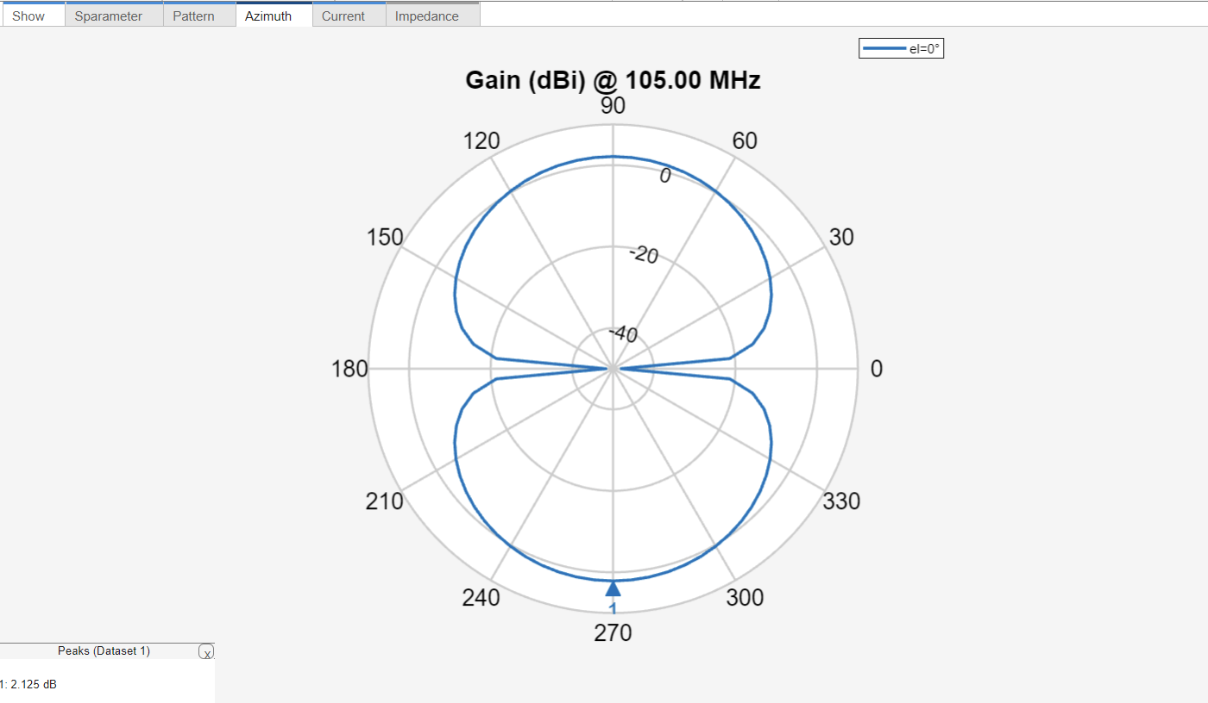
Figure 19 - Folded Dipole 2D Radiation Pattern (Azimuth)
Figure 19 shows the folded dipole Azimuth. As shown, this is bidirectional, with two main beams peaking at 90° and 270°, with nulls at 0° and 180°.

Issues
Issues were encountered whilst simulating the folded dipole, with the inability to:
- Obtain S Parameters
- Obtain impedance results

Conclusions
The Microstrip Antenna experienced a poor s11 result at resonance. This could be alleviated by altering the size of the patch, or the length and width of the feed.
The Horn Antenna performed as expected, with a strong directional signal observed, and good impedance matching.
The Folded dipole appeared to radiate energy as expected, with directionality observed. The S parameters, although showing that the gain was on the trough of the output, were rather poor at -5.1dB. This shows that this antenna was not performing so well and should require modifications to its size in order to achieve a better gain at resonance.
Overall, this report has concluded that antennas can perform slightly differently than the equations to determine their size, for example, and thus, modelling and simulation is imperative in the process of developing an antenna before manufacture.

Recommendations
- Alter the length and width of the antenna feed to the patch antenna. This should have the desired effect of moving the resonance down to the desired frequency, and thus the antennas gain should be much closer to the value expected (close to -20dB)
- Resolve the issues with the simulating the folded dipole S parameters by altering its size.
- Conduct further research into additional methods of tuning an antenna in order to extract the most optimal performance possible at the desired frequencies.

References

[1] | antenna-theory.com, "Microstrip (Patch) Antennas," antenna-theory.com, 2011. [Online]. Available: https://www.antenna-theory.com/antennas/patches/antenna.php.
[2] | https://uk.mathworks.com/help/antenna/ug/helical-antenna-design.html, "Helical Antenna Design," MathWorks, Inc, [Online]. Available: https://uk.mathworks.com/help/antenna/ug/helical-antenna-design.html.
[3] | UWTSD, "L6 - Advanced Radio Frequency Systems (ACDA6019)," 2024.
[4] | International Telecommunication Union (ITU), "Data format definition for exchanging stored IQ data for the purpose of spectrum monitoring," ITU, 2018.
[5] | F. Xiong, "Digital Modulation Techniques (Second Edition)," Artech House, Inc, Norwood, MA, 2006.
[6] | S. Rise, "Ring Modulator," The Synthesiser Academy, [Online]. Available: https://synthesizeracademy.com/ring-modulator/.
[7] | M. Steer, "Analog Modulation," LibreTexts Engineering, [Online]. Available: https://eng.libretexts.org/Bookshelves/Electrical_Engineering/Electronics/Microwave_and_RF_Design_I_-_Radio_Systems_(Steer)/02%3A_Modulation/2.04%3A_Analog_Modulation.
[8] | Ansys Inc, "Ansys HFSS," Ansys,Inc, 2024. [Online]. Available: https://www.ansys.com/en-gb/products/electronics/ansys-hfss. [Accessed 2024].

Ansys HFSS is a software for simulating and analysing the electromagnetic (EM) characteristics and behaviour of electronic products such as antennas [5].
Ansys HFSS is a software for simulating and analysing the electromagnetic (EM) characteristics and behaviour of electronic products such as antennas [5].
MATLAB is a computer environment and programming language that is used in this instance as a basis to interact with MATLAB antenna design software.

