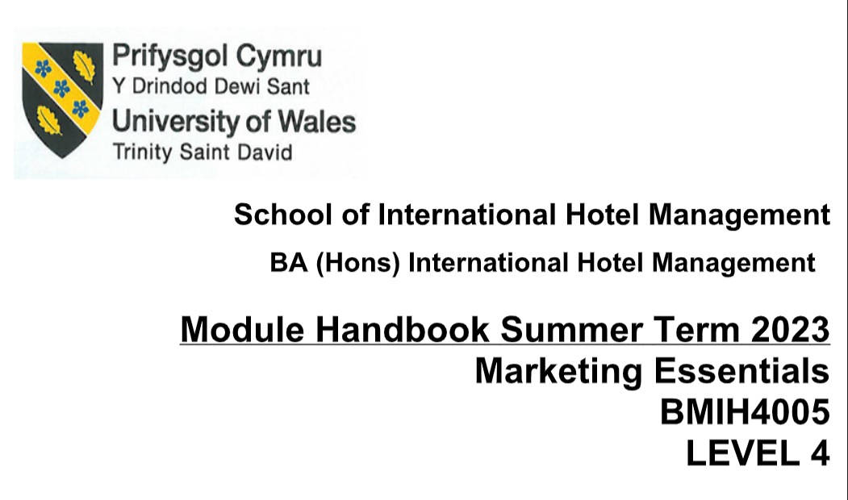

Marketing Essentials
Student name: FLORENTINA BADITA
Student ID: 2243431

Table of Contents
Introduction 3
5 C Situation analysis 4
Company analysis through Swot 4
Customers analysis through STP 4
Climate analysis through a pestle 5
Marketing mix 6
Objectives of making a marketing plan 7
Strategy making 8
The value proposition of IBIS 8
Tactics 9
Action 11
Control (KPI analysis) 12
Conclusion 13
References 14
Appendix 16

Introduction
A marketing plan reflects the critical strategy of a business organisation, where protocols and ideas are aligned according to business conveniences. The term marketing itself denotes the basic purpose and long-term aim of a business organisation which involves a sustainable foothold on the large market share, invincible strategies to stay one step ahead of the market rivalry, and continuous development of the product/service to meet diversified and ever-changing needs of the customer. Geo-political, environmental and economic spheres of the countries keep changing, customer preferences also change with time and lifestyles, and workplace management demands versatile and adaptable changes based on the nature of productivity and demand, thus marketing plan also needs to be advanced, business-friendly and most importantly which can attract more customer to its shadow. The following report will be tried to decipher different business disciplines and the core elements of the marketing approach of the French brand economy Hotel Ibis. The market nature, business needs and consumer behaviour will be researched in the light of suitable theories in order to develop a concrete knowledge base regarding marketing and its phenomena.

5 C Situation analysis

Company analysis through Swot
Swot will be the frame through which strengths, weaknesses, opportunities and threats will be discussed.
Strength- Ibis is a part of the Accor group of hotels, a conglomerate that offers services in numerous countries. It is a budget hotel that can derive service to a vast section of customers, due to its affordable price and ISO standard service. The hotel reinvents its guest experience with faster and easier check-in and check-out service. The hotel has its own mobile software, named FOLS, employees access the software to know guest preferences and needs thus service customisation goes in the favour of high consumer satisfaction (IBIS, 2023).
Weakness- Lack of professionalism, and challenges in workplace management, are weaknesses. The safety issue is another problem as reports are often published regarding unfair treatment towards disabled people and women. An article published by BBC stated that a woman's body was found in an Ibis hotel in the hull.
Opportunity- Ibis has been applying new digital technology in its workplace, which will be very useful for the upcoming business environment as present lifestyles are more dependent on digitisation and technology. 60.1% of the global population uses Internet technology and 92.8% of the world population is accommodated to mobile and Internet (ibisworld, 2023).
Threats- Innovative services like motels, spa hotels, and golf hotels, are some threats as people are intended to experience innovative services and more memorable stays.

Customers analysis through STP
Segmentation- mainly tourists, business persons, people who travel for better treatment, and people who book hotels for weddings and many other ceremonies are the main customers.
Targeting- People who are aged between 30 to 55 are the main target customers. People who have moderate to high Income and educations are also potential clients.
Competitors- Grand Hyatt, double tree Hilton, Premier Inn. When placing the company in the framework of Bowman’s clock it has been seen that the company uses the strategy of cost leadership in which specifically low-price and high-volume sales (Bowman’s Strategy Clock, 2023). They make a profit through voluminous sales operations by offering affordable pricing skims to market. Its membership skim offers a 15% discount on stay.
Collaborators- Ibis is a franchised chain, the first hotel opened in 1974, and presently the brand is grown to over 1218 hotels in 67 countries (franchisedirect.co.uk, 2023).

Climate analysis through a pestle
Politics - UK’s hospital sector comprises 143,000 people, which provide 1.8 million jobs in 2019, and generate 4044 billion British dollars in the UK economy (Statista, 2023). Thus, the government are intended to develop infrastructure which in turn will bring business feasibility to the hospitality sector. However, Brexit has imposed hindrance on tourist influx to a certain level as the UK has left the European Union.
Economic- Inflation in the UK market, the energy crisis, and the oil price hike has influenced the hospitality sector's business economy.
Social- Social lifestyle of the British people suggest UK household spent 111 billion British pounds on restaurants and hotels in 2022 (Statista, 2023).
Technological- AI, machine learning. SEO is the advanced technology that has brought an impetus to hotel service.
Legal- Consumer rights, fair trade, and ISO are some basic protocols that need follow in the UK economy.
Environmental- CSR, responsible service, waste management and ethical business practices are some modern protocols hospitality sectors follow to provide more pollution-free and community-friendly service.

Marketing mix
Product- Hotel service, an economical hotel where guests enjoy a comfortable stay. The hotel offers accommodation and food service.
Promotion- The company has focused towards digital marketing and customised service which is helpful for high customer acquisition.
Price- budget-friendly hotel, mainly focused on sales margin. The Price margin is lower than the premier inn and Grand Hyatt.
Place- UK, Australia, New Zealand, USA, and many more Asian countries.

Objectives of making a marketing plan
The main objective of the market plan is to beat the market rivalry, particularly in the UK economy and foster a sustainable long-term strategy aimed to provide valuable hotel service at a minimal range. The main target is to implement the operations, management, strategy and decisions in a way that can help to deliver value-added service to customers and supplementary to high-profit margin generation.

Strategy making

The value proposition of IBIS
The hotel has made its workplace management more customer-centric.
More friendly experience- Fold is an app that the hotel uses as a welcoming tool. The smiling team of ibis welcomes guests and provides prompt service to them.
Smart room for all-redesigned room for more comfort at a minimum price
New Food and beverage solution- Beer, wine, cocktails and local specificities are available at the bar. 24/7 food offer helps in more guest satisfaction.
Vibrant of music- IBIS music stage at Sgigzet festival, organised concerts and attract talent from all over the world. The company has collaborated with Sony and Spotify (accor, 2023). As per the framework of the Ansoff matrix, the company has adopted the strategy of product development. Collaboration with Sony and Spotify indicates investment in new products to attract a different segment of customers. Young talents and supporters of music are the new target customer (Peterdy, 2023). It is a kind of joint development and badging of the product on its own brand. Apart from product development market penetration also fit the new propositions based on the formation of the bar and welcoming team.

Tactics
Race/communication mix
The model frame-out procedure and applications of digital marketing. How a company will reach out to its customer and sustain a long-term liable plan to expand its customer base will be discussed through the race model
Reach- Testimonials, social influencers and guest posts will be effective for the propagation of positive and valuable testimony about the hotel service (shout.com/, 2022). In paid media, google ads, display ads, pay-per-click and organic searches should be used and in their own media platform email marketing and content marketing through websites, blogs and social media need to be utilised for new lead generation and transforming negative opinions of the people regarding the brand. Earned media also will be effective which will be a partnership with other brands like e-commerce platforms, hotel booking services, shopping platforms (both online and offline) and entertainment services. For example, the brand can promote its service in an app like booking. Com, make my trip by joint collaboration or can use social media platforms like Facebook, or Instagram. Sponsorship is another important path where the brand can advertise their value-added new services in the events of sports and concerts. Ibis is now a concert platform, and should effectively promote the brand via digital and mouth advertisement. Big data technology and Artificial intelligence must be used as effective tool. Because the brand is able to know the demand in an exact way it can formulate strategy accordingly.
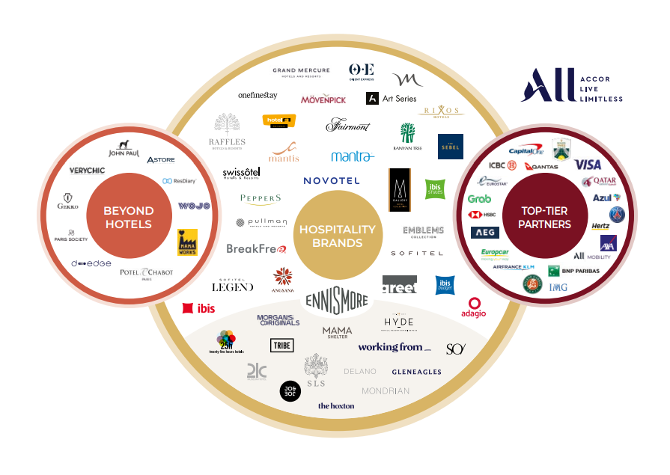
(Accor, 2021)
Act- Possess an interaction platform between the company and customers. This stage has an emphasis on the business-to-customer business approach. Apart from direct lead generation, lead can be also generated from viewed products and added baskets and listed priority. Activity 30 minutes need to perform. Short precise and to-the-point USP, easy sharing, proactive sharing content and encouragement of mashups will generate new leads.
Convert- The step is about converting the leads into real-time customers. Survey and data-driving marketing will help to determine the requirement of customers and based on that the brand can create a customised campaign and can channelise those customers to their service platform.
Engage- Turning a first-time buyer into a loyal customer is the core concept of the stage. The top-level goal of the company should be to build customer loyalty in a way that they again visit and recommend the brand to others.

Action

Objectives | Wk1 | Wk2 | Wk3 | Wk4 | Wk5 | Wk6 | Wk7
Sostac planning
Aims formulation
STP, value proposition
Marketing mix
Ansoff matrix/growth strategy
Marketing communication mix
KPI control

Control (KPI analysis)
Identified areas of improvement- Workplace management and guest security.
Retaining customers- new strategies of product development and market penetration supplementary to customer retention. The hotel offers a perceived product, a reputable brand, worth purchasing (Ken Peterson, 2023).
Increasing sales- big data technology, FOLS the brand’s own application and digitisation have increased sales.
Monitoring performance- The company can use google analytics for constant monitoring of the pricing strategy, service quality and product differentiation.
Differentiation from other customers- Collaboration with Sony and Spotify and the arrangement of concerts to attract a different customer segment is a new move for the brand.
Customer acquisition- High customer acquisition can be obtained when the new purchaser will convert into a loyal customer. Affordable budget, smart rooms, and digital service are suitable for high customer acquisition.

Conclusion
The report has discussed the main objective of the market plan of IBIS in order to attain a sustainable and competitive business platform. The new value proposition of the hotels is discussed in the frame of the Ansoff matrix to understand the brand's growth strategy in the current market, and a new marketing plan has been developed in the context of the RACE communication model.

References
Accor, (2021). 2021 Integrated report. [Online] Available at: file:///C:/Users/Lenovo/Downloads/ACCO_RI_2021_MEL_EN_300322%20(2).pdf [Accessed 05 June 2023].
Accor, 2023. ibis opens the way to vibrant hospitality !. [Online] Available at: https://group.accor.com/en/Actualites/2019/02/ibis-new-vibrant-hospitality [Accessed 30 May 2023].
Bowman’s Strategy Clock, (2023). Bowman's Strategy Clock. [Online] Available at: https://www.mindtools.com/a2rq300/bowmans-strategy-clock [Accessed 06 June 2023].
franchisedirect.co.uk, (2023). Ibis Hotels Franchise. [Online] Available at: https://www.franchisedirect.co.uk/franchise-information/ibis-hotels-franchise/ [Accessed 03 June 2023].
IBIS, (2023). Worldwide Hospitality Awards. [Online] Available at: https://hospitality-on.com/en/worldwide-hospitality-awards/ibis/ibis-reinventing-guest-experience [Accessed 30 May 2023].
IBISWorld, (2023). Industry Research Reports. [Online] Available at: https://www.ibisworld.com/market-research-reports/#united-kingdom [Accessed 02 June 2023].
Ken Peterson, (2023). 5 Important customer satisfaction KPIs. [Online] Available at: https://www.questionpro.com/blog/customer-satisfaction-kpi/#:~:text=Conclusion-,What%20are%20customer%20satisfaction%20KPIs%3F,improve%20customer%20loyalty%20and%20retention. [Accessed 05 June 2023].
Peter, K., (2023). Ansoff Matrix. [Online] Available at: https://corporatefinanceinstitute.com/resources/management/ansoff-matrix/ [Accessed 07 June 2023].
shout.com/, (2022). How To Get Customer Testimonials For Your Business. [Online] Available at: https://shout.com/customer-feedback/customer-testimonials/How To Get Customer Testimonials For Your Business [Accessed 03 June 2023].
Statista, (2023). Hospitality strategy: reopening, recovery, resilience. [Online] Available at: https://www.gov.uk/government/publications/hospitality-strategy-reopening-recovery-resilience/hospitality-strategy-reopening-recovery-resilience#:~:text=1.-,The%20hospitality%20sector,UK%20economy%20%5Bfootnote%209%5D. [Accessed 29 May 2023].
Statista, 2023. Annual expenditure on restaurants and hotels in the United Kingdom (UK) from 2005 to (2021), based on volume. [Online] Available at: https://www.statista.com/statistics/476514/annual-expenditure-on-restaurants-and-hotels-uk/ [Accessed 29 May 2023].

Appendix

Introduction
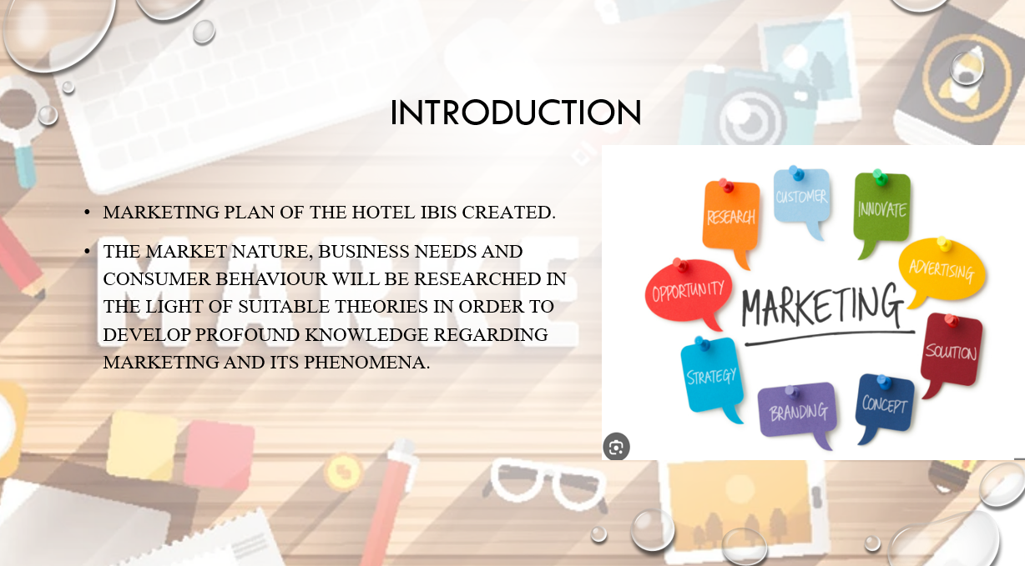
Marketing plan of the hotel IBIS created. Different models are theories have been used. The following presentation will determine different business disciplines and the core elements of the marketing approach of the French brand economy Hotel Ibis. The market nature, business needs and consumer behaviour will be researched in the light of suitable theories in order to develop a concrete knowledge base regarding marketing and its phenomena.

5 C Situation analysis
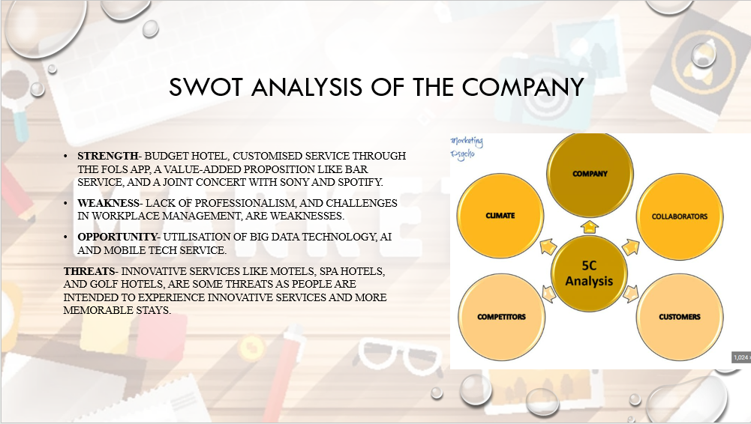

SWOT analysis of the company
Strength- Budget hotel, customised service through FOLS app, value-added proposition like bar service, a joint concert with Sony and Spotify.
Weakness- Lack of professionalism, and challenges in workplace management, are weaknesses.
Opportunity- Utilisation of big data technology, AI and mobile tech service.
Threats- Innovative services like motels, spa hotels, and golf hotels, are some threats as people are intended to experience innovative services and more memorable stays.

Customers analysis through STP
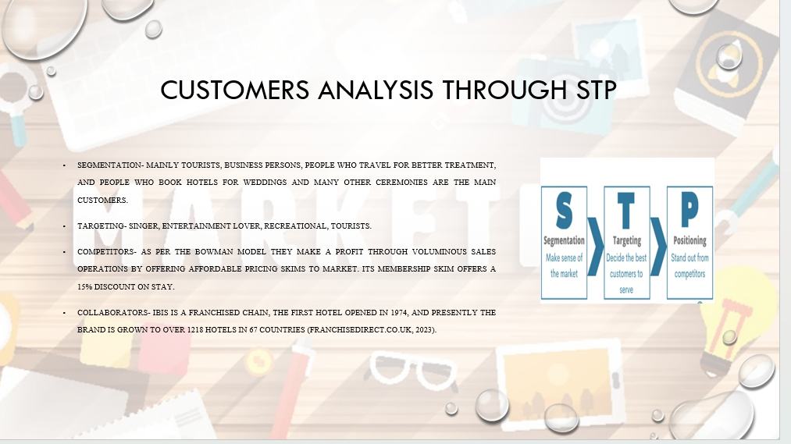

Segmentation- mainly tourists, business persons, people who travel for better treatment, and people who book hotels for weddings and many other ceremonies are the main customers.
Targeting- Singer, entertainment lover, recreational, tourists.
Competitors- as per the Bowman model they make a profit through voluminous sales operations by offering affordable pricing skims to market. Its membership skim offers a 15% discount on stay.
Collaborators- Ibis is a franchised chain, the first hotel opened in 1974, and presently the brand is grown to over 1218 hotels in 67 countries (franchisedirect.co.uk, 2023).

Climate analysis through a pestle
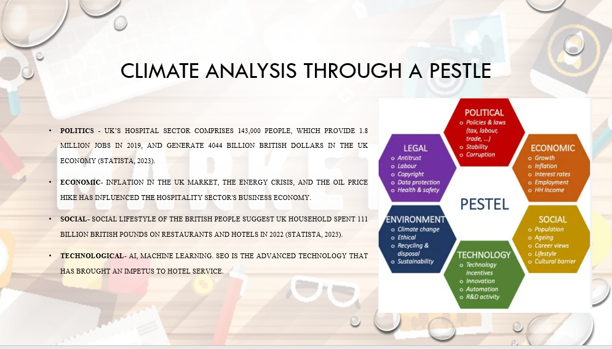

Politics - UK’s hospital sector comprises 143,000 people, which provide 1.8 million jobs in 2019, and generate 4044 billion British dollars in the UK economy (Statista, 2023).
Economic- Inflation in the UK market, the energy crisis, and the oil price hike has influenced the hospitality sector's business economy.
Social- Social lifestyle of the British people suggest UK household spent 111 billion British pounds on restaurants and hotels in 2022 (Statista, 2023).
Technological- AI, machine learning. SEO is the advanced technology that has brought an impetus to hotel service.
Legal- Consumer rights, fair trade, and ISO are some basic protocols that need follow in the UK economy.
Environmental- CSR, responsible service, waste management and ethical business practices are some modern protocols hospitality sectors follow to provide more pollution-free and community-friendly service.

Marketing mix
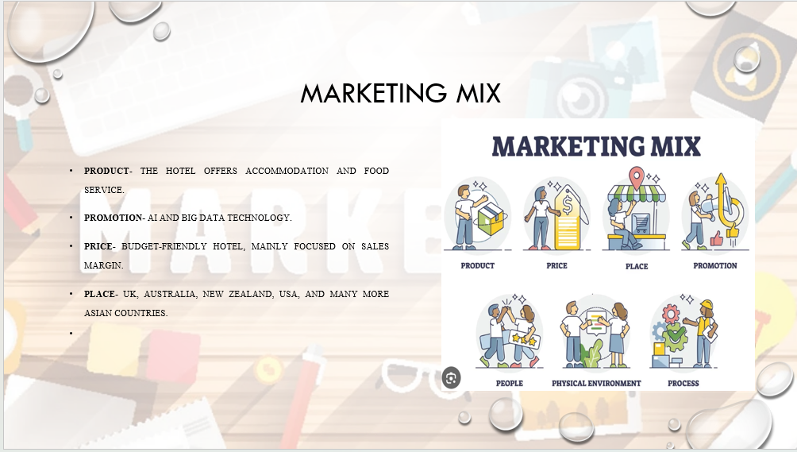
Product- The hotel offers accommodation and food service.
Promotion- AI and big data technology.
Price- budget-friendly hotel, mainly focused on sales margin.
Place- UK, Australia, New Zealand, USA, and many more Asian countries.

Strategy making
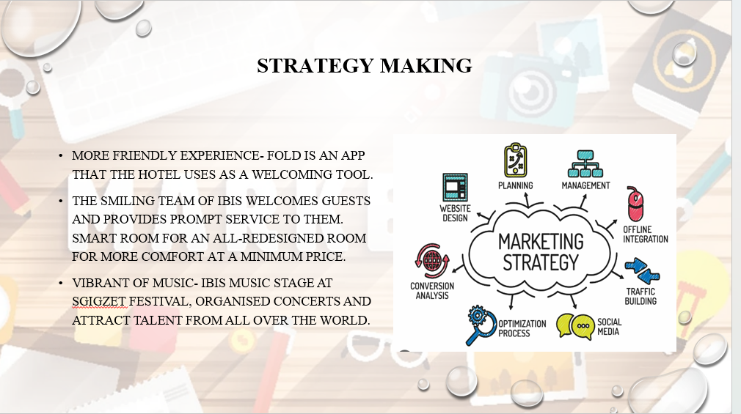

More friendly experience- Fold is an app that the hotel uses as a welcoming tool. The smiling team of ibis welcomes guests and provides prompt service to them. Smart room for an all-redesigned room for more comfort at a minimum price. Vibrant of music- IBIS music stage at Sgigzet festival, organised concerts and attract talent from all over the world.

Race/communication mix
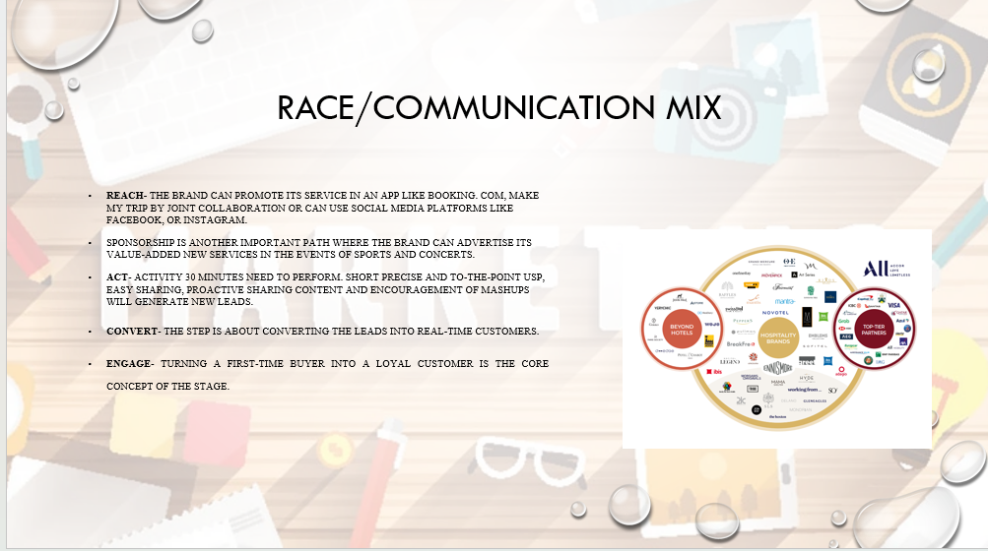

Reach- the brand can promote its service in an app like booking. Com, make my trip by joint collaboration or can use social media platforms like Facebook, or Instagram. Sponsorship is another important path where the brand can advertise their value-added new services in the events of sports and concerts. Ibis is now a concert platform, and should effectively promote the brand via digital and mouth advertisement.
Act- Activity 30 minutes need to perform. Short precise and to-the-point USP, easy sharing, proactive sharing content and encouragement of mashups will generate new leads.
Convert- The step is about converting the leads into real-time customers.
Engage- Turning a first-time buyer into a loyal customer is the core concept of the stage.

Action
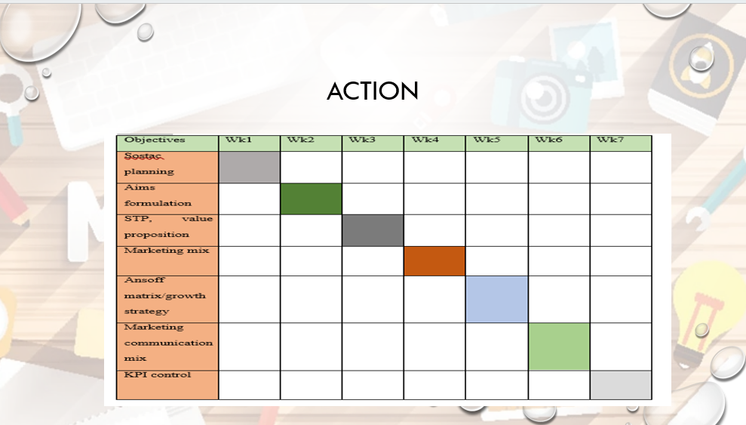
Objectives | Wk1 | Wk2 | Wk3 | Wk4 | Wk5 | Wk6 | Wk7
Sostac planning
Aims formulation
STP, value proposition
Marketing mix
Ansoff matrix/growth strategy
Marketing communication mix
KPI control

Conclusion
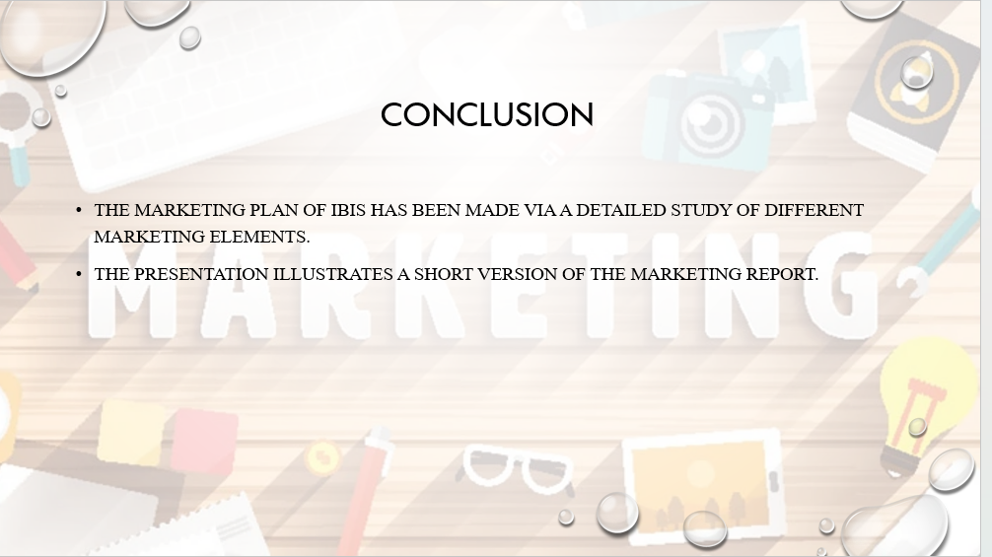
The marketing plan of IBIS has been made via a detailed study of different marketing elements. The presentation illustrates a short version of the marketing report.

References
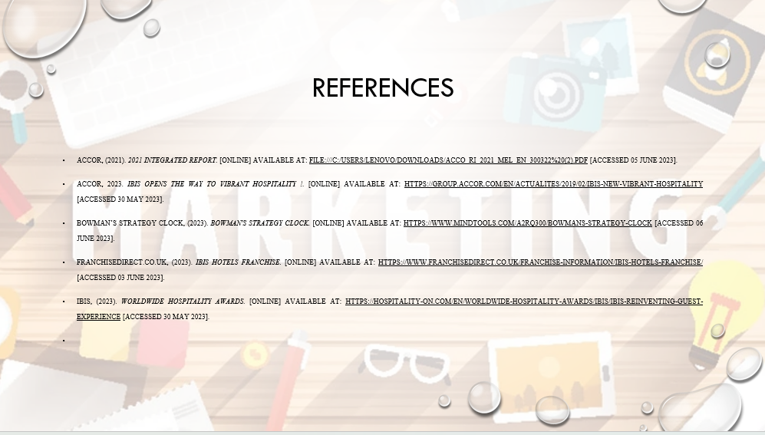
Accor, (2021). 2021 Integrated report. [Online] Available at: file:///C:/Users/Lenovo/Downloads/ACCO_RI_2021_MEL_EN_300322%20(2).pdf [Accessed 05 June 2023].
Accor, 2023. ibis opens the way to vibrant hospitality !. [Online] Available at: https://group.accor.com/en/Actualites/2019/02/ibis-new-vibrant-hospitality [Accessed 30 May 2023].
Bowman’s Strategy Clock, (2023). Bowman's Strategy Clock. [Online] Available at: https://www.mindtools.com/a2rq300/bowmans-strategy-clock [Accessed 06 June 2023].
franchisedirect.co.uk, (2023). Ibis Hotels Franchise. [Online] Available at: https://www.franchisedirect.co.uk/franchise-information/ibis-hotels-franchise/ [Accessed 03 June 2023].
IBIS, (2023). Worldwide Hospitality Awards. [Online] Available at: https://hospitality-on.com/en/worldwide-hospitality-awards/ibis/ibis-reinventing-guest-experience [Accessed 30 May 2023].

