Application Development

Name: Abdurahman Ibrahim
Student number: P150461
Course: Software Engineering
Module name: Application Development
Date: 21/11/18

Table of Contents:
Introduction
Design Principles:
Usability and User Experience (UX):
Application Development Concepts’ section:
Application Development Concepts’ section:
Requirements’ section:
Design’ section:
Implementation’ section:
Screen shots
References:

Introduction:
This will be a brief report on the use and implementation of the bootstrap software to make a mobile accessible website that is also responsive and reacts to the user demands.
Design Principles:
Visual Hierarchy:
This is the way t attract the attention of the human eye, the prominent visuals and having the colours in the right place will attract attention to the website.
Proportions:
Having good proportions make the website look attractive and professional, this will help viewers go through the page without being disappointed and leaving because of terrible proportions.
Usability and User Experience (UX):
The main thing you have to understand to design a website is to understand the people who will be visiting the website, if you implement and put in all the things they need then the website will be a success, for example if you make a charity website like the student has then it helps to have a donation page where the student donates.
Also make the website basic and easy to understand because all sorts of users will visit, some users may not understand the functions of the page, especially older users if the page is made too fancy and has too many functions.

Application Development Concepts’ section:

Requirements’ section:
•A brief introductory description of the application software you have implemented for Task 2. Note: See additional instructions in the worksheet brief.

•Using an appropriate software requirements specification technique, document the main requirements and/or features of the implemented application.

Design’ section:
Outline the design principles you have followed for the application software you have implemented.

Implementation’ section:
Outline the functionality of the main scripts or classes that you have implemented to provide the core functionality of your software application. Note: See additional instructions in the worksheet brief.

Screen shots of all of the pages/screens of the completed application software (not code).
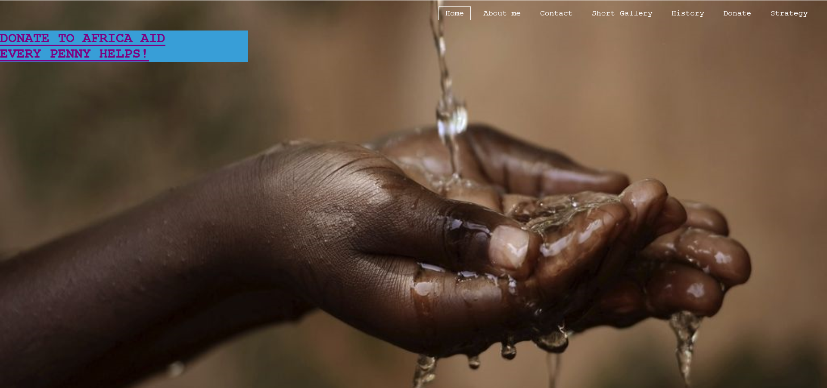
This is the front page you can hover above the buttons and have your choice.

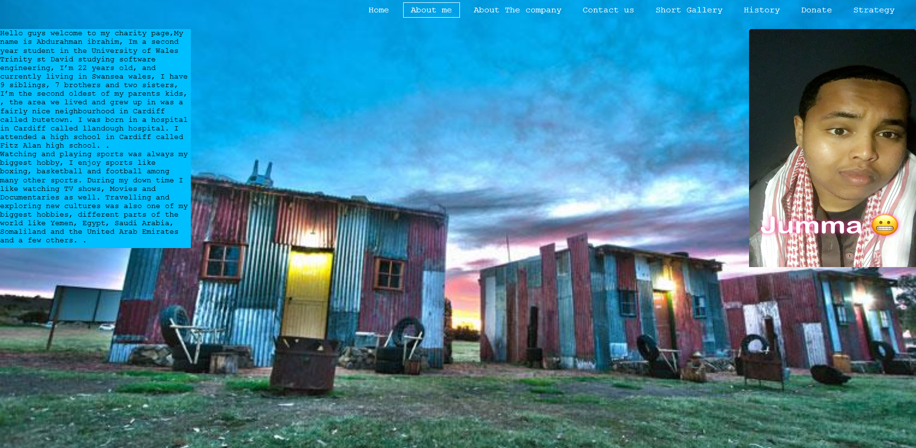
This page will be about the page designer:
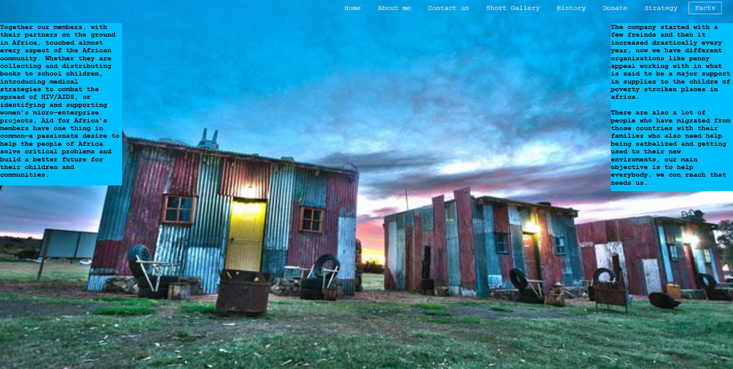
This page will be about the charity
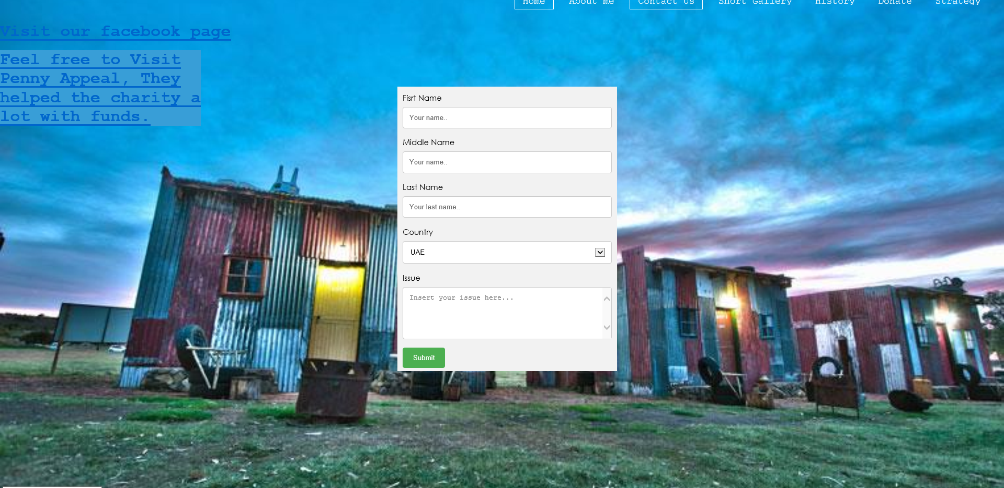This is the donation page.
The page below is a short gallery on the charity aid and the people.
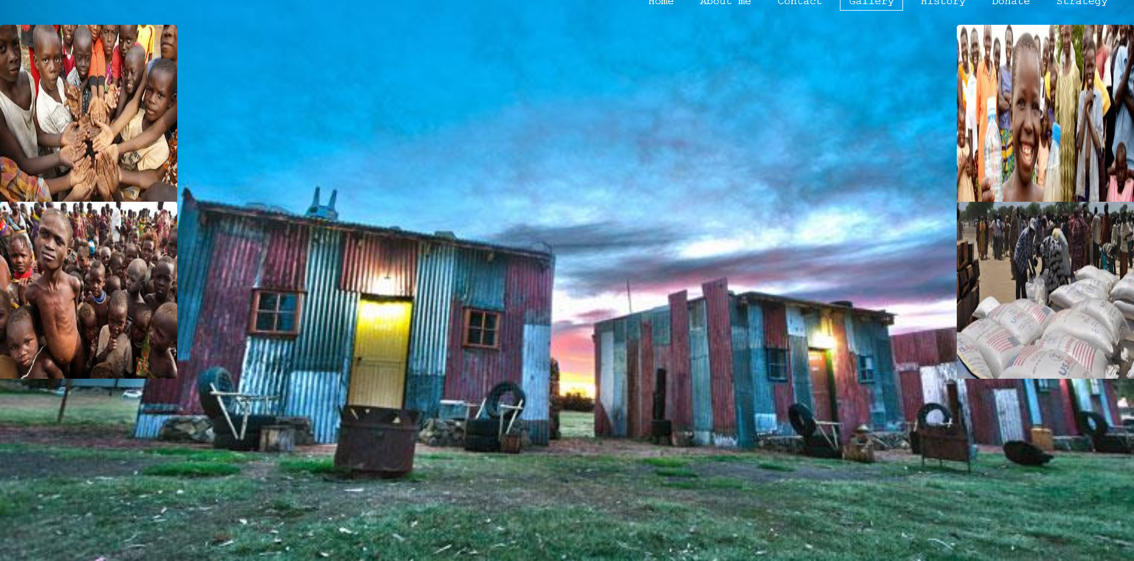
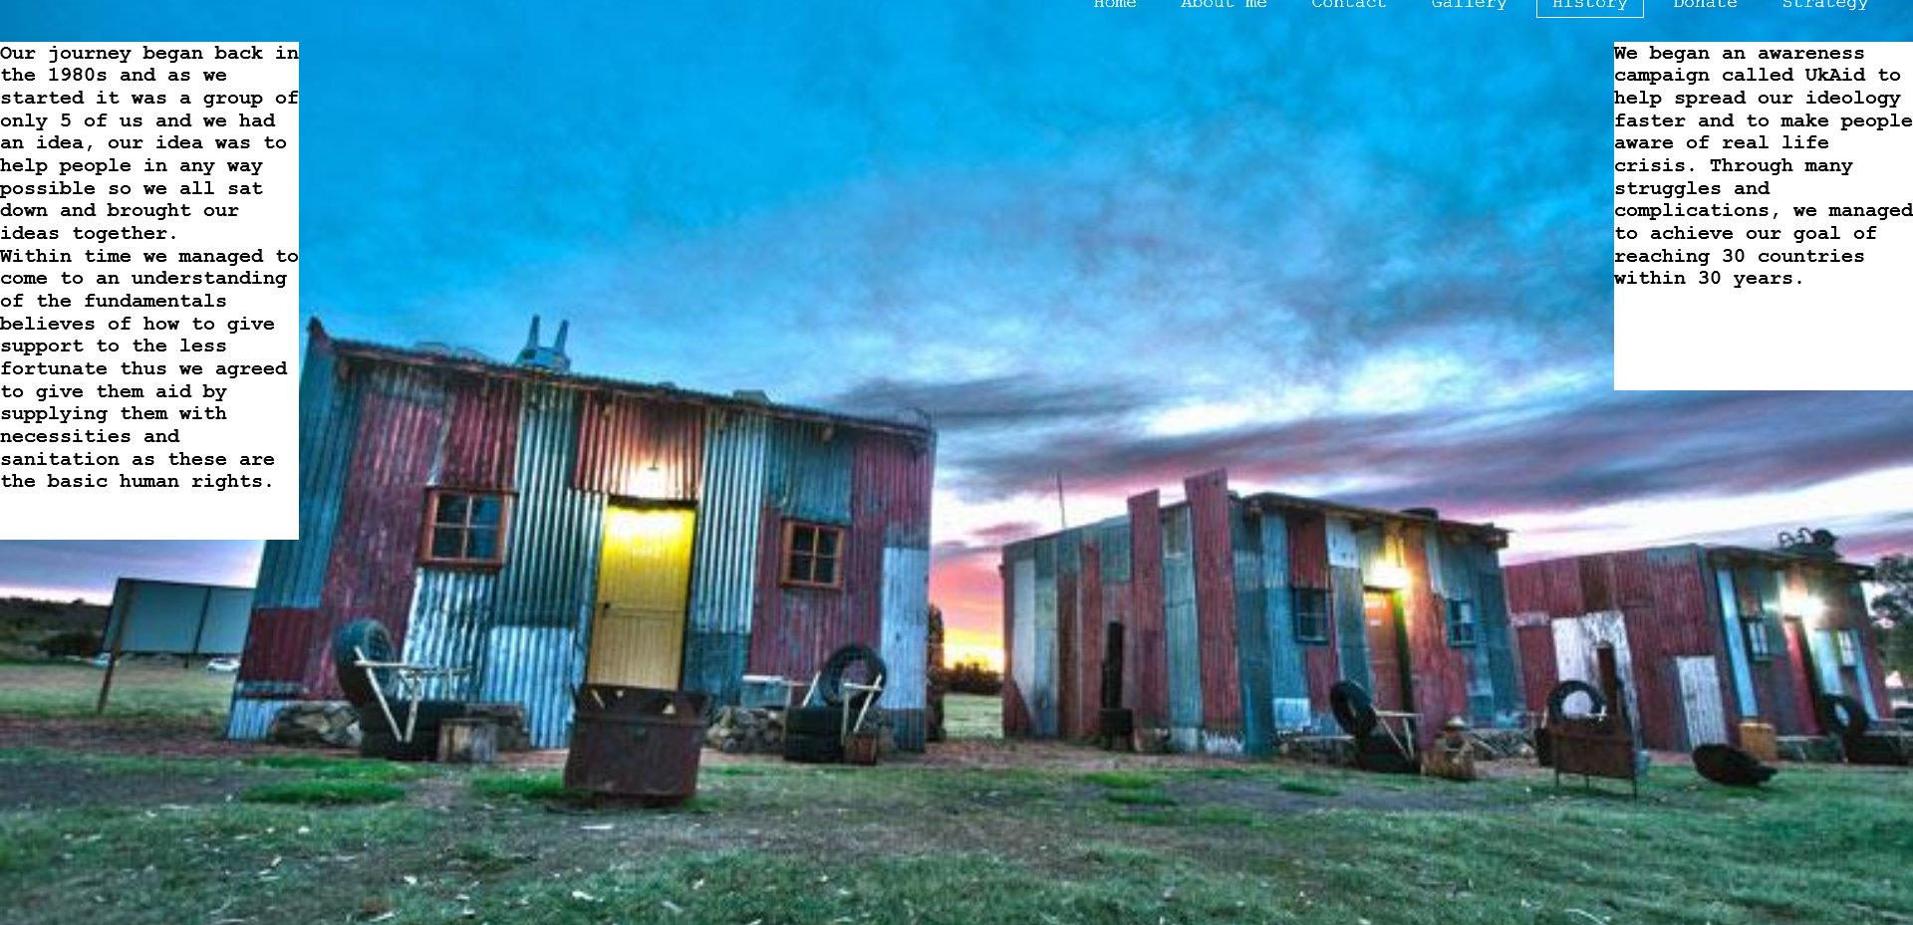
This page is on the history and foundation of our company.
And the links also lead to other pages including the media pages.

Note: If any of the pages/screens are very long, it is okay to provide a cropped view showing a reasonable amount of content.
Evaluation' section:
Software verification and validation is an important part of the software development process. Develop a set of test cases to verify and validate at least three of the requirements or features of the implemented application software.

An evaluation of the implemented application software taking into consideration its design (look and feel), usability (user experience and functionality) and content (information).

Reflect on the implemented application software and identify recommendations for future improvements.

References:
Any information sources (e.g. relevant journals, books, online sources and articles) that you have consulted.

