Programme: | Certificate of Higher Education in Skills for the Workplace
Assignment Title: | Academic and Employability Skills
Student Name: | Mohammed Yousuf
Student ID: | 1713906
Module Lecturer | Peter Allen
Module Code | BMSK4001

Table of Contents
Introduction 2
Background of my Higher Education in Skills for the Workplace 2
Academic skills that I have achieved from module 3
The employability skills I have possessed 4
The skills gap in academic skills and employability skills 6
Suggestions for the improvement of the Gaps 7
Conclusion 8
References 9

Introduction
The business world has become more sophisticated and that is why most of the organizations prefer the employees to be more updated in terms of employability skills. There are some of the courses which help the learners have the capabilities of achieving the employability skills while the study is on progress. The academic skills are required for achieving the employability skills at the same time as explained by Turner, et al, (2018). From my perception, the Certificate of Higher Education in Skills for the Workplace’ course has really helped me to achieve the academic and employability skills contributing to the career opportunities. I believe that such course in terms of the academic life will assist me to move at the top to the organizational hierarchy in my professional life. The practical professional skills oriented issues have been discussed in this session which has grown up my commitment and confidence to go forward towards achieving my career goal.

Background of my Higher Education in Skills for the Workplace
I have recently completed my graduation and now I am badly in need of a job. In term of getting the job, my academic skills will help me in this regard. In case of the cases, it has been observed that the practical knowledge rather than the theoretical knowledge in the academic life contributes most to be succeeded in the professional life because the practical academic skills are quite relevant to the employability skills in the workplace as per Brooks, (2017). The questions sometimes come in my mind whether I am eligible for any reputed job or whether my skills are adequate to get a jog and carry out the operational activities. But after going through this module, my confidence level is now on a hike as our course teacher has trained me a lot regarding the skills that I need to possess in the organizational workplace. My course teacher has suggested me to join the extracurricular activities which ultimately helped me to add a value of my CV stating that I am a proactive person supported by Fava-Verdé, et al, (2018). The course teacher has provided us with a brief idea in terms of choosing particular job field. I have learnt how to work staying in a team and how to lead a team because all the operations of the business organizations are basically executed by the help of the teamwork and I may have to lead a team after a while. That is why to lead a team, the leadership skills are the must.
In most of the cases, the company that is hiring access whether the participants are open to communication. This is to inform that I was a football team leader in my student life and that is why it has been very easy for me to capture the lecture that our course teacher has given on the leadership responsibilities. I need to carry out six types of leadership responsibilities. First of all, it is the main requirement to build the trust and loyalty among my team members. I need to use the participative leadership with my team members and should have to provide required resources as well as autonomy as discussed by Trought, (2017). I need to provide them with different incentives so that they can reach the self-esteem stage of the theory of needs. I need to be so transparent that I will always transparent to my team members. I need to keep the communication channel with my team members and that is why I have to conduct a routine based briefing with my team members every weekend. In my academic life, I was a class representative and I always liked to build the trust with my team members which helped me to bring the conformity on the class.

Academic skills that I have achieved from the module
The academic skills are known as those strategies that are required for learning for the purpose of developing the ultimate career opportunities for us. The academic skills have helped to participate and engage in the academic culture with the help of building awareness in myself. I have been able to perceive the core value of the academies. The first academic skill I basically possess is digital literacy as the current world is mostly operated by technological advancement. I can use the digital literacy in terms of communicating with others based on the skills and knowledge-based foundation signified by Feichtner, (2015).I have been able to find the core skills of emotional intelligence to manage my emotion while communicating with others. Emotional intelligence has helped me to increase my team performance, ease the decision making, and increase the leadership skills. My course teacher focused more in terms of developing emotional intelligence because it develops the interpersonal relationships among the individuals. The module has helped me to enhance my adaptability and cognitive flexibility skills. These skills are very important in terms oncoming up with different critical situations. The information analysis skills are the skills that I have been able to maximize in my academic career and this has helped me to find out the KPI to solve any problem. The self-knowledge is considered to be the best outcome of the academic skills I have gathered in my academic career as argued by Hind and Moss, (2016). I have been able to find out my SWOT analysis. My SWOT based on the self-knowledge is going to be described below:
Strength  - I am very efficient in term of the time management  - I have gathered a lot of software skills.  - I have the dominance in terms of interpersonal communication with my classmates and teachers. | Weakness  - I have a lack of confidence in myself  - I sometimes become distracted while executing any task.
Opportunity  - I have the opportunity to make an employment in the multinational organizations using my academic skills.  - I have the chance to take higher education in foreign universities. | Threat  - I am afraid of keeping up with the existing competition.  - I am still ignorant of some advanced software packages.

The employability skills I have possessed
The employability skills are considered to be an effective component of the career objectives because it helps to boost the career confidence of any student. Such a course has helped me to gain the employability skills illustrated by Lin, (2017).I have been able to have the creative CV writing skills as my department arranged a CV writing competition and I stood in the 3rd place in this competition. After the competition, some of the recognized professionals provided some suggestions regarding creative CV writing.
I have enhanced by employability skills with the help of the reflective learning. My course teacher has used the Kolb's Learning Cycle. The individuals basically tend to learn from the experience and Kolb's Learning Cycle focuses on the reflection based learning. There are four stages in the Kolb's Learning Cycle and which are the experience, reflect, Conceptualize as well as the plan component. My course teacher focused on the reflective observation in this model.
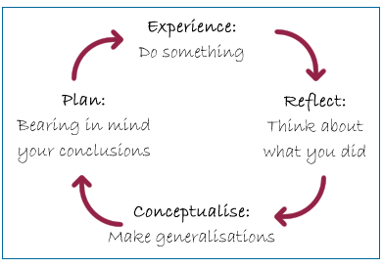
Figure 1: Kolb's Learning Cycle
Source:(Mainemelis, et al, 2018).
In terms of the experience, I tend to learn so many things from the observation of my surroundings and the experience component is related to the countless 'kick-start ‘opportunities. I am very good at the reflective observation as I always observe what I am doing and try to learn from that observation by the help of reviewing some of the experiences. The abstract conceptualization is based on the partial hypothesis as analyzed by MacDonald and Beech, (2018). The taste of the hypothesis is made in case of the planning stage. In terms of the time management skills, my teacher has advised me to create the distinction between the importance and urgency to manage the workload in both the office and university. My teacher has suggested me to follow the priority matrix to find the appropriate priorities of the work load.
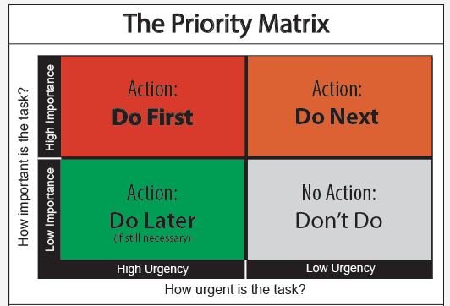
Figure 2: Time priority matrix for time management
Source: (Mainemelis, et al, 2018).
My teacher has suggested me to value the urgency on the first priority basis. I should do that work which has higher urgency as well as importance. The task having higher importance but lower urgency should not be done at this time. Apart from that I must have to minimize the distraction what so ever. I need to avoid scrolling down the Face book and waste time by gossiping with my colleagues. In term of the presentation skills, my teacher has strongly recommended following 7 laws to improve the presentation skills. Is should not make the repetition of the same state as justified by Shapiro, (2016). My feelings should be deemed at the time of the presentation period. I should make eye contact with my audience. I must have to make the issues clear to my audience in an attractive way. I need to be changed in my personality while presenting. I need to deliver at least one informative message to my audiences. I teacher has told me to keep the passion for full presentation
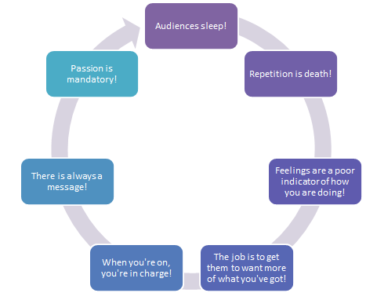
Figure 3: Laws for improving presentation skills
Source:(Turner, et al, 2018).
In terms of the software skills, the module has instructed me to gain the computer skills as much as possible. I have gained the computer skills and I have gained expertise in the Microsoft office application.

The skills gap in academic skills and employability skills
The academic skills and employability skills are considered to be the vast ranged skills are very tough to accomplish argued by Swales and Feak, (2017). I have also some gaps in the case of the academic and employability skills which are going to be described below
The gaps in the academic skills | - The practical academic skills are yet to be provided  - My course teacher did not arrange any internship program to have practical experience.  - There is a gap between theoretical and practical experience.
The gaps in the employability skills | - There is a lack of career and employability in terms of the employability skills.  - The business start-up support is not provided to the learners.  - Different employability events and competitions have not been arranged to utilize the employability skills.  - Different job fair could have been arranged.

Suggestions for the improvement of the Gaps
The suggestions for the improvement in the gaps for both the academic and employability skills are going to be given below:
- Our faculty members of this module must have to arrange a job fair to create the job facilities for the newly graduated students like me where the large companies and recruiting agencies will come and invite users to drop our CV.
- Different workshops should be sponsored for the purpose of increasing our leadership skills, soft skills, communication skills, hard skills, presentation skills etc.
- We should be provided with the opportunities to recruit use an intern in the large companies to grab practical experience by developing the personal attributes and abilities.
- This module should help us to set the personal development plan for each of the students. The following personal development plan is basically suggested in this regard
Skills | Types | Description | Deadline
Soft skills | Academic | Sufficient training should be provided to the students for the advanced software packages like SPASS. | Duration; 90 days  Completed by the end of 2020
Leadership skills | Employability | To lead a team because all the operations of the business organizations are basically executed by the help of the teamwork and I may have to lead a team after a while. | Duration; 60 days  Completed by the end of 2019

Conclusion
That is why to lead a team, the leadership skills are the must. In most of the cases, the company that is hiring access whether the participants are open to communication. There are some of the courses which help the learners have the capabilities of achieving the employability skills while the study is in progress as per Hind and Moss, (2016). The employability skills are considered to be an effective component of the career objectives because it helps to boost the career confidence of any student. Such a course has helped me to gain the employability skills. The academic skills are required for achieving the employability skills at the same time. In my academic life, I was a class representative and I always liked to build the trust with my team members which helped me to bring the conformation the class.

References
Brooks, J. (2017). Transferable academic skills kit.
Fava-Verdé, A., Fava-Verdé, A., Griffiths, P., Manning, A., Nukui, C., O'Cain, A., Russell, F. and Wilding, E. (2018). Transferable academic skills kit. Reading, UK: Garnet Publishing Ltd.
Feichtner, S. (2015). Janus employability skills prog.m.. Belmont, Calif.: Fearon/Janus/Quercus.
Hind, D. and Moss, S. (2016). Employability skills. Sunderland: Business Education.
Lin, Z. (2017). Consequences and policy implications for university students who have chosen liberal or vocational education. [Hull, Québec]: Applied Research Branch, Human Resources Development Canada.
MacDonald, A. and Beech, M. (2018). Trolls on vacation. New York, N.Y.: Bloomsbury Children's Books.
Mainemelis, C., Boyatzis, R. and Kolb, D. (2018). Learning Styles and Adaptive Flexibility. Management Learning, 33(1), pp.5-33.
Shapiro, E. (2016). Academic skills problems. New York, N.Y.: Guilford Press.
Swales, J. and Feak, C. (2017). Academic writing for graduate students. Ann Arbor: The University of Michigan Press.
Trought, F. (2017). Brilliant employability skills.
Turner, K., Krenus, B., Ireland, L. and Pointon, L. (2018). Essential Academic Skills. South Melbourne: Oxford University Preknowledge-based
ss.

