Provide a critical case study on the dynamics of Muslim interfaith OR intrafaith activity in an area of your choice
Submitted by Hsueh-Ying Hsu, student number: 1707645
Case Study on the Dynamics of Muslim Interfaith Activity in Islamic Spain of Golden Age

Introduction
Throughout history, it is very rare to find a prosperous civilization with an era of religious peace. Islamic Spain began its conquest of the Iberian Peninsula from 711 CE, when the Moorish led by the Islamic Umayyad conquered the Visigoth Kingdom, to 1492 CE when Islamic Granada was conquered by the new Christian Kingdom of Spain. The Muslim Spain was a multicultural mixture of Muslims, Jews and Christians, with a degree of civilization that was comparable to that of the Roman Empire. Though Jews and Christians lived under dhimmi restrictions, Islamic Spain prospered because of the tolerance between three religions of monotheism. They managed to get along well because they benefited mutually from one another. During the golden age (8th to 11th century) of the Moorish rein, the Umayyad dynasty of Andalusia united different Muslim regimes who conquered different parts of Spain. The Golden Age is an era of learning and opportunities abound to build many libraries and universities. Literature and poetry thrived, coming from both Muslims and non-Muslims alike. Without these interfaith interactions, everything that was achieved in Islam Spain would be impossible. The unusual religious tolerance that existed daily in this civilization was often influenced by religious diversity (Brett Middleton, Religion).
Therefore, Muslim Spain is often considered to be one of the first places in the world where Judaism, Christianity, and Islam lived in harmony and coexisted peacefully. However, further analysis and reports in this area are assessed. Some scholars disagree with such a positive statement. For example, Dario Fernandez-Morera concludes in his book: The Myth of the Andalusian Paradise that it was a myth for the idyllic life of religious tolerance in Muslim Spain. James Reston, a prominent American journalist, says ‘In the arts and agriculture, learning and tolerance, Al-Andalusia was a beacon of enlightenment to the rest of Europe’( Fernandez-Morera 2016, 85). No matter what these scholars’ summarization might be, it is no doubts that there was intercultural exchanges and interfaith interactions in Islamic Spain.
In this case studies, the discussion will focus on the dynamics of Muslim interfaith activity with Jews and Christians. I will expound the period of golden age of Islamic Spain. Further, I will analyse the society and ethnic constitution in Golden age. Next, I will expound the tolerance and intolerance, then the unique figures in that period. Finally, a conclusion will be given.

Case Study
Political Rule
From 711 to 1492 CE for nearly 800 years, Spain under the Islamic Moorish rule can be roughly divided into five periods:
1. 711-756 CE, the Al-Andalus province of the Umayyad Caliphate

2. 756-929 CE, the Independent Umayyad Emirate of Córdoba

3. 929-1031CE the Umayyad Caliphate of Córdoba

4. 1031-1238 CE, the Almoravid, the Almohad, and the Marinid Era
5. 1238-1492 CE, the Emirate of Granada
(Outlines for Spanish Moorish Era)
From a Jewish perspective, Rebecca Weiner described the Jewish golden year as:
‘The era of Muslim rule in Spain (8th-11th century) was considered the ‘Golden Age’ for Spanish Jewry. Jewish intellectual and spiritual life flourished and many Jews served in Spanish courts. Jewish economic expansion was unparalleled’. . . . The Golden Age for Jewry in Muslim Spain declined after the Almovarids gained power in 1055 . . . ‘
(Rebecca Weiner, ‘Judaism: Saphardim’ in Jewish Virtual Library)
In Spain, the golden age of Jewish culture coincided with the Middle Ages in Europe. It is a period of Muslim rule in most of the Iberian Peninsula where Jews were accepted in society. In here, their religious, cultural, and economic life flourished.
Usually this "Golden Age" refers to the period of the Caliphate of Córdoba from 756-1031 where, compared to other periods, society was more stable and prosperous (BBC, 2009). According to some scholars, the Umayyad Caliphate of Cordoba was not only a wealthy civilization, but also extremely enlightened in comparison to its contemporaries in Christian Europe. The Umayyads were not only tolerant of other faiths, but also women were permitted to learn reading and calligraphy and became scribes at the court. This period is often described as a 'golden age' of learning where libraries, colleges, public baths were established and literature, poetry and architecture flourished. Major contributions were made by both Muslims and non-Muslims to this prosperous culture (Islamic Spain and the Reconquista).
Credit goes to Amir Abd al-Rahman for the founding of the Emirate of Cordoba, in addition to joining with the various different Muslim groups who had conquered Spain in ruling. Abd Al-Rahman I established his capital at Kurtuba (modern Cordoba also called Cordova), which later became the largest and most wealthy city of Western Europe.
Muslim Spain was the gem of Europe with its capital city, Córdoba (also called Cordova) by the beginning of the ninth century. With the establishment of Abd al-Rahman III - “the great caliphate of Córdoba” - came the golden age of Al-Andalus. The intellectual center of Europe was Córdoba, in southern Spain.
James Burke (b. 1936), a British science historian described about Córdoba in the 9th Century in his book The Day The Universe Changed that when London was a tiny mud-hut village that could not find even a single street lamp, in Córdoba…
‘…there were half a million inhabitants, living in 113,000 houses. There were 700 mosques and 300 public baths throughout the 21 suburbs in the city. The streets were paved and lit.’ (Burke, 1985, p. 38)
Burke further said that for summer, there were marble balconies in the houses and for winter, there were hot-air ducts under the mosaic floors. The houses had gardens where they were adorned with artificial fountains and orchards. Paper, a material that was still unknown to the west, was everywhere at the time. There were bookshops and over seventy libraries.” (Burke, 1985, p. 38).
James Cleuge explains the significance of Córdoba in medieval Europe in his book "Spain in the Modern World",
“There was nothing like it, at that epoch, in the rest of Europe. The best minds in that continent looked to Spain for everything which most clearly differentiates a human being from a tiger.” (Cleugh, 1953, p. 70)
In the end of the first millennium, Córdoba was the intellectual well that attracted many Europeans to come to drink from it. Students from England and France traveled there to study under the guidance of scholars of the three religions (Muslim, Christianity and Judaism) to learn philosophy, science and medicine. The great library of Córdoba collected approximately 600,000 manuscripts (Burke, 1978, p. 122).
This rich and complex society was tolerant of other faiths. Tolerance was unheard of in the rest of Europe. But in Muslim Spain, “thousands of Jews and Christians lived in peace and harmony with their Muslim overlords.” (Burke, 1985, p. 38)
Unfortunately, this period of intellectual and economic prosperity began to decline. Shifting away from the rule of law, there appeared internal rifts in the Muslim power structure. The Muslim harmony started breaking up into warring factions. In the end, the caliphs were eliminated, and Córdoba fell to other Muslim forces. The Golden age of prosperity was ended (Dean Derhak, ‘A Glimpse of Muslim Spain).
Christian, Muslims, and Jews were the three main religious groups that constituted the society of Al-Andalus. This was the ethnic structure at that time. The Muslims were united on a religious level; however, they had several ethnic divisions. The main one being the distinction between the Berbers and the Arabs. Mozarabs were Christians who had lived for a long period under Muslim rule. As such, they adopted many Arabic customs, such as art and words, while maintaining their Christian rituals and Romance languages at the same time. In the city, each of these communities occupied distinct neighborhoods. In the 10th century, eighty percent of the population of Al-Andalus was comprised of muwalladûn (Iberian native Muslims n), Arabs, and Berbers by around 1100. This was due to a massive conversion of Christians took place (Al-Andalus, p. 6).
According to Thomas F Glick, the rate of conversion to Islam in al-Andalus was slow until the tenth century (less than one-quarter of the eventual entire number of converted converts); the explosive period coincided closely with the reign of 'Abd al-Rahmdn III (912-961); the process was completed (eighty percent converted) around 1100. The curve enables a reasonable estimate of the religious distribution of the population. Assuming that there were seven million Hispano-Romans in the peninsula in 711 and that the population remained level through the eleventh century (with population growth balancing out Christian migration to the north), by 912 there would have been approximately 2.8 million indigenous Muslims (muwalladûn) including Arabs and Berbers. At this point Muslims were still outnumbered by Christians. By 1100, the number of indigenous Muslims would have risen to a majority of 5.6 million (Glick 2005, 23-24).
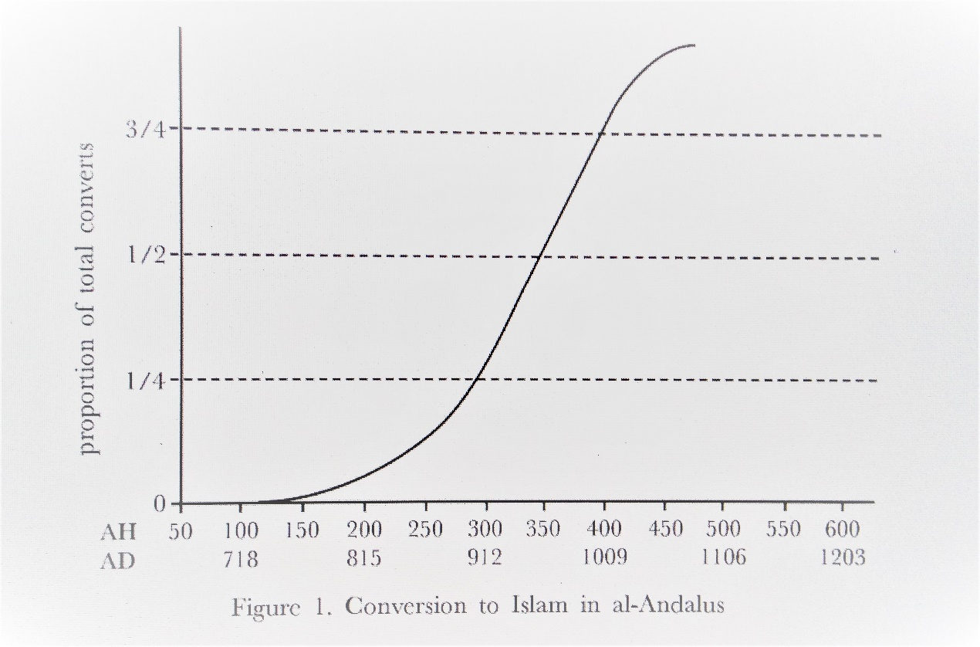
(Glick 2005, 24)
The Jewish population was primarily working as tax officers, traders, doctors or ambassadors. At the end of the 15th century, Granada had about 50,000 Jews, and there were about 100,000 Jews throughout Islam (Glick 1999, Chapter 1: at the crossroads of civilization).
Next, we are going to discuss the life for non-Muslims in Islamic Spain

Life for Jews and Christians in Islamic Spain

In Islamic Spain, non-Muslims were under the protection of Muslim law, the people of protection (dhimmis).Together with the conquered ‘People's Book’ including Jews, Christians, Sabaeans, and sometimes Zoroastrians and Hindus, a protection treaty (the dhimmis law) was established. Adult male dhimmis were required to pay a tax called Jizya to the Muslim rulers and sometimes paid higher rates of other taxes including their land. Clothing, occupation and residence restrictions and regulations were usually used. In return, Islam provides dhimmis life to ensure the security of life and property, defense against enemies, communal autonomy and freedom of religious activity (‘Dhimmi’, in Oxford Islamic Studies Online).

There are also restrictions on building churches and synagogues. For example, Jewish people were allowed to practice their religion and govern themselves according to their religious laws, but only within their communities. To prevent the expansion of Judaism, building new synagogues was usually not permitted. And their buildings must not higher than Muslim buildings. (Fernandez-Morera 2016, 180).
Some unequal treatments such as a male dhimmi man could not marry a female Muslim woman, but the reverse was acceptable and a dhimmi would only receive lower compensation than Muslims for the same injury. A dhimmi was a non-Muslim living in an Islamic state who was not a slave but did not have the same rights as a Muslim living in the same state (BBC, ‘Muslim Spain (711-1492)’).
In Islamic Spain, Jews and Christians were tolerable under the following conditions: accepted Islamic rule and superiority, paid a tax, did not speak disrespectfully about religions, did not try to win Muslims over, and adhered to established regulations.
Jews and Christians had to live in a state of ‘dhimmitude’ in Islamic Spain, given only limited freedom. It was stated by Bat Ye'or that under Muslim rule, non-Muslims were at the most inferior position in society. There was a class division according to ethnicity and religion, with the Arab tribes at the top of this class system. Berbers were considered second class, despite their Islamisation. Next was the Mullawadun converts, ranking just above the lowest in the hierarchy – Dhimmi Christians and Jews (Ye'or, 2002, pp. 50-80).
Historian Bernard Lewis wrote that the status of non-Muslims in Islamic Spain was like a second-class citizenship. However, he continued to say, ‘Second-class citizenship, though second class, is a kind of citizenship. It involves some rights, though not all, and is surely better than no rights at all... ‘ ‘...A recognized status, albeit one of inferiority to the dominant group, which is established by law, recognized by tradition, and confirmed by popular assent, is not to be despised’ (Lewis, 1984, p. 61-62).
The Muslims did not explicitly show hatred or persecute the non-Muslims. According to Bernard Lewis, The Muslims did not explicitly show hatred or persecute the non-Muslims. According to Bernard Lewis: contrary to Christian anti-Semitism, Muslim attitudes toward non-Muslims is not hatred, fear or jealousy, but contempt (Lewis, 1984, p. 33).
However, Jews and Christians retained some freedom under Islamic rule, providing they obeyed certain rules. Although the rules are considered unacceptable now, however with the standards at the time, they were not much of a burden. In many ways, non-Muslims of Islamic Spain (at least before 1050) were treated better than conquered peoples might have expected during that period of history. For example 1) they were not forced to live in ghettoes or special locations; 2) they were not enslaved; 3) they were not prevented from following their faith; 4) they were not forced to convert or die under Muslim rule; 5) Jews and Christians were able to contribute to society and culture; 6) they were able to work in the civil service of the Islamic rulers; and 7) they were not banned from any particular ways of earning a living. As a result, they often took on jobs shunned by Muslims. This included work such as tanning, butchery, banking, and dealing in gold and silver (BBC, ‘Muslim Spain (711-1492)).

Underwent such treatment, Jews and Christian held different views for dhimmi law. In the ninth century, the Mozarabs of Córdoba, led by their bishops, invited martyrdom by publicly condemning the Prophet Muhammad in public. However, violent acts against Mozarab were rare until the eleventh century when the Christian state became a serious threat to Andalusian security. Many Mozarabs fled to the northern Christian kingdom.
Under the anti-Jewish laws of the Visigoth kingdom, Jews had suffered a lot. Therefore, as Muslim and Christian medieval sources revealed, it is not surprising that the Jewish community supported Muslim invaders and even guarded major Catholic cities conquered by the Islamic warriors, thus promoting the rapid development of the Muslim army (Fernandez-Morera 2016, p.177).
Muslims and Jews lived in Islamic Spain in relative harmony. Jews had their own valid system and social services, but they were relatively powerless. They needed to pay special taxes while Muslims were no need to pay. They were forced to wear clothing with a badge and were not allowed to establish new synagogues. Jews had a strong sense of alienation and were reminded every day in various ways that they were different. There was also the fear of the possibility of persecution (People in Muslim Spain.
The Jews still succeeded in becoming craftsmen and businessmen. In fact, it was called the Hebrew “Golden Age” during the period between 900 and 1200 CE in Spain and North Africa, when the Jewish people were inspired in part by their Arab counterparts thus made progress in philosophy, astronomy, science and poetry (People in Muslim Spain).

‘It is true, then, that the Jewish community experienced better living conditions under Spain’s Muslim conquerors than under the Catholic Visigoths. It is also true that, as a result, for some centuries Andalusian Jewry thrived, producing a brilliant cultural output’ (Fernandez-Morera 2016, pp.178-179).
Cultural Interaction
There were also cultural agreements, especially in the architecture - the twelve lions in the court of Alhambra are the pioneers of Christian influence (BBC).
Muslim scholars served as the main link to bring Greek philosophy to Western Europe. And Muslims had previously been the main custodians for the Greek philosophy.
There were interchanges and alliances between Muslim and Christian rulers such as the legendary Christian Spanish warrior El-Cid (1043-1099), actually name, Rodrigo Díaz, who fought both against and alongside Muslims, yet he received respect from both Christians and Muslims (Lowney, 2005, p.133).
Many Christians in Spain had assimilated parts of the Muslim culture. Some people learned Arabic, some used the same clothes as their rulers, some Christian women even started wearing the veil; some took Arabic names. Christians who did this were known as Mozarabs (BBC).
The Hispano- Visigoth influence on Islamic Spain stretched beyond art and architectures. In Ethnic aspect, the Umayyads can hardly the original “Arabic”, because their mothers were usually Visigoth and Hispano-Roman woman or Balken and Slavic slave girl. Many Umayyads had the skin with rosy colour and reddish hair. Many famous Muslim intellectuals were also descendants of Christians. For example, an Islamic historian Ibn al-Qutiya was the son of a Goth woman (Fernandez-Morera, 2016, p. 224).
A physician and Jewish law scholar, Hasdai ibn Shaprut (915 -970), was appointed a position of influence as de facto foreign minister to the caliph (under Caliph Abd al-Rahman III) and acted as a benefactor and protector to the Jewish community (Fernandez-Morera, 2016, p. 180).
Islamic culture also influenced the Jewish people. The customs and practices of Jews and Muslims became intertwined. For example, Arabic was used for Muslim prayers rather than Hebrew or Spanish. Before entering the synagogue, the Jews washed their hands and feet, which was what the Muslims did before entering the mosque. Arabic melodies are used for Jewish songs. Jews wear the clothing style of their Moorish neighbors, although they are not allowed to wear silk or fur (Rebecca Weiner, ‘Judaism: Sephardim’ in Jewish Virtual Library).
Conclusion
The religious tolerance in Islamic Spain was not a tolerance that was equal to the United States or Britain in the modern day. The Christians and Jews were considered second class citizens to the Muslim people however the fact they were granted citizenship at all is an aberration to most other ancient civilizations. As second class citizens they still received many rights, not all, but most. Situation
Religious tolerance in Islamic Spain was not the same tolerance as modern America or the United Kingdom. Christians and Jews were considered as the second-class citizens to Muslims, but the fact was that they were granted citizenship is an aberration comparing to most other ancient civilizations. As second-class citizens, they still enjoyed many rights, not all, but most Happening.
The golden age of Islamic Spain from 756-1031CE or 711-1055 CE approximately lasted 300 years of peace in the Iberian Peninsula. Most terrible massacre and persecution would happen after 1055 CE which have been criticized by many scholars. Unequal treatment and status towards Jews and Christians in Islamic Spain were unfair, but it was tolerable during the peaceful period of Muslim Spain. It is the peace and harmony of society that secures human life and property and enhances the interfaith activity as well as cultural exchange. In this unique historical period, the Golden Age of Islamic Spain created the inevitable encountering between Jews, Christians and Muslims. This interreligious and intercultural encountering have brought richness in many aspects, such as arts, music, architecture, philosophy, science, astronomy, religious practices and many others. People at that time not only sought survival but a more beautiful and perfect attainment. In this essay only covers a very small parts, there are still many treasure waiting for exploring.

Bibliography
‘Al-Andalus’, < https://resources.saylor.org/wwwresources/archived/site/wp-content/uploads/2011/08/HIST351-4.1-Al-Andalus.pdf > [accessed 23 January 2019]
‘Dhimmi’, in Oxford Islamic Studies Online <http://www.oxfordislamicstudies.com/article/opr/t125/e536> [accessed 25 January 2019]
‘Islamic Spain and the Reconquista’ , <http://explorethemed.com/reconquista.asp > [accessed 23 January 2019]
‘Outlines for Spanish Moorish Era西班牙摩尔时代大纲’ http://www.mitbbs.com/article_t/History/32162113.html> [accessed 22 January 2019]
‘People in Muslim Spain’<http://factsanddetails.com/world/cat55/sub393/entry-5850.html> [accessed 24 January 2019]

Burke, James, The Day the Universe Changed (BBC 1985) ISBN 0-563-20192-4
Derhak, Dean, ‘A Glimpse of Muslim Spain’, ed. by IslamReligion.com (05 March 2007) < https://www.islamreligion.com/articles/522/glimpse-of-muslim-spain/ > [accessed 24 January 2019]
Fernández-Morera, Darío, The Myth of the Andalusian Paradise: Muslim, Christian, and Jews under Islamic Rule in Medieval Spain (DE: ISI Books, 2016)
Glick, Thomas F., Islamic and Christian Spain in the Early Middle Ages, 2nd ED (Leiden: Bill Academic Publishers, 2005)
James Cleuge, Spain In The Modern World (New York: Alfred A. Knopf, 1953)
Kenneth Baxter Wolf, Christian Martyrs in Muslim Spain (Cambridge: Cambridge University Press, 1988) p. 9-10
Lewis, Bernard, The Jews of Islam (Princeton: Princeton University Press, 1984), p.62
Lowney, Chris, A Vanished World: Muslim, Christians, and Jews in Medieval Spain (New York: Oxford University Press, 2006), 61-62
Maria Rosa Menocal, ‘Mother Tongues: Cordoba, 855’, in The Ornament of the World: How Muslims, Jews, and Christians Created a Culture of Tolerance in Medieval Spain (New York: Little, Brown and Company, 2002)
Trans. from French by Miriam Kochan, David Littman (Madison: Fairleigh Dickinson University Press, 2002), pp. 50-80,
Weiner, Rebecca, ‘Judaism: Saphardim’, in Jewish Virtual Library <https://www.jewishvirtuallibrary.org/sephardim> [accessed 25 January 2019]
Ye'or, Bat, Islam and Dhimmitude: Where Civilizations Collide

Maps
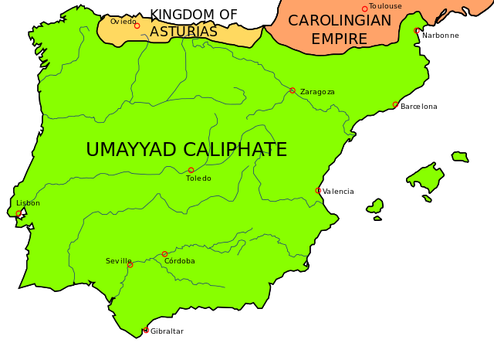
(711-756 CE) http://www.mitbbs.com/article_t/History/32162113.htm

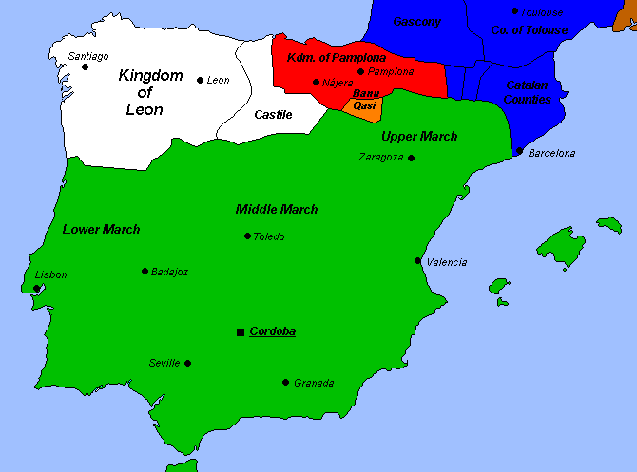
756-1031 CE http://www.mitbbs.com/article_t/History/32162113.htm

http://www.la-adrada.com/muslim-spain.html


